
SUPPLEMENTARY GAZETTE
THE SOUTH AUSTRALIAN
GOVERNMENT GAZETTE
Published by Authority

Adelaide, Friday, 26 September 2025

Contents

State Government Instruments

Summary Offences Act 1953 3972

State Government Instruments

Summary Offences Act 1953
Declared Shopping Precinct
Declaration by Delegate of the Commissioner of Police
I, Narelle Jayne Kameniar, being the Assistant Commissioner, Operations Support Service, and acting as a delegate of the Commissioner of Police, hereby declare under Section 66ZF of the Summary Offences Act 1953 (“the Act”) as a declared shopping precinct the following area at Elizabeth that includes Elizabeth City Centre and certain other retail shops and is bounded:
• To the north by Elizabeth Way, but excluding any part of the carriageway of Elizabeth Way;
• To the east by Main North Road, but excluding any part of the carriageway of Main North Road;
• To the south by Philip Highway and Elizabeth Way, but excluding any part of the carriageways of Philip Highway and Elizabeth Way; and
• To the west by Elizabeth Way, but excluding any part of the carriageway of Elizabeth Way
and I further exclude from this declaration the premises commonly known as ‘The Elizabeth Magistrates Court’ and, in addition, the premises commonly known as ‘The Elizabeth Police Station’ together with any other premises used by South Australia Police in conjunction with The Elizabeth Police Station.
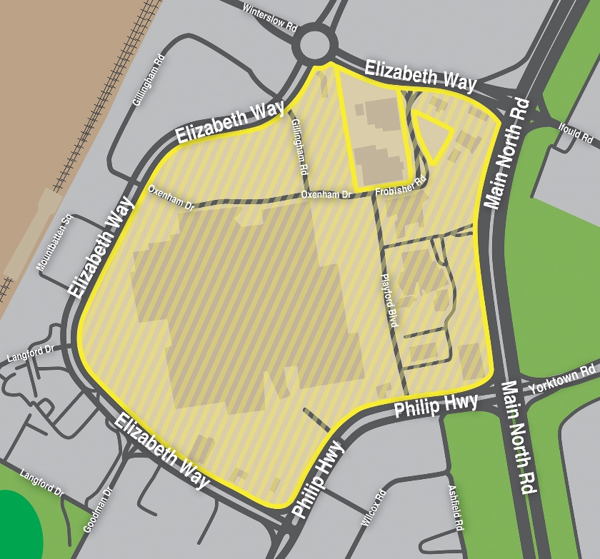
This declaration commences effect at 12:00 noon on Friday, 26 September 2025.
I am satisfied that the declaration is necessary for the purposes of deterring or detecting the commission of offences involving the possession or use of a knife or other weapons in the shopping precinct, and that the exercise of search powers under Section 66ZB of the Act is likely to be effective in deterring or detecting the commission of offences involving the possession or use of a knife or other weapons in the shopping precinct and, further, will not unduly affect lawful activity in the shopping precinct.
This declaration will remain in effect until being revoked at such time that the Commissioner of Police (or delegate) is satisfied the grounds for this declaration are no longer met.
Dated: 26 September 2025
Narelle Jayne Kameniar
Assistant Commissioner of Police

Summary Offences Act 1953
Declared Shopping Precinct
Declaration by Delegate of the Commissioner of Police
I, Narelle Jayne Kameniar, being the Assistant Commissioner, Operations Support Service, and acting as a delegate of the Commissioner of Police, hereby declare under Section 66ZF of the Summary Offences Act 1953 (“the Act”) as a declared shopping precinct the following area at Glenside that includes Burnside Village shopping centre and certain other retail shops and is bounded:
• To the north by Greenhill Road, but excluding any part of the carriageway of Greenhill Road;
• To the east by Portrush Road, but excluding any part of the carriageway of Portrush Road;
• To the south by Cator Street, but excluding any part of the carriageway of Cator Street; and
• To the west by Sydney Street, but excluding any part of the carriageway of Sydney Street.
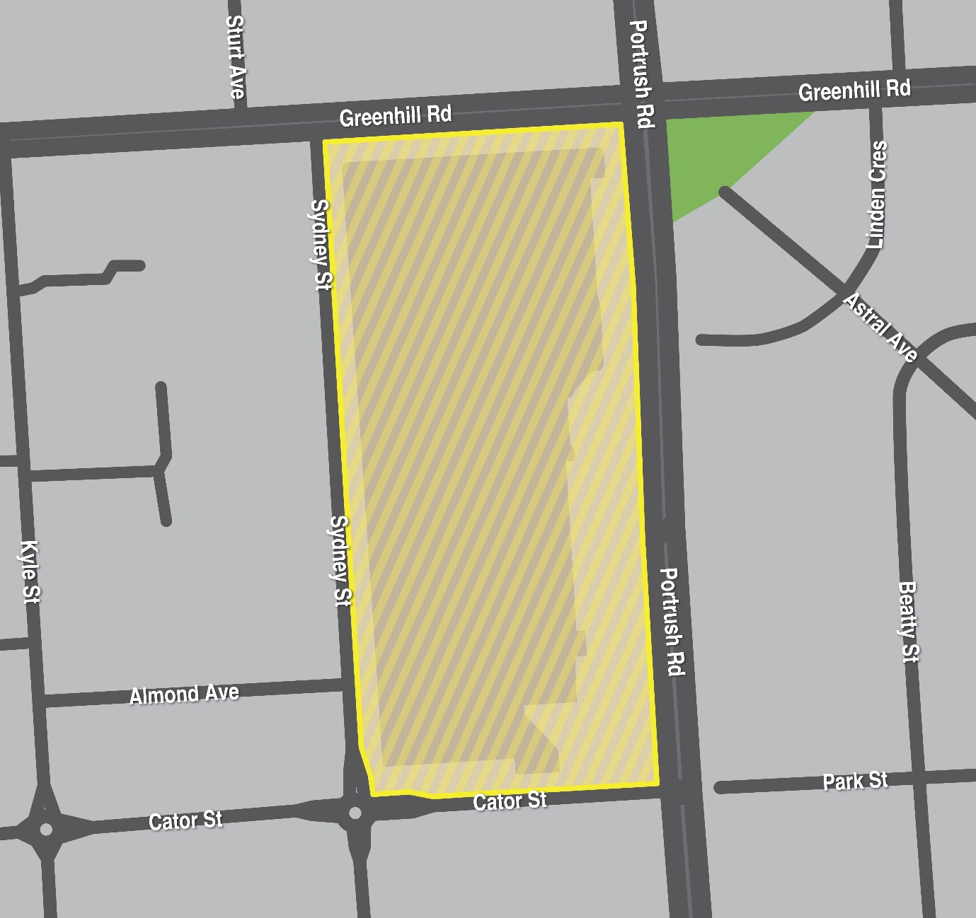
This declaration commences effect at 12:00 noon on Friday, 26 September 2025.
I am satisfied that the declaration is necessary for the purposes of deterring or detecting the commission of offences involving the possession or use of a knife or other weapons in the shopping precinct, and that the exercise of search powers under Section 66ZB of the Act is likely to be effective in deterring or detecting the commission of offences involving the possession or use of a knife or other weapons in the shopping precinct and, further, will not unduly affect lawful activity in the shopping precinct.
This declaration will remain in effect until being revoked at such time that the Commissioner of Police (or delegate) is satisfied the grounds for this declaration are no longer met.
Dated: 26 September 2025
Narelle Jayne Kameniar
Assistant Commissioner of Police

Summary Offences Act 1953
Declared Shopping Precinct
Declaration by Delegate of the Commissioner of Police
I, Narelle Jayne Kameniar, being the Assistant Commissioner, Operations Support Service, and acting as a delegate of the Commissioner of Police, hereby declare under Section 66ZF of the Summary Offences Act 1953 (“the Act”) as a declared shopping precinct the following area at Kilkenny that includes Armada Arndale Shopping Centre and certain other retail shops and is bounded:
• To the north by First Avenue, but excluding any part of the carriageway of First Avenue; and
• To the west by Hanson Road, but excluding any part of the carriageway of Hanson Road; and
• To the southwest by Torrens Road, but excluding any part of the carriageway of Torrens Road; and
• To the southeast by Regency Road, but excluding any part of the carriageway of Regency Road; and
• To the east by Arndale Street and Gray Street, but excluding any part of the carriageway of Arndale Street and Gray Street.
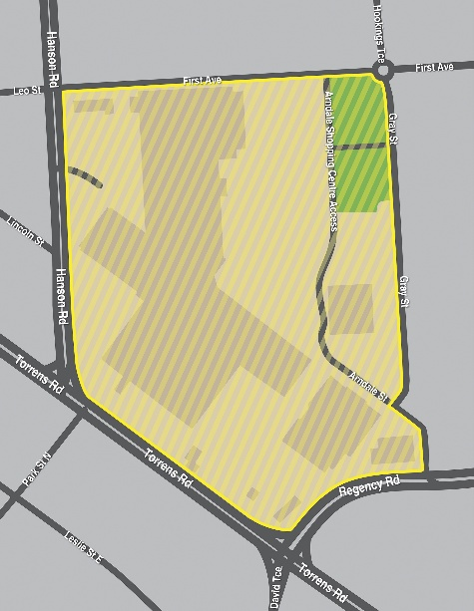
This declaration commences effect at 12:00 noon on Friday, 26 September 2025.
I am satisfied that the declaration is necessary for the purposes of deterring or detecting the commission of offences involving the possession or use of a knife or other weapons in the shopping precinct, and that the exercise of search powers under Section 66ZB of the Act is likely to be effective in deterring or detecting the commission of offences involving the possession or use of a knife or other weapons in the shopping precinct and, further, will not unduly affect lawful activity in the shopping precinct.
This declaration will remain in effect until being revoked at such time that the Commissioner of Police (or delegate) is satisfied the grounds for this declaration are no longer met.
Dated: 26 September 2025
Narelle Jayne Kameniar
Assistant Commissioner of Police

SUMMARY OFFENCES ACT 1953
Declared Shopping Precinct
Declaration by Delegate of the Commissioner of Police
I, Narelle Jayne Kameniar, being the Assistant Commissioner, Operations Support Service, and acting as a delegate of the Commissioner of Police, hereby declare under Section 66ZF of the Summary Offences Act 1953 (“the Act”) as a declared shopping precinct the following area at Oaklands Park that includes Westfield Marion Shopping Centre and certain other retail shops and is bounded:
• To the north by Diagonal Road, but excluding any part of the carriageway of Diagonal Road;
• To the south by Sturt Road, but excluding any part of the carriageway of Sturt Road; and
• To the west by Morphett Road, but excluding any part of the carriageway of Morphett Road.
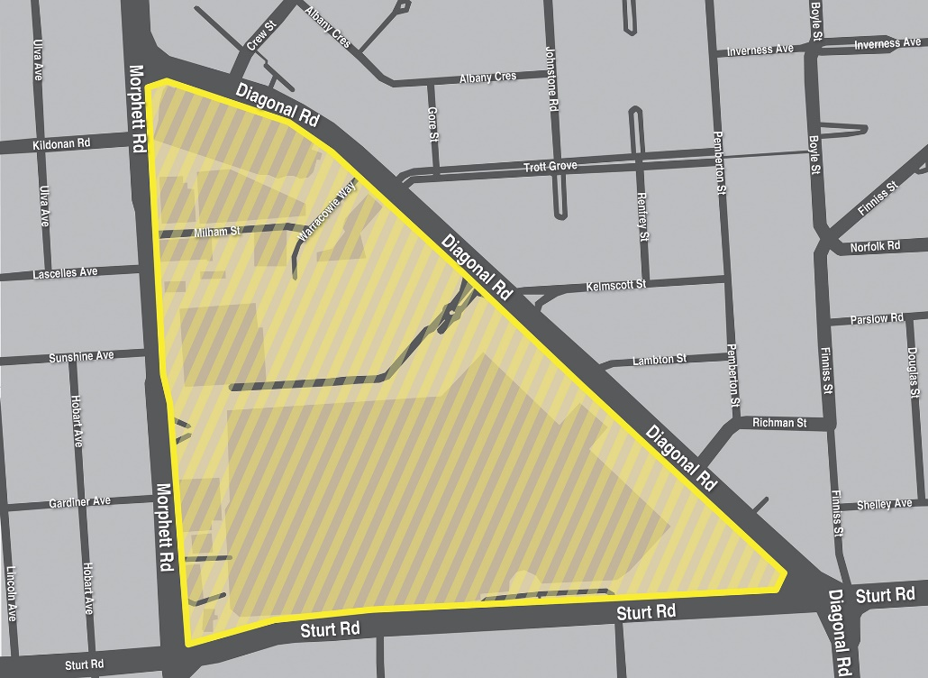
This declaration commences effect at 12:00 noon on Friday, 26 September 2025.
I am satisfied that the declaration is necessary for the purposes of deterring or detecting the commission of offences involving the possession or use of a knife or other weapons in the shopping precinct, and that the exercise of search powers under Section 66ZB of the Act is likely to be effective in deterring or detecting the commission of offences involving the possession or use of a knife or other weapons in the shopping precinct and, further, will not unduly affect lawful activity in the shopping precinct.
This declaration will remain in effect until being revoked at such time that the Commissioner of Police (or delegate) is satisfied the grounds for this declaration are no longer met.
Dated: 26 September 2025
Narelle Jayne Kameniar
Assistant Commissioner of Police

SUMMARY OFFENCES ACT 1953
Declared Shopping Precinct
Declaration by Delegate of the Commissioner of Police
I, Narelle Jayne Kameniar, being the Assistant Commissioner, Operations Support Service, and acting as a delegate of the Commissioner of Police, hereby declare under Section 66ZF of the Summary Offences Act 1953 (“the Act”) as a declared shopping precinct the following area at Salisbury that includes Parabanks Shopping Centre and certain other retail shops and is bounded:
• To the north by the southern bank of the Little Para River;
• To the east by Commercial Road, but excluding any part of the carriageway of Commercial Road;
• To the south by Wiltshire Street and Park Terrace, but excluding any part of the carriageway of Wiltshire Street and Park Terrace; and
• To the west by Gawler Street, but excluding any part of the carriageway of Gawler Street.
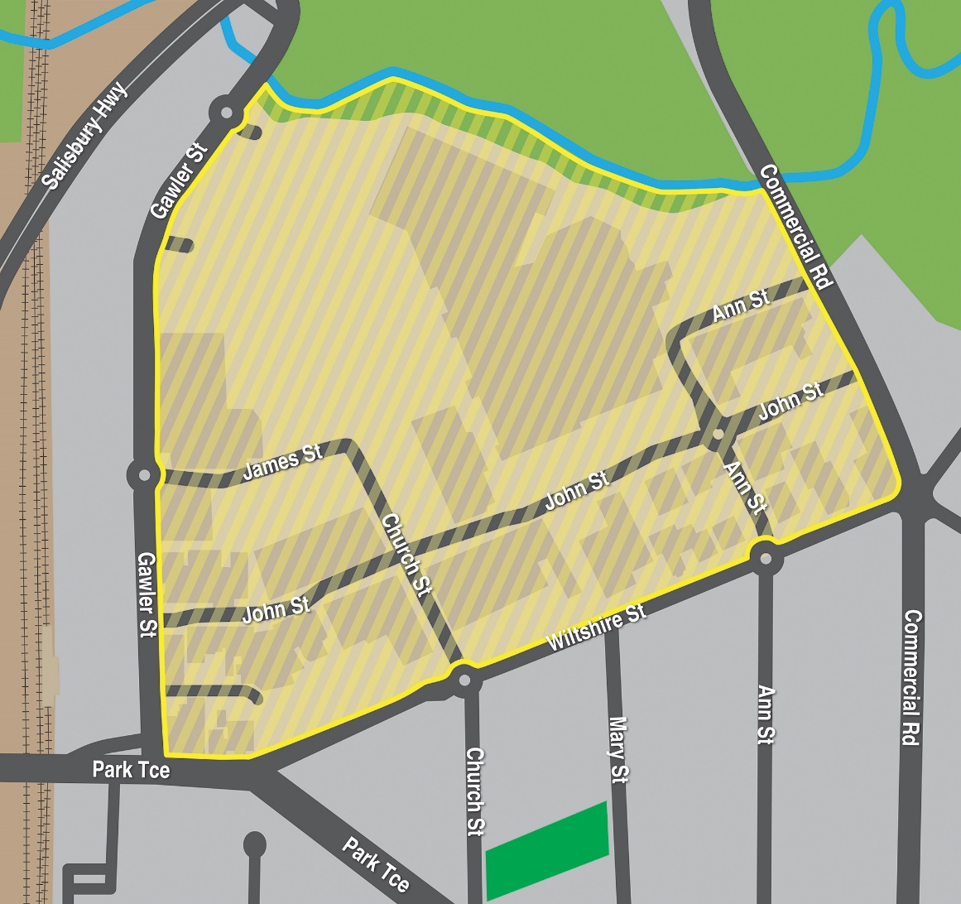
This declaration commences effect at 12:00 noon on Friday, 26 September 2025.
I am satisfied that the declaration is necessary for the purposes of deterring or detecting the commission of offences involving the possession or use of a knife or other weapons in the shopping precinct, and that the exercise of search powers under Section 66ZB of the Act is likely to be effective in deterring or detecting the commission of offences involving the possession or use of a knife or other weapons in the shopping precinct and, further, will not unduly affect lawful activity in the shopping precinct.
This declaration will remain in effect until being revoked at such time that the Commissioner of Police (or delegate) is satisfied the grounds for this declaration are no longer met.
Dated: 26 September 2025
Narelle Jayne Kameniar
Assistant Commissioner of Police

Summary Offences Act 1953
Declared Shopping Precinct
Declaration by Delegate of the Commissioner of Police
I, Narelle Jayne Kameniar, being the Assistant Commissioner, Operations Support Service, and acting as a delegate of the Commissioner of Police, hereby declare under Section 66ZF of the Summary Offences Act 1953 (“the Act”) as a declared shopping precinct the following area at Salisbury Downs that includes the Hollywood Plaza Shopping Centre and certain other retail shops and is bounded:
• To the north by Burton Road and Spains Road, but excluding any part of the carriageway of Burton Road and Spains Road;
• To the east by Hollywood Boulevard and Beverley Drive, but excluding any part of the carriageway of Hollywood Boulevard and Beverley Drive;
• To the south by Hollywood Boulevard and Winzor Street, but excluding any part of the carriageways of Hollywood Boulevard and Winzor Street; and
• To the west by Martins Road, but excluding any part of the carriageway of Martins Road.
but excluding any private dwelling on Winzor Street that is used for residential purposes.
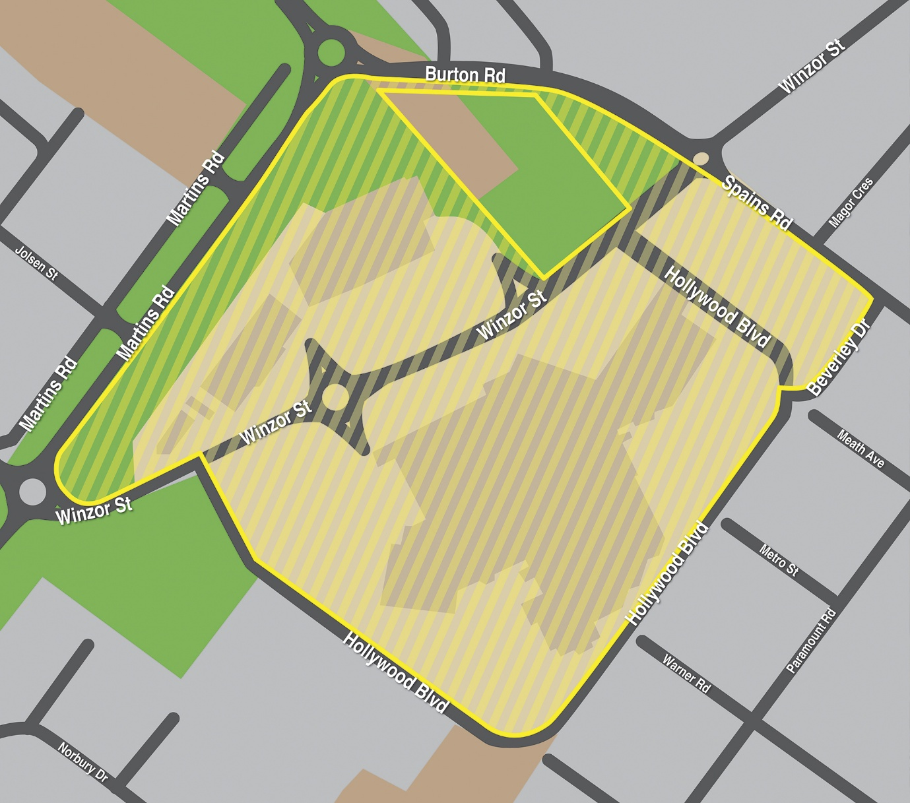
This declaration commences effect at 12:00 noon on Friday, 26 September 2025.
I am satisfied that the declaration is necessary for the purposes of deterring or detecting the commission of offences involving the possession or use of a knife or other weapons in the shopping precinct, and that the exercise of search powers under Section 66ZB of the Act is likely to be effective in deterring or detecting the commission of offences involving the possession or use of a knife or other weapons in the shopping precinct and, further, will not unduly affect lawful activity in the shopping precinct.
This declaration will remain in effect until being revoked at such time that the Commissioner of Police (or delegate) is satisfied the grounds for this declaration are no longer met.
Dated: 26 September 2025
Narelle Jayne Kameniar
Assistant Commissioner of Police

Summary Offences Act 1953
Declared Shopping Precinct
Declaration by Delegate of the Commissioner of Police
I, Narelle Jayne Kameniar, being the Assistant Commissioner, Operations Support Service, and acting as a delegate of the Commissioner of Police, hereby declare under Section 66ZF of the Summary Offences Act 1953 (“the Act”) as a declared shopping precinct the following area at Smithfield that includes the Munno Para Shopping Centre and certain other retail shops and:
• is bounded on one side by Konanda Road, but excluding any part of the carriageway of Konanda Road;
• is bounded on another side by Main North Road, but excluding any part of the carriageway of Main North Road; and
• which also includes those retail shops to the immediate north of George McCullum Road, being situated between Warooka Drive and Main North Road.
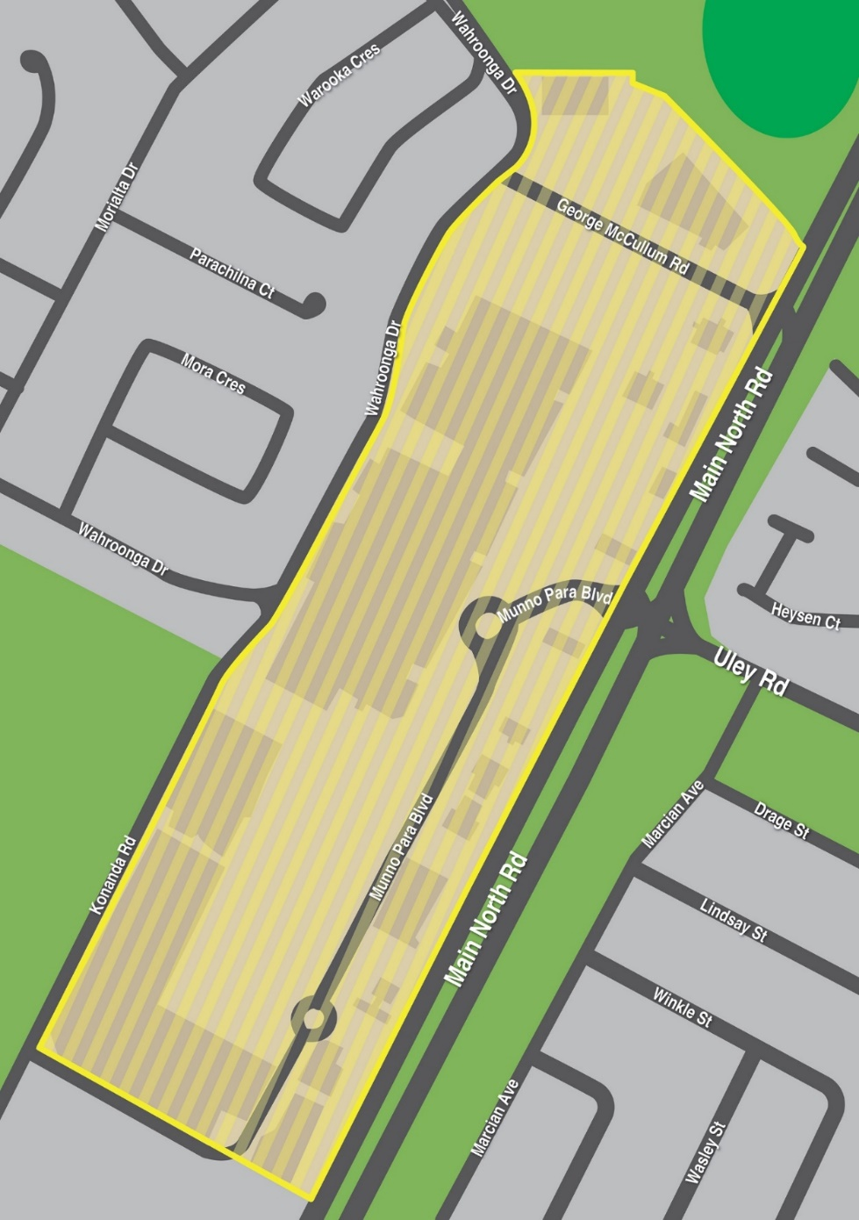
This declaration commences effect at 12:00 noon on Friday, 26 September 2025.
I am satisfied that the declaration is necessary for the purposes of deterring or detecting the commission of offences involving the possession or use of a knife or other weapons in the shopping precinct, and that the exercise of search powers under Section 66ZB of the Act is likely to be effective in deterring or detecting the commission of offences involving the possession or use of a knife or other weapons in the shopping precinct and, further, will not unduly affect lawful activity in the shopping precinct.
This declaration will remain in effect until being revoked at such time that the Commissioner of Police (or delegate) is satisfied the grounds for this declaration are no longer met.
Dated: 26 September 2025
Narelle Jayne Kameniar
Assistant Commissioner of Police

Summary Offences Act 1953
Declared Shopping Precinct
Declaration by Delegate of the Commissioner of Police
I, Narelle Jayne Kameniar, being the Assistant Commissioner, Operations Support Service, and acting as a delegate of the Commissioner of Police, hereby declare under Section 66ZF of the Summary Offences Act 1953 (“the Act”) as a declared shopping precinct the following area at West Lakes that includes Westfield West Lakes Shopping Centre and certain other retail shops and is bounded:
• to the north by West Lakes Boulevard, but excluding any part of the carriageway of West Lakes Boulevard;
• to the south and west by Brebner Drive, but excluding any part of the carriageway of Brebner Drive; and
• to the east by Turner Drive but excluding any part of the carriageway of Turner Drive.
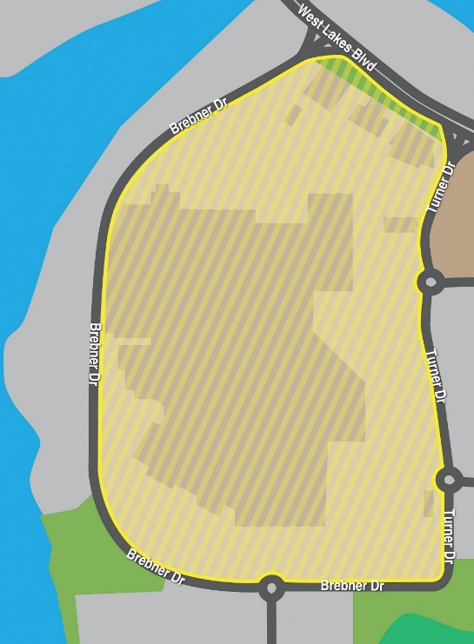
This declaration commences effect at 12:00 noon on Friday, 26 September 2025.
I am satisfied that the declaration is necessary for the purposes of deterring or detecting the commission of offences involving the possession or use of a knife or other weapons in the shopping precinct, and that the exercise of search powers under Section 66ZB of the Act is likely to be effective in deterring or detecting the commission of offences involving the possession or use of a knife or other weapons in the shopping precinct and, further, will not unduly affect lawful activity in the shopping precinct.
This declaration will remain in effect until being revoked at such time that the Commissioner of Police (or delegate) is satisfied the grounds for this declaration are no longer met.
Dated: 26 September 2025
Narelle Jayne Kameniar
Assistant Commissioner of Police

By Authority of T. Foresto, Government Printer, South Australia

