
No. 19 p. 771
THE SOUTH AUSTRALIAN
GOVERNMENT GAZETTE
Published by Authority

Adelaide, Thursday, 2 April 2026

Contents

State Government Instruments
Energy Resources Act 2000 772
Housing Improvement Act 2016 773
Land Acquisition Act 1969 774
Major Events Act 2013 778
North Adelaide Public Golf Course Act 2025 782
Passenger Transport Act 1994 782
Passenger Transport Regulations 2024 783
Pastoral Land Management and Conservation Act 1989 783
Road Traffic Act 1961 784
Summary Offences Act 1953 785
Local Government Instruments
Rural City of Murray Bridge, The 786
Light Regional Council 786
Public Notices
National Energy Retail Law 787
National Gas Law 787
Trustee Act 1936 787

State Government Instruments

Energy Resources Act 2000
Grant of Associated Activities Licence—AAL 329
Adjunct to Petroleum Production Licence—PPL 224
Notice is hereby given that the undermentioned Associated Activities Licence has been granted with effect 20 March 2026, under the provisions of the Energy Resources Act 2000, pursuant to delegated powers.
Licence Number | Licensees | Locality | Area in km² | Reference
AAL 329 | Beach Energy Limited  Amplitude Energy Limited | Cooper Basin | 1.85 | MER-2025/0056
Description of Area
All that part of the State of South Australia, bounded as follows:
All coordinates in GDA2020, Zone 54
332603.32mE 6906556.90mN
331813.51mE 6906545.87mN
331778.62mE 6907213.73mN
331283.89mE 6908640.63mN
332057.47mE 6908894.20mN
332561.68mE 6907410.89mN
332603.32mE 6906556.90mN
AREA: 1.85 square kilometres approximately
Dated: 20 March 2026
Paul De Ionno
Executive Director
Regulation and Compliance Division
Department for Energy and Mining
Delegate of the Minister for Energy and Mining

Energy Resources Act 2000
Grant of Associated Activities Licence—AAL 330
Adjunct to Petroleum Production Licence—PPL 245
Notice is hereby given that the undermentioned Associated Activities Licence has been granted with effect 20 March 2026, under the provisions of the Energy Resources Act 2000, pursuant to delegated powers.
Licence Number | Licensees | Locality | Area in km² | Reference
AAL 330 | Beach Energy Limited  Amplitude Energy Limited | Cooper Basin | 0.98 | MER-2025/0057
Description of Area
All that part of the State of South Australia, bounded as follows:
All coordinates in GDA2020, Zone 54
329562.58mE 6901433.16mN
330382.14mE 6901444.77mN
330397.35mE 6900369.02mN
330124.19mE 6900365.15mN
330126.66mE 6900190.63mN
329580.35mE 6900182.88mN
329562.58mE 6901433.16mN
AREA: 0.98 square kilometres approximately
Dated: 20 March 2026
Paul De Ionno
Executive Director
Regulation and Compliance Division
Department for Energy and Mining
Delegate of the Minister for Energy and Mining

Energy Resources Act 2000
Grant of Associated Activities Licence—AAL 331
Adjunct to Petroleum Production Licence—PPL 248
Notice is hereby given that the undermentioned Associated Activities Licence has been granted with effect from 20 March 2026, under the provisions of the Energy Resources Act 2000, pursuant to delegated powers.
Licence Number | Licensees | Locality | Area in km² | Reference
AAL 331 | Beach Energy Limited  Amplitude Energy Limited | Cooper Basin | 0.35 | MER-2025/0058
Description of Area
All that part of the State of South Australia, bounded as follows:
All coordinates in GDA2020, Zone 54
330913.71mE 6929775.23mN
331215.65mE 6929779.43mN
331352.57mE 6929781.33mN
331358.99mE 6929319.67mN
331363.55mE 6928991.49mN
330924.71mE 6928985.38mN
330913.71mE 6929775.23mN
AREA: 0.35 square kilometres approximately
Dated: 20 March 2026
Paul De Ionno
Executive Director
Regulation and Compliance Division
Department for Energy and Mining
Delegate of the Minister for Energy and Mining

Energy Resources Act 2000
Grant of Associated Activities Licence—AAL 334
Adjunct to Petroleum Retention Licence PRL 229
Notice is hereby given that the undermentioned Associated Activities Licence has been granted with effect from 24 March 2026, under the provisions of the Energy Resources Act 2000, pursuant to delegated powers.
Licence Number | Licensees | Locality | Area in km² | Reference
AAL 334 | Vamgas Pty Ltd  Impress (Cooper Basin) Pty Ltd | Cooper Basin | 0.44 | MER-2025/0112
Description Of Area
All that part of the State of South Australia, bounded as follows:
All coordinates GDA2020, Zone 54
433001.66mE 6959019.00mN
433074.76mE 6958831.74mN
432801.88mE 6958729.04mN
432853.77mE 6956936.73mN
432654.56mE 6956935.63mN
432597.62mE 6958867.08mN
433001.66mE 6959019.00mN
AREA: 0.44 square kilometres approximately
Dated: 24 March 2026
Paul De Ionno
Executive Director
Regulation and Compliance Division
Department for Energy and Mining
Delegate of the Minister for Energy and Mining

Housing Improvement Act 2016
Rent Control
In the exercise of the powers conferred by the Housing Improvement Act 2016, the Delegate of the Minister for Housing and Urban Development hereby fixes the maximum rental amount per week that shall be payable subject to Section 55 of the Residential Tenancies Act 1995, in respect of each premises described in the following table. The amount shown in the said table shall come into force on the date of this publication in the Gazette.
Address of Premises | Allotment Section | Certificate of Title  Volume/Folio | Maximum Rental per week payable
Unit 2/7A Hedley Street, Mount Gambier SA 5290 | Unit 2 Strata Plan 6524  Hundred of Blanche | CT5013/673 | $315.00
7 Letchford Street, Bedford Park SA 5042 | Allotment 162 Deposited Plan 3608 Hundred of Adelaide | CT5093/719 | $516.00
Dated: 2 April 2026
Craig Thompson
Housing Regulator and Registrar
Housing Safety Authority
Delegate of the Minister for Housing and Urban Development

Housing Improvement Act 2016
Rent Control Revocations
In the exercise of the powers conferred by the Housing Improvement Act 2016, the Delegate of the Minister for Housing and Urban Development hereby revokes the maximum rental amount per week that shall be payable subject to Section 55 of the Residential Tenancies Act 1995, in respect of each premises described in the following table.
Address of Premises | Allotment Section | Certificate of Title  Volume/Folio
1 Main Street, Lipson SA 5607 (AKA 39-40) | Allotment 40 Town Plan 511601 Hundred of Yaranyacka | CT5506/830
1/56 Barham Street, Allenby Gardens SA 5009 | Allotment 31 Deposited Plan 1838 Hundred of Yatala | CT6048/450
Flat 2/56 Barham Street, Allenby Gardens SA 5009 | Allotment 31 Deposited Plan 1838 Hundred of Yatala | CT6048/450
10 Taylor Street, Brompton SA 5007 | Allotment 127, 128 and 129 Deposited Plan 459  Hundred of Yatala | CT6162/14
88 West Street, Brompton SA 5007 | Allotment 102 Deposited Plan 74346 Hundred of Yatala | CT5994/486
129 Hawker Street, Ridleyton SA 5008 | Allotment 3 Deposited Plan 64270 Hundred of Yatala | CT5921/762
11 Belmore Terrace, Woodville SA 5011 | Allotment 10 Filed Plan 106039 Hundred of Yatala | CT5167/809
19 Amber Avenue, Clearview SA 5085 | Allotment 1 Deposited Plan 76933 Hundred of Yatala | CT6135/765
Dated: 2 April 2026
Craig Thompson
Housing Regulator and Registrar
Housing Safety Authority
Delegate of the Minister for Housing and Urban Development

Land Acquisition Act 1969
Section 26F
Form 6B—Notice of Acquisition of Underground Land
1. Notice of acquisition
The Commissioner of Highways (the Authority), of 83 Pirie Street, Adelaide SA 5000 acquires the following interests in the following land:
An unencumbered estate in fee simple in the whole of Allotment 100 in D136767 lodged in the Lands Titles Office, being
First, portion of the Common Property in Strata Plan 12687 comprised in Certificate of Title Volume 5173 Folio 530, expressly excluding the right(s) of way over the land marked A on DP 14457 appurtenant only to the land marked Y on SP 12687 (GRO No. 488 Book 34); and
Secondly, portion of the easement over the land marked Z in SP 12687 created by T 2306976 comprised in Certificate of Title Volume 6116 Folio 284 as is contained within and forms portion of the said Allotment 100, to the intent that the easement will merge with and be extinguished in the fee simple in Allotment 100.
This notice is given under Section 26F of the Land Acquisition Act 1969.
2. Compensation not payable unless certain water infrastructure or rights are affected
You are not entitled to compensation in relation to the acquisition of the underground land to which this notice relates, unless the following conditions are satisfied:
• you held at least one of the following interests in relation to the underground land immediately before the notice of acquisition was published in relation to the land—
◦ ownership of a lawful well that provides access to underground water in the underground land, and any underground infrastructure associated with the well; or
◦ a right to take underground water from the underground land by means of such a well;
• you notified the Authority of your interest in response to a notice given under Section 26G of the Land Acquisition Act 1969;
• the acquisition of the underground land either—
◦ involved the acquisition of your interest; or
◦ resulted in the discharge of your interest; or
◦ resulted in you being unable to take water by means of, or pursuant to, your interest;
• you make an application for compensation to the Authority under Section 26H of the Land Acquisition Act 1969.
3. Application for compensation under Section 26H
If you believe you are entitled to compensation, you must apply to the Authority for compensation within 6 months after the publication of the notice of acquisition in relation to the underground land to which this notice relates.
The application must be in the following manner and form:
“Application for Compensation for Acquisition of Underground Land” (enclosed) to be submitted by email to DIT.ULAapplications@sa.gov.au or by mail marked attention: Property Acquisition c/- GPO Box 1533, Adelaide SA 5001.
The application must be accompanied by the following information or documents:
Any relevant supporting documentation including, but not limited to water licences, bore licences etc.
After receiving your application, the Authority may (but is not required to) make you a written offer of compensation not exceeding $50,000.
See Section 26H(4) of the Land Acquisition Act 1969 for further details on the payment of compensation.

4. Inquiries
Inquiries should be directed to: T2D Project Team
GPO Box 1533
Adelaide SA 5001
Telephone: 1800 572 414
Dated: 31 March 2026
The Common Seal of the COMMISSIONER OF HIGHWAYS was hereto affixed by authority of the Commissioner in the presence of:
Rocco Caruso
Director, Property Acquisition
(Authorised Officer)
Department for Infrastructure and Transport
DIT 2024/08259/01

Land Acquisition Act 1969
Section 26F
Form 6B—Notice of Acquisition of Underground Land
1. Notice of acquisition
The Commissioner of Highways (the Authority), of 83 Pirie Street, Adelaide SA 5000 acquires the following interests in the following land:
An unencumbered estate in fee simple in the whole of Allotment 1000 in D139221 lodged in the Lands Titles Office, being portion of the Common Property in Strata Plan 12187 comprised in Certificate of Title Volume 5100 Folio 303.
This notice is given under Section 26F of the Land Acquisition Act 1969.
2. Compensation not payable unless certain water infrastructure or rights are affected
You are not entitled to compensation in relation to the acquisition of the underground land to which this notice relates, unless the following conditions are satisfied:
• you held at least one of the following interests in relation to the underground land immediately before the notice of acquisition was published in relation to the land—
◦ ownership of a lawful well that provides access to underground water in the underground land, and any underground infrastructure associated with the well; or
◦ a right to take underground water from the underground land by means of such a well;
• you notified the Authority of your interest in response to a notice given under Section 26G of the Land Acquisition Act 1969;
• the acquisition of the underground land either—
◦ involved the acquisition of your interest; or
◦ resulted in the discharge of your interest; or
◦ resulted in you being unable to take water by means of, or pursuant to, your interest;
• you make an application for compensation to the Authority under Section 26H of the Land Acquisition Act 1969.
3. Application for compensation under Section 26H
If you believe you are entitled to compensation, you must apply to the Authority for compensation within 6 months after the publication of the notice of acquisition in relation to the underground land to which this notice relates.
The application must be in the following manner and form:
“Application for Compensation for Acquisition of Underground Land” (enclosed) to be submitted by email to DIT.ULAapplications@sa.gov.au or by mail marked attention: Property Acquisition c/- GPO Box 1533, Adelaide SA 5001.
The application must be accompanied by the following information or documents:
Any relevant supporting documentation including, but not limited to water licences, bore licences etc.
After receiving your application, the Authority may (but is not required to) make you a written offer of compensation not exceeding $50,000.
See Section 26H(4) of the Land Acquisition Act 1969 for further details on the payment of compensation.
4. Inquiries
Inquiries should be directed to: T2D Project Team
GPO Box 1533
Adelaide SA 5001
Telephone: 1800 572 414
Dated: 31 March 2026
The Common Seal of the COMMISSIONER OF HIGHWAYS was hereto affixed by authority of the Commissioner in the presence of:
Rocco Caruso
Director, Property Acquisition
(Authorised Officer)
Department for Infrastructure and Transport
DIT: 2024/08280/01

Land Acquisition Act 1969
Section 26F
Form 6B—Notice of Acquisition of Underground Land
1. Notice of acquisition
The Commissioner of Highways (the Authority), of 83 Pirie Street, Adelaide SA 5000 acquires the following interests in the following land:
An unencumbered estate in fee simple in the whole of Allotment 11 in D138528 lodged in the Lands Titles Office, being:
First, portion of the land comprised in Certificate of Title Volume 5249 Folio 694, expressly excluding the free and unrestricted right(s) of way over the land marked B.
Secondly, that portion of the easement over the land marked A created by T1775331 to the City of Mitcham comprised within Certificate of Title Volume 2263 Folio 188, as is contained within and forms portion of the said Allotment 11, to the intent that the easement will merge with and be extinguished in the fee simple in Allotment 11.
This notice is given under Section 26F of the Land Acquisition Act 1969.
2. Compensation not payable unless certain water infrastructure or rights are affected
You are not entitled to compensation in relation to the acquisition of the underground land to which this notice relates, unless the following conditions are satisfied:
• you held at least one of the following interests in relation to the underground land immediately before the notice of acquisition was published in relation to the land—
◦ ownership of a lawful well that provides access to underground water in the underground land, and any underground infrastructure associated with the well; or
◦ a right to take underground water from the underground land by means of such a well;
• you notified the Authority of your interest in response to a notice given under Section 26G of the Land Acquisition Act 1969;
• the acquisition of the underground land either—
◦ involved the acquisition of your interest; or
◦ resulted in the discharge of your interest; or
◦ resulted in you being unable to take water by means of, or pursuant to, your interest;
• you make an application for compensation to the Authority under Section 26H of the Land Acquisition Act 1969.
3. Application for compensation under Section 26H
If you believe you are entitled to compensation, you must apply to the Authority for compensation within 6 months after the publication of the notice of acquisition in relation to the underground land to which this notice relates.
The application must be in the following manner and form:
“Application for Compensation for Acquisition of Underground Land” (enclosed) to be submitted by email to DIT.ULAapplications@sa.gov.au or by mail marked attention: Property Acquisition c/- GPO Box 1533, Adelaide SA 5001.
The application must be accompanied by the following information or documents:
Any relevant supporting documentation including, but not limited to water licences, bore licences etc.
After receiving your application, the Authority may (but is not required to) make you a written offer of compensation not exceeding $50,000.
See Section 26H(4) of the Land Acquisition Act 1969 for further details on the payment of compensation.
4. Inquiries
Inquiries should be directed to: T2D Project Team
GPO Box 1533
Adelaide SA 5001
Telephone: 1800 572 414
Dated: 30 March 2026
The Common Seal of the COMMISSIONER OF HIGHWAYS was hereto affixed by authority of the Commissioner in the presence of:
Rocco Caruso
Director, Property Acquisition
(Authorised Officer)
Department for Infrastructure and Transport
DIT 2024/08293/01

Land Acquisition Act 1969
Section 26F
Form 6B—Notice of Acquisition of Underground Land
1. Notice of acquisition
The Commissioner of Highways (the Authority), of 83 Pirie Street, Adelaide SA 5000 acquires the following interests in the following land:
An estate in fee simple in the whole of Allotment 21 in D138529 lodged in the Lands Titles Office, being portion of the land comprised in Certificate of Title Volume 5249 Folio 695, expressly excluding the free and unrestricted right(s) of way over the land marked B.
This notice is given under Section 26F of the Land Acquisition Act 1969.
2. Compensation not payable unless certain water infrastructure or rights are affected
You are not entitled to compensation in relation to the acquisition of the underground land to which this notice relates, unless the following conditions are satisfied:

• you held at least one of the following interests in relation to the underground land immediately before the notice of acquisition was published in relation to the land—
◦ ownership of a lawful well that provides access to underground water in the underground land, and any underground infrastructure associated with the well; or
◦ a right to take underground water from the underground land by means of such a well;
• you notified the Authority of your interest in response to a notice given under Section 26G of the Land Acquisition Act 1969;
• the acquisition of the underground land either—
◦ involved the acquisition of your interest; or
◦ resulted in the discharge of your interest; or
◦ resulted in you being unable to take water by means of, or pursuant to, your interest;
• you make an application for compensation to the Authority under Section 26H of the Land Acquisition Act 1969.
3. Application for compensation under Section 26H
If you believe you are entitled to compensation, you must apply to the Authority for compensation within 6 months after the publication of the notice of acquisition in relation to the underground land to which this notice relates.
The application must be in the following manner and form:
“Application for Compensation for Acquisition of Underground Land” (enclosed) to be submitted by email to DIT.ULAapplications@sa.gov.au or by mail marked attention: Property Acquisition c/- GPO Box 1533, Adelaide SA 5001.
The application must be accompanied by the following information or documents:
Any relevant supporting documentation including, but not limited to water licences, bore licences etc.
After receiving your application, the Authority may (but is not required to) make you a written offer of compensation not exceeding $50,000.
See Section 26H(4) of the Land Acquisition Act 1969 for further details on the payment of compensation.
4. Inquiries
Inquiries should be directed to: T2D Project Team
GPO Box 1533
Adelaide SA 5001
Telephone: 1800 572 414
Dated: 30 March 2026
The Common Seal of the COMMISSIONER OF HIGHWAYS was hereto affixed by authority of the Commissioner in the presence of:
Rocco Caruso
Director, Property Acquisition
(Authorised Officer)
Department for Infrastructure and Transport
DIT 2024/08293/01

Major Events Act 2013
Section 6B
Declaration of a Major Event
Pursuant to Section 6B of the Major Events Act 2013, I, Hon. Emily Bourke MLC, Minister for Tourism declare the 2026 AFL Gather Round tournament to be held from Thursday 9 April to Sunday 12 April 2026 to be declared a major event.
By virtue of the provisions of the Major Events Act 2013, I do hereby:
1. Declare the 2026 AFL Gather Round to be a major event.
2. Specify the period of the Major Event Legislation to be enacted for the event, being 7:00am on Thursday, 9 April 2026 to 11:59pm on Sunday, 12 April 2026.
3. Declare the major event venue to be:
(a) Adelaide Oval—9 to 12 April 2026 as shown as the “Major Event Venue” in the map and specify an area bounded by the northern boundary of North Terrace, King William Road, Kermode Street, Palmer Place (South of Kermode Street), Montefiore Hill and Montefiore Road as a controlled area in relation to the event and shown as “Declared Controlled Area” in the map, including Elder Park and Pinky Flat.
(b) Norwood Oval—11 to 12 April 2026 as shown as the “Major Event Venue” in the map and specify any public place or part of a public place that is within 250 metres from the boundary of the major event venue as a controlled area in relation to the event and shown as “Declared Controlled Area” in the map.
(c) Barossa Park—11 to 12 April 2026 as shown as the “Major Event Venue” in the map and specify any public place or part of a public place that is within 250 metres from the boundary of the major event venue as a controlled area in relation to the event and shown as “Declared Controlled Area” in the map.
(d) The Parade—12 April 2026 as shown as the “Major Event Venue” in the map and specify any public place or part of a public place that is within 250 metres from The Parade, between Portrush Road and Woods Street as a controlled area in relation to the event and shown as “Declared Controlled Area” in the map.
4. Designate Australian Football League (ABN 97 489 912 318) to be the event organiser for the event as detailed under 3a, 3b and 3c above.
5. Designate the South Australian Tourism Commission (ABN 80 485 623 691) to be the event organiser as detailed under 3d above.
6. Declare that the following provisions of Part 3 of the Act apply to the event, the major event venues and the declared controlled areas for the event:
(a) Section 8
(b) Section 10
(c) Section 11
(d) Section 12
(e) Section 13
(f) Section 14

7. Being satisfied that the title “2026 AFL Gather Round” and the logos as they appear below are sufficiently connected with the identity and conduct of the major event, and that the event has commercial arrangements that are likely to be adversely affected by unauthorised use of the title and logos, I hereby declare, pursuant to Section 14(1) of the Act, that “2026 AFL Gather Round” is an official title and the logos as they appear below is official logos in respect of the event.

Dated: 2 April 2026
Hon Emily Bourke MLC
Minister for Tourism

Maps of Controlled Areas
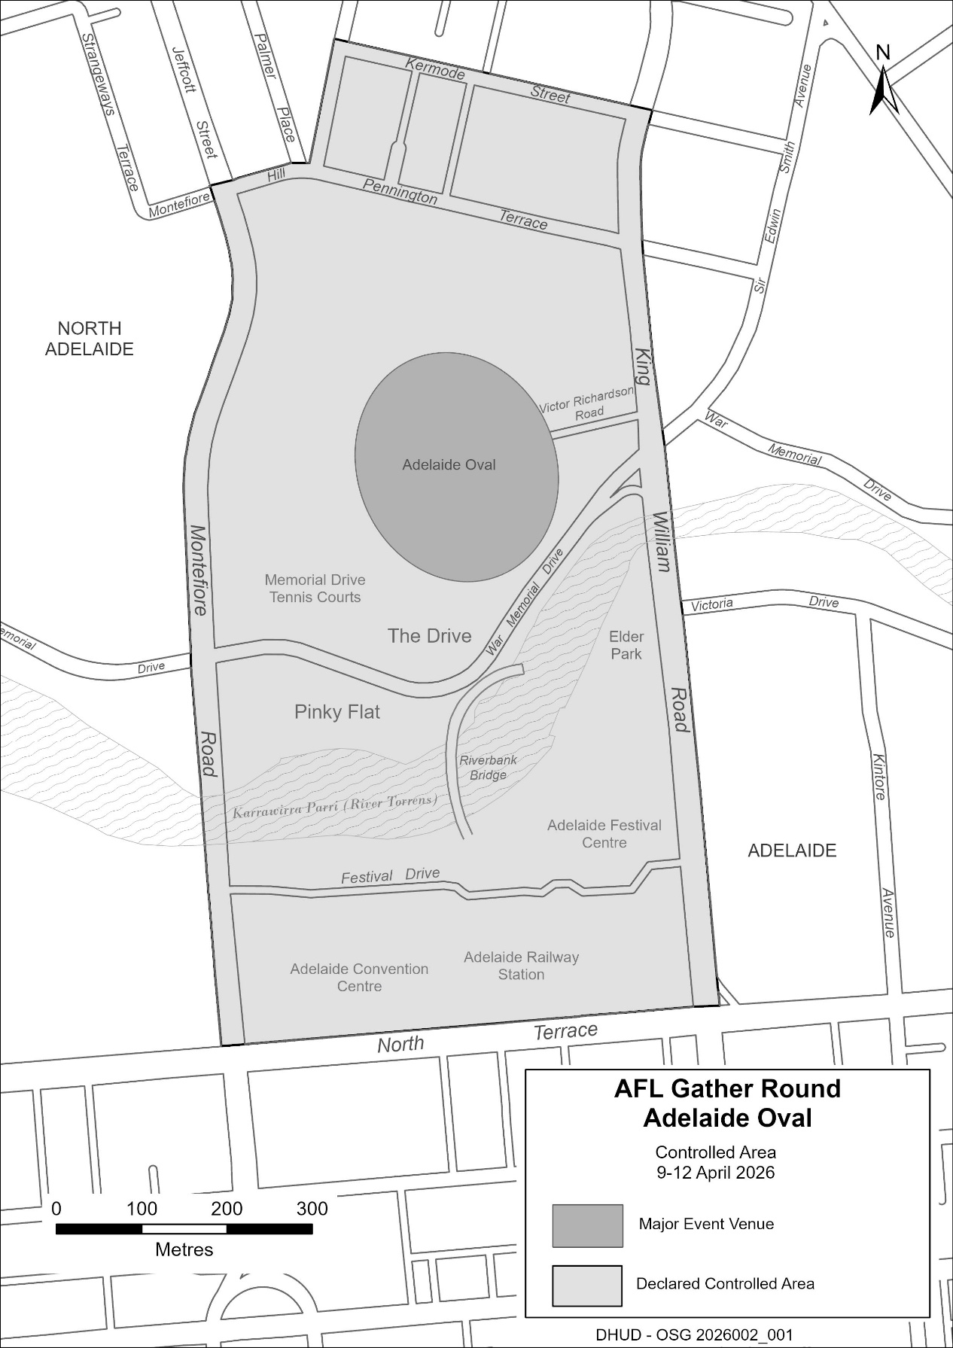
2026 AFL Gather Round
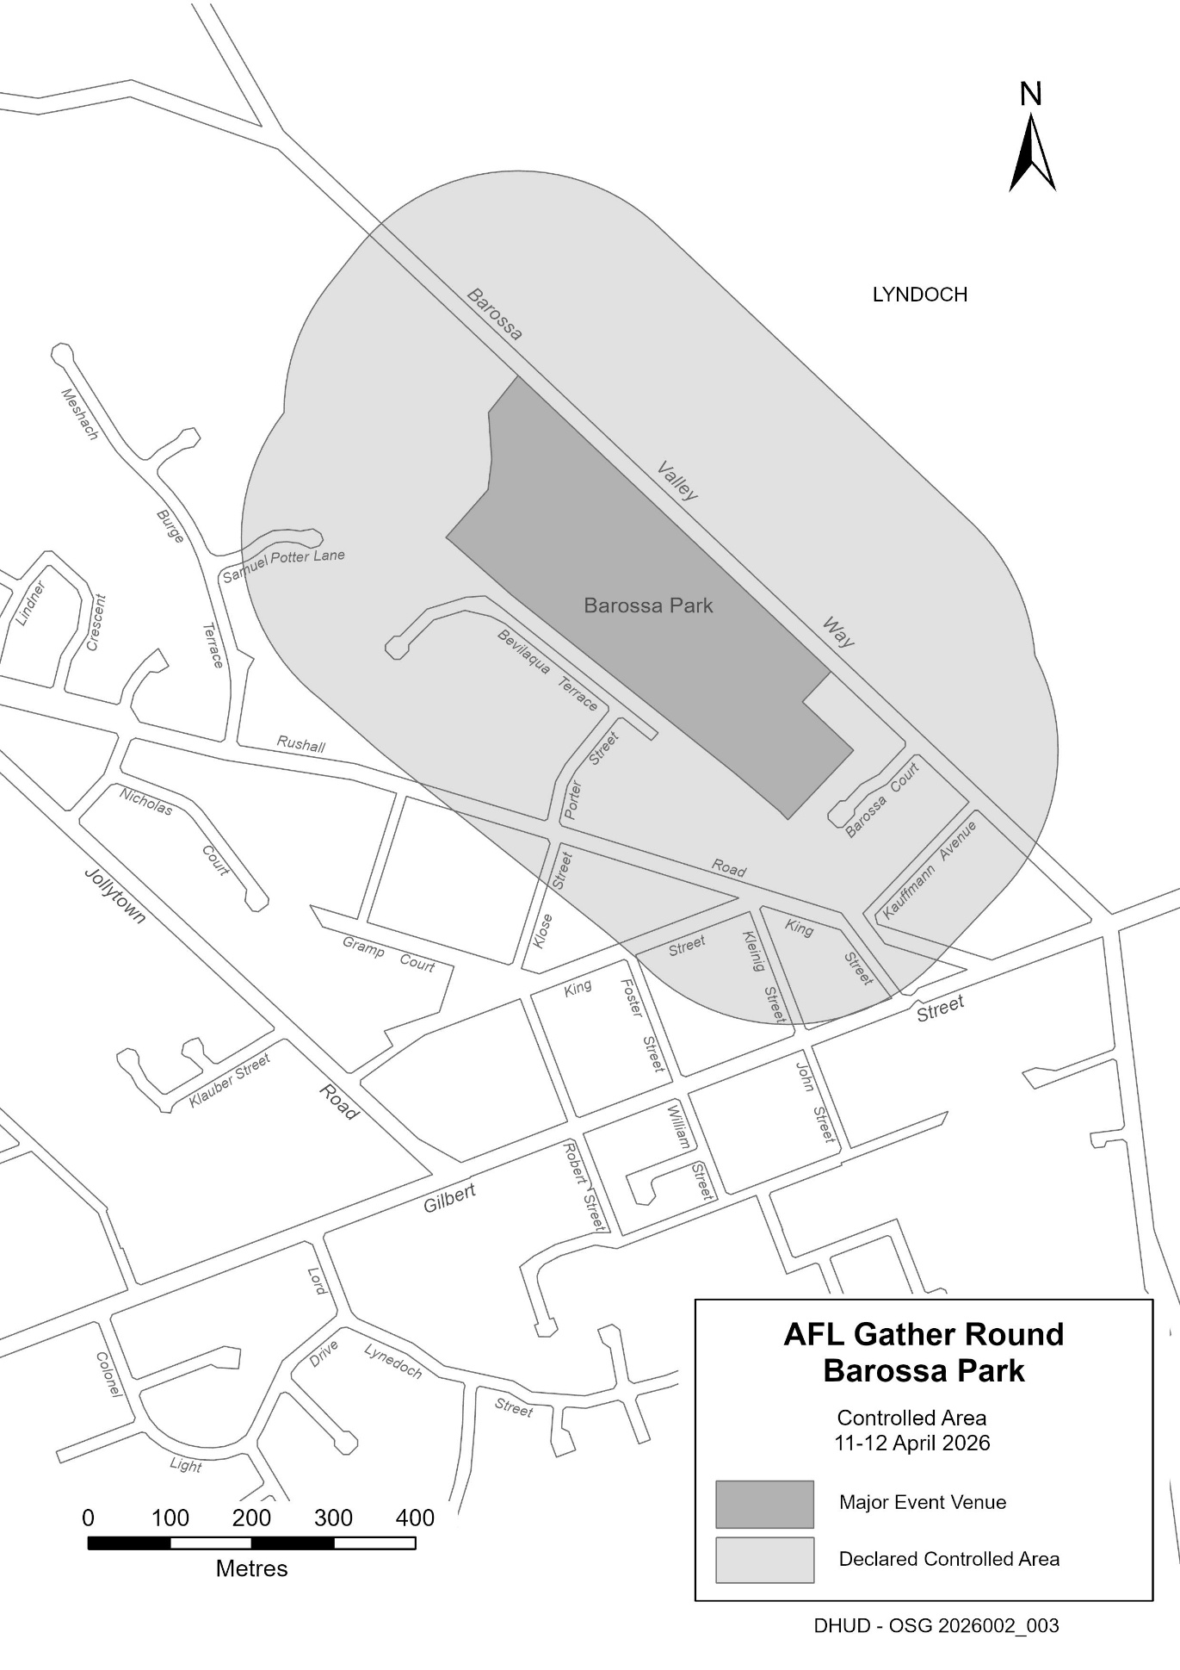
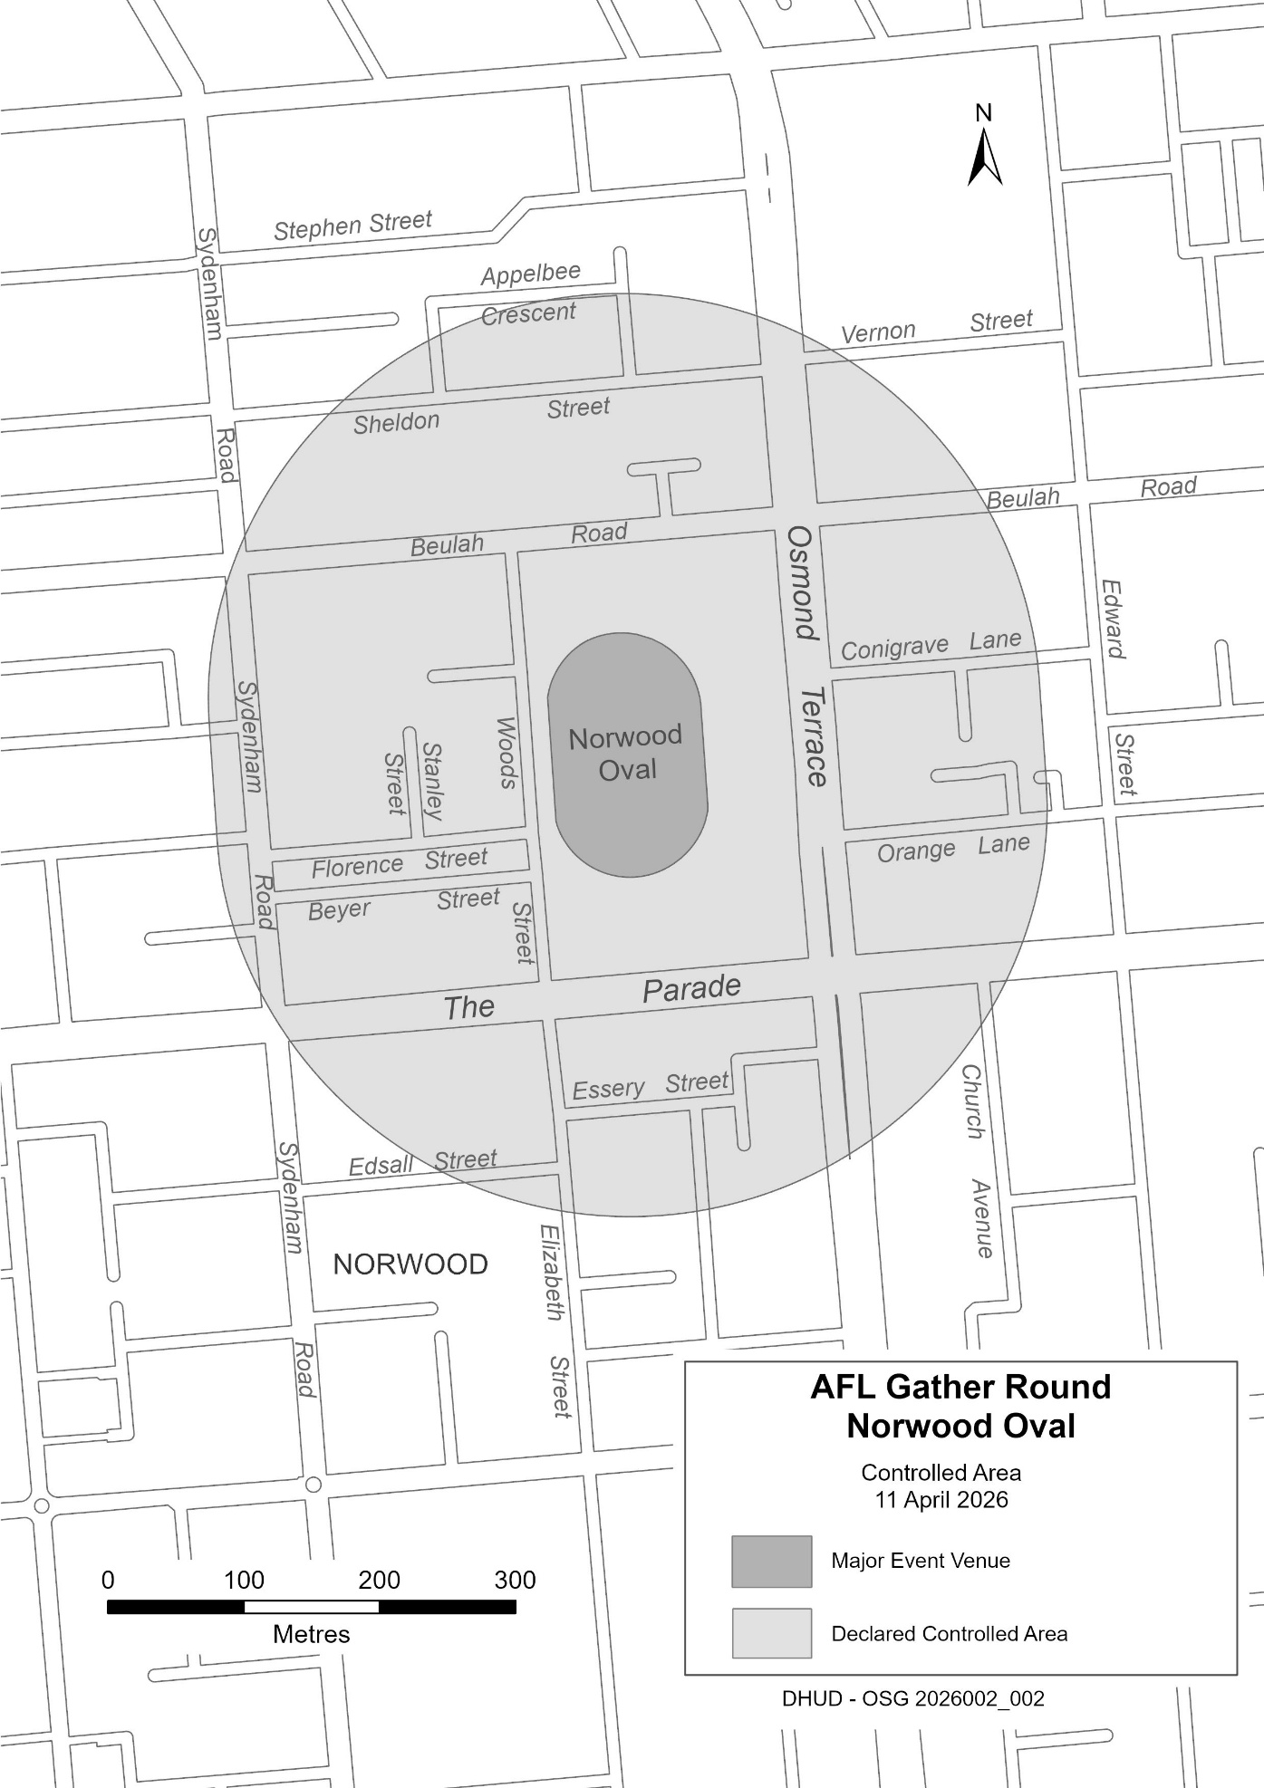
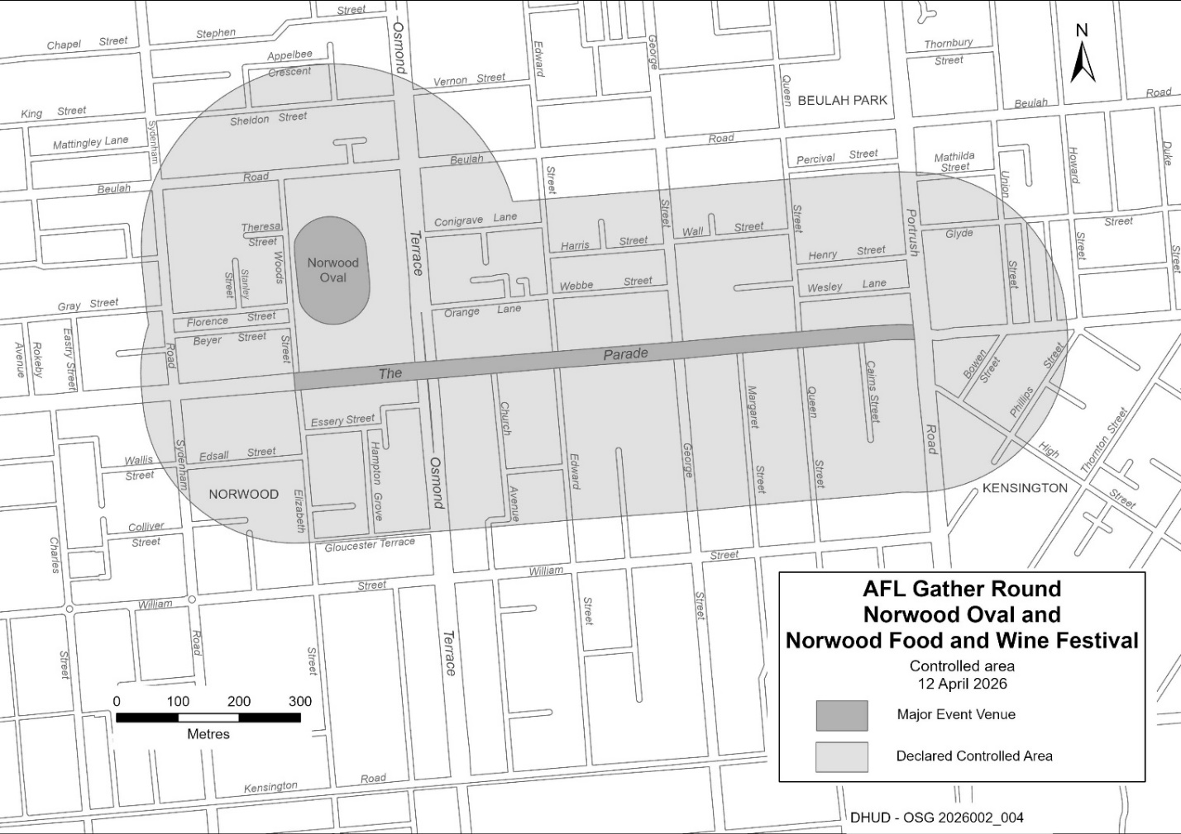

North Adelaide Public Golf Course Act 2025
Sections 5 and 14
Approval of the Project Site and Support Zones
I, Peter Malinauskas, Premier of South Australia and Minister responsible for the North Adelaide Public Golf Course Act 2025, give notice:
1. Pursuant to Sections 5(1) and 14(1) of the North Adelaide Public Golf Course Act 2025, the Project Site and Support Zones under that Act are as delineated in GRO Plan G17/2026 deposited in the General Registry Office at Adelaide on 2 April 2026 (GRO Plan).
Dated: 2 April 2026
Peter Malinauskas
Premier of South Australia

Passenger Transport Act 1994
Section 52D
Notice to Vary Prescribed Maximum Fare
I, the Hon Joe Szakacs MP, Minister for Infrastructure and Transport in the State of South Australia, pursuant to Section 52D(4) of the Passenger Transport Act 1994 (the Act) hereby approve the following alteration to the prescribed maximum fares applying to a journey undertaken by a metropolitan taxi as set out in Schedule 2 of the Passenger Transport Regulations 2024 (the Regulations) as follows:
(i) an additional amount of $1.00 be applied as a surcharge to any journey undertaken by a metropolitan taxi providing a general taxi service; and
(ii) an additional amount of $2.00 to be applied as a surcharge to any journey undertaken by a metropolitan taxi providing an access taxi service.
Conditions of Notice
This Notice is subject to the following conditions:
(i) Only one surcharge amount can be applied per journey.
(ii) The surcharge amount is required to be programmed through the meter.
(iii) That the surcharge amount must be shown on the meter and the eftpos receipt as a separate item.
Commencement and Operation of Notice
(a) This Notice will come into operation from date of gazettal and will remain in force until midnight 28 June 2026 or unless revoked earlier by a subsequent Notice.
(b) This Notice may be varied by further subsequent Notice.
Interpretation
For the purposes of this Notice, terms used have the same meaning as defined in the Act and/or the Regulations unless otherwise indicated.
The following terms are defined:
access taxi service means a service provided by an access taxi.
journey means a single entire trip (including if several stops are made).
regular taxi service means a passenger transport service provided by use of a taxi that is not an access taxi.
Dated: 1 April 2026
Hon Joe Szakacs MP
Minister for Infrastructure and Transport

Passenger Transport Regulations 2024
Regulation 3(1)
Determination to Temporarily Vary Legal Fare (Variation)
I, the Hon Joe Szakacs MP, Minister for Infrastructure and Transport in the State of South Australia, pursuant to Regulation 3(1) of the Passenger Transport Regulations 2024 (the Regulations), hereby determine that the legal fare in relation to a journey undertaken by a country taxi as determined in the ‘Determination of legal fare (including lifting fee) for Country Taxis’, dated 22 January 2025, published in the South Australian Government Gazette on 6 February 2025 (p. 125) (Prior Determination) is temporarily varied in the following manner.
Paragraph (i) in the Prior Determination is deleted and replaced with the following new Paragraph (i):
(i) “with the exception of the lifting fee in (ii) below, a fare not exceeding more than 20% above the rates applicable to the hiring of metropolitan taxis or a journey by a metropolitan taxi as published in Schedule 2, clause 1 of the Regulations and as altered by the “Notice To Vary Prescribed Maximum Fare” (approved by Minister for Infrastructure and Transport in the State of South Australia pursuant to Section 52D(4) of the Passenger Transport Act 1994 on 1 April 2026); and”
The intention of the above variation is to apply the surcharge amounts specified in the “Notice To Vary Prescribed Maximum Fare” (approved by Minister for Infrastructure and Transport in the State of South Australia pursuant to Section 52D(4) of the Passenger Transport Act 1994 on 1 April 2026) to the legal fare for the hiring of and journeys undertaken by country taxis.
Other than this variation the Prior Determination remains unchanged and in force.
The above variation to the determined legal fare is only valid during the Effective Period. Upon expiry of the Effective Period the Prior Determination will remain in force, and the original wording of the Prior Determination will be resumed.
Conditions of Notice
This Notice is subject to the following conditions:
(i) Only one surcharge amount can be applied per journey.
(ii) The surcharge amount is required to be programmed through the meter.
(iii) The surcharge amount must be shown on the meter and the eftpos receipt as a separate item.
Commencement and Operation of Notice
(a) This Notice will come into operation from the date of Gazettal and will remain in force until midnight 28 June 2026 or unless revoked earlier by a subsequent Notice (Effective Period).
(b) This Notice may be varied by further subsequent Notice.
Dated: 1 April 2026
Hon Joe Szakacs MP
Minister for Infrastructure and Transport

Pastoral Land Management and Conservation Act 1989
Public Access Route Cancellation of Closure 2026
Notice of Intent to Cancel Temporary Closure of Public Access Route Number 4, Artimore
Notice is hereby given of the intent to cancel the temporary closure of Artimore Public Access Route from 30 March 2026 until further notice, pursuant to Section 45(7) of the Pastoral Land Management and Conservation Act 1989. Notification of the re-opening of the Public Access Route will be provided on the Department for Infrastructure and Transport’s Outback Road Warnings website at https://dit.sa.gov.au/OutbackRoads/outback-road-report.
Notice of Intent to Cancel Temporary Closure of Public Access Route Number 5, Patawarta Gap
Notice is hereby given of the intent to cancel the temporary closure of Patawarta Gap Public Access Route from WP 64 to Narrina boundary gate from 30 March 2026 until further notice, pursuant to Section 45(7) of the Pastoral Land Management and Conservation Act 1989. Notification of the re-opening of the Public Access Route will be provided on the Department for Infrastructure and Transport’s Outback Road Warnings website at https://dit.sa.gov.au/OutbackRoads/outback-road-report.
Dated: 30 March 2026
Mark May
Pastoral Board Delegate
Program Leader, Pastoral Operations
Department for Environment and Water

Road Traffic Act 1961
Authorisation to Operate Breath Analysing Instruments
I, Grant Stevens, Commissioner of Police, do hereby notify that on and from 27 March 2026, the following persons were authorised by the Commissioner of Police to operate breath analysing instruments as defined in and for the purposes of the:
• Road Traffic Act 1961;
• Harbors and Navigation Act 1993;
• Security and Investigation Industry Act 1995; and
• Rail Safety National Law (South Australia) Act 2012.
PD Number | Officer Name
15721 | BOSHOFF, Deirdre Wilna
12468 | GROTTOLI, Andrea
15635 | MANSELL, Taylor Liam
14245 | MATHISON, Catriona Jane
17976 | MCCABE, Jack Harvey
18564 | RICHARDS, Scott Malcolm
15868 | ROLLINSON, Brodie Kym
16212 | SMITH, Dylan Mitchell
13283 | WALKER, Hannah Laurie
Dated: 2 April 2026
Grant Stevens
Commissioner of Police
Reference: 2026-0025

Road Traffic Act 1961
Authorisation to Operate Breath Analysing Instruments
I, Grant Stevens, Commissioner of Police, do hereby notify that on and from 27 March 2026, the following persons were authorised by the Commissioner of Police to operate breath analysing instruments as defined in and for the purposes of the:
• Road Traffic Act 1961;
• Harbors and Navigation Act 1993;
• Security and Investigation Industry Act 1995; and
• Rail Safety National Law (South Australia) Act 2012.
PD Number | Officer Name
15483 | BERRIE, Steven Richard
12466 | FRANKLIN, Alexander James
15724 | GIROLAMO, Lara Simone
15160 | GRAY, Joshua Richard Keith
15141 | HAND, Emily Jade
17578 | HOLLYWOOD, Hamilton Montgomery
16315 | JURY, Matthew Robert
15838 | KONECNY, Thomas Mark
16004 | PORTLOCK, Zach
74884 | ROGIC, Goran
14692 | VICE, Ryan James
11082 | WILLIAMS, David Lee
Dated: 2 April 2026
Grant Stevens
Commissioner of Police
Reference: 2026-0035

Summary Offences Act 1953
Declared Shopping Precinct
Declaration by Delegate of the Commissioner of Police
I, Scott Anthony Fitzgerald, occupying the position of Assistant Commissioner, Operations Support Service, and acting as a delegate of the Commissioner of Police, hereby declare under Section 66ZF of the Summary Offences Act 1953 (“the Act”) as a declared shopping precinct the following area at Castle Plaza Shopping Centre that contains Castle Plaza Shopping Centre and is bounded:
• to the north by Raglan Avenue to Brooks Terrace car park adjacent to the eastern car park of Castle Medical Centre and Flinders Street to the west excluding any part of the carriageway of Raglan Avenue.
• to the east by South Road to Furness Avenue to the south excluding any part of the carriageway of South Road;
• to the south by Furness Avenue to Lindsay Way excluding any part of the carriageway of Furness Avenue; and
• to the west by Lindsay Way and Lindsay Avenue but excluding any part of the carriageway of Lindsay Way and Lindsay Avenue.
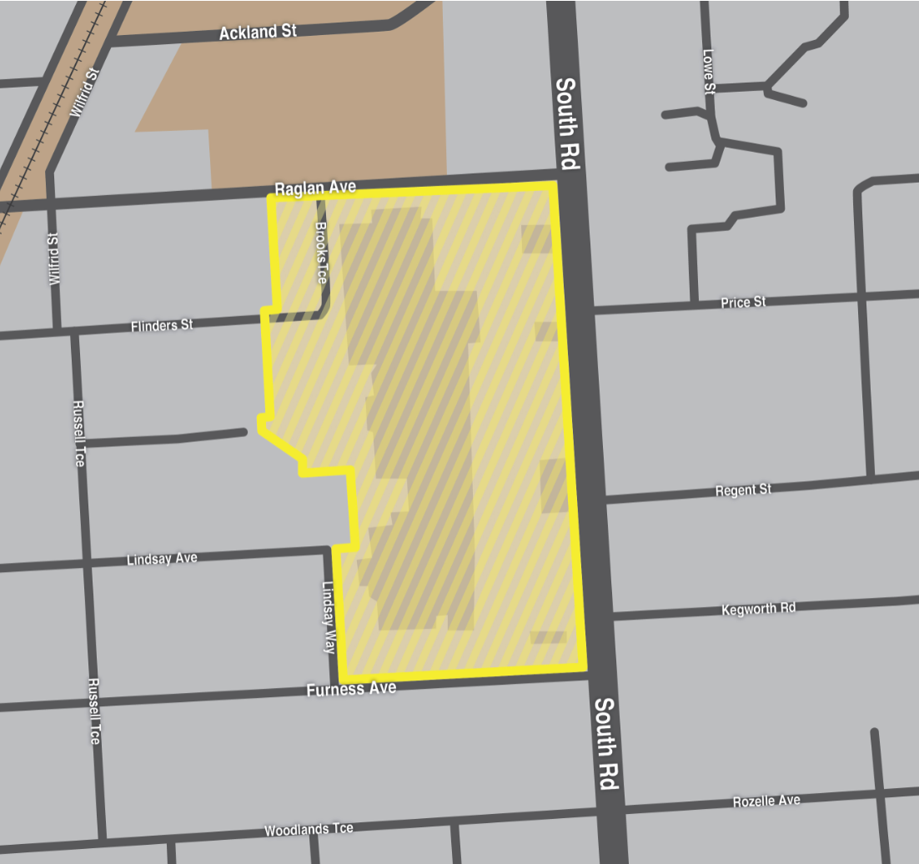
This declaration commences effect at 12:00 noon on 2 April 2026.
I am satisfied that the declaration is appropriate for the purposes of deterring or detecting the commission of offences involving
the possession or use of a knife or other weapons in the shopping precinct, and that the exercise of search powers under Section 66ZB of the Act is likely to be effective in deterring or detecting the commission of offences involving the possession or use of a knife or other weapons in the shopping precinct and, further, will not unduly affect lawful activity in the shopping precinct.
This declaration will remain in effect until being revoked at such time that the Commissioner of Police (or delegate) is satisfied the grounds for this declaration are no longer met.
Dated: 2 April 2026
Scott Anthony Fitzgerald
Acting Assistant Commissioner of Police

Local Government Instruments

The Rural City of Murray Bridge
Roads (Opening and Closing) Act 1991
Road Opening—Corner Lugard Street and 41 Chaucer Terrace Murray Bridge
Notice is hereby given, pursuant to Section 10 of the Roads (Opening and Closing) Act 1991, that the Rural City of Murray Bridge proposes to make a Road Process Order to open Corner Lugard Street and 41 Chaucer Terrace Murray Bridge in the Hundred of Mobilong in the area named Murray Bridge, more particularly delineated and numbered ‘1’ on Preliminary Plan PP260006 being portion of Allotment 16 in D2256: CT 6268/681.
The Preliminary Plan and Statement of Persons Affected is available for public inspection at the offices of the Rural City of Murray Bridge, 2 Seventh Street Murray Bridge SA 5253, and the Adelaide Office of the Surveyor-General during normal office hours. The Preliminary Plan can also be viewed at www.sa.gov.au/roadsactproposals.
Any application for easement or objection must set out the full name, address and details of the submission and must be fully supported by reasons. The application for easement or objection must be made in writing to the Rural City of Murray Bridge, 2 Seventh Street, Murray Bridge SA 5253 within 28 days of this notice and a copy must be forwarded to the Surveyor-General at GPO Box 1815, Adelaide SA 5001. Where a submission is made, the applicant must be prepared to support their submission in person upon council giving notification of a meeting at which the matter will be considered.
Dated: 25 March 2026
Heather Barclay
Chief Executive Officer

Light Regional Council
Adoption of amended Community Land Management Plan
Notice is hereby provided that pursuant to Section 197(3) of the Local Government Act 1999, Council, at its Ordinary Council meeting held on Tuesday, 24 March 2026 resolved to adopt the Community Land Management Plan for the land located at Allotment 2001 in Deposited Plan 125920, The Boulevard Roseworthy held in Certificate of Title Volume 6249 Folio 53 known as St Yves Reserve
(formerly ‘Reserve 2001)’.
Dated: 26 March 2026
Darryl Whicker
Chief Executive Officer

Public Notices

National Energy Retail Law
Notice of Final Rule
The Australian Energy Market Commission (AEMC) gives notice under the National Energy Retail Law as follows:
Under ss 259, 260 and 261, the making of the National Energy Retail Amendment (Establishing a regulatory framework for retail customer initiated gas abolishment) Rule 2026 No. 1 (Ref. RRC0068) and related final determination. Provisions commence as follows: Schedule 2 commences on 9 April 2026 and Schedule 1 commences on 1 October 2026.
Documents referred to above are available on the AEMC’s website and are available for inspection at the AEMC’s office.
Australian Energy Market Commission
Level 15, 60 Castlereagh St
Sydney NSW 2000
Telephone: (02) 8296 7800
www.aemc.gov.au
Dated: 2 April 2026

National Gas Law
Notice of Final Rule
The Australian Energy Market Commission (AEMC) gives notice under the National Gas Law as follows:
Under ss 311, 312 and 313, the making of the National Gas Amendment (Establishing a regulatory framework for retail customer initiated gas abolishment) Rule 2026 No. 1 (Ref. GRC0086) and related final determination. Provisions commence as follows: Schedule 2 commences on 9 April 2026 and Schedule 1 commences on 1 October 2026.
Documents referred to above are available on the AEMC’s website and are available for inspection at the AEMC’s office.
Australian Energy Market Commission
Level 15, 60 Castlereagh St
Sydney NSW 2000
Telephone: (02) 8296 7800
www.aemc.gov.au
Dated: 2 April 2026

Trustee Act 1936
Public Trustee
Estates of Deceased Persons
In the matter of the estates of the undermentioned deceased persons:
BAIN Ross William late of 45 Mooringe Avenue Plympton Retired Public Servant who died 24 February 2025
BLAKE Joan Henderson late of 147 Saint Bernards Road Rostrevor Retired Bank Officer who died 4 September 2025
BLAKEWAY Christopher Kenneth late of 7 Partridge Street Goolwa Retired Gardener who died 27 August 2025
CASS Elsie late of 25 Newton Street Whyalla Retired Business Owner who died 24 July 2025
CHIUCHIOLO Alessandra late of 59 George Street Paradise of no occupation who died 13 November 2025
GILES Anstey Hugh late of 3 Grant Avenue Gilles Plains Retired Wool Classer who died 29 July 2025
HOLMAN Ronald William late of 393 Morphett Road Oaklands Park Retired Sheet Metal Worker who died 18 November 2025
LEWIS Robert Theodore late of 6 Booth Avenue Linden Park Retired Technician who died 20 June 2025
MANGELS Trevor John late of 56 Warren Avenue Blair Athol Retired Factory Hand who died 29 July 2025
MASTERS Brain James late of 17 Hill Street Kingswood Retired Accountant who died 31 August 2025
OLSON Gary Eric late of 47 Dew Street Thebarton Retired Bricklayer who died 7 December 2023
OLSSON John Olof late of 2 Hutchinson Street Mount Barker Retired Ships Captain who died 12 August 2025
PALEY Desmond Angus late of 46 McShane Street Campbelltown Retired State Public Servant who died 6 June 2025
PHILLIPS Phyllis Margaret late of 39 Campus Drive Aberfoyle Park of no occupation who died 10 September 2025
RAU Patricia Jean late of Mill Street Laura of no occupation who died 2 June 2025
SAMAHA Khalil late of 172 Trimmer Parade Seaton Retired Shopkeeper who died 6 January 2026
WESTING Stanley Edward late of 8 Porter Crescent Enfield of no occupation who died on or about 3 June 2025
Notice is hereby given pursuant to the Trustee Act 1936 (SA), the Succession Act 2023 (SA) and the Family Relationships Act 1975 (SA) that all creditors, beneficiaries, and other persons having claims against the said estates are required to send, in writing, to the office of Public Trustee at GPO Box 1338, Adelaide 5001, full particulars and proof of such claims, on or before the 1 May 2026 otherwise they will be excluded from the distribution of the said estate; and notice is also hereby given that all persons indebted to the said estates are required to pay the amount of their debts to the Public Trustee or proceedings will be taken for the recovery thereof; and all persons having any property belonging to the said estates are forthwith to deliver same to the Public Trustee.
Dated: 2 April 2026
T. Brumfield
Public Trustee

Notice Submission

The South Australian Government Gazette is published each Thursday afternoon.
Notices must be emailed by 4 p.m. Tuesday, the week of publication.
Submissions are formatted per the gazette style and a proof will be supplied prior to publication, along with a quote if applicable. Please allow one day for processing notices.
Alterations to the proof must be returned by 4 p.m. Wednesday.

Gazette notices must be submitted as Word files, in the following format:
• Title—the governing legislation
• Subtitle—a summary of the notice content
• Body—structured text, which can include numbered lists, tables, and images
• Date—day, month, and year of authorisation
• Signature block—name, role, and department/organisation authorising the notice

Please provide the following information in your email:
• Date of intended publication
• Contact details of the person responsible for the notice content
• Name and organisation to be charged for the publication—Local Council and Public notices only
• Purchase order, if required—Local Council and Public notices only

Email: governmentgazettesa@sa.gov.au
Phone: (08) 7133 3552
Website: www.governmentgazette.sa.gov.au

All instruments appearing in this gazette are to be considered official, and obeyed as such

Printed and published weekly by authority of T. Foresto, Government Printer, South Australia
$9.50 per issue (plus postage), $479.00 per annual subscription—GST inclusive
Online publications: www.governmentgazette.sa.gov.au

