
No. 22 p. 827
THE SOUTH AUSTRALIAN
GOVERNMENT GAZETTE
Published by Authority

Adelaide, Thursday, 23 April 2026

Contents

Governor’s Instruments
Appointments, Resignations and General Matters 828
Rules
Uniform Special Statutory (No 10) Amending Rules 2026 829
State Government Instruments
Building Work Contractors Act 1995 865
Energy Resources Act 2000 865
Fisheries Management (General) Regulations 2017 866
Fisheries Management (Prawn Fisheries) Regulations 2017 866
Fisheries Management Act 2007 868
Housing Improvement Act 2016 869
Justices of the Peace Act 2005 870
Land Acquisition Act 1969 870
Mental Health Act 2009 883
Mining Act 1971 883
Planning, Development and Infrastructure Act 2016 884
Road Traffic Act 1961 907
Local Government Instruments
City of Mount Gambier 908
City of Port Adelaide Enfield 908
City of Salisbury 908
Adelaide Plains Council 908
Alexandrina Council 908
Kangaroo Island Council 909
Public Notices
National Electricity Law 910

Governor’s Instruments

Appointments, Resignations and General Matters
Department of the Premier and Cabinet
Adelaide, 23 April 2026
Her Excellency the Governor in Executive Council has been pleased to appoint the undermentioned to the Police Disciplinary Tribunal, pursuant to the provisions of the Police Complaints and Discipline Act 2016:
Magistrate in Charge: from 29 April 2026 until 28 April 2029
Karim Wardhana Soetratma
Deputy Magistrate in Charge: from 29 April 2026 until 28 April 2029
Edward Paul Stratton-Smith
Panel Member: from 29 April 2026
David John White
By command,
Katrine Anne Hildyard, MP
For Premier
AGO0018-26CS

Department of the Premier and Cabinet
Adelaide, 23 April 2026
Her Excellency the Governor in Executive Council has been pleased to appoint Melanie Turner as the Chief Psychiatrist, for a term of three years commencing on 7 May 2026 and expiring on 6 May 2029 - pursuant to section 89 of the Mental Health Act 2009.
By command,
Katrine Anne Hildyard, MP
For Premier
HEAC-2025-00049

Rules
Supreme Court Act 1935
District Court Act 1991
Environment, Resources and Development Court Act 1993
Magistrates Court Act 1991
Youth Court Act 1993
South Australia
Uniform Special Statutory (No 10) Amending Rules 2026
By virtue and in pursuance of the Supreme Court Act 1935, the District Court Act 1991, the Environment, Resources and Development Court Act 1993, the Magistrates Court Act 1991 and the Youth Court Act 1993, and all other enabling powers, we, the Chief Justice of the Supreme Court, the Chief Judge of the District Court, the Senior Judge of the Environment, Resources and Development Court, the Chief Magistrate of the Magistrates Court, and the Judge of the Youth Court make the following Uniform Special Statutory (No 10) Amending Rules 2026.
1. These Rules may be cited as the Uniform Special Statutory (No 10) Amending Rules 2026.
2. The Uniform Special Statutory Rules 2022 (‘the Rules’) are amended as set out below.
3. The amendments made by these rules come into effect on the later of—
(a) 1 April 2026; or
(b) the date of their publication in the Gazette.
4. In these Rules, the commencement date means the date on which these rules come into effect under rule 3.
5. Chapter 3, Part 13A (immediately above Part 13) is inserted as follows:
Part 13A—Declared street gangs: Supreme Court
Division 1—General
136.1—Scope of Part
This Part applies to all proceedings under Part 3BA of the Criminal Law Consolidation Act 1935.
136.2—Definitions
In this Part—
Act means the Criminal Law Consolidation Act 1935;
Group means the group the subject of an application under Section 83GI(1) or declaration under Section 84GK of the Act or a corresponding declaration.
Declared Street Gang means a group declared under Section 83GK of the Act
Division 2—Declarations
137.1—Application for declaration
(1) An application under Section 83GI(1) of the Act for a declaration that a group be declared street gang must be—
(a) in the prescribed form that;
(i) identifies the particular group in respect of which the declaration is sought; and
(ii) describes the nature and any distinguishing characteristics of the group; and
(iii) sets out the grounds of the application; and
Note—
Where an existing Declared Street Gang order exists under Section 83GK of the Act, and the group the subject of this declaration is known by different identifying or distinguishing characteristics that was not included in the original application, the Commissioner of Police may make an application to the Court for a further declaration relating to this group. The latest application may reference details of an earlier application.

(b) supported by an affidavit in the prescribed form.
Prescribed forms—
Form 4DSG Originating Application – Declared Street Gang
Form 7 Affidavit
(2) The supporting affidavit must—
(a) identify the group (by name or otherwise), its nature and its distinguishing characteristics;
(b) depose to the facts forming the basis for the application;
(c) verify the grounds of the application; and
(d) identify any previous applications for a declaration in relation to the group and their outcome.
Note—
Section GJ(1) of the Act requires the Commissioner of Police to publish notice of the application in the Gazette and a newspaper circulating generally throughout the State. Further, to advise interested parties of their rights relating to making or providing submissions to the Court at the hearing of the application.
(3) The Court may make an order joining a person as a party to the action or for the giving of notice of the action to a person or class of persons.
138.2—Inspection of documents
An application under Section 83GI(4)(d) of the Act for inspection of the originating application or supporting affidavit must be made—
(a) by an interlocutory application and supporting affidavit which, unless the Court otherwise orders, must be filed not less than 7 days before the return date; or
(b) by oral application at the hearing on the return date.
Note—
Section 83GI(4) of the Act requires the Commissioner of Police, subject to preserving confidentiality in criminal intelligence, to make a copy of an application and supporting affidavit available for inspection by a representative, member or former member of the group, person who may be directly affected by the outcome of the application and any other person whom the Court considers should be provided with an opportunity to inspect them.
138.3—Response and responding affidavit
An interested party—
(a) who wishes to adduce evidence or make submissions in relation to the orders sought in an originating application must file a response in accordance with rule 83.1 of the Uniform Civil Rules; and
(b) who wishes to adduce evidence in relation to the orders sought in an originating application must file an affidavit in response in accordance with rule 83.2 of the Uniform Civil Rules.

138.4—Hearing and determination
(1) An application under Section 83GO(1) of the Act to make written submissions or under Section 83GO(4) of the Act to adduce evidence or cross-examine the deponent of an affidavit at the hearing of the application must be made—
(a) by interlocutory application in the prescribed form and supported by an affidavit in the prescribed form, which, unless the Court otherwise orders, must be filed not less than 7 days before the return date; or
Prescribed forms—
Form 61 Interlocutory Application
Form 7 Affidavit
(b) by oral application at the hearing on the return date.
Note—
Section 83GQ of the Act provides that the Court is not bound by the rules of evidence but may inform itself on any matter as it thinks fit and must act according to equity, good conscience and the substantial merits of the case without regard to technicalities and legal forms.
(2) The Court may make a declaration under Section 83GK of the Act where there has been an application under Section 83GI of the Act.
Note—
Declaration made under Section 83GZI(1) of the Act, following application by the Director of Public Prosecutions, provides that the during criminal proceedings, the court is satisfied beyond reasonable doubt that a group at a particular time met the criteria of a street gang, within the meaning of paragraph (a) of the definition of street gang in Section 83GH(1) of the Act.
(3) A record of outcome of a declaration must be in the prescribed form.
Prescribed form—
Form 91 Record of Outcome
(4) If the Court makes a declaration, the Court will issue a formal order in the prescribed form.
Prescribed form—
Form 92DSG Order
Note—
Section 83GL(1) of the Act requires the Commissioner of Police to publish notice of a declaration made under Division 2, in the Gazette, a newspaper circulating generally throughout the State and on a website maintained by the Commissioner
Division 3—Revocation
139.1—Application to revoke declaration
(1) An application under Section 83GN(1) of the Act to revoke a declaration that a group is a declared street gang must be—
(a) in the prescribed form; and
(b) supported by an affidavit in the prescribed form.
Prescribed forms—
Form 111RD Interlocutory Application to Revoke Declaration
Form 7 Affidavit
Note—
Section 83GN(1) of the Act specifies who has standing to make an application.

(2) The supporting affidavit must—
(a) identify the interest and standing of the person applying for revocation;
(b) depose to the facts forming the basis for the application;
(c) verify the grounds of the application; and
(d) identify any previous applications for revocation of the declaration in relation to the declared street gang and their outcome.
(3) If it not an application made by the Commissioner of Police, they must be joined as the respondent.
Notes—
Section 83GN(3) of the Act requires the grounds and information supporting the grounds to be set out and verified by affidavit.
Section 83GN(4) requires the application and supporting affidavit, if not made by the Commissioner of Police, to be served on the Commissioner of Police.
139.2—Application for leave to make application
(1) If leave is required under Section 83GN(1)(b)(iii) or Section 83GN(2) of the Act—
(a) the application must be made in the ordinary way in accordance with rule 139.1;
(b) the originating application must seek the necessary leave; and
(c) the application for leave must be supported by an affidavit deposing to the grounds on which leave is sought.
Notes—
Section 83GN(1)(b)(iii) of the Act specifies who has standing to apply for permission to make the application.
Section 83GN(2) provides that permission of the Court is required if a revocation application has been made within the preceding 12 months and been refused or not finally determined.
(2) The Court may determine an application for leave in chambers on the basis of the supporting affidavit or make orders for its determination.
(3) If an application seeking leave is filed under this rule—
(a) the revocation application is conditional on leave being granted; and
(b) if leave is refused, the revocation application lapses.
139.3—Hearing and determination
(1) An application under Section 83GO(1) of the Act to make written submissions or under Section 83GO(4) of the Act to adduce evidence or cross-examine the deponent of an affidavit at the hearing of the application must be made—
(a) by interlocutory application in the prescribed form and supported by an affidavit in the prescribed form, which, unless the Court otherwise orders, must be filed not less than 7 days before the return date; or
Prescribed forms—
Form 61 Interlocutory Application
Form 7 Affidavit

(b) by oral application at the hearing on the return date.
Note—
Section 83GQ of the Act provides that the Court is not bound by the rules of evidence but may inform itself on any matter as it thinks fit and must act according to equity, good conscience and the substantial merits of the case without regard to technicalities and legal forms.
(2) A record of outcome of revocation must be in the prescribed form.
Prescribed form—
Form 114 Record of Outcome [Variation or Revocation]
(3) If the Court makes a revocation order, the Court will issue a formal order in the prescribed form.
Prescribed form—
Form 115RD Order for Revocation
Note—
Section 83GN(7) requires the Commissioner of Police to publish notice of the application in the Gazette, a newspaper circulating generally throughout the State and make reasonable effort to notify in relation to the revocation any persons who made or provided submissions on the making of the declaration.
6. New Part 19 in Chapter 3—Preventative Control Measures inserted:
Part 19—Street gang control orders: Supreme Court and Youth Court
Division 1—General
168.1 —Scope of Part
This Part applies to all proceedings under Part 3AB of the Criminal Law Consolidation Act 1935.
168.2—Definitions
In this Part—
Act means the Criminal Law Consolidation Act 1935;
associate means a person alleged to be an associate of the subject for the purpose of Section 83GT(2)(b)(ii) or (c) of the Act;
street gang means the group the subject of a declaration under Section 83GK(1) of the Act or a corresponding declaration;
subject means the person who is the subject of a street gang control order or an application for a street gang control order under Section 83GT of the Act or a corresponding control order.
Division 2—Street gang control orders
169.1—Application for street gang control order
(1) An application under Section 83GT(1) of the Act for a street gang control order must be—
(a) in the prescribed form; and
(b) supported by an affidavit in the prescribed form.
Prescribed forms—
Form 1SG Originating Application – Street Gang Control Order
Form 7 Affidavit
(2) The supporting affidavit must—
(a) if the application is made under Section 83GT(2)(a) or (b)—identify the street gang;
(b) if the application is made under Section 83GT(2)(b)(ii) or (c)—identify the associates of the subject;
(c) if the application is made under Section 83GT(2)(a) or (b)(i)—identify the nature of the subject’s participation in the group;
(d) if the application is made under Section 83GT(2)(b)(ii)—identify the serious criminal activity engaged in;
(e) depose to the facts forming the basis of the application;
(f) verify the grounds of the application;
(g) identify any previous applications for a street gang control order against the subject and their outcome;
(h) address the following matters relevant to the exercise of the discretion to make a control order—
(i) the likelihood that the respondent will engage in serious criminal activity if they are not subject to an order;
(ii) if applicable, the reasons given by the court for making the relevant declaration in relation to the street gang;
(iii) the extent to which a control order might assist in preventing the subject from participating or further participating in a street gang;
(iv) the prior criminal record (if any) of the subject and any alleged associate;
(v) any legitimate reason the subject may have for associating with an associate; and
(vi) any other matter relevant to the exercise of discretion; and
(i) if an interim street gang control order is sought—depose to the facts on the basis of which the interim order is sought.
(3) The application must be accompanied by a draft order in the prescribed form.
Prescribed Form—
Form 92SG Order—Street Gang Control Order
(4) The applicant must join the subject as the respondent.
(5) Subject to subrule (6), the applicant must serve a multilingual notice in the prescribed form at the same time as serving the originating application and supporting affidavit.
Prescribed form—
Form 21 Multilingual Notice
(6) If the applicant applies for an interim street gang control order without notice under Section 83GU of the Act, the originating application, supporting affidavit, and draft order need not be served in the first instance.
169.2—Interim street gang control order
(1) A record of outcome of an application for an interim street gang control order must be in the prescribed form.
Prescribed form—
Form 31 Record of Outcome (Interim Order)
(2) If the Court makes an interim street gang control order without notice—
(a) the Court will issue a formal order and notice about objection in the prescribed form; and
(b) the applicant must serve the interim street gang control order, together with the originating application, supporting affidavit, draft order, and multilingual notice in the prescribed form, on the subject as soon as practicable.
Prescribed forms—
Form 33SG Order (Interim)—Street Gang Control Order
Form 36C Multilingual Notice—Interim Order and Notice about Objection
(3) If the Court makes an interim street gang control order with notice—
(a) the Court will issue a formal order in the prescribed form; and
(b) the applicant must serve the interim order on the subject as soon as practicable, which may be served at the subject’s address for service if the subject has one.
Prescribed forms—
Form 33SG Order (Interim)—Street Gang Control Order
Notes—
Section 83GW of the Act requires the Commissioner to serve an interim variation order on the subject by personal service if the order was not made in the presence of the subject or their lawyer.
Section 83GZJ(3) provides for alternative service if a process server is unable to gain access to the respondent, at premises at which the process server has reasonable cause to believe that the person is present, for the purpose of effecting personal service.
Section 83GZJ(4) empowers the Court to make such orders as to service of an application, order or other document relating to a proceeding in the Court as it thinks fit.
Section 83GZA(3) of the Act requires that where the subject of a street gang control order is a child, the Commissioner must give written notice of the making of an order or variation or revocation of an order to a parent or guardian of the child, or if unable to after making reasonable attempts, any other prescribed person or person of a prescribed class.
169.3—Objection when interim order made without notice
(1) A notice of objection under Section 83GX of the Act to an interim order made without notice must be in the prescribed form.
Prescribed form—
Form 63 Notice of Objection
Note—
Section 83GX(3) of the Act requires that the Commissioner of Police be served with the notice of objection by registered post.
(2) An application for an extension of time in which to lodge a notice of objection must be made by interlocutory application in the prescribed form and supported by an affidavit in the prescribed form.
Prescribed forms—
Form 61 Interlocutory Application
Form 7 Affidavit
Note—
Section 83GX(2) of the Act requires a notice of objection to be lodged within 14 calendar days of service of the interim street gang control order or such longer period as the court may allow.

169.4—Hearing and determination of street gang control order application
(1) A record of outcome on an application for a street gang control order must be in the prescribed form.
Prescribed form—
Form 91 Record of Outcome
(2) If the Court makes a street gang control order, the Court will issue a formal order in the prescribed form—
Prescribed Form—
Form 92SG Order—Street Gang Control Order
(3) If the Court makes a street gang control order, unless the subject is present in court when the order is made, the applicant must serve the order on the subject as soon as practicable.
Notes—
Section 83GV(1)(b) and (2) of the Act require the Commissioner to serve a control order on the respondent by personal service if the order was not made in the presence of the respondent or their lawyer.
Section 83GZJ(3) provides for alternative service if a process server is unable to gain access to the respondent, at premises at which the process server has reasonable cause to believe that the person is present, for the purpose of effecting personal service.
Section 83GZJ(4) empowers the Court to make such orders as to service of an application, order or other document relating to a proceeding in the Court as it thinks fit.
Section 83GZA(3) of the Act requires that where the subject of a street gang control order is a child, the Commissioner must give written notice of the making of an order or variation or revocation of an order to a parent or guardian of the child, or if unable to after making reasonable attempts, any other prescribed person or person of a prescribed class.
Division 3—Variation and revocation
170.1—Application to vary or revoke street gang control order
(1) An application under Section 83GW(1) of the Act to vary, or revoke a street gang control order must be—
(a) in the prescribed form; and
(b) supported by an affidavit in the prescribed form.
Prescribed forms—
Form 111SG Originating Application to Vary or Revoke Order—Street Gang Control Order
Form 7 Affidavit
(2) The supporting affidavit must—
(a) depose to the facts forming the basis for the application; and
(b) if an interim variation order is sought—
(i) set out the grounds for seeking an interim variation order; and
(ii) set out whether the interim variation order is sought without notice and if so the grounds and whether it is sought to defer service of the originating application until the hearing and determination of the application for an interim order.
(3) If a variation is sought, the application must be accompanied by a draft order in the prescribed form.
Prescribed form—
Form 115SG Order for Variation or Revocation—Street Gang Control Order
(4) If an interim variation is sought, the application must be accompanied by a draft order in the prescribed form.
Prescribed form—
Form 116SG Order for Interim Variation – Street Gang Control Order
(5) The applicant must join the respondent—
(a) if the applicant is the subject—the Commissioner of Police; and
(b) if the applicant is the Commissioner of Police—the subject.
(6) Subject to subrule (7), if the applicant is the Commissioner of Police, the applicant must serve a multilingual notice in the prescribed form on the subject at the same time as serving the originating application and supporting affidavit.
Prescribed form—
Form 113A Multilingual Notice—Variation or Revocation of Order
(7) If the applicant applies for an interim variation order without notice under Section 83GW(5) of the Act, the originating application and supporting affidavit need not be served on the respondent in the first instance.
(8) An application to vary or revoke an interim street gang control order is to be made on the prescribed form.
Prescribed forms—
Form 61 Interlocutory Application
170.2—Application for leave to make application
(1) If leave is required under Section 83GW(2) of the Act—
(a) the application must be made in the ordinary way in accordance with rule 170.1;
(b) the application must seek the necessary leave; and
(c) the application for leave must be supported by an affidavit deposing to the grounds on which leave is sought.
Note—
Section 83GW(2) of the Act provides that permission of the of the Court is required if the application is made by the respondent. Under rule 2.4, a statutory reference to permission is equivalent to a reference in these Rules to ‘leave’.
(2) The Court may determine an application for leave in chambers on the basis of the supporting affidavit or make orders for its determination.
(3) If an originating application seeking leave is filed under this rule—
(a) the revocation or variation application is conditional on leave being granted; and
(b) if leave is refused, the application lapses.
170.3—Hearing and determination of interim variation order application
(1) A record of outcome of an application for an interim variation order must be in the prescribed form.
Prescribed form—
Form 31 Record of Outcome (Interim Order)
(2) If the Court makes an interim variation order without notice—
(a) the Court will issue a formal order in the prescribed form; and
(b) the applicant must serve the interim order, together with the originating application, supporting affidavit, and a multilingual notice in the prescribed form on the subject as soon as practicable.
Prescribed form—
Form 116SG Order for Interim Variation – Street Gang Control Order
Form 36C Multilingual Notice – Interim Order and Notice about Objection
(3) If the Court makes an interim variation order with notice—
(a) the Court will issue a formal order in the prescribed form; and
(b) the applicant must serve the interim order on the respondent as soon as practicable.
Prescribed form—
Form 116SG Order for Interim Variation – Street Gang Control Order
Notes—
Section 83GW(8) of the Act requires the Commissioner to serve an interim variation order on the subject by personal service if the order was not made in the presence of the subject or their lawyer.
Section 83GZJ(3) provides for alternative service if a process server is unable to gain access to the respondent, at premises at which the process server has reasonable cause to believe that the person is present, for the purpose of effecting personal service.
Section 83GZJ(4) empowers the Court to make such orders as to service of an application, order or other document relating to a proceeding in the Court as it thinks fit.
Section 83GZA(3) of the Act requires that where the subject of a street gang control order is a child, the Commissioner must give written notice of the making of an order or variation or revocation of an order to a parent or guardian of the child, or if unable to after making reasonable attempts, any other prescribed person or person of a prescribed class.
170.4—Objection when interim variation order made without notice
(1) A notice of objection under Section 83GX of the Act to an interim variation order made without notice must be made by filing a notice of objection in the prescribed form.
Prescribed form—
Form 63 Notice of Objection
Note—
Section 83GX(3) of the Act requires that the Commissioner of Police be served with the notice of objection by registered post.
(2) An application for an extension of time to lodge a notice of objection must be made by interlocutory application in the prescribed form and supported by an affidavit in the prescribed form.
Prescribed form—
Form 61 Interlocutory Application
Form 7 Affidavit
Note—
Section 83X(2) of the Act requires a notice of objection to be lodged within 14 calendar days of service of the interim variation order or such longer period as the Court may allow.
170.5—Hearing and determination of variation or revocation application
(1) A record of outcome of an application for a variation or revocation order must be in the prescribed form.
Prescribed form—
Form 114 Record of Outcome [Variation or Revocation]
(2) If the Court makes a variation or revocation order, the Court will issue a formal variation or revocation order in the prescribed form.
Prescribed form—
Form 115SG Order for Variation or Revocation—Street Gang Control Order
(3) If the Court makes a revocation or variation order on the application of the Commissioner of Police, unless the subject is present in court when the order is made, the applicant must serve the order on the subject as soon as practicable.
Notes—
Section 83GW(8) of the Act requires the Commissioner to serve an interim variation order on the subject by personal service if the order was not made in the presence of the subject or their lawyer.
Section 83GZJ(3) provides for alternative service if a process server is unable to gain access to the respondent, at premises at which the process server has reasonable cause to believe that the person is present, for the purpose of effecting personal service.
Section 83GZJ(4) empowers the Court to make such orders as to service of an application, order or other document relating to a proceeding in the Court as it thinks fit.
Section 83GZA(3) of the Act requires that where the subject of a street gang control order is a child, the Commissioner must give written notice of the making of an order or variation or revocation of an order to a parent or guardian of the child, or if unable to after making reasonable attempts, any other prescribed person or person of a prescribed class.
7. Schedule 1 amended to include new Forms under the respective headers:
1—Origination
Form 1SG Originating Application—Street Gang Control Order
Form 4SG Originating Application—Declared Street Gang
3—Interim Order
Form 33SG Order (Interim)—Street Gang Control Order
7—Final Order
Form 92DSG Order—Declaration
Form 92SG Order—Street Gang Control Order
9—Variation
Form 111RD Originating Application to Revoke Declaration
Form 111SG Originating Application to Vary or Revoke Order—Street Gang Control Order
Form 115RD Order for Revocation
Form 115SG Order for Variation or Revocation—Street Gang Control Order
Form 116SG Order for Interim Variation—Street Gang Control Order

8. In Schedule 1, Form 1SG Originating Application—Street Gang Control Order, is inserted:
Form 1SG
To be inserted by Court
Case Number:
Date Filed:
FDN:

Hearing Date and Time:

Hearing Location:

ORIGINATING APPLICATION—STREET GANG CONTROL ORDER
s 83GT Criminal Law Consolidation Act 1935
[SUPREME/YOUTH] Select one COURT OF SOUTH AUSTRALIA
SPECIAL STATUTORY JURISDICTION
[FULL NAME]
Applicant
[FULL NAME]
Respondent
Duplicate panel if multiple Applicants
Applicant | Full Name
Name of law firm/solicitor If any | Law Firm |  |  | Responsible Solicitor
Address for service | Street Address (including unit or level number and name of property if required)
Address for service | City/town/suburb | State | Postcode |  | Country
Address for service | Email address
Phone Details | Type (eg. home; work; mobile) - Number |  |  | Another number (optional)

Duplicate panel if multiple Respondents
Respondent | Full Name
Address | Street Address (including unit or level number and name of property if required)
Address | City/town/suburb | State | Postcode |  | Country
Address | Email address
Phone Details | Type (eg. Home; work; mobile) – Number |  |  | Another number (optional)

Next box to only appear if applicable
Duplicate panel if multiple Interested Parties
Interested Party | Full Name
Address | Street Address (including unit or level number and name of property if required)
Address | City/town/suburb | State | Postcode |  | Country
Address | Email address
Phone Details
Phone Details | Type (eg. Home; work; mobile) – Number |  |  | Another number (optional)

Application Details
Matter type: Special Jurisdiction
This Application is for a Street Gang Control Order.

This Application is made under Section 83GT of the Criminal Law Consolidation Act 1935.
The Applicant seeks the following orders prohibiting the Respondent from:
Orders sought in separately numbered paragraphs.

 | 1. | associating with [a specified person/persons of a specified class]
 | 2. | holding an authorisation to carry on a prescribed activity while the control order remains in force
 | 3. | being present at, or being within a specified distance of, [a specified place or premises/a place or premises of a specified class]
 | 4. | possessing a [specified article or weapon/articles or weapons of a specified class].
 | 5. | carrying on [his/her/their] person more than [specified amount] in cash.
 | 6. | using for communication purposes, or being in possession of, a telephone, mobile phone, computer or other communication device except for [record exceptions].
 | 7. | engaging in [other conduct of a specified kind that the Court considers could be relevant to the commission of serious offences].
This Application is made on the grounds
 set out in the accompanying Affidavit sworn by [name] on [date].
 | (a) | that the Respondent is a participant in a street gang; or
 | (b) | that the Respondent—  (i) has been a participant in a group that is, at the time of the application a declared street gang; and  (ii) associates with 1 or more participants in a street gang and that the making of the order is appropriate in the circumstances; or
 | (c) | that the Respondent has engaged in serious criminal activity with 1 or more participants in a street gang, and that the making of the order is appropriate in the circumstances.
If applicable – if the Applicant is the Commissioner of Police
 The Applicant seeks that this order be made on an interim basis:
 with notice to the Respondent.
 without notice to the Respondent.
If applicable
The Application is urgent because
grounds in separately numbered paragraphs where more than one
1.
If applicable
Extension of time
The Applicant seeks an extension of time to institute this action pursuant to
Act and Section or other particular provision
The grounds for seeking an extension are set out in the accompanying Affidavit.
Declaration of Street Gang if applicable- required only if a Declaration has been made
[Group Name] was declared a Street Gang on [date] under Section 83GK of the Criminal Law Consolidation Act 1935 in case number [Court file number].

Ethnicity of Person the subject of this Application
Is the person Aboriginal or Torres Strait Islander?
 | Yes
 |  Aboriginal
 |  Torres Strait Islander
 |  Both
 | No
 | (Other – please specify)

To the Other Parties: WARNING
This Application will be considered at the hearing at the date and time set out at the top of this document.
If you wish to oppose the Application or make submissions about it:
• you must attend the hearing; and
• if you wish to rely on any facts in addition to or contrary to those relied on by the party seeking the orders, you must file and serve on all parties an Affidavit within 14 days after service of the Application.
If you do not do so, the Court may proceed in your absence and orders may be made finally determining this proceeding without further warning.
For instructions on how to obtain access to the file, visit https://courtsa.courts.sa.gov.au/?g=node/482.

Service
The party filing this document is required to serve it on all other parties in accordance with the Rules of Court.

Accompanying Documents
Accompanying this Application is a:
 Multilingual Notice mandatory
 Supporting Affidavit mandatory
 Copy of Declaration mandatory if there is a relevant Declaration made under Section 83GK of the Criminal Law Consolidation Act 1935
 Notice to Respondent Served Interstate mandatory when address of party to be served is interstate
 Notice to Respondent Served in New Zealand mandatory when address of party to be served is in NZ
 Notice to Respondent Served outside Australia mandatory when address of party to be served is overseas & not in NZ
 If other additional document(s) please list below:

9. In Schedule 1, Form 4SG Originating Application—Declared Street Gang, is inserted:
Form 4DSG
To be inserted by Court
Case Number:
Date Filed:
FDN:
Hearing Date and Time:

Hearing Location:
ORIGINATING APPLICATION – DECLARED STREET GANG
SUPREME COURT OF SOUTH AUSTRALIA
SPECIAL STATUTORY JURISDICTION
[FULL NAME]
Applicant
Applicant
Applicant | Full Name
Name of law firm/
solicitor
If any
Name of law firm/  solicitor  If any | Law Firm |  |  | Responsible Solicitor
Address for service
Address for service | Street Address (including unit or level number and name of property if required)
Address for service | City/town/suburb | State | Postcode |  | Country
Address for service | Email address
Phone Details
Phone Details | Type - Number

Application Details
Matter Type: Special Jurisdiction
This Application is made under Section 83GI of the Criminal Law Consolidation Act 1935 that [set out name or identity of group], which has
(a) the following nature, namely [set out nature] and the following distinguishing characteristics, namely [set out characteristics]
is a street gang and a declaration be made under Section 83GK of the Criminal Law Consolidation Act 1935.
An existing/revoked Declared Street Gang order relating to this group was made on [case number] on [date]. Delete if not applicable
The Applicant seeks the following orders:
Orders sought in separately numbered paragraphs.
1.
This Application is made on the grounds set out in the accompanying Affidavit sworn by [name] on [date]. The Affidavit must set out and verify the grounds and information supporting the grounds on which the declaration is sought and other matters set out in Section 83GI(2)(b) to (f) of the Criminal Law Consolidation Act 1935.

Accompanying Documents
Accompanying service of this Application is a:
 Supporting Affidavit (mandatory) (must be filed and served)
 Multilingual Notice (mandatory)
 If other additional document(s) please list them below:

10. In Schedule 1, Form 33SG Order (Interim)—Street Gang Control Order, is inserted:
Form 33SG
To be inserted by Court
Case Number:
Date Filed:
FDN:
Hearing Date and Time:

Hearing Location:
ORDER (INTERIM) – STREET GANG CONTROL ORDER
s 83GT, s 83GU, s 83GX Criminal Law Consolidation Act 1935
[SUPREME/YOUTH] Select one COURT OF SOUTH AUSTRALIA
SPECIAL STATUTORY JURISDICTION
[FULL NAME]
Applicant
[FULL NAME]
Respondent
Introduction
Remarks
The Court is satisfied that:
☐ | (a) | the Respondent is a participant in a street gang; or
☐ | (b) | the Respondent—  (i) has been a participant in a group that is, at the time of the application, a declared street gang; and  (ii) associates with 1 or more participants in a street gang and that the making of the order is appropriate in the circumstances; or
 | (c) | the Respondent has engaged in serious criminal activity with 1 or more participants in a street gang, and that the making of the order is appropriate in the circumstances.

Order
Date of Order: [date]
Terms of Order
It is ordered that:
Orders in separately numbered paragraphs.
 | 1. | The Respondent is prohibited from associating with [names of persons/persons of a certain class] under Section 83GT(5) of the Criminal Law Consolidation Act 1935.
 | 2. | The Respondent is prohibited from holding an authorisation to [carry out a prescribed activity (as defined by the Regulations)] while the street gang control order remains in force.
 | 3. | The Respondent is prohibited from being present at, or being within a specified distance of, [a specified place or premises or a place or premises of a specified class].
 | 4. | The Respondent is prohibited from possessing [a specified article or weapon, or articles or weapons of a specified class].
 | 5. | The Respondent is prohibited from carrying on [his/her/their] person more than a [specified amount] in cash.
 | 6. | The Respondent is prohibited from, using for communication purposes, or being in possession of, a telephone, mobile phone, computer or other communication device except for [record exceptions].
 | 7. | The Respondent is prohibited from engaging in [other conduct of a specified kind that the Court considers could be relevant to the commission of serious offences].
 | 8. | If the Court prohibits a respondent from holding an authorisation to carry on a prescribed activity [further prohibition in relation to the conduct of the activity to which the authorisation relates].
 | 9. | The interim control order remains in force until [date/it is revoked]. Period cannot exceed 6 months
 | 10. | The interim control order made on [date] is substituted by this order.
 | 11. | [other]

To the Respondent: WARNING
Right to object: Section 83GX of the Criminal Law Consolidation Act 1935
If you are the Respondent in this matter and you were not served with the Originating Application, you may lodge a Notice of Objection with the Court within 14 days of being served with this order. A form of Notice of Objection may be obtained from the Registry of the Court. You must serve a copy of the Notice on the Commissioner of Police by registered post.
The grounds of the objection must be stated fully and in detail in the Notice of Objection.
Contravention of order: Section 83GZB of the Criminal Law Consolidation Act 1935
If you disobey this order, you will be liable to a term of [imprisonment/detention] not exceeding 5 years.

Accompanying Documents (if applicable)
Only required if interim order made without notice to Respondent/subject of order.
Accompanying this Interim Order is a:
 Multilingual Notice mandatory if Interim Order made without notice to Respondent
 Originating Application and Supporting Affidavit mandatory if Interim Order made without notice to Respondent
 if applicable [identify additional documents]

Authentication
…………………………………………
Signature of Court Officer
[title and name]

11. In Schedule 1, Form 92DSG Order—Declaration, is inserted:
Form 92DSG
To be inserted by Court
Case Number:
Date Filed:
FDN:
ORDER—DECLARED STREET GANG
SUPREME COURT OF SOUTH AUSTRALIA
SPECIAL STATUTORY JURISDICTION
[FULL NAME]
Applicant
Order
Date of Order: [date]
Orders
It is ordered that:
Orders in separately numbered paragraphs.
1. [Group name] is a declared street gang within the meaning of Part 3BA Division 2 of the Criminal Law Consolidation Act 1935.
2. This declaration remains in force unless and until it is revoked in accordance with Part 3BA Division 2 of the Criminal Law Consolidation Act 1935.

Authentication
…………………………………………
Signature of Court Officer
[title and name]

12. In Schedule 1, Form 92SG Order—Street Gang Control Order, is inserted:
Form 92SG
To be inserted by Court
Case Number:
Date Filed:
FDN:
ORDER—STREET GANG CONTROL ORDER AND ACKNOWLEDGEMENT
s 83GT Criminal Law Consolidation Act 1935
[SUPREME/YOUTH] Select one COURT OF SOUTH AUSTRALIA
SPECIAL STATUTORY JURISDICTION
Commissioner of Police
Applicant
[FULL NAME]
Respondent
Introduction
Remarks
The Court is satisfied that:
☐ | (a) | the Respondent is a participant in a street gang; or
☐ | (b) | the Respondent—  (i) has been a participant in a group that is, at the time of the application, a declared street gang; and  (ii) associates with 1 or more participants in a street gang and that the making of the order is appropriate in the circumstances; or
 | (c) | the Respondent has engaged in serious criminal activity with 1 or more participants in a street gang,  and that the making of the order is appropriate in the circumstances.

Order
Date of Order: [date]
Terms of Order
It is ordered that:
Orders in separately numbered paragraphs.
 | 1. | The Respondent is prohibited from associating with [names of persons/persons of a certain class] under Section 83GT(5) of the Criminal Law Consolidation Act 1935.
 | 2. | The Respondent is prohibited from holding an authorisation to [carry out a prescribed activity (as defined by the Regulations)] while the street gang control order remains in force.
 | 3. | The Respondent is prohibited from being present at, or being within a specified distance of, [a specified place or premises or a place or premises of a specified class].
 | 4. | The Respondent is prohibited from possessing [a specified article or weapon, or articles or weapons of a specified class].
 | 5. | The Respondent is prohibited from carrying on [his/her/their] person more than a [specified amount] in cash.
 | 6. | The Respondent is prohibited from, using for communication purposes, or being in possession of, a telephone, mobile phone, computer or other communication device except for [record exceptions].
 | 7. | The Respondent is prohibited from engaging in [other conduct of a specified kind that the Court considers could be relevant to the commission of serious offences].
 | 8. | If the Court prohibits a respondent from holding an authorisation to carry on a prescribed activity [further prohibition in relation to the conduct of the activity to which the authorisation relates].
 | 9. | The street gang control order remains in force until [date/it is revoked].
 | 10. | [Other]

To the Respondent: WARNING
Contravention of order: Section 83GZB of the Criminal Law Consolidation Act 1935
If you disobey this order, you will be liable to a term of imprisonment not exceeding 5 years.

Authentication
…………………………………………
Signature of Judicial Officer
[title and name]
Acknowledgement by Respondent
I acknowledge that I have received a copy of this order. I understand its conditions, and I understand what will happen if I fail to obey these conditions.
…………………………………………
Signature of Respondent

…………………………………………
Name printed

Witness

………………………………………………
Signature of authorised witness
witness must be the Judicial Officer making order, the registrar or deputy registrar of a Court, a justice of the peace, a police officer of or above the rank of sergeant or the responsible officer for a police station, the manager of a training centre if the Defendant is in a training centre, the person in charge of a prison if the Defendant is in a prison, or a delegate of any of these persons or any other person or class of persons specified by the Court

next item not displayed if witness is Judicial Officer making order

………………………………………….
Printed name and title of witness stamp here if applicable

………………………….
Date

13. In Schedule 1, Form 111RD Originating Application to Revoke Declaration, is inserted:
Form 111RD
To be inserted by Court
Case Number:
Date Filed:
FDN:
Hearing Date and Time:

Hearing Location:
ORIGINATING APPLICATION TO REVOKE DECLARATION
SUPREME COURT OF SOUTH AUSTRALIA
SPECIAL STATUTORY JURISDICTION
[FULL NAME]
Applicant
Applicant
Applicant | Full Name
Name of law firm/solicitor
If any
Name of law firm/solicitor  If any | Law Firm |  |  | Responsible Solicitor
Address for service
Address for service | Street Address (including unit or level number and name of property if required)
Address for service | City/town/suburb | State | Postcode |  | Country
Address for service | Email address
Phone Details
Phone Details | Number |  |  | Alternative number (optional)

Application details
Matter type: Special Jurisdiction
Original Case Number: [Enter original case number]
This Application is to revoke Declared Street Gang order made under Section 83GI of the Criminal Law Consolidation Act 1935.
The applicant seeks the following orders:
1. Order made on [date] is revoked under Section 83GN(6) of the Criminal Law Consolidation Act 1935.
2. Any other orders sought

To the Respondent: WARNING
This Application will be considered at the hearing at the date and time set out at the top of this document.
If you wish to oppose the Application or make submissions about it:
• you must attend the hearing; and
• if you wish to rely on any facts in addition to or contrary to those relied on by the party seeking the orders, you must file and serve on all parties an Affidavit within 14 days after service of the Application.
If you do not do so, the Court may proceed in your absence and orders may be made against you without further warning.
For instructions on how to obtain access to the file, visit https://courtsa.courts.sa.gov.au

Service
The party filing this document is required to serve it on all other parties in accordance with the Rules of Court.

Accompanying documents
Accompanying this Application is a:
Supporting Affidavit mandatory
Original order mandatory
If other additional document(s) please list below

14. In Schedule 1, Form 111SG Originating Application to Vary or Revoke Order—Street Gang Control Order, is inserted:
Form 111SG
To be inserted by Court
Case Number:
Date Filed:
FDN:
Hearing Date and Time:

Hearing Location:
ORIGINATING APPLICATION TO VARY OR REVOKE ORDER
s 83GW Criminal Law Consolidation Act 1935

[SUPREME/YOUTH] Select one COURT OF SOUTH AUSTRALIA
SPECIAL STATUTORY JURISDICTION
[FULL NAME]
Applicant
[FULL NAME]
Respondent
Applicant
Applicant | Full Name
Name of law firm/solicitor
If any
Name of law firm/solicitor  If any | Law Firm |  |  | Responsible Solicitor
Address for service
Address for service | Street Address (including unit or level number and name of property if required)
Address for service | City/town/suburb | State | Postcode |  | Country
Address for service | Email address
Phone Details
Phone Details | Number |  |  | Alternative number (optional)

Respondent
Respondent | Full Name
Address
Address | Street Address (including unit or level number and name of property if required)
Address | City/town/suburb | State | Postcode |  | Country
Address | Email address
Phone Details
Phone Details | Number |  |  | Alternative number (optional)
Application details
Matter type: Special Jurisdiction
Original Case Number: [Enter original case number]
This Application is for [variation/revocation] of a street gang control order.
This Application is made under s 83GW of the Criminal Law Consolidation Act 1935.
The applicant seeks the following orders:
Enter orders in numbered paragraphs
 1. The following conditions of the Street Gang Control Order made on [date] [Court file number] by [Judicial Officer], the order commencing on [date] be varied:
provision for multiple [details of variation]

 2. The following conditions of the Street Gang Control Order made on [date] [Court file number] by [Judicial Officer], the order commencing on [date] be varied on an interim basis:
provision for multiple [details of variation]

 3. The Street Gang Control Order made on [date] [Court file number] by [Judicial Officer], the order commencing on [date] be revoked.

 4. [any other orders sought]
This Application is made on the grounds
 set out in the accompanying Affidavit sworn by [Enter name] on [Enter date].
 that:
Enter grounds in numbered paragraphs

Only complete if applicable otherwise delete
The Applicant seeks that an interim variation order be made without notice on the grounds
 set out in the accompanying Affidavit sworn by [Enter name] on [Enter date].
 that:
Provision for grounds in numbered paragraphs

Only complete if applicable otherwise delete – applicable if the Applicant is the subject of the street gang control order
The Applicant seeks leave to make this application on the grounds
 set out in the accompanying Affidavit sworn by [Enter name] on [Enter date].
 that:
Provision for grounds in numbered paragraphs

Only complete if applicable otherwise delete
This Application is urgent on the grounds
 set out in the accompanying Affidavit sworn by [Enter name] on [Enter date].
 that:
Enter grounds in numbered paragraphs
1.

Declaration of Street Gang if applicable- required only if a Declaration has been made
[Group Name] was declared a Street Gang on [date] under Section 83GK of the Criminal Law Consolidation Act 1935 in case number [Court file number].

To the Respondent: WARNING
This Application will be considered at the hearing at the date and time set out at the top of this document.
If you wish to oppose the Application or make submissions about it:
• you must attend the hearing; and
• if you wish to rely on any facts in addition to or contrary to those relied on by the party seeking the orders, you must file and serve on all parties an Affidavit within 14 days after service of the Application.
If you do not do so, the Court may proceed in your absence and orders may be made against you without further warning.
For instructions on how to obtain access to the file, visit https://courtsa.courts.sa.gov.au/?g=node/482

Service
The party filing this document is required to serve it on all other parties in accordance with the Rules of Court.

Accompanying documents
Accompanying this Application is a:
 Supporting Affidavit mandatory
 Multilingual Notice mandatory if Applicant is Commissioner of Police
 Copy of Declaration mandatory if there is a relevant Declaration made under Section 83GK of the Criminal Law Consolidation Act 1935
 If other additional document(s) please list below:

15. In Schedule 1, Form 115RD Order for Revocation, is inserted:
Form 115RD
To be inserted by Court
Case Number:
Date Filed:
FDN:
ORDER—REVOKE DECLARATION
SUPREME COURT OF SOUTH AUSTRALIA
SPECIAL STATUTORY JURISDICTION
[FULL NAME]
Applicant
Order
Date of Order: [date]
Orders
It is ordered that:

Declaration made on [date] under Part 3BA Division 2 of the Criminal Law Consolidation Act 1935, on case [case file number] is revoked.

Authentication
…………………………………………
Signature of Court Officer
[title and name]

16. In Schedule 1, Form 115SG Order for Variation or Revocation—Street Gang Control Order, is inserted:
Form 115SG
To be inserted by Court
Case Number:
Date Filed:
FDN:
ORDER FOR VARIATION OR REVOCATION – STREET GANG CONTROL ORDER
s 83GW Criminal Law Consolidation Act 1935
[SUPREME/YOUTH] Select one COURT OF SOUTH AUSTRALIA
SPECIAL STATUTORY JURISDICTION
[FULL NAME]
Applicant
[FULL NAME]
Respondent
Order
Date of Order: [date]
Terms of Order
It is ordered that:
Orders in separately numbered paragraphs.
 1. The following conditions of the Street Gang Control Order made on [date] [Court case number] by [Judicial Officer], be varied.
• provision for multiple [details of variation].
 2. The entire Street Gang Control Order made on [date] [Court case number] by [Judicial Officer], be revoked.
 3. [other orders].

To the Respondent: WARNING
Contravention of order: Section 83GZB of the Criminal Law Consolidation Act 1935
If you disobey this order, you will be liable to a term of imprisonment not exceeding 5 years.

Not applicable if order is revoked.

Authentication
…………………………………………
Signature of Court Officer
[title and name]

17. In Schedule 1, Form 116SG Order for Interim Variation—Street Gang Control Order, is inserted:
Form 116SG
To be inserted by Court
Case Number:
Date Filed:
FDN:
Hearing Date and Time:
Hearing Location:
ORDER FOR INTERIM VARIATION – STREET GANG CONTROL ORDER
S 83GT, s 83GW Criminal Law Consolidation Act 1935
[SUPREME/YOUTH] Select one COURT OF SOUTH AUSTRALIA
SPECIAL STATUTORY JURISDICTION
[FULL NAME]
Applicant
[FULL NAME]
Respondent
Introduction
Remarks
1. The Court is satisfied that:
 (a) it appears that there are grounds for issuing an interim variation order;
 (b) [other matters]
2. [other matters]

Order
Date of Order: [date]
Terms of Order
It is ordered that:
Orders in separately numbered paragraphs.
1. The Street Gang Control Order made on [date] be varied on an interim basis pursuant to Section
83GW of the Criminal Law Consolidation Act 1935 so that the conditions are set out below.

 | 2. | The Respondent is prohibited from associating with [names of persons/persons of a certain class] under Section 83GT(5) of the Criminal Law Consolidation Act 1935.
 | 3. | The Respondent is prohibited from holding an authorisation to [carry out a prescribed activity (as defined by the Regulations)] while the street gang control order remains in force.
 | 4. | The Respondent is prohibited from being present at, or being within a specified distance of, [a specified place or premises or a place or premises of a specified class].
 | 5. | The Respondent is prohibited from possessing [a specified article or weapon, or articles or weapons of a specified class].
 | 6. | The Respondent is prohibited from carrying on [his/her/their] person more than a [specified amount] in cash.
 | 7. | The Respondent is prohibited from, using for communication purposes, or being in possession of, a telephone, mobile phone, computer or other communication device except for [record exceptions].
 | 8. | The Respondent is prohibited from engaging in [other conduct of a specified kind that the Court considers could be relevant to the commission of serious offences].
 | 9. | If the Court prohibits a respondent from holding an authorisation to carry on a prescribed activity [further prohibition in relation to the conduct of the activity to which the authorisation relates].
 | 10. | The interim control order remains in force until [date/it is revoked].
 | 11. | [other orders].

To the Respondent: WARNING
Right to object: Section 83GX of the Criminal Law Consolidation Act 1935
If you are the Respondent in this matter and you were not served with the Originating Application, you may lodge a Notice of Objection with the Court within 14 days of being served with this order. A form of Notice of Objection may be obtained from the Registry of the Court. You must serve a copy of the Notice on the Commissioner of Police by registered post.
The grounds of the objection must be stated fully and in detail in the Notice of Objection.
Contravention of order: Section 83GZB of the Criminal Law Consolidation Act 1935
If you disobey this order, you will be liable to a term of [imprisonment/detention] not exceeding 5 years.

Accompanying Documents (if applicable)
Only required if interim variation order made without notice to Respondent/subject of order.
Accompanying this Interim Order is a:
 Multilingual Notice mandatory if Interim Variation Order made without notice to Respondent
 Originating Application and Supporting Affidavit mandatory if Interim Variation Order made without notice to Respondent
 if applicable [identify additional documents]

Authentication
…………………………………………
Signature of Court Officer
[title and name]

18. Schedule 1 Form 92Y Firearms Act—Firearms Order substituted with the following:
Form 92Y
To be inserted by Court
Case Number:
Date Filed:
FDN:
ORDER—FIREARMS ORDER
[SUPREME/DISTRICT/MAGISTRATES/YOUTH] Select one COURT OF SOUTH AUSTRALIA
SPECIAL STATUTORY JURISDICTION
[FULL NAME]
Applicant
[FULL NAME]
Respondent
Introduction
Remarks
The Court is satisfied that:
 (a) a firearm was used in the commission of an offence
 (b) the commission of an offence was facilitated by the use of a firearm
 (c) in the circumstances is it expedient that an order be made under Section 180 of the Criminal Procedure Act 1921
 (d)

Order
Date of Order: [date]
Terms of Order
Pursuant to Section 180 of the Criminal Procedure Act 1921, it is ordered that:
Orders in separately numbered paragraphs.
 | 1. | [description of firearm/ammunition/firearm part/sound/moderator/restricted firearms mechanism] in the Respondent’s possession be [description of manner of disposal directed by Court].
 | 2. | the firearms licence [licence number] held by the Respondent is:   subject to the following conditions:  • provision for multiple [description of condition].   suspended until [date/further order].   cancelled.
 | 3. | the Respondent is disqualified from holding or obtaining a licence until [date/further order].
 | 4. | the Respondent is subject to a Firearms Prohibition Order within the meaning of Section 45 of the Firearms Act 2015 until further order.

 | 5. | optional if order 4 selected above [set out any exemptions to the Firearms Prohibition Order] see the Firearms Act 2015 s 45(17)
 | 6. | [other].
Next box only to appear if Firearms Prohibition Order
Firearm Prohibition Conditions
Subject to any exemptions set out above or in a notice in writing from the Registrar of Firearms, the following conditions are conditions of a Firearm Prohibition Order under Section 45 of the Firearms Act 2015.
1. | Any licence or permit under the Firearms Act 2015 held by the Respondent is suspended while the Firearm Prohibition Order is in force.
2. | The Respondent must not acquire, possess or use a firearm (e.g. guns), a firearm part, a sound moderator or ammunition.
3. | The Respondent must immediately surrender (hand in) to the Registrar of Firearms any and all firearms (e.g. guns), firearm parts, sound moderators and ammunition owned by them or in their possession.
4. | The Respondent must not be present at:  a. the grounds of a firearms club, paintball operator or the range of a commercial range operator;  b. a shooting gallery;  c. an arms fair;  d. a place where a person carries on the business of repairing, modifying or testing firearms (e.g. guns), firearm parts or ammunition, or buying, selling or hiring out firearms, firearm parts or ammunition;  e. a place where a person manufactures a firearm, firearm part, or sound moderator;  f. a place where a person carries on the business of refurbishing firearms; or  g. any other place of a kind prescribed by Regulation.
5. | The Respondent must not become or remain a member of a firearms club.
6. | The Respondent must not be in the company of a person who has physical possession or control of a firearm (e.g. guns).
7. | The Respondent must not be present or reside at premises on which there is a firearm (e.g. guns), firearm part, sound moderator or ammunition.
8. | The Respondent must inform each other person of or over the age of 18 years who resides or proposes to reside at the same premises of the fact that a Firearms Prohibition Order is in force against the Respondent and ask each such person whether or not they have or propose to have a firearm (e.g. guns), firearm part, sound moderator or ammunition on the premises.
9. | Any person who supplies the Respondent with a firearm (e.g. guns), firearm part, a sound moderator or ammunition commits an offence.
10. | Any person who permits the Respondent to gain possession of a firearm, firearm part, a sound moderator or ammunition commits an offence.
11. | Any person who has physical possession or control of a firearm whilst in the Respondent’s company commits an offence.
12. | Any person who brings a firearm, firearm part, sound moderator or ammunition onto, or has possession of any such item on, the premises where the Respondent resides commits an offence.

13. | If the Respondent changes address, the [Defendant/Youth] must give the Registrar of Firearms written notice of the new address within 7 days.
14. | Any person who fails to or refuses, without reasonable excuse, to comply with a requirement by a police officer, who suspects on reasonable grounds is the subject of a Firearms Prohibition Order, to state their full name, address and date of birth and the full name of persons with whom they reside commits an offence.

To the Respondent: WARNING
If you fail to comply with the terms of this order, you will be guilty of an offence and may be liable for a fine of up to $75,000 or up to 10 years imprisonment.

Authentication
…………………………………………
Signature of Court Officer
[title and name]

In accordance with the Supreme Court Act 1935, the District Court Act 1991 and the Magistrates Court Act 1991, and all other enabling powers, the Uniform Special Statutory (No 10) Amending Rules 2026 have been made—
• as rules of the Supreme Court by 3 or more Judges of the Supreme Court; and
• as rules of the District Court by the Acting Chief Judge and 2 or more other Judges of that Court; and
• as rules of the Magistrates Court by the Chief Magistrate and 2 or more other Magistrates; and
• as rules of the Environment, Resources and Development Court by the Senior Judge and 1 other Judge; and
• as rules of the Youth Court by the Judge and the magistrates who are members of the principal judiciary of that Court,
and such rules will apply to and in relation to the Court in accordance with their terms.
Dated this 1st day of April 2026.
Chief Justice Stein
Chief Judge Evans
Senior Judge Durrant
Chief Magistrate Hribal
Judge Sutcliffe

State Government Instruments

Building Work Contractors Act 1995
Exemption
Take notice that, pursuant to Section 45 of the Building Work Contractors Act 1995, I, Brett Humphrey as a delegate for the Minister for Consumer and Business Affairs, do hereby exempt the licensee named in Schedule 1 from the application of Division 3 of Part 5 of the above Act in relation to domestic building work described in Schedule 2 and subject to the conditions specified in Schedule 3.
Schedule 1
KARL PITEO (BLD 329015)
Schedule 2
Construction of a concrete swimming pool at Allotment 23 Deposited Plan 7415, being a portion of the land described in Certificate of Title Volume 5593 Folio 425, more commonly known as 19 College Drive, Rostrevor SA 5073.
Schedule 3
1. This exemption is limited to domestic building work personally performed by the licensee in relation to the building work described in Schedule 2.
2. This exemption does not apply to any domestic building work the licensee contracts to another building work contractor, for which that contractor is required by law to hold building indemnity insurance.
3. That the licensee does not transfer his interest in the land prior to five years from the date of completion of the building work the subject of this exemption, without the prior authorisation of Consumer and Business Services (CBS). Before giving such authorisation, CBS may require the licensee to take any reasonable steps to protect the future purchaser(s) of the property, including but not limited to:
• Providing evidence that an adequate policy of building indemnity insurance is in force to cover the balance of the five-year period from the date of completion of the building work the subject of this exemption;
• Providing evidence of an independent expert inspection of the building work the subject of this exemption;
• Making an independent expert report available to prospective purchasers of the property;
• Giving prospective purchasers of the property notice of the absence of a policy of building indemnity insurance.
Dated: 15 April 2026
Brett Humphrey
Commissioner for Consumer Affairs
Delegate for the Minister for Consumer and Business Affairs

Energy Resources Act 2000
Application for Grant of Associated Activities Licence—AAL 338
Pursuant to Section 65(6) of the Energy Resources Act 2000 notice is hereby given that an application for the grant of an associated activities licence over the area described below has been received from:
Beach Energy Limited
Great Artesian Oil and Gas Pty Ltd
The application will be determined on or after 22 May 2026.
Description of Application Area
All that part of the State of South Australia, bounded as follows:
All coordinates in GDA2020, Zone 54
343024.74mE 6937785.84mN
344038.52mE 6937798.88mN
344070.66mE 6936453.16mN
343363.27mE 6936450.16mN
343037.06mE 6936831.78mN
343024.74mE 6937785.84mN
AREA: 1.31 square kilometres approximately
Dated: 20 April 2026
Michael Smith
Director, Regulatory Risk and Resource Tenure
Regulation and Compliance Division
Department for Energy and Mining
Delegate of the Minister for Energy and Mining

Energy Resources Act 2000
Application for Grant of Associated Activities Licence—AAL 339
Pursuant to Section 65(6) of the Energy Resources Act 2000 and delegation, notice is hereby given that an application for the grant of an associated activities licence over the area described below has been received from:
Santos QNT Pty Ltd
Drillsearch (513) Pty Limited
The application will be determined on or after 22 May 2026.
Description of Application Area
All that part of the State of South Australia, bounded as follows:
All coordinates in GDA2020, Zone 54
387525.65mE 6909736.38mN
389454.79mE 6910356.59mN
389510.80mE 6910006.32mN
389339.03mE 6909971.14mN
389301.28mE 6910287.97mN
387525.94mE 6909704.68mN
387525.65mE 6909736.38mN
AREA: 0.10 square kilometres approximately
Dated: 20 April 2026
Michael Smith
Director, Regulatory Risk and Resource Tenure
Regulation and Compliance Division
Department for Energy and Mining
Delegate of the Minister for Energy and Mining

Fisheries Management (General) Regulations 2017
Regulation 23A(1)
Determination—Taking of Bivalve Filter-Feeding Molluscs in Port Adelaide River Estuary
As delegate of the Minister for Primary Industries and Regional Development, I Professor Gavin Begg, Executive Director of Fisheries and Aquaculture make the following determination for the purposes of Regulation 23A(1) of the Fisheries Management (General) Regulations 2017 in regard to the taking of bivalve molluscs in the Port Adelaide River Estuary, unless this notice is otherwise varied or revoked:
Mr Simon Spencer of MC Dredging & Port Development Pty Ltd and his nominated agents (authorised employees of MC Dredging & Port Development Pty Ltd) and persons acting under the supervision of authorised employees of MC Dredging & Port Development Pty Ltd may take bivalve filter-feeding molluscs within the waters of the Port Adelaide River Estuary excluding the waters of aquatic reserves (unless otherwise authorised under the Fisheries Management Act 2007) as may be incidental during the cleaning of marine infrastructure beneath the wharf in the Port Adelaide River at the Outer Harbour 4 Wharf, Bourne-Jones Rd, North Haven SA 5018 at:
• Latitude: 34° 46′28″S
• Longitude: 138°29′03″E.
This determination is made subject to the following conditions:
1. All equipment used in collecting specimens must be appropriately decontaminated in accordance with the “AQUAVETPLAN Operational Procedures Manual—Decontamination”.
2. All bivalve molluscs collected during the cleaning of marine infrastructure as part of the project must be disposed of appropriately in accordance with AQUAVETPLAN Operational Procedures Manual—Disposal.
3. The incidental taking of bivalve filter feeding molluscs as contemplated by this determination may only occur between 16 April 2026 and 15 April 2027 unless this notice is otherwise varied or revoked.
Dated: 15 April 2026
Professor Gavin Begg
Executive Director
Fisheries and Aquaculture
Delegate of the Minister for Primary Industries and Regional Development

Fisheries Management (Prawn Fisheries) Regulations 2017
Prohibition of Fishing Activities in the Spencer Gulf Prawn Fishery—Variation
Take note that pursuant to Regulation 10 of the Fisheries Management (Prawn Fisheries) Regulations 2017, the notice dated 8 September 2025 published on pages 3810 and 3811 of the South Australian Government Gazette on 11 September 2025 prohibiting fishing activities in the Spencer Gulf Prawn Fishery, is hereby varied such that it will not be unlawful for a person fishing pursuant to a Spencer Gulf Prawn Fishery licence to use prawn trawl nets in the areas specified in Schedule 1, during the period specified in Schedule 2, and under the conditions specified in Schedule 3.
Schedule 1
The waters of the Spencer Gulf Prawn Fishery:
(a) Except the Northern closure area, which is defined as the area north of the following closure index points:
1. 33°37.00S 137°14.00E East Shore
2. 33°37.00S 137°33.00E
3. 33°46.00S 137°44.00E West Shore
Points 1-2, and 2-3 are designated east-west lines.
(b) Except the Wallaroo closure area, which is defined as the waters contained within the following closure index points:
1. 33°44.00S 137°25.00E
2. 33°48.30S 137°32.30E
3. 33°55.36S 137°25.75E
4. 33°54.51S 137°23.55E
5. 33°52.98S 137°24.78E
6. 33°50.00S 137°21.00E
Then back to point 1
Points 1-2, 3-4 and 5-6 are designated east-west lines.
(c) Except the Southern closure area, which is defined as the waters contained within the following closure index points:
1. 33°41.70S 137°05.60E West Shore
2. 33°52.20S 137°14.60E
3. 33°53.36S 137°12.43E
4. 33°57.66S 137°15.12E
5. 34°14.20S 136°59.00E
6. 34°35.30S 136°59.00E
7. 34°35.30S 136°33.00E
8. 34°06.10S 136°47.00E
9. 34°04.11S 136°44.86E
10. 34°02.70S 136°47.64E
11. 34°00.00S 136°44.47E
12. 33°58.70S 136°46.76E
13. 33°52.00S 136°40.75E West Shore
Points 1-2, 3-4, 6-7, 8-9, 10-11 and 12-13 are designated east-west lines.
(d) Except the Wardang closure area, which is defined as the waters contained within the following closure index points:
1. 34°10.00S 137°28.00E
2. 34°21.00S 137°12.00E
3. 34°45.00S 137°15.00E
4. 34°48.53S 137°09.45E
5. 34°48.53S 137°06.00E
6. 34°50.75S 137°06.00E
7. 34°54.00S 137°01.00E
(e) Except the Corny closure area, which is defined as the waters contained within the following closure index points:
1. 34°27.00S 136°53.00E
2. 34°27.00S 137°02.00E
3. 34°35.00S 136°56.00E
4. 34°48.60S 136°52.00E
5. 34°54.00S 136°52.00E
6. 34°54.00S 136°48.50E
7. 34°49.50S 136°48.50E
8. 34°49.50S 136°40.50E
9. 34°39.50S 136°40.50E
Then back to point 1
(f) Except the Illusions Park closure area, which is defined as the waters contained within the following closure index points:
1. 33°28.80S 137°32.20E
2. 33°28.30S 137°33.20E
3. 33°28.85Sz 137°33.50E
4. 33°29.40S 137°32.50E
Then back to point 1
(g) Except the Jurassic Park closure area, which is defined as the waters contained within the following closure index points:
1. 33°54.90S 137°17.60E
2. 33°54.40S 137°19.40E
3. 33°54.70S 137°19.60E
4. 33°55.20S 137°17.80E
Then back to point 1
(h) Except the Estelle Star closure area, which is defined as the waters contained within the following closure index points:
1. 33°58.80S 136°49.80E
2. 33°58.20S 136°51.00E
3. 33°59.10S 136°51.70E
4. 33°59.80S 136°50.40E
Then back to point 1
Schedule 2
Commencing at sunset on 17 April 2026 and ending at sunrise on 26 April 2026.
Schedule 3
1. The coordinates in Schedule 1 are defined as degrees decimal minutes and are based on the World Geodetic System 1984 (WGS 84).
2. No fishing activity may be undertaken between the prescribed times of sunrise and sunset for Adelaide (as published in the South Australian Government Gazette pursuant to the requirements of the Proof of Sunrise and Sunset Act 1923) during the period specified in Schedule 2.
3. Fishing must cease:
(a) in the fishing area known as Southern Wallaroo and North End (the ‘Mid/North Gulf’ area as described on page 40 of the Management Plan for the South Australian Commercial Spencer Gulf Prawn Fishery October 2020) if the average catch per vessel, per night (based on the best information available to the committee at sea) drops below 500kg; and
(b) in the fishing area known as the ‘Southern Gulf’ area (as described on page 40 of the Management Plan for the South Australian Commercial Spencer Gulf Prawn Fishery October 2020) if the average catch per vessel over two consecutive nights (based on the best information available to the committee at sea) falls below 350kg.
4. Based on the best information available from the fleet, fishing must cease in an area in the Mid/North Gulf if the average prawn bucket count exceeds 260 prawns per 7kg; or in an area in the Southern Gulf if the average prawn bucket count exceeds 260 prawns per 7kg.
5. No fishing activity may occur without the authorisation of Coordinator at Sea, Ashley Lukin, or other nominated Coordinator at Sea appointed by the Spencer Gulf and West Coast Prawn Association.
6. The authorisation of the Coordinator at Sea must be in writing, signed and record the day, date, and permitted fishing area within the waters of Schedule 1 in the form of a notice sent to the fishing fleet or vary an earlier authorisation issued by the Coordinator at Sea.
7. The Coordinator at Sea must cause a copy of any authorisation for fishing activity or variation of same, made under this notice to be emailed to the Prawn Fisheries Manager immediately after it is made.
8. The Spencer Gulf and West Coast Prawn Association must keep records of all authorisations issued pursuant to this notice.
Dated: 17 April 2026
Ashley Lukin
Coordinator at Sea, Spencer Gulf & West Coast Prawn Association Inc.
Delegate of the Minister for Primary Industries and Regional Development

Fisheries Management Act 2007
Section 115
Ministerial Exemption: ME9903417
Take notice that pursuant to Section 115 of the Fisheries Management Act 2007, Dr Taylor Hunt, Manager of Recreational Fisheries, Victorian Fisheries Authority, 1 Spring Street, Melbourne Victoria 3068 (the ‘exemption holder’) and his nominated agents, are exempt from Section 70 and 72(2)(c) of the Fisheries Management Act 2007, Regulation 5 and 6, Clause 14 of Schedule 2 and Clauses 63, 74 and 113 of Schedule 6 of the Fisheries Management (General) Regulations 2017 but only insofar as the exemption holder may collect
Golden Perch (Macquaria ambigua) in the waters specified in Schedule 1 using the devices described in Schedule 2, subject to the conditions specified in Schedule 3 from 17 April 2026 until 16 April 2027, unless varied or revoked earlier.
Schedule 1
• Waters of the River Murray and its anabranches, tributaries, lagoons and lakes within South Australia upstream of the Tailem Bend Ferry crossing.
Schedule 2
• Electrofishing fishing unit: 7.5kVa Smithroot system
Schedule 3
1. Nominated agents of the exemption holder are employees of the South Australian Research and Development Institute.
2. The exempted activity may only be conducted by the exemption holder or his nominated agents.
3. During the exempted activity a maximum of 100 Golden Perch (Macquaria ambigua) may be collected between 25cm to 40cm measured from the foremost part of the head to the end of the tail as shown in Diagram 14 in Schedule 2 of the Fisheries Management (General) Regulations 2017.
4. Any native fish species other than Golden Perch captured incidentally while undertaking this exempted activity must immediately be returned to the water.
5. All noxious species captured during the exempted activity must not be returned to the water and must be disposed of appropriately.
6. Use of electrofishing gear must comply with guidelines set out by the Australian Code of Electrofishing Practice. All persons using the devices must be trained in accordance with these guidelines.
7. At least 1 hour before conducting activities under this exemption, the exemption holder or nominated agent must contact the Department of Primary Industries and Regions (PIRSA) FISHWATCH on 1800 065 522 and answer a series of questions about the exempted activity. The caller will need to have a copy of this notice in their possession at the time of making the call and be able to provide information about the area and time of the exempted activity, the vehicles and/or boats involved, the number of persons assisting with undertaking the exempted activity and other related questions.
8. The exemption holder must provide a report in writing detailing the activities carried out pursuant to this notice to the Executive Director, Fisheries and Aquaculture (GPO Box 1625, Adelaide SA 5001) within 30 days of the expiry of this exemption that includes the following details:
• date and location of sampling
• gear used
• number and description of all species collected
• any interactions with protected species; and
• other information regarding size, breeding or anything deemed relevant or of interest that is able to be volunteered.
9. While engaging in the exempted activity, the exemption holder or nominated agents must be in possession of a copy of this exemption, and the exemption must be produced to a PIRSA Fisheries Officer if requested.
10. The exemption holder or nominated agents must not contravene or fail to comply with the Fisheries Management Act 2007 or any regulations made under that Act, except where specifically exempted by this notice.
This notice does not purport to override the provisions or operation of any other Act including, but not limited to, the River Murray Act 2003.
Dated: 16 April 2026
Professor Gavin Begg
Executive Director
Fisheries and Aquaculture
Delegate of the Minister for Primary Industries and Regional Development

Housing Improvement Act 2016
Rent Control
In the exercise of the powers conferred by the Housing Improvement Act 2016, the Delegate of the Minister for Housing and Urban Development hereby fixes the maximum rental amount per week that shall be payable subject to Section 55 of the Residential Tenancies Act 1995, in respect of each premises described in the following table. The amount shown in the said table shall come into force on the date of this publication in the Gazette.
Address of Premises | Allotment Section | Certificate of Title  Volume/Folio | Maximum Rental per week payable
13 Scott Street, Sefton Park SA 5083 | Allotment 94 Deposited Plan 3649 Hundred of Yatala | CT5344/80 | $150.00
Dated: 23 April 2026
Craig Thompson
Housing Regulator and Registrar
Housing Safety Authority
Delegate of the Minister for Housing and Urban Development

Housing Improvement Act 2016
Rent Control Revocations
In the exercise of the powers conferred by the Housing Improvement Act 2016, the Delegate of the Minister for Housing and Urban Development hereby revokes the maximum rental amount per week that shall be payable subject to Section 55 of the Residential Tenancies Act 1995, in respect of each premises described in the following table.
Address of Premises | Allotment Section | Certificate of Title  Volume/Folio
37 Gladstone Avenue, Kilburn SA 5084 | Allotment 307 Deposited Plan 1515 Hundred of Yatala | CT5100/463
14 Childers Street, North Adelaide SA 5006 (Units 1 and 2) | Allotment 6 Filed Plan 26971 Hundred of Yatala | CT6005/107
Dated 23 April 2026
Craig Thompson
Housing Regulator and Registrar
Housing Safety Authority
Delegate of the Minister for Housing and Urban Development

Housing Improvement Act 2016
Rent Control Variations
In the exercise of the powers conferred by the Housing Improvement Act 2016, the Delegate of the Minister for Housing and Urban Development hereby varies the maximum rental amount per week that shall be payable subject to Section 55 of the Residential Tenancies Act 1995, in respect of each premises described in the following table. The amount shown in the said table shall come into force on the date of this publication in the Gazette.
Address of Premises | Allotment Section | Certificate of Title  Volume/Folio | Reason for Variation | Maximum Rental per week payable
48 Second Street, Brompton SA 5007 | Allotment 166, 167 and 168 Deposited  Plan 459Hundred of Yatala | CT6162/23, CT6162/24 |  | $0.00
595 Glynburn Road, Hazelwood Park  SA 5066 | Allotment 77 Filed Plan 15758  Hundred of Adelaide | CT5560/418 |  | $0.00
46 Orlando Avenue, Hampstead  Gardens SA 5086 | Allotment 50 Deposited Plan 43864  Hundred of Yatala | CT5506/301 |  | $0.00
Dated: 23 April 2026
Craig Thompson
Housing Regulator and Registrar
Housing Safety Authority
Delegate of the Minister for Housing and Urban Development

Justices of the Peace Act 2005
Section 4
Notice of Appointment of Justices of the Peace for South Australia
by the Commissioner for Consumer Affairs
I, Brett Humphrey, Commissioner for Consumer Affairs, delegate of the Attorney-General, pursuant to Section 4 of the Justices of the Peace Act 2005, do hereby appoint the people listed as Justices of the Peace for South Australia as set out below.
For a period of ten years for a term commencing on 2 June 2026 and expiring on 1 June 2036:
Stephen Russ WAKE
Frederika Anne SILC
Johnny Nazzaro RUSSO
Kelly ROBSON
Kimberley Mia PARKER
Craig Robert HILL
Lynne Catherine GILES ANGLEY
Samantha Ellen Hyland ELEFTHERIOU
Robert Desmond CLIFFORD
Dated: 16 April 2026
Brett Humphrey
Commissioner for Consumer Affairs
Delegate of the Attorney-General

Land Acquisition Act 1969
Section 16
Form 5—Notice of Acquisition
1. Notice of acquisition
The Commissioner of Highways (the Authority), of 83 Pirie Street, Adelaide SA 5000, acquires the following interests in the following land:
Comprising an unencumbered estate in fee simple in that piece of land being portion of Allotment 23 in Deposited Plan 132781 comprised in Certificate of Title Volume 6291 Folio 804, and being the whole of the land identified as Allotment 31 in D140417 lodged in the Lands Titles Office.
This notice is given under Section 16 of the Land Acquisition Act 1969.
2. Compensation
A person who has or had an interest consisting of native title or an alienable interest in the land that is divested or diminished by the acquisition or the enjoyment of which is adversely affected by the acquisition who does not receive an offer of compensation from the Authority may apply to the Authority for compensation.
2A. Payment of professional costs relating to acquisition (Section 26B)
If you are the owner in fee simple of the land to which this notice relates, you may be entitled to a payment of up to $10,000 from the Authority for use towards the payment of professional costs in relation to the acquisition of the land.
Professional costs include legal costs, valuation costs and any other costs prescribed by the Land Acquisition Regulations 2019.
3. Inquiries
Inquiries should be directed to: William Ridgway
GPO Box 1533
Adelaide SA 5001
Telephone: (08) 71332 465
Dated: 21 April 2026
The Common Seal of the COMMISSIONER OF HIGHWAYS was hereto affixed by authority of the Commissioner in the presence of:
Rocco Caruso
Director, Property Acquisition
(Authorised Officer)
Department for Infrastructure and Transport
File Reference: 2025/05192/01

Land Acquisition Act 1969
Section 26F
Form 6B—Notice of Acquisition of Underground Land
1. Notice of acquisition
The Commissioner of Highways (the Authority), of 83 Pirie Street, Adelaide SA 5000 acquires the following interests in the following land:
An unencumbered estate in fee simple in the whole of Allotment 404 in D138153 lodged in the Lands Titles Office, being portion of the land comprised in Certificate of Title Volume 5102 Folio 347, expressly excluding party wall right(s) over the land marked ‘A’ and ‘B’ (T 1741309).
This notice is given under Section 26F of the Land Acquisition Act 1969.

2. Compensation not payable unless certain water infrastructure or rights are affected
You are not entitled to compensation in relation to the acquisition of the underground land to which this notice relates, unless the following conditions are satisfied:
• you held at least one of the following interests in relation to the underground land immediately before the notice of acquisition was published in relation to the land—
◦ ownership of a lawful well that provides access to underground water in the underground land, and any underground infrastructure associated with the well; or
◦ a right to take underground water from the underground land by means of such a well;
• you notified the Authority of your interest in response to a notice given under Section 26G of the Land Acquisition Act 1969;
• the acquisition of the underground land either—
◦ involved the acquisition of your interest; or
◦ resulted in the discharge of your interest; or
◦ resulted in you being unable to take water by means of, or pursuant to, your interest;
• you make an application for compensation to the Authority under Section 26H of the Land Acquisition Act 1969.
3. Application for compensation under Section 26H
If you believe you are entitled to compensation, you must apply to the Authority for compensation within 6 months after the publication of the notice of acquisition in relation to the underground land to which this notice relates.
The application must be in the following manner and form:
“Application for Compensation for Acquisition of Underground Land” (enclosed) to be submitted by email to DIT.ULAapplications@sa.gov.au or by mail marked attention: Property Acquisition c/- GPO Box 1533, Adelaide SA 5001.
The application must be accompanied by the following information or documents:
Any relevant supporting documentation including, but not limited to water licences, bore licences etc.
After receiving your application, the Authority may (but is not required to) make you a written offer of compensation not exceeding $50,000.
See Section 26H(4) of the Land Acquisition Act 1969 for further details on the payment of compensation.
4. Inquiries
Inquiries should be directed to: T2D Project Team
GPO Box 1533
Adelaide SA 5001
Telephone: 1800 572 414
Dated: 17 April 2026
The Common Seal of the COMMISSIONER OF HIGHWAYS was hereto affixed by authority of the Commissioner in the presence of:
Rocco Caruso
Director, Property Acquisition
(Authorised Officer)
Department for Infrastructure and Transport
DIT: 2024/07192/01

Land Acquisition Act 1969
Section 26F
Form 6B—Notice of Acquisition of Underground Land
1. Notice of acquisition
The Commissioner of Highways (the Authority), of 83 Pirie Street, Adelaide SA 5000 acquires the following interests in the following land:
An unencumbered estate in fee simple in the whole of Allotment 406 in D138154 lodged in the Lands Titles Office, being portion of the land comprised in Certificate of Title Volume 5102 Folio 348, and expressly excluding party wall rights(s) over the land marked ‘C’ and ‘D’ (T 1741309).
This notice is given under Section 26F of the Land Acquisition Act 1969.
2. Compensation not payable unless certain water infrastructure or rights are affected
You are not entitled to compensation in relation to the acquisition of the underground land to which this notice relates, unless the following conditions are satisfied:
• you held at least one of the following interests in relation to the underground land immediately before the notice of acquisition was published in relation to the land—
◦ ownership of a lawful well that provides access to underground water in the underground land, and any underground infrastructure associated with the well; or
◦ a right to take underground water from the underground land by means of such a well;
• you notified the Authority of your interest in response to a notice given under Section 26G of the Land Acquisition Act 1969;
• the acquisition of the underground land either—
◦ involved the acquisition of your interest; or
◦ resulted in the discharge of your interest; or
◦ resulted in you being unable to take water by means of, or pursuant to, your interest;
• you make an application for compensation to the Authority under Section 26H of the Land Acquisition Act 1969.
3. Application for compensation under Section 26H
If you believe you are entitled to compensation, you must apply to the Authority for compensation within 6 months after the publication of the notice of acquisition in relation to the underground land to which this notice relates.
The application must be in the following manner and form:
“Application for Compensation for Acquisition of Underground Land” (enclosed) to be submitted by email to DIT.ULAapplications@sa.gov.au or by mail marked attention: Property Acquisition c/- GPO Box 1533, Adelaide SA 5001.
The application must be accompanied by the following information or documents:
Any relevant supporting documentation including, but not limited to water licences, bore licences etc.
After receiving your application, the Authority may (but is not required to) make you a written offer of compensation not exceeding $50,000.
See Section 26H(4) of the Land Acquisition Act 1969 for further details on the payment of compensation.
4. Inquiries
Inquiries should be directed to: T2D Project Team
GPO Box 1533
Adelaide SA 5001
Telephone: 1800 572 414
Dated: 17 April 2026
The Common Seal of the COMMISSIONER OF HIGHWAYS was hereto affixed by authority of the Commissioner in the presence of:
Rocco Caruso
Director, Property Acquisition
(Authorised Officer)
Department for Infrastructure and Transport
DIT: 2024/07200/01

Land Acquisition Act 1969
Section 26F
Form 6B—Notice of Acquisition of Underground Land
1. Notice of acquisition
The Commissioner of Highways (the Authority), of 83 Pirie Street, Adelaide SA 5000 acquires the following interests in the following land:
An unencumbered estate in fee simple in the whole of Allotment 1012 in D138077 lodged in the Lands Titles Office, being portion of the land comprised in Certificate of Title Volume 5086 Folio 50, expressly excluding free and unrestricted rights(s) of way over Allotments 285 and 286 in DP 1761 and expressly excluding free and unrestricted rights(s) of way over the Land marked A.
This notice is given under Section 26F of the Land Acquisition Act 1969.
2. Compensation not payable unless certain water infrastructure or rights are affected
You are not entitled to compensation in relation to the acquisition of the underground land to which this notice relates, unless the following conditions are satisfied:
• you held at least one of the following interests in relation to the underground land immediately before the notice of acquisition was published in relation to the land—
◦ ownership of a lawful well that provides access to underground water in the underground land, and any underground infrastructure associated with the well; or
◦ a right to take underground water from the underground land by means of such a well;
• you notified the Authority of your interest in response to a notice given under Section 26G of the Land Acquisition Act 1969;
• the acquisition of the underground land either—
◦ involved the acquisition of your interest; or
◦ resulted in the discharge of your interest; or
◦ resulted in you being unable to take water by means of, or pursuant to, your interest;
• you make an application for compensation to the Authority under Section 26H of the Land Acquisition Act 1969.
3. Application for compensation under Section 26H
If you believe you are entitled to compensation, you must apply to the Authority for compensation within 6 months after the publication of the notice of acquisition in relation to the underground land to which this notice relates.
The application must be in the following manner and form:
“Application for Compensation for Acquisition of Underground Land” (enclosed) to be submitted by email to DIT.ULAapplications@sa.gov.au or by mail marked attention: Property Acquisition c/- GPO Box 1533, Adelaide SA 5001.
The application must be accompanied by the following information or documents:
Any relevant supporting documentation including, but not limited to water licences, bore licences etc.
After receiving your application, the Authority may (but is not required to) make you a written offer of compensation not exceeding $50,000.
See Section 26H(4) of the Land Acquisition Act 1969 for further details on the payment of compensation.
4. Inquiries
Inquiries should be directed to: T2D Project Team
GPO Box 1533
Adelaide SA 5001
Telephone: 1800 572 414
Dated: 17 April 2026
The Common Seal of the COMMISSIONER OF HIGHWAYS was hereto affixed by authority of the Commissioner in the presence of:
Rocco Caruso
Director, Property Acquisition
(Authorised Officer)
Department for Infrastructure and Transport
DIT: 2024/07381/01

Land Acquisition Act 1969
Section 26F
Form 6B—Notice of Acquisition of Underground Land
1. Notice of acquisition
The Commissioner of Highways (the Authority), of 83 Pirie Street, Adelaide SA 5000 acquires the following interests in the following land:
An unencumbered estate in fee simple in the whole of Allotment 1020 in D138081 lodged in the Lands Titles Office, being portion of the land comprised in Certificate of Title Volume 5115 Folio 588, expressly excluding right(s) of way over Allotments 285 and 286 in DP 1761 (T 497912) and expressly excluding right(s) of way over the land marked A (T516638).
This notice is given under Section 26F of the Land Acquisition Act 1969.
2. Compensation not payable unless certain water infrastructure or rights are affected
You are not entitled to compensation in relation to the acquisition of the underground land to which this notice relates, unless the following conditions are satisfied:
• you held at least one of the following interests in relation to the underground land immediately before the notice of acquisition was published in relation to the land—
◦ ownership of a lawful well that provides access to underground water in the underground land, and any underground infrastructure associated with the well; or
◦ a right to take underground water from the underground land by means of such a well;
• you notified the Authority of your interest in response to a notice given under Section 26G of the Land Acquisition Act 1969;
• the acquisition of the underground land either—
◦ involved the acquisition of your interest; or
◦ resulted in the discharge of your interest; or
◦ resulted in you being unable to take water by means of, or pursuant to, your interest;
• you make an application for compensation to the Authority under Section 26H of the Land Acquisition Act 1969.
3. Application for compensation under Section 26H
If you believe you are entitled to compensation, you must apply to the Authority for compensation within 6 months after the publication of the notice of acquisition in relation to the underground land to which this notice relates.
The application must be in the following manner and form:
“Application for Compensation for Acquisition of Underground Land” (enclosed) to be submitted by email to DIT.ULAapplications@sa.gov.au or by mail marked attention: Property Acquisition c/- GPO Box 1533, Adelaide SA 5001.
The application must be accompanied by the following information or documents:
Any relevant supporting documentation including, but not limited to water licences, bore licences etc.
After receiving your application, the Authority may (but is not required to) make you a written offer of compensation not exceeding $50,000.
See Section 26H(4) of the Land Acquisition Act 1969 for further details on the payment of compensation.
4. Inquiries
Inquiries should be directed to: T2D Project Team
GPO Box 1533
Adelaide SA 5001
Telephone: 1800 572 414
Dated: 17 April 2026
The Common Seal of the COMMISSIONER OF HIGHWAYS was hereto affixed by authority of the Commissioner in the presence of:
Rocco Caruso
Director, Property Acquisition
(Authorised Officer)
Department for Infrastructure and Transport
DIT: 2024/07382/01

Land Acquisition Act 1969
Section 26F
Form 6B—Notice of Acquisition of Underground Land
1. Notice of acquisition
The Commissioner of Highways (the Authority), of 83 Pirie Street, Adelaide SA 5000 acquires the following interests in the following land:
An unencumbered estate in fee simple in the whole of Allotment 1016 in D138079 lodged in the Lands Titles Office, being portion of the land comprised in Certificate of Title Volume 5137 Folio 546, expressly excluding right(s) of way over Allotments 285 and 286 in DP 1761 (T 497912) and expressly excluding free and unrestricted right(s) of way over the land marked A.
This notice is given under Section 26F of the Land Acquisition Act 1969.
2. Compensation not payable unless certain water infrastructure or rights are affected
You are not entitled to compensation in relation to the acquisition of the underground land to which this notice relates, unless the following conditions are satisfied:
• you held at least one of the following interests in relation to the underground land immediately before the notice of acquisition was published in relation to the land—
◦ ownership of a lawful well that provides access to underground water in the underground land, and any underground infrastructure associated with the well; or
◦ a right to take underground water from the underground land by means of such a well;
• you notified the Authority of your interest in response to a notice given under Section 26G of the Land Acquisition Act 1969;
• the acquisition of the underground land either—
◦ involved the acquisition of your interest; or
◦ resulted in the discharge of your interest; or
◦ resulted in you being unable to take water by means of, or pursuant to, your interest;
• you make an application for compensation to the Authority under Section 26H of the Land Acquisition Act 1969.
3. Application for compensation under Section 26H
If you believe you are entitled to compensation, you must apply to the Authority for compensation within 6 months after the publication of the notice of acquisition in relation to the underground land to which this notice relates.
The application must be in the following manner and form:
“Application for Compensation for Acquisition of Underground Land” (enclosed) to be submitted by email to DIT.ULAapplications@sa.gov.au or by mail marked attention: Property Acquisition c/- GPO Box 1533, Adelaide SA 5001.
The application must be accompanied by the following information or documents:
Any relevant supporting documentation including, but not limited to water licences, bore licences etc.
After receiving your application, the Authority may (but is not required to) make you a written offer of compensation not exceeding $50,000.
See Section 26H(4) of the Land Acquisition Act 1969 for further details on the payment of compensation.
4. Inquiries
Inquiries should be directed to: T2D Project Team
GPO Box 1533
Adelaide SA 5001
Telephone: 1800 572 414
Dated: 17 April 2026
The Common Seal of the COMMISSIONER OF HIGHWAYS was hereto affixed by authority of the Commissioner in the presence of:
Rocco Caruso
Director, Property Acquisition
(Authorised Officer)
Department for Infrastructure and Transport
DIT: 2024/07384/01

Land Acquisition Act 1969
Section 26F
Form 6B—Notice of Acquisition of Underground Land
1. Notice of acquisition
The Commissioner of Highways (the Authority), of 83 Pirie Street, Adelaide SA 5000 acquires the following interests in the following land:
An unencumbered estate in fee simple in the whole of Allotment 1018 in D138080 lodged in the Lands Titles Office, being portion of the land comprised in Certificate of Title Volume 5119 Folio 808, expressly excluding right(s) of way over Allotments 285 and 286 in DP 1761 (T 497912) and expressly excluding free and unrestricted right(s) of way over the land marked A.
This notice is given under Section 26F of the Land Acquisition Act 1969.
2. Compensation not payable unless certain water infrastructure or rights are affected
You are not entitled to compensation in relation to the acquisition of the underground land to which this notice relates, unless the following conditions are satisfied:
• you held at least one of the following interests in relation to the underground land immediately before the notice of acquisition was published in relation to the land—
◦ ownership of a lawful well that provides access to underground water in the underground land, and any underground infrastructure associated with the well; or
◦ a right to take underground water from the underground land by means of such a well;
• you notified the Authority of your interest in response to a notice given under Section 26G of the Land Acquisition Act 1969;
• the acquisition of the underground land either—
◦ involved the acquisition of your interest; or
◦ resulted in the discharge of your interest; or
◦ resulted in you being unable to take water by means of, or pursuant to, your interest;
• you make an application for compensation to the Authority under Section 26H of the Land Acquisition Act 1969.
3. Application for compensation under Section 26H
If you believe you are entitled to compensation, you must apply to the Authority for compensation within 6 months after the publication of the notice of acquisition in relation to the underground land to which this notice relates.
The application must be in the following manner and form:
“Application for Compensation for Acquisition of Underground Land” (enclosed) to be submitted by email to DIT.ULAapplications@sa.gov.au or by mail marked attention: Property Acquisition c/- GPO Box 1533, Adelaide SA 5001.
The application must be accompanied by the following information or documents:
Any relevant supporting documentation including, but not limited to water licences, bore licences etc.
After receiving your application, the Authority may (but is not required to) make you a written offer of compensation not exceeding $50,000.
See Section 26H(4) of the Land Acquisition Act 1969 for further details on the payment of compensation.
4. Inquiries
Inquiries should be directed to: T2D Project Team
GPO Box 1533
Adelaide SA 5001
Telephone: 1800 572 414
Dated: 17 April 2026
The Common Seal of the COMMISSIONER OF HIGHWAYS was hereto affixed by authority of the Commissioner in the presence of:
Rocco Caruso
Director, Property Acquisition
(Authorised Officer)
Department for Infrastructure and Transport
DIT: 2024/07385/01

Land Acquisition Act 1969
Section 26F
Form 6B—Notice of Acquisition of Underground Land
1. Notice of acquisition
The Commissioner of Highways (the Authority), of 83 Pirie Street, Adelaide SA 5000 acquires the following interests in the following land:
An unencumbered estate in fee simple in the whole of Allotment 1006 in D138074 lodged in the Lands Titles Office, being portion of the land comprised in Certificate of Title Volume 5082 Folio 851, expressly excluding right(s) of way over Allotments 285 and 286 in DP 1761 (T 497912) and expressly excluding free and unrestricted right(s) of way over the land marked A.
This notice is given under Section 26F of the Land Acquisition Act 1969.
2. Compensation not payable unless certain water infrastructure or rights are affected
You are not entitled to compensation in relation to the acquisition of the underground land to which this notice relates, unless the following conditions are satisfied:
• you held at least one of the following interests in relation to the underground land immediately before the notice of acquisition was published in relation to the land—
◦ ownership of a lawful well that provides access to underground water in the underground land, and any underground infrastructure associated with the well; or
◦ a right to take underground water from the underground land by means of such a well;
• you notified the Authority of your interest in response to a notice given under Section 26G of the Land Acquisition Act 1969;
• the acquisition of the underground land either—
◦ involved the acquisition of your interest; or
◦ resulted in the discharge of your interest; or
◦ resulted in you being unable to take water by means of, or pursuant to, your interest;
• you make an application for compensation to the Authority under Section 26H of the Land Acquisition Act 1969.
3. Application for compensation under Section 26H
If you believe you are entitled to compensation, you must apply to the Authority for compensation within 6 months after the publication of the notice of acquisition in relation to the underground land to which this notice relates.
The application must be in the following manner and form:
“Application for Compensation for Acquisition of Underground Land” (enclosed) to be submitted by email to DIT.ULAapplications@sa.gov.au or by mail marked attention: Property Acquisition c/- GPO Box 1533, Adelaide SA 5001.
The application must be accompanied by the following information or documents:
Any relevant supporting documentation including, but not limited to water licences, bore licences etc.
After receiving your application, the Authority may (but is not required to) make you a written offer of compensation not exceeding $50,000.
See Section 26H(4) of the Land Acquisition Act 1969 for further details on the payment of compensation.
4. Inquiries
Inquiries should be directed to: T2D Project Team
GPO Box 1533
Adelaide SA 5001
Telephone: 1800 572 414
Dated: 17 April 2026
The Common Seal of the COMMISSIONER OF HIGHWAYS was hereto affixed by authority of the Commissioner in the presence of:
Rocco Caruso
Director, Property Acquisition
(Authorised Officer)
Department for Infrastructure and Transport
DIT: 2024/07403/01

Land Acquisition Act 1969
Section 26F
Form 6B—Notice of Acquisition of Underground Land
1. Notice of acquisition
The Commissioner of Highways (the Authority), of 83 Pirie Street, Adelaide SA 5000 acquires the following interests in the following land:
An unencumbered estate in fee simple in the whole of Allotment 1010 in D138076 lodged in the Lands Titles Office, being portion of the land comprised in Certificate of Title Volume 5107 Folio 391, expressly excluding right(s) of way over Allotments 285 and 286 in DP 1761 (T 497912) and expressly excluding free and unrestricted right(s) of way over the land marked A.
This notice is given under Section 26F of the Land Acquisition Act 1969.
2. Compensation not payable unless certain water infrastructure or rights are affected
You are not entitled to compensation in relation to the acquisition of the underground land to which this notice relates, unless the following conditions are satisfied:
• you held at least one of the following interests in relation to the underground land immediately before the notice of acquisition was published in relation to the land—
◦ ownership of a lawful well that provides access to underground water in the underground land, and any underground infrastructure associated with the well; or
◦ a right to take underground water from the underground land by means of such a well;
• you notified the Authority of your interest in response to a notice given under Section 26G of the Land Acquisition Act 1969;
• the acquisition of the underground land either—
◦ involved the acquisition of your interest; or
◦ resulted in the discharge of your interest; or
◦ resulted in you being unable to take water by means of, or pursuant to, your interest;
• you make an application for compensation to the Authority under Section 26H of the Land Acquisition Act 1969.
3. Application for compensation under Section 26H
If you believe you are entitled to compensation, you must apply to the Authority for compensation within 6 months after the publication of the notice of acquisition in relation to the underground land to which this notice relates.
The application must be in the following manner and form:
“Application for Compensation for Acquisition of Underground Land” (enclosed) to be submitted by email to DIT.ULAapplications@sa.gov.au or by mail marked attention: Property Acquisition c/- GPO Box 1533, Adelaide SA 5001.
The application must be accompanied by the following information or documents:
Any relevant supporting documentation including, but not limited to water licences, bore licences etc.
After receiving your application, the Authority may (but is not required to) make you a written offer of compensation not exceeding $50,000.
See Section 26H(4) of the Land Acquisition Act 1969 for further details on the payment of compensation.
4. Inquiries
Inquiries should be directed to: T2D Project Team
GPO Box 1533
Adelaide SA 5001
Telephone: 1800 572 414
Dated: 17 April 2026
The Common Seal of the COMMISSIONER OF HIGHWAYS was hereto affixed by authority of the Commissioner in the presence of:
Rocco Caruso
Director, Property Acquisition
(Authorised Officer)
Department for Infrastructure and Transport
DIT: 2024/07426/01

Land Acquisition Act 1969
Section 26F
Form 6B—Notice of Acquisition of Underground Land
1. Notice of acquisition
The Commissioner of Highways (the Authority), of 83 Pirie Street, Adelaide SA 5000 acquires the following interests in the following land:
An unencumbered estate in fee simple in the whole of Allotment 1008 in D138075 lodged in the Lands Titles Office, being portion of the land comprised in Certificate of Title Volume 5089 Folio 826, expressly excluding right(s) of way over Allotments 285 and 286 in DP 1761 (T 497912) and expressly excluding free and unrestricted right(s) of way over the land marked A.
This notice is given under Section 26F of the Land Acquisition Act 1969.
2. Compensation not payable unless certain water infrastructure or rights are affected
You are not entitled to compensation in relation to the acquisition of the underground land to which this notice relates, unless the following conditions are satisfied:
• you held at least one of the following interests in relation to the underground land immediately before the notice of acquisition was published in relation to the land—
◦ ownership of a lawful well that provides access to underground water in the underground land, and any underground infrastructure associated with the well; or
◦ a right to take underground water from the underground land by means of such a well;
• you notified the Authority of your interest in response to a notice given under Section 26G of the Land Acquisition Act 1969;
• the acquisition of the underground land either—
◦ involved the acquisition of your interest; or
◦ resulted in the discharge of your interest; or
◦ resulted in you being unable to take water by means of, or pursuant to, your interest;
• you make an application for compensation to the Authority under Section 26H of the Land Acquisition Act 1969.
3. Application for compensation under Section 26H
If you believe you are entitled to compensation, you must apply to the Authority for compensation within 6 months after the publication of the notice of acquisition in relation to the underground land to which this notice relates.
The application must be in the following manner and form:
“Application for Compensation for Acquisition of Underground Land” (enclosed) to be submitted by email to DIT.ULAapplications@sa.gov.au or by mail marked attention: Property Acquisition c/- GPO Box 1533, Adelaide SA 5001.
The application must be accompanied by the following information or documents:
Any relevant supporting documentation including, but not limited to water licences, bore licences etc.
After receiving your application, the Authority may (but is not required to) make you a written offer of compensation not exceeding $50,000.
See Section 26H(4) of the Land Acquisition Act 1969 for further details on the payment of compensation.
4. Inquiries
Inquiries should be directed to: T2D Project Team
GPO Box 1533
Adelaide SA 5001
Telephone: 1800 572 414
Dated: 17 April 2026
The Common Seal of the COMMISSIONER OF HIGHWAYS was hereto affixed by authority of the Commissioner in the presence of:
Rocco Caruso
Director, Property Acquisition
(Authorised Officer)
Department for Infrastructure and Transport
DIT: 2024/07431/01

Land Acquisition Act 1969
Section 26F
Form 6B—Notice of Acquisition of Underground Land
1. Notice of acquisition
The Commissioner of Highways (the Authority), of 83 Pirie Street, Adelaide SA 5000 acquires the following interests in the following land:
First: An unencumbered estate in fee simple in the whole of Allotment 1841 in D138834 lodged in the Lands Titles Office, being portion of the land comprised in Certificate of Title Volume 6128 Folio 478, expressly excluding:
• The free and unrestricted right(s) of way over the land marked A
• The right(s) of way and easement(s) over the land marked B (T 6537504)
Secondly: An unencumbered estate in fee simple in the whole of Allotment 1851 in D138835 lodged in the Lands Titles Office, being portion of the land comprised in Certificate of Title Volume 6128 Folio 479, expressly excluding:
• The free and unrestricted right(s) of way over the land marked A
• The right(s) of way and easement(s) over the land marked B (T 6537504)
This notice is given under Section 26F of the Land Acquisition Act 1969.
2. Compensation not payable unless certain water infrastructure or rights are affected
You are not entitled to compensation in relation to the acquisition of the underground land to which this notice relates, unless the following conditions are satisfied:
• you held at least one of the following interests in relation to the underground land immediately before the notice of acquisition was published in relation to the land—
◦ ownership of a lawful well that provides access to underground water in the underground land, and any underground infrastructure associated with the well; or
◦ a right to take underground water from the underground land by means of such a well;
• you notified the Authority of your interest in response to a notice given under Section 26G of the Land Acquisition Act 1969;
• the acquisition of the underground land either—
◦ involved the acquisition of your interest; or
◦ resulted in the discharge of your interest; or
◦ resulted in you being unable to take water by means of, or pursuant to, your interest;
• you make an application for compensation to the Authority under Section 26H of the Land Acquisition Act 1969.
3. Application for compensation under Section 26H
If you believe you are entitled to compensation, you must apply to the Authority for compensation within 6 months after the publication of the notice of acquisition in relation to the underground land to which this notice relates.
The application must be in the following manner and form:
“Application for Compensation for Acquisition of Underground Land” (enclosed) to be submitted by email to DIT.ULAapplications@sa.gov.au or by mail marked attention: Property Acquisition c/- GPO Box 1533, Adelaide SA 5001.
The application must be accompanied by the following information or documents:
Any relevant supporting documentation including, but not limited to water licences, bore licences etc.
After receiving your application, the Authority may (but is not required to) make you a written offer of compensation not exceeding $50,000.
See Section 26H(4) of the Land Acquisition Act 1969 for further details on the payment of compensation.
4. Inquiries
Inquiries should be directed to: T2D Project Team
GPO Box 1533
Adelaide SA 5001
Telephone: 1800 572 414
Dated: 17 April 2026
The Common Seal of the COMMISSIONER OF HIGHWAYS was hereto affixed by authority of the Commissioner in the presence of:
Rocco Caruso
Director, Property Acquisition
(Authorised Officer)
Department for Infrastructure and Transport
DIT: 2024/08116/01

Land Acquisition Act 1969
Section 26F
Form 6B—Notice of Acquisition of Underground Land
1. Notice of acquisition
The Commissioner of Highways (the Authority), of 83 Pirie Street, Adelaide SA 5000 acquires the following interests in the following land:
An unencumbered estate in fee simple in the whole of Allotment 1011 in D138787 lodged in the Lands Titles Office, being portion of the land comprised in Certificate of Title Volume 5129 Folio 777, expressly excluding the free and unrestricted right(s) of the way over the land marked A.
This notice is given under Section 26F of the Land Acquisition Act 1969.
2. Compensation not payable unless certain water infrastructure or rights are affected
You are not entitled to compensation in relation to the acquisition of the underground land to which this notice relates, unless the following conditions are satisfied:
• you held at least one of the following interests in relation to the underground land immediately before the notice of acquisition was published in relation to the land—
◦ ownership of a lawful well that provides access to underground water in the underground land, and any underground infrastructure associated with the well; or
◦ a right to take underground water from the underground land by means of such a well;
• you notified the Authority of your interest in response to a notice given under Section 26G of the Land Acquisition Act 1969;
• the acquisition of the underground land either—
◦ involved the acquisition of your interest; or
◦ resulted in the discharge of your interest; or
◦ resulted in you being unable to take water by means of, or pursuant to, your interest;
• you make an application for compensation to the Authority under Section 26H of the Land Acquisition Act 1969.
3. Application for compensation under Section 26H
If you believe you are entitled to compensation, you must apply to the Authority for compensation within 6 months after the publication of the notice of acquisition in relation to the underground land to which this notice relates.
The application must be in the following manner and form:
“Application for Compensation for Acquisition of Underground Land” (enclosed) to be submitted by email to DIT.ULAapplications@sa.gov.au or by mail marked attention: Property Acquisition c/- GPO Box 1533, Adelaide SA 5001.
The application must be accompanied by the following information or documents:
Any relevant supporting documentation including, but not limited to water licences, bore licences etc.
After receiving your application, the Authority may (but is not required to) make you a written offer of compensation not exceeding $50,000.
See Section 26H(4) of the Land Acquisition Act 1969 for further details on the payment of compensation.
4. Inquiries
Inquiries should be directed to: T2D Project Team
GPO Box 1533
Adelaide SA 5001
Telephone: 1800 572 414
Dated: 17 April 2026
The Common Seal of the COMMISSIONER OF HIGHWAYS was hereto affixed by authority of the Commissioner in the presence of:
Rocco Caruso
Director, Property Acquisition
(Authorised Officer)
Department for Infrastructure and Transport
DIT: 2024/08150/01

Land Acquisition Act 1969
Section 26F
Form 6B—Notice of Acquisition of Underground Land
1. Notice of acquisition
The Commissioner of Highways (the Authority), of 83 Pirie Street, Adelaide SA 5000 acquires the following interests in the following land:
An unencumbered estate in fee simple in the whole of Allotment 1831 in D138833 lodged in the Lands Titles Office, being portion of the land comprised in Certificate of Title Volume 5206 Folio 283, expressly excluding the:
• Free and unrestricted right(s) of way over the land marked C,
• Right(s) of way and easement(s) over the land marked D (T 6537504) This notice is given under Section 26F of the Land Acquisition Act 1969.
This notice is given under Section 26F of the Land Acquisition Act 1969.
2. Compensation not payable unless certain water infrastructure or rights are affected
You are not entitled to compensation in relation to the acquisition of the underground land to which this notice relates, unless the following conditions are satisfied:
• you held at least one of the following interests in relation to the underground land immediately before the notice of acquisition was published in relation to the land—
◦ ownership of a lawful well that provides access to underground water in the underground land, and any underground infrastructure associated with the well; or
◦ a right to take underground water from the underground land by means of such a well;
• you notified the Authority of your interest in response to a notice given under Section 26G of the Land Acquisition Act 1969;
• the acquisition of the underground land either—
◦ involved the acquisition of your interest; or
◦ resulted in the discharge of your interest; or
◦ resulted in you being unable to take water by means of, or pursuant to, your interest;
• you make an application for compensation to the Authority under Section 26H of the Land Acquisition Act 1969.
3. Application for compensation under Section 26H
If you believe you are entitled to compensation, you must apply to the Authority for compensation within 6 months after the publication of the notice of acquisition in relation to the underground land to which this notice relates.
The application must be in the following manner and form:
“Application for Compensation for Acquisition of Underground Land” (enclosed) to be submitted by email to DIT.ULAapplications@sa.gov.au or by mail marked attention: Property Acquisition c/- GPO Box 1533, Adelaide SA 5001.
The application must be accompanied by the following information or documents:
Any relevant supporting documentation including, but not limited to water licences, bore licences etc.
After receiving your application, the Authority may (but is not required to) make you a written offer of compensation not exceeding $50,000.
See Section 26H(4) of the Land Acquisition Act 1969 for further details on the payment of compensation.
4. Inquiries
Inquiries should be directed to: T2D Project Team
GPO Box 1533
Adelaide SA 5001
Telephone: 1800 572 414
Dated: 17 April 2026
The Common Seal of the COMMISSIONER OF HIGHWAYS was hereto affixed by authority of the Commissioner in the presence of:
Rocco Caruso
Director, Property Acquisition
(Authorised Officer)
Department for Infrastructure and Transport
DIT: 2024/08165/01

Land Acquisition Act 1969
Section 26F
Form 6B—Notice of Acquisition of Underground Land
1. Notice of acquisition
The Commissioner of Highways (the Authority), of 83 Pirie Street, Adelaide SA 5000 acquires the following interests in the following land:
An unencumbered estate in fee simple in the whole of Allotment 141 in D138637 lodged in the Lands Titles Office, being portion of the land comprised in Certificate of Title Volume 5382 Folio 463 expressly excluding the:
• Easement(s) over the land marked G for drainage purposes (RTC 8100128)
• Free and unrestricted right(s) of way over the land marked B (RTC 8100128)
• Right(s) of way and easement(s) over the land marked H (RTC 8100128)
This notice is given under Section 26F of the Land Acquisition Act 1969.

2. Compensation not payable unless certain water infrastructure or rights are affected
You are not entitled to compensation in relation to the acquisition of the underground land to which this notice relates, unless the following conditions are satisfied:
• you held at least one of the following interests in relation to the underground land immediately before the notice of acquisition was published in relation to the land—
◦ ownership of a lawful well that provides access to underground water in the underground land, and any underground infrastructure associated with the well; or
◦ a right to take underground water from the underground land by means of such a well;
• you notified the Authority of your interest in response to a notice given under Section 26G of the Land Acquisition Act 1969;
• the acquisition of the underground land either—
◦ involved the acquisition of your interest; or
◦ resulted in the discharge of your interest; or
◦ resulted in you being unable to take water by means of, or pursuant to, your interest;
• you make an application for compensation to the Authority under Section 26H of the Land Acquisition Act 1969.
3. Application for compensation under Section 26H
If you believe you are entitled to compensation, you must apply to the Authority for compensation within 6 months after the publication of the notice of acquisition in relation to the underground land to which this notice relates.
The application must be in the following manner and form:
“Application for Compensation for Acquisition of Underground Land” (enclosed) to be submitted by email to DIT.ULAapplications@sa.gov.au or by mail marked attention: Property Acquisition c/- GPO Box 1533, Adelaide SA 5001.
The application must be accompanied by the following information or documents:
Any relevant supporting documentation including, but not limited to water licences, bore licences etc.
After receiving your application, the Authority may (but is not required to) make you a written offer of compensation not exceeding $50,000.
See Section 26H(4) of the Land Acquisition Act 1969 for further details on the payment of compensation.
4. Inquiries
Inquiries should be directed to: T2D Project Team
GPO Box 1533
Adelaide SA 5001
Telephone: 1800 572 414
Dated: 17 April 2026
The Common Seal of the COMMISSIONER OF HIGHWAYS was hereto affixed by authority of the Commissioner in the presence of:
Rocco Caruso
Director, Property Acquisition
(Authorised Officer)
Department for Infrastructure and Transport
DIT: 2024/08221/01

Land Acquisition Act 1969
Section 26F
Form 6B—Notice of Acquisition of Underground Land
1. Notice of acquisition
The Commissioner of Highways (the Authority), of 83 Pirie Street, Adelaide SA 5000 acquires the following interests in the following land:
An unencumbered estate in fee simple in the whole of Allotment 200 in D136758 lodged in the Lands Titles Office, being portion of the Common Property in Strata Plan 7846 comprised in Certificate of Title Volume 5896 Folio 456, expressly excluding the right(s) of way with limitations over the land marked B and C on SP 7846 (TG6790949 and TG 6790951 Respectively).
This notice is given under Section 26F of the Land Acquisition Act 1969.
2. Compensation not payable unless certain water infrastructure or rights are affected
You are not entitled to compensation in relation to the acquisition of the underground land to which this notice relates, unless the following conditions are satisfied:
• you held at least one of the following interests in relation to the underground land immediately before the notice of acquisition was published in relation to the land—
◦ ownership of a lawful well that provides access to underground water in the underground land, and any underground infrastructure associated with the well; or
◦ a right to take underground water from the underground land by means of such a well;
• you notified the Authority of your interest in response to a notice given under Section 26G of the Land Acquisition Act 1969;
• the acquisition of the underground land either—
◦ involved the acquisition of your interest; or
◦ resulted in the discharge of your interest; or
◦ resulted in you being unable to take water by means of, or pursuant to, your interest;
• you make an application for compensation to the Authority under Section 26H of the Land Acquisition Act 1969.
3. Application for compensation under Section 26H
If you believe you are entitled to compensation, you must apply to the Authority for compensation within 6 months after the publication of the notice of acquisition in relation to the underground land to which this notice relates.
The application must be in the following manner and form:
“Application for Compensation for Acquisition of Underground Land” (enclosed) to be submitted by email to DIT.ULAapplications@sa.gov.au or by mail marked attention: Property Acquisition c/- GPO Box 1533, Adelaide SA 5001.
The application must be accompanied by the following information or documents:
Any relevant supporting documentation including, but not limited to water licences, bore licences etc.
After receiving your application, the Authority may (but is not required to) make you a written offer of compensation not exceeding $50,000.
See Section 26H(4) of the Land Acquisition Act 1969 for further details on the payment of compensation.
4. Inquiries
Inquiries should be directed to: T2D Project Team
GPO Box 1533
Adelaide SA 5001
Telephone: 1800 572 414
Dated: 17 April 2026
The Common Seal of the COMMISSIONER OF HIGHWAYS was hereto affixed by authority of the Commissioner in the presence of:
Rocco Caruso
Director, Property Acquisition
(Authorised Officer)
Department for Infrastructure and Transport
DIT: 2024/08258/01

Land Acquisition Act 1969
Section 26F
Form 6B—Notice of Acquisition of Underground Land
1. Notice of acquisition
The Commissioner of Highways (the Authority), of 83 Pirie Street, Adelaide SA 5000 acquires the following interests in the following land:
An unencumbered estate in fee simple in the whole of Allotment 441 in D139336 lodged in the Lands Titles Office, being portion of the land comprised in Certificate of Title Volume 6129 Folio 105, expressly excluding the free and unrestricted right(s) of way over the land marked B.
This notice is given under Section 26F of the Land Acquisition Act 1969.
2. Compensation not payable unless certain water infrastructure or rights are affected
You are not entitled to compensation in relation to the acquisition of the underground land to which this notice relates, unless the following conditions are satisfied:
• you held at least one of the following interests in relation to the underground land immediately before the notice of acquisition was published in relation to the land—
◦ ownership of a lawful well that provides access to underground water in the underground land, and any underground infrastructure associated with the well; or
◦ a right to take underground water from the underground land by means of such a well;
• you notified the Authority of your interest in response to a notice given under Section 26G of the Land Acquisition Act 1969;
• the acquisition of the underground land either—
◦ involved the acquisition of your interest; or
◦ resulted in the discharge of your interest; or
◦ resulted in you being unable to take water by means of, or pursuant to, your interest;
• you make an application for compensation to the Authority under Section 26H of the Land Acquisition Act 1969.
3. Application for compensation under Section 26H
If you believe you are entitled to compensation, you must apply to the Authority for compensation within 6 months after the publication of the notice of acquisition in relation to the underground land to which this notice relates.
The application must be in the following manner and form:
“Application for Compensation for Acquisition of Underground Land” (enclosed) to be submitted by email to DIT.ULAapplications@sa.gov.au or by mail marked attention: Property Acquisition c/- GPO Box 1533, Adelaide SA 5001.
The application must be accompanied by the following information or documents:
Any relevant supporting documentation including, but not limited to water licences, bore licences etc.
After receiving your application, the Authority may (but is not required to) make you a written offer of compensation not exceeding $50,000.
See Section 26H(4) of the Land Acquisition Act 1969 for further details on the payment of compensation.
4. Inquiries
Inquiries should be directed to: T2D Project Team
GPO Box 1533
Adelaide SA 5001
Telephone: 1800 572 414
Dated: 17 April 2026
The Common Seal of the COMMISSIONER OF HIGHWAYS was hereto affixed by authority of the Commissioner in the presence of:
Rocco Caruso
Director, Property Acquisition
(Authorised Officer)
Department for Infrastructure and Transport
DIT: 2024/08268/01

Land Acquisition Act 1969
Section 26F
Form 6B—Notice of Acquisition of Underground Land
1. Notice of acquisition
The Commissioner of Highways (the Authority), of 83 Pirie Street, Adelaide SA 5000 acquires the following interests in the following land:
An estate in fee simple in the whole of Allotment 5041 in D139165 lodged in the Lands Titles Office, being portion of the land comprised in Certificate of Title Volume 5456 Folio 731, subject to easement(s) over the land marked Y to the Minister for Infrastructure (T 5415905).
This notice is given under Section 26F of the Land Acquisition Act 1969.
2. Compensation not payable unless certain water infrastructure or rights are affected
You are not entitled to compensation in relation to the acquisition of the underground land to which this notice relates, unless the following conditions are satisfied:
• you held at least one of the following interests in relation to the underground land immediately before the notice of acquisition was published in relation to the land—
◦ ownership of a lawful well that provides access to underground water in the underground land, and any underground infrastructure associated with the well; or
◦ a right to take underground water from the underground land by means of such a well;
• you notified the Authority of your interest in response to a notice given under Section 26G of the Land Acquisition Act 1969;
• the acquisition of the underground land either—
◦ involved the acquisition of your interest; or
◦ resulted in the discharge of your interest; or
◦ resulted in you being unable to take water by means of, or pursuant to, your interest;
• you make an application for compensation to the Authority under Section 26H of the Land Acquisition Act 1969.
3. Application for compensation under Section 26H
If you believe you are entitled to compensation, you must apply to the Authority for compensation within 6 months after the publication of the notice of acquisition in relation to the underground land to which this notice relates.
The application must be in the following manner and form:
“Application for Compensation for Acquisition of Underground Land” (enclosed) to be submitted by email to DIT.ULAapplications@sa.gov.au or by mail marked attention: Property Acquisition c/- GPO Box 1533, Adelaide SA 5001.
The application must be accompanied by the following information or documents:
Any relevant supporting documentation including, but not limited to water licences, bore licences etc.
After receiving your application, the Authority may (but is not required to) make you a written offer of compensation not exceeding $50,000.
See Section 26H(4) of the Land Acquisition Act 1969 for further details on the payment of compensation.
4. Inquiries
Inquiries should be directed to: T2D Project Team
GPO Box 1533
Adelaide SA 5001
Telephone: 1800 572 414
Dated: 17 April 2026
The Common Seal of the COMMISSIONER OF HIGHWAYS was hereto affixed by authority of the Commissioner in the presence of:
Rocco Caruso
Director, Property Acquisition
(Authorised Officer)
Department for Infrastructure and Transport
DIT: 2024/08287/01

Mental Health Act 2009
Authorised Medical Practitioner
Notice is hereby given in accordance with Section 93(1) of the Mental Health Act 2009 that the Chief Psychiatrist has determined the following person as an Authorised Medical Practitioner:
Erin Green
A determination will be automatically revoked upon the person being registered as a specialist psychiatrist with the Australian Health Practitioner Regulation Agency and as a fellow of the Royal Australian and New Zealand College of Psychiatrists.
The Chief Psychiatrist may vary or revoke this determination at any time.
Dated: 23 April 2026
Dr John Brayley
Chief Psychiatrist

Mining Act 1971
Application for a Mining Lease
Notice is hereby given in accordance with Section 56H of the Mining Act 1971, that an application for a Mining Lease over the undermentioned mineral claim has been received:
Applicant: Kalkaroo Copper Pty Ltd (ACN 111 129 812)
Claim Number: 3828
Location: CL 6162/839, Kalkaroo area, approximately 45km northeast of Cockburn
Area: 90 hectares approximately
Purpose: Extractive Minerals (Siltstone)
Reference: T02692
To arrange an inspection of the proposal at the Department for Energy and Mining, please call the Department on 08 8463 3103.
An electronic copy of the proposal can be found on the Department for Energy and Mining website:
https://www.energymining.sa.gov.au/industry/minerals-and-mining/mining/community-engagement-opportunities
Written submissions in relation to this application are invited to be received at the Department for Energy and Mining, Mining Regulation, Attn: Business Support Officer, GPO Box 618, Adelaide SA 5001 or dem.miningregrehab@sa.gov.au by no later than 21 May 2026.
The delegate of the Minister for Energy and Mining is required to have regard to these submissions in determining whether to grant or refuse the application and, if granted, the terms and conditions on which it should be granted.
When you make a written submission, that submission becomes a public record. Your submission will be provided to the applicant and may be made available for public inspection.
Dated: 23 April 2026
C. Andrews
Mining Registrar
Delegate for the Minister for Energy and Mining
Department for Energy and Mining

MINING ACT 1971
Section 56X(4)
Surrender of a Private Mine
Notice is hereby given in accordance with Section 56X (4) of the Mining Act 1971 that the following Private Mines have been surrendered and the declaration of the relevant area as a private mine made under this Act is taken to be revoked:
Private Mine: 254
Proprietor: Habermann H M
Location: Certificate of Title Volume 5892 Folio 397 Approximately 5km of southeast from Tanunda
Area: 24.50 hectares approximately
Purpose: Surrender on Application/Revocation
Private Mine: 72
Proprietor: D J Trowse
Location: Certificate of Title Volume 5667 Folio 11 Approximately 10km of northeast from Port Broughton
Area: 260.05 hectares approximately
Purpose: Surrender on Application/Revocation
Private Mine: 257
Proprietor: G A Smith Pastoral Co
Location: Certificate of Title Volume 5500 Folio 251, Certificate of Title Volume 6131 Folio 372 Approximately 1.7km of northeast from Hope Forest
Area: 43.70 hectares approximately
Purpose: Surrender on Application/Revocation
Private Mine: 242
Proprietor: Yvonne Shirley Johnsson
Location: Certificate of Title Volume 6285 Folio 744, Certificate of Title Volume 5299 Folio 509, Certificate of Title Volume 5409 Folio 431, Certificate of Title Volume 6285 Folio 745 Approximately 0.5km of south from Paracombe
Area: 17.16 hectares approximately
Purpose: Surrender on Application/Revocation
Private Mine: 186
Proprietor: Bradley Phillip Furlong
Location: Certificate of Title Volume 6175 Folio 598 Approximately 1.5km of east from One Tree Hill
Area: 46.67 hectares approximately
Purpose: Surrender on Application/Revocation
Please direct queries to Mineral Tenements, Department for Energy and Mining: DEM.Tenements@sa.gov.au.
Dated: 15 April 2026
Caroline Andrews
Mining Registrar
Delegate of the Minister for Energy and Mining
Department for Energy and Mining

Planning, Development and Infrastructure Act 2016
Section 80
Alterations to the Building Rules—Ministerial Building Standards
Preamble
1. The Planning, Development and Infrastructure Act 2016 (the Act) defines the Building Rules as meaning (amongst other things) the Building Code, being the Building Code of Australia published by the Australian Building Codes Board from time to time, and Ministerial building standards published by the Minister under the Act.
2. Under Section 80(1) of the Act, the Minister may publish Ministerial building standards that:
(a) relate to any aspect of building work (including the regulation, control, restriction or prohibition of building work);
(b) relate to any aspect of the design, construction, quality, safety, health, amenity, sustainability, adaptive re-use or maintenance of buildings; or
(c) modify the Building Code as it applies under the Act (including pursuant to Section 79(1)(b)).
3. Under Section 80(4) of the Act, the Minister may vary or revoke a Ministerial building standard.
4. Pursuant to Section 80 of the Act, notice of publishing, varying, or revoking a Ministerial building standard must be placed in the Government Gazette before they can take effect.
Notice
Pursuant to Section 80(1) of the Act, I give notice, that the following Ministerial building standard that modifies the Building Code (including further modifications to modifications that are made under Section 79(1)(a) of the Act) has been varied and is to commence from the date of this notice:
Ministerial Building Standard MBS 007—Modifications to the Building Code of Australia (Amendment 6) dated April 2026 as published on the PlanSA portal.
Dated: 20 April 2026
Jodie Evans
Director, Building
Department for Housing and Urban Development
Delegate of the Minister for Planning

Ministerial Building Standard MBS 007
Modifications to the Building Code of Australia—April 2026
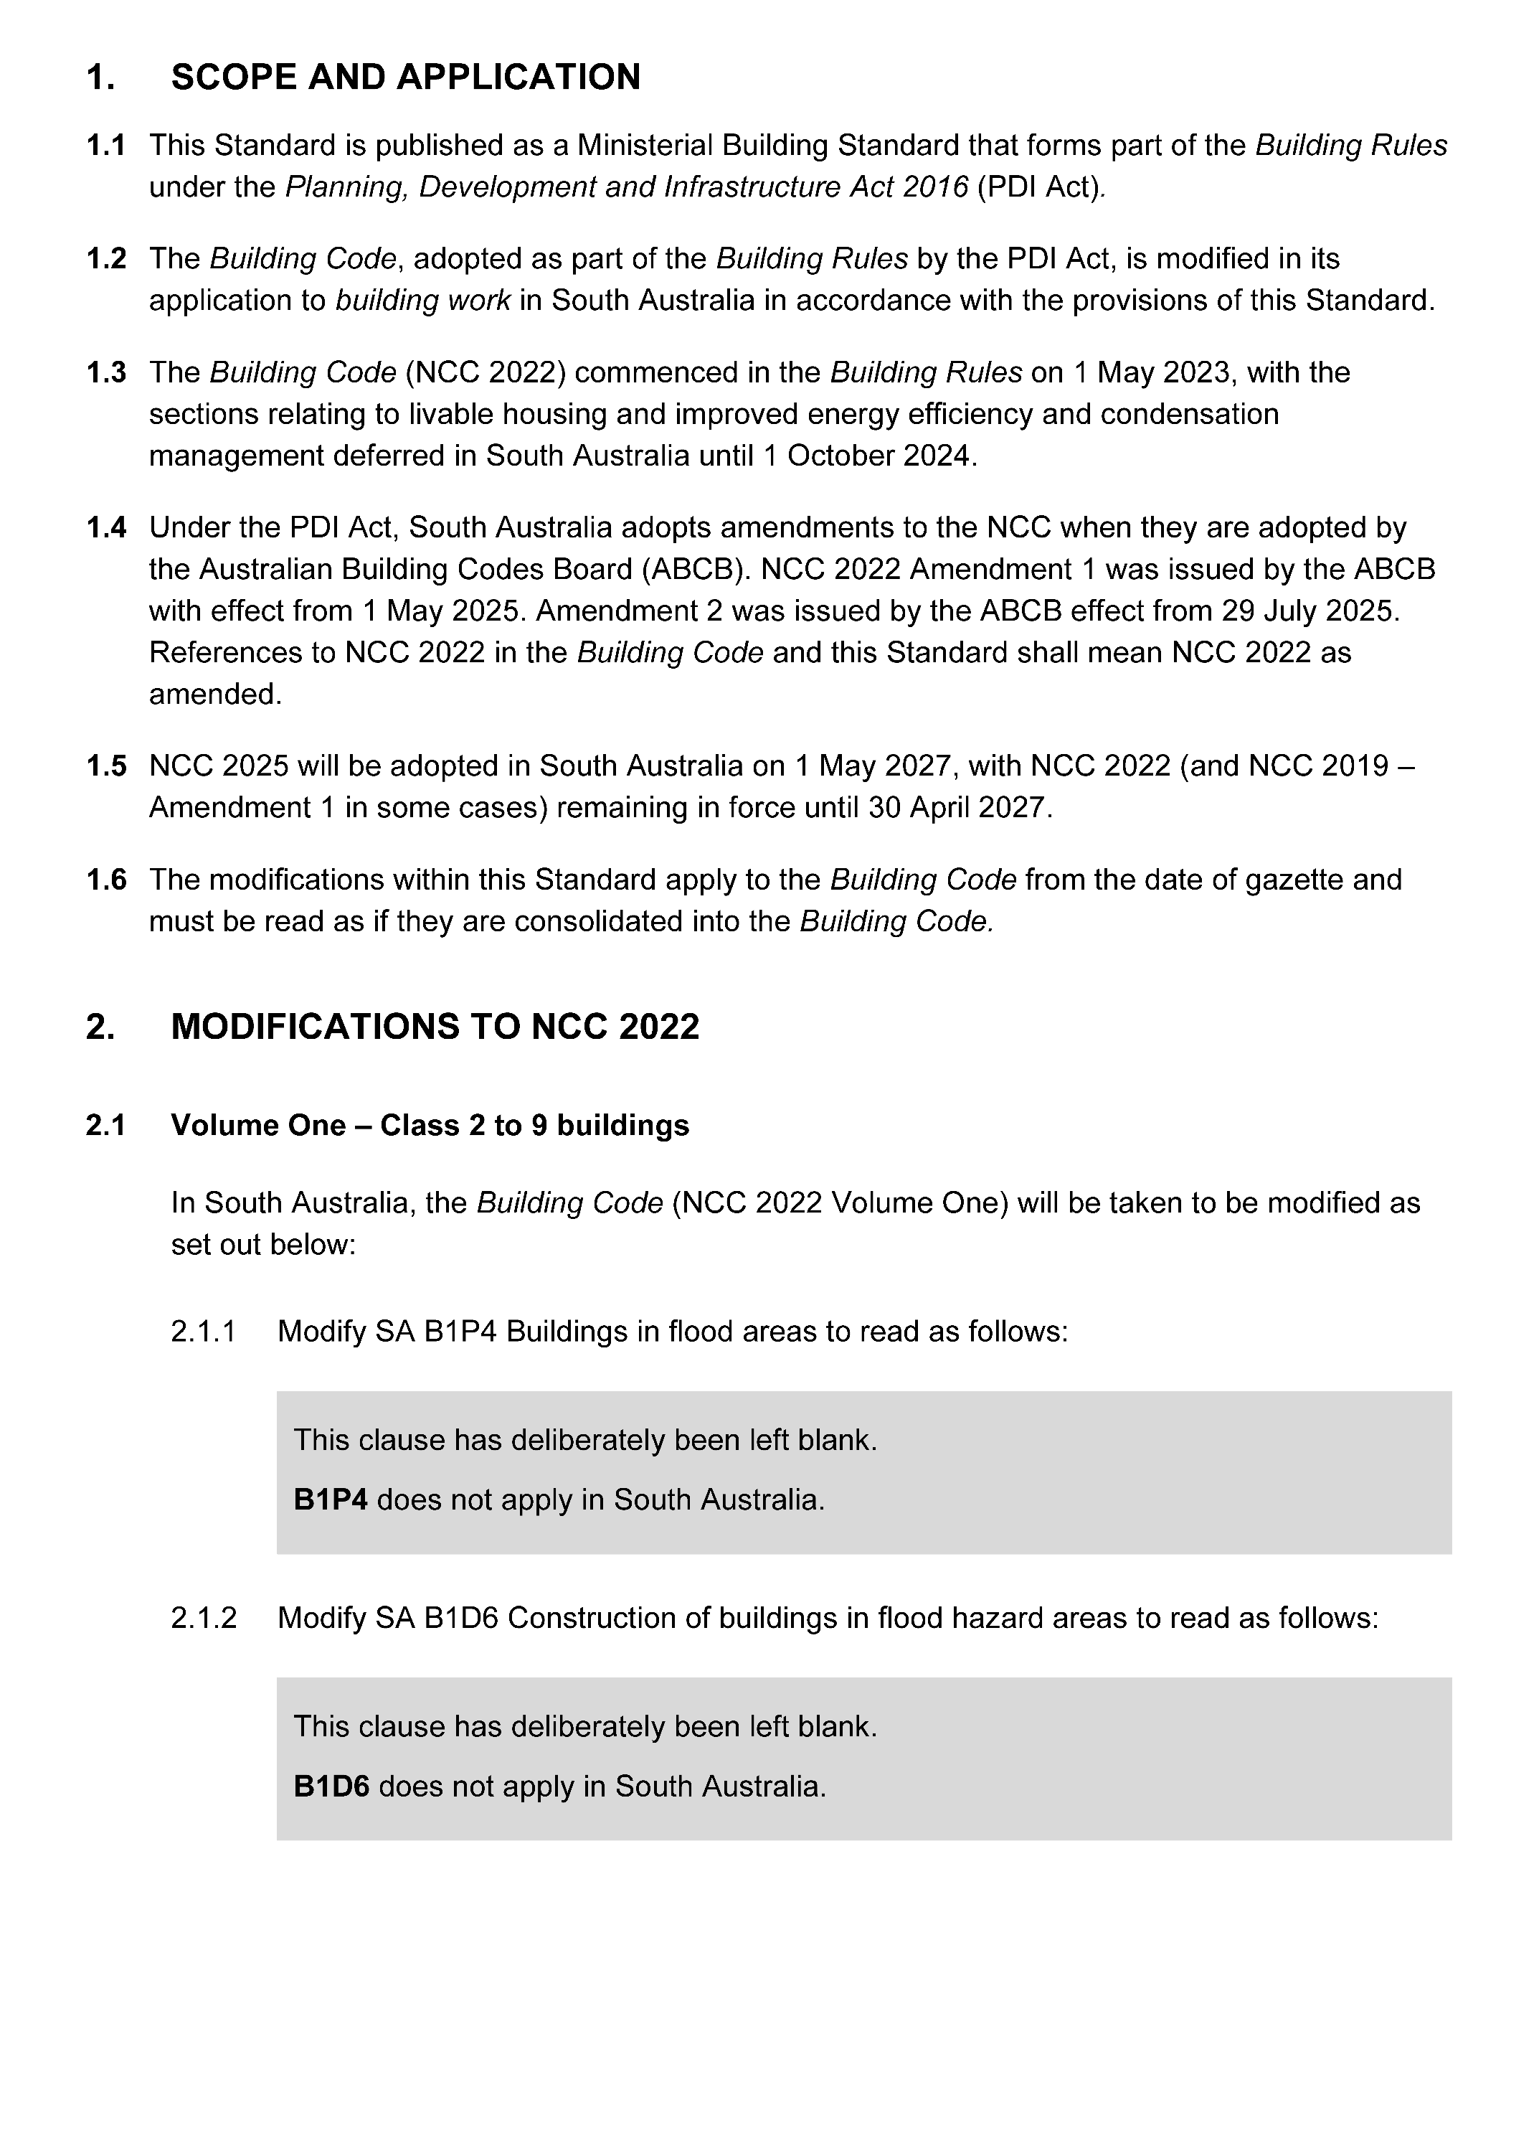
Published by the Minister for Planning
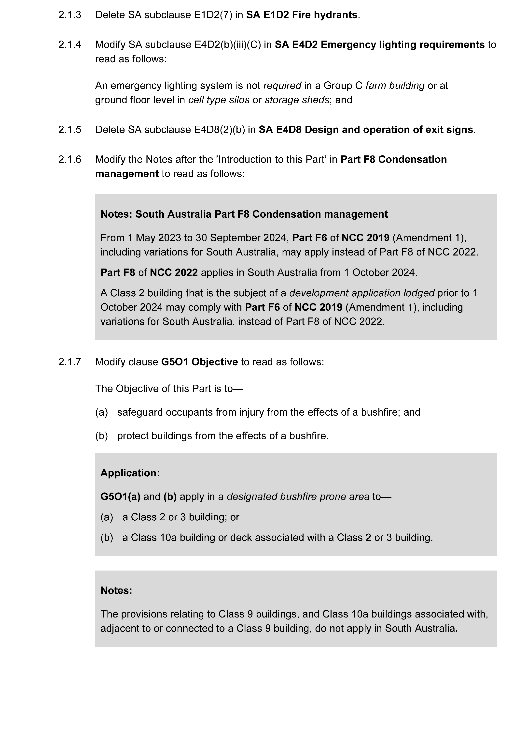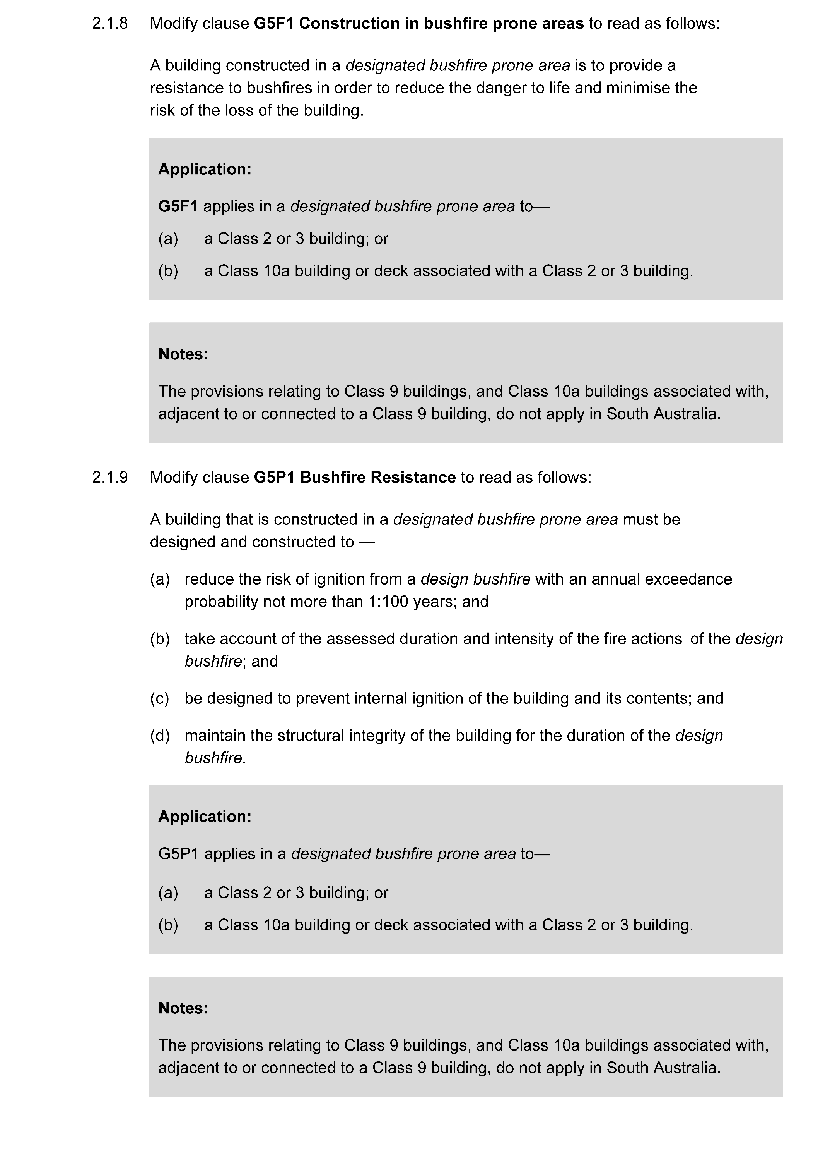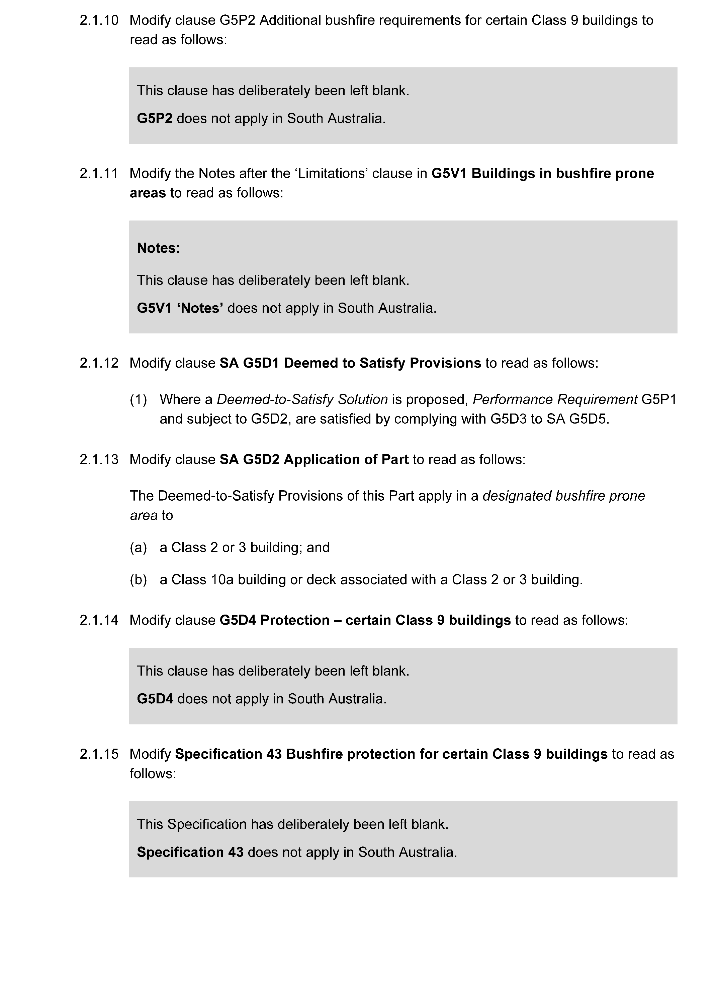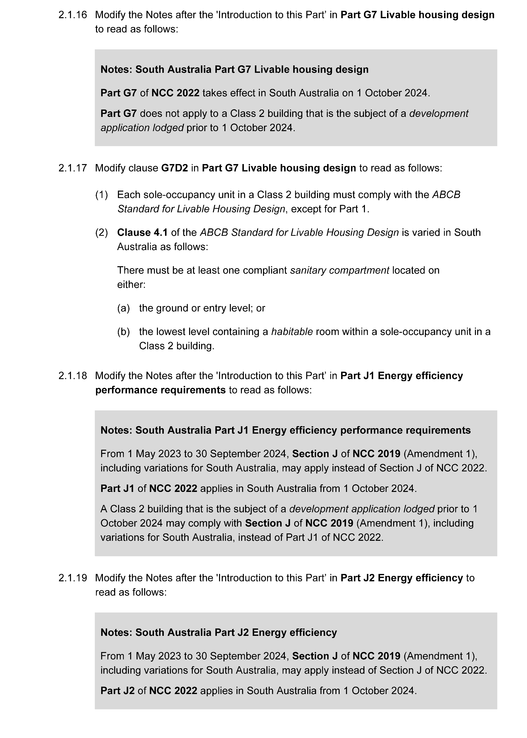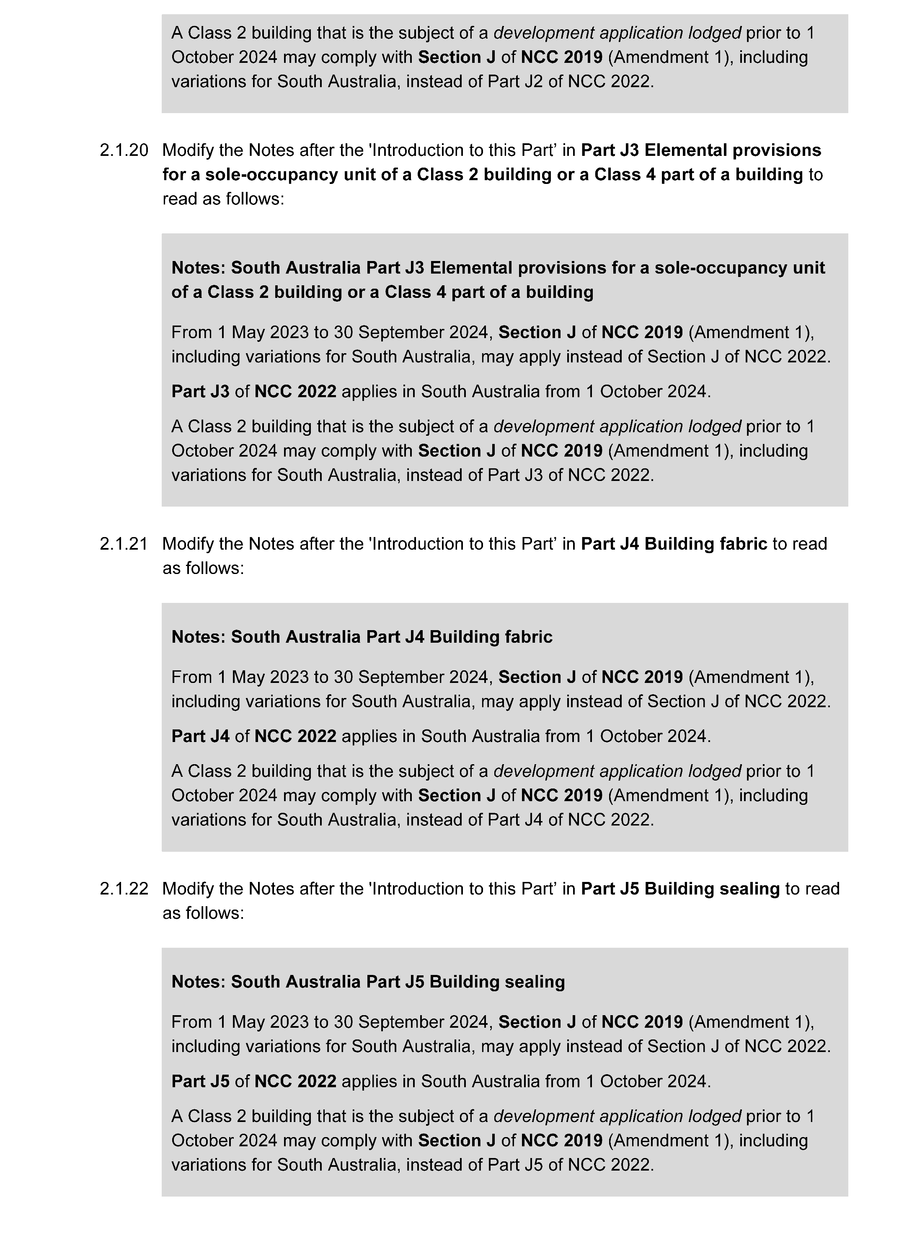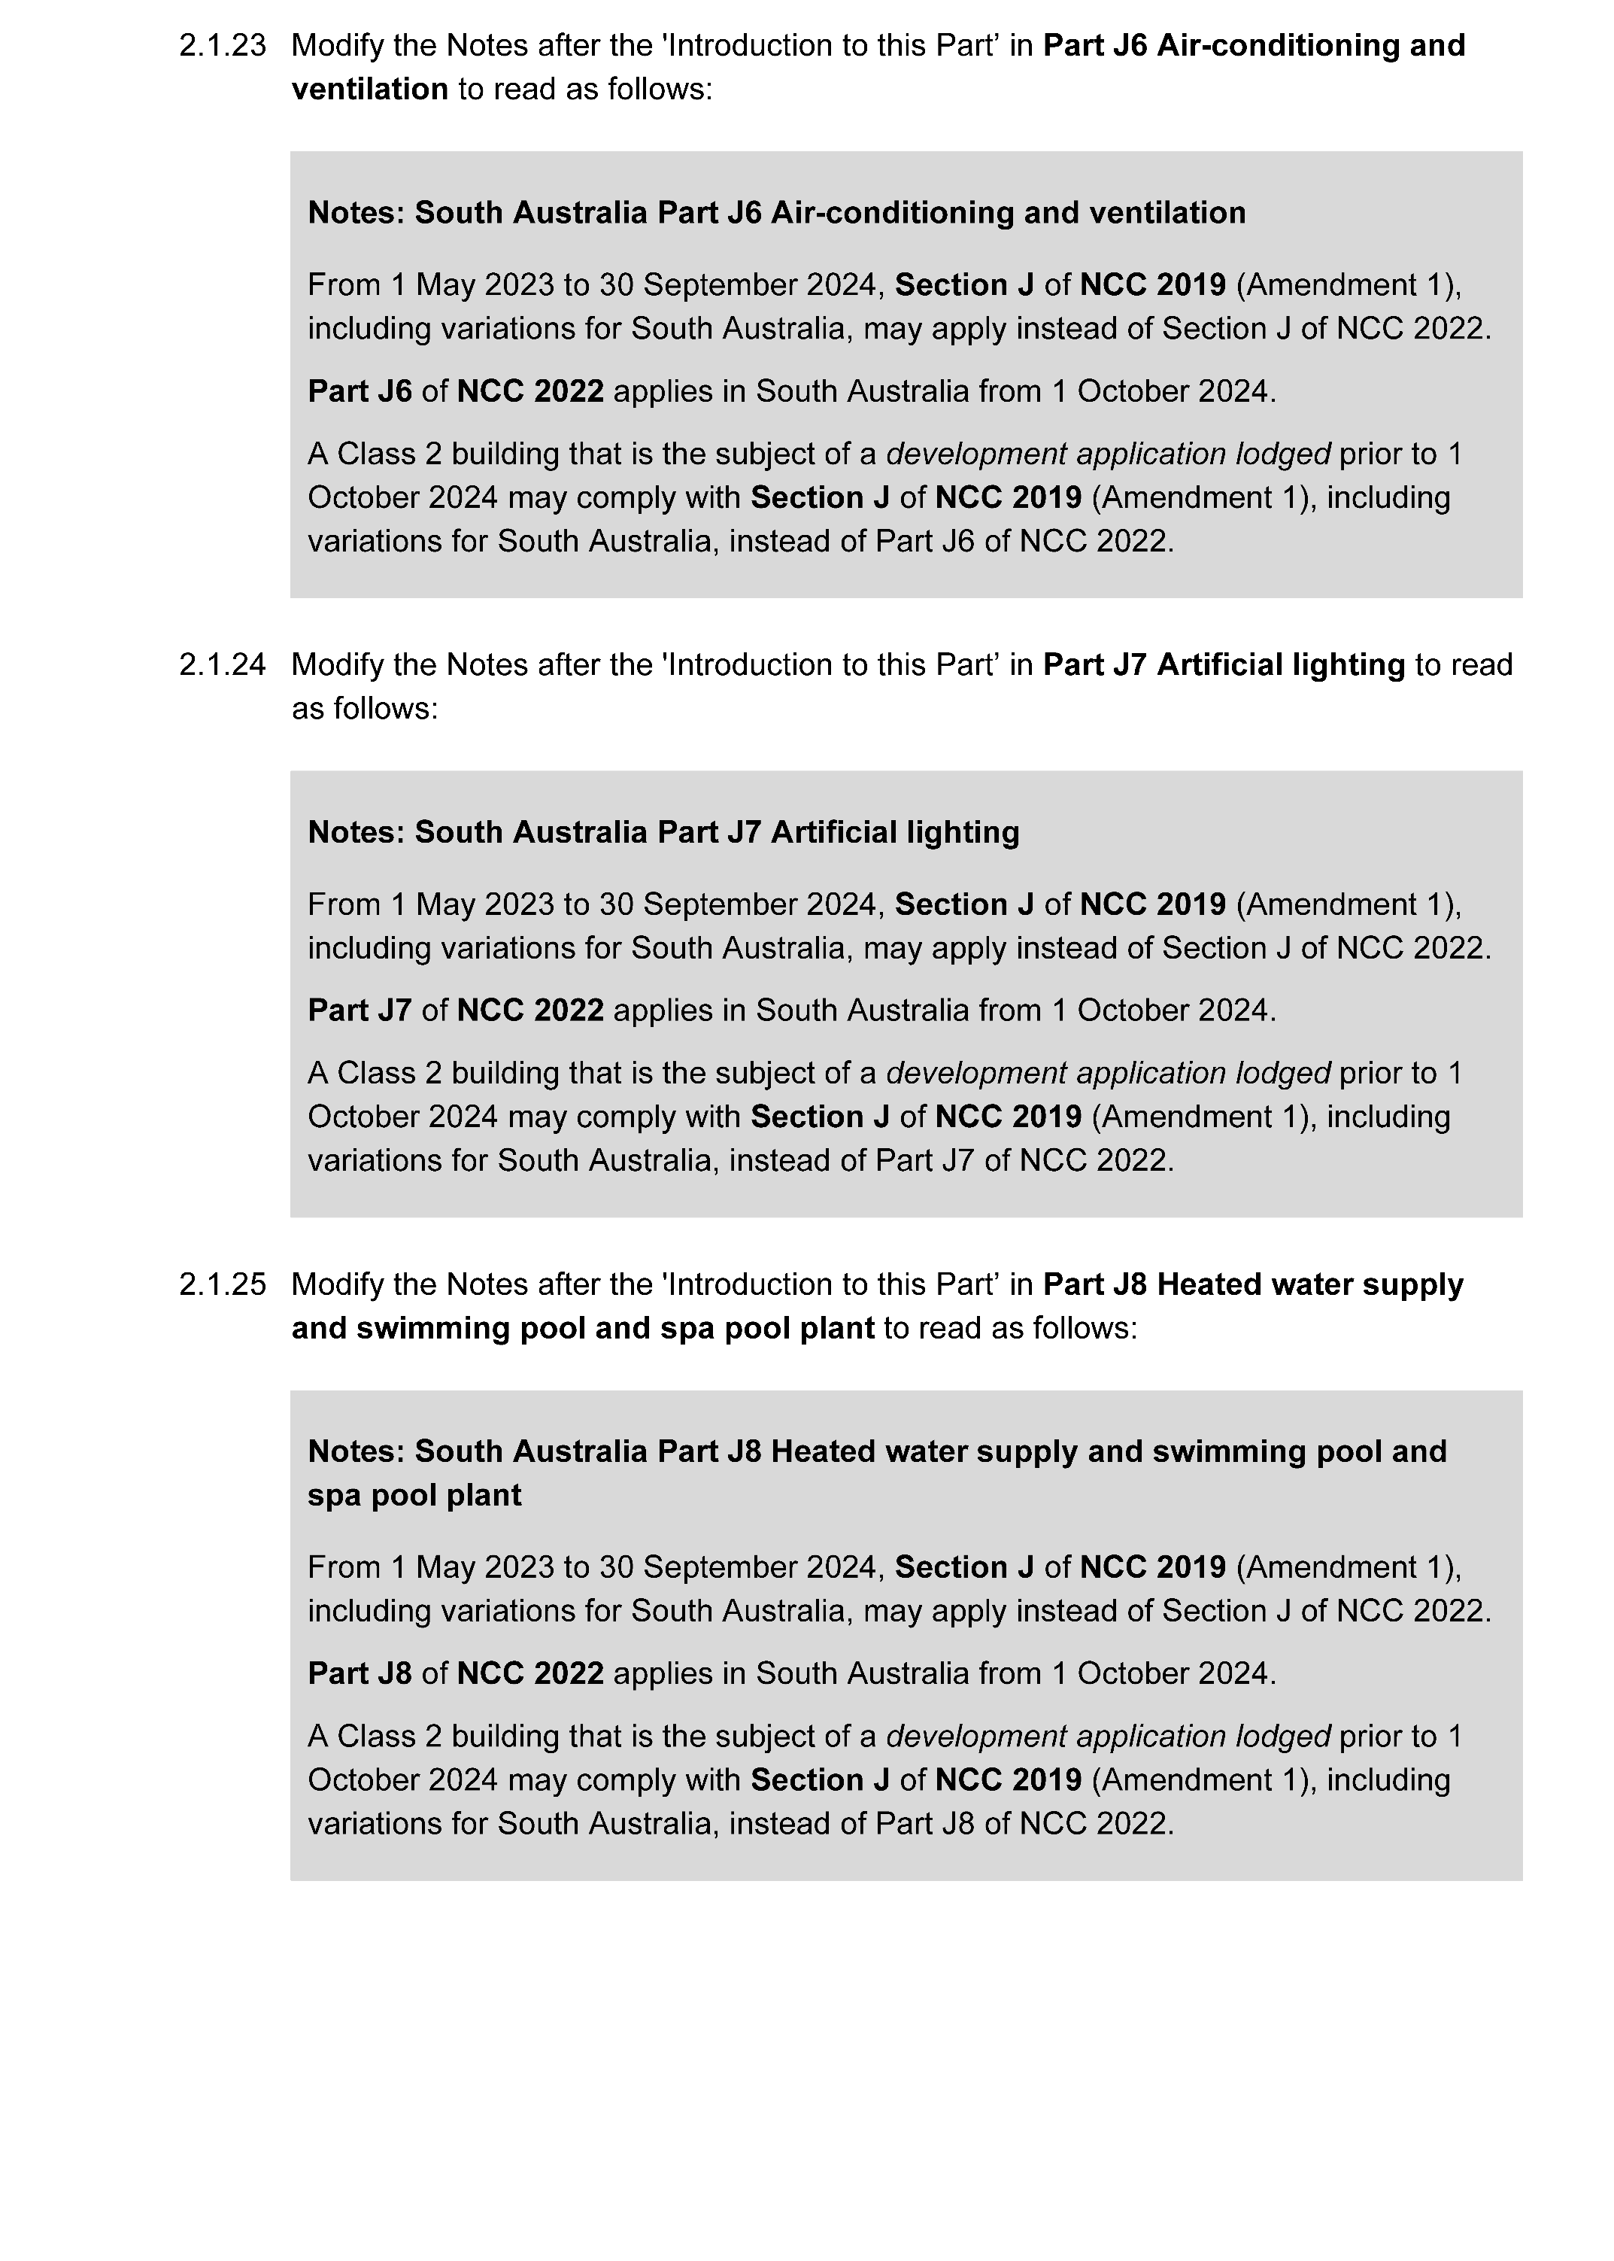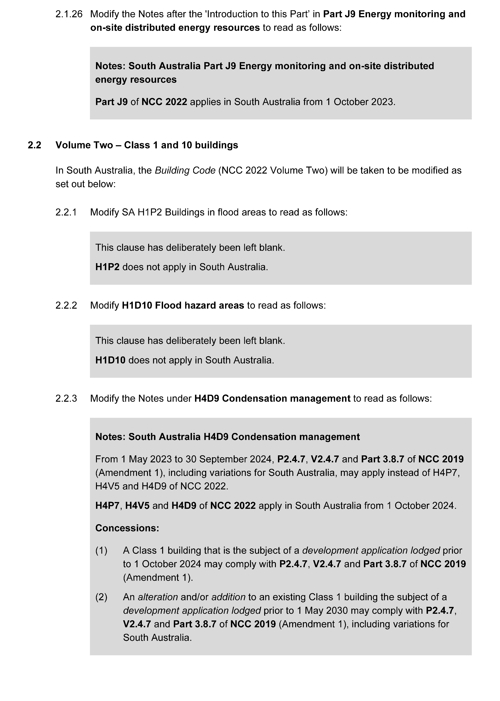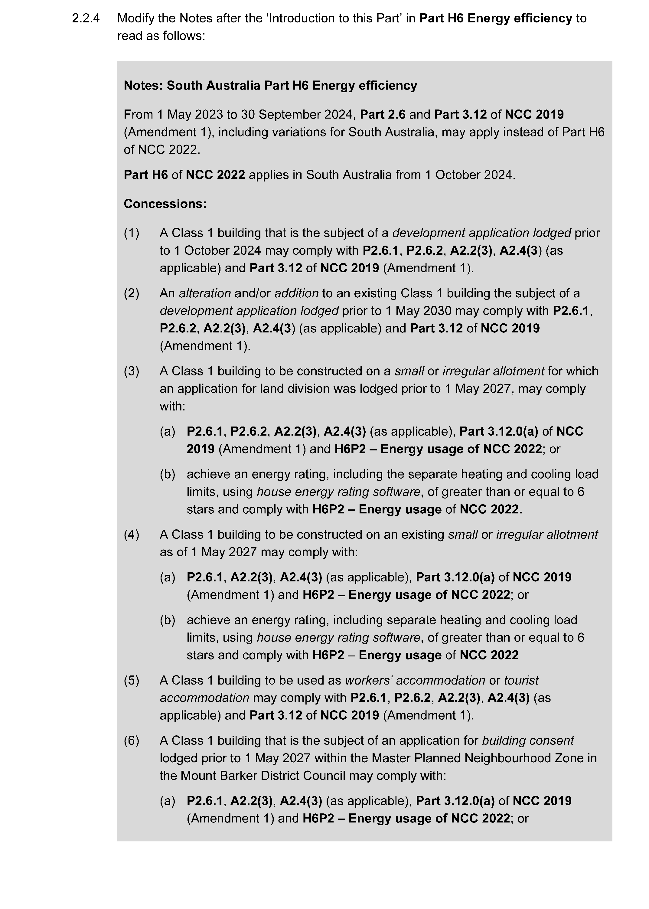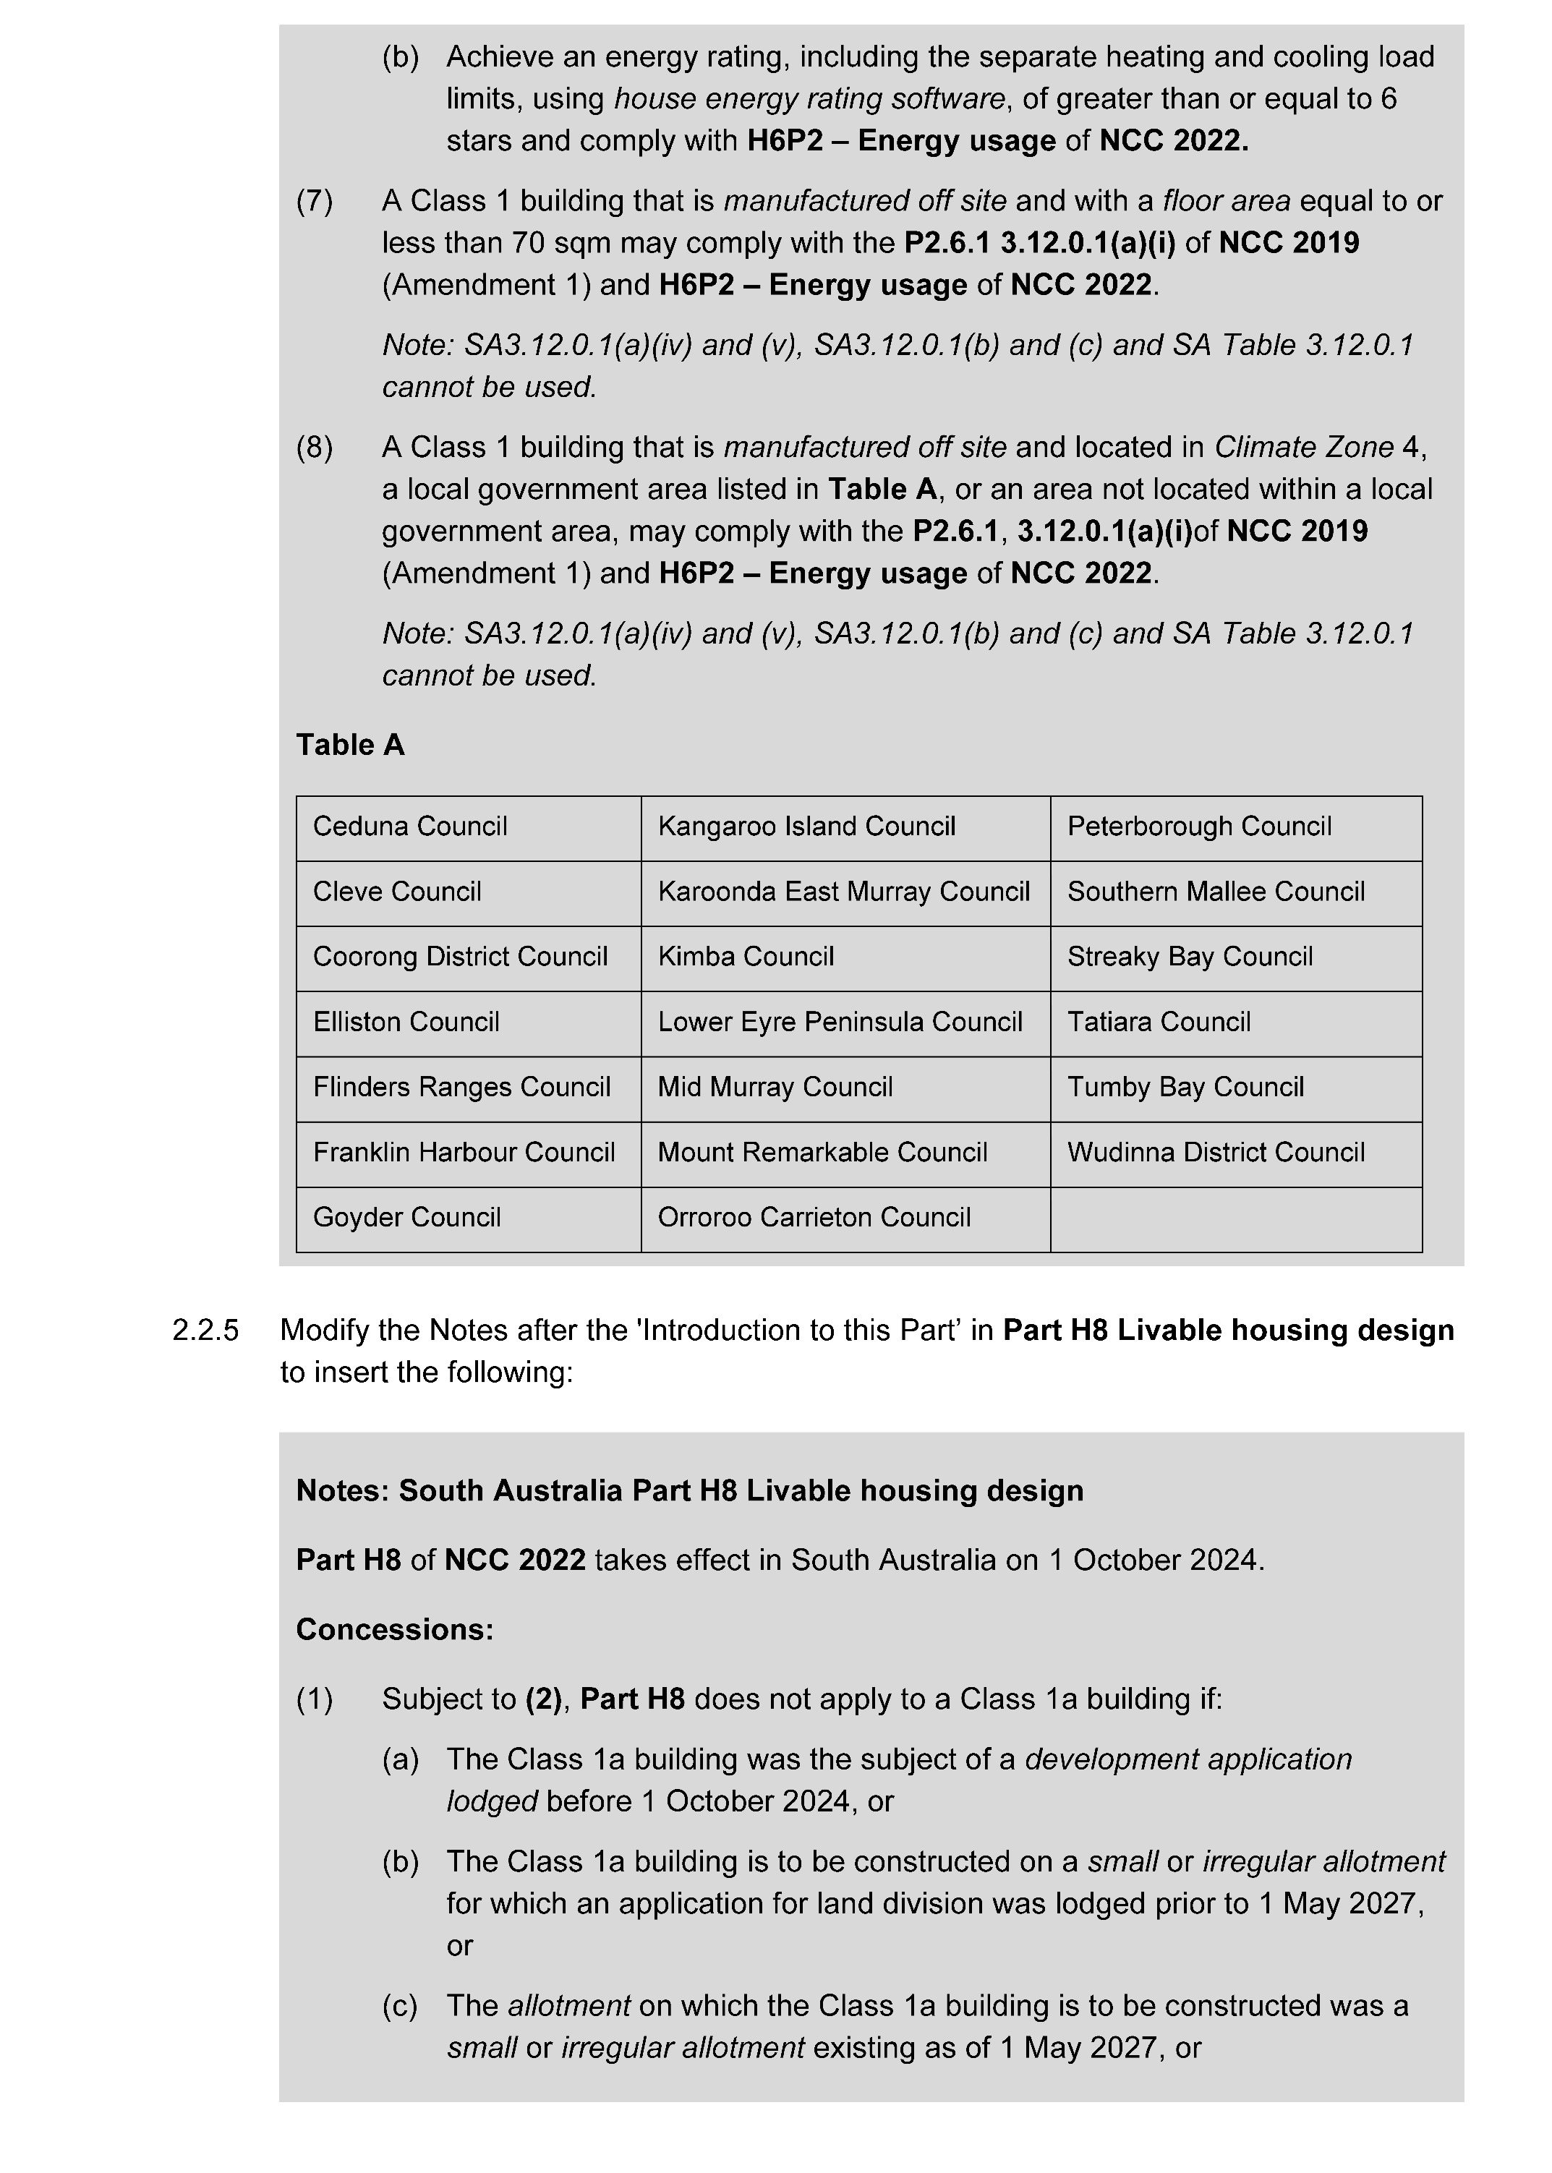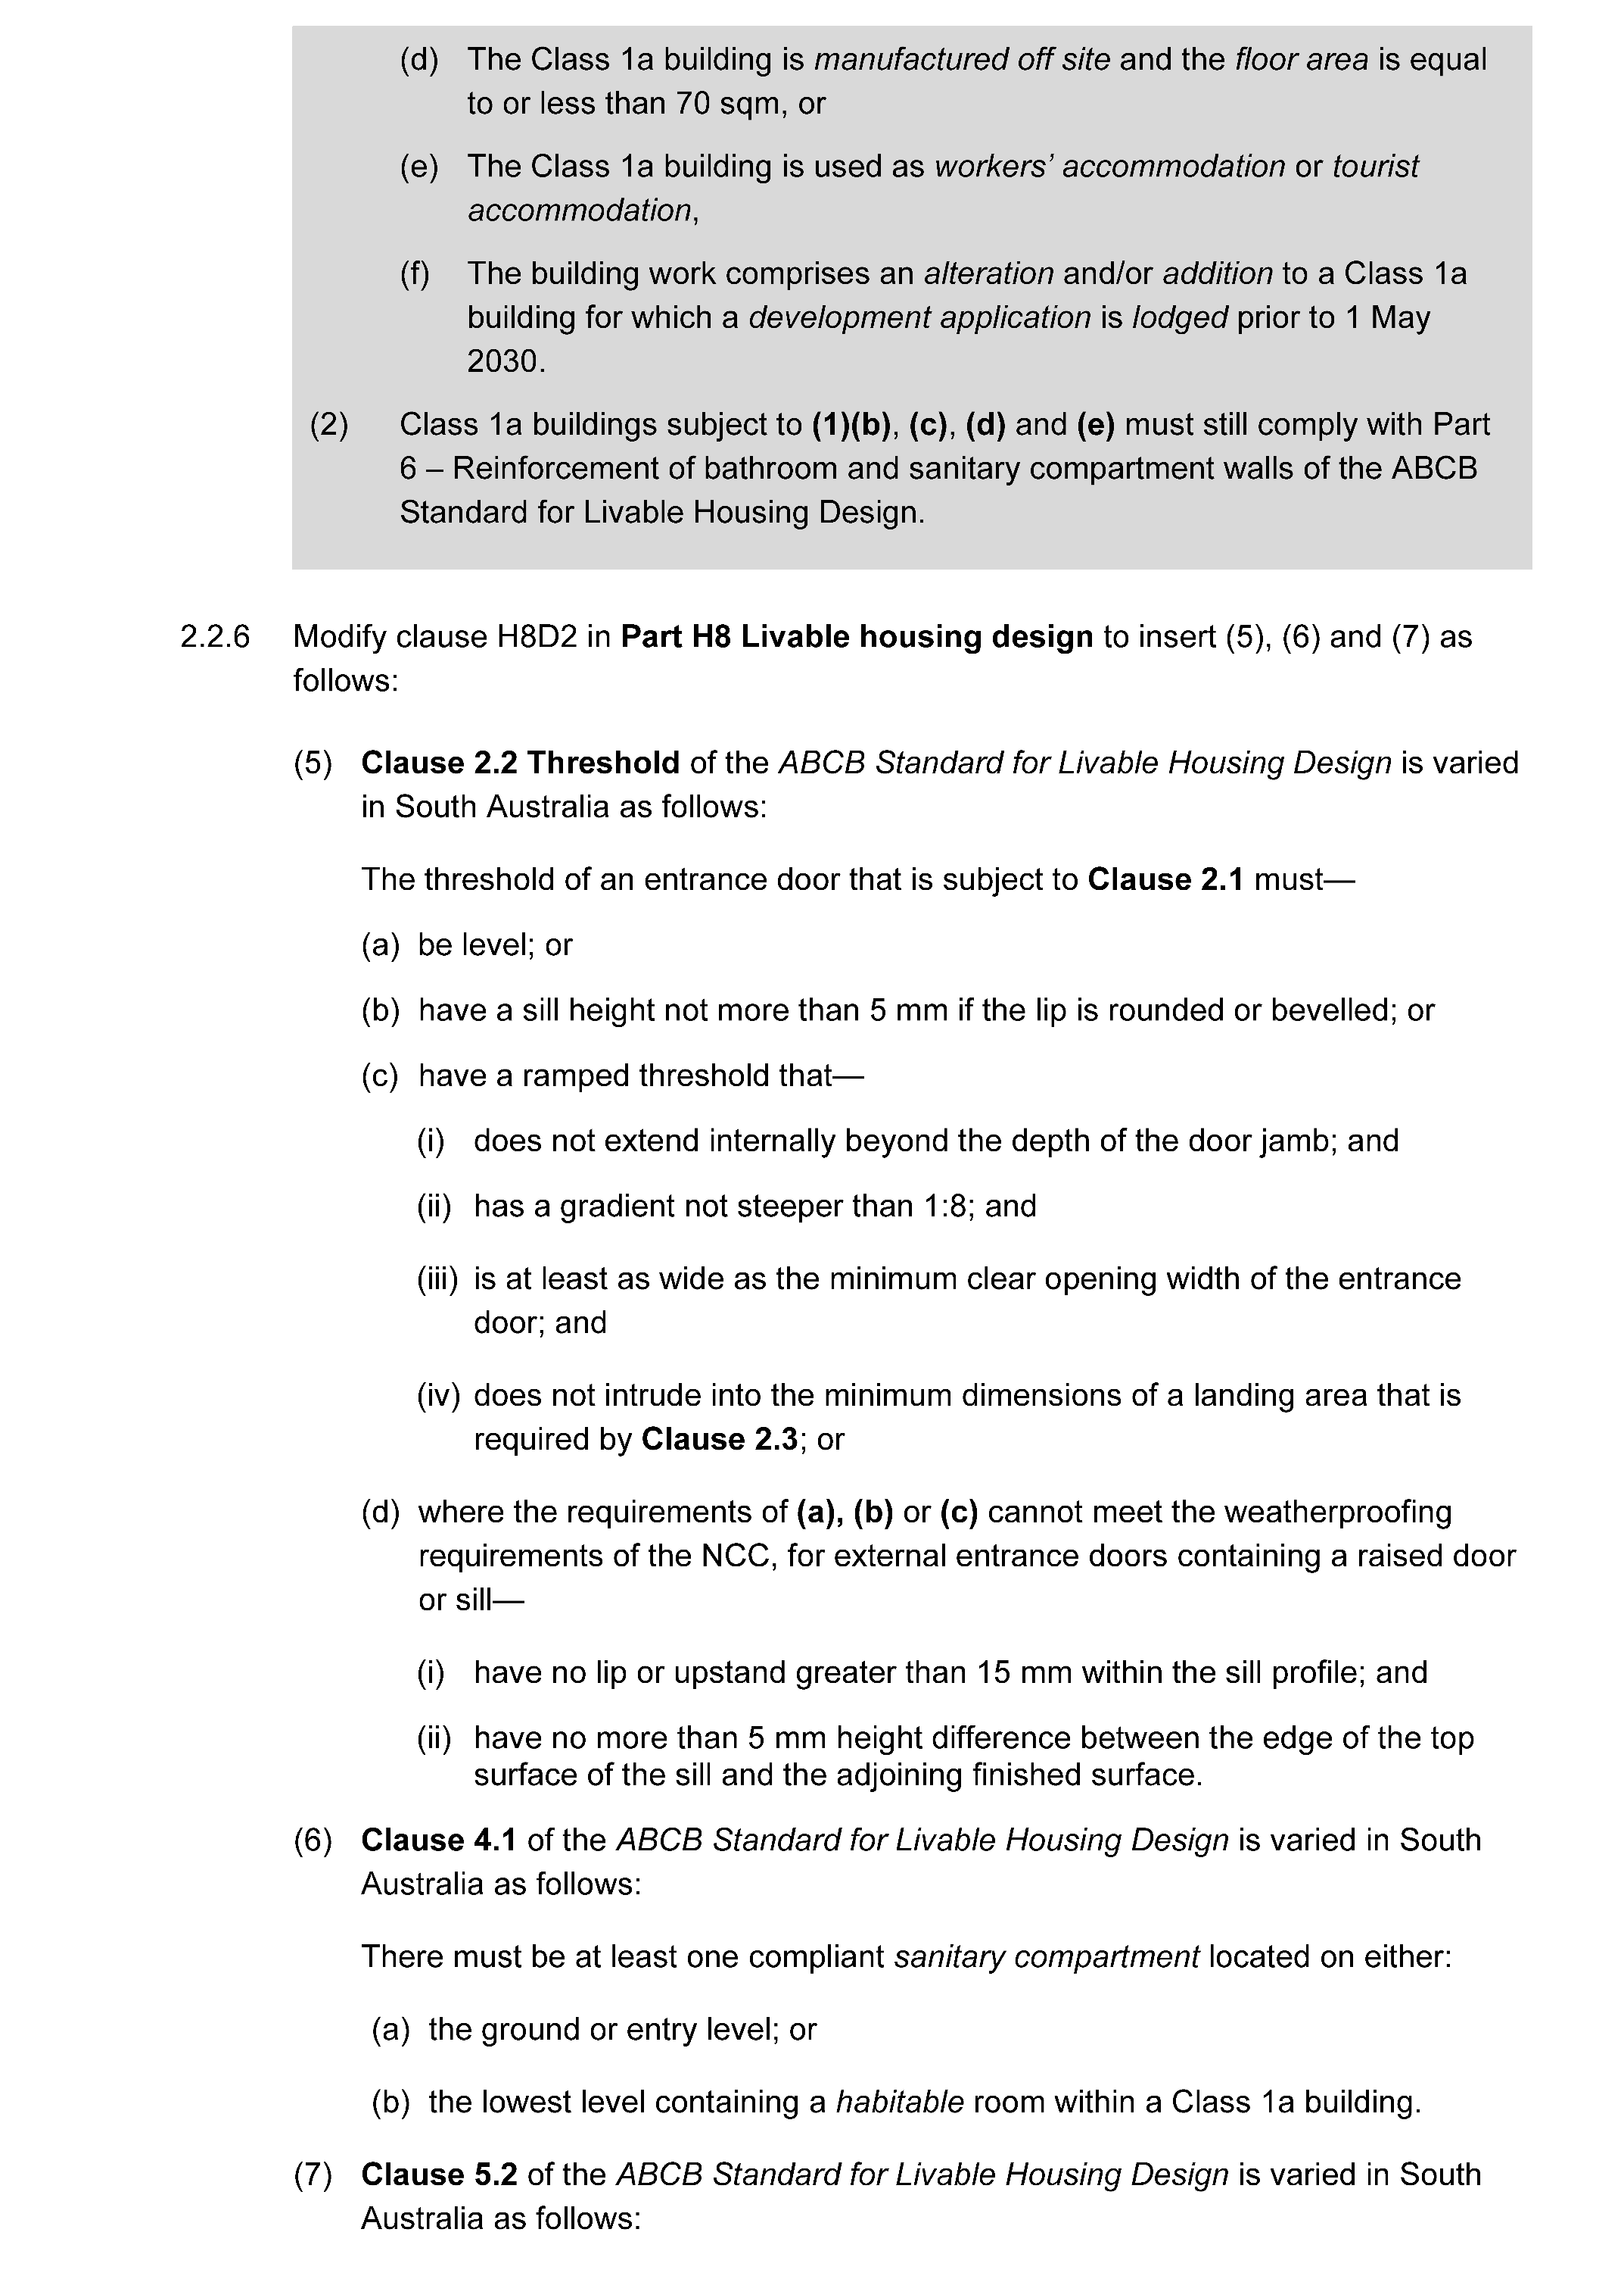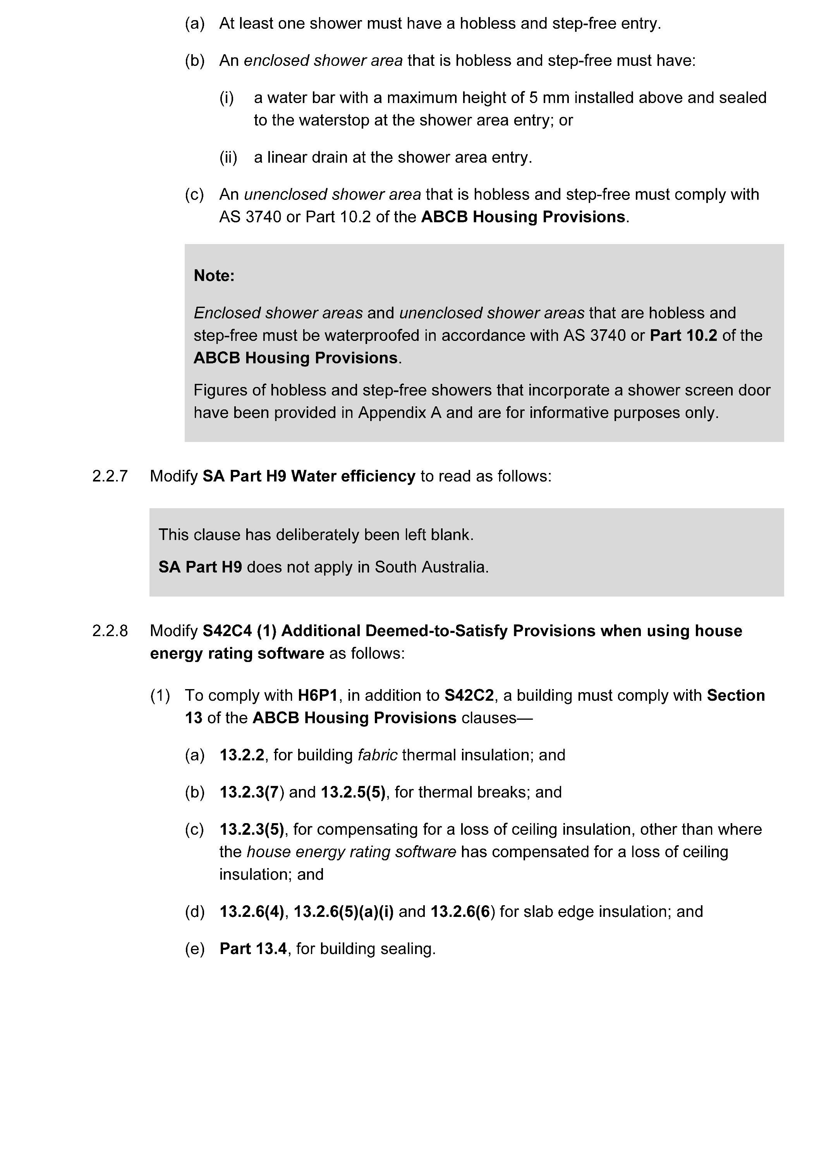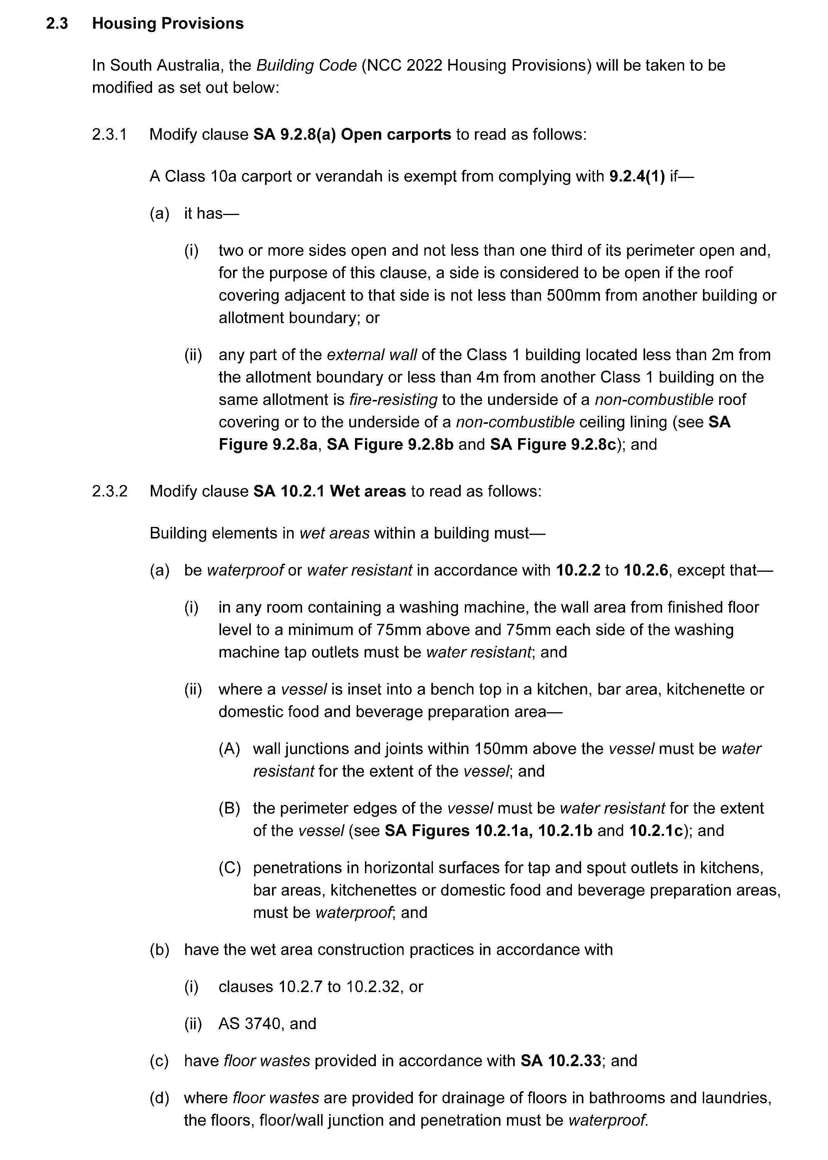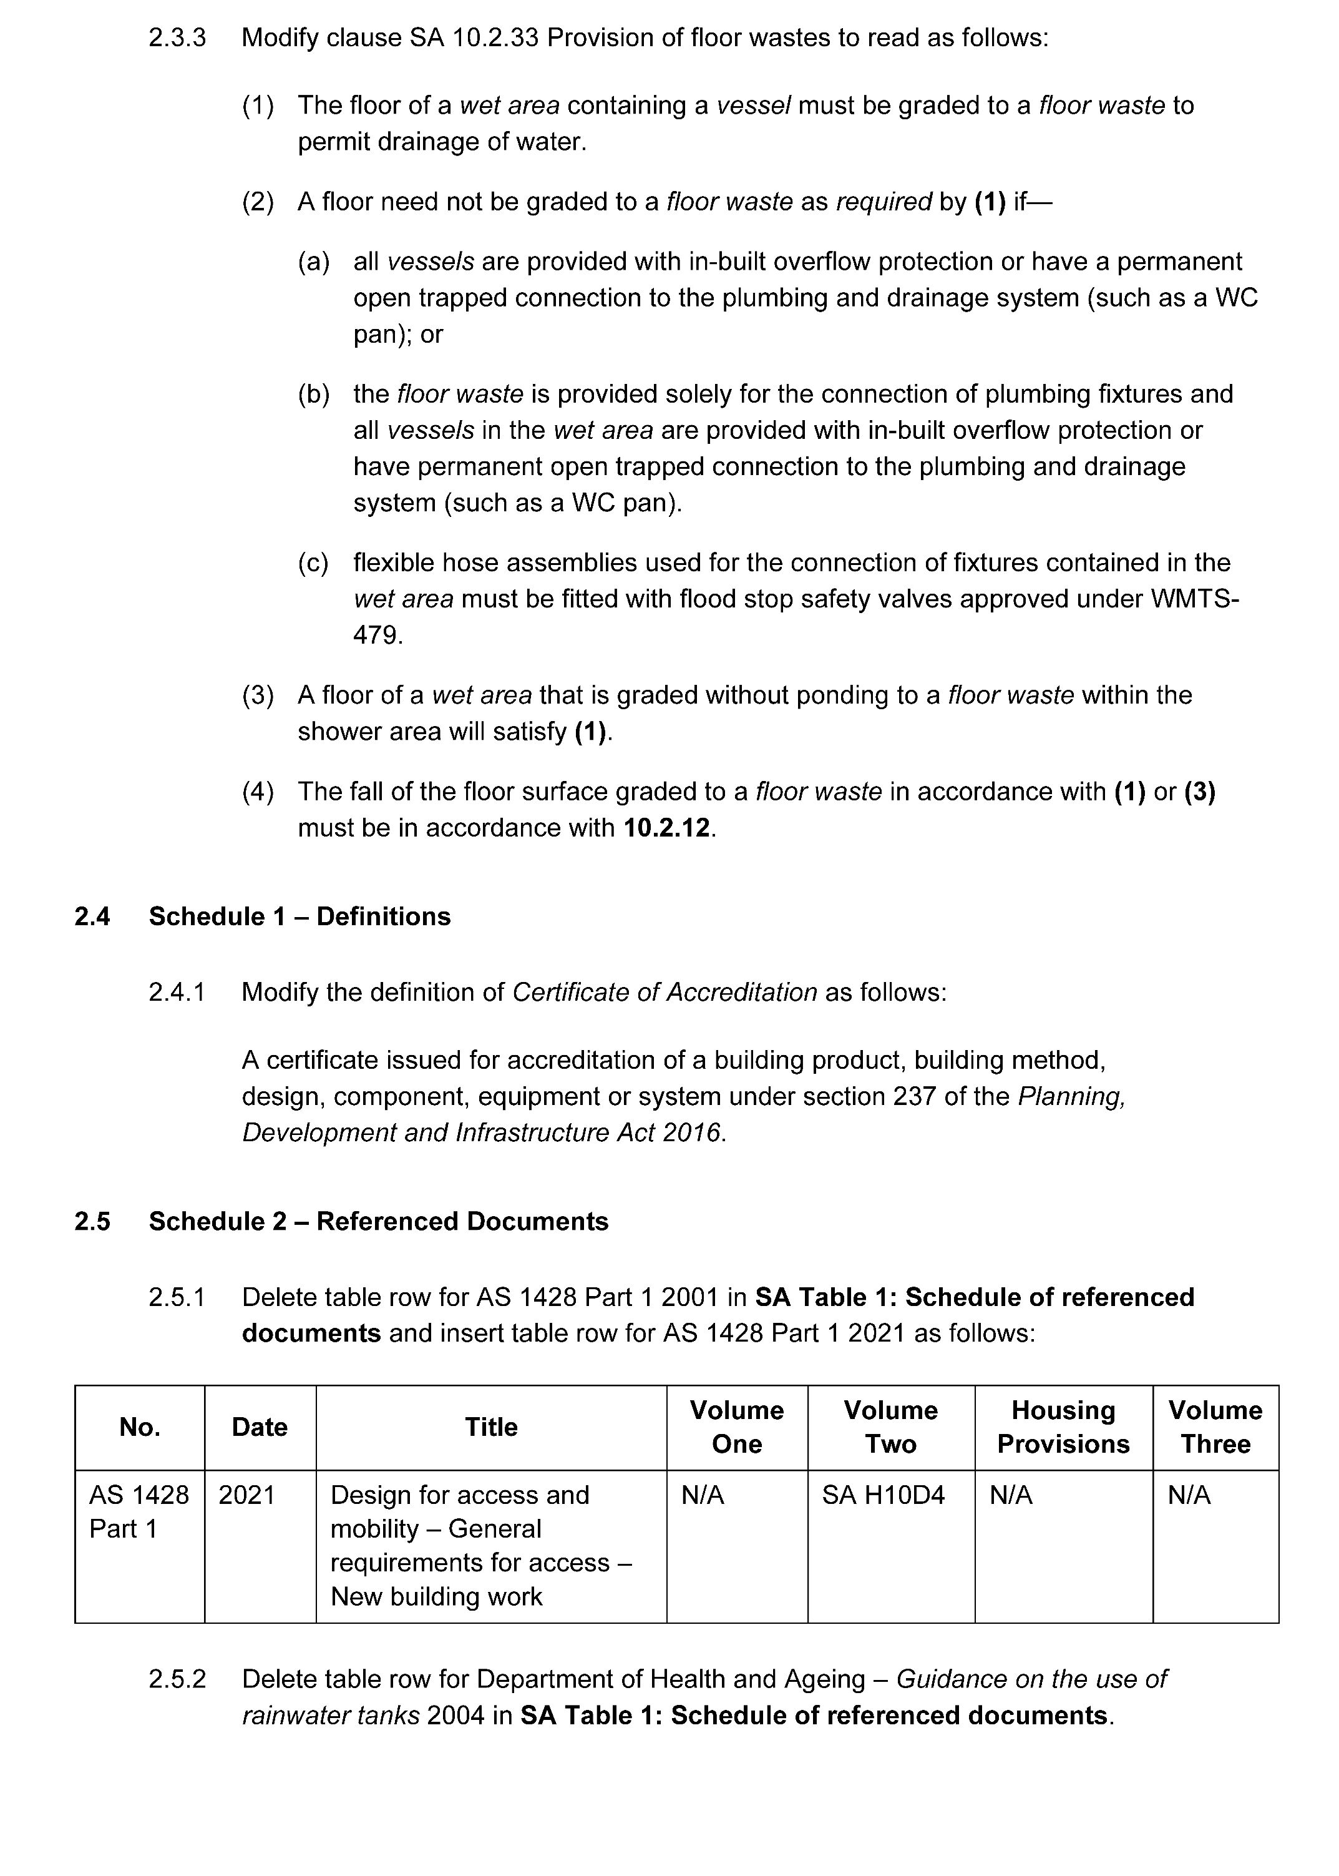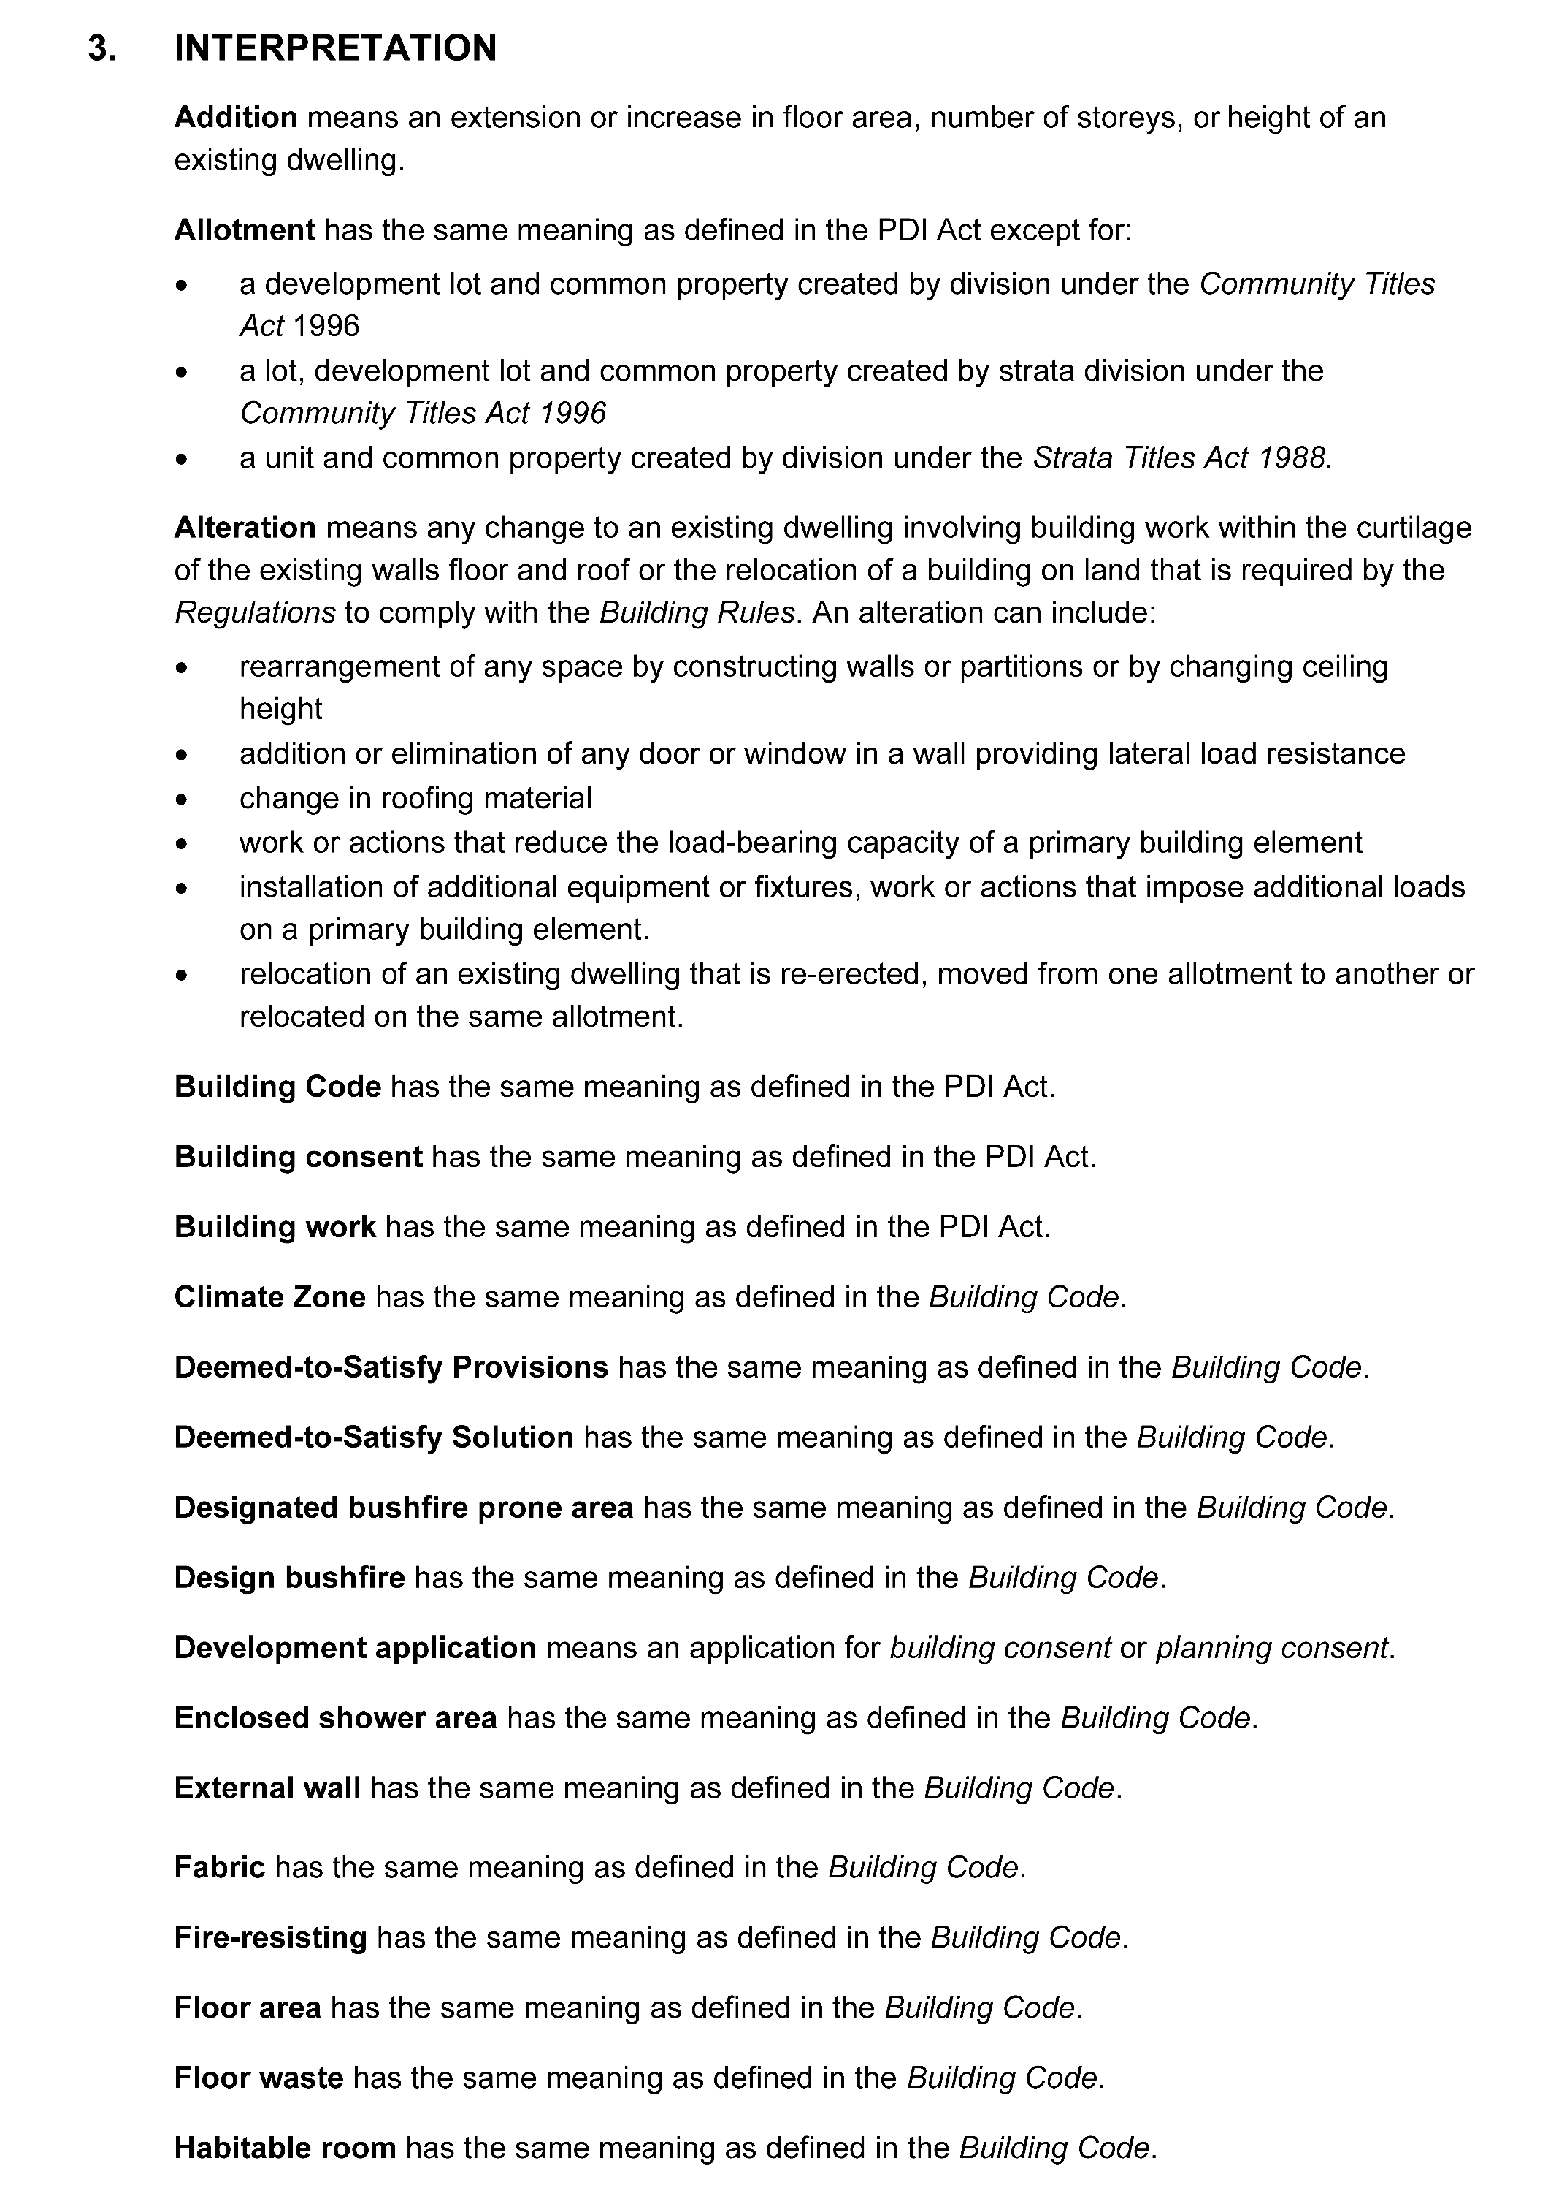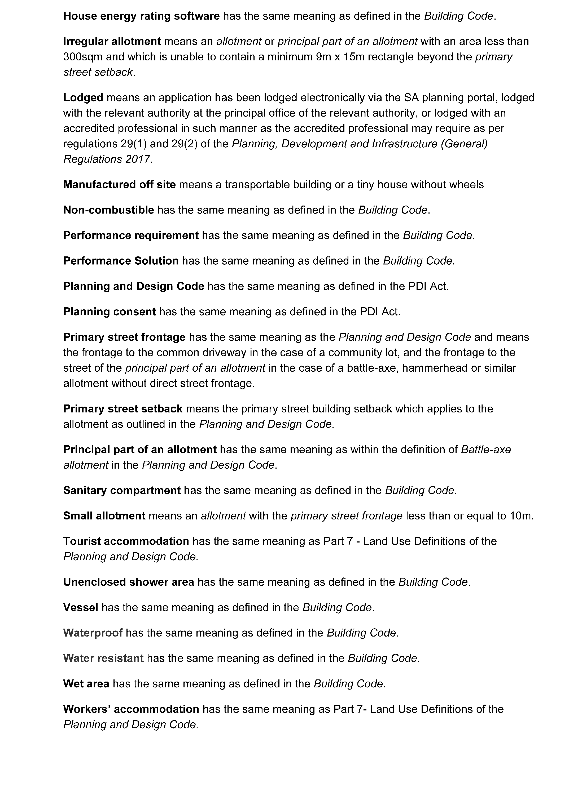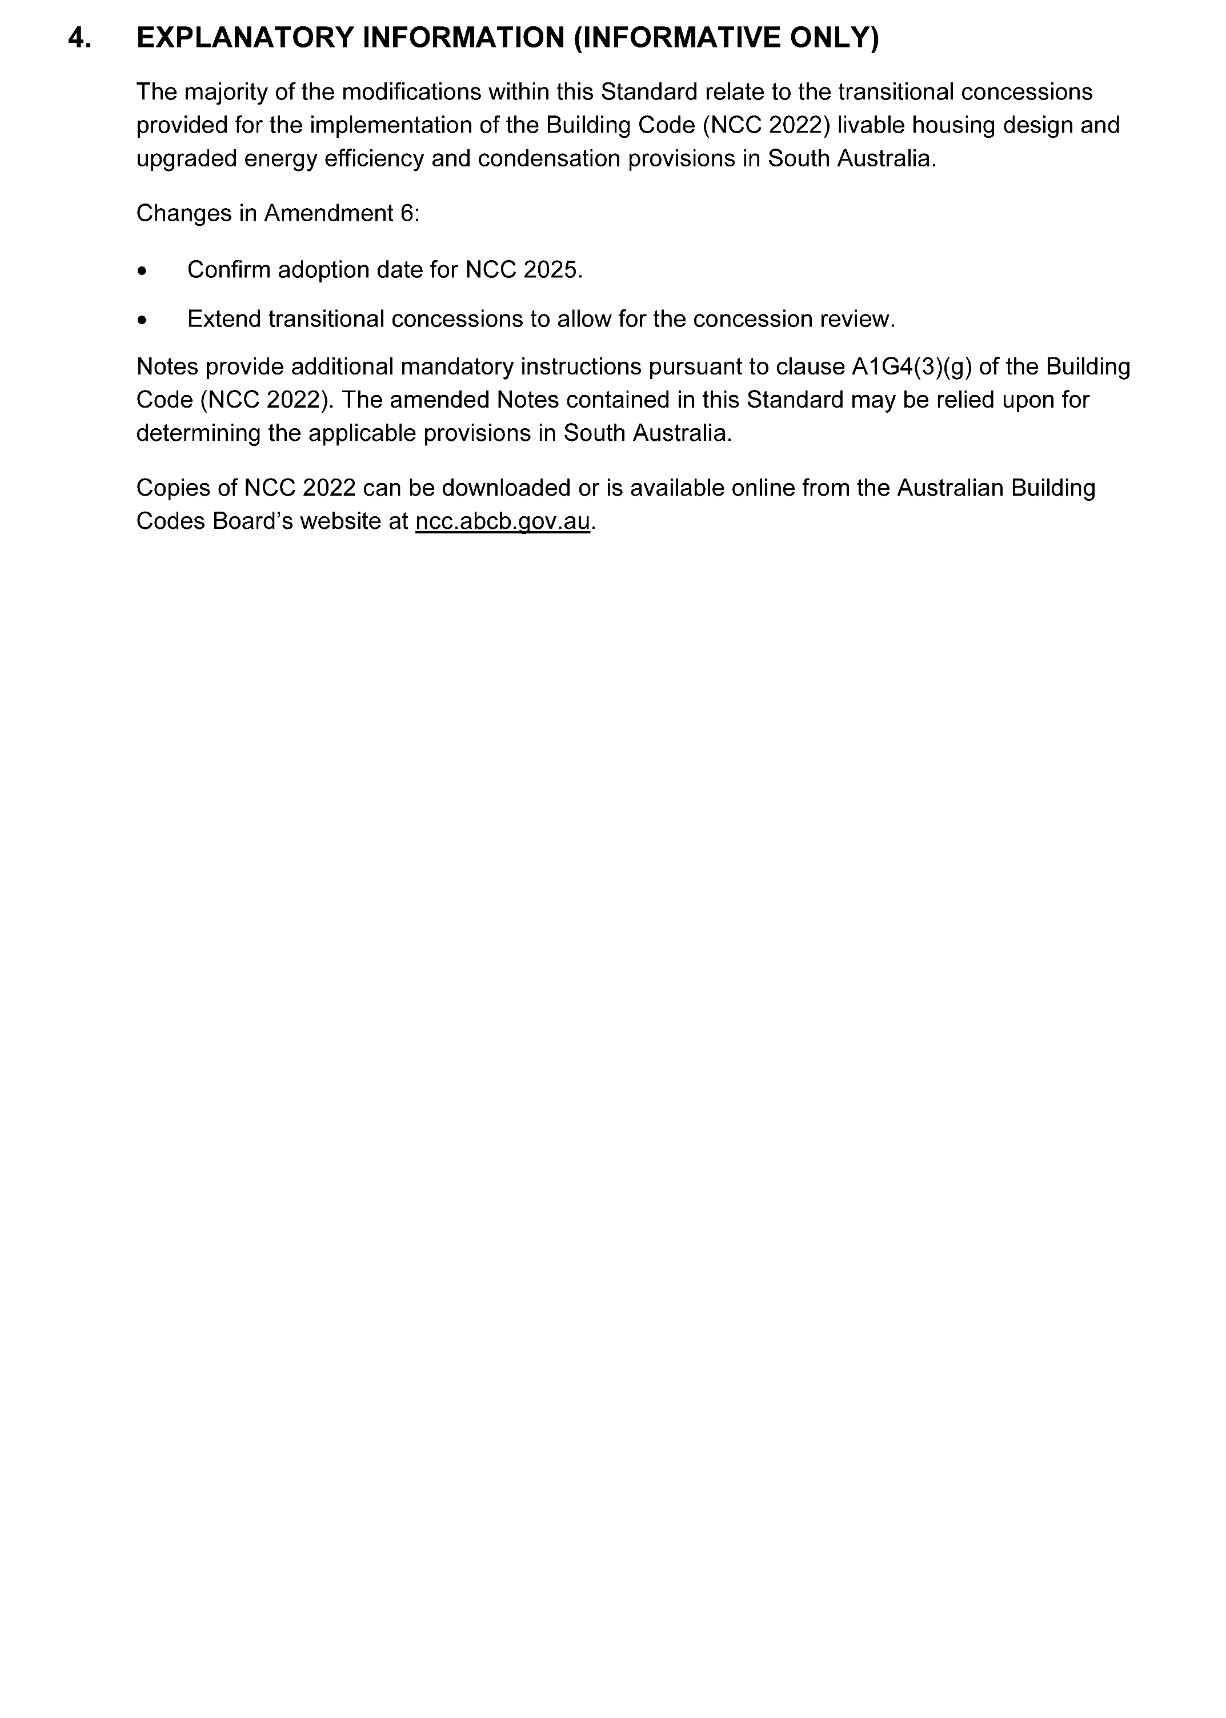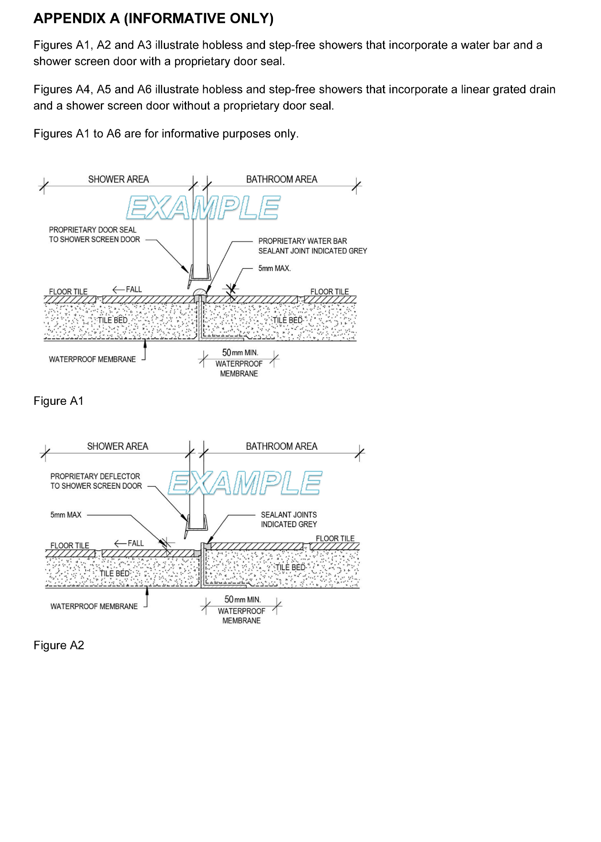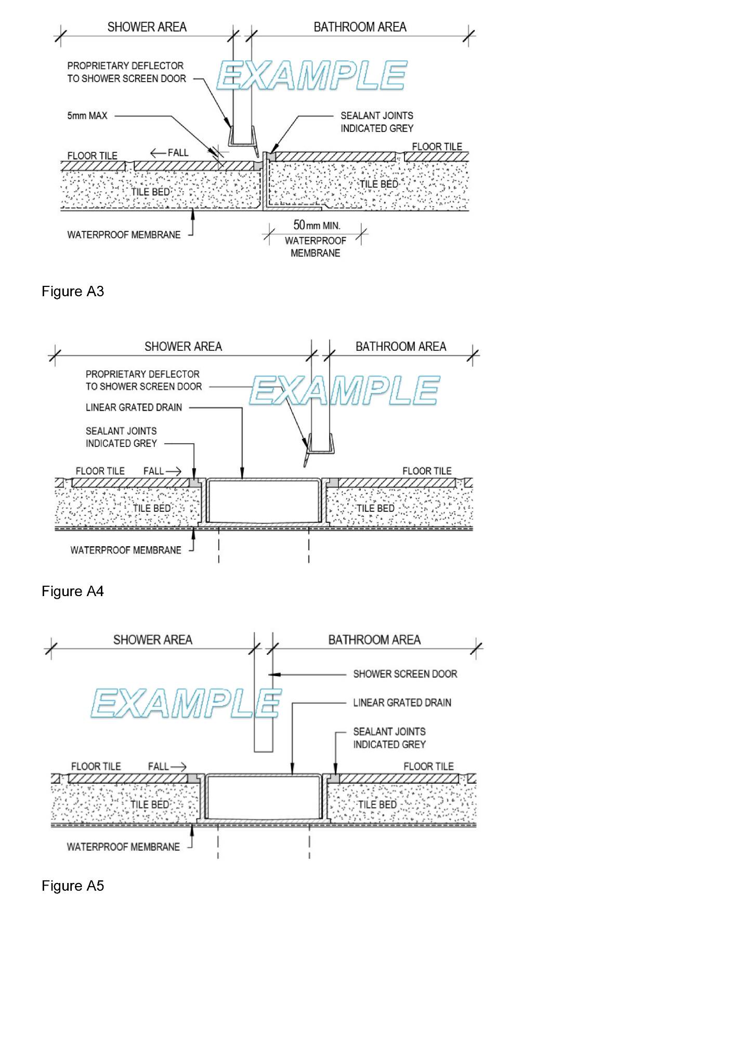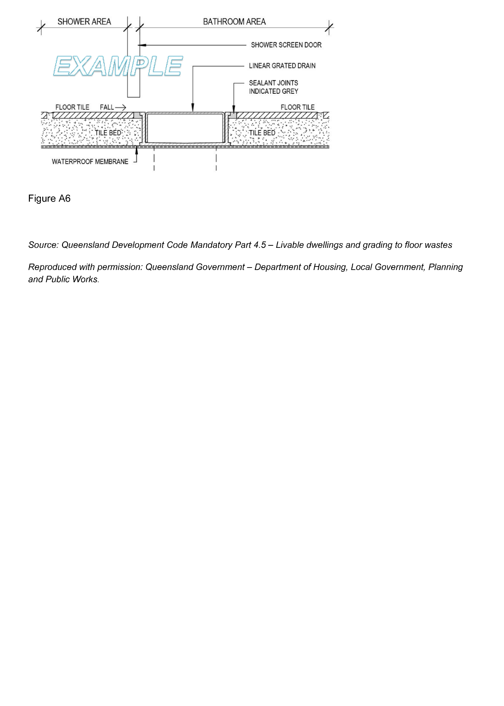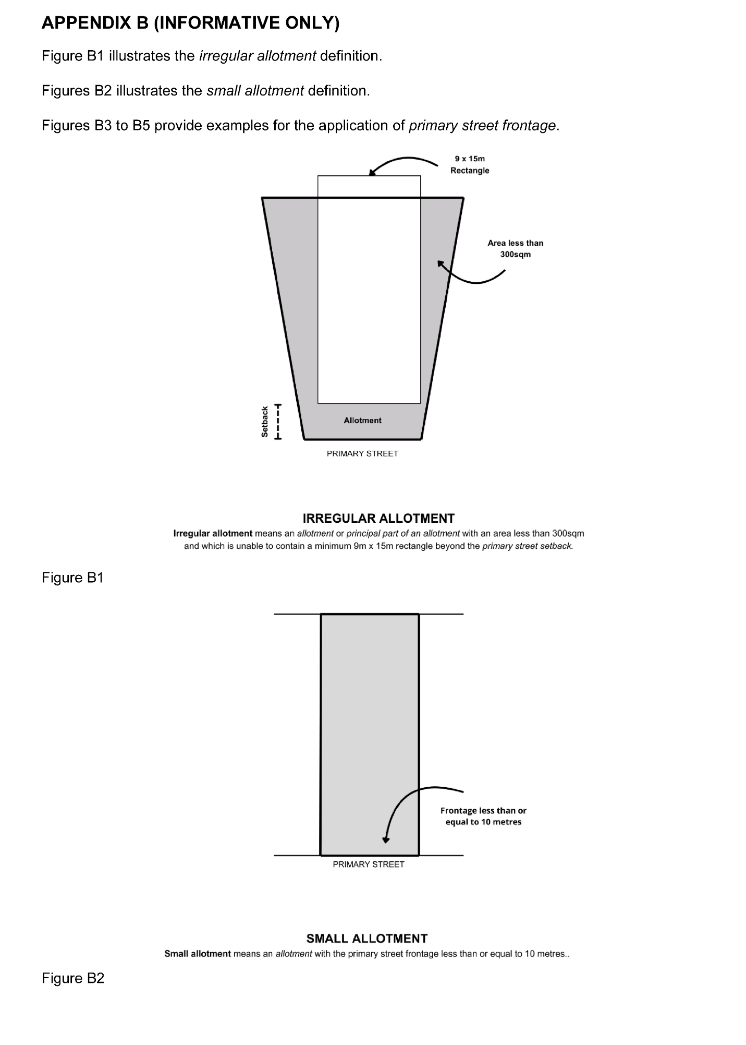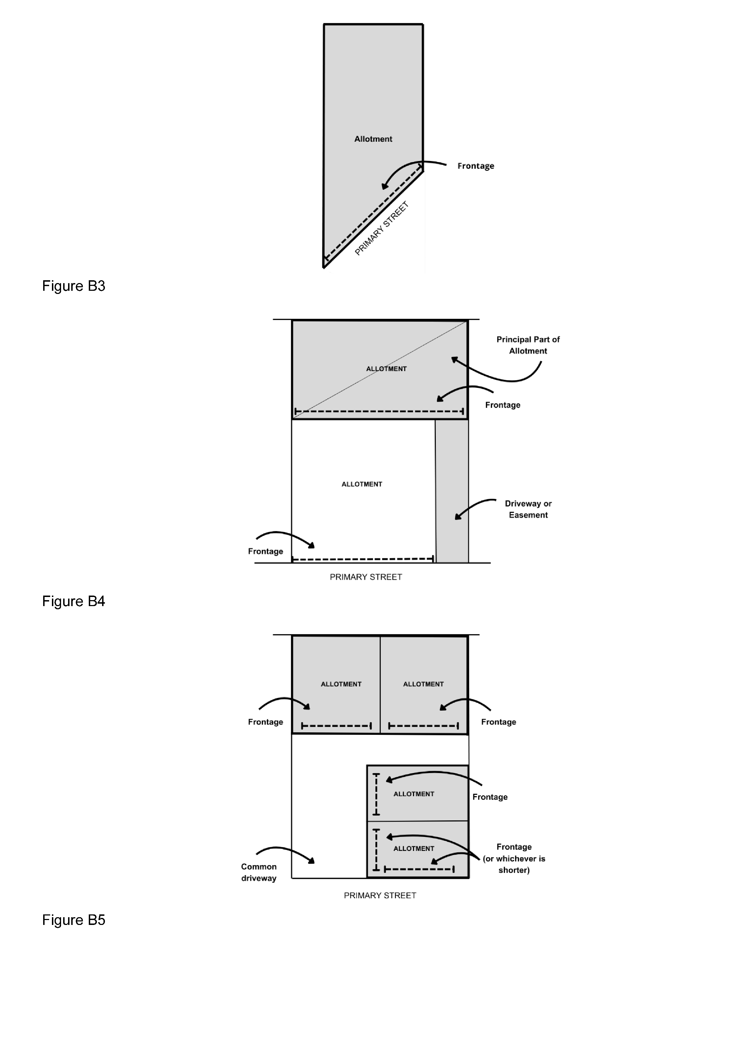

Road Traffic Act 1961
Authroisation to Operate Breath Analysing Instruments
I, Grant Stevens, Commissioner of Police, do hereby notify that on and from 17 April 2026, the following persons were authorised by the Commissioner of Police to operate breath analysing instruments as defined in and for the purposes of the:
• Road Traffic Act 1961;
• Harbors and Navigation Act 1993;
• Security and Investigation Industry Act 1995; and
• Rail Safety National Law (South Australia) Act 2012.
PD Number | Officer Name
16188 | DIXON, Gemma Ann
15469 | HAY, Shaun Edward
15639 | HEINZE, Ryan James
12536 | HERNANDEZ, Robert Landon
16385 | KRAEMER, Mitchell Garry
11348 | LEWIS, Peter James
15640 | MCINERNEY, Michael John
15730 | MCPHEE, Camron
16070 | OLSEN, Jordan Anne
16064 | SENECA, Nicole
12802 | TAYLOR, Molly Christine
16214 | WILLIAMS, Oliver Noah
Dated: 23 April 2026
Grant Stevens
Commissioner of Police
Reference: 2026-0026

Local Government Instruments

City of Mount Gambier
Local Government Act 1999
Resignation of Councillor
Notice is given in accordance with Section 54(6) of the Local Government Act 1999 (SA) that a vacancy has occurred in the office of Area Councillor, due to the resignation of Councillor Jason Virgo, effective from 30 March 2026.
Dated: 14 April 2026
Paul Simpson
Chief Executive Officer

City of Port Adelaide Enfield
Notice of Casual Vacancy
Notice is hereby given pursuant to Section 54(6) of the Local Government Act 1999 that the office of Councillor for the Semaphore Ward has become vacant following Councillor David Wilkins election to the South Australian parliament, effective 1 April 2026.
In accordance with Section 6(2) of the Local Government (Elections) Act 1999, a supplementary election will not be held to fill the casual vacancy as this occurred within 12 months before polling day in which a periodic election is due to be held.
Dated: 23 April 2026
Mark Withers
Chief Executive Officer

City of Salisbury
Local Government Act 1999
Proposal to Lease Community Land
Notice is hereby given that at a meeting held on 23 March 2026, pursuant to Section 202 of the Local Government Act 1999, the Council of the City of Salisbury resolved to seek public comment on a proposal to lease portion of the land known as Edinburgh Road Reserve North, Edinburgh Road, Edinburgh identified as Allotment 802 in Deposited Plan 71564, for commercial purposes to Indara, a telecommunication provider for a period of up to 20 years.
Details on this proposal are available for inspection at the Salisbury Community Hub, 34 Church Street, Salisbury.
Any person is entitled to object to the proposed lease. Such objections must set out the full name and address of the person making the objection and must be fully supported by reasons.
Council invites written submissions on the proposal which are to be received by close of business on Thursday, 21 May 2026 and addressed to the Chief Executive Officer, City of Salisbury, PO Box 8, Salisbury SA 5108.
Any further information can be obtained from Emma Robinson, on (08) 8406 8216 or by email at, erobinson@salisbury.sa.gov.au.
Dated: 23 April 2026
John Harry
Chief Executive Officer

Adelaide Plains Council
Local Government Act 1999
Casual Vacancy of Councillor
Adelaide Plains Council has received formal notice of (former) Councillor David Paton successful state election dated as 21 March 2026.
As a result, Adelaide Plains Council now has a Casual Vacancy under Section 54(1)(e) of the Local Government Act 1999 (the Act).
Dated: 23 April 2026
James Miller
Chief Executive Officer

Alexandrina Council
Local Government Act 1999
Vacancy in the Office of Member of Council
Notice is given in accordance with Section 54(6) of the Local Government Act 1999 (SA) that a vacancy has occurred in the office of ward councillor for West Ward, formerly occupied by Louise Nicholson, became vacant by operation of Section 54(1)(b) of the Local Government Act 1999 on 7 April 2026.
Dated: 23 April 2026
Andrew Macdonald
Chief Executive Officer

ALEXANDRINA COUNCIL
Roads (Opening and Closing) Act 1991
Road Closing—Unmade Portions of Chance Street and Browne Street, Currency Creek
Notice is hereby given, pursuant to Section 10 of the Roads (Opening and Closing) Act 1991 that Alexandrina Council proposes to make a Road Process Order to close and merge with Allotment 351 in the Town Plan of Currency Creek the public road delineated and lettered ‘A’ and close and merge with Allotment 309 the public road delineated and lettered ‘B’ on preliminary plan PP 26/004.
The preliminary plan and statement of persons affected is available for public inspection at the offices of Alexandrina Council, 11 Cadell Street, Goolwa and the Adelaide Office of the Surveyor-General during normal office hours. The preliminary plan can also be viewed at www.sa.gov.au/roadsactproposals.
Any application for easement or objection must set out the full name, address and details of the submission and must be fully supported by reasons. The application for easement or objection must be made in writing to Alexandrina Council, PO Box 21, Goolwa SA 5214 within 28 days of this notice and a copy must be forwarded to the Surveyor-General at GPO Box 1815, Adelaide SA 5001. Where a submission is made, the applicant must be prepared to support their submission in person upon Council giving notification of a meeting at which the matter will be considered.
Dated: 15 April 2026
Andrew Macdonald
Chief Executive Officer

Kangaroo Island Council
Local Government Act 1999—Section 246(3)(e) and 246(4a)
Local Government Land By-Law No. 3 (2024)—Designated Area
Notice is hereby given that at its meeting held on 14 April 2026, Kangaroo Island Council resolved, pursuant to Section 246(3)(e) and Section 246(4a) of the Local Government Act 1999, that the following area be designated for the purposes of Clause 9.28.1 of
Local Government Land By-Law No. 3 (2024): Clause 9.28.1—Launching and Retrieval of Boats
A boat may be launched or retrieved from or onto certain foreshore areas without the use of a boat ramp within the area comprising a portion of Allotment 10, Hundred of D’Estrees Bay, and part of Section 395, Hundred of Haines, D’Estrees Bay as indicated by signage in the vicinity of the area. The designated area is delineated in maps available on the Council’s website at: www.kangarooisland.sa.gov.au/ByLaws.
Dated: 17 April 2026
Roy Jones
Acting Chief Executive Officer

Public Notices

National Electricity Law
Notice of Final Rule
Notice of Draft Determination
The Australian Energy Market Commission (AEMC) gives notice under the National Electricity Law as follows:
Under ss 102, 102A and 103, the making of the National Electricity Amendment (Calculating the cumulative price) Rule 2026 No. 1 (Ref. ERC0356) and related final determination. All provisions commence on 1 November 2028.
Under s 93 the AEMC consolidated these three Rule requests into one consolidated Rule request:
• ERC0414: Flexible communication requirements for SAPS generation connection points;
• ERC0413: Refining the eligibility requirements for Secondary Settlement Points; and
• ERC0409: Consultation requirements for the Metrology Procedures.
The name of the consolidated Rule request is Improving metering and metrology arrangements.
Under ss 102, 102A and 103, the making of the National Electricity Amendment (Improving metering and metrology arrangements) Rule 2026 No. 2 (Ref. ERC0414) and related final determination. All provisions commence on 30 April 2026.
Under s 99, the making of a draft determination and related draft rule on the Enhancing distribution network planning and reporting proposal (Ref. ERC0410) Written requests for a pre-determination hearing must be received by 30 April 2026. Submissions must be received by 4 June 2026.
Submissions can be made via the AEMC’s website. Before making a submission, please review the AEMC’s privacy statement on its website, and consider the AEMC’s Tips for making a submission. The AEMC publishes all submissions on its website, subject to confidentiality.
Written requests should be sent to submissions@aemc.gov.au and cite the reference in the title. Before sending a request, please review the AEMC’s privacy statement on its website.
Documents referred to above are available on the AEMC’s website and are available for inspection at the AEMC’s office.
Australian Energy Market Commission
Level 15, 60 Castlereagh St
Sydney NSW 2000
Telephone: (02) 8296 7800
www.aemc.gov.au
Dated: 23 April 2026

Notice Submission

The South Australian Government Gazette is published each Thursday afternoon.
Notices must be emailed by 4 p.m. Tuesday, the week of publication.
Submissions are formatted per the gazette style and a proof will be supplied prior to publication, along with a quote if applicable. Please allow one day for processing notices.
Alterations to the proof must be returned by 4 p.m. Wednesday.

Gazette notices must be submitted as Word files, in the following format:
• Title—the governing legislation
• Subtitle—a summary of the notice content
• Body—structured text, which can include numbered lists, tables, and images
• Date—day, month, and year of authorisation
• Signature block—name, role, and department/organisation authorising the notice

Please provide the following information in your email:
• Date of intended publication
• Contact details of the person responsible for the notice content
• Name and organisation to be charged for the publication—Local Council and Public notices only
• Purchase order, if required—Local Council and Public notices only

Email: governmentgazettesa@sa.gov.au
Phone: (08) 7133 3552
Website: www.governmentgazette.sa.gov.au

All instruments appearing in this gazette are to be considered official, and obeyed as such

Printed and published weekly by authority of T. Foresto, Government Printer, South Australia
$9.50 per issue (plus postage), $479.00 per annual subscription—GST inclusive
Online publications: www.governmentgazette.sa.gov.au

