
No. 24 p. 919
THE SOUTH AUSTRALIAN
GOVERNMENT GAZETTE
Published by Authority

Adelaide, Thursday, 30 April 2026

Contents

State Government Instruments
Administrative Arrangements Act 1994 920
Education and Children’s Services Act 2019 920
Energy Resources Act 2000 929
Fisheries Management Act 2007 932
Geographical Names Act 1991 940
Housing Improvement Act 2016 941
Land Acquisition Act 1969 942
Planning, Development and Infrastructure Act 2016 957
Voluntary Assisted Dying Regulations 2022 958
Local Government Instruments
City of Burnside 1016
City of Marion 1016
City of Salisbury 1016
City of Victor Harbor 1017
City of Whyalla 1017
District Council of Mount Remarkable 1017
Public Notices
National Electricity Law 1018
National Gas Law 1018
Northern Adelaide Waste Management Authority 1018
Trustee Act 1936 1018

State Government Instruments

Administrative Arrangements Act 1994
Section 9
Delegation
I, Nicholas David Champion, as Minister for Planning and the Minister to whom the Planning, Development and Infrastructure Act 2016 is committed, pursuant to Section 9 of the Administrative Arrangements Act 1994, hereby delegate all my powers and functions under the Planning, Development and Infrastructure Act 2016 to the:
• Minister for Climate, Environment and Water; and
• Minister for Police.
This notice revokes the previous Instrument of Delegation, executed under the Administrative Arrangements Act 1994 on 7 May 2024, and published in the Government Gazette on 9 May 2024, that delegated all my powers and functions under the Planning, Development and Infrastructure Act 2016.
This instrument of delegation has effect from the day on which it is published in the Government Gazette.
Dated: 23 April 2026
Nicholas David Champion
Minister for Planning

Education and Children’s Services Act 2019
Amending the Constitution of a Governing Council for a Government Preschool
I, Lynne Rutherford, Director, Quality Preschools, consider it necessary to amend the constitution of C.a.F.E Enfield Children’s Centre Preschool to ensure that it takes the form of the proposed model constitution for children’s services centres, and to reflect the change of name to the C.a.F.E Enfield Children’s Centre for Early Childhood Development and Parenting Preschool Incorporated. Therefore, in accordance with Section 22(1) and (2) of the Education and Children’s Services Act 2019, I amend the governing councils’ constitution such that it now reads as follows:
C.a.F.E Enfield Children’s Centre for Early Childhood Development
and Parenting Preschool Incorporated
Constitution
Table of Contents
1. Name
2. Interpretation
3. Object and Establishment
4. Powers of the Centre
5. Membership of the Centre
6. Meetings of the Centre
7. The Governing Council
8. Voting
9. Minutes
10. Finances and Accounts
11. Audit
12. Reporting
13. Seal
15. Amendment of Constitution and Rules
16. Dissolution
17. Liability
Children’s Services Centre Constitution
(under Education and Children’s Services Act 2019)
1. Name
The name of the Children’s Services Centre is the C.a.F.E Enfield Children’s Centre for Early Childhood Development and Parenting Preschool Incorporated (hereinafter called ‘the Centre’).
2. Interpretation
In this constitution, unless the contrary intention appears:
‘the Act’ means the Education and Children’s Services Act 2019
‘administrative instruction’ means an administrative instruction issued by the Chief Executive (or delegate) pursuant to Section 9 of the Act
‘Centre Staff’ means persons employed to work at the Centre who are employed by the Chief Executive or who are employed by the Centre on terms and conditions approved by the Chief Executive
‘Chairperson’ means the presiding member of the Council
‘Chief Executive’ means the Chief Executive of the administrative unit of the Public Service responsible for assisting the Minister with the administration of the Act
‘Child Care Service’ means C.a.F.E Enfield Childcare Centre Inc
‘Children’s Services Centre’ means a stand-alone children’s services centre continuing in existence under Section 26 of the Act at which one or more children’s services are provided
‘children’s service provided by the Centre’ means a children’s service run by the Centre and funded by the department. To avoid doubt, this does not include children’s services offered by external agencies co-hosted at the Centre
‘Council’ means the Governing Council of the Centre
‘Council member’ means member of the Council
‘department’ means the Department for Education
‘Director’ means the person for the time being designated by the Chief Executive as the Director of the Centre
‘Governing Council’ of the Centre means the Governing Council of the Centre continued under Section 26 of the Act
‘meeting’ means an Annual General Meeting or a General Meeting or Special General Meeting of members of the Centre convened in accordance with this constitution
‘member’ means a member of the Centre and whose name appears in the register referred to in Clause 5.2 of this constitution
‘Minister’ means the person to whom the administration of the Act is committed pursuant to the Administrative Arrangements Act 1994
‘parent’—the Act uses the term “person responsible for a child or student”. In this constitution, the term “parent” will be used instead. This term includes parents, guardians, and persons standing in loco parentis to a child, but excludes any person whose custody or guardianship of a child, or whose responsibility for a child, has been excluded under any Act or law (for example, the Family Law Act 1975 (Cth)).
‘preschool’ means a place at which education services are provided to children who have not yet attained the compulsory school age (and preschool education will be taken to have a corresponding meaning) but a reference to a preschool, or to preschool education, will be taken not to include a reference to the provision of primary education to such children at a school.
‘Quality Improvement Plan’ means a document created by the Centre for the purposes of assessing its performance in delivering quality education and care and to plan future improvements
‘Regulations’ means the Education and Children’s Services Regulations 2020
‘special resolution’ of the Council means a resolution for the purposes of removing an office holder from office, passed by a duly convened meeting of the Council if—
(1) at least 14 days written notice has been given to all Council members specifying the intention to propose the resolution as a special resolution; and
(2) it is passed by a majority of not less than three quarters of Council members who vote in person or by proxy at that meeting.
3. Object and Establishment
3.1. The objects and purposes of the Centre are to provide preschool education and other services and activities to further the development, education, care and wellbeing of young children in the community. In provision of these services the Centre shall:
(i) ensure that the children’s services provided to children by the Centre are of a high quality
(ii) ensure the development of an accessible range of education and children’s services that meet the needs of all groups in the community
(iii) promote the involvement of and consultation with persons responsible for children attending, or who are to attend, the Centre and other members of the community in the provision of children’s services to children
(iv) evaluate and monitor the nature of these services to ensure that the highest standards are attained
(v) ensure, as far as possible, that special needs of individual groups of children are addressed by the provision of services from the Centre
(vi) ensure that the Centre, in providing services, does not unlawfully discriminate against a child on the ground of their, or their parents’, gender, mental or physical impairment, religion or race
(vii) do all other such things as may be incidental to the attainment of the objects of the Centre.
3.2. The Centre:
(i) is an incorporated body with perpetual succession and a common seal in accordance with Section 26 of the Act;
(ii) has the powers and functions set out in Section 23 of the Act; and
(iii) has such other powers and functions as may be conferred on it by or under the Act, by the Minister or the Chief Executive, or by this constitution.
4. Powers of the Centre
4.1 For the purposes of carrying out its objectives the Centre may, subject to the Act, to any other law, to this constitution and to any administrative instructions issued by the Chief Executive:
(i) with the written consent of the Minister, acquire, hold, deal with and dispose of any real property
(ii) acquire, hold, deal with and dispose of any personal property
(iii) administer any property on trust
(iv) open and operate bank accounts
(v) manage its finances in line with the administrative instruction issued by the Chief Executive under Section 9 of the Act
(vi) with the written consent of the Minister, borrow money
(vii) give such security for the discharge of liabilities incurred as it thinks fit
(viii) appoint agents to transact any business on its behalf
(ix) employ staff, except as teachers (in addition to those members of the Centre Staff who are employed by the Chief Executive), on such terms and conditions as are approved by the Chief Executive
(x) enter into any contract it considers necessary or desirable in accordance with the objects of the Centre in Clause 3 of this constitution.
4.2 The Centre will appoint a Governing Council to manage the Centre in accordance with this constitution, the provisions of the Act, other relevant legislation, and any administrative instructions issued by the Chief Executive.
5. Membership of the Centre
5.1 The following persons who have agreed to support the objects are eligible to be members:
(i) parents of children—
(a) attending the Centre;
(b) who are to attend the Centre and are enrolled;
(c) who commenced attending the Centre as part of a mid-year intake, and who have completed their preschool program—in which case the parents retain membership for the remainder of the year in which the child completes their program and until the next Annual General Meeting;
(ii) Centre Staff;
(iii) persons who have applied in writing for membership and who are accepted as members by a majority vote at a General Meeting, and who retain membership until the next Annual General Meeting.
5.2 The Secretary of the Council must ensure that a register of the names and addresses of all members is kept and maintained.
5.3 The Council must ensure that persons who are eligible to be members pursuant to Clause 5.1(i) and (ii) of this constitution are notified of that eligibility as soon as practicable after the eligibility arises.
5.4 Membership of the Centre does not confer on members any right, title or interest in any real or personal property of the Centre.
5.5 Membership ceases when a member:
(i) dies
(ii) resigns from membership of the Centre by giving written notice delivered to the Centre
(iii) ceases to be a parent of a child attending, or who is to attend, the Centre, except where the child has completed a preschool program as part of a mid-year intake, as provided for in Clause 5.1(i)(c)
(iv) ceases to be employed as Centre Staff.
5.6 A member whose membership has ceased under 5.5(iii) or (iv) may reapply for membership under Clause 5.1(iii).
5.7 Each member is eligible to vote at annual, special and general meetings of the Centre and for nomination to the Governing Council.
6. Meetings of the Centre
6.1 Annual General Meeting
6.1.1 The Annual General Meeting must be held at least once in each calendar year and the period between each Annual General Meeting must not exceed 16 months.
6.1.2 Members are each entitled to one vote at any Annual General Meeting at which they are present.
6.1.3 The quorum is not less than ten (10) percent of the total members.
6.1.4 If at any Annual General Meeting there is no quorum within thirty (30) minutes of the time appointed for the meeting, the meeting will stand adjourned to a time and place determined by those members present.
6.1.5 The business of the Annual General Meeting will be:
(i) to confirm the minutes of the preceding Annual General Meeting
(ii) to receive the Chairperson’s report for the previous year. The Chairperson must report on:
• strategic and operational plans
• the proceedings and operations of the Council and Centre for the period since the date of the previous Annual General Meeting
• the outcomes of those proceedings in relation to the functions of the Council and the operation of the Centre.
(iii) to receive the Treasurer’s report including an up-to-date statement of receipts and expenditure with respect to all accounts of the Centre, which shall be prepared in accordance with the requirements of this constitution, the Minister, funding agreements in place and administrative instructions published by the Chief Executive.
(iv) where any statement has been subject to an audit, to determine when the audited statement is to be subsequently made available for inspection, at the Centre.
(v) to receive the Director’s report
(vi) to elect or re-elect the Council members, who must consent in writing or in person, and to announce the commencement of the term of nominated and representative members
(vii) to conduct any other business placed on the agenda before the commencement of the meeting.
6.1.6 The Centre must give notice and call for agenda items for the Annual General Meeting no less than fourteen (14) days before the meeting.
6.1.7 Written notice of the Annual General Meeting must be displayed at the premises of the Centre and distributed to all members and to users of the Centre who do not visit the premises regularly.

6.2 General Meeting
6.2.1 General Meetings of the Centre will be held at intervals determined at the Annual General Meeting.
6.2.2 A general meeting must be held:
(i) at least once annually (the Annual General Meeting) to present reports, to elect members to the Council and/or declare election results, as set out in Clause 6.1
(ii) for any other reason relating to the affairs, functions or membership of the Centre, determined by agreement between the Council Chairperson and the Director.
6.2.3 A conference by telephone or other electronic means will be taken to be a general meeting of the Centre community provided that all procedures in this constitution relating to general meetings are complied with and each participating member can communicate with every other participating member during the conference.
6.2.4 The Centre must give notice and call for agenda items for a General Meeting no less than fourteen (14) days prior to the meeting.
6.2.5 The Centre must display written notice of the meeting at the Centre and distribute it to all members and to users of the Centre who do not visit the premises regularly.
6.2.6 Members are each entitled to one vote at any General Meeting at which they are present.
6.2.7 A quorum at any General Meeting is ten (10) percent of members.
6.2.8 If at any General Meeting there is no quorum within thirty (30) minutes of the time appointed for the meeting, the meeting will stand adjourned to a time and place determined by those members present.
6.3 Special General Meeting
6.3.1 A Special General Meeting must be called by the Secretary within twenty-eight (28) days of receiving:
(i) a directive of the Council or
(ii) a written request of three (3) Council members or
(iii) a written request of six (6) Centre members
to call a Special General Meeting that specifies the business to be conducted at that meeting.
7. The Governing Council
7.1 Membership
7.1.1 The Council must comprise no less than 5 Council members and no more than 12 Council members, all of whom must be members of the Centre.
7.1.2 The Council members must include:
(i) a majority of members who are parents of the Centre
(ii) the Director of the Centre
(iii) a staff representative for the preschool service, elected by the Centre Staff who are employed for the provision of the preschool service
(iv) one representative nominated by any other children’s service provided by the Centre.
7.1.3 The Council members may include up to three individuals:
(i) representing services provided at the Centre that are not children’s services provided by the Centre; and/or
(ii) appointed by the Council from the local community who have specific skills and expertise or perspectives that will contribute to the effectiveness of the Council and the Centre.
7.1.4 All Council members will have one vote each.
7.2 Functions of the Governing Council
7.2.1 The Council is responsible for involving the Centre community in the governance of the Centre by:
(i) providing a focus and forum for the involvement of parents and the Centre community
(ii) ensuring that the cultural and social diversity of the community is considered and particular needs are appropriately identified.
7.2.2 The Council is responsible for setting the broad direction and vision of the Centre and strategic planning for the Centre including:
(i) developing, monitoring and reviewing the objectives and targets of the Centre’s Quality Improvement Plan
(ii) determining the application of the total financial resources available to the Centre including the regular review of the budget
(iii) reporting to the Centre community and the Minister on:
(a) the finances of the Centre
(b) operational plans and the Council’s operations.
7.2.3 The Council is responsible for determining policies for the Centre.
7.2.4 The Council may appoint such officers and employees as are required to carry out the objects of the Centre.
7.2.5 The Council may, in accordance with Clause 7.15 of this constitution, establish sub committees as required from time to time to further the objectives of the Centre.
7.2.6 The Council may raise money for Centre-related purposes, in accordance with administrative instructions.
7.2.7 The Council may perform such functions as necessary to further and attain the objects of the Centre.
7.2.8 The Council may do all those acts and things incidental to the exercise of these functions.
7.3 Functions of the Director on the Governing Council
7.3.1 The functions of the Director on Council are undertaken in the context of the Director’s joint responsibility with the Council for the governance of the Centre.
7.3.2 The Director is answerable to the Chief Executive for providing educational leadership in the Centre and for other general responsibilities prescribed in the Act and Regulations.
7.3.3 The Director must also:
(i) implement the Centre’s Quality Improvement Plan and Centre policies
(ii) provide accurate and timely reports, information and advice relevant to the Council’s functions
(iii) report on learning and care outcomes
(iv) supervise and promote the development of Centre Staff
(v) be responsible for the financial, physical and human resource management of the Centre
(vi) be an ex-officio member of Council with full voting rights
(vii) be the returning officer for the election, nomination and appointment of councillors if called upon to do so
(viii) contribute to the formulation of the agenda of Council meetings.
7.4 Election of Council Members
7.4.1 The Secretary must call for nominations for membership of the Council no less than fourteen (14) days prior to the Annual General Meeting, by notice displayed on the premises occupied by the Centre.
7.4.2 Subject to Clause 7.4.3, any parent is eligible to nominate for election as a Council member.
7.4.3 A person is not eligible for election, appointment or nomination to the Council if the person:
(i) is an undischarged bankrupt or is receiving the benefit of a law for the relief of insolvent debtors; or
(ii) has been convicted of:
(a) any offence of dishonesty
(b) any offence of a sexual nature involving a minor or
(c) any offence of violence against a person; or
(iii) has been issued with a barring notice in accordance with Part 8 of the Act;
(iv) has had an intervention order has been issued against them in accordance with the Intervention Orders (Prevention of Abuse) Act 2009, or had a foreign intervention order as defined in that Act issued against them;
(v) is a prohibited person in accordance with the Child Safety (Prohibited Persons) Act 2016;
(vi) is not compliant with, or states that they will not comply with, directions issued under the Emergency Management Act 2004 or the South Australian Public Health Act 2011;
(vii) is serving a sentence of imprisonment (whether or not the sentence is suspended, or being served in the community on home detention or under an intensive correction order); or
(viii) has been removed from a governing council pursuant to Section 27 or Section 44 of the Act.
7.4.4 If at any election there are fewer nominations than vacancies to be filled, additional nominations will be called for and accepted at the meeting at which the election is to take place.
7.4.5 In the event of there being a greater number of nominations than required for a particular office, a ballot for election must be conducted.
7.4.6 All Council members must be elected by a majority vote of all those Centre members present and voting.
7.4.7 The new Council comes into operation at the declaration of the election.
7.5 Term of Office
7.5.1 Elected and appointed Council members will hold office for a term not exceeding two years.
7.5.2 Nominated staff representatives will hold office for a term not exceeding one year subject to being a member of the Centre Staff.
7.5.3 Upon expiry of the term of office, each Council member will remain incumbent until the position is declared vacant at the Annual General Meeting.
7.5.4 All Council members are eligible for subsequent re-election or appointment, unless they cease to be a member of the Centre or are not re-nominated as a representative of an eligible group as per Clause 7.1.2(iv).
7.5.5 The Council may appoint a person to temporarily fill a casual vacancy in its membership until a Council member can be elected, nominated or appointed in accordance with this constitution.
7.6 Removal of a Council Member
7.6.1 A Council member ceases to be a Council member if they:
(i) die
(ii) complete their term of office and they are not reelected, re-nominated or re-appointed
(iii) resign in writing
(iv) are removed as a Council member of the Centre in accordance with Clause 7.6.2
(v) in circumstances where they are a staff representative for the preschool service or a representative nominated by any other children’s service provided by the Centre, they are no longer a member of the Centre Staff or part of the other service
(vi) during their term as a Council member, are sentenced to or are serving a term of imprisonment (whether or not the sentence is suspended, or being served in the community on home detention or under an intensive correction order)
(vii) are a parent member and:
(a) they are no longer a parent of a child enrolled at or attending the preschool, except where the child has completed a preschool program as part of a mid-year intake, in which case the Council member may continue as a Council member for the remainder of the year of completion and until the next Annual General Meeting; or
(b) their guardianship or custody of, or responsibility for, a child enrolled at or attending the preschool is, during their term as a Council member, excluded under any Act or law
(viii) let their working with children check issued under the Child Safety (Prohibited Persons) Act 2016 lapse
(ix) become a prohibited person in accordance with the Child Safety (Prohibited Persons) Act 2016
(x) are issued with a barring notice under Part 8 of the Act
(xi) are removed from the Council by the Minister in accordance with Section 27 of the Act
(xii) have an intervention order issued against them in accordance with the Intervention Orders (Prevention of Abuse) Act 2009, or with a foreign intervention order as defined in that Act.
7.6.2 A Council member’s position will be vacated after absence for three consecutive Council meetings without leave. Acceptance of an apology at the Council meeting will be deemed a grant of such leave.
7.6.3 The Council may resolve to expel a Council member upon a charge of conduct detrimental to the interests of the Centre, subject to giving a Council member an opportunity to be heard or to make a written submission. Reasons for expulsion include, but are not limited to:
(i) being undischarged bankrupt or receiving the benefit of a law for the relief of insolvent debtors
(ii) conviction of:
(a) any offence of dishonesty
(b) any offence of a sexual nature involving a minor or
(c) any offence of violence against a person.
7.6.4 If there is a motion to expel a Council member, the Council must provide written particulars of the charge to the Council member concerned at least fourteen (14) days prior to the Council meeting at which the motion is to be considered.
7.6.5 Expulsion may only occur where the resolution is carried by a not less than two-thirds majority vote at a Council meeting.
7.6.6 Voting on expulsion must be by secret ballot.
7.6.7 Notice of any expulsion must be given in writing to the last known address of the Council member and will be deemed to have been received on the third business day following the posting of such notice. In addition, the Council member will be provided a written notice by electronic mail to the person’s last known electronic mail address.
7.6.8 A Council member may be expelled for such period as the Council may decide.
7.6.9 Any expelled Council member may require the expulsion to be reconsidered at a Special General Meeting called for that purpose. The Council member’s request for reconsideration at a Special General Meeting must be received no more than two weeks after the expelled Council member receives written notification of their expulsion.
7.6.10 An affirmative vote of at least two thirds of the members present at the Special General Meeting convened for the purposes of reconsidering the proposed expulsion must be recorded to rescind the expulsion.
7.6.11 A Council member may be removed from the Council, but not from membership of the Centre.
7.6.12 The Director of the Centre may not cease to be a member of the Council without the prior written approval of the Chief Executive.
7.7 Council Office Holders
7.7.1 The office holders of the Council are the Chairperson, Deputy Chairperson (if required), Secretary and Treasurer who must be elected by the Council from amongst its councillors within one month of the Annual General Meeting.
7.7.2 The Council may appoint an Executive Committee comprising the office holders and the Director to meet to carry out business delegated or referred by the Council and to report to subsequent Council meetings.
7.8 Chairperson
The Chairperson:
(i) must not be a member of the Centre Staff or a person employed in an administrative unit for which the Minister is responsible
(ii) must call and preside at the meetings of the Council and the Executive Committee. If the Chairperson and deputy Chairperson of the Council are absent or unable to preside at a meeting, a Council member elected by the Council must preside
(iii) must, in consultation with the Director and Secretary, prepare the agenda for all Council and general meetings
(iv) must include on the agenda any item requested by the Director
(v) must facilitate full and balanced participation in meetings by all Council members and decide on the manner in which meetings are conducted and matters of order
(vi) must report at the Annual General Meeting on the proceedings and operations of the Council for the period since the date of the previous Annual General Meeting
(vii) must act as spokesperson on behalf of the Council, unless an alternative spokesperson has been appointed by the Council, and may only comment on Council matters
(viii) at any meeting has a deliberative vote and does not have a casting vote if votes are equal.

7.9 Secretary
The Secretary must:
(i) ensure that notices of meetings are given in accordance with the provisions of this constitution
(ii) ensure, prior to each meeting, that a copy of the meeting agenda is forwarded to each Council member
(iii) ensure that the minutes of meetings are recorded and forwarded to each Council member prior to the next meeting
(iv) conduct the official correspondence of the Council
(v) be responsible for ensuring the maintenance and safekeeping of:
• the constitution and the code of practice of the Council
• official records of the business of the Council and a register of minutes of meetings
• copies of notices and a file of correspondence and records of submissions or reports made by or on behalf of the Council
• the register of members of the Centre and Council members
• contracts or agreements entered into by the Centre
• copies of policies of the Centre
• the Common Seal, and must record of every use of the Common Seal.
7.10 Treasurer
The Treasurer must:
(i) not be a member of the Centre Staff
(ii) be the Chairperson of, and preside at the meetings of, the Finance Advisory Committee of the Council (if the Centre has such a committee)
(iii) be aware of the bank accounts held by the Centre
(iv) ensure that the Centre’s financial budgets and statements are prepared
(v) submit a financial management report to each Council meeting
(vi) must at the Annual General Meeting provide a report including an up-to-date statement of receipts and expenditure with respect to all of the Centre’s accounts
(vii) ensure that, where the Centre has been subject to an audit, the most recent audited accounts are presented to the Annual General Meeting.
7.11 Removal of an Office Holder
7.11.1 The position of any office holder absent for three (3) consecutive executive committee meetings without leave automatically becomes vacant. Acceptance of an apology will be deemed a grant of such leave.
7.11.2 An office holder of the Council may be removed from office, but not from membership of the Council, by special resolution of the Council provided that:
(i) at least 14 days written notice is given to all Council members and to the office holder concerned, of any proposed resolution, giving reasons for the proposed removal
(ii) the office holder is given the right to be heard at the Council meeting
(iii) voting on the special resolution is by secret ballot.
7.12 Proceedings of the Council
7.12.1 The Council will meet as often as may be required to conduct the business of the Centre but not less than eight (8) times each calendar year at intervals not exceeding ninety (90) days.
7.12.2 Notice of meetings must be provided at the previous Council meeting or by at least seven (7) days written notice distributed to all Council members, or in an emergency by such other notice as shall be ratified by the Council. Notice of meetings must be posted in a prominent place on a noticeboard at the premises of the Centre.
7.12.3 A conference by telephone or other electronic means between the Council members will be taken to be a meeting of the Council provided that all procedures in this constitution relating to Council meetings are complied with and each participating member can communicate with every other participating member during the conference.
7.12.4 Where there are one or more vacancies in the membership of the Council, the Council is not prevented from acting.
7.12.5 The Council may from time to time determine procedures to facilitate and expedite its business.
7.12.6 All acts done or performed by the Council or a sub-committee or an officer or employee of the Centre will, notwithstanding that it is afterwards discovered that there was some defect in the appointment, be as valid as if the Council, sub-committee, officer or employee has been duly appointed and was properly qualified.
7.12.7 At Council meetings:
(i) a quorum will be the majority of the filled positions. If at the expiration of thirty (30) minutes after the appointed time for the meeting there is not a quorum present, the meeting will stand adjourned to a time and place determined by those members present
(ii) resolutions must be passed by a majority of the Council members present and voting
(iii) the Chairperson will have a deliberative vote only. In the event of a tied vote, the Chairperson does not have a second or casting vote and the motion must be taken to be defeated
(iv) any member of the Centre may attend any Council meeting as an observer without voting rights; however the Council has the right to determine that a particular meeting or part of it is closed to observers in order to deal with confidential business of the Centre.

7.13 Extraordinary Council Meetings
7.13.1 The Chairperson or two (2) other members of the Council, by written request, have the power to call an extraordinary meeting of the Council.
7.13.2 Written notice of the meeting must be given to all Council members within a reasonable time, setting out the time, date, place and object of the meeting.
7.13.3 The business of any extraordinary meeting must be confined to the object for which it is convened.
7.14 Conflict of Interest
7.14.1 Council members who are also employed at the Centre must not take part in decisions relating to their employment and, at the request of a majority of the Council, must absent themselves from any relevant deliberations.
7.14.2 A Council member who has a direct or indirect pecuniary interest in a contract or proposed contract with the Centre must:
(i) disclose the nature of the interest to the Council as soon as the Council member becomes aware of the interest
(ii) not take part in deliberations or decisions of the Council with respect to that contract
(iii) not vote in relation to that contract and
(iv) be absent from the meeting room when any such discussion or voting is taking place.
7.14.3 A disclosure of such interest must be recorded in the minutes of the Council.
7.14.4 If a Council member discloses an interest in a contract or proposed contract:
(i) the contract is not liable to be avoided by the Council on any ground arising from the fiduciary relationship between the Council member and the Council
(ii) the Council member is not liable to account for the profits derived from the contract.
7.14.5 This clause does not apply in relation to a contract in which a Council member has an interest while the Council member remains unaware that they have an interest in the contract, but in any proceedings against the Council member the burden will lie on the Council member to prove that they were not, at the material time, aware of the interest.
7.15 Sub-committees
7.15.1 The Council may appoint sub-committees comprising Council members and non-Council members for specific purposes who shall meet as directed by the Council, and who shall report to the Council as required by the Council.
7.15.2 Any sub-committee must consist of at least three (3) people and at least one of those must be a Council member.
7.15.3 The Council must specify terms of reference for its sub-committees.
8. Voting
8.1 Members of the Centre and appointed Council members only are eligible to vote at any meeting of the Centre.
8.2 At the discretion of the Chairperson, persons with special interests or knowledge relevant to the Centre may be invited to attend any meeting and to speak, but such persons may not vote.
8.3 Voting at all meetings must be by a show of hands except when the majority of the meeting supports a secret ballot and in the case of:
(i) a contested election at an Annual General Meeting
(ii) a motion to remove a Council member or office holder
(iii) where the Centre is voting to close or amalgamate.
9. Minutes
9.1 Proper minutes of all meetings of the Centre and of the Council must be kept in a location created for that purpose. A copy of any reports presented must be kept with the minutes.
9.2 The minutes must be confirmed by members at the subsequent meeting, and signed by the Chairperson of the meeting at which the proceedings took place or by the Chairperson of the subsequent meeting.
9.3 Upon reasonable notice, the minutes of any meetings must be made available for inspection by any member.
9.4 A copy of any minutes required by the Chief Executive must be forwarded to the Chief Executive by the Council.
10. Finances and Accounts
10.1 Revenue additional to grants from the Minister must be derived from contributions by parents, donations from others, fundraising and any other arrangements allowed by the administrative instructions issued by the Chief Executive. The Centre may set the level of contribution for parents, as determined by the Council, in relation to the children’s services at the Centre.
10.2 No child will be excluded from the department-funded preschool service operated at the Centre because of the inability of the child’s parents to contribute financially or for non-payment.
10.3 The Centre may only borrow money with the Minister’s written consent.
10.4 The Centre is not able to hold and invest funds outside of banking arrangements outlined in this constitution without the approval of the Chief Executive.
10.5 The property and funds of the Centre must only be used towards the promotion of its objects and must not be paid or transferred to the members or relatives of members. Centre Staff and Council members and their associates must not personally benefit from purchases. This does not prevent any payment in good faith to any person in return for services actually rendered or to any person in the promotion of the objects of the Centre and without undue preference.
10.6 All accounts must be operated on the basis of the designated financial year as specified in Clause 11.1.
10.7 Accounts must be kept in accordance with the provisions of the Act, the Regulations, this constitution and administrative instructions issued by the Chief Executive.
10.8 The Chief Executive may mandate that the Centre maintains appropriate financial records using accounting systems approved by the Chief Executive.
11. Audit
11.1 The financial year for the Centre is 1 January to 31 December.
11.2 The Centre must make available to the Chief Executive or the Auditor-General any accounts under its control, including all relevant records and papers connected with an account, for inspection or audit at any time.
11.3 The Centre may arrange for accounts to be audited at such other intervals as the Council determines, by a person appointed by the Centre.
11.4 The audit of any of the Centre’s accounts must be in accordance with the provisions of the Act, the Regulations, administrative instructions and this constitution.
12. Reporting
12.1 The Council must report to the Centre members at least once a year, at the Annual General Meeting.
12.2 The Council must report to the Minister at least once a year, in accordance with administrative instructions.
13. Seal
13.1 The Council, through the Secretary, must provide for the safe custody of the Common Seal of the Centre.
13.2 The Seal must not be affixed other than pursuant to a resolution of the Council. The Seal must be affixed in the presence of at least two (2) members of the Council, one of whom must be an office bearer.
14. Records and Access
14.1 Staff of the department and any other person authorised by the Chief Executive must be given access to the records, environs and property of the Centre when requested.
14.2 The Council must provide any information concerning the operations of the Centre that may be required from time to time by the Chief Executive or his/her nominee.
15. Amendment of Constitution and Rules
15.1 This constitution may be amended by the Council subject to a resolution of two-thirds of Centre members present and voting at a general meeting of the Centre, provided that not less than fourteen (14) days written notice of the meeting, including notice of the proposed amendment, has been distributed to all members.
15.2 An amendment by the Council in accordance with 15.1 has no effect until approved by the Minister in accordance with Section 22 of the Act.
15.3 The Minister may, in accordance with Section 22 of the Act, amend this constitution or direct that it be amended.
15.4 Rules for the proper administration of meetings or business may be made, repealed or amended by a General Meeting, or by a Council Meeting subject to subsequent disallowance at a General Meeting, provided that not less than fourteen (14) days written notice of the meeting, including notice of the proposed new rule, repeal or amendment, has been distributed to all members.
16. Dissolution
16.1 The Centre cannot be dissolved except by:
16.1.1 approval of not less than two-thirds members present and voting at a Special General Meeting called for that purpose, for which at least one (1) month’s written notice, including notice of the proposed dissolution, has been given to all members; or
16.1.2 the Chief Executive who may, by one (1) month’s written notice, direct that the Centre be dissolved in the following circumstances:
(i) the Minister has withdrawn funding for the Centre
(ii) the Council has acted beyond the powers conferred by this constitution
(iii) the Centre has failed to comply with a notice to amend this constitution pursuant to a direction of the Minister in accordance with Section 22(3) of the Act
(iv) any other proper reason exists; or
16.1.3 the Minister in accordance with:
(i) Section 29(5) of the Act
(ii) a written notice published in the Gazette pursuant to Section 26A declaring the Centre to be established under Division 2 of the Act.
16.2 On dissolution, all property, rights and liabilities vested in or attached to the Centre will vest in the Minister.
16.3 The Council may provide recommendations to the Minister concerning the transfer and/or dispersal of all or part of the Centre’s assets to another children’s services centre or other entity having similar objectives to those of the Centre.
17. Liability
17.1 No member of the Centre will be liable for the debts and liabilities of the Centre.
17.2 Membership of the Centre does not confer on members any right, title or interest in any real or personal property of the Centre.
17.3 Persons who, by authority, accept or incur any pecuniary liability on behalf of the Centre will be held indemnified against any personal loss in respect of such liability.
17.4 Members of the Council, Council Office holders and subcommittees appointed pursuant to 7.2.5 will be indemnified against any civil liability which attaches for a bona fide act or omission in the exercise or purported exercise of their powers or functions under this constitution.
18. Code of Practice
Members of the Council must comply with the code of practice approved by the Minister.
19. Dispute Resolution
The Council must participate in a scheme for the resolution of disputes between the Council and the Director, as set out in Appendix 1 to this Constitution.
20. Public Access to the Constitution and Code of Practice
The Council must keep available for public inspection a copy of its constitution (as in force from time to time) and the code of practice, at the Centre, during the normal operating hours of the Centre.
Appendix 1
Scheme for the Resolution of Disputes Between the Council and the Director
Where the governing council considers it is in dispute with the Director, the chairperson will ensure the dispute is recorded appropriately in the minutes at a formal meeting of the council.
The governing council must be operating within the scope of its designated role and function, that is, the dispute must be in relation to the powers and functions of council.
At its next meeting, the governing council must move and pass a formal resolution by a majority of the council members present and eligible to vote that independent mediation is required.
The chairperson must then write to the Education Director with line management of the relevant Director detailing the nature of the and issues in dispute. The chairperson and Education Director will then jointly agree on the appointment of an independent mediator.
Once appointed, the independent mediator, in accordance with their professional conduct rules, will convene a meeting of representatives of both the governing council and the department to help them identify the issues, explore options, and, if possible, agree to a quick resolution of the dispute.
These amendments take effect from the date of the Gazette notice.
Dated: 23 April 2026
Lynne Rutherford
Director, Quality Preschools
Delegate of the Minister for Education, Training and Skills

Energy Resources Act 2000
Application for Grant of Associated Activities Licence—AAL 340
Pursuant to Section 65(6) of the Energy Resources Act 2000, notice is hereby given that an application for the grant of an associated activities licence over the area described below has been received from:
Santos QNT Pty Ltd
Drillsearch (513) Pty Limited
The application will be determined on or after 29 May 2026.
Description of Application Area
All that part of the State of South Australia, bounded as follows:
All coordinates in GDA2020, Zone 54
383608.10mE 6909435.26mN
384708.08mE 6909445.85mN
384717.34mE 6908479.78mN
383617.44mE 6908469.18mN
383608.10mE 6909435.26mN
AREA: 1.06 square kilometres approximately
Dated: 21 April 2026
Michael Smith
Director, Regulatory Risk and Resource Tenure
Regulation and Compliance Division
Department for Energy and Mining
Delegate of the Minister for Energy and Mining

Energy Resources Act 2000
Application for Renewal of Associated Activities Licence—AAL 280
Pursuant to Section 65(6) of the Energy Resources Act 2000 notice is hereby given that an application for the renewal of Associated Activities Licence (AAL) 280 over the area described below has been received from:
Santos Limited
The renewal application will be determined on or after 28 May 2026.
Description of Application Area
All that part of the State of South Australia, bounded as follows:
All coordinates MGA2020, Zone 54
437387.34mE 6836450.53mN
437292.46mE 6836474.73mN
436647.43mE 6836613.51mN

436372.43mE 6836672.85mN
435958.41mE 6836763.99mN
435486.19mE 6836856.90mN
434925.22mE 6837009.45mN
434921.69mE 6837011.32mN
435308.96mE 6838120.38mN
434992.50mE 6838118.63mN
434677.89mE 6837225.89mN
434555.20mE 6836817.61mN
435048.39mE 6836664.36mN
434999.65mE 6836443.94mN
435144.07mE 6836410.06mN
435188.64mE 6836624.81mN
435434.32mE 6836562.57mN
435875.11mE 6836476.03mN
436394.06mE 6836363.30mN
436972.72mE 6836237.46mN
436958.57mE 6836158.51mN
436952.52mE 6835449.97mN
436950.54mE 6834981.52mN
437053.27mE 6834388.56mN
436926.04mE 6833524.81mN
436842.34mE 6833167.38mN
436363.42mE 6831541.74mN
436677.17mE 6831543.46mN
437131.54mE 6833086.62mN
437220.60mE 6833465.90mN
437357.05mE 6834400.39mN
437250.30mE 6835002.08mN
437253.00mE 6835445.38mN
437258.75mE 6836142.17mN
437352.68mE 6836347.97mN
437387.34mE 6836450.53mN
AREA: 2.64 square kilometres approximately
Dated: 27 April 2026
Michael Smith
Director, Regulatory Risk and Resource Tenure
Regulation and Compliance Division
Department for Energy and Mining
Delegate of the Minister for Energy and Mining

Energy Resources Act 2000
Application for Renewal of Associated Activities Licence—AAL 323
Pursuant to Section 65(6) of the Energy Resources Act 2000 notice is hereby given that an application for the renewal of Associated Activities Licence (AAL) 323 over the area described below has been received from:
Santos Limited
The renewal application will be determined on or after 28 May 2026.
Description of Application Area
All that part of the State of South Australia, bounded as follows:
All coordinates GDA2020, Zone 54
440444.560000mE 6851412.134300mN
440681.229221mE 6851602.866944mN
440829.162131mE 6851429.101111mN
440445.438900mE 6851103.949100mN
440445.430500mE 6851105.477500mN
440446.111800mE 6851105.481000mN
440444.560000mE 6851412.134300mN
AREA: 0.09 square kilometres approximately
Dated: 27 April 2026
Michael Smith
Director, Regulatory Risk and Resource Tenure
Regulation and Compliance Division
Department for Energy and Mining
Delegate of the Minister for Energy and Mining

Energy Resources Act 2000
Application for Renewal of Associated Activities Licences—AALs 332 and 333
Pursuant to Section 65(6) of the Energy Resources Act 2000 notice is hereby given that applications for the renewal of Associated Activities Licences (AALs) 332 and 333 over the areas described below has been received from:
Santos Limited
The renewal applications will be determined on or after 28 May 2026.
Description of Application Area
AAL 332
All that part of the State of South Australia, bounded as follows:
Area A
433227.77mE 6850890.86mN
434033.51mE 6850529.88mN
434360.02mE 6849992.55mN
434025.97mE 6849627.08mN
433871.82mE 6849772.49mN
434043.02mE 6849957.34mN
433799.87mE 6850240.18mN
433230.00mE 6850499.77mN
433227.77mE 6850890.86mN
Area B
432490.81mE 6849844.13mN
432043.76mE 6849392.70mN
431816.82mE 6849408.11mN
431646.16mE 6849135.47mN
431653.23mE 6848642.38mN
431484.32mE 6848073.07mN
430916.32mE 6846663.32mN
430790.11mE 6846836.32mN
431017.95mE 6847376.68mN
430849.60mE 6847434.19mN
431006.92mE 6847823.73mN
431196.38mE 6847749.62mN
431493.07mE 6848733.38mN
431473.62mE 6849188.79mN
431347.13mE 6849267.46mN
431622.25mE 6849839.11mN
432490.81mE 6849844.13mN
AREA: 1.44 square kilometres approximately
AAL 333
All that part of the State of South Australia, bounded as follows:
430830.25mE 6846907.36mN
431305.02mE 6846162.24mN
431725.24mE 6846122.91mN
431853.64mE 6846069.34mN
432031.23mE 6846224.96mN
432159.04mE 6845912.35mN
432173.98mE 6845507.17mN
432802.37mE 6844493.52mN
432629.21mE 6844231.18mN
432920.42mE 6843865.69mN
432784.31mE 6843748.18mN
432626.84mE 6843906.13mN
432713.28mE 6843998.64mN
432509.23mE 6844215.60mN
432685.78mE 6844481.62mN
432444.20mE 6844890.42mN
432391.90mE 6844856.70mN
432222.65mE 6845077.14mN
432285.11mE 6845169.41mN
432085.83mE 6845498.31mN
432079.47mE 6845872.20mN
431994.28mE 6846078.52mN
431856.32mE 6845969.09mN

431719.41mE 6846042.45mN
431419.11mE 6846043.84mN
431229.80mE 6846099.13mN
430763.72mE 6846794.16mN
430830.25mE 6846907.36mN
AREA: 0.45 square kilometres approximately.
Dated: 27 April 2026
Michael Smith
Director, Regulatory Risk and Resource Tenure
Regulation and Compliance Division
Department for Energy and Mining
Delegate of the Minister for Energy and Mining

Fisheries Management Act 2007
Section 79
Revocation of Temporary Restrictions Related to Algal Bloom and Shark and Ray Fishing Arrangements
Pursuant to Section 79 of the Fisheries Management Act 2007, I, Hon Clare Scriven MLC, Minister for Primary Industries and Regional Development, hereby revoke the following temporary restrictions of fishing activities published in the Government Gazette:
• the declaration titled Temporary Closure—Commercial Marine Scalefish and Blue Crab in Waters of Gulf St Vincent dated 31 October 2025 and published in the South Australian Government Gazette on 31 October 2025 on page 4338 (being the first notice on that page);
• the declaration titled Temporary Restrictions on Recreational Bag and Boat Limits in Waters of Gulf St Vincent and Spencer Gulf dated 31 October 2025 and published in the South Australian Government Gazette on 31 October 2025 on page 4338 (being the second notice on that page) and varied by notice dated 16 December 2025 and published in the South Australian Government Gazette on 18 December 2025 on page 5076 (being the second notice on that page);
• the declaration titled Temporary Restrictions on Recreational Charter Boat Limits in Waters of Gulf St Vincent and Spencer Gulf dated 31 October 2025 and published in the South Australian Government Gazette on 31 October 2025 on page 4341 (being the first notice on that page) including variation notice dated 16 December 2025 and published in the South Australian Government Gazette on 18 December 2025 on page 5076 (being the third notice on that page); and
• the declaration titled Temporary Prohibition of Fishing Activity Shark, Ray and other Fishing Arrangements dated 14 November 2025 and published in the South Australian Government Gazette on 20 November 2025 on page 4567 (being the second notice on that page);
effective 00.00 hours 1 May 2026.
Dated: 29 April 2026
Hon Clare Scriven MLC
Minister for Primary Industries and Regional Development

Fisheries Management Act 2007
Section 79
Temporary Commercial Fishing Prohibitions in Waters of Gulf St Vincent and Spencer Gulf Fishing Zone and Other Waters
Pursuant to Section 79 of the Fisheries Management Act 2007, I, Hon Clare Scriven MLC, the Minister for Primary Industries and Regional Development, hereby declare that it shall be unlawful for a person as described in this notice to engage in the act of, or an act preparatory to or otherwise involved in, the fishing activities specified in Schedule 1, or to have possession or control of specified aquatic resources within the area described in Schedule 2 during the period specified in Schedule 3.
Schedule 1
1. The taking, by the holder of a Marine Scalefish Fishery or Northern Zone Rock Lobster Fishery licence or their registered masters, of the following:
• aquatic resources prescribed in Schedule 1 of the Fisheries Management (Marine Scalefish Fishery) Regulations 2017 within the waters of the Gulf St. Vincent and Kangaroo Island Fishing Zone; and the Port Adelaide River Estuary;
• Southern Calamari (Sepioteuthis australis) within the waters of the Spencer Gulf Fishing Zone;
• King George Whiting (Sillaginodes punctatus) within the waters of the King George Whiting Spawning Spatial Closure Area (within the Gulf St. Vincent and Kangaroo Island Fishing Zone and the Spencer Gulf Fishing Zone), during the period of 1 May 2026 to 31 July 2026 and 1 April 2027 to 30 April 2027 only.
2. The use of a prawn trawl net (as defined in the Fisheries Management (General) Regulations 2017) within the King George Whiting Spawning Spatial Closure Area, during the period of 1 May 2026 to 31 July 2026 and 1 April 2027 to 30 April 2027 only (the spawning period).
3. The taking of the following species by any licensed person or registered master in all waters:
(a) Whitefin Swellshark (Cephaloscyllium albipinnum)
(b) Oceanic Whitetip Shark (Carcharhinus longimanus)
(c) Green Sawfish (Pristis zijsron)
(d) Greeneye Spurdog (Squalus chloroculus)
(e) Southern Dogfish (Centrophorus uyato)
(f) Basking Shark (Cetorhinus maximus)
(g) Grey Nurse Shark (Carcharias taurus)
(h) All stingaree species of genus Urolophus
(i) All skate species of genus Dipturus or Dentiraja.
4. The failure to immediately return a fish, other than a noxious species, to the water with the least possible injury or damage, unless the person is lawfully retaining that fish.
Schedule 2
1. The possession by a Marine Scalefish Fishery or Northern Zone Rock Lobster Fishery licence or their registered masters of aquatic resources prescribed in Schedule 1 of the Fisheries Management (Marine Scalefish Fishery) Regulations 2017 within the waters of the Gulf St. Vincent and Kangaroo Island Fishing Zone and the Port Adelaide River estuary; or possession of Southern Calamari within the waters of the Spencer Gulf Fishing Zone, other than Southern Calamari bait purchased lawfully, or lawfully taken prior to 1 May 2026; or possession of King George Whiting within the waters of the King George Whiting Spawning Spatial Closure Area during the relevant spawning period, unless transiting through the relevant zone or area with the abovementioned aquatic resources lawfully taken in the waters of other fishing zones in the following circumstances:
• where the registered boat travels to the intended place of landing without engaging in any fishing activity, other than setting or retrieving rock lobster pots under a Northern Zone Rock Lobster licence; and
• where prior to entering the zone, the licence holder or register master has made a report to the Department, by using the Commercial Fishing SA app or by calling Fishwatch 1800 065 522 and has provided the following information:
◦ the name of the person submitting the report;
◦ the contact number of the person submitting the report;
◦ the licence number and name of the holder of the licence, or the registered master operating the vessel;
◦ the species on board and estimated weight;
◦ the zone fish were taken from; and
◦ the estimated date, time and place of landing.
2. The possession of any of the following species by the holder of any fishery authority or their registered master in any waters of the State:
(a) Whitefin Swellshark (Cephaloscyllium albipinnum)
(b) Oceanic Whitetip Shark (Carcharhinus longimanus)
(c) Green Sawfish (Pristis zijsron)
(d) Greeneye Spurdog (Squalus chloroculus)
(e) Southern Dogfish (Centrophorus uyato)
(f) Basking Shark (Cetorhinus maximus)
(g) Grey Nurse Shark (Carcharias taurus)
(h) All stingaree species of genus Urolophus
(i) All skate species of genus Dipturus or Dentiraja.
Schedule 3
From 1 May 2026 to 30 April 2027 unless varied or revoked earlier.
For the purpose of this notice:
Gulf St. Vincent and Kangaroo Island Fishing Zone means the waters of Gulf St. Vincent and surrounding waters contained within and bounded by a line commencing at Mean High Water Springs closest to 34°59′59.95″ South, 136°58′07.73″ East (Gleesons Landing, Yorke Peninsula), then beginning southerly following the line of Mean High Water Springs to the location closest to 35°38′26.13″ South, 138°07′28.73″ East (southern Fleurieu Peninsula), then southerly to Mean High Water Springs closest to 35°48′07.14″ South, 138°07′28.73″ East (Cape St. Albans, Kangaroo Island), then beginning south-westerly following the line of Mean High Water Springs to the location closest to 35°59′59.95″ South, 136°41′04.52″ East (south-western Kangaroo Island), then westerly to 35°59′59.95″ South, 136°00′00.03″ East, then northerly to 35°29′59.95″ South, 136°00′00.03″ East, then easterly to 35°29′59.95″ South, 136°40′12.03″ East, then northerly to 34°59′59.95″ South, 136°40′12.03″ East, then easterly to the point of commencement.
King George Whiting Spawning Spatial Closure Area means the State waters contained within and bounded by a line commencing at 35°06.699′ South, 138°00.000′ East, then south to 35°33.166′ South, 138°00.000′ East, then west to 35°33.166′ South, 136°40.000′ East, then north to 34°29.999′ South, 136°40.000′ East, then east to the location on mean high water springs closest to 34°30.000′ South, 137°20.236′ East, then beginning southerly following the line of mean high water springs to the location closest to 34°31.649′ South, 137°20.800′ East, then south to the location on mean high water springs closest to 34°55.802′ South, 137°20.800′ East, then beginning north-westerly following the line of mean high water springs to the location closest to 35°06.699′ South, 137°45.390′ East, then east to the point of commencement.
Port Adelaide River estuary means all waters of the Port Adelaide River estuary contained within and bounded by a line commencing at the line of Mean High Water Springs closest to 34°40′12.26″ South, 138°26′35.25″ East (end of Port Gawler Road), then beginning easterly following the line of Mean High Water Springs, including West Lakes, North Arm and tributaries, to the location closest to 34°46′59.03″ South, 138°28′40.48″ East, then north-westerly to the point of commencement, but excluding any land or waters so encompassed that lie landward of the line of Mean High Water Springs.
Spencer Gulf Fishing Zone means the waters of Spencer Gulf and surrounding water contained within and bounded by a line commencing at Mean High Water Springs closest to 33°59′59.90″ South, 135°15′32.12″ East (western Eyre Peninsula), then beginning southerly following the line of Mean High Water Springs to the location closest to 34°59′59.95″ South, 136°58′07.73″ East (Gleesons Landing, Yorke Peninsula), then westerly to 34°59′59.95″ South, 136°40′12.03″ East, then southerly to 35°29′59.95″ South, 136°40′12.03″ East, then westerly to 35°29′59.95″ South, 136°00′00.03″ East, then southerly to 36°59′59.95″ South, 136°00′00.03″ East, then westerly to 36°59′59.95″ South, 135°00′00.03″ East, then northerly to 35°59′59.95″ South, 135°00′00.03″ East, then westerly to 35°59′59.95″ South, 134°00′00.03″ East, then northerly to 33°59′59.95″ South, 134°00′00.03″ East, then easterly to the point of commencement.
All coordinates are expressed in GDA2020.
Dated: 29 April 2026
Hon Clare Scriven MLC
Minister for Primary Industries and Regional Development

Fisheries Management Act 2007
Section 79
Temporary Prohibition on the Take and Possession of Snapper in the Gulf St. Vincent and Kangaroo Island Fishing Zone,
the Spencer Gulf Fishing Zone, the West Coast Fishing Zone or the Port Adelaide River Estuary
Pursuant to Section 79 of the Fisheries Management Act 2007, I, Hon Clare Scriven MLC, the Minister for Primary Industries and Regional Development, hereby declare that it shall be unlawful for any person to engage in a fishing activity specified in Schedule 1, or to have possession or control of aquatic resources specified in Schedule 2, during the period specified in Schedule 3.
Schedule 1
The act of taking or an act preparatory to or involved in the taking of Snapper (Chrysophrys auratus) within the waters of the Gulf St. Vincent and Kangaroo Island Fishing Zone, the Spencer Gulf Fishing Zone, the West Coast Fishing Zone or the Port Adelaide River estuary.
Schedule 2
The possession or control of Snapper (Chrysophrys auratus) within the waters of the Gulf St. Vincent and Kangaroo Island Fishing Zone, the Spencer Gulf Fishing Zone, the West Coast Fishing Zone or the Port Adelaide River estuary.
Schedule 3
From 1 July 2026 to 30 June 2027 unless varied or revoked earlier.
For the purpose of this notice:
Gulf St. Vincent and Kangaroo Island Fishing Zone means the waters of Gulf St. Vincent and surrounding waters contained within and bounded by a line commencing at Mean High Water Springs closest to 34°59′59.95″ South, 136°58′07.73″ East (Gleesons Landing, Yorke Peninsula), then beginning southerly following the line of Mean High Water Springs to the location closest to 35°38′26.13″ South, 138°07′28.73″ East (southern Fleurieu Peninsula), then southerly to Mean High Water Springs closest to 35°48′07.14″ South, 138°07′28.73″ East (Cape St. Albans, Kangaroo Island), then beginning south-westerly following the line of Mean High Water Springs to the location closest to 35°59′59.95″ South, 136°41′04.52″ East (south-western Kangaroo Island), then westerly to 35°59′59.95″ South, 136°00′00.03″ East, then northerly to 35°29′59.95″ South, 136°00′00.03″ East, then easterly to 35°29′59.95″ South, 136°40′12.03″ East, then northerly to 34°59′59.95″ South, 136°40′12.03″ East, then easterly to the point of commencement and includes the Port Adelaide River estuary.
Spencer Gulf Fishing Zone means the waters of Spencer Gulf and surrounding water contained within and bounded by a line commencing at Mean High Water Springs closest to 33°59′59.90″ South, 135°15′32.12″ East (western Eyre Peninsula), then beginning southerly following the line of Mean High Water Springs to the location closest to 34°59′59.95″ South, 136°58′07.73″ East (Gleesons Landing, Yorke Peninsula), then westerly to 34°59′59.95″ South, 136°40′12.03″ East, then southerly to 35°29′59.95″ South, 136°40′12.03″ East, then westerly to 35°29′59.95″ South, 136°00′00.03″ East, then southerly to 36°59′59.95″ South, 136°00′00.03″ East, then westerly to 36°59′59.95″ South, 135°00′00.03″ East, then northerly to 35°59′59.95″ South, 135°00′00.03″ East, then westerly to 35°59′59.95″ South, 134°00′00.03″ East, then northerly to 33°59′59.95″ South, 134°00′00.03″ East, then easterly to the point of commencement.
West Coast Fishing Zone means the waters adjacent to the west coast of South Australia contained within and bounded by a line commencing at Mean High Water Springs closest to 31°41′16.13″ South, 129°00′00.03″ East (Western Australian-South Australian border), then beginning southerly following the line of Mean High Water Springs to the location closest to 33°59′59.90″ South, 135°15′32.12″ East (western Eyre Peninsula), then westerly to 33°59′59.95″ South, 134°00′00.03″ East, then southerly to 34°59′59.95″ South, 134°00′00.03″ East, then westerly to 34°59′59.95″ South, 132°00′00.03″ East, then northerly to 33°59′59.95″ South, 132°00′00.03″ East, then westerly to 33°59′59.95″ South, 131°00′00.03″ East, then northerly to 32°59′59.95″ South, 131°00′00.03″ East, then westerly to 32°59′59.95″ South, 129°00′00.03″ East, then northerly to the point of commencement.
Port Adelaide River estuary means all waters of the Port Adelaide River estuary contained within and bounded by a line commencing at the line of Mean High Water Springs closest to 34°40′12.26″ South, 138°26′35.25″ East (end of Port Gawler Road), then beginning easterly following the line of Mean High Water Springs, including West Lakes, North Arm and tributaries, to the location closest to 34°46′59.03″ South, 138°28′40.48″ East, then north-westerly to the point of commencement, but excluding any land or waters so encompassed that lie landward of the line of Mean High Water Springs.
All coordinates are described in GDA2020.
Dated: 29 April 2026
Hon Clare Scriven MLC
Minister for Primary Industries and Regional Development

FISHERIES MANAGEMENT ACT 2007
Section 79
Temporary Restrictions on Recreational Charter Fishing Management Arrangements
Pursuant to Section 79 of the Fisheries Management Act 2007, I, Hon Clare Scriven MLC, Minister for Primary Industries and Regional Development, hereby declare that it shall be unlawful for an unlicensed person fishing under a lawful charter boat fishing agreement to engage in the act of, or an act preparatory to or otherwise involved in, the fishing activities specified in Schedule 1, or to have possession or control of specified aquatic resources within waters described in Schedule 2, during the period specified in Schedule 3.
Schedule 1
1. The taking, from any waters of the state, of any of the following:
• Smooth Stingray (Bathytoshia brevicaudata), Black Stingray (Bathythoshia lata) or Southern Eagle Ray (Myliobatis tenuicaudatus) with a disc width greater than 100cm; or
• Southern Fiddler Ray (Trygonorrhina dumerilii) or Western Shovelnose Ray (Aptychotrema vincentiana) with a total length greater than 80cm.
2. The taking of King George Whiting (Sillaginodes punctatus) from within the King George Whiting Spawning Spatial Closure Area (the KGW Spawning Closure) during the period 1 May 2026 to 31 July 2026 and 1 April 2027 to 30 April 2027 only (the spawning period).

3. The taking of an aquatic resource specified in column 1 of the following table, if—
• the corresponding daily bag limit specified in column 2 or 4 has been taken that day; or
• in the case of a trip lasting more than 3 days, the maximum trip limit in Column 3 or 5 has been taken, within the waters specified in the table.
Species | Daily Passenger Limit (Trip <3 Days) | Passenger Trip Limit (Trip > 3 Days)
Waters of the Spencer Gulf Fishing Zone
Southern Calamari | 0* | 0*
Shark and Ray species | See Shark and Ray section below
Waters of the Gulf St. Vincent and Kangaroo Island Fishing Zone or the Port Adelaide River Estuary
Abalone (each species) | 2 | 5
Bight Redfish | 3* | 8*
Blue Morwong | 2 | 5
Blue Warehou | Trip limit applies | 5
Bloodworm | 2 litres | -
Bream | 3 | 8
Cockle (other than Pipi) | 75* | 225*
Cuttlefish | 4* | 12*
Flathead | 3 | 8
Flounder | 5 | 15
Garfish | 0 | 0
Gemfish | 3 | 8
Giant Crab | 1 | 3
Gummy Shark | See Shark and Ray section below
Harlequin Fish | 1 | 3
King George Whiting  (subject to the KGW Spawning Closure specified in Schedule 1 paragraph 3) | 5 | 15
Jackass Morwong | 3 | 8
Mullet | 15 | 45
Rock Ling | Trip limit applies | 2
Samsonfish | Trip limit applies | 1
Sand Crab | 10* | 30*
School Shark | See Shark and Ray section below
School Whiting | 5 | 15
Silver Warehou | Trip limit applies | 5
Snook | 5 | 15
Southern Calamari | 0 | 0
Southern Rock Lobster | 2 | 6
Swallowtail | 3 | 8
Sweep | 5 | 15
Trevally | 5 | 15
Whaler Shark | See Shark and Ray section below
Wrasse (other than Western Blue Groper) | 3 | 8
Yelloweye Redfish | 3* | 8*
Yellowfin Whiting | 5 | 15
Sea Urchin | 10 | 30
Pipi | 150 | 450
Razorfish | 7 | 20
Scallop | 25 | 75
Vongole | 75* | 225*

Sharks/Rays | Waters of the Gulf St. Vincent and Kangaroo Island Fishing Zone or the Port Adelaide River Estuary |  | All Other Waters
Species | Daily Passenger Limit  (Trip <3 Days) | Passenger  Trip Limit  (Trip > 3 Days) | Daily Passenger Limit  (Trip <3 Days) | Passenger  Trip Limit  (Trip > 3 Days)
Endangered species:  • Whitefin Swellshark  • Oceanic Whitetip Shark  • Green Sawfish  • Greeneye Spurdog (Squalus chloroculus)  • Southern Dogfish (Centrophorus uyato)  • Basking Shark (Cetorhinus maximus)  • Grey Nurse Shark (Carcharias taurus)  • All stingaree species of genus Urolophus  • All skate species of genus Dipturus or Dentiraja | 0 | 0 | 0 | 0
Combined limits for following high risk species:  • Common Thresher (Alopias vulpinus)  • Broadnose Sevengill Shark (Notorynchus cepedianus)  • Hammerhead Shark (Sphyrna zygaena)  • Smooth Stingray (Bathytoshia brevicaudata)  • Black Stingray (Bathytoshia lata)  • Bigeye Thresher (Alopias superciliosus)  • Bronze Whaler (Carcharhinus brachyurus)  • Dusky Whaler (Carcharhinus obscurus)  • Shortfin Mako (Isurus oxyrinchus)  • Melbourne Skate (Spiniraga whitleyi)  • School Shark (Galeorhinus galeus) | 1* | 2* | 1* | 3*
• Combined limits for all other shark/ray species including Gummy Shark | 1* | 2* | 2* | 6*
* Combined limit applying to Southern Calamari and Cuttlefish (limit of Southern Calamari must not be exceeded), Cockle and Vongole, Blue Swimmer Crab and Sand Crab (limit of Sand Crab must not be exceeded), Yelloweye Redfish and Bight Redfish, Sharks and Rays.
4. The failure to immediately return a fish, other than a noxious species, to the water with the least possible injury or damage, unless the person is lawfully retaining that fish.
Schedule 2
1. The possession or control of:
(a) Southern Calamari within the waters of the Spencer Gulf Fishing Zone, Gulf St. Vincent and Kangaroo Island Fishing Zone or Port Adelaide River estuary, other than Southern Calamari bait purchased lawfully, or lawfully taken prior to 1 May 2026;
(b) Southern Garfish within the waters of the Gulf St. Vincent and Kangaroo Island Fishing Zone, or the Port Adelaide River estuary;
(c) King George Whiting within the King George Whiting Spawning Spatial Closure Area during the spawning period, unless the person is transiting with fish lawfully taken within another fishing zone and the holder of the Charter Boat Fishery licence or their registered master has made a report in respect to the fish prior to entering the relevant waters, pursuant to Regulation 12 of the Fisheries Management (Charter Boat Fishery) Regulations 2016.
2. The possession or control of the following species in any waters:
(a) Whitefin Swellshark
(b) Oceanic Whitetip Shark
(c) Green Sawfish
(d) Greeneye Spurdog (Squalus chloroculus)
(e) Southern Dogfish (Centrophorus uyato)
(f) Basking Shark (Cetorhinus maximus)
(g) Grey Nurse Shark (Carcharias taurus)
(h) All stingaree species of genus Urolophus
(i) All skate species of genus Dipturus or Dentiraja.
Schedule 3
From 1 May 2026 to 30 April 2027 unless varied or revoked earlier.

For the purpose of this notice:
Disc width means the distance across the width from one wing tip to the other.
Gulf St. Vincent and Kangaroo Island Fishing Zone means the waters of Gulf St. Vincent and surrounding waters contained within and bounded by a line commencing at Mean High Water Springs closest to 34°59′59.95″ South, 136°58′07.73″ East (Gleesons Landing, Yorke Peninsula), then beginning southerly following the line of Mean High Water Springs to the location closest to 35°38′26.13″ South, 138°07′28.73″ East (southern Fleurieu Peninsula), then southerly to Mean High Water Springs closest to 35°48′07.14″ South, 138°07′28.73″ East (Cape St. Albans, Kangaroo Island), then beginning south-westerly following the line of Mean High Water Springs to the location closest to 35°59′59.95″ South, 136°41′04.52″ East (south-western Kangaroo Island), then westerly to 35°59′59.95″ South, 136°00′00.03″ East, then northerly to 35°29′59.95″ South, 136°00′00.03″ East, then easterly to 35°29′59.95″ South, 136°40′12.03″ East, then northerly to 34°59′59.95″ South, 136°40′12.03″ East, then easterly to the point of commencement including the waters of the Port Adelaide River estuary and West Lakes.
King George Whiting Spawning Spatial Closure Area means the State waters contained within and bounded by a line commencing at 35°06.699′ South, 138°00.000′ East, then south to 35°33.166′ South, 138°00.000′ East, then west to 35°33.166′ South, 136°40.000′ East, then north to 34°29.999′ South, 136°40.000′ East, then east to the location on mean high water springs closest to 34°30.000′ South, 137°20.236′ East, then beginning southerly following the line of mean high water springs to the location closest to 34°31.649′ South, 137°20.800′ East, then south to the location on mean high water springs closest to 34°55.802′ South, 137°20.800′ East, then beginning north-westerly following the line of mean high water springs to the location closest to 35°06.699′ South, 137°45.390′ East, then east to the point of commencement.
Port Adelaide River estuary means all waters of the Port Adelaide River estuary contained within and bounded by a line commencing at the line of Mean High Water Springs closest to 34°40′12.26″ South, 138°26′35.25″ East (end of Port Gawler Road), then beginning easterly following the line of Mean High Water Springs, including West Lakes, North Arm and tributaries, to the location closest to 34°46′59.03″ South, 138°28′40.48″ East, then north-westerly to the point of commencement, but excluding any land or waters so encompassed that lie landward of the line of Mean High Water Springs.
Sharks, Rays or Skates means any species of the Class Elasmobranchii.
Spencer Gulf Fishing Zone means the waters of Spencer Gulf and surrounding water contained within and bounded by a line commencing at Mean High Water Springs closest to 33°59′59.90″ South, 135°15′32.12″ East (western Eyre Peninsula), then beginning southerly following the line of Mean High Water Springs to the location closest to 34°59′59.95″ South, 136°58′07.73″ East (Gleesons Landing, Yorke Peninsula), then westerly to 34°59′59.95″ South, 136°40′12.03″ East, then southerly to 35°29′59.95″ South, 136°40′12.03″ East, then westerly to 35°29′59.95″ South, 136°00′00.03″ East, then southerly to 36°59′59.95″ South, 136°00′00.03″ East, then westerly to 36°59′59.95″ South, 135°00′00.03″ East, then northerly to 35°59′59.95″ South, 135°00′00.03″ East, then westerly to 35°59′59.95″ South, 134°00′00.03″ East, then northerly to 33°59′59.95″ South, 134°00′00.03″ East, then easterly to the point of commencement.
Taking includes the act of taking or act preparatory to taking.
Total length means the distance from tip of the nose to the end of the tail.
All coordinates are described in GDA2020.
Dated: 29 April 2026
Hon Clare Scriven MLC
Minister for Primary Industries and Regional Development

Fisheries Management Act 2007
Section 79
Temporary Restrictions on Recreational Fishing Management Arrangements (Including Bag, Boat and Size Limits)
Pursuant to Section 79 of the Fisheries Management Act 2007, I, Hon Clare Scriven MLC, Minister for Primary Industries and Regional Development, hereby declare that it shall be unlawful for any unlicensed person, to engage in the act of, or an act preparatory to or otherwise involved in, the fishing activities specified in Schedule 1, or to have possession or control of specified aquatic resources within waters described in Schedule 2, during the period specified in Schedule 3, other than a person approved by the Executive Director Fisheries and Aquaculture in writing.
Schedule 1
1. The taking, from any waters of the state, of any of the following:
• Smooth Stingray (Bathytoshia brevicaudata), Black Stingray (Bathythoshia lata) or Southern Eagle Ray (Myliobatis tenuicaudatus) with a disc width greater than 100cm; or
• Southern Fiddler Ray (Trygonorrhina dumerilii) or Western Shovelnose Ray (Aptychotrema vincentiana) with a total length greater than 80cm.
2. The taking of King George Whiting (Sillaginodes punctatus) from within the King George Whiting Spawning Spatial Closure Area (KGW Spawning Closure) during the period of 1 May 2026 to 31 July 2026 and 1 April 2027 to 30 April 2027 only (the spawning period).
3. The taking of an aquatic resource specified in Column 1 of the following table, if—
• the corresponding daily bag limit specified in Column 2 has already been taken the same day, or
• in the case of fishing from a boat with 2 or more unlicensed persons taking abalone or rock lobster and 3 or more unlicensed persons taking any other listed species, the corresponding boat limit in Column 3 has already been taken the same day within the waters specified in the table.
Species | Bag Limit | Boat Limit
Waters of the Spencer Gulf Fishing Zone
Southern Calamari | 0* | 0*
Shark and Ray species | See Shark and Ray section below
Waters of the Gulf St. Vincent and Kangaroo Island Fishing Zone or the Port Adelaide River estuary
Abalone (each species) | 3 | 5
Bight Redfish | 5 | 15
Black Cowrie | 1 | -
Bloodworm | 2 litres | -
Blue Morwong | 3 | 8
Bream | 5 | 15
Cuttlefish | 8* | 23*
Flathead | 5 | 15
Flounder | 10 | 30
Garfish | 0 | 0
Gummy Shark | See Shark and Ray section below
Harlequin Fish | 1 | 3
King George Whiting  (subject to the KGW Spawning Closure  specified in Schedule 1 paragraph 3) | 5 | 15
Mullet | 30 | 90
Pipi | 165 | 495
Samsonfish | 1 | 2
Sand Crab | 10* | 30*
School Shark | See Shark and Ray section below
Snook | 10 | 30
Southern Calamari | 0* | 0*
Southern Rock Lobster | 4 | 8
Swallowtail | 5 | 15
Sweep | 10 | 30
Trevally | 10 | 30
Whaler Shark | See Shark and Ray section below
Wrasse (other than Western Blue Groper) | 3 | 8
Yellowfin Whiting | 10 | 30
Sea Urchin | 10 | 30
Razorfish | 13 | 38
Scallop | 25 | 75
Redfish | 5 | 15
Vongole | 150 | -

Sharks/Rays | Waters of the Gulf St. Vincent and Kangaroo Island Fishing Zone or the Port Adelaide River estuary |  | All Other Waters
Species | Bag Limit | Boat Limit | Bag Limit | Boat Limit
Endangered Species:  • Whitefin Swellshark  • Oceanic Whitetip Shark  • Green Sawfish  • Greeneye Spurdog (Squalus chloroculus)  • Southern Dogfish (Centrophorus uyato)  • Basking Shark (Cetorhinus maximus)  • Grey Nurse Shark (Carcharias taurus)  • All stingaree species of genus Urolophus  • All skate species of genus Dipturus or Dentiraja | 0 | 0 | 0 | 0
Combined limits for following high risk species:  • Common Thresher (Alopias vulpinus)  • Broadnose Sevengill Shark (Notorynchus cepedianus)  • Hammerhead Shark (Sphyrna zygaena)  • Smooth Stingray (Bathytoshia brevicaudata)  • Black Stingray (Bathytoshia lata)  • Bigeye Thresher (Alopias superciliosus)  • Bronze Whaler (Carcharhinus brachyurus)  • Dusky Whaler (Carcharhinus obscurus)  • Shortfin Mako (Isurus oxyrinchus)  • Melbourne Skate (Spiniraga whitleyi)  • School Shark (Galeorhinus galeus). | 1* | 2* | 1* | 3*
• Combined limits for all other shark/ray species including Gummy Shark | 1* | 2* | 2* | 6*
* Combined limit applying to Southern Calamari and Cuttlefish (limit of Southern Calamari must not be exceeded), Cockle and Vongole, Blue Swimmer Crab and Sand Crab (limit of Sand Crab must not be exceeded), Shark and Rays.
4. The failure to immediately return a fish, other than a noxious species, to the water with the least possible injury or damage, unless the person is lawfully retaining that fish.
Schedule 2
1. The possession or control of:
(a) Southern Calamari within the waters of the Spencer Gulf Fishing Zone, Gulf St. Vincent and Kangaroo Island Fishing Zone or Port Adelaide River estuary, other than Southern Calamari bait purchased lawfully, or lawfully taken prior to 1 May 2026.
(b) Southern Garfish within the waters of the Gulf St. Vincent and Kangaroo Island Fishing Zone, or the Port Adelaide River estuary.
(c) King George Whiting within the King George Whiting Spawning Spatial Closure Area during the spawning period.
2. The possession or control of the following species in any waters:
(a) Whitefin Swellshark
(b) Oceanic Whitetip Shark
(c) Green Sawfish
(d) Greeneye Spurdog (Squalus chloroculus)
(e) Southern Dogfish (Centrophorus uyato)
(f) Basking Shark (Cetorhinus maximus)
(g) Grey Nurse Shark (Carcharias taurus)
(h) All stingaree species of genus Urolophus
(i) All skate species of genus Dipturus or Dentiraja
Schedule 3
From 1 May 2026 to 30 April 2027 unless varied or revoked earlier.
For the purpose of this notice:
Disc width means the distance across the width from one wing tip to the other.
Gulf St. Vincent and Kangaroo Island Fishing Zone means the waters of Gulf St. Vincent and surrounding waters contained within and bounded by a line commencing at Mean High Water Springs closest to 34°59′59.95″ South, 136°58′07.73″ East (Gleesons Landing, Yorke Peninsula), then beginning southerly following the line of Mean High Water Springs to the location closest to 35°38′26.13″ South, 138°07′28.73″ East (southern Fleurieu Peninsula), then southerly to Mean High Water Springs closest to 35°48′07.14″ South, 138°07′28.73″ East (Cape St. Albans, Kangaroo Island), then beginning south-westerly following the line of Mean High Water Springs to the location closest to 35°59′59.95″ South, 136°41′04.52″ East (south-western Kangaroo Island), then westerly to 35°59′59.95″ South, 136°00′00.03″ East, then northerly to 35°29′59.95″ South, 136°00′00.03″ East, then easterly to 35°29′59.95″ South, 136°40′12.03″ East, then northerly to 34°59′59.95″ South, 136°40′12.03″ East, then easterly to the point of commencement and includes the Port Adelaide River estuary.
King George Whiting Spawning Spatial Closure Area means the State waters contained within and bounded by a line commencing at 35°06.699′ South, 138°00.000′ East, then south to 35°33.166′ South, 138°00.000′ East, then west to 35°33.166′ South, 136°40.000′ East, then north to 34°29.999′ South, 136°40.000′ East, then east to the location on mean high water springs closest to 34°30.000′ South, 137°20.236′ East, then beginning southerly following the line of mean high water springs to the location closest to 34°31.649′ South, 137°20.800′ East, then south to the location on mean high water springs closest to 34°55.802′ South, 137°20.800′ East, then beginning north-westerly following the line of mean high water springs to the location closest to 35°06.699′ South, 137°45.390′ East, then east to the point of commencement.
Port Adelaide River estuary means all waters of the Port Adelaide River estuary contained within and bounded by a line commencing at the line of Mean High Water Springs closest to 34°40′12.26″ South, 138°26′35.25″ East (end of Port Gawler Road), then beginning easterly following the line of Mean High Water Springs, including West Lakes, North Arm and tributaries, to the location closest to 34°46′59.03″ South, 138°28′40.48″ East, then north-westerly to the point of commencement, but excluding any land or waters so encompassed that lie landward of the line of Mean High Water Springs.
Sharks, Rays or Skates means any species of the Class Elasmobranchii.
Spencer Gulf Fishing Zone means the waters of Spencer Gulf and surrounding water contained within and bounded by a line commencing at Mean High Water Springs closest to 33°59′59.90″ South, 135°15′32.12″ East (western Eyre Peninsula), then beginning southerly following the line of Mean High Water Springs to the location closest to 34°59′59.95″ South, 136°58′07.73″ East (Gleesons Landing, Yorke Peninsula), then westerly to 34°59′59.95″ South, 136°40′12.03″ East, then southerly to 35°29′59.95″ South, 136°40′12.03″ East, then westerly to 35°29′59.95″ South, 136°00′00.03″ East, then southerly to 36°59′59.95″ South, 136°00′00.03″ East, then westerly to 36°59′59.95″ South, 135°00′00.03″ East, then northerly to 35°59′59.95″ South, 135°00′00.03″ East, then westerly to 35°59′59.95″ South, 134°00′00.03″ East, then northerly to 33°59′59.95″ South, 134°00′00.03″ East, then easterly to the point of commencement.
Taking includes the act of taking or act preparatory to taking.
Total length means the distance from tip of the nose to the end of the tail.
All coordinates are described in GDA2020.
Dated: 29 April 2026
Hon Clare Scriven MLC
Minister for Primary Industries and Regional Development

Geographical Names Act 1991
Notice to Alter the Boundary of a Place
Notice is hereby given that, pursuant to Section 11B(1)(b) of the Geographical Names Act 1991, I, Bradley Slape, Surveyor-General and Delegate appointed by the Honourable Nick Champion MP, Minister for Planning, Minister of the Crown to whom the administration of the Geographical Names Act 1991 is committed, do hereby:
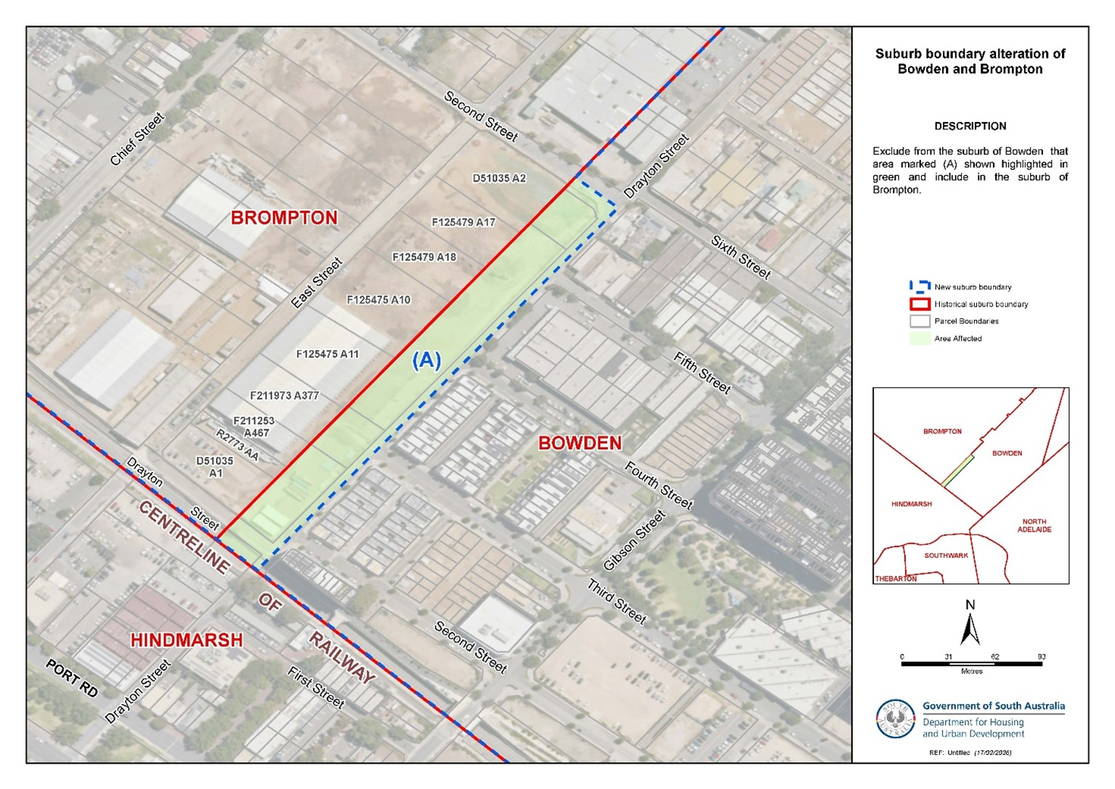
• Alter the suburb boundary between Bowden and Brompton to exclude that area marked (A) highlighted in green as shown on the plan from the bounded suburb of BOWDEN and include in the suburb of BROMPTON.
This notice is to take effect immediately upon its publication in the Government Gazette.
Dated: 30 April 2026
Bradley Slape
Surveyor-General
Delegate of the Minister for Planning
DHUD: 2020/03056/01

Geographical Names Act 1991
Notice of Intention to Assign a Name to a Feature
Notice is hereby given that, pursuant to Section 11B(2)(d) of the Geographical Names Act 1991, I, the Honourable Nick Champion MP, Minister for Planning, Minister of the Crown to whom the administration of the Geographical Names Act 1991 is committed, seeks public comment on a proposal to:
• Assign the name ANDY BENNETT BRIDGE to state-maintained bridge infrastructure located on Townsend Street in the township of Mount Torrens.
The location for this naming proposal is shown marked in orange on the image below.
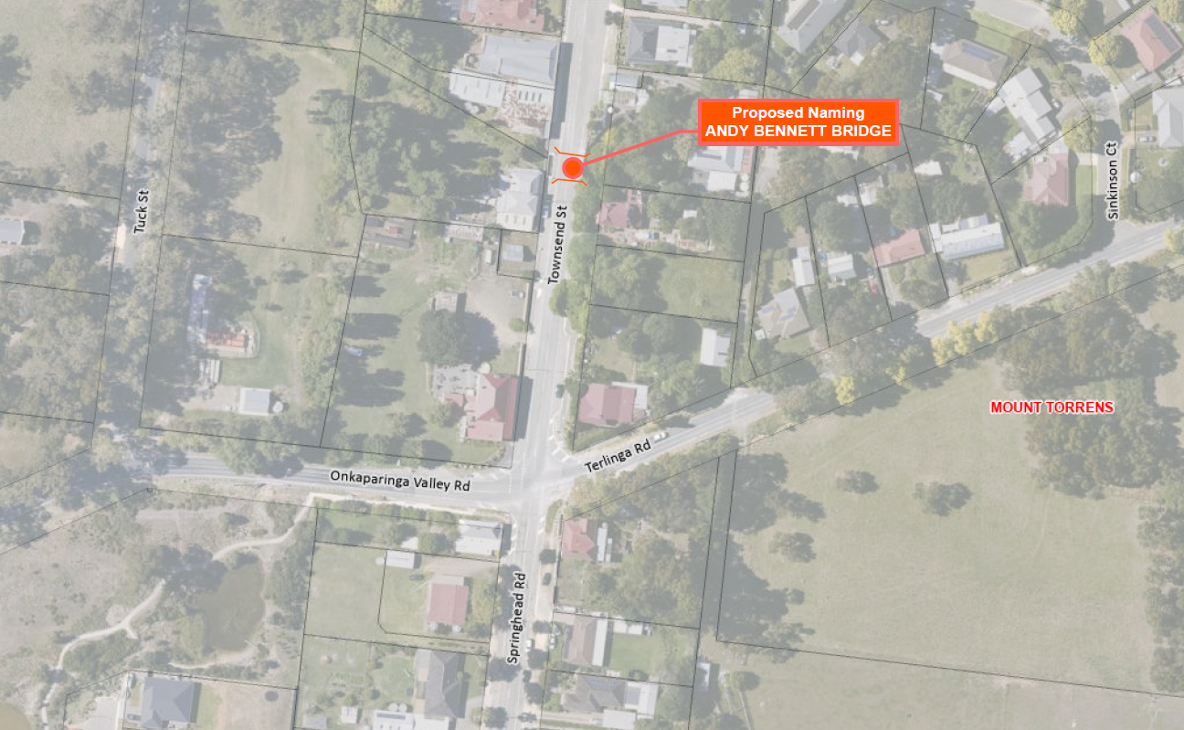
Further information can be found at www.sa.gov.au/placenameproposals.
Submissions in writing regarding this proposal may be lodged with the Surveyor-General, GPO Box 1815, Adelaide SA 5001, or DHUD.PlaceNames@sa.gov.au within one month of the publication of this notice.
Dated: 30 April 2026
Hon Nick Champion MP
Minister for Planning
DHUD: 2025/03335/01

Housing Improvement Act 2016
Rent Control
In the exercise of the powers conferred by the Housing Improvement Act 2016, the Delegate of the Minister for Housing and Urban Development hereby fixes the maximum rental amount per week that shall be payable subject to Section 55 of the Residential Tenancies Act 1995, in respect of each premises described in the following table. The amount shown in the said table shall come into force on the date of this publication in the Gazette.
Address of Premises | Allotment Section | Certificate of Title  Volume/Folio | Maximum Rental per week payable
9 Bond Court, Woodville North SA 5012 | Allotment 6 Filed Plan 115718  Hundred of Yatala | CT5563/363 | $0.00
105 Seventh Avenue, Joslin SA 5070 | Allotment 54 Deposited Plan 3079  Hundred of Adelaide | CT5745/250 | $0.00
Dated: 30 April 2026
Craig Thompson
Housing Regulator and Registrar
Housing Safety Authority
Delegate of the Minister for Housing and Urban Development

Housing Improvement Act 2016
Rent Control Revocations
In the exercise of the powers conferred by the Housing Improvement Act 2016, the Delegate of the Minister for Housing and Urban Development hereby revokes the maximum rental amount per week that shall be payable subject to Section 55 of the Residential Tenancies Act 1995, in respect of each premises described in the following table.
Address of Premises | Allotment Section | Certificate of Title  Volume/Folio
18 Daly Street, Gawler East SA 5118 | Allotment 4 Deposited Plan 20835 Hundred of Nuriootpa | CT5450/374
48 Mitcham Avenue, Lower Mitcham SA 5062 | Allotment 140 Deposited Plan 2956 Hundred of Adelaide | CT5110/10
67 Railway Terrace, Snowtown SA 5520 | Allotment 15 Deposited Plan 26890 Hundred of Barunga | CT5088/200
Dated: 30 April 2026
Craig Thompson
Housing Regulator and Registrar
Housing Safety Authority
Delegate of the Minister for Housing and Urban Development

Land Acquisition Act 1969
Section 16
Form 5—Notice of Acquisition
1. Notice of acquisition
The Commissioner of Highways (the Authority), of 83 Pirie Street, Adelaide SA 5000, acquires the following interests in the following land:
Comprising an unencumbered estate in fee simple in the whole of Allotment 6 in Deposited Plan No 139569 lodged in the Lands Titles Office, being portion of the land situated on the southeastern corner of South Road and Adam Street and being portion of Part Section 353 in the Hundred of Yatala (not under the Real Property Act 1886).
This notice is given under Section 16 of the Land Acquisition Act 1969.
2. Compensation
A person who has or had an interest consisting of native title or an alienable interest in the land that is divested or diminished by the acquisition or the enjoyment of which is adversely affected by the acquisition who does not receive an offer of compensation from the Authority may apply to the Authority for compensation.
2A. Payment of professional costs relating to acquisition (Section 26B)
If you are the owner in fee simple of the land to which this notice relates, you may be entitled to a payment of up to $10,000 from the Authority for use towards the payment of professional costs in relation to the acquisition of the land.
Professional costs include legal costs, valuation costs and any other costs prescribed by the Land Acquisition Regulations 2019.
3. Inquiries
Inquiries should be directed to: Petrula Pettas
GPO Box 1533
Adelaide SA 5001
Telephone: 0439 743 183
Dated: 28 April 2026
The Common Seal of the COMMISSIONER OF HIGHWAYS was hereto affixed by authority of the Commissioner in the presence of:
Rocco Caruso
Director, Property Acquisition
(Authorised Officer)
Department for Infrastructure and Transport
DIT: 2022/17858/01

Land Acquisition Act 1969
Section 26F
Form 6B—Notice of Acquisition of Underground Land
1. Notice of acquisition
The Commissioner of Highways (the Authority), of 83 Pirie Street, Adelaide SA 5000 acquires the following interests in the following land:
An unencumbered estate in fee simple in the whole of Allotment 1002 in D138072 lodged in the Lands Titles Office, being portion of the land comprised in Certificate of Title Volume 5119 Folio 948, expressly excluding right(s) of way over Allotments 285 and 286 in DP 1761 (T497912) and expressly excluding rights(s) of way A in D138072 created by T 506665 (being one and the same as allotment 287 in DP 1761 created by T 506665).
This notice is given under Section 26F of the Land Acquisition Act 1969.
2. Compensation not payable unless certain water infrastructure or rights are affected
You are not entitled to compensation in relation to the acquisition of the underground land to which this notice relates, unless the following conditions are satisfied:
• you held at least one of the following interests in relation to the underground land immediately before the notice of acquisition was published in relation to the land—
◦ ownership of a lawful well that provides access to underground water in the underground land, and any underground infrastructure associated with the well; or
◦ a right to take underground water from the underground land by means of such a well;
• you notified the Authority of your interest in response to a notice given under Section 26G of the Land Acquisition Act 1969;
• the acquisition of the underground land either—
◦ involved the acquisition of your interest; or
◦ resulted in the discharge of your interest; or
◦ resulted in you being unable to take water by means of, or pursuant to, your interest;
• you make an application for compensation to the Authority under Section 26H of the Land Acquisition Act 1969.
3. Application for compensation under Section 26H
If you believe you are entitled to compensation, you must apply to the Authority for compensation within 6 months after the publication of the notice of acquisition in relation to the underground land to which this notice relates.
The application must be in the following manner and form:
“Application for Compensation for Acquisition of Underground Land” (enclosed) to be submitted by email to DIT.ULAapplications@sa.gov.au or by mail marked attention: Property Acquisition c/- GPO Box 1533, Adelaide SA 5001.
The application must be accompanied by the following information or documents:
Any relevant supporting documentation including, but not limited to water licences, bore licences etc.
After receiving your application, the Authority may (but is not required to) make you a written offer of compensation not exceeding $50,000.
See Section 26H(4) of the Land Acquisition Act 1969 for further details on the payment of compensation.
4. Inquiries
Inquiries should be directed to: T2D Project Team
GPO Box 1533
Adelaide SA 5001
Telephone: 1800 572 414
Dated: 27 April 2026
The Common Seal of the COMMISSIONER OF HIGHWAYS was hereto affixed by authority of the Commissioner in the presence of:
Rocco Caruso
Director, Property Acquisition
(Authorised Officer)
Department for Infrastructure and Transport
DIT: 2024/07290/01

Land Acquisition Act 1969
Section 26F
Form 6B—Notice of Acquisition of Underground Land
1. Notice of acquisition
The Commissioner of Highways (the Authority), of 83 Pirie Street, Adelaide SA 5000 acquires the following interests in the following land:
An unencumbered estate in fee simple in the whole of Allotment 1032 in D138087 lodged in the Lands Titles Office, being portion of the land comprised in Certificate of Title Volume 5771 Folio 142, expressly excluding right(s) of way over Allotments 285 and 286 in DP 1761 (T 497912), expressly excluding right(s) of way over the land marked A, C, D and E appurtenant only to the Land marked X (T 522500), expressly excluding free and unrestricted right(s) of way over the land marked A, B and D appurtenant only to the Land marked Y and expressly excluding free and unrestricted right(s) of way over the Land marked E.
This notice is given under Section 26F of the Land Acquisition Act 1969.
2. Compensation not payable unless certain water infrastructure or rights are affected
You are not entitled to compensation in relation to the acquisition of the underground land to which this notice relates, unless the following conditions are satisfied:
• you held at least one of the following interests in relation to the underground land immediately before the notice of acquisition was published in relation to the land—
◦ ownership of a lawful well that provides access to underground water in the underground land, and any underground infrastructure associated with the well; or
◦ a right to take underground water from the underground land by means of such a well;
• you notified the Authority of your interest in response to a notice given under Section 26G of the Land Acquisition Act 1969;
• the acquisition of the underground land either—
◦ involved the acquisition of your interest; or
◦ resulted in the discharge of your interest; or
◦ resulted in you being unable to take water by means of, or pursuant to, your interest;
• you make an application for compensation to the Authority under Section 26H of the Land Acquisition Act 1969.
3. Application for compensation under Section 26H
If you believe you are entitled to compensation, you must apply to the Authority for compensation within 6 months after the publication of the notice of acquisition in relation to the underground land to which this notice relates.
The application must be in the following manner and form:
“Application for Compensation for Acquisition of Underground Land” (enclosed) to be submitted by email to DIT.ULAapplications@sa.gov.au or by mail marked attention: Property Acquisition c/- GPO Box 1533, Adelaide SA 5001.
The application must be accompanied by the following information or documents:
Any relevant supporting documentation including, but not limited to water licences, bore licences etc.
After receiving your application, the Authority may (but is not required to) make you a written offer of compensation not exceeding $50,000.
See Section 26H(4) of the Land Acquisition Act 1969 for further details on the payment of compensation.
4. Inquiries
Inquiries should be directed to: T2D Project Team
GPO Box 1533
Adelaide SA 5001
Telephone: 1800 572 414
Dated: 27 April 2026
The Common Seal of the COMMISSIONER OF HIGHWAYS was hereto affixed by authority of the Commissioner in the presence of:
Rocco Caruso
Director, Property Acquisition
(Authorised Officer)
Department for Infrastructure and Transport
DIT: 2024/07383/01

Land Acquisition Act 1969
Section 26F
Form 6B—Notice of Acquisition of Underground Land
1. Notice of acquisition
The Commissioner of Highways (the Authority), of 83 Pirie Street, Adelaide SA 5000 acquires the following interests in the following land:
An unencumbered estate in fee simple in the whole of Allotment 1060 in D138102 lodged in the Lands Titles Office, being portion of the land comprised in Certificate of Title Volume 5119 Folio 947, expressly excluding right(s) of way over Allotments 285 and 286 in DP 1761 (T 497912), and expressly excluding free and unrestricted rights(s) of way A in D138102 (being one and the same as allotment 287 in DP 1761).
This notice is given under Section 26F of the Land Acquisition Act 1969.
2. Compensation not payable unless certain water infrastructure or rights are affected
You are not entitled to compensation in relation to the acquisition of the underground land to which this notice relates, unless the following conditions are satisfied:
• you held at least one of the following interests in relation to the underground land immediately before the notice of acquisition was published in relation to the land—
◦ ownership of a lawful well that provides access to underground water in the underground land, and any underground infrastructure associated with the well; or
◦ a right to take underground water from the underground land by means of such a well;
• you notified the Authority of your interest in response to a notice given under Section 26G of the Land Acquisition Act 1969;
• the acquisition of the underground land either—
◦ involved the acquisition of your interest; or
◦ resulted in the discharge of your interest; or
◦ resulted in you being unable to take water by means of, or pursuant to, your interest;
• you make an application for compensation to the Authority under Section 26H of the Land Acquisition Act 1969.
3. Application for compensation under Section 26H
If you believe you are entitled to compensation, you must apply to the Authority for compensation within 6 months after the publication of the notice of acquisition in relation to the underground land to which this notice relates.
The application must be in the following manner and form:
“Application for Compensation for Acquisition of Underground Land” (enclosed) to be submitted by email to DIT.ULAapplications@sa.gov.au or by mail marked attention: Property Acquisition c/- GPO Box 1533, Adelaide SA 5001.
The application must be accompanied by the following information or documents:
Any relevant supporting documentation including, but not limited to water licences, bore licences etc.
After receiving your application, the Authority may (but is not required to) make you a written offer of compensation not exceeding $50,000.
See Section 26H(4) of the Land Acquisition Act 1969 for further details on the payment of compensation.
4. Inquiries
Inquiries should be directed to: T2D Project Team
GPO Box 1533
Adelaide SA 5001
Telephone: 1800 572 414
Dated: 27 April 2026
The Common Seal of the COMMISSIONER OF HIGHWAYS was hereto affixed by authority of the Commissioner in the presence of:
Rocco Caruso
Director, Property Acquisition
(Authorised Officer)
Department for Infrastructure and Transport
DIT: 2024/07404/01

Land Acquisition Act 1969
Section 26F
Form 6B—Notice of Acquisition of Underground Land
1. Notice of acquisition
The Commissioner of Highways (the Authority), of 83 Pirie Street, Adelaide SA 5000 acquires the following interests in the following land:
An unencumbered estate in fee simple in the whole of Allotment 1024 in D138083 lodged in the Lands Titles Office, being portion of the land comprised in Certificate of Title Volume 5120 Folio 740, expressly excluding right(s) of way over Allotments 285 and 286 in DP 1761 (T 497912) and expressly excluding right(s) of way over the land marked A (T 515443).
This notice is given under Section 26F of the Land Acquisition Act 1969.
2. Compensation not payable unless certain water infrastructure or rights are affected
You are not entitled to compensation in relation to the acquisition of the underground land to which this notice relates, unless the following conditions are satisfied:
• you held at least one of the following interests in relation to the underground land immediately before the notice of acquisition was published in relation to the land—
◦ ownership of a lawful well that provides access to underground water in the underground land, and any underground infrastructure associated with the well; or
◦ a right to take underground water from the underground land by means of such a well;
• you notified the Authority of your interest in response to a notice given under Section 26G of the Land Acquisition Act 1969;
• the acquisition of the underground land either—
◦ involved the acquisition of your interest; or
◦ resulted in the discharge of your interest; or
◦ resulted in you being unable to take water by means of, or pursuant to, your interest;
• you make an application for compensation to the Authority under Section 26H of the Land Acquisition Act 1969.
3. Application for compensation under Section 26H
If you believe you are entitled to compensation, you must apply to the Authority for compensation within 6 months after the publication of the notice of acquisition in relation to the underground land to which this notice relates.
The application must be in the following manner and form:
“Application for Compensation for Acquisition of Underground Land” (enclosed) to be submitted by email to DIT.ULAapplications@sa.gov.au or by mail marked attention: Property Acquisition c/- GPO Box 1533, Adelaide SA 5001.
The application must be accompanied by the following information or documents:
Any relevant supporting documentation including, but not limited to water licences, bore licences etc.
After receiving your application, the Authority may (but is not required to) make you a written offer of compensation not exceeding $50,000.
See Section 26H(4) of the Land Acquisition Act 1969 for further details on the payment of compensation.
4. Inquiries
Inquiries should be directed to: T2D Project Team
GPO Box 1533
Adelaide SA 5001
Telephone: 1800 572 414
Dated: 27 April 2026
The Common Seal of the COMMISSIONER OF HIGHWAYS was hereto affixed by authority of the Commissioner in the presence of:
Rocco Caruso
Director, Property Acquisition
(Authorised Officer)
Department for Infrastructure and Transport
DIT: 2024/07407/01

Land Acquisition Act 1969
Section 26F
Form 6B—Notice of Acquisition of Underground Land
1. Notice of acquisition
The Commissioner of Highways (the Authority), of 83 Pirie Street, Adelaide SA 5000 acquires the following interests in the following land:
An unencumbered estate in fee simple in the whole of Allotment 1026 in D138084 lodged in the Lands Titles Office, being portion of the land comprised in Certificate of Title Volume 5119 Folio 366, expressly excluding right(s) of way over Allotments 285 and 286 in DP 1761 (T 497912) and expressly excluding free and unrestricted right(s) of way over the land marked A.
This notice is given under Section 26F of the Land Acquisition Act 1969.
2. Compensation not payable unless certain water infrastructure or rights are affected
You are not entitled to compensation in relation to the acquisition of the underground land to which this notice relates, unless the following conditions are satisfied:
• you held at least one of the following interests in relation to the underground land immediately before the notice of acquisition was published in relation to the land—
◦ ownership of a lawful well that provides access to underground water in the underground land, and any underground infrastructure associated with the well; or
◦ a right to take underground water from the underground land by means of such a well;
• you notified the Authority of your interest in response to a notice given under Section 26G of the Land Acquisition Act 1969;
• the acquisition of the underground land either—
◦ involved the acquisition of your interest; or
◦ resulted in the discharge of your interest; or
◦ resulted in you being unable to take water by means of, or pursuant to, your interest;
• you make an application for compensation to the Authority under Section 26H of the Land Acquisition Act 1969.
3. Application for compensation under Section 26H
If you believe you are entitled to compensation, you must apply to the Authority for compensation within 6 months after the publication of the notice of acquisition in relation to the underground land to which this notice relates.
The application must be in the following manner and form:
“Application for Compensation for Acquisition of Underground Land” (enclosed) to be submitted by email to DIT.ULAapplications@sa.gov.au or by mail marked attention: Property Acquisition c/- GPO Box 1533, Adelaide SA 5001.
The application must be accompanied by the following information or documents:
Any relevant supporting documentation including, but not limited to water licences, bore licences etc.
After receiving your application, the Authority may (but is not required to) make you a written offer of compensation not exceeding $50,000.
See Section 26H(4) of the Land Acquisition Act 1969 for further details on the payment of compensation.
4. Inquiries
Inquiries should be directed to: T2D Project Team
GPO Box 1533
Adelaide SA 5001
Telephone: 1800 572 414
Dated: 27 April 2026
The Common Seal of the COMMISSIONER OF HIGHWAYS was hereto affixed by authority of the Commissioner in the presence of:
Rocco Caruso
Director, Property Acquisition
(Authorised Officer)
Department for Infrastructure and Transport
DIT: 2024/07408/01

Land Acquisition Act 1969
Section 26F
Form 6B—Notice of Acquisition of Underground Land
1. Notice of acquisition
The Commissioner of Highways (the Authority), of 83 Pirie Street, Adelaide SA 5000 acquires the following interests in the following land:
An unencumbered estate in fee simple in the whole of Allotment 1030 in D138086 lodged in the Lands Titles Office, being portion of the land comprised in Certificate of Title Volume 5771 Folio 143, expressly excluding right(s) of way over Allotments 285 and 286 in DP 1761 (T 497912), expressly excluding right(s) of way over the land marked A, C, D and E appurtenant only to the Land marked X (T 522500), expressly excluding free and unrestricted right(s) of way over the land marked A.B and D appurtenant only to the Land marked Y and expressly excluding free and unrestricted right(s) of way over the Land marked E.
This notice is given under Section 26F of the Land Acquisition Act 1969.
2. Compensation not payable unless certain water infrastructure or rights are affected
You are not entitled to compensation in relation to the acquisition of the underground land to which this notice relates, unless the following conditions are satisfied:
• you held at least one of the following interests in relation to the underground land immediately before the notice of acquisition was published in relation to the land—
◦ ownership of a lawful well that provides access to underground water in the underground land, and any underground infrastructure associated with the well; or
◦ a right to take underground water from the underground land by means of such a well;
• you notified the Authority of your interest in response to a notice given under Section 26G of the Land Acquisition Act 1969;
• the acquisition of the underground land either—
◦ involved the acquisition of your interest; or
◦ resulted in the discharge of your interest; or
◦ resulted in you being unable to take water by means of, or pursuant to, your interest;
• you make an application for compensation to the Authority under Section 26H of the Land Acquisition Act 1969.

3. Application for compensation under Section 26H
If you believe you are entitled to compensation, you must apply to the Authority for compensation within 6 months after the publication of the notice of acquisition in relation to the underground land to which this notice relates.
The application must be in the following manner and form:
“Application for Compensation for Acquisition of Underground Land” (enclosed) to be submitted by email to DIT.ULAapplications@sa.gov.au or by mail marked attention: Property Acquisition c/- GPO Box 1533, Adelaide SA 5001.
The application must be accompanied by the following information or documents:
Any relevant supporting documentation including, but not limited to water licences, bore licences etc.
After receiving your application, the Authority may (but is not required to) make you a written offer of compensation not exceeding $50,000.
See Section 26H(4) of the Land Acquisition Act 1969 for further details on the payment of compensation.
4. Inquiries
Inquiries should be directed to: T2D Project Team
GPO Box 1533
Adelaide SA 5001
Telephone: 1800 572 414
Dated: 27 April 2026
The Common Seal of the COMMISSIONER OF HIGHWAYS was hereto affixed by authority of the Commissioner in the presence of:
Rocco Caruso
Director, Property Acquisition
(Authorised Officer)
Department for Infrastructure and Transport
DIT: 2024/07409/01

Land Acquisition Act 1969
Section 26F
Form 6B—Notice of Acquisition of Underground Land
1. Notice of acquisition
The Commissioner of Highways (the Authority), of 83 Pirie Street, Adelaide SA 5000 acquires the following interests in the following land:
An unencumbered estate in fee simple in the whole of Allotment 1062 in D138103 lodged in the Lands Titles Office, being portion of the land comprised in Certificate of Title Volume 5119 Folio 762, expressly excluding right(s) of way over Allotments 285 and 286 in DP 1761 (T 497912) and expressly excluding right(s) of way A in D138103 created by T 506665 (being one and the same as allotment 287 in DP 1761 created by T 506665).
This notice is given under Section 26F of the Land Acquisition Act 1969.
2. Compensation not payable unless certain water infrastructure or rights are affected
You are not entitled to compensation in relation to the acquisition of the underground land to which this notice relates, unless the following conditions are satisfied:
• you held at least one of the following interests in relation to the underground land immediately before the notice of acquisition was published in relation to the land—
◦ ownership of a lawful well that provides access to underground water in the underground land, and any underground infrastructure associated with the well; or
◦ a right to take underground water from the underground land by means of such a well;
• you notified the Authority of your interest in response to a notice given under Section 26G of the Land Acquisition Act 1969;
• the acquisition of the underground land either—
◦ involved the acquisition of your interest; or
◦ resulted in the discharge of your interest; or
◦ resulted in you being unable to take water by means of, or pursuant to, your interest;
• you make an application for compensation to the Authority under Section 26H of the Land Acquisition Act 1969.
3. Application for compensation under Section 26H
If you believe you are entitled to compensation, you must apply to the Authority for compensation within 6 months after the publication of the notice of acquisition in relation to the underground land to which this notice relates.
The application must be in the following manner and form:
“Application for Compensation for Acquisition of Underground Land” (enclosed) to be submitted by email to DIT.ULAapplications@sa.gov.au or by mail marked attention: Property Acquisition c/- GPO Box 1533, Adelaide SA 5001.
The application must be accompanied by the following information or documents:
Any relevant supporting documentation including, but not limited to water licences, bore licences etc.
After receiving your application, the Authority may (but is not required to) make you a written offer of compensation not exceeding $50,000.
See Section 26H(4) of the Land Acquisition Act 1969 for further details on the payment of compensation.

4. Inquiries
Inquiries should be directed to: T2D Project Team
GPO Box 1533
Adelaide SA 5001
Telephone: 1800 572 414
Dated: 27 April 2026
The Common Seal of the COMMISSIONER OF HIGHWAYS was hereto affixed by authority of the Commissioner in the presence of:
Rocco Caruso
Director, Property Acquisition
(Authorised Officer)
Department for Infrastructure and Transport
DIT: 2024/07410/01

Land Acquisition Act 1969
Section 26F
Form 6B—Notice of acquisition of Underground Land
1. Notice of acquisition
The Commissioner of Highways (the Authority), of 83 Pirie Street, Adelaide SA 5000 acquires the following interests in the following land:
An unencumbered estate in fee simple in the whole of Allotment 1022 in D138082 lodged in the Lands Titles Office, being portion of the land comprised in Certificate of Title Volume 5101 Folio 450, expressly excluding right(s) of way over Allotments 285 and 286 in DP 1761 (T 497912) and expressly excluding free and unrestricted right(s) of way over the land marked A.
This notice is given under Section 26F of the Land Acquisition Act 1969.
2. Compensation not payable unless certain water infrastructure or rights are affected
You are not entitled to compensation in relation to the acquisition of the underground land to which this notice relates, unless the following conditions are satisfied:
• you held at least one of the following interests in relation to the underground land immediately before the notice of acquisition was published in relation to the land—
◦ ownership of a lawful well that provides access to underground water in the underground land, and any underground infrastructure associated with the well; or
◦ a right to take underground water from the underground land by means of such a well;
• you notified the Authority of your interest in response to a notice given under Section 26G of the Land Acquisition Act 1969;
• the acquisition of the underground land either—
◦ involved the acquisition of your interest; or
◦ resulted in the discharge of your interest; or
◦ resulted in you being unable to take water by means of, or pursuant to, your interest;
• you make an application for compensation to the Authority under Section 26H of the Land Acquisition Act 1969.
3. Application for compensation under Section 26H
If you believe you are entitled to compensation, you must apply to the Authority for compensation within 6 months after the publication of the notice of acquisition in relation to the underground land to which this notice relates.
The application must be in the following manner and form:
“Application for Compensation for Acquisition of Underground Land” (enclosed) to be submitted by email to DIT.ULAapplications@sa.gov.au or by mail marked attention: Property Acquisition c/- GPO Box 1533, Adelaide SA 5001.
The application must be accompanied by the following information or documents:
Any relevant supporting documentation including, but not limited to water licences, bore licences etc.
After receiving your application, the Authority may (but is not required to) make you a written offer of compensation not exceeding $50,000.
See Section 26H(4) of the Land Acquisition Act 1969 for further details on the payment of compensation.
4. Inquiries
Inquiries should be directed to: T2D Project Team
GPO Box 1533
Adelaide SA 5001
Telephone: 1800 572 414
Dated: 27 April 2026
The Common Seal of the COMMISSIONER OF HIGHWAYS was hereto affixed by authority of the Commissioner in the presence of:
Rocco Caruso
Director, Property Acquisition
(Authorised Officer)
Department for Infrastructure and Transport
DIT: 2024/07427/01

Land Acquisition Act 1969
Section 26F
Form 6B—Notice of Acquisition of Underground Land
1. Notice of acquisition
The Commissioner of Highways (the Authority), of 83 Pirie Street, Adelaide SA 5000 acquires the following interests in the following land:
An unencumbered estate in fee simple in the whole of Allotment 1054 in D138099 lodged in the Lands Titles Office, being portion of the land comprised in Certificate of Title Volume 5118 Folio 351, expressly excluding right(s) of way over Allotments 285 and 286 in DP 1761 (T 497912) and expressly excluding rights(s) of way A in D138099 created by T 506666 (being one and the same as allotment 287 in DP 1761 created by T 506666).
This notice is given under Section 26F of the Land Acquisition Act 1969.
2. Compensation not payable unless certain water infrastructure or rights are affected
You are not entitled to compensation in relation to the acquisition of the underground land to which this notice relates, unless the following conditions are satisfied:
• you held at least one of the following interests in relation to the underground land immediately before the notice of acquisition was published in relation to the land—
◦ ownership of a lawful well that provides access to underground water in the underground land, and any underground infrastructure associated with the well; or
◦ a right to take underground water from the underground land by means of such a well;
• you notified the Authority of your interest in response to a notice given under Section 26G of the Land Acquisition Act 1969;
• the acquisition of the underground land either—
◦ involved the acquisition of your interest; or
◦ resulted in the discharge of your interest; or
◦ resulted in you being unable to take water by means of, or pursuant to, your interest;
• you make an application for compensation to the Authority under Section 26H of the Land Acquisition Act 1969.
3. Application for compensation under Section 26H
If you believe you are entitled to compensation, you must apply to the Authority for compensation within 6 months after the publication of the notice of acquisition in relation to the underground land to which this notice relates.
The application must be in the following manner and form:
“Application for Compensation for Acquisition of Underground Land” (enclosed) to be submitted by email to DIT.ULAapplications@sa.gov.au or by mail marked attention: Property Acquisition c/- GPO Box 1533, Adelaide SA 5001.
The application must be accompanied by the following information or documents:
Any relevant supporting documentation including, but not limited to water licences, bore licences etc.
After receiving your application, the Authority may (but is not required to) make you a written offer of compensation not exceeding $50,000.
See Section 26H(4) of the Land Acquisition Act 1969 for further details on the payment of compensation.
4. Inquiries
Inquiries should be directed to: T2D Project Team
GPO Box 1533
Adelaide SA 5001
Telephone: 1800 572 414
Dated: 27 April 2026
The Common Seal of the COMMISSIONER OF HIGHWAYS was hereto affixed by authority of the Commissioner in the presence of:
Rocco Caruso
Director, Property Acquisition
(Authorised Officer)
Department for Infrastructure and Transport
DIT: 2024/07432/01

Land Acquisition Act 1969
Section 26F
Form 6B—Notice of Acquisition of Underground Land
1. Notice of acquisition
The Commissioner of Highways (the Authority), of 83 Pirie Street, Adelaide SA 5000 acquires the following interests in the following land:
An unencumbered estate in fee simple in the whole of Allotment 1028 in D138085 lodged in the Lands Titles Office, being portion of the land comprised in Certificate of Title Volume 5771 Folio 144, expressly excluding:
• Right(s) of way over Allotments 285 and 286 in DP 1761 (T 497912)
• Free and unrestricted right(s) of way over the land marked B.C and D appurtenant only to the Land marked Z
• Free and unrestricted right(s) of way over the land marked B.C and D appurtenant only to the Land marked Y.
This notice is given under Section 26F of the Land Acquisition Act 1969.

2. Compensation not payable unless certain water infrastructure or rights are affected
You are not entitled to compensation in relation to the acquisition of the underground land to which this notice relates, unless the following conditions are satisfied:
• you held at least one of the following interests in relation to the underground land immediately before the notice of acquisition was published in relation to the land—
◦ ownership of a lawful well that provides access to underground water in the underground land, and any underground infrastructure associated with the well; or
◦ a right to take underground water from the underground land by means of such a well;
• you notified the Authority of your interest in response to a notice given under Section 26G of the Land Acquisition Act 1969;
• the acquisition of the underground land either—
◦ involved the acquisition of your interest; or
◦ resulted in the discharge of your interest; or
◦ resulted in you being unable to take water by means of, or pursuant to, your interest;
• you make an application for compensation to the Authority under Section 26H of the Land Acquisition Act 1969.
3. Application for compensation under Section 26H
If you believe you are entitled to compensation, you must apply to the Authority for compensation within 6 months after the publication of the notice of acquisition in relation to the underground land to which this notice relates.
The application must be in the following manner and form:
“Application for Compensation for Acquisition of Underground Land” (enclosed) to be submitted by email to DIT.ULAapplications@sa.gov.au or by mail marked attention: Property Acquisition c/- GPO Box 1533, Adelaide SA 5001.
The application must be accompanied by the following information or documents:
Any relevant supporting documentation including, but not limited to water licences, bore licences etc.
After receiving your application, the Authority may (but is not required to) make you a written offer of compensation not exceeding $50,000.
See Section 26H(4) of the Land Acquisition Act 1969 for further details on the payment of compensation.
4. Inquiries
Inquiries should be directed to: T2D Project Team
GPO Box 1533
Adelaide SA 5001
Telephone: 1800 572 414
Dated: 27 April 2026
The Common Seal of the COMMISSIONER OF HIGHWAYS was hereto affixed by authority of the Commissioner in the presence of:
Rocco Caruso
Director, Property Acquisition
(Authorised Officer)
Department for Infrastructure and Transport
DIT: 2024/07435/01

Land Acquisition Act 1969
Section 26F
Form 6B—Notice of Acquisition of Underground Land
1. Notice of acquisition
The Commissioner of Highways (the Authority), of 83 Pirie Street, Adelaide SA 5000 acquires the following interests in the following land:
First, an unencumbered estate in fee simple in the whole of Allotment 101 in D139062 lodged in the Lands Titles Office, being portion of the land comprised in Certificate of Title Volume 6182 Folio 579, expressly excluding the:
• Easement(s) over the land marked C on D112426 for eaves and gutters (RTC 12572978)
• Easement(s) over the land marked D.E.F.G.H.J and K on D112426 to park a vehicle (RTC 12572978)
• Easement(s) over the land marked M and N on D112426 to park a vehicle (RTC 12572978)
• Free and unrestricted right(s) of way over the land marked X on D112426 (RTC 12572978) (one and the same as P on D139062)
• Free and unrestricted right(s) of way over the land marked Y on D112426 (RTC 12572978) (one and the same as R on D139062)
Secondly, an unencumbered estate in fee simple in the whole of Allotment 111 in D139063 lodged in the Lands Titles Office, being portion of the land comprised in Certificate of Title Volume 6182 Folio 580, expressly excluding the:
• Easement(s) over the land marked M and N on D112426 to park a vehicle (RTC 12572978)
• Free and unrestricted right(s) of way over the land marked X on D112426 (RTC12572978) (one and the same as P on D139063)
This notice is given under Section 26F of the Land Acquisition Act 1969.
2. Compensation not payable unless certain water infrastructure or rights are affected
You are not entitled to compensation in relation to the acquisition of the underground land to which this notice relates, unless the following conditions are satisfied:
• you held at least one of the following interests in relation to the underground land immediately before the notice of acquisition was published in relation to the land—
◦ ownership of a lawful well that provides access to underground water in the underground land, and any underground infrastructure associated with the well; or
◦ a right to take underground water from the underground land by means of such a well;
• you notified the Authority of your interest in response to a notice given under Section 26G of the Land Acquisition Act 1969;
• the acquisition of the underground land either—
◦ involved the acquisition of your interest; or
◦ resulted in the discharge of your interest; or
◦ resulted in you being unable to take water by means of, or pursuant to, your interest;
• you make an application for compensation to the Authority under Section 26H of the Land Acquisition Act 1969.
3. Application for compensation under Section 26H
If you believe you are entitled to compensation, you must apply to the Authority for compensation within 6 months after the publication of the notice of acquisition in relation to the underground land to which this notice relates.
The application must be in the following manner and form:
“Application for Compensation for Acquisition of Underground Land” (enclosed) to be submitted by email to DIT.ULAapplications@sa.gov.au or by mail marked attention: Property Acquisition c/- GPO Box 1533, Adelaide SA 5001.
The application must be accompanied by the following information or documents:
Any relevant supporting documentation including, but not limited to water licences, bore licences etc.
After receiving your application, the Authority may (but is not required to) make you a written offer of compensation not exceeding $50,000.
See Section 26H(4) of the Land Acquisition Act 1969 for further details on the payment of compensation.
4. Inquiries
Inquiries should be directed to: T2D Project Team
GPO Box 1533
Adelaide SA 5001
Telephone: 1800 572 414
Dated: 28 April 2026
The Common Seal of the COMMISSIONER OF HIGHWAYS was hereto affixed by authority of the Commissioner in the presence of:
Rocco Caruso
Director, Property Acquisition
(Authorised Officer)
Department for Infrastructure and Transport
DIT 2024/08120/01

Land Acquisition Act 1969
Section 26F
Form 6B—Notice of Acquisition of Underground Land
1. Notice of acquisition
The Commissioner of Highways (the Authority), of 83 Pirie Street, Adelaide SA 5000 acquires the following interests in the following land:
An estate in fee simple in the whole of Allotment 5011 in D139076 lodged in the Lands Titles Office, being portion of the land comprised in Certificate of Title Volume 5062 Folio 161, subject to service easement(s) over the land marked A for electricity supply purposes to Distribution Lessor Corporation (Subject to Lease 8890000) (223LG RPA).
This notice is given under Section 26F of the Land Acquisition Act 1969.
2. Compensation not payable unless certain water infrastructure or rights are affected
You are not entitled to compensation in relation to the acquisition of the underground land to which this notice relates, unless the following conditions are satisfied:
• you held at least one of the following interests in relation to the underground land immediately before the notice of acquisition was published in relation to the land—
◦ ownership of a lawful well that provides access to underground water in the underground land, and any underground infrastructure associated with the well; or
◦ a right to take underground water from the underground land by means of such a well;
• you notified the Authority of your interest in response to a notice given under Section 26G of the Land Acquisition Act 1969;
• the acquisition of the underground land either—
◦ involved the acquisition of your interest; or
◦ resulted in the discharge of your interest; or
◦ resulted in you being unable to take water by means of, or pursuant to, your interest;
• you make an application for compensation to the Authority under Section 26H of the Land Acquisition Act 1969.
3. Application for compensation under Section 26H
If you believe you are entitled to compensation, you must apply to the Authority for compensation within 6 months after the publication of the notice of acquisition in relation to the underground land to which this notice relates.

The application must be in the following manner and form:
“Application for Compensation for Acquisition of Underground Land” (enclosed) to be submitted by email to DIT.ULAapplications@sa.gov.au or by mail marked attention: Property Acquisition c/- GPO Box 1533, Adelaide SA 5001.
The application must be accompanied by the following information or documents:
Any relevant supporting documentation including, but not limited to water licences, bore licences etc.
After receiving your application, the Authority may (but is not required to) make you a written offer of compensation not exceeding $50,000.
See Section 26H(4) of the Land Acquisition Act 1969 for further details on the payment of compensation.
4. Inquiries
Inquiries should be directed to: T2D Project Team
GPO Box 1533
Adelaide SA 5001
Telephone: 1800 572 414
Dated: 28 April 2026
The Common Seal of the COMMISSIONER OF HIGHWAYS was hereto affixed by authority of the Commissioner in the presence of:
Rocco Caruso
Director, Property Acquisition
(Authorised Officer)
Department for Infrastructure and Transport
DIT 2024/08123/01

Land Acquisition Act 1969
Section 26F
Form 6B—Notice of Acquisition of Underground Land
1. Notice of acquisition
The Commissioner of Highways (the Authority), of 83 Pirie Street, Adelaide SA 5000 acquires the following interests in the following land:
An unencumbered estate in fee simple in the whole of Allotment 981 in D139079 lodged in the Lands Titles Office being
First, portion of the Land comprised in Certificate of Title Volume 6270 Folio 119 and
Secondly, that portion of the easement over the land marked B on F257537 created by TG13764083 comprised in Certificate of Title Volume 6270 Folio 117 as is contained within and forms portion of the said Allotment 981 to the intent that the easement will merge with and be extinguished in the fee simple in Allotment 981.
This notice is given underSection 26F of the Land Acquisition Act 1969.
2. Compensation not payable unless certain water infrastructure or rights are affected
You are not entitled to compensation in relation to the acquisition of the underground land to which this notice relates, unless the following conditions are satisfied:
• you held at least one of the following interests in relation to the underground land immediately before the notice of acquisition was published in relation to the land—
◦ ownership of a lawful well that provides access to underground water in the underground land, and any underground infrastructure associated with the well; or
◦ a right to take underground water from the underground land by means of such a well;
• you notified the Authority of your interest in response to a notice given under Section 26G of the Land Acquisition Act 1969;
• the acquisition of the underground land either—
◦ involved the acquisition of your interest; or
◦ resulted in the discharge of your interest; or
◦ resulted in you being unable to take water by means of, or pursuant to, your interest;
• you make an application for compensation to the Authority under Section 26H of the Land Acquisition Act 1969.
3. Application for compensation under Section 26H
If you believe you are entitled to compensation, you must apply to the Authority for compensation within 6 months after the publication of the notice of acquisition in relation to the underground land to which this notice relates.
The application must be in the following manner and form:
“Application for Compensation for Acquisition of Underground Land” (enclosed) to be submitted by email to DIT.ULAapplications@sa.gov.au or by mail marked attention: Property Acquisition c/- GPO Box 1533, Adelaide SA 5001.
The application must be accompanied by the following information or documents:
Any relevant supporting documentation including, but not limited to water licences, bore licences etc.
After receiving your application, the Authority may (but is not required to) make you a written offer of compensation not exceeding $50,000.
See Section 26H(4) of the Land Acquisition Act 1969 for further details on the payment of compensation.

4. Inquiries
Inquiries should be directed to: T2D Project Team
GPO Box 1533
Adelaide SA 5001
Telephone: 1800 572 414
Dated: 28 April 2026
The Common Seal of the COMMISSIONER OF HIGHWAYS was hereto affixed by authority of the Commissioner in the presence of:
Rocco Caruso
Director, Property Acquisition
(Authorised Officer)
Department for Infrastructure and Transport
DIT 2024/08194/01

Land Acquisition Act 1969
Section 26F
Form 6B—Notice of Acquisition of Underground Land
1. Notice of acquisition
The Commissioner of Highways (the Authority), of 83 Pirie Street, Adelaide SA 5000 acquires the following interests in the following land:
An unencumbered estate in fee simple in the whole of Allotment 991 in D139080 lodged in the Lands Titles Office, being portion of the Land comprised in Certificate of Title Volume 5101 Folio 808.
This notice is given under Section 26F of the Land Acquisition Act 1969.
2. Compensation not payable unless certain water infrastructure or rights are affected
You are not entitled to compensation in relation to the acquisition of the underground land to which this notice relates, unless the following conditions are satisfied:
• you held at least one of the following interests in relation to the underground land immediately before the notice of acquisition was published in relation to the land—
◦ ownership of a lawful well that provides access to underground water in the underground land, and any underground infrastructure associated with the well; or
◦ a right to take underground water from the underground land by means of such a well;
• you notified the Authority of your interest in response to a notice given under Section 26G of the Land Acquisition Act 1969;
• the acquisition of the underground land either—
◦ involved the acquisition of your interest; or
◦ resulted in the discharge of your interest; or
◦ resulted in you being unable to take water by means of, or pursuant to, your interest;
• you make an application for compensation to the Authority under Section 26H of the Land Acquisition Act 1969.
3. Application for compensation under Section 26H
If you believe you are entitled to compensation, you must apply to the Authority for compensation within 6 months after the publication of the notice of acquisition in relation to the underground land to which this notice relates.
The application must be in the following manner and form:
“Application for Compensation for Acquisition of Underground Land” (enclosed) to be submitted by email to DIT.ULAapplications@sa.gov.au or by mail marked attention: Property Acquisition c/- GPO Box 1533, Adelaide SA 5001.
The application must be accompanied by the following information or documents:
Any relevant supporting documentation including, but not limited to water licences, bore licences etc.
After receiving your application, the Authority may (but is not required to) make you a written offer of compensation not exceeding $50,000.
See Section 26H(4) of the Land Acquisition Act 1969 for further details on the payment of compensation.
4. Inquiries
Inquiries should be directed to: T2D Project Team
GPO Box 1533
Adelaide SA 5001
Telephone: 1800 572 414
Dated: 28 April 2026
The Common Seal of the COMMISSIONER OF HIGHWAYS was hereto affixed by authority of the Commissioner in the presence of:
Rocco Caruso
Director, Property Acquisition
(Authorised Officer)
Department for Infrastructure and Transport
DIT: 2024/08194/01

Land Acquisition Act 1969
Section 26F
Form 6B—Notice of Acquisition of Underground Land
1. Notice of acquisition
The Commissioner of Highways (the Authority), of 83 Pirie Street, Adelaide SA 5000 acquires the following interests in the following land:
An unencumbered estate in fee simple in the whole of Allotment 2232 in D139124 lodged in the Lands Titles Office being
First, Portion of the land comprised in Certificate of Title Volume 6297 Folio 437.
Secondly, That portion of the easement over the land marked E on D131238 (being one and the same as the land marked E on D135320) for drainage purposes created by RTC 14163925 comprised in Certificate of Title Volume 6304 Folio 851 appurtenant to that portion of Allotment 500 in DP135230 that is marked Y thereon, as is contained within and forms portion of the said Allotment 2232, to the intent that the easement will merge with and be extinguished in the fee simple in Allotment 2232.
This notice is given under Section 26F of the Land Acquisition Act 1969.
2. Compensation not payable unless certain water infrastructure or rights are affected
You are not entitled to compensation in relation to the acquisition of the underground land to which this notice relates, unless the following conditions are satisfied:
• you held at least one of the following interests in relation to the underground land immediately before the notice of acquisition was published in relation to the land—
◦ ownership of a lawful well that provides access to underground water in the underground land, and any underground infrastructure associated with the well; or
◦ a right to take underground water from the underground land by means of such a well;
• you notified the Authority of your interest in response to a notice given under Section 26G of the Land Acquisition Act 1969;
• the acquisition of the underground land either—
◦ involved the acquisition of your interest; or
◦ resulted in the discharge of your interest; or
◦ resulted in you being unable to take water by means of, or pursuant to, your interest;
• you make an application for compensation to the Authority under Section 26H of the Land Acquisition Act 1969.
3. Application for compensation under Section 26H
If you believe you are entitled to compensation, you must apply to the Authority for compensation within 6 months after the publication of the notice of acquisition in relation to the underground land to which this notice relates.
The application must be in the following manner and form:
“Application for Compensation for Acquisition of Underground Land” (enclosed) to be submitted by email to DIT.ULAapplications@sa.gov.au or by mail marked attention: Property Acquisition c/- GPO Box 1533, Adelaide SA 5001.
The application must be accompanied by the following information or documents:
Any relevant supporting documentation including, but not limited to water licences, bore licences etc.
After receiving your application, the Authority may (but is not required to) make you a written offer of compensation not exceeding $50,000.
See Section 26H(4) of the Land Acquisition Act 1969 for further details on the payment of compensation.
4. Inquiries
Inquiries should be directed to: T2D Project Team
GPO Box 1533
Adelaide SA 5001
Telephone: 1800 572 414
Dated: 28 April 2026
The Common Seal of the COMMISSIONER OF HIGHWAYS was hereto affixed by authority of the Commissioner in the presence of:
Rocco Caruso
Director, Property Acquisition
(Authorised Officer)
Department for Infrastructure and Transport
DIT 2024/08240/01

Land Acquisition Act 1969
Section 26F
Form 6B—Notice of Acquisition of Underground Land
1. Notice of acquisition
The Commissioner of Highways (the Authority), of 83 Pirie Street, Adelaide SA 5000 acquires the following interests in the following land:
First, an unencumbered estate in fee simple in the whole of Allotment 131 in D139061 lodged in the Lands Titles Office, being portion of the land comprised in Certificate of Title Volume 6182 Folio 582, expressly excluding the:
• Easement(s) over the land marked D.E.F.G.H.J and K on D112426 to park a vehicle
• (RTC 12572978)
• Free and unrestricted right(s) of way over the land marked Y on D112426 (RTC 12572978) (one and the same as R on D139061)
Secondly, an unencumbered estate in fee simple in the whole of Allotment 121 in D139060 lodged in the Lands Titles Office, being portion of the land comprised in Certificate of Title Volume 6182 Folio 581, expressly excluding the:
• Easement(s) over the land marked D.E.F.G.H.J and K on D112426 to park a vehicle (RTC 12572978)
• Easement(s) over the land marked M and N on D112426 to park a vehicle (RTC 12572978)
• Free and unrestricted right(s) of way over the land marked X on D112426 (RTC 12572978) (one and the same as P on D139060)
• Free and unrestricted right(s) of way over the land marked Y on D112426 (RTC 12572978) (one and the same as R on D139060)
This notice is given under Section 26F of the Land Acquisition Act 1969.
2. Compensation not payable unless certain water infrastructure or rights are affected
You are not entitled to compensation in relation to the acquisition of the underground land to which this notice relates, unless the following conditions are satisfied:
• you held at least one of the following interests in relation to the underground land immediately before the notice of acquisition was published in relation to the land—
◦ ownership of a lawful well that provides access to underground water in the underground land, and any underground infrastructure associated with the well; or
◦ a right to take underground water from the underground land by means of such a well;
• you notified the Authority of your interest in response to a notice given under Section 26G of the Land Acquisition Act 1969;
• the acquisition of the underground land either—
◦ involved the acquisition of your interest; or
◦ resulted in the discharge of your interest; or
◦ resulted in you being unable to take water by means of, or pursuant to, your interest;
• you make an application for compensation to the Authority under Section 26H of the Land Acquisition Act 1969.
3. Application for compensation under Section 26H
If you believe you are entitled to compensation, you must apply to the Authority for compensation within 6 months after the publication of the notice of acquisition in relation to the underground land to which this notice relates.
The application must be in the following manner and form:
“Application for Compensation for Acquisition of Underground Land” (enclosed) to be submitted by email to DIT.ULAapplications@sa.gov.au or by mail marked attention: Property Acquisition c/- GPO Box 1533, Adelaide SA 5001.
The application must be accompanied by the following information or documents:
Any relevant supporting documentation including, but not limited to water licences, bore licences etc.
After receiving your application, the Authority may (but is not required to) make you a written offer of compensation not exceeding $50,000.
See Section 26H(4) of the Land Acquisition Act 1969 for further details on the payment of compensation.
4. Inquiries
Inquiries should be directed to: T2D Project Team
GPO Box 1533
Adelaide SA 5001
Telephone: 1800 572 414
Dated: 28 April 2026
The Common Seal of the COMMISSIONER OF HIGHWAYS was hereto affixed by authority of the Commissioner in the presence of:
Rocco Caruso
Director, Property Acquisition
(Authorised Officer)
Department for Infrastructure and Transport
DIT: 2024/08272/01

Land Acquisition Act 1969
Section 26F
Form 6B—Notice of Acquisition of Underground Land
1. Notice of acquisition
The Commissioner of Highways (the Authority), of 83 Pirie Street, Adelaide SA 5000 acquires the following interests in the following land:
An estate in fee simple in the whole of Allotment 2312 in D139127 lodged in the Lands Titles Office, being portion of the land comprised in Certificate of Title Volume 5892 Folio 553, subject to easement(s) over the land marked A to Distribution Lessor Corporation (Subject to lease 8890000) (RTC 9520036).
This notice is given under Section 26F of the Land Acquisition Act 1969.
2. Compensation not payable unless certain water infrastructure or rights are affected
You are not entitled to compensation in relation to the acquisition of the underground land to which this notice relates, unless the following conditions are satisfied:
• you held at least one of the following interests in relation to the underground land immediately before the notice of acquisition was published in relation to the land—
◦ ownership of a lawful well that provides access to underground water in the underground land, and any underground infrastructure associated with the well; or
◦ a right to take underground water from the underground land by means of such a well;
• you notified the Authority of your interest in response to a notice given under Section 26G of the Land Acquisition Act 1969;
• the acquisition of the underground land either—
◦ involved the acquisition of your interest; or
◦ resulted in the discharge of your interest; or
◦ resulted in you being unable to take water by means of, or pursuant to, your interest;
• you make an application for compensation to the Authority under Section 26H of the Land Acquisition Act 1969.
3. Application for compensation under Section 26H
If you believe you are entitled to compensation, you must apply to the Authority for compensation within 6 months after the publication of the notice of acquisition in relation to the underground land to which this notice relates.
The application must be in the following manner and form:
“Application for Compensation for Acquisition of Underground Land” (enclosed) to be submitted by email to DIT.ULAapplications@sa.gov.au or by mail marked attention: Property Acquisition c/- GPO Box 1533, Adelaide SA 5001.
The application must be accompanied by the following information or documents:
Any relevant supporting documentation including, but not limited to water licences, bore licences etc.
After receiving your application, the Authority may (but is not required to) make you a written offer of compensation not exceeding $50,000.
See Section 26H(4) of the Land Acquisition Act 1969 for further details on the payment of compensation.
4. Inquiries
Inquiries should be directed to: T2D Project Team
GPO Box 1533
Adelaide SA 5001
Telephone: 1800 572 414
Dated: 28 April 2026
The Common Seal of the COMMISSIONER OF HIGHWAYS was hereto affixed by authority of the Commissioner in the presence of:
Rocco Caruso
Director, Property Acquisition
(Authorised Officer)
Department for Infrastructure and Transport
DIT 2024/08277/01

Land Acquisition Act 1969
Section 26F
Form 6B—Notice of Acquisition of Underground Land
1. Notice of acquisition
The Commissioner of Highways (the Authority), of 83 Pirie Street, Adelaide SA 5000 acquires the following interests in the following land:
An estate in fee simple in the whole of Allotment 1000 in D139158 lodged in the Lands Titles Office, being portion of the Common Property in Strata Plan 8114 comprised in Certificate of Title Volume 5005 Folio 855, subject only to the easement(s) over the land marked Y on SP 8114 to the Minister of Water Resources (T 5415905).
This notice is given under Section 26F of the Land Acquisition Act 1969.
2. Compensation not payable unless certain water infrastructure or rights are affected
You are not entitled to compensation in relation to the acquisition of the underground land to which this notice relates, unless the following conditions are satisfied:
• you held at least one of the following interests in relation to the underground land immediately before the notice of acquisition was published in relation to the land—
◦ ownership of a lawful well that provides access to underground water in the underground land, and any underground infrastructure associated with the well; or
◦ a right to take underground water from the underground land by means of such a well;
• you notified the Authority of your interest in response to a notice given under Section 26G of the Land Acquisition Act 1969;
• the acquisition of the underground land either—
◦ involved the acquisition of your interest; or
◦ resulted in the discharge of your interest; or
◦ resulted in you being unable to take water by means of, or pursuant to, your interest;
• you make an application for compensation to the Authority under Section 26H of the Land Acquisition Act 1969.
3. Application for compensation under Section 26H
If you believe you are entitled to compensation, you must apply to the Authority for compensation within 6 months after the publication of the notice of acquisition in relation to the underground land to which this notice relates.
The application must be in the following manner and form:
“Application for Compensation for Acquisition of Underground Land” (enclosed) to be submitted by email to DIT.ULAapplications@sa.gov.au or by mail marked attention: Property Acquisition c/- GPO Box 1533, Adelaide SA 5001.
The application must be accompanied by the following information or documents:
Any relevant supporting documentation including, but not limited to water licences, bore licences etc.
After receiving your application, the Authority may (but is not required to) make you a written offer of compensation not exceeding $50,000.
See Section 26H(4) of the Land Acquisition Act 1969 for further details on the payment of compensation.
4. Inquiries
Inquiries should be directed to: T2D Project Team
GPO Box 1533
Adelaide SA 5001
Telephone: 1800 572 414
Dated: 28 April 2026
The Common Seal of the COMMISSIONER OF HIGHWAYS was hereto affixed by authority of the Commissioner in the presence of:
Rocco Caruso
Director, Property Acquisition
(Authorised Officer)
Department for Infrastructure and Transport
DIT 2024/08281/01

Planning, Development and Infrastructure Act 2016
Section 76
Amendment to the Planning and Design Code
Preamble
It is necessary to amend the Planning and Design Code (the Code) in operation at 16 April 2026 (Version 2026.07) in order to make changes of form relating to the Code’s spatial layers and their relationship with land parcels. Note: There are no changes to the application of zone, subzone or overlay boundaries and their relationship with affected parcels or the intent of policy application as a result of this amendment.
1. Pursuant to Section 76 of the Planning, Development and Infrastructure Act 2016 (the Act), I hereby amend the Code in order to make changes of form (without altering the effect of underlying policy), correct errors and make operational amendments as follows:
(a) Undertake minor alterations to the geometry of the spatial layers and data in the Code to maintain the current relationship between the parcel boundaries and Code data as a result of the following:
(i) New plans of division deposited in the Land Titles Office between 8 April 2026 and 21 April 2026 affecting the following spatial and data layers in the Code:
A. Zones and subzones
B. Technical and Numeric Variations
• Building Heights (Levels)
• Building Heights (Metres)
• Gradient Minimum Site Area
• Minimum Frontage
• Minimum Site Area
• Minimum Primary Street Setback
• Minimum Side Boundary Setback
• Future Local Road Widening Setback
• Site Coverage
C. Overlays
• Affordable Housing
• Defence Aviation Area
• Environment and Food Production Area
• Future Local Road Widening
• Future Road Widening
• Hazards (Acid Sulfate Soils)
• Hazards (Bushfire—High Risk)
• Hazards (Bushfire—Medium Risk)
• Hazards (Bushfire—General Risk)
• Hazards (Bushfire—Urban Interface)
• Hazards (Bushfire—Regional)
• Hazards (Bushfire—Outback)
• Heritage Adjacency
• Historic Area
• Local Heritage Place
• Regulated and Significant Tree
• River Murray Flood Plain Protection Area
• Significant Retirement Facility and Supported Accommodation Sites
• State Heritage Place
• Stormwater Management
• Urban Tree Canopy
(b) In Part 13 of the Code—Table of Amendments, update the publication date, Code version number, amendment type and summary of amendments within the ‘Table of Planning and Design Code Amendments’ to reflect the amendments to the Code as described in this Notice.
2. Pursuant to Section 76(5)(a) of the Act, I further specify that the amendments to the Code as described in this Notice will take effect upon the date those amendments are published on the SA planning portal.
Dated: 23 April 2026
Greg van Gaans
Director, Geospatial Information Services,
Department for Housing and Urban Development
Delegate of the Minister for Planning

Voluntary Assisted Dying Regulations 2022
Regulations 4 to 11, 14, 15, 17 and 19
Determination of Prescribed Forms
I, BLAIR BOYER, Minister for Health and Wellbeing, hereby determine:
• the First Assessment Report Form in Schedule 1 as the prescribed form for the purposes of Regulation 8 of the of the Voluntary Assisted Dying Regulations 2022 (the Regulations);
• the Consulting Assessment Report Form in Schedule 2 as the prescribed form for the purposes of Regulation 4 of the Regulations;
• the Written Declaration in Schedule 3 as the prescribed form for the purposes of Regulation 11 of the Regulations;
• the Contact Person Appointment Form in Schedule 4 as the prescribed form for the purposes of Regulation 5 of the Regulations;
• the Final Review Form in Schedule 5 as the prescribed form for the purposes of Regulation 7 of the Regulations;
• the Application for Practitioner Administration Permit in Schedule 6 as the prescribed form for the purposes of Regulation 15 of the Regulations;
• the Application for Self Administration Permit in Schedule 7 as the prescribed form for the purposes of Regulation 14 of the Regulations;
• the Voluntary Assisted Dying Permit in Schedule 8 as the prescribed form for the purposes of Regulation 17 of the Regulations;
• the Labelling Requirements for Voluntary Assisted Dying Substance in Schedule 9 as the prescribed form for the purposes of Regulation 19 of the Regulations.
• the Voluntary Assisted Dying Substance Dispensing Form in Schedule 10 as the prescribed form for the purposes of Regulation 9 of the Regulations;
• the Coordinating Medical Practitioner Administration Form in Schedule 11 as the prescribed form for the purposes of Regulation 6 of the Regulations;
• the Voluntary Assisted Dying Substance Disposal Form in Schedule 12 as the prescribed form for the purposes of Regulation 10 of the Regulations;
Dated: 30 April 2026
Hon Blair Boyer MP
Minister for Health and Wellbeing

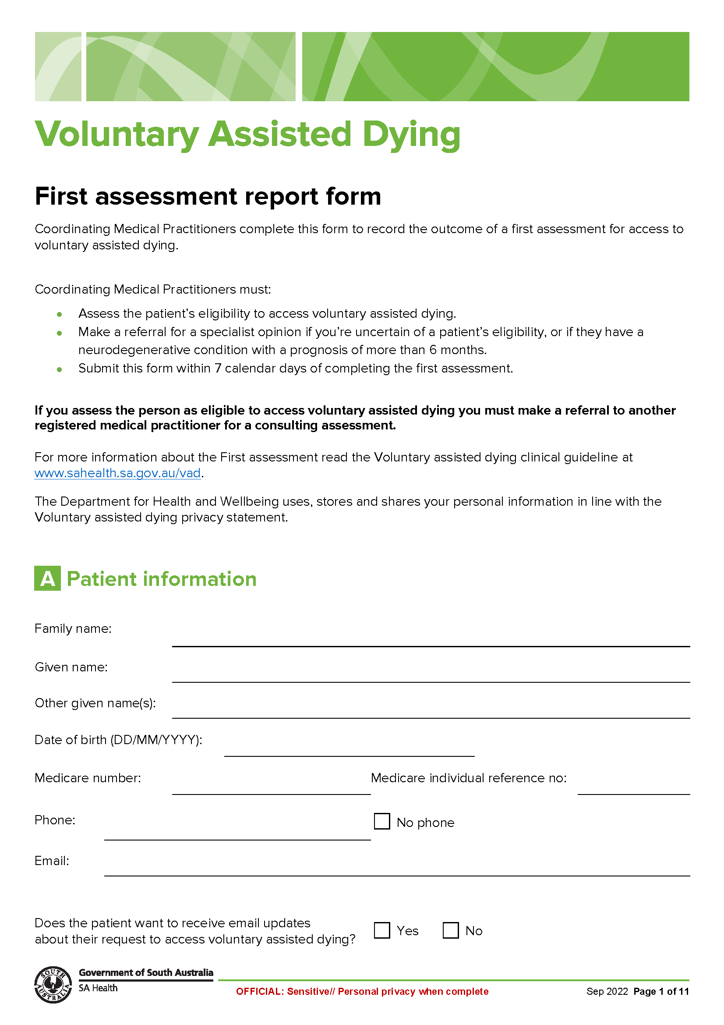
Schedule 1

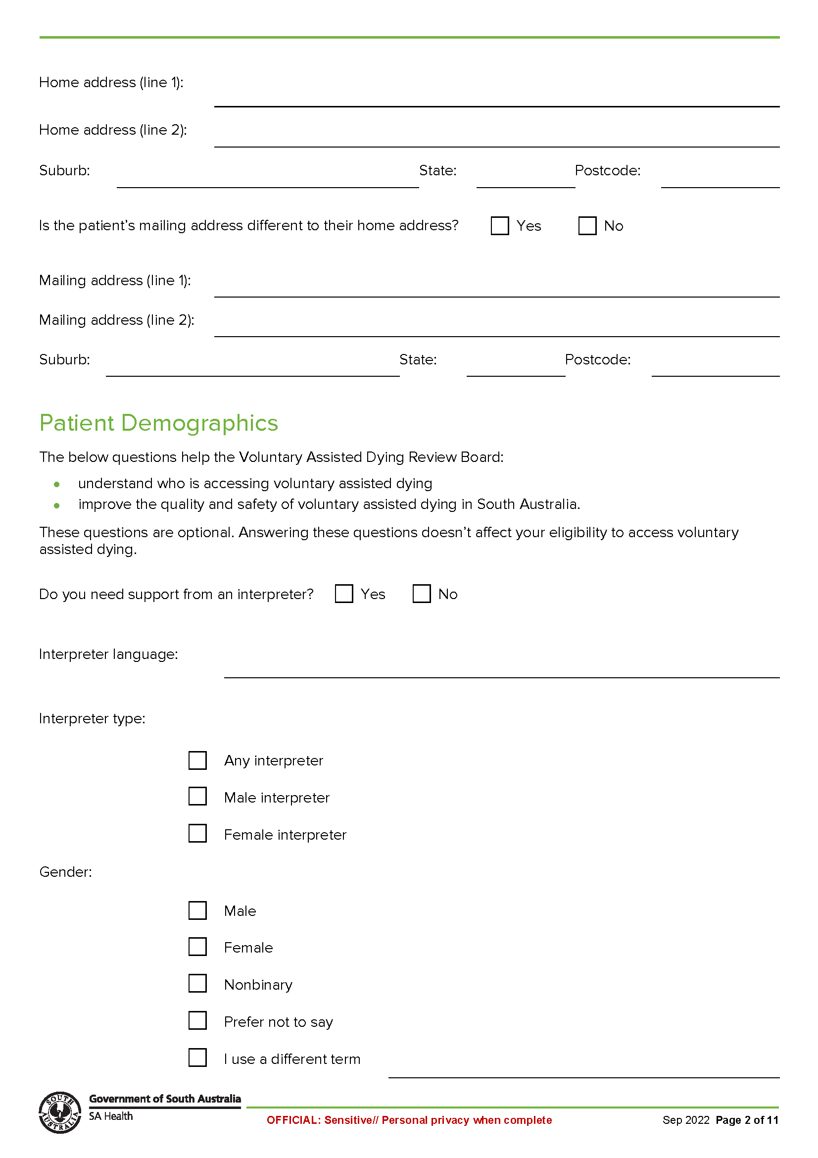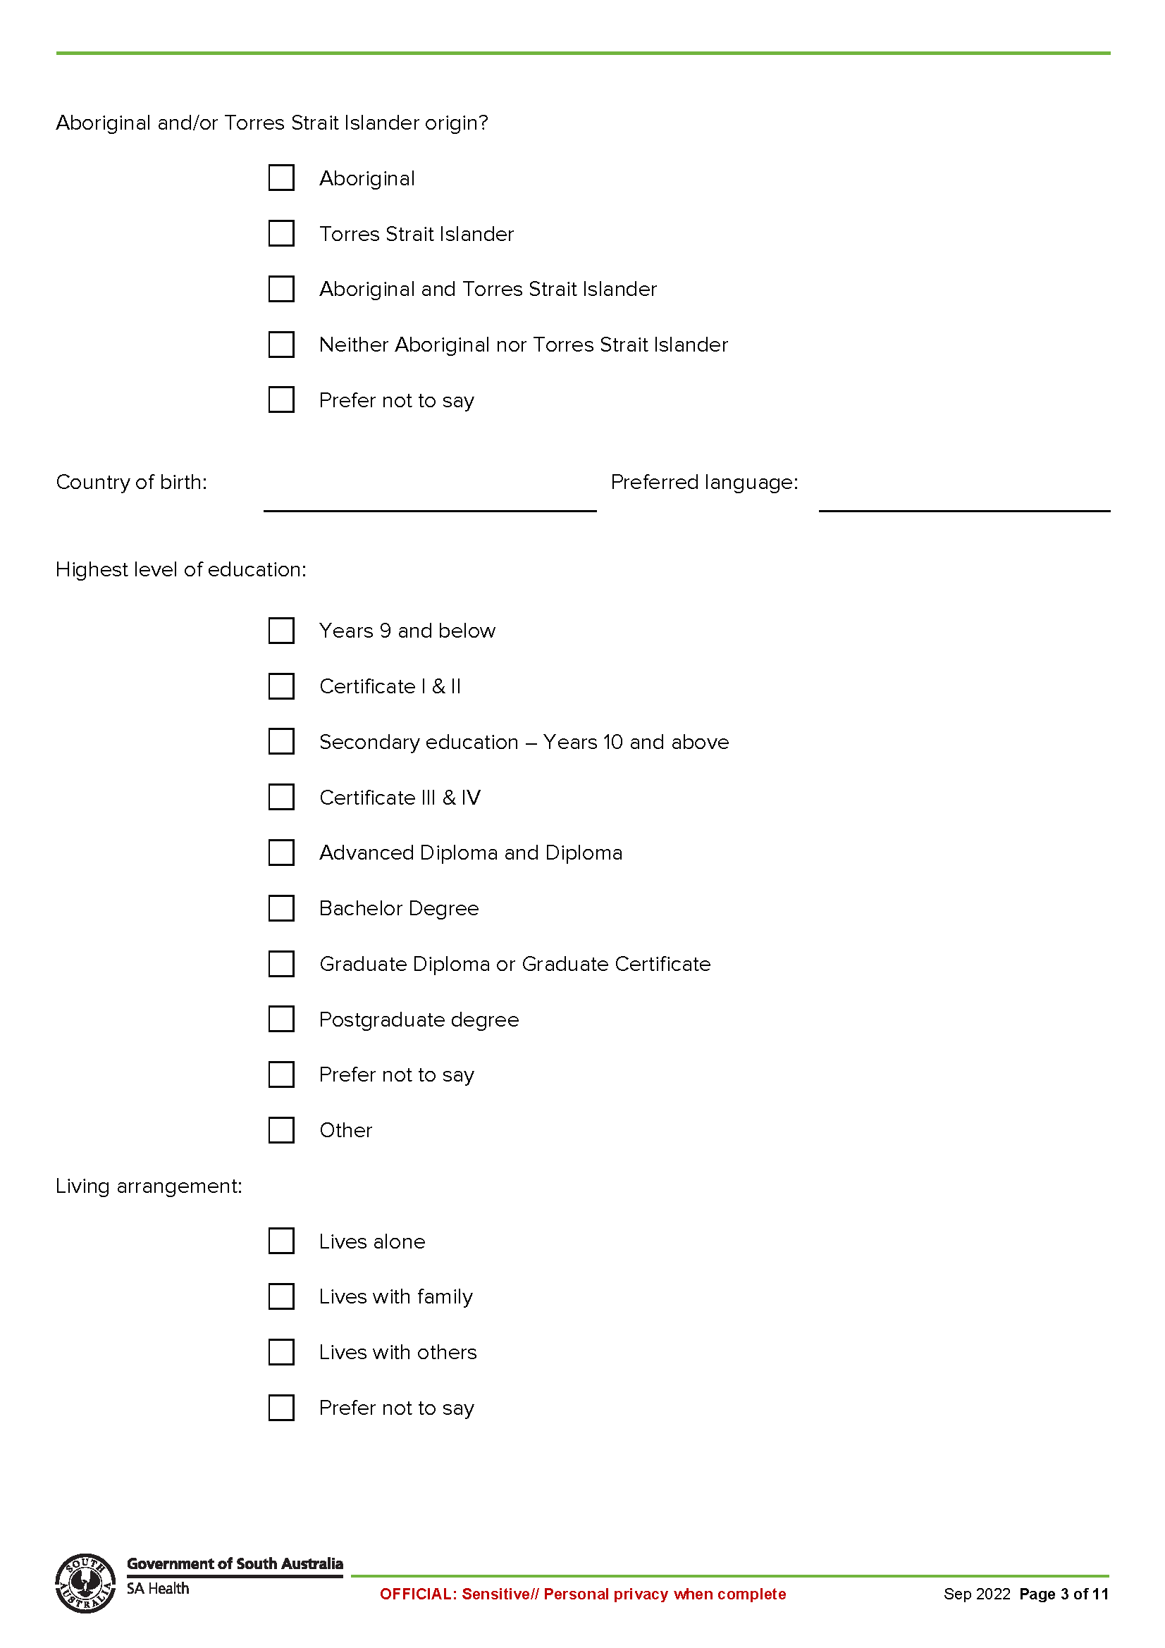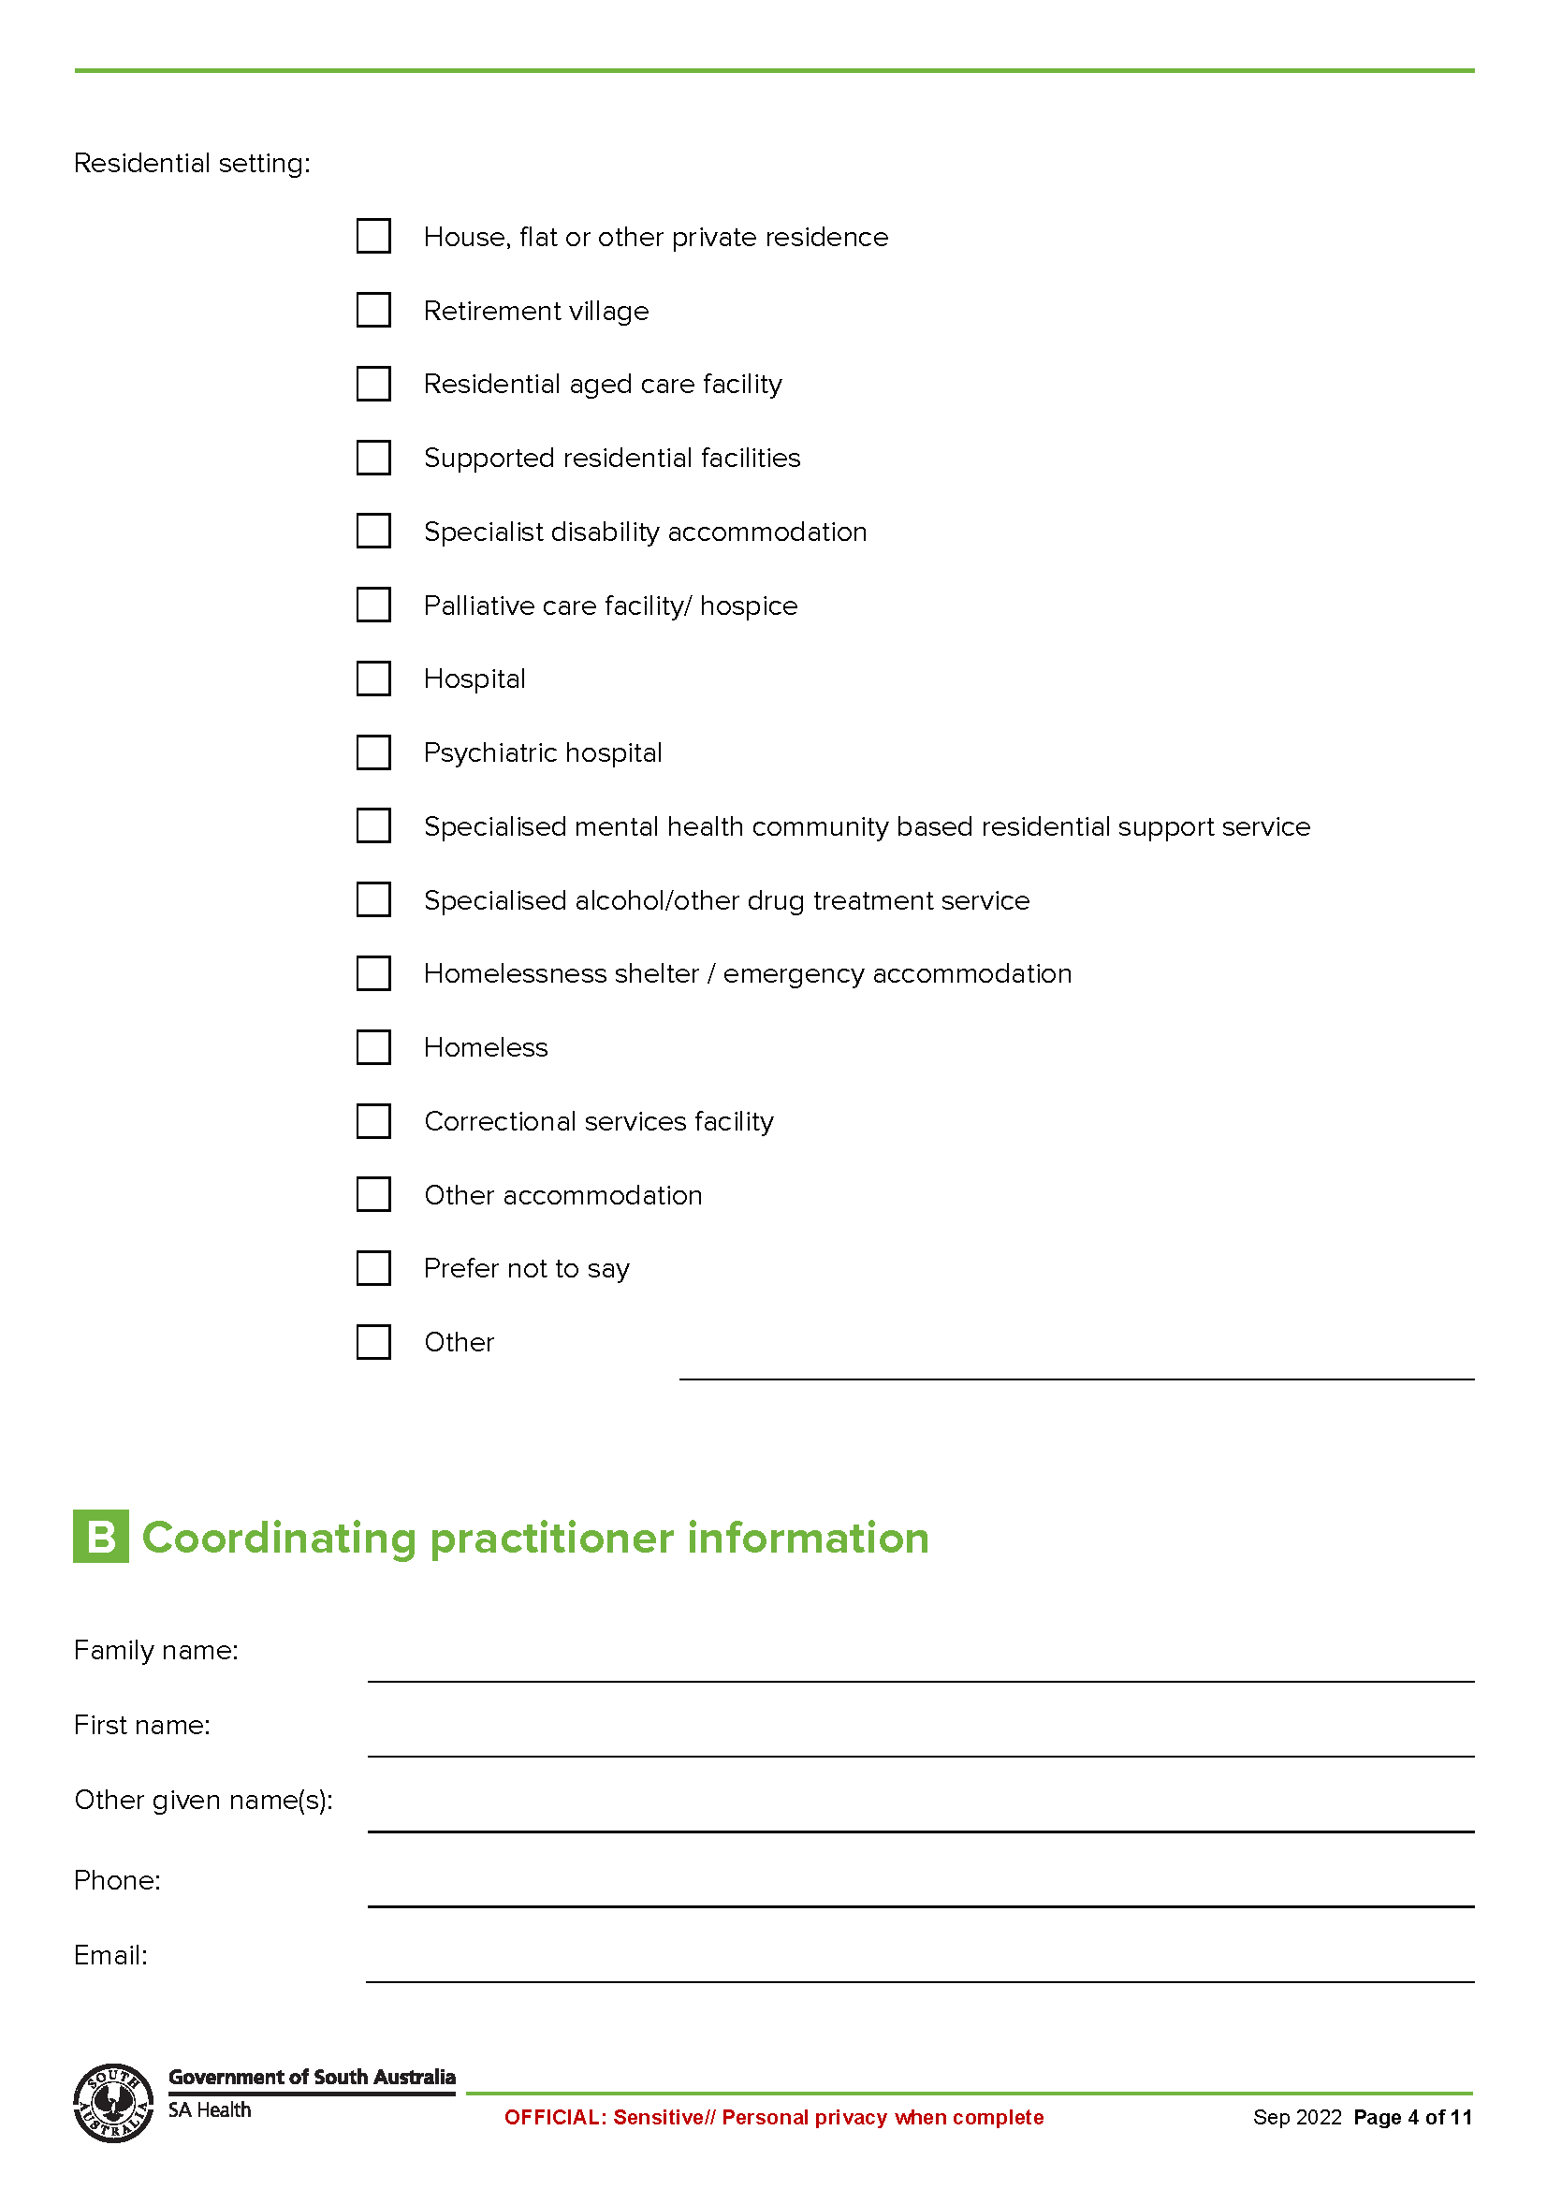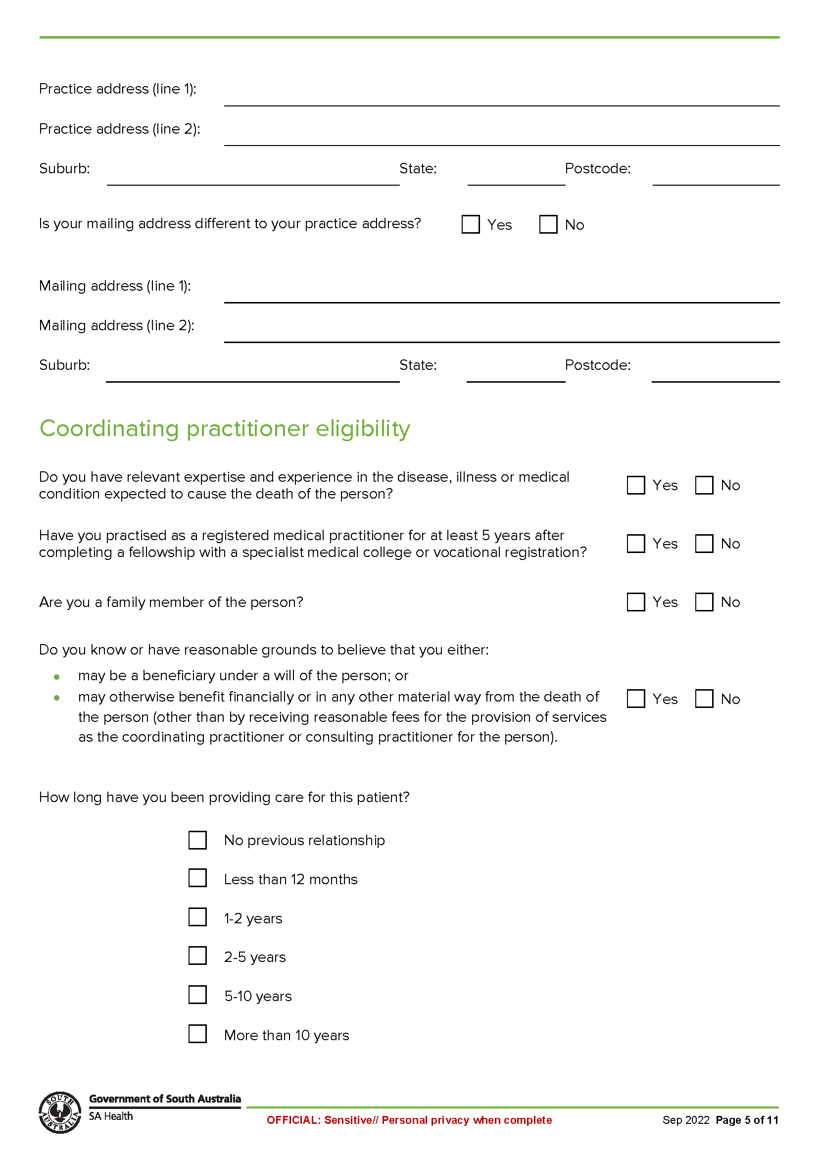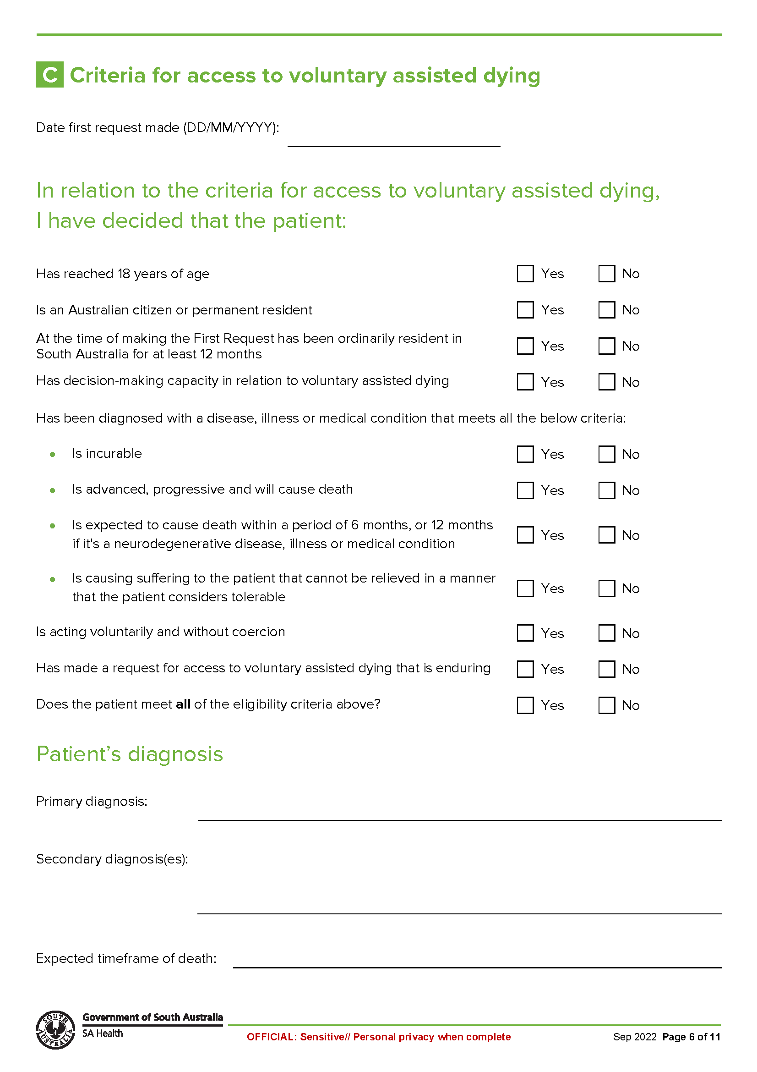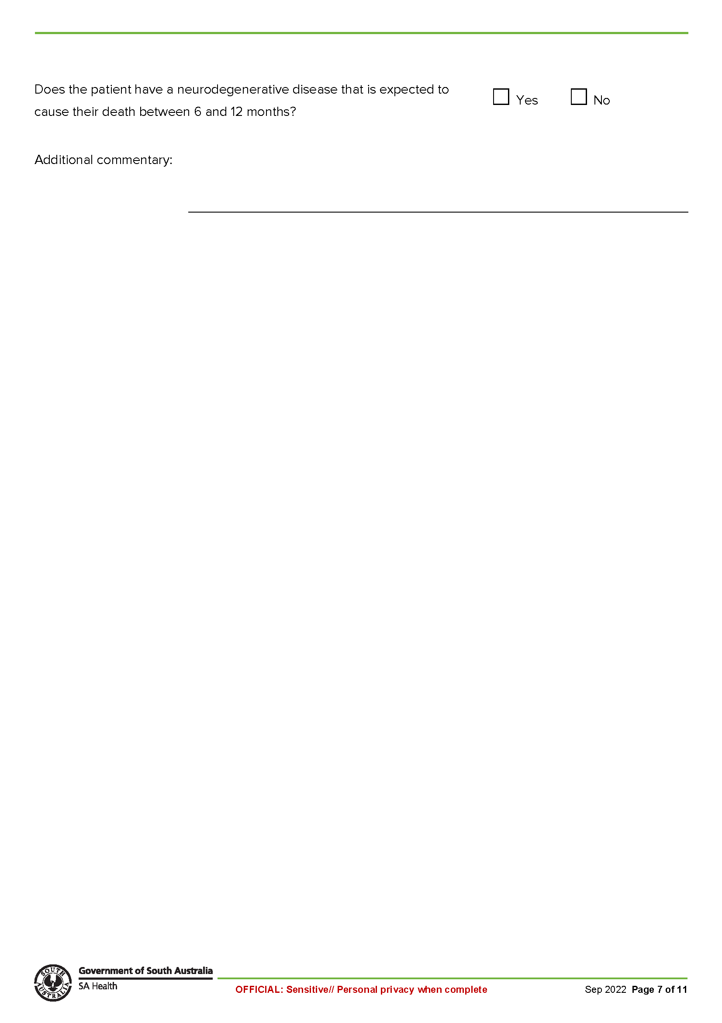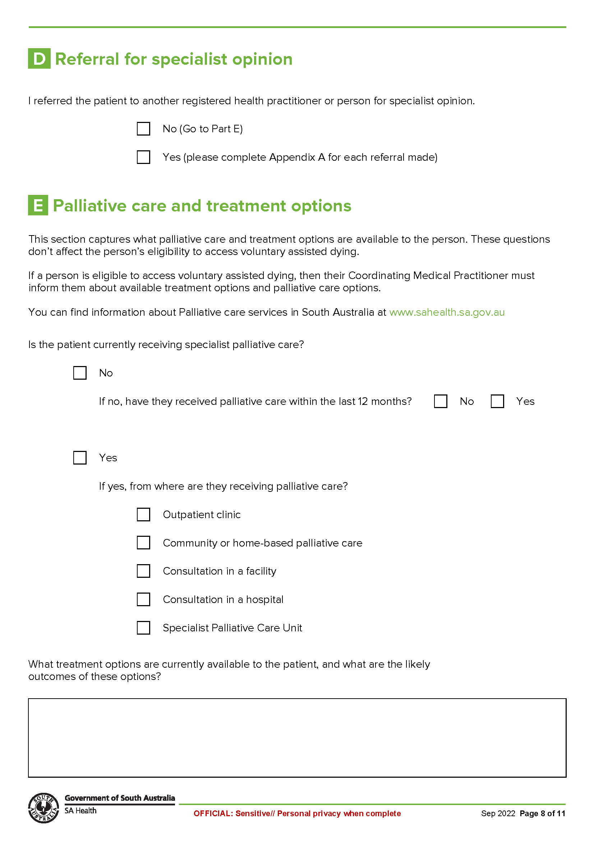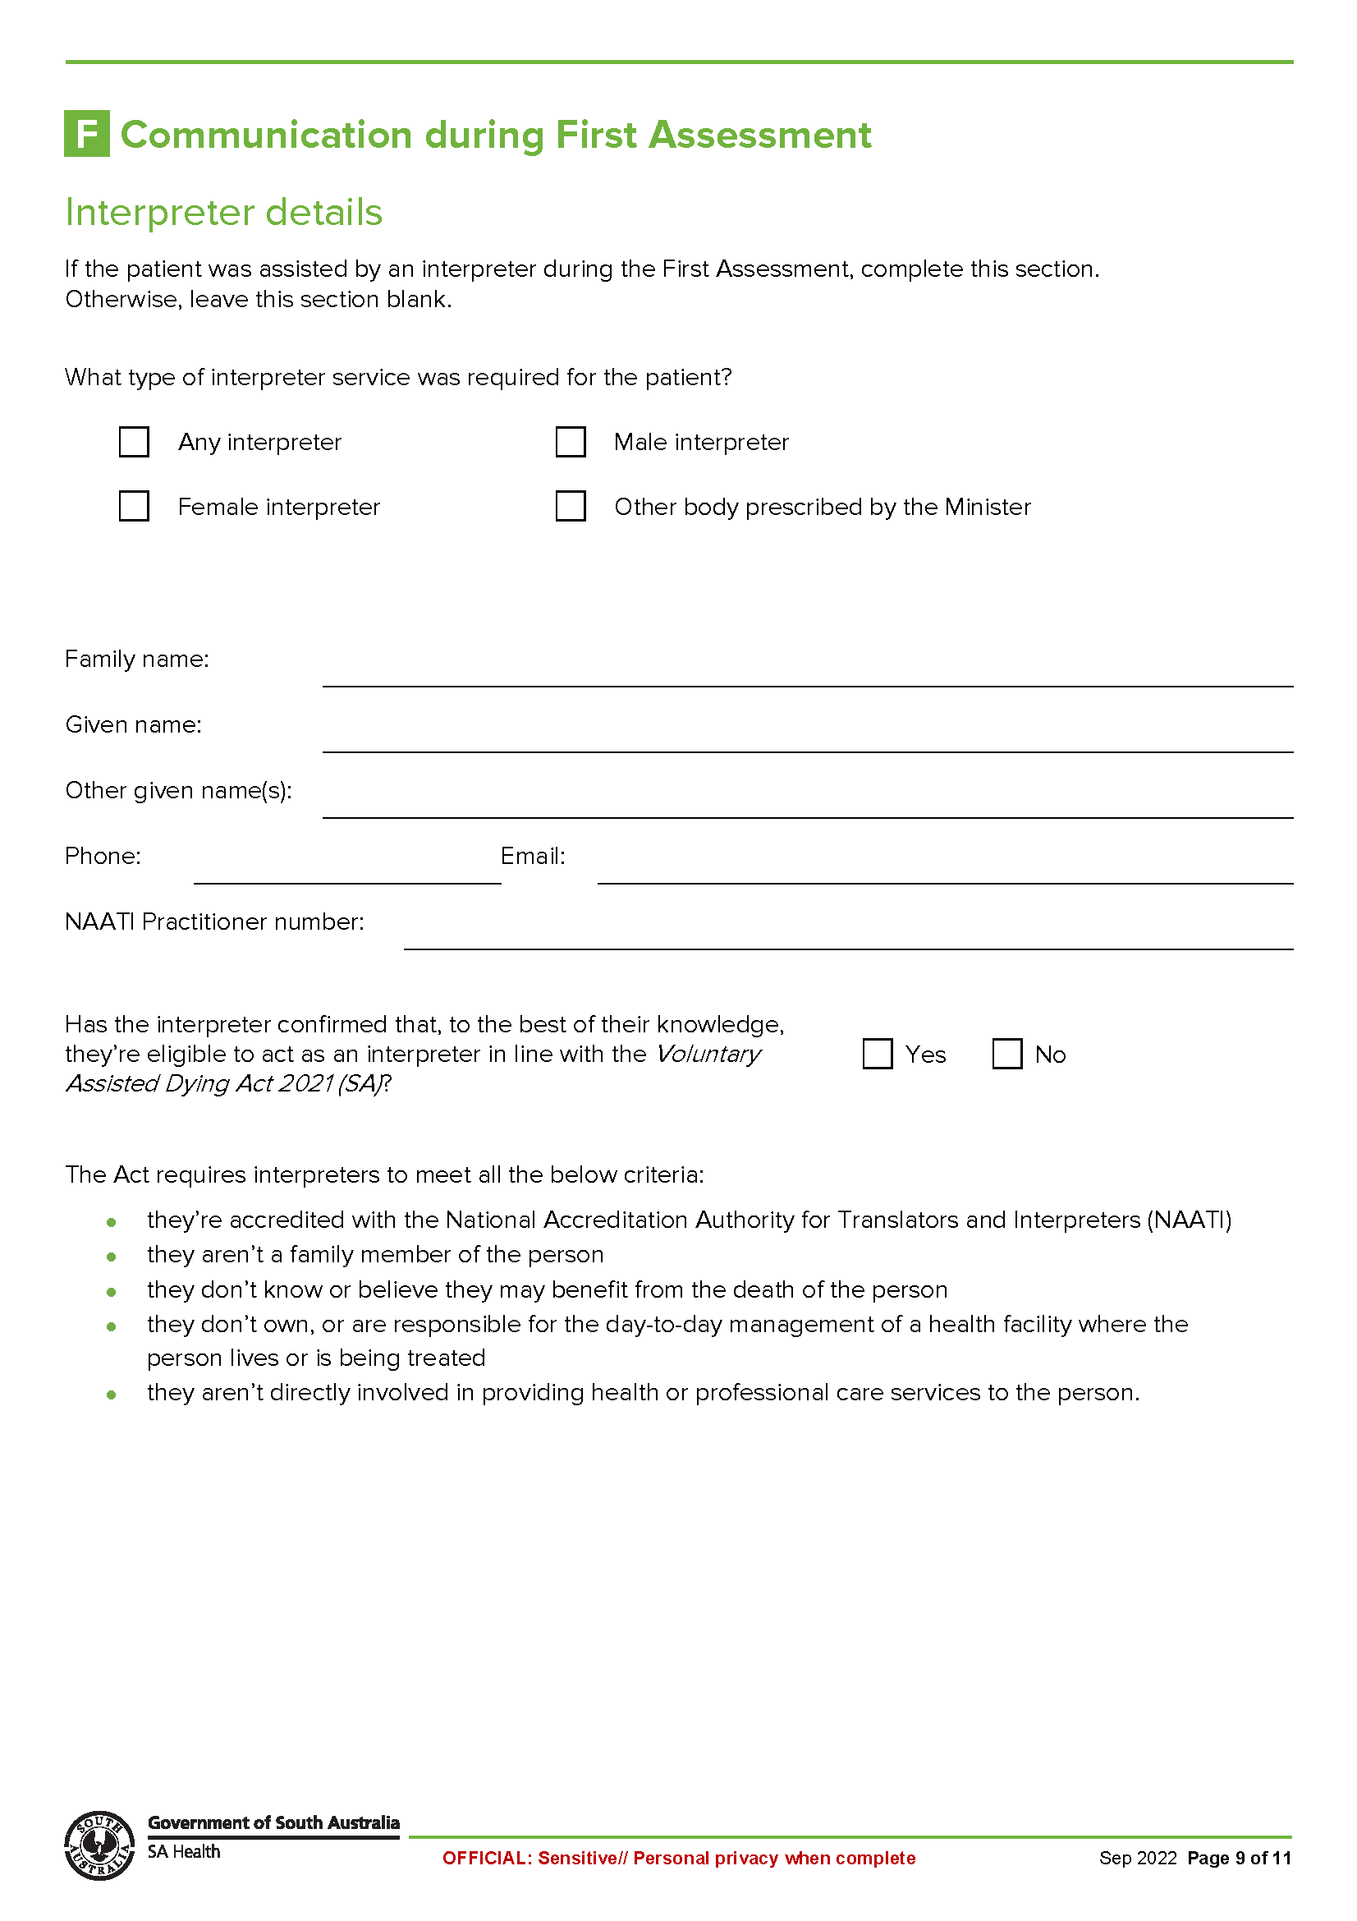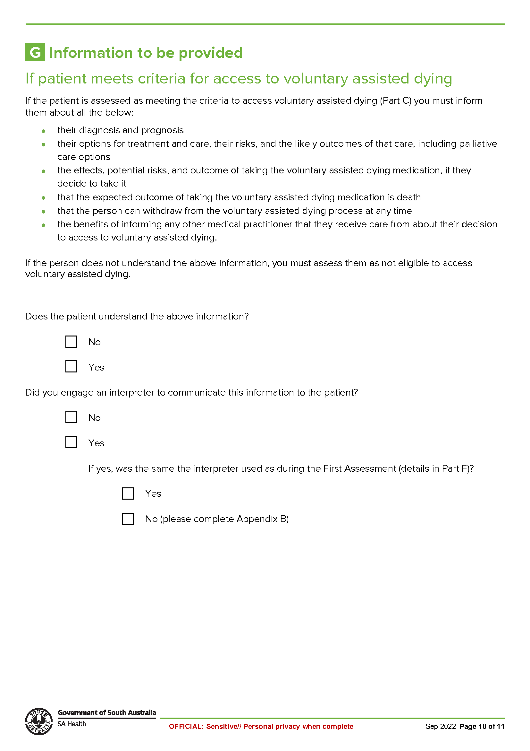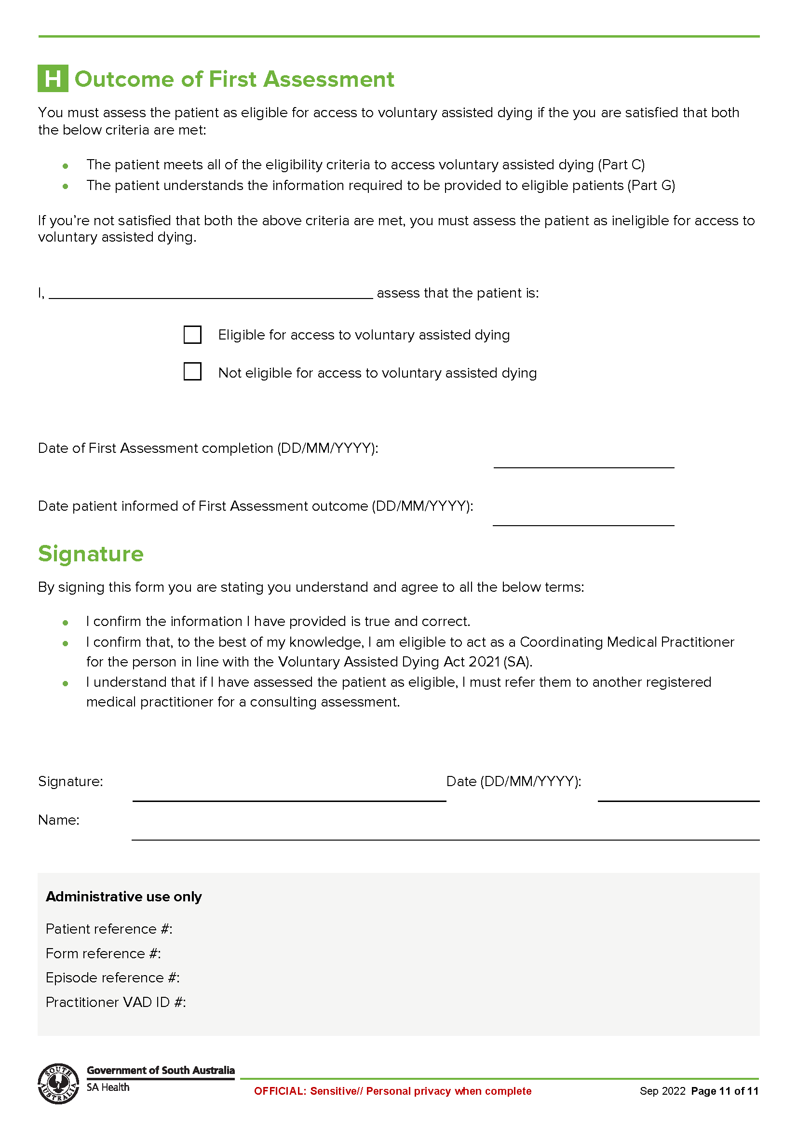

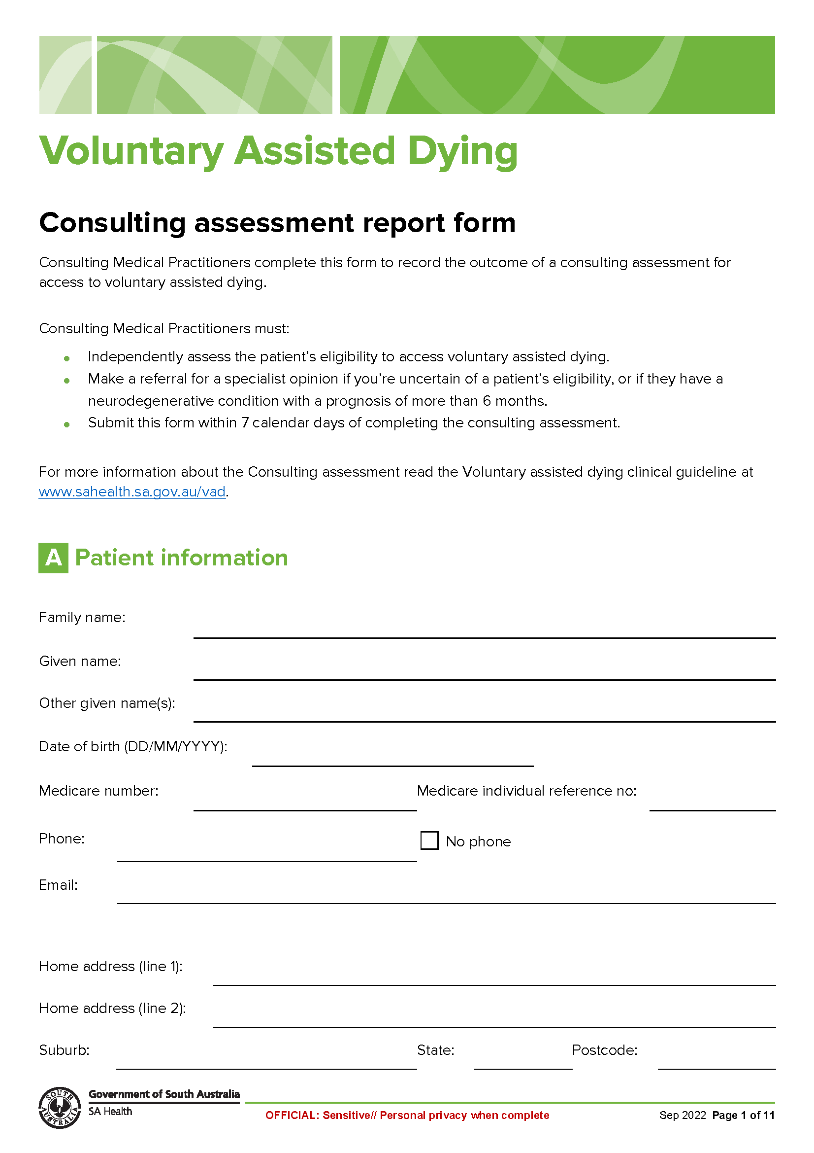
Schedule 2

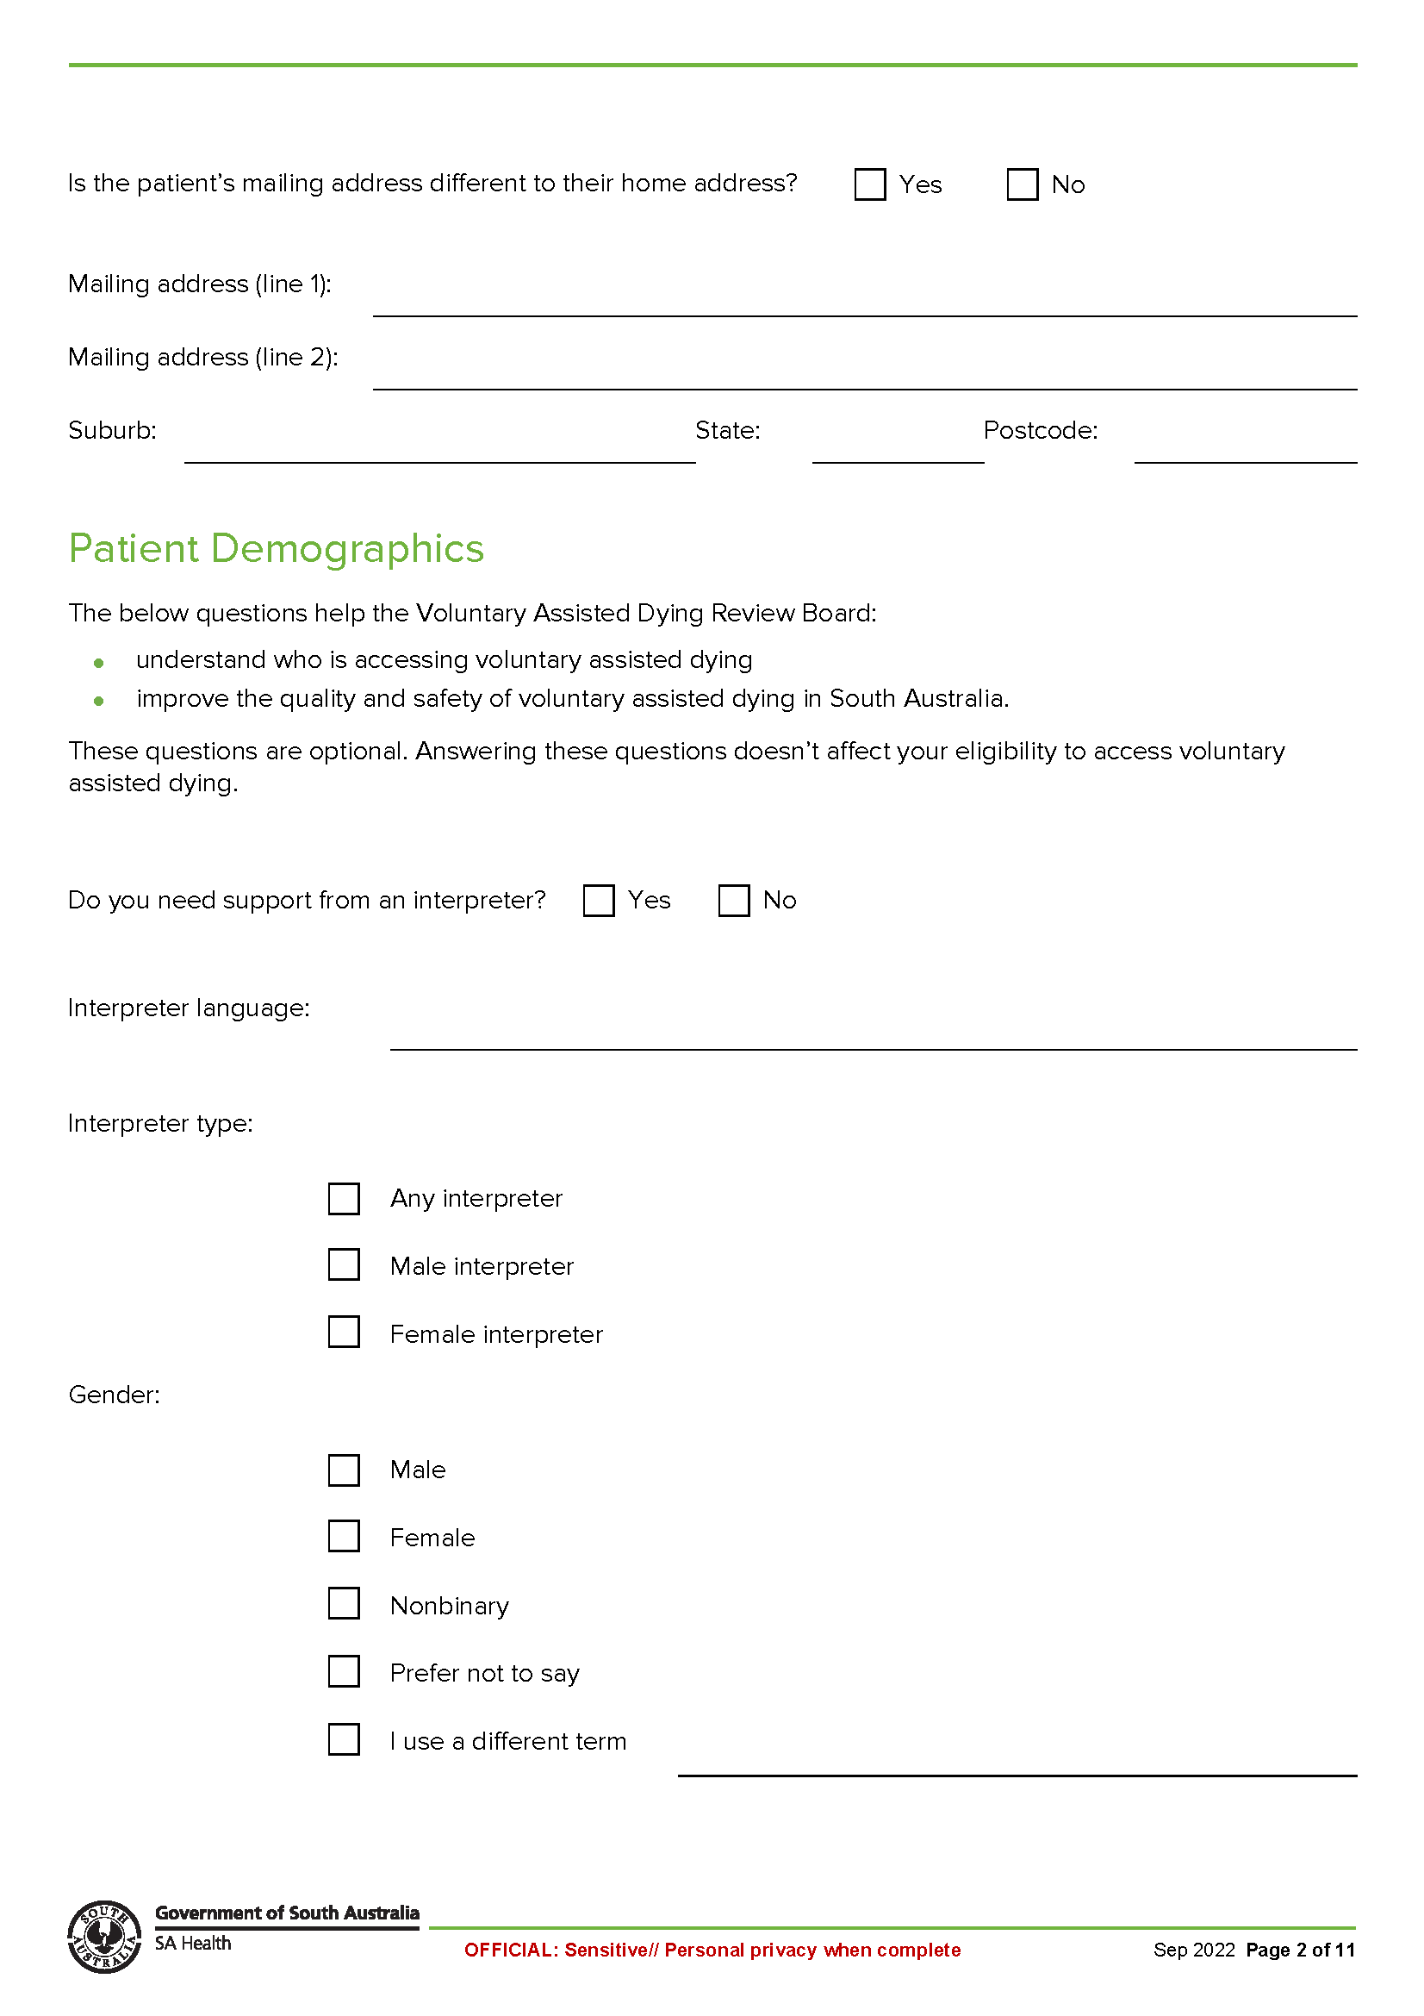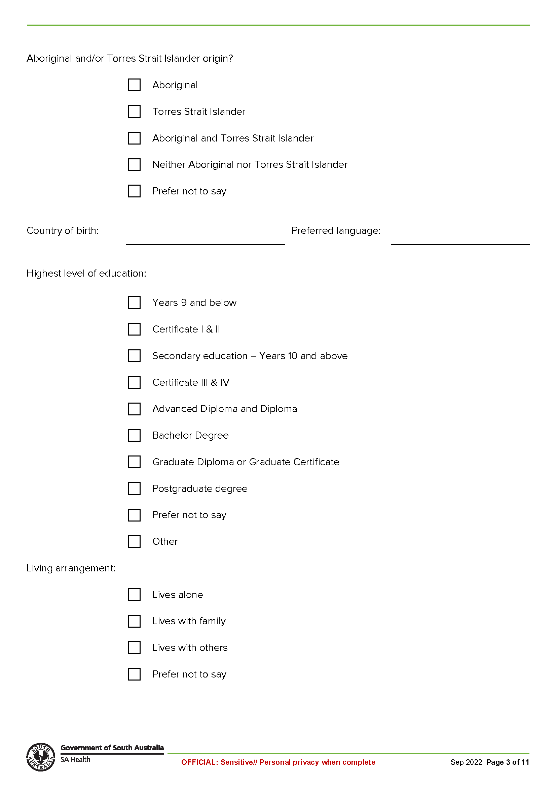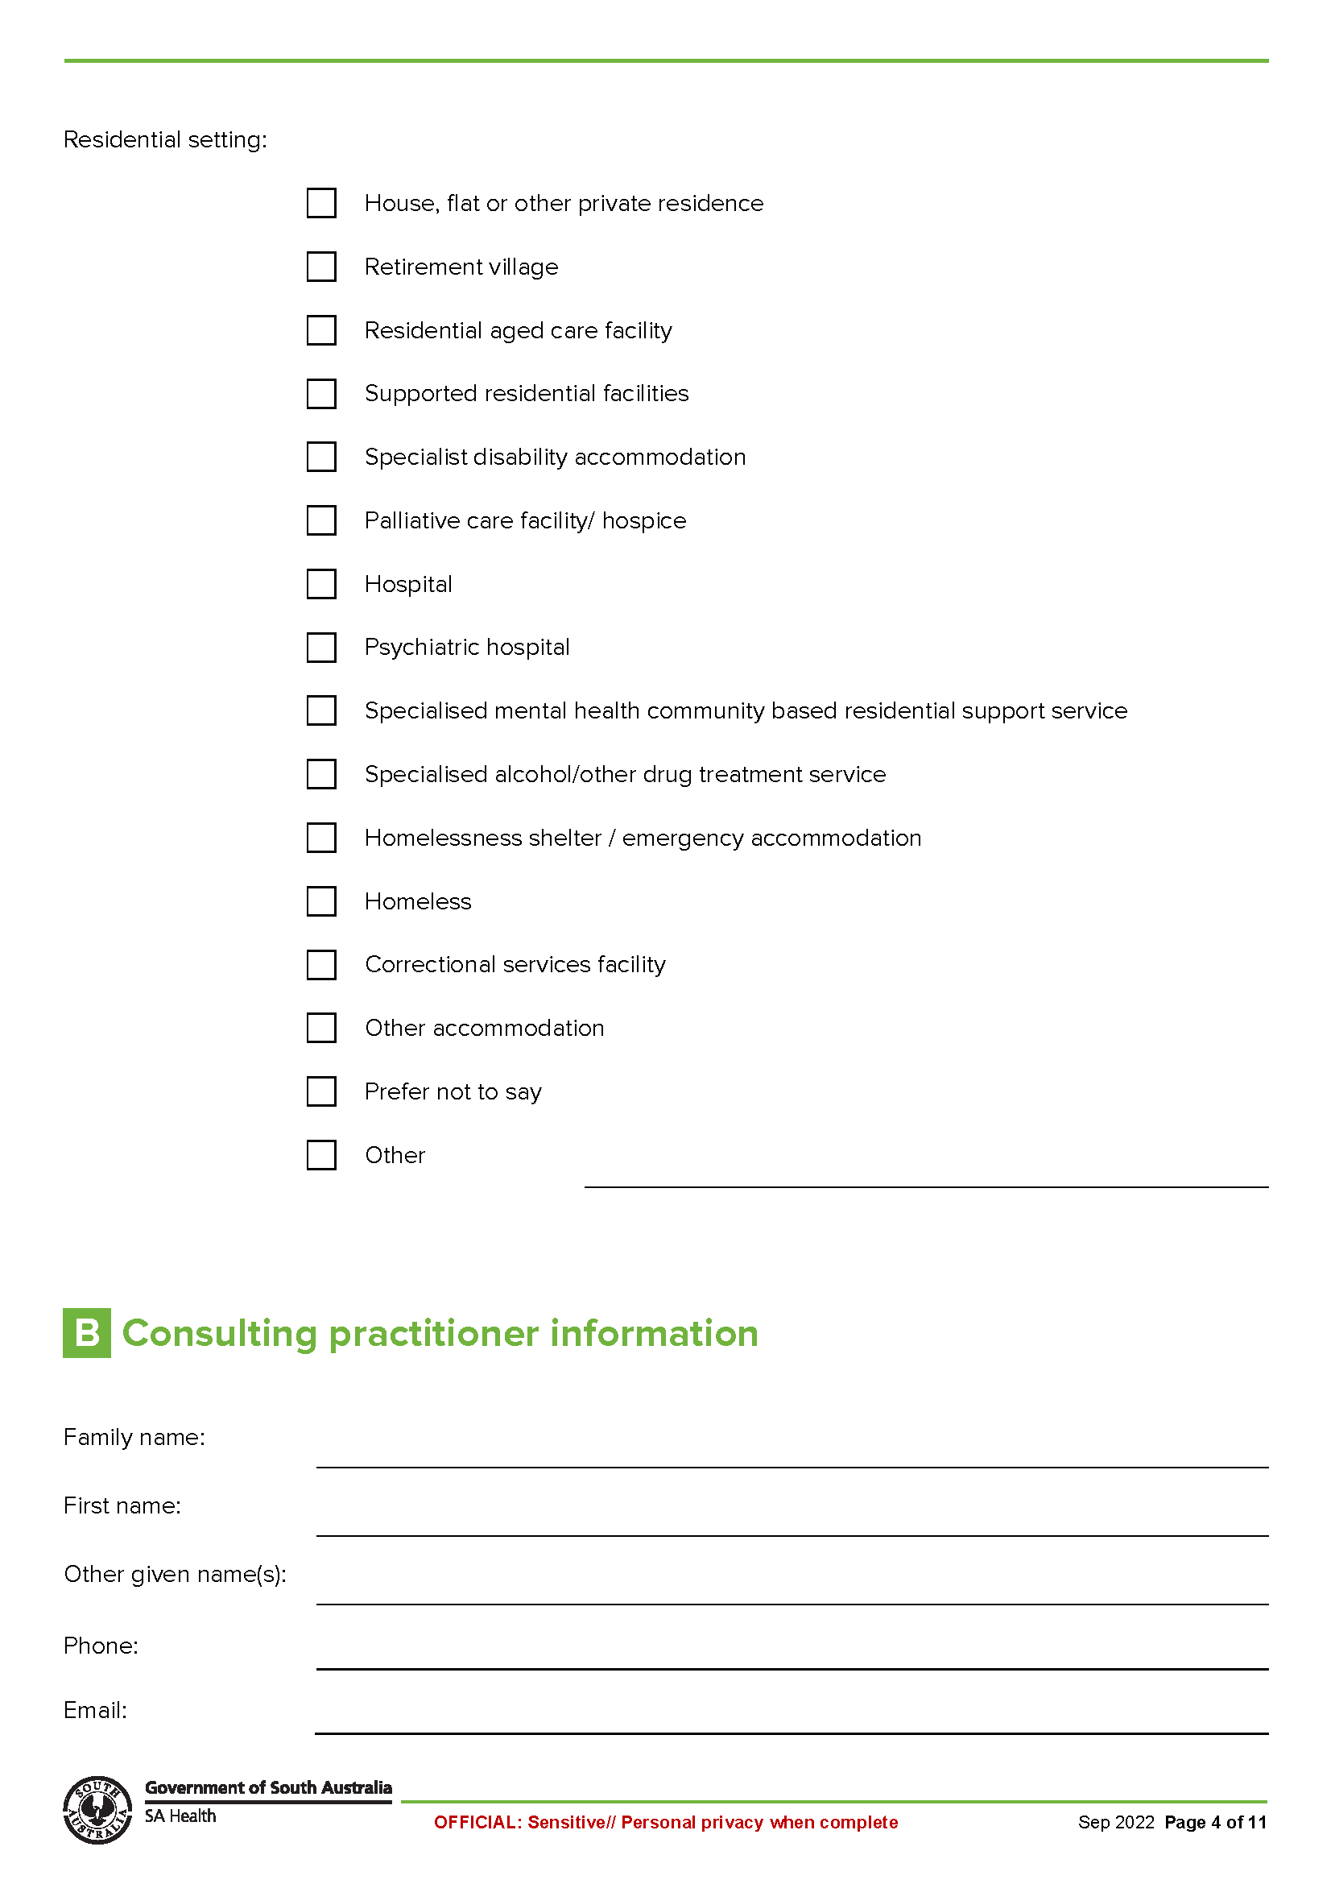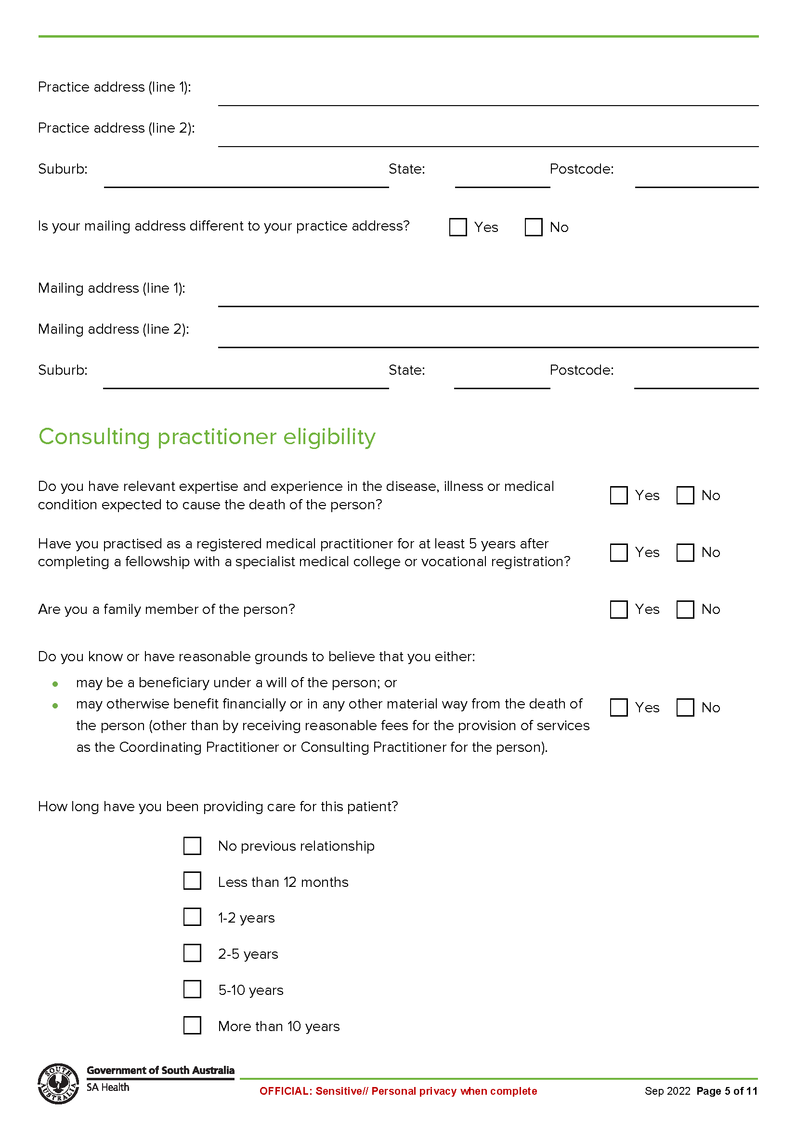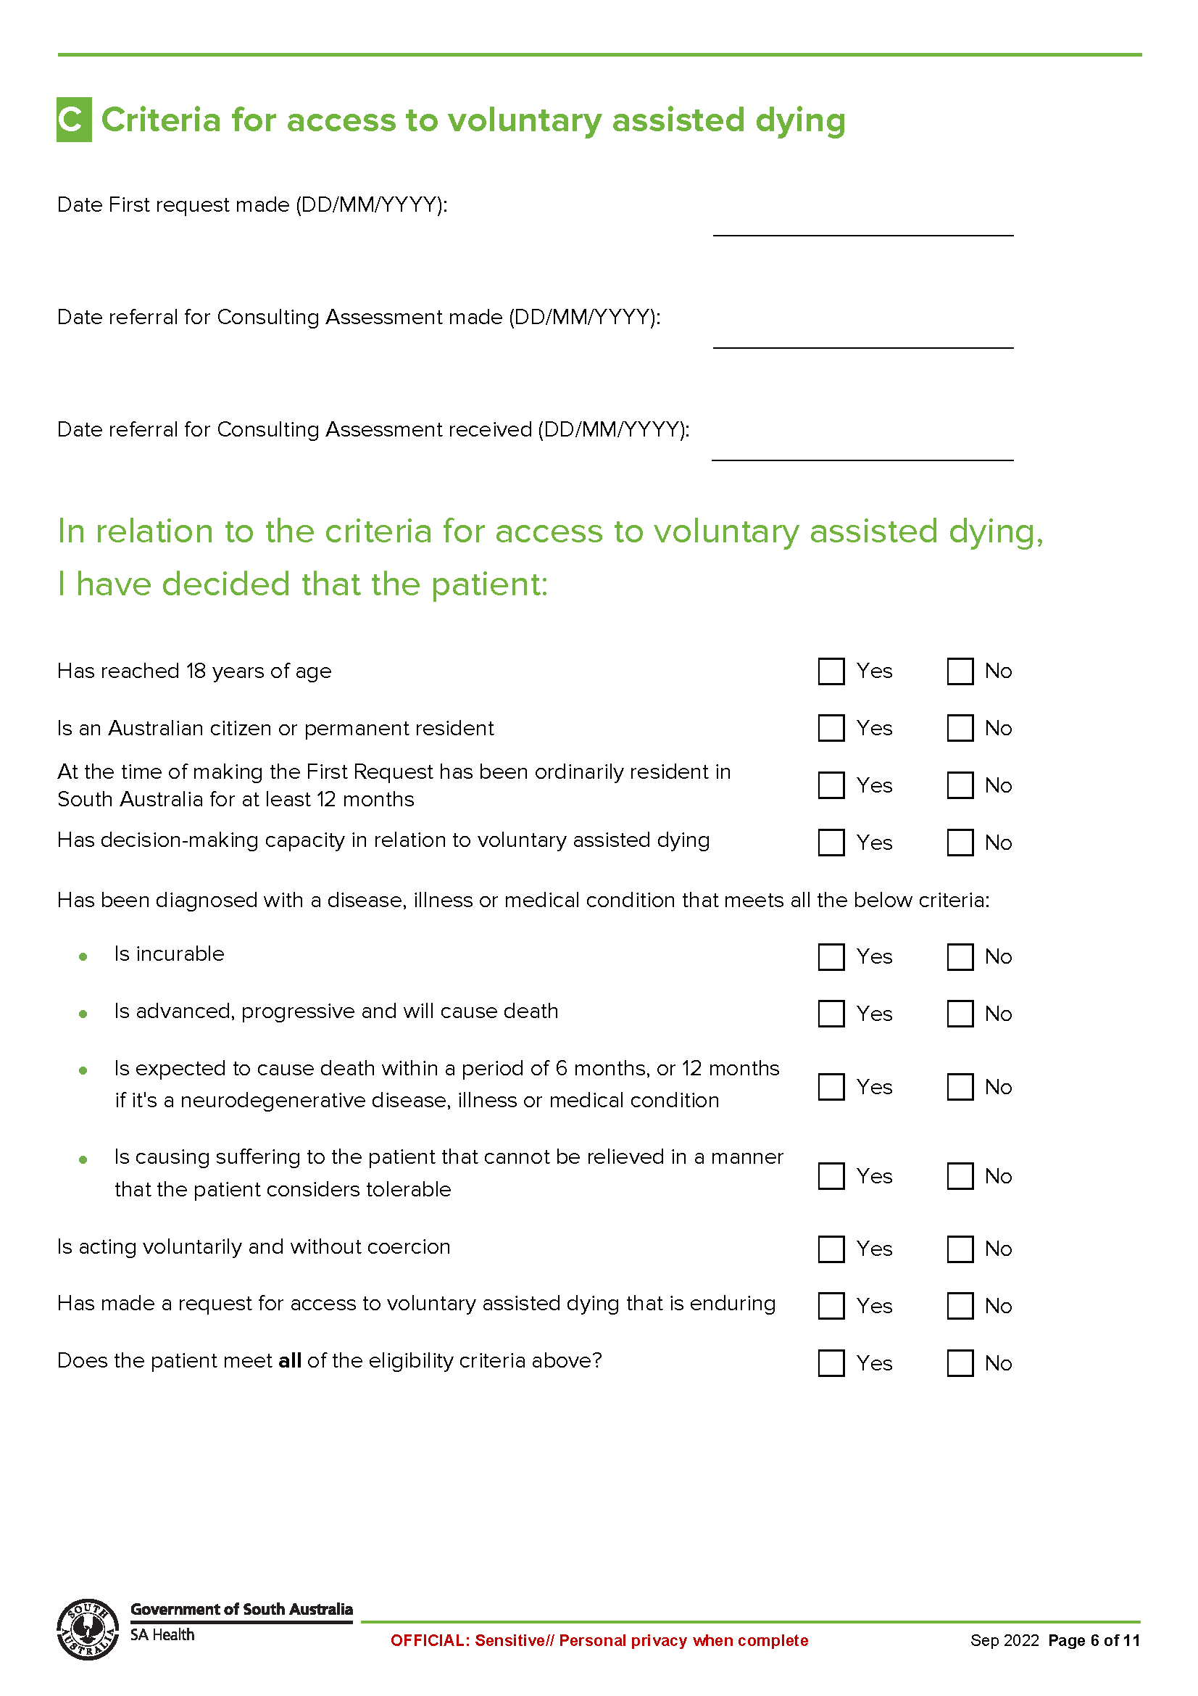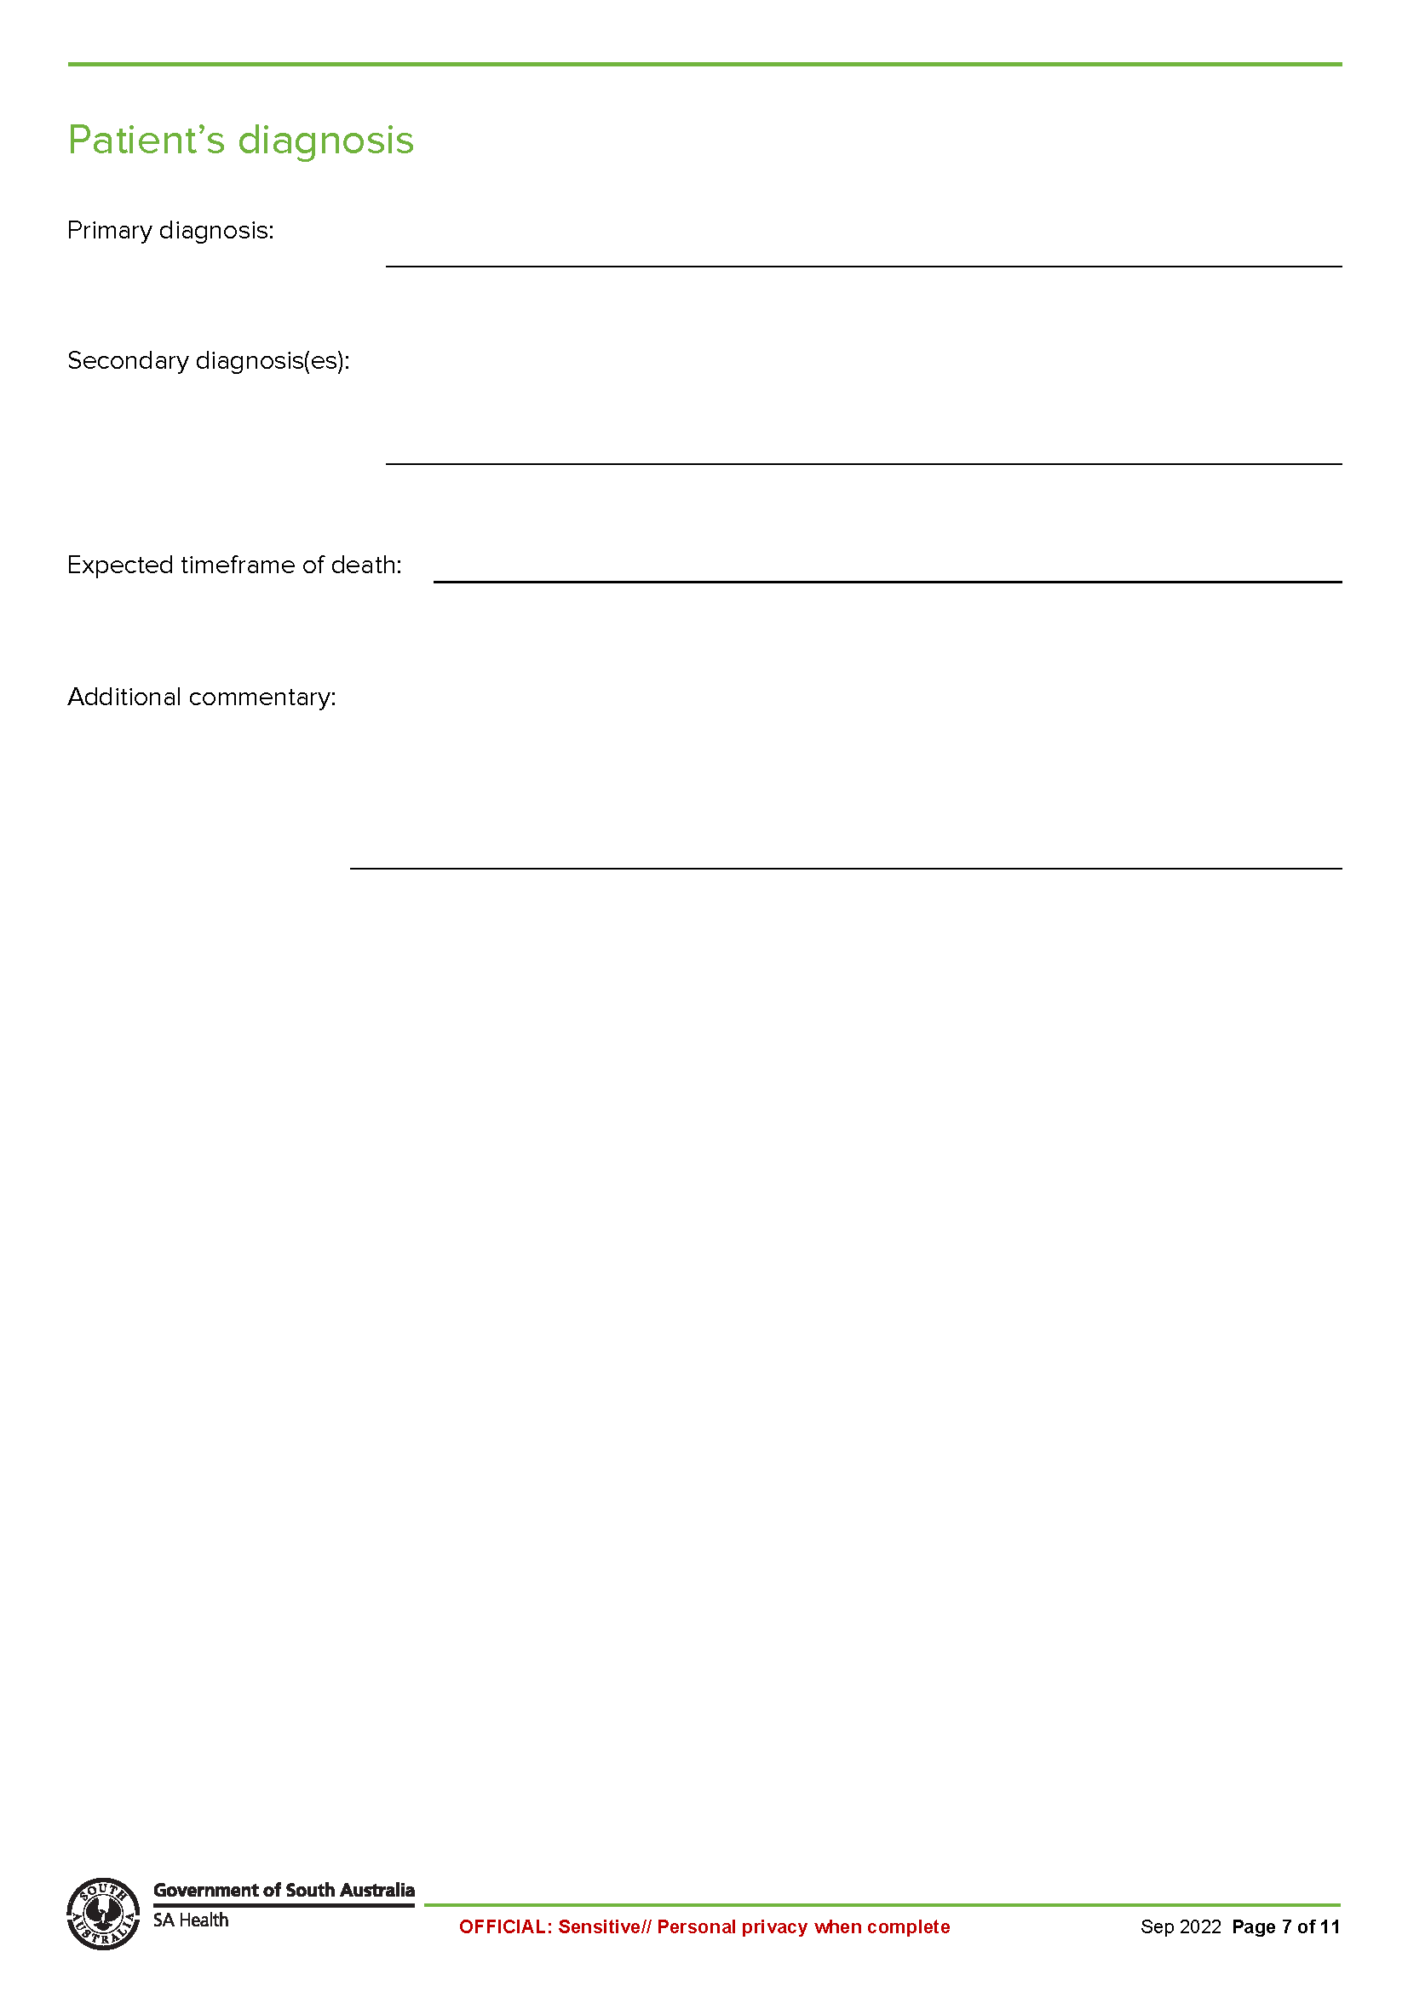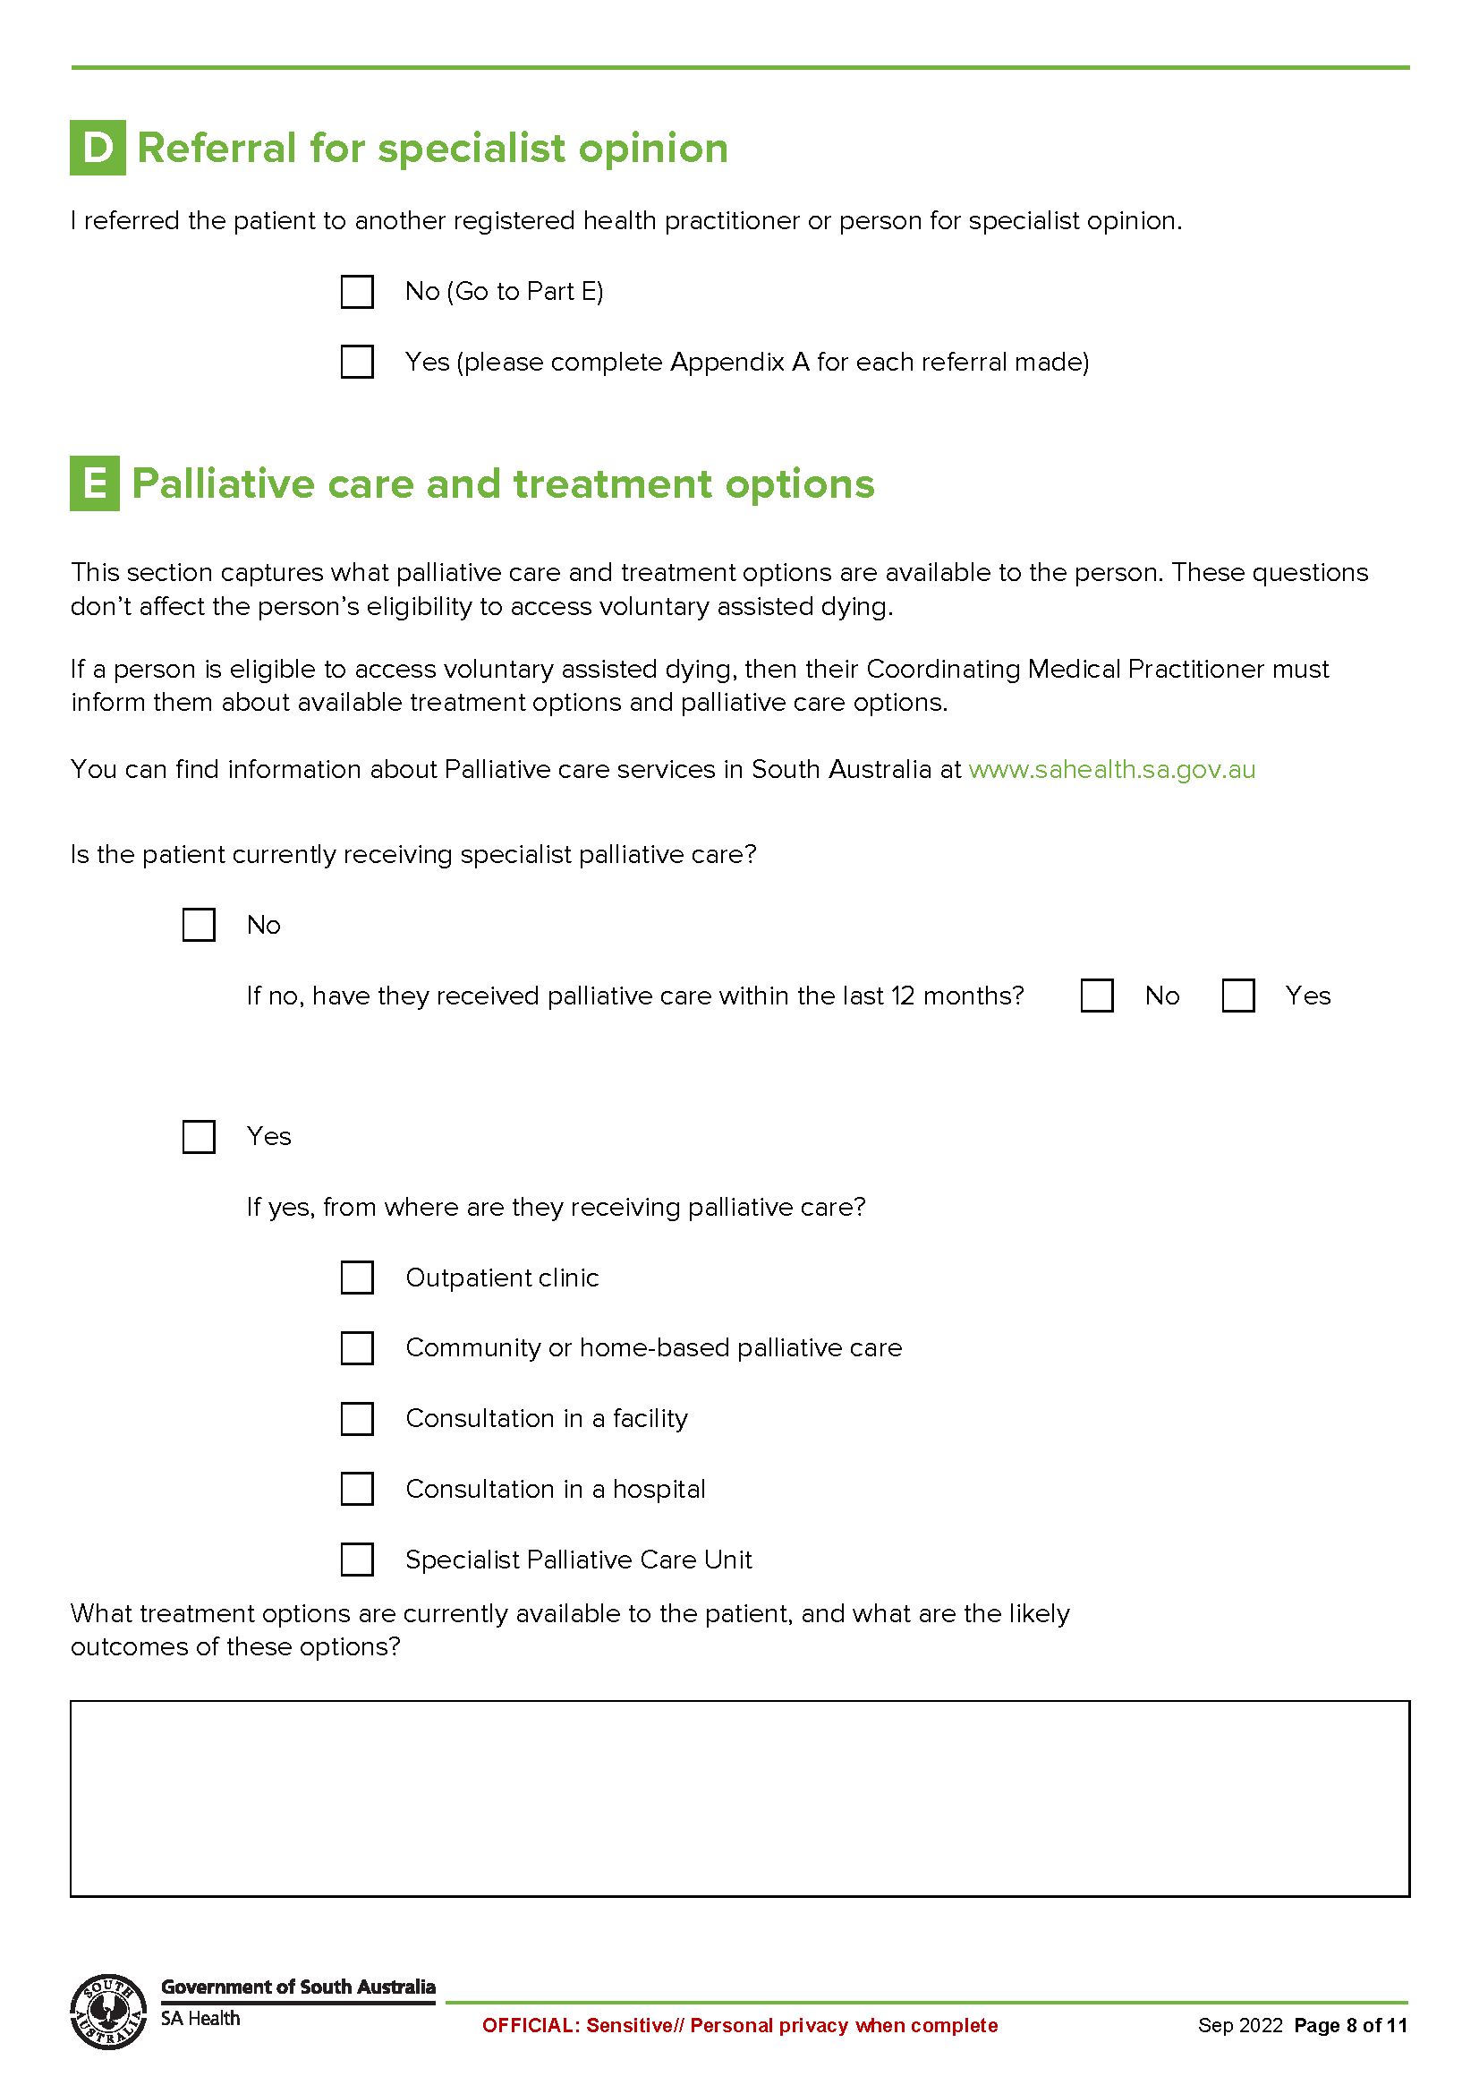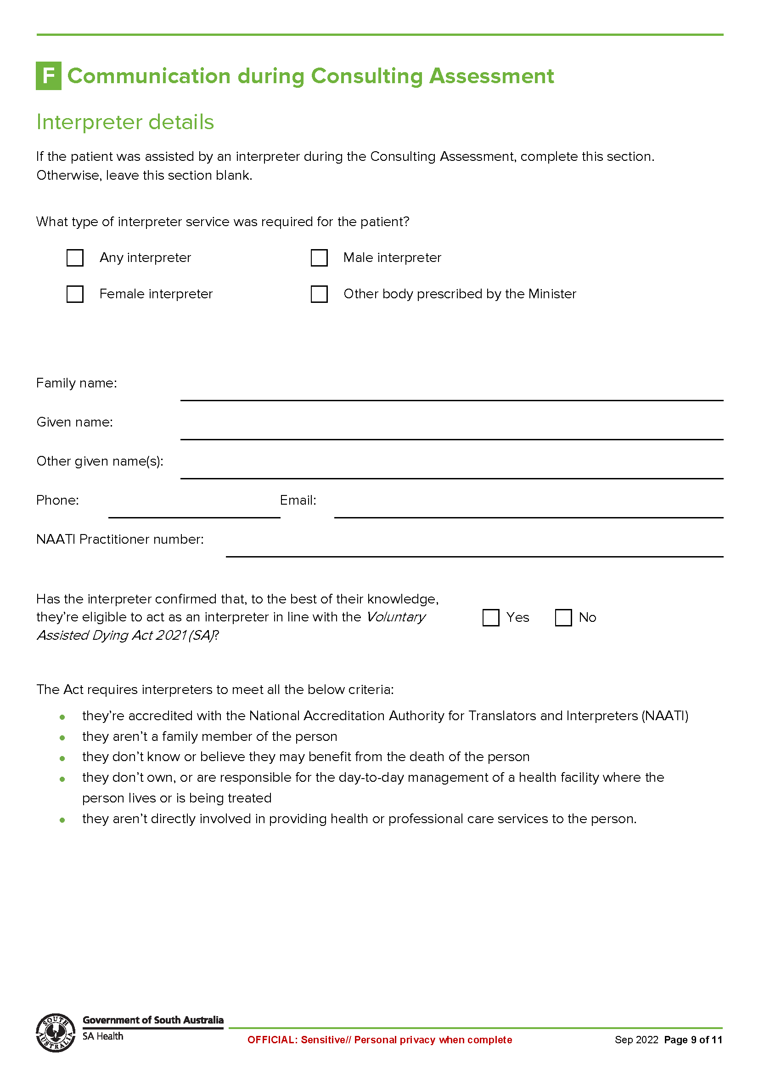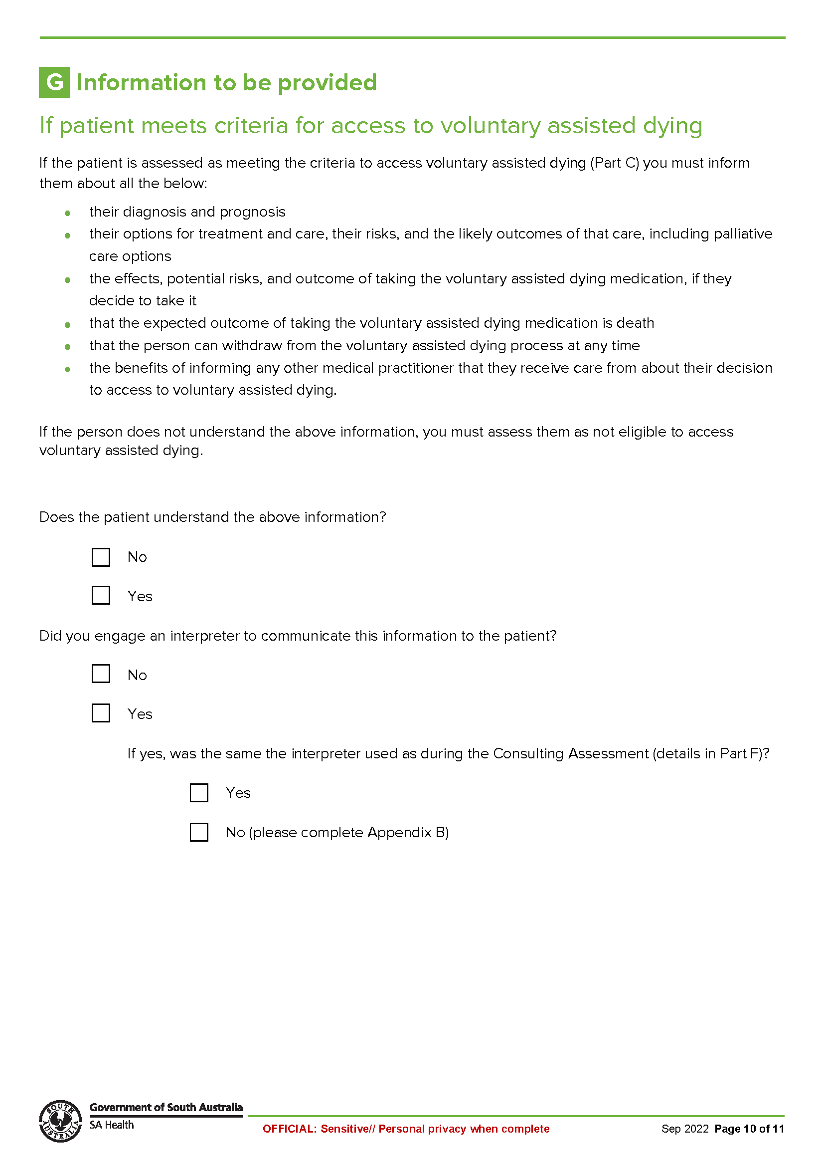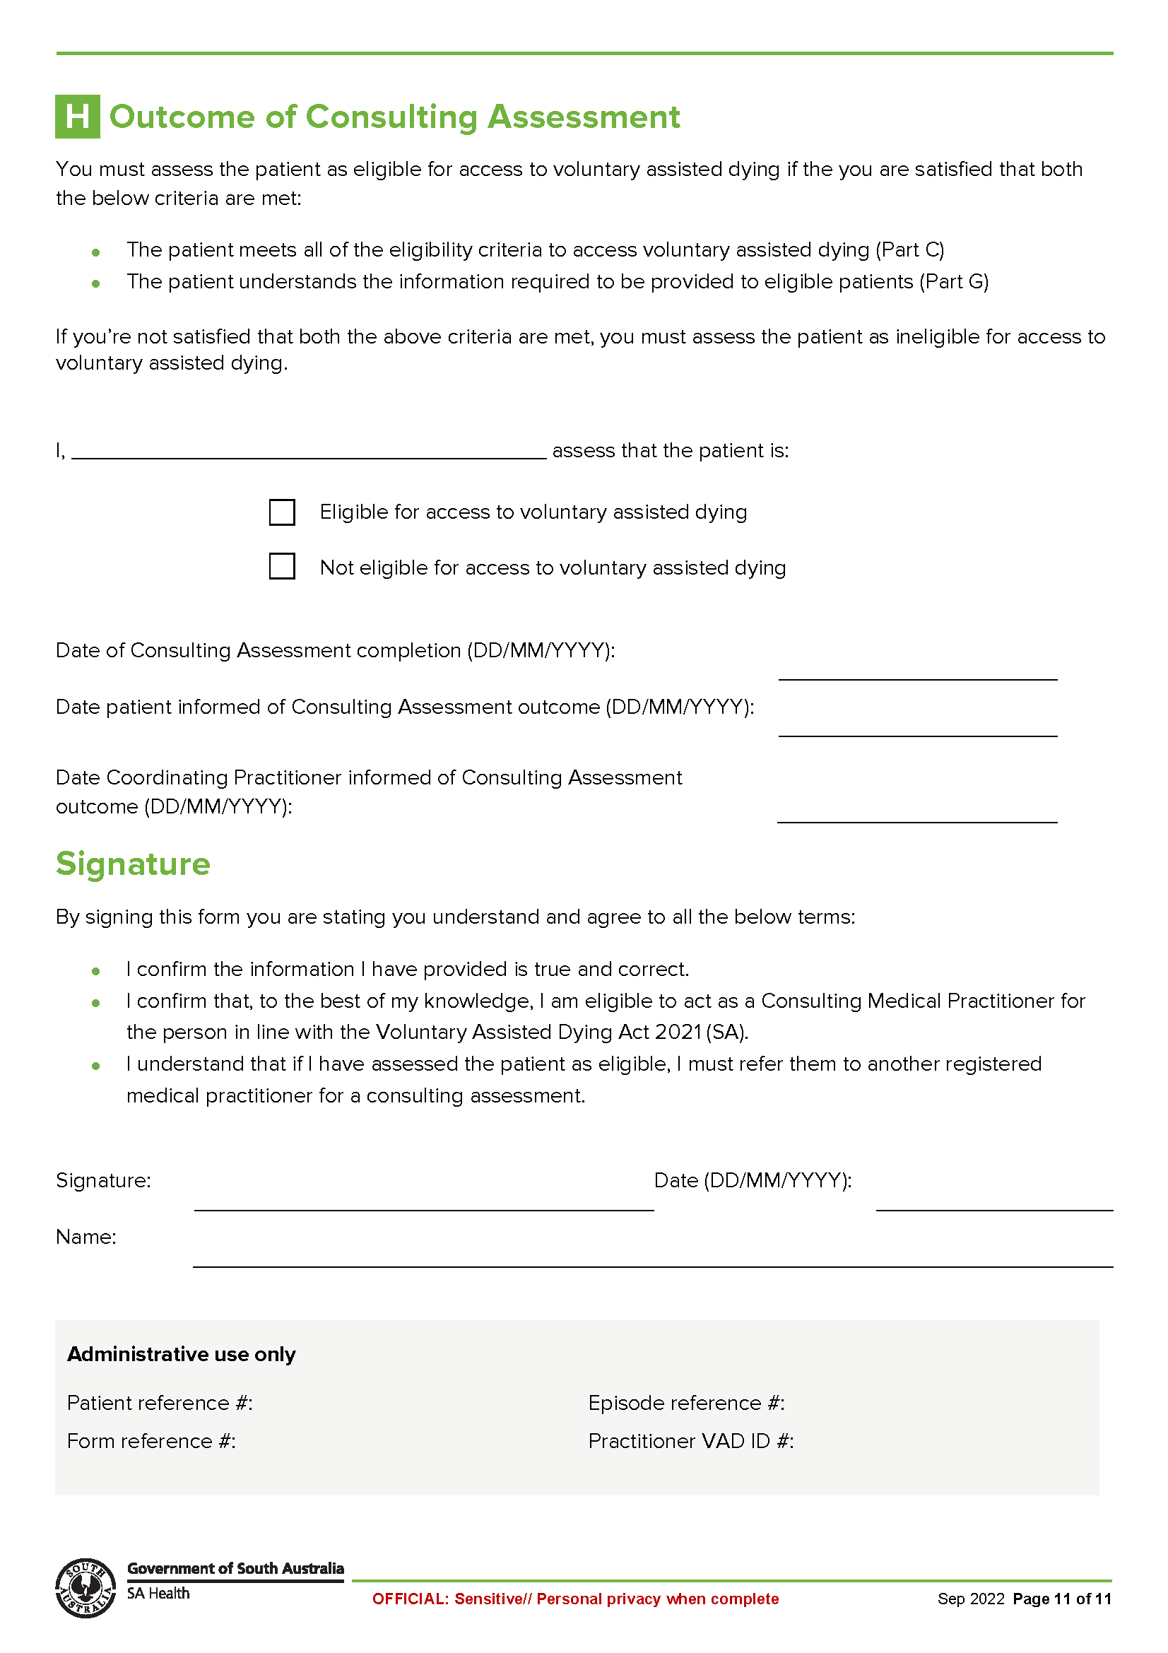
Schedule 3
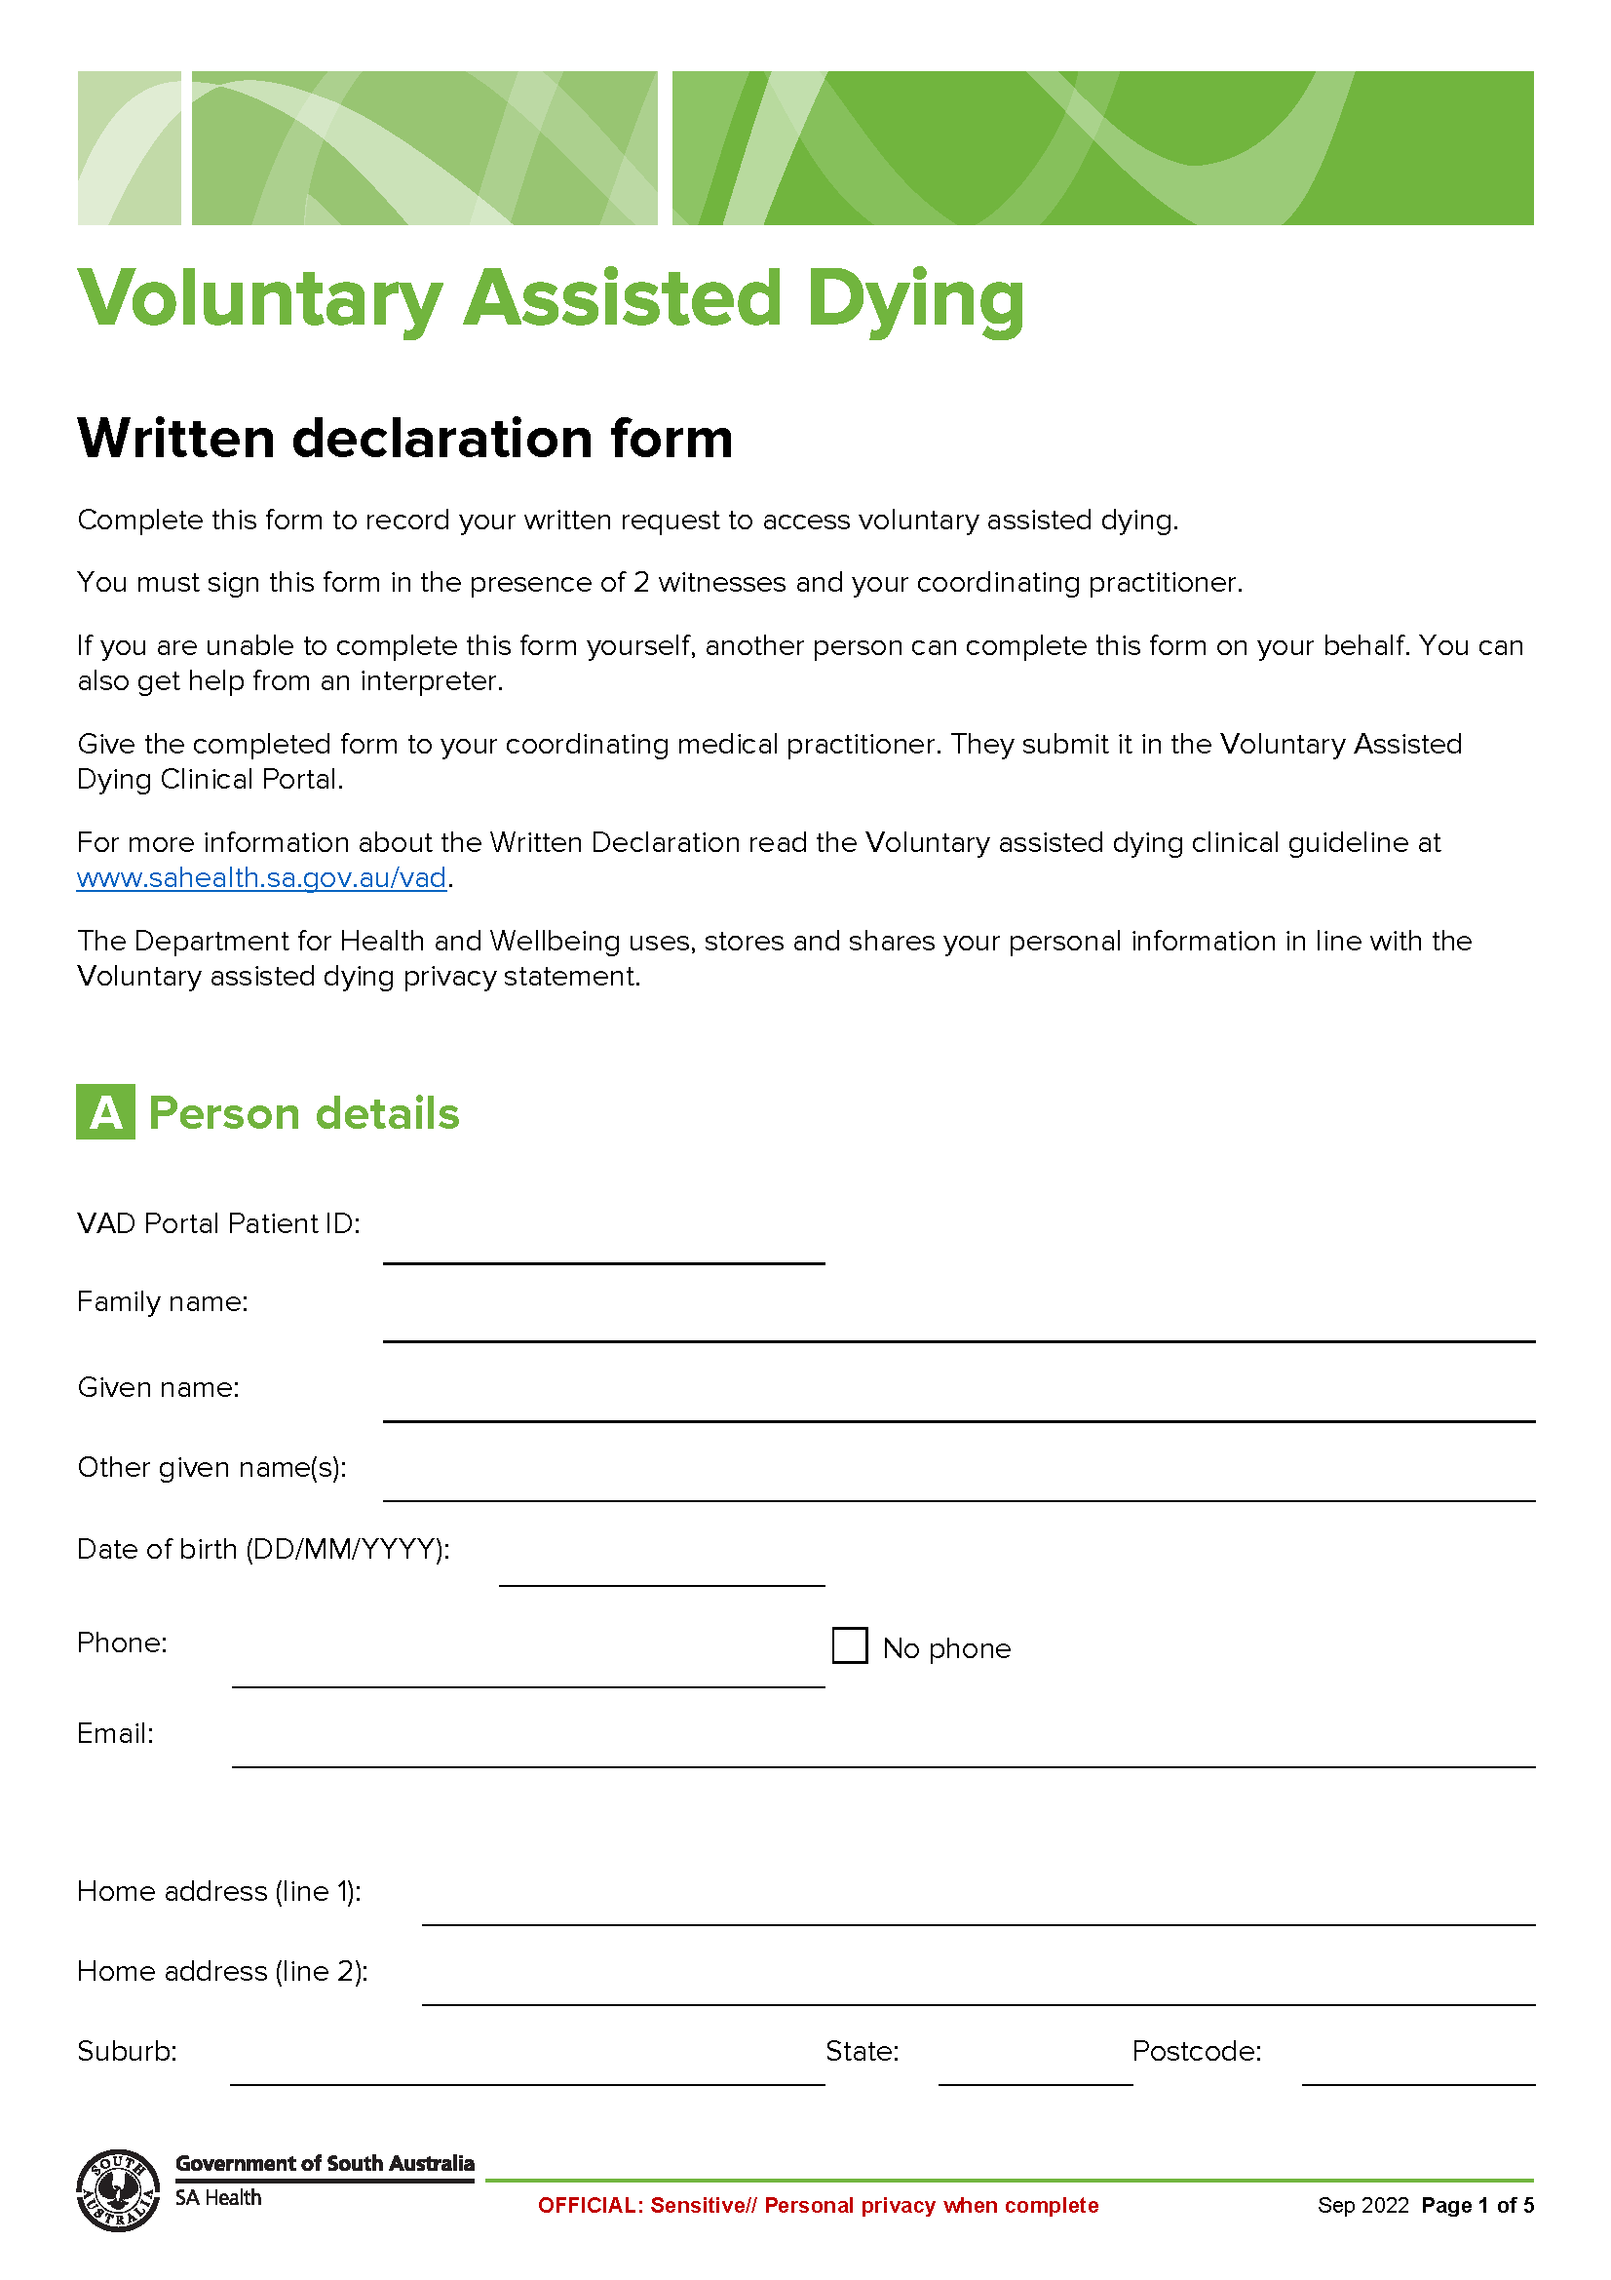
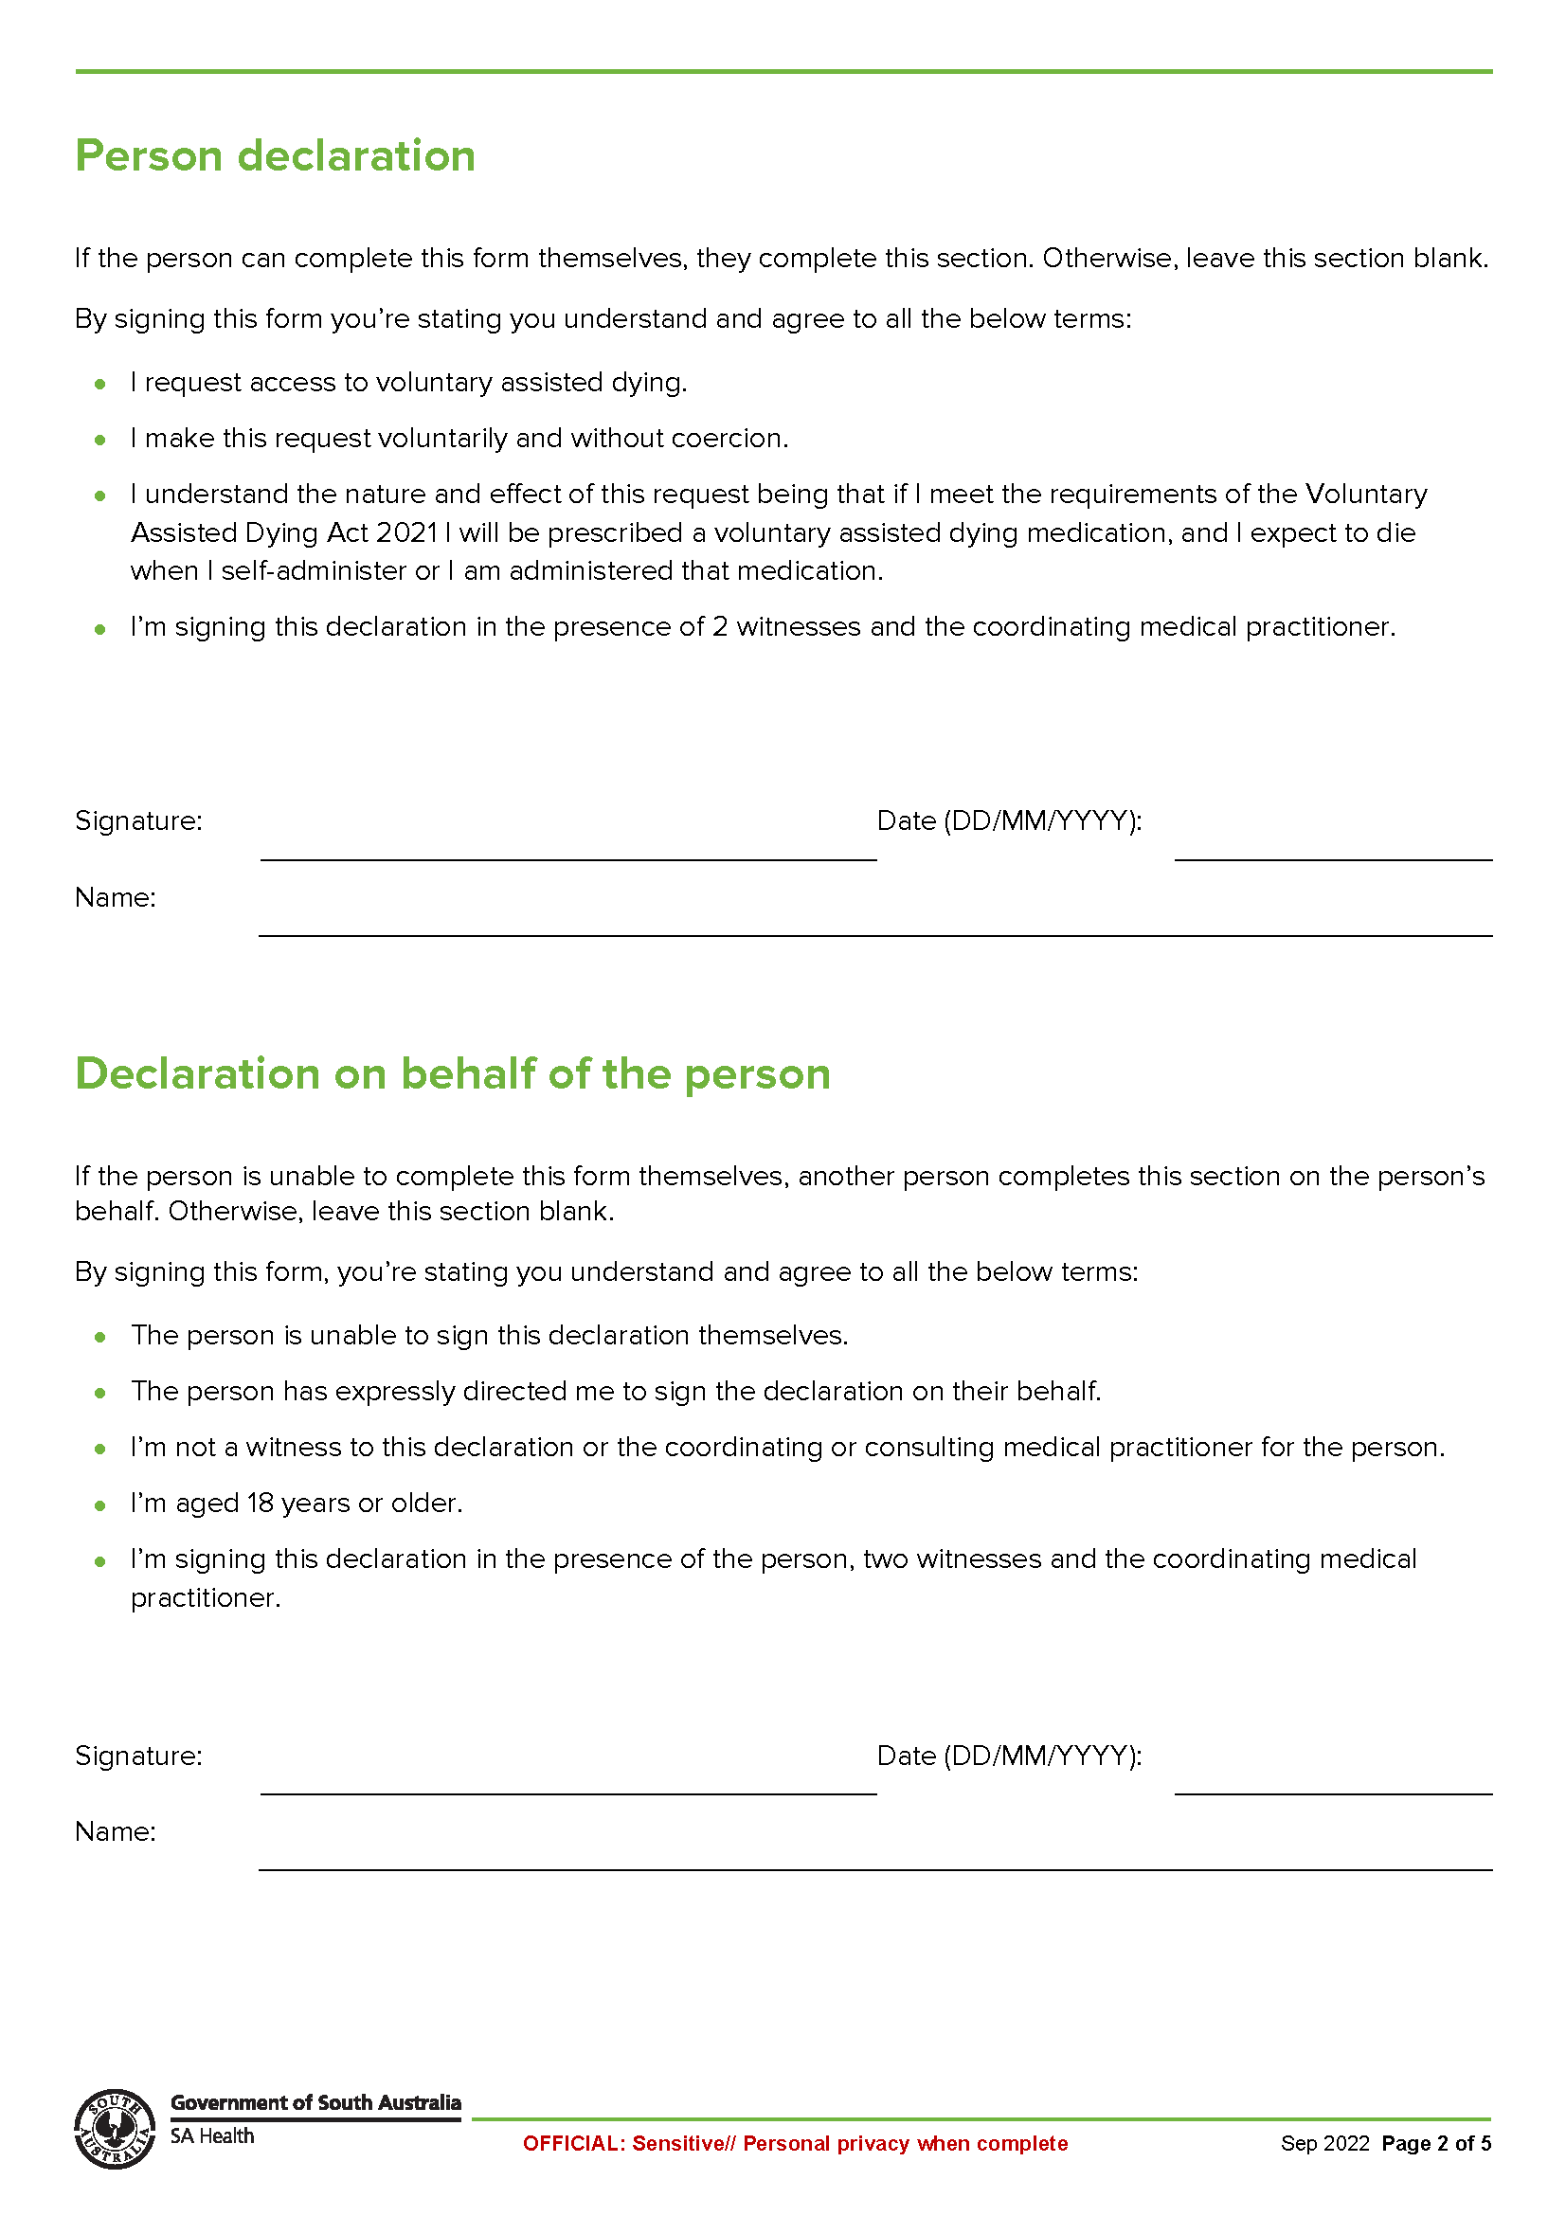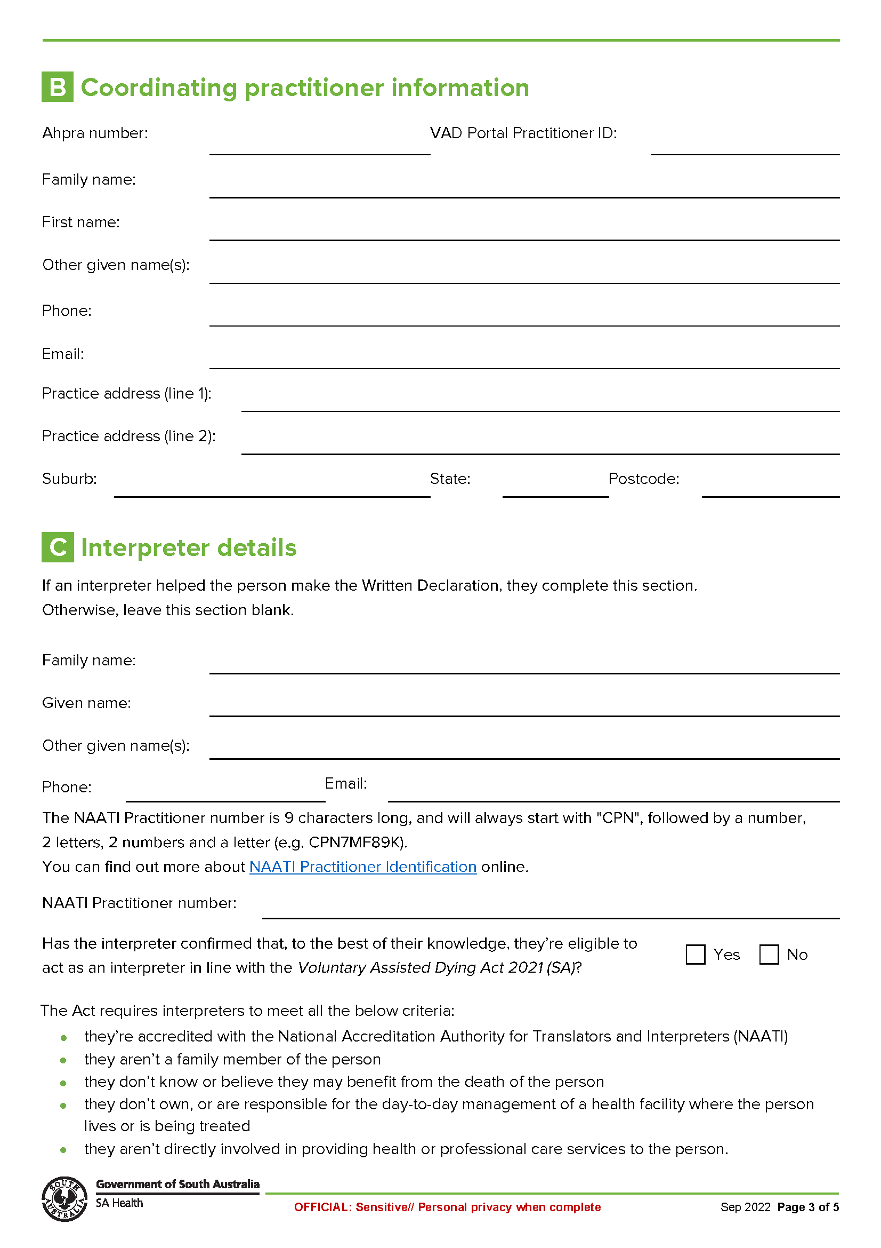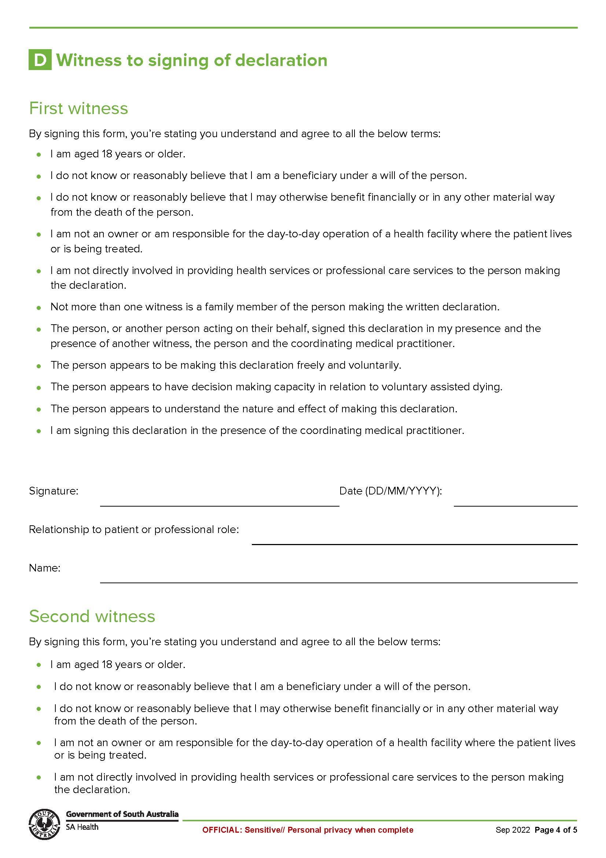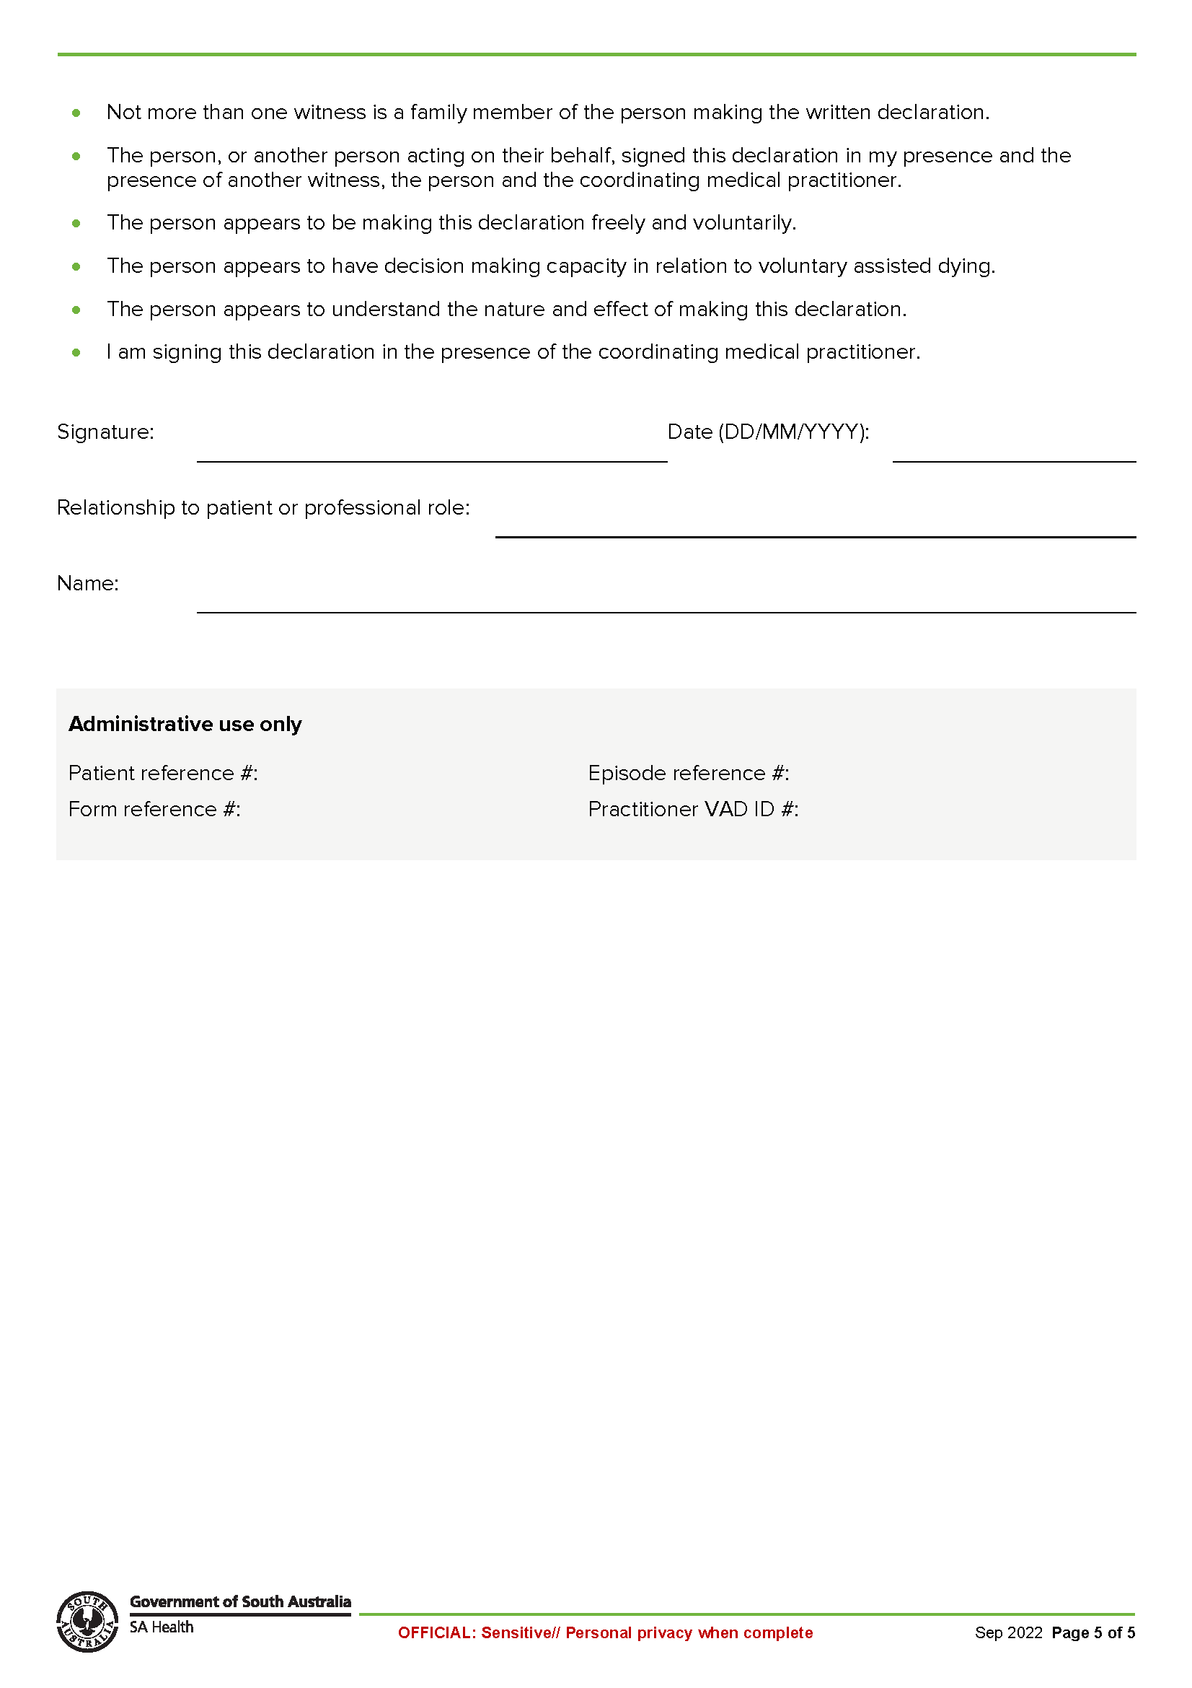
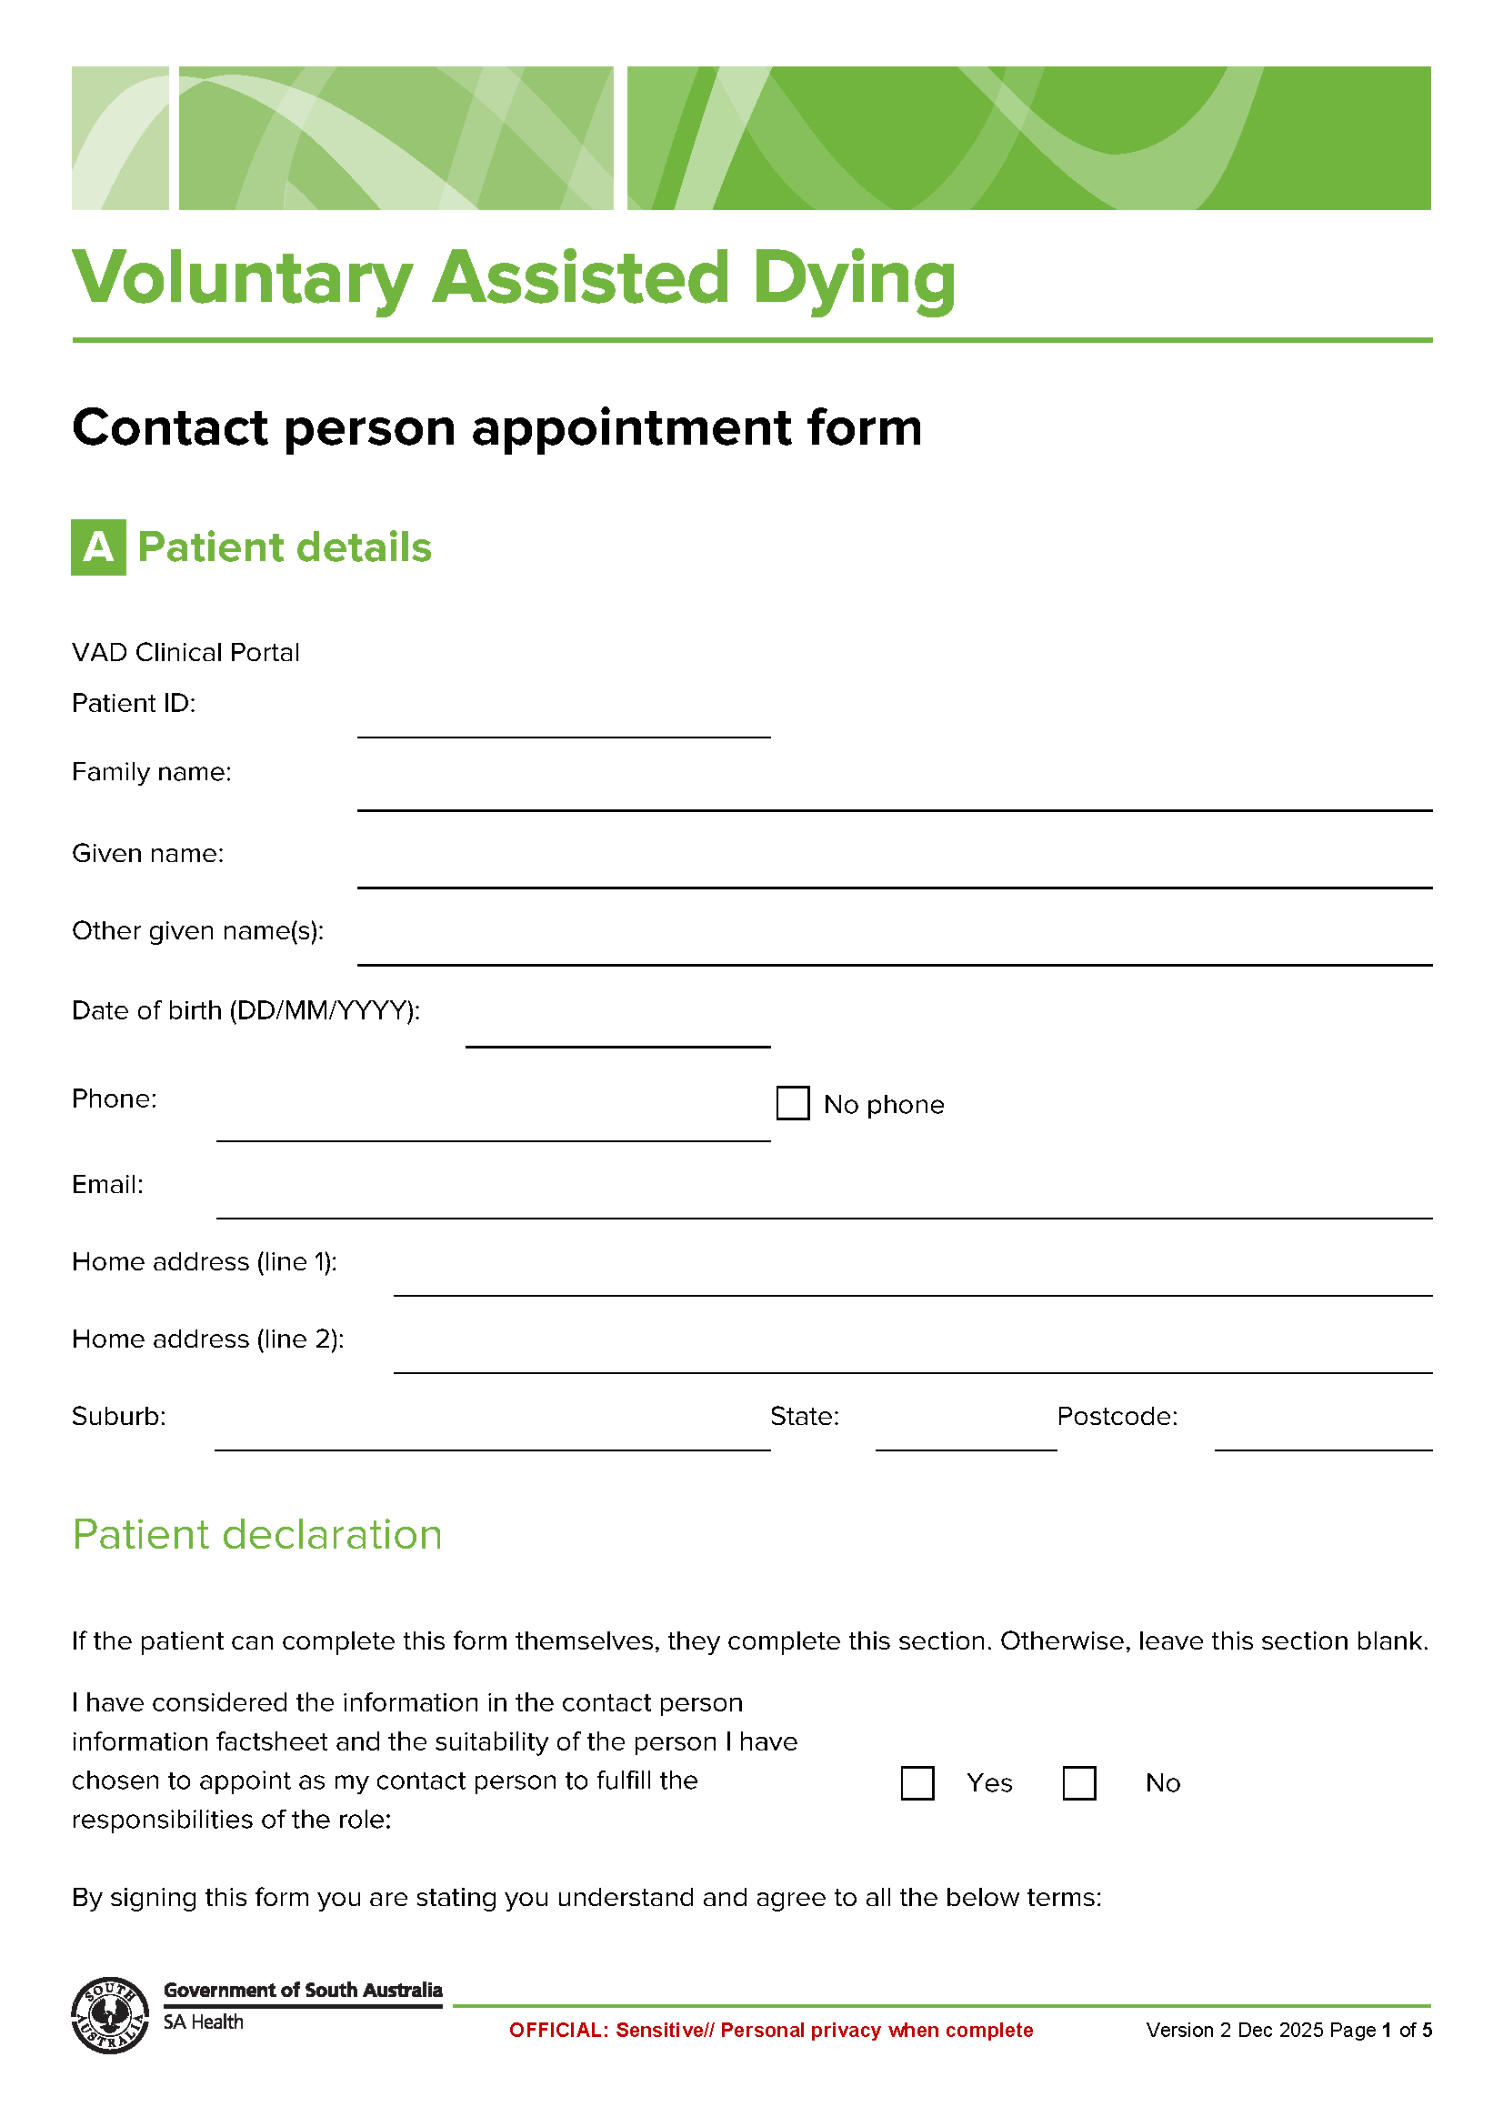
Schedule 4

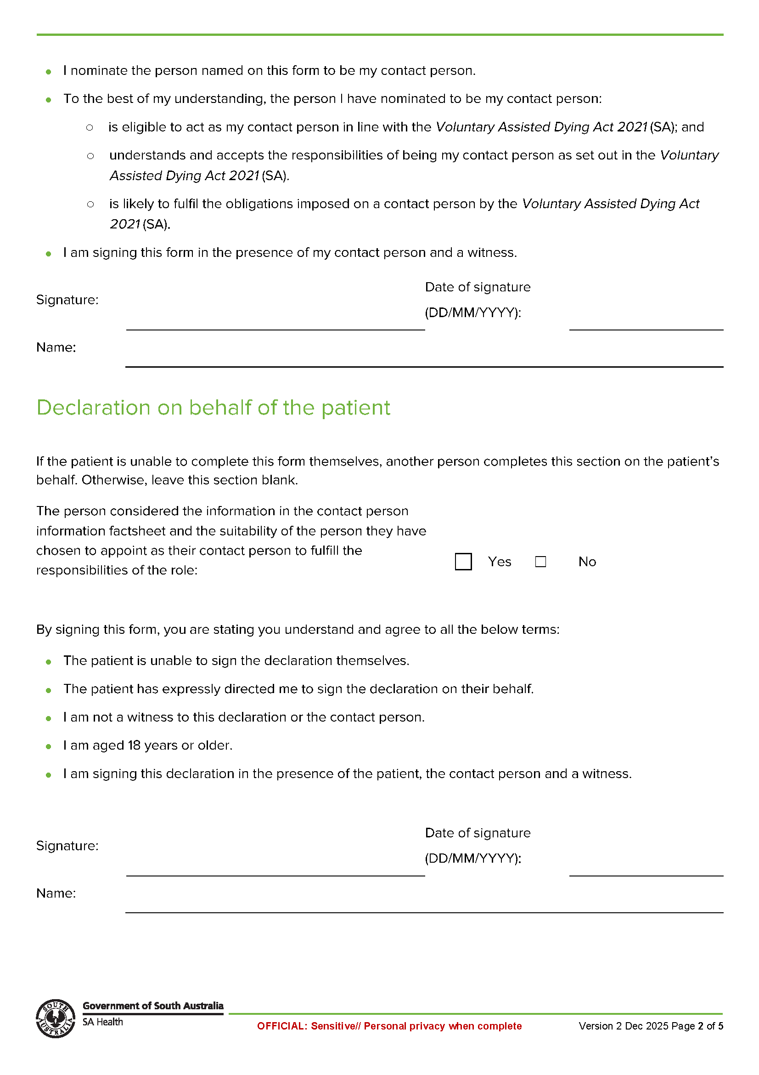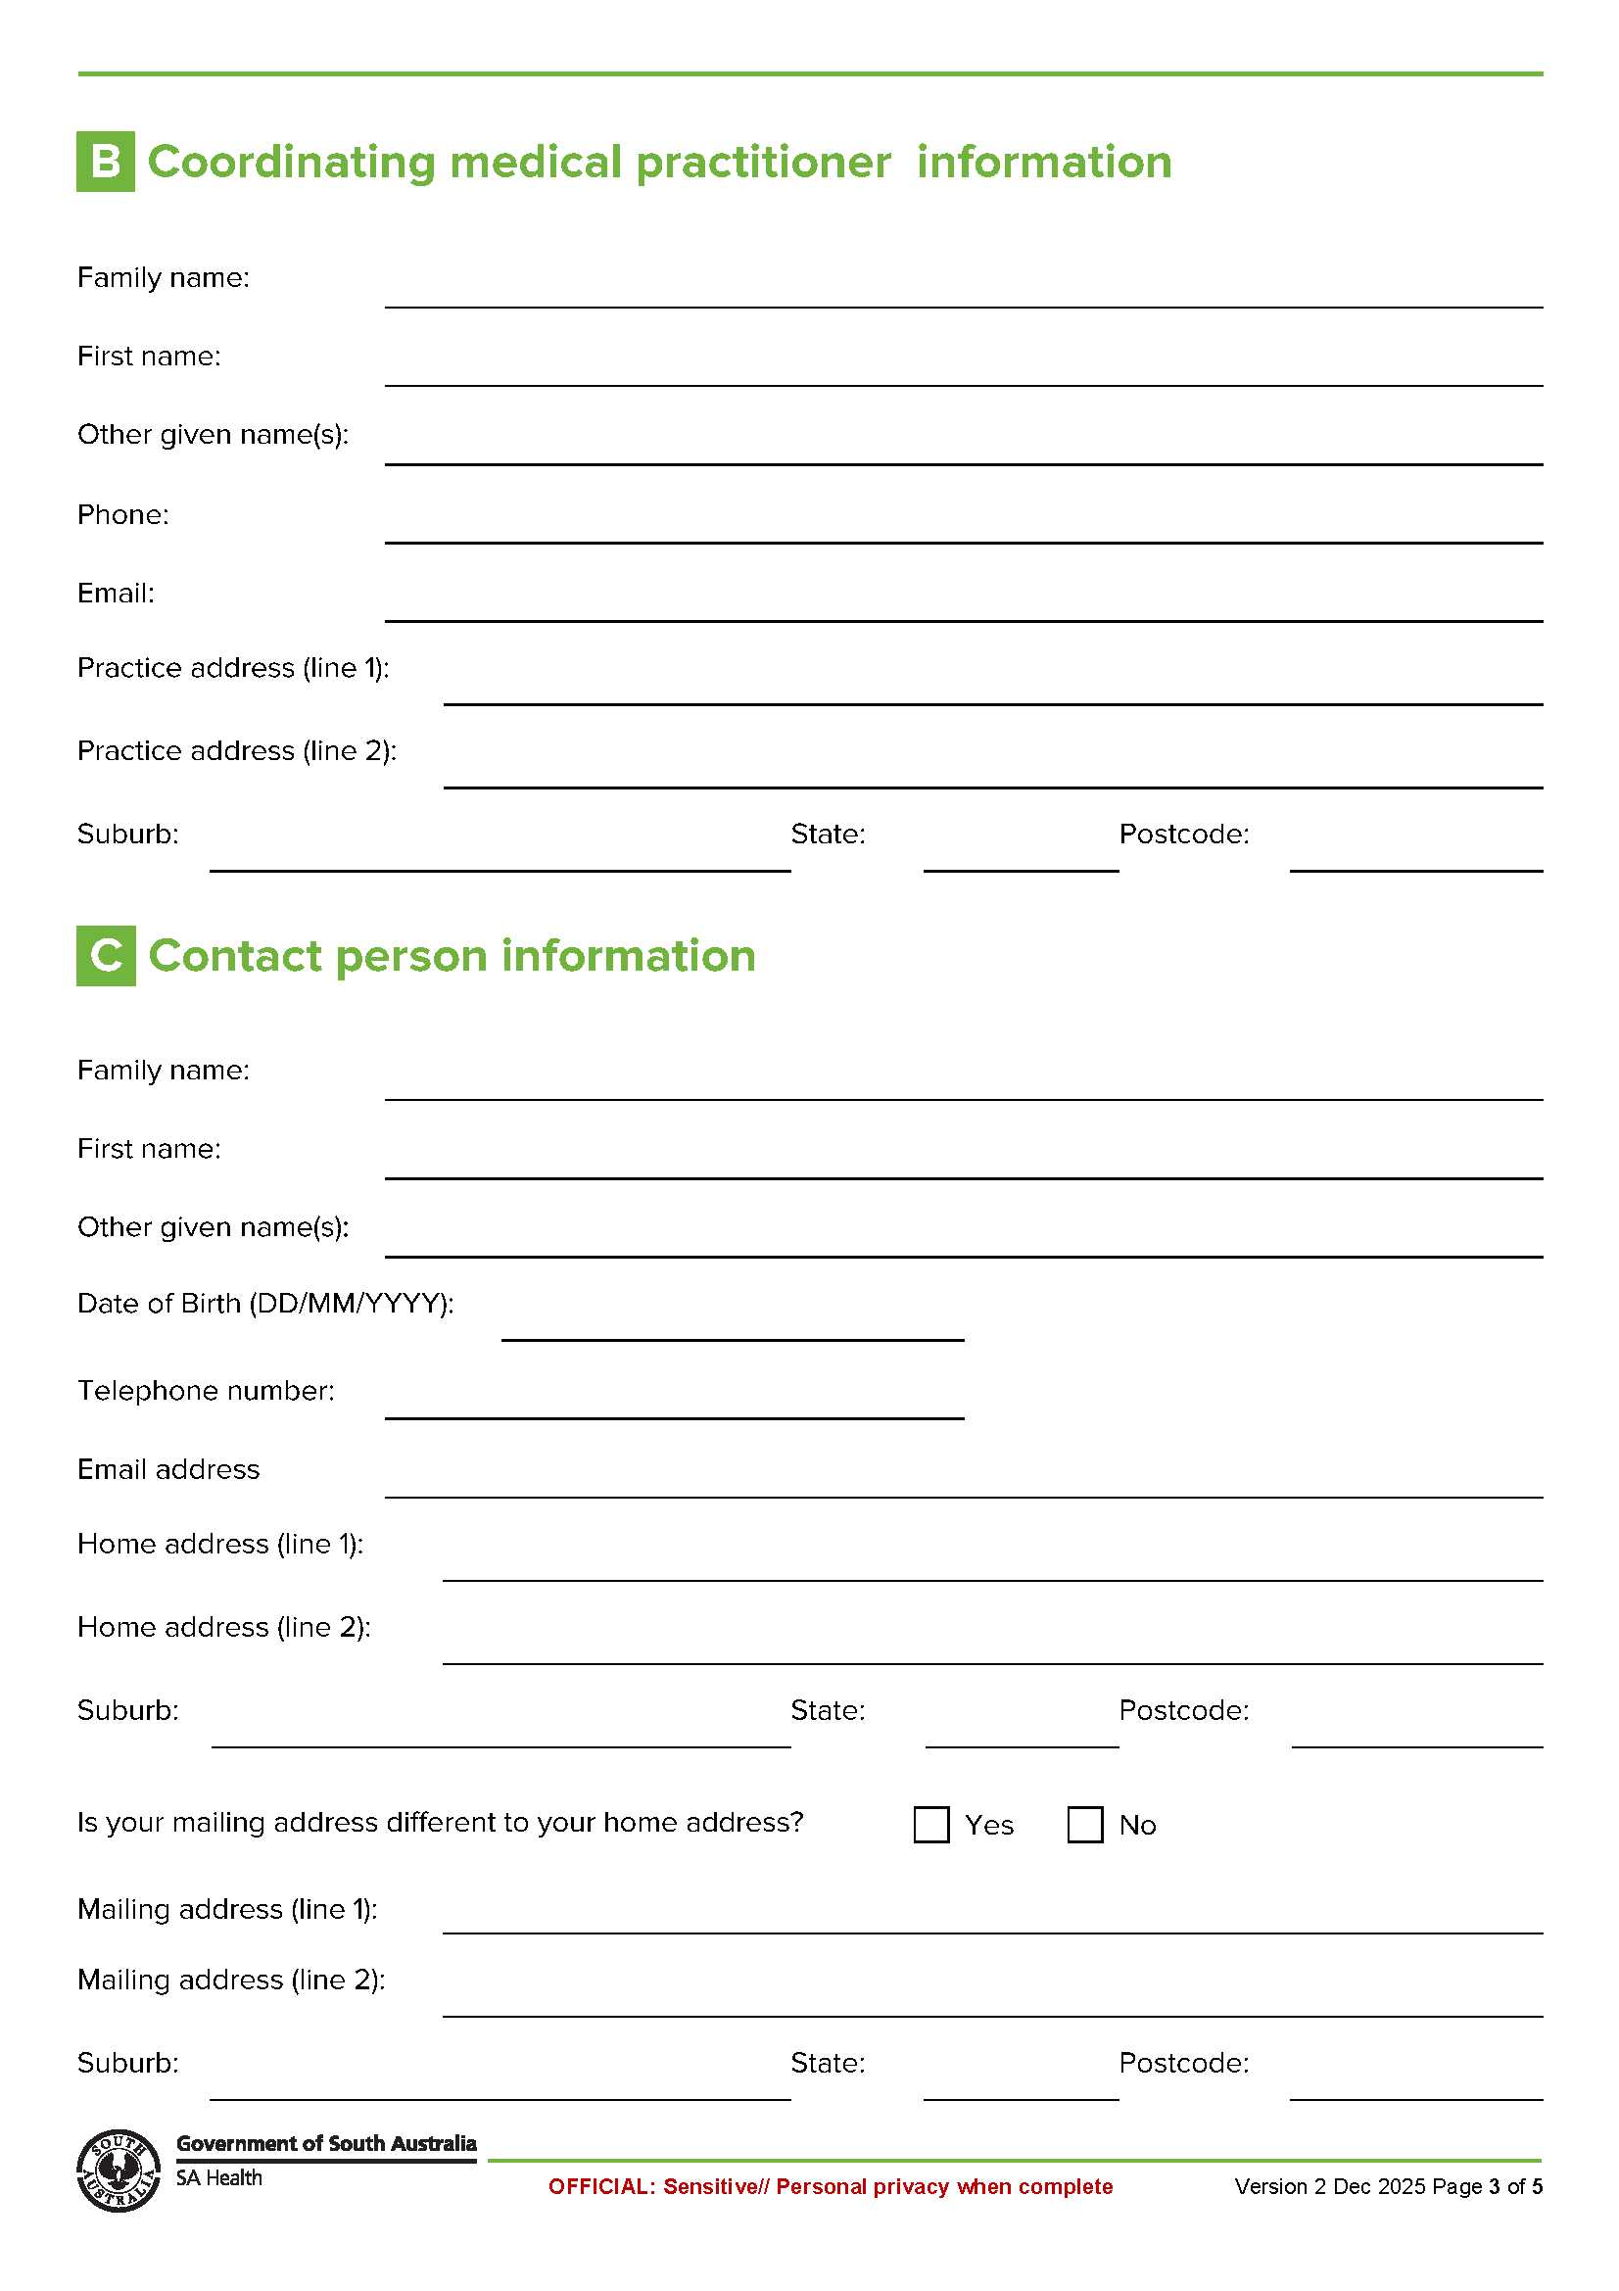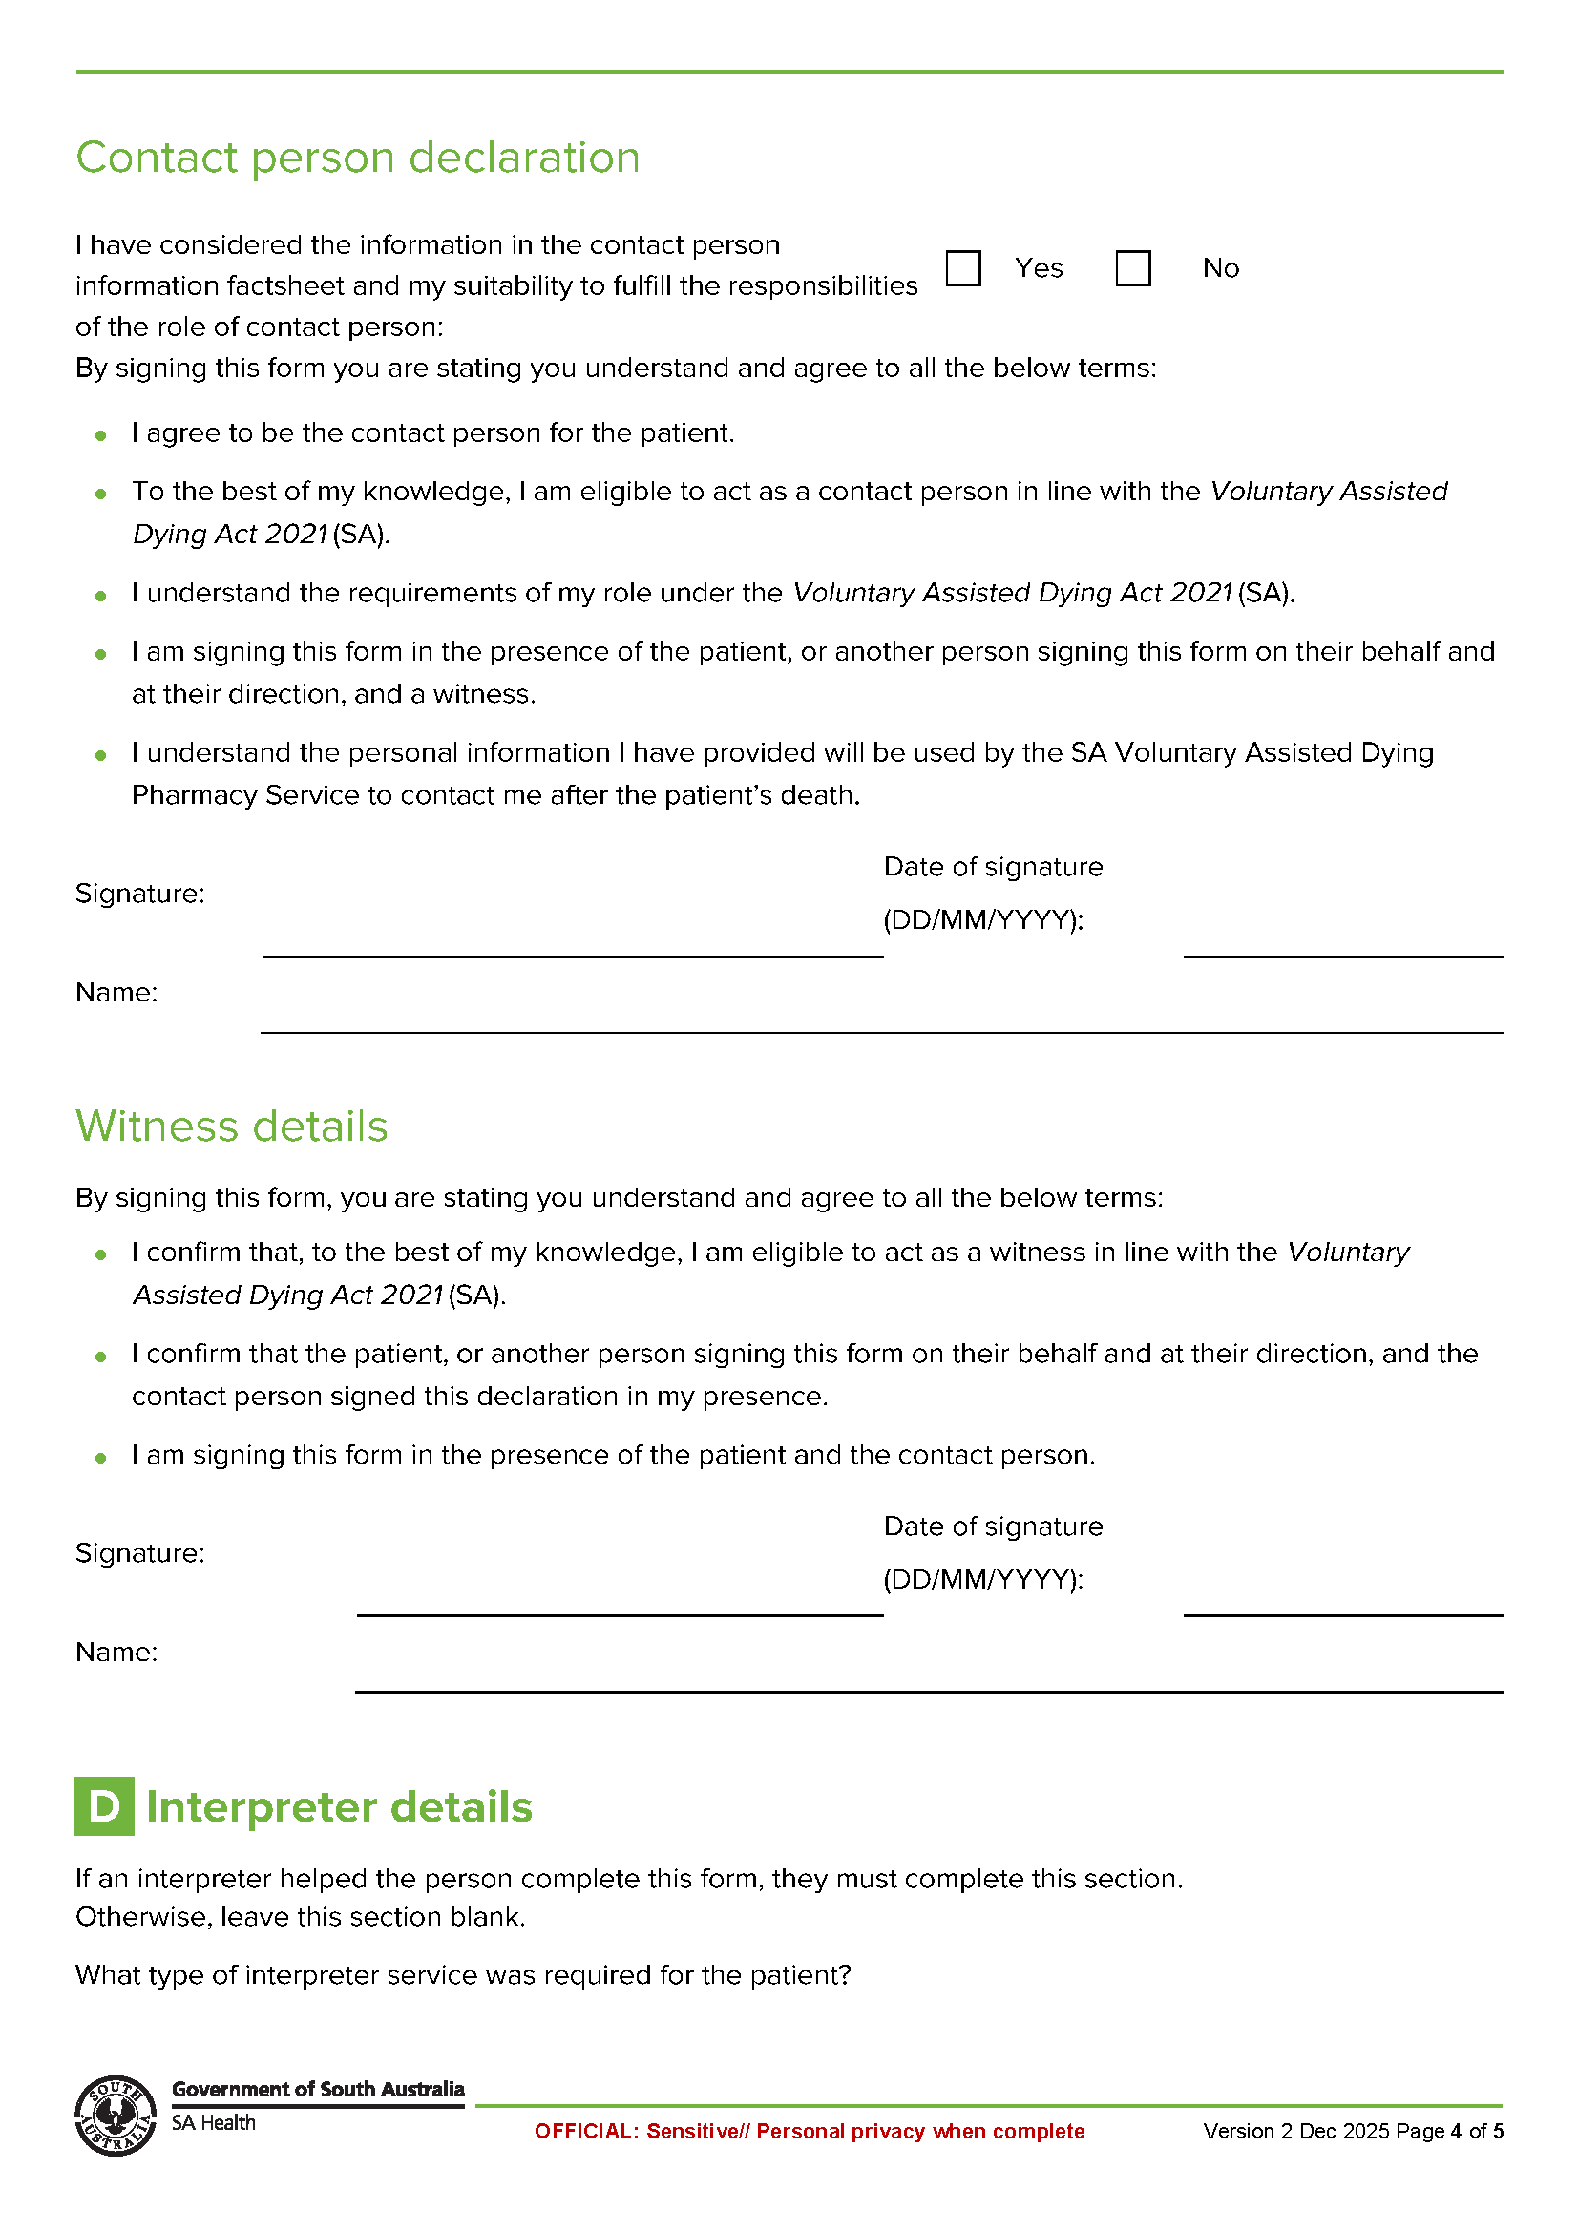

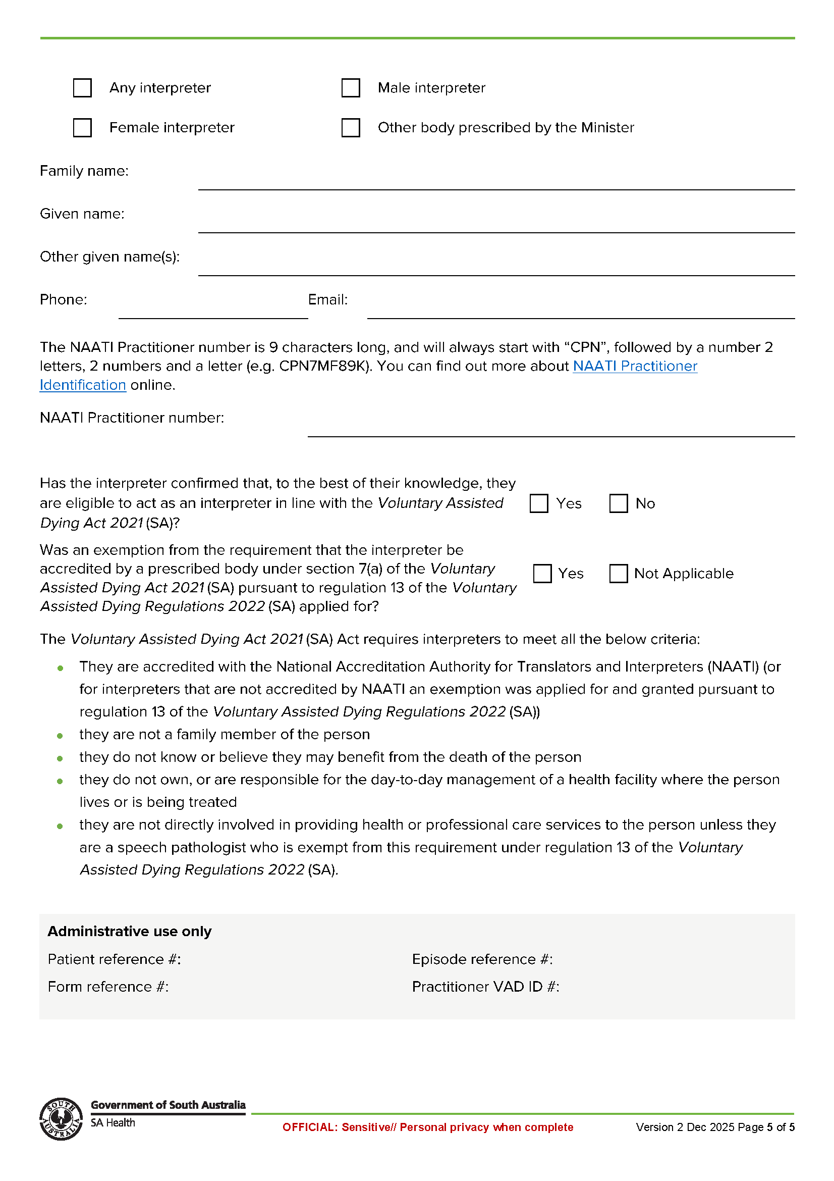

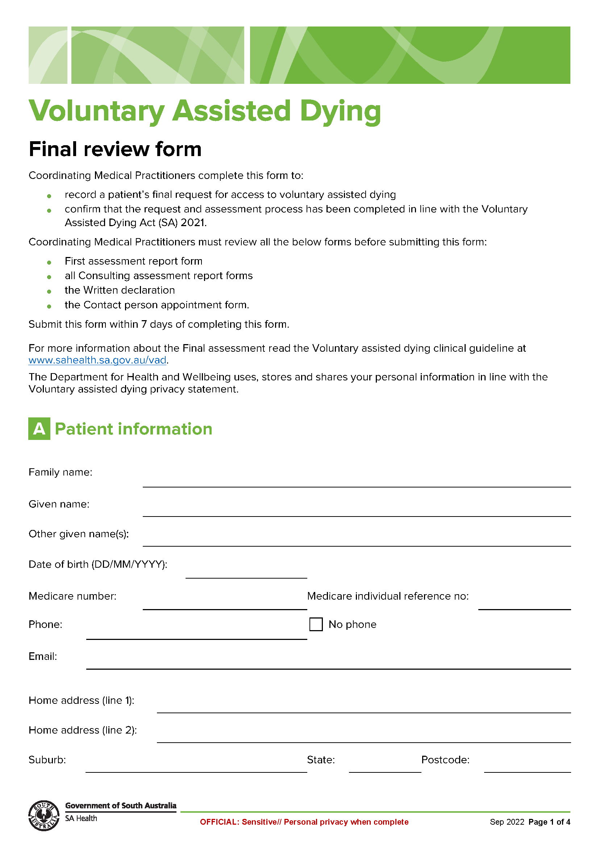
Schedule 5

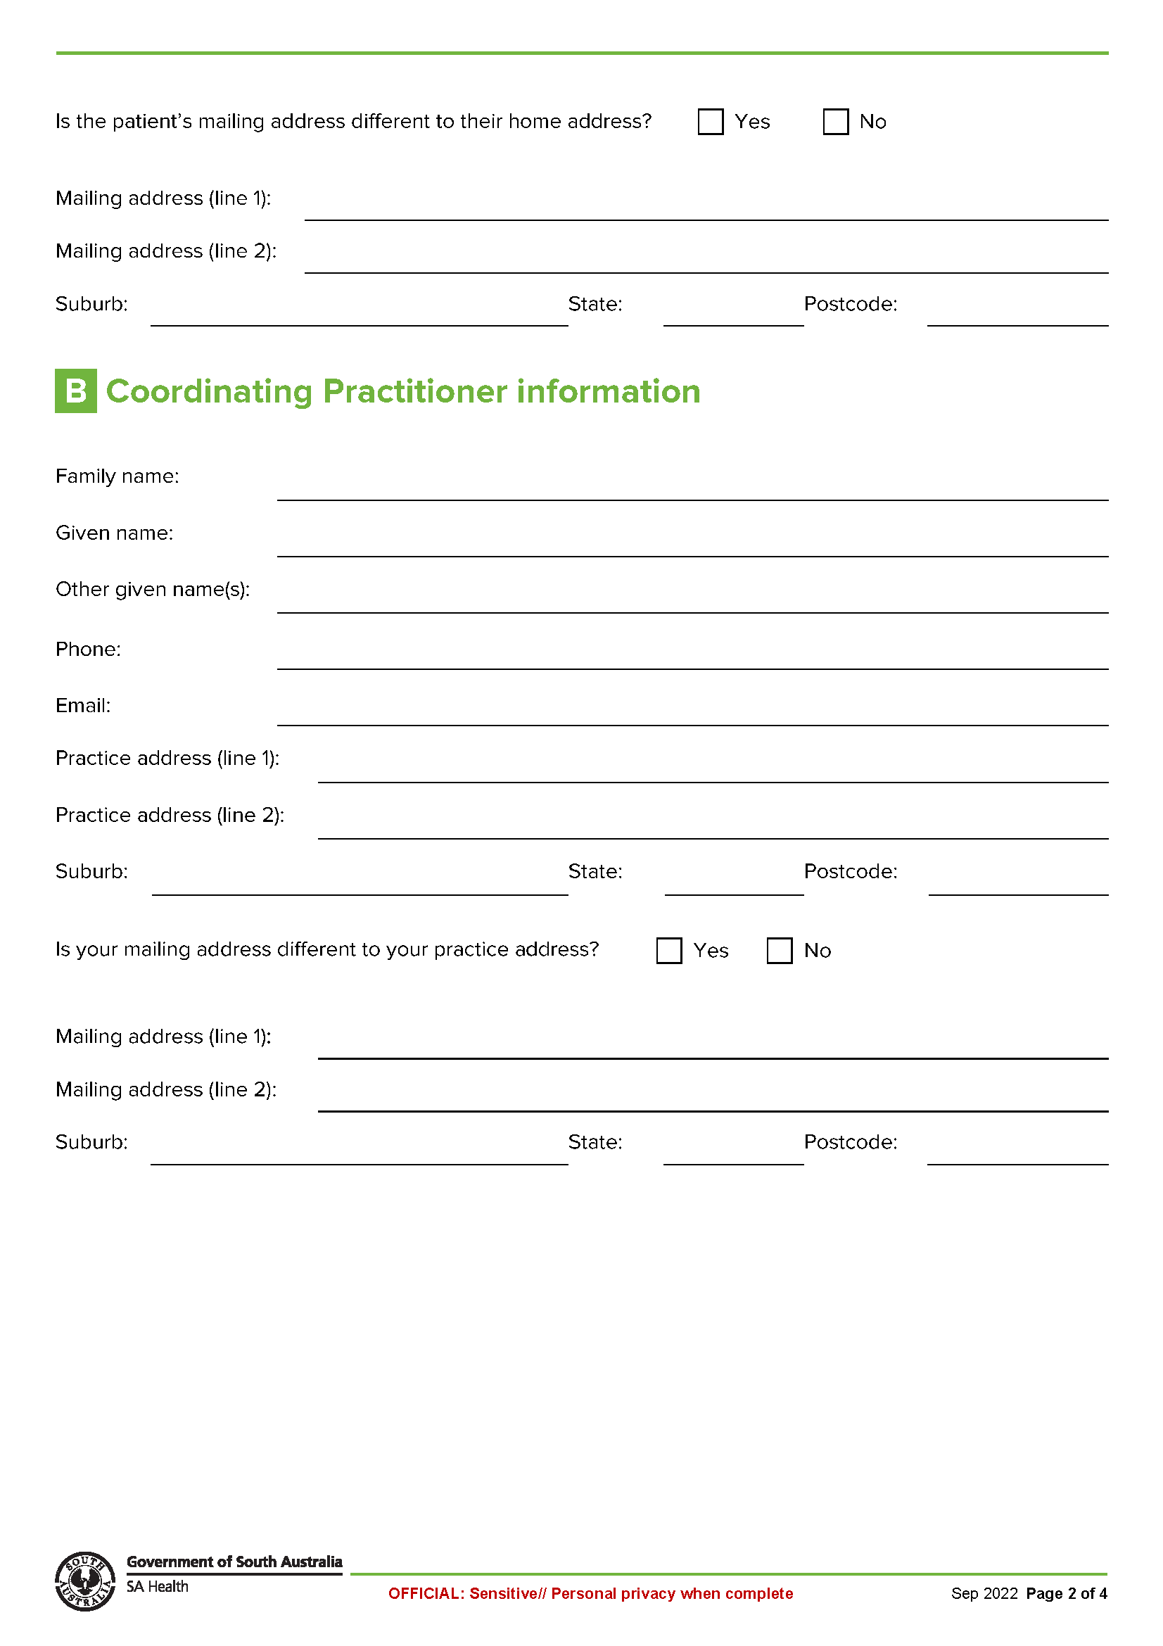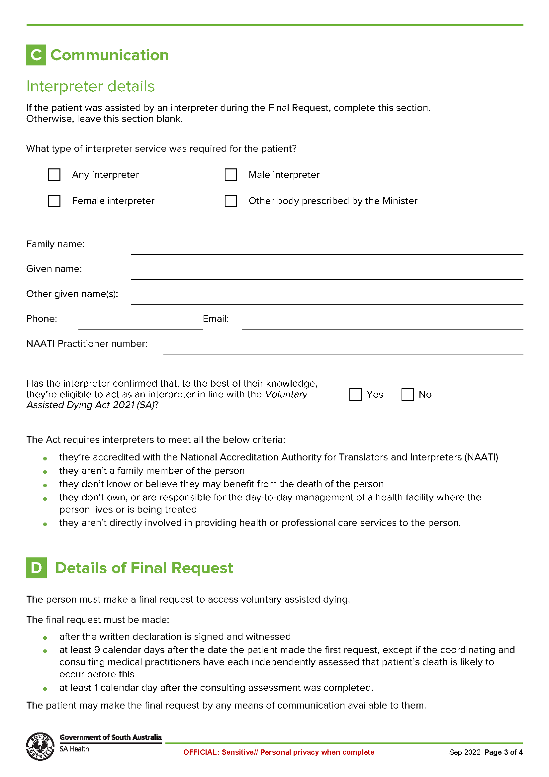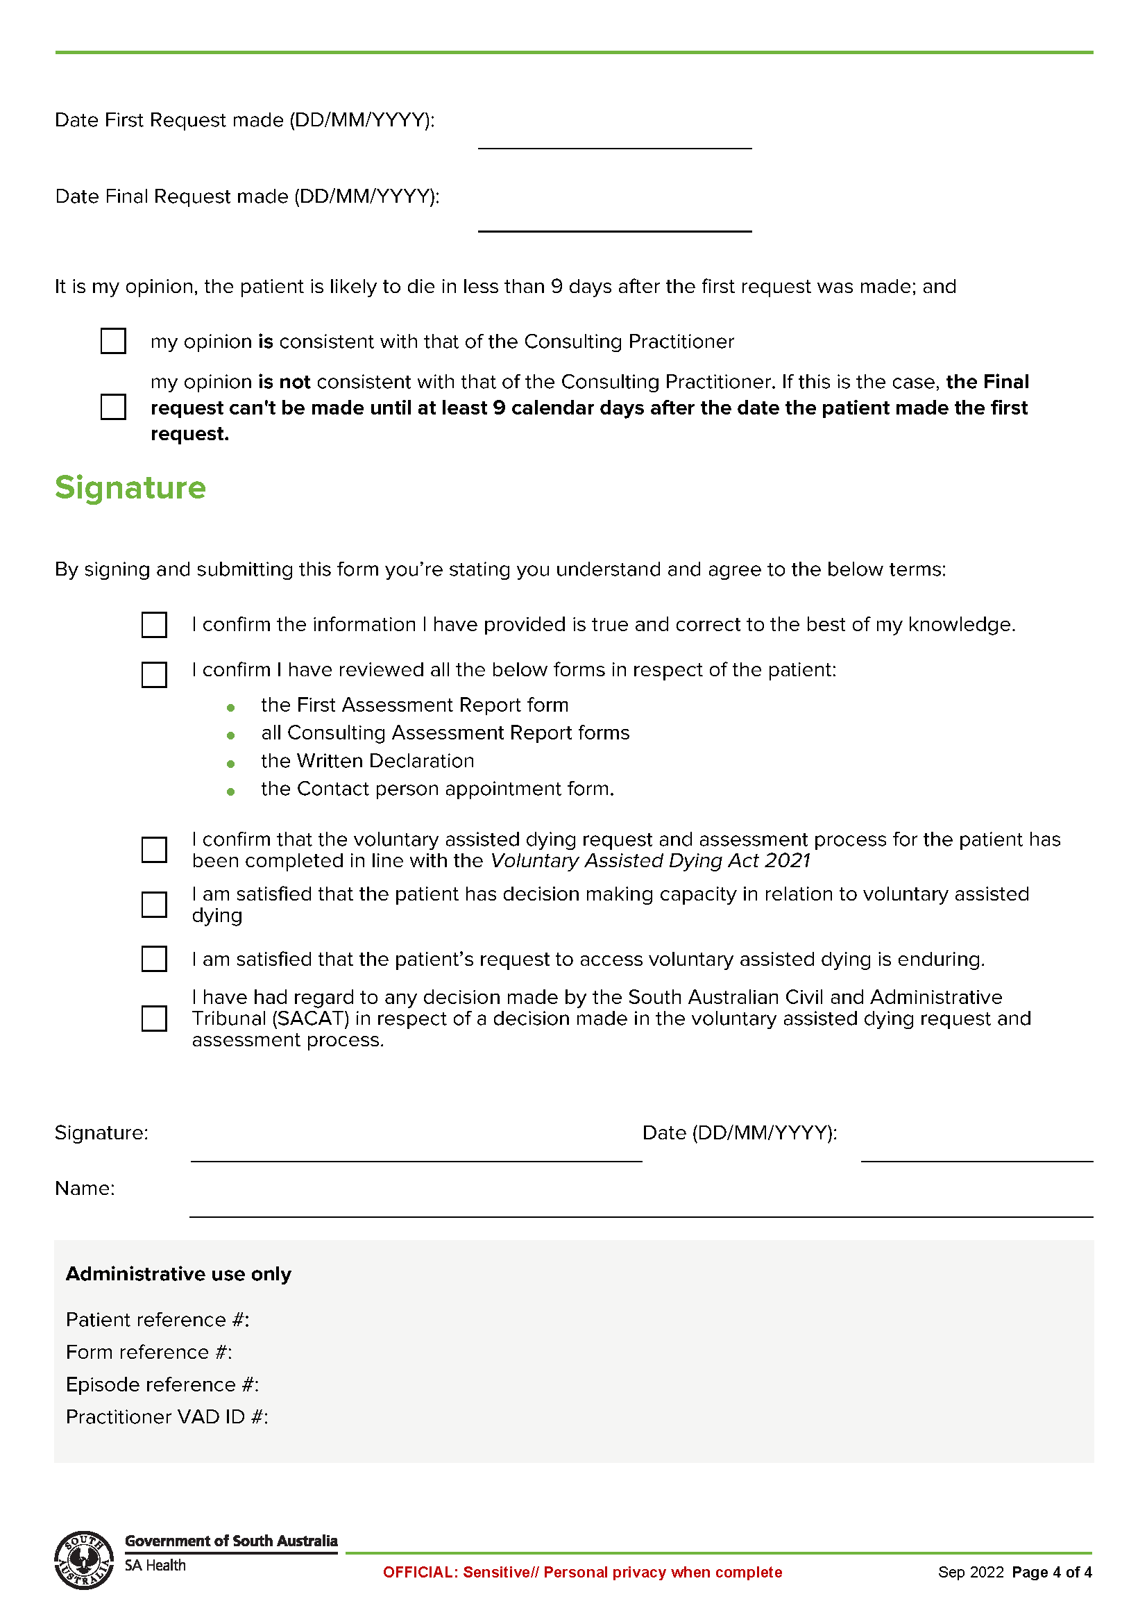
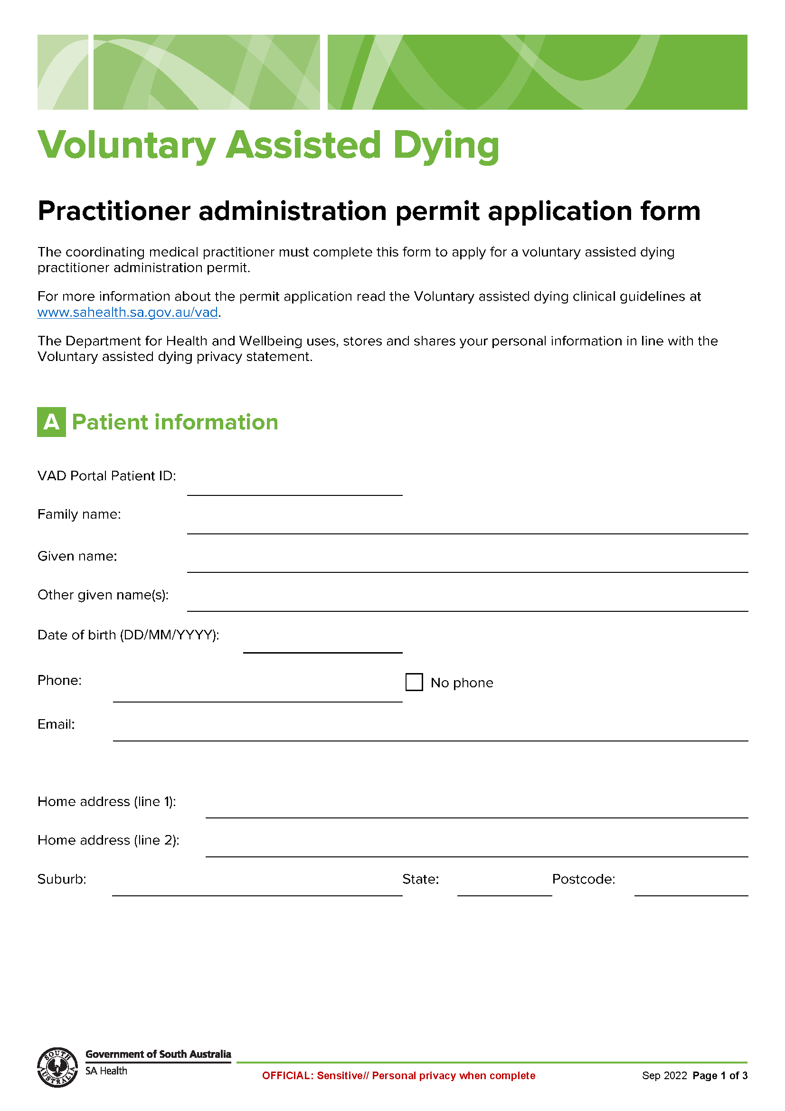
Schedule 6

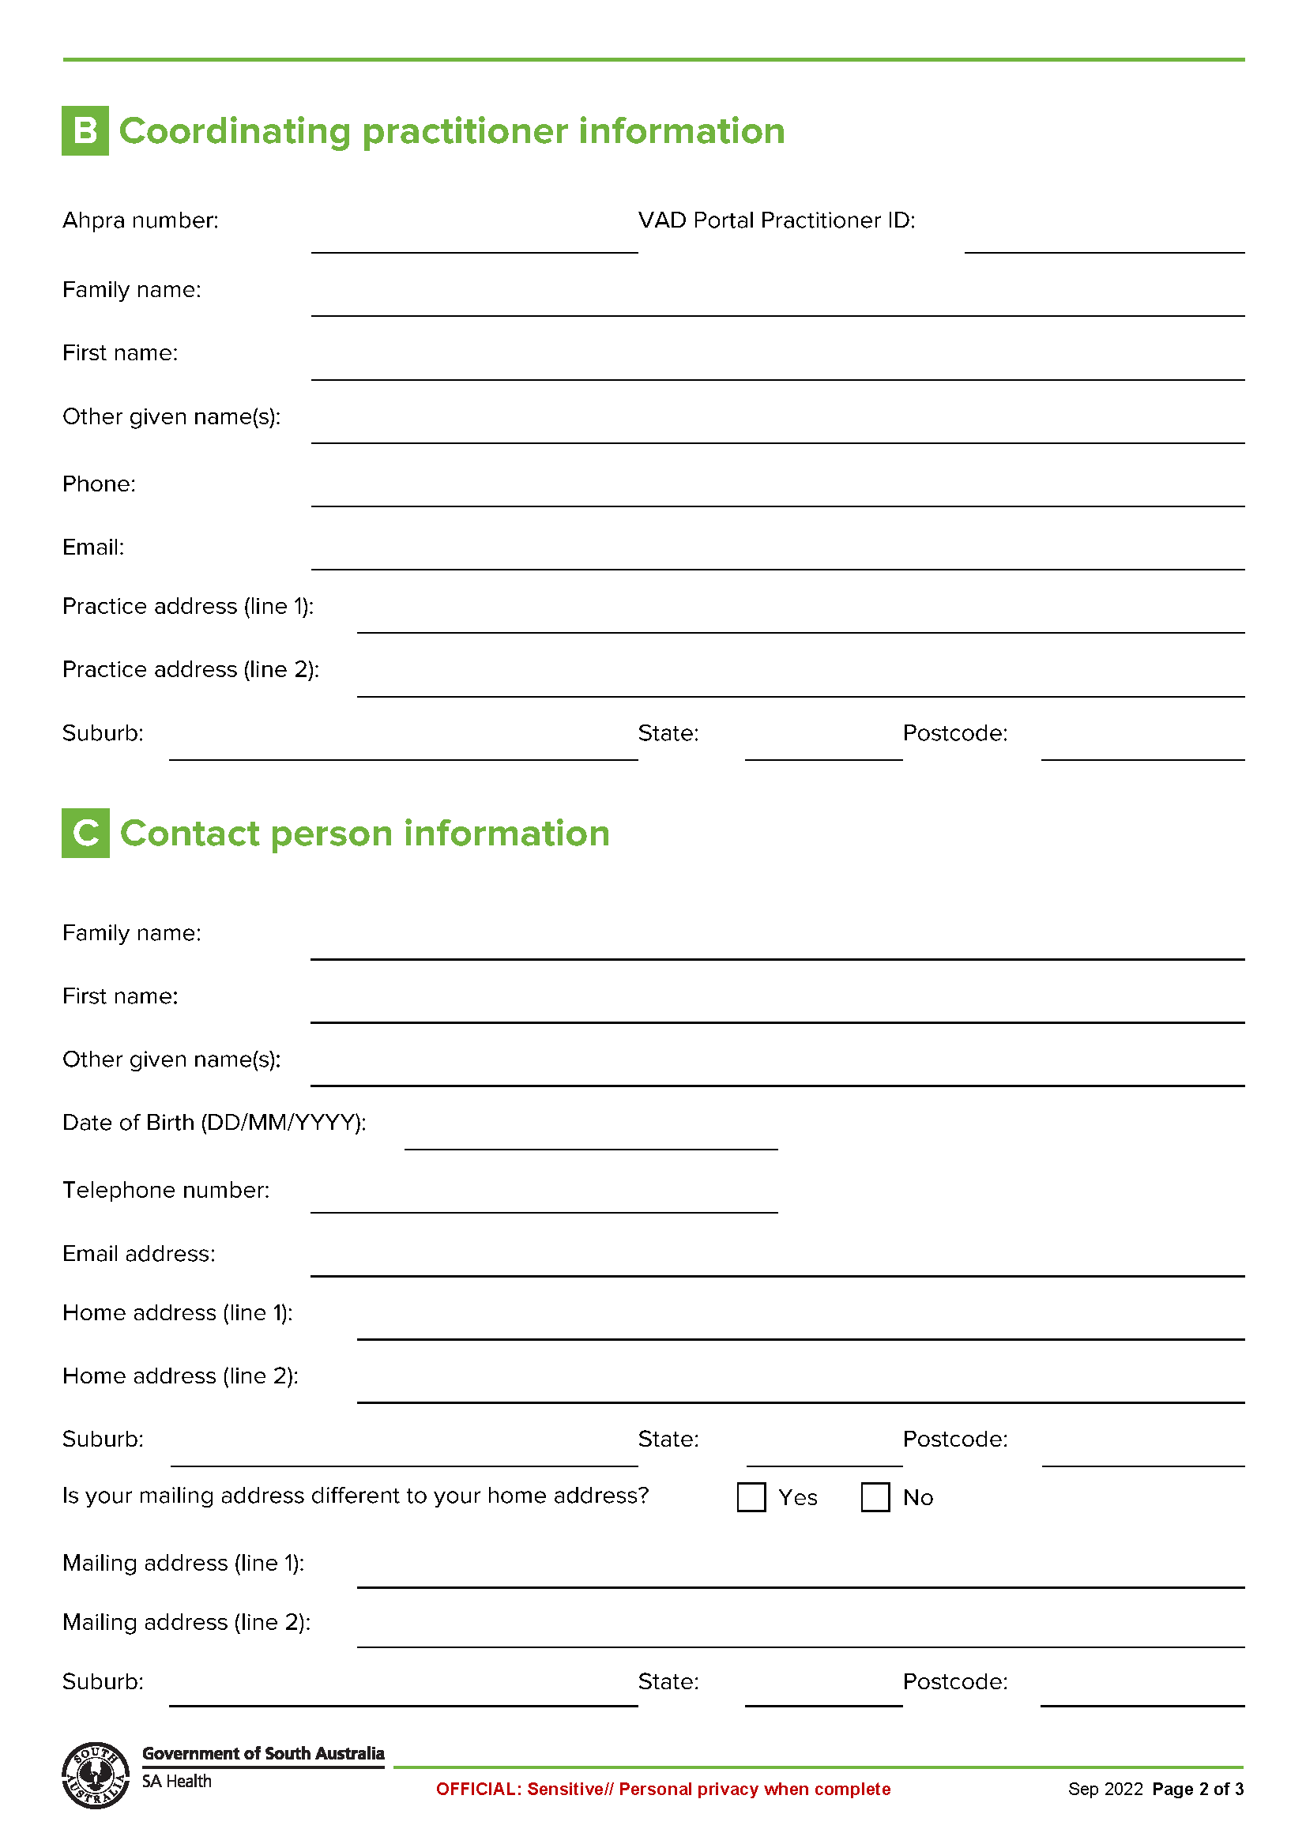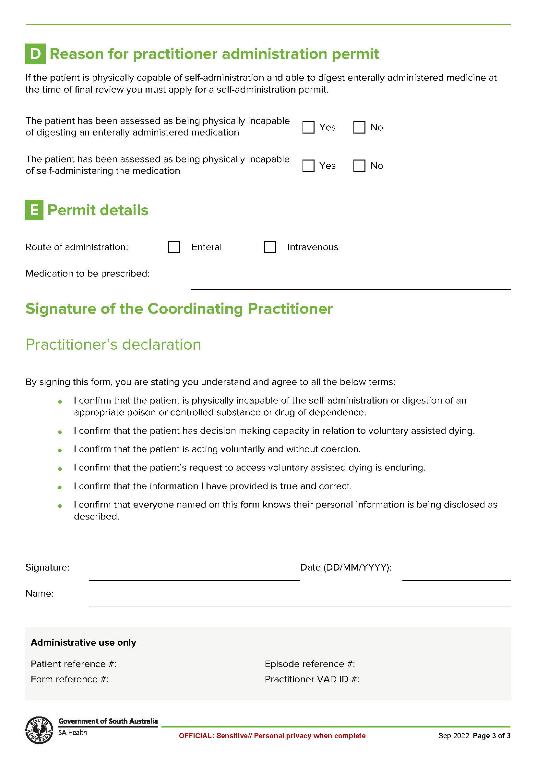

Schedule 7
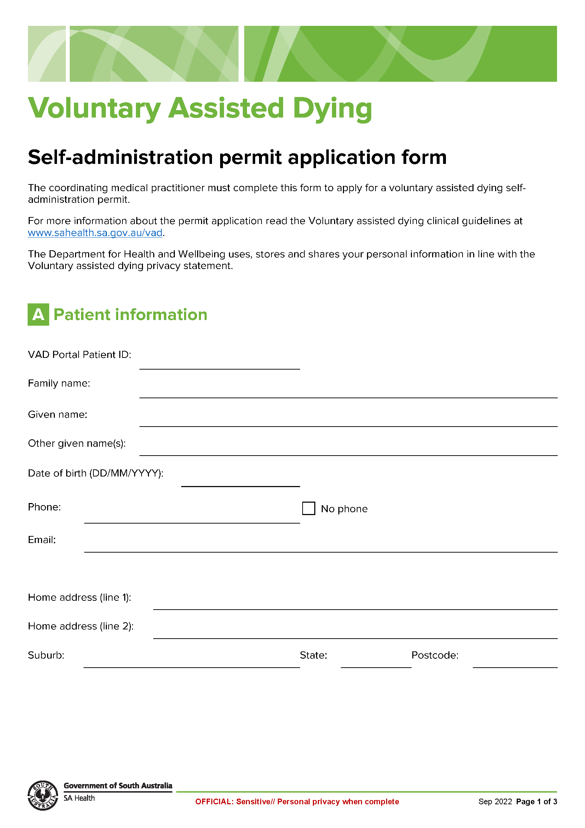
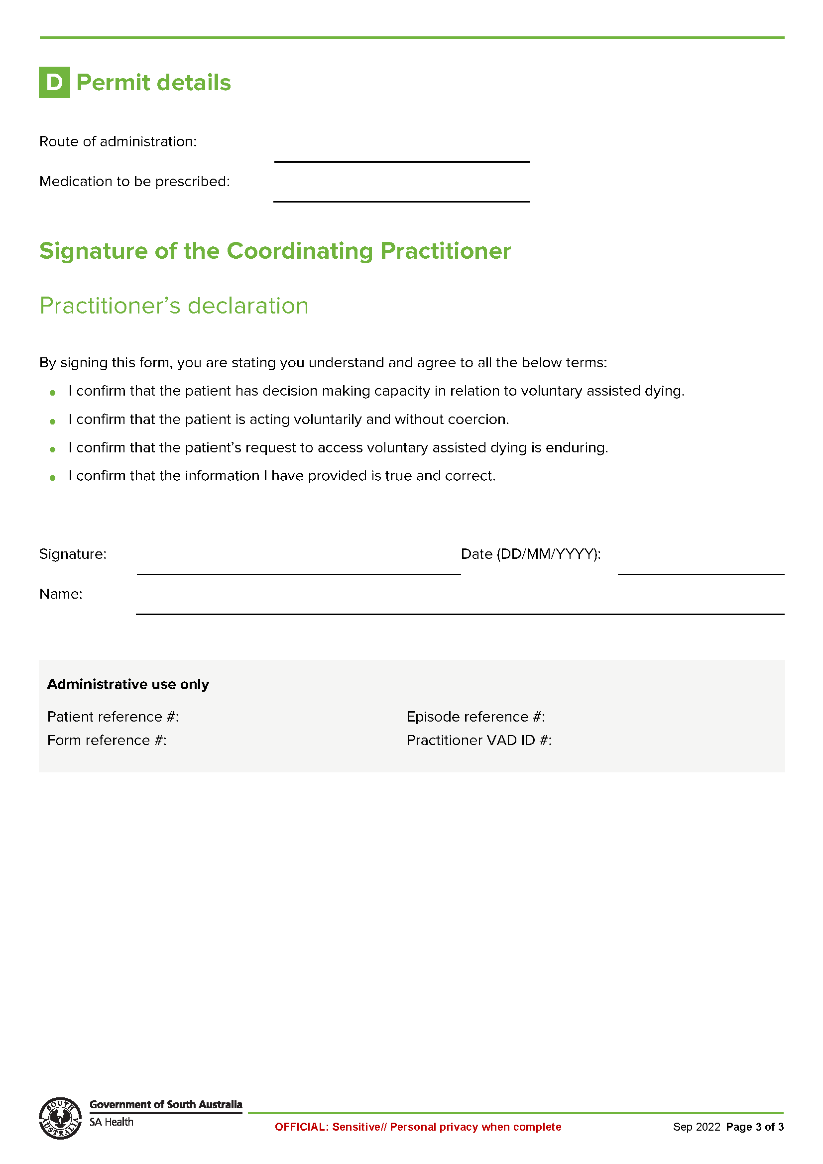

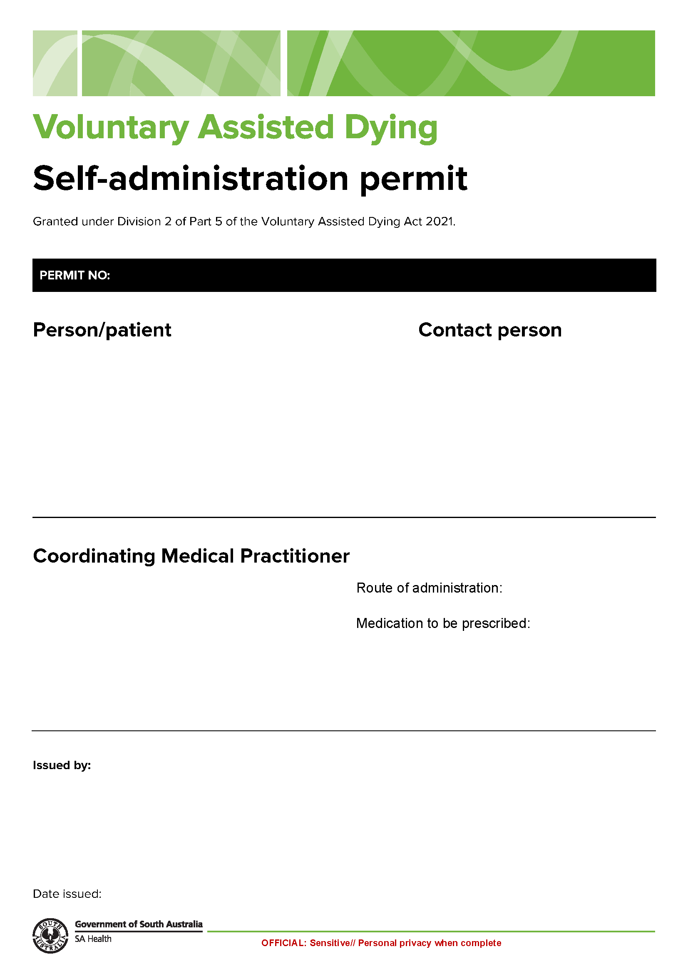
Schedule 8

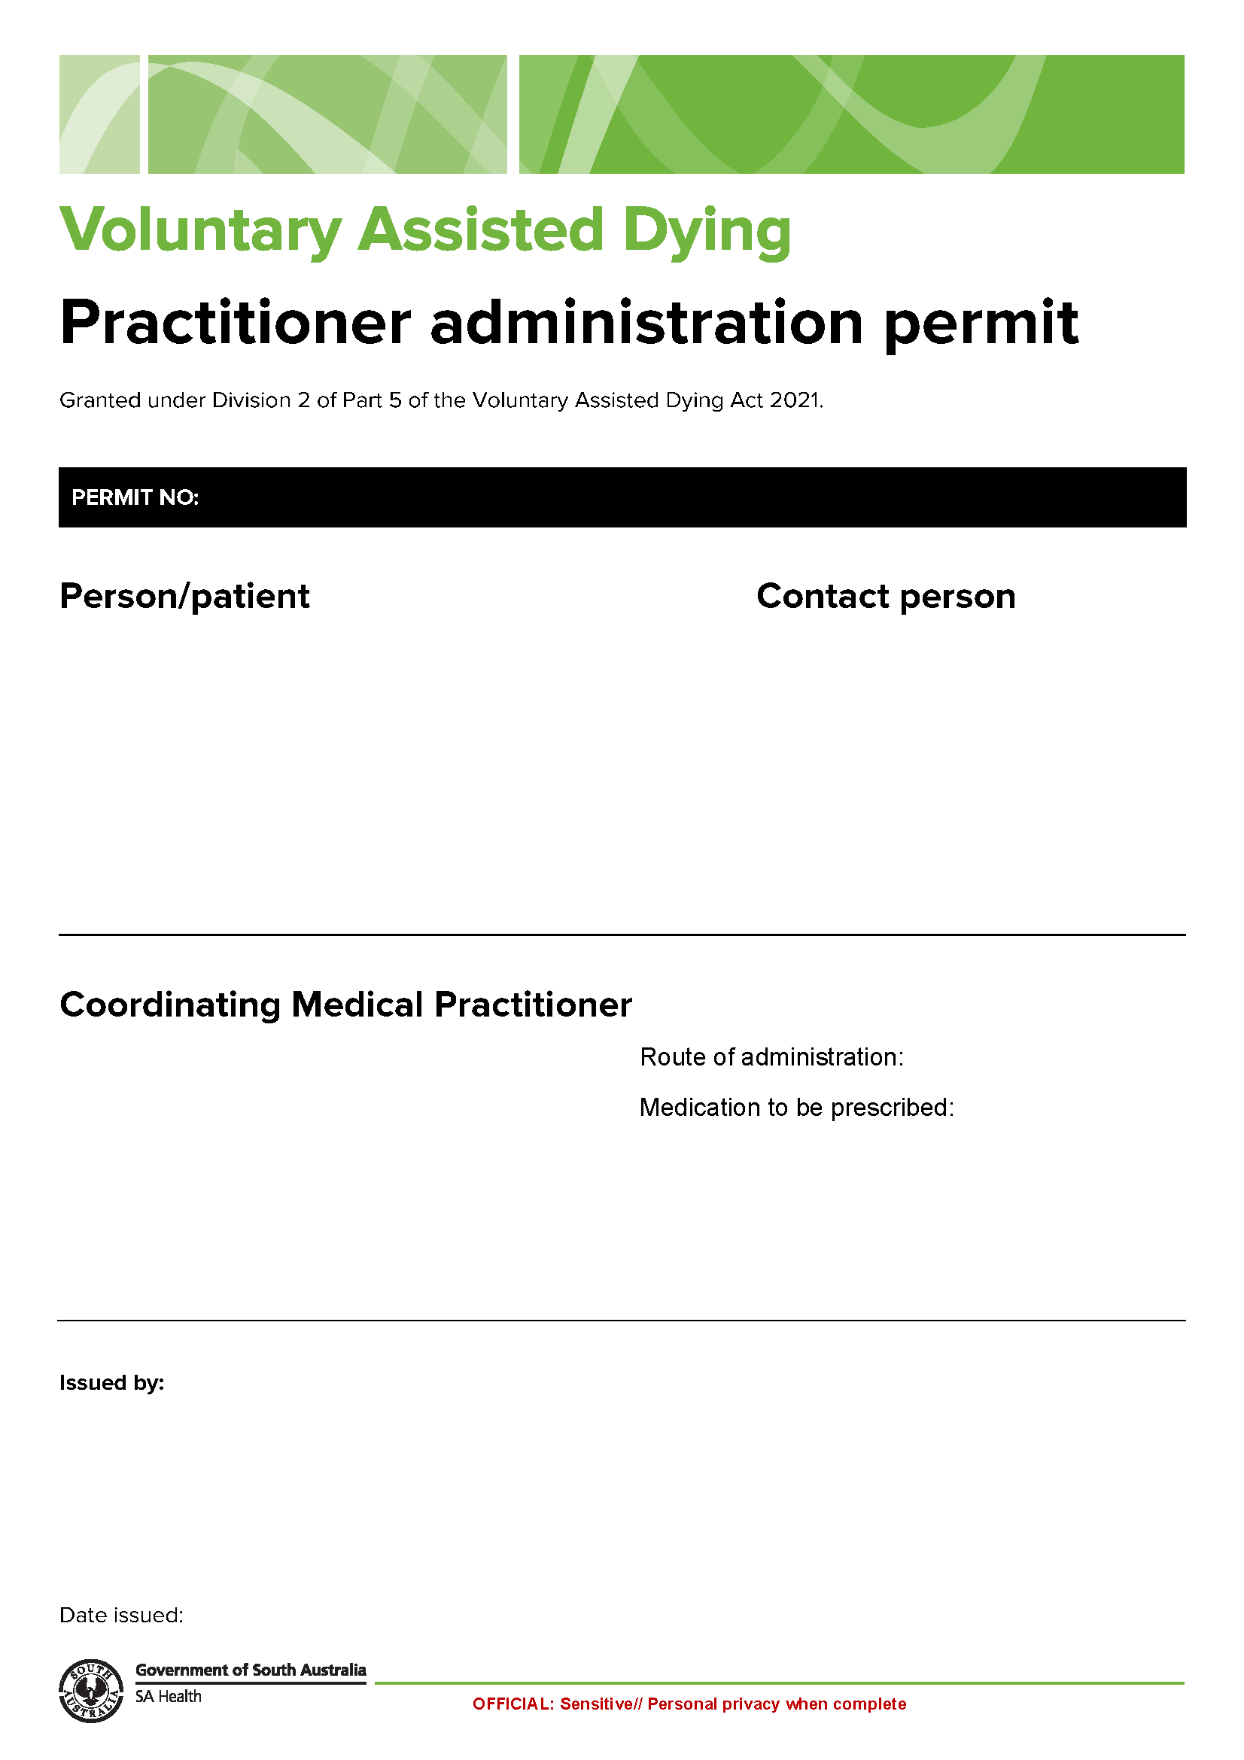
Schedule 9
Labelling Statement for the Voluntary Assisted Dying Substance

WARNING: IF INGESTED THIS MEDICINE WILL CAUSE DEATH

This medicine has been supplied in accordance with the Voluntary Assisted Dying Act 2021 (SA), as authorised by the Voluntary Assisted Dying Permit issued by the Chief Executive of SA Health.
Only persons named on the Voluntary Assisted Dying permit are permitted to possess and/or administer this medication within South Australia.
This medication has been prescribed for the purposes of causing death.
Administration of this medication will result in death.
This medication must be stored in a locked box. The locked box must be constructed of steel, must not be easily penetrable and must be of sturdy construction.
Any unused or remaining medication must be returned, by the person to whom it was dispensed or the relevant contact person, to a pharmacist at the SA Voluntary Assisted Dying Pharmacy Service.

SA Voluntary Assisted Dying Pharmacy Service
Repat Health Precinct Pharmacy
Daws Road, Daws Park SA 5041
7326 1746

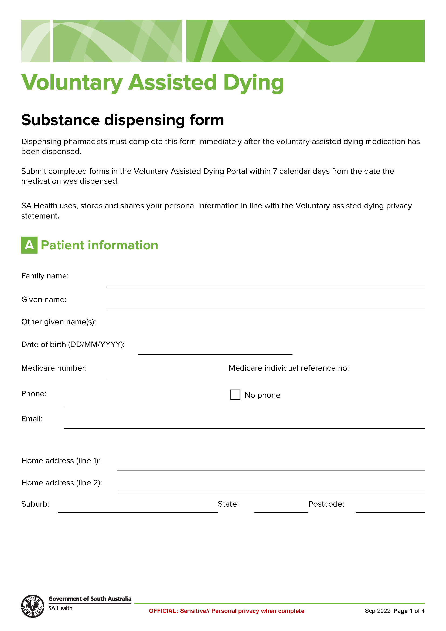
Schedule 10

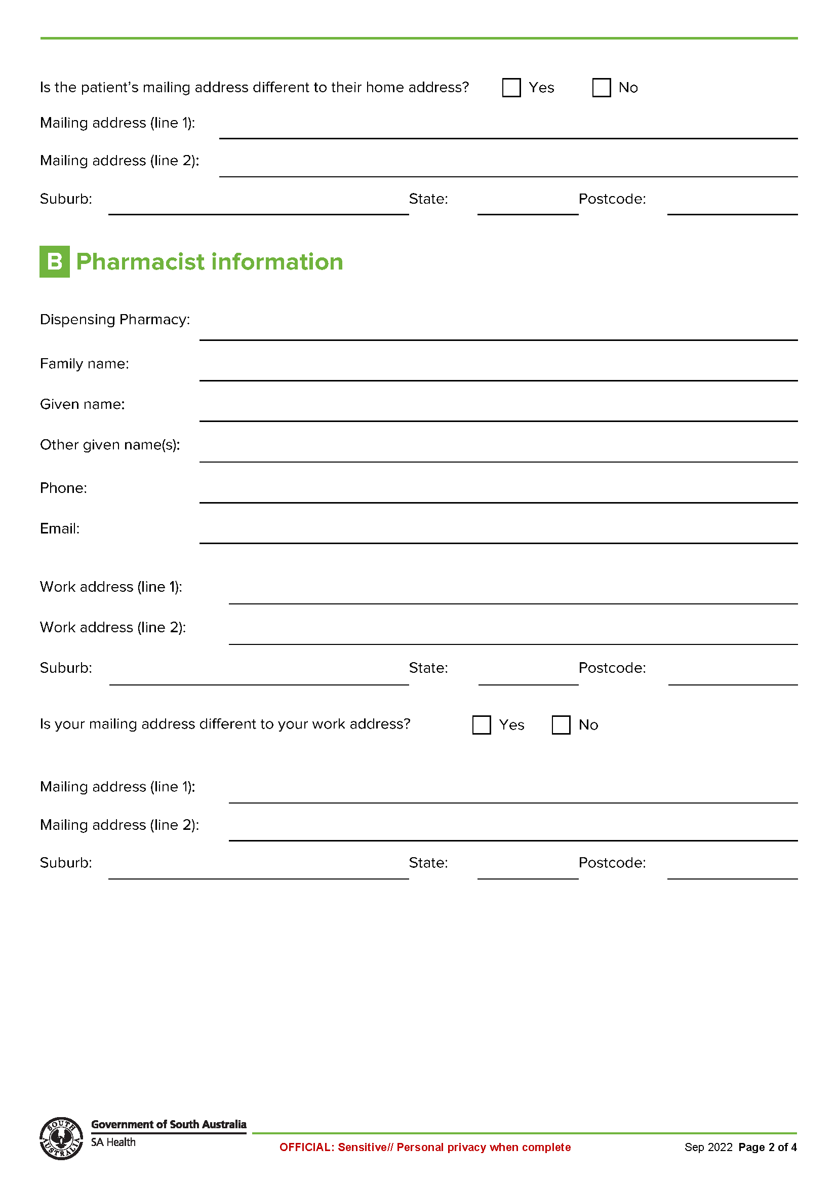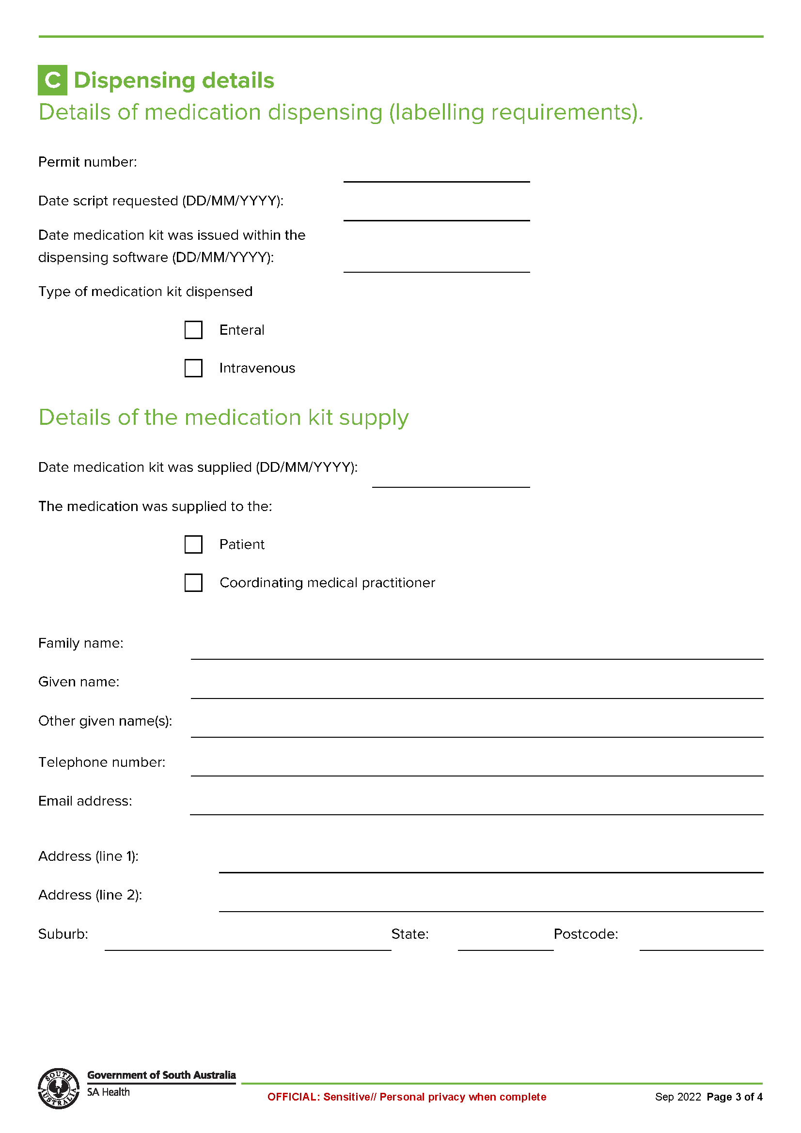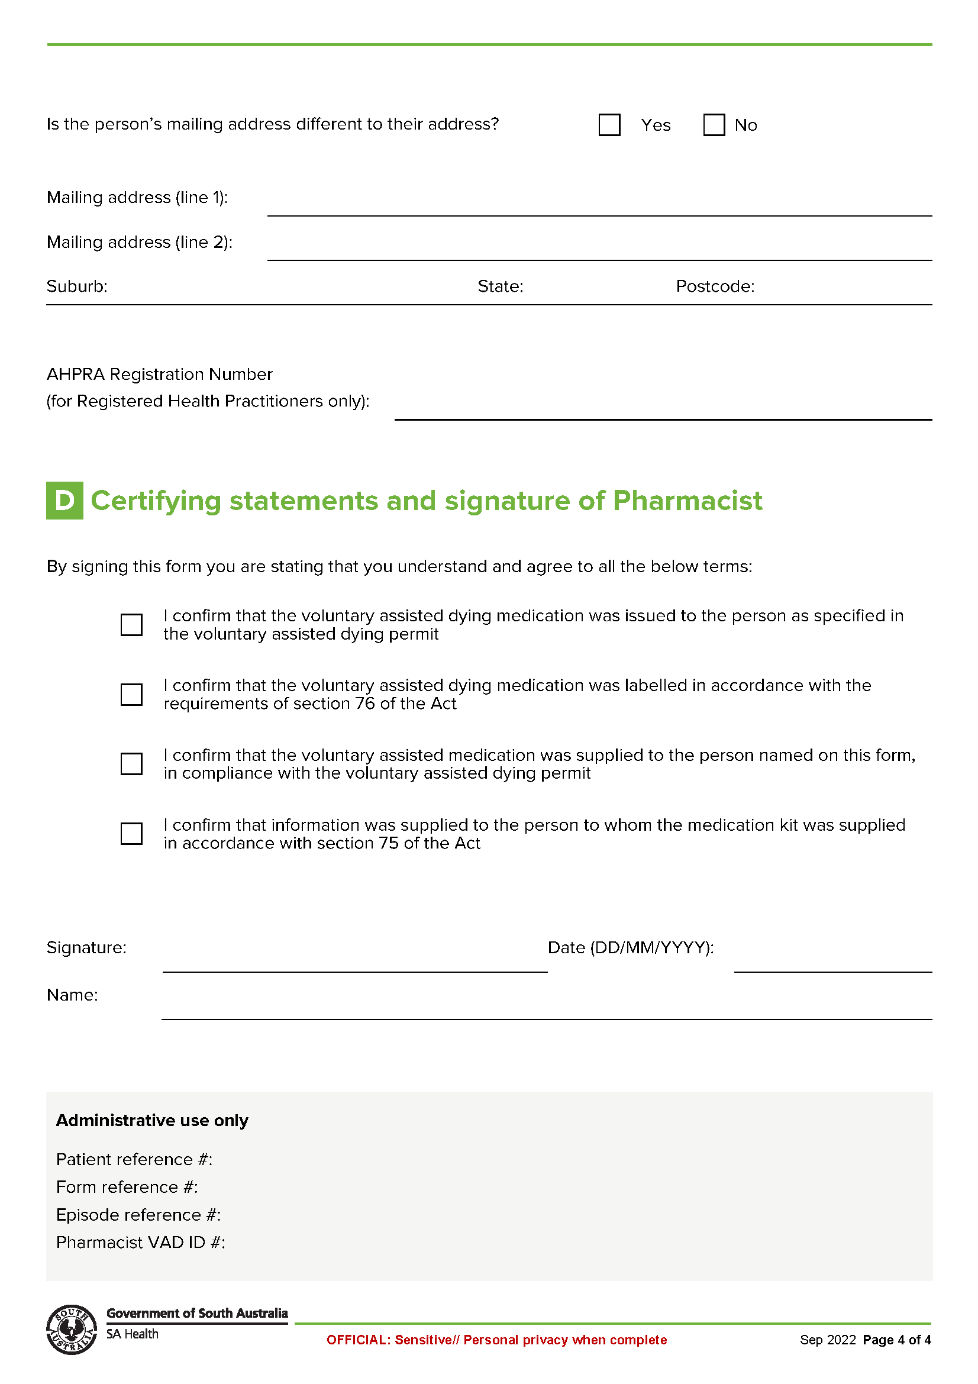
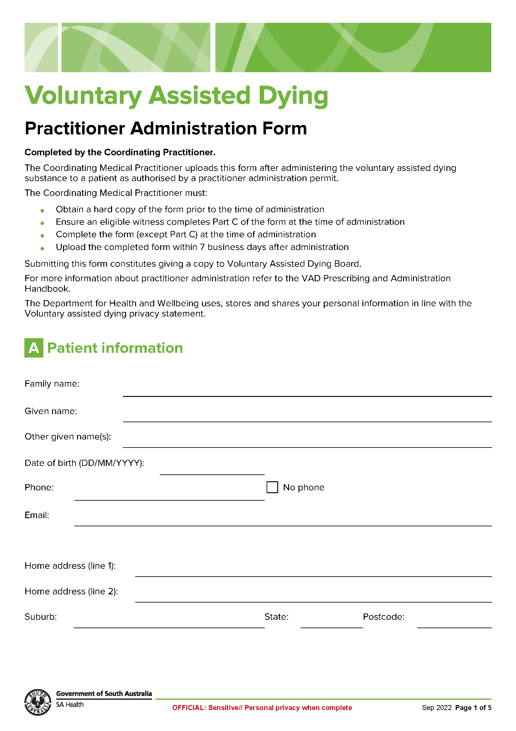
Schedule 11

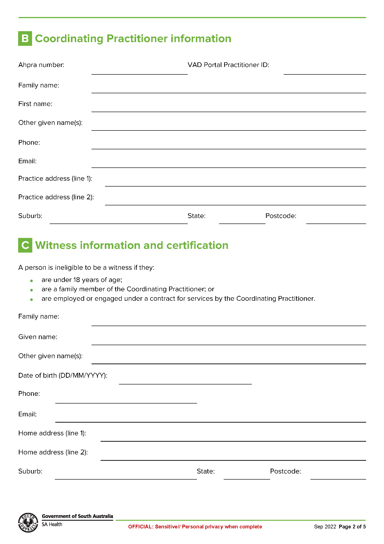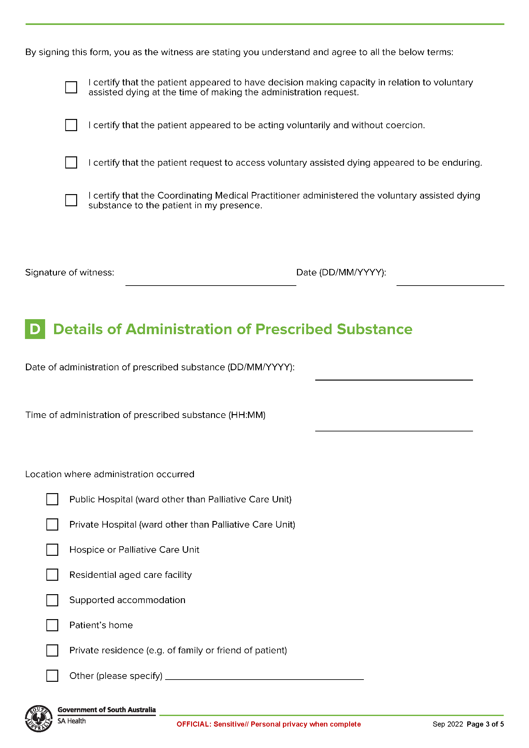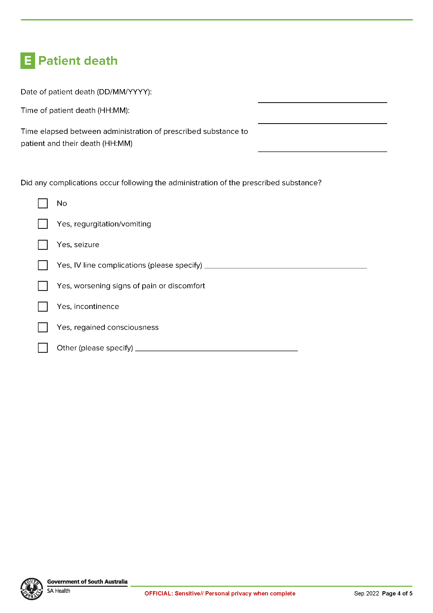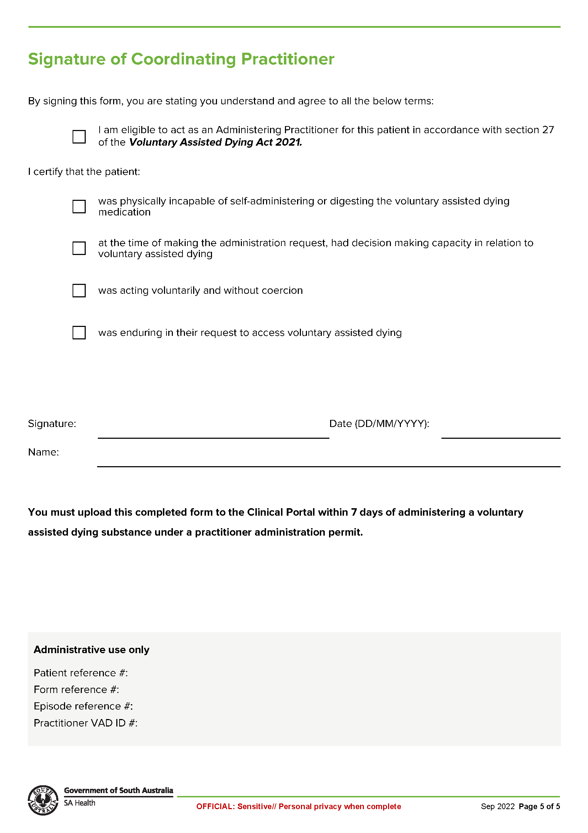
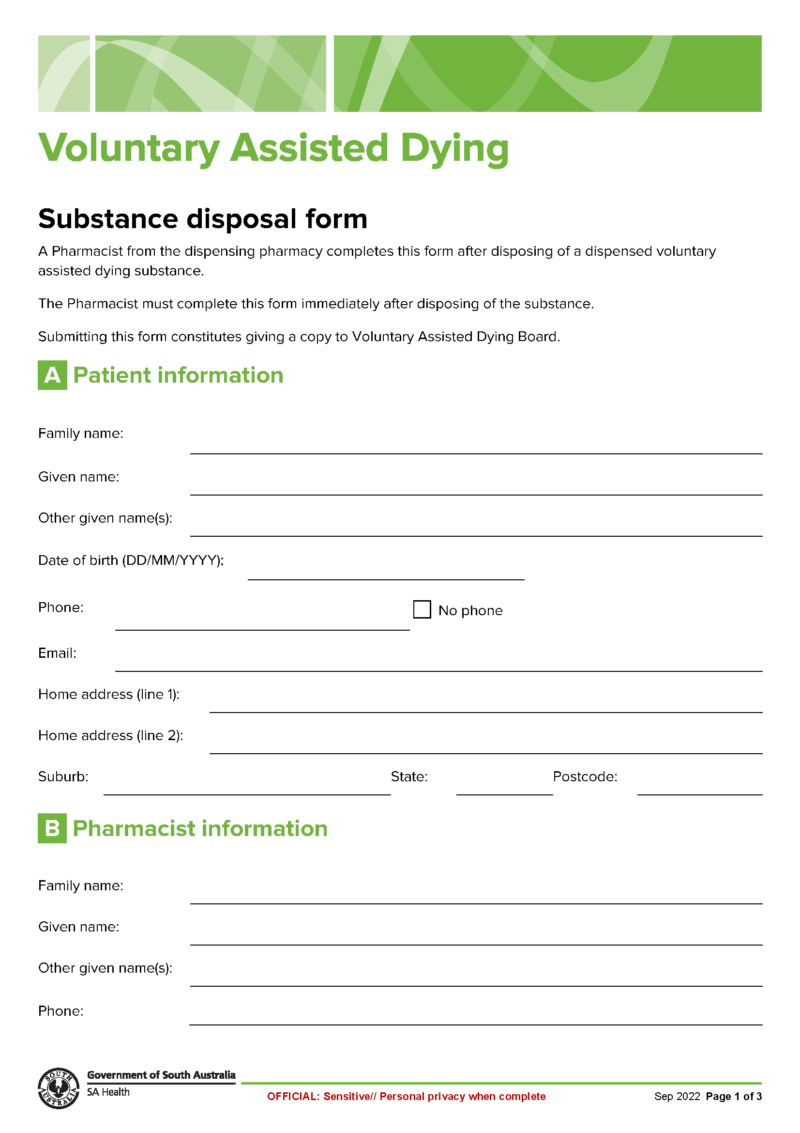
Schedule 12

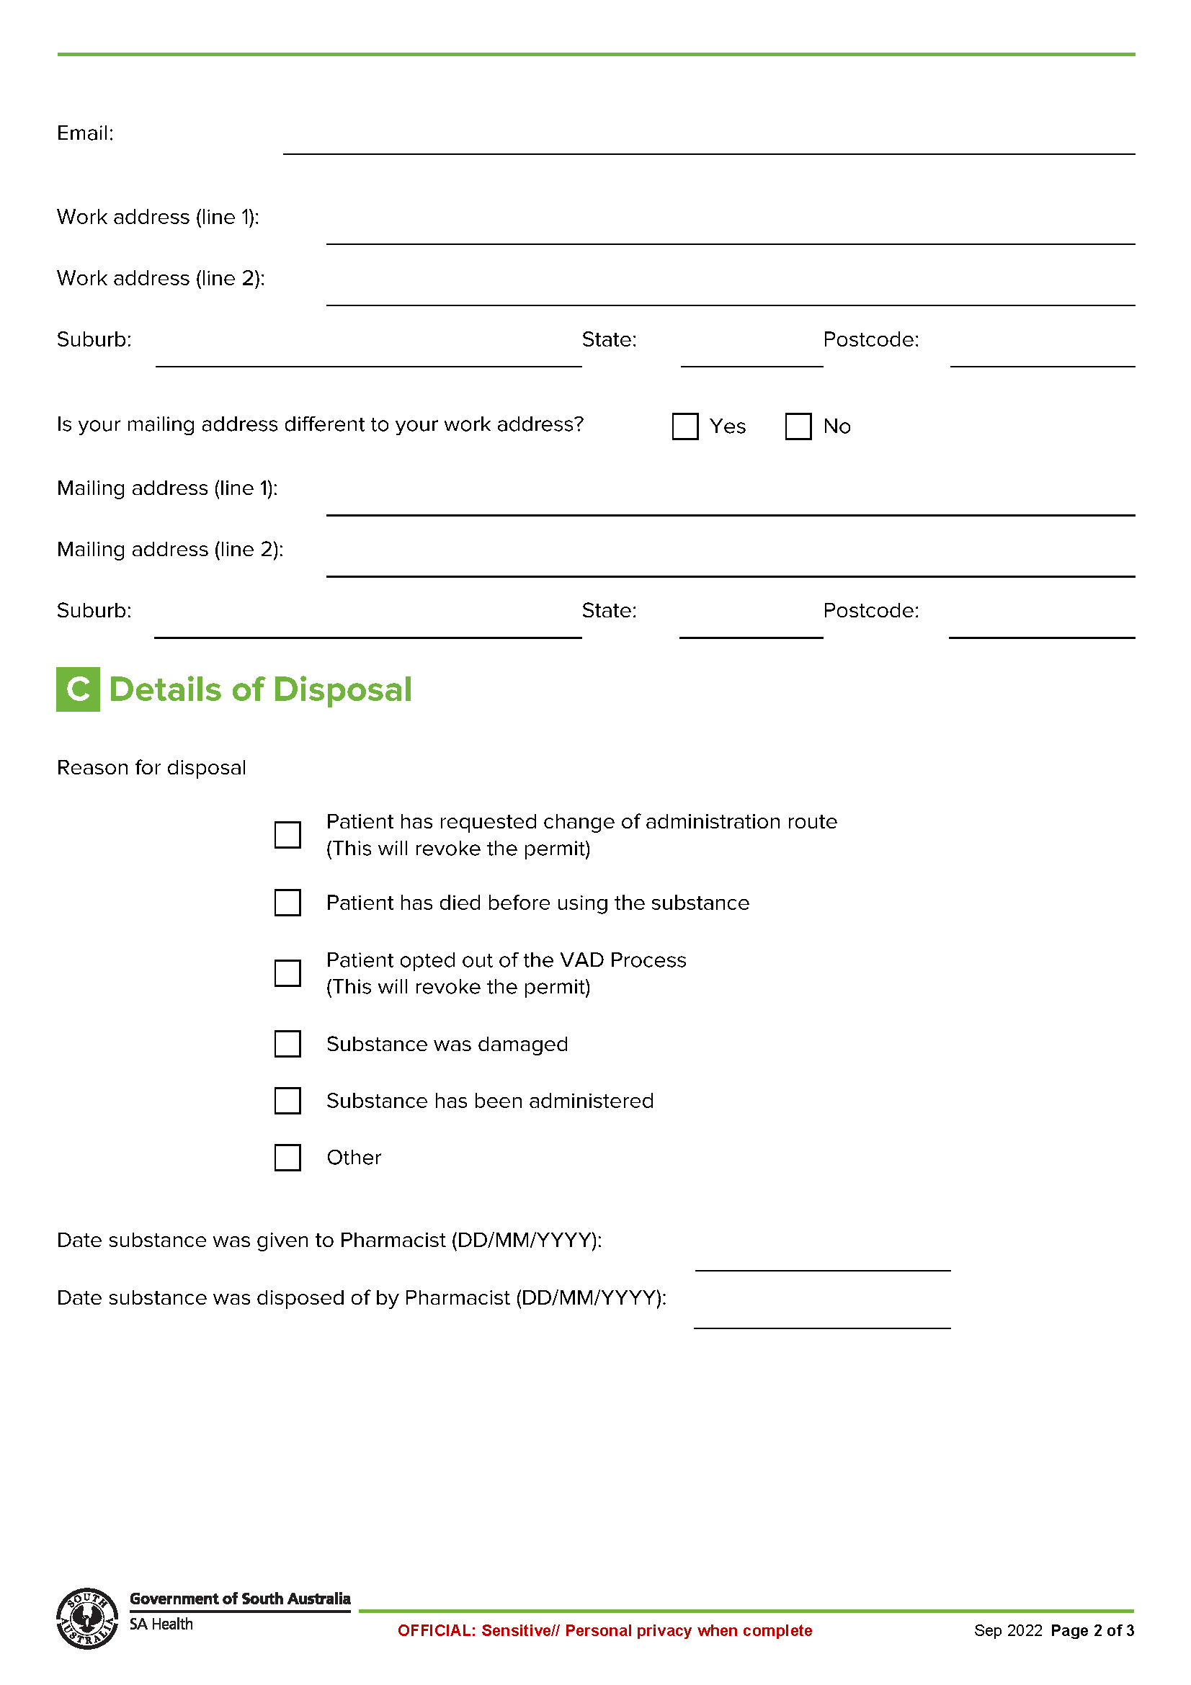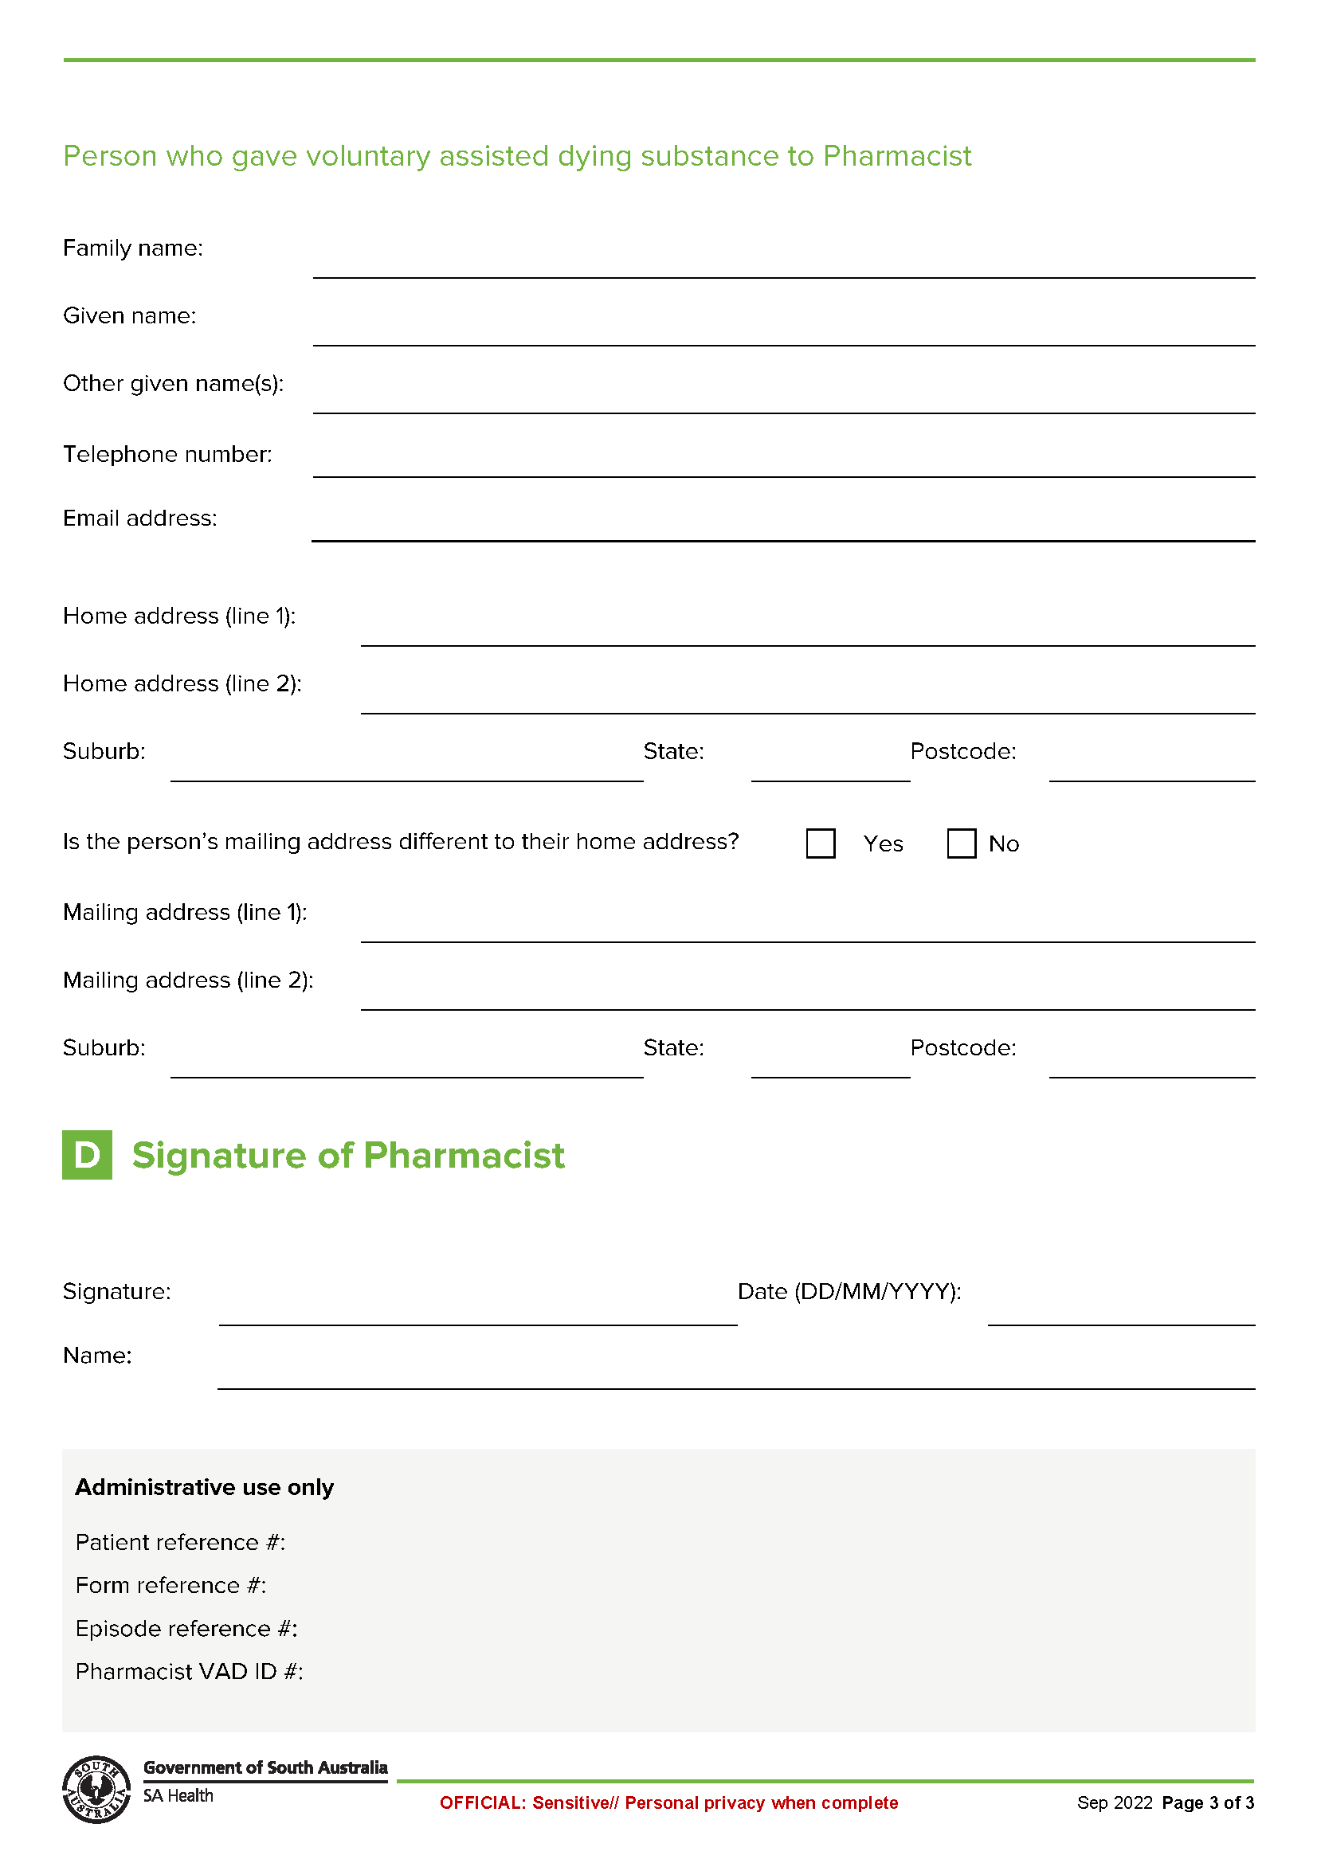

Local Government Instruments

City of Burnside
Local Government Act 1999
By-law No. 1 of 2026—City of Burnside (Miscellaneous) Amendment By-law 2026
To amend the Council’s Local Government Land By-law 2025, Dogs By-law 2025, Waste Management By-law 2025 and Lodging Houses By-law 2025 and for related purposes.
Part 1—Preliminary
1. Short title
This by-law may be cited as the City of Burnside (Miscellaneous) Amendment By-law 2026.
2. Commencement
This by-law will come into operation on the day in which it is published in the Gazette in accordance with Section 249(6)(b) of the Local Government Act 1999.
3. Amendment Provisions
In this by-law, a provision under a heading referring to the amendment of a specified by-law amends the by-law so specified.
Part 2—Amendment of Local Government Land By-law 2025
4. Amendment of Paragraph 3—Interpretation
4.1 Paragraph 3.1—delete ‘;’ and insert after ‘animals’ ‘, but does not include a dog;’.
Part 3—Amendment of Dogs By-law 2025
5. Amendment of Paragraph 9—Application
5.1 Paragraph 9.2—after ‘paragraphs’, delete ‘4.2.1’ and insert ‘4.2’.
Part 4—Amendment of Waste Management By-law 2025
6. Amendment of Paragraph 5—Collection Services
6.1 Paragraph 5.7.1—after ‘premises’, delete ‘should be placed’ and insert ‘by placing the container or containers for the collection of domestic waste, recyclables or green organics (as the case may be)’.
Part 5—Amendment of Lodging Houses By-law 2025
7. Amendment of paragraph 19—Refusal or Revocation of Licence
7.1 Paragraph 19.1.1—after ‘house’, delete ‘,’ and insert ‘is’.
Part 6—Expiry
8. Expiry
This by-law will expire 24 hours after it comes into operation in accordance with Section 251(1) of the Local Government Act 1999.
Note: In accordance with Section 32(2)(c) of the Legislation Interpretation Act 2021, the expiry of this by-law does not affect any direct amendments made by this by-law.
The foregoing by-law was duly made and passed at a meeting of the Council of the City of Burnside held on the 21st day of April 2026 by an absolute majority of the members for the time being constituting the Council, there being at least two-thirds of the members present.
Dated: 30 April 2026
Julia Grant
Chief Executive Officer

City of Marion
Local Government Act 1999
Exclusion of Land from Community Land Classification
Notice is hereby given that pursuant to Section 194 of the Local Government Act 1999, the Council resolved at its meeting held on 26 August 2025, that the whole of the land comprised in Allotment 31, Deposited Plan 25435 comprised in Certificate of Title Volume 6326 Folio 951, known as 7A Chestnut Court, Tonsley SA 5042, be revoked from classification as Community Land.
Dated: 30 April 2026
Tony Harrison
Chief Executive Officer

City of Salisbury
Draft Long Term Financial Plan and Annual Business Plan
Provide your feedback on City of Salisbury’s Draft Long Term Financial Plan and Annual Business Plan 2026/27 to help shape Council’s services now and in the future.
The draft plans outline the annual budget, services delivered, rate levels and long-term financial projections in line with the City Plan 2040 and its key directions.
The draft plan continues an ambitious program of City enhancement and service delivery, while remaining committed to long-term financial sustainability to ensure we are best placed to support our community in coming years.

Provide written comments by Wednesday, 20 May to Deputy Chief Executive Officer, PO Box 8, Salisbury SA 5108 or Financial.Services@salisbury.sa.gov.au. If you would like to provide verbal comments, you can register to attend the Council meeting on Monday, 25 May at 6:30pm.
To read the plan or register to attend the Council meeting, visit salisbury.sa.gov.au/haveyoursay.
Dated: 30 April 2026
John Harry
Chief Executive Officer

City of Salisbury
Draft Strategic Asset Management Plan
Provide your feedback on City of Salisbury’s Draft Strategic Asset Management Plan 2026/27 to help ensure infrastructure decisions reflect community needs and priorities.
The draft plan outlines a framework to guide planning, construction, maintenance and operation of the City of Salisbury’s infrastructure.
Provide written comments by Wednesday, 20 May to General Manager City Infrastructure, PO Box 8, Salisbury SA 5108 or city@salisbury.sa.gov.au with subject Strategic Asset Management Plan.
To read the plan, visit salisbury.sa.gov.au/haveyoursay.
Dated: 30 April 2026
John Harry
Chief Executive Officer

City of Victor Harbor
Resignation of Councillor
Notice is hereby given in accordance with Section 54(6) of the Local Government Act 1999 that a vacancy has occurred in the office of Councillor of the City of Victor Harbor, due to the resignation of Councillor Carlos Quaremba, effective immediately.
In accordance with Section 6(2)(a)(i) of the Local Government (Elections) Act 1999, a supplementary election will not be held to fill the casual vacancy, as the vacancy has occurred within 12 months before polling day for a periodic election.
Dated: 30 April 2026
Victoria MacKirdy
Chief Executive Officer

City of Whyalla
Councillor Resignation
In accordance with Section 54(6) of the Local Government Act 1999, Whyalla City Council provides notice that Councillor Sharon Todd has resigned her office, creating a casual vacancy. In accordance with Section 6(2)(b) of the Local Government (Election) Act 1999, the Council will not be filling the vacancy.
Dated: 20 April 2026
Justin Commons
Chief Executive Officer

District Council of Mount Remarkable
Road Traffic Act 1961
Road Closure—Stuart Street, Near Nott Street, Melrose
I, Christopher Drew Holland, Senior Sergeant First Class of Police, for, and on behalf of the Commissioner of Police, exercise the authority delegated by the Minister for Transport under Section 11 of the Road Traffic Act 1961, and make the following order under Section 33 of the Act.
I declare that the ‘Melrose Community Event’ is an event to which this section applies and that the following road be closed to traffic between 6:00pm on Friday, 1 May 2026 and 6:00pm on Sunday, 3 May 2026:
Within the District Council of Mount Remarkable council area:
• Stuart Street (Horrocks Highway), Melrose between Nott Street and Joes Road.
I direct that persons taking part in the ‘Melrose Community Event’ on the above road be exempted from all Australian Road Rules relating to pedestrian behaviour on roads.
I also hereby authorise the District Council of Mount Remarkable or its agents and contractors to install and remove, or cause the installation and removal of necessary and appropriate traffic control devices for the conduct of this event.
I direct that the installation and removal of necessary and appropriate traffic control devices for the conduct of this event can only be performed by a person with work zone traffic management training.
All works to be undertaken must be done so in accordance with the “SA Standards for Workzone Traffic Management” (which calls up the Austroads Guide to Temporary Traffic Management and AS1742.3).
The permit holder must ensure that, a legible and complete copy of this Approval (as either a hard copy or electronic copy) is available at the event site at all times that workers are present and is immediately provided to an Authorised Officer upon request.
Dated: 2 April 2026
C. D. Holland
Senior Sergeant First Class of Police (SS1C 36182)
For and on behalf of Commissioner of Police
(PCO 2002/0001)

Public Notices

National Electricity Law
Notice of Final Determination and Final Rule
The Australian Energy Market Commission (AEMC) gives notice under the National Electricity Law as follows:
Under ss 102, 102A and 103, the making of the National Electricity Amendment (Enhancing access for registered participant representatives) Rule 2026 No. 3 (Ref. ERC0415) and related final determination. All provisions commence as follows, Schedule 1 commences operation on 1 March 2027, Schedule 2 commences operation on 7 May 2026.
Documents referred to above are available on the AEMC’s website and are available for inspection at the AEMC’s office.
Australian Energy Market Commission
Level 15, 60 Castlereagh St
Sydney NSW 2000
Telephone: (02) 8296 7800
www.aemc.gov.au
Dated: 30 April 2026

National Gas Law
Notice of Final Determination and Final Rule
The Australian Energy Market Commission (AEMC) gives notice under the National Gas Law as follows:
Under ss 311, 312 and 313, the making of the National Gas Amendment (Enhancing access for registered participant representatives) Rule 2026 No. 2 (Ref. GRC0087) and related final determination. All provisions commence as follows, Schedule 1 commences operation on 1 March 2027, Schedule 2 commences operation on 7 May 2026.
Documents referred to above are available on the AEMC’s website and are available for inspection at the AEMC’s office.
Australian Energy Market Commission
Level 15, 60 Castlereagh St
Sydney NSW 2000
Telephone: (02) 8296 7800
www.aemc.gov.au
Dated: 30 April 2026

Northern Adelaide Waste Management Authority
Local Government Act 1999
Amendment of Charter for Northern Adelaide Waste Management Authority (NAWMA)
The NAWMA Constituent Councils of City of Salisbury (23 March 2026), City of Playford (24 March 2026) and Town of Gawler
(24 March 2026) have each agreed to the amended NAWMA Charter. In accordance with Schedule 2, Clause 19(5)(b) and (c) of the
Local Government Act 1999, a copy of the amended Charter has been furnished to the Minister for Local Government and a copy is published on the NAWMA website and available for public inspection at www.nawma.sa.gov.au/about-nawma/.
Dated: 30 April 2026
Graham Dooley
NAWMA Independent Chairperson

Trustee Act 1936
Deceased Estate
Notice to Creditors and Claimants
Winston Charles Stone, late of 28 Eugene Crescent, Parafield Gardens SA 5107, died on 22 January 2026.
Notice is hereby given pursuant to the Trustee Act 1936 (SA),the Succession Act 2023 (SA) and Relationship Act 1975 (SA) that all creditors, beneficiaries and other persons having claims against the estate of the above named deceased are required to send in writing via email, to the executor of the estate Damian Sherin on sherm1.ds@gmail.com full particulars and proof of such claim, within thirty (30) days of the date of publication hereof, after which date the executor may proceed to distribute the estate among the persons entitled there to having regard only to the claims of which the executor then have noticed.
Dated: 30 April 2026
Damian Sherin
Executor

Notice Submission

The South Australian Government Gazette is published each Thursday afternoon.
Notices must be emailed by 4 p.m. Tuesday, the week of publication.
Submissions are formatted per the gazette style and a proof will be supplied prior to publication, along with a quote if applicable. Please allow one day for processing notices.
Alterations to the proof must be returned by 4 p.m. Wednesday.

Gazette notices must be submitted as Word files, in the following format:
• Title—the governing legislation
• Subtitle—a summary of the notice content
• Body—structured text, which can include numbered lists, tables, and images
• Date—day, month, and year of authorisation
• Signature block—name, role, and department/organisation authorising the notice

Please provide the following information in your email:
• Date of intended publication
• Contact details of the person responsible for the notice content
• Name and organisation to be charged for the publication—Local Council and Public notices only
• Purchase order, if required—Local Council and Public notices only

Email: governmentgazettesa@sa.gov.au
Phone: (08) 7133 3552
Website: www.governmentgazette.sa.gov.au

All instruments appearing in this gazette are to be considered official, and obeyed as such

Printed and published weekly by authority of T. Foresto, Government Printer, South Australia
$9.50 per issue (plus postage), $479.00 per annual subscription—GST inclusive
Online publications: www.governmentgazette.sa.gov.au

