
No. 8 p. 239
THE SOUTH AUSTRALIAN
GOVERNMENT GAZETTE
Published by Authority

Adelaide, Thursday, 12 February 2026

Contents

Governor’s Instruments
Appointments, Resignations and General Matters 240
Proclamations—
Child Sex Offenders Registration (Public Register)
Amendment Act (Commencement)
Proclamation 2026 241
Criminal Law Consolidation (Street Gangs) Amendment
Act (Commencement) Proclamation 2026 241
Education and Children’s Services (Enrolment and
Attendance) Amendment Act (Commencement) Proclamation 2026 242
Education and Children’s Services (Inclusive Education) Amendment Act (Commencement) Proclamation 2026 242
Harbors and Navigation (Miscellaneous) Amendment
Act (Commencement) Proclamation 2026 243
Statutes Amendment (Recidivist Young Offenders) Act (Commencement) Proclamation 2026 243
TAFE SA Act (Commencement) Proclamation 2026 244
Workplace Protection (Personal Violence) Act (Commencement) Proclamation 2026 244
Administrative Arrangements (Administration of
TAFE SA Act) Proclamation 2026 245
Administrative Arrangements (Administration of
Workplace Protection (Personal Violence) Act) Proclamation 2026 245
Regulations—
TAFE SA Regulations 2026—No. 10 of 2026 246
Road Traffic (Road Rules—Ancillary and Miscellaneous Provisions) (Use of Mobile Phone) Amendment Regulations 2026—No. 11 of 2026 264
Criminal Law Consolidation (General) (Street Gangs) Amendment Regulations 2026—No. 12 of 2026 266
Summary Offences (Street Gangs) Amendment Regulations 2026—No. 13 of 2026 268
State Government Instruments
Associations Incorporation Act 1985 270
Building Work Contractors Act 1995 270
Electricity Act 1996 271
Gas Act 1997 271
Fisheries Management Act 2007 343
Health Care Act 2008 345
Housing Improvement Act 2016 345
Justices of the Peace Act 2005 345
Land Acquisition Act 1969 346
Landscape South Australia Act 2019 346
Mental Health Act 2009 347
Planning, Development and Infrastructure Act 2016 347
Remuneration Tribunal, The 348
South Australian Civil and Administrative Tribunal 351
Survey Act 1992 352
Local Government Instruments
City of Charles Sturt 355
City of Port Adelaide Enfield 355
City of West Torrens 355
District Council of Peterborough 355
District Council of Robe 356
District Council of Yankalilla 356

Governor’s Instruments

Appointments, Resignations and General Matters
Department of the Premier and Cabinet
Adelaide, 12 February 2026
Her Excellency the Governor in Executive Council has determined that eligible members of the South Australian Superannuation Board, being those members who are eligible for remuneration according to the terms of Premier and Cabinet Circular PC016, are entitled to remuneration, effective from 12 February 2026 - pursuant to the Superannuation Act 1988.
By command,
Anastasios Koutsantonis, MP
For Premier
T&F26/0001CS

Proclamations
South Australia

Child Sex Offenders Registration (Public Register) Amendment Act (Commencement) Proclamation 2026
1—Short title
This proclamation may be cited as the Child Sex Offenders Registration (Public Register) Amendment Act (Commencement) Proclamation 2026.
2—Commencement of suspended provisions
The following provisions of the Child Sex Offenders Registration (Public Register) Amendment Act 2024 (No 45 of 2024) come into operation on 16 February 2026:
(a) section 5;
(b) section 6, insofar as it inserts section 66FA(2), (3), (4), (5), (6), (7) and (12) and section 66FB into the Child Sex Offenders Registration Act 2006;
(c) section 7;
(d) section 8.
Made by the Governor
with the advice and consent of the Executive Council
on 12 February 2026

South Australia

Criminal Law Consolidation (Street Gangs) Amendment Act (Commencement) Proclamation 2026
1—Short title
This proclamation may be cited as the Criminal Law Consolidation (Street Gangs) Amendment Act (Commencement) Proclamation 2026.
2—Commencement of Act
The Criminal Law Consolidation (Street Gangs) Amendment Act 2025 (No 45 of 2025) comes into operation on 16 February 2026.
Made by the Governor
with the advice and consent of the Executive Council
on 12 February 2026

South Australia

Education and Children's Services (Enrolment and Attendance) Amendment Act (Commencement) Proclamation 2026
1—Short title
This proclamation may be cited as the Education and Children's Services (Enrolment and Attendance) Amendment Act (Commencement) Proclamation 2026.
2—Commencement of Act
The Education and Children's Services (Enrolment and Attendance) Amendment Act 2025 (No 65 of 2025) comes into operation on 16 February 2026.
Made by the Governor
with the advice and consent of the Executive Council
on 12 February 2026

South Australia

Education and Children's Services (Inclusive Education) Amendment Act (Commencement) Proclamation 2026
1—Short title
This proclamation may be cited as the Education and Children's Services (Inclusive Education) Amendment Act (Commencement) Proclamation 2026.
2—Commencement of Act
(1) Subject to this clause, the Education and Children's Services (Inclusive Education) Amendment Act 2025 (No 59 of 2025) comes into operation on 12 February 2026.
(2) The following provisions of the Act come into operation on 1 January 2027:
(a) section 8;
(b) section 10, except insofar as it inserts section 81B.
(3) The following provisions of the Act come into operation on 1 September 2027:
(a) section 7, insofar as it inserts section 63B;
(b) section 9;
(c) section 10, insofar as it inserts section 81B;
(d) Schedule 1.
Made by the Governor
with the advice and consent of the Executive Council
on 12 February 2026

South Australia

Harbors and Navigation (Miscellaneous) Amendment Act (Commencement) Proclamation 2026
1—Short title
This proclamation may be cited as the Harbors and Navigation (Miscellaneous) Amendment Act (Commencement) Proclamation 2026.
2—Commencement of Act and suspension of certain provisions
(1) Subject to subclause (2), the Harbors and Navigation (Miscellaneous) Amendment Act 2025 (No 49 of 2025) comes into operation on 12 February 2026.
(2) The operation of the following provisions of the Act is suspended until a day or time or days or times to be fixed by subsequent proclamation or proclamations:
(a) sections 9 and 10;
(b) sections 16 to 21 (inclusive);
(c) sections 23 and 24.
Made by the Governor
with the advice and consent of the Executive Council
on 12 February 2026

South Australia

Statutes Amendment (Recidivist Young Offenders) Act (Commencement) Proclamation 2026
1—Short title
This proclamation may be cited as the Statutes Amendment (Recidivist Young Offenders) Act (Commencement) Proclamation 2026.
2—Commencement of Act
The Statutes Amendment (Recidivist Young Offenders) Act 2025 (No 52 of 2025) comes into operation on 16 February 2026.
Made by the Governor
with the advice and consent of the Executive Council
on 12 February 2026

South Australia

TAFE SA Act (Commencement) Proclamation 2026
1—Short title
This proclamation may be cited as the TAFE SA Act (Commencement) Proclamation 2026.
2—Commencement of Act
The TAFE SA Act 2025 (No 62 of 2025) comes into operation on 1 March 2026.
Made by the Governor
with the advice and consent of the Executive Council
on 12 February 2026

South Australia

Workplace Protection (Personal Violence) Act (Commencement) Proclamation 2026
1—Short title
This proclamation may be cited as the Workplace Protection (Personal Violence) Act (Commencement) Proclamation 2026.
2—Commencement of Act
The Workplace Protection (Personal Violence) Act 2025 (No 76 of 2025) comes into operation on 4 May 2026.
Made by the Governor
with the advice and consent of the Executive Council
on 12 February 2026

South Australia

Administrative Arrangements (Administration of TAFE SA Act) Proclamation 2026
under section 5 of the Administrative Arrangements Act 1994
1—Short title
This proclamation may be cited as the Administrative Arrangements (Administration of TAFE SA Act) Proclamation 2026.
2—Commencement
This proclamation comes into operation on the day on which it is made.
3—Administration of Act committed to Minister for Education, Training and Skills
The administration of the TAFE SA Act 2025 is committed to the Minister for Education, Training and Skills.
Made by the Governor
with the advice and consent of the Executive Council
on 12 February 2026

South Australia

Administrative Arrangements (Administration of Workplace Protection (Personal Violence) Act) Proclamation 2026
under section 5 of the Administrative Arrangements Act 1994
1—Short title
This proclamation may be cited as the Administrative Arrangements (Administration of Workplace Protection (Personal Violence) Act) Proclamation 2026.
2—Commencement
This proclamation comes into operation on the day on which it is made.
3—Administration of Act committed to Attorney-General
The administration of the Workplace Protection (Personal Violence) Act 2025 is committed to the Attorney-General.
Made by the Governor
with the advice and consent of the Executive Council
on 12 February 2026

Regulations
South Australia

TAFE SA Regulations 2026
under the TAFE SA Act 2025

Contents
Part 1—Preliminary
1 Short title
2 Commencement
3 Interpretation
Part 2—Prescribed employees
Division 1—Employment and classification
4 Application for employment
5 Employment and classification
6 Committee to make recommendation on certain applications
7 Re-employment after resignation to contest election
8 Acting appointments
Division 2—Leave and non-attendance days
9 Application for leave and non-attendance days
10 Recreation leave
11 Recreation leave loading allowance
12 Non-attendance days
13 Sick leave
14 Special leave
15 Special leave for infectious diseases
16 Special leave for war service disabilities
17 Maternity leave
18 Determination of long service leave entitlements
19 Certain prescribed employees subject to Public Service conditions
20 Failure to resume duty after leave or non-attendance days
21 Continuity of service
Division 3—Remuneration
22 Remuneration for temporary duties not covered by award
23 Commencing salary at higher increment
24 Increments not payable in certain circumstances
25 Reduction of salary for absence from duty
26 TAFE SA may recover remuneration wrongly paid to prescribed employee
27 Travelling expenses
28 Removal expenses
Division 4—Appeals and disciplinary provisions
29 Rights of review in respect of administrative acts or decisions
30 Selection of panel members for particular SAET proceedings
31 Suspension of further action while proceedings underway
32 Suspension of proceedings on commencement of criminal proceedings
Division 5—Duties of prescribed employees
33 Prescribed employees to serve where required
34 Prescribed employees to comply with regulations, determinations
35 Outside employment
36 Impartiality of instruction
37 Political intervention to obtain unfair advantage
38 Prescribed employee not to incur liability on behalf of TAFE SA
Division 6—Resignation
39 Notice of resignation
Division 7—Retrenchment
40 Retrenchment
Part 3—Miscellaneous
41 Compulsory medical examination of prescribed employee
42 Notice and notification
43 Election of officers as supplementary panel members
Schedule 1—Repeal of TAFE SA Regulations 2012
1 Repeal of TAFE SA Regulations 2012

Part 1—Preliminary
1—Short title
These regulations may be cited as the TAFE SA Regulations 2026.
2—Commencement
These regulations come into operation on the day on which section 1 of the TAFE SA Act 2025 comes into operation.
3—Interpretation
In these regulations—
Act means the TAFE SA Act 2025;
the board means the board of directors of TAFE SA;
domestic partner means a person who is a domestic partner within the meaning of the Family Relationships Act 1975, whether declared as such under that Act or not;
duty day means a day on which a prescribed employee is required to be on duty;
duty hour means an hour during which a prescribed employee is required to be on duty;
industrial award or agreement means an award or agreement under the Fair Work Act 1994, as in force from time to time;
medical certificate means a medical certificate from a legally qualified medical practitioner, or, if a prescribed employee does not reside in the vicinity of a legally qualified medical practitioner, such other medical evidence as the Chief Executive requires;
part-time, in relation to a prescribed employee, means a prescribed employee employed on the basis that they will work in any pay period a specified percentage of the time ordinarily expected of a prescribed employee employed on a full-time basis (regardless of the number of working days and the period of time in any one day over which the prescribed employee performs the required amount of work in any pay period);
prescribed employee means an employee of the Chief Executive of TAFE SA employed on an ongoing basis or term basis (that is, for a specified term or for the duration of a specified project, but not on a weekly, daily or hourly basis) as an employee of any of the following classifications:
(a) Lecturer;
(b) Lecturer's Assistant;
(c) Educational Manager;
the previous regulations means—
(a) the Technical and Further Education Regulations 1976; or
(b) the Technical and Further Education Regulations 1997; or
(c) the Technical and Further Education Regulations 1998; or
(d) the Technical and Further Education Regulations 1999; or
(e) the TAFE SA Regulations 2012;
spouse—a person is the spouse of another if they are legally married;
student means a person enrolled at or attending a course or class at TAFE SA;
TAFE year means the period from 1 February to 31 January in the following year (both dates inclusive);
the Union means the South Australian Branch of the Australian Education Union.
Part 2—Prescribed employees
Division 1—Employment and classification
4—Application for employment
(1) The Chief Executive may require a person who applies for employment as a prescribed employee to provide any of the following:
(a) a certified birth extract from an official register of births or such other evidence of the applicant's age as is satisfactory to the Chief Executive;
(b) a medical certificate certifying that the applicant is of sound health and free from a physical or mental defect likely to impair the applicant's efficiency in the performance of the duties they would be required to perform if employed;
(c) documentary evidence of the applicant's experience and qualifications or other evidence satisfactory to the Chief Executive of the applicant's suitability to perform the duties that they would be required to perform if employed.

(2) TAFE SA must pay the medical expenses, if any, incurred by an applicant under this regulation.
5—Employment and classification
(1) The Chief Executive may appoint a prescribed employee to a classification level determined by the Chief Executive.
(2) The board may determine the qualifications required for appointment of a person as a prescribed employee.
(3) However, the Chief Executive may appoint as a prescribed employee a person who does not have all of the required qualifications.
(4) The Chief Executive may, if a prescribed employee applies for a position at a lower classification level than the employee's existing position, appoint the employee to that position.
6—Committee to make recommendation on certain applications
(1) An application for appointment at a classification level of Educational Manager must be considered by a committee established under this regulation.
(2) The committee must make a recommendation to the Chief Executive on the application.
(3) The committee for the purposes of this regulation will consist of—
(a) at least 1 representative of TAFE SA appointed by the Chief Executive; and
(b) at least 1 representative of the Union, appointed by the Chief Executive from a panel supplied at the Chief Executive's request by the managing committee of the Union.
(4) The panel from which the representatives of the Union are chosen must be reviewed by the managing committee of the Union at least every 3 years.
7—Re-employment after resignation to contest election
(1) If—
(a) a prescribed employee resigns for the purpose of standing as a candidate for election to the Parliament of the State or of the Commonwealth; and
(b) the resignation takes effect not more than 1 month before the issue of the writ for the election; and
(c) the former prescribed employee is not elected and applies in writing for re-employment as a prescribed employee within 2 months after the return of the writ for the election,
the Chief Executive must re-employ that person as a prescribed employee (without probation) at the classification and salary level that they enjoyed immediately before resigning to contest the election.
(2) For the purposes of determining the rights of a person re-employed under this regulation—
(a) the person will be taken not to have resigned; and
(b) the period between the resignation and re-employment will be taken to have been leave without pay granted under these regulations.

8—Acting appointments
(1) If—
(a) a vacancy occurs and the Chief Executive determines that it is inexpedient to make a permanent appointment to fill the vacancy at that time; or
(b) a prescribed employee is unable for any reason to perform their duties,
the Chief Executive may appoint a prescribed employee to the unoccupied position in an acting capacity.
(2) If a prescribed employee is appointed in an acting capacity to a position at a higher classification level than the employee's existing position, the employee is entitled—
(a) if the prescribed employee acts in that capacity for a period of more than 1 week—to receive as from the date of that appointment and while they continue to so act the salary and increments applicable to that higher classification level (but not if the employee's salary would thereby be reduced); and
(b) if the prescribed employee acts in that capacity for a period of more than 3 months—to receive as from the date of that appointment and while they continue to so act the non-attendance days applicable to that higher classification level.
(3) If a prescribed employee, while acting in a position at such a higher classification level, is appointed to a position at that level, their service in that acting capacity will for all purposes of salary and promotion be taken to have been service at that higher classification level.
Division 2—Leave and non-attendance days
9—Application for leave and non-attendance days
(1) Subject to subregulation (3), a prescribed employee who proposes to be or is absent from duty must apply to the Chief Executive for the appropriate type of leave or for non-attendance days, as the case may be.
(2) Application must be made in writing in a form approved by the Chief Executive.
(3) If it is not practicable for a prescribed employee to apply for leave or non-attendance days, an application may be made on the employee's behalf by another prescribed employee employed at their place of work.
10—Recreation leave
(1) Subject to this regulation, a prescribed employee is entitled to recreation leave as follows:
(a) such recreation leave as is specified in an applicable industrial award or agreement; but
(b) if a determination by the board in relation to recreation leave entitlements is at any time in force—such recreation leave as is specified in that determination.
(2) A determination referred to in subregulation (1)(b)—
(a) may relate to prescribed employees of a specified class; and
(b) cannot provide for recreation leave entitlements that are less than those that would, but for that determination, apply under an applicable industrial award or agreement.

(3) A part-time prescribed employee is entitled to pro rata recreation leave in respect of their hours of duty.
(4) Recreation leave accrues on an annual basis in respect of completed years of service, but if a prescribed employee resigns or retires before the end of a given year of service, the employee is in respect of that year entitled to payment of recreation leave entitlements on a pro rata basis.
(5) The Chief Executive may require a prescribed employee to take recreation leave at specified times, and if a prescribed employee who has not completed a year of service is so required, leave will be granted on a pro rata basis.
(6) Recreation leave must be taken within 1 year of accrual unless the Chief Executive approves otherwise, but all such leave must be taken within a period of 2 years from accrual.
11—Recreation leave loading allowance
(1) A prescribed employee is entitled to be paid a recreation leave loading allowance in accordance with this regulation.
(2) Subject to this regulation, the allowance—
(a) is 17.5% of the salary payable to a prescribed employee for the first 4 weeks' recreation leave commenced in a TAFE year; and
(b) in the case of a prescribed employee who has their services terminated, may be paid pro rata in accordance with each complete month for which the employee has not been granted recreation leave; and
(c) only applies to a prescribed employee who is employed for the whole of the TAFE year; and
(d) is not cumulative.
(3) The recreation leave loading allowance for prescribed employees eligible for the allowance for a TAFE year must not exceed the maximum amount that would be payable if the employee were a Public Service employee entitled to recreation leave loading.
(4) The Chief Executive may authorise the payment of a proportionate recreation leave loading allowance to a prescribed employee who has not been employed for the whole of the TAFE year.
(5) For the purposes of this regulation, the salary payable to a prescribed employee includes the Whyalla cost of living loading and any other allowance (other than a locality allowance) payable to the employee in accordance with an applicable industrial award or agreement.
12—Non-attendance days
(1) Subject to this regulation, a prescribed employee is entitled to non-attendance days as follows:
(a) such non-attendance days as are specified in an applicable industrial award or agreement; but
(b) if a determination by the board in relation to non-attendance day entitlements is at any time in force—such non-attendance days as are specified in that determination.

(2) The entitlement of a prescribed employee to non-attendance days is subject to any conditions that the board may from time to time determine and specify in non-attendance day determinations.
(3) A determination referred to in subregulation (1)(b) or (2)—
(a) may relate to prescribed employees of a specified class; and
(b) cannot provide for non-attendance day entitlements that are less than those that would, but for that determination, apply under an applicable industrial award or agreement.
(4) A part-time prescribed employee is entitled to pro rata non-attendance days in respect of their hours of duty.
(5) Non-attendance days accrue on an annual basis in respect of completed years of service, but if a prescribed employee resigns or retires before the end of a given year of service, the employee is in respect of that year entitled to payment of non-attendance day entitlements on a pro rata basis.
(6) The Chief Executive may require a prescribed employee to take non-attendance days at specified times and if a prescribed employee who has not completed a year of service is so required, non-attendance days will be granted on a pro rata basis.
(7) Non-attendance days must be taken within 1 year of accrual.
13—Sick leave
(1) Subject to these regulations, the Chief Executive will grant sick leave with pay to a prescribed employee on the ground of sickness or injury for a period not exceeding the sick leave standing to the credit of that employee.
(2) The sick leave standing to the credit of a prescribed employee (other than a prescribed employee at the classification level of Lecturer's Assistant), whenever employed, is, subject to this regulation—
(a) 70 duty hours credited on the employee's employment as a prescribed employee; plus
(b) 70 duty hours credited on each 1 January succeeding the day of employment during the continuous service of the employee,
less the number of duty hours of sick leave (debited in hours and quarters of an hour, to the nearest quarter of an hour) that have been taken by the employee under these regulations or the previous regulations.
(3) The sick leave standing to the credit of a prescribed employee at the classification level of Lecturer's Assistant, whenever employed, is, subject to this regulation—
(a) 45 duty hours credited on the employee's employment as a prescribed employee; plus
(b) the duty hours credited as follows:
(i) in the case of a prescribed employee employed during the period 1 January to 30 June (inclusive) in any year—90 duty hours credited on each 1 July succeeding the day of employment during the continuous service of the employee; or
(ii) in the case of a prescribed employee employed during the period 1 July to 31 December (inclusive) in any year—
(A) 45 duty hours credited on the 1 January next succeeding the day of employment; and
(B) 90 duty hours credited on each 1 July thereafter,
during the continuous service of the employee,
less the number of duty hours of sick leave (debited in hours and quarters of an hour, to the nearest quarter of an hour) that have been taken by the employee under these regulations or the previous regulations.
(4) However—
(a) a prescribed employee referred to in subregulation (3) who is appointed to a position at a higher classification level will retain the sick leave standing to their credit in accordance with subregulation (3) and will from the time of that appointment (except where it is an acting appointment) be credited with sick leave in accordance with subregulation (2)(b); and
(b) a person who is appointed as a prescribed employee at the classification level of Lecturer's Assistant is not entitled to be granted paid sick leave exceeding—
(i) 45 duty hours in aggregate during the first 6 months; or
(ii) 90 duty hours in aggregate during the first 12 months,
of their service at that level or in an acting capacity at a higher classification level.
(5) For the purposes of determining the sick leave entitlement of a prescribed employee, the following provisions apply:
(a) leave of absence on full pay will be taken to be service as a prescribed employee;
(b) leave of absence without pay or on part pay will be taken to be service as a prescribed employee to the extent (if any) determined by the Chief Executive;
(c) if leave of absence is determined under paragraph (b) not to be service as a prescribed employee, the sick leave credit to which the employee would otherwise be entitled under this regulation is reduced by 7 duty hours (or, in the case of a prescribed employee whose substantive classification level is that of Lecturer's Assistant, 7.5 duty hours) for each complete 4 weeks of that leave of absence, to a maximum reduction of 70 duty hours (or, in the case of a Lecturer's Assistant, 75 duty hours) for the year ending on 31 December in which the leave of absence is taken;
(d) if a prescribed employee takes a period of long service leave on half salary, the employee will be taken to be on full pay for the first half of that period and on leave without pay for the remainder of that period;
(e) if a prescribed employee is retired by reason of invalidity or physical or mental incapacity and is subsequently re-employed as a prescribed employee, their continuity of service will not be taken to have been broken by the retirement;

(f) a prescribed employee's prior service in prescribed employment (within the meaning of section 23(2) of the Technical and Further Education Act 1975) that is continuous with their service as a prescribed employee will be taken to be service as a prescribed employee, unless the sick leave taken during that prior service is not established to the satisfaction of the Chief Executive, in which case the sick leave credited to the employee in respect of that prior service (if any) may be determined by the Chief Executive.
(6) The sick leave entitlement of a part-time officer must be determined on a pro rata basis in respect of their hours of duty (to the nearest quarter of an hour).
(7) If a prescribed employee is absent from duty due to sickness or injury for a period exceeding 3 duty days, the employee must provide a medical certificate with the employee's application for sick leave.
(8) The Chief Executive may, at the Chief Executive's discretion, require a prescribed employee who applies for sick leave for a period of 3 duty days or less to provide evidence satisfactory to the Chief Executive of the existence of the sickness or injury claimed by the employee.
(9) If a medical certificate or other evidence required by the Chief Executive is not provided by a prescribed employee in respect of a period of absence in accordance with this regulation, the leave will be taken to be leave without pay.
(10) If a prescribed employee suffers or sustains sickness or injury while on recreation leave, the prescribed employee may, on provision of a medical certificate and with the approval of the Chief Executive, convert the relevant period of recreation leave into a debit against any sick leave standing to the employee's credit.
(11) If a prescribed employee, while on long service leave (other than long service leave taken immediately prior to the resignation, retirement, retrenchment or other termination of the services of the employee), is confined to a residence or hospital for a period of at least 14 days due to sickness or injury suffered or sustained by the employee, the prescribed employee may—
(a) on provision of a medical certificate satisfactory to the Chief Executive as evidence of that fact; and
(b) with the approval of the Chief Executive,
convert that period of long service leave into a debit against any sick leave standing to the employee's credit.
14—Special leave
(1) The Chief Executive may, where reasonable cause exists, grant to a prescribed employee special leave with pay for a period or periods not exceeding, in aggregate, 15 duty days in any 1 TAFE year.
(2) The Chief Executive may grant to a prescribed employee special leave with pay or with part pay for such period and on such conditions as the Chief Executive thinks fit.
(3) The Chief Executive may, where reasonable cause exists, grant to a prescribed employee special leave without pay for such period and on such conditions as the Chief Executive thinks fit.
(4) Special leave granted under this regulation is in addition to any other leave to which a prescribed employee may be entitled.

15—Special leave for infectious diseases
(1) If a prescribed employee is absent from duty and provides to the Chief Executive a medical certificate indicating that the prescribed employee has an infectious disease, the Chief Executive must, if satisfied that the infectious disease was probably contracted by the employee while on duty or as a result of the employee's contact with the students or staff of TAFE SA, grant the employee special leave with pay (not debited against sick leave credits) for the period of the employee's absence from duty due to the infectious disease.
(2) Special leave granted under this regulation must not exceed a total of 52 weeks in aggregate for any particular infectious disease.
(3) Special leave granted under this regulation is in addition to any other leave to which a prescribed employee may be entitled.
(4) In this regulation—
infectious disease means Chicken Pox, Diphtheria, Erysipelas, Glandular Fever, Infectious Hepatitis, Herpetic Whitlow, Infectious Mononucleosis, Measles, Meningitis, Mumps, Poliomyelitis, Rubella, Scarlet Fever, Staphylococcal Infection of a cutaneous nature, Typhoid, Whooping Cough, or any other disease determined by the board to be an infectious disease for the purposes of this regulation.
16—Special leave for war service disabilities
(1) The Chief Executive may grant a prescribed employee who provides evidence that they are absent from duty because of a disability accepted by the Commonwealth Repatriation Commission as due to war service special leave with pay (not debited against sick leave credits) for a period not exceeding the leave standing to the credit of that employee under this regulation.
(2) The special leave standing to the credit of a prescribed employee absent due to a disability arising from war service is as follows:
(a) a non-accumulative credit of 45 duty days credited on 1 July 1955 or on employment as a prescribed employee (whichever is the later); plus
(b) a cumulative credit of 15 duty days credited on 1 July 1964, or on employment as a prescribed employee (whichever is the later) and on the anniversary of that date in each succeeding year to a maximum accumulation of 45 duty days at any one time under this paragraph,
less the number of duty days of leave that have been taken by the employee under this regulation or a corresponding provision of the previous regulations, debited in accordance with subregulation (3).
(3) The special leave standing to the credit of a prescribed employee under subregulation (2)(b)—
(a) may only be taken after the special leave standing to the employee's credit under subregulation (2)(a) has been exhausted; and
(b) re-accumulates in accordance with subregulation (2)(b) if taken, but not so as to exceed the specified maximum accumulation.
(4) Special leave granted under this regulation is in addition to any other leave to which a prescribed employee may be entitled.

17—Maternity leave
(1) Subject to these regulations, the Chief Executive will grant a female prescribed employee who is pregnant maternity leave for a period commencing at any time after the issue of a medical certificate confirming the employee's pregnancy and ending no later than the close of the TAFE year in which the first anniversary of the birth falls.
(2) An application for maternity leave must—
(a) specify the period for which leave is sought; and
(b) be accompanied by a medical certificate indicating the expected date of birth.
(3) The Chief Executive may, on application by a prescribed employee, vary the period of leave previously specified in an application for leave under this regulation (but not so as to extend the leave beyond the end of the period specified in subregulation (1)).
(4) Maternity leave granted in accordance with this regulation is without pay, but—
(a) a prescribed employee entitled to long service leave under the Act may use any of that entitlement during the period that she is on leave; and
(b) if a prescribed employee, while on maternity leave, suffers or sustains a sickness or injury that is, in the opinion of the Chief Executive, unconnected with the pregnancy or birth or is a significant abnormal medical condition arising out of the pregnancy or birth, the Chief Executive may, on application by the employee accompanied by a medical certificate, grant the employee paid sick leave for a period not exceeding the sick leave standing to the credit of the employee.
(5) A prescribed employee who has been granted maternity leave must give the Chief Executive at least 4 weeks' prior notice in writing of the date on which she intends to resume duty.
(6) A prescribed employee who resumes duty after a period of maternity leave will, subject to any agreement to the contrary between the employee and the Chief Executive, resume in the position she held at the time she commenced that leave.
18—Determination of long service leave entitlements
For the purposes of determining the long service leave entitlements of a prescribed employee—
(a) leave of absence on full pay will be taken to be service as a prescribed employee; and
(b) leave of absence without pay or on part pay will be taken to be service as a prescribed employee to the extent (if any) determined by the Chief Executive; and
(c) if a prescribed employee takes a period of long service leave on half salary, the employee will be taken to be on full pay for the first half of that period and on leave without pay for the remainder of that period.
19—Certain prescribed employees subject to Public Service conditions
If the Chief Executive appoints a prescribed employee to a position the duties of which do not, in the Chief Executive's opinion, justify the employee working normal hours and taking the recreation leave and non-attendance days that would otherwise apply, the Chief Executive may declare that the employee is subject to the hours of work, recreation leave, non-attendance days and overtime applicable to Public Service employees.

20—Failure to resume duty after leave or non-attendance days
A prescribed employee who fails to resume duty on completion of leave or non-attendance days will be taken to be absent from duty without proper cause.
21—Continuity of service
The continuity of service of a prescribed employee is not broken by leave or non-attendance days under this Division.
Division 3—Remuneration
22—Remuneration for temporary duties not covered by award
If a prescribed employee performs, on a temporary basis, duties to which no industrial award or agreement applies, the Chief Executive may determine the remuneration payable in respect of those duties.
23—Commencing salary at higher increment
If a prescribed employee is employed in a position the salary of which has a number of incremental levels, the Chief Executive may determine that the commencing salary for the employment is to be at a particular incremental level, despite the fact that the employee does not meet the requirements for payment at that level.
24—Increments not payable in certain circumstances
If a prescribed employee—
(a) resigns under regulation 39(2)(a); or
(b) retires on or after the day on which the prescribed employee reaches the age of 55 years,
and the effective date of resignation or retirement is 31 January in any year, the employee is not entitled to be paid an increment that would otherwise have been payable to the employee from 1 January of that year.
25—Reduction of salary for absence from duty
(1) If—
(a) a prescribed employee has, without proper cause, absented themselves from their place of work during ordinary hours of duty (or other hours during which the employee is lawfully directed to work); or
(b) has not discharged their duties as a result of or in the furtherance of industrial action taken by the employee,
the Chief Executive may direct that the employee's remuneration be reduced by one seventieth (or in the case of a prescribed employee at the classification level of Lecturer's Assistant, one seventy-fifth) of the employee's fortnightly salary for each hour (or part of an hour) for which the employee was so absent or so failed to discharge their duties.
(2) For the purposes of this regulation, the fortnightly salary of a prescribed employee who is employed on a part-time basis is the fortnightly salary that the employee would be entitled to receive if they were employed on a full-time basis.

26—TAFE SA may recover remuneration wrongly paid to prescribed employee
The Chief Executive may require a prescribed employee who has in any circumstances received remuneration to which they are not entitled to repay the amount of the overpayment and, in default of repayment, may recover the amount as a debt due and owing by the employee to TAFE SA.
27—Travelling expenses
(1) A prescribed employee must be reimbursed in accordance with this regulation for expenses reasonably and actually incurred in undertaking, in connection with their duties, travel approved by the Chief Executive.
(2) Reimbursement must be at the same rate as would be applicable to a Public Service employee, but if it appears necessary because of special circumstances, the Chief Executive may authorise reimbursement at a different rate.
28—Removal expenses
(1) Subject to subregulation (2), if a prescribed employee is transferred to another place of employment with TAFE SA and moves residence as a result of that transfer, the employee is entitled to be paid the following:
(a) the cost of the removal of the employee's household furniture and effects removed under arrangements made or approved by the Chief Executive; and
(b) a packing allowance determined by the Chief Executive; and
(c) the cost of any fares paid for moving the employee and their dependent family to the new residence; and
(d) such other expenses as the Chief Executive may determine—
(i) of which satisfactory proof is provided; and
(ii) that have been, in the opinion of the Chief Executive, necessarily and reasonably incurred by the employee or their dependent family in connection with the transfer.
(2) Subregulation (1) does not apply if a prescribed employee is transferred solely at their own request after less than 3 years' satisfactory service at a place of employment with TAFE SA.
(3) Where a person is first employed as a prescribed employee and moves residence as a result of that employment, the employee is entitled to be paid the following:
(a) if the prescribed employee was resident in this State at the time of the employment—the amounts specified in subregulation (1); or
(b) if the prescribed employee was resident outside this State at the time of the employment—any amount approved by the Chief Executive prior to the employment for costs and expenses of a kind referred to in subregulation (1).
(4) If a prescribed employee retires or dies while employed at a location to which they moved wholly or largely at the expense of TAFE SA and the employee, or their surviving spouse or domestic partner, (as the case may be) moves residence on that retirement or death to another location in South Australia, the employee or surviving spouse or domestic partner is entitled to be paid the amounts specified in subregulation (1), subject to the following limitations:
(a) in the case of a prescribed employee who was resident in this State at the time of their employment as a prescribed employee—travelling expenses are limited to not more than the amounts that would be payable under that subregulation on removal from their current location back to that original residence;
(b) in the case of a prescribed employee resident outside this State at the time of their employment as a prescribed employee—all amounts specified in subregulation (1) are limited to not more than the amounts that would be payable under that subregulation on removal from their current location to Adelaide.
(5) The Chief Executive may authorise the payment to a prescribed employee who is transferred to another place of employment with TAFE SA and moves residence as a result of that transfer of an allowance approved by the Chief Executive for the depreciation of the employee's household furniture and effects, except where—
(a) the employee is establishing a home for the first time; or
(b) the employee has less than 3 years' satisfactory service at a place of employment with TAFE SA and is transferred solely at their own request.
(6) The Chief Executive may, where travelling expenses are payable under this regulation, grant an allowance to the employee concerned in lieu of payment of those expenses.
(7) Despite this regulation, the Chief Executive may approve the payment—
(a) of an allowance greater than is otherwise payable under this regulation; or
(b) the whole or part of an allowance of a kind provided for in this regulation to a prescribed employee who is not entitled to claim such an allowance.
(8) For the purposes of this regulation a transfer will not be taken to be solely at an employee's own request if the employee applied for the transfer to another place of employment with TAFE SA in response to a call by TAFE SA for such applications.
Division 4—Appeals and disciplinary provisions
29—Rights of review in respect of administrative acts or decisions
(1) If a prescribed employee is aggrieved by an administrative act or decision of the Chief Executive or any other employee in TAFE SA that directly affects the employee, the employee may apply in writing to the Chief Executive for a review of the act or decision.
(2) An application under subregulation (1) must be made within 28 days after the date of the act or decision in question.
(3) The Chief Executive must notify the employee in writing of any act or decision of the Chief Executive resulting from the review.
(4) If the employee is aggrieved by an act or decision of the Chief Executive resulting from the review, the employee may, within 14 days after receiving written notification of that act or decision, apply to SAET under Part 3 Division 1 of the South Australian Employment Tribunal Act 2014 for a review of the act or decision.
(5) An application cannot be made under subregulation (4) in relation to an act or decision that concerns the initial employment of a person as a prescribed employee or the promotion of a prescribed employee.
(6) Nothing in this regulation prevents the reference of a dispute concerning the employment of a person as a prescribed employee to a Board of Reference established for that purpose under an applicable industrial award or agreement.
30—Selection of panel members for particular SAET proceedings
If the President of SAET determines under section 18(2) of the Technical and Further Education Act 1975 that SAET is to sit with supplementary panel members for the purposes of particular proceedings, the President must not select a person who took the action or made the decision to which the proceedings relate.
31—Suspension of further action while proceedings underway
If SAET is hearing review proceedings brought by an employee, the Chief Executive must take no further action against the employee in respect of the matter until SAET has made a determination in those proceedings.
32—Suspension of proceedings on commencement of criminal proceedings
(1) If a prescribed employee is charged with a criminal offence, any proceedings by the Chief Executive or before SAET arising out of the incident that is the subject of that charge must be suspended pending the determination of the criminal proceedings.
(2) Despite subregulation (1), a prescribed employee may be suspended by the Chief Executive pending the outcome of all proceedings in relation to the employee.
Division 5—Duties of prescribed employees
33—Prescribed employees to serve where required
A prescribed employee must, at any time during their service, serve in such part of the State as the Chief Executive may require.
34—Prescribed employees to comply with regulations, determinations
A prescribed employee must comply with these regulations, and any determination of the board under these regulations, as in force from time to time.
35—Outside employment
(1) A prescribed employee must not engage in remunerative employment or in an occupation or business outside TAFE SA unless the prescribed employee—
(a) is a prescribed employee employed on a part-time basis; or
(b) obtains the permission of the Chief Executive.
(2) The Chief Executive may at any time withdraw permission given under this regulation.
(3) The Chief Executive must, when deciding whether to give or withdraw permission under this regulation, have regard to the following:
(a) whether the employment, occupation or business is to be, or has been, conducted outside the hours of duty of the prescribed employee; and

(b) whether the employment, occupation or business is likely to affect, or has affected, the performance of the employee's duties as a prescribed employee; and
(c) whether the employment, occupation or business may give rise, or has given rise, to a conflict or potential conflict of interest with the employee's duties as a prescribed employee.
36—Impartiality of instruction
If, in the course of their duties, a prescribed employee discusses social, religious or political issues with students, the employee must present those issues impartially.
37—Political intervention to obtain unfair advantage
A prescribed employee must not seek political intervention to obtain an unfair advantage in appointment, reclassification, transfer or any other aspect of their employment as a prescribed employee.
38—Prescribed employee not to incur liability on behalf of TAFE SA
Except as otherwise provided in these regulations, a prescribed employee must not incur any liability or make or alter any contract on behalf of TAFE SA, or attempt to do so, without the prior written authority of the Chief Executive.
Division 6—Resignation
39—Notice of resignation
(1) Subject to these regulations, a prescribed employee who seeks to resign must give the Chief Executive at least 6 weeks' prior notice in writing of that intention to resign.
(2) Despite subregulation (1)—
(a) a prescribed employee who is on maternity leave (or long service leave taken during maternity leave) may resign at any time during that leave on giving the Chief Executive at least 2 weeks' prior notice in writing of her intention to resign; and
(b) a prescribed employee appointed on a temporary basis may resign on giving the Chief Executive at least 2 weeks' prior notice in writing of their intention to do so.
(3) The Chief Executive may, where reasonable cause exists, waive notice of resignation and permit a resignation to take effect at a time other than that provided for in this regulation.
(4) If a prescribed employee resigns without complying with this regulation, the Chief Executive may, by notice in writing, require the employee to pay to TAFE SA—
(a) in the case of a failure to comply with subregulation (1)—an amount not exceeding 6 weeks' salary of that employee; or
(b) in the case of a failure to comply with subregulation (2)(b)—an amount not exceeding 2 weeks' salary of that employee.
(5) If a prescribed employee fails to pay an amount required to be paid under this regulation, the amount may be recovered as a debt due and owing by the employee to TAFE SA.

Division 7—Retrenchment
40—Retrenchment
(1) If the Chief Executive is satisfied that—
(a) the volume of work for prescribed employees in a section has diminished; and
(b) in consequence a reduction in the number of prescribed employees has become necessary in the interest of economy; and
(c) a prescribed employee should be retrenched for that purpose,
the Chief Executive may, by written determination, retrench that employee as from a date specified in the determination.
(2) A prescribed employee who is retrenched under this regulation is entitled to receive—
(a) at least 12 weeks notice in writing prior to the date of retrenchment; or
(b) if the notice is less than 12 weeks, a sum equal to their salary for the period by which the notice falls short of 12 weeks.
Part 3—Miscellaneous
41—Compulsory medical examination of prescribed employee
(1) A prescribed employee must, if required to do so by the Chief Executive, submit themselves to an examination by a legally qualified medical practitioner selected by the Chief Executive.
(2) The Chief Executive must, before making a requirement under subregulation (1), consult with the President of the Union.
(3) If a medical examination is required in respect of a prescribed employee under subregulation (1)—
(a) the examination must be at the expense of TAFE SA; and
(b) the medical practitioner conducting the examination must, if so required by the employee or a member of the employee's family, consult with some other medical practitioner nominated by the employee or member of the employee's family.
42—Notice and notification
A notice or other written notification required or authorised to be given to a person under the Act or these regulations may be given—
(a) by personal service on the person or the agent of the person; and
(b) in the case of a notice or written notification to an employee—
(i) by personal delivery to the employee's place of employment with TAFE SA in an envelope addressed to the employee; and
(ii) by post to the employee at the employee's place of employment with TAFE SA or last known residential address; and

(c) in the case of a notice or written notification to the Minister or Chief Executive—by personal delivery, or by post, to the office of the Minister or Chief Executive;
(d) in the case of a notice or written notification to TAFE SA—by personal delivery, or by post, to an office of TAFE SA designated by the Chief Executive for the purposes of this regulation.
43—Election of officers as supplementary panel members
(1) Elections must be held in accordance with this regulation whenever there is a vacancy in the membership of a panel of officers under section 18(1)(b) of the Technical and Further Education Act 1975.
(2) The Branch Returning Officer of the Union must publish in a publication that is circulated to members of the Union a notice specifying—
(a) the number of vacancies to be filled; and
(b) the date (being not less than 21 days after the date of the notice) and the hour by which nominations for candidates for election to those vacancies must be received by the Branch Returning Officer; and
(c) such other information as the Branch Returning Officer thinks fit.
(3) If the number of candidates duly nominated is the same as or is less than the number of vacancies to be filled, the Branch Returning Officer of the Union must declare those candidates to be duly elected.
(4) If the number of candidates nominated is greater than the number of vacancies to be filled, an election must be held at a meeting of the Branch Council of the Union.
Schedule 1—Repeal of TAFE SA Regulations 2012
1—Repeal of TAFE SA Regulations 2012
The TAFE SA Regulations 2012 are repealed.
Editorial note—
As required by section 10AA(2) of the Legislative Instruments Act 1978, the Minister has certified that, in the Minister's opinion, it is necessary or appropriate that these regulations come into operation as set out in these regulations.
Made by the Governor
with the advice and consent of the Executive Council
on 12 February 2026
No 10 of 2026

South Australia

Road Traffic (Road Rules—Ancillary and Miscellaneous Provisions) (Use of Mobile Phone) Amendment Regulations 2026
under the Road Traffic Act 1961

Contents
Part 1—Preliminary
1 Short title
2 Commencement
Part 2—Amendment of Road Traffic (Road Rules—Ancillary and Miscellaneous Provisions) Regulations 2014
3 Amendment of regulation 43B—Use of mobile phone

Part 1—Preliminary
1—Short title
These regulations may be cited as the Road Traffic (Road Rules—Ancillary and Miscellaneous Provisions) (Use of Mobile Phone) Amendment Regulations 2026.
2—Commencement
These regulations come into operation on the day on which they are made.
Part 2—Amendment of Road Traffic (Road Rules—Ancillary and Miscellaneous Provisions) Regulations 2014
3—Amendment of regulation 43B—Use of mobile phone
Regulation 43B, definition of use—delete the definition and substitute:
use, in relation to a mobile phone, includes any of the following actions by a driver:
(a) holding the body of the phone (whether or not engaged in a phone call or operating or engaging with any other function of the phone), except while in the process of giving the body of the phone to a passenger in the vehicle;
(b) resting the body of the phone on any part of the driver's body (whether or not engaged in a phone call or operating or engaging with any other function of the phone), except where the body of the phone is in a pocket of the driver's clothing or in a pouch worn by the driver and the driver is not engaged in a phone call or operating or engaging with any other function of the phone;
(c) entering or placing, other than by the use of voice, anything into the phone, or sending or looking at anything that is in the phone;
(d) turning the phone on or off;
(e) operating any other function of the phone.
Editorial note—
As required by section 10AA(2) of the Legislative Instruments Act 1978, the Minister has certified that, in the Minister's opinion, it is necessary or appropriate that these regulations come into operation as set out in these regulations.
Made by the Governor
with the advice and consent of the Executive Council
on 12 February 2026
No 11 of 2026

South Australia

Criminal Law Consolidation (General) (Street Gangs) Amendment Regulations 2026
under the Criminal Law Consolidation Act 1935

Contents
Part 1—Preliminary
1 Short title
2 Commencement
Part 2—Amendment of Criminal Law Consolidation (General) Regulations 2021
3 Insertion of regulation 10A
10A Prescribed activity (section 83GT)

Part 1—Preliminary
1—Short title
These regulations may be cited as the Criminal Law Consolidation (General) (Street Gangs) Amendment Regulations 2026.
2—Commencement
These regulations come into operation on the day on which the Criminal Law Consolidation (Street Gangs) Amendment Act 2025 comes into operation.
Part 2—Amendment of Criminal Law Consolidation (General) Regulations 2021
3—Insertion of regulation 10A
After regulation 10 insert:
10A—Prescribed activity (section 83GT)
For the purposes of the definition of prescribed activity in section 83GT(9) of the Act, any occupation or activity engaged in pursuant to an authorisation (within the meaning of section 83GT of the Act) issued under any of the following Acts is prescribed:
(a) Firearms Act 2015;
(b) Gaming Machines Act 1992;
(c) Hydroponics Industry Control Act 2009;
(d) Liquor Licensing Act 1997;
(e) Security and Investigation Industry Act 1995.

Editorial note—
As required by section 10AA(2) of the Legislative Instruments Act 1978, the Minister has certified that, in the Minister's opinion, it is necessary or appropriate that these regulations come into operation as set out in these regulations.
Made by the Governor
with the advice and consent of the Executive Council
on 12 February 2026
No 12 of 2026

South Australia

Summary Offences (Street Gangs) Amendment Regulations 2026
under the Summary Offences Act 1953

Contents
Part 1—Preliminary
1 Short title
2 Commencement
Part 2—Amendment of Summary Offences Regulations 2016
3 Insertion of regulation 17AB
17AB Prescribed person (section 66ZA)

Part 1—Preliminary
1—Short title
These regulations may be cited as the Summary Offences (Street Gangs) Amendment Regulations 2026.
2—Commencement
These regulations come into operation on the day on which the Criminal Law Consolidation (Street Gangs) Amendment Act 2025 comes into operation.
Part 2—Amendment of Summary Offences Regulations 2016
3—Insertion of regulation 17AB
After regulation 17A insert:
17AB—Prescribed person (section 66ZA)
(1) For the purposes of section 66ZA(1)(c) of the Act, persons who are participants in street gangs are a prescribed class of person.
(2) In this regulation—
participant, in a street gang, has the same meaning as in Part 3BA of the Criminal Law Consolidation Act 1935;
street gang has the same meaning as in Part 3BA of the Criminal Law Consolidation Act 1935.

Editorial note—
As required by section 10AA(2) of the Legislative Instruments Act 1978, the Minister has certified that, in the Minister's opinion, it is necessary or appropriate that these regulations come into operation as set out in these regulations.
Made by the Governor
with the advice and consent of the Executive Council
on 12 February 2026
No 13 of 2026

State Government Instruments

Associations Incorporation Act 1985
Section 43A
Deregistration of Associations
Notice is hereby given that the Corporate Affairs Commission approves the applications for deregistration received from the associations named below pursuant to Section 43A of the Associations Incorporation Act 1985 (SA). Deregistration takes effect on the date of publication of this notice:
CONSUMERS' ASSOCIATION OF SOUTH AUSTRALIA INCORPORATED (A5343)
CONNECT ED CAMBODIA INCORPORATED (A42948)
SAAA CHAPTER 25 PORT LINCOLN INCORPORATED (A38979)
HOME OWNERSHIP MATTERS INCORPORATED (A44002)
NATIVE GRASS RESOURCES GROUP INCORPORATED (A23442)
THE ADELAIDE UNIVERSITY RIFLE CLUB INCORPORATED (A39349)
ADELAIDE UNIVERSITY CHEERLEADING CLUB INCORPORATED (A44683)
THE WHYALLA DANCE CLUB INCORPORATED (A39116)
FRIENDS OF THE WOODSIDE LIBRARY INCORPORATED (A36603)
MURRAY BRIDGE FRIENDSHIP FORCE INCORPORATED (A9278)
PROSPECT RESIDENTS’ ASSOCIATION INCORPORATED (A12864)
MAKING IT HAHNDORF ASSOCIATION INCORPORATED (A45523)
Given under the seal of the Commission at Adelaide.
Dated: 12 February 2026
Aleena Dar
Acting Team Leader, Gambling and Associations
A delegate of the Corporate Affairs Commission

Building Work Contractors Act 1995
Exemption
Take notice that, pursuant to Section 45 of the Building Work Contractors Act 1995, I, Brett Humphrey as a delegate for the Minister for Consumer and Business Affairs, do hereby vary the exemption granted on 31 July 2025 for the licensee named in Schedule 1 from the application of Division 3 of Part 5 of the above Act for the domestic building work described in Schedule 2, to the domestic building work now described in Schedule 3 and subject to the conditions specified in Schedule 4.
Schedule 1
GARTH ANTONY HOCTER (BLD 222155)
Schedule 2
Construction of two attached residential dwellings at Allotment 202 Deposited Plan 3791 being a portion of the land described in Certificate of Title Volume 5684 Folio 707, more commonly known as 13 Renwick Street, West Beach SA 5024.
Schedule 3
Construction of two attached residential dwellings in accordance with development approval number 22026443 at Allotment 202 Deposited Plan 3791 being a portion of the land described in Certificate of Title Volume 5684 Folio 707, more commonly known as 13 Renwick Street, West Beach SA 5024.
Schedule 4
1. This exemption is limited to domestic building work personally performed by the licensee in relation to the building work described in Schedule 3.
2. This exemption does not apply to any domestic building work the licensee contracts to another building work contractor, for which that contractor is required by law to hold building indemnity insurance.
3. That the licensee does not transfer his interest in the land prior to five years from the date of completion of the building work the subject of this exemption, without the prior authorisation of Consumer and Business Services (CBS). Before giving such authorisation, CBS may require the licensee to take any reasonable steps to protect the future purchaser(s) of the property, including but not limited to:
• Providing evidence that an adequate policy of building indemnity insurance is in force to cover the balance of the five-year period from the date of completion of the building work the subject of this exemption;
• Providing evidence of an independent expert inspection of the building work the subject of this exemption;
• Making an independent expert report available to prospective purchasers of the property;
• Giving prospective purchasers of the property notice of the absence of a policy of building indemnity insurance.
Dated: 12 February 2026
Brett Humphrey
Commissioner for Consumer Affairs
Delegate for the Minister for Consumer and Business Affairs

Electricity Act 1996

Gas Act 1997
Retailer Energy Productivity Scheme
Minimum Specifications for Energy Productivity Activities
Pursuant to Regulation 28(5) of the Electricity (General) Regulations 2012 under the Electricity Act 1996, and Regulation 22(5) of the Gas Regulations 2012 under the Gas Act 1997, I revoke the Ministerial Notice—Purchase High Efficiency New Refrigerator or Refrigerator-Freezer; Residential or Commercial—Activity No. APP1A—in the South Australian Government Gazette No. 55 dated 1 August 2024, on pages 2353-2357.
Pursuant to Regulation 28 of the Electricity (General) Regulations 2012 and Regulation 22 of the Gas Regulations 2012, I determine the activities within the following document to be an energy productivity activity for the purposes of Part 4 of the Electricity (General) Regulations 2012 and Part 4 of the Gas Regulations 2012.
This notice will take effect from 1 January 2026.
Dated: 9 February 2026
Hon Tom Koutsantonis MP
Minister for Energy and Mining

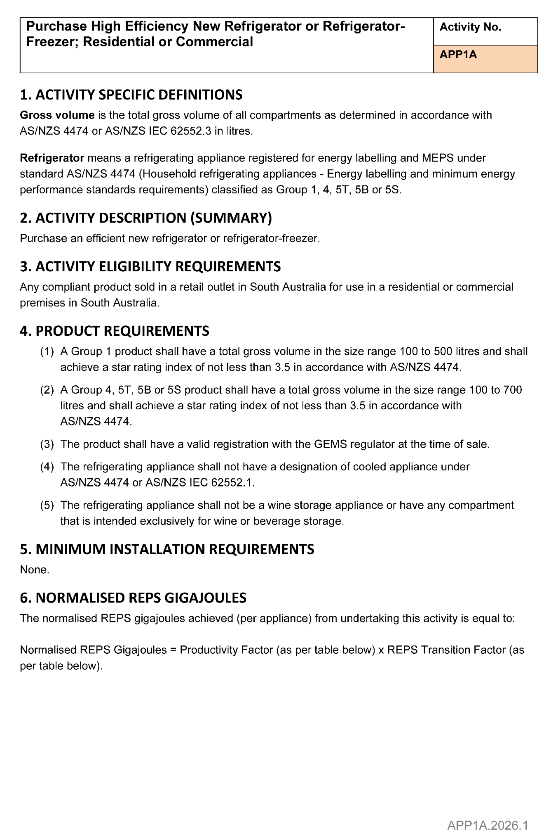
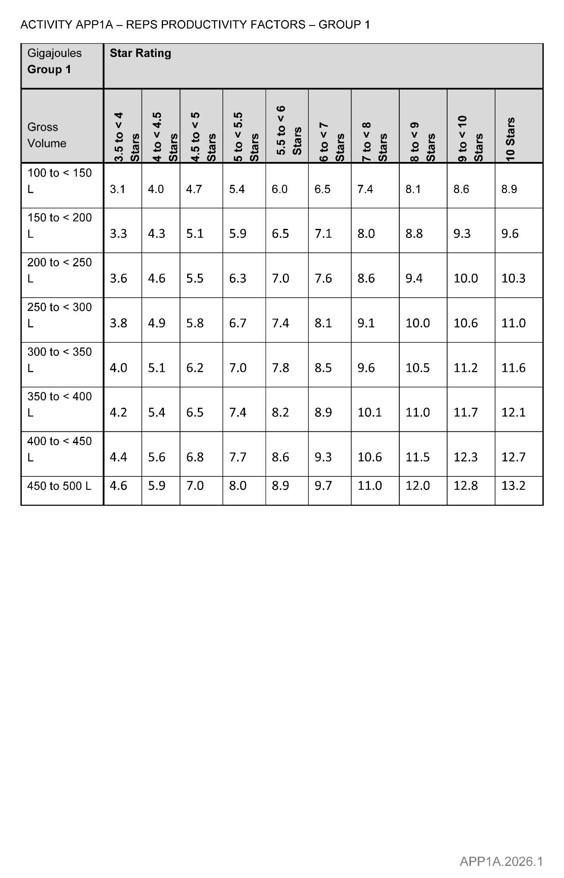
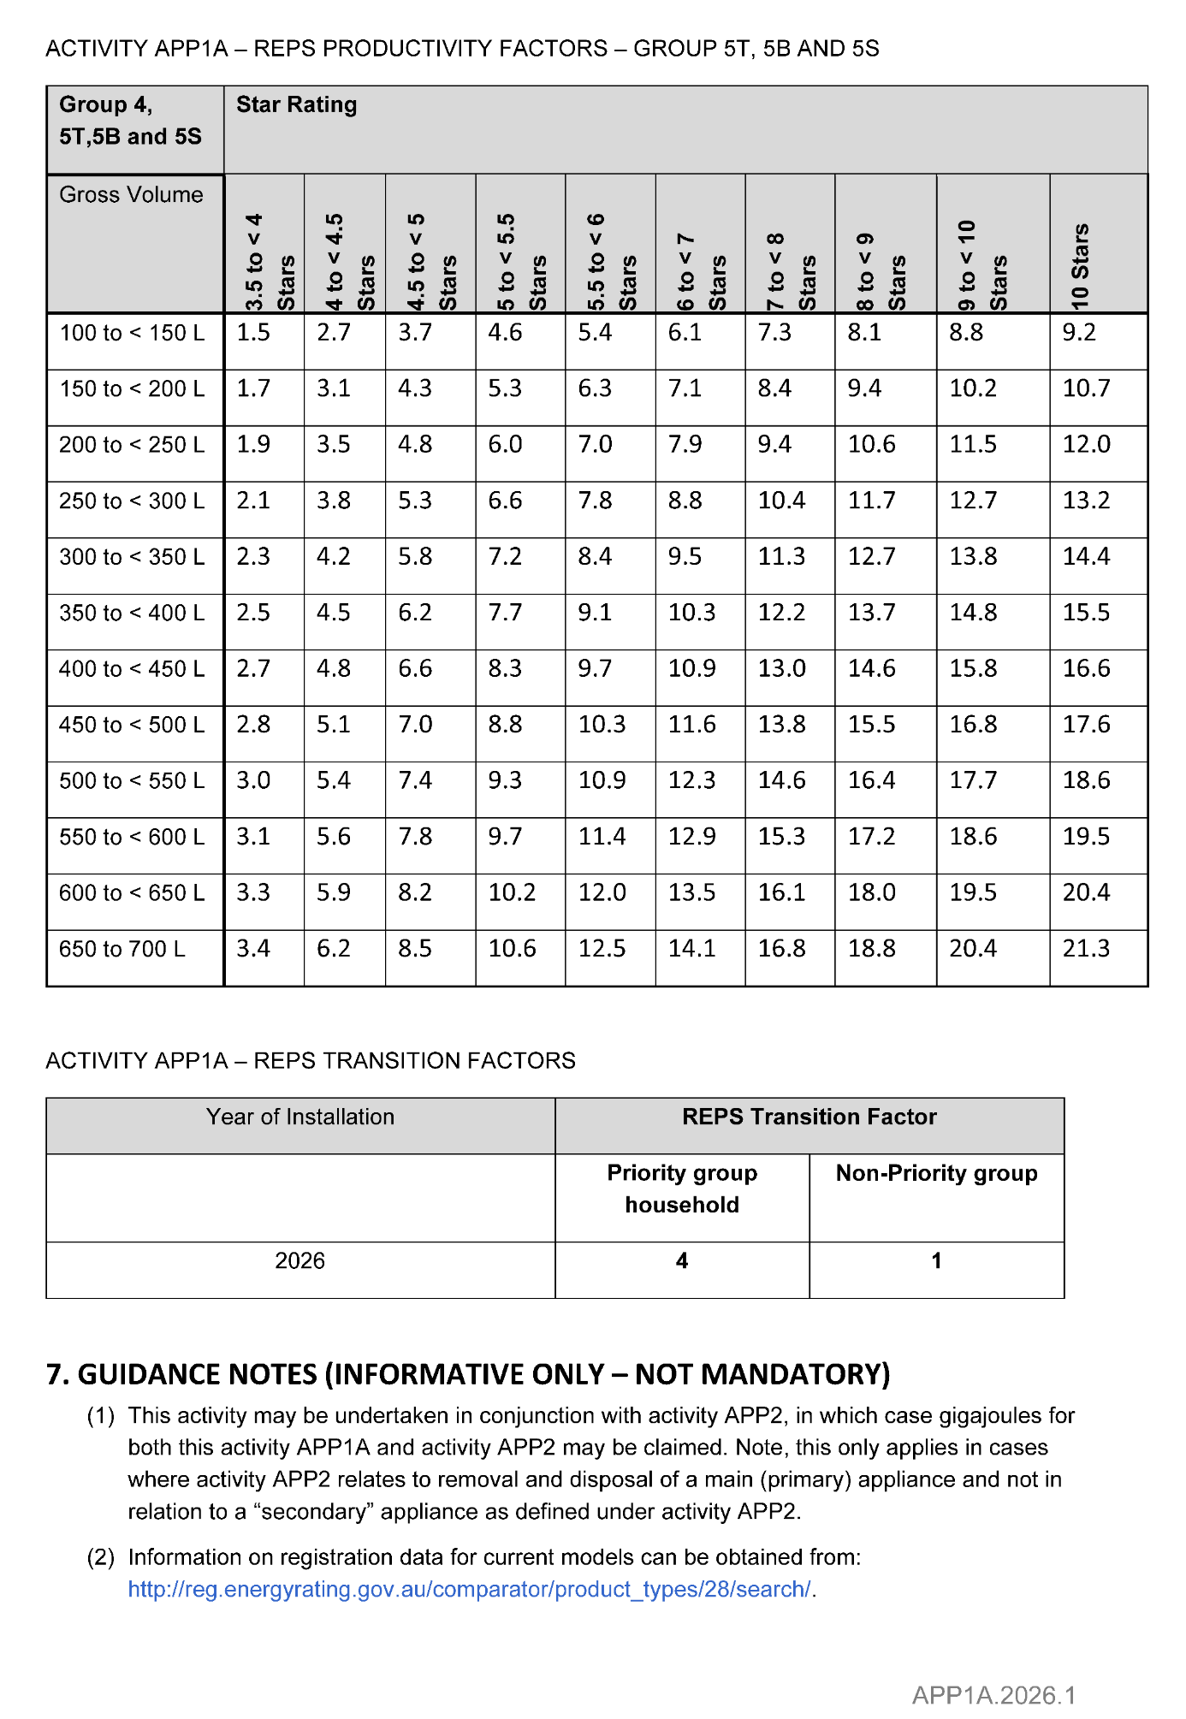



ELECTRICITY ACT 1996
GAS ACT 1997
Retailer Energy Productivity Scheme
Minimum Specifications for Energy Productivity Activities
Pursuant to Regulation 28(5) of the Electricity (General) Regulations 2012 under the Electricity Act 1996, and Regulation 22(5) of the
Gas Regulations 2012 under the Gas Act 1997, I revoke the Ministerial Notice—Purchase High Efficiency New Freezer; Residential or Commercial—Activity No. APP1B—in the South Australian Government Gazette No. 55 dated 1 August 2024, on pages 2357-2360.
Pursuant to Regulation 28 of the Electricity (General) Regulations 2012 and Regulation 22 of the Gas Regulations 2012, I determine the activities within the following document to be an energy productivity activity for the purposes of Part 4 of the Electricity (General) Regulations 2012 and Part 4 of the Gas Regulations 2012.
This notice will take effect from 1 January 2026.
Dated: 9 February 2026
Hon Tom Koutsantonis MP
Minister for Energy and Mining

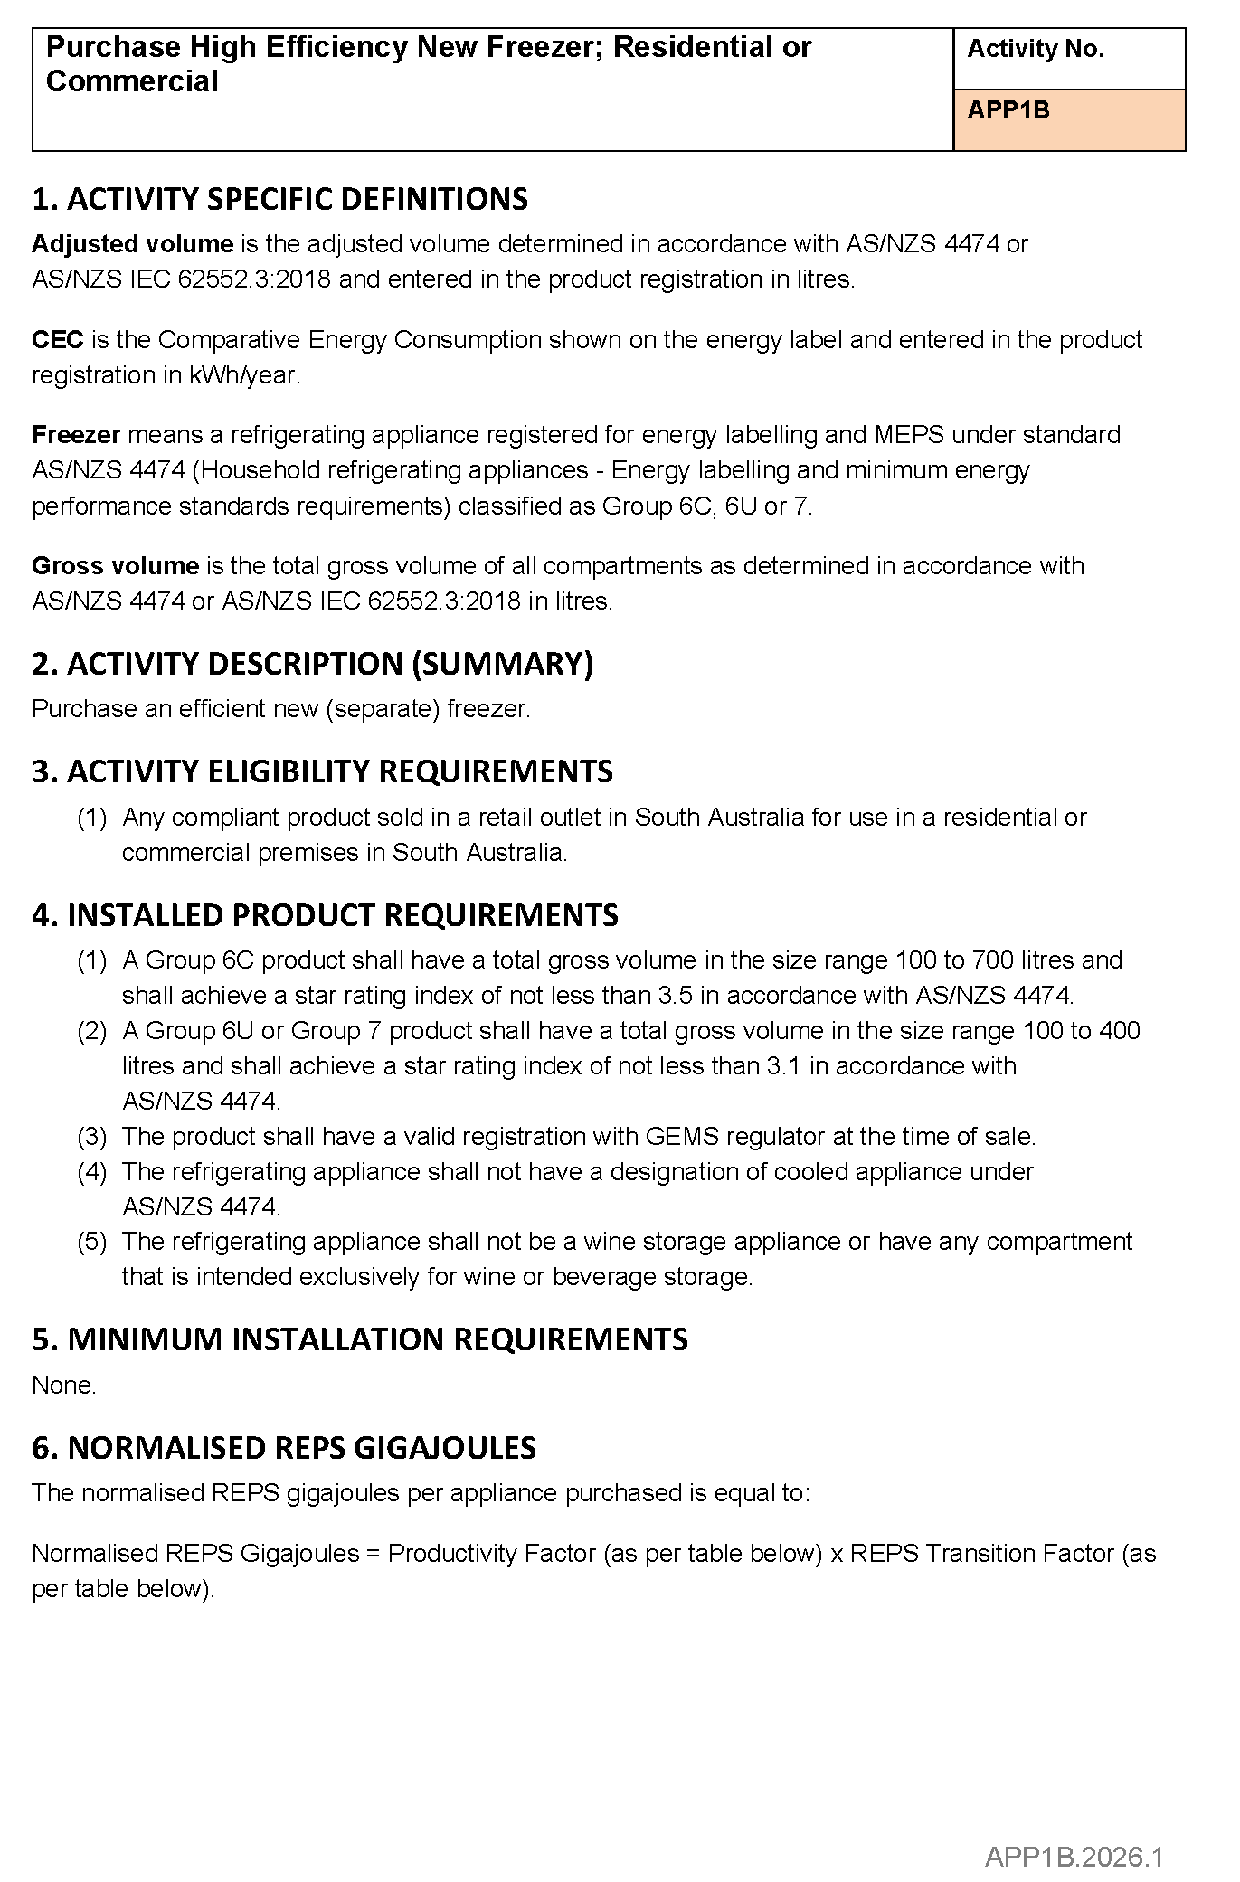
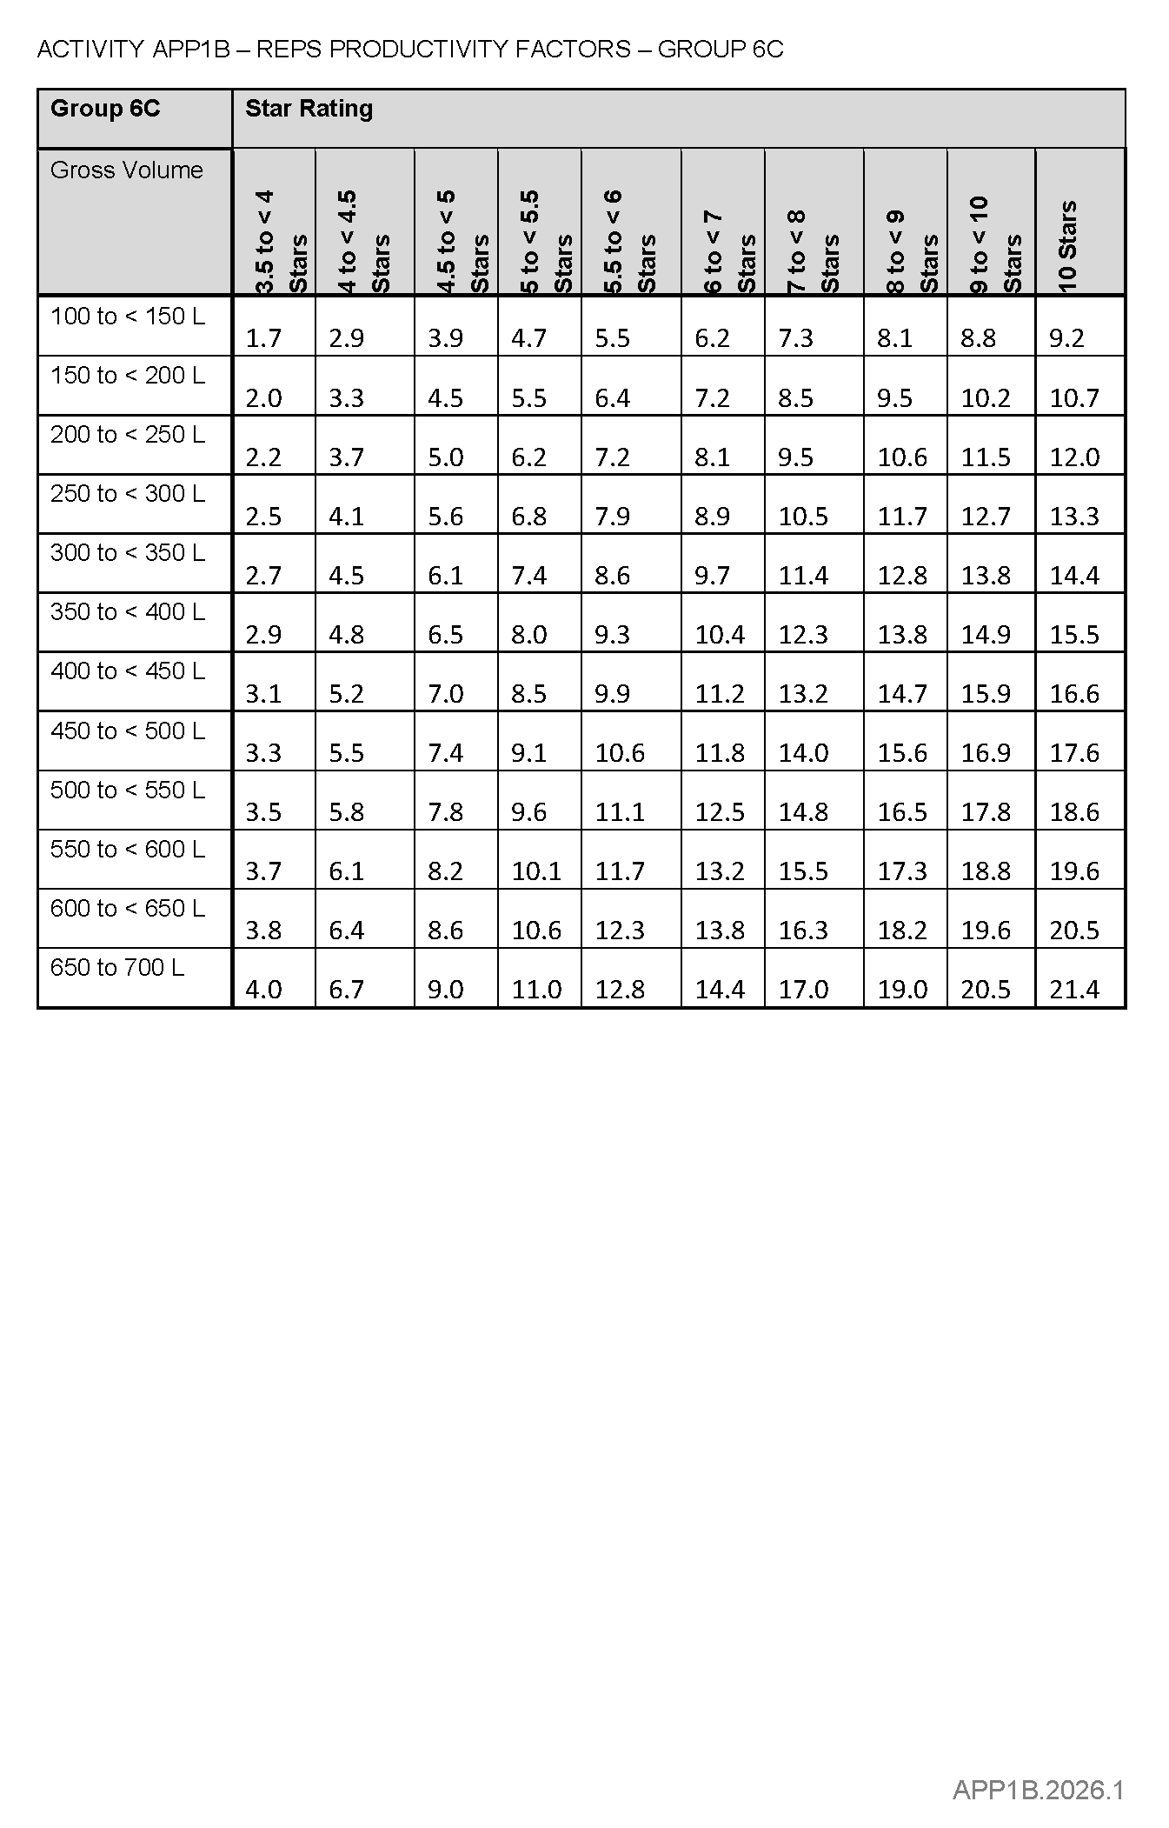
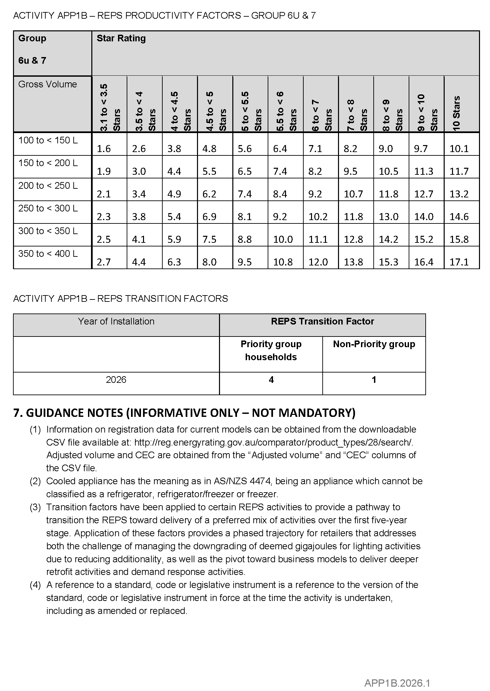

Electricity Act 1996
Gas Act 1997
Retailer Energy Productivity Scheme
Minimum Specifications for Energy Productivity Activities
Pursuant to Regulation 28(5) of the Electricity (General) Regulations 2012 under the Electricity Act 1996, and Regulation 22(5) of the
Gas Regulations 2012 under the Gas Act 1997, I revoke the Ministerial Notice—Purchase a High Efficiency New Clothes Dryer; Residential or Commercial—Activity No. APP1D—in the South Australian Government Gazette No. 55 dated 1 August 2024, on pages 2361-2363.
Pursuant to Regulation 28 of the Electricity (General) Regulations 2012 and Regulation 22 of the Gas Regulations 2012, I determine the activities within the following document to be an energy productivity activity for the purposes of Part 4 of the Electricity (General) Regulations 2012 and Part 4 of the Gas Regulations 2012.
This notice will take effect from 1 January 2026.
Dated: 9 February 2026
Hon Tom Koutsantonis MP
Minister for Energy and Mining

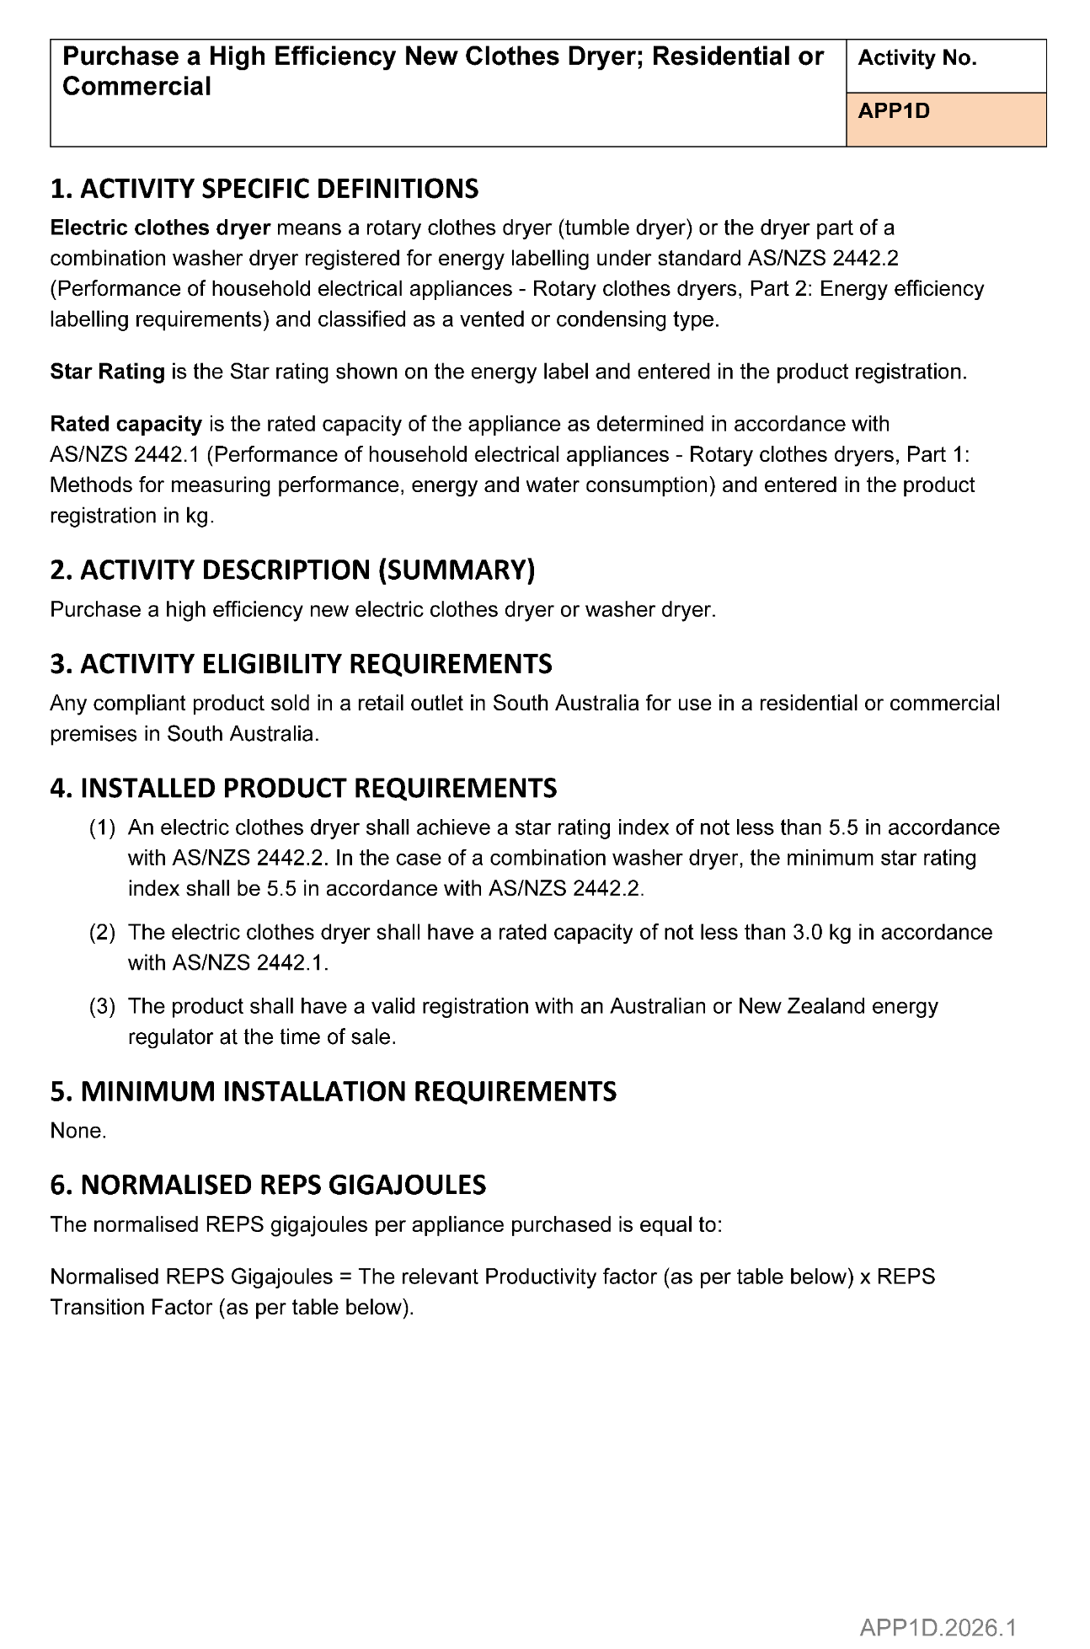
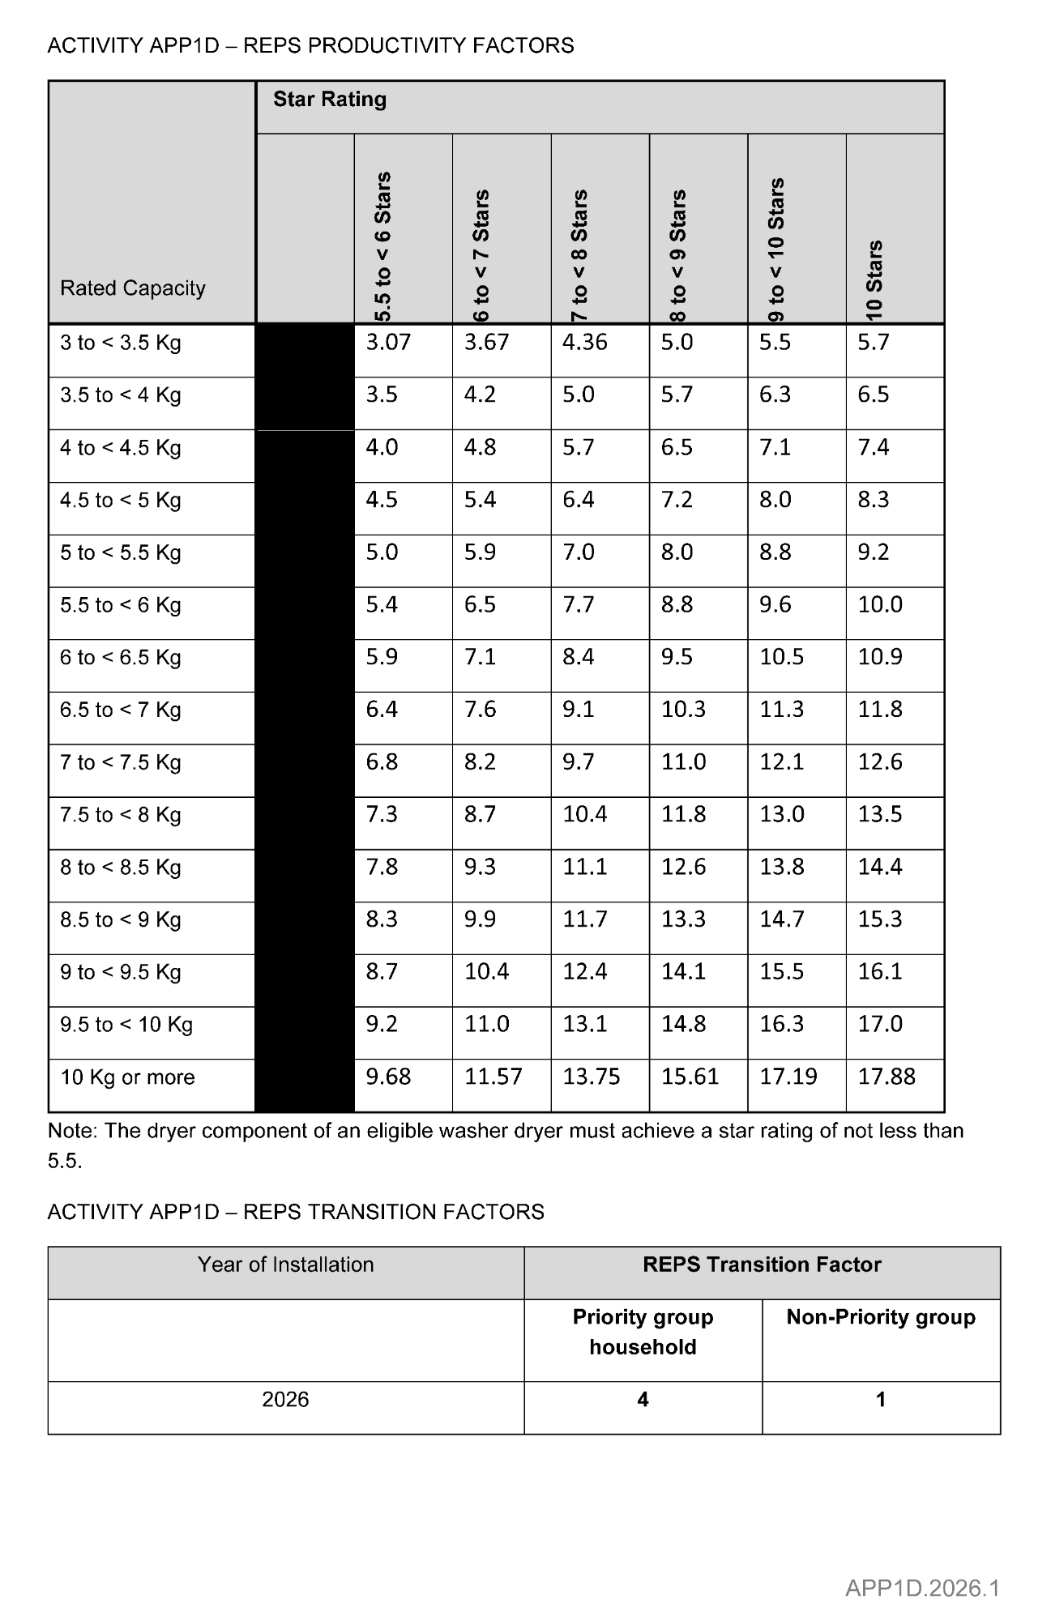
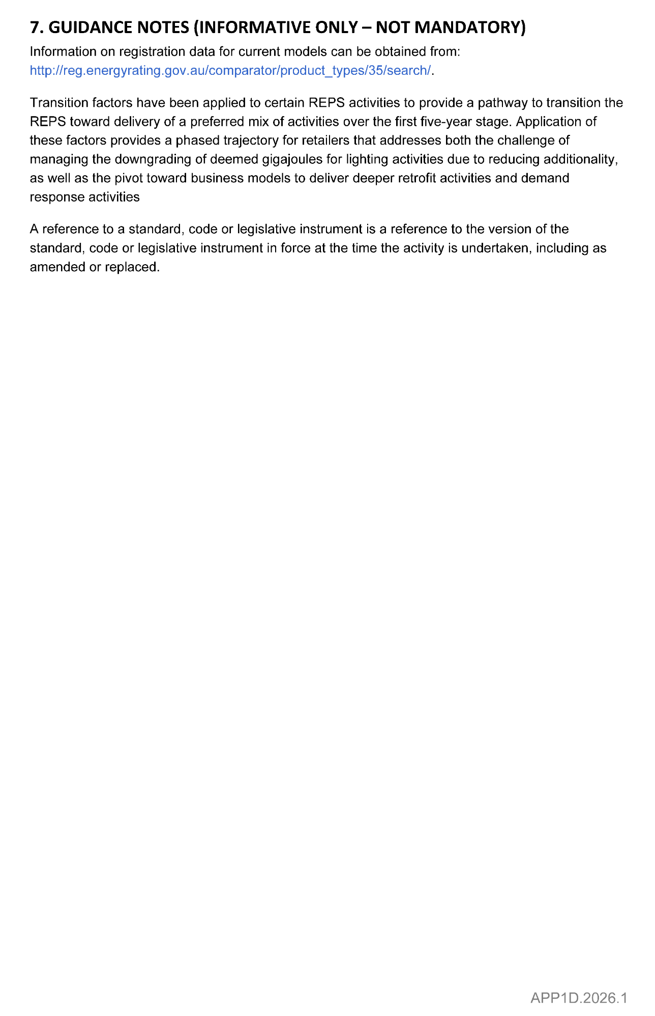

Electricity Act 1996
Gas Act 1997
Retailer Energy Productivity Scheme
Minimum Specifications for Energy Productivity Activities
Pursuant to Regulation 28(5) of the Electricity (General) Regulations 2012 under the Electricity Act 1996, and Regulation 22(5) of the
Gas Regulations 2012 under the Gas Act 1997, I revoke the Ministerial Notice—Connecting a New or Existing Pool Pump to an Approved DR Aggregator; Residential Only—Activity No. APP4—in the South Australian Government Gazette No. 98 dated 21 December 2020, on pages 6105-6106.
Pursuant to Regulation 28 of the Electricity (General) Regulations 2012 and Regulation 22 of the Gas Regulations 2012, I determine the activities within the following document to be an energy productivity activity for the purposes of Part 4 of the Electricity (General) Regulations 2012 and Part 4 of the Gas Regulations 2012.
This notice will take effect from 1 January 2026.
Dated: 9 February 2026
Hon Tom Koutsantonis MP
Minister for Energy and Mining

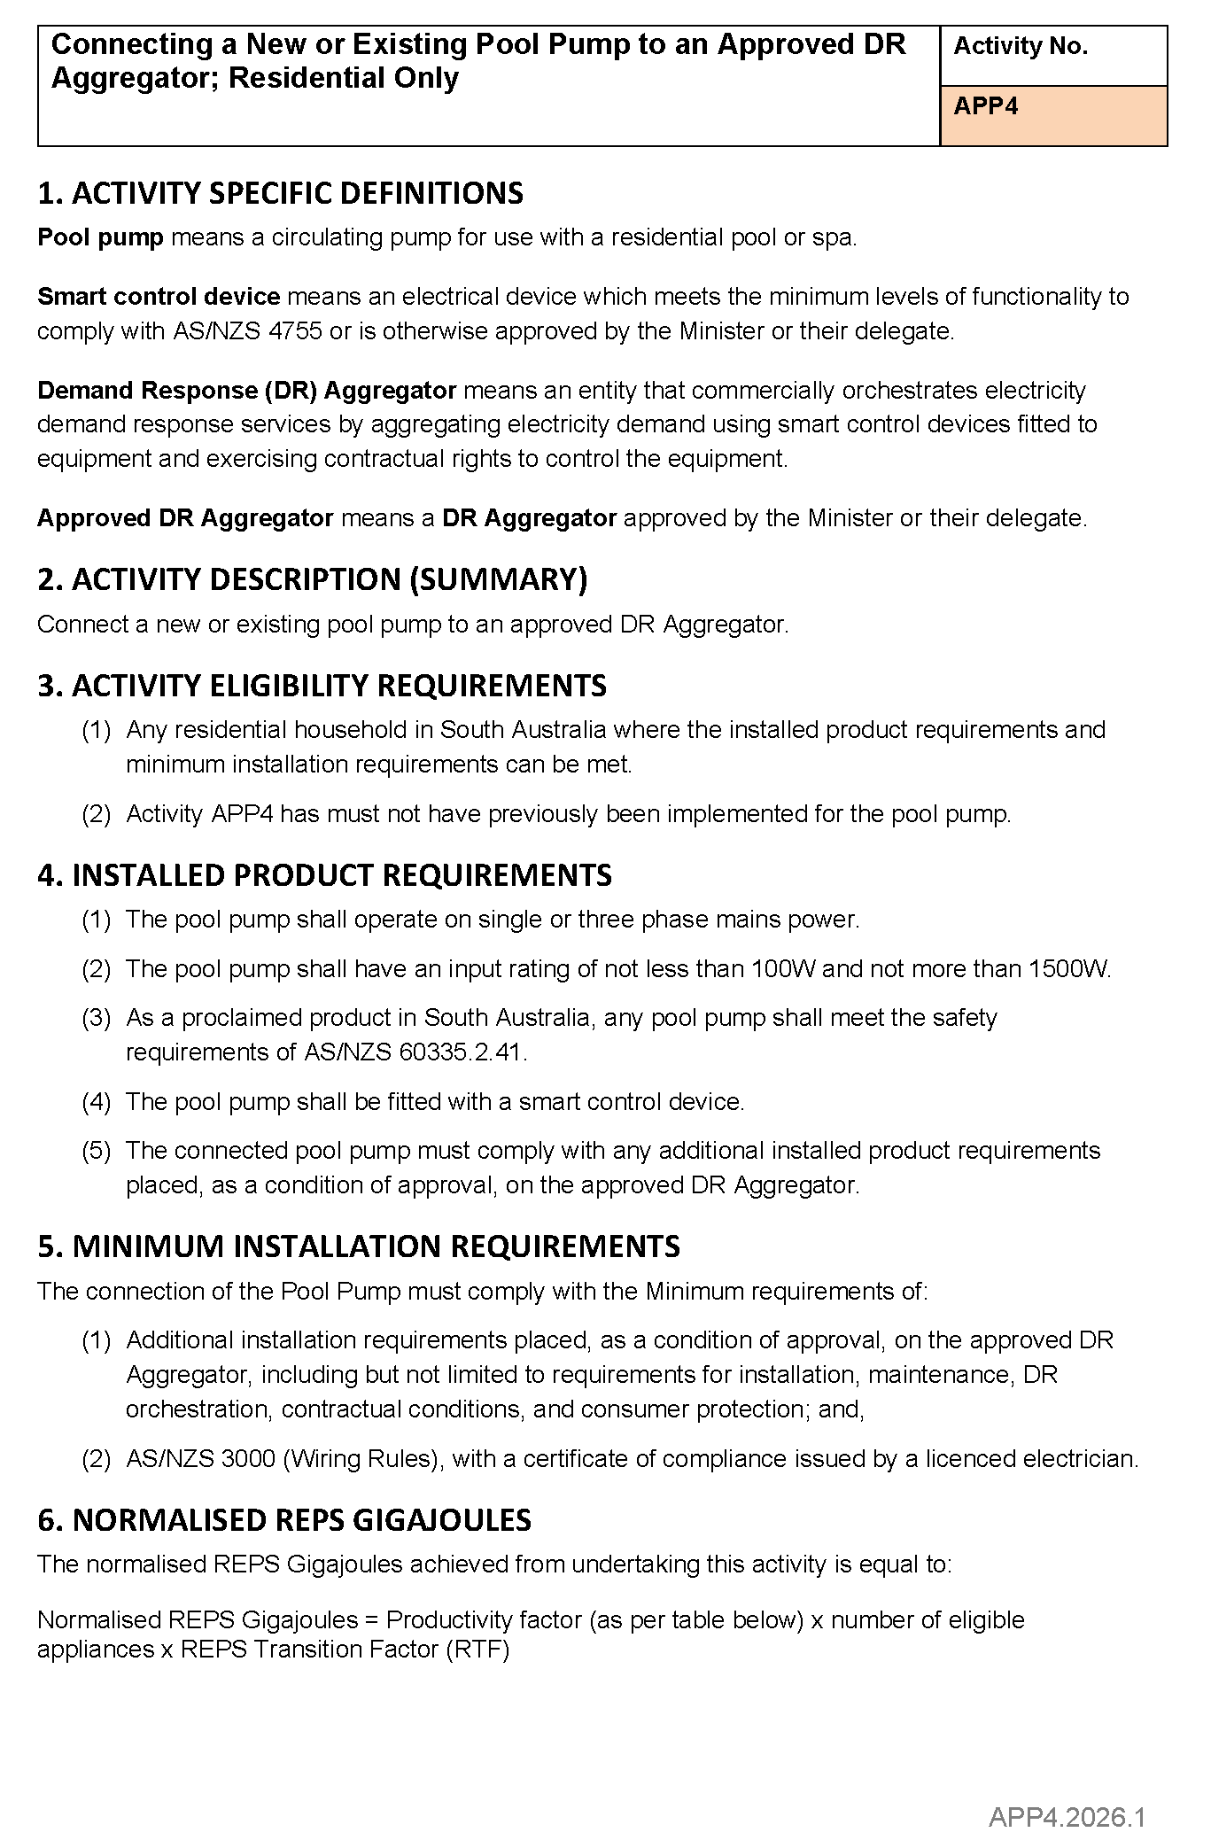
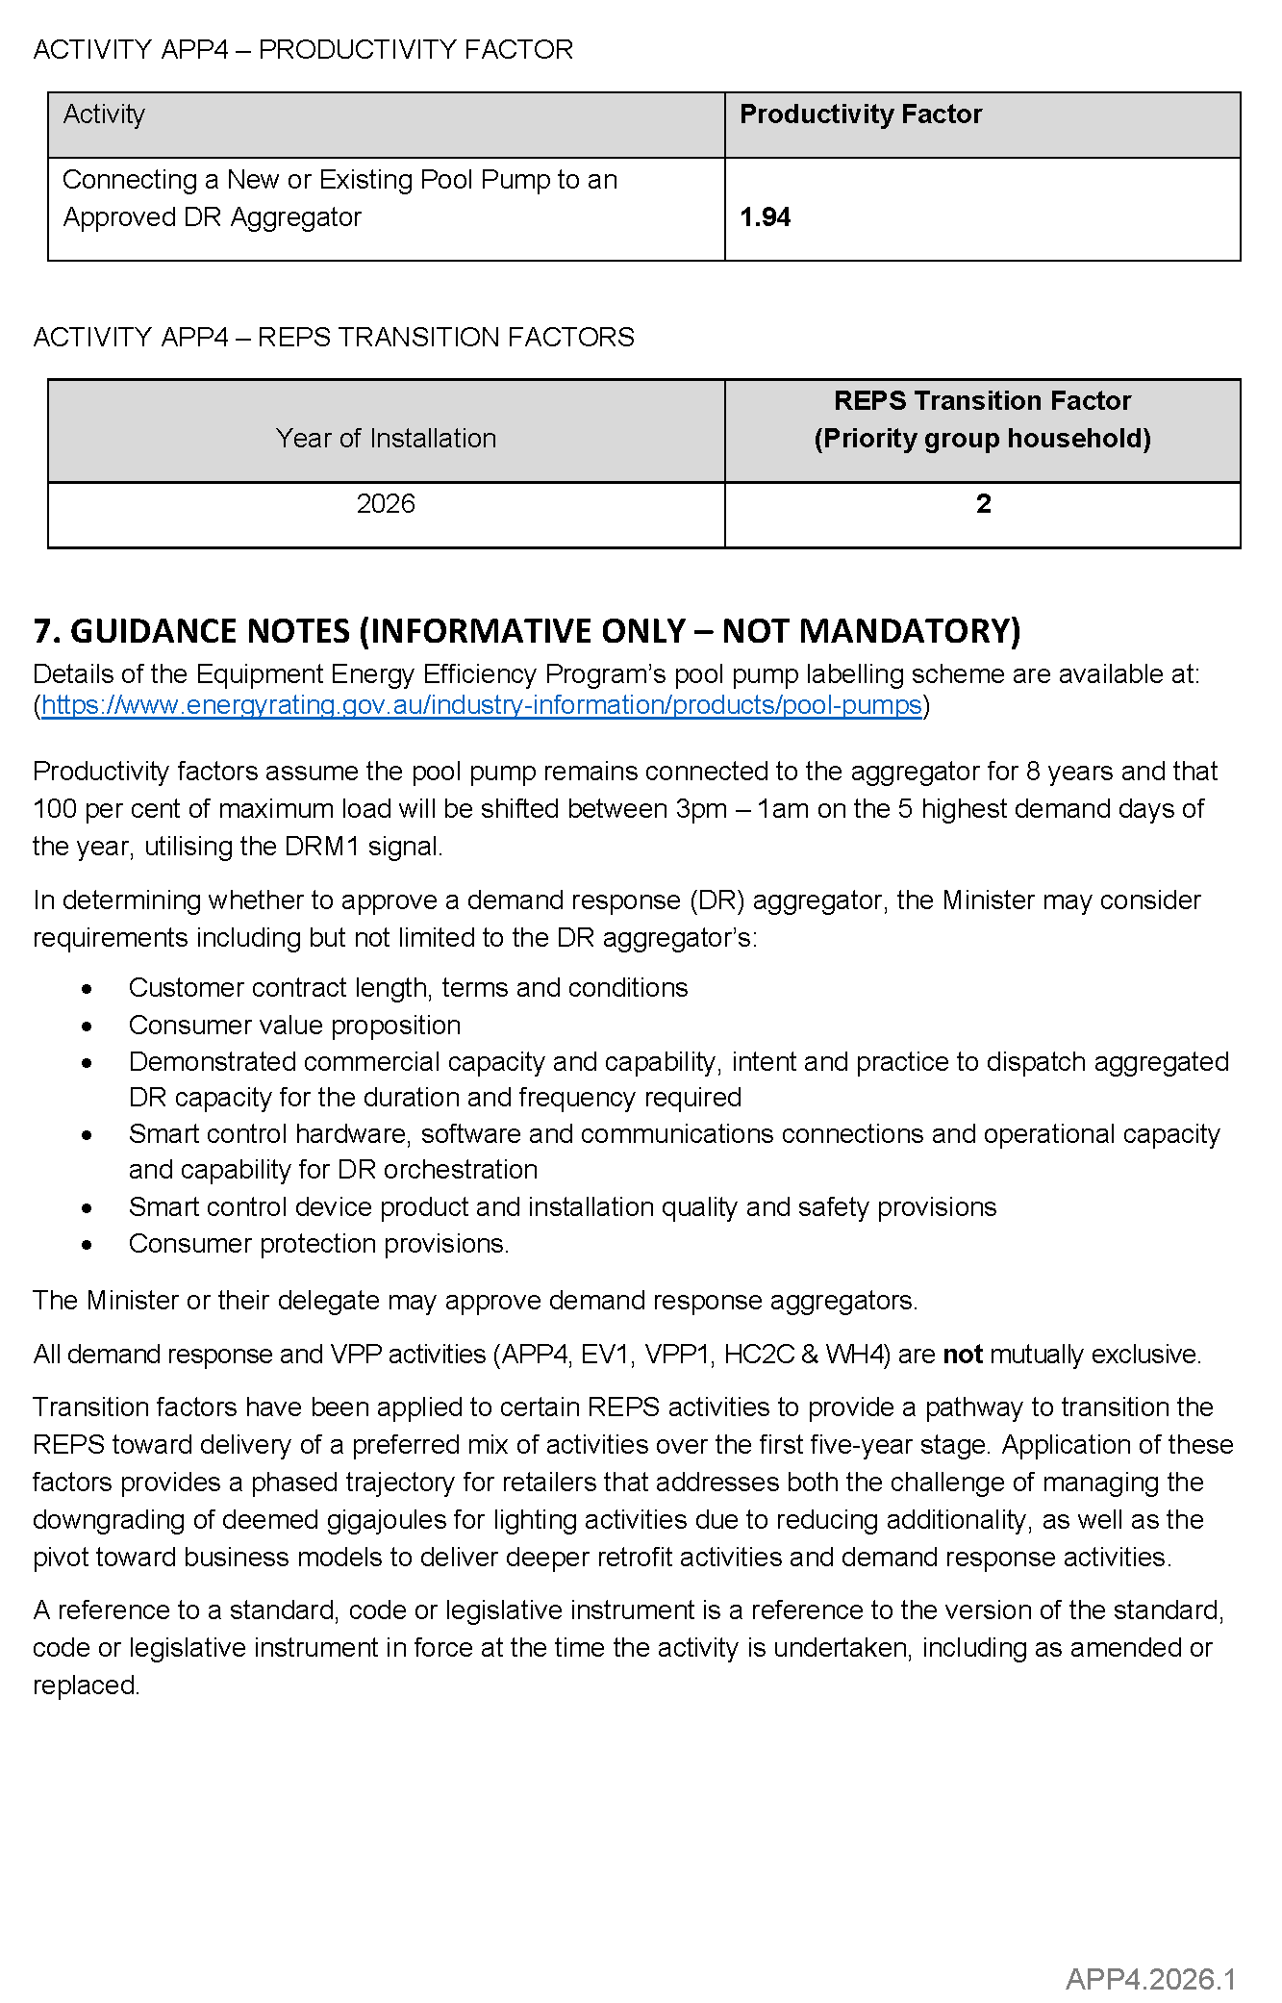

Electricity Act 1996
Gas Act 1997
Retailer Energy Productivity Scheme
Minimum Specifications for Energy Productivity Activities
Pursuant to Regulation 28(5) of the Electricity (General) Regulations 2012 under the Electricity Act 1996, and Regulation 22(5) of the
Gas Regulations 2012 under the Gas Act 1997, I revoke the Ministerial Notice—Install Insulation in an Uninsulated Ceiling Space; (Residential and Small Energy Consuming Customers Only)—Activity BS1A—in the South Australian Government Gazette No. 55,
dated 1 August 2024, on pages 2363-2366.
Pursuant to Regulation 28 of the Electricity (General) Regulations 2012 and Regulation 22 of the Gas Regulations 2012, I determine the activities within the following document to be an energy productivity activity for the purposes of Part 4 of the Electricity (General) Regulations 2012 and Part 4 of the Gas Regulations 2012.
This notice will take effect from 1 January 2026.
Dated: 9 February 2026
Hon Tom Koutsantonis MP
Minister for Energy and Mining

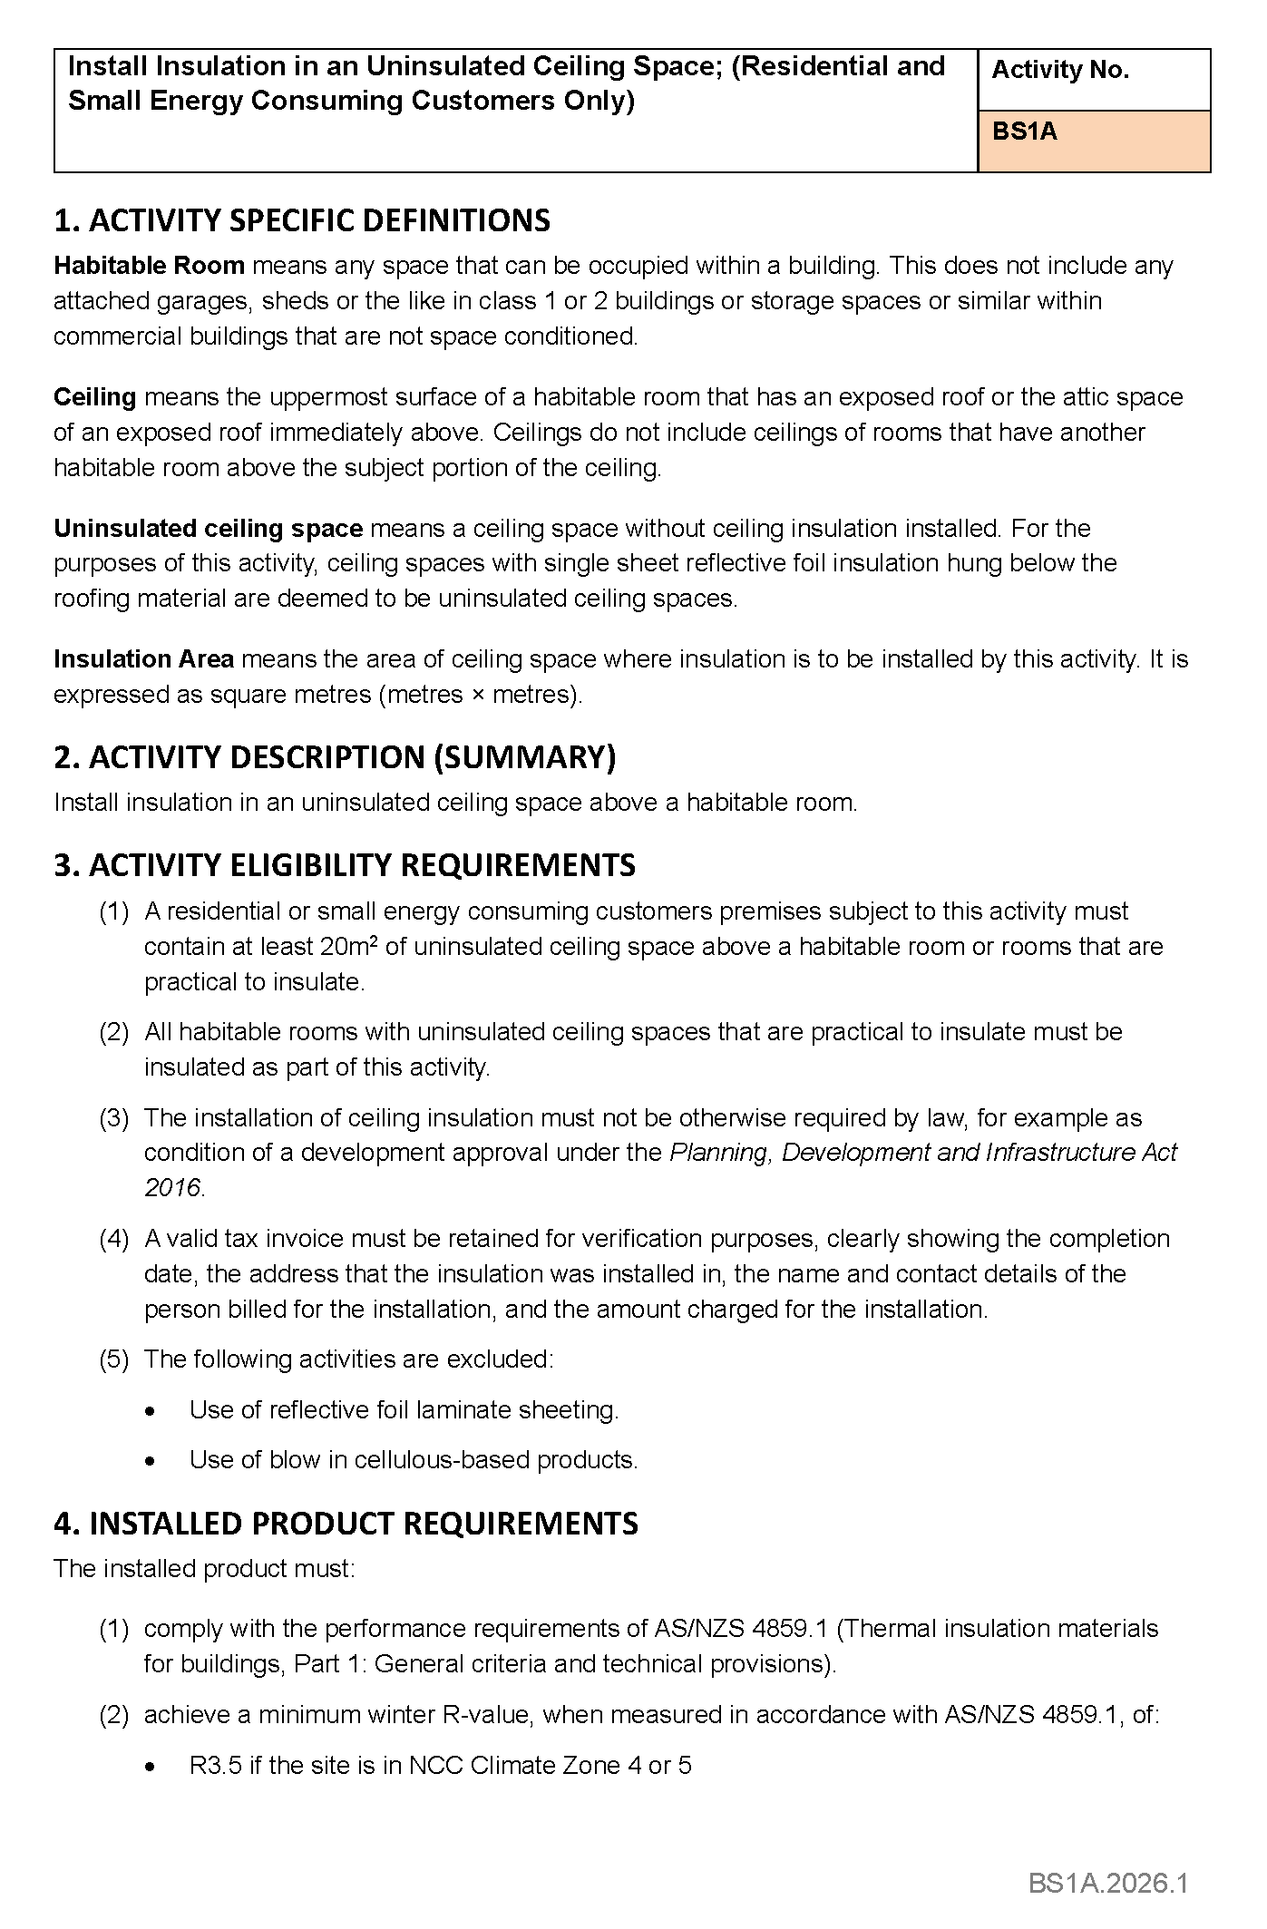
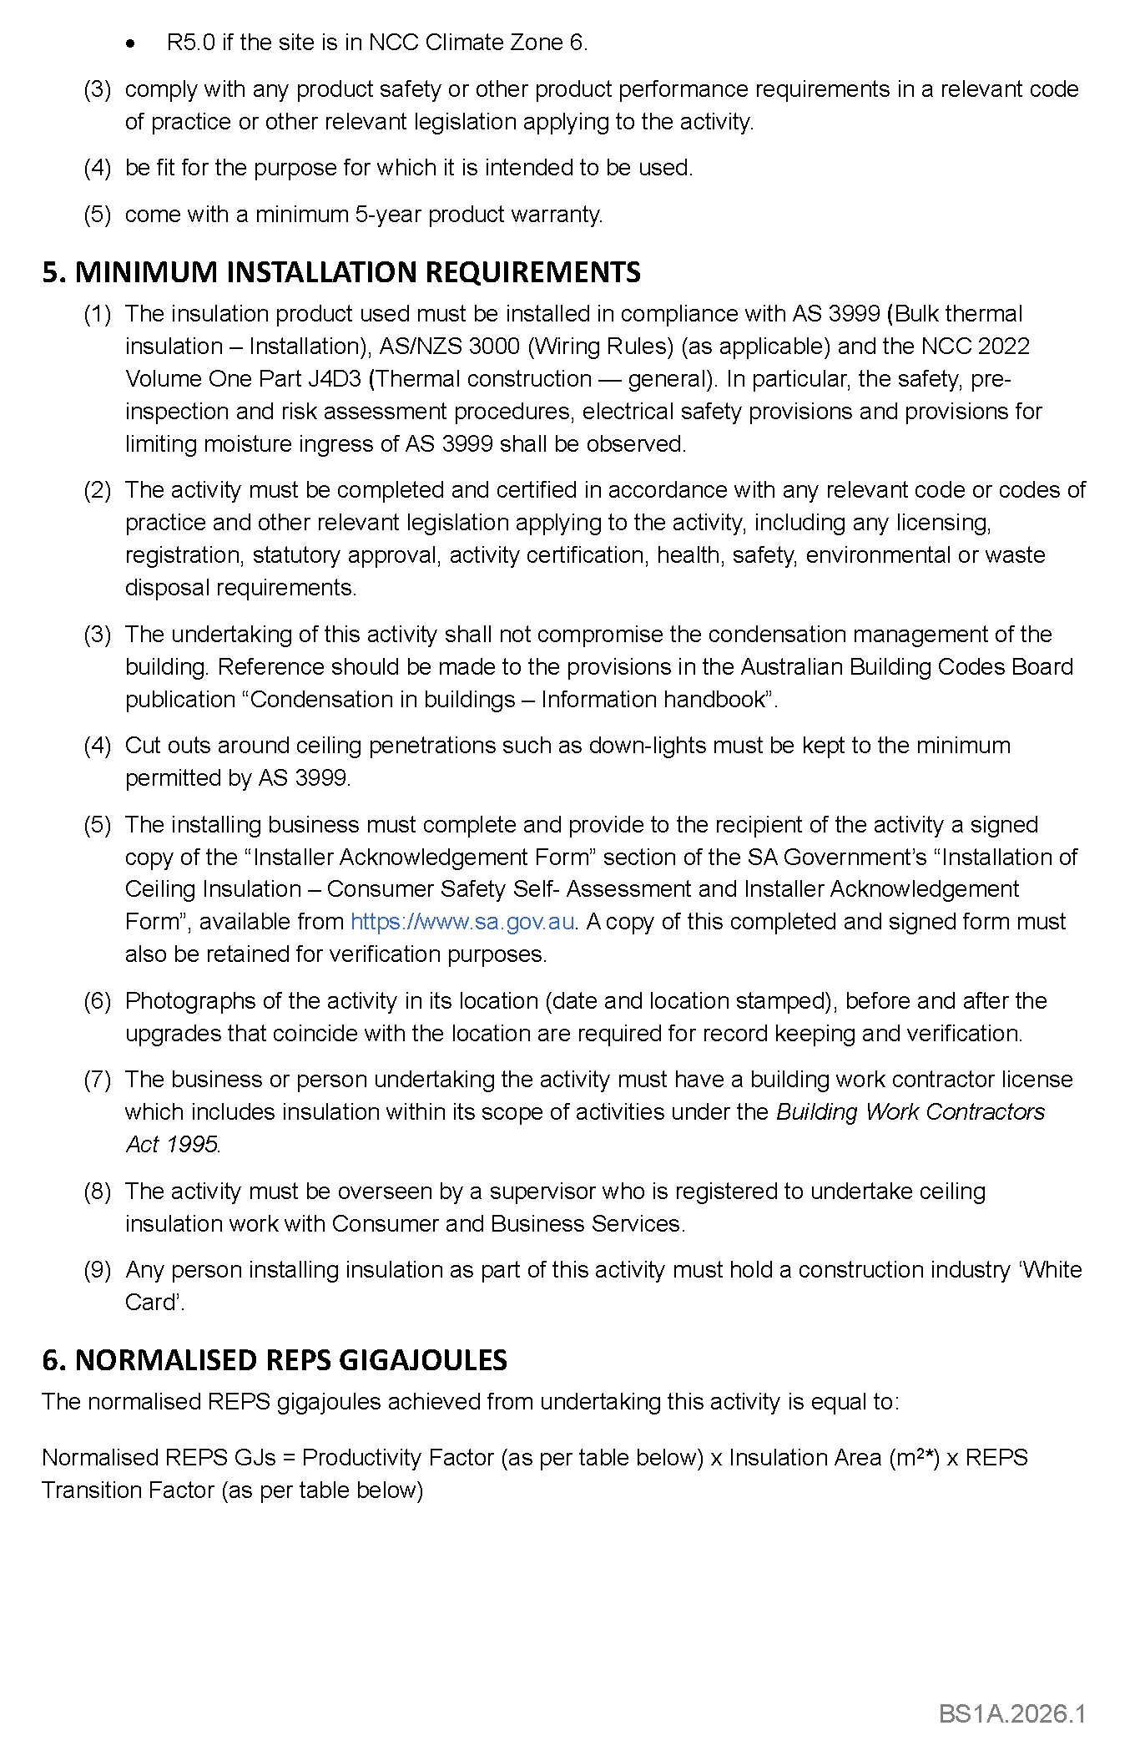
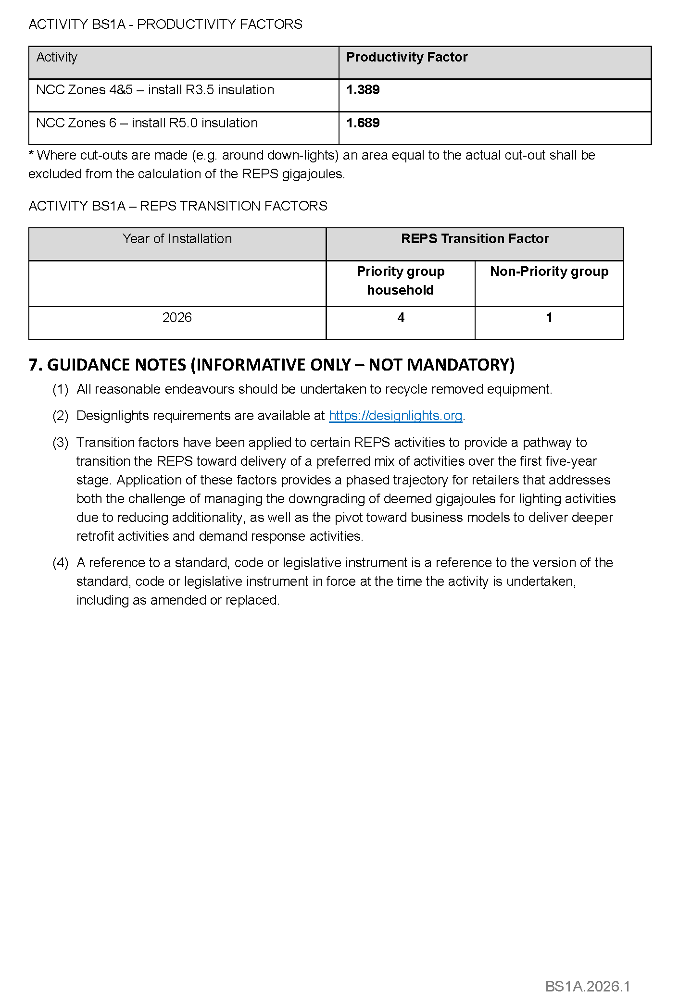

Electricity Act 1996
Gas Act 1997
Retailer Energy Productivity Scheme
Minimum Specifications for Energy Productivity Activities
Pursuant to Regulation 28(5) of the Electricity (General) Regulations 2012 under the Electricity Act 1996, and Regulation 22(5) of the Gas Regulations 2012 under the Gas Act 1997, I revoke the Ministerial Notice—Install Top Up Insulation in a Ceiling Space (Residential and Small Energy Consuming Customers Only)—Activity No. BS1B—in the South Australian Government Gazette No. 55, dated 1 August 2024, on pages 2367-2370.
Pursuant to Regulation 28 of the Electricity (General) Regulations 2012 and Regulation 22 of the Gas Regulations 2012, I determine the activities within the following documents to be an energy productivity activity for the purposes of Part 4 of the Electricity (General) Regulations 2012 and Part 4 of the Gas Regulations 2012.
This notice will take effect from 1 January 2026.
Dated: 9 February 2026
Hon Tom Koutsantonis MP
Minister for Energy and Mining

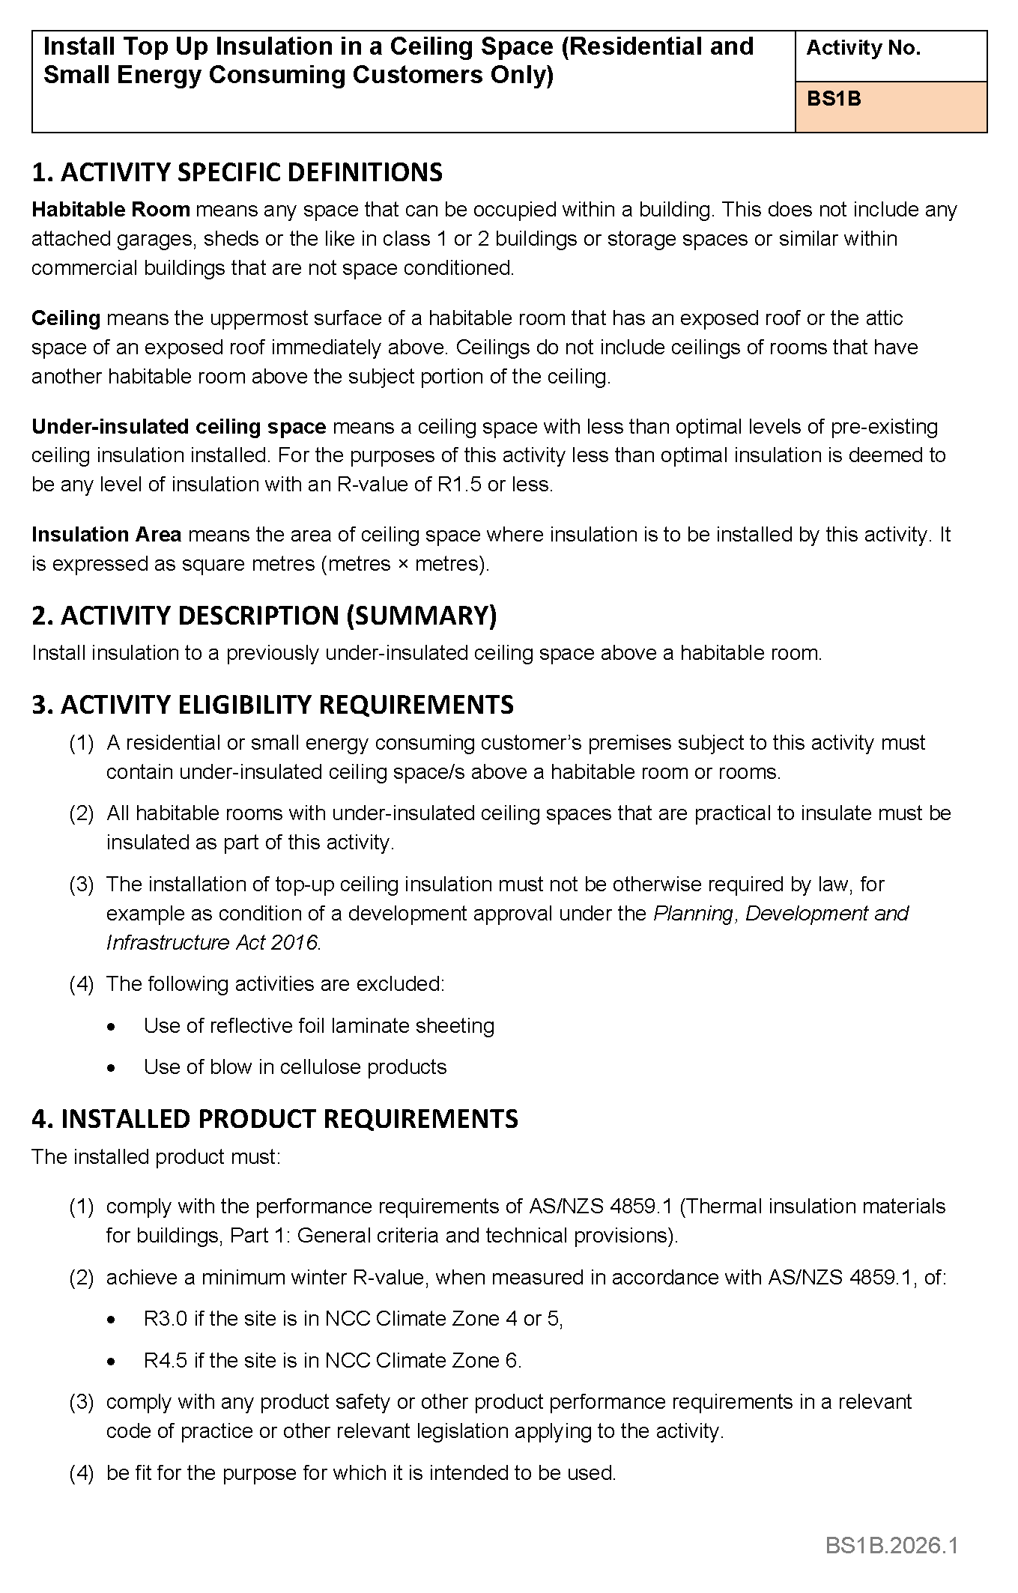

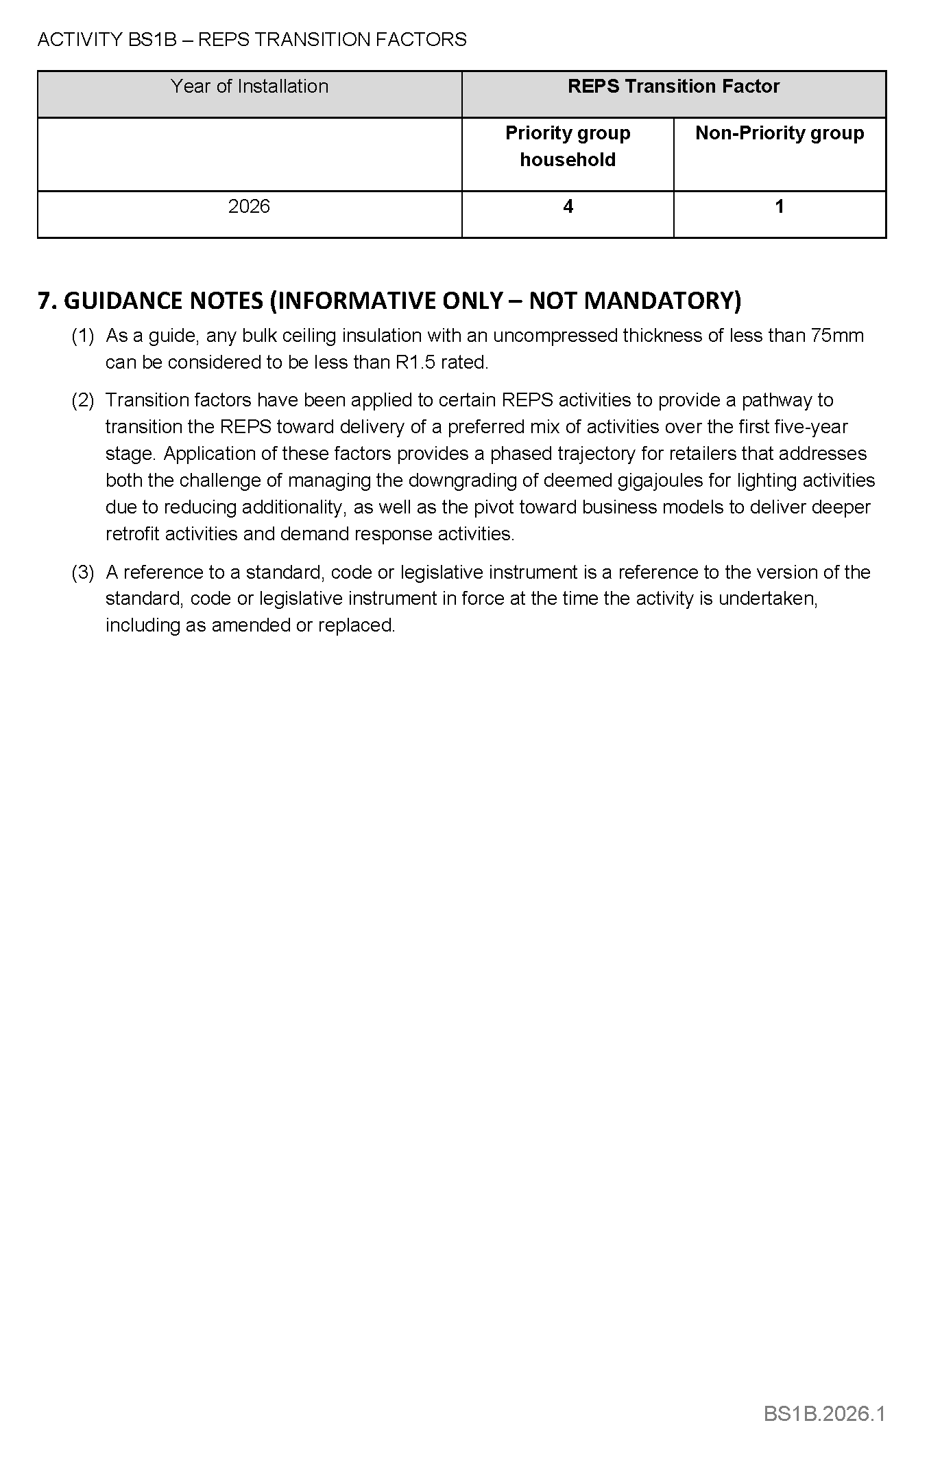

Electricity Act 1996
Gas Act 1997
Retailer Energy Productivity Scheme
Minimum Specifications for Energy Productivity Activities
Pursuant to Regulation 28 of the Electricity (General) Regulations 2012 and Regulation 22 of the Gas Regulations 2012, I determine the activities within the following document to be an energy productivity activity for the purposes of Part 4 of the Electricity (General) Regulations 2012 and Part 4 of the Gas Regulations 2012.
This notice will take effect from 1 January 2026.
Dated: 9 February 2026
Hon Tom Koutsantonis MP
Minister for Energy and Mining

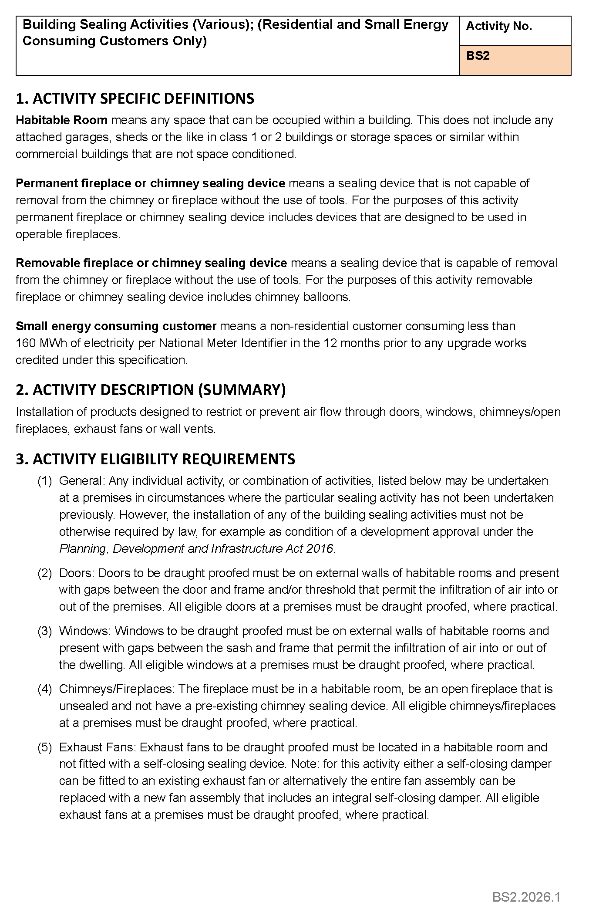

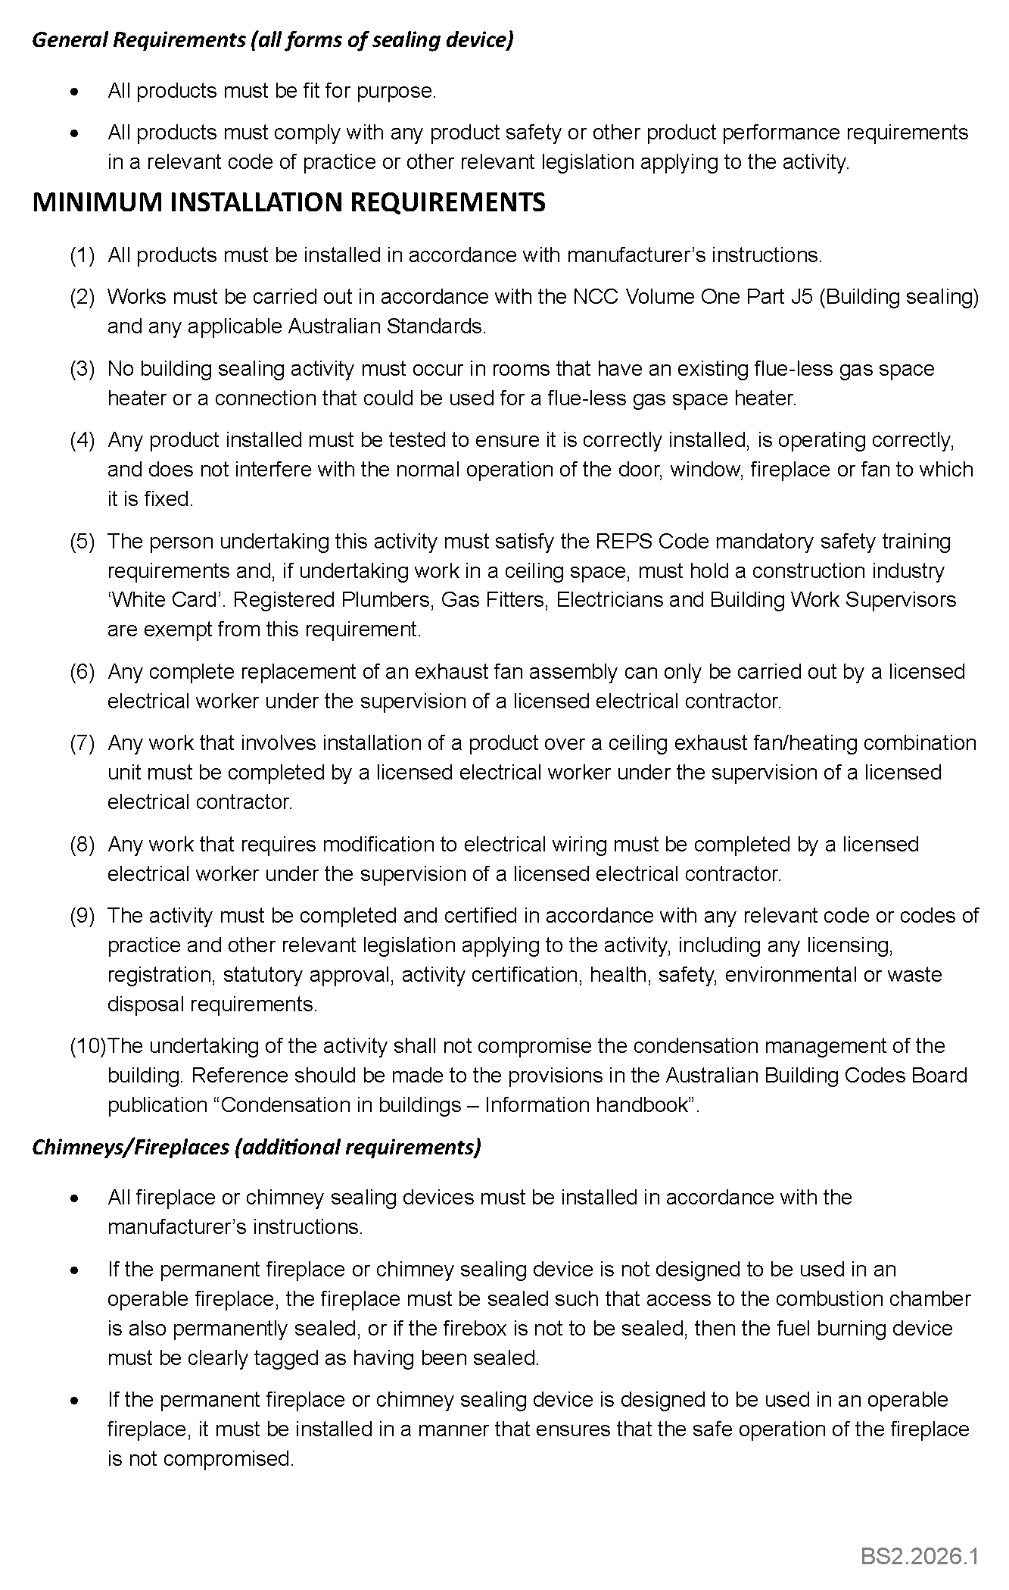
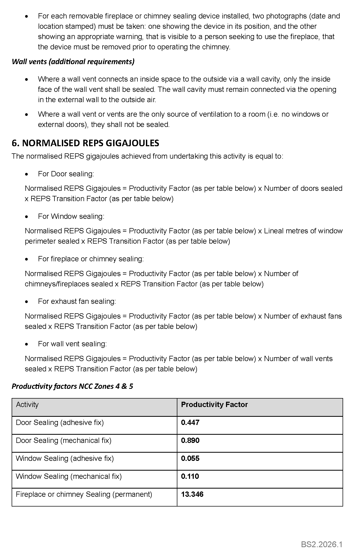
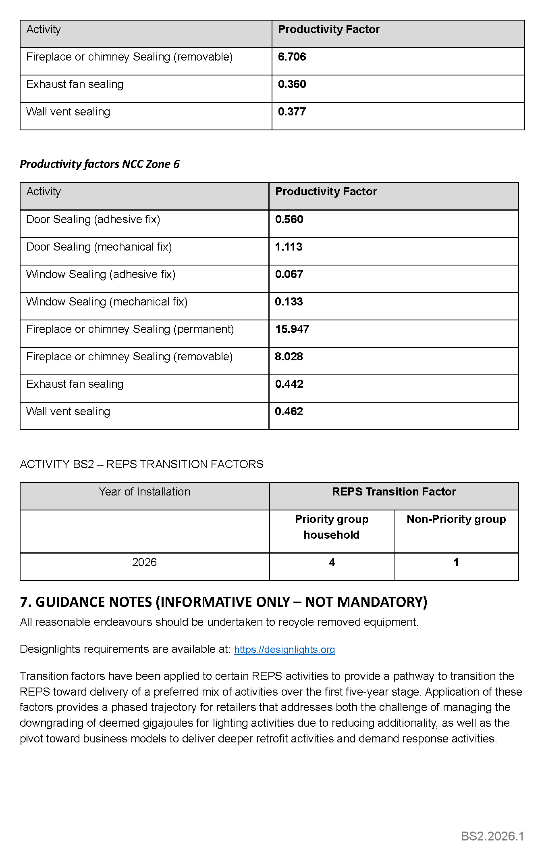


Electricity Act 1996
Gas Act 1997
Retailer Energy Productivity Scheme
Minimum Specifications for Energy Productivity Activities
Pursuant to Regulation 28(5) of the Electricity (General) Regulations 2012 under the Electricity Act 1996, and Regulation 22(5) of the Gas Regulations 2012 under the Gas Act 1997, I revoke the Ministerial Notice—Secondary Glazing Retrofit; (Residential and Small Energy Consuming Customers Only)—Activity No. BS3B—in the South Australian Government Gazette No. 55, dated 1 August 2024, on pages 2376-2379.
Pursuant to Regulation 28 of the Electricity (General) Regulations 2012 and Regulation 22 of the Gas Regulations 2012, I determine the activities within the following documents to be an energy productivity activity for the purposes of Part 4 of the Electricity (General) Regulations 2012 and Part 4 of the Gas Regulations 2012.
This notice will take effect from 1 January 2026.
Dated: 9 February 2026
Hon Tom Koutsantonis MP
Minister for Energy and Mining

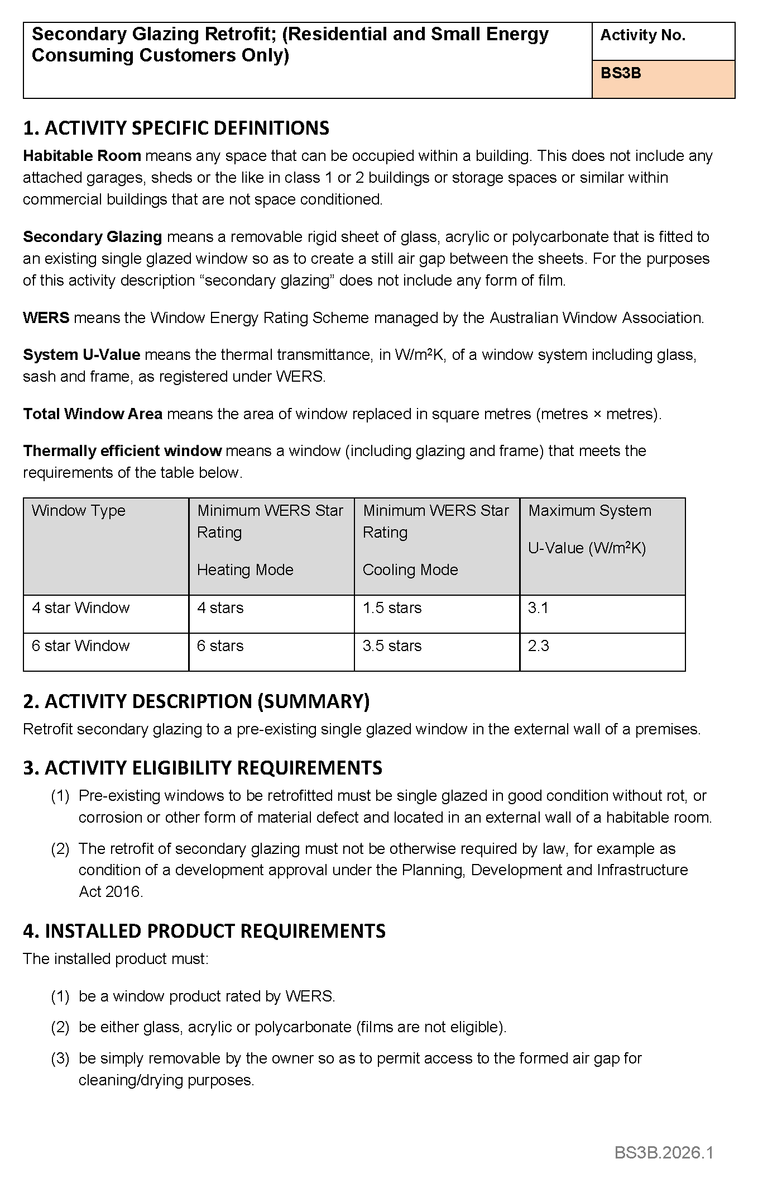
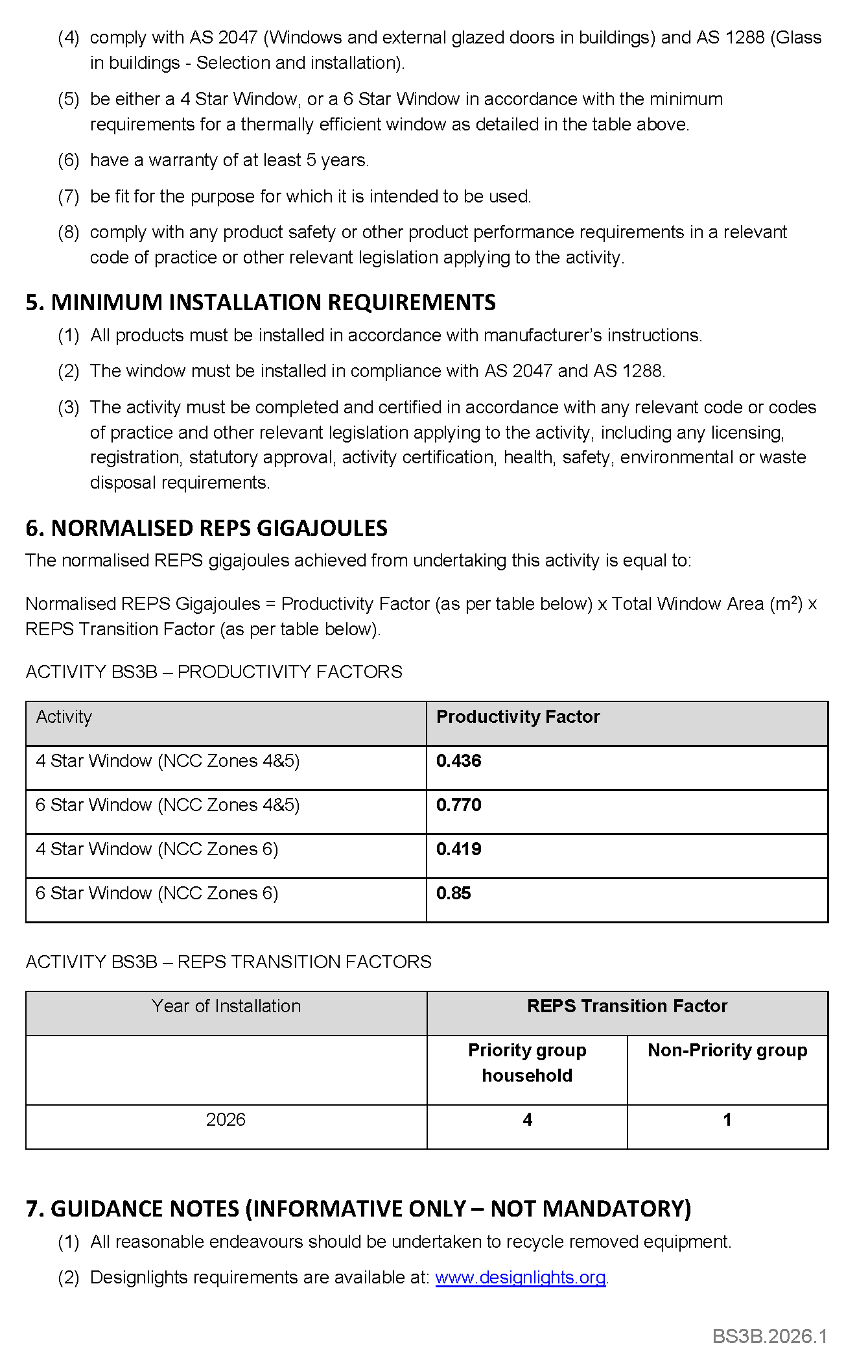


ELECTRICITY ACT 1996
GAS ACT 1997
Retailer Energy Productivity Scheme
Minimum Specifications for Energy Productivity Activities
Pursuant to Regulation 28 of the Electricity (General) Regulations 2012 and Regulation 22 of the Gas Regulations 2012, I determine the activities within the following document to be an energy productivity activity for the purposes of Part 4 of the Electricity (General) Regulations 2012 and Part 4 of the Gas Regulations 2012.
This notice will take effect from 1 January 2026.
Dated: 9 February 2026
Hon Tom Koutsantonis MP
Minister for Energy and Mining


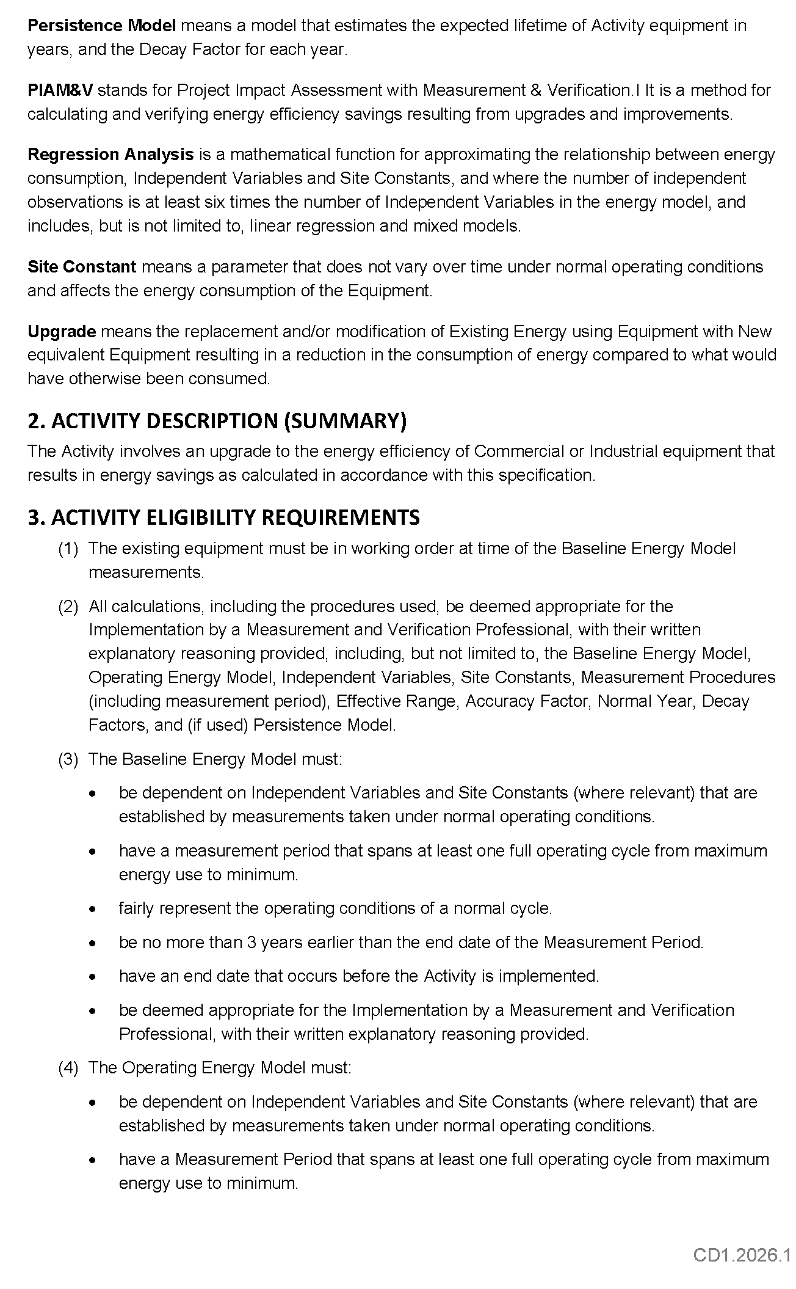
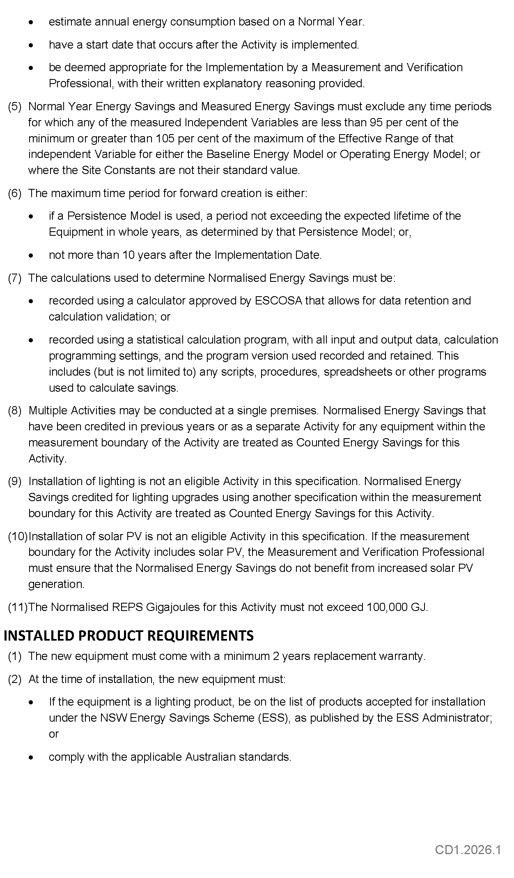
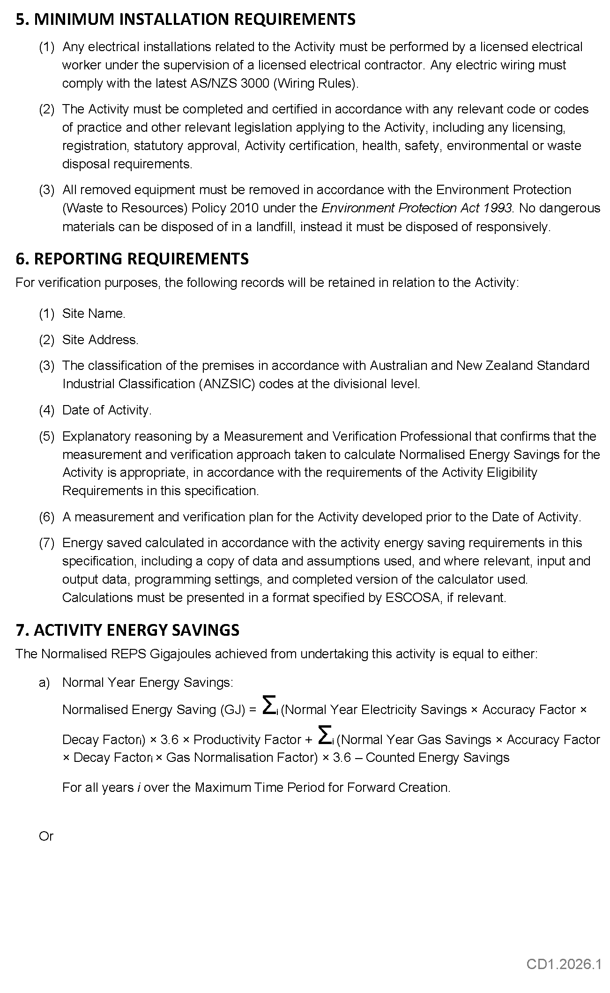



ELECTRICITY ACT 1996
GAS ACT 1997
Retailer Energy Productivity Scheme
Minimum Specifications for Energy Productivity Activities
Pursuant to Regulation 28 of the Electricity (General) Regulations 2012 and Regulation 22 of the Gas Regulations 2012, I determine the activities within the following document to be an energy productivity activity for the purposes of Part 4 of the Electricity (General) Regulations 2012 and Part 4 of the Gas Regulations 2012.
This notice will take effect from 1 January 2026.
Dated: 9 February 2026
Hon Tom Koutsantonis MP
Minister for Energy and Mining

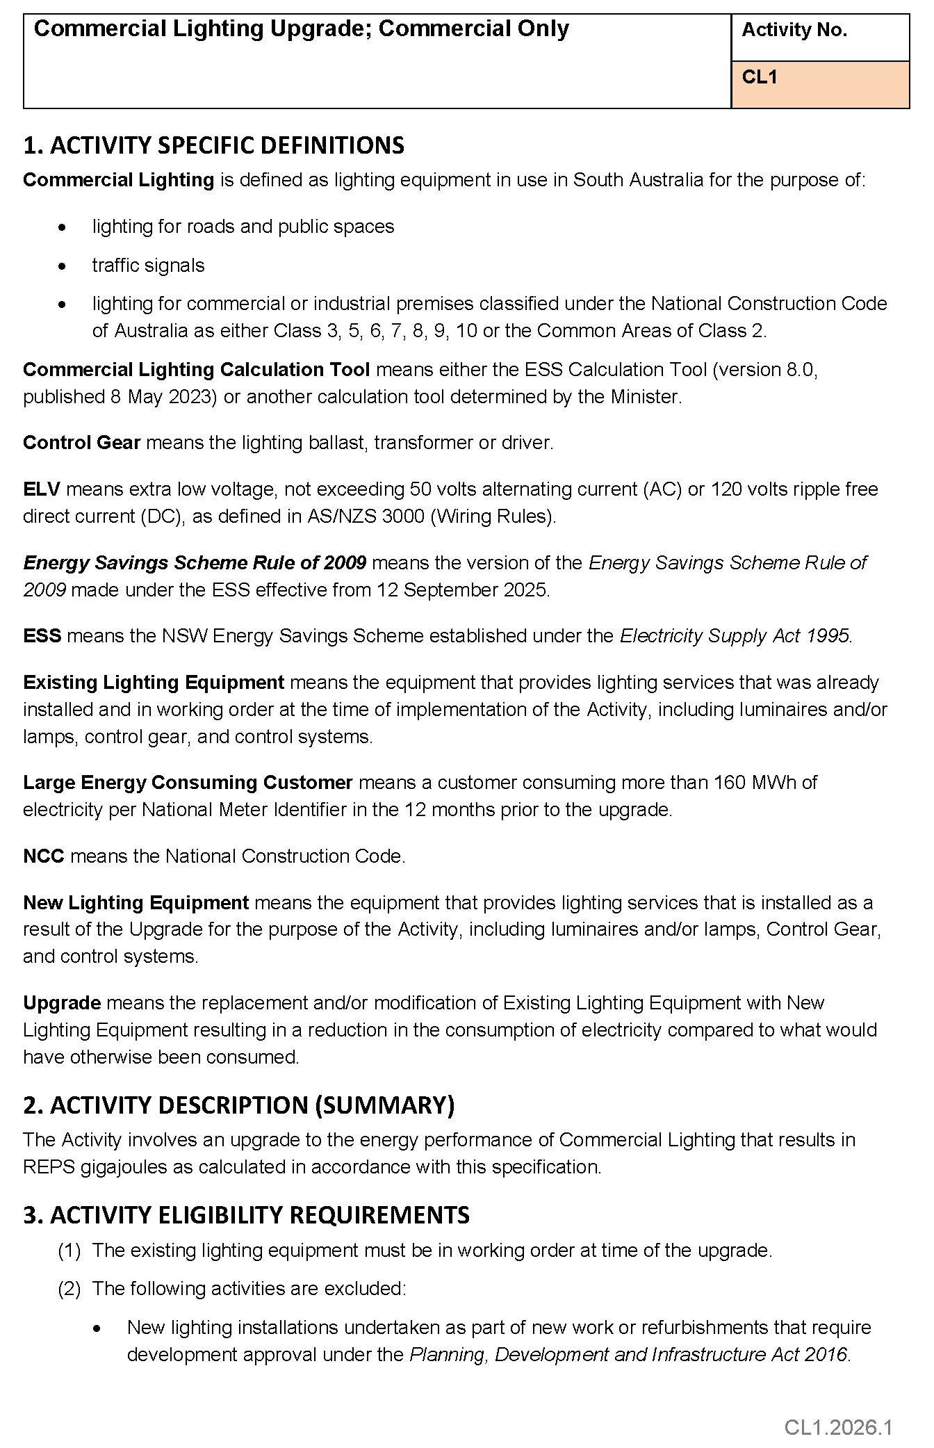

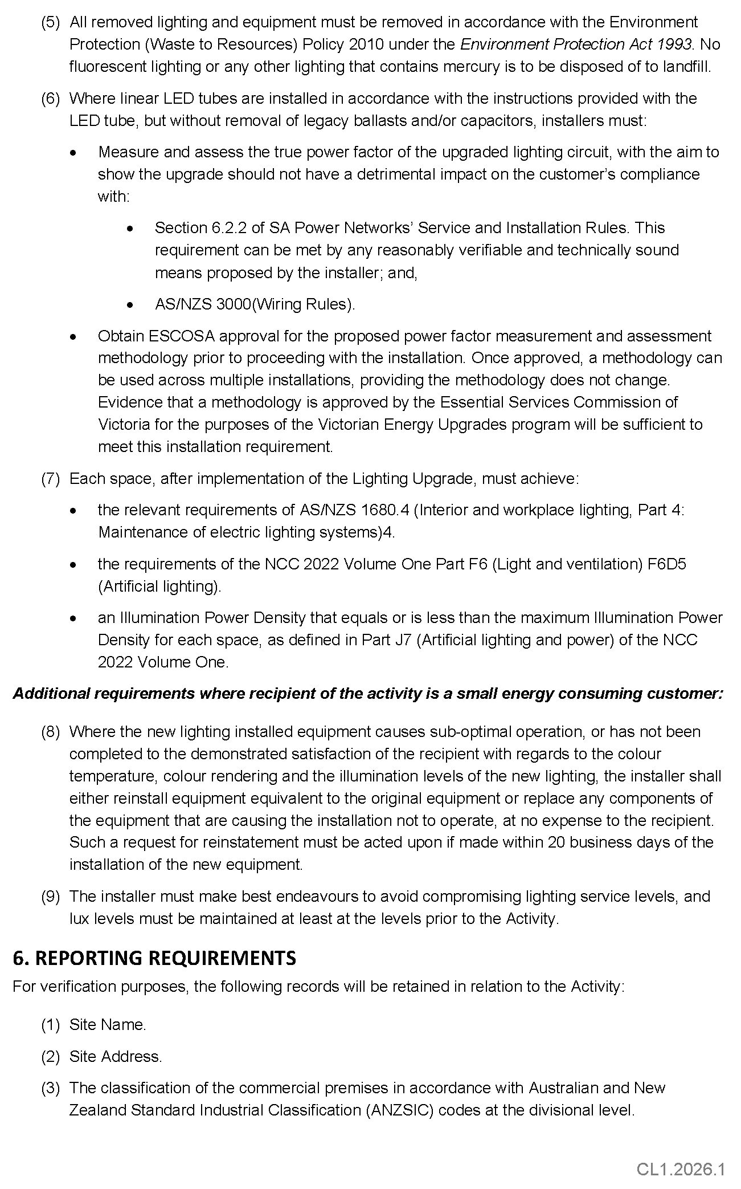
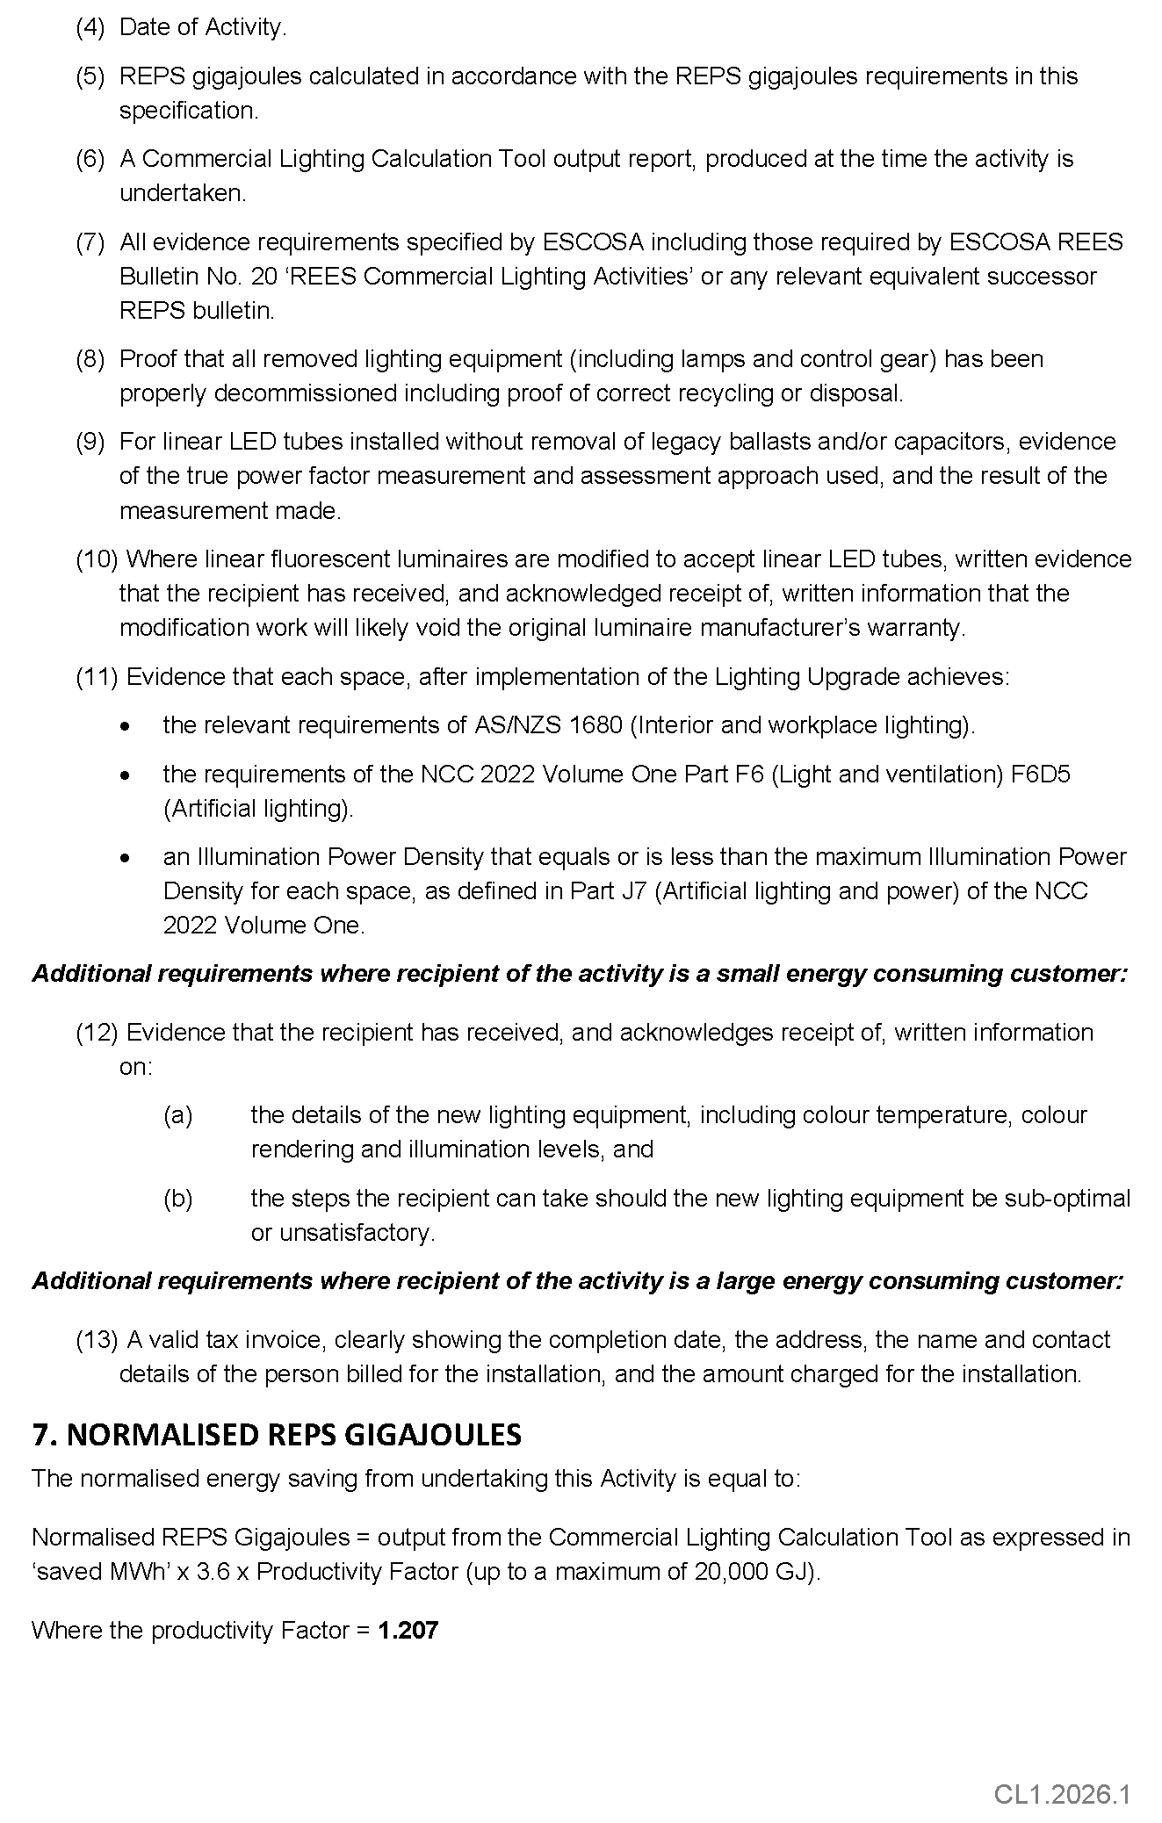


ELECTRICITY ACT 1996
GAS ACT 1997
Retailer Energy Productivity Scheme
Minimum Specifications for Energy Productivity Activities
Pursuant to Regulation 28(5) of the Electricity (General) Regulations 2012 under the Electricity Act 1996, and Regulation 22(5) of the Gas Regulations 2012 under the Gas Act 1997, I revoke the Ministerial Notice—Connecting a New or Existing EV Charger to an Approved DR Aggregator; Residential or Small Energy Consuming Customer (SECC) Only—Activity No. EV1—in the South Australian Government Gazette No. 98 dated 21 December 2020, on pages 6110-6111.
Pursuant to Regulation 28 of the Electricity (General) Regulations 2012 and Regulation 22 of the Gas Regulations 2012, I determine the activities within the following document to be an energy productivity activity for the purposes of Part 4 of the Electricity (General) Regulations 2012 and Part 4 of the Gas Regulations 2012.
This notice will take effect from 1 January 2026.
Dated: 9 February 2026
Hon Tom Koutsantonis MP
Minister For Energy and Mining

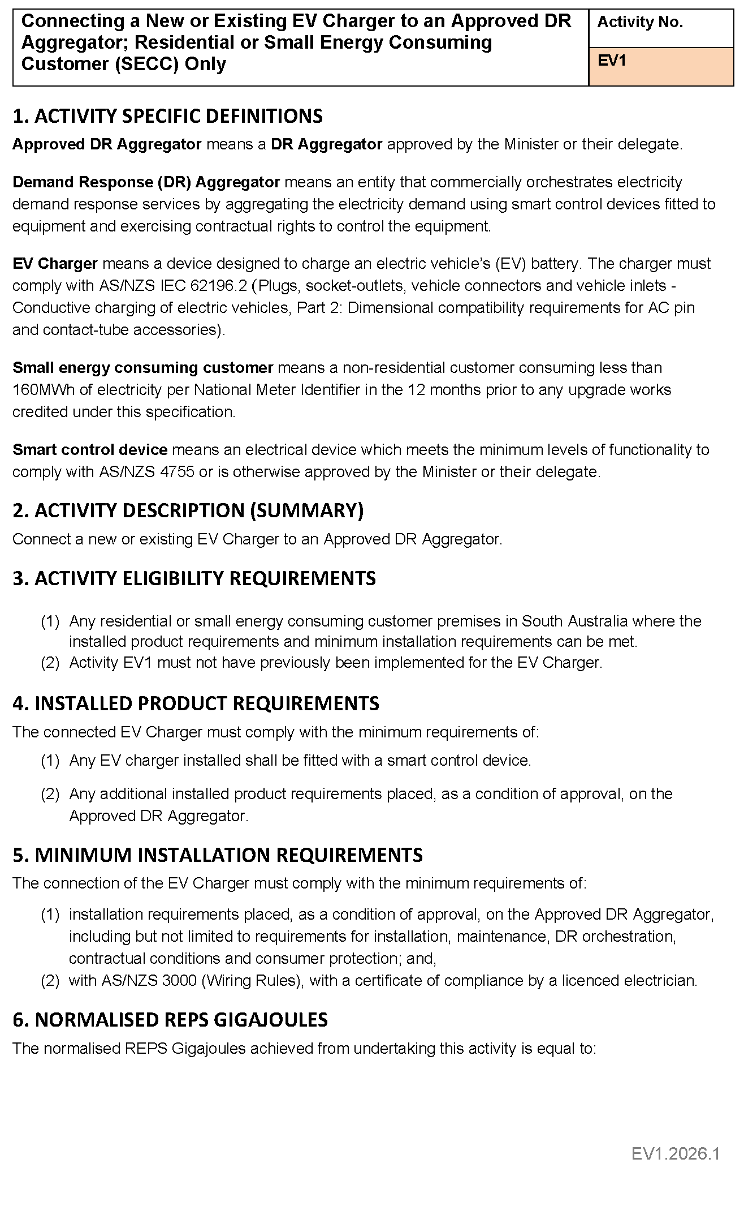
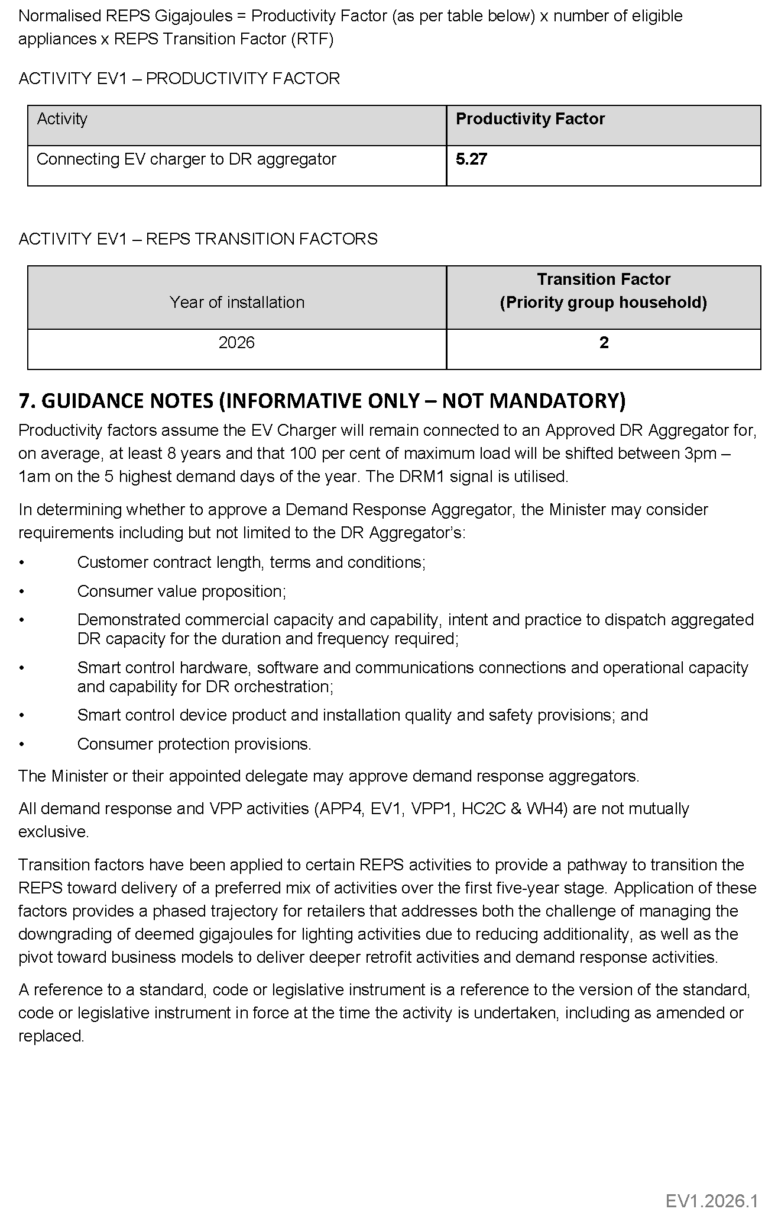

Electricity Act 1996
Gas Act 1997
Retailer Energy Productivity Scheme
Minimum Specifications for Energy Productivity Activities
Pursuant to Regulation 28(5) of the Electricity (General) Regulations 2012 under the Electricity Act 1996, and Regulation 22(5) of the Gas Regulations 2012 under the Gas Act 1997, I revoke the Ministerial Notice—Install an Efficient New Reverse Cycle Air Conditioner (Non-Ducted); (Residential and Small Energy Consuming Customers Only), Activity No. HC2A—in the South Australian Government Gazette No. 55, dated 1 August 2024, on pages 2379-2385.
Pursuant to Regulation 28 of the Electricity (General) Regulations 2012 and Regulation 22 of the Gas Regulations 2012, I determine the activities within the following document to be an energy productivity activity for the purposes of Part 4 of the Electricity (General) Regulations 2012 and Part 4 of the Gas Regulations 2012.
This notice will take effect from 1 January 2026.
Dated: 9 February 2026
Hon Tom Koutsantonis MP
Minister for Energy and Mining

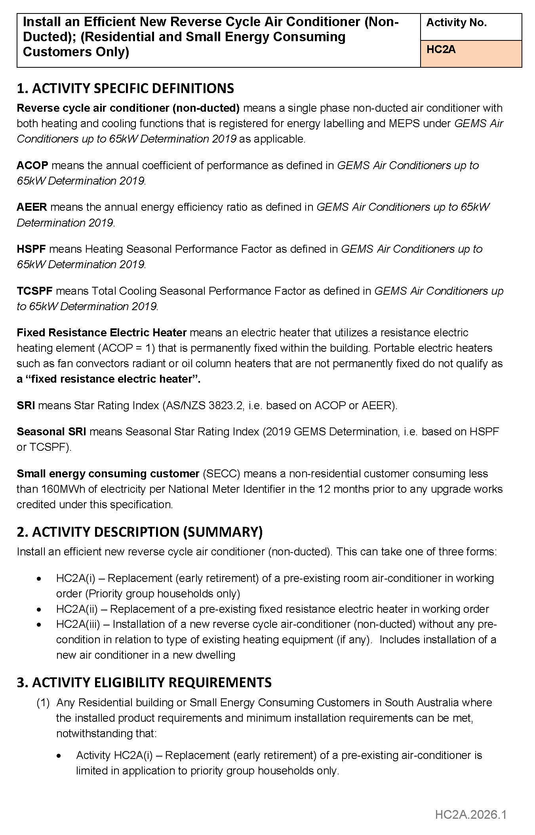

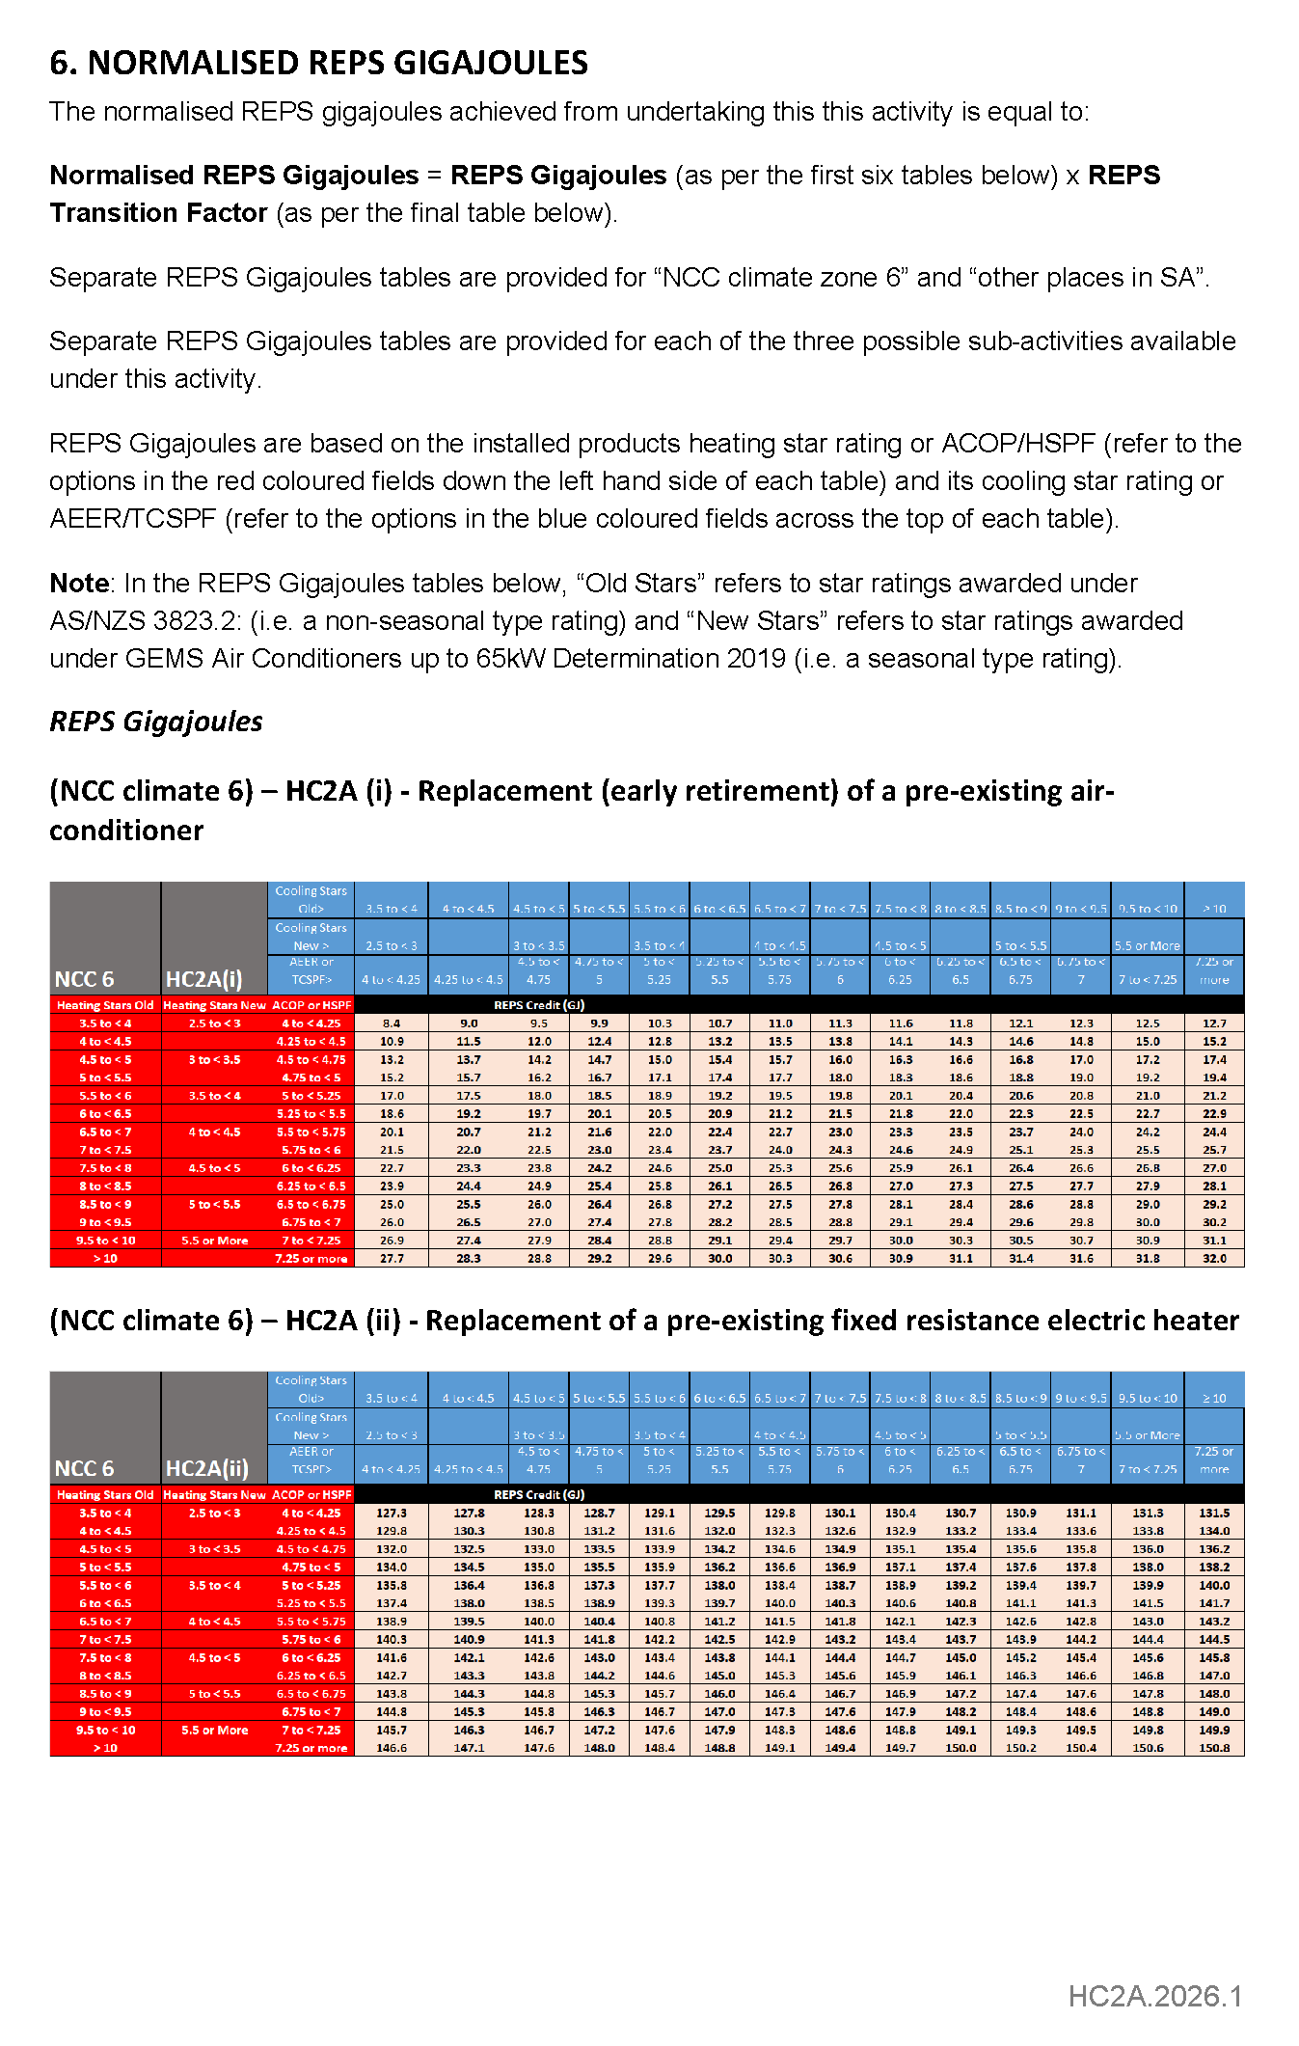
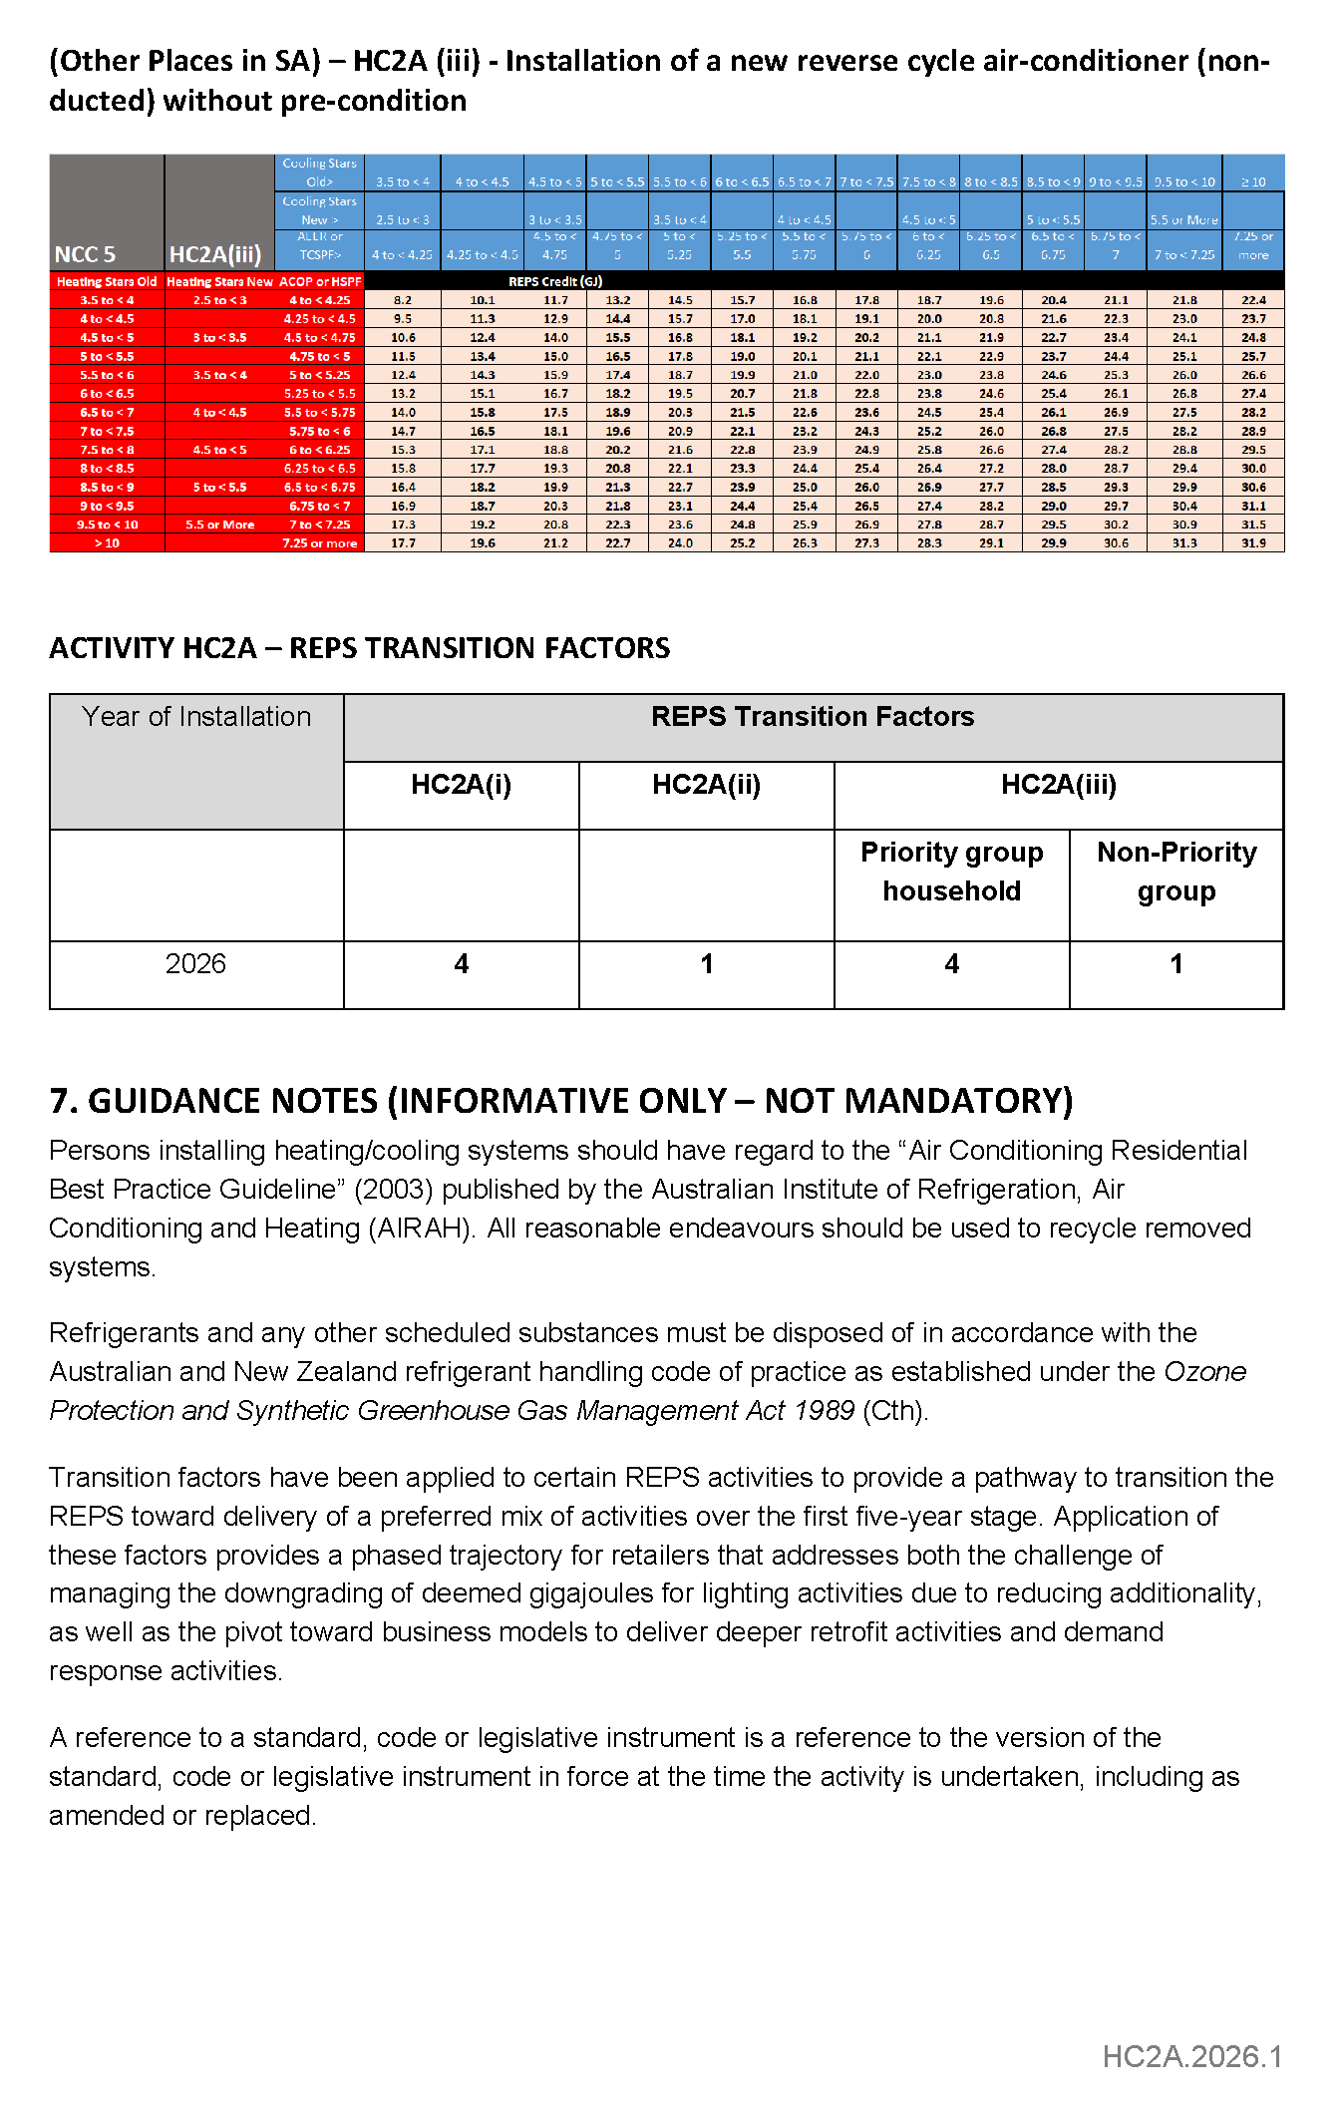
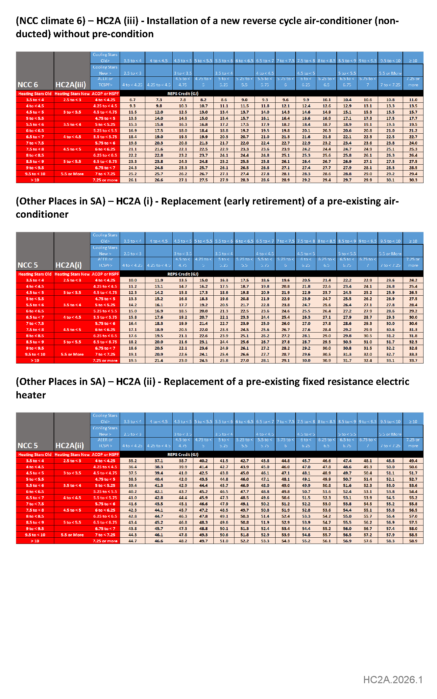

ELECTRICITY ACT 1996
GAS ACT 1997
Retailer Energy Productivity Scheme
Minimum Specifications for Energy Productivity Activities
Pursuant to Regulation 28(5) of the Electricity (General) Regulations 2012 under the Electricity Act 1996, and Regulation 22(5) of the
Gas Regulations 2012 under the Gas Act 1997, I revoke the Ministerial Notice—Connecting a New or Existing HVAC to an Approved DR Aggregator (Ducted and Non-Ducted); Residential Only, Activity No. HC2C—in the South Australian Government Gazette No. 98, dated 21 December 2020, on pages 6107-6109.
Pursuant to Regulation 28 of the Electricity (General) Regulations 2012 and Regulation 22 of the Gas Regulations 2012, I determine the activities within the following document to be an energy productivity activity for the purposes of Part 4 of the Electricity (General) Regulations 2012 and Part 4 of the Gas Regulations 2012.
This notice will take effect from 1 January 2026.
Dated: 9 February 2026
Hon Tom Koutsantonis MP
Minister for Energy and Mining

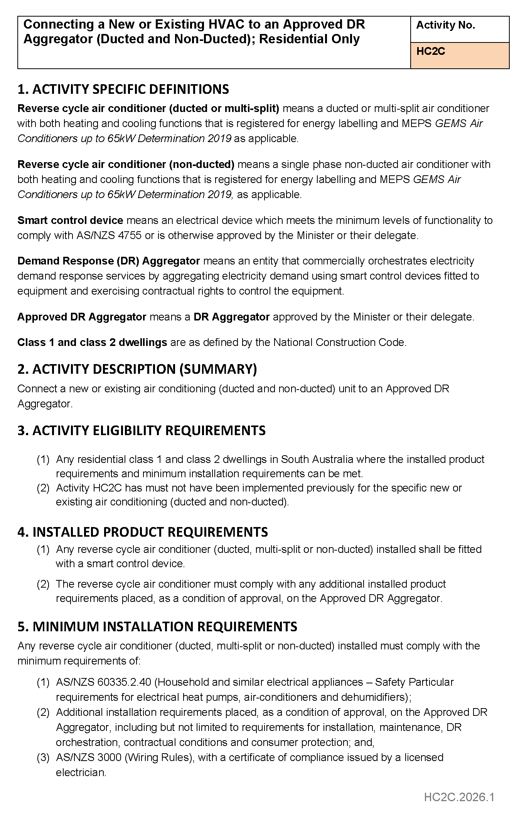
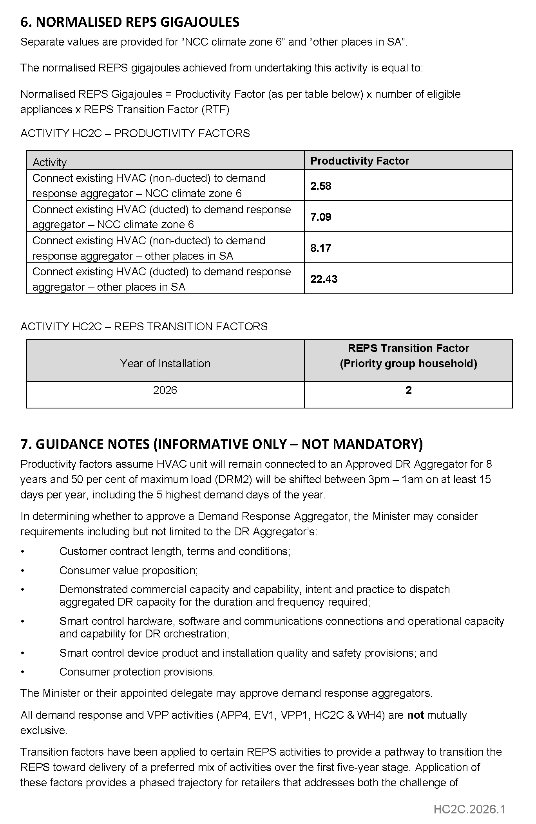


ELECTRICITY ACT 1996
GAS ACT 1997
Retailer Energy Productivity Scheme
Minimum Specifications for Energy Productivity Activities
Pursuant to Regulation 28(5) of the Electricity (General) Regulations 2012 under the Electricity Act 1996, and Regulation 22(5) of the
Gas Regulations 2012 under the Gas Act 1997, I revoke the Ministerial Notice—Install an Efficient New Ducted Evaporative Air Conditioner Residential and Small Energy Consuming Customers Only, Activity No. HC3—in the South Australian Government Gazette No. 31, dated 2 May 2024, on pages 789-791.
Pursuant to Regulation 28 of the Electricity (General) Regulations 2012 and Regulation 22 of the Gas Regulations 2012, I determine the activities within the following document to be an energy productivity activity for the purposes of Part 4 of the Electricity (General) Regulations 2012 and Part 4 of the Gas Regulations 2012.
This notice will take effect from 1 January 2026.
Dated: 9 February 2026
Hon Tom Koutsantonis MP
Minister for Energy and Mining

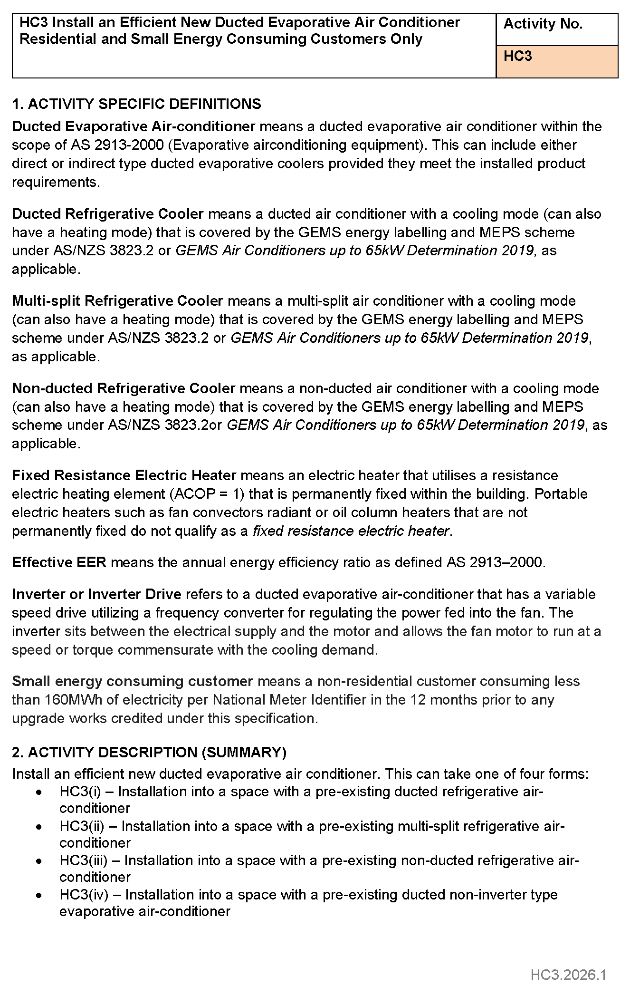
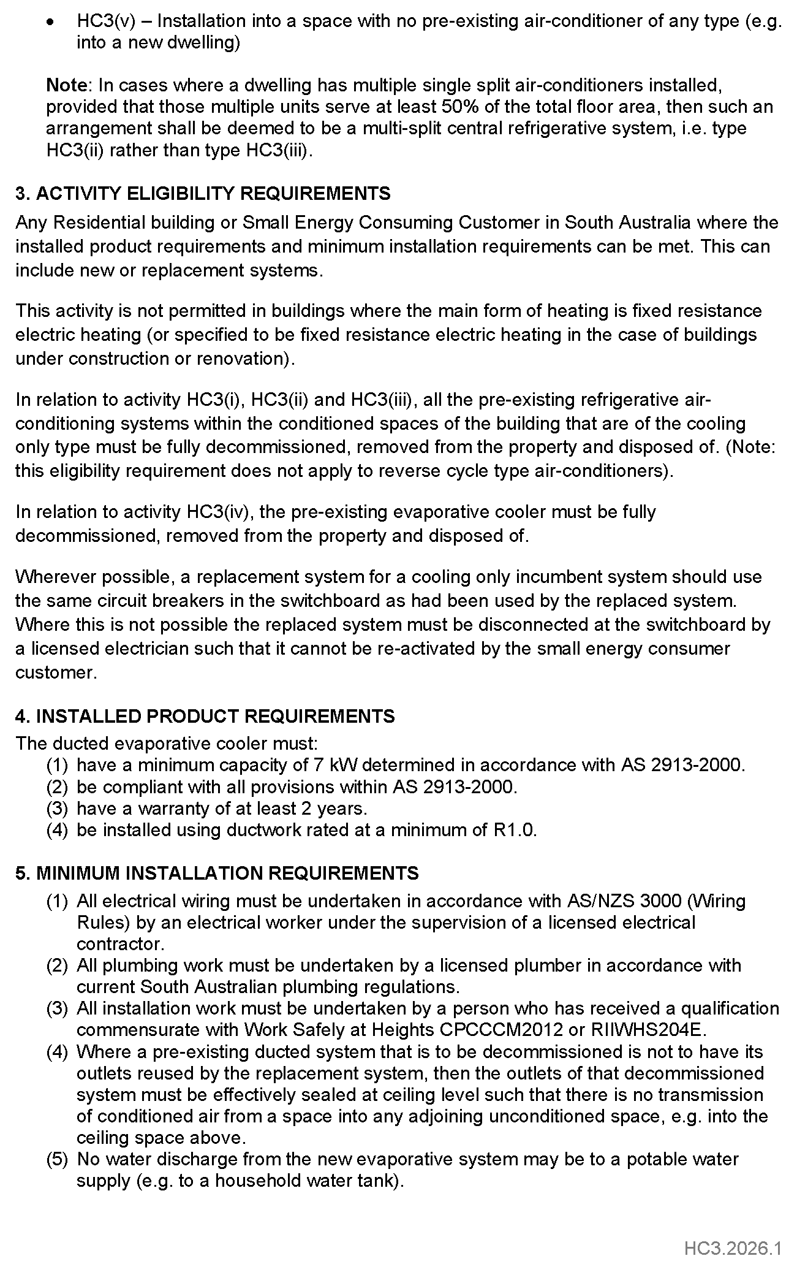
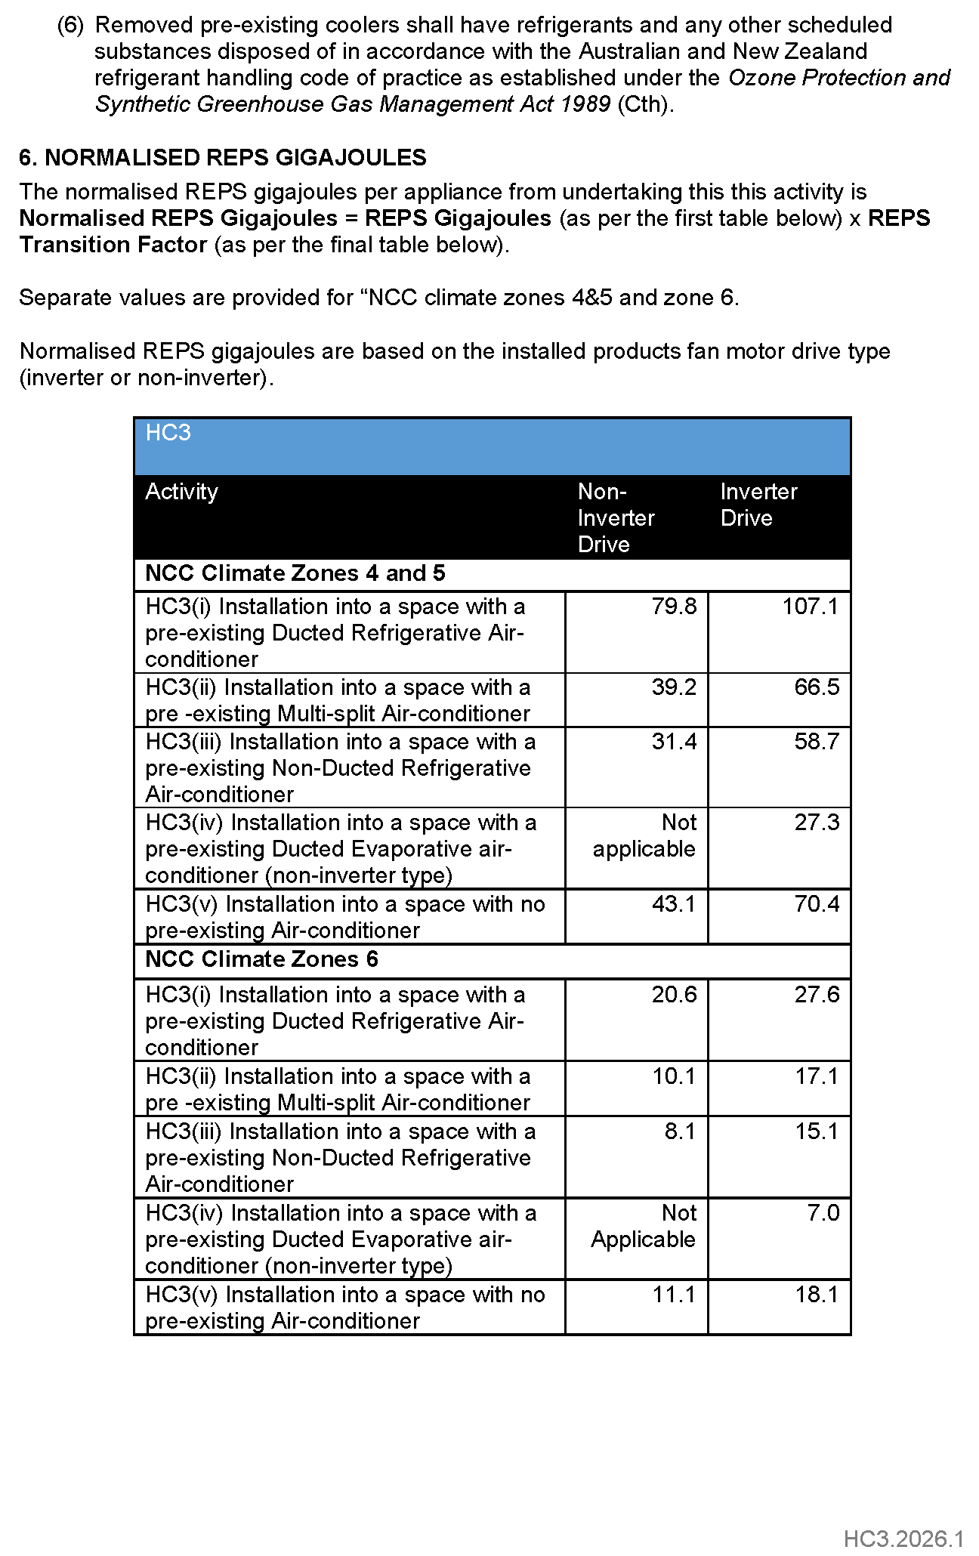
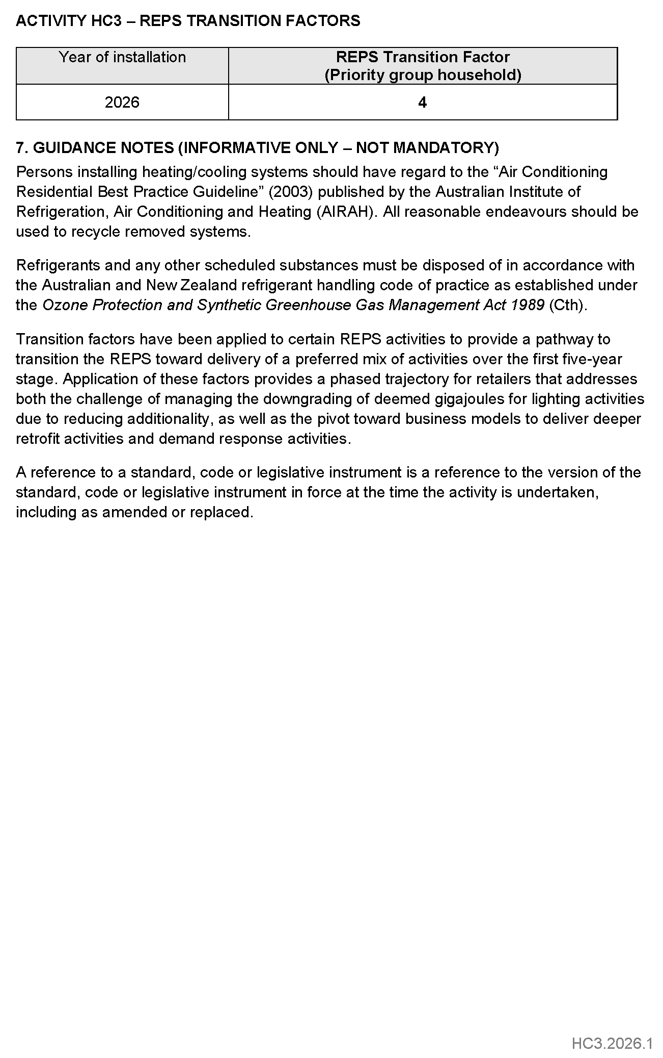

ELECTRICITY ACT 1996
GAS ACT 1997
Retailer Energy Productivity Scheme
Minimum Specifications for Energy Productivity Activities
Pursuant to Regulation 28 of the Electricity (General) Regulations 2012 and Regulation 22 of the Gas Regulations 2012, I determine the activities within the following document to be an energy productivity activity for the purposes of Part 4 of the Electricity (General) Regulations 2012 and Part 4 of the Gas Regulations 2012.
This notice will take effect from 1 January 2026.
Dated: 10 February 2026
Hon Tom Koutsantonis MP
Minister for Energy and Mining

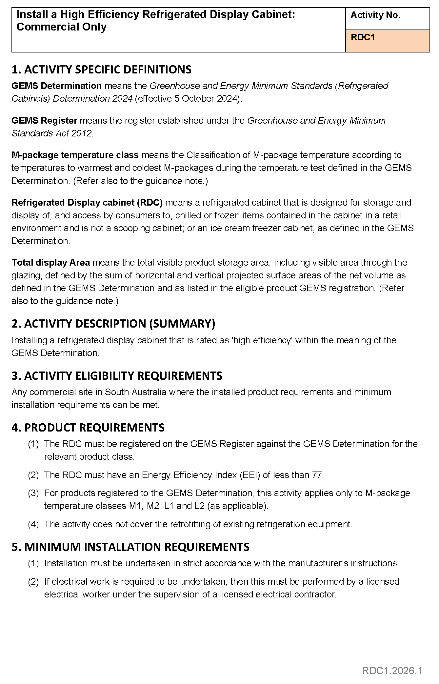
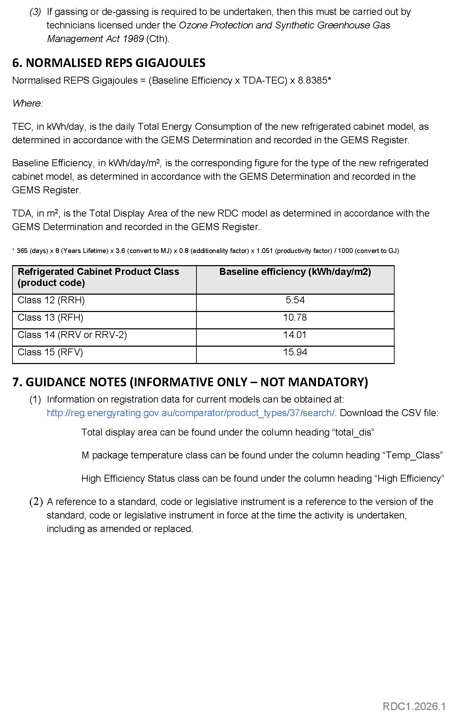

ELECTRICITY ACT 1996
GAS ACT 1997
Retailer Energy Productivity Scheme
Minimum Specifications for Energy Productivity Activities
Pursuant to Regulation 28(5) of the Electricity (General) Regulations 2012 under the Electricity Act 1996, and Regulation 22(5) of the
Gas Regulations 2012 under the Gas Act 1997, I revoke the Ministerial Notice—Connecting a New or Existing Electric Heat Pump Water Heater to an Approved DR Aggregator; Residential Only, Activity No. WH4—in the South Australian Government Gazette No. 98,
dated 21 December 2020, on pages 6112-6113.
Pursuant to Regulation 28 of the Electricity (General) Regulations 2012 and Regulation 22 of the Gas Regulations 2012, I determine the activities within the following document to be an energy productivity activity for the purposes of Part 4 of the Electricity (General) Regulations 2012 and Part 4 of the Gas Regulations 2012.
This notice will take effect from 1 January 2026.
Dated: 9 February 2026
Hon Tom Koutsantonis MP
Minister for Energy and Mining

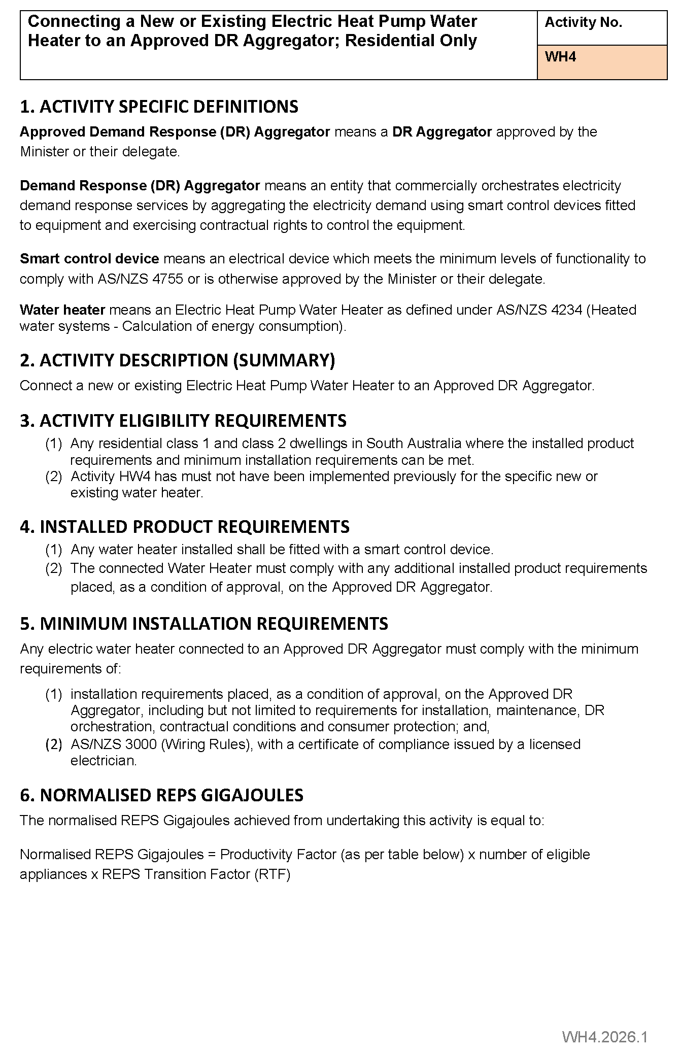
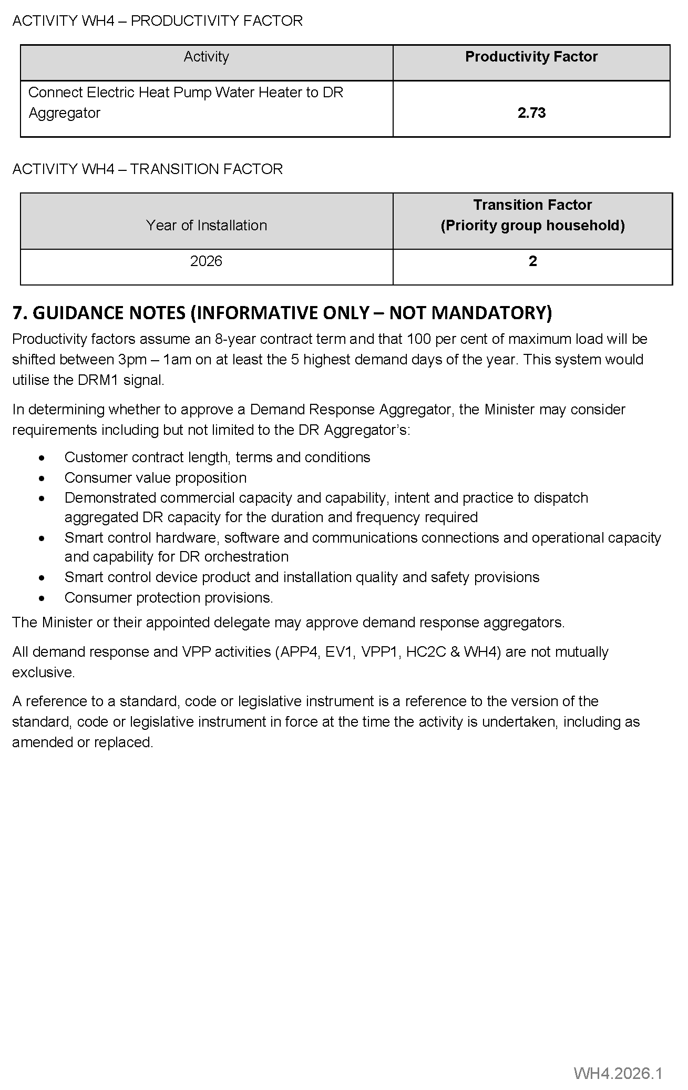

Fisheries Management Act 2007
Section 115
Ministerial Exemption ME9903410
Take notice that pursuant to Section 115 of the Fisheries Management Act 2007 (the Act), Neil Schmucker (M012), Yanni Retsas (M092), Daniel Hertz (M238) and Con Retsas (M126) (hereinafter referred to as the “exemption holder”) or their registered masters or replacement masters (hereinafter referred to as the “agents”) are exempt from Sections 55(3), 70 and 72(2)(c) of the Act and Regulations 5(a) and 6, Schedule 6 Clause 21(c)(i) and 21(d)(ii) of the Fisheries Management (General) Regulations 2017 and within the waters specified in Schedule 1 but only insofar as they may use up to seven fish traps with increased entrance sizes, and take Snapper using a fish trap and be in possession of Snapper (the “exempted activity”) subject to the conditions specified in Schedule 2 from 10 February 2026 until 9 February 2027, unless varied or revoked earlier.
Schedule 1
Waters within the West Coast Fishing Zone as defined in the Fisheries Management (Marine Scalefish Fishery) Regulations 2017, South Australia, excluding aquatic reserves and sanctuary or restricted access zones of any marine park (unless otherwise authorised under the Marine Parks Act 2007).
Schedule 2
1. The exemption holders will be deemed responsible for the conduct of any agents or persons assisting the exempted activities under this notice. Any person conducting activities under this exemption must be provided with a copy of this notice, which they must have signed as an indication that they have read and understand the conditions under it.
2. The exemption holder or agent may use a maximum of seven exempted fish traps (being a fish trap other than a crab or rock lobster pot) in any fishing trip under their marine scalefish fishery licences with maximum opening dimensions of 30cm by 13.5cm (exempted fish traps).
3. The exemption holder or agent may only use or have onboard the registered vessel 14 fish traps, including exempted fish traps, at any one time.
4. Snapper caught in any fish trap used while conducting the exempted activity may be retained only under direction and in the presence of a SARDI employee onboard the registered vessel and must be provided to a SARDI employee upon landing. Without a direction from SARDI all Snapper must be immediately returned to the water.
5. The exemption holder must, during any trip conducting the exempted activity, accurately complete the SARDI Fish Trap Daily Data Sheets for each Fish Trap retrieved before retrieving another Fish Trap, including exempted fish traps.
6. The exemption holder must mark the buoy attached to each Fish Trap used on a fishing trip conducting the exempted activity with exemption number, ME9903410, and a unique identifying number (1 to 14) and record data for that Fish Trap as such on the SARDI Fish Trap Daily Data Sheets.
7. Completed SARDI Fish Trap Daily Data Sheets must be sent by way of attaching to a text or email to the nominated SARDI employee as specified on the SARDI Fish Trap Daily Data Sheet, within 24 hours of concluding a fishing trip where fishing activity pursuant to this exemption were undertaken and retain a hard copy for a minimum 24 months from the commencement of this exemption. In this condition “concluding a fishing trip” means either when fish taken during a fishing trip leave the registered boat or when the registered boat containing fish taken during the fishing trip is removed from the water, whichever is first.
8. If a SARDI observer is onboard the vessel, fish, including undersize Snapper, may be taken and retained by that SARDI observer where that person is authorised under the Fisheries Management Act 2007 to take and possess such fish for the purpose of research. Any fish retained by SARDI must still be recorded on the SARDI Fish Trap Daily Data Sheets and will remain the property and possession of SARDI for research purposes only with no financial benefit or compensation paid to the participating licence or exemption holder.
9. At least 48 hours before conducting activities under this Ministerial exemption, the exemption holder must notify SARDI of their intent to conduct the exempted activity on a fishing trip on 0413 550 910 or 0498 069 714 by call or text message.
10. A SARDI or PIRSA Fisheries and Aquaculture employee (Independent Observer), must be present onboard the registered vessel for at least one in the first five permitted fishing trips under this exemption and then on at least one of the subsequent ten permitted fishing trips for the duration of this Ministerial exemption.
11. The exemption holder must allow an Independent Observer on board the registered boat at any time, including for the duration of a fishing trip being conducted under this exemption, where the Independent Observer has advised the licence holder at least 24 hours prior to the observer going on board the boat by phone call or email.
12. The exemption holder must not continue to fish under this permit if the minimum Independent Observer requirements have not been met as specified in condition 9.
13. The exemption holder must notify PIRSA on 1800 065 522 or by the PIRSA Fisheries Commercial Reporting Application at least 1 hour prior to engaging in the fishing activity completing a commencing an exemption report and provide the requested information.
14. The exemption holders must not contravene or fail to comply with the Fisheries Management Act 2007, or any regulations made under the Act, except where specifically provided for by this exemption.
This notice does not purport to override the provisions or operation of any other Act including, but not limited to, the Marine Parks Act 2007, Harbours and Navigation Act 1993 and the National Parks and Wildlife Act 1972. The exemption holder and his agents must comply with any relevant regulations permits, requirements and directions from the Department for Environment and Water when undertaking activities within a marine or national park.
Dated: 4 February 2026
Professor Gavin Begg
Executive Director
Fisheries and Aquaculture
Delegate of the Minister for Primary Industries and Regional Development

Fisheries Management Act 2007
Section 115
Ministerial Exemption ME9903411
Take notice that pursuant to Section 115 of the Fisheries Management Act 2007 (the Act), Laurence Condo (M453), Mark Eckermann (M036) and Eleftherios Toumazos (M209) (hereinafter referred to as the “exemption holder”) or their registered masters or replacement masters (hereinafter referred to as the “agents”) are exempt from Sections 55(3) and 70 of the Act and Regulation 5(a), Schedule 6 Clause 21(c)(i) and 21(d)(ii) of the Fisheries Management (General) Regulations 2017 within the waters specified in Schedule 1 but only insofar as they may use up to seven fish traps with increased entrance sizes and take Snapper from fish traps (the ‘exempted activity’) subject to the conditions specified in Schedule 2 from 10 February 2026 until 9 February 2027, unless varied or revoked earlier.
Schedule 1
Waters within the South East Fishing Zone as defined in the Fisheries Management (Marine Scalefish Fishery) Regulations 2017, South Australia, excluding aquatic reserves and sanctuary or restricted access zones of any marine park (unless otherwise authorised under the Marine Parks Act 2007).
Schedule 3
1. The exemption holder will be deemed responsible for the conduct of any agents or persons assisting the exempted activities under this notice. Any person conducting activities under this exemption must be provided with a copy of this notice, which they must have signed as an indication that they have read and understand the conditions under it.
2. The exemption holder or agent may use a maximum of seven exempted fish traps (being a fish trap other than a crab or rock lobster pot) in any fishing trip under their marine scalefish fishery licences with maximum opening dimensions of 30cm by 13.5cm (exempted fish traps).
3. The exemption holder or agent may only use or have onboard the registered vessel 14 fish traps, including exempted fish traps, at any one time.
4. The exemption holder must, during any trip conducting the exempted activity, accurately complete the SARDI Fish Trap Daily Data Sheet for each Fish Trap retrieved before retrieving another Fish trap, including exempted Fish Traps.
5. The exemption holder must mark the buoy attached to each fish trap used on a fishing trip conducting the exempted activity with exemption number, ME9903411, and a unique identifying number (1 to 14) and record data for that fish trap as such on the SARDI Fish Trap Daily Data Sheets.
6. Completed SARDI Fish Trap Daily Data Sheets must be sent by way of attaching to a text or email to the nominated SARDI employee as specified on the SARDI Fish Trap Daily Data Sheet, within 24 hours of concluding a fishing trip where fishing activity pursuant to this exemption were undertaken and retain a hard copy for a minimum 24 months from the commencement of this exemption. In this condition “concluding a fishing trip” means either when fish taken during a fishing trip leave the registered boat or when the registered boat containing fish taken during the fishing trip is removed from the water, whichever is first.
7. If a SARDI observer is onboard the vessel, fish, including undersize Snapper, may be taken and retained by that SARDI observer where that person is authorised under the Fisheries Management Act 2007 to take and possess such fish for the purpose of research. Any fish retained by SARDI must still be recorded on the SARDI Fish Trap Daily Data Sheets and will remain the property and possession of SARDI for research purposes only with no financial benefit or compensation paid to the participating licence or exemption holder.
8. At least 48 hours before conducting activities under this Ministerial exemption, the exemption holder must notify SARDI of their intent to conduct the exempted activity on 0413 550 910 or 0498 069 714 by call or text message.
9. A SARDI or PIRSA Fisheries and Aquaculture employee (Independent Observer), must be present onboard the registered vessel for at least one in the first five permitted fishing trips under this exemption and then on at least one of the subsequent ten permitted fishing trips for the duration of this Ministerial exemption.
10. The exemption holder must allow an Independent Observer on board the registered boat at any time, including for the duration of a fishing trip being conducted under this exemption, where the Independent Observer has advised the licence holder at least 24 hours prior to the observer going on board the boat by phone call or email.
11. The exemption holder must not continue to fish under this permit if the minimum Independent Observer requirements have not been met as specified in condition 10.
12. The exemption holder must notify PIRSA on 1800 065 522 or by the PIRSA Fisheries Commercial Reporting Application at least 1 hour prior to engaging in the fishing activity completing a commencing an exemption report and provide the requested information
13. The exemption holders must not contravene or fail to comply with the Fisheries Management Act 2007, or any regulations made under the Act, except where specifically provided for by this exemption.
This notice does not purport to override the provisions or operation of any other Act including, but not limited to, the Marine Parks Act 2007, Harbours and Navigation Act 1993 and the National Parks and Wildlife Act 1972. The exemption holder and his agents must comply with any relevant regulations permits, requirements and directions from the Department for Environment and Water when undertaking activities within a marine or national park.
Dated: 4 February 2026
Professor Gavin Begg
Executive Director
Fisheries and Aquaculture
Delegate of the Minister for Primary Industries and Regional Development

Health Care Act 2008
Clause 5A of Schedule 3
Notice of Appointment of Members of a Governing Board of an Incorporated Hospital
Chris Picton, Minister for Health and Wellbeing, has been pleased to appoint the persons named in Column 1 of the Schedule to the respective position in Column 2 of the Schedule as a member of the governing board of the respective incorporated hospital in Column 3 of the Schedule for the respective term in Column 4 of the Schedule.
Schedule
Column 1 | Column 2 | Column 3 | Column 4
Person | Position | Incorporated Hospital | Term
Candice Clare Fennell | Member | Limestone Coast Local Health Network Incorporated | Commencing 9 February 2026 and expiring 30 June 2028
Dated: 4 February 2026
Chris Picton MP
Minister for Health and Wellbeing

Housing Improvement Act 2016
Rent Control
In the exercise of the powers conferred by the Housing Improvement Act 2016, the Delegate of the Minister for Housing and Urban Development hereby fixes the maximum rental amount per week that shall be payable subject to Section 55 of the Residential Tenancies Act 1995, in respect of each premises described in the following table. The amount shown in the said table shall come into force on the date of this publication in the Gazette.
Address of Premises | Allotment Section | Certificate of Title  Volume/Folio | Maximum Rental per week payable
2 Grenache Avenue, Modbury SA 5092 | Allotment 38 Deposited Plan 7086 Hundred of Yatala | CT5334/408 | $0.00
Dated: 12 February 2026
Craig Thompson
Housing Regulator and Registrar
Housing Safety Authority
Delegate of the Minister for Housing and Urban Development

Housing Improvement Act 2016
Rent Control Revocations
In the exercise of the powers conferred by the Housing Improvement Act 2016, the Delegate of the Minister for Housing and Urban Development hereby revokes the maximum rental amount per week that shall be payable subject to Section 55 of the Residential Tenancies Act 1995, in respect of each premises described in the following table.
Address of Premises | Allotment Section | Certificate of Title  Volume/Folio
28 Hackett Street, Risdon Park SA 5540 | Allotment 32 Filed Plan 47006 Hundred of Pirie | CT5951/99
Dated: 12 February 2026
Craig Thompson
Housing Regulator and Registrar
Housing Safety Authority
Delegate of the Minister for Housing and Urban Development

Justices of the Peace Act 2005
Section 11(5)(a)
Notice of Removal from the Office of Justice of the Peace by the Attorney-General
I, Hon Kyam Maher, Attorney-General, pursuant to the power vested in me by Section 11(5) of the Justices of the Peace Act 2005 (the ‘Act’), do hereby remove Paul Arthur Schiller, Justice of the Peace identification number 15890, from the office of Justice of the Peace for South Australia effective from the date of the publication of this notice in the SA Government Gazette.
Pursuant to Section 11(6) of the Act, I declare that Paul Arthur Schiller may not apply for reappointment as a justice for a period of five years from the date of the publication of this notice in the SA Government Gazette.
Dated: 30 January 2026
Hon Kyam Maher MLC
Deputy Premier
Attorney-General

Land Acquisition Act 1969
Section 16
Form 5—Notice of Acquisition
1. Notice of acquisition
The Commissioner of Highways (the Authority), of 83 Pirie Street, Adelaide SA 5000, acquires the following interests in the following land:
Comprising an unencumbered estate in fee simple in that piece of land being portion of Allotment 2811 in Deposited Plan No. 133732 comprised in Certificate of Title Volume 6297 Folio 309, and being the whole of the land identified as Allotment 1 in D139723 lodged in the Lands Titles Office.
This notice is given under Section 16 of the Land Acquisition Act 1969.
2. Compensation
A person who has or had an interest consisting of native title or an alienable interest in the land that is divested or diminished by the acquisition or the enjoyment of which is adversely affected by the acquisition who does not receive an offer of compensation from the Authority may apply to the Authority for compensation.
2A. Payment of professional costs relating to acquisition (Section 26B)
If you are the owner in fee simple of the land to which this notice relates, you may be entitled to a payment of up to $10,000 from
the Authority for use towards the payment of professional costs in relation to the acquisition of the land.
Professional costs include legal costs, valuation costs and any other costs prescribed by the Land Acquisition Regulations 2019.
3. Inquiries
Inquiries should be directed to: Daniel Tuk
GPO Box 1533
Adelaide SA 5001
Telephone: (08) 7133 2479
Dated: 12 February 2026
The Common Seal of the COMMISSIONER OF HIGHWAYS was hereto affixed by authority of the Commissioner in the presence of:
Rocco Caruso
Director, Property Acquisition
(Authorised Officer)
Department for Infrastructure and Transport
File Reference: 2023/04617/01

Landscape South Australia Act 2019
Declaration of Penalty in Relation to the Unauthorised or Unlawful Taking of Water
from the River Murray Prescribed Watercourse
Pursuant to Section 88(1) of the Landscape South Australia Act 2019 (the Act), I, Dan Jordan, delegate of the Minister for Climate, Environment and Water and Minister to whom the Act is committed, hereby declare that the following penalties are payable in relation to the unauthorised or unlawful taking or use of water during the consumption period that corresponds to the accounting period defined in Column 1 of Schedule 1:
1. Where a person who is the holder of a water allocation takes water from the River Murray Prescribed Watercourse in excess of the amount available under the allocation, the penalty declared pursuant to Section 88(1)(a) is:
(a) the corresponding rate in Column 2 of Schedule 1 to this notice for all water taken in excess of the amount available under the allocation endorsed on the relevant instrument under the terms of the water licence to which the allocation is attributable, up to and including 500,000 kilolitres; and
(b) the corresponding rate in Column 3 of Schedule 1 to this notice for all water taken in excess of the quantity of water referred to in paragraph (a) above 500,000 kilolitres.
2. Where a person who is authorised under Section 105 of the Act takes water from the River Murray Prescribed Watercourse that exceeds the amount authorised under the terms of that authorisation the penalty declared pursuant to Section 88(1)(e) is:
(a) the corresponding rate in Column 2 of Schedule 1 to this notice for all water taken in excess of the amount authorised by a notice under Section 105 of the Act, up to and including 500,000 kilolitres; and
(b) the corresponding rate in Column 3 of Schedule 1 to this notice for all water taken in excess of the quantity referred to in paragraph (a) above 500,000 kilolitres.
3. Where water is taken from the River Murray Prescribed Watercourse by a person who is not the holder of a water management authorisation or who is not authorised under Section 105 of the Act to take the water, the penalty declared under Section 88(1)(e) is the corresponding rate in Column 4 of Schedule 1 to this notice per kilolitre of water determined or assessed to have been taken in accordance with Section 79 of the Act.
4. Where a person takes water from the River Murray Prescribed Watercourse in excess of the amount authorised for use under Section 109 of the Act the penalty declared pursuant to Section 88(1)(f) is:
(a) the corresponding rate in Column 2 of Schedule 1 to this notice for all water taken in excess of the amount authorised for use by a notice under Section 109 of the Act, up to and including 500,000 kilolitres; and
(b) the corresponding rate in Column 3 of Schedule 1 to this notice for all water taken in excess of the quantity referred to in paragraph (a) above 500,000 kilolitres.
5. Where water is taken from the River Murray Prescribed Watercourse subject to a notice under Section 109 of the Act by a person who is not authorised to use the water the penalty declared under Section 88(1)(f) is the corresponding rate in Column 4 of Schedule 1 to this notice per kilolitre of water determined or assessed to have been taken in accordance with Section 79 of the Act.
6. Where a person may be subject to more than one penalty under Section 88, the penalty that is the greater shall be imposed.
Schedule 1
Penalties for overuse from the River Murray Prescribed Watercourse between 1 January 2026 and 31 March 2026 inclusive:
Column 1 | Column 2 | Column 3 | Column 4
Accounting Period | Penalty for overuse up to and including 500,000 kL (per kL) | Penalty for overuse above 500,000 kL (per kL) | Penalty for unlawful taking or use of water (per kL)
1 January 2026 to 31 March 2026 | $1.362 | $1.816 | $1.816
Unit of measure kL is the abbreviation of kilolitre.
For the purposes of this notice:
‘the River Murray Prescribed Watercourse’ means the watercourses and lakes declared to be the River Murray Proclaimed Watercourse by proclamation under Section 25 of the Water Resources Act 1976 (see Gazette 10 August 1978, p. 467)
‘accounting period’ means the period determined by the Minister from time to time by notice in the Gazette (with the period not necessarily being the same period as the accounting period under Division 2).
‘consumption period’ in relation to an accounting period means a period of approximately the same length as the accounting period that commences or terminates during the accounting period and during which water is taken or used.
Words used in this notice that are defined in the Act shall have the meanings as set out in the Act.
Dated: 9 February 2026
Dan Jordan
Acting Executive Director, Water and River Murray
Department for Environment and Water
Delegate of the Minister for Climate, Environment and Water

Mental Health Act 2009
Authorised Medical Practitioner
Notice is hereby given in accordance with Section 93(1) of the Mental Health Act 2009 that the Chief Psychiatrist has determined the following person as an Authorised Medical Practitioner:
Shih Yang Tan
A determination will be automatically revoked upon the person being registered as a specialist psychiatrist with the Australian Health Practitioner Regulation Agency and as a fellow of the Royal Australian and New Zealand College of Psychiatrists.
The Chief Psychiatrist may vary or revoke this determination at any time.
Dated: 12 February 2026
Dr John Brayley
Chief Psychiatrist

Planning, Development and Infrastructure Act 2016
Section 76
Amendment to the Planning and Design Code
Preamble
It is necessary to amend the Planning and Design Code (the Code) in operation at 29 January 2026 (Version 2026.02) in order to make changes of form relating to the Code’s spatial layers and their relationship with land parcels. Note: There are no changes to the application of zone, subzone or overlay boundaries and their relationship with affected parcels or the intent of policy application as a result of this amendment.
1. Pursuant to Section 76 of the Planning, Development and Infrastructure Act 2016 (the Act), I hereby amend the Code in order to make changes of form (without altering the effect of underlying policy), correct errors and make operational amendments as follows:
(a) Undertake minor alterations to the geometry of the spatial layers and data in the Code to maintain the current relationship between the parcel boundaries and Code data as a result of the following:
(i) New plans of division deposited in the Land Titles Office between 21 January 2026 and 3 February 2026 affecting the following spatial and data layers in the Code:
A. Zones and subzones
B. Technical and Numeric Variations
• Building Heights (Levels)
• Building Heights (Metres)
• Concept Plan
• Finished Ground and Floor Levels
• Interface Height
• Minimum Dwelling Allotment Size
• Minimum Frontage
• Minimum Site Area
• Minimum Primary Street Setback
• Minimum Side Boundary Setback
• Future Local Road Widening Setback

C. Overlays
• Affordable Housing
• Coastal Areas
• Defence Aviation Area
• Future Local Road Widening
• Future Road Widening
• Hazards (Acid Sulfate Soils)
• Hazards (Bushfire—High Risk)
• Hazards (Bushfire—Medium Risk)
• Hazards (Bushfire—General Risk)
• Hazards (Bushfire—Urban Interface)
• Hazards (Bushfire—Regional)
• Hazards (Bushfire—Outback)
• Heritage Adjacency
• Historic Area
• Limited land Division
• Local Heritage Place
• Noise and Air Emissions
• Significant Retirement Facility and Supported Accommodation Sites
• State Heritage Place
• Stormwater Management
• Urban Tree Canopy
(b) In Part 13 of the Code—Table of Amendments, update the publication date, Code version number, amendment type and summary of amendments within the ‘Table of Planning and Design Code Amendments’ to reflect the amendments to the Code as described in this Notice.
2. Pursuant to Section 76(5)(a) of the Act, I further specify that the amendments to the Code as described in this Notice will take effect upon the date those amendments are published on the SA planning portal.
Dated: 5 February 2026
Brett Steiner
Director, Growth Planning
Department for Housing and Urban Development
Delegate of the Minister for Planning

The Remuneration Tribunal
Report No. 2 of 2026
2025 Review of Remuneration of Auditor-General, Electoral Commissioner,
Deputy Electoral Commissioner and Health and Community Services Complaints Commissioner
Executive Summary
1. The Remuneration Tribunal (Tribunal) has conducted a review of Determination 19 of 2024 which sets salaries payable to the following statutory offices as conferred under Section 14 of the Remuneration Act 1990 (SA) (Act):
(a) the Auditor-General;
(b) the Electoral Commissioner;
(c) the Deputy Electoral Commissioner; and
(d) the Health and Community Services Complaints Commissioner.
2. As explained in this report, the Tribunal has decided to increase the remuneration amounts for the Auditor-General and Health and Community Services Complaints Commissioner by 4% and to increase the remuneration for the Electoral Commissioner and the Deputy Electoral Commissioner by 11.36%.
3. The Tribunal has also determined not to increase the Communication Allowance.
4. The Tribunal has issued a new Determination, effective 6 February 2026.
Background
5. Section 14 of the Act provides that the Tribunal has jurisdiction to set the remuneration payable to office holders as conferred under any other legislation. The Tribunal’s jurisdiction to determine the remuneration for the statutory offices considered by this review are as follows:
(a) the Auditor-General by Section 24 of the Public Finance and Audit Act 1987 (SA);
(b) the Electoral Commissioner by Section 7 of the Electoral Act 1985 (SA);
(c) the Deputy Electoral Commissioner by Section 7 of the Electoral Act 1985 (SA); and
(d) the Health and Community Services Complaints Commissioner by Section 7 of the Health and Community Services Complaints Act 2004 (SA).
6. As required by Section 8 of the Act, the Tribunal has conducted its annual review of the salaries of these statutory offices.

The Review Process
7. On 11 November 2025, in accordance with Sections 10(2) and 10(4) of the Act, the Tribunal wrote to and invited submissions by 2 December 2025 in respect of this review from:
(a) the Honourable Premier of South Australia—as the Minister responsible for the Act who may make submissions or introduce evidence in the public interest;
(b) the Auditor-General;
(c) the Electoral Commissioner;
(d) the Deputy Electoral Commissioner; and
(e) the Health and Community Services Complaints Commissioner.
8. The Tribunal also placed a notice on its website from 11 November 2025 inviting submissions from affected persons by 2 December 2025.
9. On 11 November 2025 the Auditor-General confirmed that no submission would be made.
10. On 1 December 2025 the Premier’s representative confirmed that no submission would be made.
11. On 1 December 2025 the Tribunal received a submission from the Electoral Commissioner noting that at that time the position of Deputy Electoral Commissioner was vacant and included a request for an opportunity to make oral submissions to the Tribunal to elaborate on the written submissions.
12. The Electoral Commissioner’s submission focused on the additional work demands resulting from the passage of the Electoral (Accountability and Integrity) Amendment Bill 2024 (Bill). Similar submissions were made to the Tribunal as part of the 2024 Review, when the Tribunal stated:
While the Tribunal has recognised the potential for additional work demands arising from the Electoral Integrity Amendment Bill, it has adopted the position that any such additional demands should be more fully reviewed after that system has been implemented.
13. The Electoral (Accountability and Integrity) Amendment Act 2024 (SA) (Electoral Accountability and Integrity Act) took effect on 1 July 2025.
14. The Electoral Commissioner submitted that since 1 July 2025 the Electoral Accountability and Integrity Act has resulted in additional work demands for the Electoral Commissioner. The Tribunal has summarised its assessment of the Electoral Commissioner’s submission in the following terms:
• The introduction of advance payments for General Elections;
• An increase to the per-vote funding for General and by-elections;
• An increase to the level of administrative funding;
• The introduction of policy development funding for non-parliamentary parties;
• The introduction of a one-off payment to those entities entitled to administrative funding;
• An increase in the powers and discretion of the Electoral Commissioner, including but not limited to audit powers;
• The creation of additional offences which are to be investigated and prosecuted by the Electoral Commissioner (both minor and major indictable); and
• The introduction of an ability for the Electoral Commissioner to recover electoral funding in certain circumstances.
15. The Electoral Commissioner advised that these changes have resulted in:
• An increase in the number of funding applications and payments and additional party registration requirements;
• The creation of the need for regular on-going meetings with political participants to ensure compliance; and
• An increase of 24% in the number of staff of the Electoral Commission.
16. On 14 January 2026 the Tribunal met with the Electoral Commissioner who provided further insights into the effects of the Electoral Accountability and Integrity Act on his workload and that of the Deputy Electoral Commissioner.
17. On 15 January 2026 the Electoral Commissioner also provided the Tribunal with a copy of the Position Description for the Deputy Electoral Commissioner and the Executive Total Remuneration Package Values for South Australian Public Sector Executives.
Consideration and Conclusion
18. In assessing these statutory office holder positions, the Tribunal has considered the following economic data:
(a) The Consumer Price Index (All groups Adelaide) shows the following percentage changes from the corresponding quarters of previous years:
(i) 2.5% for December 2024
(ii) 2.2% for March 2025
(iii) 1.8% for June 2025
(iv) 2.4% for September 2025
(v) 3.3% for December 2025
(b) The Australian Bureau of Statistics Wage Price Index (Public Sector in South Australia) shows the following percentage changes from the corresponding quarters of previous years:
(i) 3.5% September 2024
(ii) 3.2% December 2024
(iii) 3.3% March 2025
(iv) 2.6% June 2025
(v) 2.7% September 2025
19. The last extensive review of the Auditor-General’s role was conducted in 2022 and included a work value assessment of the role. The Tribunal then determined that a substantial market assessment-based increase of remuneration was appropriate.
20. Consistent with past practice, the Tribunal has considered the comparable remuneration rates and increases for Auditor-Generals in other states and has determined that it is appropriate to apply a comparable increase to the Auditor-General’s remuneration.
21. While a work value assessment has not been undertaken for the Health and Community Services Complaints Commissioner,
the Tribunal has, in line with precedent, determined to apply the same percentage increase to the Health and Community Services Complaints Commissioner.
22. If future submissions propose a significant increase to the Health and Community Services Complaints Commissioner’s remuneration, or an increase that differs from that applied to the Auditor General, the Tribunal will consider conducting a work value assessment of the Commissioner’s role.
23. Consistent with its approach to other professional positions, the Tribunal has applied a 4% increase to the remuneration of the Auditor-General and the Health and Community Services Complaints Commissioner. On the information available to the Tribunal, this increase is consistent with remuneration adjustments in other jurisdictions.
The Electoral Commissioner
24. Separate to its consideration of a 4% remuneration increase the Tribunal has assessed the impact on this position of the Electoral Accountability and Integrity Act. The Tribunal has had particular regard to the extent to which this is legislation unique to South Australia, requiring the development of systems and approaches not applied elsewhere. In addition, the new legislation requires the exercise of judgement and discretion in a range of complex and contentious circumstances.
25. Whilst the addition of increased staffing resources will likely assist the Electoral Commissioner, that increase does not detract from the added complexity of the function. The Tribunal has considered the added responsibilities vested in the Electoral Commissioner under this new legislation and has assessed the Electoral Commissioner’s role accordingly. This increase in complexity warrants a further increase. The capacity for the Commissioner to delegate tasks within this function is a matter of discretion but does not detract from the responsibilities of the role.
26. The Tribunal has reviewed Electoral Commissioner roles throughout Australia. That comparison is of limited utility as the role requirements vary substantially. The Tribunal has also had regard to remuneration arrangements applicable to Chief Executives of comparably sized public sector agencies, where those Chief Executives are required to have, and exercise specialist knowledge within a given discipline.
27. The Tribunal has concluded that the Electoral Commissioner’s remuneration should increase by 11.36% to $325,000 plus superannuation.
The Deputy Electoral Commissioner
28. In his presentation to the Tribunal on 14 January 2026 the Electoral Commissioner noted that the Deputy Electoral Commissioner’s remuneration has historically been linked to that of the Commissioner. He reported that a new Deputy Electoral Commissioner had now been appointed and noted that senior public sector employees reported to her. The Commissioner expressed concern that the remuneration level was inadequate given the demands of the role.
29. Absent more substantial details about the nature of the role, together with the skills and attributes required, the Tribunal is not inclined to alter the existing percentage relativity with the Electoral Commissioner role.
30. It is open to the Electoral Commissioner and/or the Deputy Electoral Commissioner to submit a changed position in the future.
31. However, the Tribunal notes that the Electoral Accountability and Integrity Act will also add to the complexity of the Deputy Electoral Commissioner’s role and has determined that it is appropriate for the same percentage increase to be applied to the Deputy Electoral Commissioner.
Communication Allowance
32. The Tribunal is not changing the communication allowance of $800 per annum for each of the four office holders because there is no information before the Tribunal indicating that a change is necessary.
33. While the amount was last determined in 2013, the allowance is payable for expenditure on mobile and landline telephones,
and internet usage connected with the office holder’s official duties. It excludes the full costs of mobile telephones for business purposes because it is likely that these office holders receive mobile phones for business purposes from their employer.
34. As the Tribunal has explained in previous reports, if this is not the case, statutory office holders to whom this Determination applies are invited to make an application for an additional annual allowance.
Other Determinations
35. The Tribunal notes that all four office holders are covered by other Determinations of the Tribunal which set conveyance allowances, accommodation and meal allowances, and salary sacrifice arrangements for judges, court officers, and statutory officers.
36. The Determination giving effect to this Report will come into effect from 6 February 2026.
Dated: 4 February 2026
Matthew O’Callaghan
President
Donny Walford
Member
Mark Young
Member

THE REMUNERATION TRIBUNAL
Determination No. 2 of 2026
Remuneration of Auditor-General, Electoral Commissioner, Deputy Electoral Commissioner,
and Health and Community Services Complaints Commissioner
Scope of Determination
1. The Remuneration Tribunal (Tribunal) has jurisdiction under Section 14 of the Remuneration Act 1990 (SA) to determine the remuneration, or a specified part of remuneration, of certain statutory office holders, as conferred by other Acts or by proclamation by the Governor.
2. This Determination is applicable to the following statutory office holders:
2.1. the Auditor-General;
2.2. the Electoral Commissioner;
2.3. the Deputy Electoral Commissioner; and
2.4. the Health and Community Services Complaints Commissioner.
Salary
3. The annual salaries for the following statutory office holders will be:
3.1. Auditor-General
$502,759 plus superannuation.
3.2. Electoral Commissioner
$325,000 plus superannuation.
3.3. Deputy Electoral Commissioner
$239,388 plus superannuation.
When acting as Electoral Commissioner for a continuous period of more than one week, the Deputy Electoral Commissioner will be paid for the acting period at the rate of salary applicable to the office of the Electoral Commissioner.
3.4. Health and Community Services Complaints Commissioner
$287,009 plus superannuation.
4. Where a statutory office holder listed at Clause 2 of this Determination is appointed on a part-time basis, that person is entitled to be paid the applicable salary as a pro rata amount, based on the hours worked as a proportion of the full-time equivalent.
Communication Allowance
5. Each of the statutory office holders listed at Clause 2 of this Determination are entitled to be paid a communication allowance at the rate of $800 per annum, for expenditures for the purpose of mobile telephone, landline telephone and internet usage incurred in relation to the conduct of their official duties.
6. The allowance is payable fortnightly and at a fortnightly rate of the annual amount payable at Clause 5 of this Determination.
7. Where a statutory office holder listed at Clause 2 of this Determination is appointed on a part-time basis, that person is entitled to be paid a communication allowance as a pro rata amount, based on the hours worked as a proportion of the full-time equivalent.
Date of Operation
8. This Determination operates from 6 February 2026. It supersedes Determination 19 of 2024.
Dated: 4 February 2026
Matthew O’Callaghan
President
Donny Walford
Member
Mark Young
Member

South Australian Civil and Administrative Tribunal
SACAT Reference Number: 2025/SA003663
Notice of Renewal of Exemption Before Tribunal Member Alex Lazarevich
I hereby certify that on the 17 December 2025, the South Australian Civil and Administrative Tribunal, on application of the state of South Australia (Chief Executive, Department for Health and Wellbeing), made the following orders (as amended by Order dated 3 February 2026), for renewal of an exemption:
1. That an exemption be granted to the State of South Australia (Chief Executive, Department for Health and Wellbeing, SA Ambulance Service, Commission on Excellence and Innovation in Health, Preventive Health, Central Adelaide Local Health Network, Barossa Hills Fleurieu Local Health Network, Flinders and Upper North Local Health Network, Limestone Coast Local Health Network, Northern Adelaide Local Health Network, Riverland Mallee Coorong Local Health Network, Southern Adelaide Local Health Network, Women’s and Children’s Local Health Network, and Yorke and Northern Local Health Network, Eyre Far North Local Health Network) and members of the AHCSA from the provisions of Sections 30(1), 52(1) and 103 of the EO Act for a period of three years, to enable the State of South Australia and the AHCSA and its members to advertise for Aboriginal and/or Torres Strait Islander persons, including Aboriginal and/or Torres Strait Islander persons of a specific gender (men and/or women), to apply for positions which undertake Aboriginal and/or Torres Strait Islander Health Worker roles and functions including, but not limited to, Aboriginal and/or Torres Strait Islander Health Practitioner; Health Worker (Clinical); Aboriginal Health Worker; Cultural Consultant; Mental Health Worker; Mental Health Consultant; Hospital Liaison Officer; Social and Emotional Wellbeing Worker; Maternal and Infant Care Worker; Director and Manager of Aboriginal Health; Patient Pathway Officer; Project/Program Officer; Disability Liaison Officer; Administration Officer/Trainee; Alcohol and Other Drugs Worker; Assistant in Nursing; Allied Health Practitioner; Allied Health Assistant Trainee; Board Member; Child and Mental Health Worker; Children’s Health and Development Practitioner/Trainee; Enrolled Nurse; Environmental Health Worker; Executive Assistant; Family Resource Worker; Health Services Coordinator; Health Team Leader; Human Resources Officer; Aboriginal Infant Care Worker and/or Trainee; Mental Health Cultural Worker; Chronic Disease Worker; Mental Health Cultural Advisor; Mental Health Nurse; Mental Health Nurse Practitioner; Midwife; Registered Nurse; and Transport Officer and to prefer Aboriginal and Torres Strait Islander applicants, including Aboriginal and Torres Strait Islander applicants of a specific gender (men and/or women), in offering employment in such positions, and to appoint Aboriginal and/or Torres Strait Islander applicants to such positions.
2. The above exemption is to remain in force for a period of 3 years commencing on 17 December 2025.
Dated: 6 February 2026
Anne Lindsay
Principal Registrar
South Australian Civil and Administrative Tribunal

Survey Act 1992
Licensed and Registered Surveyors in South Australia at 30 January 2026
It is hereby notified for general information that the names of the undermentioned persons are duly registered or licensed under the above Act.
List of Licensed Surveyors
Licensed Surveyor’s Name | Licensed Surveyor’s Address | Date of Licence
Afnan, Ruhi | 19 Dunn Street, Bridgewater SA 5155 | 9.4.1992
Allen, Scott Lewis—Non-Practicing | GPO Box 2471, Adelaide SA 5001 | 8.5.1986
Anderson, Ralph Ian | 26 Evans Street, Renmark SA 5341 | 10.5.1990
Andrew, Robert Lindsay | PO Box 329, Seacliff Park SA 5049 | 23.10.1974
Arnold, Timothy | PO Box 27, Hove SA 5048 | 9.12.2010
Aslanidis, Nicholas Peter | 3/2 Lydia Street, Plympton SA 5038 | 20.9.2012
Bacchus, Scott John | 84 Sawpit Gully Road, Dawesley SA 5252 | 6.8.2003
Baker, Trevor John | PO Box 708, Stirling SA 5152 | 18.5.2017
Barnes, Lyall Bruce—Non-Practicing | 7 Boronia Court, Paradise SA 5075 | 14.4.1994
Barwick, Craig | 62 The Parade, Norwood SA 5067 | 15.11.2001
Bennett, Mark Nicholas | 15 Military Road, Tennyson SA 5022 | 18.11.2004
Bested, Antony John | 362 Magill Road, Kensington Park SA 5068 | 1.1.1992
Bevan, Matthew John | 137 Days Road, Regency Park SA 5010 | 21.2.2013
Bleeze, Denis Robert | 130 Range Road South, Houghton SA 5131 | 30.8.1981
Blok, Timothy | 5 Seventh Avenue, Hove SA 5048 | 13.9.1990
Blundell, Marc John Pole | GPO Box 1815, Adelaide SA 5001 | 17.7.2003
Brinkley, Peter James | GPO Box 1815, Adelaide SA 5001 | 19.8.2010
Brogden, Damian John | 176 Prospect Road, Prospect SA 5082 | 13.7.1989
Burgess, Gregory Stephen | 18A Cameron Road, Mount Barker SA 5251 | 6.7.1995
Burgess, Kevin Trevor | 46 Second Avenue, St Peters SA 5069 | 8.7.1982
Cameron, Michael Leigh | 45 Helen Street, Mount Gambier SA 5290 | 20.4.2006
Castelanelli, Carmelo | 25 Hardys Road, Underdale SA 5032 | 11.3.1993
Cavallo, Rocco | GPO Box 416, Adelaide SA 5001 | 19.9.1990
Christie, Brenton Andrew | 23 Sydenham Road, Norwood SA 5067 | 21.7.2005
Ciccarello, Mark Alexander | 2/10 Koonga Avenue, Rostrevor SA 5073 | 16.11.2015
Clarke, Matthew James | 69 Heather Road, Heathfield SA 5153 | 19.11.2009
Cooper, Daniel Charles | 226 Leslie Creek Road, Mylor SA 5153 | 20.6.2013
Crowe, Simon John | GPO Box 1815, Adelaide SA 5001 | 17.3.2012
D’Aloia, Giuseppe | 9 Cassia Crescent, Kidman Park SA 5025 | 20.6.2002
Deane, Harry James | 62 The Parade, Norwood SA 5067 | 20.8.2020
Della Torre, Wade Christopher—Non-Practicing | 9 Belmont Crescent, Mount Barker SA 5251 | 16.5.2002
Eiternick, Paul | 5 Gulfview Road, Blackwood SA 5051 | 17.10.2013
Evans, Jesse Troy | 185 Fairfield Road, Kadina, SA 5554 | 19.3.2020
Ferretti, Damien  Filmer, Scott John | GPO Box 1815, Adelaide SA 5001  1 Railway Place, Mount Barker SA 5251 | 17.4.2025  16.8.2007
Fritsch, Luke Ian | 45 Helen Street, Mount Gambier SA 5290 | 1.12.2022
Fudge, Jeffrey Charles | 202 Gordon Street, Naracoorte SA 5271 | 11.8.1978
Gathercole, Dylan Luke | 255 Pulteney Street, Adelaide SA 5000 | 16.2.2012
Gehren, Noel Ralfe | 62 The Parade, Norwood SA 5067 | 13.12.2007
Georgiou, Kristan Michael | 2 Elm Grove, Lobethal SA 5241 | 19.6.2016
Gilbert, Peter Mark | 7 Seaview Avenue, Middleton, SA 5213 | 8.9.1994
Gluis, Joel Mark | PO Box 182, Aldinga Beach SA 5173 | 17.3.2011
Goodwin, Daniel Lee | 62 The Parade, Norwood SA 5067 | 16.11.2023
Grear, Michael Stuart | 24b Willunga Street, Eden Hills SA 5050 | 1.1.1992
Harmer, Michael William | 4 Tay Road, Woodforde SA 5072 | 18.11.2010
Heinrich, Chad Anthony | 17B Whiteleaf Crescent, Glengowrie SA 5044 | 16.8.2018
Henley, John Edward | PO Box 2099, Magill North SA 5072 | 12.10.1989
Hillyard, Tyson Peter | 62 The Parade, Norwood SA 5067 | 15.11.2012
Holland, Damian John | 62 The Parade, Norwood SA 5067 | 1.12.2016
Hordacre, Glenn Ian | 62 The Parade, Norwood SA 5067 | 12.11.1992
Hughes, James Edward | 23 Sydenham Road, Norwood SA 5067 | 20.4.2023
Hynes, Matthew David | Level 1, 1 Tonsley Boulevard, Tonsley SA 5042 | 20.5.2004
Janke, Curtis Alexander | 87A Sydney Street, Glenside SA 5064 | 16. 1.2025
Jeanes, Peter Ian | 4/44 Ningana Avenue, Kings Park SA 5034 | 3.2.1982
Jeffrey, Thomas Samuel | 325 Port Road Hindmarsh SA 5007 | 18.6.2013
Jericho, David Allan | 48 Lawrence Street, Kadina SA 5554 | 11.3.1993
Johnson, Timothy Luke | 62 The Parade, Norwood SA 5067 | 16.11.2023
Keefe, Steven Andrew  Klau, Timothy David | GPO Box 416, Adelaide SA 5001  7 Bunker Court, Port Hughes SA 5558 | 20.11.2025  18.5.2006
Klitscher, Simon Martin | PO Box 226, Brooklyn Park SA 5032 | 15.6.2000
Kruimel, Daniel Nigel | 1323 Elati Street, Denver, Colorado USA | 22.4.2010
Ksiazkiewicz, Joshua Luke  Lambis, Haralambos Michael | 78 Goodwood Road, Goodwood SA 5034  PO Box 358, Prospect SA 5082 | 20.11.2025  21.4.2005
Langman, James Stephen | 62 The Parade, Norwood SA 5067 | 18.3.2010
Leaker, Martin John | 24 Richardson Avenue, Glenelg North SA 5045 | 11.10.1994
Leith, Grantley David | PO Box 811, St Agnes SA 5097 | 10.5.1990
Liebelt, Michael John | 6 Graves Street, Kadina SA 5554 | 11.6.1992
Light, Brenton Andrew | 51 Bettes Road, Ward Hill SA 5522 | 21.1.2021
Linsell, John Thomas | GPO Box 1815, Adelaide SA 5001 | 20.8.2009
Lock, Michael Grant | 87 Springbank Road, Clapham SA 5062 | 13.2.1986
McIlwraith, Alexander Hamish  Mann, Grant Glenn | 78 Goodwood Road, Wayville SA 5034  7 Kirby Street, Encounter Bay SA 5211 | 7.12.2023  11.3.1993
Mattsson, Jeffrey Ian | 10 Braeside Avenue, Seacombe Heights SA 5047 | 10.11.1985
Millett, Christopher John | 124 South Terrace, Adelaide SA 5000 | 1.1.1992
Neale, Graeme Edward | 27 Dover Street, Malvern SA 5061 | 15.5.1980
Nietschke, Michael Dean | 62 The Parade, Norwood SA 5067 | 16.10.1997
North, Ashley Linton | 178 Main Road, McLaren Vale SA 5171 | 20.8.2009
Paull, Gregory John | GPO Box 1815, Adelaide SA 5001 | 21.3.2013
Pennino, Damiano | PO Box 917, Salisbury SA 5108 | 20.6.2013
Petrilli, Kevin John | 64 Gladstone Road, North Brighton SA 5048 | 19.7.1990
Phillips, Perry Mark | 2/110 Victoria Street, Victor Harbor SA 5211 | 13.12.1984
Pittman, Mark Roger | Level 2/124 South Terrace, Adelaide SA 5000 | 21.8.1997
Pohl, Henry Michael | 23 Sydenham Road, Norwood SA 5067 | 31.3.1983
Rea, Franco | 62 The Parade, Norwood SA 5067 | 15.6.2000
Reddy, Max Charles | 178 Main Road, McLaren Vale SA 5171 | 16.6.2022
Richardson, Brett John | 7 First Avenue, Tanunda SA 5352 | 17.3.2011
Rigon, Dario | 19 Bankside Drive, Old Reynella SA 5161 | 10.3.1998
Ryan, Kane Benjamin | GPO Box 1815, Adelaide SA 5001 | 18.3.2010
Sayer, Max Alfred Michael | 5 Abilene Close, Wynn Vale SA 5127 | 12.10.1989
Seskis, Samuel Thomas | 62 The Parade, Norwood SA 5067 | 16.6.2015
Severns, Neil Robert | 26 Premier Court, Warana QLD 4575 | 23.2.2023
Shepherd, Ben Christopher | 62 The Parade, Norwood SA 5067 | 21.4.2016
Sibly, Timothy Ian Reeves | PO Box 26, Marleston DC SA 5033 | 17.10.2024
Slape, Bradley James | GPO Box 1815, Adelaide SA 5001 | 20.4.2006
Stockley, Nathan James | 62 The Parade, Norwood SA 5067 | 17.2.2021
Struthers, David Barrie | PO Box 1284, Strathalbyn SA 5255 | 16.4.2015
Summers, Clayton Myles | 9 St Georges Street, Willunga SA 5172 | 12.6.1986
Switell, Michael Terrence  Thorley, Beau | 189 Ninth Street, Mildura, VIC 3500  62 The Parade, Norwood SA 5067 | 20.2.2025  17.11.2011
Townsend, Steven James | 8 Beaver Court, Port Lincoln SA 5606 | 18.8.2005
Tripodi, Alfredo | 10 Paula Street, Athelstone SA 5076 | 15.3.2007
Tucker, Nelson Lionel | 62 The Parade, Norwood SA 5067 | 21.3.2024
Tucker, Paul | PO Box 445, Edithburgh SA 5583 | 31.5.1973
Turner, George Joseph—Non-Practicing | 21 Nish Street, Echuca VIC 3564 | 19.5.2011
van Senden, Geoffrey Clifton | 11 Chapel Street, Strathalbyn SA 5255 | 11.10.1990
Waye, Rowan Samuel | 62 The Parade, Norwood SA 5067 | 19.6.2016
Weston, David Arthur Giles | 78 Castle Street, Parkside SA 5063 | 12.3.1992
Whitford, Mark Kenneth | 4 Wycliff Street, Fullarton SA 5063 | 21.11.2013
Wiggins, Adam Michael | 2 Cardinal Street, St Clair SA 5011 | 16.6.2015
Williams, Mark Antony Peter | 62 The Parade, Norwood SA 5067 | 17.6.2004
Window, Ashley Greg | 362 Magill Road, Kensington Park SA 5068 | 13.3.2008
Wood, Adam Browning | 24 Hakea Avenue, Athelstone SA 5076 | 17.8.2006
List of Registered Surveyors
Registered Surveyor’s Name | Registered Surveyor’s Address | Date of Registration
Chemny, Luke Vasyl | 62 The Parade, Norwood SA 5067 | 19.3.2020
McFarlane, John Alexander | 62 The Parade, Norwood SA 5067 | 19.7.2007
Pickett, Richard Bruce | 3A Fuller Street, Parkside SA 5063 | 1.1.2000
Walker, Graham | Flinders University Bedford Park SA 5042 | 5.12.2019
Dated: 30 January 2026
J. M. Oddy
Registrar

Local Government Instruments

City of Charles Sturt
Roads (Opening and Closing) Act 1991
Road Closing—Public Road, Woodville Park
Notice is hereby given, pursuant to Section 10 of the Roads (Opening and Closing) Act 1991 that the City of Charles Sturt proposes to make a Road Process Order to close and merge with allotment 104 in D731 a portion of the Public Road adjoining allotments 104, 196 in D731, allotment 83 in F124177 and allotment 84 in F124178, more particularly delineated and lettered ‘A’ on Preliminary Plan 26/0003.
The Preliminary Plan is available for public inspection at the office of the City of Charles Sturt, 72 Woodville Road Woodville, and the Adelaide Office of the Surveyor-General located at Level 10, 83 Pirie Street Adelaide, during normal office hours. The Preliminary Plan can also be viewed at www.sa.gov.au/roadsactproposals.
Any application for easement or objection must set out the full name, address and details of the submission and must be fully supported by reasons. The application for easement or objection must be made in writing to the Adelaide Plains Council, PO Box 1, Woodville SA 5011, within 28 days of this notice and a copy must be forwarded to the Surveyor-General at GPO Box 1815, Adelaide 5001. Where a submission is made, the applicant must be prepared to support their submission in person upon council giving notification of a meeting at which the matter will be considered.
Dated: 12 February 2026
Paul Sutton
Chief Executive Officer

City of Port Adelaide Enfield
Assignment of Names for Public Roads
Notice is hereby given that the City of Port Adelaide Enfield under Delegated Authority resolved pursuant to Section 219(1) of the Local Government Act 1999 that new roads located in the suburb of Oakden be assigned the street names as detailed below:
• New roads be assigned the names Cleland Street, Bool Lane, Horsnell Way, Gairdner Crescent, Dhilba Lane, Witjira Lane, Belair Lane, Totness Lane, Anstey Street, Morialta Way, Baudin Lane, Coorong Lane and Nilpena Lane, Oakden.
Plans that delineate the public roads that have been assigned street names in line with Council’s Street Naming and Numbering Policy are available for inspection on Council’s website: http://www.cityofpae.sa.gov.au/connect/media-hub/public-notices.
Dated: 12 February 2026
Mark Withers
Chief Executive Officer

City of West Torrens
Naming of Public Roads
Notice is hereby given that at its meeting held on 20 January 2026, the City of West Torrens approved the assignment of the names “Winwood Street”, “Cawthorne Street” and “Walsh Street” to the unnamed roads in the Southwark Grounds Development in the suburb of Southwark, effective from 20 January 2026, pursuant to Section 219(1) of the Local Government Act 1999.
Dated: 3 February 2026
Angelo Catinari
Chief Executive Officer

District Council of Peterborough
Appointment of Acting Chief Executive Officer
Notice is hereby given pursuant to the Local Government Act 1999 that the District Council of Peterborough has appointed Ms Deirdre Albrighton as Acting Chief Executive Officer, effective 28 December 2025.
This appointment replaces Mr Kristen Clarke, who previously held the position of Acting Chief Executive Officer.
Dated: 3 February 2026
Lisa Stares
Manager Corporate Services and Finance
District Council of Peterborough

DISTRICT COUNCIL OF PETERBOROUGH
Change of Principal Office Address
Notice is hereby given pursuant to the Local Government Act 1999 that the principal office of the District Council of Peterborough will change its address effective 1 March 2026.
Former address:
108 Main Street, Peterborough SA 5422
New address:
2 Telford Avenue, Peterborough SA 5422
All correspondence, notices, and service of documents should be directed to the new address from the above date.
Dated: 3 February 2026
Lisa Stares
Manager Corporate Services and Finance
District Council of Peterborough

District Council of Robe
By-Law No. 2—Local Government Land 2023
At the District Council of Robe Ordinary Council Meeting held on 21 January 2026, the Council resolved, pursuant to Section 246(3)(e) of the Local Government Act 1999, to apply Clause 9.28 of By-law No. 2—Local Government Land 2023 to all marina berths and waters within the Lake Butler Marina (“the Lake Butler Marina Area”).
The effect of this resolution is that permission from the Council is required to:
(a) lay an anchor, moor a boat or otherwise secure a boat in the Lake Butler Marina Area; and
(b) allow, cause or permit a vessel to be left unattended in the Lake Butler Marina Area unless it is securely moored (with Council’s permission) within a marina berth.
Further information is available on Council’s website at: www.robe.sa.gov.au/documents/bylaws.
Dated: 12 February 2026
Nat Traeger
Chief Executive Officer

District Council of Yankalilla
Local Government Act 1999
Review of Representation—Correction
Notice is hereby given that District Council of Yankalilla has reviewed its composition and ward structure in accordance with the requirements of Section 12 of the Local Government Act 1999 (the Act).
Pursuant to Section 12(13)(a) of the Act, the Electoral Commissioner has certified that the review undertaken by the Council satisfies the requirements of Section 12 of the Act. As such, the following arrangements will take effect as from the polling day of the periodic Local Government general election to be held November 2026:
• The Council will continue to be a district council.
• The Council will continue to retain the name ‘District Council of Yankalilla’.
• The principal member of the Council will be a Mayor as described in Section 51(1) of the Act and shall be popularly elected as a representative of the area as a whole.
• The Council will comprise of nine (9) ward councillors, plus the popularly elected Mayor.
• The Council will continue to divide its area into two wards, with four (4) councillors representing Field Ward and five (5) councillors representing Light Ward.
• There will be no change to the current internal ward boundaries of Field Ward and Light Ward.
Dated: 5 February 2026
Nathan Cunningham
Chief Executive Officer

Notice Submission

The South Australian Government Gazette is published each Thursday afternoon.
Notices must be emailed by 4 p.m. Tuesday, the week of publication.
Submissions are formatted per the gazette style and a proof will be supplied prior to publication, along with a quote if applicable. Please allow one day for processing notices.
Alterations to the proof must be returned by 4 p.m. Wednesday.

Gazette notices must be submitted as Word files, in the following format:
• Title—the governing legislation
• Subtitle—a summary of the notice content
• Body—structured text, which can include numbered lists, tables, and images
• Date—day, month, and year of authorisation
• Signature block—name, role, and department/organisation authorising the notice

Please provide the following information in your email:
• Date of intended publication
• Contact details of the person responsible for the notice content
• Name and organisation to be charged for the publication—Local Council and Public notices only
• Purchase order, if required—Local Council and Public notices only

Email: governmentgazettesa@sa.gov.au
Phone: (08) 7133 3552
Website: www.governmentgazette.sa.gov.au

All instruments appearing in this gazette are to be considered official, and obeyed as such

Printed and published weekly by authority of T. Foresto, Government Printer, South Australia
$9.50 per issue (plus postage), $479.00 per annual subscription—GST inclusive
Online publications: www.governmentgazette.sa.gov.au

Remuneration Tribunal – Report Relating to Determination 19 of 2024.
Remuneration Tribunal – Report Relating to Determination No 1 of 2013.

