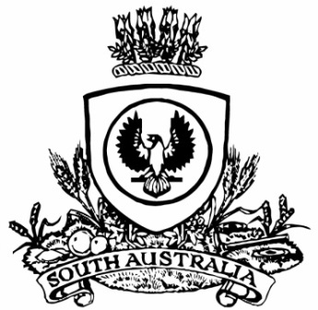
SUPPLEMENTARY GAZETTE
THE SOUTH AUSTRALIAN
GOVERNMENT GAZETTE
Published by Authority

Adelaide, Saturday, 21 February 2026

Governor’s Instrument
Proclamation
South Australia
Constitution (Dissolution of House of Assembly) Proclamation 2026
under section 28 of the Constitution Act 1934
1—Short title
This proclamation may be cited as the Constitution (Dissolution of House of Assembly) Proclamation 2026.
2—Commencement
This proclamation comes into operation on the day on which it is made.
3—Dissolution of House of Assembly
The House of Assembly is dissolved.
Made by the Governor's Deputy
with the advice and consent of the Executive Council
on 21 February 2026

