
No. 13 p. 425
THE SOUTH AUSTRALIAN
GOVERNMENT GAZETTE
Published by Authority

Adelaide, Thursday, 26 February 2026

Contents

Rules
State Lotteries Act 1966 426
State Government Instruments
Controlled Substances Act 1984 (SA) 478
Education and Children’s Services Act 2019 478
Electoral Act 1985 486
Electricity Act 1996 535
Gas Act 1997 535
Housing Improvement Act 2016 543
Justices of the Peace Act 2005 543
Landscape South Australia Act 2019 544
Local Government (Elections) Act 1999 547
Motor Vehicles Act 1959 547
Passenger Transport Regulations 2024 549
Pastoral Land Management and Conservation Act 1989 550
Planning, Development and Infrastructure Act 2016 551
Roads (Opening and Closing) Act 1991 553
Local Government Instruments
City of Adelaide 555
City of Port Lincoln 555
City of Unley 555
City of West Torrens 556
Public Notices
National Electricity Law 557
National Energy Retail Law 557
National Gas Law 558
Trustee Act 1936 558

Rules

State Lotteries Act 1966
South Australia
Lotteries (General) Amendment Rules 2026 (No. 1)
1. Preliminary
1.1 These Rules may be cited as the Lotteries (General) Amendment Rules 2026 (No. 1).
1.2 The Lotteries (General) Rules made under the State Lotteries Act 1966 and published in the Government Gazette on 26 February 2026 are herein after referred to as the “Principal Rules”.
1.3 The Principal Rules are hereby amended effective from 4 March 2026 and these Rules will take effect immediately thereafter, except as provided in these Rules.
2. Amendment of Rules
Rule 2.1 of the Principal Rules, the definition of ‘digital feature’ under Interpretation is included as follows:
“digital feature” means a digital facility made available to a player by the Master Agent, which enables a player to check whether their ticket is a prize – winning ticket and, if so, claim the prize digitally.
Rules 12.14 of the Principal Rules to be replaced by the following:
“Payment of prizes won on printed tickets or Instant Scratch-Its tickets (as applicable):
12.4.1 greater than $5,000 or such other amount as the Master Agent determines may be made by electronic funds transfer or by such other means as the Master Agent determines. Such prizes must be claimed at Head Office or through a digital feature (unless an Agent has obtained prior approval from the Master Agent to make a cash payment).
12.4.2 greater than $500 but equal to or less than $5,000 or such other amount as the Master Agent determines (either generally or in relation to a particular lottery) may be made in cash (except where the prize may be a free ticket), by electronic funds transfer or by such other means as the Master Agent determines. Such prizes may be claimed at Head Office, through a digital feature, or at an agency with the means to make a cash payment.
12.4.3 equal to or less than $500 or such other amount as the Master Agent determines shall be payable in cash (except where the prize may be a free ticket), by electronic funds transfer or by such other means as the Master Agent determines by Head Office, through a digital feature, or in cash by any Agent”
The Common Seal of the Lotteries Commission of South Australia was affixed pursuant to a resolution of the Commissioner.
Dated: 14 January 2026
Paul Williams
A/Commissioner
Approved,
Hon Tom Koutsantonis MP
Treasurer

State Lotteries Act 1966
Lotteries (General) Rules
This consolidation includes amendments as at 4 March 2026.
It is provided for convenient reference only and regard should be had to the full text of the Lottery Rules and amendments as published in the South Australian Government Gazette from time to time.
Arrangement
1. Preliminary
1.1 Citation
1.2 Existing Rules
1.3 Commencement
1.4 Current lotteries
1.5 Rules applicable to different types of lotteries
2. Interpretation
2.1 Definitions
2.2 General
2.3 SALC’s determination
3. General
3.1 Amendment or abrogation of Rules
3.2 Access to Rules
3.3 Rules binding on player
3.4 Lottery Blocs
4. Agents
4.1 Appointment and termination
4.2 Duties
4.3 Payment of price by player
4.4 Principal and Agent

5. Liability
5.1 Player’s liability
5.2 Receipt of ticket
5.3 Record of entry
5.4 Agent altering coupon
5.5 Exclusion of liability
5.6 Limitation of liability
5.7 Not For Publication request
5.8 Finality of SALC’s decision
6. Entry and Tickets
6.1 Methods of requesting entry
6.2 Payment
6.3 Incomplete request for entry or payment
6.4 Issue of ticket
6.5 Scanning of Instant Scratch-Its ticket
6.6 Cancellation of defective entry at Master Agent’s option
6.7 Cancellation of defective ticket at player’s option
6.8 Return of ticket by player for any other reason
6.9 Return of Instant Scratch-Its ticket by player
6.10 Alteration of ticket
6.11 Cash refund
6.12 ‘Play it again’ code
6.13 ‘Best pick’ entry
7. Electronic Request for Entry
7.1 Entry not to be submitted by post
7.2 Player’s obligations
7.3 Master Agent or Agent may decline request for entry
7.4 Selection of draw
8. Syndicate Entry
8.1 Formation of syndicate entry
8.2 Issue of unsold syndicate share
8.3 Payment of syndicate share by Agent
8.4 Payment of syndicate share by players
8.5 Cancellation of syndicate entry
9. Members Club (also known as Easiplay Club)
9.1 Application for membership
9.2 Membership charges
9.3 Application by minor
9.4 Temporary membership
9.5 Members Club (also known as Easiplay Club) database
9.6 Change of details
9.7 Advertising material
9.8 Refusal or cancellation of membership
9.9 Payment to bearer with Members Club (also known as Easiplay Club) card
9.10 Lost ticket report
9.11 Payment to bearer without Members Club (also known as Easiplay Club) card
9.12 Rule 9.11 not to apply after expiry of minimum Autopay period
9.13 Payment on expiry of Autopay period
10. Gift Vouchers
10.1 Availability
10.2 Payment
10.3 Inclusion of security code
10.4 Format of security code
10.5 Restriction on redemption
10.6 Expiry
10.7 Not redeemable for cash
10.8 Lodgement of claim
10.9 Conditions of claim
10.10 Master Agent’s determination
11. Disqualifications
11.1 Decision to disqualify
11.2 Reasons for disqualification
11.3 Player notification
11.4 Effect on prizes

12. Payment of Prizes
12.1 Master Agent’s records to be conclusive
12.2 Prizes not to bear interest
12.3 Share entry
12.4 Prize payments on printed tickets and Instant Scratch-Its tickets
12.5 Prize payments on electronic tickets
12.6 Handling fee
12.7 Claim administration fee
12.8 Details to be provided by applicant
12.9 Prize claim by post
12.10 Incomplete prize claim
12.11 Master Agent may decline to pay prize
12.12 Cancelled entry
12.13 Retention of winning ticket
12.14 Issue of exchange ticket
12.15 Auto payment of prize to Members Club (also known as Easiplay Club) member
12.16 Claim for a prize already paid
12.17 Claim for a prize outside relevant claim period
12.18 Unclaimed prizes
13. Syndicates and Payment of Prizes to Bearer
13.1 Bearer
13.2 Master Agent not bound by syndicate agreement or trust
14. Cancellation of Lottery or Entry
14.1 Decision to cancel lottery or ticket
14.2 Cancellation of lottery
14.3 Cancellation of ticket
Schedule
Date of commencement
1. Preliminary
1.1 These Rules may be cited as the Lotteries (General) Rules.
1.2 The Rules made under the State Lotteries Act 1966, and previously published in the Government Gazette are hereinafter referred to as “the Existing Rules”.
1.3 The Existing Rules are hereby revoked effective from the end of the day preceding the date of operation of these rules as specified in the Schedule to these Rules. These Rules will take effect immediately thereafter, except as provided in these Rules.
1.4 All current lotteries conducted by SALC through its Master Agent at the date of these Rules will be conducted pursuant to the Existing Rules as if these Rules had not been made. For this purpose each draw in each type of lottery will be regarded as a separate lottery conducted by SALC through its Master Agent.
1.5 These Rules are to be read in conjunction with the Rules applicable to each type of lottery conducted by SALC through its Master Agent from time to time.
2. Interpretation
2.1 In these Rules and in each part of these Rules unless the contrary intention appears:
“Act” means the State Lotteries Act 1966 as amended;
“Agent” means a person (other than a Master Agent) authorised by the Master Agent pursuant to the Act and the transaction documents to sell entries to the public in lotteries offered by the Master Agent from time to time;
“Agent’s Commission” means a charge determined by the Master Agent to be paid by a player to an Agent and included in the price of each ticket in a lottery and the charge may vary between each type of lottery conducted by SALC through its Master Agent from time to time;
“application form” means an application form for the issue of a Members Club (also known as Easiplay Club) membership card that is completed in either physical form or electronically;
“Autopay period” in relation to any online lottery is the timeframe during which the Master Agent automatically processes prizes, as determined by the Master Agent.
“bearer” means:
(a) in relation to a ticket, the holder of that ticket; or
(b) in relation to an electronic entry, the registered player to whom an electronic ticket is issued;
“Bloc Agreement” means an agreement between different lottery operators for the purpose of promoting and conducting a nominated game;
“cancelled” in relation to an entry means cancelled in accordance with Rule 14 or as otherwise determined by the Master Agent to be cancelled and incapable of winning a prize;
“close of acceptance of entries” means the date and time determined by the Master Agent after which entries and/or syndicate entries will not be accepted;

“conditions” means the conditions to which an issued ticket is subject and includes instructions printed on a coupon or a ticket in any type of lottery or available through any form of electronic media;
“coupon” means a printed form for requesting an entry in an online lottery;
“digital feature” means a digital facility made available to a player by the Master Agent, which enables a player to check whether their ticket is a prize-winning ticket and, if so, claim the prize digitally;
“Draw” includes a draw, determination or series;
“electronic request” means a request for an entry in an online lottery placed via a selling point of an internet site;
“electronic ticket” means a ticket or confirmation of order in an online lottery generated at the selling point of an internet site that is linked to a central computer system used in the Master Agent’s business to generate and/or validate tickets upon acceptance of an electronic request for entry;
“entry” means an entitlement to participate in a lottery on payment of its price as evidenced by the issue of a ticket(s) for that lottery;
“entry fee” means the cost of an entry in a lottery as determined by the Master Agent, excluding the Agent’s Commission and any handling fee charged for an electronic request, and the Master Agent may determine different entry fees for different lotteries;
“game” means:
(a) any one of the game panels of a coupon or other request for entry on which number selections may be made;
(b) any one of the game panels of a ticket or electronic record of entry on which number selections are recorded; or
(c) any one of the game panels on an Instant Scratch-Its ticket,
as the case may be (and “panel” and “set” have a corresponding meaning);
“Head Office” means the principal place of business of the Master Agent;
“lottery” means a lottery as defined by the Act and conducted by SALC through its Master Agent from time to time;
“Lottery Rules” means these Rules and the Rules applicable to the different types of lotteries conducted by SALC through its Master Agent from time to time;
“Master Agent” means Tatts Lotteries SA Pty Ltd as exclusive master agent of SALC, to:
(a) sell entries and pay prizes associated with those entries in lotteries operated by SALC from time to time;
(b) appoint Agents; and
(c) authorise the premises at which Agents may sell tickets for the purposes of section 19(10) of the Act.
“Members Club member” (also known as Easiplay Club Member) means a player whose personal details have been provided to the Master Agent and have been recorded for the purpose of providing a player registration service to the player;
“minor” means a minor as defined by the Act;
“online lottery” means a lottery in which the Master Agent generates a ticket through a selling point terminal;
“player” means, in relation to a lottery, a person who purchases and receives a ticket;
“price” in relation to an entry or a gift voucher means the entry fee or purchase price, the Agent’s Commission and any handling fee for an electronic request paid on request of an entry or purchase of a gift voucher;
“printed ticket” means a ticket in an online lottery genera ted by a selling point terminal upon acceptance of a coupon or verbal request for entry.
“SALC” means the Lotteries Commission of South Australia;
“selling point” means an Agent’s place of business or an internet site that is linked to a central computer system, or any other computer system used in the Master Agent’s business to process requests for entries, where the price may be paid or received, or such other place as determined by the Master Agent;
“selling point terminal” means the computer equipment located at an Agent’s place of business, an internet site that is linked to a central computer system used in the Master Agent’s business to generate and/or validate tickets, or such other place as determined by the Master Agent;
“sports lottery” means a sports lottery as defined by the Act;
“symbol” includes an amount, number, picture, word or any other representation (but excludes any security code) appearing on an entry;
“syndicate entry” means an entry relating to one or more lotteries that is divided into a number of equal shares;
“syndicate player” mean a person is the bearer of a valid syndicate share; “syndicate share” means a share of a syndicate entry;
“syndicate share price” means the price payable by a syndicate player to participate in a syndicate entry, rounded as necessary to the nearest whole cent in accordance with these Rules;
“ticket” means either:
(a) a printed ticket, including a ticket evidencing a syndicate share;
(b) an electronic ticket; or
(c) a ticket in an Instant Scratch-Its lottery, as defined in the Lotteries (Instant Scratch-Its) Rules;
“ticket checker” means a reading device provided at an agency to allow players to determine the prize status of a printed ticket or an Instant Scratch-Its ticket;
“Ticket Packs” means a selection of tickets promoted from time to time that includes tickets from a variety of lotteries;
“traditional lottery” means a lottery in which a maximum number of entries is offered for sale and the prize winning entries are ascertained at such time and in such manner as the Master Agent determines;
“transaction documents” means the documents executed by the Master Agent to facilitate its appointment as the exclusive Master Agent to operate SALC’s brands and products.

2.2 Unless the contrary intention appears:
2.2.1 headings are for convenient reference only and do not limit or extend the meaning of the language of the provisions to which they refer;
2.2.2 words in the singular number include the plural and vice versa; and
2.2.3 words importing a gender include any other gender.
2.3 SALC may at any time and from time to time make or vary any determination under these Rules.
3. General
3.1 SALC may at any time amend or abrogate all or part of the Lottery Rules, whether or not an entry has been accepted or prize winning entries have been determined.
3.2 The Lottery Rules may be made public by such means as determined by the Master Agent.
3.3 By submitting a request for an entry (whether by coupon, verbal or electronic), a player will be deemed to agree to be bound by the Lottery Rules. If a ticket is issued, it will be on the basis that the player is so bound.
3.4 Where applicable, the Lottery Rules are to be read in conjunction with and as part of any Bloc Agreement entered into by SALC for the conduct of any Bloc lottery. If there is any inconsistency between a Bloc Agreement and the Lottery Rules, the provisions of the Lottery Rules will prevail.
4. Agents
4.1 Subject to the terms of any agreement between the Master Agent and SALC, the Master Agent:
4.1.1 may receive an application in such form as it determines from a party interested in being appointed an Agent for the purpose of selling tickets in lotteries conducted by SALC through its Master Agent;
4.1.2 will consider and accept or reject such application without being liable to give any reason for its decision;
4.1.3 may appoint an Agent on such terms as the Master Agent determines; and
4.1.4 subject to any other statutory or contractual provision, may terminate the appointment summarily, if the application is subsequently found to have been completed dishonestly, incorrectly or inadequately.
4.2 An Agent:
4.2.1 will be an Agent only for the purpose of selling tickets in lotteries conducted by SALC through its Master Agent and will not have the power to pledge either the Master Agent’s or SALC’s credit;
4.2.2 must sign an agreement as specified by the Master Agent;
4.2.3 must comply with any directions or requirements issued by the Master Agent (in writing or otherwise) concerning conduct of the Agent’s business, including sale and return of tickets, selling point terminal operation, and provision of such details or returns of information or money or compliance with such performance criteria as the Master Agent requires; and
4.2.4 who breaches the said agreement or the Lottery Rules may at any time;
4.2.4.1 have its appointment terminated by the Master Agent in accordance with the transaction documents; or
4.2.4.2 be suspended for such period and on such terms and conditions as the Master Agent determines.
4.3 A player who requests an entry in a lottery must pay the price at the time of purchase of the ticket.
4.4 Principal and Agent
4.4.1 An Agent who is paid an Agent’s Commission will be the player’s agent for the purpose of submitting a request for entry to the Master Agent.
4.4.2 SALC (excluding the Master Agent) may deal with a player as principal. A player who uses an Agent will be bound by all the Agent’s acts or omissions.
4.4.3 Use of an Agent does not exempt a player from observing these Rules.
4.4.4 If the Master Agent sells an entry or issues a ticket to a player it will be deemed to be acting as an agent for the purpose of these Rules in determining its relationship to the player.
5. Liability
5.1 The player:
5.1.1 will accept all risks, losses, delays, errors or omissions that might occur in the course of delivery to the Master Agent of any request for entry, whether electronically, through an Agent or by any other means; and
5.1.2 must ensure that any coupon or electronic request submitted for entry is completed in accordance with these Rules and acknowledges that neither the Master Agent nor the Agent has any responsibility to check the same when accepting it.
5.2 Receipt of a ticket (whether issued as a result of a coupon, verbal or electronic request) by a player constitutes an acknowledgment that the symbols and other details it contains are the player’s selections. A player who does not immediately notify the selling point terminal operator of any error will be deemed to have accepted that the symbols and other details are their selections. No coupon or other evidence will thereafter be valid for the purposes of proving an entry in a draw.
5.3 If details on a ticket in a lottery differ from the central computer record of that ticket, the central computer record will be the sole determinant in identifying what prize (if any) is payable in respect of the ticket.
5.4 Neither SALC nor the Master Agent will be liable where an Agent has altered a coupon in any way without the player’s authority.
5.5 Neither SALC, the Master Agent, an Agent, nor an employee or agent of any of them, will be liable:
5.5.1 if a selling point terminal fails to read a coupon and operator intervention is required to correctly process the coupon or if an operator incorrectly keys into the selling point terminal from the player’s verbal or coupon selections any number(s) not selected by the player; or

5.5.2 for any loss, damage, injury or expense sustained by a player by reason of any act, neglect, omission, delay or failure:
5.5.2.1 to forward to the Master Agent any request for entry in any lottery;
5.5.2.2 to properly validate, process or enter a request for entry in any particular draw;
5.5.2.3 for any assistance given in completing an application form, coupon or other form; or
5.5.2.4 to properly or accurately process any request by a player to participate in any lottery conducted by SALC through its Master Agent,
and this Rule may be pleaded as a bar to any legal proceedings brought by any player alleging breach, default or non-performance of any contract or duty by SALC, the Master Agent or such Agent, or an employee or agent of any of them.
5.6 In respect of:
5.6.1 any representation made by an employee or any other person on SALC’s or the Master Agent’s behalf;
5.6.2 loss or damage arising from an unlawful act by an employee or agent of SALC, the Master Agent or a third party;
5.6.3 fire, flood, tempest, storm, riot, civil commotion, lockouts or strikes in respect of which a claim is made;
5.6.4 any failure of or malfunction in any selling point terminal or central computer system used in the Master Agent’s business, an Agent or any person on either’s behalf, in respect of which a claim is made; or
5.6.5 subject to Rule 6.6, a cancelled entry;
SALC’s or the Master Agent’s liability (if any and at SALC’s or the Master Agent’s discretion) will be limited to the refund of the price of the ticket, on which the player is claiming a prize, in full and final settlement of any claim.
5.7 The Master Agent will use its best endeavours to respect any request by a prize winning player for Not For Publication (NFP) status and will not reveal any details of the prize that will identify the player without their consent. If the Master Agent releases a prize winning player’s name and address contrary to their instructions it will not be liable for any inconvenience, loss, damage or injury thereby suffered by any person unless otherwise required by law.
5.8 Any decision made by SALC or the Master Agent concerning any lottery conducted by SALC through its Master Agent (including but without limiting the generality thereof eligibility of entries, determination of prize winners, the amount and distribution of prize money and the meaning and effect of these Rules) will be final and binding on all players participating in that lottery and on every person making a claim in respect of that lottery.
6. Entry and Tickets
6.1 A coupon or verbal or electronic request for any available type of entry may be delivered, communicated or forwarded to the Master Agent by a player or an Agent.
6.2 The price of an entry must be paid in either Australian currency, by credit card, by funds transfer from a player’s account or by redemption of a gift voucher issued by the Master Agent or such other means as the Master Agent determines. Payment must accompany or be made with transmission of a coupon or other request for entry.
6.3 The Master Agent or an Agent will refuse to accept, or reject after acceptance, any coupon or other request for entry that has not been duly completed or is not accompanied by full payment of the price for the number of games to be played.
6.4 Subject to Rule 6.3 the issue of a ticket by a selling point terminal will constitute acknowledgment by the Master Agent of acceptance of the request for entry in the online lottery referred to on the ticket.
6.5 Subject to Rule 6.3 the scanning of an Instant Scratch-Its ticket by the selling point terminal at the time of sale will constitute acknowledgement by the Master Agent of acceptance of the request for entry into the series referred to on the Instant Scratch-Its ticket.
6.6 If the Master Agent or an Agent decides that an issued online lottery ticket is defective and the prize winners in the draw to which it relates have not been determined, the Master Agent or an Agent may cancel the ticket and at its discretion either:
6.6.1 replace the ticket with another ticket, in which event the player will be taken to have authorised an employee of the Master Agent or an Agent to determine their selections and, if necessary, to complete a request for entry on their behalf that will then be accepted for participation in the appropriate draw for the appropriate lottery; or
6.6.2 refund the price of the ticket to its bearer or the player.
6.7 If a player considers that an issued ticket is illegible or defective in any way, the ticket may be cancelled. No duplicate ticket will be provided.
6.8 A player who requests to return a ticket in an online lottery for any other reason may apply to the Master Agent or an Agent to cancel the ticket:
6.8.1 for all lotteries, excluding Keno, the ticket must be cancelled at the place of purchase and prior to the close of acceptance of entries in respect of the first draw on that ticket;
6.8.2 for Keno, a ticket must be cancelled at the place of purchase and prior to the close of acceptance of entries in respect of the draws from which the player wishes to cancel their participation.
The Master Agent or an Agent may at its absolute discretion accept or reject the return of the ticket. On return of a ticket, a player will be entitled at their option to:
6.8.3 a full refund of the price of the ticket or, in the case of a Keno, a consecutive draw entry, the price of the undrawn portion of the ticket; or
6.8.4 for all lotteries, excluding Keno, a further ticket in exchange for the returned ticket.
6.9 A player who requests to return an Instant Scratch-Its ticket must apply to the selling Agent at the time of purchase. The selling Agent may at its absolute discretion accept or reject the return of the Instant Scratch-Its ticket. On return of an Instant Scratch-Its ticket, a player will be entitled at their option to:
6.9.1 a full refund of the price of the Instant Scratch-Its ticket; or
6.9.2 a further Instant Scratch-Its ticket of the same monetary value in exchange for the returned Instant Scratch-Its ticket.

6.10 A ticket must not be altered. Any alteration will have no validity for any purpose.
6.11 No cash refund will be made except as provided under these Rules.
6.12 A player may be entitled to purchase a ‘best pick’ entry, as determined by the Master Agent, whereby the selling point terminal will select and optimise the mix of standard entries based on the amount and games specified by the player across the lotteries conducted by SALC through its Master Agent, equivalent or as close as possible to the nominated dollar amount. The Master Agent will determine the minimum dollar value required for the game options selected.
7. Electronic Request for Entry
7.1 A player cannot submit a request for entry to the Master Agent or an Agent by post.
7.2 A player who sends a request for entry to the Master Agent or an Agent electronically must:
7.2.1 do so prior to the close of acceptance of entries for the draw of the lottery to which it relates;
7.2.2 comply with all laws of any applicable jurisdiction regulating lotteries of the type in which the player seeks to participate; and
7.2.3 in the case of an electronic request for entry:
7.2.3.1 first establish an account for use in connection with the player’s participation in the lottery; and
7.2.3.2 have sufficient funds held in credit in the account to pay the price of any entry requested.
7.3 The Master Agent or an Agent may refuse to accept a request for entry received electronically that:
7.3.1 does not comply with the Lottery Rules; or
7.3.2 is not accompanied by full payment of the price.
7.4 A request for entry received electronically may, at the absolute discretion of the Master Agent or an Agent;
7.4.1 be entered in the draw(s) nominated by the player;
7.4.2 if not received in time for it to be processed for participation in a particular draw(s), be entered in the next draw(s) of the same lottery;
7.4.3 if accompanied by payment other than in cash be entered in the next available draw(s) of the lottery for which it is intended after full payment is credited to the account of the Master Agent or an Agent, as the case may be; or
7.4.4 in any other case, be entered in the draw(s) current at the date on which the Master Agent or an Agent processes the entry.
8. Syndicate Entry
8.1 A syndicate entry may be formed for each lottery or a combination of each and any of the lotteries by:
8.1.1 the Master Agent (“central syndicate”);
8.1.2 the Agent (“store syndicate”); or
8.1.3 a group of two (2) or more Agents (“group syndicate”).
8.2 If a syndicate share remains unsold 10 minutes prior to the close of acceptance of entries for the first draw applicable to the syndicate entry, the syndicate share is automatically issued:
8.2.1 for a store syndicate to the Agent that formed the syndicate entry;
8.2.2 for a group syndicate;
8.2.2.1 to the Agent who is responsible for the sale of the syndicate share; or
8.2.2.2 to the Agent who cancelled the syndicate share if the syndicate share was sold and then cancelled by an Agent; or
8.2.2.3 in accordance with Rule 8.2.3.2 if the Master Agent participated in the syndicate and was responsible for the sale of the relevant syndicate share;
8.2.3 for a central syndicate;
8.2.3.1 to the Agent who cancelled the syndicate share if the syndicate share was sold and then cancelled by an Agent; or
8.2.3.2 to a person (at no cost to that person) who is at that time a Members Club (also known as Easiplay Club) member and to whom the selling point terminal randomly registers the syndicate share;
8.3 If a syndicate share is issued under Rule 8.2.1, 8.2.2.1, 8.2.2.2, or 8.2.3.1 the Master Agent will collect the amount owing for the syndicate share from the Agent to whom the syndicate share is issued under this Rule.
8.4 A syndicate player must pay the syndicate share price in respect of each syndicate share at the time of purchase by the syndicate player (except for syndicate shares issued under Rule 8.2.3.2).
8.5 A syndicate entry will be cancelled if all syndicate shares remain unsold prior to the close of acceptance of entries for the first draw applicable to the syndicate entry.
9. Members Club (also known as Easiplay Club)
9.1 To become a Members Club (also known as Easiplay Club) member, an applicant must complete a current application form and forward it to the Master Agent either directly or through any Agent’s place of business.
9.2 The Master Agent may impose membership charges as it determines at any time. Prior to the imposition or any change to such a charge, the Master Agent will provide notification to players.
9.3 The Master Agent will be entitled to assume that any Members Club (also known as Easiplay Club) member or any applicant for Members Club (also known as Easiplay Club) membership is not a minor. An Members Club (also known as Easiplay Club) member or an applicant for Members Club (also known as Easiplay Club) membership must provide such evidence of their age as the Master Agent requires. If the Master Agent subsequently ascertains that Members Club (also known as Easiplay Club) membership has been issued to a minor, the Master Agent will cancel such membership and, in accordance with these Rules, decline to pay any prize that would otherwise have been payable.

9.4 An Agent, to whom a duly completed application form is submitted, together with such evidence of the applicant’s age as the Agent may require, will forthwith issue an Members Club (also known as Easiplay Club) temporary membership slip to the applicant for immediate use. The autopay facility will be activated once the Members Club (also known as Easiplay Club) application form is processed and accepted by the Master Agent.
9.5 Once a duly completed application form has been processed and accepted by the Master Agent, the member’s personal details will be included in the Members Club (also known as Easiplay Club) database and an actual or electronic Members Club (also known as Ea siplay Club) card will be issued and details provided to the member. Subject to the issuing conditions, the card will be evidence of Members Club (also known as Easiplay Club) membership.
9.6 An Members Club (also known as Easiplay Club) member must ensure that the Master Agent is advised of any changes to details held in the Members Club (also known as Easiplay Club) database. When requested by the Master Agent, an Members Club (also known as Easiplay Club) member must notify the Master Agent of a change of details . Neither the Master Agent nor any Agent will be liable to make good any loss incurred in respect of any prize forwarded to an address shown in the Members Club (also known as Easiplay Club) database at the time of expiration of the relevant claim period.
9.7 The Master Agent will maintain a record of the information provided by each Members Club (also known as Easiplay Club) member and will be permitted to use that information for the purpose of distributing advertising material and similar information. An Members Club (also known as Easiplay Club) member who does not want to receive such material or information must advise the Master Agent in writing. The Master Agent will use its best endeavours to protect each member’s personal information and maintain the highest level of confidentiality.
9.8 The Master Agent shall be entitled to refuse a new membership or cancel an existing membership, for whatever reason, without the requirement to outline the reasons for such refusal or cancellation.
9.9 Once the Master Agent has paid a prize won on a ticket purchased on presentation of an Members Club (also known as Easiplay Club) membership card, there will be no further claim to that prize.
9.10 If a player who complies with the requirements of these Rules reports that a winning ticket is lost, the Master Agent may decline to pay the prize to the ticket’s bearer.
9.11 If a person (“the bearer”) lodges a printed ticket that bears the name of an Members Club (also known as Easiplay Club) member (“the member”) with the Master Agent for payment of a prize, but the bearer fails to produce the corresponding Members Club (also known as Easiplay Club) membership card, the Master Agent will invite the bearer to provide a statutory declaration and such other documentation as the Master Agent requires to determine the rightful owner of the printed ticket.
9.11.1 If the Master Agent is satisfied that the bearer is the rightful owner of the printed ticket, and the prize has not been autopaid to the member in accordance with Rule 12.15, the Master Agent will pay the prize to the bearer and neither the member nor any other person will have any claim in respect of the printed ticket.
9.11.2 A decision by the Master Agent under this Rule is final and without appeal. The Master Agent has no obligation beyond the strict requirements of this Rule to provide a right to be heard in relation to its decision.
9.12 The procedure under Rule 9.11 is not available to a ticket’s bearer after expiration of the Autopay period as determined by the Master Agent. After expiration of that period any prize payable in respect of the ticket will only be paid to the member whose name first appears on the application form.
9.13 If:
9.13.1 a prize is won on a ticket purchased on presentation of a n Members Club (also known as Easiplay Club) membership card; and
9.13.2 the ticket’s bearer has not claimed the prize at the expiration of the determined Autopay period,
the Master Agent will pay the prize into the account nominated by the member or by such other means as determined by the Master Agent. Thereafter, the ticket’s bearer will have no claim to the prize.
10. Gift Vouchers
10.1 The Master Agent may make available to players the purchase of gift vouchers for such defined value(s) as determined by the Master Agent from time to time.
10.2 The price of a gift voucher must be paid in Australian currency, by credit card, by funds transfer from a player’s account or by such other means as the Master Agent determines. Payment must be made at the time of requesting the gift voucher.
10.3 The Master Agent may include a security code on any part of the gift voucher for the purpose of identifying counterfeit or reconstituted gift vouchers.
10.4 A security code may be:
10.4.1 symbols or other markings; and
10.4.2 printed, stamped, embossed or otherwise shown on the gift voucher.
10.5 A gift voucher can only be presented once for redemption unless otherwise determined by the Master Agent.
10.6 Gift vouchers must be redeemed within twelve months of their date of issue or such other period as determined by the Master Agent.
10.7 A gift voucher will not be redeemable for cash.
10.8 Any player who claims to be entitled to redeem a gift voucher but:
10.8.1 whose gift voucher has not been identified by a central computer system used in the Master Agent’s business as a validly issued gift voucher; or
10.8.2 considers that their gift voucher has been incorrectly evaluated by the Master Agent;
may lodge a claim with the Master Agent.

10.9 A claim under Rule 10.8:
10.9.1 may be lodged with the Master Agent either personally or by registered mail;
10.9.2 must reach the Master Agent within the period specified for the redemption of a gift voucher;
10.9.3 must be accompanied by the gift voucher in question and proof of purchase, clearly endorsed with the claimant’s full name and address; and
10.9.4 if posted, must be accompanied by a self-addressed envelope bearing the correct postage.
10.10 The Master Agent:
10.10.1 will not be obliged to recognise any claim not identified by a central computer system used in the Master Agent’s business within the period specified for the redemption of a gift voucher; and
10.10.2 may in its absolute discretion accept or refuse to accept a claim in whole or in part.
11. Disqualifications
11.1 Notwithstanding that:
11.1.1 acceptance of entries into a lottery has closed;
11.1.2 a ticket may have issued; or
11.1.3 the draw has occurred in respect of which the ticket is entered an entry in a lottery may be disqualified and no prize claim shall be made in respect of it, if the Master Agent is of the opinion that it should be so disqualified. Any ticket which has issued in respect of an entry in a lottery which is disqualified shall automatically be cancelled.
11.2 The reasons for disqualification may include but are not limited to:
11.2.1 failure to pay the full price of entry;
11.2.2 reasonable suspicion of fraud or attempted fraud (whether computer related or otherwise);
11.2.3 reasonable suspicion of unauthorised use of a selling point terminal or central computer system used in the Master Agent’s business; or
11.2.4 any other breach of these Rules which justifies disqualification.
11.3 The Master Agent shall use its best endeavours to notify a player whose name and address is known to the Master Agent that an entry has been disqualified and the reason therefor and the Master Agent shall refund to the player any price paid. Where the Master Agent does not know the name and address of a player, the Master Agent shall publicise, in a manner determined by the Master Agent, the disqualification of such an entry.
11.4 If an entry which would otherwise be eligible for a prize, is disqualified during the claim period then the value of the remaining prizes shall be varied to take into account such disqualification.
12. Payment of Prizes
12.1 The Master Agent’s records as to payment of prizes in respect of a ticket shall be conclusive.
12.2 No prize will bear interest as against SALC or the Master Agent.
12.3 Any prize won on a syndicate share entry will be payable to the bearer of the syndicate share entry to the extent of the bearer’s entitlement as appears on the syndicate share entry, rounded in each division to the nearest whole cent above or below the bearer’s syndicate share of the actual prize otherwise payable, with any resulting surplus being paid into the Division 1 prize pool, and any shortfall being drawn from the Division 1 prize pool.
12.4 Payment of prizes won on printed tickets or Instant Scratch-Its tickets (as applicable):
12.4.1 greater than $5,000 or such other amount as the Master Agent determines may be made by electronic funds transfer or by such other means as the Master Agent determines. Such prizes must be claimed at Head Office or through a digital feature (unless an Agent has obtained prior approval from the Master Agent to make a cash payment).
12.4.2 greater than $500 but equal to or less than $5,000 or such other amount as the Master Agent determines (either generally or in relation to a particular lottery) may be made in cash (except where the prize may be a free ticket), by electronic funds transfer or by such other means as the Master Agent determines. Such prizes may be claimed at Head Office, through a digital feature, or at an agency with the means to make a cash payment.
12.4.3 equal to or less than $500 or such other amount as the Master Agent determines shall be payable in cash (except where the prize may be a free ticket), by electronic funds transfer or by such other means as the Master Agent determines by Head Office, through a digital feature, or in cash by any Agent.
12.5 Payment of cash prizes won on an electronic ticket will be paid by electronic funds transfer directly into the account established for use in connection with the player’s participation in electronic requests.
12.6 A handling fee (which may include postage costs and a processing fee) will be charged in each case as the Master Agent determines for payment of prizes won on printed tickets or Instant Scratch-Its tickets by electronic funds transfer or such other manner as the Master Agent determines. The handling fee will be deducted from the prize.
12.7 A non-refundable claim administration fee as determined by the Master Agent may be required to accompany a claim for an ex gratia payment under section 16D of the Act.
12.8 The applicant for payment of a prize must provide their name and address:
12.8.1 for payment of a prize greater than $5,000 (or such other amount as provided by law) in any online lottery;
12.8.2 for payment of any prize to be paid by electronic funds transfer; or
12.8.3 in any other case as required by the Master Agent.
12.9 A printed ticket or Instant Scratch-Its ticket forwarded by post for payment of a prize must have the winner’s name and address completed on its reverse.

12.10 A prize claim incomplete in any detail required by the Master Agent may be rejected.
12.11 The Master Agent may decline to pay a prize in respect of any ticket presented as evidence of a winning entry if, in the Master Agent’s opinion:
12.11.1 the ticket was purchased by a minor or an Members Club (also known as Easiplay Club) membership card issued to a minor was submitted at the time of purchase of the ticket;
12.11.2 any number or security marking on the ticket has been tampered with in any way; or
12.11.3 the ticket has been stolen, mutilated, altered, defaced or is counterfeit, misprinted, illegible, incomplete or defective in any way; or
12.11.4 the ticket was found to have been purchased fraudulently,
and furthermore, the Master Agent shall retain such a ticket for such period as the Master Agent determine.
12.12 A ticket that has been recorded as cancelled on a central computer system used in the Master Agent’s business will be of no validity in claiming a prize. The player will have no claim against SALC or the Master Agent (whether such cancelled recording is at the player’s request or due to a computer system malfunction, operator error or otherwise). A ticket incorrectly recorded on a central computer system used in the Master Agent’s business will be deemed cancelled. The Master Agent will determine whether a ticket has been correctly recorded.
12.13 A ticket identified by a central computer used in the Master Agent’s business system as a prize winning ticket may, after evaluation by a selling point terminal and payment of the prize, be retained by the Master Agent for such period as the Master Agent determine.
12.14 Where a prize winning ticket processed in accordance with these Rules is acknowledged by a central computer system used in the Master Agent’s business to contain an entry in any online lottery that has not yet been drawn or conducted, the selling point terminal operator will:
12.14.1 for all online lotteries, excluding Keno, issue an exchange ticket to the bearer; and
12.14.2 for Keno, cancel the remaining entries in accordance with Rule 6.8.
Should an exchange ticket be issued, it will contain the same selections and specify the remaining draw numbers in which it will be entered.
12.15 Subject to Rule 9.11, a Members Club (also known as Easiplay Club) member who has not claimed a prize within the Autopay period will be paid by the nominated prize payment method. If the nominated method is cheque (and that method is unavailable), the member must nominate an alternative payment method. Payment will be issued in the name and details on the Members Club (also known as Easiplay Club) database at the time of issue, provided that:
12.15.1 in the Master Agent’s opinion, the name and details are adequate to ensure safe delivery; and
12.15.2 the net amount of the payment payable to the player exceeds the handling fee as determined by the Master Agent.
12.16 A claim for a prize already paid by the Master Agent will not be considered.
12.17 Subject to the provisions of the Act, a claim for a prize received by the Master Agent outside the relevant claim period will not be considered, nor will the Master Agent accept or recognise any reason for late lodgement or receipt of a claim.
12.18 (a) Prizes in a lottery, other than a special appeal lottery, not collected or taken delivery of within 12 months of the date of the draw or such other date as SALC determines, will be forfeited in accordance with the Act.
(b) Prizes in a special appeal lottery not collected or taken delivery of within the period specified by the Minister will be payable to the beneficiary or beneficiaries of the net proceeds of the special appeal lottery, in the proportions specified by the Minister.
13. Syndicates and Payment of Prizes to Bearer
13.1 Except as otherwise provided by these Rules, the bearer of a ticket that is evidence of a winning entry will be regarded as its owner and will be paid the prize upon the ticket’s redemption, notwithstanding:
13.1.1 any name on the ticket;
13.1.2 any name on an application form for an Members Club (also known as Easiplay Club) membership card submitted at the time of purchase of the ticket;
13.1.3 any name and address in the database for an Members Club (also known as Easiplay Club) membership card submitted at the time of purchase of the ticket;
13.1.4 that a person has reported the ticket’s loss to the Master Agent;
13.1.5 that the Master Agent has had notice that someone other than the ticket’s bearer may have a claim in respect of the prize won by the ticket; or
13.1.6 that payment is made to a person not named on an application form for a Members Club (also known as Easiplay Club) membership card submitted at the time of purchase of the ticket.
Payment of any prize to the bearer of the ticket will be deemed a full and final discharge of the Master Agent’s liability in respect of the ticket.
13.2 The Master Agent will not be bound:
13.2.1 by any agreement made between any syndicate or group participants other than an agreement between the Master Agent and a player in a central syndicate; or
13.2.2 to take notice or to see to the execution of any trust whether express, implied or constructive to which a ticket may be subject.

14. Cancellation of Lottery or Ticket
14.1 The Master Agent may in respect of any lottery conducted by SALC through its Master Agent:
14.1.1 cancel the lottery;
14.1.2 cancel any ticket without cancelling the lottery to which it relates; or
14.1.3 recall any Instant Scratch-Its ticket(s) and cancel the remainder of the series of which they are part,
if it considers that doing so is necessary for the fair conduct of the lottery or for such other reason as the Master Agent in its absolute discretion determines. Such cancellation may be effected either before or after the draw or payment of prizes in any lottery.
14.2 If the Master Agent cancels a lottery it may:
14.2.1 pay anyone who has purchased a ticket in the lottery the price of the ticket;
14.2.2 conduct another lottery (“the second lottery”) and issue to anyone who purchased a ticket in the cancelled lottery a ticket in the second lottery. The price of a ticket and the value and number of prizes in the second lottery will not differ from the price of a ticket and the value and number of prizes in the cancelled lottery; or
14.2.3 deal with the tickets in the cancelled lottery in such manner as the Master Agent considers fair and reasonable in all the circumstances.
14.3 If the Master Agent cancels a ticket in a lottery it may:
14.3.1 repay the price of the ticket; or
14.3.2 issue another ticket with a different serial number in the same lottery,
and in either case the cancelled ticket will not be included with other tickets in determining the prizes of the lottery to be won.
Schedule
Date of operation of these Rules:
4 March 2026.

State Lotteries Act 1966
South Australia
Lotteries (Lucky Lotteries) Amendment Rules 2026 (No. 1)
1. Preliminary
1.1 These Rules may be cited as the Lotteries (Lucky Lotteries) Amendment Rules 2026 (No. 1).
1.2 The Lotteries (Lucky Lotteries) Rules made under the State Lotteries Act 1966 and published in the Government Gazette on
26 February 2026 are herein after referred to as the “Principal Rules”.
1.3 The Principal Rules are hereby amended effective from 4 March 2026 and these Rules will take effect immediately thereafter, except as provided in these Rules.
2. Amendment of Rules
Rule 9.2.1 of the Principal Rules to be replaced by the following:
“prizes will be paid as soon as practicable after the conclusion of the Draw either at Head Office, through a digital feature, or through any selling point terminal on presentation of the ticket or record of electronic entry for evaluation by a selling point terminal through the central computer system, or as otherwise determined by the Master Agent, subject to these Rules; and”
The Common Seal of the Lotteries Commission of South Australia was affixed pursuant to a resolution of the Commissioner.
Dated: 14 January 2026
Paul Williams
A/Commissioner
Approved,
Hon Tom Koutsantonis MP
Treasurer

State Lotteries Act 1966
Lotteries (Lucky Lotteries) Rules
This consolidation includes amendments as at 4 March 2026.
It is provided for convenient reference only and regard should be had to the full text of the Lottery Rules and amendments as published in the South Australian Government Gazette from time to time.
Arrangement
1. Preliminary
1.1 Citation
1.2 Commencement
1.3 Lotteries (General) Rules
1.4 Application
2. Interpretation
2.1 Definitions
3. General
3.1 Ticket number
3.2 Maximum number of tickets
3.3 Advance entry
3.4 Method of creating an entry
3.5 Marking a coupon
4. Supervision of Draw
4.1 Supervision and finality of draw
4.2 Prize pool
5. Determination of Winning Number(s)
5.1 Draw number
5.2 Drawing equipment
5.3 Conduct of the Draw
5.4 Advertising the date of the Draw
5.5 Determination of winning numbers
5.6 Determination of jackpot number
6. Publication of Results
6.1 Publication
6.2 Content
7. Prize Pool Structure
7.1 Prize structure in a Draw
7.2 Determination of prize(s)
7.3 Determination of jackpot roll
7.4 Single ticket
7.5 Prize pool
7.6 Jackpot increment
7.7 Contribution to prize pool

8. Prize Reserve Fund
8.1 Creation
8.2 Jackpot prize
8.3 Distribution
8.4 Agreement with Bloc members
8.5 Assignment
9. Prize Claims
9.1 First prize and jackpot prize
9.2 Any other prize
9.3 Lodgement of claim
9.4 Requirements for lodgement of claim
9.5 SALC’s discretion
10. Ticket Checkers
10.1 Location
10.2 Use
10.3 Validation of ticket
Schedule 1
Ticket pool and prize structure for Lucky Lotteries Super Jackpot
Schedule 2
Ticket pools and prize structure for Lucky Lotteries Mega Jackpot
Schedule 3
Date of commencement
1. Preliminary
1.1 These Rules may be cited as the Lotteries (Lucky Lotteries) Rules.
1.2 These Rules will come into operation on the date specified in the Schedule to these Rules.
1.3 These Rules are to be read in conjunction with and are subject to the Lotteries (General) Rules.
1.4 These Rules apply to the lottery known as “Lucky Lotteries” and includes Lucky Lotteries Super Jackpot and Lucky Lotteries Mega Jackpot.
2. Interpretation
2.1 In these Rules and in each part of these Rules unless the contrary intention appears:
“Bloc members” means the parties from time to time to the Bloc Agreement entered into by SALC with other lottery operators for the promotion, conduct and sale of tickets in Lucky Lotteries on a joint basis with a common winning number determination and a declaration of a common prize pool based on the equal participation of all players in the aggregated prize pool;
“claim period” means the period commencing at midnight on the day of determination of the draw results and ending on the 14th day thereafter;
“consolation prize” means the prize won in a Draw of Lucky Lotteries Super Jackpot or Lucky Lotteries Mega Jackpot in accordance with Schedule 1 and Schedule 2 respectively; for a ticket with a six (6) digit number occurring in sequence immediately before or after the winning number;
“drawing equipment” means the random number generator or other approved drawing device operated by Golden Casket Lottery Corporation Limited on behalf of the Master Agent for ascertaining the winning number(s);
“jackpot fund contribution” means the amount that will be set aside to fund the guaranteed minimum jackpot prize as set out for a Draw of Lucky Lotteries Super Jackpot in accordance with Schedule 1 or for Lucky Lotteries Mega Jackpot in accordance with Schedule 2;
“jackpot increment” means the amount the jackpot will increase if the jackpot prize is not won as set out for a Draw of Lucky Lotteries Super Jackpot in accordance with Schedule 1 or for Lucky Lotteries Mega Jackpot in accordance with Schedule 2;
“jackpot number” means the six (6) digit number selected in a Draw by the drawing equipment after the selection of the winning number(s) in that Draw;
“jackpot prize” means the prize in respect of an entry containing the jackpot number that is also a winning number and being the amount specified in Schedule 1 in respect of an entry in Lucky Lotteries Super Jackpot or Schedule 2 in respect of an entry in Lucky Lotteries Mega Jackpot;
“number” means a six (6) digit number from:
(a) 000,001 to 270,000 for Lucky Lotteries Super Jackpot;
(b) 000,001 to 200,000 for Lucky Lotteries Mega Jackpot;
guaranteed in the manner descripted in section 3;
“ticket pool” means the number of tickets in a Draw of Lucky Lotteries Super Jackpot and Lucky Lotteries Mega Jackpot in accordance with Schedule 1 and Schedule 2 respectively;
“winning number” is one of the six (6) digit numbers selected in a Draw by the drawing equipment in respect of each prize, except for the jackpot prize and consolation prize.

3. General
3.1 Each ticket in each Draw will be identified by a unique ticket number.
3.2 There will be a limit to the maximum number of tickets that can be issued to a player in each Draw, and the Master Agent may decline to issue more than 2,000 tickets to a player in any one Draw.
3.3 A player may request that an entry be issued in advance of a current Draw. The maximum number of advance Draws in which an entry can be issued will be as determined by the Master Agent and notified to players.
3.4 A player may enter a Draw by:
3.4.1 submitting a coupon provided for that purpose from time to time by the Master Agent, together with an Easiplay Club membership card if applicable; or
3.4.2 making a verbal or electronic request at the selling point, together with providing an Easiplay Club membership card if applicable.
3.5. In the case of a coupon:
3.5.1 a player must mark a coupon in accordance with the instructions appearing on the coupon. No other mark will be accepted. All marks on a coupon must be legible and if a coupon cannot be read by a selling point terminal, it will be rejected. A coupon must not be marked in red.
3.5.2 If a player marks more than the number of squares specified in the instructions appearing on the coupon, a ticket will not be issued until the player has nominated the incorrect selection(s) to be removed. The player may be require to complete another coupon.
4. Supervision of Draw
4.1 The drawing of the winning number(s) will be conducted in such manner as agreed by the Master Agent and:
4.1.1 should be conducted and supervised in accordance with the requirements of the relevant regulatory body for the State in which the Draw is conducted; and
4.1.2 will be final for the purpose of determining the prize winner(s) for that Draw.
4.2 The total amount of the prize pool will be as set out in Schedule 1 in respect of Lucky Lotteries Super Jackpot and Schedule 2 in respect of Lucky Lotteries Mega Jackpot.
5. Determination of Winning Number(s)
5.1 Each Draw will be identified by a Draw number.
5.2 Each Draw will be conducted using drawing equipment as the Master Agent determines.
5.3 A Draw will be conducted on the day and at the time determined by the Master Agent when all numbers available for sale in a Draw have been sold in respect of that Draw.
5.4 The Master Agent will publicly advise when a Draw is to be conducted.
5.5 The winning numbers in a Draw are determined by the drawing equipment randomly selecting the required six (6) digit numbers equivalent to the number of prizes available to be won as set out in Schedule 1 for Lucky Lotteries Super Jackpot and Schedule 2 for Lucky Lotteries Mega Jackpot.
5.6 The jackpot number in a Draw is determined by the drawing equipment randomly selecting one unique six (6) digit number from the selected range of numbers.
6. Publication of Results
6.1 The Master Agent will publish the results of each Draw as soon as practicable after each Draw.
6.2 The information published may include:
6.2.1 the winning numbers and the jackpot number for each Draw;
6.2.2 the amount of the prizes, which will be as specified in Schedule 1 for Lucky Lotteries Super Jackpot and Schedule 2 for Lucky Lotteries Mega Jackpot;
6.2.3 the date(s) from which the prize(s) will be paid;
6.2.4 the date the claim period expires; and
6.2.5 the guaranteed jackpot prize for the next Draw.
7. Prize Pool Structure
7.1 Prizes will be distributed in accordance with:
7.1.1 Schedule 1 for Lucky Lotteries Super Jackpot; and
7.1.2 Schedule 2 for Lucky Lotteries Mega Jackpot.
7.2 In a Draw:
7.2.1 a prize is won by a ticket in that Draw that contains a winning number;
7.2.2 a consolation prize is won by a ticket in that Draw that contains;
7.2.2.1 a number that occurs in sequence either immediately before or immediately after, a winning number, as the case may be, except that:
7.2.2.1.1 if the number “000,001” in a ticket pool is a winning number then the number “000,002” will win two consolation prizes; and
7.2.2.1.2 if the highest number of the ticket pool is a winning number then the second highest number of the ticket pool will win two consolation prizes.
7.2.2.2 the jackpot number, where the jackpot number does not win the jackpot prize.
7.2.3 the jackpot prize is won by a ticket in that Draw that contains the jackpot number and the jackpot number in that Draw is the same as a winning number in that Draw.

7.3 If the jackpot prize is not won in a Draw of:
7.3.1 Lucky Lotteries Super Jackpot, it will increase in value by the jackpot increment specified in Schedule 1, in each subsequent Draw until won, after which it will revert to the guaranteed minimum jackpot prize amount specified in Schedule 1;
7.3.2 Lucky Lotteries Mega Jackpot, it will increase in value by the jackpot increment specified in Schedule 2, in each subsequent Draw until won, after which it will revert to the guaranteed minimum jackpot prize amount specified in Schedule 2.
7.4 A single ticket can win more than one prize in a Draw as set out in Schedule 1 for Lucky Lotteries Super Jackpot or Schedule 2 for Lucky Lotteries Mega Jackpot.
7.5 The total prize pool for:
7.5.1 Lucky Lotteries Super Jackpot is 61.5209% of the total entry fees received for each Draw;
7.5.2 Lucky Lotteries Mega Jackpot is 62.2515% of the total entry fees received for each Draw,
(or such greater amount as SALC determines in consultation with Bloc members).
7.6 The jackpot increment for Lucky Lotteries Super Jackpot and Lucky Lotteries Mega Jackpot will be as set out in Schedule 1 and Schedule 2 respectively.
7.7 Each of the Bloc members must contribute the same percentage of the total entry fees received by them into the prize pool.
8. Prize Reserve Fund
8.1 From time to time, SALC may set aside a proportion of the total amount received from entry fees to any Draw in Lucky Lotteries Super Jackpot and Lucky Lotteries Mega Jackpot to constitute a pool called the Prize Reserve Fund.
8.2 The Prize Reserve Fund will be accumulated to constitute the jackpot prize as set out in Schedule 1 and Schedule 2 and be applied as follows;
8.2.1 if the jackpot prize is not won any Draw, the jackpot increment will be added to the jackpot prize in the next Draw as set out in Schedule 1 and Schedule 2 respectively; and
8.2.2 the jackpot fund contribution in each game as set out in Schedule 1 and Schedule 2 respectively will be accumulated to fund the guaranteed minimum jackpot prize.
8.3 The Prize Reserve Fund will be applied from time to time for or towards the payment of any of the following:
8.3.1 prizes in respect of missed prize entries for lotteries conducted through its Master Agent;
8.3.2 additional or increased prizes in subsequent lotteries conducted by SALC through its Master Agent;
in such amount(s) and to such player(s) as SALC in its absolute discretion determines.
8.4 The amounts to be set aside and the amounts to be distributed must be agreed with the Bloc members.
8.5 In the event that the game of Lucky Lotteries is replaced, enhanced, renamed or otherwise varied, the Prize Reserve Fund as constituted by this Rule 8 shall be assigned to the game replacing, enhancing, renaming or otherwise varying the game of Lucky Lotteries.
9. Prize Claims
9.1 In the case of a first prize or jackpot prize:
9.1.1 prizes will be distributed after the relevant claim period has elapsed;
9.1.2 any player who claims to be entitled to a prize won on a printed ticket must lodge a claim at Head Office; and
9.1.3 prizes payable on an electronic ticket will be paid electronically in accordance with the terms upon which the electronic ticket was issued, following the elapsing of the claim period.
9.2 In the case of prizes other than a first prize or jackpot prize:
9.2.1 prizes will be paid as soon as practicable after the conclusion of the Draw either at Head Office, through a digital feature, or through any selling point terminal on presentation of the ticket or record of electronic entry for evaluation by a selling point terminal through the central computer system, or as otherwise determined by the Master Agent, subject to these Rules; and
9.2.2 prizes payable on an electronic ticket will be paid electronically in accordance with the terms upon which the electronic ticket was issued, as soon as practicable after the Draw.
9.3. Any player who claims to be entitled to a prize but:
9.3.1 whose ticket has not been identified by the central computer system as a prize winning ticket;
9.3.2 considers that their ticket has been incorrectly evaluated by the Master Agent; or
9.3.3 has not obtained confirmation that the ticket has won a prize after its evaluation by a selling point terminal through the central computer system,
must lodge a claim with the Master Agent.
9.4 A claim under Rule 9.3:
9.4.1 may be lodged with the Master Agent either personally or by registered mail;
9.4.2 must reach the Master Agent within the period specified for the collection or taking delivery of a prize; and
9.4.3 must be accompanied by the ticket or record of electronic entry in respect of which the claim is made, clearly endorsed with the claimant’s full name and address, and/or proof of purchase.
9.5 SALC:
9.5.1 will not be obliged to recognise any claim not identified as a prize winning ticket by the central computer system and not lodged within the period specified for the collection or taking delivery of a prize; and
9.5.2 may in its absolute discretion accept or refuse to accept a claim in whole or in part.

10. Ticket Checkers
10.1 Ticket checkers are located at all selling points and are linked to the central computer system via the selling point terminal.
10.2 A player can obtain the prize status of a printed ticket by inserting the bar code of each ticket into the scanning device.
10.3 A prize winning ticket must be identified by the central computer system as a prize winning ticket before payment of the prize is made.
Schedule 1
Ticket pool and prize pool structure for Lucky Lotteries Super Jackpot is as follows:
Ticket pool = 270,000 sequential numbers from 000,001 to 270,000
Prize Pool Structure for Lucky Lotteries Super Jackpot
Prize Level | Order Drawn by Drawing Device | Prize | Number of Prizes
1st Prize | 1 | $100,000 | 1
2nd Prize | 2 | $10,000 | 1
3rd Prize | 3 | $5,000 | 1
4th Prize | 4 and 5 | $500 | 2
5th Prize | 6 to 15 | $200 | 10
6th Prize | 16 to 35 | $100 | 20
7th Prize | 36 to 135 | $50 | 100
8th Prize | 136 to 735 | $25 | 600
9th Prize | 736 to 1,485 | $15 | 750
10th Prize | 1,486 to 3,965 | $10 | 2,480

Consolation Prizes
Consolation Prize Levels | Prize | Number of Prizes
An Entry where its six (6) digit number occurs in sequence immediately before or after the number that won the:
1st Prize | $1,000 | 2
2nd Prize | 25 x “$2 Free Ticket” | 2
3rd Prize | 15 x “$2 Free Ticket” | 2
4th Prize | 10 x “$2 Free Ticket” | 4
5th Prize | 5 x “$2 Free Ticket” | 20
6th Prize | 3 x “$2 Free Ticket” | 40
7th Prize | 2 x “$2 Free Ticket” | 200
8th Prize | 1 x “$2 Free Ticket” | 1,200
9th Prize | 1 x “$2 Free Ticket” | 1,500
10th Prize | 1 x “$2 Free Ticket” | 4,960
jackpot number | 10 x “$2 Free Ticket” | 1

Jackpot Prize
guaranteed minimum jackpot prize | $500,000
jackpot increment | $120,000-$137,000

Funding of Guaranteed Minimum Jackpot Prize
jackpot fund contribution | $343-$17,343
“$2 Free Ticket” means an Entry in a future Draw of Lucky Lotteries Super Jackpot.

Schedule 2
Ticket pool and prize pool structure for Lucky Lotteries Mega Jackpot is as follows:
Ticket pool = 200,000 sequential numbers from 000,001 to 200,000
Prize Pool Structure for Lucky Lotteries Mega Jackpot
Prize Level | Order Drawn by Drawing Device | Prize | Number of Prizes
1st Prize | 1 | $200,000 | 1
2nd Prize | 2 | $20,000 | 1
3rd Prize | 3 | $5,000 | 1
4th Prize | 4 to 8 | $1,000 | 5
5th Prize | 9 to 18 | $500 | 10
6th Prize | 19 to 43 | $100 | 25
7th Prize | 44 to 118 | $75 | 75
8th Prize | 119 to 718 | $40 | 600
9th Prize | 719 to 1,418 | $20 | 700
10th Prize | 1,419 to 4,218 | $12 | 2,800

Consolation Prizes
Consolation Prize Levels | Prize | Number of Prizes
An Entry where its six (6) digit number occurs in sequence immediately before or after the number that won the:
1st Prize | $1,000 | 2
2nd Prize | 25 x “$5 Free Ticket” | 2
3rd Prize | 15 x “$5 Free Ticket” | 2
4th Prize | 10 x “$5 Free Ticket” | 10
5th Prize | 5 x “$5 Free Ticket” | 20
6th Prize | 3 x “$5 Free Ticket” | 50
7th Prize | 2 x “$5 Free Ticket” | 150
8th Prize | 1 x “$5 Free Ticket” | 1,200
9th Prize | 1 x “$5 Free Ticket” | 1,400
10th Prize | 1 x “$5 Free Ticket” | 5,600
jackpot number | 10 x “$5 Free Ticket” | 1

Jackpot Prize
guaranteed minimum jackpot prize | $1,000,000
jackpot increment | $215,000-$255,000

Funding of Guaranteed Minimum Jackpot Prize
jackpot fund contribution | $6,090-$46,090
“$5 Free Ticket” means an Entry in a future Draw of Lucky Lotteries Mega Jackpot.
Schedule
Date of operation of these Rules:
4 March 2026
© The Crown in right of the State of South Australia 2025

State Lotteries Act 1966
South Australia
Lotteries (Oz Lotto) Amendment Rules 2026 (No. 1)
1. Preliminary
1.1 These Rules may be cited as the Lotteries (Oz Lotto) Amendment Rules, 2026 (No. 1).
1.2 The Lotteries (Oz Lotto) Rules made under the State Lotteries Act 1966 and published in the Government Gazette on 26 February 2026 are herein after referred to as the “Principal Rules”.
1.3 The Principal Rules are hereby amended effective from 4 March 2026 and these Rules will take effect immediately thereafter, except as provided in these Rules.
2. Amendment of Rules
Rule 13.2.1 of the Principal Rules to be replaced by the following:
“prizes payable on a printed ticket will be paid as soon as practicable after the draw either at Head Office, through a digital feature, or at an Agent’s place of business upon presentation of the printed ticket, or as otherwise determined by the Master Agent, subject to these Rules;”
The Common Seal of the Lotteries Commission of South Australia was affixed pursuant to a resolution of the Commissioner.
Dated: 14 January 2026
Paul Williams
A/Commissioner
Approved,
Hon Tom Koutsantonis MP
Treasurer

State Lotteries Act 1966
Lotteries (Oz Lotto) Rules
This consolidation includes amendments as at 4 March 2026.
It is provided for convenient reference only and regard should be had to the full text of the Lottery Rules and amendments as published in the South Australian Government Gazette from time to time.
Arrangement
1. Preliminary
1.1 Citation
1.2 Commencement
1.3 Lotteries (General) Rules
1.4 Application
2. Interpretation
2.1 Definitions
3. Ordinary Entry
3.1 Creation
3.2 Participation of ordinary entry
3.3 Minimum number of games
3.4 Maximum number of games
3.5 Advance entry
3.6 Methods of requesting entry
3.7 Marking a coupon
4. Multi-Week Entry
4.1 Creation
4.2 Rules governing ordinary entries apply
5. System/Pick Entry
5.1 Creation
5.2 Methods of requesting entry
5.3 Marking a coupon
5.4 Picks 5 and 6
5.5 Formula for picks 5 or 6
5.6 Creating pick 5 entry
5.7 Creating pick 6 entry
5.8 Formula for systems 8 to 20
5.9 Maximum number of system/pick entries on coupon
5.10 Multi-week system/pick entry
5.11 Price of system/pick entry
6. QuickPick Entry
6.1 Creation
6.2 Limitations when using a coupon
6.3 Generation of entry

7. Supervision of Draw
7.1 Supervision and finality of draw
7.2 Announcement of prize pool
8. Determination of Winning Numbers
8.1 Draw number
8.2 Drawing equipment
8.3 Balls to be drawn
8.4 Winning numbers and supplementary numbers
8.5 Prize divisions
9. Publication of Results
9.1 Publication
9.2 Content
10. Prize Pool Structure
10.1 Single prize
10.2 Creation of prize pool
10.3 Aggregation of prize pool
10.4 Distribution between divisions
10.5 Apportionment between winners in a division
10.6 Notification of change in prize pool distribution
10.7 Allocation to other divisions
10.8 Rounding out
11. Prize Reserve Fund
11.1 Creation
11.2 Distribution
11.3 Agreement with Bloc members
11.4 Assignment
12. Jackpots
12.1 Creation
12.2 Augmentation of Division 1
13. Prize Claims
13.1 Division 1
13.2 Other than Division 1
13.3 Lodgement of claim
13.4 Requirements for lodgement of claim
13.5 SALC’s discretion
14. Ticket Checkers
14.1 Location
14.2 Use
14.3 Validation of ticket
Schedule
Date of commencement
1. Preliminary
1.1 These Rules may be cited as the Lotteries (Oz Lotto) Rules.
1.2 These Rules will come into operation on the date specified in the Schedule to these Rules.
1.3 These Rules are to be read in conjunction with and are subject to the Lotteries (General) Rules.
1.4 These Rules apply to the lottery known as “Oz Lotto”.
2. Interpretation
2.1 In these Rules and in each part of these Rules unless the contrary intention appears:
“Bloc members” means the parties from time to time to the Bloc Agreement entered into by SALC with other lottery operators for the promotion, conduct and sale of tickets (among other things) in the game of Oz Lotto on a joint basis with a common winning number determination and a declaration of common dividends based on the equal participation of all players in the aggregated prize pool;
“claim period” means the period commencing at midnight on the day of determination of the draw results (“relevant day”) and ending on the 14th day thereafter;
“drawing equipment” means equipment operated by the Bloc members for ascertaining the winning numbers;
“Oz Lotto” means a lottery drawn at such intervals as the Bloc members determine in which a player is required to forecast 7 numbers to be drawn from the range of numbers 1 to 47 inclusive;
“QuickPick entry” means a nomination made by a player indicating that the player wishes to make a QuickPick selection in accordance with Rule 6 of these Rules.

3. Ordinary Entry
3.1 To create an ordinary entry a player must forecast or cause to be forecast 7 numbers.
3.2 An ordinary entry will provide participation for the number of games selected and paid for in one (1) draw only.
3.3 The minimum number of games that must be completed will be one (1) or such number as otherwise determined by the Master Agent.
3.4 There will be a limit to the maximum number of games that can be played, including that in any one draw:
3.4.1 the Master Agent may decline to issue more than 1,000 entries to a player; and
3.4.2 a player can be issued with no more than 100,000 equivalent games.
3.5 A player may request that an entry be issued in advance of the current draw. The maximum number of advance draws in which an entry can be issued will be notified to players by the Master Agent following determination by SALC.
3.6 Subject to Rule 6, a player may enter a draw by:
3.6.1 submitting a coupon provided for that purpose from time to time by the Master Agent, together with an Easiplay Club membership card if applicable; or
3.6.2 making a verbal or electronic request at the selling point, together with providing an Easiplay Club membership card if applicable.
3.7 In the case of a coupon:
3.7.1 a player’s forecast must be marked with a cross mark in the centre of the square, a vertical mark in the centre of the square or such other mark as the Master Agent determines. No other mark will be accepted. All marks on a coupon must be legible and if a coupon cannot be read by a selling point terminal, it will be rejected. A coupon must not be marked in red.
3.7.2 the relevant “system/pick” box must be left blank.
3.7.3 a player who marks a “top up games” box will be taken to have authorised the selling point operator to generate a random forecast of a sufficient quantity of numbers to complete the game, the coupon or the nominated number of games, as the case may be.
3.7.4 if a player marks more than the specified number of squares in any game, a ticket will not issue until the player has either nominated the number(s) to be deleted or nominated a system/pick entry. The player may be required to complete another coupon.
3.7.5 if a player marks fewer than the specified number of squares in any game and does not mark the relevant “top up games” box, a ticket will not issue until the player has either nominated the number(s) to be added or nominated a top up games entry or a system/pick entry.
4. Multi-Week Entry
4.1 A player may enter their number forecasts for a series of consecutive draws by marking the appropriate square in the “multi-week” box on a coupon or by verbally or electronically requesting such an entry at the selling point. The maximum number of consecutive draws that may be entered in this way will be notified to players by the Master Agent following determination by SALC.
4.2 The Rules governing ordinary entries will apply to every multi-week entry.
5. System/Pick Entry
5.1 A player may create a system/pick entry by forecasting or causing to be forecast 5, 6 or from 8 to 20 numbers, rather than the 7 to be forecast in the case of an ordinary entry.
5.2 In the case of a coupon, a system/pick entry must be created by marking the relevant “system/pick” box and forecasting or causing to be forecast the quantity of numbers corresponding to the system/pick to be entered by the player. (Thus, to play system 8, 8 numbers are forecast; to play system 9, 9 numbers are forecast and so on to a maximum of 20 numbers forecast to play a system 20 entry.) In all other instances, a system/pick entry is created by verbally or electronically requesting such an entry at the selling point. Ordinary and system/pick entry participation will be accepted if completed on the same coupon and more than one system/pick entry type can be played on the one coupon.
5.3 In the case of a coupon, if more numbers are marked in any game than the requested system/pick requires, a ticket will not issue until the player has nominated the number(s) to be deleted. If fewer numbers are marked in any game than the requested system/pick requires and the relevant “top up games” box is not marked, a ticket will not issue until the player has either nominated the number(s) to be added or selected a top up games entry.
5.4 Picks 5 and 6 are entries in which the quantity of numbers forecast is less than 7 numbers.
5.5 A pick 5 or 6 entry will be equivalent to playing a certain number of separate games of 7 numbers as determined by the following formula:
Pick 6 entry:
(47 – P)! | (where P = pick number)
41! × (7-P)!
5.6 A player who seeks to participate in a pick 5 entry must forecast or cause to be forecast any 5 numbers. These 5 numbers will be combined with all combinations of two numbers from the remaining unforecast numbers. This pick entry will be equivalent to playing 861 games of 7 numbers.
5.7 A player who seeks to participate in a pick 6 entry must forecast or cause to be forecast any 6 numbers. These 6 numbers will be combined with each of the remaining unforecast numbers in turn. This pick entry will be equivalent to playing 41 games of 7 numbers.

5.8 A player who seeks to participate in a system 8 to 20 entry inclusive must forecast or cause to be forecast the quantity of numbers according to the system number to be played. These numbers will be combined with one another in all possible combinations of 7 numbers. This system entry will be equivalent to playing a certain number of separate games of 7 numbers as determined by the following formula:
S! | (where S = system number)
7! × (S 7)!
5.9 Subject to Rule 3.4, a player may enter up to 18 games of any type of system/pick entry on the one coupon or such other number as the Master Agent determines.
5.10 A system/pick entry may be entered for multi week participation, in which case the Rules relating to multi week and QuickPick entries will also apply as appropriate.
5.11 The price of a system/pick entry will be as determined by the Master Agent from time to time.
6. QuickPick Entry
6.1 A player can play by means of a QuickPick nomination at the selling point whereby the selling point terminal will process the information nominated by the player to generate a forecast of the type nominated by the player. Such entries will be limited to such number of games for an ordinary entry and subject to Rule 3.4, such number of any type of system/pick entry as the Master Agent determines.
6.2 When using a coupon, QuickPick entries can be played by marking the appropriate ‘top up games’ box or the ‘top up selection’ box (if this option is available) and will be limited to 6, 12, 18, 25, 36 or 50 games (of 7 numbers) for an ordinary entry, and subject to Rule 3.4, such number of any type of system/pick entry as the Master Agent determines.
6.3 The QuickPick forecast will be generated by the selling point terminal, and the generated selections will be deemed to be those selections nominated by the player as if they were marked on a coupon by the player in accordance with these Rules.
7. Supervision of Draw
7.1 The selection of winning numbers and supplementary numbers will be conducted in such a manner as agreed by the Bloc members and:
7.1.1 should be conducted and supervised in accordance with the requirements of the relevant regulatory body for the State in which the draw is conducted; and
7.1.2 will be final for the purpose of determining the prize winners in that draw.
7.2 The total amount of the prize pool will be announced at each draw.
8. Determination of Winning Numbers
8.1 Each draw will be identified by a number.
8.2 Each draw will be conducted using drawing equipment agreed by the Bloc members.
8.3 For each draw, the Bloc members will cause 10 numbered balls to be drawn from the drawing equipment.
8.4 The first 7 balls drawn will be the winning numbers and the final 3 balls will be the supplementary numbers.
8.5 There will be 7 prize winning divisions in each draw:
Division 1—player(s) who correctly forecast the 7 winning numbers in any one game.
Division 2—player(s) who correctly forecast any 6 of the 7 winning numbers and at least one of the supplementary numbers in any one game.
Division 3—player(s) who correctly forecast any 6 of the 7 winning numbers in any one game.
Division 4—player(s) who correctly forecast any 5 of the 7 winning numbers and at least one of the supplementary numbers in any one game.
Division 5—player(s) who correctly forecast any 5 of the 7 winning numbers in any one game.
Division 6—player(s) who correctly forecast any 4 of the 7 winning numbers in any one game.
Division 7—player(s) who correctly forecast any 3 of the 7 winning numbers and at least one of the supplementary numbers in any one game.
9. Publication of Results
9.1 The Master Agent will publish the results of each draw as soon as practicable after each draw.
9.2 The information published may include:
9.2.1 the winning numbers;
9.2.2 the amount of the prize pool allocated to each division;
9.2.3 the number of prize winners or provisional prize winners in each division;
9.2.4 the value or provisional value of each prize in each division;
9.2.5 the date when prizes will be paid;
9.2.6 the date the claim period expires; and
9.2.7 the guaranteed Division 1 prize pool in the next draw.
10. Prize Pool Structure
10.1 Only one prize can be won by any one ordinary entry in a game.
10.2 60% of the total entry fees received for each draw (or such greater amount as SALC determines in consultation with Bloc members) will be allocated as the prize pool.

10.3 Each of the Bloc members must contribute the same percentage of the total entry fees received by them into the prize pool.
10.4 The total prize pool will be distributed between the prize divisions in accordance with the determination of SALC, after consultation with the Bloc members.
10.5 The prize money allocated to each division will be apportioned in equal shares between the winners in that division.
10.6 Any variation to the prize divisions or the prize pool distributions between the prize divisions, as determined by SALC, will be advised to players by way of the Master Agent’s website and at all selling points, at least fourteen (14) days prior to their operational date.
10.7 If there is no winner in any of Divisions 2, 3, 4, 5 or 6 of any draw, the prize money allocated to that division will be added to the prize money allocated to the next lower division in which there is a winner.
10.8 Notwithstanding any other Rule, the Master Agent may, at its discretion round out the amount of any prize other than a Division 1 prize to the nearest five cents above or below the actual prize otherwise payable. The resulting surplus or deficit will be added to or deducted from the Division 1 prize pool.
11. Prize Reserve Fund
11.1 From time to time, SALC may set aside a proportion of the total amount received from entry fees to any draw and, in respect of that draw, the distribution of prizes will be reduced pro rata in all prize winning divisions. The amount set aside will be accumulated by SALC to constitute a pool called the Prize Reserve Fund.
11.2 The Prize Reserve Fund will be applied from time to time for or towards the payment of any of the following:
11.2.1 prizes in respect of missed prize entries for lotteries conducted by SALC through its Master Agent;
11.2.2 additional or increased prizes in subsequent lotteries conducted by SALC through its Master Agent;
in such amount(s) and to such player(s) as SALC in its absolute discretion determines.
11.3 The amounts to be set aside and the amounts to be distributed must be agreed with the Bloc members.
11.4 In the event that the game of Oz Lotto is replaced, enhanced, renamed or otherwise varied, the Prize Reserve Fund as constituted by this Rule 11 shall be assigned to the game replacing, enhancing, renaming or otherwise varying the game of Oz Lotto.
12. Jackpots
12.1 If there is no Division 1 prize winner, that portion of the prize pool that would have been payable to a single Division 1 winner in that draw will be added to or jackpotted with the Division 1 prize money in the next draw. This jackpotting will continue for no more than 25 consecutive draws. If there is no Division 1 prize winner in the next (or 26th) consecutive draw, the total amount of the jackpot and the Division 1 prize that would have been payable to a single winner in that 26th draw, will be added to the prize money allocated to the next lower division in which there is a winner.
12.2 If the Master Agent guarantees a minimum prize payout in Division 1 of any draw, the amount by which the Master Agent has augmented the portion of the prize pool allocated to Division 1 in that draw will not be taken into account in determining the amount of any jackpot subsequently paid in respect of that division.
13. Prize Claims
13.1 In the case of a Division 1 prize:
13.1.1 prize money will be distributed after the claim period has elapsed;
13.1.2 claims lodged with the Master Agent within the claim period and determined by the central computer system to be prize winning tickets and any tickets subsequently identified as prize winning tickets will share equally in the prize pool available to winners in their respective division;
13.1.3 any player who claims to be entitled to a prize won on a printed ticket must lodge a claim at Head Office; and
13.1.4 prizes payable on an electronic ticket will be paid electronically in accordance with the terms upon which the electronic ticket was issued, following the elapsing of the claim period.
13.2 In the case of prizes other than a Division 1 prize:
13.2.1 Prizes payable on a printed ticket will be paid as soon as practicable after the draw either at Head Office, through a digital feature, or at an Agent’s place of business upon presentation of the printed ticket, or as otherwise determined by the Master Agent, subject to these Rules;
13.2.2 prizes payable on an electronic ticket will be paid electronically in accordance with the terms upon which the electronic ticket was issued, as soon as practicable after the draw; and
13.2.3 if a printed or electronic ticket includes a game that has won a prize in Division 2 or a lower division in addition to a Division 1 prize then the lower division prize will not be paid until the Division 1 prize is payable.
13.3 Any player who claims to be entitled to a prize but:
13.3.1 whose ticket has not been identified by the central computer system as a prize winning ticket;
13.3.2 considers that their ticket has been incorrectly evaluated; or
13.3.3 has not obtained confirmation that their ticket has won a prize after its evaluation by the central computer system, must lodge a claim with the Master Agent in the case of a printed ticket and with the provider of the electronic ticket in the case of an electronic ticket.
13.4 A claim under Rule 13.1.3 or 13.3:
13.4.1 may be lodged with the Master Agent either personally or by registered mail;
13.4.2 must reach the Master Agent within 12 months of the relevant day; and
13.4.3 must be accompanied by the printed ticket in respect of which the claim is made, clearly endorsed with the claimant’s full name and address, and/or proof of purchase.

13.5 SALC:
13.5.1 will not be obliged to recognise any claim not identified as a prize winning ticket by the central computer system and not lodged within 12 months of the relevant day; and
13.5.2 may in its absolute discretion accept or refuse to accept a claim in whole or in part.
14. Ticket Checkers
14.1 Ticket checkers are located at all selling points except an internet site and are linked to the central computer system via the selling point terminal.
14.2 A player can obtain the prize status of a printed ticket by inserting the bar code of each printed ticket into the scanning device.
14.3 A prize winning ticket must be identified by the central computer system as a prize winning ticket before payment of the prize is made.
Schedule
Date of operation of these Rules:
4 March 2026
© The Crown in right of the State of South Australia 2014

State Lotteries Act 1966
South Australia
Lotteries (Powerball) Amendment Rules 2026 (No. 1)
1. Preliminary
1.1 These Rules may be cited as the Lotteries (Powerball) Amendment Rules 2026 (No. 1).
1.2 The Lotteries (Powerball) Rules made under the State Lotteries Act 1966 and published in the Government Gazette on 26 February 2026 are herein after referred to as the “Principal Rules”.
1.3 The Principal Rules are hereby amended effective from 4 March 2026 and these Rules will take effect immediately thereafter, except as provided in these Rules.
2. Amendment of Rules
Rule 14.2.1 of the Principal Rules to be replaced by the following:
“prize money will be paid as soon as practicable after the draw either at Head Office, through a digital feature, or at an Agent’s place of business upon presentation of the printed ticket, or as otherwise determined by the Master Agent, subject to these Rules;”
The Common Seal of the Lotteries Commission of South Australia was affixed pursuant to a resolution of the Commissioner.
Dated: 14 January 2026
Paul Williams
A/Commissioner
Approved,
Hon Tom Koutsantonis MP
Treasurer

State Lotteries Act 1966
Lotteries (Powerball) Rules
This consolidation includes amendments as at 4 March 2026.
It is provided for convenient reference only and regard should be had to the full text of the Lottery Rules and amendments as published in the South Australian Government Gazette from time to time.
Arrangement
1. Preliminary
1.1 Citation
1.2 Commencement
1.3 Lotteries (General) Rules
1.4 Application
2. Interpretation
2.1 Definitions
3. Ordinary Entry
3.1 Creation
3.2 Participation of ordinary entry
3.3 Minimum number of games
3.4 Maximum number of games
3.5 Advance entry
3.6 Methods of requesting entry
3.7 Marking a coupon
4. Multi-Week Entry
4.1 Creation
4.2 Rules governing ordinary entries apply
5. System/Pick Entry
5.1 Creation
5.2 Methods of requesting entry
5.3 Marking a coupon
5.4 Picks 5 and 6
5.5 Formula for picks 5 or 6
5.6 Creating pick 5 entry
5.7 Creating pick 6 entry
5.8 Formula for systems 8 to 20
5.9 Maximum number of system/pick entries on coupon
5.10 Multi-week system/pick entry
5.11 Price of system/pick entry
6. QuickPick Entry
6.1 Creation
6.2 Limitations when using a coupon
6.3 Generation of entry

7. PowerHit Entry
7.1 Creating PowerHit entry using a coupon or QuickPick method
7.2 Ordinary PowerHit entry
7.3 System/pick PowerHit entry
8. Supervision of Draw
8.1 Supervision and finality of draw
8.2 Announcement of prize pool
9. Determination of Winning Numbers
9.1 Draw number
9.2 Drawing equipment
9.3 Balls to be drawn
9.4 Prize divisions
10. Publication of Results
10.1 Publication
10.2 Content
11. Prize Pool Structure
11.1 Single prize
11.2 Creation of prize pool
11.3 Aggregation of prize pool
11.4 Distribution between divisions
11.5 Apportionment between winners in a division
11.6 Notification of change in prize pool distribution
11.7 Allocation to other divisions
11.8 Rounding out
12. Prize Reserve Fund
12.1 Creation
12.2 Distribution
12.3 Agreement with Bloc members
12.4 Assignment
13. Jackpots
13.1 Creation
13.2 Augmentation of Division 1
14. Prize Claims
14.1 Division 1
14.2 Other than Division 1
14.3 Lodgement of claim
14.4 Requirements for lodgement of claim
14.5 SALC’s discretion
15. Ticket Checkers
15.1 Location
15.2 Use
15.3 Validation of ticket
Schedule
Date of commencement
1. Preliminary
1.1 These Rules may be cited as the Lotteries (Powerball) Rules.
1.2 These Rules will come into operation on the date specified in the Schedule to these Rules.
1.3 These Rules are to be read in conjunction with and are subject to the Lotteries (General) Rules.
1.4 These Rules apply to the lottery known as “Powerball”.
2. Interpretation
2.1 In these Rules and in each part of these Rules unless the contrary intention appears:
“Bloc members” means the parties from time to time to the Bloc agreement entered into by SALC with other lottery operators for the promotion, conduct and sale of tickets in the game of Powerball on a joint basis with a common winning number determination and a declaration of common dividends based on the equal participation of all players in the aggregated prize pool;
“claim period” means the period commencing at midnight on the day of determination of the draw results (“relevant day”) and ending on the 14th day thereafter;
“drawing equipment” means equipment operated by the Bloc members for ascertaining the winning numbers;

“Powerball” means a lottery drawn at such intervals as the Bloc members determine in which a player is required to forecast 7 numbers to be drawn from the range of numbers 1 to 35 inclusive in the 7 Ball Barrel and 1 number to be drawn from the range of numbers 1 to 20 inclusive in the Powerball Barrel;
“Powerball Barrel” means the drawing barrel from which the Powerball is drawn;
“PowerHit” means a method of entry where all 20 Powerball numbers are deemed to have been selected for each game played;
“Powerball number” means the single ball drawn from balls numbered 1 to 20 inclusive from the Powerball Barrel;
“QuickPick entry” means a nomination made by a player indicating that the player wishes to make a QuickPick selection in accordance with Rule 6 of these Rules;
“7 Ball Barrel” means the drawing barrel from which 7 balls are drawn.
3. Ordinary Entry
3.1 To create an ordinary entry, a player must forecast or cause to be forecast 7 numbers and the Powerball number.
3.2 An ordinary entry will provide participation for the number of games selected and paid for in one (1) draw only.
3.3 The minimum number of games that must be completed will be four (4) or such number as otherwise determined by the Master Agent.
3.4 There will be a limit to the maximum number of games that can be played, including that in any one draw:
3.4.1 the Master Agent may decline to issue more than 1,000 entries to a player. and
3.4.2 a player can be issued with no more than 150,000 equivalent games.
3.5 A player may request that an entry be issued in advance of a current draw. The maximum number of advance draws in which an entry can be issued will be notified to players by the Master Agent following determination by SALC.
3.6 Subject to Rule 6, a player may enter a draw by:
3.6.1 submitting a coupon provided for that purpose from time to time by the Master Agent, together with an Easiplay Club membership card if applicable; or
3.6.2 making a verbal or electronic request at the selling point, together with providing an Easiplay Club membership card if applicable.
3.7 In the case of a coupon:
3.7.1 a player’s forecast must be marked with either a cross mark or vertical mark within the designated square and circle, or such other mark as the Master Agent determines. No other mark will be accepted. All marks on a coupon must be legible and if a coupon cannot be read by a selling point terminal, it will be rejected. A coupon must not be marked in red.
3.7.2 the relevant “system/pick” box must be left blank.
3.7.3 a player who marks a “top up” box or circle will be taken to have authorised the selling point terminal operator to generate a random forecast of a sufficient quantity of numbers or the Powerball to complete the game, the coupon or the nominated number of games, as the case may be.
3.7.4 if a player marks more than the specified number of squares or circles in either panel in any one game, a ticket will not issue until the player has either nominated the number(s) to be deleted or nominated a system/pick entry. The player may be required to complete another coupon.
3.7.5 if a player marks fewer than the specified number of squares or no circle in either panel in any one game and does not mark the relevant “top up” box or circle, a ticket will not issue until the player has either nominated the number(s) to be added or nominated a top up entry or a system/pick entry.
4. Multi-Week Entry
4.1 A player may enter their number forecasts for a series of consecutive draws by marking the appropriate square in the “multi-week” box on a coupon or by verbally or electronically requesting such an entry at the selling point. The maximum number of consecutive draws that may be entered in this way will be notified to players by the Master Agent following determination by SALC.
4.2 The Rules governing ordinary entries will apply to every multi-week entry.
5. System/Pick Entry
5.1 Subject to Rule 7.3, a player may create a system/pick entry in the top panel by forecasting or causing to be forecast in that panel 5, 6 or from 8 to 20 numbers, rather than the 7 to be forecast in the case of an ordinary entry.
5.2 In the case of a coupon, a system/pick entry must be completed by marking the relevant “system/pick” box and forecasting or causing to be forecast in the top panel the quantity of numbers corresponding to the system/pick to be entered by the player. (Thus, to play system 8, 8 numbers are forecast; to play system 9, 9 numbers are forecast and so on to a maximum of 20 numbers forecast to play a system 20 entry.) In all other instances, a system/pick entry is created by verbally or electronically requesting such an entry at the selling point. Ordinary and system/pick entry participation will be accepted if completed on the same coupon and more than one system/pick entry type can be played on the one coupon.
5.3 In the case of a coupon, if more numbers are marked in any panel than the requested system/pick requires, a ticket will not issue until the player has nominated the number(s) to be deleted. If fewer numbers are marked in any panel than the requested system/pick requires and the “top up” box or circle is not marked, a ticket will not issue until the player has either nominated the number(s) to be added or selected a top up entry.
5.4 Picks 5 and 6 are entries in which the quantity of numbers forecast in the top panel is less than 7 numbers and the Powerball number.
5.5 A pick 5 or 6 entry will be equivalent to playing a certain number of separate games of 7 numbers in the top panel in conjunction with the Powerball number forecast by the player as determined by the following formula:
 | (35 – P)! | (where P = pick number)
 | 28! x (7-P)!

5.6 A player who seeks to participate in a pick 5 entry must forecast or cause to be forecast any 5 numbers from the top panel. These 5 numbers will be combined with all combinations of 2 numbers from the remaining unforecast numbers. This pick entry will be equivalent to playing 435 games of 7 numbers.
5.7 A player who seeks to participate in a pick 6 entry must forecast or cause to be forecast any 6 numbers from the top panel. These 6 numbers will be combined with each of the remaining unforecast numbers in turn. This pick entry will be equivalent to playing 29 games of 7 numbers.
5.8 A player who seeks to participate in a system 8 to 20 entry inclusive must forecast or cause to be forecast the quantity of numbers according to the system number to be played. The forecast numbers in the top panel will be combined with one another in all possible combinations of 7 numbers in conjunction with the Powerball number forecast by the player. This system entry will be equivalent to playing a certain number of separate games of 7 numbers in conjunction with the Powerball number selected by the player as determined by the following formula:
 | S! | (where S = system number)
 | 7! x (S-7)!
5.9 Subject to Rule 3.4, a player may enter up to 18 games of any type of system/pick entry on the one coupon or such other number as the Master Agent determines.
5.10 A system/pick entry may be entered for multi-week participation, in which case the Rules relating to multi-week and QuickPick entries will also apply, as appropriate.
5.11 The price of a system/pick entry will be as determined by the Master Agent from time to time.
6. QuickPick Entry
6.1 A player can play by means of a QuickPick nomination at the selling point whereby the selling point terminal will process the information nominated by the player to generate a forecast of the type nominated by the player. Such entries will be limited to such number of games (each of 7 numbers and a Powerball number) for an ordinary entry, and subject to Rule 3.4, such number of any type of system/pick entry as the Master Agent determines.
6.2 When using a coupon, QuickPick entries can be played by marking the appropriate ‘top up’ box and circle and will be limited to 8, 12, 18, 25, 36 or 50 games (of 7 numbers and a Powerball number) for an ordinary entry, and subject to Rule 3.4, such number of any type of system/pick entry as the Master Agent determines.
6.3 The QuickPick forecast will be generated by the selling point terminal, and the generated selections will be deemed to be those selections nominated by the player as if they were marked on a coupon by the player in accordance with these Rules.
7. PowerHit Entry
7.1 PowerHit can be played using a Powerball coupon or a QuickPick request for entry.
7.1.1 In the case of a coupon entry, a player must mark their selections to meet the requirements of an ordinary or a system/pick entry and mark the ‘PowerHit’ box in lieu of selecting a Powerball number.
7.1.2 In the case of a QuickPick entry, a player can nominate the number of games via either:
7.1.2.1 verbal or electronic request at the selling point;
7.1.2.2 by marking the appropriate ‘Top Up Selection’ box (up to a maximum of 18 if this option is available) in each panel on a coupon to denote the number of games they wish to play, and marking the ‘PowerHit’ box; or
7.1.2.3 marking the appropriate ‘Top Up Games’ box (limited to 8, 12, 18, 25, 36 or 50 games) on a coupon, and marking the ‘PowerHit’ box.
7.1.3 The selling point terminal will process the information nominated by the player, either via coupon, verbal or electronic request, to generate a forecast of the type nominated by the player. Such entries will be limited to such number of games (each of 7 numbers and a Powerball number) for an ordinary entry, and subject to Rule 3.4, such number of the same type of system/pick entry as the Master Agent determines.
7.2 Ordinary PowerHit entry
7.2.1 To place an ordinary PowerHit entry, a player must make a forecast of 7 numbers from 1 to 35.
7.2.2. The selling point terminal will combine the number selections in Rule 7.2.1 with each and every Powerball number.
7.3 System/pick PowerHit entry
7.3.1 To place a system/pick PowerHit entry, a player must make a system/pick forecast in accordance with Rule 5.
7.3.2 All possible combinations of 7 numbers from the number forecast in Rule 7.3.1 will be combined with each and every Powerball number.
8. Supervision of Draw
8.1 The selection of winning numbers will be conducted in such manner as agreed by the Bloc members and:
8.1.1 should be conducted and supervised in accordance with the requirements of the relevant regulatory body for the State in which the draw is conducted; and
8.1.2 will be final for the purpose of determining the prize winners for that draw.
8.2 The total amount of the prize pool will be announced at each draw.
9. Determination of Winning Numbers
9.1 Each draw will be identified by a number.
9.2 Each draw will be conducted using drawing equipment agreed by the Bloc members.
9.3 For each draw the Bloc members will cause 7 numbered balls to be drawn from the 7 Ball Barrel and 1 numbered ball to be drawn from the Powerball Barrel.

9.4 There will be 9 prize winning divisions in each draw as follows:
Division 1— player(s) who correctly forecast the 7 balls drawn from the 7 Ball Barrel and the Powerball number from the Powerball Barrel in any one game.
Division 2— player(s) who correctly forecast the 7 balls drawn from the 7 Ball Barrel in any one game.
Division 3— player(s) who correctly forecast the 6 balls drawn from the 7 Ball Barrel and the Powerball number from the Powerball Barrel in any one game.
Division 4— player(s) who correctly forecast the 6 balls drawn from the 7 Ball Barrel in any one game.
Division 5— player(s) who correctly forecast 5 of the 7 balls drawn from the 7 Ball Barrel and the Powerball number from the Powerball Barrel in any one game.
Division 6— player(s) who correctly forecast 4 of the 7 balls drawn from the 7 Ball Barrel and the Powerball number from the Powerball Barrel in any one game.
Division 7— player(s) who correctly forecast 5 of the 7 balls drawn from the 7 Ball Barrel in any one game.
Division 8— player(s) who correctly forecast 3 of the 7 balls drawn from the 7 Ball Barrel and the Powerball number from the Powerball Barrel in any one game.
Division 9— player(s) who correctly forecast 2 of the 7 balls drawn from the 7 Ball Barrel and the Powerball number from the Powerball Barrel in any one game.
10. Publication of Results
10.1 The Master Agent will publish the results of each draw as soon as practicable after each draw.
10.2 The information published may include:
10.2.1 the winning numbers;
10.2.2 the amount of the prize pool allocated to each division;
10.2.3 the number of prize winners or provisional prize winners in each division;
10.2.4 the value or provisional value of each prize in each division;
10.2.5 the dates when prizes will be paid;
10.2.6 the date the claim period expires; and
10.2.7 the guaranteed Division 1 prize pool in the next draw.
11. Prize Pool Structure
11.1 Only one prize can be won by any one ordinary entry in a game.
11.2 60% of the total entry fees received for each draw (or such greater amount as SALC determines in consultation with Bloc members) will be allocated as the prize pool.
11.3 Each of the Bloc members will contribute the same percentage of the entry fees received by them into the prize pool.
11.4 The total prize pool will be distributed between the prize divisions in accordance with the determination of SALC, after consultation with the Bloc members.
11.5 The prize money allocated to each division will be apportioned in equal shares between the winners in that division.
11.6 Any variation to the prize divisions or the prize pool distributions between the prize divisions, as determined by SALC, will be advised to players by way of the Master Agent’s website and at all selling points, at least fourteen (14) days prior to their operational date.
11.7 If there is no winner in any of Divisions 2, 3, 4, 5, 6, 7 or 8 of any draw, the prize money allocated to that division will be added to the prize money allocated to the next lower division in which there is a winner.
11.8 Notwithstanding any other Rule, the Master Agent may, at its discretion round out the amount of any prize other than a Division 1 prize to the nearest five cents above or below the actual prize otherwise payable. The resulting surplus or deficit will be added to or deducted from the Division 1 prize pool.
12. Prize Reserve Fund
12.1 From time to time, SALC may set aside a proportion of the total amount received from entry fees to any draw and, in respect of that draw, the distribution of prizes will be reduced pro rata in all prize winning divisions. The amount set aside will be accumulated by SALC to constitute a pool called the Prize Reserve Fund.
12.2 The Prize Reserve Fund will be applied from time to time for or towards the payment of any of the following:
12.2.1 prizes in respect of missed prize entries for lotteries conducted by SALC thought its Master Agent;
12.2.2 additional or increased prizes in subsequent lotteries conducted by SALC through its Master Agent;
in such amount(s) and to such player(s) as SALC in its absolute discretion determines.
12.3 The amounts to be set aside and the amounts to be distributed must be agreed with the Bloc members.
12.4 In the event that the game of Powerball is replaced, enhanced, renamed or otherwise varied, the Prize Reserve Fund as constituted by this Rule 12 shall be assigned to the game replacing, enhancing, renaming or otherwise varying the game of Powerball.
13. Jackpots
13.1 If there is no Division 1 prize winner, that portion of the prize pool that would have been payable to a single Division 1 winner in that draw will be added to or jackpotted with the Division 1 prize money in the next draw. This jackpotting will continue for no more than 25 consecutive draws. If there is no Division 1 prize winner in the next (or 26th) consecutive draw, the total amount of the jackpot and the Division 1 prize that would have been payable to a single winner in that 26th draw will be added to the prize money allocated to the next lower Division in which there is a winner.
13.2 If the Master Agent guarantees a minimum prize payout in Division 1 of any draw, the amount by which the Master Agent has augmented the portion of the prize pool allocated to Division 1 in that draw will not be taken into account in determining the amount of any jackpot subsequently paid in respect of that division.

14. Prize Claims
14.1 In the case of a Division 1 prize:
14.1.1 prize money will be distributed after the claim period has elapsed;
14.1.2 claims lodged within the claim period and determined by the central computer system to be prize winning tickets and any tickets subsequently identified as prize winning tickets will share equally in the prize pool available to winners in their respective division;
14.1.3 any player who claims to be entitled to a prize won on a printed ticket must lodge a claim at Head Office; and
14.1.4 prizes payable on an electronic ticket will be paid electronically in accordance with the terms upon which the electronic ticket was issued, following the elapsing of the claim period.
14.2 In the case of prizes other than a Division 1 prize:
14.2.1 prize money will be paid as soon as practicable after the draw either at Head Office, through a digital feature, or at an Agent’s place of business upon presentation of the printed ticket, or as otherwise determined by the Master Agent, subject to these Rules;
14.2.2 if a printed or electronic ticket includes a game that has won a prize in Division 2 or a lower division in addition to a Division 1 prize the lower division prize will not be paid until the Division 1 prize is payable; and
14.2.3 prizes payable on an electronic ticket will be paid electronically in accordance with the terms upon which the electronic ticket was issued, as soon as practicable after the draw.
14.3 Any player who claims to be entitled to a prize but:
14.3.1 whose ticket has not been identified by the central computer system as a prize winning ticket;
14.3.2 considers that their ticket has been incorrectly evaluated; or
14.3.3 has not obtained confirmation that their entry has won a prize after its evaluation by the central computer system must lodge a claim with the Master Agent in the case of a printed ticket and with the provider of the electronic ticket in the case of an electronic ticket.
14.4 A claim under Rule 14.1.3 or 14.3:
14.4.1 may be lodged with the Master Agent either personally or by registered mail;
14.4.2 must reach the Master Agent within 12 months of the relevant day; and
14.4.3 must be accompanied by the printed ticket in respect of which the claim is made, clearly endorsed with the claimant’s full name and address, and/or proof of purchase.
14.5 SALC:
14.5.1 will not be obliged to recognise any claim not identified as a prize winning ticket by the central computer system and not lodged within 12 months of the relevant day; and
14.5.2 may in its absolute discretion accept or refuse to accept a claim in whole or in part.
15. Ticket Checkers
15.1 Ticket checkers are located at all selling points except an internet site and are linked to the central computer system via the selling point terminal.
15.2 A player can obtain the prize status of a printed ticket by inserting the bar code of each ticket into the scanning device.
15.3 A prize winning ticket must be identified by the central computer system as a prize winning ticket before payment of the prize is made.
Schedule
Date of operation of these Rules:
4 March 2026
© The Crown in right of the State of South Australia 2014

State Lotteries Act 1966
South Australia
Lotteries (Saturday X Lotto) Amendment Rules 2026 (No. 1)
1. Preliminary
1.1 These Rules may be cited as the Lotteries (Saturday X Lotto) Amendment Rules 2026 (No. 1).
1.2 The Lotteries (Saturday X Lotto) Rules made under the State Lotteries Act 1966 and published in the Government Gazette on 26 February 2026 are herein after referred to as the “Principal Rules”.
1.3 The Principal Rules are hereby amended effective from 4 March 2026 and these Rules will take effect immediately thereafter, except as provided in these Rules.
2. Amendment of Rules
Rule 13.2.1 of the Principal Rules to be replaced by the following:
“prizes payable on a printed ticket will be paid as soon as practicable after the draw either at Head Office, through a digital feature, or at an Agent’s place of business upon presentation of the printed ticket, or as otherwise determined by the Master Agent, subject to these Rules;”
The Common Seal of the Lotteries Commission of South Australia was affixed pursuant to a resolution of the Commissioner.
Dated: 14 January 2026
Paul Williams
A/Commissioner
Approved,
Hon Tom Koutsantonis MP
Treasurer

State Lotteries Act 1966
Lotteries (Saturday X Lotto) Rules
This consolidation includes amendments as at 4 March 2026.
It is provided for convenient reference only and regard should be had to the full text of the Lottery Rules and amendments as published in the South Australian Government Gazette from time to time.
Arrangement
1. Preliminary
1.1. Citation
1.2. Commencement
1.3. Lotteries (General) Rules
1.4. Application
2. Interpretation
2.1. Definitions
3. Ordinary Entry
3.1. Creation
3.2. Participation of ordinary entry
3.3. Minimum number of games
3.4. Maximum number of games
3.5. Advance entry
3.6. Methods of requesting entry
3.7. Marking a coupon
4. Multi-Week Entry
4.1. Creation
4.2. Rules governing ordinary entries apply
5. System/Pick Entry
5.1. Creation
5.2. Methods of requesting entry
5.3. Marking a coupon
5.4. Picks 4 and 5
5.5. Formula for picks 4 or 5
5.6. Creating pick 4 entry
5.7. Creating pick 5 entry
5.8. Formula for systems 7 to 20
5.9. Maximum number of system/pick entries on coupon
5.10. Multi-week system/pick entry
5.11. Price of system/pick entry
6. QuickPick Entry
6.1. Creation
6.2. Limitations when using a coupon
6.3. Generation of entry

7. Supervision of Draw
7.1. Supervision and finality of draw
7.2. Announcement of prize pool
8. Determination of Winning Numbers
8.1. Draw number
8.2. Drawing equipment
8.3. Balls to be drawn
8.4. Winning numbers and supplementary numbers
8.5. Prize divisions
9. Publication of Results
9.1. Publication
9.2. Content
10. Prize Pool Structure
10.1. Single prize
10.2. Creation of prize pool
10.3. Aggregation of prize pool
10.4. Distribution between divisions
10.5. Apportionment between winners in a division
10.6. Notification of change in prize pool distribution
10.7. Allocation where no winner in divisions 2 to 5
10.8. Allocation where no winner in division 6
10.9. Rounding out
11. Prize Reserve Fund
11.1. Creation
11.2. Distribution
11.3. Agreement with Bloc members
11.4. Assignment
12. Jackpots
12.1. Creation
12.2. Augmentation of Division 1
13. Prize Claims
13.1. Division 1
13.2. Other than Division 1
13.3. Lodgement of claim
13.4. Requirements for lodgement of claim
13.5. SALC’s discretion
14. Ticket Checkers
14.1. Location
14.2. Use
14.3. Validation of ticket
15. Special Draw
15.1. Division 1
Schedule
Date of commencement
1. Preliminary
1.1. These Rules may be cited as the Lotteries (Saturday X Lotto) Rules.
1.2. These Rules will come into operation on the date specified in the Schedule to these Rules.
1.3. These Rules are to be read in conjunction with and are subject to the Lotteries (General) Rules.
1.4. These Rules apply only to the lottery known as “X Lotto” as played on a Saturday or such other day as determined by the Bloc members.
2. Interpretation
2.1. In these Rules and in each part of these Rules unless the contrary intention appears:
“Bloc members” means the parties from time to time to the Bloc Agreement entered into by SALC with other lottery operators for the promotion, conduct and sale of tickets in inter alia the game drawn generally each Saturday night on a joint basis with a common winning number determination and a declaration of common dividends based on the equal participation of all players in the aggregated prize pool;
“claim period” means the period commencing at midnight on the day of determination of the draw results (“relevant day”) and ending on the 14th day thereafter;
“drawing equipment” means equipment operated by the Bloc members for ascertaining the winning numbers;

“QuickPick entry” means a nomination made by a player indicating that the player wishes to make a QuickPick selection in accordance with Rule 6 of these Rules;
“Special Draw” means a Saturday X Lotto draw with a guaranteed Division 1 prize for a maximum number of winners conducted in accordance with Rule 15;
“X Lotto” means a lottery drawn on a Saturday or such other day or days as the Bloc members determine in which a player is required to forecast 6 numbers to be drawn from the range of numbers 1 to 45 inclusive.
3. Ordinary Entry
3.1. To create an ordinary entry, a player must forecast or cause to be forecast 6 numbers.
3.2. An ordinary entry will provide participation for the number of games selected and paid for in one (1) draw only.
3.3. The minimum number of games that must be completed will be four (4) or such number as otherwise determined by the Master Agent.
3.4. There will be a limit to the maximum number of games that can be played, including that in any one draw:
3.4.1. the Master Agent may decline to issue more than 1,000 entries to a player; and
3.4.2. a player can be issued with no more than 201,000 equivalent games.
3.5. A player may request that an entry be issued in advance of a current draw. The maximum number of advance draws in which an entry can be issued will be notified to players by the Master Agent, following determination by SALC.
3.6. Subject to Rule 6, a player may enter a draw by:
3.6.1. submitting a coupon provided for that purpose from time to time by the Master Agent, together with an Easiplay Club membership card if applicable; or
3.6.2. making a verbal or electronic request at the selling point, together with providing an Easiplay Club membership card if applicable.
3.7. In the case of a coupon:
3.7.1. a player’s forecast must be marked with a cross mark in the centre of the square, a vertical mark in the centre of the square or such other mark as the Master Agent determines. No other mark will be accepted. All marks on a coupon must be legible and if a coupon cannot be read by a selling point terminal, it will be rejected. A coupon must not be marked in red.
3.7.2. the relevant “system/pick” box must be left blank.
3.7.3. a player who marks a “top up games” box will be taken to have authorised the selling point terminal operator to generate a random forecast of a sufficient quantity of numbers to complete the game, the coupon or the nominated number of games, as the case may be.
3.7.4. if a player marks more than the specified number of squares in any game, a ticket will not issue until the player has either nominated the number(s) to be deleted or nominated a system/pick entry. The player may be required to complete another coupon.
3.7.5. if a player marks fewer than the specified number of squares in any game and does not mark the relevant “top up games” box, a ticket will not issue until the player has either nominated the number(s) to be added or nominated a top up games entry or a system/pick entry.
4. Multi-Week Entry
4.1. A player may enter their number forecasts for a series of consecutive draws by marking the appropriate square in the “multi-week” box on a coupon or by verbally or electronically requesting such an entry at the selling point. The maximum number of consecutive draws that may be entered in this way will be notified to players by the Master Agent following determination by SALC.
4.2. The Rules governing ordinary entries will apply to every multi-week entry.
5. System/Pick Entry
5.1. A player may create a system/pick entry by forecasting or causing to be forecast 4, 5 or from 7 to 20 numbers, rather than the 6 to be forecast in the case of an ordinary entry.
5.2. In the case of a coupon, a system/pick entry must be completed by marking the relevant “system/pick” box and forecasting or causing to be forecast the quantity of numbers corresponding to the system/pick to be entered by the player. (Thus, to play system 7, 7 numbers are forecast; to play system 8, 8 numbers are forecast and so on to a maximum of 20 numbers forecast to play a system 20 entry.) In all other instances, a system/pick entry is created by verbally or electronically requesting such an entry at the selling point. Ordinary and system/pick entry participation will be accepted if completed on the same coupon and more than one system/pick entry type can be played on the one coupon.
5.3. In the case of a coupon, if more numbers are marked in any game than the requested system/pick requires, a ticket will not issue until the player has nominated the number(s) to be deleted. If fewer numbers are marked in any game than the requested system/pick requires and the relevant “top up games” box is not marked, a ticket will not issue until the player has either nominated the number(s) to be added or selected a top up games entry.
5.4. Picks 4 and 5 are entries in which the quantity of numbers forecast is less than 6 numbers.
5.5. A pick 4 or 5 entry will be equivalent to playing a certain number of separate games of 6 numbers as determined by the following formula:
(45 – P)! | (where P = pick number)
39! × (6-P)!

5.6. A player who seeks to participate in a pick 4 entry must forecast or cause to be forecast any 4 numbers. These 4 numbers will be combined with all combinations of 2 numbers from the remaining unforecast numbers. This pick entry will be equivalent to playing 820 games of 6 numbers.
5.7. A player who seeks to participate in a pick 5 entry must forecast or cause to be forecast any 5 numbers. These 5 numbers will be combined with each of the remaining unforecast numbers in turn. This pick entry will be equivalent to playing 40 games of 6 numbers.
5.8. A player who seeks to participate in a system 7 to 20 entry inclusive must forecast or cause to be forecast the quantity of numbers according to the system number to be played. These numbers will be combined with one another in all possible combinations of 6 numbers. This system entry will be equivalent to playing a certain number of separate games of 6 numbers as determined by the following formula:
S! | (where S = system number)
6! × (S-6)!
5.9. Subject to Rule 3.4, a player may enter up to 18 games of any type of system/pick entry on the one coupon or such other number as the Master Agent determines.
5.10. A system/pick entry may be entered for multi-week participation, in which case the Rules relating to multi-week and QuickPick entries will also apply.
5.11. The price of a system/pick entry will be as determined by the Master Agent from time to time.
6. QuickPick Entry
6.1. A player can play by means of a QuickPick nomination at the selling point whereby the selling point terminal will process the information nominated by the player to generate a forecast of the type nominated by the player. Such entries will be limited to such number of games for an ordinary entry, and subject to Rule 3.4, such number of any type of system or pick entry, as the Master Agent determines.
6.2. When using a coupon, QuickPick entries can be played by marking the appropriate ‘top up games’ box or the ‘top up selection’ box (if this option is available) and will be limited to such number of games for an ordinary entry, and subject to Rule 3.4, such number of any type of system/pick entry as the Master Agent determines.
6.3. The QuickPick forecast will be generated by the selling point terminal, and the generated selections will be deemed to be those selections nominated by the player as if they were marked on a coupon by the player in accordance with these Rules.
7. Supervision of Draw
7.1. The selection of winning numbers and supplementary numbers will be conducted in such manner as agreed by the Bloc members and:
7.1.1. should be conducted and supervised in accordance with the requirements of the relevant regulatory body for the State in which the draw is conducted; and
7.1.2. will be final for the purpose of determining the prize winners in that draw.
7.2. The total amount of the prize pool will be announced at each draw.
8. Determination of Winning Numbers
8.1. Each draw will be identified by a number.
8.2. Each draw will be conducted using drawing equipment agreed by the Bloc members.
8.3. For each draw, the Bloc members will cause 8 numbered balls to be drawn from the drawing equipment.
8.4. The first 6 balls drawn will be the winning numbers and the final 2 balls will be the supplementary numbers.
8.5. There will be 6 prize winning divisions in each draw:
Division 1—player(s) who correctly forecast the 6 winning numbers in any one game.
Division 2—player(s) who correctly forecast any 5 of the 6 winning numbers and either one of the supplementary numbers in any one game.
Division 3—player(s) who correctly forecast any 5 of the 6 winning numbers in any one game.
Division 4—player(s) who correctly forecast any 4 of the 6 winning numbers in any one game.
Division 5—player(s) who correctly forecast any 3 of the 6 winning numbers and either or both of the supplementary numbers in any one game.
Division 6—player(s) who correctly forecast any 3 of the 6 winning numbers in any one game.
9. Publication of Results
9.1. The Master Agent will publish the results of each draw as soon as practicable after each draw.
9.2. The information published may include:
9.2.1. the winning numbers;
9.2.2. the amount of the prize pool allocated to each division;
9.2.3. the number of prize winners or provisional prize winners in each division;
9.2.4. the value or provisional value of each prize in each division;
9.2.5. the dates when prizes will be paid;
9.2.6. the date the claim period expires; and
9.2.7. the guaranteed or estimated Division 1 prize pool in the next draw.

10. Prize Pool Structure
10.1. Only one prize can be won by any one ordinary entry in a game.
10.2. 60% of the total entry fees received for each draw (or such greater amount as SALC determines in consultation with Bloc members) will be allocated as the prize pool.
10.3. Each of the Bloc members must contribute the same percentage of the total entry fees received by them into the prize pool.
10.4. The total prize pool will be distributed between the prize divisions in accordance with the determination of SALC, after consultation with the Bloc members.
10.5. The prize money allocated to each division will be apportioned in equal shares between the winners in that division.
10.6. Any variation to the prize divisions or the prize pool distributions between the prize divisions, as determined by SALC, will be advised to players by way of the Master Agent’s website and at all selling points, at least fourteen (14) days prior to their operational date.
10.7. If there is no winner in any of Divisions 2, 3, 4 or 5 of any draw, the prize money allocated to that division will be added to the prize money allocated to the next lower division in which there is a winner.
10.8. If there is no winner in Division 6 of any draw, the prize money allocated to that division will be added to the Prize Reserve Fund.
10.9. Notwithstanding any other Rule, the Master Agent may, at its discretion round out the amount of any prize other than a Division 1 prize to the nearest five cents above or below the actual prize otherwise payable. The resulting surplus or deficit will be added to or deducted from the Division 1 prize pool.
11. Prize Reserve Fund
11.1. From time to time, SALC may set aside a proportion of the total amount received from entry fees to any draw and, in respect of that draw, the distribution of prizes will be reduced pro rata in all prize winning divisions. The amount set aside will be accumulated by SALC to constitute a pool called the Prize Reserve Fund.
11.2. The Prize Reserve Fund will be applied from time to time for or towards the payment of any of the following:
11.2.1. prizes in respect of missed prize entries for lotteries conducted by SALC through its Master Agent;
11.2.2. additional or increased prizes in subsequent lotteries conducted by SALC through its Master Agent;
in such amount(s) and to such player(s) as SALC in its absolute discretion determines.
11.3. The amounts to be set aside and the amounts to be distributed must be agreed with the Bloc members.
11.4. In the event that the game of X Lotto as played on a Saturday is replaced, enhanced, renamed or otherwise varied, the Prize Reserve Fund as constituted by this Rule 11 shall be assigned to the game replacing, enhancing, renaming or otherwise varying the game of X Lotto as played on a Saturday.
12. Jackpots
12.1. If there is no Division 1 prize winner, that portion of the prize pool that would have been payable to a single Division 1 winner in that draw will be added to or jackpotted with the Division 1 prize money in the next draw, except in the case of a Special Draw in which case Rule 15.1.3 will apply. This jackpotting will continue for no more than 4 consecutive draws. If there is no Division 1 prize winner in the next (or 5th) consecutive draw, the total amount of the jackpot and the Division 1 prize that would have been payable to a single winner in that 5th draw will be added to the prize money allocated to the next lower division in which there is a winner.
12.2. If the Master Agent guarantees a minimum prize payout in Division 1 of any draw, the amount by which the Master Agent has augmented the portion of the prize pool allocated to Division 1 in that draw will not be taken into account in determining the amount of any jackpot subsequently paid in respect of that division.
13. Prize Claims
13.1. In the case of a Division 1 prize:
13.1.1. prize money will be distributed after the claim period has elapsed;
13.1.2. claims lodged with the Master Agent within the claim period and determined by the central computer system to be prize winning tickets and any tickets subsequently identified as prize winning tickets will share equally in the prize pool available to winners in their respective division;
13.1.3. any player who claims to be entitled to a prize won on a printed ticket must lodge a claim at Head Office; and
13.1.4. prizes payable on an electronic ticket will be paid electronically in accordance with the terms upon which the electronic ticket was issued, following the elapsing of the claim period.
13.2. In the case of prizes other than a Division 1 prize:
13.2.1. prizes payable on a printed ticket will be paid as soon as practicable after the draw either at Head Office, through a digital feature, or at an Agent’s place of business upon presentation of the printed ticket, or as otherwise determined by the Master Agent, subject to these Rules;
13.2.2. prizes payable on an electronic ticket will be paid electronically in accordance with the terms upon which the electronic ticket was issued, as soon as practicable after the draw; and
13.2.3. if a printed or electronic ticket includes a game that has won a prize in Division 2 or a lower division in addition to a Division 1 prize then the lower division prize will not be paid until the Division 1 prize is payable.
13.3. Any player who claims to be entitled to a prize but:
13.3.1. whose ticket has not been identified by the central computer system as a prize winning ticket;
13.3.2. considers that their ticket has been incorrectly evaluated; or
13.3.3. has not obtained confirmation that their ticket has won a prize after its evaluation by the central computer system,
must lodge a claim with the Master Agent in the case of a printed ticket and with the provider of the electronic ticket in the case of an electronic ticket.

13.4. A claim under Rule 13.1.3 or 13.3:
13.4.1. may be lodged with the Master Agent either personally or by registered mail;
13.4.2. must reach the Master Agent within 12 months of the relevant day; and
13.4.3. must be accompanied by the printed ticket in respect of which the claim is made, clearly endorsed with the claimant’s full name and address, and/or proof of purchase.
13.5. SALC:
13.5.1. will not be obliged to recognise any claim not identified as a prize winning ticket by the central computer system and not lodged within 12 months of the relevant day; and
13.5.2. may in its absolute discretion accept or refuse to accept any claim in whole or in part.
14. Ticket Checkers
14.1. Ticket checkers are located at all selling points except an internet site and are linked to the central computer system via the selling point terminal.
14.2. A player can obtain the prize status of a printed ticket by inserting the bar code of each printed ticket into the scanning device.
14.3. A prize winning ticket must be identified by the central computer system as a prize winning ticket before payment of the prize is made.
15. Special Draw
15.1. The Master Agent may, from time to time declare a Saturday X Lotto draw to be a Special Draw with a guaranteed Division 1 prize for a maximum number of winners as determined by the Master Agent prior to the conduct of the declared draw. The following provisions will apply:
15.1.1. If the total number of Division 1 prize winners is less than or equal to the maximum number of winners as determined by the Master Agent, then each prize winner will receive a guaranteed Division 1 prize.
15.1.2. If the total number of Division 1 prize winners is greater than the maximum number of winners as determined by the Master Agent, then the total of all guaranteed Division 1 prizes will be apportioned in equal shares between the winners in accordance with Rule 10.5.
15.1.3. If there is no Division 1 prize winner in a Special Draw, the portion of the prize pool that would have been payable to Division 1 in the Special Draw will be added to the Prize Reserve Fund and applied in accordance with Rule 11.2.
15.1.4. If the total of all Division 1 prizes payable in a Special Draw is less than the Division 1 prize pool, then the balance of the Division 1 prize pool that has not been won in the Special Draw will be added to the Prize Reserve Fund and applied in accordance with Rule 11.2.
Schedule
Date of operation of these Rules:
4 March 2026
© The Crown in right of the State of South Australia 2025

State Lotteries Act 1966
South Australia
Lotteries (Set for Life) Amendment Rules 2026 (No. 1)
1. Preliminary
1.1 These Rules may be cited as the Lotteries (Set for Life) Amendment Rules 2026 (No. 1).
1.2 The Lotteries (Set for Life) Rules made under the State Lotteries Act 1966 and published in the Government Gazette on 26 February 2026 are herein after referred to as the “Principal Rules”.
1.3 The Principal Rules are hereby amended effective from 4 March 2026 and these Rules will take effect immediately thereafter, except as provided in these Rules.
2. Amendment of Rules
Rule 13.4.1 of the Principal Rules to be replaced by the following:
“prizes payable on a printed ticket will be paid as soon as practicable after the draw either at Head Office, through a digital feature, or at an Agent’s place of business upon presentation of the printed ticket, or as otherwise determined by the Master Agent, subject to these Rules;”
The Common Seal of the Lotteries Commission of South Australia was affixed pursuant to a resolution of the Commissioner.
Dated: 14 January 2026
Paul Williams
A/Commissioner
Approved,
Hon Tom Koutsantonis MP
Treasurer

State Lotteries Act 1966
Lotteries (Set For Life) Rules
This consolidation is of effect as at 4 March 2026.
It is provided for convenient reference only and regard should be had to the full text of the Lottery Rules and amendments as published in the South Australian Government Gazette from time to time.
Arrangement
1. Preliminary
1.1 Citation
1.2 Commencement
1.3 Lotteries (General) Rules
1.4 Application
2. Interpretations
2.1 Definitions
3. Ordinary Entry
3.1 Creation
3.2 Participation of ordinary entry
3.3 Number of games
3.4 Maximum number of games
3.5 Advance entry
3.6 Methods of requesting entry
3.7 Marking a coupon
4. Multi-Week Entry
4.1 Creation
4.2 Rules governing ordinary entries apply
5. QuickPick Entry
5.1 Creation
5.2 Limitations when using a coupon
5.3 Generation of entry
6. Supervision of Draw
6.1 Supervision and finality of draw
6.2 Announcement of prize pool
7. Determination of Winning Numbers
7.1 Draw number
7.2 Drawing equipment
7.3 Numbers to be drawn
7.4 Winning numbers and supplementary numbers
7.5 Prize divisions
8. Publication of Results
8.1 Publication
8.2 Content

9. Prize Structure
9.1 Single prize
9.2 Creation of prize pool
9.3 Aggregation of prize pool
9.4 Distribution between prize divisions
10. Division 1 and Division 2 Prize Reserve
10.1 Amount
10.2 Determination of prizes
10.3 Payment by instalments
10.4 Augmentation
11. Divisions 2 to 8 Prize Pool
11.1 Apportionment between winners in a prize level
11.2 Allocation to other prize level
11.3 Jackpot to next draw
11.4 Notification of change in prize pool distribution
11.5 Rounding out
12. Prize Reserve Fund
12.1 Creation
12.2 Distribution
12.3 Agreement with Bloc members
12.4 Assignment
13. Prize Claims
13.1 Division 1 prize
13.2 Division 2 prize
13.3 Division 1 and Division 2 prizes
13.4 Prizes other than a Division 1 or Division 2 prize
13.5 Lodgment of claim
13.6 Requirements for lodgment of claim
13.7 SALC’s discretion
14. Ticket Checkers
14.1 Location
14.2 Use
14.3 Validation of ticket
Schedule
Date of commencement
1. Preliminary
1.1 These Rules may be cited as the Lotteries (Set for Life) Rules.
1.2 These Rules will come into operation on the date specified in the Schedule to these Rules.
1.3 These Rules are to be read in conjunction with and are subject to the Lotteries (General) Rules.
1.4 These Rules apply only to the lottery known as “Set for Life”.
2. Interpretation
2.1 In these Rules and in each part of these Rules unless the contrary intention appears:
“Bloc members” means the parties from time to time to the Set for Life Bloc Agreement entered into by SALC with other lottery operators for the promotion, conduct and sale of tickets in the game of Set for Life on a joint basis with a common winning number determination and a declaration of common dividends based on the equal participation of all players in the aggregated prize pool;
“claim period” means the period commencing at midnight on the day of determination of the draw results (“relevant day”) and ending on the 14th day thereafter;
“Division 1 and Division 2 Prize Reserve” means the reserve created by Rule 10 from which Division 1 and Division 2 prizes are paid;
“drawing equipment” means the random number generator or other approved drawing device operated by Golden Casket Lottery Corporation Limited on behalf of the Bloc members for ascertaining the winning numbers;
“Master Agent” means Tatts Lotteries SA Pty Ltd;
“prize pool” means the pool created by Rule 9 from which all prizes are paid;
“QuickPick entry” means a nomination made by a player indicating that the player wishes to make a QuickPick selection in accordance with Rule 5 of these Rules;
“SALC” means the Lotteries Commission of South Australia;
“Set for Life” means a lottery in which a player is required to forecast seven numbers to be drawn from the range of numbers 1 to 44 inclusive for seven consecutive draws.

3. Ordinary Entry
3.1 To create an ordinary entry, a player must forecast or cause to be forecast seven numbers per game for seven consecutive draws.
3.2 An ordinary entry will provide participation for the number of games selected and paid for in seven consecutive draws.
3.3 The minimum number of games that must be completed in respect of each draw will be two or such number as otherwise determined by the Master Agent.
3.4 There will be a limit to the maximum number of games that can be played, including that in any one draw, the Master Agent may decline to issue more than 1,000 entries to a player.
3.5 A player may request that an entry be issued in advance of a current draw. The maximum number of advance draws in which an entry can be issued will be notified to players by the Master Agent following determination by SALC.
3.6 Subject to Rule 5, a player may enter a draw by:
3.6.1 submitting a coupon provided for that purpose from time to time by the Master Agent, together with an Easiplay Club membership card if applicable; or
3.6.2 making a verbal or electronic request at the selling point, together with providing an Easiplay Club membership card if applicable.
3.7 In the case of a coupon:
3.7.1 a player’s forecast must be marked with a cross mark in the centre of the circle, by filling the selected circle or by such other mark as the Master Agent determines. No other mark will be accepted. All marks on a coupon must be legible and if a coupon cannot be read by a selling point terminal, it will be rejected. A coupon must not be marked in red.
3.7.2 a player who marks a “top up” circle will be taken to have authorised the selling point operator to generate a random forecast of a sufficient quantity of numbers to complete the games, the coupon or the nominated number of games, as the case may be.
3.7.3 if a player marks more than the specified number of circles in any game panel, a ticket will not issue until the player has nominated the number(s) to be deleted. The player may be required to complete another coupon.
3.7.4 if a player marks fewer than the specified number of circles in any game panel and does not mark the relevant “top up” circle, a ticket will not issue until the player has marked the relevant “top up” circle or has nominated the number(s) to be added.
3.7.5 a player can nominate to commence their entry by marking their preference in the “choose when you play” section of the coupon for either:
3.7.5.1 the current draw day or a specific draw day within the following six day period; or
3.7.5.2 a start later draw day beyond that period in which case a verbal request for the commencement date must also be made at the selling point.
If no circle is marked the entry will default to commence from the current draw day and will be played for seven consecutive draws.
4. Multi-Week Entry
4.1 A player may enter their number forecasts for a series of consecutive draws by marking the appropriate circle in the “Play Multi-Weeks” section on a coupon or by verbally or electronically requesting such an entry at the selling point. The maximum number of consecutive draws that may be entered in this way will be notified to players by the Master Agent following determination by SALC.
4.2 The Rules governing ordinary entries will apply to every multi-week entry.
5. QuickPick Entry
5.1 A player can play by means of a QuickPick nomination at the selling point whereby the selling point terminal will process the information nominated by the player to generate a forecast of the type nominated by the player. Such entries will be limited to such number of games for an ordinary entry as the Master Agent determines.
5.2 When using a coupon, a player can “top up” to any of the QuickPick entry levels, namely 2, 3, 4, 5, 10, 15, 25 or 50 games (of 7 numbers), by marking the appropriate “top up” circle for an ordinary entry for each draw.
5.3 The QuickPick forecast will be generated by the selling point terminal, and the generated selections will be deemed to be those selections nominated by the player as if they were marked on a coupon by the player in accordance with these Rules.
6. Supervision of Draw
6.1 The selection of winning numbers and supplementary numbers will be conducted in such manner as agreed by the Bloc members and:
6.1.1 should be conducted and supervised in accordance with the requirements of the relevant regulatory body for the State in which the draw is conducted; and
6.1.2 will be final for the purpose of determining the prize winners in that draw.
6.2 The provisional amount of the prize pool will be announced at each draw.
7. Determination of Winning Numbers
7.1 Each draw will be identified by a number.
7.2 Each draw will be conducted using drawing equipment agreed by the Bloc members.
7.3 For each draw the Bloc members will cause 9 numbers to be drawn by the drawing equipment.
7.4 The first 7 numbers drawn will be the winning numbers and the final 2 numbers will be the supplementary numbers.
7.5 There will be 8 prize winning divisions in each draw as follows:
Division 1—player(s) who correctly forecast the 7 winning numbers in any one game.
Division 2—player(s) who correctly forecast any 6 of the 7 winning numbers and one of the supplementary numbers in any one game.

Division 3—player(s) who correctly forecast any 6 of the 7 winning numbers in any one game.
Division 4—player(s) who correctly forecast any 5 of the 7 winning numbers and at least one of the supplementary numbers in any one game.
Division 5—player(s) who correctly forecast any 5 of the 7 winning numbers in any one game.
Division 6—player(s) who correctly forecast any 4 of the 7 winning numbers and at least one of the supplementary numbers in any one game.
Division 7—player(s) who correctly forecast any 4 of the 7 winning numbers in any one game.
Division 8—player(s) who correctly forecast any 3 of the 7 winning numbers and at least of the supplementary numbers in any one game.
8. Publication of Results
8.1 The Master Agent will publish the results of each draw as soon as practicable after each draw.
8.2 The information published may include the:
8.2.1 winning numbers;
8.2.2 number of prize winners or provisional prize winners in each division;
8.2.3 value or provisional value of each prize in each division;
8.2.4 dates when prizes will be paid; and
8.2.5 date the claim period expires.
9. Prize Structure
9.1 Only one prize can be won by any one ordinary entry in a game.
9.2 A percentage of the total entry fees received for each draw, as determined by SALC in consultation with Bloc members shall be allocated as the prize pool.
9.3 Each of the Bloc members must contribute the same percentage of the total entry fees received by them into the prize pool.
9.4 The prize pool will be distributed between the prize levels in accordance with the determination of SALC, after consultation with the Bloc members.
10. Division 1 and Division 2 Prize Reserve
10.1 A percentage of the total entry fees received for each draw, as determined by SALC in consultation with Bloc members shall be put aside to accumulate as part of a Division 1 and Division 2 Prize Reserve.
10.2 Subject to Rule 10.3, the Master Agent will pay from the Division 1 and Division 2 Prize Reserve:
10.2.1 Division 1 Prize:
10.2.1.1 if there are no more than four Division 1 winners, $4,800,000 to each Division 1 winner;
10.2.1.2 if there are more than four Division 1 winners, $19,200,000 divided equally among the Division 1 winners.
10.2.2 Division 2 Prize:
10.2.2.1 if there are no more than four Division 2 winners, $60,000 to each Division 2 winner;
10.2.2.2 if there are more than four Division 2 winners, $240,000 divided equally among the Division 2 winners.
10.3 If there is not enough money in the Division 1 and Division 2 Prize Reserve to pay the prizes mentioned in Rule 10.2, the Master Agent will draw upon the Prize Reserve Fund to fund any such shortfall.
11. Divisions 3 to 8 Prize Pool
11.1 The prize money allocated to each of Divisions 3 to 8 inclusive will be apportioned in equal shares between the winners in that division.
11.2 If there is no winner in any of Divisions 3, 4, 5, 6, or 7 of any draw, the prize money allocated to that prize level will be added to the prize money allocated to the next lower prize level in which there is a winner.
11.3 If there is no winner in Division 8 of any draw, the prize money allocated to that division will be added to the prize money allocated in the next higher prize level in which there is a winner.
11.4 Any variation to the divisions or the prize pool distributions between prize levels 3 to 8 inclusive, as determined by SALC, will be advised to players by way of the Master Agent’s website and at all selling points, at least fourteen (14) days prior to their operational date.
11.5 Notwithstanding any other Rule, the Master Agent may, at its discretion round out the amount of any prize to the nearest five cents above or below the actual prize otherwise payable. The resulting surplus or deficit will be added to or deducted from the Prize Reserve Fund.
12. Prize Reserve Fund
12.1 From time to time, SALC may set aside a proportion of the total amount received from entry fees to any draw and, in respect of that draw, the distribution of prizes will be reduced pro rata. The amount set aside will be accumulated to constitute a pool called the Prize Reserve Fund.
12.2 The Prize Reserve Fund will be applied from time to time for or towards the payment of any of the following:
12.2.1 fund the shortfall of funds in the Division 1 and Division 2 Prize Reserve in such amount(s) and to such player(s) as the Master Agent in its absolute discretion determines;
12.2.2 prizes in respect of missed prize entries for lotteries conducted by the Master Agent, or additional or increased prizes in subsequent lotteries conducted by the Master Agent, in such amount(s) and to such player(s) as SALC in its absolute discretion determines.
12.3 The amounts to be set aside and the amounts to be distributed must be agreed with the Bloc members.
12.4 In the event that the game of Set for Life is replaced, enhanced, renamed or otherwise varied, the Prize Reserve Fund as constituted by this Rule 12 shall be assigned to the game replacing, enhancing, renaming or otherwise varying the game of Set for Life.

13. Prize Claims
13.1 In the case of a Division 1 prize:
13.1.1 the first instalment of the prize money will be distributed as soon as practicable after the claim period has elapsed. Each subsequent instalment payment will be made on the 15th day of each subsequent month until all instalments have been paid. Where any payment for an instalment of the prize money would fall due on a day that is a weekend or public holiday, the payment will be made on the next business day.
13.1.2 claims lodged with the Master Agent within the claim period and determined by the central computer system to be prize winning tickets and any tickets subsequently identified as prize winning tickets will entitle the owner of each such ticket to:
(a) receive a maximum amount of $4,800,000; or
(b) share equally a maximum total sum of $19,200,000, where there are more than four prize winning tickets in one draw; and
(c) subject to the relevant amount determined as payable in accordance with 13.1.2(a) or 13.1.2(b) as the case may be, that amount be paid by 240 equal monthly instalments of such prize.
13.1.3 A prize payable on an electronic ticket shall be payable by remittance of funds by electronic funds transfer into the online account or the nominated bank account (at the master agent’s discretion) of the owner of such a ticket following the elapsing of the claim period.
13.2 In the case of a Division 2 prize:
13.2.1 the first instalment of the prize money will be distributed as soon as practicable after the draw. Each subsequent instalment payment will be made on the 15th day of each subsequent month until all instalments have been paid. Where any payment for an instalment of the prize money would fall due on a day that is a weekend or public holiday, the payment will be made on the next business day.
13.2.2 claims lodged with the Master Agent and determined by the central computer system to be prize winning tickets, and any tickets subsequently identified as prize winning tickets, will entitle the owner of each such ticket to:
(a) receive a maximum amount of $60,000; or
(b) share equally a maximum total sum of $240,000, where there are more than four prize winning tickets in one draw; and
(c) subject to the relevant amount determined as payable in accordance with 13.2.2(a) or 13.2.2(b) as the case may be, that amount be paid by 12 equal monthly instalments of such prize.
13.2.3 A prize payable on an electronic ticket shall be payable as soon as reasonably practicable following the relevant draw by remittance of funds by electronic funds transfer into the online account or the nominated bank account (at the master agent’s discretion) of the owner of such a ticket.
13.3 In the case of both Division 1 and Division 2 prizes:
13.3.1 any player who claims to be entitled to a prize on a printed ticket must lodge a claim at Head Office.
13.3.2 the right of a winner to receive a prize by instalments is not transferable or assignable.
13.3.3 if the winner of a prize dies whilst instalments of the prize remain unpaid, then the remaining instalments will be paid as soon as the Master Agent is provided with acceptable documentation to facilitate payment to the estate of such winner of the prize.
13.3.4 if the winner of a prize receives one or more instalments of the prize and then fails to update his or her personal details and/or his or her nominated bank account details resulting in an instalment of the prize being unpaid to such winner then the relevant unpaid instalment of the prize will remain payable to such winner and the right to that unpaid instalment of the prize will be treated by the Master Agent as unclaimed monies under the Unclaimed Moneys Act 1891 (South Australia) (if applicable).
13.4 In the case of prizes other than a Division 1 or Division 2 prize:
13.4.1 prizes payable on a printed ticket will be paid as soon as practicable after the draw either at Head Office, through a digital feature, or at an Agent’s place of business upon presentation of the printed ticket, or as otherwise determined by the Master Agent, subject to these Rules;
13.4.2 prizes payable on an electronic ticket will be paid electronically in accordance with the terms upon which the electronic ticket was issued, as soon as practicable after the draw; and
13.4.3 if a printed or electronic ticket includes a game that has won a prize in Division 3 or a lower division in addition to a Division 1 or Division 2 prize, the lower prize level will not be paid until the Division 1 or Division 2 prize is payable.
13.5 Any player who claims to be entitled to a prize but:
13.5.1 whose ticket has not been identified by the central computer system as a prize winning ticket;
13.5.2 considers that their ticket has been incorrectly evaluated; or
13.5.3 has not obtained confirmation that their ticket has won a prize after its evaluation by the central computer system,
must lodge a claim with the Master Agent.
13.6 A claim under Rule 13.3.1 or 13.5:
13.6.1 may be lodged with the Master Agent either personally or by registered mail;
13.6.2 must reach the Master Agent within 12 months of the relevant draw; and
13.6.3 must be accompanied by the printed ticket in respect of which the claim is made, clearly endorsed with the claimant’s full name and address, and/or proof of purchase.
13.7 SALC:
13.7.1 will not be obliged to recognise any claim not identified as a prize winning ticket by the central computer system and not lodged within 12 months of the relevant day; and
13.7.2 may in its absolute discretion accept or refuse to accept any claim in whole or in part.

14. Ticket Checkers
14.1 Ticket checkers are located at all selling points and are linked to the central computer system via the selling point terminal.
14.2 A player can obtain the prize status of a printed ticket by inserting the bar code of each printed ticket into the scanning device.
14.3 A prize winning ticket must be identified by the central computer system as a prize winning ticket before payment of the prize is made.
Schedule
Date of operation of these Rules:
4 March 2026
© The Crown in right of the State of South Australia 2020

STATE LOTTERIES ACT 1966
South Australia
Lotteries (Super 66) Amendment Rules 2026 (No. 1)
1. Preliminary
1.1 These Rules may be cited as the Lotteries (Super 66) Amendment Rules, 2026 (No. 1).
1.2 The Lotteries (Super 66) Rules made under the State Lotteries Act 1966 and published in the Government Gazette on 26 February 2026 are herein after referred to as the “Principal Rules”.
1.3 The Principal Rules are hereby amended effective from 4 March 2026 and these Rules will take effect immediately thereafter, except as provided in these Rules.
2. Amendment of Rules
Rule 11.2.1 of the Principal Rules to be replaced by the following:
“prize money will be paid as soon as practicable after the conclusion of the Draw either at Head Office, through a digital feature, or at an Agent’s place of business upon presentation of the printed ticket or as otherwise determined by the Master Agent, subject to these Rules;”
The Common Seal of the Lotteries Commission of South Australia was affixed pursuant to a resolution of the Commissioner.
Dated: 14 January 2026
Paul Williams
A/Commissioner
Approved,
Hon Tom Koutsantonis MP
Treasurer

State Lotteries Act 1966
Lotteries (Super 66) Rules
This consolidation includes amendments as at 4 March 2026.
It is provided for convenient reference only and regard should be had to the full text of the Lottery Rules and amendments as published in the South Australian Government Gazette from time to time.
Arrangement
1. Preliminary
1.1 Citation
1.2 Commencement
1.3 Lotteries (General) Rules
1.4 Application
2. Interpretation
2.1 Definitions
3. Ordinary Entry
3.1 Creation
3.2 Participation of ordinary entry
3.3 Minimum number of games
3.4 Maximum number of games
3.5 Advance entry
3.6 Maximum number of games for an ordinary entry
3.7 Entry in conjunction with another online lottery
3.8 Entry not in conjunction with another online lottery
4. Multi-Week Entry
4.1 Creation
4.2 In conjunction with multi-week entry in another online lottery
4.3 Rules governing ordinary entries apply
5. Supervision of Draw
5.1 Supervision and finality of draw
5.2 Announcement of prize pool
6. Determination of Winning Number
6.1 Draw number
6.2 Drawing equipment
6.3 Balls to be drawn and determination of winning number
6.4 Prize divisions
7. Publication of Results
7.1 Publication
7.2 Content

8. Prize Pool Structure
8.1 Single prize
8.2 Creation of prize pool
8.3 Aggregation of prize pool
8.4 Prize payable in each division
8.5 Allocation to winners
9. Prize Reserve Fund
9.1 Creation
9.2 Distribution
9.3 Agreement with Bloc members
9.4 Assignment
10. Jackpots
10.1 Creation
10.2 Augmentation of prize pool
11. Prize Claims
11.1 Division 1
11.2 Other than Division 1
11.3 Lodgement of claim
11.4 Requirements for lodgement of claim
11.5 SALC’s discretion
12. Ticket Checkers
12.1 Location
12.2 Use
12.3 Validation of ticket
Schedule
Date of commencement
1. Preliminary
1.1 These Rules may be cited as the Lotteries (Super 66) Rules.
1.2 These Rules will come into operation on the date specified in the Schedule to these Rules.
1.3 These Rules are to be read in conjunction with and are subject to the Lotteries (General) Rules.
1.4 These Rules apply to the lottery known as “Super 66”.
2. Interpretation
2.1 In these Rules and in each part of these Rules unless the contrary intention appears:
“Bloc members” means the parties from time to time to the Bloc Agreement entered into by SALC with other lottery operators for the promotion, conduct and sale of tickets in the game of Super 66 on a joint basis with a common winning number determination and a declaration of common dividends based on the equal participation of all players in the aggregated prize pool;
“claim period” means the period commencing at midnight on the day of determination of the draw results (“relevant day”) and ending on the 14th day thereafter;
“drawing equipment” means equipment operated by the Bloc members for ascertaining the winning numbers;
“Super 66” means a lottery drawn at such intervals as the Bloc members determine in which a player is required to cause the forecasting of a 6 digit number and the result is determined by the degree of concurrence of that number with a 6 digit number in the range 000000 to 999999 inclusive.
“QuickPick entry” means a nomination made by a player at the selling point thereby the selling point terminal will process the information nominated by the player to generate a forecast of the type nominated by the player.
3. Ordinary Entry
3.1 To create an ordinary entry, a player must cause to be forecast a 6 digit number by way of QuickPick entry.
3.2 An ordinary entry will provide participation for the number of games selected and paid for in one (1) draw only.
3.3 The minimum number of games that must be played will be one (1) or such number as otherwise determined by the Master Agent.
3.4 There will be a limit to the maximum number of games that can be played, including that in any one draw:
3.4.1 the Master Agent may decline to issue more than 1,000 entries to a player; and
3.4.2 a player can be issued with no more than 1,000 equivalent games.
3.5 Subject to Rule 3.7, a player may request that an entry be issued in a draw to be conducted within 52 weeks or such lesser period as determined by SALC.
3.6 Super 66 entries will be limited to 50 games for an ordinary entry, or such other number as the Master Agent determines.
3.7 When played in conjunction with Saturday X Lotto, Weekday Windfall, Powerball and Oz Lotto, a player must request a Super 66 entry by:
3.7.1 marking the “Super 66” box on a coupon; or
3.7.2 verbally requesting the required number of games when making a request for entry in another lottery.
3.8 When not played in conjunction with another lottery, a player may request a Super 66 entry by making a verbal or electronic request at the selling point terminal.

4. Multi-Week Entry
4.1 A player may enter a Super 66 entry for a series of consecutive draws by verbally or electronically requesting such an entry at the selling point. The maximum number of consecutive draws that may be entered in this way will be notified to players by the Master Agent following determination by SALC.
4.2 When played in conjunction with a multi-week entry in another lottery, a Super 66 entry will be placed in the corresponding weekly draw for which the other lottery has been entered.
4.3 The Rules governing ordinary entries will apply to every multi-week entry.
5. Supervision of Draw
5.1 The selection of winning numbers will be conducted in such manner as agreed by the Bloc members and:
5.1.1 should be conducted and supervised in accordance with the requirements of the relevant regulatory body for the State in which the draw is conducted; and
5.1.2 will be final for the purpose of determining the prize winners in that draw.
5.2 The total amount of the prize pool will be declared prior to each draw.
6. Determination of Winning Number
6.1 Each draw will be identified by a number.
6.2 Each draw will be conducted using drawing equipment agreed by the Bloc members.
6.3 For each draw, the Bloc members will cause a series of 6 numbered balls to be drawn from the drawing equipment. The winning number so determined will be in the range from 000000 to 999999 inclusive.
6.4 There will be 5 winning divisions in each draw as follows:
Division 1—player(s) who correctly forecast the 6 digit number identical to and in the same sequence as the 6 digit number drawn for that draw.
Division 2—player(s) who correctly forecast:
6.4.1 the first 5 digits of the number identical to and in the same sequence as the first 5 digits of the 6 digit number drawn for that draw; or
6.4.2 the last 5 digits of the number identical to and in the same sequence as the last 5 digits of the 6 digit number drawn for that draw.
Division 3—player(s) who correctly forecast:
6.4.3 the first 4 digits of the number identical to and in the same sequence as the first 4 digits of the 6 digit number drawn for that draw; or
6.4.4 the last 4 digits of the number identical to and in the same sequence as the last 4 digits of the 6 digit number drawn for that draw.
Division 4—player(s) who correctly forecast:
6.4.5 the first 3 digits of the number identical to and in the same sequence as the first 3 digits of the 6 digit number drawn for that draw; or
6.4.6 the last 3 digits of the number identical to and in the same sequence as the last 3 digits of the 6 digit number drawn for that draw.
Division 5—player(s) who correctly forecast:
6.4.7 the first 2 digits of the number identical to and in the same sequence as the first 2 digits of the 6 digit number drawn for that draw; or
6.4.8 the last 2 digits of the number identical to and in the same sequence as the last 2 digits of the 6 digit number drawn for that draw.
7. Publication of Results
7.1 The Master Agent will publish the results of each draw as soon as practicable after each draw.
7.2 The information published may include:
7.2.1 the winning numbers;
7.2.2 the amount of the prize pool allocated to each division;
7.2.3 the number of prize winners or provisional prize winners in each division;
7.2.4 the value or provisional value of each prize in each division;
7.2.5 the dates when prizes will be paid;
7.2.6 the date the claim period expires; and
7.2.7 the guaranteed or estimated Division 1 prize pool in the next draw.
8. Prize Pool Structure
8.1 Only one prize can be won by any one 6 digit number selection. If a 6 digit number selection satisfies the criteria for a prize in more than one division, only the prize in the highest of those divisions will be payable.
8.2 60% of the total entry fees received for each draw (or such greater amount as SALC determines in consultation with Bloc members) will be allocated as the prize pool.
8.3 Each of the Bloc members must contribute the same percentage of the total entry fees received by them into the prize pool.

8.4 Subject to Rules 8.5 and 10.2, the following prizes will be payable:
Division 1—$16,666 per prize, subject to Rule 10.
Division 2—$6,666 per prize.
Division 3—$666 per prize.
Division 4—$66 per prize.
Division 5—$6.60 per prize.
8.5 After the prize pool has been allocated amongst the winners in all divisions:
8.5.1 if there is any amount remaining, that amount will be apportioned equally between the winner(s) in Division 1;
8.5.2 if the prize pool is insufficient to pay each winner in each division the prize specified in Rule 8.4, the prize pool will be augmented from the Prize Reserve Fund by the amount of the deficiency.
9. Prize Reserve Fund
9.1 From time to time, SALC may set aside a proportion of the total amount received from entry fees to any draw and, in respect of that draw, the distribution of prizes will be reduced pro rata in all prize winning divisions. The amount set aside will be accumulated by SALC to constitute a pool called the Prize Reserve Fund.
9.2 The Prize Reserve Fund will be applied from time to time for or towards the payment of any of the following:
9.2.1 prizes in respect of missed prize entries for lotteries conducted by SALC through its Master Agent;
9.2.2 additional or increased prizes in subsequent lotteries conducted by SALC through its Master Agent;
in such amount(s) and to such player(s) as SALC in its absolute discretion determines.
9.3 The amounts to be set aside and the amounts to be distributed must be agreed with the Bloc members.
9.4 In the event that the game of Super 66 is replaced, enhanced, renamed or otherwise varied, the Prize Reserve Fund as constituted by this Rule 9 shall be assigned to the game replacing, enhancing, renaming or otherwise varying the game of Super 66.
10. Jackpots
10.1 If there is no Division 1 prize winner, that portion of the prize pool that would have been payable to a single Division 1 winner in that draw will be added to or jackpotted with the Division 1 prize money in the next draw. This jackpotting will continue for no more than 25 consecutive draws. If there is no Division 1 prize winner in the next (or 26th) consecutive draw, the total amount of the jackpot and the Division 1 prize that would have been payable to a single winner in that 26th draw will be added to the prize money allocated to the next lower division in which there is a winner.
10.2 (a) If the Master Agent guarantees a minimum prize payout in Division 1 of a super draw and the prize is not won, the amount
by which the Master Agent has augmented the prize pool allocated to Division 1 in that super draw will not be taken into account in determining the amount of any subsequent jackpot paid in respect of a Division 1 prize.
(b) For the purpose of this Rule, the Master Agent may from time to time declare a draw to be a super draw and fix a minimum guaranteed Division 1 prize pool for that draw.
(c) If the prize pool is insufficient to pay the jackpot under this Rule, the amount of the deficit will be paid from the Prize Reserve Fund.
11. Prize Claims
11.1 In the case of a Division 1 prize:
11.1.1 prize money will be distributed after the claim period has elapsed;
11.1.2 claims lodged within the claim period and determined by the central computer system to be prize winning tickets and any tickets subsequently identified as prize winning tickets will be paid the prize in accordance with Rule 8;
11.1.3 any player who claims to be entitled to a prize won on a printed ticket must lodge a claim at Head Office; and
11.1.4 prizes payable on an electronic ticket will be paid electronically in accordance with the terms upon which the electronic ticket was issued, following the elapsing of the claim period.
11.2 In the case of prizes other than a Division 1 prize:
11.2.1 prize money will be paid as soon as practicable after the draw either at Head Office, through a digital feature, or at an Agent’s place of business upon presentation of the printed ticket or as otherwise determined by the Master Agent, subject to these Rules;
11.2.2 prizes payable on an electronic ticket will be paid electronically in accordance with the terms upon which the electronic ticket was issued, as soon as practicable after the draw; and
11.2.3 if a printed or electronic ticket includes a game that has won a prize in Division 2 or a lower division in addition to a Division 1 prize, the lower division prize will not be paid until the Division 1 prize is payable.
11.3 Any player who claims to be entitled to a prize but:
11.3.1 whose ticket has not been identified by the central computer system as a prize winning ticket;
11.3.2 considers that their ticket has been incorrectly evaluated; or
11.3.3 has not obtained confirmation that their ticket has won a prize, after its evaluation by the central computer system,
must lodge a claim with the Master Agent in the case of a printed ticket and with the provider of the electronic ticket in the case of an electronic ticket.
11.4 A claim under Rule 11.1.3 or 11.3:
11.4.1 may be lodged with the Master Agent either personally or by registered mail;
11.4.2 must reach the Master Agent within 12 months of the relevant day; and
11.4.3 must be accompanied by the printed ticket in respect of which the claim is made, clearly endorsed with the claimant’s full name and address, and/or proof of purchase.

11.5 SALC:
11.5.1 will not be obliged to recognise any claim not identified as a prize winning ticket by the central computer system and not lodged within 12 months of the relevant day; and
11.5.2 may in its absolute discretion accept or refuse to accept a claim in whole or in part.
12. Ticket Checkers
12.1 Ticket checkers are located at all selling points except an internet site and are linked to the central computer system via the selling point terminal.
12.2 A player can obtain the prize status of a printed ticket by inserting the bar code of each printed ticket into the scanning device.
12.3 A prize winning ticket must be identified by the central computer system as a prize winning ticket before payment of the prize is made.
Schedule
Date of operation of these Rules:
4 March 2026
© The Crown in right of the State of South Australia 2024

State Lotteries Act 1966
South Australia
Lotteries (Weekday Windfall) Amendment Rules 2026 (No. 1)
1. Preliminary
1.1 These Rules may be cited as the Lotteries (Weekday Windfall) Amendment Rules, 2026 (No. 1).
1.2 The Lotteries (Weekday Windfall) Rules made under the State Lotteries Act 1966 and published in the Government Gazette on 26 February 2026 are herein after referred to as the “Principal Rules”.
1.3 The Principal Rules are hereby amended effective from 4 March 2026 and these Rules will take effect immediately thereafter, except as provided in these Rules.
2. Amendment of Rules
Rule 13.2.1 of the Principal Rules to be replaced by the following:
“prize money will be paid as soon as practicable after the draw either at Head Office, through a digital feature, or at an Agent’s place of business upon presentation of the printed ticket, or as otherwise determined by the Master Agent, subject to these Rules;”
The Common Seal of the Lotteries Commission of South Australia was affixed pursuant to a resolution of the Commissioner.
Dated: 14 January 2026
Paul Williams
A/Commissioner
Approved,
Hon Tom Koutsantonis MP
Treasurer

State Lotteries Act 1966
Lotteries (Weekday Windfall) Rules
This consolidation includes amendments as at 4 March 2026.
It is provided for convenient reference only and regard should be had to the full text of the Lottery Rules and amendments as published in the South Australian Government Gazette from time to time.
Arrangement
1. Preliminary
1.1 Citation
1.2 Commencement
1.3 Lotteries (General) Rules
1.4 Application
2. Interpretation
2.1 Definitions
3. Ordinary Entry
3.1 Creation
3.2 Participation of ordinary entry
3.3 Minimum number of games
3.4 Maximum number of games
3.5 Advance entry
3.6 Methods of requesting entry
3.7 Marking a coupon
4. Multi-Week Entry
4.1 Creation
4.2 Rules governing ordinary entries apply
5. System/Pick Entry
5.1 Creation
5.2 Methods of requesting entry
5.3 Marking a coupon
5.4 Picks 4 and 5
5.5 Formula for picks 4 or 5
5.6 Creating pick 4 entry
5.7 Creating pick 5 entry
5.8 Formula for systems 7 to 20
5.9 Maximum number of system/pick entries on coupon
5.10 Multi-week system/pick entry
5.11 Price of system/pick entry
6. QuickPick Entry
6.1 Creation
6.2 Limitations when using a coupon
6.3 Generation of entry

7. Supervision of Draw
7.1 Supervision and finality of draw
7.2 Announcement of prize pool
8. Determination of Winning Numbers
8.1 Draw number
8.2 Drawing equipment
8.3 Balls to be drawn
8.4 Winning numbers and supplementary numbers
8.5 Prize divisions
9. Publication of Results
9.1 Publication
9.2 Content
10. Prize Pool Allocation
10.1 Single prize
10.2 Creation of prize pool
10.3 Aggregation of prize pool
10.4 Distribution between divisions
10.5 Apportionment between winners in a division
10.6 Notification of change in prize pool distribution
10.7 Allocation to other divisions
10.8 Rounding out
11. Division 1 Prize Reserve
11.1 Amount
11.2 Determination of Division 1 prizes
11.3 Augmentation
12. Prize Reserve Fund
12.1 Creation
12.2 Distribution
12.3 Agreement with Bloc members
12.4 Assignment
13. Prize Claims
13.1 Division 1
13.2 Other than Division 1
13.3 Lodgement of claim
13.4 Requirements for lodgement of claim
13.5 SALC’s discretion
14. Ticket Checkers
14.1 Location
14.2 Use
14.3 Validation of ticket
Schedule
Date of commencement
1. Preliminary
1.1 These Rules may be cited as the Lotteries (Weekday Windfall) Rules.
1.2 These Rules will come into operation on the date specified in the Schedule to these Rules.
1.3 These Rules are to be read in conjunction with and are subject to the Lotteries (General) Rules.
1.4 These Rules apply only to the lottery known as “Weekday Windfall” as played on a Monday, Wednesday and Friday or such other day or days as determined by the Bloc members.
2. Interpretation
2.1 In these Rules and in each part of these Rules unless the contrary intention appears:
“Bloc members” means the parties from time to time to the Bloc Agreement entered into by SALC with other lottery operators for the promotion, conduct and sale of tickets in the game of Weekday Windfall drawn generally on each Monday, Wednesday and Friday night on a joint basis with a common winning number determination and a declaration of common dividends based on the equal participation of all players in the aggregated prize pool;
“claim period” means the period commencing at midnight on the day of determination of the draw results (“relevant day”) and ending on the 14th day thereafter;
“Division 1 prize reserve” means the reserve created by Rule 9 from which Division 1 prizes are paid;
“drawing equipment” means equipment operated by the Bloc members for ascertaining the winning numbers;
“prize pool” means the pool created by Rule 10 from which Divisions 2 to 6 prizes are paid;
“QuickPick entry” means a nomination made by a player indicating that the player wishes to make a QuickPick selection in accordance with Rule 6 of these Rules;
“Weekday Windfall” means a lottery drawn on a Monday, Wednesday and Friday or such other day or days as the Bloc members determine in which a player is required to forecast 6 numbers to be drawn from the range of numbers 1 to 45 inclusive.

3. Ordinary Entry
3.1 To create an ordinary entry, a player must forecast or cause to be forecast 6 numbers.
3.2 An ordinary entry will provide participation for the number of games selected and paid for in one (1) draw only.
3.3 The minimum number of games that must be completed will be four (4) or such number as otherwise determined by the Master Agent.
3.4 There will be a limit to the maximum number of games that can be played, including that in any one draw:
3.4.1 the Master Agent may decline to issue more than 1,000 entries to a player; and
3.4.2 a player can be issued with no more than 201,000 equivalent games.
3.5 A player may request that an entry be issued in advance of a current draw. The maximum number of advance draws in which an entry can be issued will be notified to players by the Master Agent following determination by SALC.
3.6 Subject to Rule 6, a player may enter a draw by:
3.6.1 submitting a coupon provided for that purpose from time to time by the Master Agent, together with an Easiplay Club membership card if applicable; or
3.6.2 making a verbal or electronic request at the selling point, together with providing an Easiplay Club membership card if applicable.
3.7 In the case of a coupon:
3.7.1 a player’s forecast must be marked with a cross mark in the centre of the square, a vertical mark in the centre of the square or by such other mark as the Master Agent determines. No other mark will be accepted. All marks on a coupon must be legible and if a coupon cannot be read by a selling point terminal, it will be rejected. A coupon must not be marked in red.
3.7.2 the relevant “system/pick” box must be left blank.
3.7.3 a player who marks a “top up games” box will be taken to have authorised the selling point operator to generate a random forecast of a sufficient quantity of numbers to complete the game, the coupon or the nominated number of games, as the case may be.
3.7.4 if a player marks more than the specified number of squares in any game, a ticket will not issue until the player has either nominated the number(s) to be deleted or nominated a system/pick entry. The player may be required to complete another coupon.
3.7.5 if a player marks fewer than the specified number of squares in any game and does not mark the relevant “top up games” box, a ticket will not issue until the player has either nominated the number(s) to be added or nominated a top up games entry or a system/pick entry.
4. Multi-Week Entry
4.1 A player may enter their number forecasts for a series of consecutive draws by marking the appropriate square in the “multi-week” box on a coupon or by verbally or electronically requesting such an entry at the selling point. The maximum number of consecutive draws that may be entered in this way will be notified to players by the Master Agent following determination by SALC.
4.2 The Rules governing ordinary entries will apply to every multi-week entry.
5. System/Pick Entry
5.1 A player may create a system/pick entry by forecasting or causing to be forecast 4, 5 or from 7 to 20 numbers, rather than the 6 to be forecast in the case of an ordinary entry.
5.2 In the case of a coupon, a system/pick entry must be completed by marking the relevant “system/pick” box and forecasting or causing to be forecast the quantity of numbers corresponding to the system/pick to be entered by the player. (Thus, to play system 7, 7 numbers are forecast; to play system 8, 8 numbers are forecast and so on to a maximum of 20 numbers forecast to play a system 20 entry.) In all other instances, a system/pick entry is created by requesting such an entry at the selling point. Ordinary and system/pick entry participation will be accepted if completed on the same coupon and more than one system/pick entry type can be played on the one coupon.
5.3 In the case of a coupon, if more numbers are marked in any game than the requested system/pick requires, a ticket will not issue until the player has nominated the number(s) to be deleted. If fewer numbers are marked in any game than the requested system/pick requires and the relevant “top up games” box is not marked, a ticket will not issue until the player has either nominated the number(s) to be added or selected a top up games entry.
5.4 Picks 4 and 5 are entries in which the quantity of numbers forecast is less than 6 numbers.
5.5 A pick 4 or 5 entry will be equivalent to playing a certain number of separate games of 6 numbers as determined by the following formula:
 | (45 – P)! | (where P = pick number)
 | 39! x (6-P)!
5.6 A player who seeks to participate in a pick 4 entry must forecast or cause to be forecast any 4 numbers. These 4 numbers will be combined with all combinations of 2 numbers from the remaining unforecast numbers. This pick entry will be equivalent to playing 820 games of 6 numbers.
5.7 A player who seeks to participate in a pick 5 entry must forecast or cause to be forecast any 5 numbers. These 5 numbers will be combined with each of the remaining unforecast numbers in turn. This pick entry will be equivalent to playing 40 games of 6 numbers.
5.8 A player who seeks to participate in a system 7 to 20 entry inclusive must forecast or cause to be forecast the quantity of numbers according to the system number to be played. These numbers will be combined with one another in all possible combinations of 6 numbers. This system entry will be equivalent to playing a certain number of separate games of 6 numbers as determined by the following formula:
 | S! | (where P = system number)
 | 6! x (S-6)!

5.9 Subject to Rule 3.4, a player may enter up to 18 games of any type of system/pick entry on the one coupon or such other number as the Master Agent determines.
5.10 A system/pick entry may be entered for multi-week participation, in which case the Rules relating to multi-week and QuickPick entries will also apply, as appropriate.
5.11 The price of a system/pick entry will be as determined by the Master Agent from time to time.
6. QuickPick Entry
6.1 A player can play by means of a QuickPick nomination at the selling point whereby the selling point terminal will process the information nominated by the player to generate a forecast of the type nominated by the player. Such entries will be limited to such number of games for an ordinary entry and subject to Rule 3.4, such number of any type of system/pick entry as the Master Agent determines.
6.2 When using a coupon, QuickPick entries can be played by marking the appropriate ‘top up games’ box or the ‘top up selection’ box (if this option is available) and will be limited to 6, 12, 18, 25, 36 or 50 games (of 6 numbers) for an ordinary entry, and subject to Rule 3.4, such number of any type of system/pick entry as the Master Agent determines.
6.3 The QuickPick forecast will be generated by the selling point terminal, and the generated selections will be deemed to be those selections nominated by the player as if they were marked on a coupon by the player in accordance with these Rules.
7. Supervision of Draw
7.1 The selection of winning numbers and supplementary numbers will be conducted in such manner as agreed by the Bloc members and:
7.1.1 should be conducted and supervised in accordance with the requirements of the relevant regulatory body for the State in which the draw is conducted; and
7.1.2 will be final for the purpose of determining the prize winners in that draw.
7.2 The provisional amount of the prize pool will be announced at each draw.
8. Determination of Winning Numbers
8.1 Each draw will be identified by a number.
8.2 Each draw will be conducted using drawing equipment agreed by the Bloc members.
8.3 For each draw the Bloc members will cause 8 numbered balls to be drawn from the drawing equipment.
8.4 The first 6 balls drawn will be the winning numbers and the final 2 balls will be the supplementary numbers.
8.5 There will be 6 prize winning divisions in each draw as follows:
Division 1—player(s) who correctly forecast the 6 winning numbers in any one game.
Division 2—player(s) who correctly forecast any 5 of the 6 winning numbers and either one of the supplementary numbers in any one game.
Division 3—player(s) who correctly forecast any 5 of the 6 winning numbers in any one game.
Division 4—player(s) who correctly forecast any 4 of the 6 winning numbers in any one game.
Division 5—player(s) who correctly forecast any 3 of the 6 winning numbers and either one of the supplementary numbers in any one game.
Division 6—player(s) who correctly forecast any 1 of the 6 winning numbers and both of the supplementary numbers in any one game.
9. Publication of Results
9.1 The Master Agent will publish the results of each draw as soon as practicable after each draw.
9.2 The information published may include:
9.2.1 the winning numbers;
9.2.2 the number of prize winners or provisional prize winners in each division;
9.2.3 the value or provisional value of each prize in each division
9.2.4 the dates when prizes will be paid; and
9.2.5 the date the claim period expires.
10. Prize Pool Structure
10.1 Only one prize can be won by any one ordinary entry in a game.
10.2 A percentage of the total entry fees received for each draw, as determined by SALC in consultation with Bloc members will be allocated as the prize pool.
10.3 Each of the Bloc members must contribute the same percentage of the total entry fees received by them into the prize pool.
10.4 The prize pool will be distributed between Divisions 2 to 6 inclusive in accordance with the determination of SALC, after consultation with the Bloc members.
10.5 The prize money allocated to each of Divisions 2 to 6 inclusive will be apportioned in equal shares between the winners in that division.
10.6 Any variation to the prize divisions or the prize pool distributions between Divisions 2 to 6 inclusive, as determined by SALC, will be advised to players by way of the Master Agent’s website and at all selling points, at least fourteen (14) days prior to their operational date.

10.7 If there is no winner in any of Divisions 2, 3, 4 or 5 of any draw, the prize money allocated to that division will be added to the prize money allocated to the next lower division in which there is a winner.
10.8 Notwithstanding any other Rule, the Master Agent may, at its discretion round out the amount of any prize other than a Division 1 prize to the nearest five cents above or below the actual prize otherwise payable. The resulting surplus or deficit will be added to or deducted from the Prize Reserve Fund.
11. Division 1 Prize Reserve
11.1 A percentage of the total entry fees received for each draw, as determined by SALC in consultation with Bloc members shall be put aside to accumulate as part of a Division 1 prize reserve.
11.2 The Master Agent will pay from the Division 1 prize reserve:
11.2.1 if there are no more than six Division 1 winners, $1,000,000 to each Division 1 winner; or
11.2.2 if there are more than six Division 1 winners, $6,000,000 divided equally among the Division 1 winners.
11.3 If there is not enough money in the Division 1 prize reserve to pay the prizes mentioned in Rule 11.2, the Master Agent will draw upon the Prize Reserve Fund to fund any such shortfall.
12. Prize Reserve Fund
12.1 From time to time, SALC may set aside a proportion of the total amount received from entry fees to any draw and, in respect of that draw, the distribution of prizes will be reduced pro rata in all prize winning divisions. The amount set aside will be accumulated by SALC to constitute a pool called the Prize Reserve Fund.
12.2 The Prize Reserve Fund will be applied from time to time for or towards the payment of any of the following:
12.2.1 fund the shortfall of funds in the Division 1 prize reserve in such amount(s) and to such player(s) as the Master Agent in its absolute discretion determines;
12.2.2 prizes in respect of missed prize entries for lotteries conducted by SALC through its Master Agent;
12.2.3 additional or increased prizes in subsequent lotteries conducted by SALC through its Master Agent;
in such amount(s) and to such player(s) as SALC in its absolute discretion determines.
12.3 The amounts to be set aside and the amounts to be distributed must be agreed with the Bloc members.
12.4 In the event that the game of Weekday Windfall as played on a Monday, Wednesday and Friday is replaced, enhanced, renamed or otherwise varied, the Prize Reserve Fund as constituted by this Rule 12 shall be assigned to the game replacing, enhancing, renaming or otherwise varying the game of Weekday Windfall as played on a Monday, Wednesday and Friday.
13. Prize Claims
13.1 In the case of a Division 1 prize:
13.1.1 prize money will be distributed after the claim period has elapsed;
13.1.2 claims lodged within the claim period and determined by the central computer system to be prize winning tickets and any tickets subsequently identified as prize winning tickets will share equally in the prize pool available to winners in their respective division;
13.1.3 any player who claims to be entitled to a prize on a printed ticket must lodge a claim at Head Office; and
13.1.4 prizes payable on an electronic ticket will be paid electronically in accordance with the terms upon which the electronic ticket was issued, following the elapsing of the claim period.
13.2 In the case of prizes other than a Division 1 prize:
13.2.1 prize money will be paid as soon as practicable after the draw either at Head Office, through a digital feature, or at an Agent’s place of business upon presentation of the printed ticket, or as otherwise determined by the Master Agent, subject to these Rules;
13.2.2 prizes payable on an electronic ticket will be paid electronically in accordance with the terms upon which the electronic ticket was issued, as soon as practicable after the draw; and
13.2.3 if a printed or electronic ticket includes a game that has won a prize in Division 2 or a lower division in addition to a Division 1 prize, the lower division prize will not be paid until the Division 1 prize is payable.
13.3 Any player who claims to be entitled to a prize but:
13.3.1 whose ticket has not been identified by the central computer system as a prize winning ticket;
13.3.2 considers that their ticket has been incorrectly evaluated; or
13.3.3 has not obtained confirmation that their ticket has won a prize after its evaluation by the central computer system,
must lodge a claim with the Master Agent in the case of a printed ticket and with the provider of the electronic ticket in the case of an electronic ticket.
13.4 A claim under Rule 13.1.3 or 13.3:
13.4.1 may be lodged with the Master Agent either personally or by registered mail;
13.4.2 must reach the Master Agent within 12 months of the relevant day; and
13.4.3 must be accompanied by the printed ticket in respect of which the claim is made, clearly endorsed with the claimant’s full name and address, and/or proof of purchase.
13.5 SALC:
13.5.1 will not be obliged to recognise any claim not identified as a prize winning ticket by the central computer system and not lodged within 12 months of the relevant day; and
13.5.2 may in its absolute discretion accept or refuse to accept any claim in whole or in part.

14. Ticket Checkers
14.1 Ticket checkers are located at all selling points except an internet site and are linked to the central computer system via the selling point terminal.
14.2 A player can obtain the prize status of a printed ticket by inserting the bar code of each printed ticket into the scanning device.
14.3 A prize winning ticket must be identified by the central computer system as a prize winning ticket before payment of the prize is made.
Schedule
Date of operation of these Rules:
4 March 2026
© The Crown in right of the State of South Australia 2024

State Government Instruments

Controlled Substances Act 1984 (SA)
Section 57(1)(c)
Prohibition Order
Take notice that on 16 February 2026, I, Vicki Burns, Acting Director, Clinical Regulation Branch, Health Protection and Regulation, Department for Health and Wellbeing, SA Health exercising the power of the Minister under Section 57(1)(c) of the Controlled Substances Act 1984 (the Act) as delegated pursuant to Section 62A of the Act, have formed the opinion that Nicole Richardson has prescribed, sold, supplied or administered a prescription drug/prescription drugs in an irresponsible manner and made an order that:
Nicole Richardson (Date of Birth 12/01/1984)
is Prohibited from manufacturing, producing, packaging, selling, supplying, prescribing, administering, using or having possession of:
• Any drug of dependence as declared by Regulation 7 of the Controlled Substances (Poisons) Regulations 2011, pursuant to Section 12(3) of the Controlled Substances Act 1984, namely any poison listed in Schedule 8 of the Standard for the Uniform Scheduling of Medicines and Poisons as published and amended by the Secretary to the Department of Health and Ageing under the Commonwealth’s Therapeutic Goods Act 1989.
Subject to the following conditions:
- This Order:
- Operates from its execution date; and
- May be varied or revoked at any time.
Dated: 16 February 2026
Vicki Burns
Acting Director, Clinical Regulation Branch
Health Protection and Regulation
Department for Health and Wellbeing
SA Health

Education and Children’s Services Act 2019
Establishment of a Governing Council for a Government School
I, Peter Kelly, Deputy Chief Executive, Schools and Preschools, in accordance with Section 34(1) of the Education and Children’s Services Act 2019, establish the following school governing council, Point Pearce Aboriginal School Governing Council:
Point Pearce Aboriginal School Governing Council Incorporated
Constitution
Table of Contents
1. Name
2. Interpretation
3. Object
4. Powers of the Governing Council
5. Functions of the Council
6. Functions of the Principal On Council
7. Membership
8. Term of Office
9. Office Holders and Executive Committee
9.1. Appointment
9.2. Removal From Office
9.3. The Chairperson
9.4. The Secretary
9.5. The Treasurer
10. Vacancies
11. Meetings
11.1. General Meetings of the School Community
11.2. Council Meetings
11.3. Extraordinary Council Meetings
11.4. Voting
12. Proceedings of the Council
12.1. Meetings
12.2. Conflict of Interest

13. Election of Council Members
13.1. Eligibility for Nomination for Election
13.2. Eligibility To Vote
13.3. Conduct of Elections for Parent Council Members
13.4. Notice of Election
13.5. Election Without Ballot
13.6. Contested Elections
13.7. Scrutineers
13.9. Further Nomination for Unfilled Positions
13.10. Nomination and Appointment of Council Members
14. Minutes
15. Subcommittees
15.1. Committees
15.2. Terms of Reference
15.3. Finance Advisory Committee
16. Finance and Accounts
17. Audit
18. Reporting To the School Community and the Minister
19. the Common Seal
20. Records
21. Amendment of the Constitution
22. Code of Practice
23. Dispute Resolution
24. Public Access To the Constitution & Code of Practice
25. Dissolution
26. Prohibition Against Securing Profits for Members
Governing Council Model Constitution
(School with a school-based preschool)
1. Name
the name of the council is Point Pearce Aboriginal School Governing Council Incorporated.
2. Interpretation
In this constitution, unless the contrary intention appears:
‘the Act’ means the Education and Children’s Services Act 2019 as amended.
‘administrative instructions’ means administrative instructions issued pursuant to Section 9 of the Act.
‘administrative unit’ means a government department or attached office.
‘adult’ means a person who has attained 18 years of age.
‘affiliated committee’ means a committee affiliated with the governing council operating under the model constitution for affiliated committees or a constitution approved by the Minister in accordance with Section 36 and 39 of the Act.
‘chairperson’ means the presiding member of the governing council as referred to in Section 35(3) of the Act.
‘Chief Executive’ means the Chief Executive of the Department for Education.
‘governing council’ means the Point Pearce Aboriginal School Governing Council established under Section 34 of the Act.
‘council member are the members of the governing council.
‘department’ means the Department for Education.
‘financial year’ means the year ending 31 December or as varied by administrative instruction.
‘general meeting’ means a public meeting of the school community.
‘government school’ means a school established under the Act, or a repealed Act and includes (other than for the purposes of Part 5 of the Act) a special purpose school.
‘majority’ means more than half the total number.
‘Minister’ means the person to whom the administration of the Act is committed, pursuant to the Administrative Arrangements Act 1994.
‘parent’—the Act uses the term “person responsible for a child or student”. In this constitution, the term “parent” will be used instead. This term includes parents, guardians, and persons standing in loco parentis to a student or child, but excludes any person whose custody or guardianship of a student or child, or whose responsibility for a student or child, has been excluded under any Act or law (for example, the Family Law Act 1975 (Cth)).
‘principal’ means the person for the time being designated by the Chief Executive as the principal of the school.
‘regulations’ means the Education and Children’s Services Regulations 2020.
‘school’ means a school at which primary or secondary education or both is, or is to be, provided (whether or not preschool education is also provided at the school).
‘school community’ means parents, students enrolled in or children who are to attend the school, staff of the school and all other persons who have a legitimate interest in or connection with the school.
‘school improvement plan’ means the agreement signed by the principal and the presiding member of the council that summarises the school’s contribution to improving student learning at the site.
‘special resolution’ of the council means a resolution passed by a duly convened meeting of the council where:
(1) at least 14 days written notice has been given to all council members specifying the intention to propose the resolution as a special resolution; and
(2) it is passed by a majority of not less than three quarters of council members who vote in person or by proxy at that meeting.
‘student’ is a person enrolled in the school or approved learning program.
3. Object
The object of the council is to involve the school community in the governance of the school to strengthen and support public education in the community.
4. Powers of the Governing Council
4.1 In addition to the powers conferred under the Act, the council may:
4.1.1 employ persons, except as teachers, as members of the staff of the school on terms and conditions approved by the Chief Executive
4.1.2 enter into contracts
4.1.3 construct any building or structure for the benefit of the school, or make any improvements to the premises or grounds of the school, with the approval of the Chief Executive
4.1.4 purchase or take a lease or licence of premises for student residential facilities, and enter into any other agreements or arrangements for the establishment, management, staffing and operation of such facilities;
4.1.5 establish and conduct, or arrange for the conduct of, facilities and services to enhance the education, development, care, safety, health or welfare of children and students.
4.1.6 do all those acts and things incidental to the exercise of these powers.
4.2 The Council’s powers must be exercised in accordance with legislation, administrative instructions and this constitution.
5. Functions of the Council
5.1 In the context of the council’s joint responsibility with the principal for the governance of the school, the council must perform the following functions:
5.1.1 involve the school community in the governance of the school by:
(i) providing a forum for the involvement of parents and others in the school community
(ii) determining the educational needs of the local community, and their attitude towards educational developments within the school
(iii) ensuring that the cultural and social diversity of the community is considered and particular needs are appropriately identified.
5.1.2 strategic planning for the school including:
(i) developing, monitoring and reviewing the objectives and targets of the strategic plan
(ii) considering, approving and monitoring human resource and asset management plans.
5.1.3 determine local policies for the school.
5.1.4 determine the application of the total financial resources available to the school including the regular review of the budget.
5.1.5 present plans and reports on the council’s operations to the school community and Minister.
5.2 The council must be responsible for the proper care and maintenance of any property owned by the council.
5.3 The council may perform such functions as necessary to establish and conduct, or arrange for the conduct of:
5.3.1 facilities and services to enhance the education, development, care, safety, health or welfare of children and students;
5.3.2 residential facilities for the accommodation of students.
5.4 The council may raise money for school related purposes.
5.5 The council may perform other functions as determined by the Minister or Chief Executive.
5.6 The council may do all those acts and things incidental to the exercise of these functions.
5.7 The council’s functions must be exercised in accordance with legislation, administrative instructions and this constitution.
6. Functions of the Principal on Council
The functions of the principal on council are undertaken in the context of the principal’s joint responsibility with the council for the governance of the school.
6.1 The principal is answerable to the Chief Executive for providing educational leadership in the school and for other general responsibilities prescribed in the Act and Regulations.
6.2 The principal must also:
6.2.1 implement the school’s strategic plan, the school improvement plan and school policies
6.2.2 provide accurate and timely reports, information and advice relevant to the council’s functions
6.2.3 report on learning, care, training and participation outcomes to council
6.2.4 supervise and promote the development of staff employed by the council
6.2.5 be responsible for the financial, physical and human resource management of the school
6.2.6 be an ex-officio member of council with full voting rights
6.2.7 be the returning officer for the election, nomination and appointment of council members
6.2.8 chair the first meeting of the council held for the purpose of receiving nominations from nominating bodies, the direct appointment of council members by the council and the election of office holders
6.2.9 contribute to the formulation of the agenda of council meetings.
7. Membership
7.1 The Point Pearce Aboriginal School Governing Council must comprise 7 council members including:
1 | Principal of the school (ex-officio)
4 | Elected parent members (including preschool parents)
2 | Community member appointed by the council
7.2 The majority of council members must be elected parents of the school.
7.3 At the time of election, nomination or appointment, persons who are on the staff of a government school, persons who are employees of an administrative unit for which the Minister is responsible, and those appointed under the Act, or the Technical and Further Education Act 1975, must not comprise the majority of elected parent members and must not comprise the majority of council members.
7.4 In considering any nominations to the council by a nominating body or direct appointments by the council, the council must observe the requirements of 7.3.
7.5 A person is not eligible for election, appointment or nomination to the council, if the person:
7.5.1 is an undischarged bankrupt or is receiving the benefit of a law for the relief of insolvent debtors;
7.5.2 has been convicted of any offence prescribed by administrative instruction;
7.5.3 is subject to any other disqualifying circumstances a prescribed by administrative instruction.
8. Term of Office
8.1 Elected parent members will be appointed for a term not exceeding two years, except in the case of the first council only, where one-half (or, if the total number of council members to be elected is odd, the highest integer that is less than one-half) of the parent members elected at the Annual General Meeting of the school will be elected for a term not exceeding one year.
8.2 A council member nominated by an affiliated committee will be nominated for a term not exceeding two years, subject to the provisions that:
8.2.1 for the first council only, where two or more affiliated committees each nominate a council member, one will be appointed for a term not exceeding one year. The person so appointed must be determined by agreement between the affiliated committees, or on failure to agree, by lot.
8.2.2 the nomination may be revoked, in writing, by the affiliated committee.
8.3 Any council member nominated by the Student Representative Council (or equivalent) or elected by the body of students will hold office for a term not exceeding one year or until the nomination is revoked, in writing, by the nominating body.
8.4 A council member elected by the staff of the school will hold office for a term not exceeding one year subject to being a member of the staff of the school.
8.5 Each council member directly appointed by the council, will serve for a period not exceeding two years.
8.6 Upon expiry of term of office, each council member will remain incumbent until the position is declared vacant at the Annual General Meeting.
8.7 Council members are eligible for subsequent re-election, re-nomination or re-appointment.
9. Office Holders and Executive Committee
9.1 Appointment
9.1.1 The office holders of the council are the chairperson, deputy chairperson, secretary and treasurer who must be elected by the council from amongst its council members within one month of the Annual General Meeting.
9.1.2 The chairperson must not be a member of the staff of the school, a person employed in an administrative unit for which the Minister is responsible.
9.1.3 The treasurer must not be a member of the staff of the school.
9.1.4 The council may appoint an executive committee comprising the office holders and the principal, which is to
(i) meet to carry out business delegated or referred by the council; and
(ii) report to subsequent council meetings.
9.2 Removal from office
9.2.1 The position of any office holder absent for three consecutive executive committee meetings without leave of absence automatically becomes vacant. Acceptance of an apology at the executive committee meeting will be deemed a grant of such leave.
9.2.2 An office holder of the council may be removed from office, but not from membership of the council, by special resolution of the council, provided that:
(i) at least 14 days written notice is given to all council members and to the office holder concerned of any proposed resolution, giving reasons for the proposed removal;
(ii) the office holder is given the right to be heard at the council meeting;
(iii) voting on the special resolution is by secret ballot.
9.3 The chairperson
9.3.1 The chairperson must:
(i) call and preside at the meetings of the council and the executive committee;
(ii) in consultation with the principal and secretary, prepare the agenda for all council meetings;
(iii) include on the agenda any item requested by the principal;
(iv) facilitate full and balanced participation in meetings by all council members and decide on the manner in which meetings are conducted and matters of order;
(v) report at the Annual General Meeting on the proceedings and operations of the Council for the period since the date of the previous Annual General Meeting.
9.3.2 The chairperson must act as spokesperson on behalf of the council unless an alternative spokesperson has been appointed by the council. The spokesperson may only comment on council matters.
9.3.3 In the chairperson’s absence or inability to act, the deputy chairperson must undertake any role or function normally fulfilled by the chairperson.
9.3.4 If the chairperson and deputy chairperson of the council are absent or unable to preside at a meeting, a council member elected by the council must preside.
9.4 The secretary
9.4.1 The secretary must ensure that notices of meetings are given in accordance with the provisions of this constitution.
9.4.2 The secretary is responsible for ensuring the maintenance and safekeeping of:
(i) the constitution of the council and the code of practice;
(ii) official records of the business of the council and a register of minutes of meetings;
(iii) copies of notices, a file of correspondence and records of submissions or reports made by or on behalf of the council;
(iv) the register of council members;
(v) contracts or agreements entered into by the council;
(vi) copies of policies of the council.
9.4.3 The secretary must ensure that copies of the constitution and the code of practice are available for public inspection at the school during normal school hours, and that any copies requested are provided.
9.4.4 The secretary must ensure the safekeeping of the common seal and must ensure a record is kept of every use of the common seal.
9.4.5 Prior to each meeting, the secretary must ensure that a copy of the meeting agenda is forwarded to each council member.
9.4.6 The secretary must conduct the official correspondence of the council.
9.4.7 The secretary must ensure that the minutes of meetings are recorded and forwarded to each council member prior to the next meeting.
9.5 The treasurer
9.5.1 The treasurer must be the chairperson of the Finance Advisory Committee of the council and preside at the meetings of this committee.
9.5.2 The treasurer must:
(i) ensure that the council’s financial budgets and statements are prepared
(ii) submit a report of those finances to each council meeting;
(iii) present the council’s statement of accounts to the Annual General Meeting.
10. Vacancies
10.1 Membership of the council ceases when a council member:
10.1.1 dies;
10.1.2 in the case of an elected council member or a council member nominated or appointed for a term, completes a term of office and is not re-elected, re-nominated or re-appointed;
10.1.3 ceases to hold office in accordance with 8.2.2 and 8.3;
10.1.4 in the case of a member nominated by the staff of the school, is no longer a staff member of the school;
10.1.5 resigns by written notice to the council;
10.1.6 is removed from office by the Minister in accordance with Section 44 of the Act;
10.1.7 is declared bankrupt or applies for the benefit of a law for the relief of insolvent debtors;
10.1.8 has been convicted of any offence prescribed by administrative instruction;
10.1.9 is subject to any disqualifying circumstance as prescribed by administrative instruction; or
10.1.10 is absent from three consecutive council meetings without leave of absence approved by the council. Acceptance of an apology at a council meeting will be deemed a grant of such leave.
10.2 The council may appoint a person to temporarily fill a casual vacancy in its membership until a council member can be elected, nominated or appointed in accordance with this constitution.

11. Meetings
11.1 General meetings of the school community
11.1.1 Subject to 13.2, all persons within the school community are eligible to attend general meetings of the school community and vote on any matters proposed for resolution.
11.1.2 The chairperson of the council must call and preside at general meetings of the school community, the timing to be agreed between the chairperson and the principal of the school.
11.1.3 At least 14 days written notice of the meeting must be given to the school community by the means generally used to communicate with the school community. The notice must specify the date, time and place of the meeting.
11.1.4 A general meeting must be held:
(i) at least once annually (the Annual General Meeting) to present reports, to elect parents to the council and/or declare election results;
(ii) for any other reason relating to the affairs, functions or membership of the council, determined by agreement between the chairperson and the principal.
11.1.5 The period between each Annual General Meeting must not exceed 16 months.
11.1.6 A general meeting must be held to elect council members, to discuss the finances of the council or for any other reason relating to the affairs or functions of the council:
(i) at the request of the Chief Executive;
(ii) by the resolution of the council;
(iii) at the request of 20 parents or one half of the parents of the school, whichever is less.
11.1.7 A conference by telephone or other electronic means will be taken to be a general meeting of the school community provided that all procedures in this constitution relating to general meetings are complied with and each participating member is capable of communicating with every other participating member during the conference.
11.2 Council meetings
11.2.1 The council must meet at least twice in each school term.
11.2.2 Notice of meetings must be given at the previous council meeting or by at least 7 days written notice distributed to all council members or in an emergency by such other notice as the council may determine.
11.2.3 A conference by telephone or other electronic means between the council members will be taken to be a meeting of the council provided that all procedures in this constitution relating to council meetings are complied with and each participating member is capable of communicating with every other participating member during the conference.
11.3 Extraordinary council meetings
11.3.1 The chairperson of the council must call an extraordinary meeting of the council by written request from at least 3 council members.
11.3.2 Notice of meeting must be given by written notice to all council members within a reasonable time, setting out the time, date, place and object of the meeting.
11.3.3 The business of any extraordinary meeting must be confined to the object for which it is convened.
11.4 Voting
11.4.1 Voting must be by show of hands, or in the case of a meeting held pursuant to 11.1.7 and 11.2.3, by voices or in writing, but a secret ballot must be conducted for:
(i) a contested election; or
(ii) a special resolution to remove an office holder from office.
11.4.2 For the purposes of voting on a special resolution, each council member is entitled to appoint another council member as their proxy.
12. Proceedings of the Council
12.1 Meetings
12.1.1 The quorum for a council meeting is a majority of the filled positions of the council.
12.1.2 If at the expiration of 30 minutes after the appointed time for the meeting there is no quorum present, the meeting must stand adjourned to such time and place as those council members present determine.
12.1.3 Except in the case of a special resolution, a decision of the majority of those council members present and eligible to vote is the decision of the council.
12.1.4 The chairperson must have a deliberative vote only. In the event of an equality of votes, the chairperson does not have a second or casting vote and the motion must be taken to be defeated.
12.1.5 The council or any committee of council may, at its discretion, allow non-members who have special interests or knowledge relevant to the council to attend its meetings as observers and, if it agrees, take part in discussions on particular issues. Non-members cannot vote. This Clause does not apply to the finance advisory committee.
12.1.6 Where there are one or more vacancies in the membership of the council, the council is not prevented from acting by the requirement that the majority of its members must be elected parents of the school or by any other requirement of membership (except the requirement as to quorum).
12.1.7 The council may from time to time determine procedures to facilitate and expedite its business.

12.2 Conflict of interest
12.2.1 In accordance with Section 37 of the Act, a council member who has a direct or indirect pecuniary interest in a contract or proposed contract with the council must:
(i) disclose the nature of the interest to the council as soon as the council member becomes aware of the interest;
(ii) not take part in deliberations or decisions of the council with respect to that contract;
(iii) not vote in relation to the contract; and
(iv) be absent from the meeting room when any such discussion or voting is taking place.
12.2.2 A disclosure of such an interest, and any associated actions taken to mitigate the disclosed interest, must be recorded in the minutes of the council.
12.2.3 If a council member discloses an interest in a contract or proposed contract:
(i) the contract is not liable to be avoided by the council on any ground arising from the fiduciary relationship between the council member and the council; and
(ii) the member is not liable to account for the profits derived from the contract.
13. Election of Council Members
13.1 Eligibility for nomination for election
Subject to 7.5, all people who are parents of the school are eligible to nominate for election as a council member.
13.2 Eligibility to vote
Only parents of the school may vote to elect parent council members.
13.3 Conduct of elections for parent council members
The principal must conduct elections for parent council members by one of the following methods, as determined by the council:
(i) an election at a general meeting of the school community;
(ii) a postal ballot of the parents of the school.
13.4 Notice of election
13.4.1 The timetable for an election must be determined by the council, in consultation with the principal.
13.4.2 Notice of the date and time for an election must be specified by the principal by the means generally used to communicate with the school community.
13.4.3 The notice must:
(i) fix the period during which nominations for election as council members must be accepted and outline the process to be followed;
(ii) fix the date and time of the general meeting for the election (not being less than 14 days from publication of the notice); and
(iii) in the case of the postal ballot:
(a) fix the date by which ballot papers must be available and advise how they may be obtained; and
(b) fix the date by which ballot papers must be returned and advise how they must be lodged.
13.4.4 In consultation with the council, the principal must determine the form for nominations and the period during which nominations will be accepted.
13.4.5 A nomination for election as a council member must be:
(i) in a form approved by the principal; and
(ii) received by the principal at or before the time the nomination is due.
13.5 Election without ballot
If the number of persons nominated is the same or less than the number of vacancies to be filled by election, the principal may declare that the vacancy or vacancies has or have been filled by the person or persons nominated.
13.6 Contested elections
13.6.1 If the number of persons nominated is greater than the number of vacancies to be filled, the ballot conditions apply.
13.6.2 A contested election must be conducted by secret ballot.
13.7 Scrutineers
The principal must permit such scrutineers, who are independent of the election, to be present at the counting of votes as the principal sees fit. A candidate in the election cannot be a scrutineer.
13.8 Declaration of election
13.8.1 The principal must declare the candidate or candidates elected to fill the vacancy or vacancies:
(i) at a general meeting of the school community; or
(ii) in the form generally used to communicate with the school community.
13.8.2 The new council comes into operation at the declaration of the election.
13.9 Further nomination for unfilled positions
After the result of an election has been declared and if the required number of positions of elected parent council member positions has not been filled, parents present at a general meeting may be invited to nominate and be elected by a further ballot to the remaining vacancies.

13.10 Nomination and appointment of council members
13.10.1 As soon as is practicable after the declaration of the results of an election, the principal must call and preside at the first council meeting for the purpose only of:
(i) receiving the nominations from nominating bodies and determining the direct appointment of members of the community; and
(ii) electing office holders.
13.10.2 The first meeting of the council must be adjourned to a date decided by the meeting if the purpose of the meeting cannot be achieved.
13.10.3 If upon the resumption of the meeting the appointment of community members or receiving nominations cannot be resolved, the council may proceed to the election of office holders.
14. Minutes
14.1 Proper minutes of council meetings, the Annual General Meeting and general meetings of the school community must be appropriately kept.
14.2 The minutes must be confirmed at the next respective annual, general or council meeting and signed by the chairperson of the meeting at which the proceedings took place or by the chairperson of the subsequent meeting.
14.3 Upon reasonable notice, copies of the minutes of any meetings must be made available for inspection by any council member.
15. Subcommittees
15.1 Committees
The council may appoint committees, comprised of council members or both council members and non-council members, which will meet as directed by the council and report to the council at subsequent council meetings. Any committee must consist of at least three people and at least one of those must be a council member.
15.2 Terms of reference
The council must specify terms of reference for its committees.
15.3 Finance Advisory Committee
15.3.1 The council must establish a Finance Advisory Committee to advise the council on budgetary and financial matters, including the preparation of the preliminary budget showing:
(i) the anticipated income available for the ensuing twelve months (both from normal transactions and from fund-raising activities);
(ii) the proposed expenditure to be made; and
(iii) details of any funds held for special purposes.
15.3.2 The membership must be determined by the council and must include
(i) the treasurer;
(ii) the principal or nominee.
15.3.3 The Finance Advisory Committee must meet at least once each school term to examine receipts and payments and review the school budget.
16. Finance and Accounts
16.1 The council must ensure that proper accounts are kept of its financial affairs, and in controlling any account must ensure proper books and accounts are kept of all funds paid to that account, together with details of any dealing involving those funds.
16.2 All accounts must be operated on the basis of the designated finance year, which is a calendar year ending on 31 December.
16.3 All accounts must be kept in accordance with provisions of the Act, Regulations, this constitution and administrative instructions.
16.4 The funds of the council must only be expended for school related purposes.
16.5 The council may transfer funds as it thinks fit to:
16.5.1 an affiliated committee;
16.5.2 another existing or proposed Government school.
17. Audit
17.1 The Council must make available to the Chief Executive or the Auditor-General any accounts under its control, including all relevant records and papers connected with an account, for inspection or audit at any time.
17.2 The council may arrange for accounts to be audited at such other intervals as the council determines, by a person appointed by the council.
17.3 The audit of any accounts under the control of the council must be in accordance with the provisions of the Act, Regulations, this constitution and administrative instructions.
18. Reporting to the School Community and the Minister
18.1 The council must report to the school community at least once a year, at the Annual General Meeting called by the chairperson.
18.2 At that meeting:
18.2.1 the chairperson must report on:
(i) strategic and other plans;
(ii) the proceedings and operations of the council for the period since the date of the previous Annual General Meeting of the school community;
(iii) the outcomes of those proceedings in relation to the functions of the council; and
18.2.2 the treasurer must present an up-to-date statement of receipts and expenditure with respect to all accounts controlled by the council, and a copy of the statement of receipts and expenditure of the council for the year ended as at the designated financial year.
18.3 Where any statement has been subject to an audit, the audited statement is to be subsequently made available for inspection, at the school, as determined at the meeting.
18.4 The council must report to the Minister at least once a year, in accordance with administrative instructions.
19. The Common Seal
19.1 The council must have a common seal. The common seal must be affixed only by resolution of the council and in the presence of two council members, one of whom must be the principal or the chairperson of the council.
19.2 The council must keep a record of every use of the seal, including date, purpose and any other relevant information.
20. Records
20.1 The council is responsible for the safe and proper storage of its records.
20.2 The council must make the records available at any time to the Minister or to any person authorised by the Minister and allow those records to be removed by any such person.
21. Amendment of the Constitution
21.1 This constitution may be altered, modified or substituted at the direction of the Minister, in accordance with Section 40 of the Act.
21.2 This constitution may also be amended, altered, modified or substituted by the council by special resolution and approval in writing by the Minister.
21.3 An amendment to the constitution has no effect until submitted to and approved by the Minister.
22. Code of Practice
Members of the council must comply with the code of practice approved by the Minister.
23. Dispute Resolution
The council must participate in a scheme for the resolution of disputes between the council and the department/principal, as prescribed in administrative instruction.
24. Public Access to the Constitution and Code of Practice
The council must keep available for public inspection a copy of its constitution (as in force from time to time) and the code of practice, at the school, during normal school hours.
25. Dissolution
In accordance with Section 43 of the Act, the Minister may dissolve the council.
26. Prohibition Against Securing Profits for Members
The assets and income of the council must be applied exclusively for school related purposes and no portion may be paid or distributed directly or indirectly to council members in their role as a council member, except for expenses incurred on behalf of the council.
Dated: 19 February 2026
Peter Kelly
Deputy Chief Executive, Schools and Preschools
Delegate of the Minister for Education, Training and Skills

Electoral Act 1985
Part 3, Division 2
Division of the House of Assembly Electoral Districts
Take notice that pursuant to Section 15 of the Electoral Act 1985, I, Mick Sherry, Electoral Commissioner, divide the House of Assembly electoral districts, named in the Schedule, that were defined in the Electoral Districts Boundaries Commission Order of 12 December 2024 and that become effective at the next general elections.
The division of the 47 district boundaries into 81 subdivisions are named, delineated and described in the separate sketch plans contained in the Schedule.

Schedule
Adelaide | Enfield | King | Port Adelaide
Badcoe | Finniss | Lee | Ramsay
Black | Flinders | Light | Reynell
Bragg | Florey | MacKillop | Schubert
Chaffey | Gibson | Mawson | Stuart
Cheltenham | Giles | Morialta | Taylor
Colton | Hammond | Morphett | Torrens
Croydon | Hartley | Mount Gambier | Unley
Davenport | Heysen | Narungga | Waite
Dunstan | Hurtle Vale | Newland | West Torrens
Elder | Kaurna | Ngadjuri | Wright
Elizabeth | Kavel | Playford
[see maps from next page]

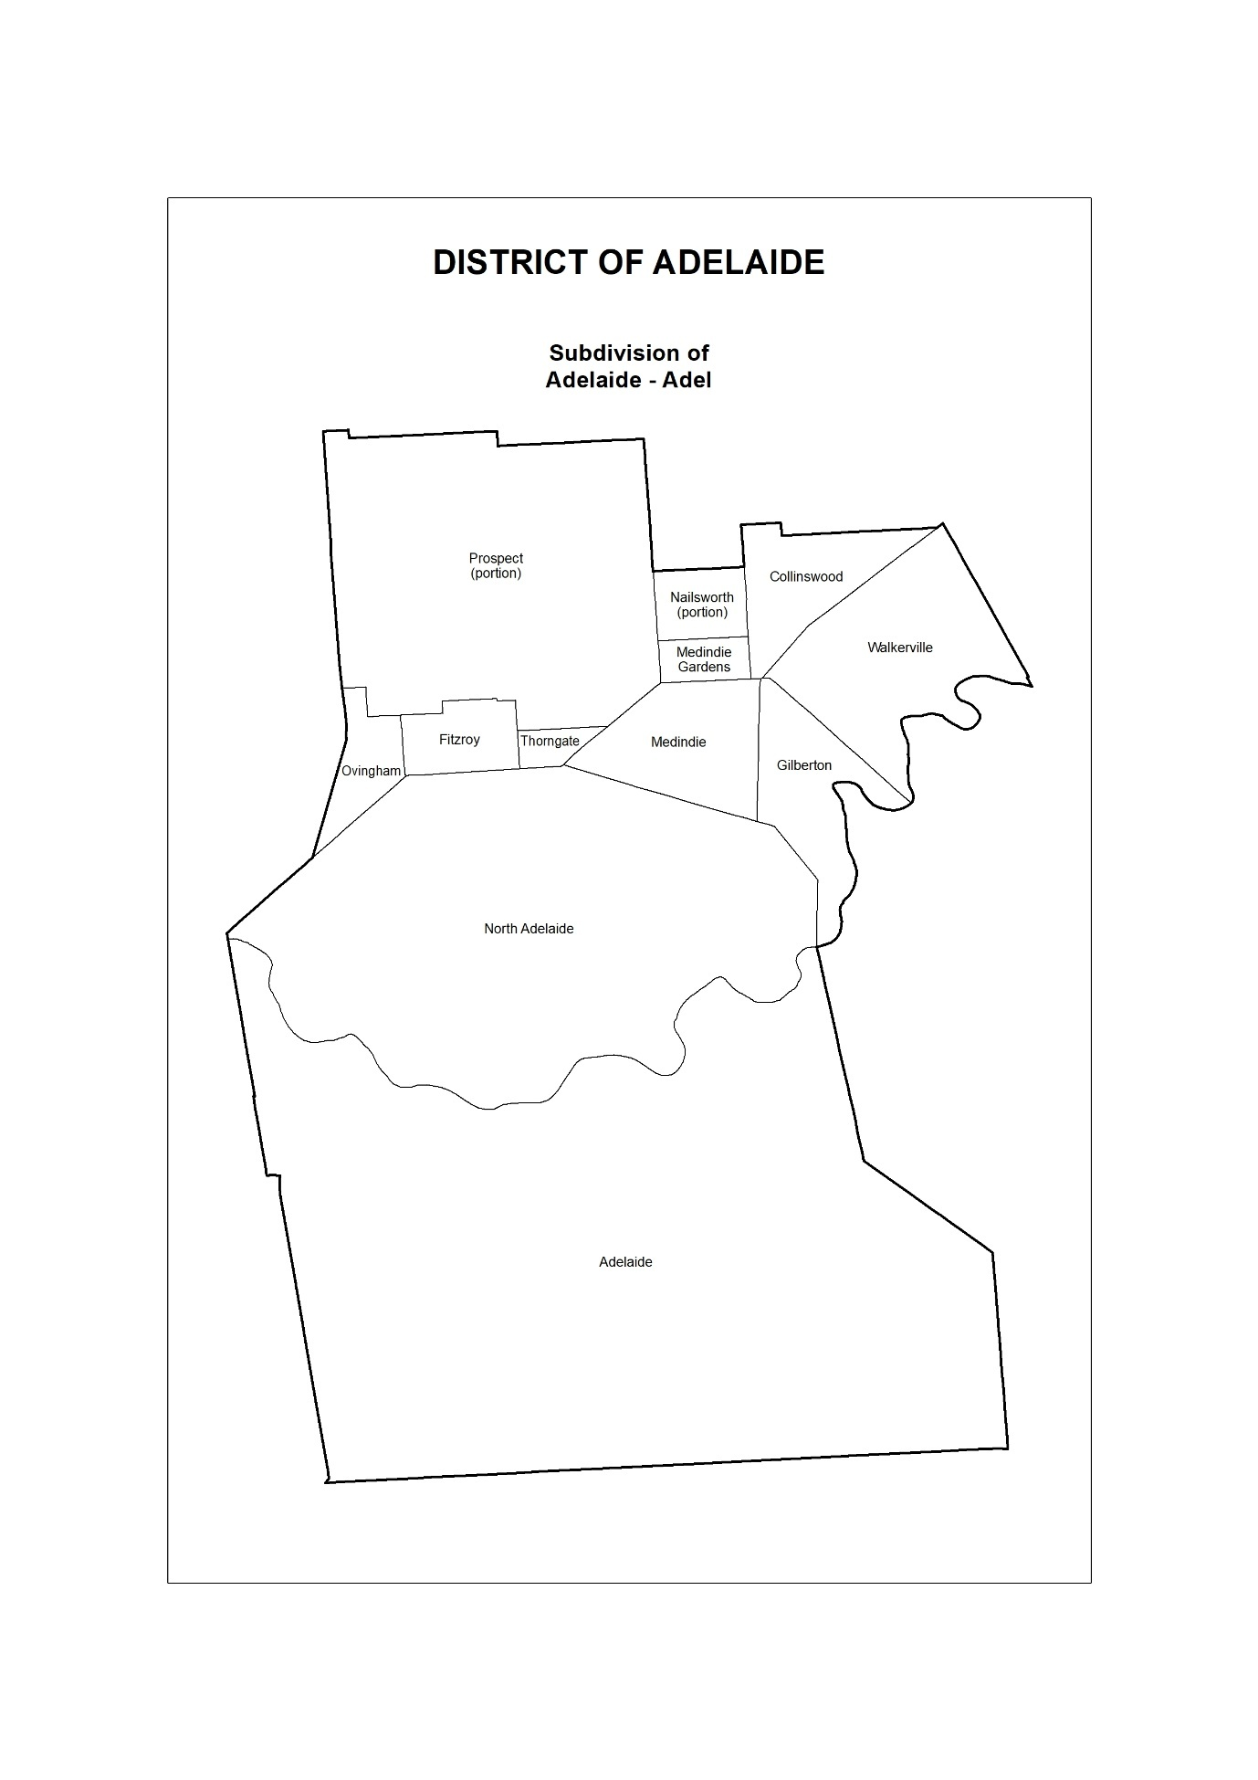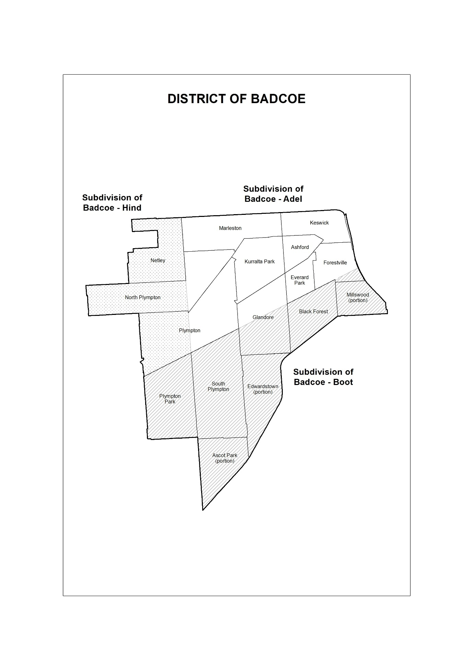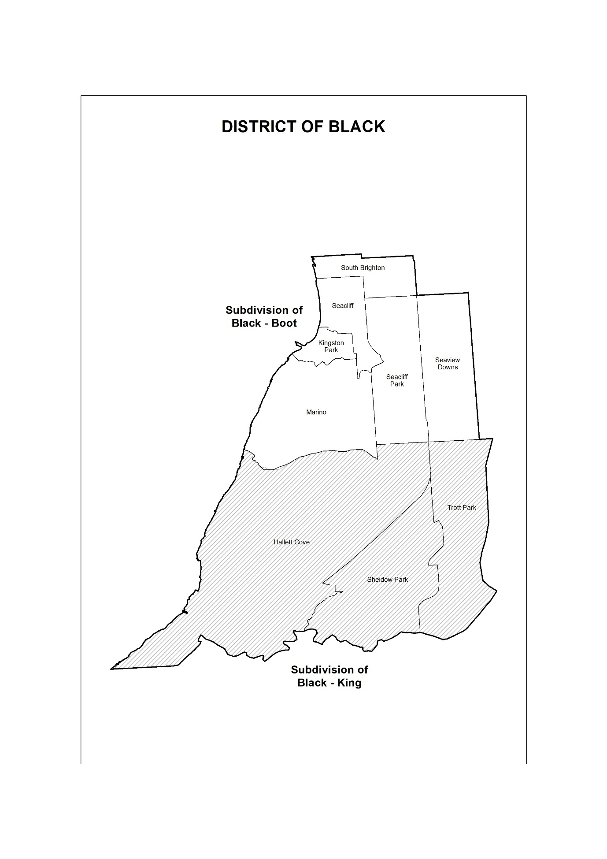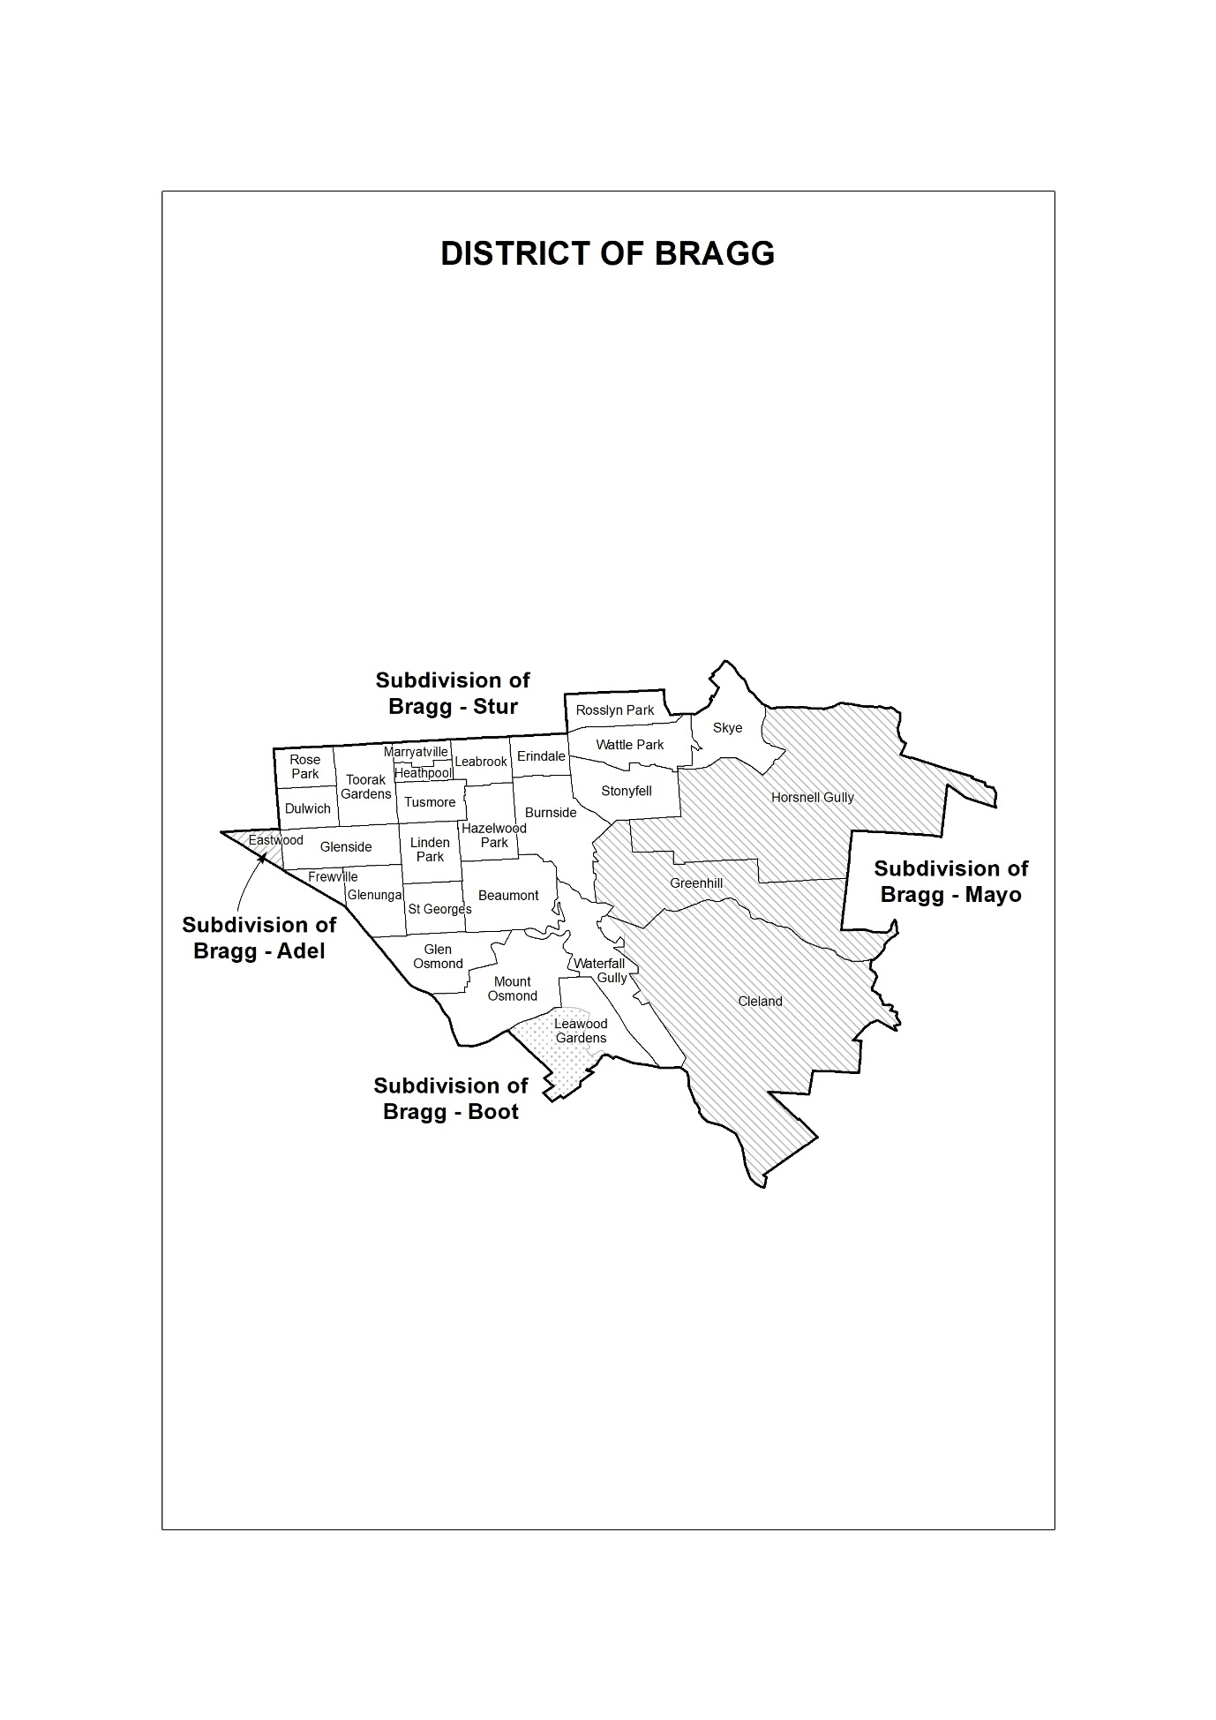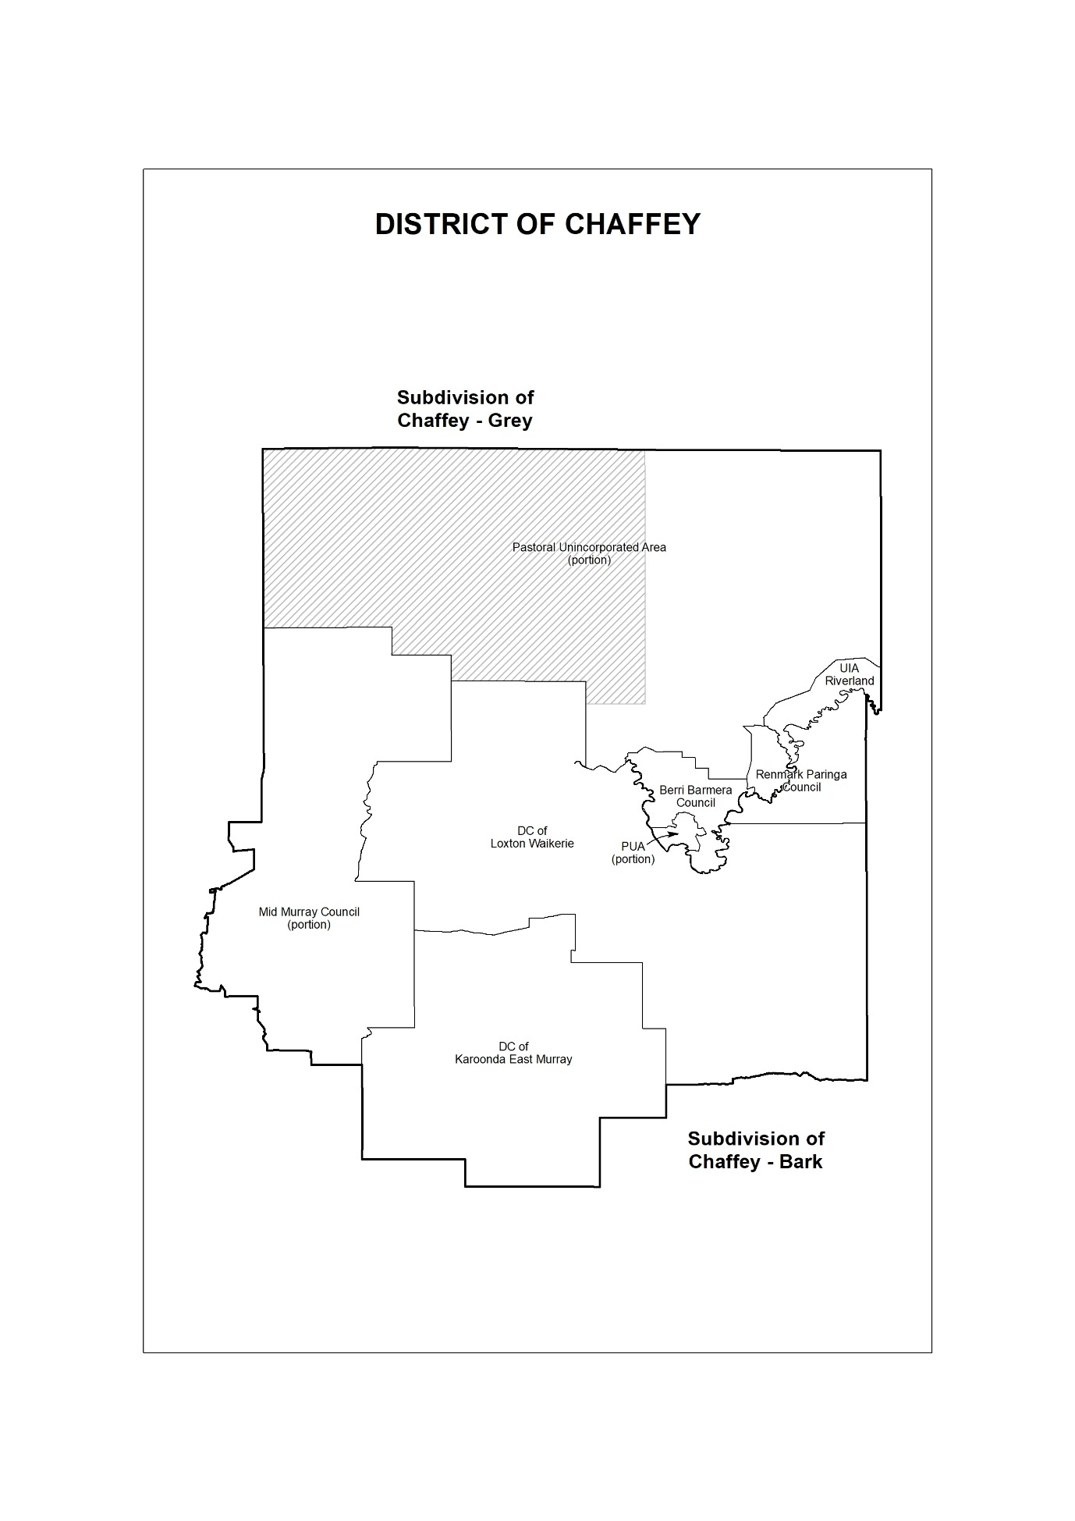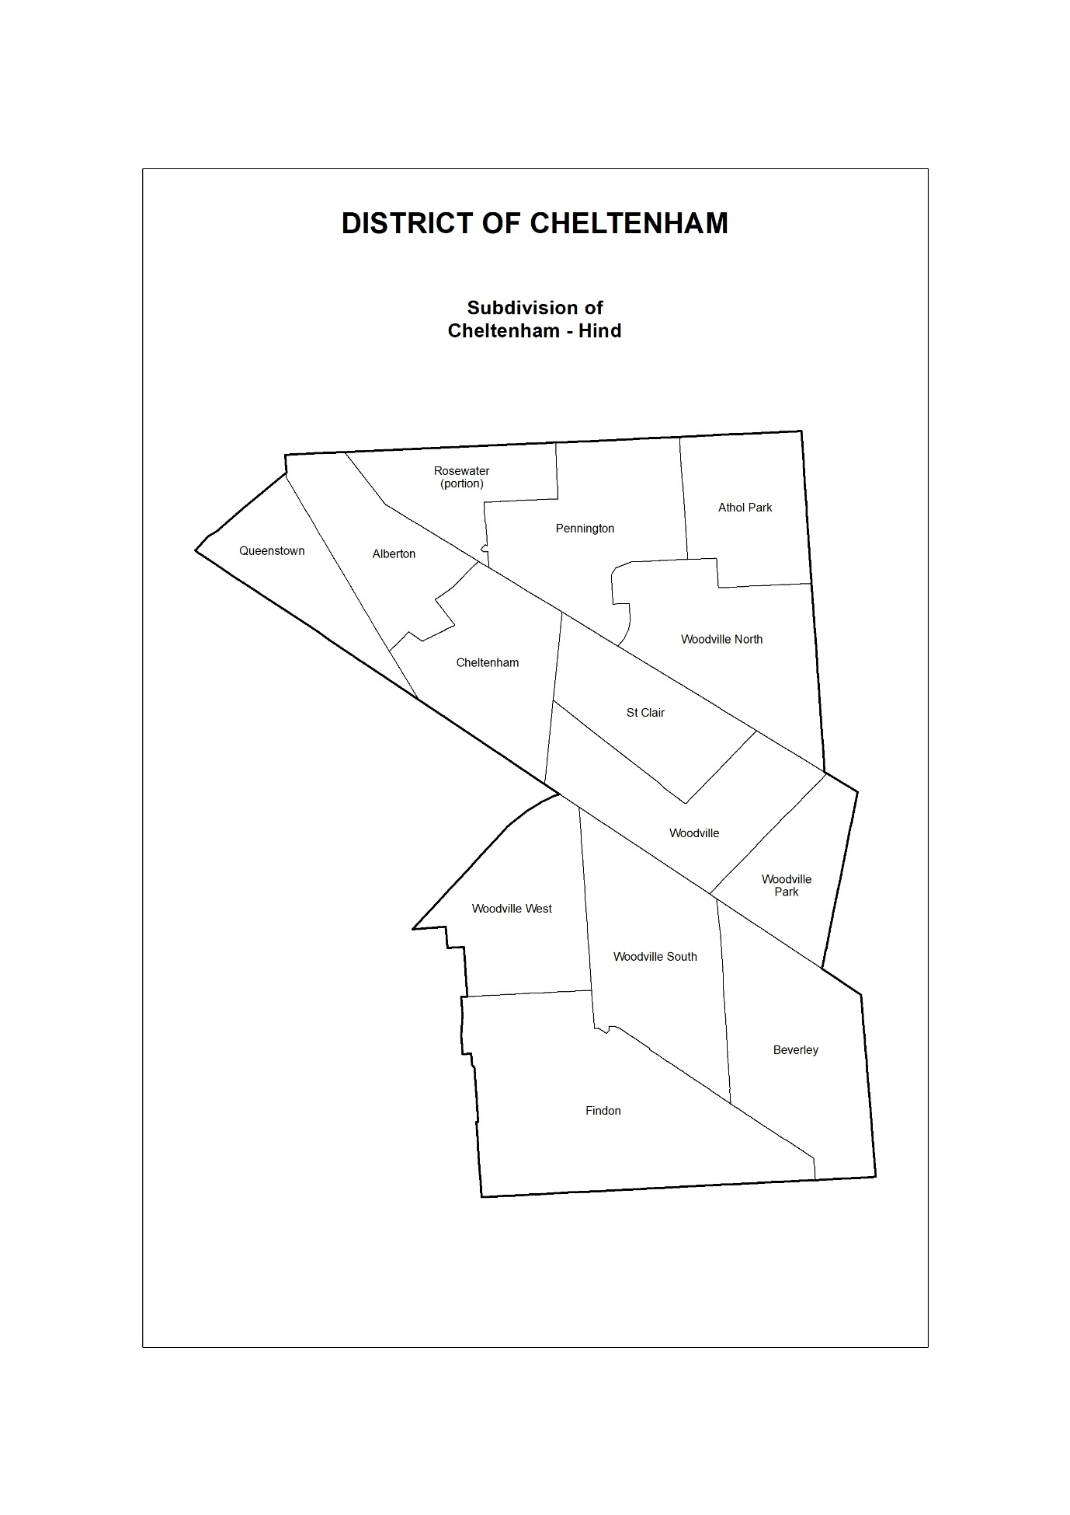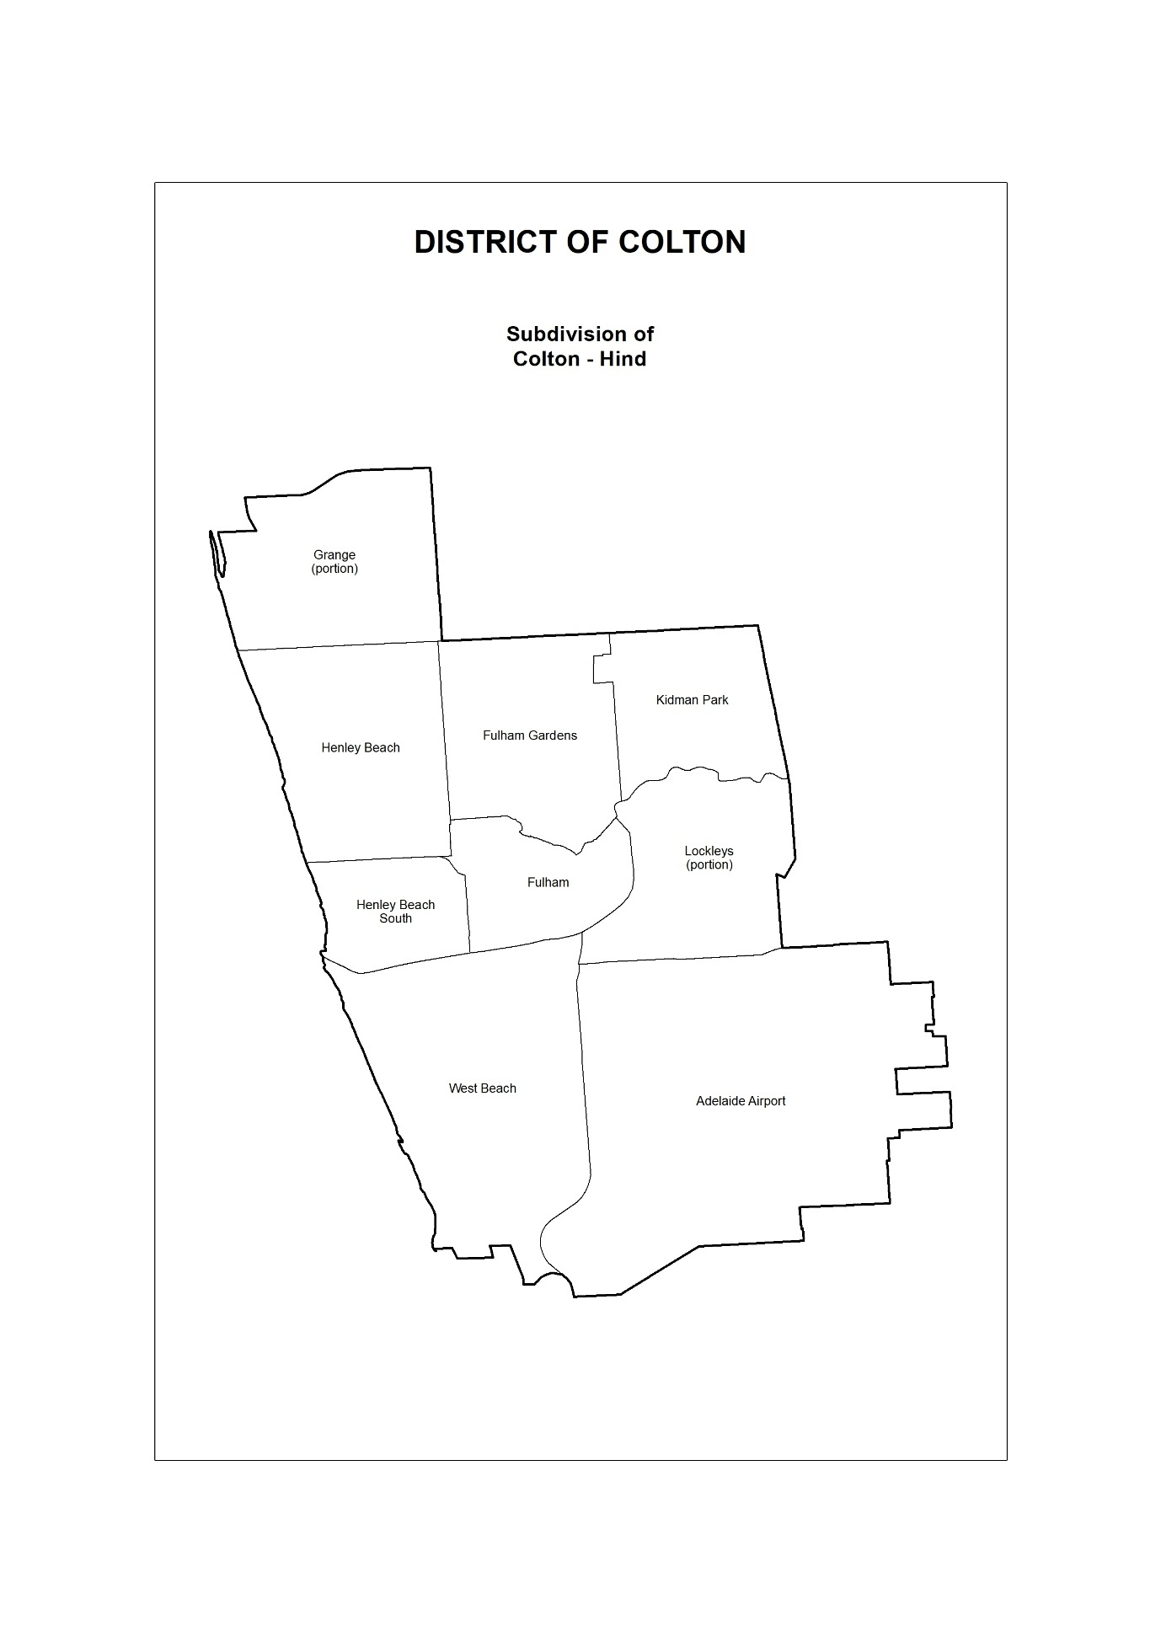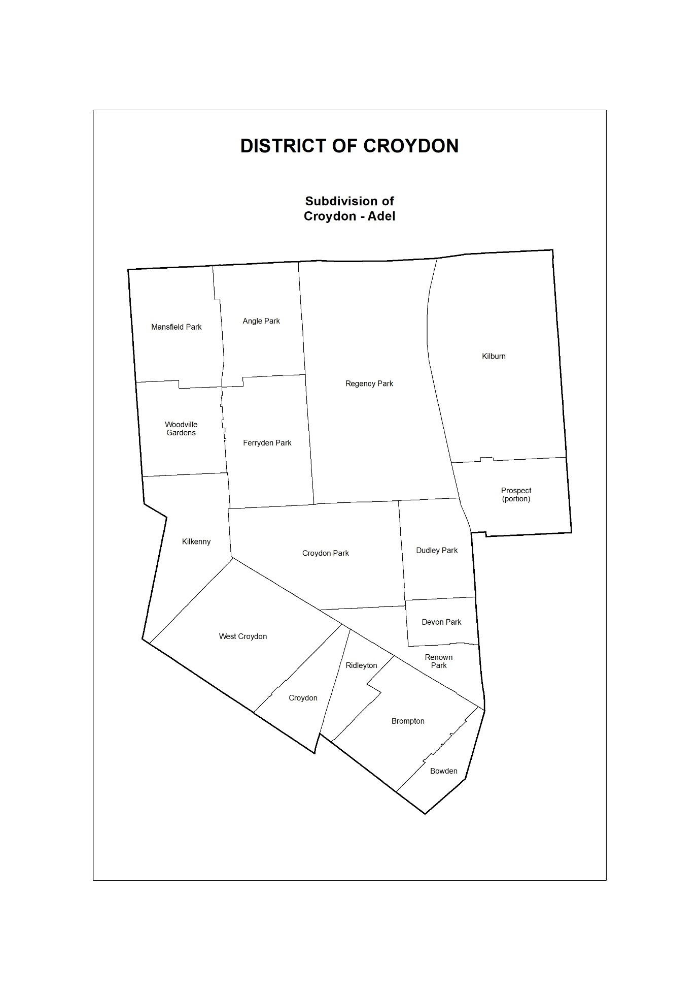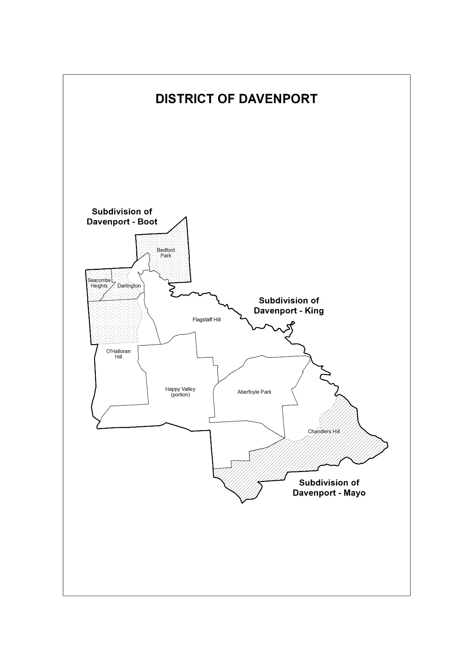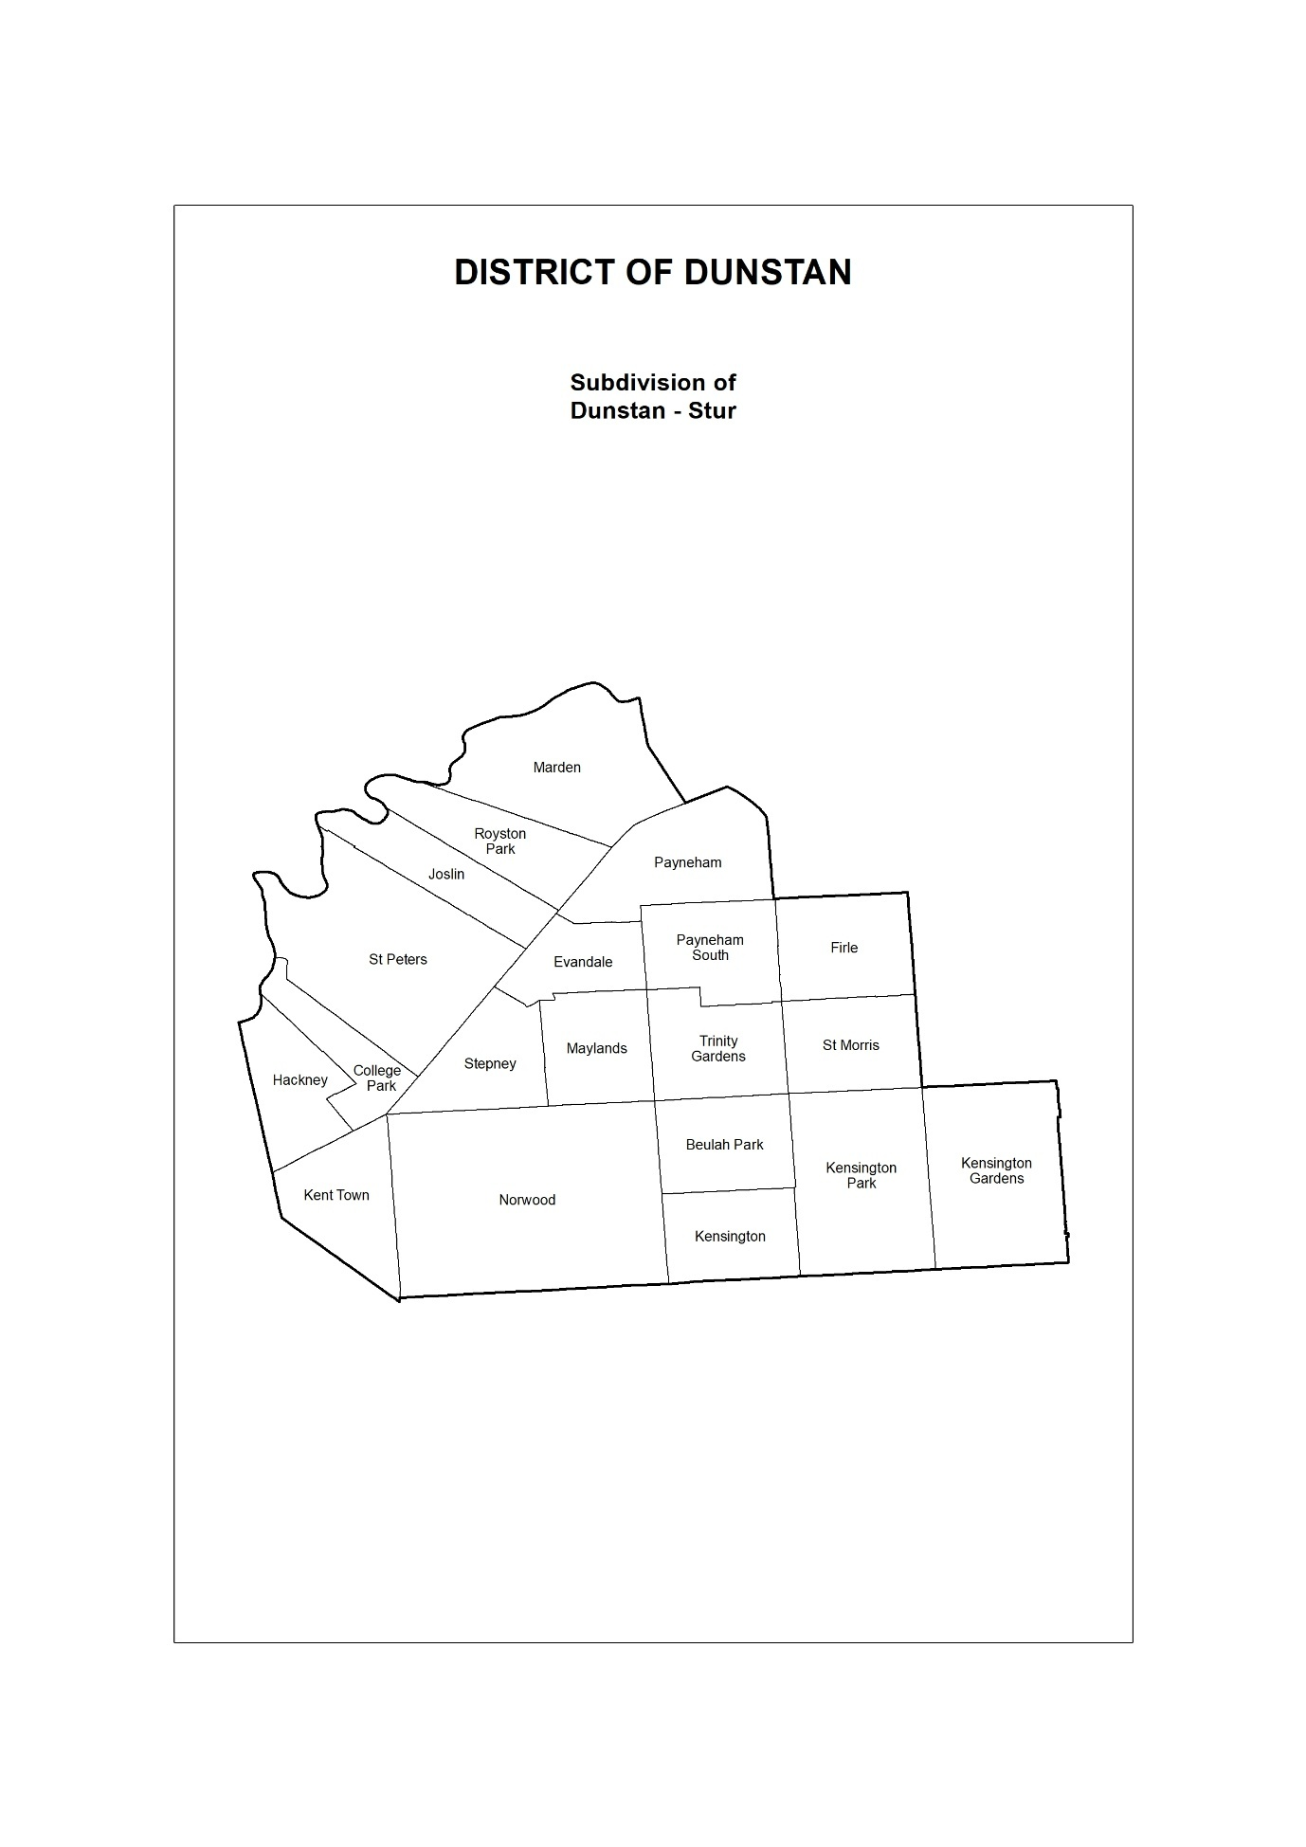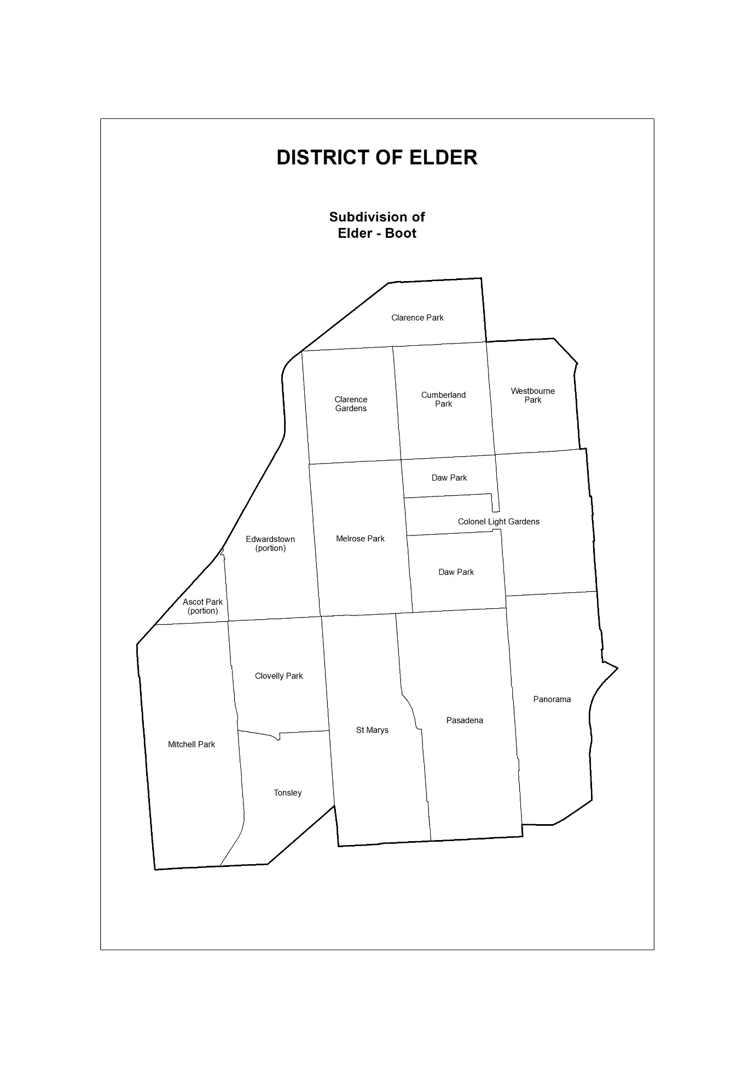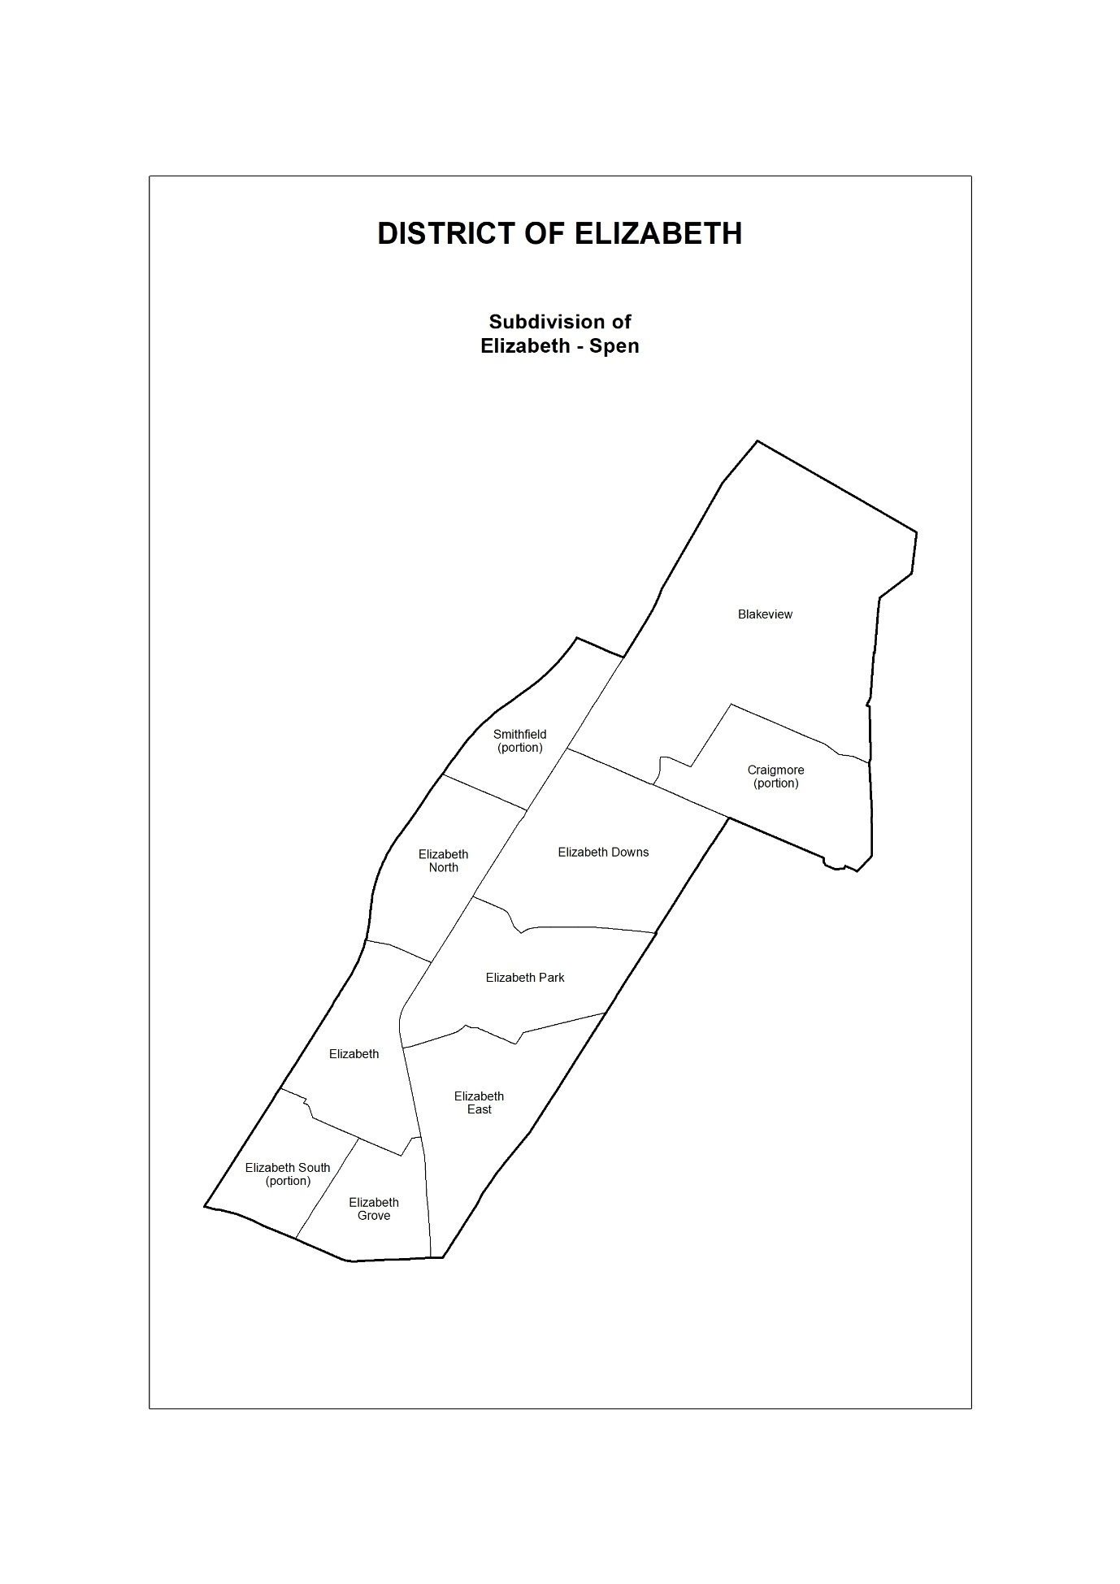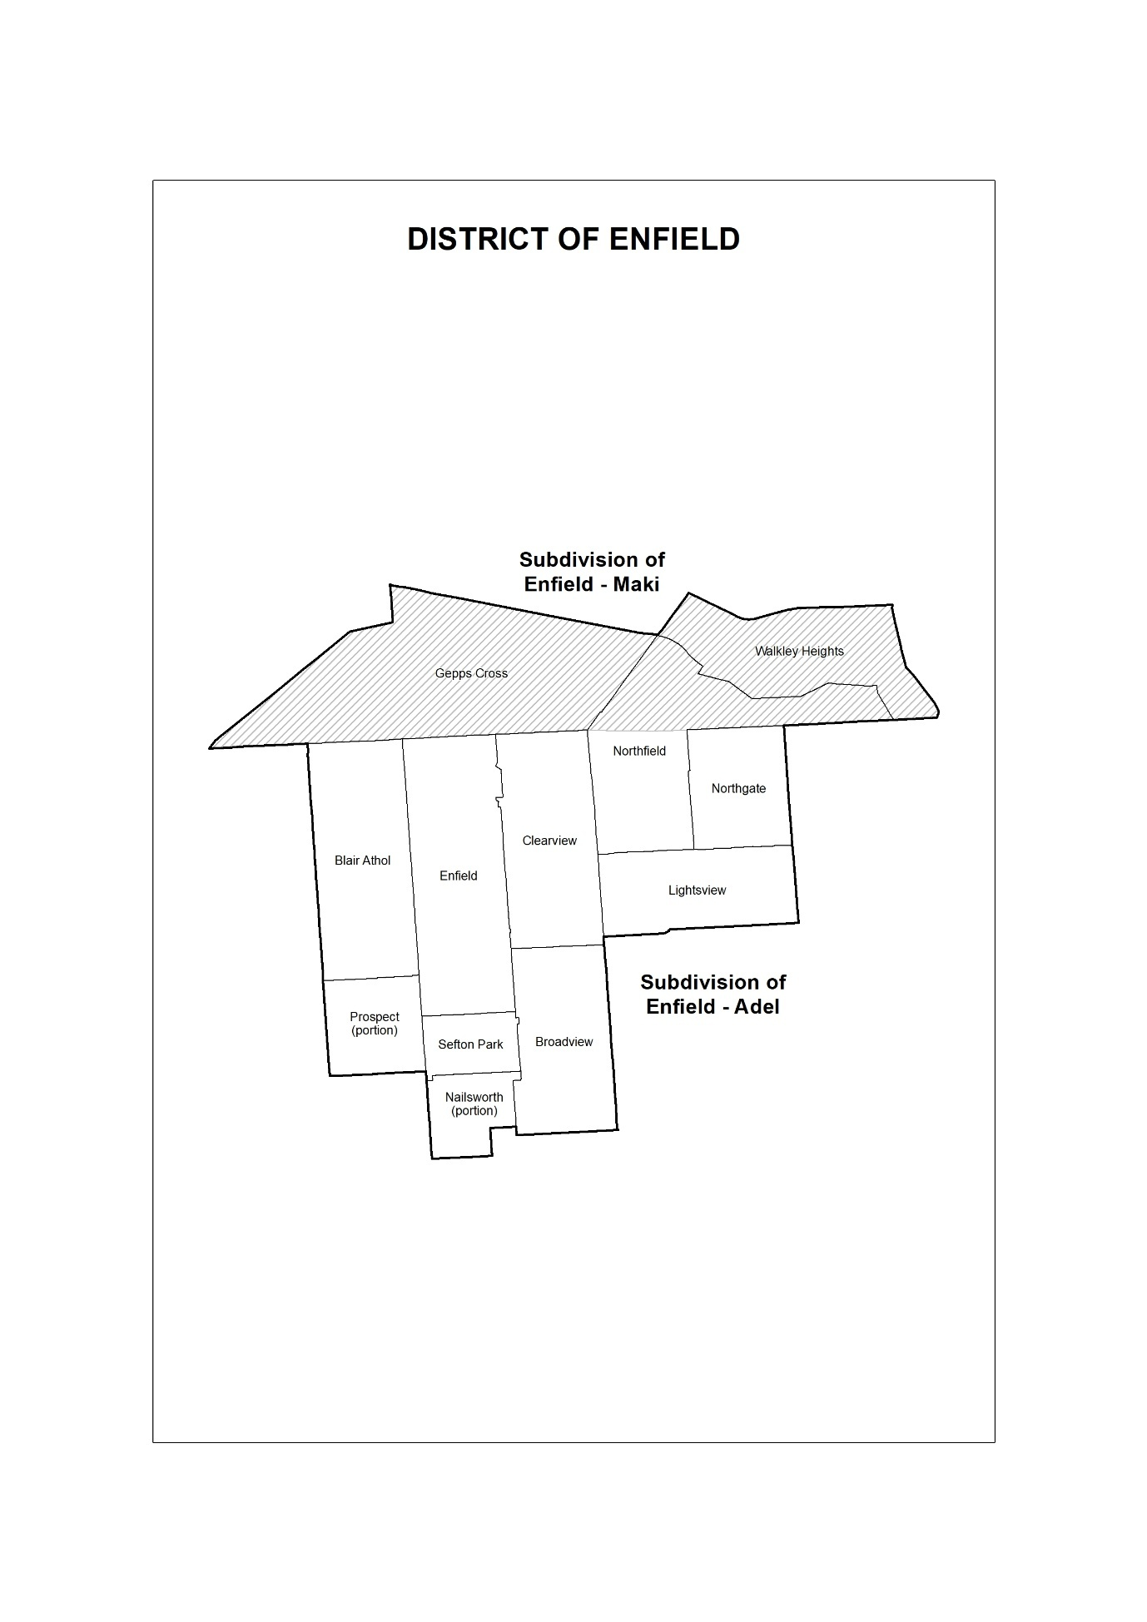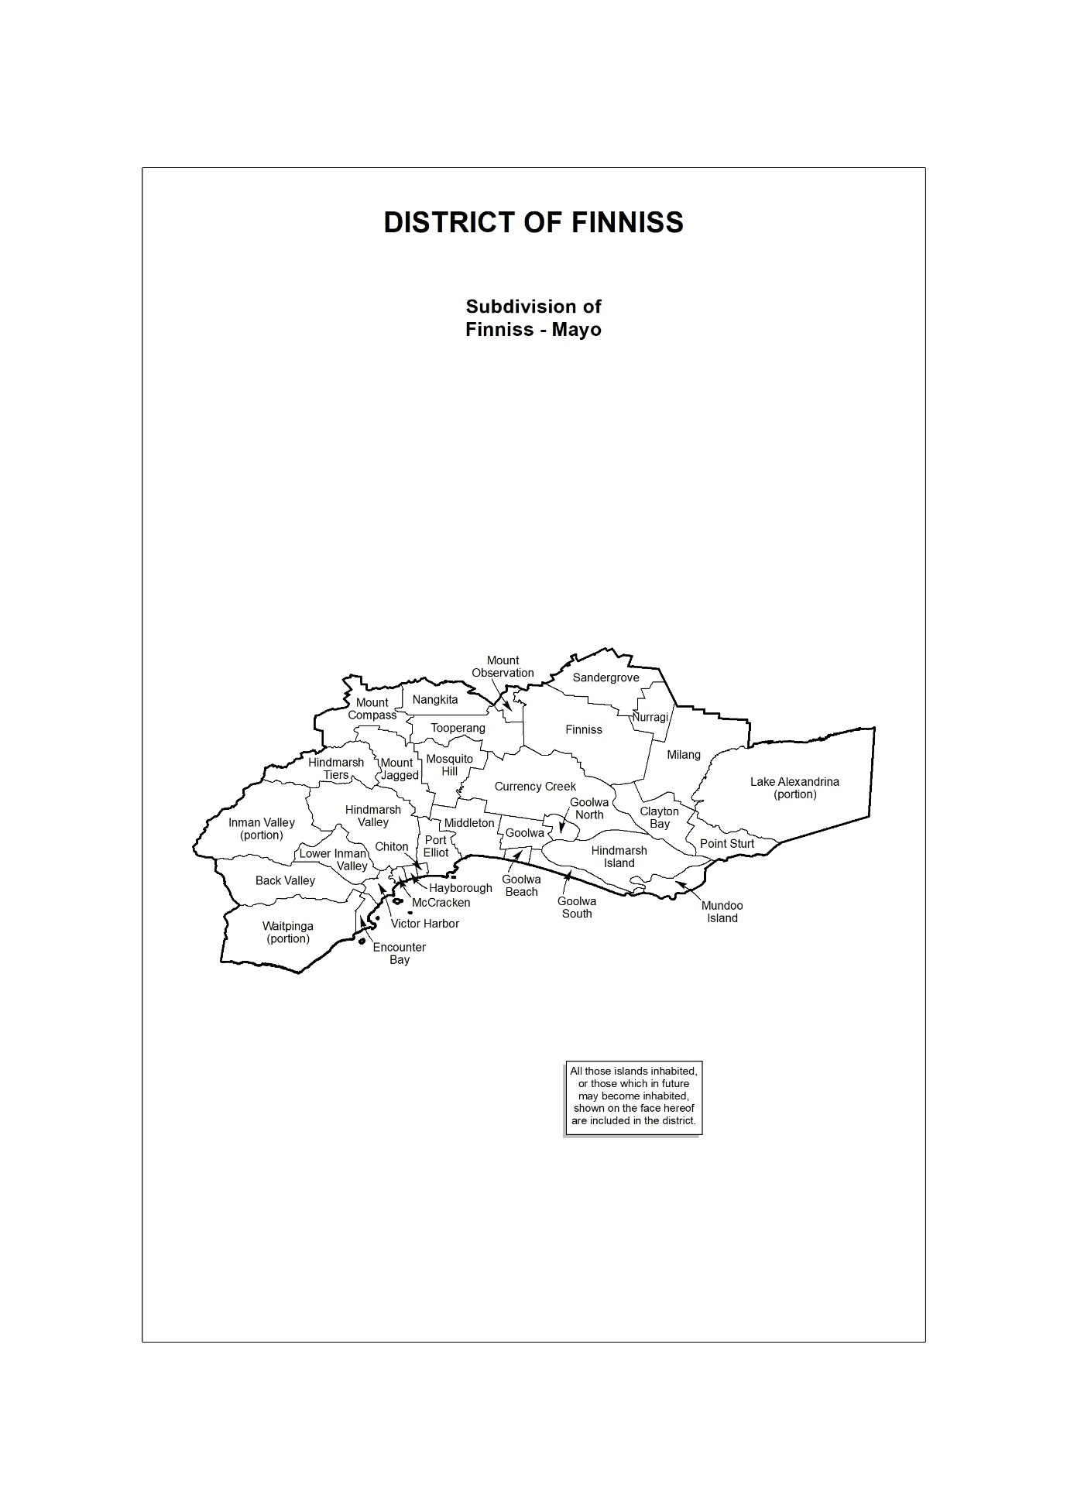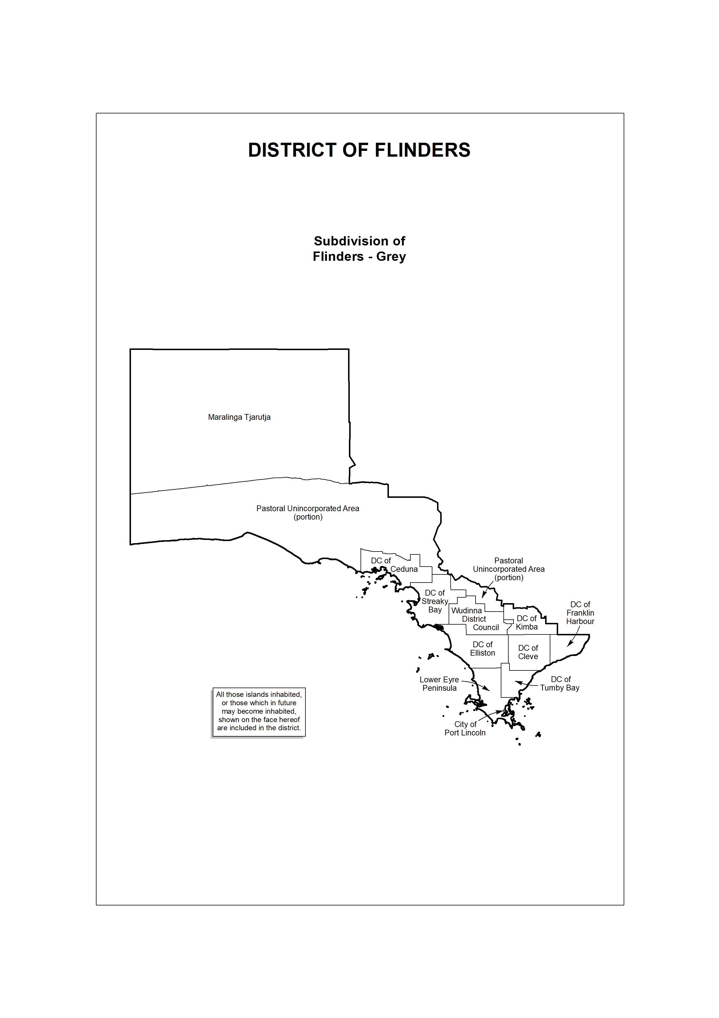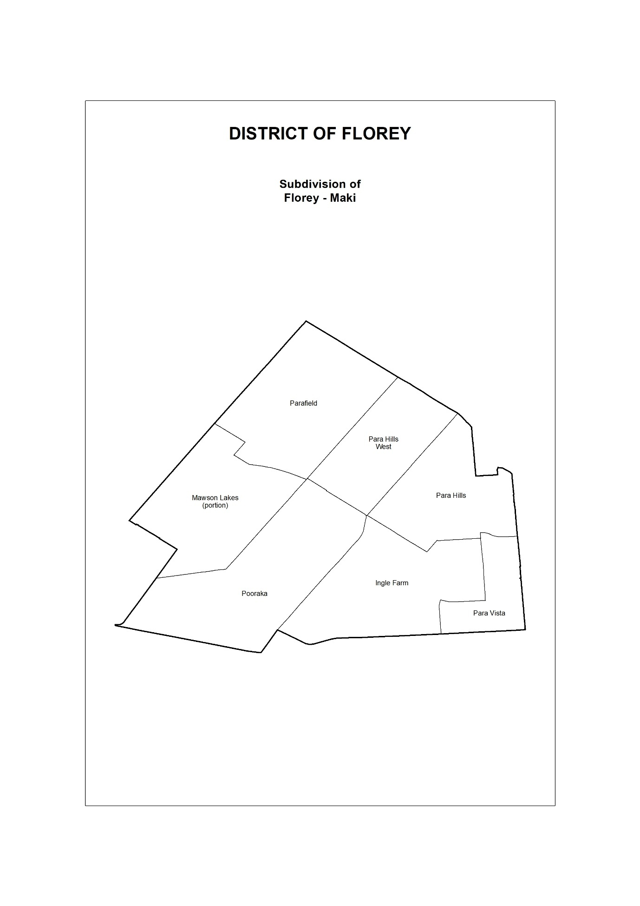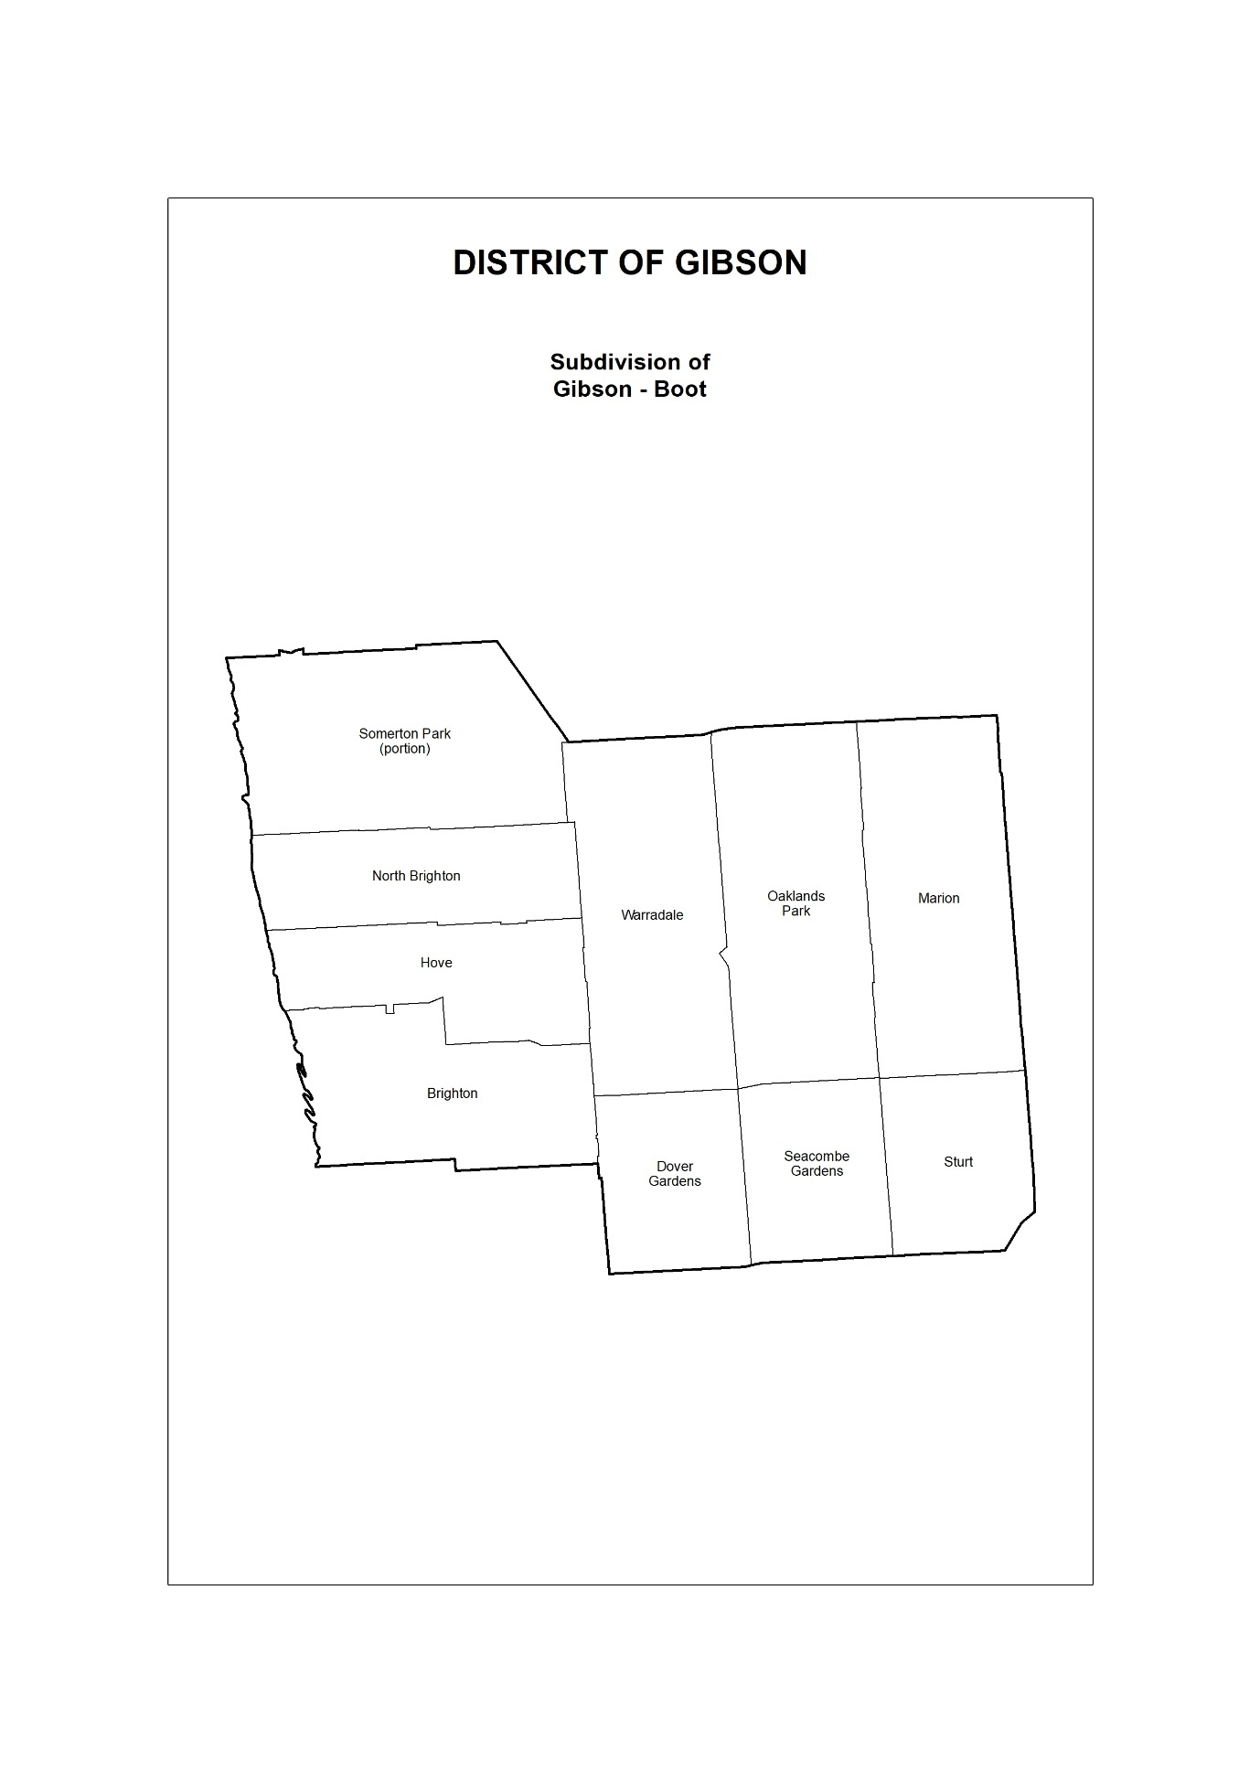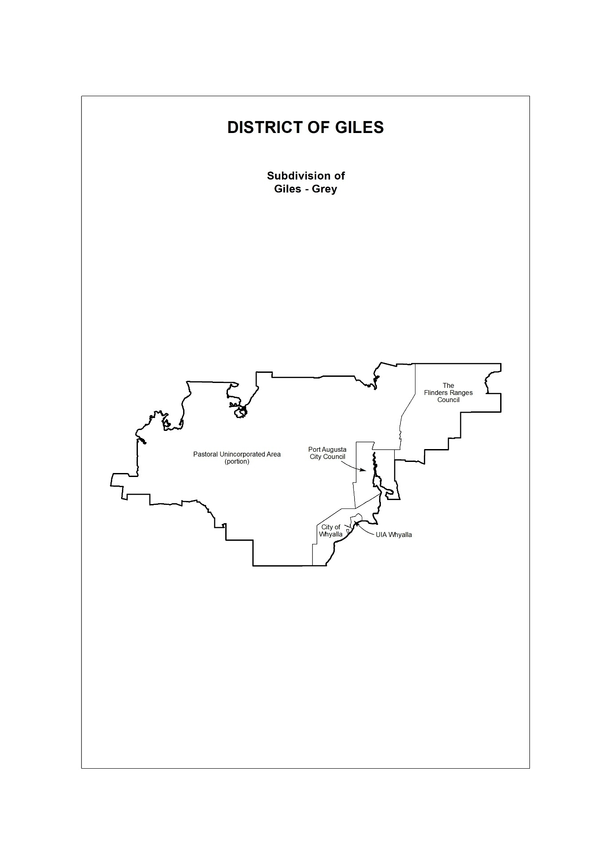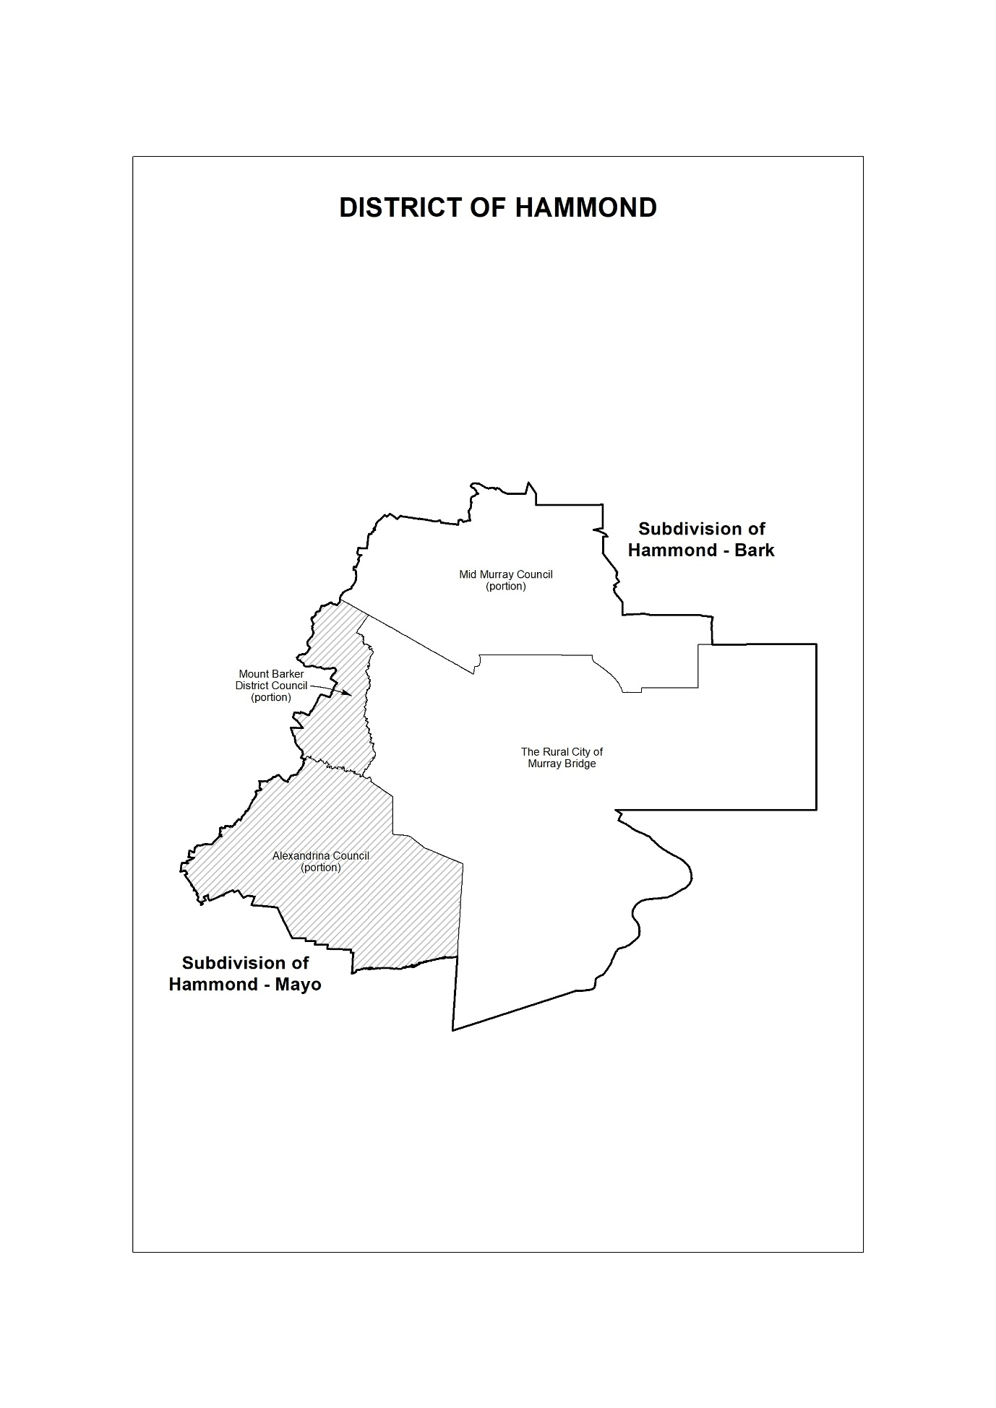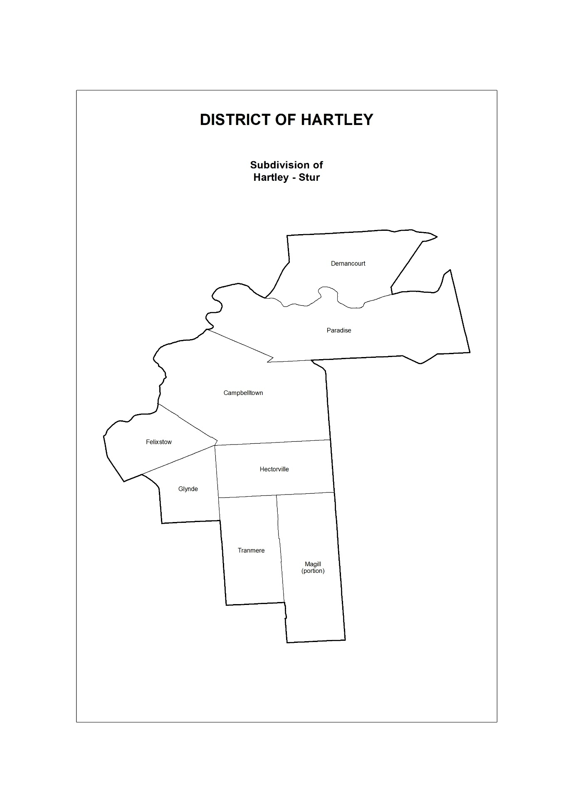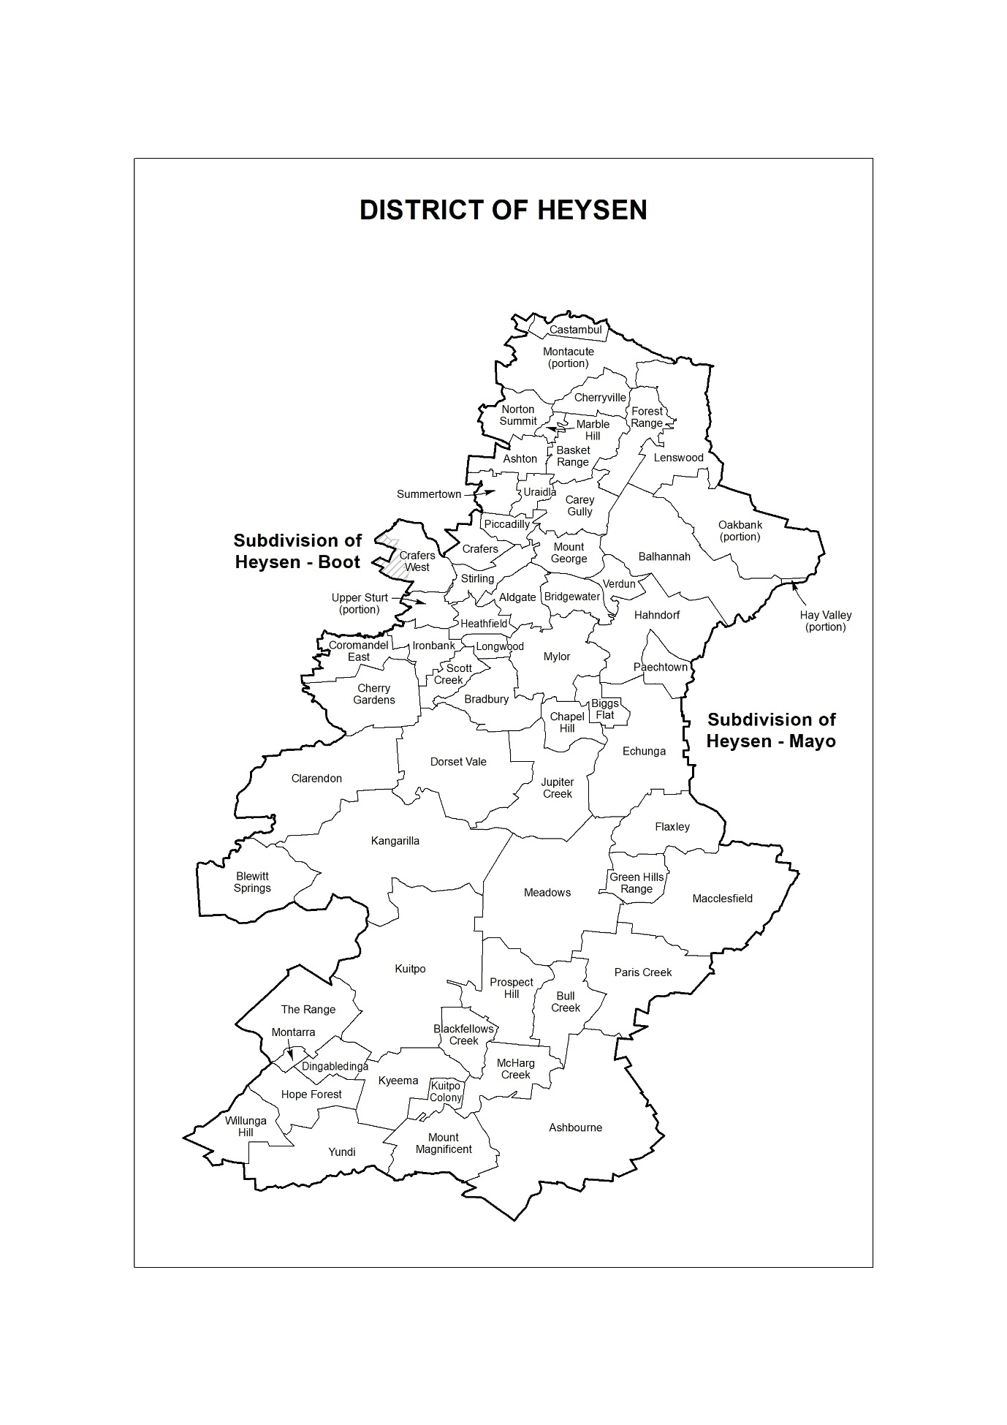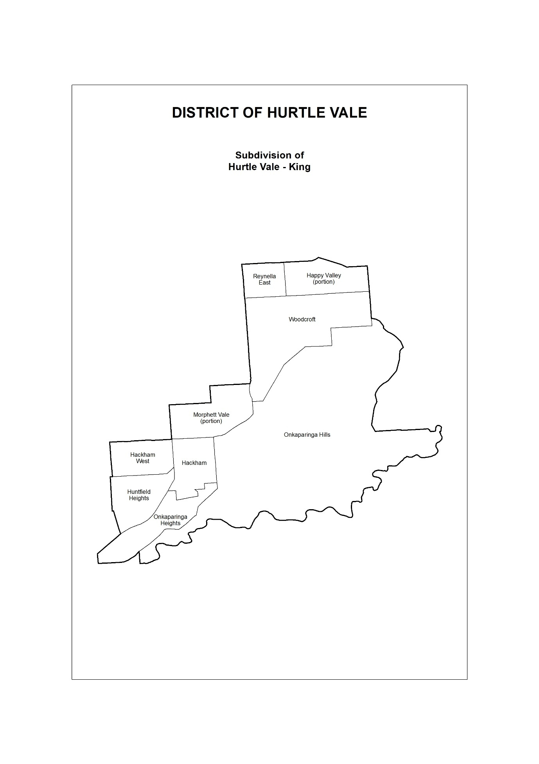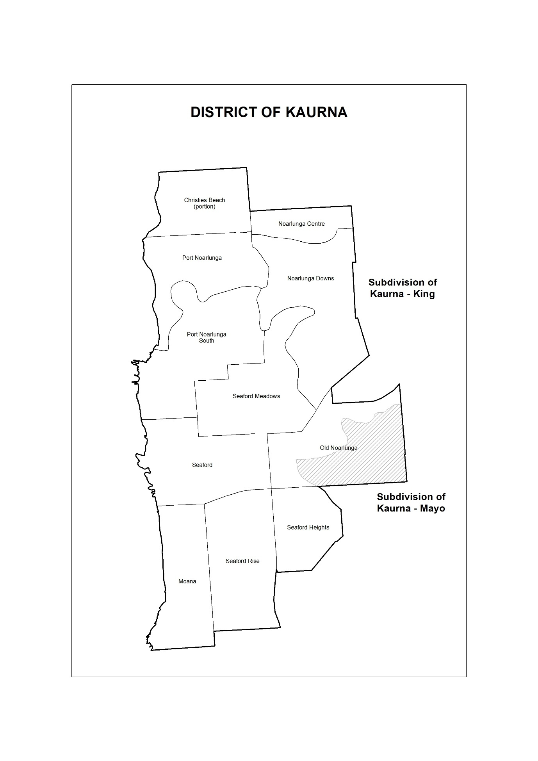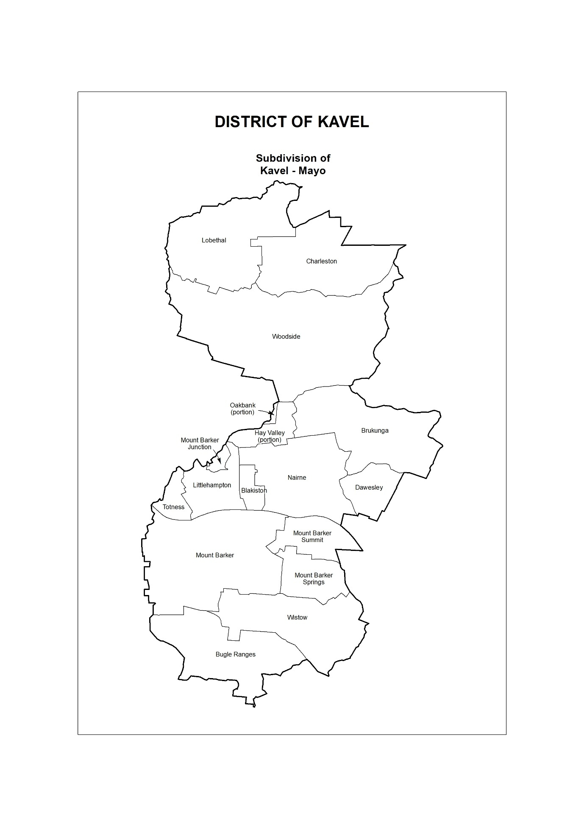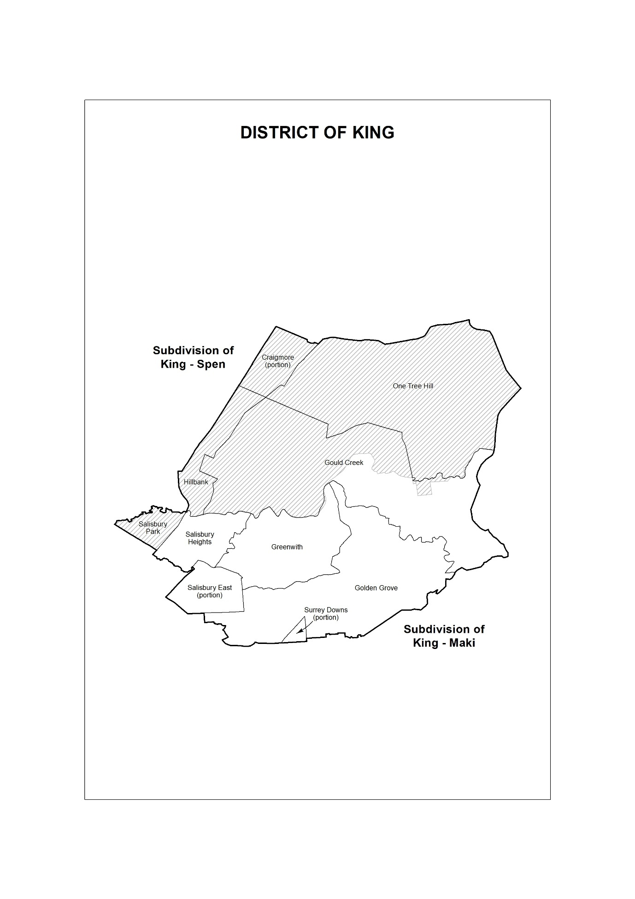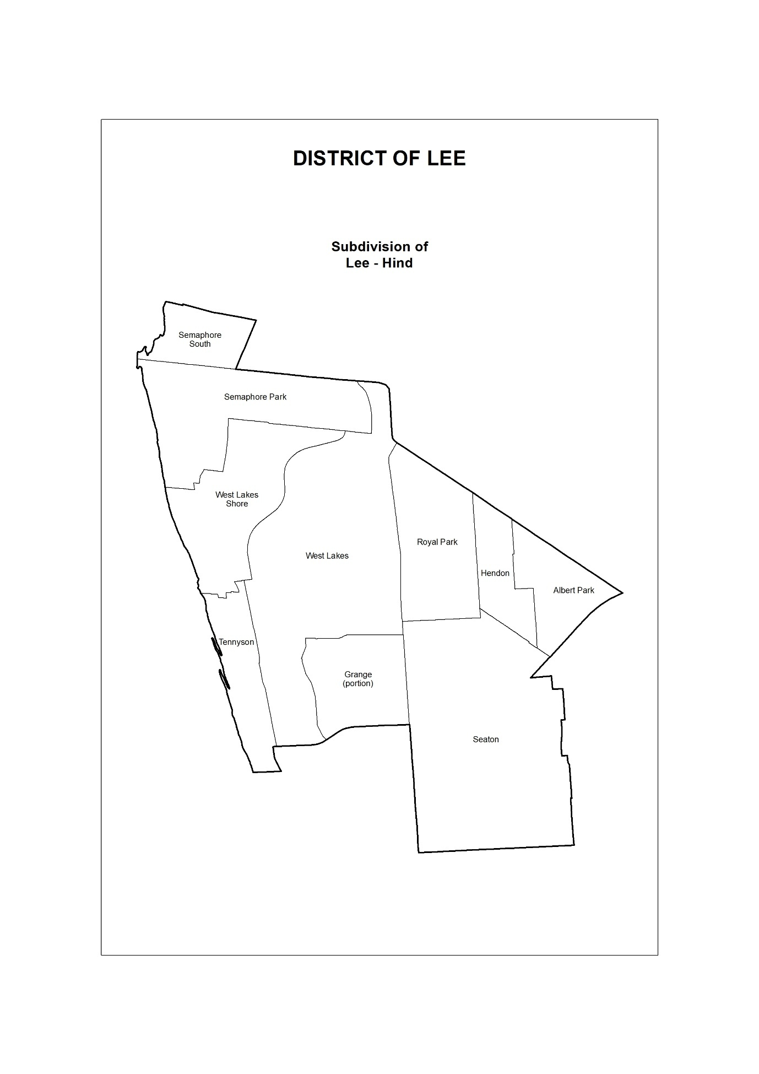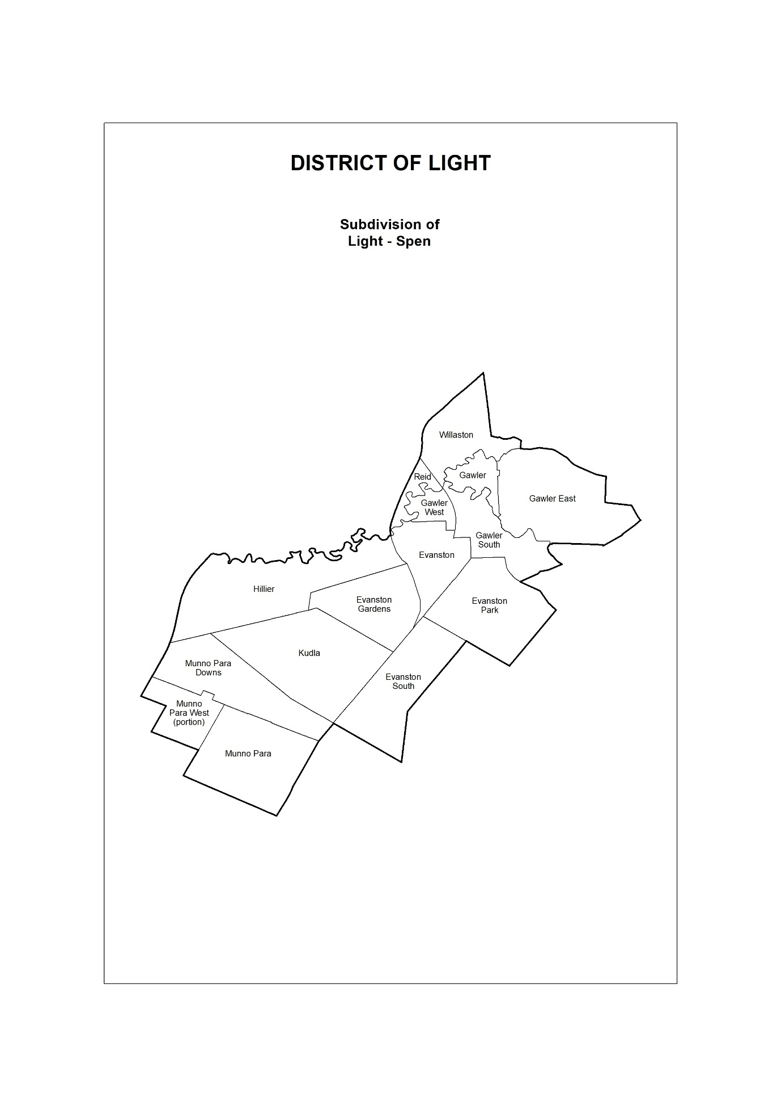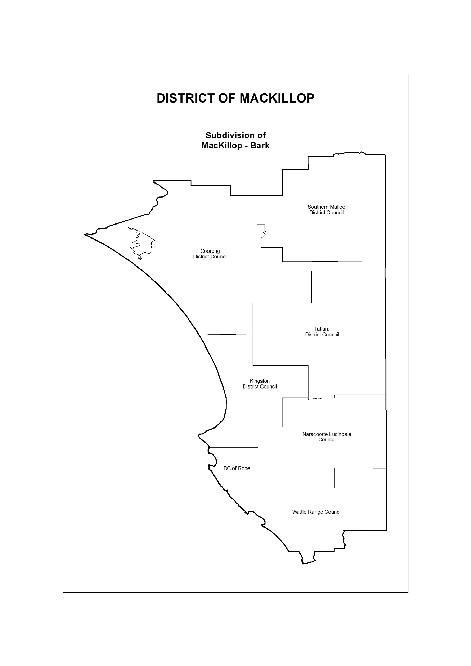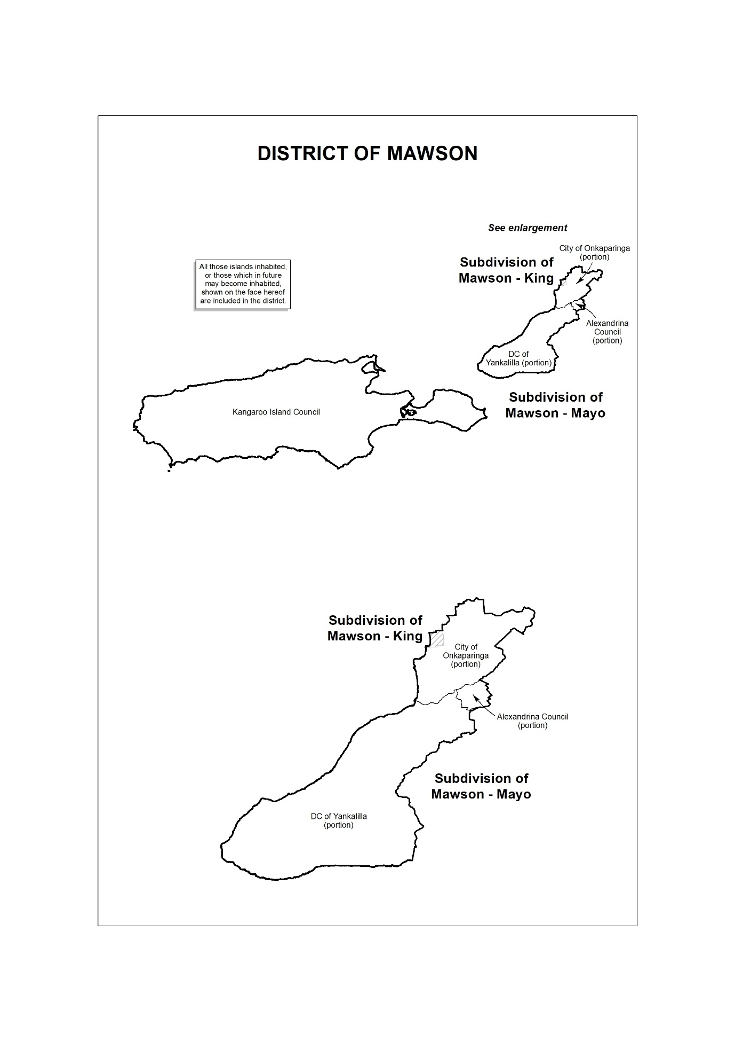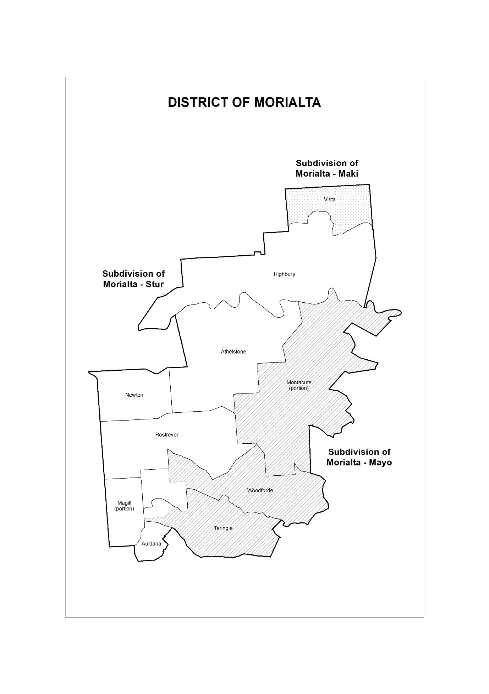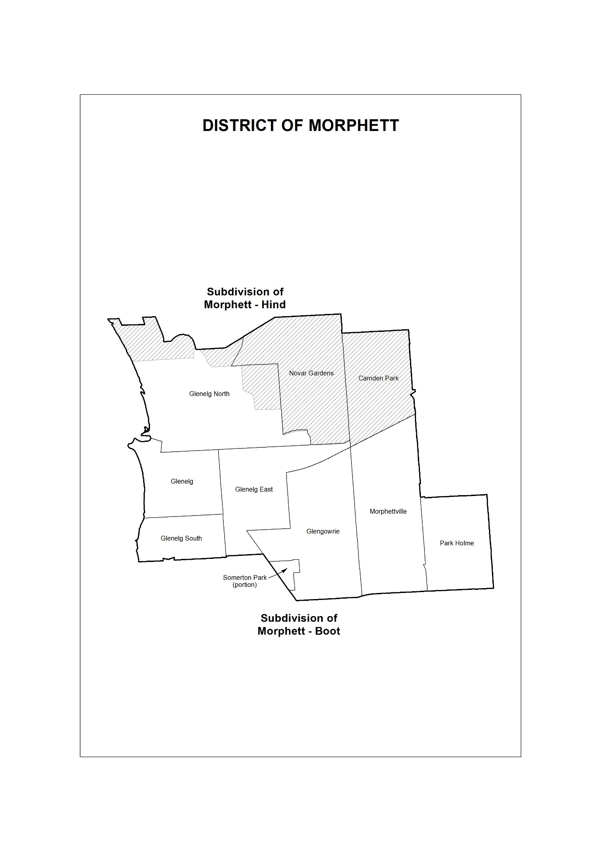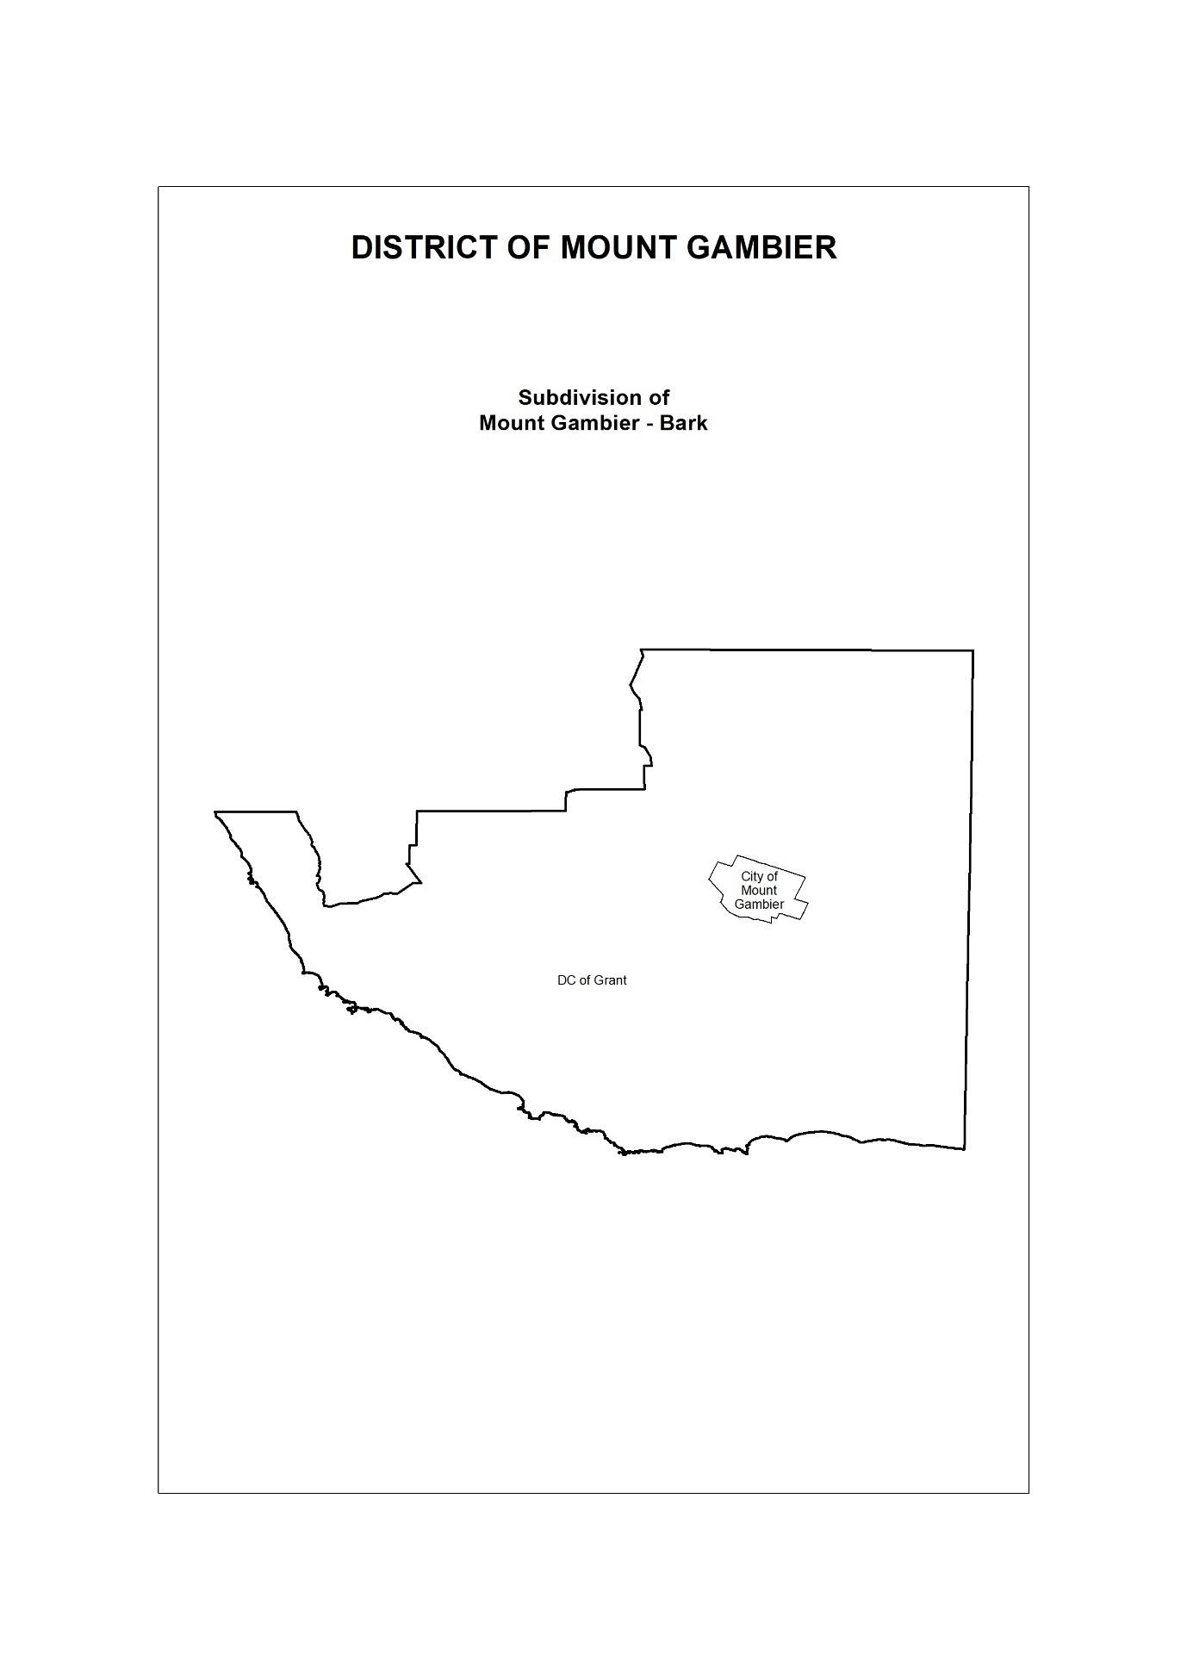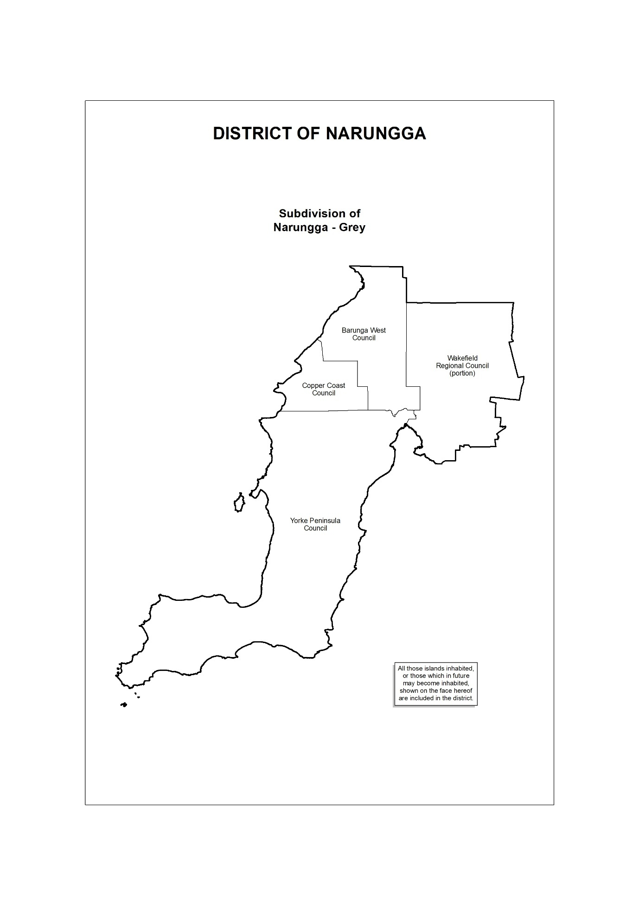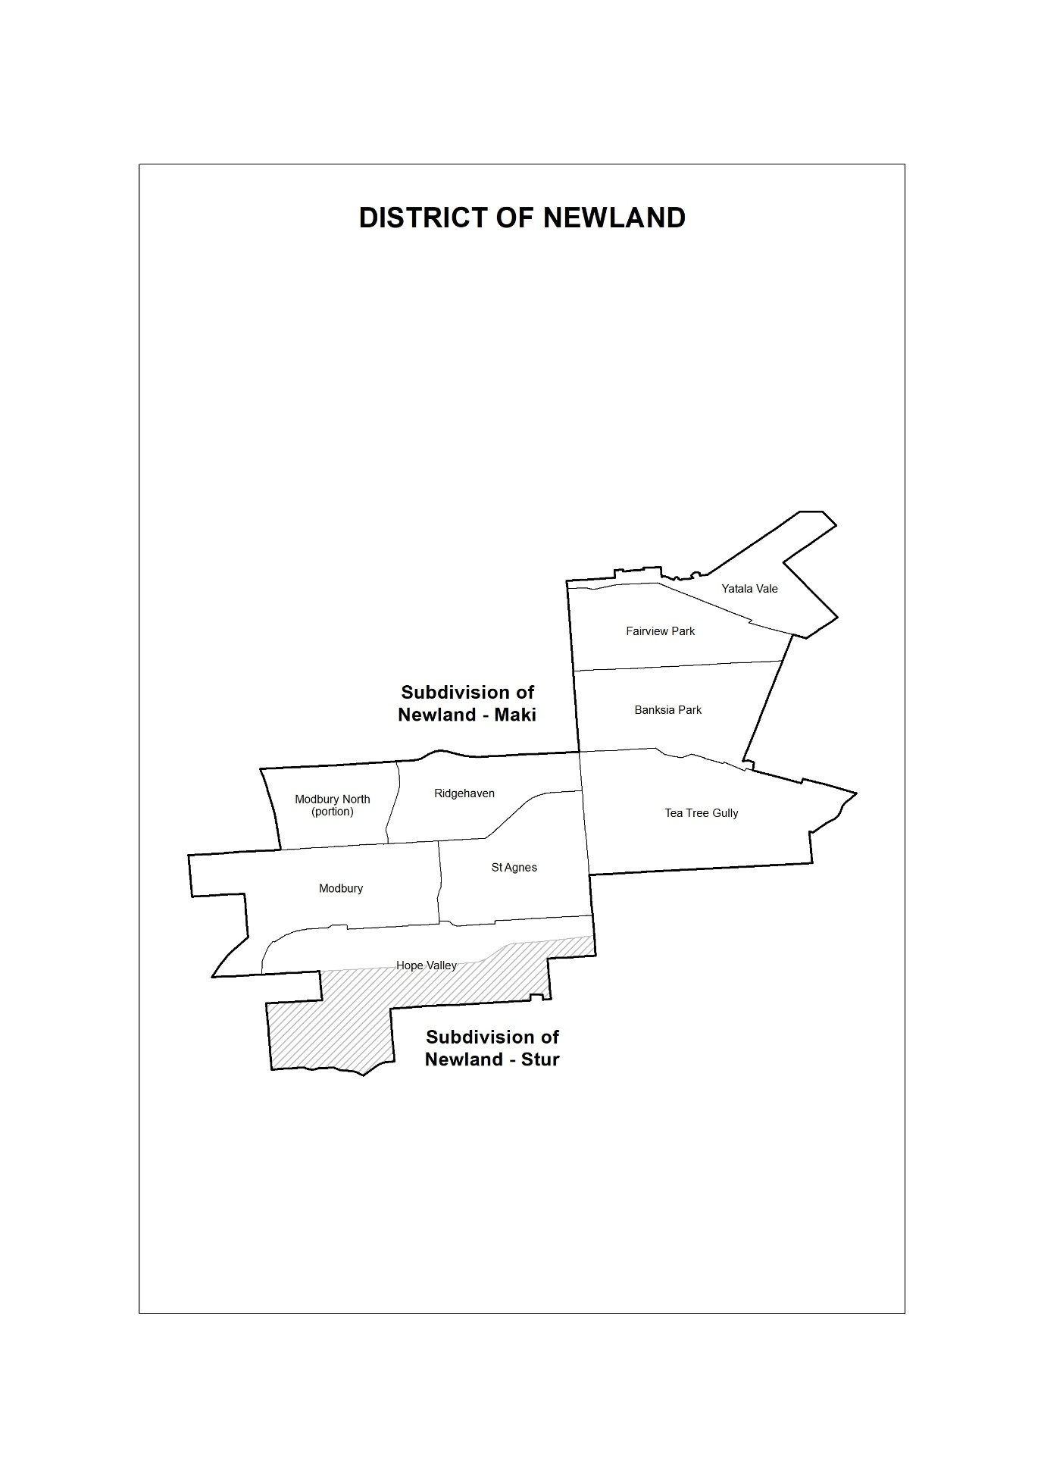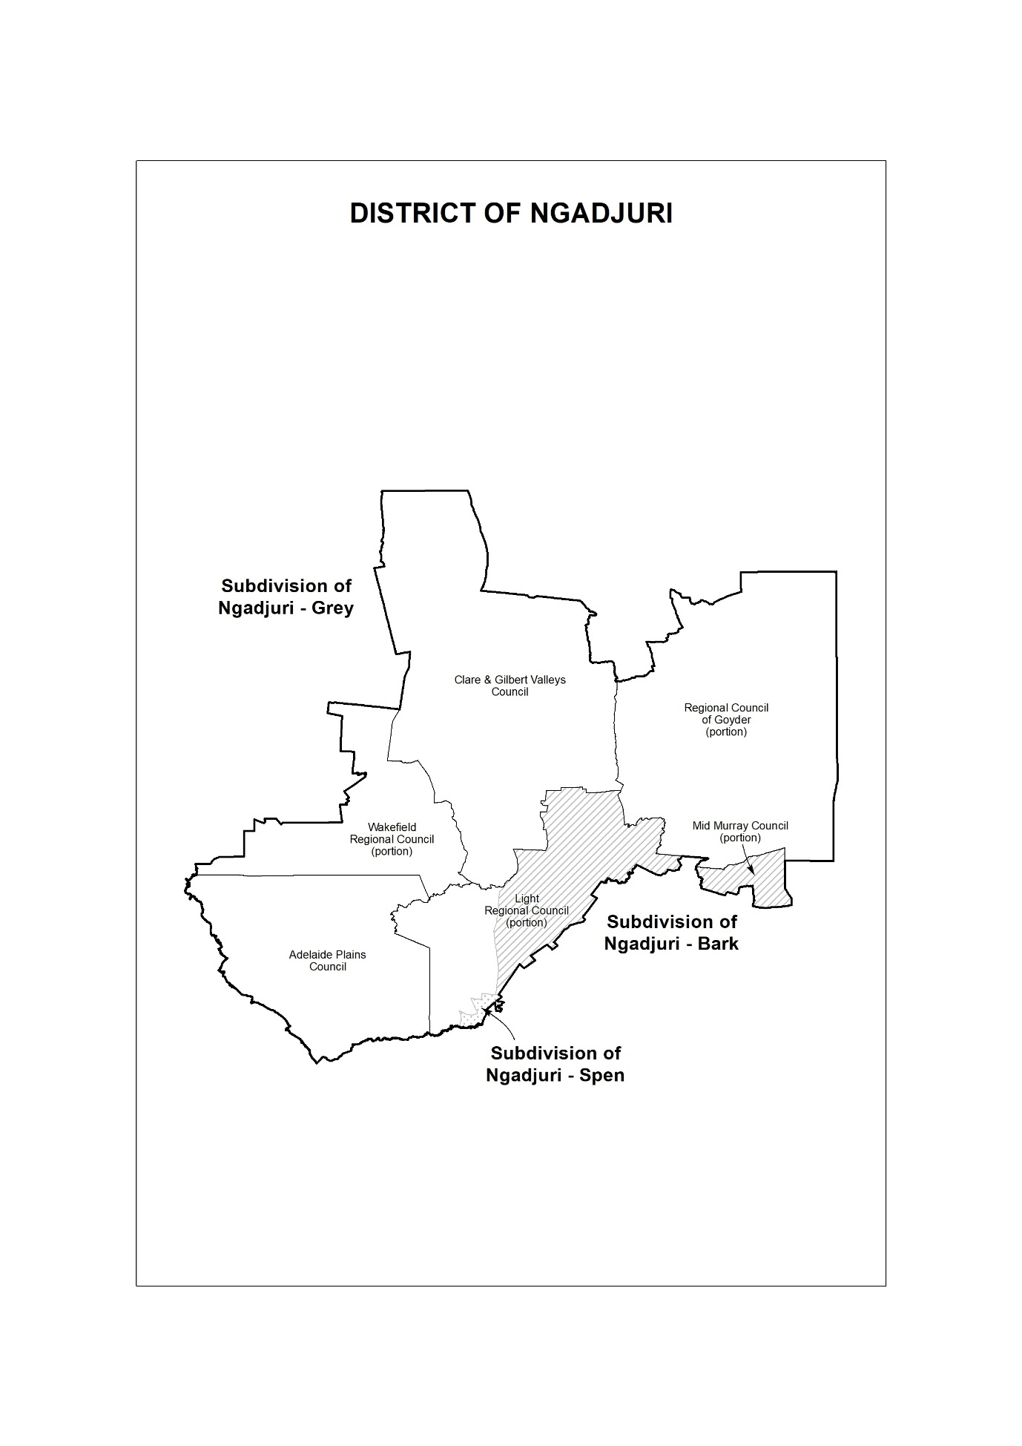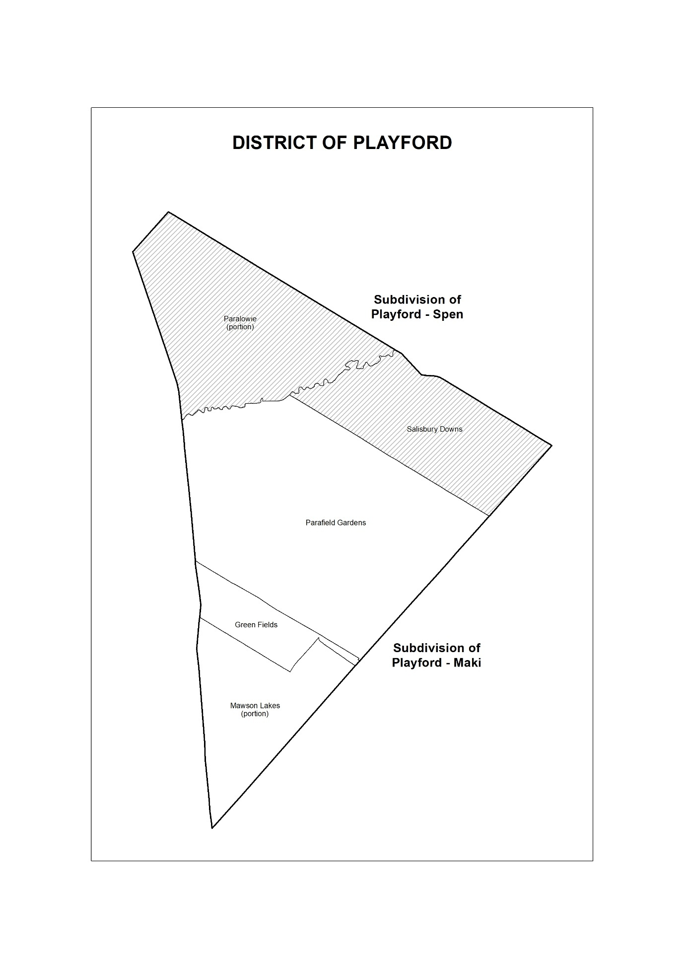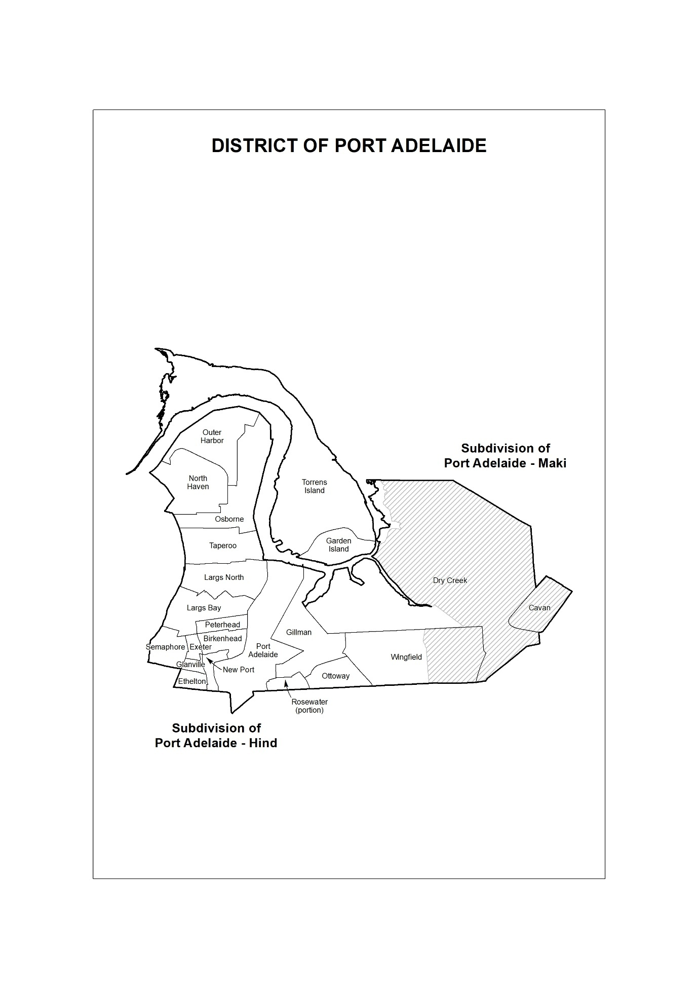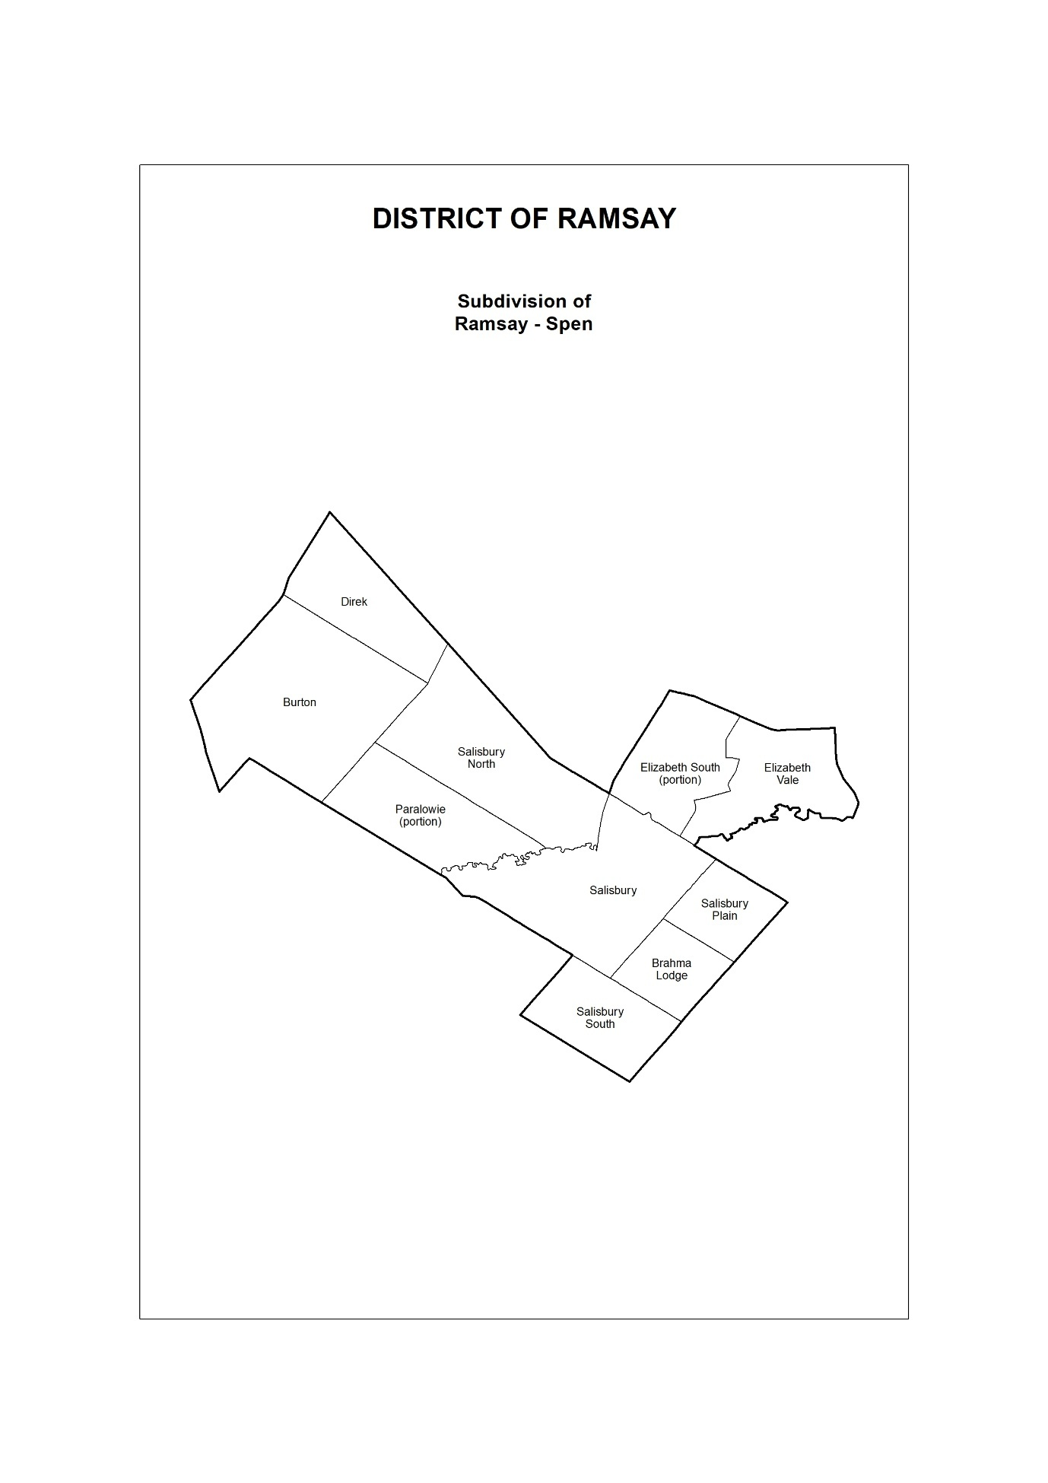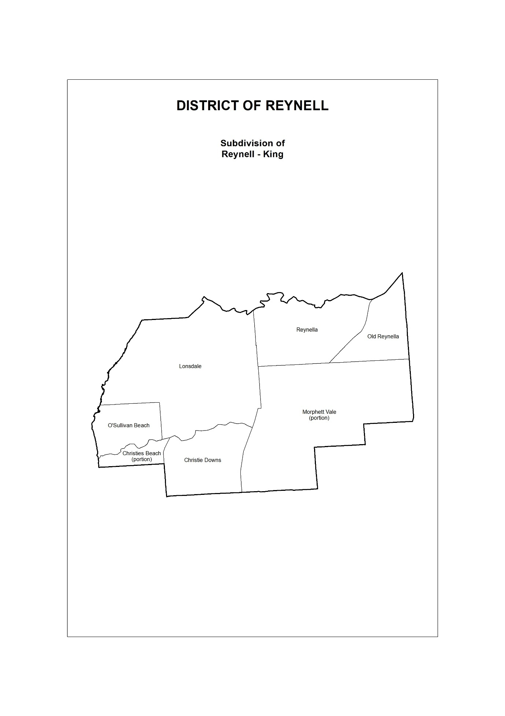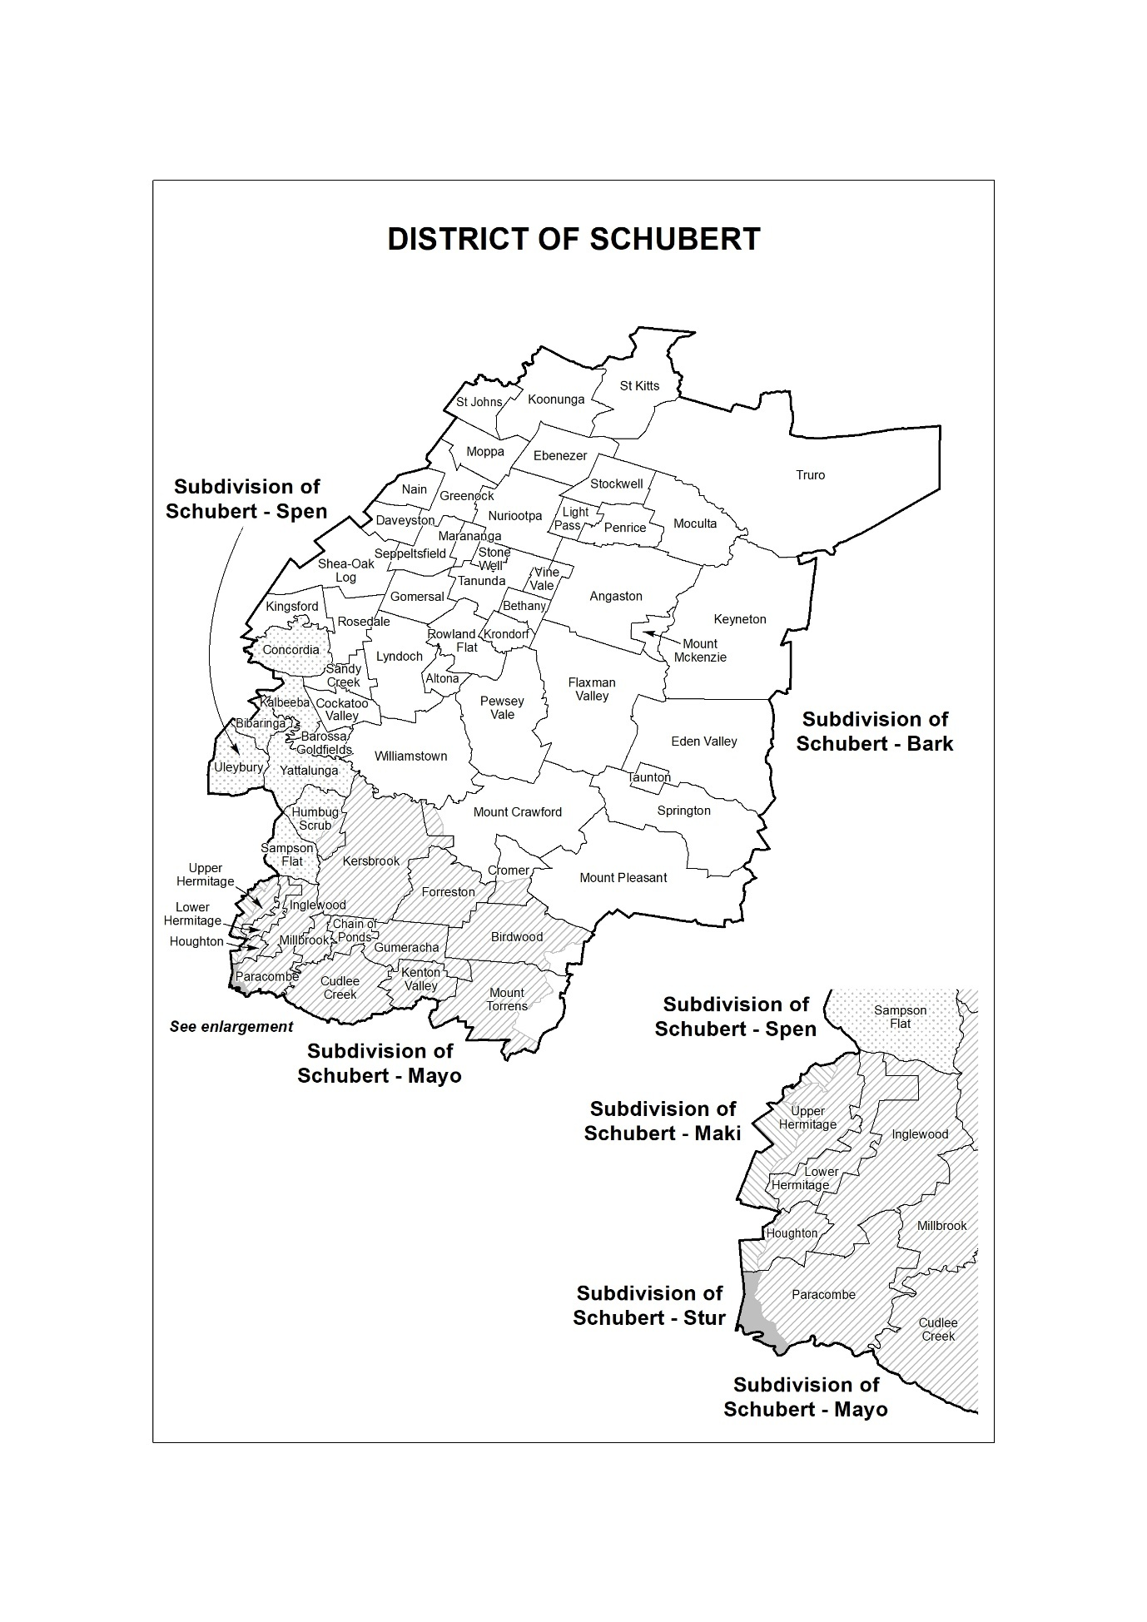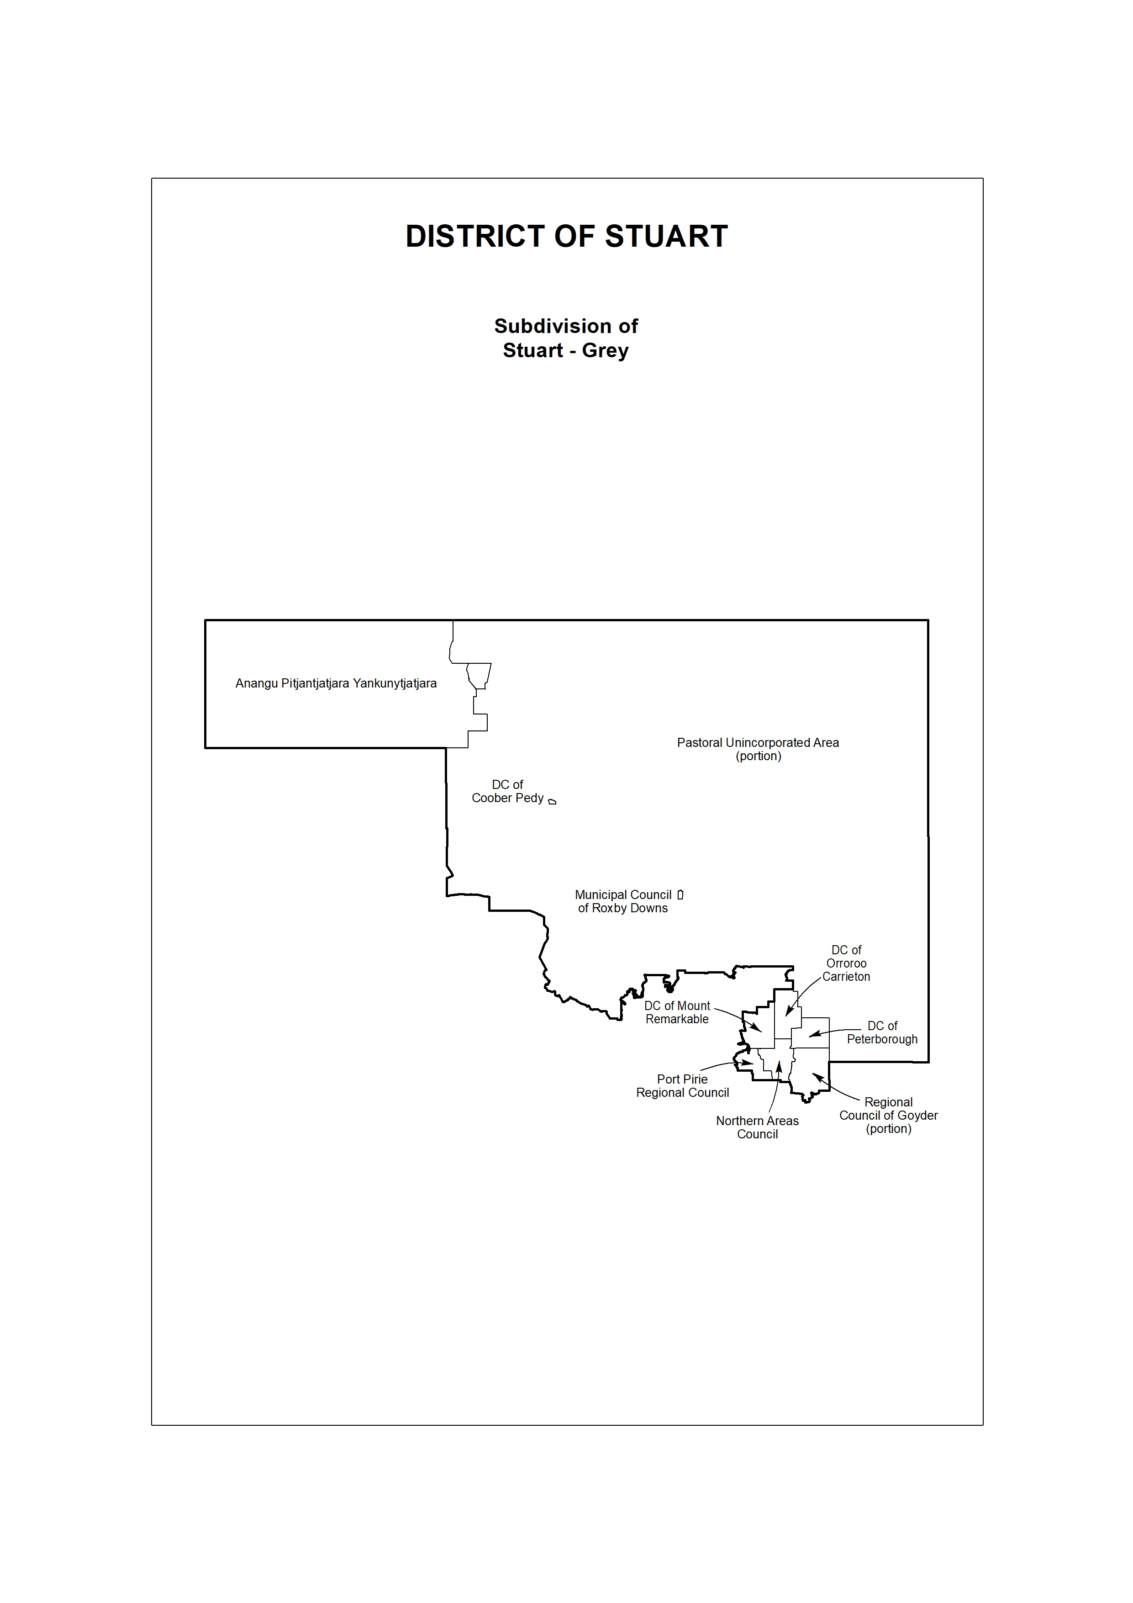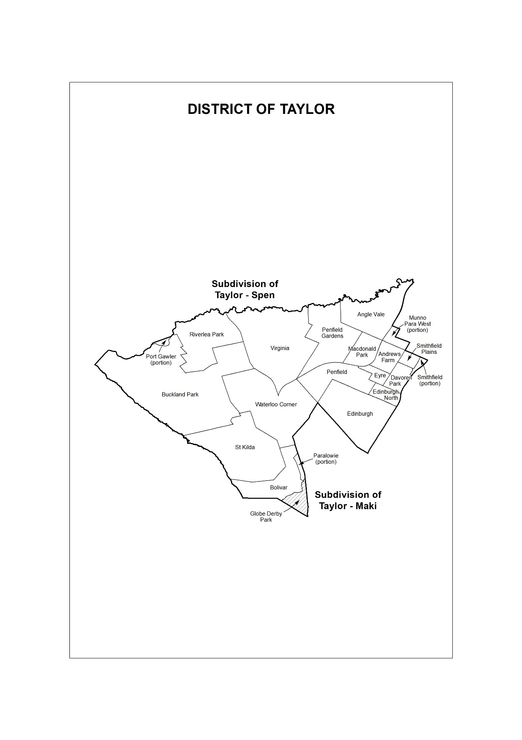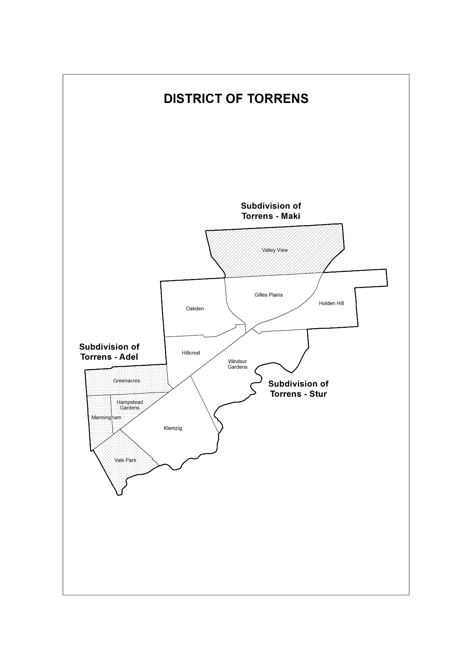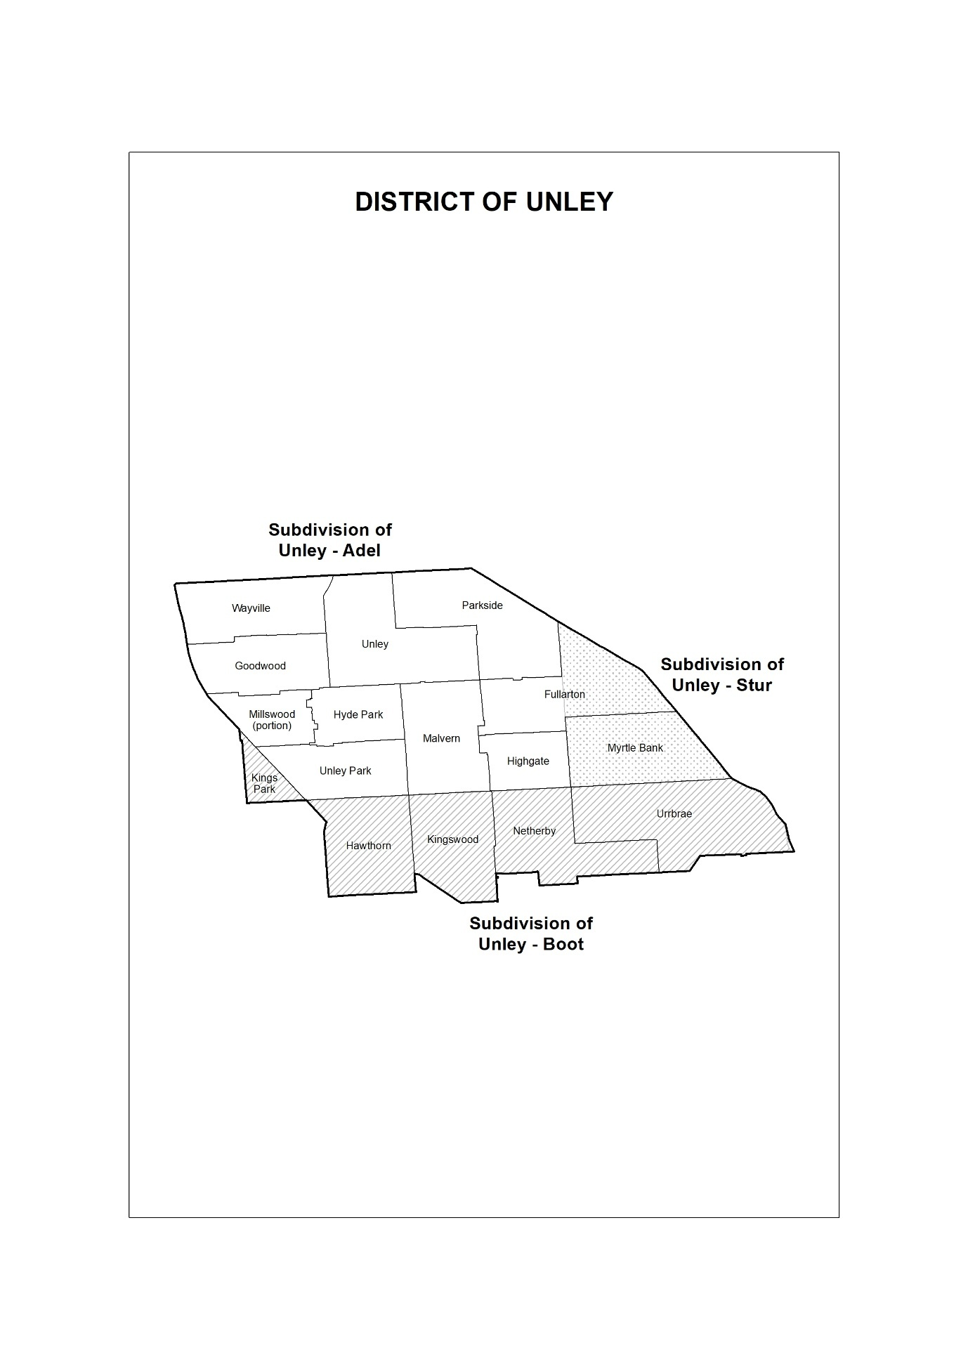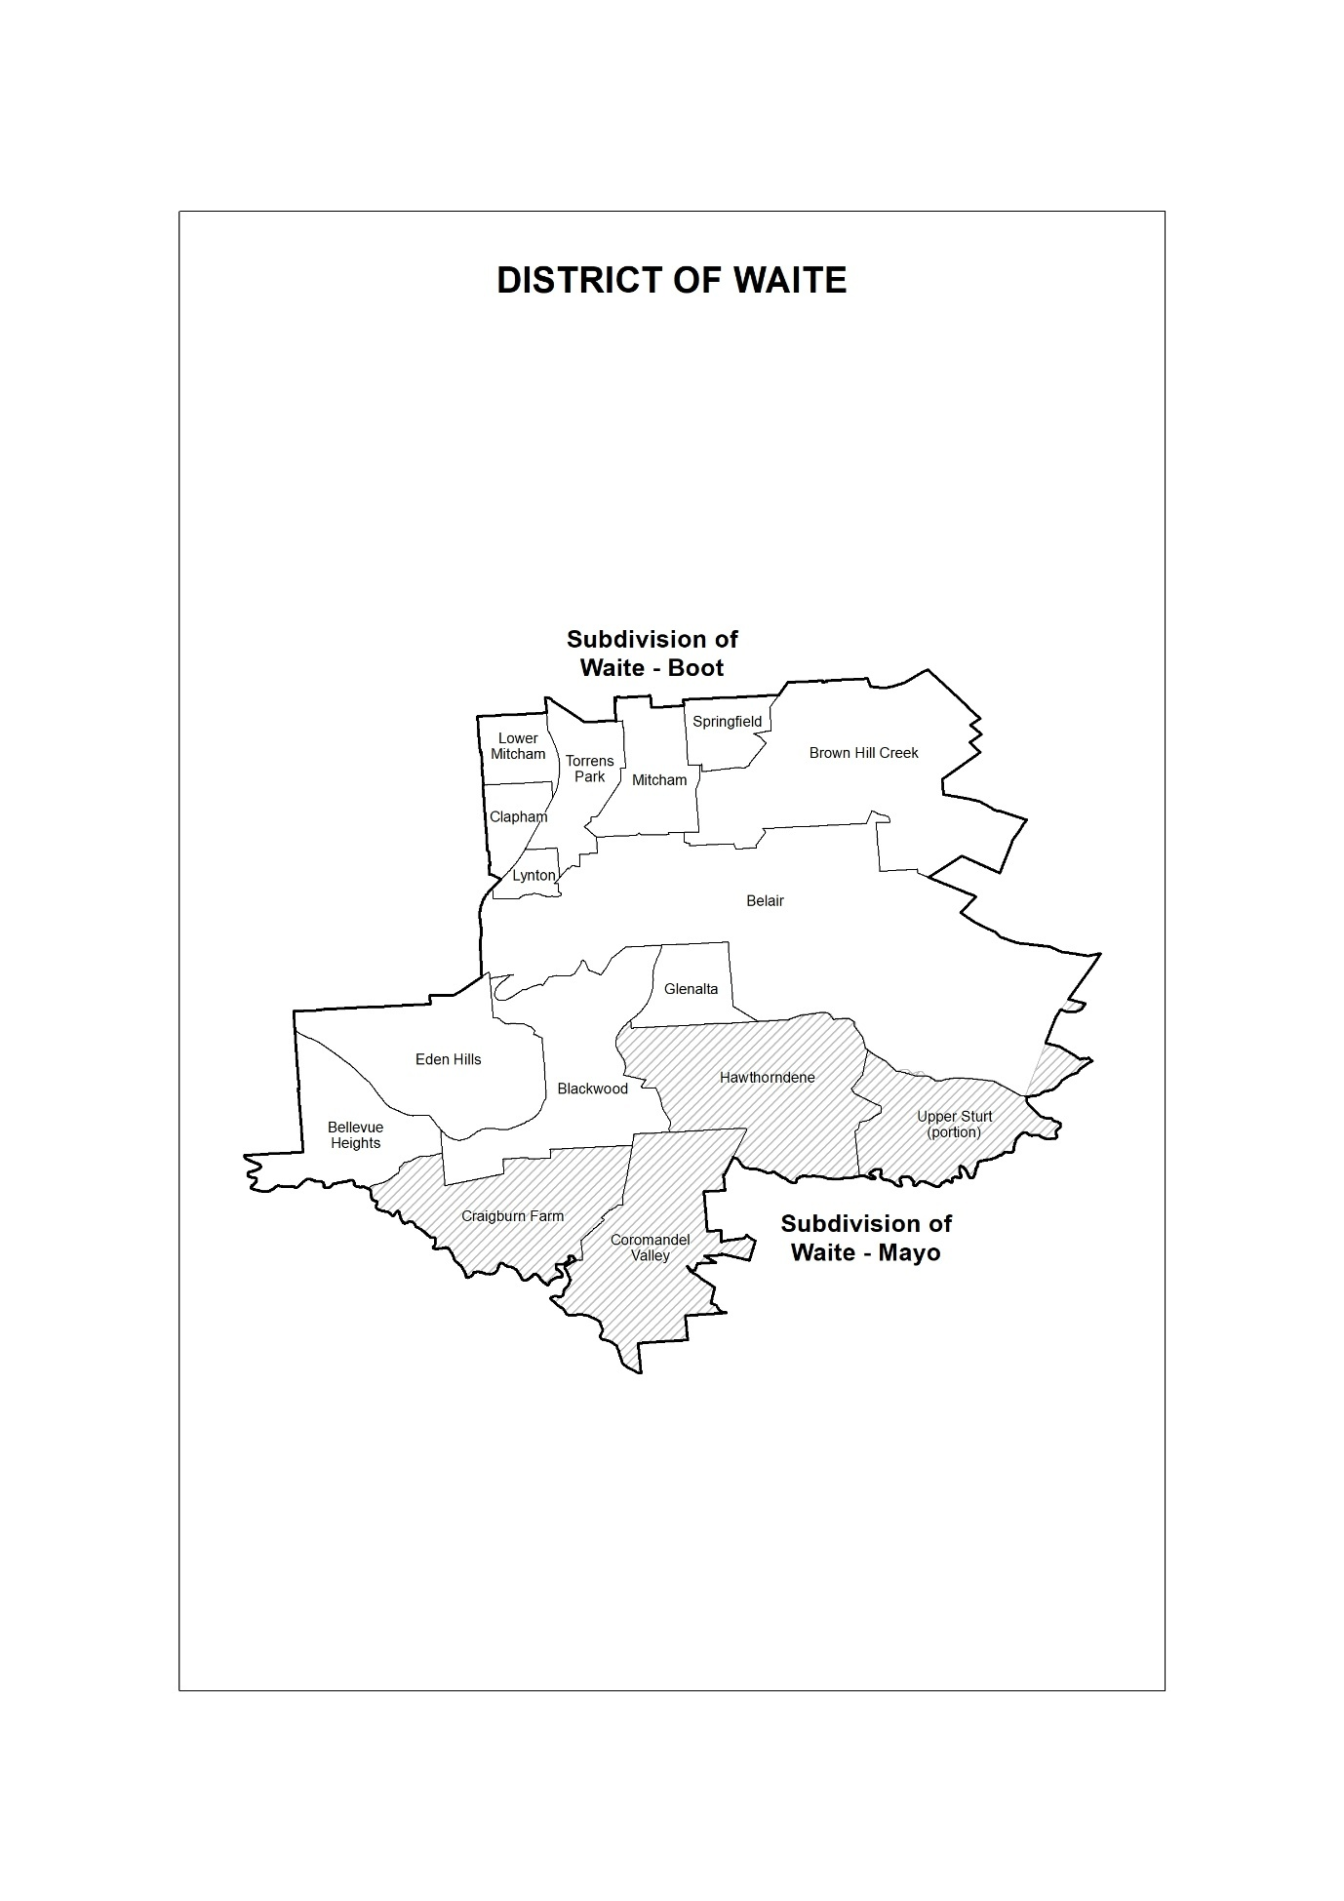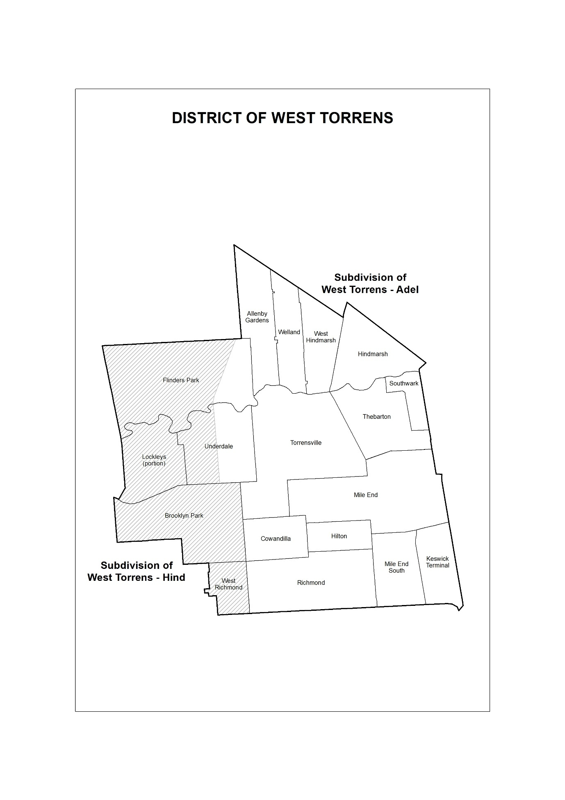
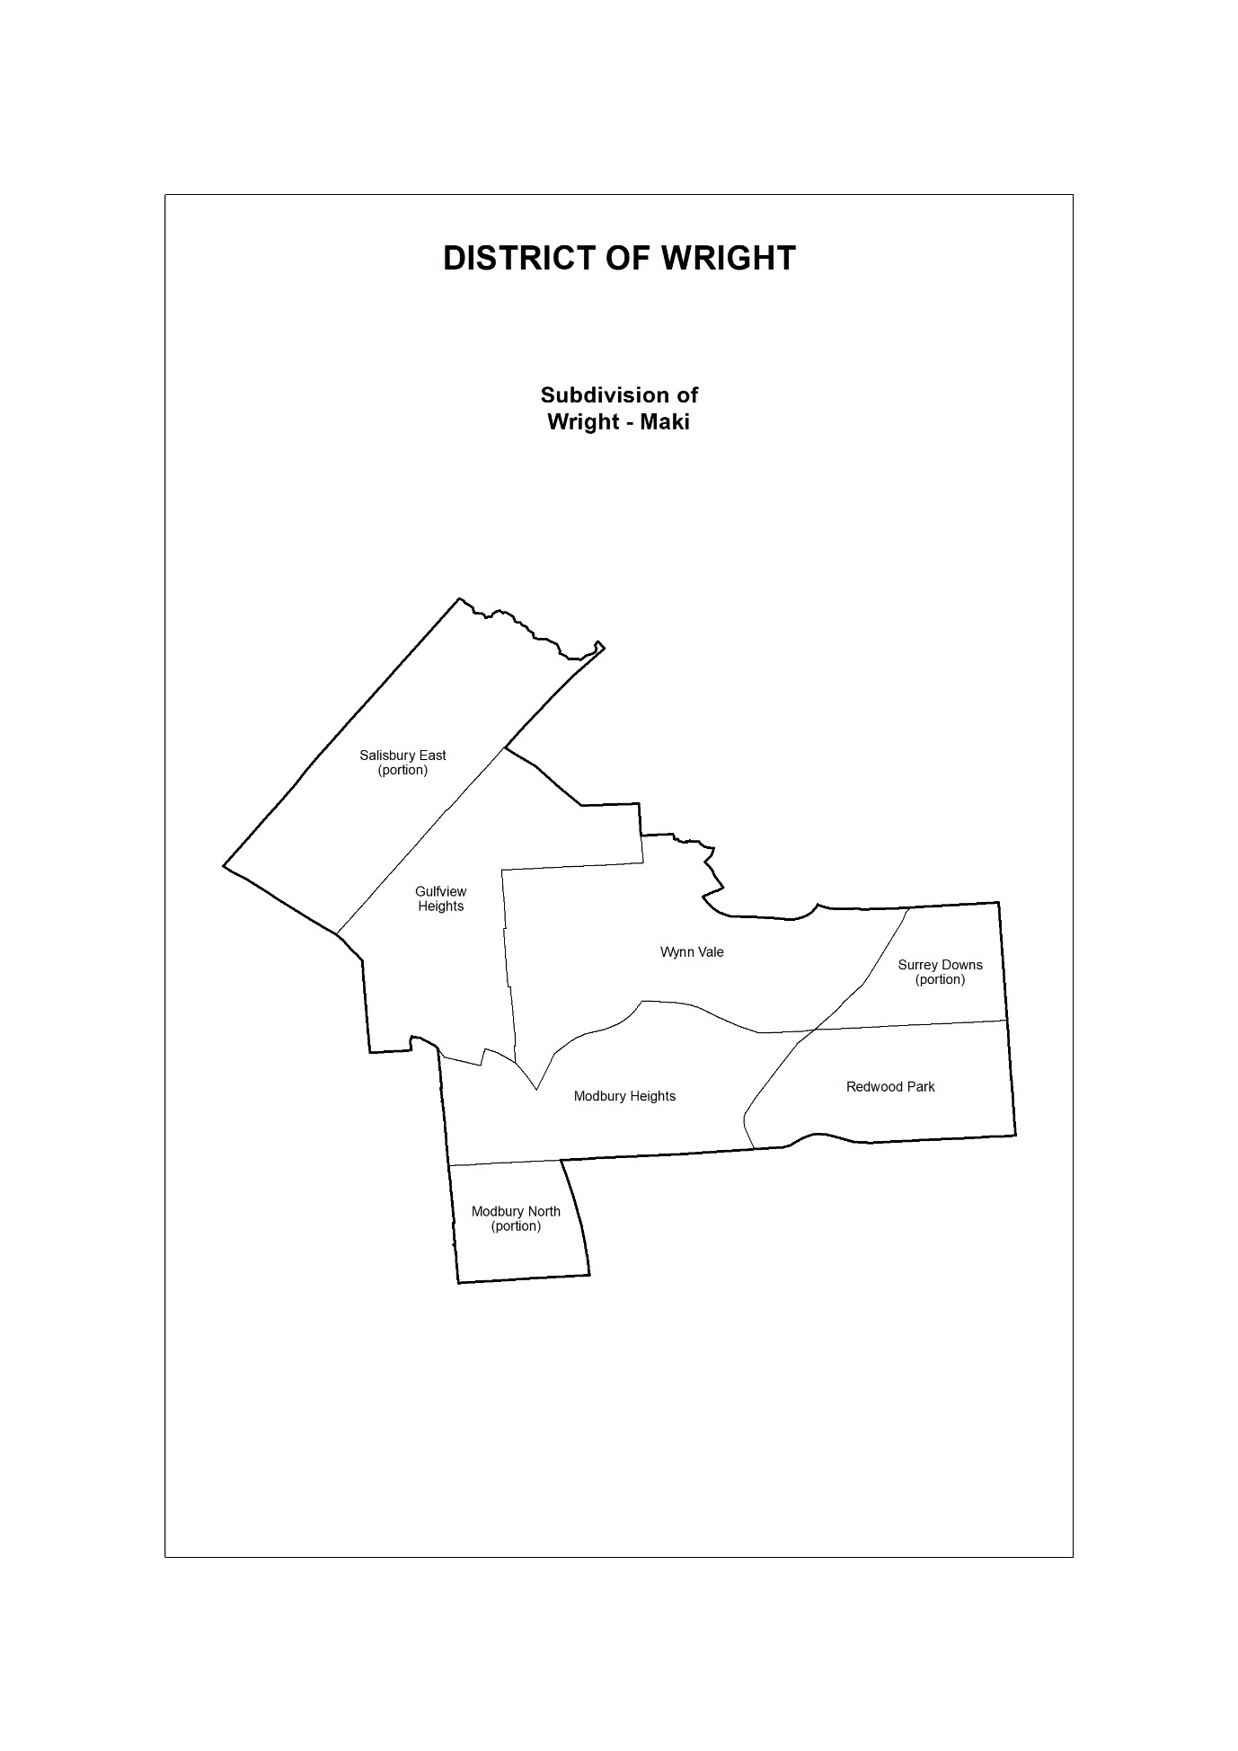
Dated: 26 February 2026
Mick Sherry
Electoral Commissioner

Electoral Act 1985
Part 7, Division 48(7)
Notification of Writs for General Elections in the State of South Australia
I have received Writs issued by Her Excellency the Governor for the election of ELEVEN Members of the LEGISLATIVE COUNCIL and FORTY-SEVEN Members of the HOUSE OF ASSEMBLY to serve in the Parliament of the State of South Australia. The following dates and times have been appointed for the conduct of the elections:
Close of rolls: Friday, 27 February 2026 at 5pm
Nominations to be received by: Monday, 2 March 2026 at 12 noon
Polling day: Saturday, 21 March 2026 8am to 6pm
Return of the Writs: on or before Monday, 4 May 2026
From the date of this notice and not later than 12 noon on nomination day, the Returning Officer for the Legislative Council, whose name and contact details appear below, will receive the nominations of Legislative Council candidates.
Name: Daniel Marx
Phone: (08) 8429 0579
Email: daniel.marx@sa.gov.au
Address: Level 6, 60 Light Square, Adelaide
From the date of this notice and not later than 12 noon on nomination day, Returning Officers for the 47 House of Assembly Districts, whose names and contact details appear below, will receive the nominations of independent candidates.
Bulk nominations for House of Assembly candidates endorsed by a registered political party can be lodged by the registered officer of a party at the Office of the Electoral Commissioner, Level 6, 60 Light Square, Adelaide, no later than 5pm, 27 February 2026.
Intending candidates and/or party officers are advised to contact the appropriate electoral official by phone to arrange a suitable time to lodge nomination forms and a deposit of $3,000 for each candidate for the Legislative Council or $1,000 for each candidate for the House of Assembly. The deposit must be in the form of a banker’s cheque or Electronic Funds Transfer to the Electoral Commission of South Australia.
Nomination Forms, Candidate and Scrutineer Guides can be downloaded from www.ecsa.sa.gov.au.
Nomination forms received by fax or e-mail will not be accepted.
District | RO Name | Email | Phone | Street | Suburb | State | Postcode
Adelaide | Roy Bushaway | RO.adelaide@sa.gov.au | 61873237650 | 300 Richmond Road | Netley | SA | 5037
Badcoe | Carolyn Pyatt | RO.badcoe@sa.gov.au | 61873237651 | 300 Richmond Road | Netley | SA | 5037
Black | Anne Rhodes | RO.black@sa.gov.au | 61873237652 | 54 Burgess Street | Noarlunga Centre | SA | 5168
Bragg | Annette Tonissen | RO.bragg@sa.gov.au | 61873237653 | 15-31 Ayliffes Road | St Marys | SA | 5042
Chaffey | Sharon Schrapel | RO.chaffey@sa.gov.au | 61873237654 | 52 Field Day Drive | Barmera | SA | 5345
Cheltenham | Calvin Dee | RO.cheltenham@sa.gov.au | 61873237655 | 308 St Vincent Street | Port Adelaide | SA | 5015
Colton | Deb  Borkowski-Uphill | RO.colton@sa.gov.au | 61873237656 | 300 Richmond Road | Netley | SA | 5037
Croydon | Mario Vitagliano | RO.croydon@sa.gov.au | 61873237657 | 513 Grand Junction Road | Wingfield | SA | 5013
Davenport | Anthony Thomas | RO.davenport@sa.gov.au | 61873237658 | 15-31 Ayliffes Road | St Marys | SA | 5042
Dunstan | Wayne Turner | RO.dunstan@sa.gov.au | 61873237659 | 41 Beulah Road | Norwood | SA | 5067
Elder | Emma Griffin | RO.elder@sa.gov.au | 61873237660 | 300 Richmond Road | Netley | SA | 5037
Elizabeth | Sandy Gladdis | RO.elizabeth@sa.gov.au | 61873237661 | 485 Main North Road | Evanston | SA | 5116
Enfield | Henry Sloniec | RO.enfield@sa.gov.au | 61873237662 | 33-37 Port Wakefield Road | Gepps Cross | SA | 5094
Finniss | Sandy Spencer | RO.finniss@sa.gov.au | 61873237663 | 24 and 24A North Terrace | Port Elliot | SA | 5215
Flinders | Vicki Seidel | RO.flinders@sa.gov.au | 61873237664 | 16-18 Hallett Place | Port Lincoln | SA | 5606
Florey | Trish Marshall | RO.florey@sa.gov.au | 61873237665 | 33-37 Port Wakefield Road | Gepps Cross | SA | 5094
Gibson | Cobie Sinclair | RO.gibson@sa.gov.au | 61873237666 | 300 Richmond Road | Netley | SA | 5037
Giles | Robert Genahl | RO.giles@sa.gov.au | 61873237667 | 21 Grundel Street | Whyalla Norrie | SA | 5608
Hammond | Ken Coventry | RO.hammond@sa.gov.au | 61873237668 | 28 Bridge Street | Murrary Bridge | SA | 5253
Hartley | Greg Wright | RO.hartley@sa.gov.au | 61873237669 | 2 Turner Street | Felixstow | SA | 5070
Heysen | Michelle Judd | RO.heysen@sa.gov.au | 61873237670 | 23 Adelaide Road | Echunga | SA | 5153
Hurtle Vale | Terry Ellis | RO.hurtlevale@sa.gov.au | 61873237671 | 54 Burgess Street | Noarlunga Centre | SA | 5168
Kaurna | David Hitchcock | RO.kaurna@sa.gov.au | 61873237672 | 54 Burgess Street | Noarlunga Centre | SA | 5168
Kavel | Andrew Fort | RO.kavel@sa.gov.au | 61873237673 | 23 Adelaide Road | Echunga | SA | 5153
King | Brian Hemming | RO.king@sa.gov.au | 61873237674 | 33-37 Port Wakefield Road | Gepps Cross | SA | 5094
Lee | Anna Allard | RO.lee@sa.gov.au | 61873237754 | 308 St Vincent Street | Port Adelaide | SA | 5015
Light | John Arnold | RO.light@sa.gov.au | 61873237675 | 485 Main North Road | Evanston | SA | 5116
Mackillop | Karen Johnstone | RO.mackillop@sa.gov.au | 61873237676 | 148 Racecourse Road | Bordertown | SA | 5268
Mawson | Adrian Kemp | RO.mawson@sa.gov.au | 61873237677 | 54 Burgess Street | Noarlunga Centre | SA | 5168
Morialta | Gerry Butler | RO.morialta@sa.gov.au | 61873237678 | 33-37 Port Wakefield Road | Gepps Cross | SA | 5094
Morphett | Tania Poole | RO.morphett@sa.gov.au | 61873237679 | 15-31 Ayliffes Road | St Marys | SA | 5042
Mount Gambier | Simon Kennett | RO.mountgambier@sa.gov.au | 61873237680 | 27-29 Commercial Street West | Mount Gambier | SA | 5290
Narungga | Wendy O’Sullivan | RO.narungga@sa.gov.au | 61873237681 | 5/36 Graves Street | Kadina | SA | 5554
Newland | Sandra Lowe | RO.newland@sa.gov.au | 61873237682 | 33-37 Port Wakefield Road | Gepps Cross | SA | 5094
Ngadjuri (Frome) | Garry Davies | RO.ngadjuri@sa.gov.au | 61873237683 | 155 Horrocks Highway | Clare | SA | 5453
Playford | David Harris | RO.playford@sa.gov.au | 61873237684 | 33-37 Port Wakefield Road | Gepps Cross | SA | 5094
Port Adelaide | Greg Borg | RO.portadelaide@sa.gov.au | 61873237685 | 3/171 Commercial Road | Port Adelaide | SA | 5015
Ramsay | Brian Skelly | RO.ramsay@sa.gov.au | 61873237686 | 33-37 Port Wakefield Road | Gepps Cross | SA | 5094
Reynell | Tosha Bottroff | RO.reynell@sa.gov.au | 61873237687 | 54 Burgess Street | Noarlunga Centre | SA | 5168
Schubert | Heather Bitter | RO.schubert@sa.gov.au | 61873237688 | 1221 Barossa Valley Way | Lyndoch | SA | 5351
Stuart | Roger Moroney | RO.stuart@sa.gov.au | 61873237689 | 68 Commercial Road | Port Augusta | SA | 5700
Taylor | Nerida Sweet | RO.taylor@sa.gov.au | 61873237690 | 485 Main North Road | Evanston | SA | 5116
Torrens | Damian Leach | RO.torrens@sa.gov.au | 61873237691 | 33-37 Port Wakefield Road | Gepps Cross | SA | 5094
Unley | Rachael Wepener | RO.unley@sa.gov.au | 61873237692 | 15-31 Ayliffes Road | St Marys | SA | 5042
Waite | Colin Cameron | RO.waite@sa.gov.au | 61873237693 | 15-31 Ayliffes Road | St Marys | SA | 5042
West Torrens | Kathryn Nagle | RO.westtorrens@sa.gov.au | 61873237694 | 300 Richmond Road | Netley | SA | 5037
Wright | Faye Gough | RO.wright@sa.gov.au | 61873237695 | 33-37 Port Wakefield Road | Gepps Cross | SA | 5094
Dated: 21 February 2026
Mick Sherry
Electoral Commissioner

Electricity Act 1996

Gas Act 1997
Retailer Energy Productivity Scheme
Minimum Specifications for Energy Productivity Activities
Pursuant to Regulation 28 of the Electricity (General) Regulations 2012 and Regulation 22 of the Gas Regulations 2012, I determine the activities within the following document to be an energy productivity activity for the purposes of Part 4 of the Electricity (General) Regulations 2012 and Part 4 of the Gas Regulations 2012.
This notice will take effect from 1 January 2026.
Dated: 20 February 2026
Hon Tom Koutsantonis MP
Minister for Energy and Mining

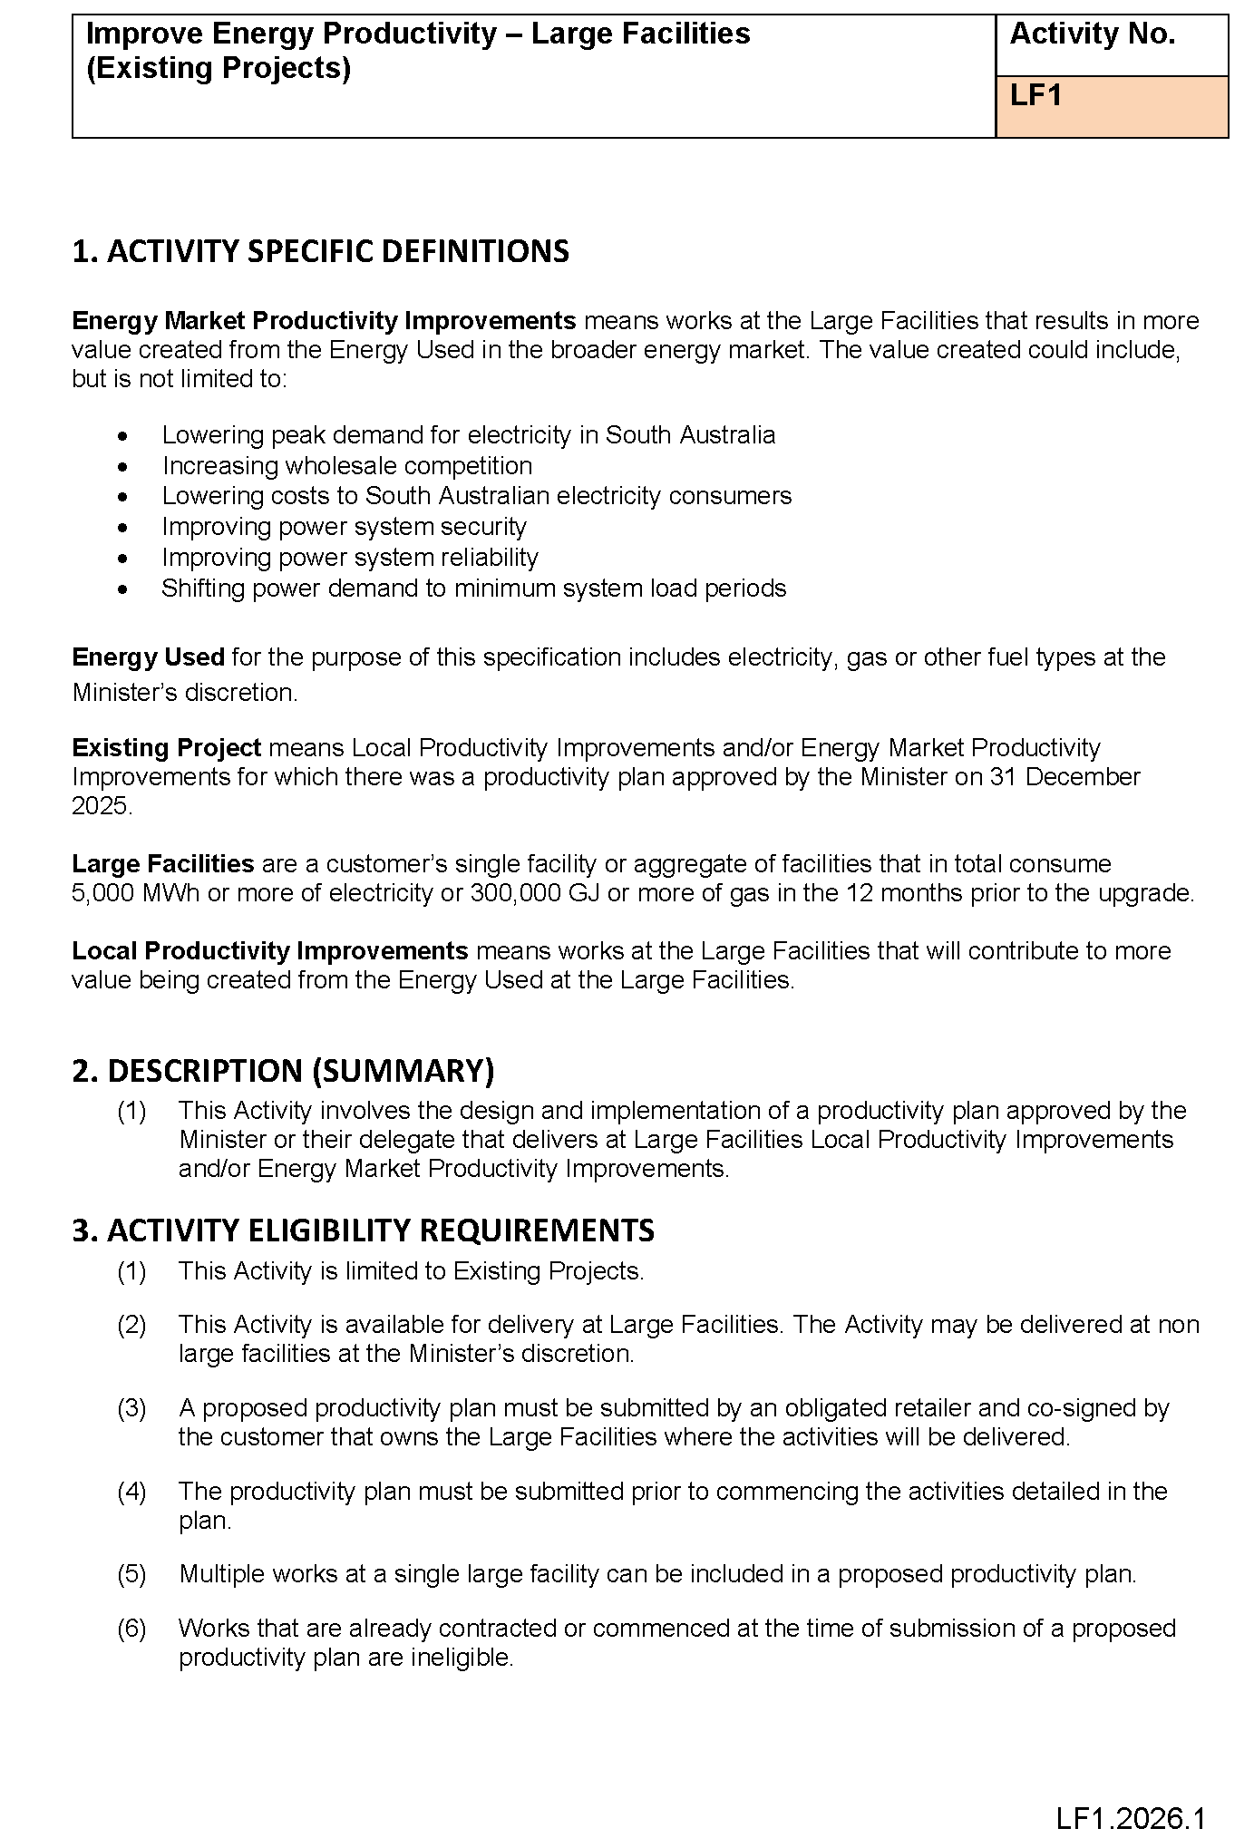
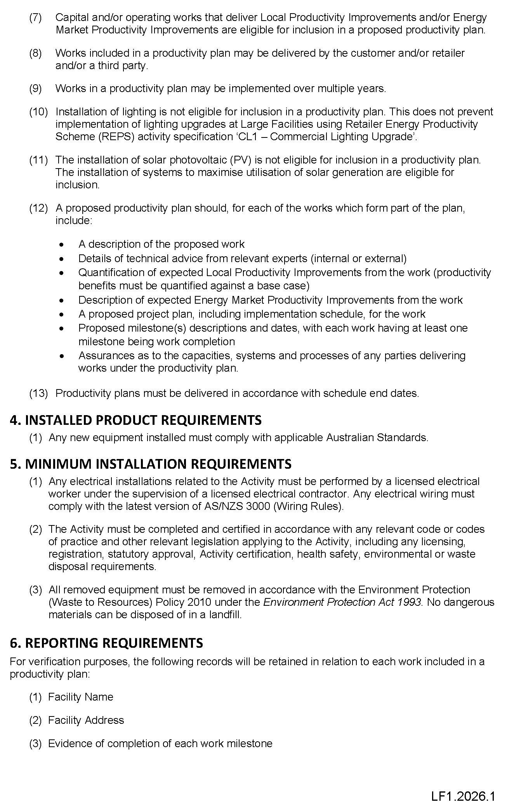

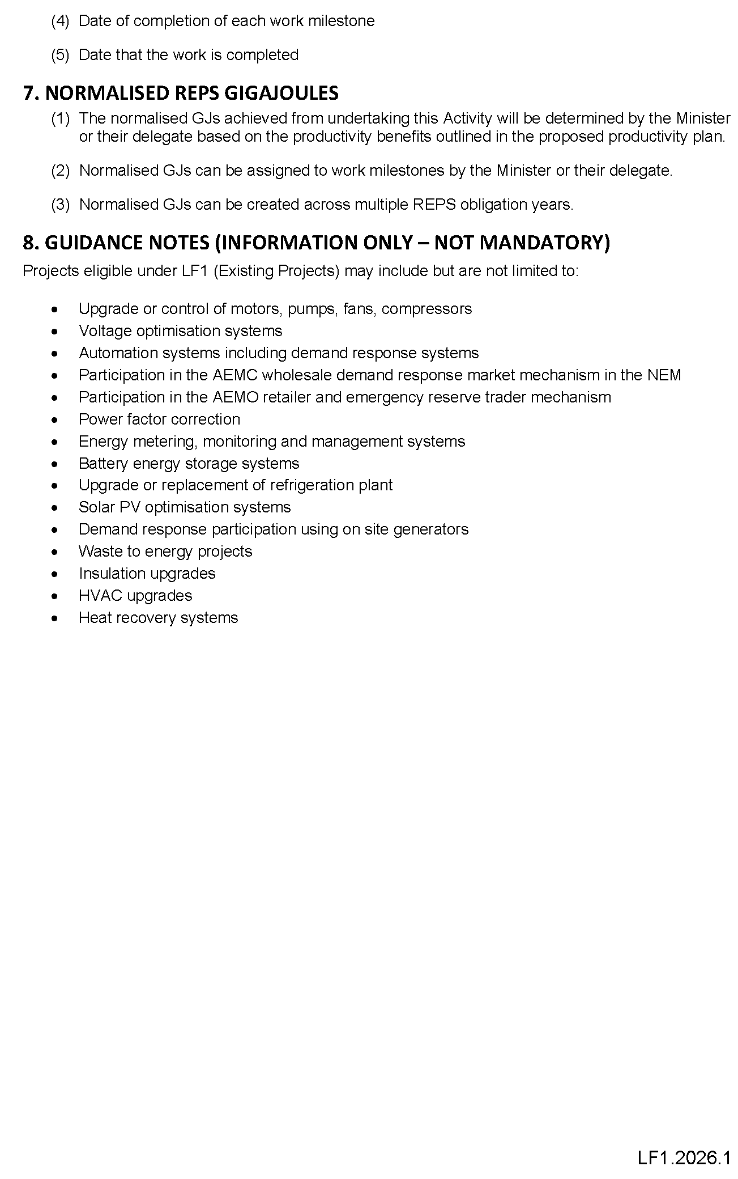

Electricity Act 1996
Gas Act 1997
Retailer Energy Productivity Scheme
Minimum Specifications for Energy Productivity Activities
Pursuant to Regulation 28(5) of the Electricity (General) Regulations 2012 under the Electricity Act 1996, and Regulation 22(5) of the Gas Regulations 2012 under the Gas Act 1997, I revoke the Ministerial Notice—Replace or Upgrade Water Heater; Residential and Small Energy Consuming Customers Only, Activity No. WH1 in the South Australian Government Gazette No. 81 dated 19 December 2024 on pages 5023-5026.
Pursuant to Regulation 28 of the Electricity (General) Regulations 2012 and Regulation 22 of the Gas Regulations 2012, I determine the activities within the following document to be an energy productivity activity for the purposes of Part 4 of the Electricity (General) Regulations 2012 and Part 4 of the Gas Regulations 2012.
This notice will take effect from 1 January 2026.
Dated: 18 February 2026
Hon Tom Koutsantonis MP
Minister for Energy and Mining

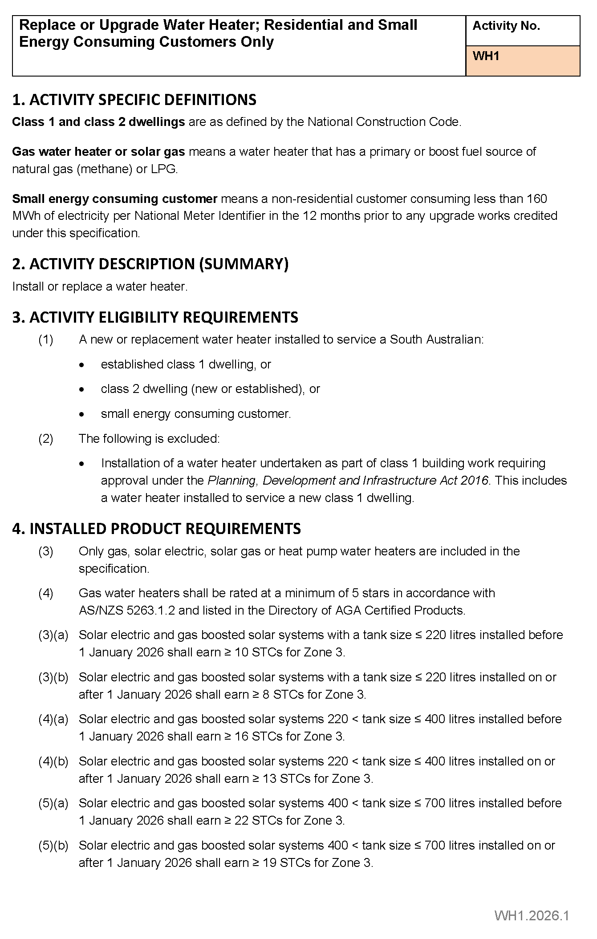
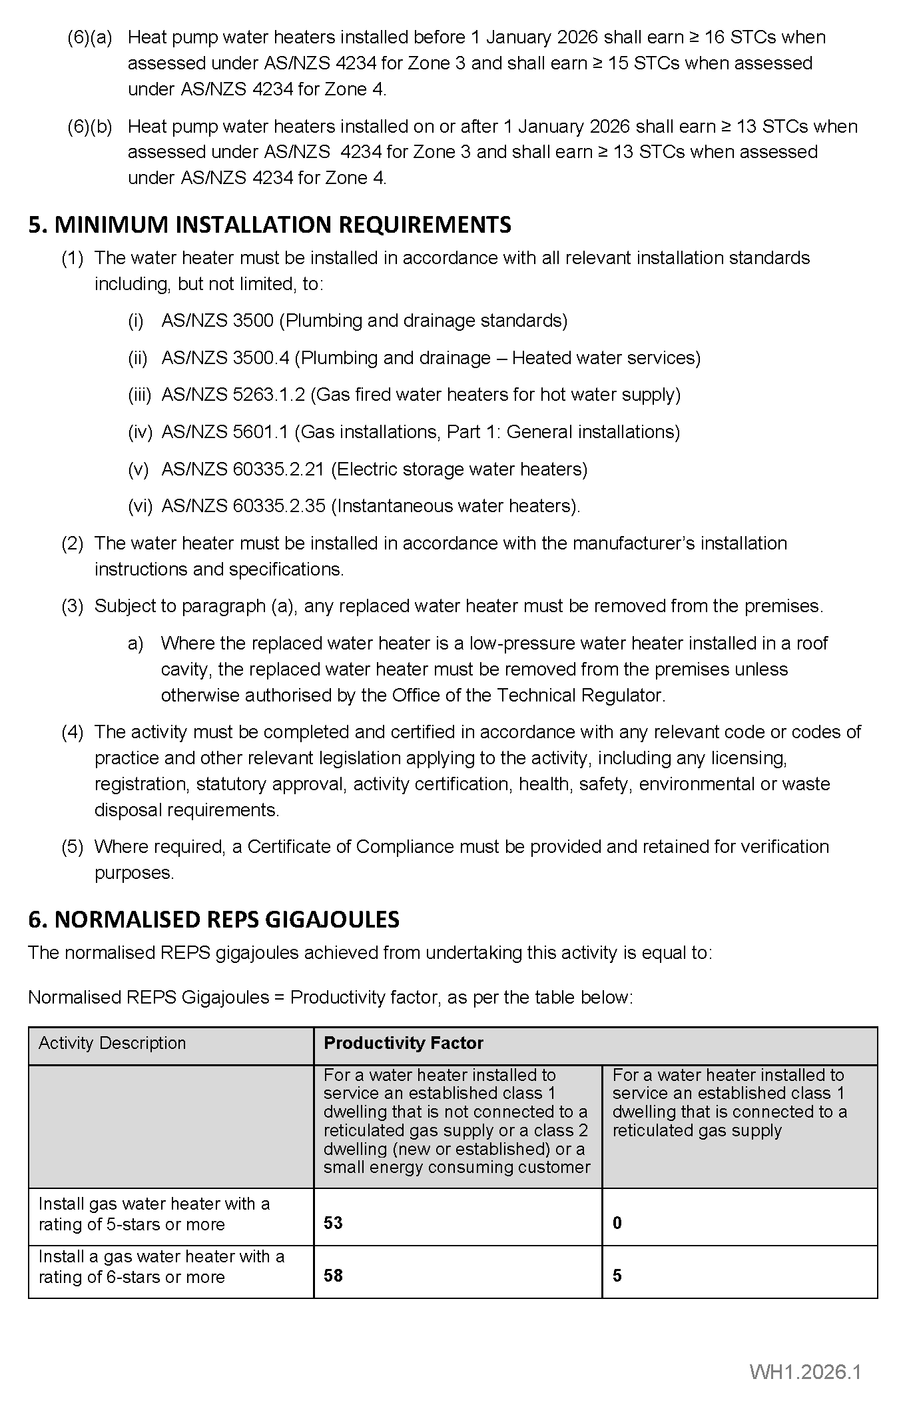
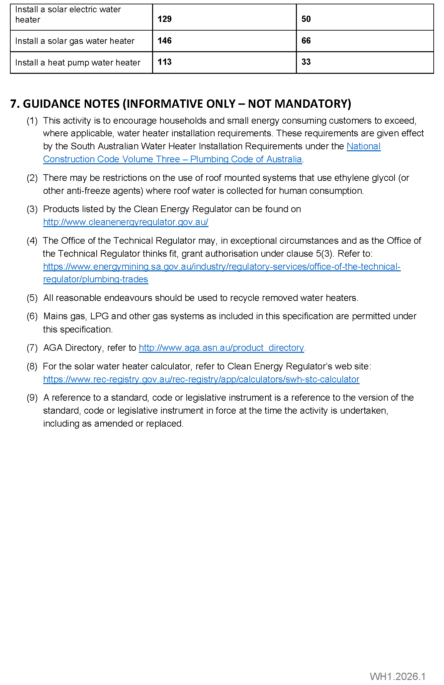

Housing Improvement Act 2016
Rent Control
In the exercise of the powers conferred by the Housing Improvement Act 2016, the Delegate of the Minister for Housing and Urban Development hereby fixes the maximum rental amount per week that shall be payable subject to Section 55 of the Residential Tenancies Act 1995, in respect of each premises described in the following table. The amount shown in the said table shall come into force on the date of this publication in the Gazette.
Address of Premises | Allotment Section | Certificate of Title  Volume/Folio | Maximum Rental per week payable
2 Seaton Avenue, Hazelwood Park SA 5066 | Allotment 506 Deposited Plan 2975 Hundred of Adelaide | CT6136/902 | $0.00
130 Wright Street, Adelaide SA 5000 | Allotment 591 Filed Plan 183053 Hundred of Adelaide | CT5537/860 | $0.00
Dated: 26 February 2026
Craig Thompson
Housing Regulator and Registrar
Housing Safety Authority
Delegate of the Minister for Housing and Urban Development

HOUSING IMPROVEMENT ACT 2016
Rent Control Revocations
In the exercise of the powers conferred by the Housing Improvement Act 2016, the Delegate of the Minister for Housing and Urban Development hereby revokes the maximum rental amount per week that shall be payable subject to Section 55 of the Residential Tenancies Act 1995, in respect of each premises described in the following table.
Address of Premises | Allotment Section | Certificate of Title  Volume/Folio
44 Coast Road, Moonta Bay SA 5558 | Allotment 25 Deposited Plan 139635 Hundred of Wallaroo | CT6327/643
Dated: 26 February 2026
Craig Thompson
Housing Regulator and Registrar
Housing Safety Authority
Delegate of the Minister for Housing and Urban Development

Justices of the Peace Act 2005
Section 4
Notice of Appointment of Justices of the Peace for South Australia
by the Commissioner for Consumer Affairs
I, Brett Humphrey, Commissioner for Consumer Affairs, delegate of the Attorney-General, pursuant to Section 4 of the Justices of the Peace Act 2005, do hereby appoint the people listed as Justices of the Peace for South Australia as set out below.
For a period of ten years for a term commencing on 31 March 2026 and expiring on 30 March 2036:
Sirui ZHANG
Joanna Louise WRIGHT
John Paul Edward WOODWARD
Christine Joy WOOD
Aldona WILLIS
David James VENNER
Luke Wakefield TONKIN
Garry Frederick TAYLOR
Nicole Deanne STEPHENSON
Shannon Victor SPADAVECCHIA
Trevor Charles Morton SMITH
Scott Edward SMITH
Greg Campbell SMITH
Helen Margaret SLATER
Arshdeep SINGH
Sarah Jane SIMPSON
Matthew David SHILLING
Anish Bharat SHAH
Lee-Ann Judith SANDERCOCK
Daryle Ronald ROBERTS
Robert William PHILLIPS
Rowan Lee MARRA
Andrew Simeon KULIKOVSKY
Michelle Anne HOLTHOUSE
Vera HOLT
Alexandra HOLEVA
Robyn Therese GROSE
Peter Lindley FARLEY
Andrew John DAVIS
Trudy Estelle DALGETTY
Penny Jane CRAIK
James Edward BAILEY
Darren Peter BACCHUS
Dated: 24 February 2026
Brett Humphrey
Commissioner for Consumer Affairs
Delegate of the Attorney-General

Landscape South Australia Act 2019
Notice of Volume of Water Available for Allocation from the River Murray Consumptive Pool
Pursuant to Section 121(4) of the Landscape South Australia Act 2019 (‘the Act’), I, Lisa Stribley, delegate of the Minister for Climate, Environment and Water and Minister to whom the Act is committed, hereby determine the volume of water available for allocation from each of the Consumptive Pools within the River Murray Prescribed Watercourse to water access entitlement holders for the period 1 July 2025 to 30 June 2026, as set out in Schedule 1 below:
Schedule 1
Consumptive Pool | Classes | Volume of Water Available for Allocation | Water Access Entitlement | Water Allocation Rate as % of Nominal Maximum Water Allocation Rate  of 1kL/unit share
 |  | kL | unit share | (%)
Metropolitan Adelaide | Class 6 | 161,200,000 | 130,000,000 | 124
This Notice will remain in effect until 30 June 2026, unless varied earlier.
Dated: 24 February 2026
Lisa Stribley
Acting Executive Director, Water and River Murray
Department for Environment and Water
Delegate of the Minister for Climate, Environment and Water

Landscape South Australia Act 2019
Section 192(1)
Notice Requiring Action to Destroy Wild Dogs in the Declared Area
For the purposes of Section 192(1) of the Landscape South Australia Act 2019 (the Act) and in accordance with Regulation 24 of the Landscape South Australia (General) Regulations 2020 (the Regulations), I, Ben Bruce, Chief Executive of the Department for Environment and Water, hereby notify that, within the declared area of mainland South Australia, an owner of land in a region designated by this notice must take action to destroy wild dogs in the manner set out in this notice.
Designated Regions:
Region 1 comprises the area of South Australia (the State) that is located inside the dog fence but outside council areas under the
Local Government Act 1999.
Region 2 comprises all properties greater than 300 hectares within the boundaries of the Flinders Ranges Council, District Council of Orroroo Carrieton, District Council of Peterborough, Northern Areas Council, Regional Council of Goyder or District Council of Ceduna.
Region 3 comprises the areas of the Southern Mallee Council, Tatiara Council and Coorong Council incorporating Ngarkat Conservation Park and all properties that have a shared boundary with the Ngarkat Conservation Park.
Region 4 comprises all land mainland South Australia inside the dog fence and not within Regions 1, 2 or 3.
In this notice:
dog fence means the dog-proof fence established and maintained in the northern areas of the State in accordance with subsection 18(2) of the Dog Fence Act 1946.
inside the dog fence means land within that portion of the State that is bounded by the dog fence, the eastern border of the State and the coast of the State.
lethal wild dog bait means a wild dog bait containing 0.6mg of Sodium Fluoroacetate (1080) or 1,000mg of Paramino Propriophenome (PAPP).
owner of land means—
(a) if the land is unalienated from the Crown—the Crown; or
(b) if the land is alienated from the Crown by grant in fee simple—the owner (at law or in equity) of the estate in fee simple; or
(c) if the land is held from the Crown by lease or licence—the lessee or licensee, or a person who has entered into an agreement to acquire the interest of the lessee or licensee; or
(d) if the land is held from the Crown under an agreement to purchase—the person who has the right to purchase; or
(e) a person who holds native title in the land; or
(f) a person who has arrogated to themselves (lawfully or unlawfully) the rights of an owner of the land,
and includes an occupier of the land and any other person of a prescribed class included within the ambit of this definition by a regulation made under the Act.
trapping means trapping an animal in a manner that complies with Regulation 9(2) of the Animal Welfare Regulations 2012.
wild dog means a dingo; and any dog that is any cross of a dingo; and any feral dog.
1. In all Regions, baits must be laid in a manner that complies with the “Bait label for Wild Dog Control” set out at the PIRSA website.
2. In all Regions, an owner of land must not bait or trap wild dogs on land they do not own, unless they have permission to do so.
3. In Region 1:
All owners of land must, once every autumn and once every spring (and irrespective of evidence of wild dog activity) lay at least one lethal wild dog bait per 2km² of property and for properties exceeding 2,000km² in size, at least 1,000 baits must be laid, or if organically certified, the land owner must provide to the local landscape board a plan that outlines an alternative method for laying the equivalent amount of baits, once approved by the local landscape board, immediately enact the approved plan.
(a) If an owner of land becomes aware of evidence of wild dog activity on that land, they:
(i) must, as soon as practicable, report the evidence to all owners of land adjoining that land and the local landscape board; and
(ii) must take the following measures:
(1) as soon as practicable, within 10 kilometres of such evidence lay at least one lethal wild dog bait per 2km² of property and for properties exceeding 2,000km² in size, at least 1,000 baits must be laid; or
(2) if the property is organically certified, the land owner must, as soon as practicable, provide to the local landscape board, for approval by that board, a wild dog control plan that outlines an alternative method for laying the equivalent amount of baits, based on baiting within 10 kilometres of such evidence, laying at least one lethal wild dog bait per 2km² of property and for properties exceeding 2,000km² in size, at least 1,000 baits must be laid, once approved by the local landscape board, immediately enact the approved plan;
(3) Whether the property is organically certified or not, if wild dog activity is still detected after one month of baits being laid, repeat the baiting or undertake trapping or employ the services of a professional trapper to destroy all wild dogs until no further evidence is detected for a period of at least one month and report the continued wild dog activity and control activities to all adjoining owners of the land and the local landscape board contemporaneously with the further control activities.
4. In Region 2:
(a) If an owner of land becomes aware of evidence of wild dog activity on that land, they:
(i) must, as soon as practicable, report the evidence to all owners of land adjoining that land and the local landscape board; and
(ii) The owner of the land, and the owners of all land adjoining that land, must take the following measures:
(1) as soon as practicable, lay ten lethal wild dog baits per 100 hectares of land, or one bait at minimum intervals of
200 metres along any established vehicle tracks or roads; or
(2) if the property is organically certified, the land owner must, as soon as practicable, provide to the local landscape board, for approval by that board, a wild dog control plan that outlines an alternative method for laying the equivalent amount of baits, based on baiting within 10 kilometres of such evidence, laying at least one lethal wild dog bait along every
200 metres of any established vehicle track or road and, once approved by the local landscape board, immediately enact the approved plan;
(3) Whether the property is organically certified or not, if wild dog activity is still detected after one month of baits being laid, repeat the baiting or undertake trapping or employ the services of a professional trapper to destroy all wild dogs until no further evidence is detected for a period of at least one month and report the continued wild dog activity and control activities to all adjoining owners of the land and the local landscape board contemporaneously with the further control activities.
5. In Region 3:
(a) If an owner of land becomes aware of evidence of wild dog activity on that land, they must, as soon as practicable, report the evidence to all owners of land adjoining that land and the local landscape board.
(b) Within Ngarkat Conservation Park:
(i) The owner of the land must provide to the local landscape board, for approval by that board, a plan which provides for baiting within the Ngarkat Conservation Park and, once approved by the local landscape board, immediately enact the approved plan.
(ii) The plan must include the following requirements:
(1) That periodic baiting is to address the whole of the Ngarkat Conservation Park;
(2) That periodic baiting is to occur four times per year;
(3) That the location of periodic baiting must be identified e.g. through identifying tracks to be baited;
(4) That lethal baits must be laid at minimum intervals of 500 metres along any track identified and every 250 metres along the vehicle track that borders Victoria.
(c) Outside Ngarkat Conservation Park:
(i) If the owner of land becomes aware of wild dog activity on their land, that owner and the owners of all land adjoining that land, must undertake the following measures:
(1) as soon as practicable, lay baits at minimum intervals of 500 metres along established tracks or roads;
(d) Within all of Region 3:
(i) If wild dog activity is still detected after one month of baits being laid, repeat the baiting or undertake trapping or employ the services of a professional trapper to destroy all wild dogs until no further evidence is detected for a period of at least one month and report the continued wild dog activity and control activities to all adjoining owners of the land and the local landscape board contemporaneously with the further control activities.
6. In Region 4:
(a) If an owner of land becomes aware of evidence of wild dog activity on that land, they must, as soon as practicable, report the evidence to the local landscape board and should report that evidence to all owners of land adjoining that land; and
(b) must comply with any instructions of the board to destroy wild dogs on that land.
Note—REGION 5 is addressed under a separate Notice pursuant to Section 192(3)(a) of the Act and Regulation 25 of the Regulations.

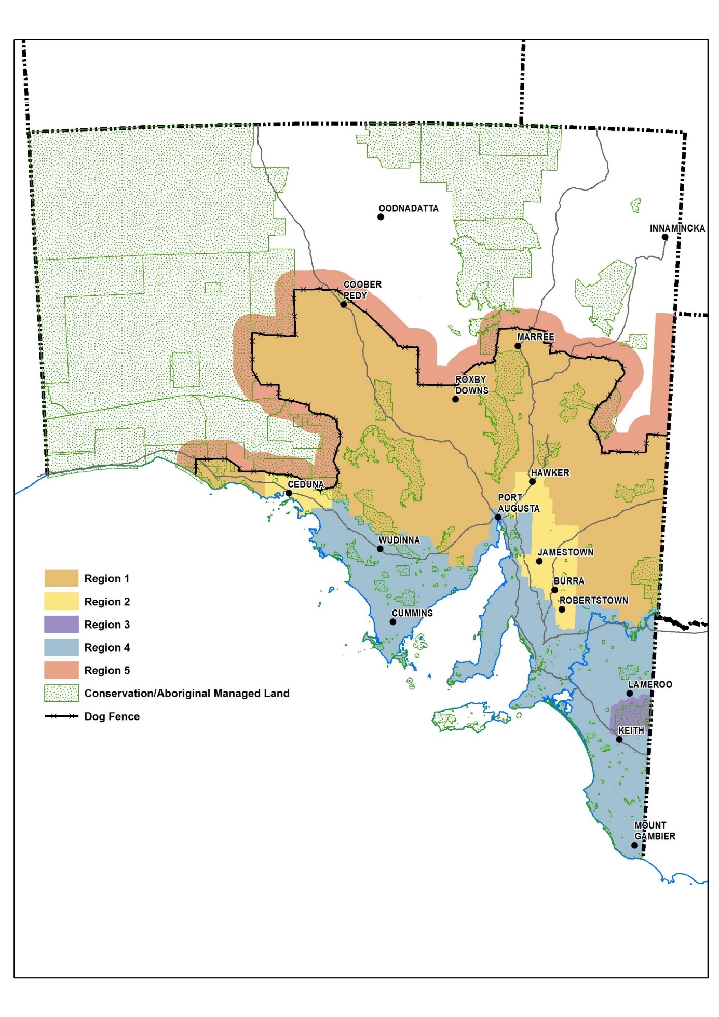
Designated Regions
Dated: 26 February 2026
Ben Bruce
Chief Executive, Department for Environment and Water

Local Government (Elections) Act 1999
Adelaide Hills Council
Supplementary Election of Mayor—Election Results
Conducted on Tuesday, 10 February 2026
Formal Ballot Papers—7320
Informal Ballot Papers—26
Quota—3661
Candidates | First Preference Votes | Elected or Excluded | Votes at Election or Exclusion
DANIELL, Nathan | 3572 | Elected | 4179
STRATFORD, Andrew Mark | 2507 |  | 2758
MCDONNELL, Georgia | 1241 | Excluded | 1241
Dated: 26 February 2026
Mick Sherry
Returning Officer

Local Government (Elections) Act 1999
Yorke Peninsula Council
Supplementary Election of Councillor for Innes/Penton Vale Ward—Election Results
Conducted on Tuesday, 10 February 2026
Formal Ballot Papers—1240
Informal Ballot Papers—2
Quota—621
Candidates | First Preference Votes | Elected or Excluded |  | Votes at Election or Exclusion
GLAZBROOK, William | 719 | Elected |  | 719
DINHAM, Phil | 521 |  |  | 521
Dated: 26 February 2026
Mick Sherry
Returning Officer

Motor Vehicles Act 1959
South Australia
Motor Vehicles (Conditional Registration—Recognition of Motor Vehicle Clubs) Notice 2026—Naracoorte SA 4WD Club Incorporated
under the Motor Vehicles Act 1959
1—Short title
This notice may be cited as the Motor Vehicles (Conditional Registration—Recognition of Motor Vehicle Clubs) Notice 2026—Naracoorte SA 4WD Club Incorporated
2—Commencement
This notice takes effect from the date it is published in the Gazette.
3—Interpretation
In this notice—
Act means the Motor Vehicles Act 1959;
Code of Practice means the ‘Code of Practice—Conditional Registration Scheme for Historic, Individually Constructed, Left-Hand Drive and Street Rod Vehicles’ published by the Department for Infrastructure and Transport;
Conditional Registration Scheme or Scheme means the scheme for conditional registration of historic, individually constructed, left hand drive, street rod and vehicles under Section 25 of the Act and Regulation 23 of the Motor Vehicles Regulations 2025;
Department means the Department for Infrastructure and Transport;
Federation means the Federation of Historic Motoring Clubs SA Incorporated;
MR334 form means an ‘Approval for Registration of Vehicle on the Club Registration Scheme (MR334)’;
Prescribed log book means a log book in a form approved by the Registrar;
Registrar means the Registrar of Motor Vehicles;
Regulations means the Motor Vehicles Regulations 2025.
4—Recognition of motor vehicles clubs
The motor vehicle clubs specified in Schedule 1 are, subject to the conditions set out in Clause 5, recognised for the purposes of Regulation 23(3) of the Regulations.
5—Conditions of recognition
A motor vehicle club specified in Schedule 1 must comply with the following conditions:
(a) the club must maintain a constitution approved by the Registrar;
(b) the club must nominate and have members authorised by the Registrar (authorised persons). The club’s authorised person(s) are responsible for approving applicants and motor vehicles for registration under the Scheme. This includes confirming that Scheme applicants are financial members of a club; any other details as required by the Registrar on the MR334 form; and to inspect members’ vehicles when requested to do so by the Registrar;
(c) the club must issue a prescribed log book to club members for each of their vehicles to record vehicle use;
(d) the club must cancel a member’s prescribed log book when a member resigns, must ensure that a statutory declaration is provided when a member’s log book is lost or destroyed, must keep details of members’ prescribed log book return sheets and forward copies of the same to the Registrar or Federation annually as required;
(e) the club must create and maintain records detailing all its financial members, its authorised persons, all vehicles for which an MR334 form has been issued, all statutory declarations received and prescribed log books issued and returned to the club;
(f) the club must keep records for a period of 5 years from the date of the document and these records must include all duplicate MR334 forms, all records of motor vehicle inspections undertaken in accordance with paragraph (b), all statutory declarations provided by members for the purposes of paragraphs (d), all prescribed log books issued by reference to their serial number, the member’s name and the vehicle for which it was issued, and to make all such records available for inspection or provide copies of the records at the request of the Registrar for audit purposes;
(g) the club must ensure, as far as practicable, that all members comply with the Code of Practice;
(h) the club, as far as practicable, must report to the Registrar or the Federation details of members and motor vehicles not complying with the conditions and criteria set out in the Code of Practice for the Scheme;
(i) the club must provide to the Registrar, within 2 months after the end of the club’s financial year, an annual report detailing members from that financial year with vehicles registered under the Scheme who are no longer financial members of the club;
(j) the club must notify the Registrar, in writing, within 14 days of resolution to cease operation as a club and must provide the club records specified in paragraph (f) to the Registrar within 14 days of its dissolution.
Note—
Under Regulation 23(3)(c) of the Motor Vehicle Regulations 2025, the Registrar may, by notice in the Gazette, withdraw the recognition of a motor vehicle club if satisfied that the club has contravened or failed to comply with a condition applying to its recognition by the Registrar, or if there is other good cause to withdraw the recognition.
Schedule 1—Recognised motor vehicle clubs
Historic, individually constructed, left-hand drive and street rod vehicles motor vehicle clubs
Naracoorte SA 4WD Club Incorporated
Made by the Deputy Registrar of Motor Vehicles
On 19 February 2026

Passenger Transport Regulations 2024
Regulation 122(2)
Bicycles and Surfboards Onboard Trains
I, the Hon Emily Bourke MLC, Minister for Infrastructure and Transport in the State of South Australia, pursuant to Regulation 122(2)(a) of the Passenger Transport Regulations 2024 (the Regulations) hereby:
(i) revoke the ‘Bicycles and Surfboards Onboard Trains’ determination dated 28 April 2025 and previously made under Regulation 122(2)(a) of the Regulations; and
(ii) determine that trains that are used to provide regular passenger services are suitable to carry bicycles (with the exception of bicycles that are ‘modified e-bikes’) and surfboards and these items may be taken onboard.
1. Interpretation
In this instrument terms defined in the Passenger Transport Act 1994 and the Regulations have the same meaning unless otherwise indicated.
For the purposes of this determination, the following terms are defined:
modified e-bike means a bicycle that—
(a) did not, at the time the bicycle was manufactured, have an auxiliary motor; and
(i) has been modified to have an auxiliary motor; and
(ii) has a lithium battery used for supplying power to the auxiliary motor of the bicycle, whether or not the battery is attached to the bicycle; or
(b) did, at the time the bicycle was manufactured, have an auxiliary motor and a lithium battery used for supplying power to the auxiliary motor of the bicycle, and either—
(i) the auxiliary motor or lithium battery has been altered; or
(ii) an additional lithium battery is being used for supplying power to an auxiliary motor of the bicycle, whether or not the battery is attached to the bicycle.
2. Commencement and Operation
This determination:
(i) will come into operation on the day it is published in the South Australian Government Gazette; and
(ii) may be revoked or varied at any time by further instrument in writing.
Dated: 17 February 2026
Hon Emily Bourke MLC
Minister for Infrastructure and Transport

Pastoral Land Management and Conservation Act 1989
Public Access Route Closure 2026
Notice of Intent to Temporarily Close Public Access Route Number 4, Artimore
Notice is hereby given of the intent to temporarily close the Artimore Public Access Route, from 26 February 2026 until further notice, pursuant to Section 45(7) of the Pastoral Land Management and Conservation Act 1989. Notification of the re-opening of the Public Access Route will be provided on the Department for Infrastructure and Transport’s Outback Road Warnings website at https://www.dit.sa.gov.au/OutbackRoads/outback_road_warnings/special_notices.
Notice of Intent to Temporarily Close Public Access Route Number 5, Patawarta Gap
Notice is hereby given of the intent to temporarily close the Patawarta Gap Public Access Route from WP 64 to Narrina boundary gate, from 26 February 2026 until further notice, pursuant to Section 45(7) of the Pastoral Land Management and Conservation Act 1989. Notification of the re-opening of the Public Access Route will be provided on the Department for Infrastructure and Transport’s Outback Road Warnings website at https://www.dit.sa.gov.au/OutbackRoads/outback_road_warnings/special_notices.
Notice of Intent to Temporarily Close Public Access Route Number 8, Named Pedirka
Notice is hereby given of the intent to temporarily close the Pedirka Public Access Route the from Hamilton Homestead to the Witjira National Park boundary, from 26 February 2026 until further notice, pursuant to Section 45(7) of the Pastoral Land Management and Conservation Act 1989. Notification of the re-opening of the Public Access Route will be provided on the Department for Infrastructure and Transport’s Outback Road Warnings website at https://www.dit.sa.gov.au/OutbackRoads/outback_road_warnings/special_notices.
Notice of Intent to Temporarily Close Public Access Route Number 12, named Old Peake Telegraph
Notice is hereby given of the intent to temporarily close the Old Peake Telegraph Public Access Route from the turn off on the Oodnadatta Track to the Freeling Springs carpark and the Old Peake ruins, from 26 February 2026 until further notice, pursuant to Section 45(7) of the Pastoral Land Management and Conservation Act 1989. Notification of the re-opening of the Public Access Route will be provided on the Department for Infrastructure and Transport’s Outback Road Warnings website at https://www.dit.sa.gov.au/OutbackRoads/outback_road_warnings/special_notices.
Notice of Intent to Temporarily Close Public Access Route Number 14, Strangway Springs
Notice is hereby given of the intent to temporarily close the Strangway Springs Public Access Route from T-junction on Oodnadatta track to the stile at the carpark, from 26 February 2026 until further notice, pursuant to Section 45(7) of the Pastoral Land Management and Conservation Act 1989. Notification of the re-opening of the Public Access Route will be provided on the Department for Infrastructure and Transport’s Outback Road Warnings website at https://www.dit.sa.gov.au/OutbackRoads/outback_road_warnings/special_notices.
Notice of Intent to Temporarily Close Public Access Route Number 18, Lake Cadibarrawirracanna
Notice is hereby given of the intent to temporarily close the Lake Cadibarrawirracanna Public Access Route from William Creek road turn off to the lookout, from 26 February 2026 until further notice, pursuant to Section 45(7) of the Pastoral Land Management and Conservation Act 1989. Notification of the re-opening of the Public Access Route will be provided on the Department for Infrastructure and Transport’s Outback Road Warnings website at https://www.dit.sa.gov.au/OutbackRoads/outback_road_warnings/special_notices.
Notice of Intent to Temporarily Close Public Access Route Number 20, Beresford Bore
Notice is hereby given of the intent to temporarily close the Beresford Bore Public Access Route from the Oodnadatta track turn off to Beresford Bore Ruins, from 26 February 2026 until further notice, pursuant to Section 45(7) of the Pastoral Land Management and Conservation Act 1989. Notification of the re-opening of the Public Access Route will be provided on the Department for Infrastructure and Transport’s Outback Road Warnings website at https://www.dit.sa.gov.au/OutbackRoads/outback_road_warnings/special_notices.
Dated: 24 February 2026
Mark May
Pastoral Board Delegate
Program Leader, Pastoral Operations
Department for Environment and Water

Pastoral Land Management and Conservation Act 1989
Revocation of Public Access Route Cancellation of Closure 2026
Notice of Intent to Revoke the Temporary Closure Public Access Route Number 22, Named Googs Track
Notice is hereby given of the intent to revoke the temporary closure of Googs Track Public Access Route from the southern end of track where Wilgena joins Yellabinna Regional Reserve and the northern end of track where Googs Track meets Tarcoola Road from 28 February 2026 until further notice, pursuant to Section 45(7) of the Pastoral Land Management and Conservation Act 1989. Notification of the re-opening of the Public Access Route will be provided on the Department for Infrastructure and Transport’s Outback Road Warnings website at https://www.dit.sa.gov.au/OutbackRoads/outback_road_warnings/special_notices.
Dated: 24 February 2026
Mark May
Pastoral Board Delegate
Program Leader, Pastoral Operations
Department for Environment and Water

Planning, Development and Infrastructure Act 2016
Section 76
Amendment to the Planning and Design Code
Preamble
It is necessary to amend the Planning and Design Code (the Code) in operation at 12 February 2026 (Version 2026.03) in order to make changes of form relating to the Code’s spatial layers and their relationship with land parcels. Note: There are no changes to the application of zone, subzone or overlay boundaries and their relationship with affected parcels or the intent of policy application as a result of this amendment.
1. Pursuant to Section 76 of the Planning, Development and Infrastructure Act 2016 (the Act), I hereby amend the Code in order to make changes of form (without altering the effect of underlying policy), correct errors and make operational amendments as follows:
(a) Undertake minor alterations to the geometry of the spatial layers and data in the Code to maintain the current relationship between the parcel boundaries and Code data as a result of the following:
(i) New plans of division deposited in the Land Titles Office between 4 February 2026 and 17 February 2026 affecting the following spatial and data layers in the Code:
A. Zones and subzones
B. Technical and Numeric Variations
• Building Heights (Levels)
• Building Heights (Metres)
• Concept Plan
• Gradient Minimum Frontage
• Gradient Minimum Site Area
• Interface Height
• Minimum Frontage
• Minimum Site Area
• Minimum Primary Street Setback
• Minimum Side Boundary Setback
• Future Local Road Widening Setback
• Site Coverage
C. Overlays
• Affordable Housing
• Airport Building Heights (Regulated)
• Character Preservation District
• Co-located Housing
• Coastal Areas
• Defence Aviation Area
• Future Local Road Widening
• Future Road Widening
• Hazards (Bushfire—High Risk)
• Hazards (Bushfire—Medium Risk)
• Hazards (Bushfire—General Risk)
• Hazards (Bushfire—Urban Interface)
• Hazards (Bushfire—Regional)
• Hazards (Bushfire—Outback)
• Heritage Adjacency
• Historic Area
• Limited Land Division
• Local Heritage Place
• Regulated and Significant Tree
• Significant Retirement Facility and Supported Accommodation Sites
• State Heritage Place
• Stormwater Management
• Urban Tree Canopy
(b) In Part 13 of the Code—Table of Amendments, update the publication date, Code version number, amendment type and summary of amendments within the ‘Table of Planning and Design Code Amendments’ to reflect the amendments to the Code as described in this Notice.
2. Pursuant to Section 76(5)(a) of the Act, I further specify that the amendments to the Code as described in this Notice will take effect upon the date those amendments are published on the SA planning portal.
Dated: 19 February 2026
Greg Van Gaans
Director, Geospatial Information Services,
Department for Housing and Urban Development
Delegate of the Minister for Planning

PLANNING, DEVELOPMENT AND INFRASTRUCTURE ACT 2016
Section 76
Amendment to the Planning and Design Code
Preamble
It is necessary to amend the Planning and Design Code (the Code) in order to make the following minor or operational amendments:
• correct errors relating to:
◦ the misapplication of the State Heritage Place Overlay to a property at Marden
◦ the misapplication of the Local Heritage Place Overlay to properties at North Plympton, Smithfield, Willunga and Mount Barker.
• remove irrelevant material, being the Local Heritage Place Overlay, from properties that have been subdivided at Mount Barker Springs and Mount Barker Summit.
• remove irrelevant material, being the Significant Interface Management Overlay, from properties at Mount Barker in response to the source of environmental and amenity impact being removed.
1. Pursuant to Section 76 of the Planning, Development and Infrastructure Act 2016 (the Act), I hereby amend the Code in order to make the following minor or operational amendments:
(a) Amend the spatial layer of the State Heritage Place Overlay so that it does not apply to Lot 100 O.G. Road Marden (CT6229/783) and update the spatial layer of the Heritage Adjacency Overlay to reflect this change.
(b) Amend the spatial layer of the Local Heritage Place Overlay, as it relates to ‘Former Railway Corridor—Birdwood Terrace McArthur Avenue North Plympton—Heritage No. 21098’ so that:
(i) it does not apply to Lot 120, CT6322/156
(ii) it applies instead to Lot 128, CT6322/156
and update the Heritage Adjacency Overlay to reflect this change.
(c) Amend the spatial layer of the Local Heritage Place Overlay, as it relates to ‘Cottage—7 Hope Street, Smithfield—Heritage No. 13274’ so that:
(i) it does not apply to Lot 150, CT5558/941
(ii) it applies instead to Lot 151, CT5558/941
and update the Heritage Adjacency Overlay to reflect this change.
(d) Amend the spatial layer of the Local Heritage Place Overlay, as it relates to ‘Undermount—house and barn complex—Pc 15 and 18 Springs Road, Mount Barker Springs—Heritage No. 18504’ so that it only applies to 537 Springs Road, Mount Barker Springs (CT6198/798), and update the Heritage Adjacency Overlay to reflect this change.
(e) In Part 11—Local Heritage Places, in the section applying to ‘Mount Barker’ replace the text ‘Pc 15 and 18 Springs Road Mount Barker Springs’ with ‘537 Springs Road Mount Barker Springs’ and reorder this row so that it appears immediately after the row applying to ‘107 Wellington Road Mount Barker’.
(f) Amend the spatial layer of the Local Heritage Place Overlay as it relates to ‘Lester farm—house and dairy—Springs Road Mount Barker Summit—Heritage No. 18507’ so that it only applies to 323 Springs Road, Mount Barker Summit (CT6008/874),
and update the Heritage Adjacency Overlay to reflect this change.
(g) In Part 11—Local Heritage Places, in the section applying to ‘Mount Barker’ for Heritage No. 18507 replace the text ‘Springs Road Mount Barker Summit’ with ‘323 Springs Road Mount Barker Summit’ and reorder this row so that it appears immediately after the row applying to ‘Williams Road Mount Barker Springs’.
(h) Amend the spatial layer of the Local Heritage Place Overlay, as it relates to ‘House—5 Cameron Road, Mount Barker—Heritage No. 18550’ so that:
(i) it does not apply to 3-5 Cameron Road, Mount Barker and 13-15 McLaren Street, Mount Barker (CT5655/382)
(ii) it applies instead to 21 Druids Avenue, Mount Barker (CT5818/699)
and update the Heritage Adjacency Overlay to reflect this change.
(i) In Part 11—Local Heritage Places, in the section applying to ‘Mount Barker’ for Heritage No. 18550 replace the text ‘5 Cameron Road Mount Barker’ with ‘21 Druids Avenue Mount Barker’ and reorder this row so that it appears immediately after the row applying to ‘7/15 Druids Avenue Mount Barker’.
(j) Spatially remove the Significant Interface Management Overlay from the area identified in the map contained in Attachment A.
(k) Amend the spatial layer of the Local Heritage Place Overlay, as it relates to ‘Avenue of White Cedars—St Peters
Terrace—Heritage No. 28519’ so that it only applies to the avenue of trees on the northern side of St Peters Terrace, Willunga, between Main Street and Kell Street, and update the Heritage Adjacency Overlay to reflect this change.
(l) In Part 13—Table of Amendments, update the publication date, Code version number, amendment type and summary of amendments within the ‘Table of Planning and Design Code Amendments’ to reflect the amendments to the Code as described in this Notice.
2. Pursuant to Section 76(5)(a) of the Act, I further specify that the amendments to the Code as described in this Notice will take effect upon the date those amendments are published on the SA planning portal.
Dated: 26 February 2026
Clare Ashmeade
Manager System Improvements and Governance
Department for Housing and Urban Development
Delegate of the Minister for Planning

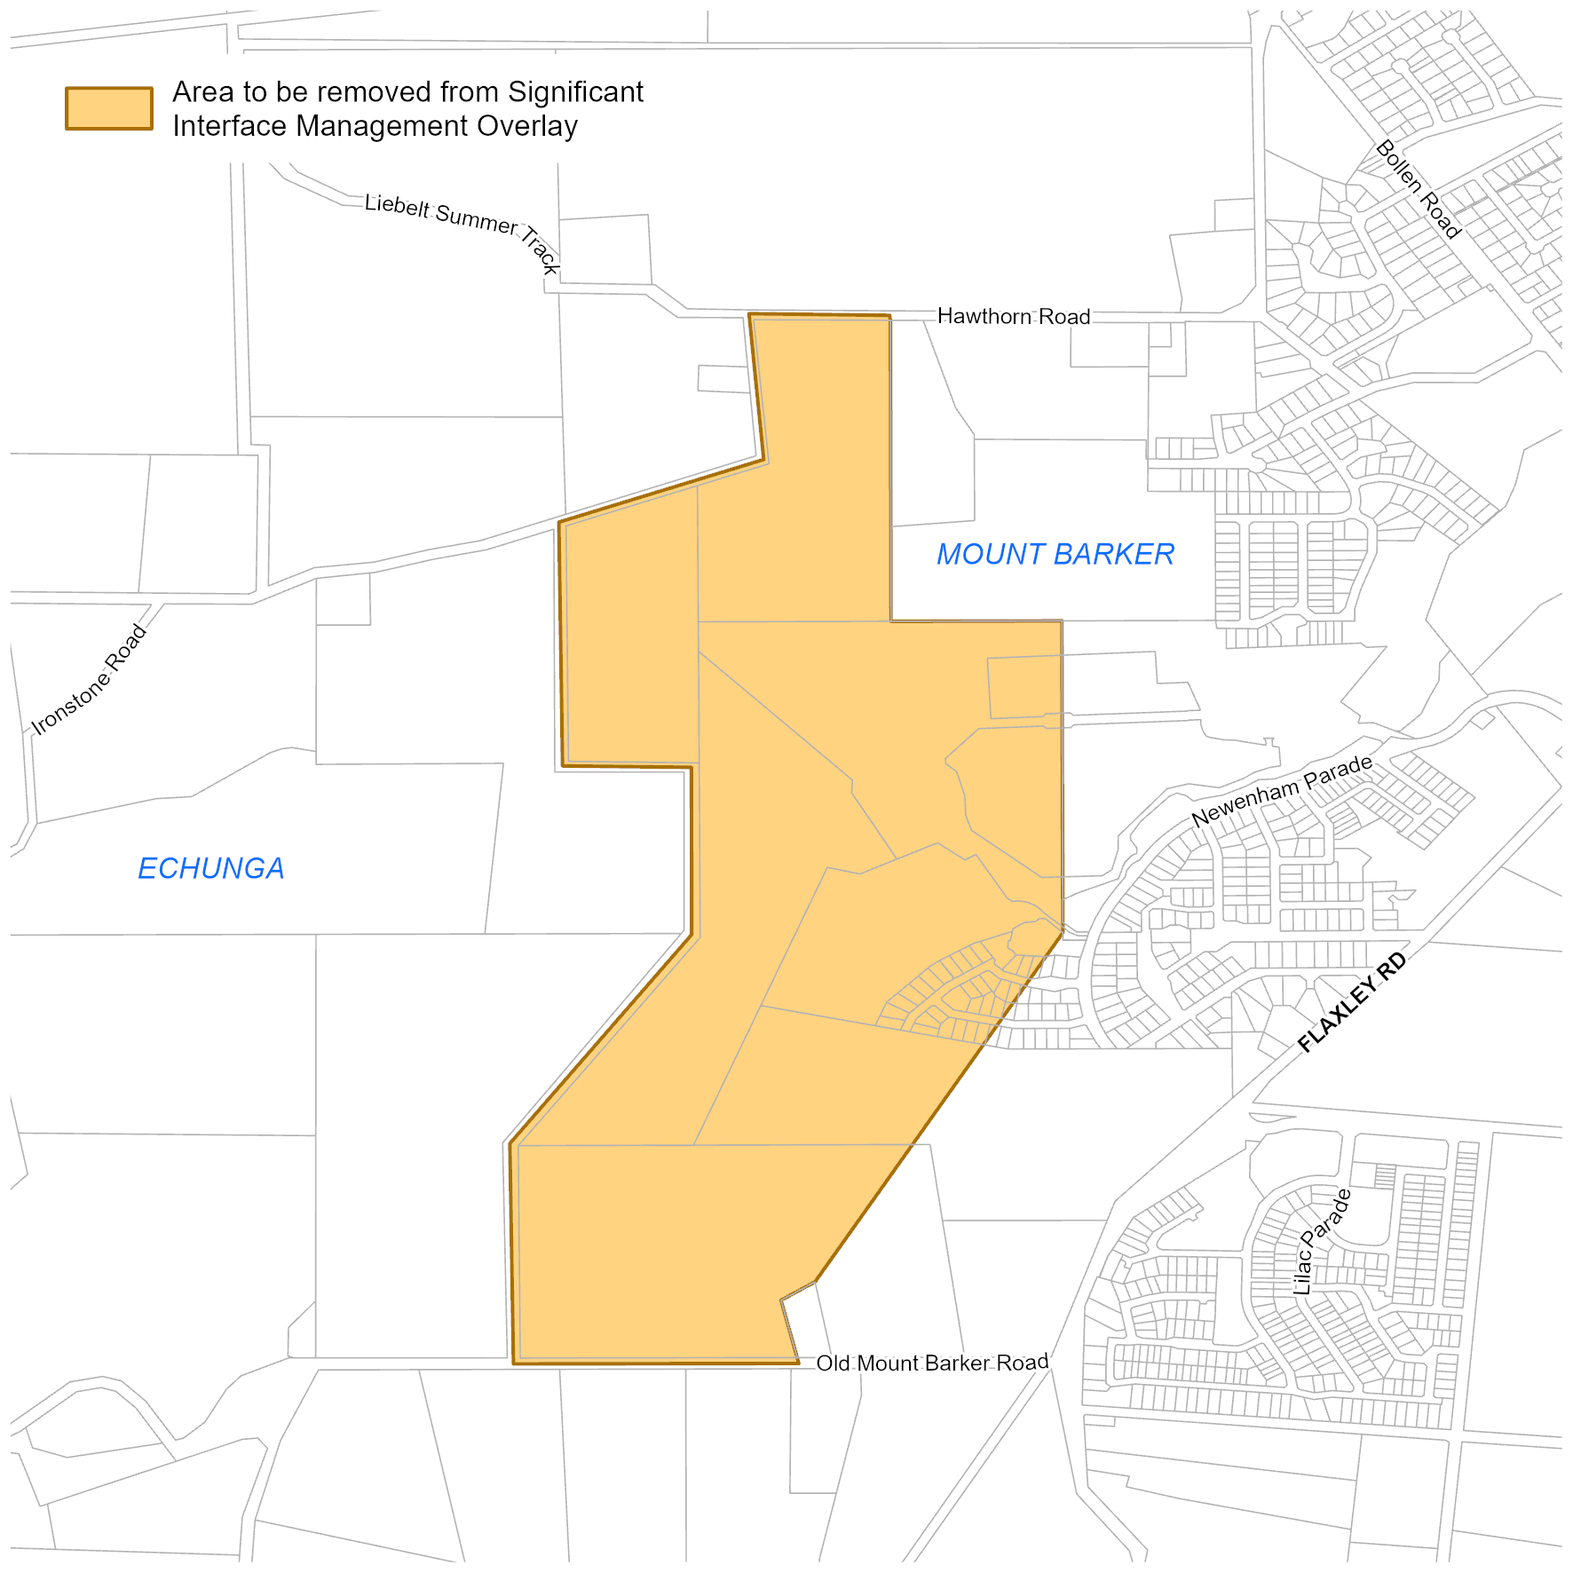
Attachment A
Note: For a coloured version of this map please refer to the online version of this gazette notice at https://www.governmentgazette.sa.gov.au/

Roads (Opening and Closing) Act 1991
Section 24
NOTICE OF CONFIRMATION OF
ROAD PROCESS ORDER
Road Closure—Portion of Buchanan Street, Clare
By Road Process Order made on 25 June 2025, the Clare and Gilbert Valleys Council ordered that:
1. Portion of Buchanan Street, Clare, situated adjoining Allotment 4 in Filed Plan 14299, Hundred of Clare, more particularly delineated and lettered ‘A’ in Preliminary Plan 24/0025 be closed.
2. Transfer the whole of the land subject to closure to Sam Mac Property Pty. Ltd. (ACN: 639 115 316) in accordance with the Agreement for Transfer dated 18 June 2025 entered into between the Clare and Gilbert Valleys Council and Sam Mac Property Pty. Ltd.
(ACN: 639 115 316).
3. The following easement is to be granted over portions of the land subject to closure:
Grant to Clare and Gilbert Valleys Council a right of way for access purposes over the land marked ‘A’ in Deposited Plan 137538.
On 23 February 2026 that order was confirmed by the Minister for Planning conditionally upon the deposit by the Registrar-General of Deposited Plan 137538 being the authority for the new boundaries.
Pursuant to Section 24 of the Roads (Opening and Closing) Act 1991, notice of the order referred to above and its confirmation is hereby given.
Dated: 26 February 2026
B. J. Slape
Surveyor-General
2024/05702/01

Roads (Opening and Closing) Act 1991
Section 24
NOTICE OF CONFIRMATION OF
ROAD PROCESS ORDER
Road Closure—Portion of Warren Road, Two Wells
By Road Process Order made on 6 August 2025, the Adelaide Plains Council ordered that:
1. Portion of Warren Road, Two Wells, situated adjoining Sections 232 and 459, Hundred of Port Gawler, more particularly lettered ‘A’ in Preliminary Plan 24/0040 be closed.
2. Transfer the whole of the land subject to closure to Hickinbotham Development (Two Wells No 1) Pty. Ltd. in accordance with the Agreement for Transfer dated 6 August 2025 entered into between the Adelaide Plains Council and Hickinbotham Development
(Two Wells No 1) Pty. Ltd.
On 23 February 2026 that order was confirmed by the Minister for Planning conditionally upon the deposit by the Registrar-General of Deposited Plan 138432 being the authority for the new boundaries.
Pursuant to Section 24(5) of the Roads (Opening and Closing) Act 1991, Notice of the Order referred to above and its confirmation is hereby given.
Dated: 26 February 2026
B. J. Slape
Surveyor-General
2024/08545/01

Roads (Opening and Closing) Act 1991
Section 24
NOTICE OF CONFIRMATION OF
ROAD PROCESS ORDER
Road Closure—Unmade Public Road, Willow Creek
By Road Process Order made on 5 December 2023, the District Council of Yankalilla ordered that:
1. Unmade Public Road, Willow Creek, situated adjoining allotment 57 and pieces comprising allotments 58 and 59, Hundred of Yankalilla and Waitpinga, more particularly lettered ‘A’ and ‘B’ in Preliminary Plan 23/0015 be closed.
2. Transfer the whole of the land subject to closure to Wesley Douglas Hurrell and Rita Hurrell in accordance with the Agreement for Transfer dated 22 November 2023 entered into between the District Council of Yankalilla and Wesley Douglas Hurrell and Rita Hurrell.
On 23 February 2026 that order was confirmed by the Minister for Planning conditionally upon the deposit by the Registrar-General of Deposited Plan 139675 being the authority for the new boundaries.
Pursuant to Section 24(5) of the Roads (Opening and Closing) Act 1991, notice of the Order referred to above and its confirmation is hereby given.
Dated: 26 February 2026
B. J. Slape
Surveyor-General
2023/05235/01

Local Government Instruments

City of Adelaide
Kadaltilla/Adelaide Park Lands Authority (a Subsidiary of the City of Adelaide)
Notice of Appointments
The City of Adelaide, pursuant to Division 2 of Part 2 of the Adelaide Park Lands Act 2005 (the Act) and Council resolution of 10 February 2026, having undertaken the required consultation with the Minister for Planning, appoints the following people as members of the Board of Management of the Kadaltilla/Adelaide Park Lands Authority:
For the purposes of Section 6(1)(a)(ii) of the Act:
Tim Agius as Member of the Board
For the purposes of Section 6(6) of the Act:
Allan Sumner as Deputy Board Member for Tim Agius.
Pursuant to Section 7(2) of the Act, Council appoints the above persons until 31 December 2028.
Dated: 24 February 2026
Michael Sedgman
Chief Executive Officer

City of Port Lincoln
Revocation of Community Land Classification
Notice is hereby given that the City of Port Lincoln resolved, at its meeting held on 16 February 2026 and with the consent of the Minister for Local Government, to revoke the community land classification of the parcels of land listed below, pursuant to Section 194 of the Local Government Act 1999:
• Allotment 70 Deposited Plan 11045 comprised in Certificate of Title Volume 5796 Folio 568, known as 25 Chapman Street Port Lincoln;
• Allotment 76 Deposited Plan 116510 comprised in Certificate of Title Volume 6210 Folio 879, known as Seaview Park, Monalena Street Port Lincoln; and
• Allotment 53 in Deposited Plan 4606 comprised in Certificate of Title Volume 2058 Folio 124, known as Trigg Street Reserve, Willison Street Port Lincoln.
Dated: 26 February 2026
Eric Brown
Chief Executive Officer

City of Unley
Roads (Opening and Closing) Act 1991
Road Closing—Mary Place, Unley
Notice is hereby given, pursuant to Section 10 of the Roads (Opening and Closing) Act 1991 that the City of Unley proposes to make a Road Process Order to close and merge with allotment 2 in F13919 the portion of Mary Place adjoining allotments 4 to 6 in F13919, more particularly delineated and lettered ‘A’ on Preliminary Plan 25/0034.
The Preliminary Plan is available for public inspection at the City of Unley located at 181 Unley Road, Unley and the Adelaide Office of the Surveyor-General located at Level 10, 83 Pirie Street Adelaide, during normal office hours. The Preliminary Plan can also be viewed at www.sa.gov.au/roadsactproposals.
Any application for easement or objection must set out the full name, address and details of the submission and must be fully supported by reasons. The application for easement or objection must be made in writing to the City of Unley, PO Box 1, Unley SA 5061, within 28 days of this notice and a copy must be forwarded to the Surveyor-General at GPO Box 1815, Adelaide 5001. Where a submission is made, the applicant must be prepared to support their submission in person upon council giving notification of a meeting at which the matter will be considered.
Dated: 26 February 2026
Peter Tsokas
Chief Executive Officer

City of West Torrens
Notice of Application of Local Government Land By-law
Notice is hereby given that at its meeting held on 17 February 2026, pursuant to the power contained in Section 246(3)(e) of the Local Government Act 1999 Council resolved the specific locations to which certain provisions of its By-law 2: Local Government Land apply:
(a) subparagraph 4.6.1.3 shall apply to all waters on local government land;
(b) subparagraph 4.8 shall apply to all waters on local government land;
(c) subparagraph 4.10 shall apply to all waters on local government land;
(d) subparagraph 4.20.1 shall apply to all waters on local government land;
(e) subparagraph 4.20.2 shall apply to all bridges and structures on local government land;
(f) subparagraph 4.28.2 shall apply to the West Torrens Memorial Gardens (Certificate of Title Volume 2437 Folio 129);
(g) subparagraph 4.32.2 shall apply to all local government land;
(h) subparagraph 4.32.3 shall apply to all local government land;
(i) subparagraph 4.46.1 shall apply to all local government land, and:
A. permission will not be granted for the activities specified in subparagraph 4.46.1 of the Local Government Land By-law 2024 to take place in West Torrens Memorial Gardens (Certificate of Title Volume 2437 Folio 129); and
B. notwithstanding (i)(A) above, memorial events may be held in the West Torrens Memorial Gardens subject to the discretion and approval of the CEO (or delegate);
(j) subparagraph 4.46.2 shall apply to all local government land, and:
A. permission will not be granted for the activities specified in subparagraph 4.46.2 of the Local Government Land By-law 2024 to take place in West Torrens Memorial Gardens (Certificate of Title Volume 2437 Folio 129; and
B. notwithstanding recommendation (j)(A) above, a marquee, stage or structure may be approved for erection in the West Torrens Memorial Gardens for Memorial events, subject to the discretion and approval of the CEO (or delegate).
Notice of Application of Dogs By-law
Notice is hereby given that at its meeting held on 17 February 2026, pursuant to the power contained in Section 246(3)(e) Council resolved the specific locations to which certain provisions of its By-law 5:Dogs apply:
The following areas are ‘Dog Free Areas’ for the purposes of subparagraph 4.1:
(a) the following areas are ‘Dog Free Areas’ for the purposes of subparagraph 4.1:
A. all fenced playgrounds at the following locations:
(i) Apex Park, West Beach (Certificate of Title Volume 5763 Folio 915);
(ii) Beare Avenue Reserve, Ramsey Street, Netley (Certificate of Title Volume 5678 Folio 881);
(iii) Coast Watchers Reserve, Coral Sea Road, Fulham (Certificate of Title Volume 3856 Folio 114);
(iv) College Grove Reserve, Lipsett Terrace, Brooklyn Park (Certificate of Title Volume 5713 Folio 495);
(v) Cromer Street Reserve, Camden Park (Certificate of Title Volume 5835 Folio 968);
(vi) Dove Street Reserve, Dew Street, Thebarton (Certificate of Title Volume 5218 Folio 560, Certificate of Title Volume 5706 Folio 288, Certificate of Title Volume 5797 Folio 293, Certificate of Title Volume 5807 Folio 344, Certificate of Title Volume 5218 Folio 561);
(vii) Frank Norton Reserve, Fairfax Terrace, Torrensville (Certificate of Title Volume 5657 Folio 421);
(viii) Fulham Community Centre, Fitch Road, Fulham (Certificate of Title Volume 5344 Folio 959);
(ix) Golflands Reserve, Aroona Avenue, Glenelg North (Certificate of Title Volume 5519 Folio 21);
(x) Grassmere Reserve, Cross Terrace, Kurralta Park (Certificate of Title Volume 5542 Folio 516);
(xi) Rex Jones Reserve, Talbot Avenue, North Plympton (Certificate of Title Volume 5839 Folio 165);
(xii) Sandringham Reserve, Kinkaid Avenue, North Plympton (Certificate of Title Volume 5998 Folio 425);
(xiii) Weigall Oval, Birdwood Terrace, Plympton (Certificate of Title Volume 5865 Folio 249);
(xiv) Westside Bikeway Reserve, Creslin Terrace, Camden Park (Certificate of Title Volume 5499 Folio 799);
B. Clifford Street Reserve, Torrensville (Certificate of Title Volume 5775 Folio 663);
C. Plympton Community Garden, Plympton (Certificate of Title Volume 5454 Folio 76);
D. Kurralta Park Community Garden, Kurralta Park (Certificate of Title Volume 5542 Folio 516); and
E. Netley Community Garden, Netley (Certificate of Title Volume 6137 Folio 601).
‘Dog on Leash Areas’ for the purposes of subparagraph 5.1 shall apply on all local government land where a sign is erected identifying the area as requiring dogs to be on leash.
The following areas are ‘Dog Exercise Areas’ for the purposes of subparagraph 6.1:
• West Torrens Dog Park, Torrensville (Certificate of Title Volume 5710 Folio 643);
• West Torrens Dog Park, Marleston (Certificate of Title Volume 6052 Folio 101); and
• Clifford Street Dog Park, Torrensville (Certificate of Title Volume 5775 Folio 663).
Further information regarding the areas described above in the Council’s area and Council’s by-laws are available on the Policies, codes, by-laws and terms of reference page on Council’s website westtorrens.sa.gov.au and at the Council’s Civic Centre at 165 Sir Donald Bradman Drive, Hilton during business hours.
Dated: 24 February 2026
Angelo Catinari
Chief Executive Officer

Public Notices

National Electricity Law
Notice of Initiation of Non-Controversial Rule Change Request
The Australian Energy Market Commission (AEMC) gives notice under the National Electricity Law as follows:
Under s 95, AEMO has requested the Consultation requirements for the Metrology Procedures (Ref. ERC0409) proposal. The proposal seeks to remove the mandatory three-month period between the publication and commencement of amendments under the Metrology Procedures. The AEMC intends to expedite the proposal under s 96 as it considers the proposed Rule is non-controversial, subject to requests not to do so. Written requests not to expedite the proposal must be received by 12 March 2026. Submissions must be received by 26 March 2026.
Under s 95, AEMO has requested the Refining the eligibility requirements for Secondary Settlement Points (Ref. ERC0413) proposal. The proposal seeks to allow Victorian Advanced Metering Infrastructure installations to also establish secondary settlement points, and other minor amendments. The AEMC intends to expedite the proposal under s 96 as it considers the proposed Rule is non-controversial, subject to requests not to do so. Written requests not to expedite the proposal must be received by 12 March 2026. Submissions must be received by 26 March 2026.
Under s 95, AEMO has requested the Flexible communication requirements for SAPS generation connection points (Ref. ERC0414) proposal. The proposal seeks to provide flexibility to use type 4A (manual-read) meters for standalone power system (SAPS) generation points with a single generator connection. The AEMC intends to expedite the proposal under s 96 as it considers the proposed Rule is non-controversial, subject to requests not to do so. Written requests not to expedite the proposal must be received by 12 March 2026. Submissions must be received by 26 March 2026.
Submissions can be made via the AEMC’s website. Before making a submission, please review the AEMC’s privacy statement on its website, and consider the AEMC’s Tips for making a submission. The AEMC publishes submissions on its website, subject to confidentiality and other considerations.
Written requests should be sent to submissions@aemc.gov.au and cite the reference in the title. Before sending a request, please review the AEMC’s privacy statement on its website.
Documents referred to above are available on the AEMC’s website and are available for inspection at the AEMC’s office.
Australian Energy Market Commission
Level 15, 60 Castlereagh St
Sydney NSW 2000
Telephone: (02) 8296 7800
www.aemc.gov.au
Dated: 26 February 2025

National Energy Retail Law
Notice of Final Determination Extension
The Australian Energy Market Commission (AEMC) gives notice under the National Energy Retail Law as follows:
Under s 266, the time for the making of the final determination on the Establishing a regulatory framework for retail customer initiated gas abolishment (Ref. RRC0068) proposal has been extended to 2 April 2026.
Australian Energy Market Commission
Level 15, 60 Castlereagh St
Sydney NSW 2000
Telephone: (02) 8296 7800
www.aemc.gov.au
Dated: 26 February 2026

National Gas Law
Notice of Draft Determination
Notice of Draft Determination and Draft Rule
Notice of Final Determination Extension
The Australian Energy Market Commission (AEMC) gives notice under the National Gas Law as follows:
Under s 308, the making of a draft determination and related draft rule on the ECGS Enhancing Reliability and Supply Adequacy Arrangements (Ref. GRC0076) proposal. Written requests for a pre-determination hearing must be received by 5 March 2026. Submissions must be received by 9 April 2026.
Under s 308, the making of a draft determination and related draft rule on ECGS supplier of last resort mechanism (Ref. GRC0077) proposal. Written requests for a pre-determination hearing must be received by 5 March 2026. Submissions must be received by 23 April 2026.
Under s 317, the time for the making of the final determination on the Establishing a regulatory framework for retail customer initiated gas abolishment (Ref. GRC0086) proposal has been extended to 2 April 2026.
Submissions can be made via the AEMC’s website. Before making a submission, please review the AEMC’s privacy statement on its website, and consider the AEMC’s Tips for making a submission. The AEMC publishes all submissions on its website, subject to confidentiality.
Written requests should be sent to submissions@aemc.gov.au and cite the reference in the title. Before sending a request, please review the AEMC’s privacy statement on its website.
Documents referred to above are available on the AEMC’s website and are available for inspection at the AEMC’s office.
Australian Energy Market Commission
Level 15, 60 Castlereagh St
Sydney NSW 2000
Telephone: (02) 8296 7800
www.aemc.gov.au
Dated: 26 February 2026

Trustee Act 1936
Deceased Estate
Notice to Creditors and Claimants
Antonio Marano late of 2A Marlborough Street College Park SA 5069, deceased who died on 3 November 1998 in South Australia.
All creditors, beneficiaries and other persons having claims (to which Section 29 of the Trustee Act 1936 (SA)) relates, against the above estate are required to send in writing to the Trustee of Antonio Marano deceased, Nicola Minicozzi, Post Office Box 182 Stepney South Australia 5069 and by email to nic@minicozzi.com.au, full particulars and proof of such claims within thirty (30) days of the date of publication hereof, after which date the Trustee will proceed to distribute the estate amongst the persons entitled thereto having regard only to the claims of which the Trustee then has notice.
Dated: 23 February 2026
Nic Minicozzi
Nimlaw Pty Ltd Trading as Minicozzi Lawyers

Trustee Act 1936
Deceased Estate
Notice to Creditors and Claimants
Howard Scott Hastings late of 36 Dulkara Avenue, Mount Gambier, SA 5290, died on 1 October 2025. Probate of his will was granted in South Australia on 11 February 2026.
Notice is hereby given pursuant to the Trustee Act 1936 (SA), the Succession Act 2023 (SA) and the Family Relationships Act 1975 (SA) that all creditors, beneficiaries, and other persons having claims against the estate of the abovenamed deceased are required to send in writing to the executors of the estate, John Steven Kyrimis and Fiona Anne Hastings Hyde, care of Kyrimis Lawyers Pty Ltd of
256 Commercial Street West, Mount Gambier SA 5290, full particulars and proof of such claims within twenty eight (28) days of the date of publication hereof, after which date the executors may proceed to distribute the estate among the persons entitled thereto having regard only to the claims of which the executors then have notice.
Dated: 26 February 2026
Kyrimis Lawyers Pty Ltd
Solicitors for the Executors

Notice Submission

The South Australian Government Gazette is published each Thursday afternoon.
Notices must be emailed by 4 p.m. Tuesday, the week of publication.
Submissions are formatted per the gazette style and a proof will be supplied prior to publication, along with a quote if applicable. Please allow one day for processing notices.
Alterations to the proof must be returned by 4 p.m. Wednesday.

Gazette notices must be submitted as Word files, in the following format:
• Title—the governing legislation
• Subtitle—a summary of the notice content
• Body—structured text, which can include numbered lists, tables, and images
• Date—day, month, and year of authorisation
• Signature block—name, role, and department/organisation authorising the notice

Please provide the following information in your email:
• Date of intended publication
• Contact details of the person responsible for the notice content
• Name and organisation to be charged for the publication—Local Council and Public notices only
• Purchase order, if required—Local Council and Public notices only

Email: governmentgazettesa@sa.gov.au
Phone: (08) 7133 3552
Website: www.governmentgazette.sa.gov.au

All instruments appearing in this gazette are to be considered official, and obeyed as such

Printed and published weekly by authority of T. Foresto, Government Printer, South Australia
$9.50 per issue (plus postage), $479.00 per annual subscription—GST inclusive
Online publications: www.governmentgazette.sa.gov.au

