
No. 1 p. 1
THE SOUTH AUSTRALIAN
GOVERNMENT GAZETTE
Published by Authority

Adelaide, Thursday, 8 January 2026

Contents

State Government Instruments
Associations Incorporation Act 1985 2
Building Work Contractors Act 1995 2
Employment Agents Registration Act 1993 4
Health Care Act 2008 4
National Parks and Wildlife Act 1972 4
Planning, Development and Infrastructure Act 2016 5
Roads (Opening and Closing) Act 1991 5
Summary Offences Act 1953 5
Work Health and Safety Regulations 2012 6
Local Government Instruments
Rural City of Murray Bridge 7
City of Tea Tree Gully 7
City of Unley 7
District Council of Mount Remarkable 7
Renmark Paringa Council 9
Public Notices
Rail Safety National Law National Regulations 2012 14

State Government Instruments

Associations Incorporation Act 1985
Section 43A
Deregistration of Associations
Notice is hereby given that the Corporate Affairs Commission approves the applications for deregistration received from the associations named below pursuant to Section 43A of the Associations Incorporation Act 1985 (SA). Deregistration takes effect on the date of publication of this notice:
SPECIAL NEEDS FOR YORKE PENINSULA INCORPORATED (A11103)
COUNCIL FOR HUMAN RIGHTS EDUCATION (SA CHAPTER) INCORPORATED (A41715)
EYRE PENINSULA FARMER AND FISHERMENS MARKET INCORPORATED (A39769)
GOOLWA TOURISM 5214 INCORPORATED (A43391)
SOUTH AUSTRALIAN VIETNAMESE BUSINESS ASSOCIATION INCORPORATED (A44726)
STUDENT REPRESENTATIVE COUNCIL (ADELAIDE) INCORPORATED (A40326)
BAROSSA TRUST MARK INCORPORATED (A41898)
TOURISM BAROSSA INCORPORATED (A39901)
SOUTH AUSTRALIAN GERMAN CULTURAL FESTIVALS INCORPORATED (A42146)
PENOLA TOWN SQUARE WORKING GROUP INCORPORATED (A44615)
INTERNATIONAL COALITION4CHILDREN INCORPORATED (A45590)
Given under the seal of the Commission at Adelaide.
Dated: 8 January 2026
Kirsty Lawrence
Team Leader, Gambling and Associations
A delegate of the Corporate Affairs Commission

Building Work Contractors Act 1995
Exemption
Take notice that, pursuant to Section 45 of the Building Work Contractors Act 1995, I, Brett Humphrey as a delegate for the Minister for Consumer and Business Affairs, do hereby exempt the licensee named in Schedule 1 from the application of Division 3 of Part 5 of the above Act in relation to domestic building work described in Schedule 2 and subject to the conditions specified in Schedule 3.
Schedule 1
ANTHONY RUBESSA (BLD 264717)
Schedule 2
Construction of a single storey detached dwelling with basement at Allotment 14, Deposited Plan 625, being a portion of the land described in Certificate of Title Volume 5226 Folio 755, more commonly known as 40 Pulsford Road, Prospect SA 5082.
Schedule 3
1. This exemption is limited to domestic building work personally performed by the licensee in relation to the building work described in Schedule 2.
2. This exemption does not apply to any domestic building work the licensee contracts to another building work contractor, for which that contractor is required by law to hold building indemnity insurance.
3. That the licensee does not transfer his interest in the land prior to five years from the date of completion of the building work the subject of this exemption, without the prior authorisation of Consumer and Business Services (CBS). Before giving such authorisation, CBS may require the licensee to take any reasonable steps to protect the future purchaser(s) of the property, including but not limited to:
• Providing evidence that an adequate policy of building indemnity insurance is in force to cover the balance of the five-year period from the date of completion of the building work the subject of this exemption;
• Providing evidence of an independent expert inspection of the building work the subject of this exemption;
• Making an independent expert report available to prospective purchasers of the property;
• Giving prospective purchasers of the property notice of the absence of a policy of building indemnity insurance.
Dated: 2 January 2026
Brett Humphrey
Commissioner for Consumer Affairs
Delegate for the Minister for Consumer and Business Affairs

Building Work Contractors Act 1995
Exemption
Take notice that, pursuant to Section 45 of the Building Work Contractors Act 1995, I, Brett Humphrey as a delegate for the Minister for Consumer and Business Affairs, do hereby exempt the licensee named in Schedule 1 from the application of Division 3 of Part 5 of the above Act in relation to domestic building work described in Schedule 2 and subject to the conditions specified in Schedule 3.
Schedule 1
CODY JAMES SPEIRS (BLD 182391)
Schedule 2
Construction of a single storey detached dwelling Allotment 3 Deposited Plan 22688, being a portion of the land described in Certificate of Title Volume 5523 Folio 253, more commonly known as 52 Bayview Road, American River SA 5221.
Schedule 3
1. This exemption is limited to domestic building work personally performed by the licensee in relation to the building work described in Schedule 2.
2. This exemption does not apply to any domestic building work the licensee contracts to another building work contractor, for which that contractor is required by law to hold building indemnity insurance.
3. That the licensee does not transfer his interest in the land prior to five years from the date of completion of the building work the subject of this exemption, without the prior authorisation of Consumer and Business Services (CBS). Before giving such authorisation, CBS may require the licensee to take any reasonable steps to protect the future purchaser(s) of the property, including but not limited to:
• Providing evidence that an adequate policy of building indemnity insurance is in force to cover the balance of the five-year period from the date of completion of the building work the subject of this exemption;
• Providing evidence of an independent expert inspection of the building work the subject of this exemption;
• Making an independent expert report available to prospective purchasers of the property;
• Giving prospective purchasers of the property notice of the absence of a policy of building indemnity insurance.
Dated: 23 December 2025
Brett Humphrey
Commissioner for Consumer Affairs
Delegate for the Minister for Consumer and Business Affairs

Building Work Contractors Act 1995
Exemption
Take notice that, pursuant to Section 45 of the Building Work Contractors Act 1995, I, Brett Humphrey as a delegate for the Minister for Consumer and Business Affairs, do hereby exempt the licensee named in Schedule 1 from the application of Division 3 of Part 5 of the above Act in relation to domestic building work described in Schedule 2 and subject to the conditions specified in Schedule 3.
Schedule 1
KANE DANIELS (BLD 341852)
Schedule 2
Construction of a single storey addition to an existing dwelling at Allotment 7, Filed Plan 103852, being a portion of the land described in Certificate of Title Volume 5139 Folio 95, more commonly known as 59 King Street, Alberton SA 5014.
Schedule 3
1. This exemption is limited to domestic building work personally performed by the licensee in relation to the building work described in Schedule 2.
2. This exemption does not apply to any domestic building work the licensee contracts to another building work contractor, for which that contractor is required by law to hold building indemnity insurance.
3. That the licensee does not transfer his interest in the land prior to five years from the date of completion of the building work the subject of this exemption, without the prior authorisation of Consumer and Business Services (CBS). Before giving such authorisation, CBS may require the licensee to take any reasonable steps to protect the future purchaser(s) of the property, including but not limited to:
• Providing evidence that an adequate policy of building indemnity insurance is in force to cover the balance of the five-year period from the date of completion of the building work the subject of this exemption;
• Providing evidence of an independent expert inspection of the building work the subject of this exemption;
• Making an independent expert report available to prospective purchasers of the property;
• Giving prospective purchasers of the property notice of the absence of a policy of building indemnity insurance.
Dated: 23 December 2025
Brett Humphrey
Commissioner for Consumer Affairs
Delegate for the Minister for Consumer and Business Affairs

Building Work Contractors Act 1995
Exemption
Take notice that, pursuant to Section 45 of the Building Work Contractors Act 1995, I, Brett Humphrey as a delegate for the Minister for Consumer and Business Affairs, do hereby exempt the licensee named in Schedule 1 from the application of Division 3 of Part 5 of the above Act in relation to domestic building work described in Schedule 2 and subject to the conditions specified in Schedule 3.
Schedule 1
STEVEN JOSEPH MINICOZZI (BLD 288403)
Schedule 2
Construction of a single storey addition to an existing dwelling at Allotment 1, Deposited Plan 17480, being a portion of the land described in Certificate of Title Volume 5087 Folio 994, more commonly known as 50 Gardiner Street, St Morris SA 5068.
Schedule 3
1. This exemption is limited to domestic building work personally performed by the licensee in relation to the building work described in Schedule 2.
2. This exemption does not apply to any domestic building work the licensee contracts to another building work contractor, for which that contractor is required by law to hold building indemnity insurance.
3. That the licensee does not transfer his interest in the land prior to five years from the date of completion of the building work the subject of this exemption, without the prior authorisation of Consumer and Business Services (CBS). Before giving such authorisation, CBS may require the licensee to take any reasonable steps to protect the future purchaser(s) of the property, including but not limited to:
• Providing evidence that an adequate policy of building indemnity insurance is in force to cover the balance of the five-year period from the date of completion of the building work the subject of this exemption;
• Providing evidence of an independent expert inspection of the building work the subject of this exemption;
• Making an independent expert report available to prospective purchasers of the property;
• Giving prospective purchasers of the property notice of the absence of a policy of building indemnity insurance.
Dated: 23 December 2025
Brett Humphrey
Commissioner for Consumer Affairs
Delegate for the Minister for Consumer and Business Affairs

Employment Agents Registration Act 1993
Exemption
Notice is hereby given that, pursuant to Section 4(1) of the Employment Agents Registration Act 1993, I, Kyam Maher MLC, Deputy Premier, Minister for Industrial Relations and Public Sector, hereby exempt 1Medical Ltd Pty of New South Wales (L11/1-Spring Street, Sydney, NSW 2000) from:
• Section 7(3) of the Employment Agents Registration Act 1993 (SA) in relation to the requirement that, in making an application for a licence, the applicant must furnish the name of a natural person, who is a resident of the State and is to act as manager of the business;
• Section 11(1) of the Employment Agents Registration Act 1993 (SA) in relation to the requirement that the business conducted in pursuance of the licence must be managed under the personal supervision of a natural person who is a resident of the State;
• Section 16(1) of the Employment Agents Registration Act 1993 (SA) in relation to the requirement that the holder of a licence must not carry on the business of an employment agent except at premises registered under this section;
• Section 17 of the Employment Agents Registration Act 1993 (SA) in relation to the requirement that a person carrying on business as an employment agent in pursuance of a licence must maintain in a conspicuous position at any registered premise a notice clearly displaying the name of the agent as it appears in the licence or a registered business name in which the agent carries on business as an agent and if a manager has been appointed, the name of the manager of the business;
• Section 19(1) of the Employment Agents Registration Act 1993 (SA) in relation to the requirement to display a notice clearly showing the scale of fees for the time being chargeable by the agent in respect of his or her business at the registered premises; and
• Section 22 of the Employment Agents Registration Act 1993 (SA) in relation to Records etc to be kept.
Dated: 23 December 2025
Hon Kyam Maher MLC
Deputy Premier
Minister for Industrial Relations and Public Sector

Health Care Act 2008
Fees and Charges
I, Chris Picton, Minister for Health and Wellbeing, pursuant to Section 99A of the Health Care Act 2008, hereby give notice that the fee to apply for the purposes of Section 58(10) of the Health Care Act 2008 for the transfer of a restricted ambulance service licence is $824. This fee will operate from 23 December 2025 to 30 June 2026.
Dated: 23 December 2025
Chris Picton MP
Minister for Health and Wellbeing

National Parks and Wildlife Act 1972
Kauwi-marnirla—Field River Conservation Park Management Plan—Draft
I, Michael Joseph Williams, Director of National Parks and Wildlife, hereby give notice under the provisions of Section 38 of the National Parks and Wildlife Act 1972 that a draft management plan has been prepared for Kauwi-marnirla—Field River Conservation Park.
Copies of the draft plan may be obtained from:
- Department for Environment and Water Customer Service Centre, Ground Floor, 81-95 Waymouth Street, Adelaide SA 5000
- Glenthorne Ranger Station, 2 Majors Road, O’Halloran Hill SA 5158
Or online at:
- https://yoursay.sa.gov.au/
- https://www.parks.sa.gov.au/park-management/management-plans
Any person may make representations in connection with the draft plan during the period up to and including 5pm 30 April 2026.
Written comments should be forwarded to Protected Area Policy Unit, Department for Environment and Water, GPO Box 1047 Adelaide SA 5001 or e-mailed to DEWProtectedAreaManagement@sa.gov.au .
Dated: 8 December 2025
M. J. Williams
Director of National Parks and Wildlife
Delegate of the Minister for Climate, Environment and Water

Planning, Development and Infrastructure Act 2016
Section 131(25)
Pursuant to Section 131(25) Planning, Development and Infrastructure Act 2016, I direct that an Environmental Impact Statement be prepared with respect to the proposed development (known as the Northern Water Project) referred to in Development Application No 25038619 lodged with the State Planning Commission on 16 December 2025 by the Northern Water Project Delivery Office, Department for Infrastructure and Transport.
Dated: 22 December 2025
Hon Nick Champion MP
Minister for Planning

Roads (Opening and Closing) Act 1991
Section 24
NOTICE OF CONFIRMATION OF
ROAD PROCESS ORDER
Road Closure—Portion of Princes Highway, Littlehampton
By Road Process Order made on 4 September 2025, the Mount Barker District Council ordered that:
1. Portion of Princes Highway, Littlehampton, situated adjoining Allotment 98 in Filed Plan 160275, more particularly lettered ‘A’ in Preliminary Plan 24/0031 be closed.
2. Transfer the whole of the land subject to closure to 2 Childs Road Pty. Ltd. (ACN: 641 739 764) in accordance with the Agreement for Transfer dated 4 September 2025 entered into between the Mount Barker District Council and 2 Childs Road Pty Ltd.
On 22 December 2025 that order was confirmed by the Minister for Planning conditionally upon the deposit by the Registrar-General of Deposited Plan 137328 being the authority for the new boundaries.
Pursuant to Section 24(5) of the Roads (Opening and Closing) Act 1991, Notice of the Order referred to above and its confirmation is hereby given.
Dated: 22 December 2025
B. J. Slape
Surveyor-General
2024/06824/01

Summary Offences Act 1953
Declared Public Precincts
Notice of Ministerial Declaration
I, Kyam Joseph Maher, Attorney-General in the State of South Australia, being the Minister responsible for the administration of Part 14B—Declared Public Precincts of the Summary Offences Act 1953, DO HEREBY DECLARE pursuant to the provisions of Section 66N of the said Act that the area, comprised of more than one public place, within the following boundaries:
• northern boundary of North Terrace to western boundary of Montefiore Road;
• western Boundary of Montefiore Road to the southern bank of the River Torrens;
• southern bank of the River Torrens to eastern boundary of King William Road (adjacent to the King William Road Bridge;
• eastern boundary of King William Road to the northern boundary of North Terrace;
• northern boundary of North Terrace to the eastern boundary of Pulteney Street;
• eastern boundary of Pulteney Street to the southern boundary of Grenfell Street;
• southern boundary of Grenfell Street and Currie Streets to the Western boundary of West Terrace;
• western boundary of West Terrace to northern boundary of North Terrace;
will be a Declared Public Precinct for a period of 12 hours from 6pm on each Friday and Saturday, commencing Friday 9 January 2026
to be a Declared Public Precinct for a period of 4 hours from 6pm to 10pm every Sunday commencing Sunday 11 January 2026.
to be a Declared Public Precinct for a period of 12 hours from 10am on each Monday, Tuesday, Wednesday and Thursday, commencing Monday 12 January 2026.
This declaration will cease to have effect at 10pm Thursday 9 July 2026.
References to boundaries identified by streets, roads or terraces for the purpose of this declaration will be taken to mean and include the area up to applicable building or fence lines, or the imagined projection thereof, on the relevant boundary.
I am satisfied that there is, during the period specified in this declaration, a reasonable likelihood of conduct in the area posing a risk to public order and safety.
I am satisfied that the inclusion of each public place in the area is reasonable having regard to that identified risk.
Dated: 4 January 2026
Kyam Joseph Maher
Attorney-General

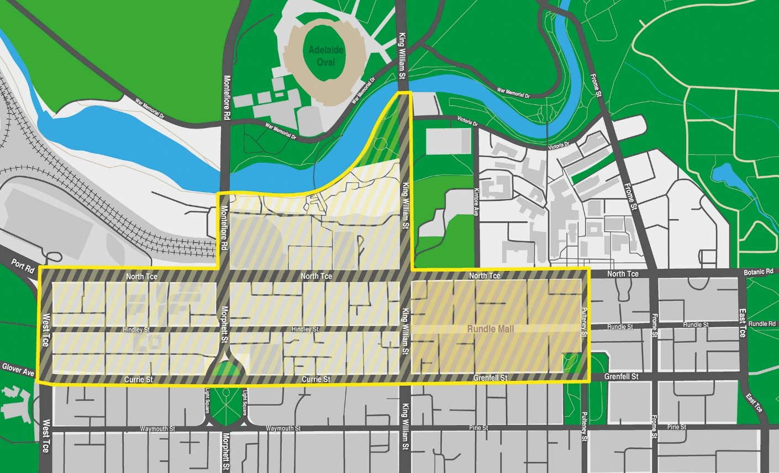

Work Health and Safety Regulations 2012
Exemption
Pursuant to Regulation 684 of the Work Health and Safety Regulations 2012 (WHS Regulations), I have determined on my own initiative to grant an exemption from Regulation 529D, in specific circumstances, to enable the reinstallation of an existing engineered stone benchtop, panel or slab that was removed in order for repair or other work to be undertaken in the location.
This exemption is applicable to persons with management or control of undertaking work to remove and reinstall an existing engineered stone benchtop, panel or slab in order to undertake repair or other work in the location.
The purpose of Regulation 529D is to prohibit a person conducting a business or undertaking (PCBU) to carry out, or direct or allow a worker to carry out, work that involves manufacturing, supplying, processing or installing engineered stone benchtops, panels or slabs.
I have considered circumstances where work is required to remove an existing engineered stone benchtop, panel or slab in order for repair or other work to be undertaken in the location and the reinstallation of the existing engineered stone benchtop, panel or slab is required.
I have had regard to the risks associated with the reinstallation of the existing engineered stone benchtop, panel or slab in limited circumstances. I have determined that placing conditions on the exemption will ensure there is no increase in risk as a result of this exemption.
In accordance with the provisions of Regulation 684(1) of the WHS Regulations, an exemption has been granted from Regulation 529D on the following conditions:
1. The exemption only applies to the reinstallation of an existing engineered stone benchtop, panel or slab:
• associated with repair or modification of underlying cabinetry or supporting structure, or to give access to repair or modify some underlying component;
• in the same location from which it was removed; and
• at the same address from which it was removed.
2. The exemption does not allow the installation of a replacement engineered stone benchtop, panel or slab if for any reason the original engineered stone benchtop, panel or slab cannot be reinstalled.
3. The relevant PCBU must:
• ensure the processing of engineered stone when reinstalling is limited to minor modification only as per Regulation 529F
• ensure the processing of engineered stone is controlled in accordance with Regulation 529B
• if processing is required, notify the Regulator of the work being undertaken in accordance with Regulation 529G.
This exemption commences on 31 March 2026 and is valid until 30 March 2027.
Dated: 23 December 2025
Glenn Farrell
Executive Director
SafeWork SA

Local Government Instruments

Rural City of Murray Bridge
Assigning of Road Name
Notice is hereby given that the Rural City of Murray Bridge has resolved, pursuant to Section 219(4) of the Local Government Act 1999, to assign the following names to roads within the Council’s area:
Gem Avenue, Grace Court, Haines Court, Hero Way, Marion Court, Muscat Court, Oscar Avenue, Poppy Court, Rothbury Street, Wanera Street.
Further information including the location of each of these roads and the dates when the name was assigned is available at the Local Government Centre, 2 Seventh Street, Murray Bridge during normal business hours.
Dated: 5 January 2026
Heather Barclay
Chief Executive Officer

City of Tea Tree Gully
Local Government Act 1999
Resignation of Councillor
Notice is hereby given in accordance with Section 54(6) of the Local Government Act 1999, that a vacancy has occurred in the office of Water Gully Ward Councillor of the City of Tea Tree Gully, due to the resignation of Councillor Blake Lawrenson, to take effect from 5 January 2026.
In accordance with Section 6(2) of the Local Government (Elections) Act 1999, a supplementary election will not be held to fill the casual vacancy as this occurred within 12 months before polling day in which a periodic election is due to be held.
Dated: 8 January 2026
R. McMahon
Chief Executive Officer

City of Unley
Exclusion from Classification of Community Land
Exclusion from Classification of Community Land Notice is hereby given pursuant to Section 193(6)(a) that the City of Unley, at its meeting held on 15 September 2025 resolved to exclude, prior to the acquisition by Council, the following property comprised within Certificate Of Title Volume 5087 Folio 303 and Certificate of Title Volume 5087 Folio 304, more commonly known as 43 Oxford Terrace, Unley, South Australia from the classification of Community Land, pursuant to Section 193(4)(a) of the Local Government Act 1999.
Dated: 5 January 2026
P. Tsokas
Chief Executive Officer

District Council of Mount Remarkable
Short Term Dry Area—Wilmington
Notice is hereby given that the District Council of Mount Remarkable pursuant to 31(1a) of the Liquor Licensing Act 1997 that Council declares Short Term Dry Areas commencing from 12 noon on Saturday, 31 January 2026 to 12 noon on Sunday, 1 February 2026.
- Pursuant to Section 131 of the Act, the consumption and possession of liquor in the area described in the Schedule is prohibited in accordance with the provisions of the Schedule.
- The prohibition has effect during the periods specified in the Schedule.
- The prohibition does not extend to private land in the area described in the Schedule.
- Unless the contrary intention appears, the prohibition of the possession of liquor in the area does not extend to:
- A person who is genuinely passing through the areas if:
- The liquor is in the original container in which it was purchased from licensed premises; and
- The container has not been opened; or
- A person who has possession of the liquor in the course of carrying on a business or in the course of his or her employment by another person in the course of carrying on a business; or
- A person who is permanently or temporarily residing at premises within the area or on the boundary of the area and who enters the area solely for the purpose of passing through it to enter those premises or who enters the area from those premises for the purpose of leaving the area.
- A person who possesses or consumes the liquor for sacramental or other similar religious purposes.
Schedule—Wilmington Area 1
Description of Area
The area in and adjacent to Wilmington bounded as follows: commencing at the intersection of the south-western boundary of Maria Terrace and the south-eastern boundary of Cudmore Terrace (at the south-eastern corner of Section 536 Hundred of Willochra), then travelling generally north-westerly along the western boundary of Maria Terrace until it intersects the southern boundary of Section 3 Hundred of Willochra, then north-easterly along that boundary until it intersects the south-western boundary of Oval Road, then generally north-westerly along that western boundary of Oval Road to the point at which the prolongation in a straight line of Oval Road intersects the northern boundary of Horrocks Pass Road, then easterly along that northern boundary of Horrocks Pass Road to the point at which the northern boundary of Horrocks Pass Road meets the south-western boundary of Gunyah Road, then north-westerly along the western boundary of Gunyah Road to the point at which it is intersected by the prolongation in a straight line of the north-western boundary of Beautiful Valley Road, then north-easterly along the northern boundary of Beautiful Valley Road to the south-western boundary of Section 716 Hundred of Willochra, then south-easterly along the prolongation in a straight line of that boundary of Section 716 to the south-eastern boundary of Horrocks Highway, then south-westerly along that boundary of Horrocks Highway to the point at which it intersects the north-eastern boundary of Alexis Road, then south-easterly along the eastern boundary of Alexis Road to the point at which it is intersected by the prolongation in a straight line of the south-eastern boundary of Gogler Road, then travelling south-westerly along the southern boundary and thence north-westerly along the western boundary of Gogler Road to a point where it intersects with the south-eastern boundary of Parkville Avenue, then in a south westerly direction along the southern boundary of Parkville Avenue to a point where the prolongation in a straight line of that boundary meets the intersection of the south-western boundary of Wilds Way and western boundary of Horrocks Highway, then north-westerly along the western boundary of Horrocks Highway until it intersects with the southern boundary of Cudmore Terrace, then south westerly along that boundary to the point of commencement.
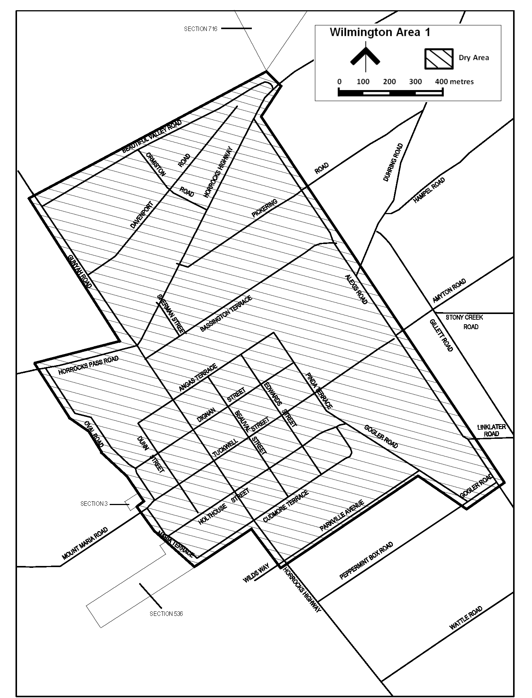
Dated: 6 January 2026
David Pluckhahn
General Manager of Built and Natural Environment

Renmark Paringa Council
Local Government Act 1999
Dog and Cat Management Act 1995
By-law No. 5 of 2025—Dogs By-law 2025
For the management and control of dogs within the Council’s area.
Part 1—Preliminary
1. Short Title
This by-law may be cited as the Dogs By-law 2025.
2. Commencement
This by-law will come into operation four months after the day on which it is published in the Gazette in accordance with Section 249(5) of the Local Government Act 1999.
3. Definitions
In this by-law:
3.1 approved kennel establishment means a building, structure or area approved by the relevant authority, pursuant to the Planning, Development and Infrastructure Act 2016 for the keeping of dogs on a temporary or permanent basis;
3.2 assistance dog means a dog trained and used for the purpose of assisting a person who is wholly or partially disabled and includes a dog undergoing training of a kind approved by the Dog and Cat Management Board for assistance dogs;
3.3 children’s playground means any enclosed area in which there is equipment, apparatus or other installed devices for the purpose of children’s play (or within 5 metres of such devices if there is no enclosed area);
3.4 control, in relation to a dog, includes the person having ownership, possession or charge of, or authority over, the dog;
3.5 dog has the same meaning as in the Dog and Cat Management Act 1995;
3.6 effective control means a person exercising effective control of a dog either:
3.6.1 by means of a physical restraint;
3.6.2 by command, the dog being in close proximity to the person, and the person being able to see the dog at all times;
3.7 keep includes the provision of food or shelter;
3.8 leash includes any chain, cord or leash;
3.9 local government land has the same meaning as in the Local Government Act 1999;
3.10 park has the same meaning as in the Dog and Cat Management Act 1995;
3.11 premises includes:
3.11.1 land;
3.11.2 a part of any premises or land;
3.12 public place has the same meaning as in the Dog and Cat Management Act 1995;
3.13 township has the same meaning as in the Local Government Act 1999;
3.14 wetland area includes any park, reserve, scrub, trail or other land adjacent to a wetland;
3.15 working livestock dog has same meaning as in Dog and Cat Management Act 1995.
Part 2—Dog Management and Control
4. Dog Prohibited Areas
4.1 A person must not allow a dog in that person’s control to be in, or remain in a dog prohibited area.
4.2 For the purposes of this paragraph, a dog prohibited area is any:
4.2.1 local government land or public place to which the Council has resolved this sub-paragraph applies; or
4.2.2 children’s playground.
4.3 The restrictions in subparagraph 4.1 do not apply to any assistance dog.
5. Dog on Leash Areas
5.1 A person must not allow a dog under that person’s control to be in, or remain in, a dog on leash area unless the dog is secured by a strong leash not exceeding two metres in length which is either:
5.1.1 tethered securely to a fixed object capable of securing the dog; or
5.1.2 held by a person capable of controlling the dog and preventing it from being a nuisance or a danger to other persons.
5.2 For the purposes of this paragraph, a dog on leash area is any:
5.2.1 local government land or public place to which the Council has resolved that this sub-paragraph applies;
5.2.2 park when organised sport is being played; or
5.2.3 wetland area.
6. Dog off Leash Areas
6.1 Subject to paragraphs 4 and 5, a person may enter any dog off leash area for the purpose of exercising a dog under his or her control.
6.2 For the purposes of this paragraph, a dog off leash area is any:
6.2.1 park; or
6.2.2 local government land that the Council has resolved is a dog off leash area.
6.3 A person must ensure that any dog under their control remains under effective control while the dog is in a dog off leash area.
7. Limit on Dog Numbers
7.1 A person must not, without permission, keep any dog on any premises where the number of dogs on the premises exceeds the prescribed limit.
7.2 Subject to subparagraph 7.3, the prescribed limit on the number of dogs to be kept on premises:
7.2.1 within a township is two dogs;
7.2.2 outside of a township shall be two dogs (other than any working livestock dog).
7.3 The prescribed limit does not apply to:
7.3.1 an approved kennel establishment;
7.3.2 a veterinary practice;
7.3.3 a pet shop;
7.3.4 any dog that is under three months of age;
7.3.5 any premises that the Council has exempted from the requirements of this paragraph; or
7.3.6 any business involving dogs provided that the business is registered in accordance with the Dog and Cat Management Act 1995.
Part 3—Miscellaneous
8. Application
8.1 The Council may from time to time, by resolution, identify local government land as a dog off leash area in accordance with subparagraph 6.2.2 of this by law.
8.2 Any of paragraphs 4.2.1 and 5.2.1 of this by-law shall apply only in such portion or portions of the area as the Council may from time to time, by resolution, direct in accordance with Section 246 of the Local Government Act 1999.
8.3 Where the Council makes a resolution under either of subparagraphs 8.1 or 8.2, the Council’s Chief Executive Officer must ensure that:
8.3.1 the area is denoted by signs erected by the Council; and
8.3.2 information is provided to the public on the Council’s website and in any other manner determined by the Council’s Chief Executive Officer.
9. Revocation
Council’s Dogs By-law 2017, published in the Gazette on 11 July 2017, is revoked on the day on which this by-law comes into operation.
The foregoing by-law was duly made and passed at a meeting of the Council of the Renmark Paringa Council held on the 16th day of December 2025 by an absolute majority of the members for the time being constituting the Council, there being at least two thirds of the members present.
Dated: 8 January 2026
Tarik Wolf
Acting Chief Executive Officer

RENMARK PARINGA COUNCIL
Local Government Act 1999
Dog and Cat Management Act 1995
By-law No. 6 of 2025—Cats By-law 2025
For the management and control of cats within the Council’s area.
Part 1—Preliminary
1. Short Title
This by-law may be cited as the Cats By-law 2025.
2. Commencement
This by-law will come into operation four months after the day on which it is published in the Gazette in accordance with Section 249(5)
of the Local Government Act 1999.
3. Definitions
In this By-law:
3.1.1 authorised Person has the same meaning as in the Dog and Cat Management Act 1995;
3.1.2 cattery means a building, structure, premises or area approved by the relevant authority pursuant to the Planning, Development and Infrastructure Act 2016 for the keeping of cats on a temporary or permanent basis;
3.1.3 cat means an animal of the species ‘Felis catus’ over four months of age;
3.1.4 designated Day means the day set by the Council by resolution and published in the Gazette and on a website determined by the Council’s Chief Executive Officer;
3.1.5 keep includes the provision of food or shelter;
3.1.6 premises includes:
3.1.6.1 land;
(b) a part of any premises or land;
3.1.7 prescribed Manner means the manner in which a cat is to be identified at all times while the cat is not effectively confined to premises of which the owner of the cat is the occupier is by means of a collar around its neck to which a tag is attached legibly setting out:
3.1.7.1 the name of the owner of the cat, or of a person entitled to possession of the cat; and
3.1.7.2 either:
3.1.7.2.1 the address of the owner or other person; or
3.1.7.2.2 the telephone number of the owner or other person;
3.1.8 prescribed premises means:
3.1.8.1 a cattery;
3.1.8.2 a veterinary practice;
3.1.8.3 a pet shop; or
3.1.8.4 any premises for which the Council has granted an exemption.
3.1.9 for the avoidance of doubt, the Council can, at its discretion, determine not to set, or to revoke once set, a designated day.
Part 2—Cat Management
4. Limit on Cat Numbers
4.1 Subject to subparagraphs 4.3 and 4.4, the limit on the number of cats to be kept on any premises is two.
4.2 A person must not, without permission, keep a cat on any premises where the number of cats being kept on those premises exceeds the limit.
4.3 Permission under subparagraph 4.2 may be given if the Council is satisfied that:
4.3.1 no insanitary condition exists on the premises as a result of the keeping of cats; and
4.3.2 a nuisance is not caused to any neighbour as a result of the keeping of cats on the premises.
4.4 Subparagraph 4.1 does not apply to prescribed premises.
Part 3—Registration and Identification of Cats
5. Registration of Cats
5.1 A person must not, after the designated day, keep a cat in the Council’s area for more than 14 days unless the cat is registered in accordance with this By-law.
5.2 Subparagraph 5.1 does not apply to prescribed premises.
6. Registration Procedure for Cats
6.1 An application for registration of a cat must:
6.1.1 be made to the Council in the manner and form approved by the Council; and
6.1.2 nominate a person of or over 16 years of age who consents to the cat being registered in their own name; and
6.1.3 nominate, with reference to an address of premises, the place at which the cat will usually be kept; and
6.1.4 include the unique identification number assigned to the microchip implanted in the cat; and
6.1.5 be accompanied by the registration fee and, if applicable, any late payment fee set by resolution of the Council for the cat.
6.2 Subject to subparagraph 6.3, on application and payment of the registration fee and any fee for late payment of the registration fee, the Council must register the cat in the name of the person nominated and issue to that person a certificate of registration in the form approved by Council.
6.3 The Council may refuse to register a cat under this by-law if:
6.3.1 the number of cats kept or proposed to be kept at premises exceeds the prescribed limit;
6.3.2 keeping a cat at the proposed premises would be contrary to any Act, Regulation or By-law.
6.4 A cat registered in the name of a particular person who consents must, on application to the Council by another person, be registered in the name of that other person who is stated in the application and is of or over 16 years of age.
7. Duration and Renewal of Registration
7.1 Registration under this by-law remains in force until 30 June next ensuing after registration was granted and may be renewed from time to time for further periods of 12 months.
7.2 If an application for renewal of registration is made before 31 August of the year in which the registration expired, the renewal operates retrospectively from the date of expiry.
8. Accuracy of Records
8.1 The person in whose name a cat is individually registered must inform the Council as soon as practicable after any of the following occurs:
8.1.1 the cat is removed from the place recorded in the register as the place at which the cat is usually kept with the intention that it will be usually kept at some other place (whether in the area of the Council, in a different Council area or outside the State);
8.1.2 the cat dies;
8.1.3 the cat has been missing for more than 72 hours;
8.1.4 the residential address or telephone number of the owner of the cat change;
8.1.5 the ownership of the cat is transferred to another person.
8.2 Information given to the Council under this paragraph must include such details as may be reasonably required for the purposes of ensuring the accuracy of records kept under the Dog and Cat Management Act 1995 and this by-law.
8.3 If ownership of a cat is transferred from the person in whose name the cat is individually registered, the person must give to the new owner the certificate of registration last issued in respect of the cat.

9. Identification of Cats
9.1 Every cat must be identified in the prescribed manner at all times while the cat is not effectively confined to premises of which the owner of the cat is the occupier.
9.2 If a cat is not identified in the prescribed manner required by paragraph 9.1, any person who owns or is responsible for the control of the cat is guilty of an offence.
9.3 A person is not guilty of an offence by reason of the fact that the cat is not identified in the prescribed manner if:
9.3.1 the cat:
(a) is travelling with the person; and
(b) is not usually kept within the area of the Council; or
9.3.2 the person is responsible for the control of the cat only by reason of the cat being kept, for business purposes, at prescribed premises; or
9.3.3 the Council has granted the owner of the cat an exemption from the requirements of this paragraph or an extension of time within which to comply with the requirements.
Part 3—Miscellaneous
10. Notices
10.1 The Council may serve notice on the occupier of premises or the owner of a cat requiring action to be taken to ensure compliance with this by-law.
10.2 The person to whom notice is given must comply with the notice.
10.3 If the person to whom notice was given does not comply with the notice, an authorised person of the Council may carry out the terms of the notice and recover the costs of so doing from that person.
11. Revocation
Council’s Cats By-law 2017, published in the Gazette on 11 July 2017, is revoked on the day on which this by-law comes into operation.
The foregoing by-law was duly made and passed at a meeting of the Council of the Renmark Paringa Council held on the 16th day
of December 2025 by an absolute majority of the members for the time being constituting the Council, there being at least two-thirds of the members present.
Dated: 8 January 2026
Tarik Wolf
Acting Chief Executive Officer

RENMARK PARINGA COUNCIL
By-Law Made Under the Local Government Act 1999
Renmark Paringa Council (Miscellaneous) Amendment By-law 2025
By-law No. 8 of 2025
To amend the Council’s Moveable Signs By-law 2024 and for related purposes.
Part 1—Preliminary
1. Short title
This by-law may be cited as the Renmark Paringa Council (Miscellaneous) Amendment By-law 2025.
2. Commencement
This by-law will come into operation on the day in which it is published in the Gazette in accordance with Section 249(6)(b) of the Local Government Act 1999.
3. Amendment Provisions
In this by-law, a provision under a heading referring to the amendment of a specified by-law amends the by-law so specified.
Part 2—Amendment of Moveable Signs by-Law 2024
4. Amendment of Paragraph 5—Placement
4.1 Paragraph 5.12—insert ‘not be placed’ before ‘within 10m of’.
The foregoing by-law was duly made and passed at a meeting of the Council of the Renmark Paringa Council held on the 16th day
of December 2025 by an absolute majority of the members for the time being constituting the Council, there being at least two thirds of the members present.
Dated: 8 January 2026
Tarik Wolf
Acting Chief Executive Officer

RENMARK PARINGA COUNCIL
By-Law made under the Local Government Act 1999
Renmark Paringa Council (Miscellaneous) Amendment By-law (No. 2) 2025
By-law No. 9 of 2025
To amend the Council’s Local Government Land By-law 2024 and for related purposes.
Part 1—Preliminary
1. Short title
This by-law may be cited as the Renmark Paringa Council (Miscellaneous) Amendment By-law (No. 2) 2025.
2. Commencement
This by-law will come into operation four months after the day on which it is published in the Gazette in accordance with Section 249(5) of the Local Government Act 1999.
3. Amendment Provisions
In this by-law, a provision under a heading referring to the amendment of a specified by-law amends the by-law so specified.
Part 2—Amendment of Local Government Land by-law 2024
4. Deletion of Paragraph 5.11
4.1 Delete paragraph 5.11.
5. Insertion of new Paragraph 5.11
5.1 After paragraph 5.10 insert:
5.11 Waste
deposit any residential or commercial waste or other rubbish emanating from residential or commercial premises in any Council rubbish bin;
6. Insertion of new Paragraph 5.12
6.1 After paragraph 5.11 insert:
5.12 Wheeled Recreational Devices
subject to the Road Traffic Act 1961 and the Local Government Act 1999, ride a wheeled recreational device on any local government land to which this subparagraph applies.
Part 3—Expiry
7. Expiry of Renmark Paringa Council (Miscellaneous) Amendment By-law 2025
The Renmark Paringa Council (Miscellaneous) Amendment By-law 2025 will expire 24 hours after it comes into operation in accordance with Section 251(1) of the Local Government Act 1999.
Note: In accordance with Section 32(2)(c) of the Legislation Interpretation Act 2021, the expiry of this Renmark Paringa Council (Miscellaneous) Amendment By-law 2025 does not affect any direct amendments made by that by-law.
8. Expiry of Renmark Paringa Council (Miscellaneous) Amendment By-law (No. 2) 2025
The Renmark Paringa Council (Miscellaneous) Amendment By-law (No. 2) 2025 will expire 24 hours after it comes into operation in accordance with Section 251(1) of the Local Government Act 1999.
Note: In accordance with Section 32(2)(c) of the Legislation Interpretation Act 2021, the expiry of this Renmark Paringa Council (Miscellaneous) Amendment By-law (No. 2) 2025 does not affect any direct amendments made by this by-law.
The foregoing by-law was duly made and passed at a meeting of the Council of the Renmark Paringa Council held on the 16th day of December 2025 by an absolute majority of the members for the time being constituting the Council, there being at least two thirds of the members present.
Dated: 8 January 2026
Tarik Wolf
Acting Chief Executive Officer

Public Notices

Rail Safety National Law National Regulations 2012
Notice of National Network for Interoperability
Under Regulation 16(3) of the Rail Safety National Law National Regulations 2012
1. Short title
This notice may be cited as the National Network for Interoperability Notice 2025.
2. Commencement
This Notice comes into operation on the day it is published in the South Australian Government Gazette.
3. Interpretation
Words and expressions used in this Notice have the same meanings as those defined in the Rail Safety National Law and its regulations.
4. Authorisation
In accordance with Regulation 16(3) of the Rail Safety National Law National Regulations 2012, this notice specifies the National Network for Interoperability by description and map (Annexure 1).
5. Revocation
This Notice may be revoked or varied by the Regulator subject to the unanimous approval of the responsible Ministers.
Dated: 5 January 2026
Peter Doggett
Acting National Rail Safety Regulator
Office of the National Rail Safety Regulator

Annexure 1
National Network for Interoperability
Notice is hereby given that, pursuant to Regulation 16(3) of the Rail Safety National Law National Regulations 2012, that the Regulator, to whom the publication of this notice is committed following the unanimous approval of responsible Ministers under the Rail Safety National Law 2012, Do Hereby:
• Specify the following as the National Network for Interoperability.
Map of the National Network for Interoperability
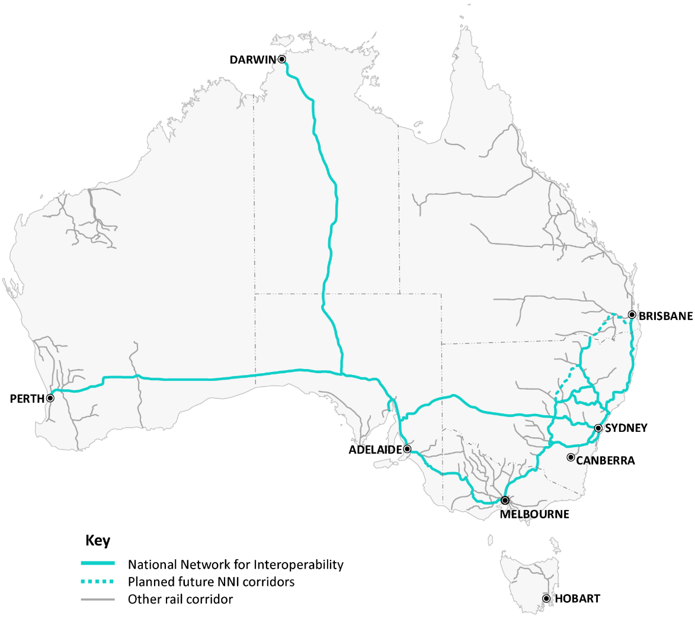
The following map is for illustrative purposes only with the National Network for Interoperability specified at Clauses 1 and 2 of this Annexure:
1. Metropolitan NNI operations
The NNI operates in the following metropolitan areas:
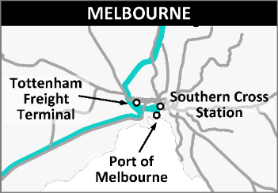
Melbourne
• The Australian Rail Track Corporation running lines from the Albion junction to Moonee Ponds Creek
• The V/Line main standard/dual gauge lines from Moonee Ponds Creek through to Southern Cross Station (Platforms 1,2)
• The Australian Rail Track Corporation connections providing access to the Port of Melbourne.
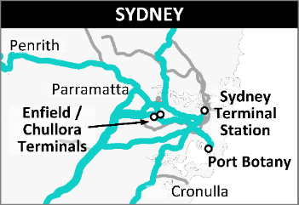
Sydney
• The Southern Sydney Freight Line, Metropolitan Freight Network and connection to Port Botany
• The running lines from Lithgow to Lidcombe and connecting to the Metropolitan Freight Network at Flemington Goods Junction
• Main Lines from Lidcombe to Strathfield and Sydney Terminal
• The running lines between the Metropolitan Freight Network at Marrickville Junction and Port Kembla
• The running lines from Newcastle to the Metropolitan Freight Network at Flemington Goods Junction, plus the Main North connection from North Strathfield to Strathfield
• The running lines from Granville to Glenlee
• The running lines from Lidcombe to Cabramatta
• The running lines from Sydney Terminal to Sydenham, East Hills and Glenfield.
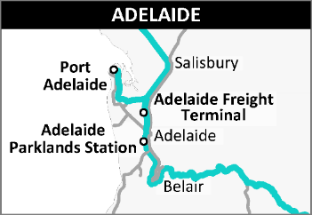
Adelaide
• The Australian Rail Track Corporation running lines through Adelaide, including connection to Keswick terminal
• The Australian Rail Track Corporation running lines through to Port of Adelaide.
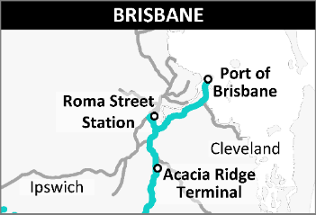
Brisbane
• Dual gauge running lines from Acacia Ridge to Roma St terminal
• Dual gauge running lines from Dutton Park to Port of Brisbane.
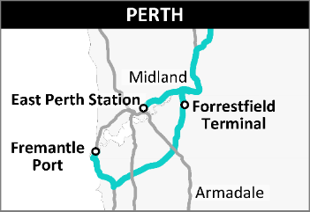
Perth
• Dual gauge running lines from Midland to East Perth terminal
• Dual gauge running lines from Midland to Port of Fremantle.
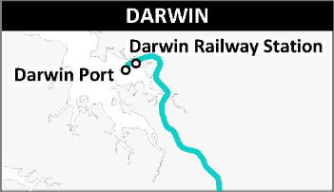
Darwin
• Running lines to Darwin Station and to the Port of Darwin

2. Interstate and intrastate NNI operations
The National Network for Interoperability operates on the following intrastate and interstate routes:
All Standard (or dual) gauge running lines from:
• Crystal Brook (SA) to Perth (WA)
• Tarcoola (SA) to Darwin (NT)
• Whyalla (SA) to Port Augusta (SA)
• Crystal Brook (SA) to Sydney (NSW) via Broken Hill (NSW), Parkes (NSW) and Lithgow (NSW)
• Crystal Brook (SA) to Adelaide (SA)
• Adelaide (SA) to Melbourne (VIC) via Geelong (VIC)
• Melbourne (VIC) to Sydney (NSW) via Albury (NSW), Cootamundra (NSW) and Macarthur (NSW)
• Moss Vale (NSW) to Sydney (NSW) via Wollongong (NSW) and Port Kembla (NSW)
• Sydney (NSW) to Brisbane (QLD) via Newcastle (NSW) and Maitland (NSW)
• Illabo (NSW) to Kagaru (QLD) via Inland Rail including:
⸰ Illabo (NSW) to Stockinbingal (NSW)
⸰ Stockinbingal (NSW) to Narromine (NSW), including Parkes North West Link (NSW)
⸰ Narromine (NSW) to Narrabri (NSW)
⸰ Narrabri (NSW) to North Star (NSW)
⸰ North Star (NSW) to Kagaru (QLD)—Sections of standard or dual gauge running lines completed or upgraded for Inland Rail that will support the operation of trains using Inland Rail.
• Stockinbingal (NSW) to Cootamundra (NSW)
• Narromine (NSW) to Newcastle (NSW), via Dubbo (NSW) and Gulgong (NSW)
• Muswellbrook (NSW) to Narrabri (NSW)
• Merrygoen (NSW) to Gap (NSW).

Notice Submission

The South Australian Government Gazette is published each Thursday afternoon.
Notices must be emailed by 4 p.m. Tuesday, the week of publication.
Submissions are formatted per the gazette style and a proof will be supplied prior to publication, along with a quote if applicable. Please allow one day for processing notices.
Alterations to the proof must be returned by 4 p.m. Wednesday.

Gazette notices must be submitted as Word files, in the following format:
• Title—the governing legislation
• Subtitle—a summary of the notice content
• Body—structured text, which can include numbered lists, tables, and images
• Date—day, month, and year of authorisation
• Signature block—name, role, and department/organisation authorising the notice

Please provide the following information in your email:
• Date of intended publication
• Contact details of the person responsible for the notice content
• Name and organisation to be charged for the publication—Local Council and Public notices only
• Purchase order, if required—Local Council and Public notices only

Email: governmentgazettesa@sa.gov.au
Phone: (08) 7133 3552
Website: www.governmentgazette.sa.gov.au

All instruments appearing in this gazette are to be considered official, and obeyed as such

Printed and published weekly by authority of T. Foresto, Government Printer, South Australia
$9.50 per issue (plus postage), $479.00 per annual subscription—GST inclusive
Online publications: www.governmentgazette.sa.gov.au

