
No. 3 p. 21
THE SOUTH AUSTRALIAN
GOVERNMENT GAZETTE
Published by Authority

Adelaide, Thursday, 15 January 2026

Contents

Governor’s Instruments
Appointments, Resignations and General Matters 22
Proclamations—
Statutes Amendment (Superannuation and Other Payments)
Act (Commencement) Proclamation 2026 23
Statutes Amendment (Planning, Infrastructure and Other Matters) Act (Commencement) Proclamation 2026 24
Waite Trust (Activities on and Use of Certain Trust Land)
Act (Commencement) Proclamation 2026 24
Administrative Arrangements (Administration of Waite
Trust (Activities on and Use of Certain Trust Land) Act) Proclamation 2026 25
Residential Tenancies (Miscellaneous) Amendment Act (Commencement) Proclamation 2026 25
Northern Parklands Act (Commencement)
Proclamation 2026 26
Administrative Arrangements (Administration of Northern Parklands Act) Proclamation 2026 26
Statutes Amendment (Building and Construction Industry Review—Penalties) Act (Commencement)
Proclamation 2026 27
Regulations—
Surveillance Devices (Prescribed Circumstances)
Amendment Regulations 2026—No. 1 of 2026 28
Survey (GDA2020) Amendment Regulations 2026
—No. 2 of 2026 30
Architectural Practice (General) (Repeal of Regulation 4) Amendment Regulations 2026—No. 3 of 2026 31
Summary Offences (Prescribed Nazi Symbols) Regulations 2026—No. 4 of 2026 32
Northern Parklands Regulations 2026—No. 5 of 2026 34
Fisheries Management (General) (Rock Lobster Pots)
Amendment Regulations 2026—No. 6 of 2026 40
State Government Instruments
Controlled Substances Act 1984 42
Energy Resources Act 2000 42
Fisheries Management Act 2007 42
Health Care Act 2008 46
Housing Improvement Act 2016 46
Hydrogen and Renewable Energy Act 2023 46
Land Acquisition Act 1969 46
Major Events Act 2013 51
National Parks and Wildlife Act 1972 53
Planning, Development and Infrastructure Act 2016 55
Radiation Protection and Control Regulations 2022 57
Retail and Commercial Leases Act 1995 58
Road Traffic Act 1961 58
Roads (Opening and Closing) Act 1991 59
Summary Offences Act 1953 59
Local Government Instruments
City of Port Adelaide Enfield 75
Adelaide Hills Council 75
Berri Barmera Council 76
Public Notices
Trustee Act 1936 77

Governor’s Instruments

Appointments, Resignations and General Matters
Department of the Premier and Cabinet
Adelaide, 15 January 2026
Her Excellency the Governor in Executive Council has been pleased to appoint the undermentioned to the Adelaide Festival Centre Trust, pursuant to the provisions of the Adelaide Festival Centre Trust Act 1971:
Member: from 15 January 2026 until 14 January 2029
Katherine Tamiko Arguile
By command,
Anastasios Koutsantonis, MP
For Premier
25ART0021CS

Department of the Premier and Cabinet
Adelaide, 15 January 2026
Her Excellency the Governor in Executive Council has been pleased to appoint the Honourable Blair Ingram Boyer MP to be Acting Minister for Health and Wellbeing from 16 January 2026 until 25 January 2026 inclusive, during the absence of the Honourable Christopher James Picton MP.
By command,
Anastasios Koutsantonis, MP
For Premier
HEAC-2026-00002

Department of the Premier and Cabinet
Adelaide, 15 January 2026
Her Excellency the Governor in Executive Council has been pleased to appoint Laura Grace Stein as the Chief Justice of the Supreme Court of South Australia, effective from 19 February 2026 - pursuant to section 9(1) of the Supreme Court Act 1935.
By command,
Anastasios Koutsantonis, MP
For Premier
AGO0231-25CS

Department of the Premier and Cabinet
Adelaide, 15 January 2026
Her Excellency the Governor in Executive Council has been pleased to appoint Benjamin Joseph Doyle, a Puisne Judge of the Supreme Court of South Australia, as a Judge of the Court of Appeal of South Australia, effective from 19 February 2026 - pursuant to section 9(1) of the Supreme Court Act 1935.
By command,
Anastasios Koutsantonis, MP
For Premier
AGO0231-25CS

Department of the Premier and Cabinet
Adelaide, 15 January 2026
Her Excellency the Governor in Executive Council has been pleased to appoint Christopher John Kourakis to the Office of Judge of the Supreme Court of South Australia on an auxiliary basis for a term commencing on 20 February 2026 and expiring on 30 June 2026, it being a condition of appointment that the powers and jurisdictions of office should be exercised only during the time or times the actual duties are being undertaken, but at no other time throughout the period of appointment - pursuant to section 3(1) of the Judicial Administration (Auxiliary Appointments and Powers) Act 1988.
By command,
Anastasios Koutsantonis, MP
For Premier
AGO0231-25CS

Department of the Premier and Cabinet
Adelaide, 15 January 2026
Her Excellency the Governor in Executive Council has been pleased to appoint the Honourable David Cameron Lovell as the Parole Administrative Review Commissioner for a term of three years commencing on 1 February 2026 and expiring on 31 January 2029 - pursuant to section 77B of the Correctional Services Act 1982.
By command,
Anastasios Koutsantonis, MP
For Premier
25MCS0007CS

Proclamations
South Australia

Statutes Amendment (Superannuation and Other Payments) Act (Commencement) Proclamation 2026
1—Short title
This proclamation may be cited as the Statutes Amendment (Superannuation and Other Payments) Act (Commencement) Proclamation 2026.
2—Commencement of certain provisions
The following provisions of the Statutes Amendment (Superannuation and Other Payments) Act 2025 (No 79 of 2025) come into operation on 20 March 2026:
(a) section 7;
(b) section 10(1), (2) and (3);
(c) section 11;
(d) sections 14 and 15;
(e) section 17(2);
(f) section 19;
(g) section 22;
(h) section 24;
(i) sections 27 to 29 (inclusive).
Made by the Governor
with the advice and consent of the Executive Council
on 15 January 2026

South Australia

Statutes Amendment (Planning, Infrastructure and Other Matters) Act (Commencement) Proclamation 2026
1—Short title
This proclamation may be cited as the Statutes Amendment (Planning, Infrastructure and Other Matters) Act (Commencement) Proclamation 2026.
2—Commencement and suspension of certain provisions
(1) Subject to subclause (2), Parts 3 to 5 (inclusive) and Part 8 of the Statutes Amendment (Planning, Infrastructure and Other Matters) Act 2025 (No 64 of 2025) come into operation on 15 January 2026.
(2) The operation of the following provisions of the Act is suspended until a day or time or days or times to be fixed by subsequent proclamation or proclamations:
(a) section 35;
(b) section 46(1);
(c) section 53;
(d) section 56(2).
Made by the Governor
with the advice and consent of the Executive Council
on 15 January 2026

South Australia

Waite Trust (Activities on and Use of Certain Trust Land) Act (Commencement) Proclamation 2026
1—Short title
This proclamation may be cited as the Waite Trust (Activities on and Use of Certain Trust Land) Act (Commencement) Proclamation 2026.
2—Commencement of Act
The Waite Trust (Activities on and Use of Certain Trust Land) Act 2025 (No 67 of 2025) comes into operation on 15 January 2026.
Made by the Governor
with the advice and consent of the Executive Council
on 15 January 2026

South Australia

Administrative Arrangements (Administration of Waite Trust (Activities on and Use of Certain Trust Land) Act) Proclamation 2026
under section 5 of the Administrative Arrangements Act 1994
1—Short title
This proclamation may be cited as the Administrative Arrangements (Administration of Waite Trust (Activities on and Use of Certain Trust Land) Act) Proclamation 2026.
2—Commencement
This proclamation comes into operation on the day on which it is made.
3—Administration of Act committed to Minister for Education, Training and Skills
The administration of the Waite Trust (Activities on and Use of Certain Trust Land) Act 2025 is committed to the Minister for Education, Training and Skills.
Made by the Governor
with the advice and consent of the Executive Council
on 15 January 2026

South Australia

Residential Tenancies (Miscellaneous) Amendment Act (Commencement) Proclamation 2026
1—Short title
This proclamation may be cited as the Residential Tenancies (Miscellaneous) Amendment Act (Commencement) Proclamation 2026.
2—Commencement of Act
The Residential Tenancies (Miscellaneous) Amendment Act 2025 (No 70 of 2025) comes into operation on 15 January 2026.
Made by the Governor
with the advice and consent of the Executive Council
on 15 January 2026

South Australia

Northern Parklands Act (Commencement) Proclamation 2026
1—Short title
This proclamation may be cited as the Northern Parklands Act (Commencement) Proclamation 2026.
2—Commencement of Act
The Northern Parklands Act 2025 (No 41 of 2025) comes into operation on the day on which this proclamation is made.
Made by the Governor
with the advice and consent of the Executive Council
on 15 January 2026

South Australia

Administrative Arrangements (Administration of Northern Parklands Act) Proclamation 2026
under section 5 of the Administrative Arrangements Act 1994
1—Short title
This proclamation may be cited as the Administrative Arrangements (Administration of Northern Parklands Act) Proclamation 2026.
2—Commencement
This proclamation comes into operation on the day on which it is made.
3—Administration of Act committed to Minister for Planning
The administration of the Northern Parklands Act 2025 is committed to the Minister for Planning.
Made by the Governor
with the advice and consent of the Executive Council
on 15 January 2026

South Australia

Statutes Amendment (Building and Construction Industry Review—Penalties) Act (Commencement) Proclamation 2026
1—Short title
This proclamation may be cited as the Statutes Amendment (Building and Construction Industry Review—Penalties) Act (Commencement) Proclamation 2026.
2—Commencement of Act
The Statutes Amendment (Building and Construction Industry Review—Penalties) Act 2025 (No 68 of 2025) comes into operation on 15 January 2026.
Made by the Governor
with the advice and consent of the Executive Council
on 15 January 2026

Regulations
South Australia

Surveillance Devices (Prescribed Circumstances) Amendment Regulations 2026
under the Surveillance Devices Act 2016

Contents
Part 1—Preliminary
1 Short title
2 Commencement
Part 2—Amendment of Surveillance Devices Regulations 2017
3 Insertion of regulation 11A
11A Data surveillance devices exemption—prescribed circumstances (section 8 of Act)

Part 1—Preliminary
1—Short title
These regulations may be cited as the Surveillance Devices (Prescribed Circumstances) Amendment Regulations 2026.
2—Commencement
These regulations come into operation on the day on which they are made.
Part 2—Amendment of Surveillance Devices Regulations 2017
3—Insertion of regulation 11A
After regulation 11 insert:
11A—Data surveillance devices exemption—prescribed circumstances (section 8 of Act)
For the purposes of section 8(2)(b) of the Act, the installation, use or maintenance of a data surveillance device by or on behalf of 1 or more of the following bodies is prescribed:
(a) the Australian Security Intelligence Organisation;
(b) the Australian Secret Intelligence Service;
(c) the Australian Signals Directorate.

Editorial note—
As required by section 10AA(2) of the Legislative Instruments Act 1978, the Minister has certified that, in the Minister's opinion, it is necessary or appropriate that these regulations come into operation as set out in these regulations.
Made by the Governor
with the advice and consent of the Executive Council
on 15 January 2026
No 1 of 2026

South Australia

Survey (GDA2020) Amendment Regulations 2026
under the Survey Act 1992

Contents
Part 1—Preliminary
1 Short title
2 Commencement
Part 2—Amendment of Survey Regulations 2020
3 Amendment of regulation 10—Interpretation

Part 1—Preliminary
1—Short title
These regulations may be cited as the Survey (GDA2020) Amendment Regulations 2026.
2—Commencement
These regulations come into operation on the day on which they are made.
Part 2—Amendment of Survey Regulations 2020
3—Amendment of regulation 10—Interpretation
Regulation 10, definition of Geocentric Datum of Australia 2020 or GDA2020—delete the definition and substitute:
Geocentric Datum of Australia 2020 or GDA2020 has the same meaning as in the determination under section 8A of the National Measurement Act 1960 of the Commonwealth for the recognised-value standard of measurement of position;
Editorial note—
As required by section 10AA(2) of the Legislative Instruments Act 1978, the Minister has certified that, in the Minister's opinion, it is necessary or appropriate that these regulations come into operation as set out in these regulations.
Made by the Governor
with the advice and consent of the Executive Council
on 15 January 2026
No 2 of 2026

South Australia

Architectural Practice (General) (Repeal of Regulation 4) Amendment Regulations 2026
under the Architectural Practice Act 2009

Contents
Part 1—Preliminary
1 Short title
2 Commencement
Part 2—Amendment of Architectural Practice (General) Regulations 2025
3 Repeal of regulation 4

Part 1—Preliminary
1—Short title
These regulations may be cited as the Architectural Practice (General) (Repeal of Regulation 4) Amendment Regulations 2026.
2—Commencement
These regulations come into operation on the day on which they are made.
Part 2—Amendment of Architectural Practice (General) Regulations 2025
3—Repeal of regulation 4
Regulation 4—delete the regulation
Editorial note—
As required by section 10AA(2) of the Legislative Instruments Act 1978, the Minister has certified that, in the Minister's opinion, it is necessary or appropriate that these regulations come into operation as set out in these regulations.
Made by the Governor
with the advice and consent of the Executive Council
on 15 January 2026
No 3 of 2026

South Australia

Summary Offences (Prescribed Nazi Symbols) Regulations 2026
under the Summary Offences Act 1953

Contents
1 Short title
2 Commencement
3 Interpretation
4 Prescribed Nazi symbols

1—Short title
These regulations may be cited as the Summary Offences (Prescribed Nazi Symbols) Regulations 2026.
2—Commencement
These regulations come into operation on the day on which they are made.
3—Interpretation
In these regulations—
Act means the Summary Offences Act 1953.
4—Prescribed Nazi symbols
For the purposes of paragraph (c) of the definition of Nazi symbol in section 32A(1) of the Act, each of the following symbols is prescribed as a Nazi symbol:
(a) a symbol consisting of a white diamond on a blue background containing 4 inwardly pointing red arrows;
Note—
This symbol is commonly used by the National Socialist Network.
The below image is provided for ease of reference only.

(b) a symbol consisting of a white circle on a blue background containing a red equilateral cross bordered by a broken red circle (such that the negative space created appears to form 4 diagonally aligned, inwardly pointing white arrows).

Note—
This symbol is commonly used by the European Australian Movement.
The below image is provided for ease of reference only.

Editorial note—
As required by section 10AA(2) of the Legislative Instruments Act 1978, the Minister has certified that, in the Minister's opinion, it is necessary or appropriate that these regulations come into operation as set out in these regulations.
Made by the Governor
with the advice and consent of the Executive Council
on 15 January 2026
No 4 of 2026

South Australia

Northern Parklands Regulations 2026
under the Northern Parklands Act 2025

Contents
Part 1—Preliminary
1 Short title
2 Commencement
3 Interpretation
Part 2—Northern Parklands Trust
4 Annual business plan
5 Payment of contributions by councils
6 Imposition of levy by councils
Part 3—Statutory trusts
7 Damage etc to property of statutory trust
Part 4—Conduct of users of trust parklands
8 Behaviour in trust parklands
9 Restricted activities
10 Animals
11 Use of motor vehicles
Part 5—Miscellaneous
12 Authorisations and permissions
13 Recovery of costs of certain acquisitions
Part 6—Transitional provisions
14 Members of the Northern Parklands Trust
15 First plans and agreements

Part 1—Preliminary
1—Short title
These regulations may be cited as the Northern Parklands Regulations 2026.
2—Commencement
These regulations come into operation on the day on which section 11 of the Northern Parklands Act 2025 comes into operation.
3—Interpretation
In these regulations—
Act means the Northern Parklands Act 2025;
camping includes sleeping overnight in a motor vehicle parked in the trust parklands;
motor vehicle has the same meaning as in the Road Traffic Act 1961.

Part 2—Northern Parklands Trust
4—Annual business plan
For the purposes of section 15(15) of the Act, the approval of the Minister is required in relation to a variation of an annual business plan of the Northern Parklands Trust in circumstances in which contributions by constituent councils under Part 4 are varied.
5—Payment of contributions by councils
Interest accrues under section 17(1) of the Act from the date on which the instalment was payable under that section at the Reserve Bank of Australia Cash Rate Target on 1 July in the financial year in which the instalment was payable, as published on the Reserve Bank of Australia website, calculated in respect of each month (or part of a month) for which the relevant amount remains unpaid.
6—Imposition of levy by councils
(1) Pursuant to section 19(5) of the Act, the following purposes for which rateable land is used are prescribed:
(a) Residential comprising the use of land for a detached dwelling, group dwelling, residential flat building, row dwelling or semi-detached dwelling within the meaning of the Planning and Design Code;
(b) Commercial—Shop comprising the use of land for a shop within the meaning of the Planning and Design Code;
(c) Commercial—Office comprising the use of land for an office within the meaning of the Planning and Design Code;
(d) Commercial—Other comprising any other commercial use of land not referred to in the categories specified in paragraph (b) or (c);
(e) Industry—Light comprising the use of land for a light industry within the meaning of the Planning and Design Code;
(f) Industry—Other comprising any other industrial use of land not referred to in the category specified in paragraph (e);
(g) Primary Production comprising—
(i) farming within the meaning of the Planning and Design Code; or
(ii) horticulture within the meaning of the Planning and Design Code; or
(iii) the use of land for horse keeping, animal keeping or intensive animal husbandry within the meaning of the Planning and Design Code; or
(iv) in respect of a dairy situated on a farm—the use of land for a dairy within the meaning of the Planning and Design Code; or
(v) commercial forestry within the meaning of the Planning and Design Code;
(h) Vacant land comprising the non-use of vacant land;
(i) Other comprising any other use of land not referred to in a previous category.
(2) Pursuant to section 19(3)(d) of the Act, the operation of section 152(2) of the Local Government Act 1999 is modified—
(a) as if it extended to a separate rate as well as a fixed charge; and

(b) as if—
(i) section 152(2)(c) provided that if a separate rate is a fixed charge based on a factor referred to in section 19(3)(a)(ii) or (iii) of the Northern Parklands Act 2025 and is imposed in respect of 2 or more pieces of contiguous rateable land (being land that is owned by the same owner and occupied by the same occupier), then only 1 fixed charge may be imposed against the whole of the land; and
(ii) section 152(2)(d) provided that if a separate rate is a fixed charge based on the factor referred to in section 19(3)(a)(ii) of the Northern Parklands Act 2025 and is imposed in respect of land constituting a single farm enterprise, then only 1 fixed charge may be imposed against the whole of the land.
(3) Pursuant to section 19(3)(d) of the Act, the operation of section 159(9) of the Local Government Act 1999 is modified—
(a) so as to not require a council that grants to a person or body a rebate of general rates under section 166 of the Local Government Act 1999 to grant a comparable rebate of a Northern Parklands levy to the person or body; and
(b) so as to allow a council to grant to a person or body a rebate of a Northern Parklands levy under section 166 of the Local Government Act 1999 that is different to a rebate of general rates granted to the person or body.
(4) In this regulation—
Planning and Design Code means the Planning and Design Code under the Planning, Development and Infrastructure Act 2016.
Part 3—Statutory trusts
7—Damage etc to property of statutory trust
For the purposes of section 38(b) of the Act, the following periods are prescribed:
(a) 21 days; or
(b) if another period is authorised by the statutory trust—that period.
Part 4—Conduct of users of trust parklands
8—Behaviour in trust parklands
A person must not, while in trust parklands—
(a) behave in a disorderly or offensive manner; or
(b) use threatening, insulting, abusive or indecent language; or
(c) create a disturbance or nuisance; or
(d) wilfully obstruct, disturb or harass another person engaged in the proper use of the trust parklands.
Maximum penalty: $1 250.
Expiation fee: $160.

9—Restricted activities
A person must not, without the permission of the responsible statutory trust, while in trust parklands—
(a) carry, use or discharge a firearm, airgun or other weapon; or
(b) deposit litter or other waste except in an area or receptacle provided for that purpose; or
(c) camp in an area other than a clearly designated camping area; or
(d) light, maintain or use a fire other than in a clearly designated fire place; or
(e) leave a fire without effectively extinguishing it; or
(f) leave property unattended for more than 24 hours; or
(g) erect a marquee, booth, gazebo or other similar structure that is not intended solely for camping or other personal use; or
(h) use a sound amplification device or other noisy equipment; or
(i) distribute printed matter; or
(j) post, paint or otherwise display an advertisement, bill, sign, poster, placard, banner or flag; or
(k) sell anything or offer anything for sale, conduct a business or provide a service; or
(l) sell raffle or lottery tickets or take up a collection.
Maximum penalty: $1 250.
Expiation fee: $160.
10—Animals
(1) A person must not, without the permission of the responsible statutory trust, bring an animal other than a dog into trust parklands.
Maximum penalty: $750.
Expiation fee: $105.
(2) If a person brings a dog into trust parklands, the person must—
(a) ensure that the dog does not enter or remain in an area of trust parklands indicated by signs or markings or a combination of signs and markings (erected or displayed with the authority of the responsible statutory trust) as an area in which dogs are not permitted; and
(b) exercise effective control over the dog at all times while it is in trust parklands.
Maximum penalty: $750.
Expiation fee: $105.
(3) For the purposes of this regulation, a dog is under the effective control of a person if—
(a) the person is exercising effective control of the dog—
(i) by means of a chain, cord or leash that does not exceed 2 m in length restraining the dog; or
(ii) by command, the dog being in close proximity to the person and the person being able to see the dog at all times; or

(b) the person has effectively secured the dog—
(i) by placing it in a cage, vehicle or other object or structure; or
(ii) by tethering it to a fixed object by means of a chain, cord or leash that does not exceed 2 m in length.
(4) Subregulation (2)(a) does not apply to an assistance dog within the meaning of the Dog and Cat Management Act 1995.
11—Use of motor vehicles
A person who drives or rides a motor vehicle in trust parklands must not, unless authorised by the responsible statutory trust—
(a) drive or ride at a speed greater than 15 kph unless otherwise indicated (with the authority of the responsible statutory trust) by signs or markings or a combination of signs and markings; or
(b) drive or ride at a speed greater than 15 kph unless otherwise indicated (with the authority of the responsible statutory trust) by signs or markings or a combination of signs and markings; or
(c) fail to pay a parking fee indicated (with the authority of the responsible statutory trust) by signs or markings or a combination of signs and markings; or
(d) fail to comply with any other speed, parking or other traffic restriction or direction indicated (with the authority of the responsible statutory trust) by signs or markings or a combination of signs and markings; or
(e) drive or ride except on roads, tracks or areas that are set aside by the responsible statutory trust for that purpose; or
(f) drive or ride in such a manner as to cause undue noise to be emitted from the vehicle; or
(g) park or leave the vehicle in a position that obstructs access to or use of trust parklands or a place in trust parklands; or
(h) drive or ride in a dangerous or careless manner or without reasonable consideration for others; or
(i) fail to comply with any reasonable speed, parking or other traffic direction of an authorised officer (within the meaning of section 40 of the Act).
Maximum penalty: $750.
Expiation fee: $105.
Part 5—Miscellaneous
12—Authorisations and permissions
An authorisation or permission granted by a statutory trust under these regulations—
(a) must be in writing or, if given orally, must be confirmed in writing as soon as practicable; and
(b) may be granted to persons of a specified class; and
(c) may be subject to conditions (including a condition requiring payment of a fee) specified by the statutory trust.

13—Recovery of costs of certain acquisitions
For the purposes of section 46(1) and (2) of the Act, an amount determined by the Minister under either of those subsections must be paid—
(a) by means of—
(i) electronic funds transfer to an account nominated by the Minister; or
(ii) a credit card; and
(b) in the instalments, and at the times, determined by the Minister.
Part 6—Transitional provisions
14—Members of the Northern Parklands Trust
(1) Pursuant to section 47(3)(c) of the Act, the persons holding office as chief executive officers of the Town of Gawler and the City of Playford will be taken to be members of the Northern Parklands Trust (ex officio) until 30 June 2028 (and the Town of Gawler and the City of Playford will be taken to have nominated each such person (respectively) for the purposes of section 12(1)(a) of the Act).
(2) The Minister may appoint a suitable person to be a deputy of a person taken to be a member of the Northern Parklands Trust under subregulation (1) and to act as a member of the Northern Parklands Trust during any period of absence of the relevant member.
(3) The first member of the Northern Parklands Trust under section 12(1)(c) of the Act may be appointed by the Minister even if they have not been nominated by the Minister responsible for the administration of the Landscape South Australia Act 2019.
15—First plans and agreements
Pursuant to section 47(3)(c) of the Act—
(a) the first annual business plan of the Northern Parklands Trust under section 15 of the Act—
(i) will relate to the financial year commencing on 1 July 2027; and
(ii) must specify that the constituent councils for the Northern Parklands region include the Town of Gawler and the City of Playford; and
(b) the first performance agreement in respect of the Northern Parklands Trust under section 41 of the Act need not take effect until 1 July 2027; and
(c) the first long-term strategic plan of the Northern Parklands Trust under section 42 of the Act need not be adopted until 1 July 2027.
Editorial note—
As required by section 10AA(2) of the Legislative Instruments Act 1978, the Minister has certified that, in the Minister's opinion, it is necessary or appropriate that these regulations come into operation as set out in these regulations.
Made by the Governor
with the advice and consent of the Executive Council
on 15 January 2026
No 5 of 2026
South Australia

Fisheries Management (General) (Rock Lobster Pots) Amendment Regulations 2026
under the Fisheries Management Act 2007

Contents
Part 1—Preliminary
1 Short title
2 Commencement
Part 2—Amendment of Fisheries Management (General) Regulations 2017
3 Amendment of regulation 10—Registration of devices for non-commercial fishing

Part 1—Preliminary
1—Short title
These regulations may be cited as the Fisheries Management (General) (Rock Lobster Pots) Amendment Regulations 2026.
2—Commencement
These regulations come into operation on the day on which they are made.
Part 2—Amendment of Fisheries Management (General) Regulations 2017
3—Amendment of regulation 10—Registration of devices for non-commercial fishing
(1) Regulation 10(4)(b)—after "rock lobster pot" insert:
, other than a short term rock lobster pot,
(2) Regulation 10—after regulation (6) insert:
(6a) The following applies in relation to the operation of subregulation (6)(c):
(a) subregulation (6)(c) does not apply to or in respect of an application for the registration of a short term rock lobster pot;
(b) in the case of an application for registration of a rock lobster pot other than a short term rock lobster pot—the registration of a short term rock lobster pot in the name of an applicant is to be disregarded.
(3) Regulation 10(7)(d)—after "rock lobster pot" insert:
, other than a short term rock lobster pot

(4) Regulation 10(7)—after paragraph (d) insert:
(da) in the case of a rock lobster pot to be registered as a short term rock lobster pot—for the period specified by the Minister in the registration of the rock lobster pot (which must fall within a period of 8 months commencing on 1 October in any year); or
(5) Regulation 10(10)—before the definition of registration period insert:
charter boat fishing agreement has the same meaning as in the Fisheries Management (Charter Boat Fishery) Regulations 2016;
(6) Regulation 10(10), definition of registration period, (a)—after "rock lobster pot" insert:
, other than a short term rock lobster pot,
(7) Regulation 10(10), definition of registration period, after paragraph (a) insert:
(ab) in relation to a short term rock lobster pot—means the period specified by the Minister in the registration of the rock lobster pot;
(8) Regulation 10(10)—after the definition of registration period insert:
short term rock lobster pot means a rock lobster pot registered on a short term basis by the Minister under subregulation (7)(da) for use under a charter boat fishing agreement.
Editorial note—
As required by section 10AA(2) of the Legislative Instruments Act 1978, the Minister has certified that, in the Minister's opinion, it is necessary or appropriate that these regulations come into operation as set out in these regulations.
Made by the Governor
with the advice and consent of the Executive Council
on 15 January 2026
No 6 of 2026

State Government Instruments

Controlled Substances Act 1984
Approval and Publication of the Community Pharmacist Prescribing Code
I, Robyn Lawrence, Chief Executive of the Department for Health and Wellbeing, approve for publication the Community Pharmacist Prescribing Code (Version 1.0) on the SA Health website, for the purposes of Regulation 17A of the Controlled Substances (Poisons) Regulations 2011.
The Code is available at: www.sahealth.sa.gov.au/pharmacyexpandedscope.
Dated: 9 January 2026
DR Robyn Lawrence
Chief Executive
Department for Health and Wellbeing

Energy Resources Act 2000
Variation of Pipeline Licence—PL6
Notice is hereby given that under the provisions of the Energy Resources Act 2000, pursuant to delegated powers, the conditions of the abovementioned Pipeline Licence held by Australian Gas Networks (SA) Limited have been varied.
Details of the variation of Pipeline Licence PL 6 are available for viewing on the Licence Register at the Department for Energy and Mining’s website via the following link:
https://www.energymining.sa.gov.au/industry/energy-resources/licensing-and-land-access/onshore-licensing/registers
Date: 12 January 2026
Paul De Ionno
Executive Director
Regulation and Compliance Division
Department for Energy and Mining
Delegate of the Minister for Energy and Mining

Fisheries Management Act 2007
South Australia
Fisheries Management (General Fees) Notice 2026
under the Fisheries Management Act 2007
1—Short title
This notice may be cited as the Fisheries Management (General Fees) Notice 2025.
Note—
This is a fee notice made in accordance with the Legislation (Fees) Act 2019 and has the effect of revoking the Fisheries Management (General Fees) Notice 2025 published on 15 May 2025 in the South Australian Gazette on page 952.
2—Commencement
This notice has effect on the day on which it is published in the Gazette.
3—Interpretation
In this notice, unless the contrary intention appears—
Act means the Fisheries Management Act 2007;
eligible person—
(a) in the case of a person applying for registration as a fish processor—means the holder of a fishery authority or an aquaculture licence who applies for registration as a fish processor for the sole purpose of processing aquatic resources taken under the fishery authority or farmed under the aquaculture licence (as the case may be) for sale to a person who—
(i) is an unregistered fish processor; and
(ii) carries on a business in the course of which aquatic resources are sold or supplied as a meal or part of a meal directly to the public;
(b) in the case of a registered fish processor—means the holder of a fishery authority or an aquaculture licence who only processes aquatic resources taken under the fishery authority or farmed under the aquaculture licence (as the case may be) for sale to a person who—
(i) is an unregistered fish processor; and
(ii) carries on a business in the course of which aquatic resources are sold or supplied as a meal or part of a meal directly to the public.
4—Fees
The Fees set out in Schedule 1 are prescribed for the purposes of the Act and the regulations under the Act, as set out in the Schedule.
Schedule 1—Fees
Part 1—Commercial fishing—fishery permit application and annual fees

Application fees payable by an applicant for the issue of a fishery permit (Section 54(1)(c) of Act)
1 | For a permit in respect of the Miscellaneous Broodstock and Seedstock Fishery | $485.00
2 | For a permit in respect of the Miscellaneous Developmental Fishery | $5,975.00
3 | For a permit in respect of the Miscellaneous Research Fishery | $485.00
Annual fees payable by the holder of a fishery permit (Section 56(5)(a) of Act)
4 | For a permit in respect of the Miscellaneous Developmental Fishery | $2,765.00
Part 2—Commercial fishing—miscellaneous fees

1 | On application for consent to the transfer of a fishery authority | $545.00
2 | On application to vary the registration of a boat used under a fishery authority other than an application to remove all boats from a Charter Boat fishery licence or an application to vary the registration of a boat under a Southern Zone Abalone fishery Licence. | $147.00
3 | On application to vary the registration of a boat under a Charter Boat fishery Licence to remove all boats. | No Fee
4 | On application to vary the registration of a boat under a Southern Zone Abalone fishery Licence | No Fee
5 | On application to vary the registration of a master | $147.00
6 | On application to vary a quota entitlement under a fishery authority. | $182.00
7 | On application to vary a rock lobster pot entitlement under a licence in respect of the Northern Zone Rock Lobster Fishery or Southern Zone Rock Lobster Fishery  The fee fixed by this clause is not payable if an application to vary a rock lobster pot entitlement under a licence in respect of the Northern Zone Rock Lobster Fishery or Southern Zone Rock Lobster Fishery is made at the same time as an application to vary a giant crab or rock lobster quota entitlement under the licence. | $182.00
8 | On application for registration of an additional boat under a fishery authority. | $147.00
9 | On application for-
 | (a) notation of an interest in a fishery authority on the register of authorities | $238.00
 | (b) removal from the register of authorities of such a notation | $238.00
Part 3—Processing fees
Division 1—Fish processor registration application and annual fees

Registration fees payable by an applicant for registration as a fish processor (Section 64(1)(d) of Act)
1 | On application for registration as a fish processor made by an eligible person | $238.00
2 | On application for registration as a fish processor made by a person other than an eligible person—
 | (a) base fee | $1,369.00
 | (b) additional fee—
 | (i) if the applicant proposes to process abalone (Haliotis spp) under the registration | $1,775.00
 | (ii) if the applicant proposes to process King Prawn (Merlicertus latisulcatus) under the registration | $1,775.00
 | (iii) if the applicant proposes to process Southern Rock Lobster (Jasus edwardsii) under the registration | $1,775.00
 | If registration is to be granted for a period of less than 12 months, the fee payable is a proportion of the fee set out above, being the proportion that the number of complete months in the term of registration bears to 12.
Annual fees payable by a registered fish processor (Section 66(2)(a) of Act)
3 | Annual fee payable by a fish processor who is an eligible person | $238.00
4 | Annual fee payable by a fish processor who is not an eligible person—
 | (a) base fee | $1,369.00
 | (b) additional fee—
 | (i) if the fish processor processes abalone (Haliotis spp) under the registration | $1,775.00
 | (ii) if the fish processor processes King Prawn (Merlicertus latisulcatus) under the registration | $1,775.00
 | (iii) if the fish processor processes Southern Rock Lobster (Jasus edwardsii) under the registration | $1,775.00
Division 2—Miscellaneous fees

5 | On application by a registered fish processor to have additional premises, places, boats or vehicles specified in the certificate of registration | $42.00

Part 4—Recreational fishing fees

Application fees payable by an applicant for registration under the Fisheries Management (General) Regulations 2017 of a device to be used for recreational fishing
1 | On application for registration of a mesh net to be used by a person for recreational fishing—
 | (a) in the case of a mesh net for use in the waters of Lake George | $192.00
 | (b) in the case of a mesh net for use in any other waters—
 | (i) if the applicant produces evidence to the satisfaction of the Minister that the applicant is entitled, as the holder of a pensioner entitlement card issued under an Act or law of the Commonwealth, to travel on public transport in this State at reduced fares (for each year in the term of the registration) | $27.50
 | (ii) in any other case (for each year in the term of the registration) | $55.50
 | No fee is payable where the Minister registers a mesh net for a period of less than 1 year for the purpose of achieving a common expiry date for the registration of that mesh net and the registration of any other mesh net owned by the same person.
2 | On application for registration of a rock lobster pot other than a short term rock lobster pot to be used by a person for recreational fishing—
 | (a) for registration of 1 rock lobster pot | $91.00
 | (b) for registration of 2 rock lobster pots | $253.00
3 | On application for registration of a short term rock lobster pot to be used by a person for recreational fishing under a charter boat fishing agreement—
 | (a) for registration of 1 rock lobster pot | $30.00
 | (b) for registration of 2 rock lobster pots | $30.00
4 | On application for the issue of a replacement tag for a rock lobster pot, or a mesh net for use in the waters of Lake George, registered for recreational fishing | $36.75
Part 5—Miscellaneous fees

1 | On application for a permit under Part 7 of the Act | $147.00
2 | On application for an exemption or a variation of an exemption under Section 115 of the Act | $182.00
3 | On application for the issue of a duplicate authority under Section 68 of the Act | $36.75
Made by the Minister for Primary Industries and Regional Development
Dated: 13 January 2026
Hon Clare Scriven MLC
Minister for Primary Industries and Regional Development

Health Care Act 2008
Section 64
Declaration of Authorised Quality Improvement Activity and Authorised Person—Notice by the Minister
Take notice that I, Blair Ingram Boyer, Acting Minister for Health and Wellbeing, pursuant to Section 64(1)(a)(i) and (b)(i) of the
Health Care Act 2008 (the Act) do hereby:
Declare auditing and reviewing instances of surgical mortality for quality improvement of surgical services to be an authorised quality improvement activity to which Part 7 of the Act applies; and
Declare South Australian Audit of Surgical Mortality Management Committee of the Royal Australasian College of Surgeons to be an authorised entity for the purposes of carrying out the authorised quality improvement activity of surgical mortality, to which Part 7 of the Act applies;
being satisfied:
(a) that the performance of the activity within the ambit of this declaration and the functions or activities of the person or group of persons within the ambit of this declaration would be facilitated by the making of the declaration; and
(b) that the making of the declaration is in the public interest.
Dated: 9 January 2026
Blair Ingram Boyer
Acting Minister for Health and Wellbeing

Housing Improvement Act 2016
Rent Control Revocations
In the exercise of the powers conferred by the Housing Improvement Act 2016, the Delegate of the Minister for Housing and Urban Development hereby revokes the maximum rental amount per week that shall be payable subject to Section 55 of the Residential Tenancies Act 1995, in respect of each premises described in the following table.
Address of Premises | Allotment Section | Certificate of Title  Volume/Folio
32 Little Gilbert Street, Adelaide SA 5000 | Allotment 278 Filed Plan 182740 Hundred of Adelaide | CT5460/66
31 Buxton CRES, Peterborough SA 5422 | Allotment 480 Deposited Plan 3873 Hundred of Yongala | CT5275/1
Unit 3, 7 Wellington Square, North Adelaide SA 5006 (AKA Unit 3G) | Unit 3 Strata Plan 549 Hundred of Yatala | CT5047/240
Dated: 15 January 2026
David Osborne
Acting Housing Regulator and Registrar
Housing Safety Authority
Delegate of the Minister for Housing and Urban Development

Hydrogen And Renewable Energy Act 2023
Statement of Environmental Objectives—Approval
Pursuant to Section 65(1) of the Hydrogen and Renewable Energy Act 2023 (the Act) I, Rob Faunt, Acting Executive Director Regulation and Compliance Division, Department for Energy and Mining do hereby publish the following document as having been approved as a statement of environmental objectives under the Act.
Documents:
- Statement of Environmental Objectives—Renewable Energy Feasibility Permit—Met Masts, 2025
This document is available for public inspection on the Hydrogen and Renewable Energy Register Section of the following webpage:
(https://www.energymining.sa.gov.au/industry/hydrogen-and-renewable-energy/hydrogen-and-renewable-energy-act/hydrogen-and-renewable-energy-register).
Dated: 7 January 2026
Rob Faunt
Acting Executive Director
Regulation and Compliance Division
Department for Energy and Mining
Delegate of the Minister for Energy and Mining

Land Acquisition Act 1969
Section 26F
Form 6B—Notice of Acquisition of Underground Land
1. Notice of acquisition
The Commissioner of Highways (the Authority), of 83 Pirie Street, Adelaide SA 5000 acquires the following interests in the following land:
An unencumbered estate in fee simple in the whole of Allotment 922 in D138114 lodged in the Lands Titles Office, being portion of the Common Property Primary Community Strata Plan 28350 comprised in Certificate of Title Volume 6151 Folio 605.
This notice is given under Section 26F of the Land Acquisition Act 1969.

2. Compensation not payable unless certain water infrastructure or rights are affected
You are not entitled to compensation in relation to the acquisition of the underground land to which this notice relates, unless the following conditions are satisfied:
• you held at least one of the following interests in relation to the underground land immediately before the notice of acquisition was published in relation to the land—
◦ ownership of a lawful well that provides access to underground water in the underground land, and any underground infrastructure associated with the well; or
◦ a right to take underground water from the underground land by means of such a well;
• you notified the Authority of your interest in response to a notice given under Section 26G of the Land Acquisition Act 1969;
• the acquisition of the underground land either—
◦ involved the acquisition of your interest; or
◦ resulted in the discharge of your interest; or
◦ resulted in you being unable to take water by means of, or pursuant to, your interest;
• you make an application for compensation to the Authority under Section 26H of the Land Acquisition Act 1969.
3. Application for compensation under Section 26H
If you believe you are entitled to compensation, you must apply to the Authority for compensation within 6 months after the publication of the notice of acquisition in relation to the underground land to which this notice relates.
The application must be in the following manner and form:
“Application for Compensation for Acquisition of Underground Land” (enclosed) to be submitted by email to DIT.ULAapplications@sa.gov.au or by mail marked attention: Property Acquisition c/- GPO Box 1533, Adelaide SA 5001.
The application must be accompanied by the following information or documents:
Any relevant supporting documentation including, but not limited to water licences, bore licences etc.
After receiving your application, the Authority may (but is not required to) make you a written offer of compensation not exceeding $50,000.
See Section 26H(4) of the Land Acquisition Act 1969 for further details on the payment of compensation.
4. Inquiries
Inquiries should be directed to: T2D Project Team
GPO Box 1533
Adelaide SA 5001
Telephone: 1800 572 414
Dated: 13 January 2026
The Common Seal of the COMMISSIONER OF HIGHWAYS was hereto affixed by authority of the Commissioner in the presence of:
Rocco Caruso
Director, Property Acquisition
(Authorised Officer)
Department for Infrastructure and Transport
DIT: 2024/07276/01

Land Acquisition Act 1969
Section 26F
Form 6B—Notice of Acquisition of Underground Land
1. Notice of acquisition
The Commissioner of Highways (the Authority), of 83 Pirie Street, Adelaide SA 5000 acquires the following interests in the following land:
An unencumbered estate in fee simple in the whole of Allotment 1155 in D139462 lodged in the Lands Titles Office, being portion of the Common Property Strata Plan 12989 comprised in Certificate of Title Volume 5193 Folio 496.
This notice is given under Section 26F of the Land Acquisition Act 1969.
2. Compensation not payable unless certain water infrastructure or rights are affected
You are not entitled to compensation in relation to the acquisition of the underground land to which this notice relates, unless the following conditions are satisfied:
• you held at least one of the following interests in relation to the underground land immediately before the notice of acquisition was published in relation to the land—
◦ ownership of a lawful well that provides access to underground water in the underground land, and any underground infrastructure associated with the well; or
◦ a right to take underground water from the underground land by means of such a well;
• you notified the Authority of your interest in response to a notice given under Section 26G of the Land Acquisition Act 1969;
• the acquisition of the underground land either—
◦ involved the acquisition of your interest; or
◦ resulted in the discharge of your interest; or
◦ resulted in you being unable to take water by means of, or pursuant to, your interest;
• you make an application for compensation to the Authority under Section 26H of the Land Acquisition Act 1969.
3. Application for compensation under Section 26H
If you believe you are entitled to compensation, you must apply to the Authority for compensation within 6 months after the publication of the notice of acquisition in relation to the underground land to which this notice relates.
The application must be in the following manner and form:
“Application for Compensation for Acquisition of Underground Land” (enclosed) to be submitted by email to DIT.ULAapplications@sa.gov.au or by mail marked attention: Property Acquisition c/- GPO Box 1533, Adelaide SA 5001.
The application must be accompanied by the following information or documents:
Any relevant supporting documentation including, but not limited to water licences, bore licences etc.
After receiving your application, the Authority may (but is not required to) make you a written offer of compensation not exceeding $50,000.
See Section 26H(4) of the Land Acquisition Act 1969 for further details on the payment of compensation.
4. Inquiries
Inquiries should be directed to: T2D Project Team
GPO Box 1533
Adelaide SA 5001
Telephone: 1800 572 414
Dated: 13 January 2026
The Common Seal of the COMMISSIONER OF HIGHWAYS was hereto affixed by authority of the Commissioner in the presence of:
Rocco Caruso
Director, Property Acquisition
(Authorised Officer)
Department for Infrastructure and Transport
DIT: 2024/07412/01

Land Acquisition Act 1969
Section 26F
Form 6B—Notice of Acquisition of Underground Land
1. Notice of acquisition
The Commissioner of Highways (the Authority), of 83 Pirie Street, Adelaide SA 5000 acquires the following interests in the following land:
An unencumbered estate in fee simple in the whole of Allotment 1241 in D139252 lodged in the Lands Titles Office, being portion of the land comprised in Certificate of Title Volume 5462 Folio 763.
This notice is given under Section 26F of the Land Acquisition Act 1969.
2. Compensation not payable unless certain water infrastructure or rights are affected
You are not entitled to compensation in relation to the acquisition of the underground land to which this notice relates, unless the following conditions are satisfied:
• you held at least one of the following interests in relation to the underground land immediately before the notice of acquisition was published in relation to the land—
• ownership of a lawful well that provides access to underground water in the underground land, and any underground infrastructure associated with the well; or
◦ a right to take underground water from the underground land by means of such a well;
◦ you notified the Authority of your interest in response to a notice given under Section 26G of the Land Acquisition Act 1969;
• the acquisition of the underground land either—
◦ involved the acquisition of your interest; or
◦ resulted in the discharge of your interest; or
◦ resulted in you being unable to take water by means of, or pursuant to, your interest;
• you make an application for compensation to the Authority under Section 26H of the Land Acquisition Act 1969.
3. Application for compensation under Section 26H
If you believe you are entitled to compensation, you must apply to the Authority for compensation within 6 months after the publication of the notice of acquisition in relation to the underground land to which this notice relates.
The application must be in the following manner and form:
“Application for Compensation for Acquisition of Underground Land” (enclosed) to be submitted by email to DIT.ULAapplications@sa.gov.au or by mail marked attention: Property Acquisition c/- GPO Box 1533, Adelaide SA 5001.
The application must be accompanied by the following information or documents:
Any relevant supporting documentation including, but not limited to water licences, bore licences etc.
After receiving your application, the Authority may (but is not required to) make you a written offer of compensation not exceeding $50,000.
See Section 26H(4) of the Land Acquisition Act 1969 for further details on the payment of compensation.
4. Inquiries
Inquiries should be directed to: T2D Project Team
GPO Box 1533
Adelaide SA 5001
Telephone: 1800 572 414
Dated: 12 January 2026
The Common Seal of the COMMISSIONER OF HIGHWAYS was hereto affixed by authority of the Commissioner in the presence of:
Rocco Caruso
Director, Property Acquisition
(Authorised Officer)
Department for Infrastructure and Transport
DIT 2024/08206/01

Land Acquisition Act 1969
Section 26F
Form 6B—Notice of Acquisition of Underground Land
1. Notice of acquisition
The Commissioner of Highways (the Authority), of 83 Pirie Street, Adelaide SA 5000 acquires the following interests in the following land:
An unencumbered estate in fee simple in the whole of Allotment 531 in D139343 lodged in the Lands Titles Office, being portion of the land comprised in Certificate of Title Volume 5343 Folio 852.
This notice is given under Section 26F of the Land Acquisition Act 1969.
2. Compensation not payable unless certain water infrastructure or rights are affected
You are not entitled to compensation in relation to the acquisition of the underground land to which this notice relates, unless the following conditions are satisfied:
• you held at least one of the following interests in relation to the underground land immediately before the notice of acquisition was published in relation to the land—
◦ ownership of a lawful well that provides access to underground water in the underground land, and any underground infrastructure associated with the well; or
◦ a right to take underground water from the underground land by means of such a well;
• you notified the Authority of your interest in response to a notice given under Section 26G of the Land Acquisition Act 1969;
• the acquisition of the underground land either—
◦ involved the acquisition of your interest; or
◦ resulted in the discharge of your interest; or
◦ resulted in you being unable to take water by means of, or pursuant to, your interest;
• you make an application for compensation to the Authority under Section 26H of the Land Acquisition Act 1969.
3. Application for compensation under Section 26H
If you believe you are entitled to compensation, you must apply to the Authority for compensation within 6 months after the publication of the notice of acquisition in relation to the underground land to which this notice relates.
The application must be in the following manner and form:
“Application for Compensation for Acquisition of Underground Land” (enclosed) to be submitted by email to DIT.ULAapplications@sa.gov.au or by mail marked attention: Property Acquisition c/- GPO Box 1533, Adelaide SA 5001.
The application must be accompanied by the following information or documents:
Any relevant supporting documentation including, but not limited to water licences, bore licences etc.
After receiving your application, the Authority may (but is not required to) make you a written offer of compensation not exceeding $50,000.
See Section 26H(4) of the Land Acquisition Act 1969 for further details on the payment of compensation.
4. Inquiries
Inquiries should be directed to: T2D Project Team
GPO Box 1533
Adelaide SA 5001
Telephone: 1800 572 414
Dated: 12 January 2026
The Common Seal of the COMMISSIONER OF HIGHWAYS was hereto affixed by authority of the Commissioner in the presence of:
Rocco Caruso
Director, Property Acquisition
(Authorised Officer)
Department for Infrastructure and Transport
DIT 2024/08266/01

Land Acquisition Act 1969
Section 26F
Form 6B—Notice of Acquisition of Underground Land
1. Notice of acquisition
The Commissioner of Highways (the Authority), of 83 Pirie Street, Adelaide SA 5000 acquires the following interests in the following land:
An unencumbered estate in fee simple in the whole of Allotment 501 in D139340 lodged in the Lands Titles Office, being portion of the land comprised in Certificate of Title Volume 5835 Folio 744.
This notice is given under Section 26F of the Land Acquisition Act 1969.
2. Compensation not payable unless certain water infrastructure or rights are affected
You are not entitled to compensation in relation to the acquisition of the underground land to which this notice relates, unless the following conditions are satisfied:
• you held at least one of the following interests in relation to the underground land immediately before the notice of acquisition was published in relation to the land—
◦ ownership of a lawful well that provides access to underground water in the underground land, and any underground infrastructure associated with the well; or
◦ a right to take underground water from the underground land by means of such a well;
• you notified the Authority of your interest in response to a notice given under Section 26G of the Land Acquisition Act 1969;
• the acquisition of the underground land either—
◦ involved the acquisition of your interest; or
◦ resulted in the discharge of your interest; or
◦ resulted in you being unable to take water by means of, or pursuant to, your interest;
• you make an application for compensation to the Authority under Section 26H of the Land Acquisition Act 1969.
3. Application for compensation under Section 26H
If you believe you are entitled to compensation, you must apply to the Authority for compensation within 6 months after the publication of the notice of acquisition in relation to the underground land to which this notice relates.
The application must be in the following manner and form:
“Application for Compensation for Acquisition of Underground Land” (enclosed) to be submitted by email to DIT.ULAapplications@sa.gov.au or by mail marked attention: Property Acquisition c/- GPO Box 1533, Adelaide SA 5001.
The application must be accompanied by the following information or documents:
Any relevant supporting documentation including, but not limited to water licences, bore licences etc.
After receiving your application, the Authority may (but is not required to) make you a written offer of compensation not exceeding $50,000.
See Section 26H(4) of the Land Acquisition Act 1969 for further details on the payment of compensation.
4. Inquiries
Inquiries should be directed to: T2D Project Team
GPO Box 1533
Adelaide SA 5001
Telephone: 1800 572 414
Dated: 12 January 2026
The Common Seal of the COMMISSIONER OF HIGHWAYS was hereto affixed by authority of the Commissioner in the presence of:
Rocco Caruso
Director, Property Acquisition
(Authorised Officer)
Department for Infrastructure and Transport
DIT 2024/08267/01

Land Acquisition Act 1969
Section 26F
Form 6B—Notice of Acquisition of Underground Land
1. Notice of acquisition
The Commissioner of Highways (the Authority), of 83 Pirie Street, Adelaide SA 5000 acquires the following interests in the following land:
An unencumbered estate in fee simple in the whole of Allotment 2212 in D139122 lodged in the Lands Titles Office, being portion of the land comprised in Certificate of Title Volume 5191 Folio 164.
This notice is given under Section 26F of the Land Acquisition Act 1969.
2. Compensation not payable unless certain water infrastructure or rights are affected
You are not entitled to compensation in relation to the acquisition of the underground land to which this notice relates, unless the following conditions are satisfied:
• you held at least one of the following interests in relation to the underground land immediately before the notice of acquisition was published in relation to the land—
◦ ownership of a lawful well that provides access to underground water in the underground land, and any underground infrastructure associated with the well; or
◦ a right to take underground water from the underground land by means of such a well;
• you notified the Authority of your interest in response to a notice given under Section 26G of the Land Acquisition Act 1969;
• the acquisition of the underground land either—
◦ involved the acquisition of your interest; or
◦ resulted in the discharge of your interest; or
◦ resulted in you being unable to take water by means of, or pursuant to, your interest;
• you make an application for compensation to the Authority under Section 26H of the Land Acquisition Act 1969.
3. Application for compensation under Section 26H
If you believe you are entitled to compensation, you must apply to the Authority for compensation within 6 months after the publication of the notice of acquisition in relation to the underground land to which this notice relates.
The application must be in the following manner and form:
“Application for Compensation for Acquisition of Underground Land” (enclosed) to be submitted by email to DIT.ULAapplications@sa.gov.au or by mail marked attention: Property Acquisition c/- GPO Box 1533, Adelaide SA 5001.
The application must be accompanied by the following information or documents:
Any relevant supporting documentation including, but not limited to water licences, bore licences etc.
After receiving your application, the Authority may (but is not required to) make you a written offer of compensation not exceeding $50,000.
See Section 26H(4) of the Land Acquisition Act 1969 for further details on the payment of compensation.
4. Inquiries
Inquiries should be directed to: T2D Project Team
GPO Box 1533
Adelaide SA 5001
Telephone: 1800 572 414
Dated: 12 January 2026
The Common Seal of the COMMISSIONER OF HIGHWAYS was hereto affixed by authority of the Commissioner in the presence of:
Rocco Caruso
Director, Property Acquisition
(Authorised Officer)
Department for Infrastructure and Transport
DIT 2024/08299/01

Major Events Act 2013
Section 6B
Declaration of a Major Event
Pursuant to Section 6B of the Major Events Act 2013, I, Hon. Zoe Bettison MP, Minister for Tourism declare the 2026 Women’s T20I Series, Australia V India to be held on 21 February 2026 to be declared a major event.
By virtue of the provisions of the Major Events Act 2013, I do hereby:
1. Declare the 2026 Women’s T20I Series, Australia V India to be a major event.
2. Specify the period of the event, for which the declaration of the major event is in force is 7:00am to 11:59pm on Saturday, 21 February 2026.
3. Declare the major event venue to be Adelaide Oval/Tarntanya Wama (Park 26)
4. Declare an area bounded by the northern boundary of Festival Drive including the Adelaide Railway Station, King William Road, Kermode Street, Palmer Place (south of Kermode Street), Montefiore Hill and Montefiore Road as a controlled area in relation to the event, as shown as the ‘Declared Controlled Area’ on the map.
5. Designate Cricket Australia (ABN 53 006 089 130) to be the event organisers for the event.
6. Declare that the following provisions of Part 3 of the Act apply to the event, the event site and the declared controlled area for the event:
(a) Section 8
(b) Section 10
(c) Section 11
(d) Section 12
(e) Section 13
(f) Section 14
7. Being satisfied that the title “Women’s T20I Series, Australia V India” and the logo as it appears below are sufficiently connected with the identity and conduct of the major event, and that the event has commercial arrangements that are likely to be adversely affected by unauthorised use of the title and logo, I hereby declare, pursuant to Section 14(1) of the Act, that “Women’s T20I Series, Australia V India” is an official title and the logo as it appears below is an official logo in respect of the event.

Dated: 28 October 2025
Hon Zoe Bettison MP
Minister for Tourism

Maps of Controlled Areas
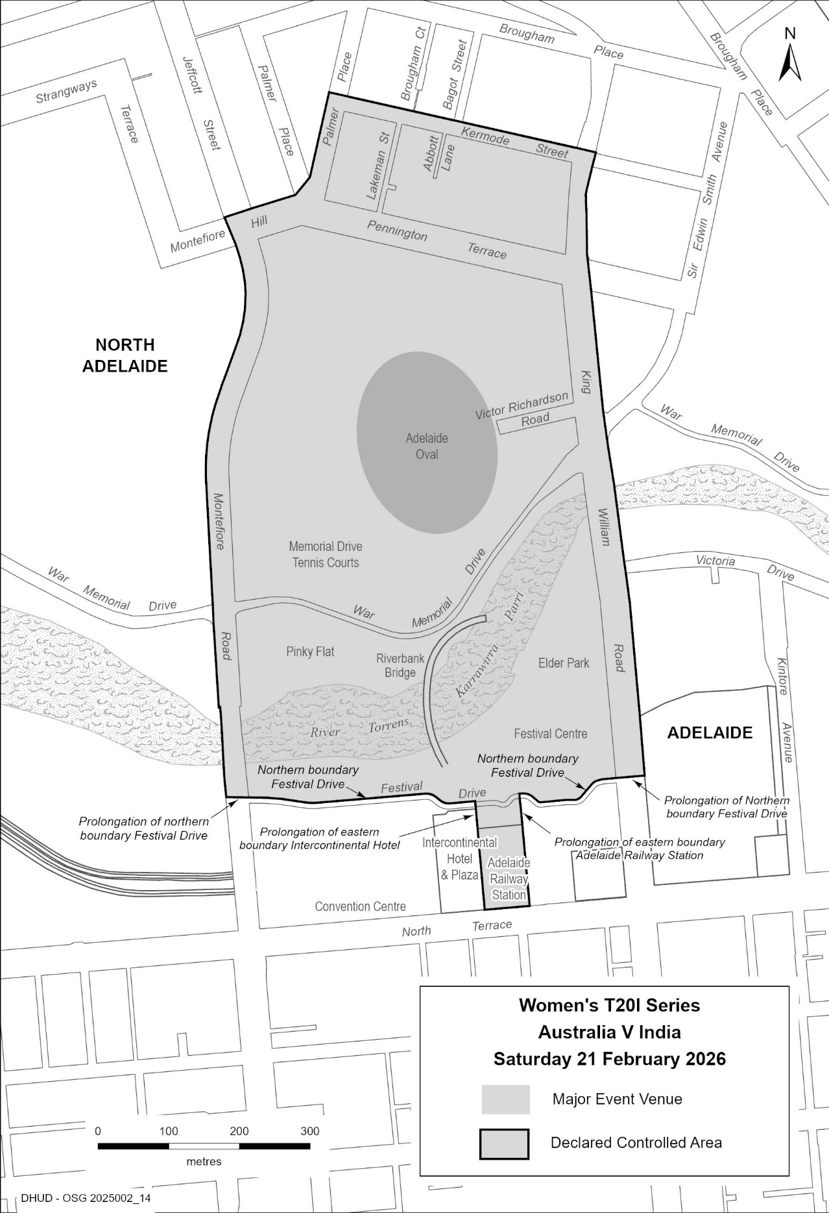
2026 Women’s T20i Series, Australia V India

National Parks And Wildlife Act 1972
Open Season for the Taking of Specified Species of Protected Animals—Ducks
Pursuant to Section 52 of the National Parks and Wildlife Act 1972, I, Hon Lucy Hood MP, Minister for Climate, Environment and Water, being the Minister for the Crown to whom the administration of the National Parks and Wildlife Act 1972 is for the time being committed, declare an Open Season for the taking of specified species of protected animals as set out in this notice.
1. Specified Species
The species to which the open season applies is limited to the following:
• grey teal (Anas gracilis)
• chestnut teal (Anas castanea)
• maned (wood) duck (Chenonetta jubata)
• Pacific black duck (Anas superciliosa)
• Australian shelduck (mountain duck) (Tadorna tadornoides)
2. Open Season Dates and Times
Subject to other provisions of this notice, the open season for the species identified in Clause 1 is Saturday, 21 March 2026 until Sunday, 28 June 2026 inclusive, and the specified species of protected animal listed in Clause 1 may only be taken in the period between sunrise and sunset on any given day of the open season.
Refer to Clause 6 for further restrictions to open season dates in Game Reserves.
3. Prohibition Against Taking Eggs
A person shall not take eggs of any species listed in Clause 1 during the open season.
4. Bag Limit
On any day of the open season, a person shall not take more than eight (8) ducks listed in Clause 1.
5. Area of the State
The open season in relation to the species of protected animal listed in Clause 1 applies to the whole of South Australia, excluding:
5.1 all reserves constituted under the National Parks and Wildlife Act 1972, other than those game reserves specified in Clause 6 below; and
5.2 all sanctuaries established under the National Parks and Wildlife Act 1972; and
5.3 all wilderness protection areas and all wilderness protection zones constituted under the Wilderness Protection Act 1992; and
5.4 all sanctuary zones within any marine park established under the Marine Parks Act 2007.
6. Open Season in Game Reserves
6.1 Subject to the further restrictions contained in this Clause, open season (including Clause 2, Clause 3 and Clause 4 restrictions) applies in relation to Chowilla Game Reserve, Loch Luna Game Reserve, Currency Creek Game Reserve, Lake Robe Game Reserve, Mud Islands Game Reserve, Poocher Swamp Game Reserve, Bucks Lake Game Reserve and Tolderol Game Reserve.
6.2 Restrictions apply to the dates of the open season for Chowilla Game Reserve and Loch Luna Game Reserve from those specified in Clause 2.
6.2.1 Chowilla Game Reserve
The specified species in Clause 1 may only be taken in Chowilla Game Reserve between sunrise and sunset on the following specified open season dates:
• Saturday 21 March 2026
• Sunday 22 March 2026
• Saturday 2 May 2026
• Sunday 3 May 2026
• Saturday 16 May 2026
• Sunday 17 May 2026
• Saturday 30 May 2026
• Sunday 31 May 2026
• Saturday 13 June 2026
• Sunday 14 June 2026
• Saturday 27 June 2026
• Sunday 28 June 2026
6.2.2 Loch Luna Game Reserve
The specified species in Clause 1 may only be taken in Loch Luna Game Reserve between sunrise and sunset on the following specified open season dates:
• Saturday 21 March 2026
• Sunday 22 March 2026
• Saturday 28 March 2026
• Sunday 29 March 2026
• Saturday 2 May 2026
• Sunday 3 May 2026
• Saturday 9 May 2026
• Sunday 10 May 2026
• Saturday 16 May 2026
• Sunday 17 May 2026
• Saturday 30 May 2026
• Sunday 31 May 2026
• Saturday 13 June 2026
• Sunday 14 June 2026
• Saturday 20 June 2026
• Sunday 21 June 2026
• Saturday 27 June 2026
• Sunday 28 June 2026
6.3 Area restrictions are imposed for the open season in relation to the specified species of protected animal listed in Clause 1 in game reserves as follows:
6.3.1 Chowilla Game Reserve
The open season applies to the whole reserve, subject to the following exclusions:
(a) for safety reasons, all of the area within a 500 metre radius centred upon the Chowilla Homestead, shearing shed, Lock 6 on the River Murray, the Chowilla Creek Regulator, Pipeclay Weir, Slaney Weir and Coombool Outstation (homestead) including any portion of creeks or waterbodies within 500 metres of these sites.
(b) For safety reasons, all areas within a 500 metre buffer zone of planned construction site zones and access tracks. Public entry into this zone is prohibited (including waterways within construction zone).
6.3.2 Loch Luna Game Reserve
The open season applies to all creeks and associated backwaters of the reserve, subject to the following exclusions:
(a) a 500 metre radius of any house or outbuilding, and within 300 metres of any road or bridge; and
(b) for safety reasons, the open season does not apply to all of the area within 500 metres radius of the homestead of Section 706 McIntosh Division Hundred of Cobdogla Irrigation Area.
6.3.3 Tolderol Game Reserve
The open season applies to the whole reserve, subject to the following exclusions:
(a) the area of Tolderol Game Reserve being the land and water west of a line commencing at E 332052, N 6084977, south to E 332014, N 6083738, and north of the southernmost track east of this line. This encompasses all areas commonly referred to as “the bays”.
6.3.4 Bucks Lake Game Reserve, Currency Creek Game Reserve, Lake Robe Game Reserve, Mud Islands Game Reserve and Poocher Swamp Game Reserve
(a) The open season applies to the whole of each reserve.
7. 2026 Hunting Survey
7.1 Pursuant to Regulation 9 of the National Parks and Wildlife (Hunting) Regulations 2011 all duck hunting permit holders are required to complete and lodge a duck hunting survey in accordance with the instructions specified in the survey form supplied with their duck hunting permit.
Dated: 7 January 2026
Hon Lucy Hood MP
Minister for Climate, Environment and Water

National Parks and Wildlife Act 1972
Open Season for the Taking of Specified Species of Protected Animals—Stubble Quail
Pursuant to Section 52 of the National Parks and Wildlife Act 1972, I, Hon Lucy Hood MP, Minister for Climate, Environment and Water, being the Minister for the Crown to whom the administration of the National Parks and Wildlife Act 1972 is for the time being committed, declare an open season for the taking of stubble quail (Coturnix pectoralis) as set out in this notice.
1. Open Season Dates and Times
Subject to other provisions of this notice, the open season for the taking of stubble quail (Coturnix pectoralis) will start on Saturday, 25 April 2026 and end on Sunday, 2 August 2026 inclusive. Stubble quail may only be taken in the period between sunrise and sunset on any given day of the open season.
2. Prohibition Against Taking Eggs
A person shall not take stubble quail (Coturnix pectoralis) eggs during the open season.
3. Bag Limit
On any day of the open season, a person shall not take more than fifteen (15) stubble quail (Coturnix pectoralis).
4 Area of the State
The open season in relation to stubble quail (Coturnix pectoralis) applies to the whole of South Australia excluding:
4.1 all reserves constituted under the National Parks and Wildlife Act 1972; and
4.2 all sanctuaries established under the National Parks and Wildlife Act 1972; and
4.3 all wilderness protection areas and all wilderness protection zones constituted under the Wilderness Protection Act 1992; and
4.4 all sanctuary zones within any marine park established under the Marine Parks Act 2007.
5 2026 Hunting Survey
Pursuant to Regulation 9 of the National Parks and Wildlife (Hunting) Regulations 2011 all quail hunting permit holders are required to complete and lodge a quail hunting survey in accordance with the instructions specified in the survey form supplied with their quail hunting permit.
Dated: 7 January 2026
Hon Lucy Hood MP
Minister for Climate, Environment and Water

Planning, Development And Infrastructure Act 2016
Section 76
Amendment to the Planning and Design Code
Preamble
It is necessary to amend the Planning and Design Code (the Code) in operation at 18 December 2025 (Version 2025.22) in order to make changes of form relating to the Code’s spatial layers and their relationship with land parcels. Note: There are no changes to the application of zone, subzone or overlay boundaries and their relationship with affected parcels or the intent of policy application as a result of this amendment.
1. Pursuant to Section 76 of the Planning, Development and Infrastructure Act 2016 (the Act), I hereby amend the Code in order to make changes of form (without altering the effect of underlying policy), correct errors and make operational amendments as follows:
(a) Undertake minor alterations to the geometry of the spatial layers and data in the Code to maintain the current relationship between the parcel boundaries and Code data as a result of the following:
(i) New plans of division deposited in the Land Titles Office between 10 December 2025 and 6 January 2026 affecting the following spatial and data layers in the Code:
A. Zones and subzones
B. Technical and Numeric Variations
• Building Heights (Levels)
• Building Heights (Metres)
• Concept Plan
• Finished Ground and Floor Levels
• Interface Height
• Minimum Dwelling Allotment Size
• Minimum Frontage
• Minimum Site Area
• Minimum Primary Street Setback
• Minimum Side Boundary Setback
• Future Local Road Widening Setback
C. Overlays
• Affordable Housing
• Coastal Areas
• Defence Aviation Area
• Design
• Future Local Road Widening
• Future Road Widening
• Hazards (Bushfire—High Risk)
• Hazards (Bushfire—Medium Risk)
• Hazards (Bushfire—General Risk)
• Hazards (Bushfire—Urban Interface)
• Hazards (Bushfire—Regional)
• Hazards (Bushfire—Outback)
• Heritage Adjacency
• Historic Area
• Local Heritage Place
• Noise and Air Emissions
• Significant Retirement Facility and Supported Accommodation Sites
• State Heritage Place
• Stormwater Management
• Urban Tree Canopy
(b) In Part 13 of the Code—Table of Amendments, update the publication date, Code version number, amendment type and summary of amendments within the ‘Table of Planning and Design Code Amendments’ to reflect the amendments to the Code as described in this Notice.
2. Pursuant to Section 76(5)(a) of the Act, I further specify that the amendments to the Code as described in this Notice will take effect upon the date those amendments are published on the SA planning portal.
Dated: 13 January 2026
Greg Van Gaans
Director, Geospatial Information Services
Department for Housing and Urban Development
Delegate of the Minister for Planning

Planning, Development And Infrastructure Act 2016
Section 76
Amendment to the Planning and Design Code
Preamble
It is necessary to amend the Planning and Design Code (the Code) to make the following minor or operational amendments:
• Correct errors related to Overlay policy provisions applying to the performance assessed pathways for shop, office and consulting room classes of development within Table 3—Applicable Policies for Performance Assessed Development across various Zones.
• Correct errors related to Overlay and Subzone policy provisions applying to performance assessed pathways for various classes of development within Table 3—Applicable Policies for Performance Assessed Development of the Master Planned Neighbourhood Zone.
1. Pursuant to Section 76 of the Planning, Development and Infrastructure Act 2016 (the Act), I hereby amend the Code to make the following minor or operational amendments:
(a) In Part 2—Zones and Subzones, in Table 3—Applicable Policies for Performance Assessed Development, remove from the ‘Overlay’ column, PO 1.1, PO 1.2, PO 2.1 and PO 2.2 of the Significant Retirement Facility and Supported Accommodation Sites Overlay from applying to consulting room, office and shop classes of development in the following Zones:
(i) City Living Zone
(ii) General Neighbourhood Zone
(iii) Golf Course Estate Zone
(iv) Housing Diversity Neighbourhood Zone
(v) Master Planned Neighbourhood Zone
(vi) Master Planned Renewal Zone
(vii) Master Planned Township Zone
(viii) Neighbourhood Zone
(ix) Suburban Neighbourhood Zone
(x) Waterfront Neighbourhood Zone.
(b) In Part 2—Zones and Subzones, in Table 3—Applicable Policies for Performance Assessed Development of the Master Planned Neighbourhood Zone, remove from the ‘Subzone’ column the policy provisions listed in Column A of the table below, from the classes of development listed in Column B of the table below:
Column A—Subzone Policy Provisions | Column B—Classes of Development
• Emerging Main Street Subzone [Land Use and Intensity]  PO 1.1, PO 1.2, PO 1.3, PO 1.5, PO 1.5, PO 1.7  • Emerging Main Street Subzone [Built Form and Character]PO 2.1, PO 2.2, PO 2.3, PO 2.4, PO 2.5, PO 2.7, PO 2.8, PO 2.9  • Emerging Main Street Subzone [Building Height and Setbacks]  PO 3.1, PO 3.2, PO 3.3, PO 3.4, PO 3.5 | • Consulting room  • Light industry  • Office  • Service trade premises  • Shop  • Store  • Warehouse
(c) In Part 2—Zones and Subzones, in Table 3—Applicable Policies for Performance Assessed Development of the Master Planned Neighbourhood Zone, remove from the ‘Overlay’ column the policy provisions listed in Column A of the table below, from the classes of development listed in Column B of the table below:
Column A—Overlay Policy Provisions | Column B—Classes of Development
• Coordinated Development Overlay [Land Use] PO 1.1  • Infrastructure Coordination Overlay [Infrastructure Delivery Scheme]  PO 1.1, PO 1.2, PO 1.3, PO 1.4  • Infrastructure Coordination Overlay [Social infrastructure]  PO 2.1, PO 2.2. | • Consulting room  • Light industry  • Office  • Service trade premises  • Shop  • Store  • Warehouse

(d) In Part 13—Table of Amendments, update the publication date, Code version number, amendment type and summary of amendments within the ‘Table of Planning and Design Code Amendments’ to reflect the amendments to the Code as described in this Notice.
2. Pursuant to Section 76(5)(a) of the Act, I further specify that the amendments to the Code as described in this Notice will take effect upon the date those amendments are published on the SA planning portal.
Dated: 12 January 2026
Jason Bailey
Manager Planning and Design Code
Department for Housing and Urban Development
Delegate of the Minister for Planning

Planning, Development and Infrastructure Act 2016
Section 167, Part 13
Adoption of Scheme—Infrastructure Frameworks
Preamble
On 19 June 2025, pursuant to Section 163 of the Planning, Development and Infrastructure Act 2016 (the Act), the Minister for Planning caused the draft outline for the Concordia Basic Infrastructure Scheme to be published in the Government Gazette.
The Scheme Coordinator appointed under Section 165 of the Act has now prepared a report on the proposed Concordia Basic Infrastructure Scheme pursuant to Section 166(8) of the Act for the consideration of the Minister for Planning.
Pursuant to Section 167(1)(a) of the Act, the Minister for Planning may, on receipt of a report on a proposed scheme furnished by a scheme coordinator, determine whether to proceed with the scheme.
In accordance with Section 167(3)(a) of the Act, if the Minister decides to proceed with the scheme under Section 167(1)(a), the Minister must cause a final outline of the scheme to be notified in the Gazette.
Notice
I, Nick Champion, Minister for Planning, determined to proceed with the Concordia Basic Infrastructure Scheme pursuant to Section 167(1)(a) of the Planning, Development and Infrastructure Act 2016 (the Act) on 19 December 2025.
The final outline of the Concordia Basic Infrastructure Scheme will be published on the SA planning portal in accordance with Section 167(3)(b) of the Act.
Dated: 7 January 2026
Hon Nick Champion MP
Minister for Planning

Planning, Development and Infrastructure Act 2016
Section 169, Part 13
Funding arrangements—Infrastructure Frameworks
Preamble
On 19 December 2025, pursuant to Section 167 of the Planning, Development and Infrastructure Act 2016 (the Act), the Minister for Planning determined to proceed with the Concordia Basic Infrastructure Scheme (the Scheme).
A funding arrangement was developed by the Scheme Coordinator for the purposes of the Scheme in accordance with their functions under Section 166 of the Act.
In accordance with Section 169(5) of the Act, a funding arrangement has no force or effect unless or until it has been approved by the Minister for Planning by notice published in the Government Gazette.
Notice
I, Nick Champion, Minister for Planning, approve the funding arrangement for the Concordia Basic Infrastructure Scheme pursuant to Section 169(5) of the Planning, Development and Infrastructure Act 2016.
Dated: 7 January 2026
Hon Nick Champion MP
Minister for Planning

Radiation Protection And Control Regulations 2022
Regulation 89
Notice RPC202601-01
Pursuant to Part 5, Division 3 of the Radiation Protection and Control Regulations 2022, I, Ian Yorke, Manager Air, Noise and Radiation Science, Environment Protection Authority, Delegate of the Minister for Climate, Environment and Water, approve the following kinds of personal monitoring devices issued by the organisations listed in Column 1 of the Schedule below for detecting and measuring external exposure to the type of ionising radiations listed in Column 2, subject to the following conditions:
1. all measurements must remain traceable to Australian standards, or international standards in the absence of an Australian standard;
2. relevant NATA or equivalent accreditation of the measurement system must be maintained;
3. the organisation must supply free of charge to the EPA, measurements of radiation workers’ exposures;
4. the approved personal monitoring devices are also to be used in accordance with any instructions given by the respective organisations or the EPA; and
5. Radiation Safety Institute of Canada must ensure continuation of the licence held by RSIC in relation to the PAD system, issued by the Canadian Nuclear Safety Commission.
The Schedule
Column 1 | Column 2
TLD Monitor…………………………………………………………………..ARPANSA* | beta, gamma, X-ray
Special TLD Monitor………………………………………………….………...ARPANSA | beta, gamma, X-ray
Neutron Monitor……………………………………………………..…………..ARPANSA | beta, gamma, X-ray, neutron
Extremity Monitor………………………………………………...…………..….ARPANSA | beta, gamma, X-ray
PADC/BeO OSL………………………………………………..……………..….ARPANSA | Photon, fast neutron
BeO OSL……………………………………………………………..…….…….ARPANSA | Gamma, X-ray
RDC Type 82 TLD-XBGN dosimeter.……………………..………….….………..….GMS* | beta, gamma, X-ray, neutron
RDC Type 83 TLD-XBGN/TE dosimeter.…………………………………….……….GMS | beta, gamma, X-ray, neutron
RDC Type 05 TLD-XBG ring dosimeter.……………………………………..……….GMS | beta, gamma, X-ray
Pa Badge.………………………………………………………………………….Landauer* | beta, gamma, X-ray
Ja Badge.…………………………………………………………………...……….Landauer | beta, gamma, X-ray, neutron
Ta Badge.……………………………………………………………………..…….Landauer | beta, gamma, X-ray, thermal
U Badge (Ring) .……………………………………………………………..……..Landauer | beta, gamma, X-ray
Personal Alpha Dosimeter.……………………………………………………..….….RSIC* | radon progeny and long-lived radioactive dust
Instadose® 2.…………………………………………………..….…………..…….….SGS* | beta, gamma, X-ray
InstadoseTM.…………………………………………………..…………………….…….SGS | gamma, X-ray
Instadose +TM.……………………………………………….………………..………….SGS | gamma, X-ray
Genesis Ultra TLD.………………………………………..………………………….….SGS | beta, gamma, neutron
Genesis Ultra TLD with CR39.………………………………………………………….SGS | beta, gamma, neutron
Film + Orange holder………………………………………………………..……..…….SGS | gamma, X-ray
Film + Yellow holder.……………………………………………..…………………….SGS | gamma, X-ray
Film + Blue holder.……………………………………………………………………….SGS | gamma, X-ray
TLD + Ring holder.…………………………………….……………..………………….SGS | gamma, X-ray
TLD + PB5 holder.………………………………………..…………..………………….SGS | gamma, X-ray
TLD + PB10 holder.…………………………………………………..………………….SGS | gamma, X-ray
Mirion DMC 3000.…………………….………………………………...……………….SGS | gamma, X-ray
Mirion SOR/R.……………………………………..…………………………………….SGS | gamma, X-ray
Mirion SOR/T.……………………………………..…………………………………….SGS | gamma, X-ray
EPD Mk2+…..……………………………………………….………………Thermo Fisher* | gamma, X-ray
RadEye PRD-ER…………………………………………………..…………..Thermo Fisher | gamma
RadEye GN+…………………………………………..………………………Thermo Fisher | gamma, thermal neutron
(*ARPANSA—Australian Radiation Protection and Nuclear Safety Agency);
(*GMS—Global Medical Solutions Pty Ltd);
(*Landauer—Landauer Australasia Pty Ltd);
(*RSIC—Radiation Safety Institute of Canada);
(*SGS—SGS Australia Pty Ltd);
(*Thermo Fisher—Thermo Fisher Scientific Australia Pty Ltd)
This notice of approval shall take effect commencing on the date of publication of this notice in the Government Gazette.
The notice of approval in respect to Part 5, Division 3 of the Radiation Protection and Control Regulations 2022 published in the South Australian Government Gazette No. 90, dated 14 December 2023 is hereby revoked.
Dated: 13 January 2026
I. Yorke
Delegate of the Minister for Climate, Environment and Water

Retail And Commercial Leases Act 1995
Exemption
Pursuant to Section 77(2) of the Retail and Commercial Leases Act 1995 (SA) I, Daniel van Holst Pellekaan, Small Business Commissioner for the State of South Australia, exempt the Lease agreement, which is to commence on 30 January 2026, between the Minister for Climate, Environment and Water and White Cross Investment Hotels Pty Ltd (ACN 008 289 049) in relation to Crown Land Volume 5756 Folio 491, being Allotment 285 in the area named Tumby Bay, Hundred of Hutchison, from the entirety of the Retail and Commercial Leases Act 1995.
Dated: 9 January 2026
Hon Daniel Van Holst Pellekaan
Small Business Commissioner

Road Traffic Act 1961
Authorisation to Operate Breath Analysing Instruments
I, Grant Stevens, Commissioner of Police, do hereby notify that on and from 22 December 2025, the following persons were authorised by the Commissioner of Police to operate breath analysing instruments as defined in and for the purposes of the:
• Road Traffic Act 1961;
• Harbors and Navigation Act 1993;
• Security and Investigation Industry Act 1995; and
• Rail Safety National Law (South Australia) Act 2012.
PD Number | Officer Name
15246 | BASEDOW, Nicholas Peter
15060 | CRANWELL, Nathan Aaron
16086 | DE VELLIS, Adam Peter
10543 | DOBBS, Liam James
16308 | GRAY, Luke Alexander
15229 | KELSEY, Grace Olivia
14921 | MILBURN, Aisha Zane
15737 | MILLETT, Curtis James
11951 | PETREVICS, Hannah
14928 | ROVER, Georgie May
Dated: 15 January 2026
Grant Stevens
Commissioner of Police
Reference: 2025-0167

Roads (Opening And Closing) Act 1991
Section 24
NOTICE OF CONFIRMATION OF
ROAD PROCESS ORDER
Road Closure—Portion of Schumacher Road, Wingfield
By Road Process Order made on 3 July 2025, the City of Port Adelaide Enfield ordered that:
1. Portion of Schumacher Road, Wingfield, (being portion of Allotment 30 in Deposited Plan 71326 and portion of Allotment 260 in Deposited Plan 73696) situated adjoining Allotment 22 in Deposited Plan 71326 and Allotments 7 to 10 in Deposited Plan 72293, Hundred of Port Adelaide, more particularly lettered ‘A’, ‘B’, ‘C’, ‘D’ and ‘E’ in Preliminary Plan 24/0032 be closed.
2. Transfer the whole of the land subject to closure lettered ‘A’ to 14 Schumacher Road Pty. Ltd. (ACN 647 075 714) in accordance with the Agreement for Transfer dated 31 March 2025 entered into between the City of Port Adelaide Enfield and 14 Schumacher Road Pty. Ltd. (ACN 647 075 714).
3. Transfer the whole of the land subject to closure lettered ‘B’ to 22 Schumacher Road Pty. Ltd. (ACN 647 075 269) in accordance with the Agreement for Transfer dated 31 March2025 entered into between the City of Port Adelaide Enfield and 22 Schumacher Road Pty. Ltd. (ACN 647 075 269).
4. Transfer the whole of the land subject to closure lettered ‘C’, ‘D’ and ‘E’ to Combined Industries Proprietary Limited (ACN 007 562 932) in accordance with the Agreement for Transfer dated 31 March 2025 entered into between the City of Port Adelaide Enfield and Combined Industries Proprietary Limited (ACN 007 562 932).
5. The following easements are to be granted over portions of the land subject to closure:
Grant to Distribution Lessor Corporation (subject to Lease 8890000) an easement for the transmission of electricity by underground cable over the land marked ‘A’ in Deposited Plan 137984.
Grant to the South Australian Water Corporation an easement for sewerage purposes over the land marked ‘B’ in Deposited Plan 137984.
Grant to the South Australian Water Corporation an easement for water supply purposes over the land marked ‘C’ in Deposited Plan 137984.
On 9 January 2026 that order was confirmed by the Minister for Planning conditionally upon the deposit by the Registrar-General of Deposited Plan 137984 being the authority for the new boundaries. Pursuant to Section 24 of the Roads (Opening and Closing) Act 1991, notice of the order referred to above and its confirmation is hereby given.
Dated: 9 January 2026
B. J. Slape
Surveyor-General
2024/06833/01

Summary Offences Act 1953
Declared Public Precincts
Notice of Ministerial Declaration
I, Kyam Maher, Attorney-General in the State of South Australia, being the Minister responsible for the administration of Part 14B—Declared Public Precincts of the Summary Offences Act 1953, do hereby declare pursuant to the provisions of Section 66N of the said Act that the area, comprised of more than one public place in the suburb of Adelaide, within the following boundaries:
• Northern boundary of North Terrace, from the eastern boundary of Pulteney Street, to Botanic Road
• Northern boundary of Botanic Road to Eastern boundary of Dequetteville Terrace
• Eastern boundary of Dequetteville Terrace to Southern boundary of Bartels Road
• Southern boundary of Bartels Road to Southern boundary of Pirie Street
• Southern boundary of Pirie Street to Eastern boundary of Pulteney Street
• Eastern Boundary of Pulteney Street to Northern boundary of North Terrace.
be a declared public precinct for a period of 8 hours from 6 pm on each night commencing on Friday 20 February 2026, recurring for each described time and day of the week until declared otherwise or until 2 am on Monday 23 March 2026, whichever occurs sooner.
I am satisfied that there is, during the periods specified in this declaration, a reasonable likelihood of conduct posing a risk to public order and safety in the area specified.
I am satisfied that the inclusion of each public place in the area is reasonable having regard to that identified risk.
Dated: 8 January 2026
Kyam Maher
Attorney-General

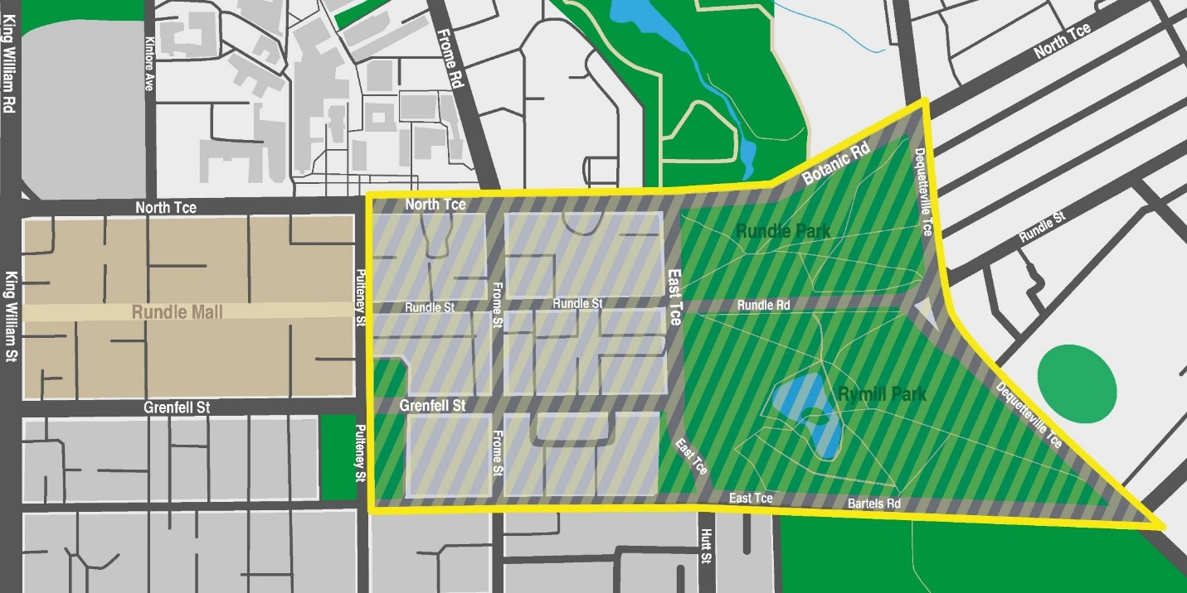

SUMMARY OFFENCES ACT 1953
Public Event Declaration
Notice is hereby given in accordance with Section 66ZE of the Summary Offences Act 1953 that the public event known as the 2026 Santos Tour Down Under is a declared public event at the place, and during the times, shown below:
Place:
• The City of Adelaide Tour Village; and
• Any public place, or any part of a public place, that is within 50 metres of the official routes, namely:
◦ Ziptrak Women’s Stage 1;
◦ Health Partners Women’s Stage 2;
◦ Hyundai Women’s Stage 3;
◦ Vanguard Women’s One-Day Race;
◦ South Australia Prologue;
◦ Vanguard Men’s Stage 1;
◦ Health Partners Men’s Stage 2;
◦ Ziptrak Men’s Stage 3;
◦ Think! Road Safety Men’s Stage 4; and
◦ EFEX Men’s Stage 5.
Further descriptions of these areas, and times of the declaration operation for each, are provided below.
Maps included in this notice are provided for general guidance only. During the declared public event, police officers may carry out a metal detector search in relation to any person who is at the relevant public place, or attempting to enter or leave the relevant public place, together with any property in the person’s possession.
Dated: 13 January 2026
Stuart Mclean
Assistant Commissioner
Delegate of the Commissioner

City of Adelaide Tour Village
Time of Effect of Declaration
Commencing on: Friday, 16 January 2026 at 12:01am
Ending on: Sunday, 25 January 2026 at 11:59pm
Description of The Area
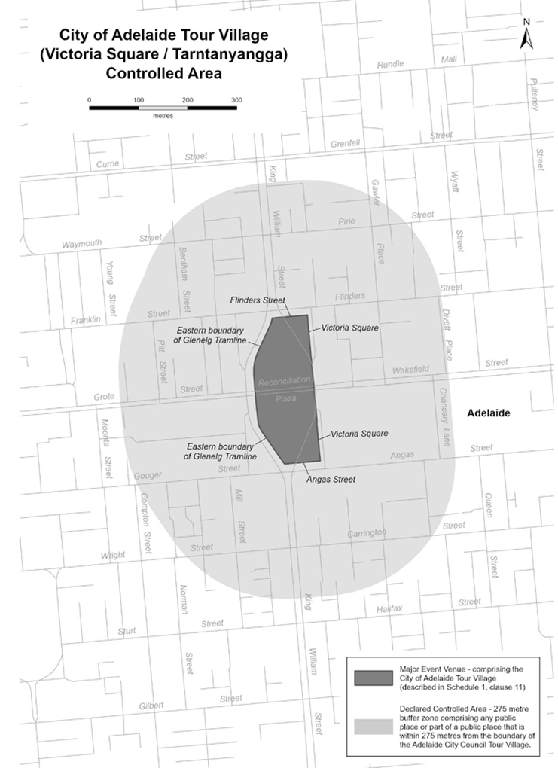
The City of Adelaide Tour Village comprises the area in Victoria Square/Tarntanyangga in Adelaide bounded as follows: commencing at the point at which the eastern boundary of the Glenelg Tramline intersects the southern boundary of Franklin Street, then easterly along the southern boundary of Franklin Street to its intersection with the western boundary of the portion of road (running generally north to south) known as Victoria Square, then southerly along that boundary to its south-eastern-most point, then southerly in a straight line across Wakefield Street to the north-eastern-most point on the western boundary of the portion of road (running generally north to south) known as Victoria Square, then southerly along that boundary to its intersection with the northern boundary of Angas Street, then westerly along the northern boundary of Angas Street to its intersection with the eastern boundary of the Glenelg Tramline, then generally north-westerly and northerly along the eastern boundary of the Glenelg Tramline to its intersection with the southern boundary of Reconciliation Plaza, then northerly in a straight line across Reconciliation Plaza to the intersection of the northern boundary of Reconciliation Plaza with the eastern boundary of the Glenelg Tramline, then northerly and generally north-easterly along the eastern boundary of the Glenelg Tramline to the point of commencement.
Ziptrak Women’s Stage 1 (Willunga to Willunga)
Time of Effect of Declaration
Commencing on: Saturday, 17 January 2026 at 12:01am
Ending on: Saturday, 17 January 2026 at 11:59pm
Description of Official Race Route
The official race route for Ziptrak Women’s Stage 1 (Willunga to Willunga) comprises—
(a) the portion of road commencing on High Street in Willunga near the Old Bush Inn, then south-easterly along High Street to its intersection with Hailstone Lane, then southerly along Hailstone Lane to its intersection with St Judes Street, then westerly along St Judes Street to its intersection with St Andrews Terrace, then northerly along St Andrews Terrace to its intersection with High Street, then north westerly along High Street to its intersection with Aldinga Road, then westerly along Aldinga Road to its intersection with Plains Road in Aldinga, then southerly along Plains Road to its intersection with Hahn Road in Sellicks Hill, then westerly along Hahn Road to its intersection with Main South Road, then southerly along Main South Road to its intersection with Norman Road, then westerly along Norman Road to its intersection with Esplanade in Aldinga Beach, then northerly along Esplanade to its intersection with Lower Esplanade, then generally northerly along Lower Esplanade to its intersection with Esplanade, then northerly and north-easterly along Esplanade to its intersection with Jetty Road in Port Willunga, then easterly along Jetty Road to its intersection with Port Road, then south-easterly and easterly along Port Road to its intersection with Old Coach Road in Aldinga, then northerly along Old Coach Road to its intersection with Maslin Beach Road in Maslin Beach, then easterly along Maslin Beach Road until it becomes Tatachilla Road, the easterly along Tatachilla Road to its intersection with Caffrey Road in McLaren Vale, then northerly along Caffrey Road to its intersection with Main Road, then south-easterly along Main Road to its intersection with Field Street, then northerly along Field Street until it becomes Olivers Road, then northerly along Olivers Road to its intersection with Seaview Road, then easterly along Seaview Road until it becomes Kays Road, then generally easterly along Kays Road to its intersection with Whitings Road in McLaren Flat, then southerly along Whitings Road to its intersection with Blewitt Springs Road, then southerly along Blewitt Springs Road to its intersection with Kangarilla Road, then south-westerly and westerly along Kangarilla Road to its intersection with Main Road in McLaren Vale, then south-easterly and southerly along Main Road to its intersection with High Street in Willunga, then south-easterly along High Street, and
(b) the portion of road commencing at the intersection of Main Road with Field Street, then south-easterly along Main Road to its intersection with Kangarilla Road.

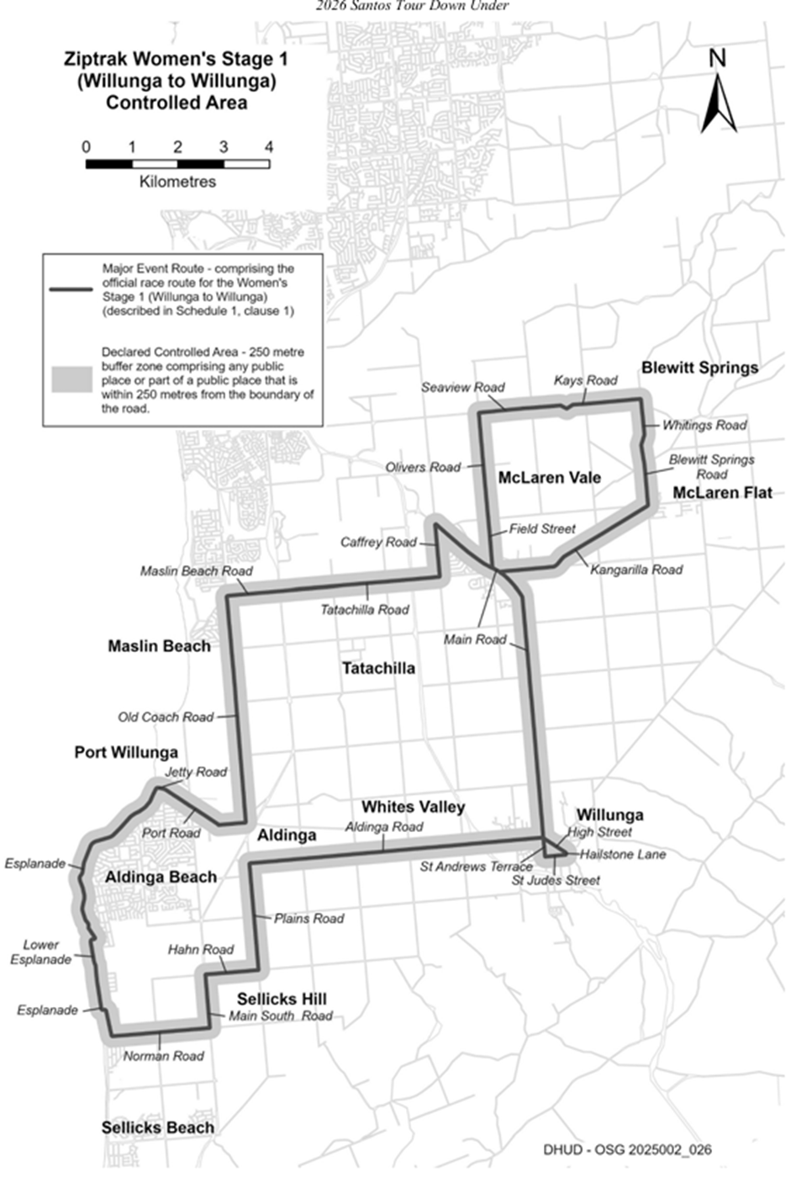

(Health Partners Women’s Stage 2 (Magill to Paracombe)
Time of Effect of Declaration
Commencing on: Sunday, 18 January 2026 at 12:01am
Ending on: Sunday, 18 January 2026 at 11:59pm
Description of Official Race Route
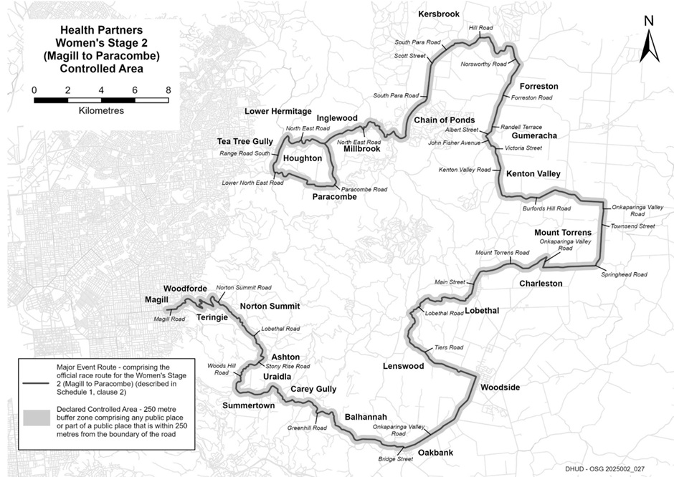
The official race route for the Health Partners Women’s Stage 2 (Magill to Paracombe) commencing at the intersection of Magill Road and Pepper Street in Magill, then easterly along Magill Road to its intersection with Norton Summit Road, then generally north-easterly, generally south-easterly, generally northerly, south-easterly, northerly and generally south-easterly until it becomes Lobethal Road in Norton Summit, then south-easterly along Lobethal Road to its intersection with Stony Rise Road in Ashton, then south-westerly and westerly along Stony Rise Road to its intersection with Woods Hill Road, then generally south-westerly, generally southerly, south westerly and southerly along Woods Hill Road to its intersection with Greenhill Road in Summertown, then south-easterly, generally easterly, north-easterly, generally south-easterly, generally easterly, generally south-easterly along Greenhill Road until it becomes Bridge Street in Balhannah, then easterly and south easterly to its intersection with Onkaparinga Valley Road, then generally north-easterly along Onkaparinga Valley Road to its intersection with Tiers Road in Woodside, then generally westerly, and generally northerly to its intersection with Lobethal Road in Lenswood, then generally north-easterly, generally easterly and generally north-easterly to its intersection with Main Street in Lobethal, then northerly along Main Street until it becomes Mount Torrens Road, then generally easterly along Mount Torrens Road to its intersection with Onkaparinga Valley Road in Mount Torrens, then south-westerly along Onkaparinga Valley Road to its intersection with Springhead Road in Charleston, then easterly and northerly along Springhead Road until it becomes Townsend Street in Mount Torrens, then northerly along Townsend Street until it becomes Onkaparinga Valley Road, then northerly along Onkaparinga Valley Road to its intersection with Burfords Hill Road, then generally westerly along Burfords Hill Road to its intersection with Kenton Valley Road in Kenton Valley, then northerly along Kenton Valley Road until it becomes Victoria Street in Gumeracha, then westerly along Victoria Street to its intersection with John Fisher Avenue, then generally north-westerly along John Fisher Avenue to its intersection with Albert Street, then north-easterly along Albert Street to its intersection with Randell Terrace, the northerly along Randell Terrace until it becomes Forreston Road, then northerly along Forreston Road to its intersection with Norsworthy Road in Forreston, then northerly, westerly, and generally south-westerly along Norsworthy Road until it becomes Hill Road, then northerly and generally westerly along Hill Road to its intersection with South Para Road in Kersbrook, then south-westerly along South Para Road until it becomes Scott Street, then south-westerly along Scott Street until it becomes South Para Road, then southerly, south-westerly and southerly to its intersection with North East Road in Chain of Ponds, then westerly, north-westerly, generally south-westerly, generally north-westerly and generally south-westerly along North East Road to its intersection with Paracombe Road in Paracombe, then southerly and generally westerly along Paracombe Road to its intersection with Lower North East Road in Houghton, then westerly along Lower North East Road to its intersection with Range Road South, then northerly along Range Road South to its intersection with North East Road, then generally easterly along North East Road to its intersection with Paracombe Road in Paracombe.

Hyundai Women’s Stage 3 (Norwood to Campbelltown)
Time of Effect of Declaration
Commencing on: Monday, 19 January 2026 at 12:01am
Ending on: Monday, 19 January 2026 at 11:59pm
Description of Official Race Route
The official race route for Hyundai Women’s Stage 3 (Norwood to Campbelltown) comprises—
(a) the portion of road commencing at the intersection of The Parade and George Street, in Norwood, then easterly along The Parade to its intersection with Glynburn Road, then northerly along Glynburn Road to its intersection with Montacute Road in Glynde, then easterly along Montacute Road to its intersection with Stradbroke Road in Rostrevor, then northerly along Stradbroke Road to its intersection with Gorge Road in Athelstone, then generally north-easterly, generally south-easterly, generally easterly and generally north-easterly to its intersection with Tippett Road in Millbrook, then generally northerly and easterly to its intersection with North East Road in Chain of Ponds, then generally easterly to its intersection with Torrens Valley Road in Gumeracha, then generally easterly until it becomes Albert Street, then north-easterly and easterly until it becomes Torrens Valley Road, then generally easterly along Torrens Valley Road until it becomes Shannon Street in Birdwood, then easterly along Shannon Street to its intersection with William Street, then southerly along William Street until it becomes Onkaparinga Valley Road, then southerly along Onkaparinga Valley Road until it becomes Townsend Street in Mount Torrens, then southerly along Townsend Street to its intersection with Springhead Road, then southerly and westerly along Springhead Road to its intersection with Onkaparinga Valley Road in Charleston, then northerly along Onkaparinga Valley Road to its intersection with Mount Torrens Road in Mount Torrens, then generally westerly along Mount Torrens Road until it becomes Main Street in Lobethal, then southerly along Main Road to its intersection with Woodside Road, then generally south-easterly along Woodside Road to its intersection with Onkaparinga Valley Road in Woodside, then generally south-westerly along Onkaparinga Vally Road to its intersection with Bridge Street in Balhannah, then westerly along Bridge Street to its intersection with Greenhill Road, then generally westerly along Greenhill Road to its intersection with Swamp Road, then generally northerly, north-easterly, generally northerly along Swamp Road to its intersection with Lobethal Road in Lenswood, then generally north-easterly along Lobethal Road to its intersection with Coldstore Road in Lobethal, then generally northerly along Coldstore Road until it becomes Fox Creek Road in Cudlee Creek, then northerly, generally westerly and northerly to its intersection with Cudlee Creek Road, then north-westerly to its intersection with Gorge Road and
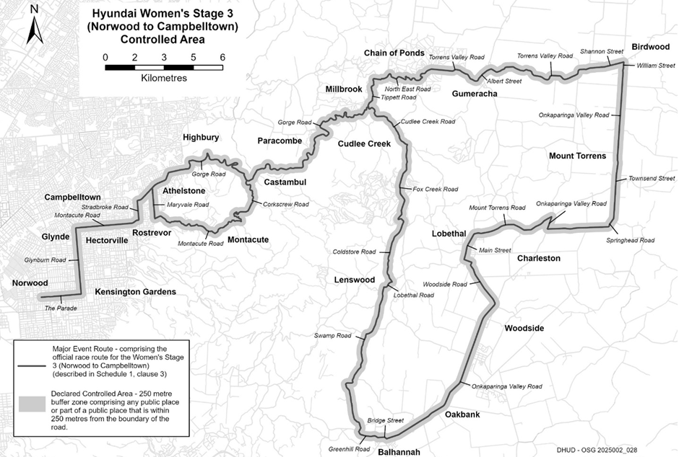
(b) the portion of road commencing at the intersection of Gorge Road and Corkscrew Road in Castambul, then generally southerly, generally south-westerly and south-easterly to its intersection with Montacute Road in Montacute, then generally south-westerly and westerly to its intersection with Maryvale Road in Athelstone, then northerly to its intersection with Gorge Road.

South Australia Prologue
Time of Effect of Declaration
Commencing on: Tuesday, 20 January 2026 at 12:01am
Ending on: Tuesday, 20 January 2026 at 11:59pm
Description of Official Race Route
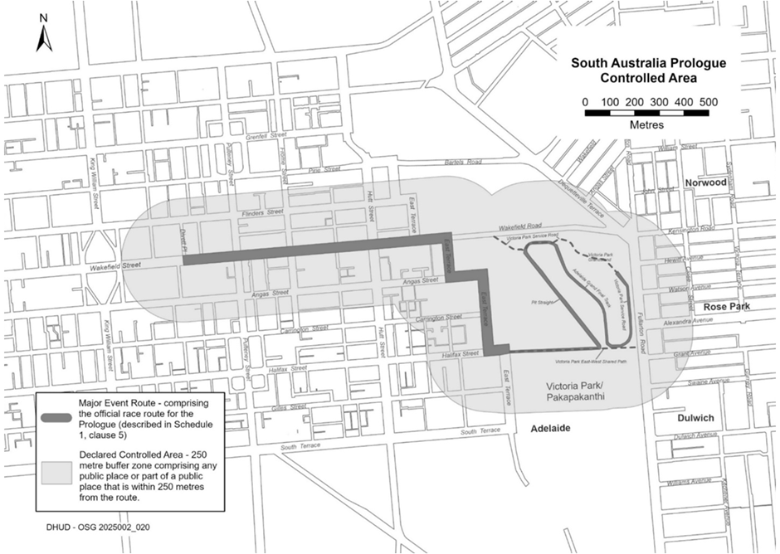
The official race route for the Men’s Prologue (Adelaide) comprises the portion of road commencing in Adelaide at the intersection of Wakefield Street and Divett Place, then easterly along Wakefield Street to its intersection with East Terrace and Wakefield Road, then southerly, easterly, southerly and easterly along East Terrace to its intersection with Victoria Park East-West Shared Path, then easterly along Victoria Park East-West Shared Path to its intersection with Pit Straight, then north-westerly along Pit Straight to its intersection with Victoria Park Service Road, then easterly along Victoria Park Service Road to its intersection with Adelaide Grand Final Track, then south-easterly along Adelaide Grand Final Track to its intersection with Victoria Park East-West Shared Path, then easterly, northerly and north-westerly to Victoria Park Grandstand.

Vanguard Women’s One Day Race (Tanunda to Tanunda)
Time of Effect of Declaration
Commencing on: Wednesday, 21 January 2026 at 12:01am
Ending on: Wednesday, 21 January 2026 at 11:59pm
Description of Official Race Route
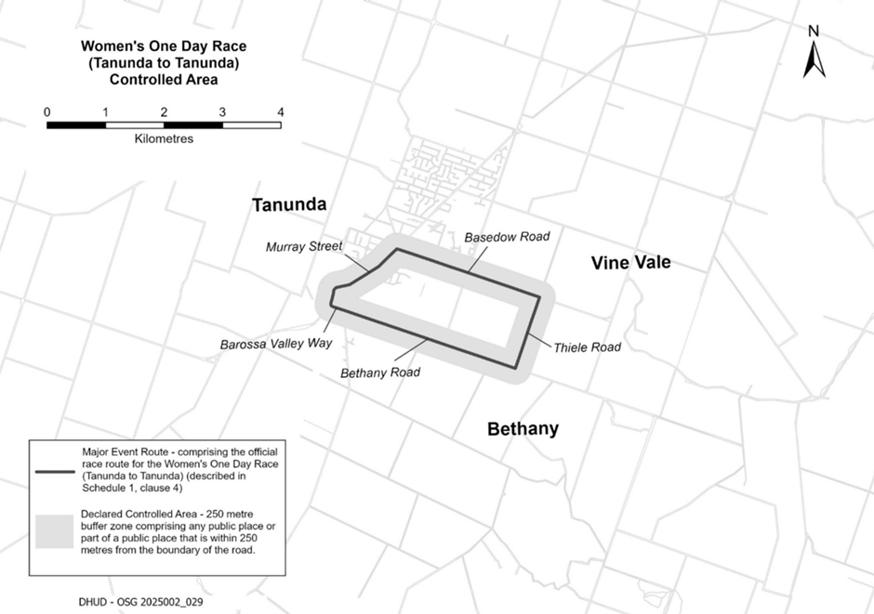
The official race route for the Women’s One Day Race (Tanunda to Tanunda) commencing at the intersection of Murray Street and John Street in Tanunda, then north-easterly along Murray Street to its intersection with Basedow Road, south-easterly along Basedow Road to its intersection with Thiele Road, then south-westerly along Thiele Road to its intersection with Bethany Road in Bethany, then north westerly along Bethany Road to its intersection with Barossa Valley Way, then north-westerly along Barossa Valley Way until it becomes Murray Street, then northerly and north-easterly along Murray Street to the place of commencement.

Vanguard Men’s Stage 1 (Tanunda to Tanunda)
Time of Effect of Declaration
Commencing on: Wednesday, 21 January 2026 at 12:01am
Ending on: Wednesday, 21 January 2026 at 11:59pm
Description of Official Race Route
The official race route for Men’s Stage 1 (Tanunda to Tanunda) comprises—
(a) the portion of road commencing at the intersection of Murray Street and John Street in Tanunda, then north-easterly along Murray Street to its intersection with Basedow Road, south-easterly along Basedow Road to its intersection with Menge Road, then south westerly along Menge Road to its intersection with Bethany Road in Bethany, then north-westerly along Bethany Road to its intersection with Barossa Valley Way in Tanunda, then southerly, generally south-westerly, generally westerly and north-westerly along Barossa Valley Way to its intersection with Hermann Thumm Drive in Lyndoch, then north-westerly, northerly and north westerly along Hermann Thumm Drive to its intersection with Lyndoch Road in Lyndoch, then northerly, easterly, generally north easterly along Lyndoch Road to its intersection with Gomersal Road in Gomersal, then generally south-easterly and generally north easterly along Gomersal Road to its intersection with Barossa Valley Way in Tanunda, then northerly and generally north-easterly along Barossa Valley Way until it becomes Murray Street to the point of commencement;
(b) from the point of commencement on Murray Street in Tanunda to its intersection with Vine Vale Road, then south-easterly along Vine Vale Road to its intersection with Stockwell Road in Vine Vale, then north-easterly along Stockwell Road to its intersection with Angaston Road in Angaston, then south-easterly along Angaston Road until it becomes Murray Street in Angaston, then generally south-easterly and north-easterly along Murray Street to its intersection with North Street, then generally south-easterly, generally easterly and southerly along North Street until it becomes Eden Valley Road, then southerly along Eden Valley Road to its intersection with Hurns Road, then generally westerly along Hurns Road to its intersection with Long Gully Road, then south easterly along Long Gully Road until it becomes Mengler Hill Road, then generally south-easterly, generally south-westerly, generally westerly, generally north-westerly, north-easterly and north-westerly along Mengler Hill Road to its intersection with Light Pass Road in Vine Vale, then south-westerly along Light Pass Road to its intersection with Bethany Road in Bethany, then north westerly along Bethany Road to its intersection with Menge Road;
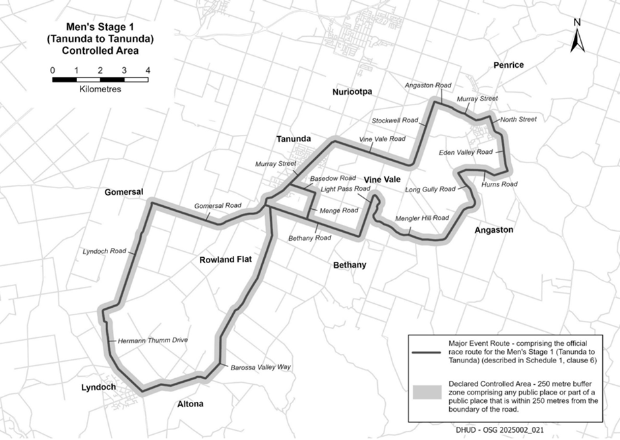
(c) the portion of road commencing at the intersection of Bethany Road and Barossa Valley Way, then north-westerly along Barossa Valley Way until it becomes Murray Street.

Health Partners Men’s Stage 2 (Norwood to Uraidla)
Time of Effect of Declaration
Commencing on: Thursday, 22 January 2026 at 12:01am
Ending on: Thursday, 22 January 2026 at 11:59 pm
Description of Official Race Route
The official race route for Health Partners Men’s Stage 2 (Norwood to Uraidla) comprises—
(a) the portion of road commencing at the intersection of The Parade and George Street in Norwood, then easterly along The Parade to its intersection with Glynburn Road in Kensington Park, then northerly along Glynburn Road to its intersection with Magill Road in Kensington Gardens, then easterly along Magill Road until its intersection with Norton Summit Road in Magill, then generally north easterly, south-easterly, generally northerly, south-easterly, generally northerly and south-easterly along Norton Summit Road until it becomes Lobethal Road in Norton Summit, then generally south-easterly along Lobethal Road to its intersection with Stony Rise Road in Ashton, then generally south-westerly and westerly along Stony Rise Road until its intersection with Tregarthen Road in Ashton, then southerly along Tregarthen Road until its intersection with Greenhill Road in Summertown, then westerly, north westerly and generally south-westerly along Greenhill Road to its intersection with Mount Lofty Summit Road, then generally southerly, generally south-westerly, south-easterly, south-westerly, generally southerly and south-westerly along Mount Lofty Summit Road to its intersection with Main Street in Crafers, then south-easterly along Main Street to its intersection with Piccadilly Road, then north-easterly and easterly along Piccadilly Road to its intersection with Swamp Road, then generally south-easterly, generally north-easterly and generally northerly along Swamp Road to its intersection with Greenhill Road in Uraidla, then south easterly, southerly, south-easterly, generally easterly, generally south-easterly, generally south-westerly, generally easterly, generally southerly, generally south-easterly and generally easterly along Greenhill Road to its intersection with Swamp Road in Balhannah, then generally northerly, easterly and generally north-easterly along Swamp Road to its intersection with Lobethal Road in Lenswood, then generally north-easterly,
easterly and north-easterly along Lobethal Road to its intersection with Main Road in Lobethal, then generally north-easterly along Main Road to its intersection with Pioneer Avenue, then westerly along Pioneer Avenue until it becomes Cudlee Creek Road, then north-westerly, northerly and north-westerly along Cudlee Creek Road to its intersection with Gorge Road in Cudlee Creek, then westerly, northerly, generally westerly, south-westerly, westerly, northerly, south-westerly, south-easterly, south-westerly, westerly and south-westerly along Gorge Road to its intersection with Corkscrew Road in Castambul, then southerly, easterly, southerly, generally south-westerly and south-easterly along Corkscrew Road to its intersection with Montacute Road in Montacute, then generally south-easterly and south-westerly along Montacute Road until it becomes Marble Hill Road, then generally south westerly along Marble Hill Road to its intersection with Monomeith Road in Ashton, then southerly and south-westerly along Monomeith Road to its intersection with Stony Rise Road, and
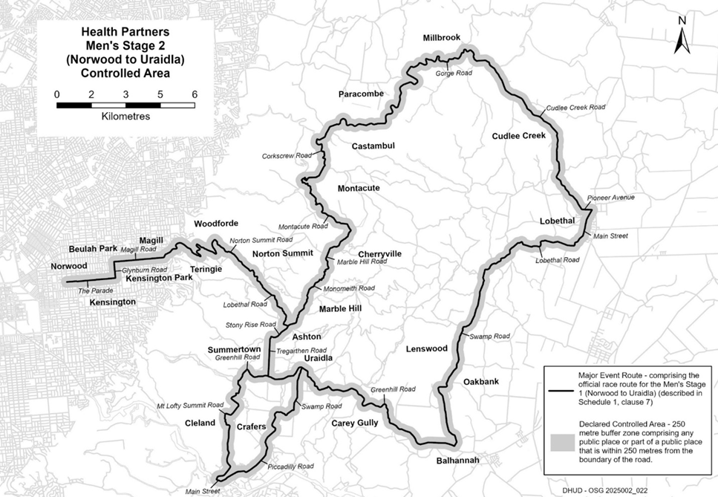
(b) the portion of road commencing at the intersection of Tregarthen Road with Greenhill Road in Summertown, then generally easterly and north-easterly along Greenhill Road to its intersection with Swamp Road in Uraidla.

Ziptrak Men’s Stage 3 (Henley Beach to Nairne)
Time of Effect of Declaration
Commencing on: Friday, 23 January 2026 at 12:01am
Ending on: Friday, 23 January 2026 at 11:59pm
Description of Official Race Route
The official race route for Ziptrak Men’s Stage 3 (Henley Beach to Nairne) comprises the portion of road commencing at the intersection of Seaview Road and Main Street, Henley Beach, then generally southerly along Seaview Road to its intersection with West Beach Road in West Beach, then easterly along West Beach Road to its intersection with Military Road, then generally southerly along Military Road until it becomes Patawalonga Frontage in Glenelg North, then southerly along Patawalonga Frontage to its intersection with King Street, then easterly along King Street to its intersection with Adelphi Terrace, then southerly along Adelphi Terrace to its intersection with Anzac Highway in Glenelg, then easterly along Anzac Highway to its intersection with Brighton Road, then south along Brighton Road to its intersection with Diagonal Road in Glenelg East, then south-easterly along Diagonal Road to its intersection with Morphett Road in Oaklands Park, then southerly along Morphett Road to its intersection with Diagonal Road, then south-easterly along Diagonal Road to its intersection with Sturt Road in Marion, then easterly along Sturt Road to its intersection with Marion Road in Mitchell Park, then southerly along Marion Road to its intersection with Flagstaff Road in Bedford Park, then generally south-easterly along Flagstaff Road to its intersection with Black Road in Flagstaff Hill, then north-easterly, south-easterly and generally easterly along Black Road to its intersection with Main Road in Coromandel Valley, then generally south-easterly, westerly, southerly, generally south-easterly, generally south westerly and south-easterly along Main Road to its intersection with Clarendon Road in Chandlers Hill, then generally south-easterly, generally south-westerly, westerly, southerly, generally north-westerly, generally south-easterly, south-westerly and southerly along Clarendon Road to its intersection with Grants Gully Road in Clarendon, then easterly and generally south-easterly until it becomes Kangarilla Road, then generally south-easterly to its intersection with Bakers Gully Road, then generally south-westerly and south-easterly to its intersection with McLaren Flat Road in Kangarilla, then generally southerly and south-westerly along McLaren Flat Road to its intersection with Wickham Hill Road in McLaren Flat, then generally easterly, north-westerly, easterly and southerly along Wickham Hill Road to its intersection with Range Road in Kuitpo, then generally south-westerly along Range Road to its intersection with Pottery Road in The Range, then generally south-easterly and southerly to its intersection with Brookman Road in Dingabledinga, then generally north-easterly along Brookman Road to its intersection with Dashwood Gully Road in Meadows, then easterly along Dashwood Gully Road until it becomes Mawson Road, then generally easterly along Mawson Road to its intersection with Bull Creek Road, then generally southerly along Bull Creek Road to its intersection with Paris Creek Road in Paris Creek, then generally south-easterly, generally easterly and generally south-easterly along Paris Creek Road until it becomes Manse Road in Strathalbyn, then south-easterly until it becomes West Terrace, then south-easterly along West Terrace to its intersection with South Terrace, then north-easterly along South Terrace to its intersection with Dawson Street, then north-westerly along Dawson Street until it becomes Commercial Road, then north-westerly along Commercial Road to its intersection with North Parade, then generally north-easterly along North Parade to its intersection with Adelaide Road, then north easterly and north-westerly along Adelaide Road until it becomes Long Valley Road, then generally north along Long Valley Road to its intersection with Gemmell Road in Gemmells, then generally north-westerly and generally westerly until it becomes Vernon Street in Macclesfield, then generally westerly along Vernon Street to its intersection with Venables Street, then north-westerly along Venables Street until it becomes Strathalbyn Road, then north-easterly, generally north-westerly, generally northerly and generally north-westerly until it becomes Angus Road in Echunga, then northerly along Angus Road to its intersection with Church Hill Road, then south-easterly along Church Hill Road to its intersection with Old Mount Barker Road, then generally north-easterly and easterly along Old Mount Barker Road to its intersection with Flaxley Road in Mount Barker, then north-easterly along Flaxley Road to its intersection with Alexandrina Road, then easterly along Alexandrina Road to its intersection with Bald Hills Road, then north-easterly along Bald Hills Road to its intersection with Springs Road, then south-easterly, north-easterly, south-easterly and easterly to its intersection with Summit Road in Mount Barker Springs, then northerly and north-westerly along Summit Road to its intersection with Bartley Street in Nairne, then generally north along Bartley Street to its intersection with Princes Highway, then north-westerly and south-westerly along Princes Highway to its intersection with Woodside Road, then generally northerly along Woodside Road until it becomes Nairne Road in Hay Valley, then generally northerly along Nairne Road to its intersection with Military Road, then easterly, north-easterly, easterly and south-easterly along Military Road to its intersection with Pyrites Road in Brukunga, then generally southerly along Pyrites Road to its intersection with Old Princes Highway in Nairne, then generally westerly along Old Princes Highway to its intersection with Bartley Street.

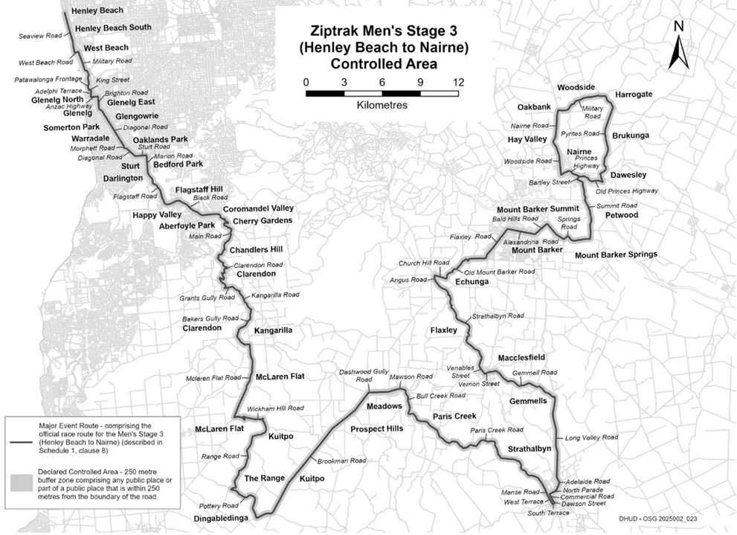

Think! Road Safety Men’s Stage 4 (Brighton to Willunga Hill)
Time of Effect of Declaration
Commencing on: Saturday, 24 January 2026 at 12:01am
Ending on: Saturday, 24 January 2026 at 11:59pm
Description of Official Race Route
The official race route for Think! Road Safety Men’s Stage 4 (Brighton to Willunga Hill) comprises—
(a) the portion of road commencing next to 133 Esplanade, Brighton, then southerly along the Esplanade to its intersection with Wheatland Street in Seacliff, then easterly along Wheatland Street to its intersection with Brighton Road, then southerly along Brighton Road until it becomes Ocean Boulevard in Seacliff Park, then generally southerly along Ocean Boulevard to its intersection with Majors Road in Seaview Downs, then easterly along Majors Road to its intersection with Main South Road in O’Halloran Hill, then southerly along Main South Road to its intersection with Black Road, then easterly, north-easterly, south-easterly and easterly along Black Road to its intersection with Main Road in Coromandel Valley, then generally south-easterly, westerly, southerly, generally south-easterly, generally south-westerly and south-easterly along Main Road to its intersection with Clarendon Road in Chandlers Hill, then generally south-easterly, generally south-westerly, westerly, southerly, generally north-westerly, generally south-easterly and south-westerly to its intersection with Grants Gully Road in Clarendon, then easterly and generally south-easterly until it becomes Kangarilla Road, then generally south-easterly to its intersection with Bakers Gully Road, then generally south westerly and south-easterly to its intersection with McLaren Flat Road in Kangarilla, then generally south-westerly and westerly along McLaren Flat Road until it becomes Main Road in McLaren Flat, then westerly along Main Road until it becomes Kangarilla Road, then south-westerly and westerly along Kangarilla Road to its intersection with Main Road in McLaren Vale, then south easterly and southerly along Main Road to its intersection with High Street in Willunga, then south-easterly along High Street until it becomes Old Willunga Hill Road, then generally south-easterly along Old Willunga Hill Road to its intersection with Brookman Road in Willunga Hill, then easterly along Brookman Road to its intersection with Range Road, then generally north easterly along Range Road to its intersection with Pennys Hill Road in The Range, then north-westerly and northerly along Pennys Hill Road to its intersection with McMurtrie Road in McLaren Vale, then westerly along McMurtrie Road to its intersection with Main Road, and
(b) the portion of road commencing at the intersection of Main Road and Aldinga Road in Willunga, then westerly along Aldinga Road to its intersection with Plains Road in Aldinga, then southerly along Plains Road to its intersection with Hahn Road in Sellicks Hill, then westerly along Hahn Road to its intersection with Main South Road, then southerly along Main South Road until its intersection with Norman Road, then westerly along Norman Road to its intersection with Esplanade in Aldinga Beach, then generally northerly along the Esplanade to its intersection with Lower Esplanade, the generally northerly to its intersection with Esplanade, then generally northerly and north-easterly along Esplanade to its intersection with Jetty Road in Port Willunga, then easterly along Jetty Road to its intersection with Port Road, then south-easterly and easterly along Port Road to its intersection with Old Coach Road in Aldinga, then northerly along Old Coach Road to its intersection with Maslin Beach Road on Maslin Beach, then easterly along Maslin Beach Road until it becomes Tatachilla Road, then easterly along Tatachilla Road to its intersection with Caffrey Street in McLaren Vale, then northerly along Caffrey Street to its intersection with Main Road.

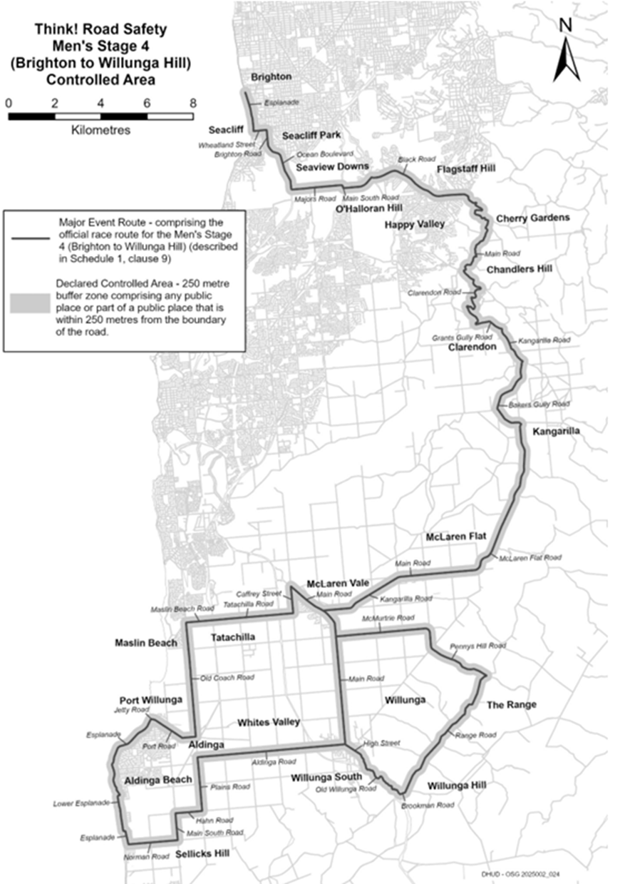

EFEX Men’s Stage 5 (Stirling to Stirling)
Time of Effect of Declaration
Commencing on: Sunday, 25 January 2026 at 12:01am
Ending on: Sunday, 25 January 2026 at 11:59pm
Description of Official Race Route
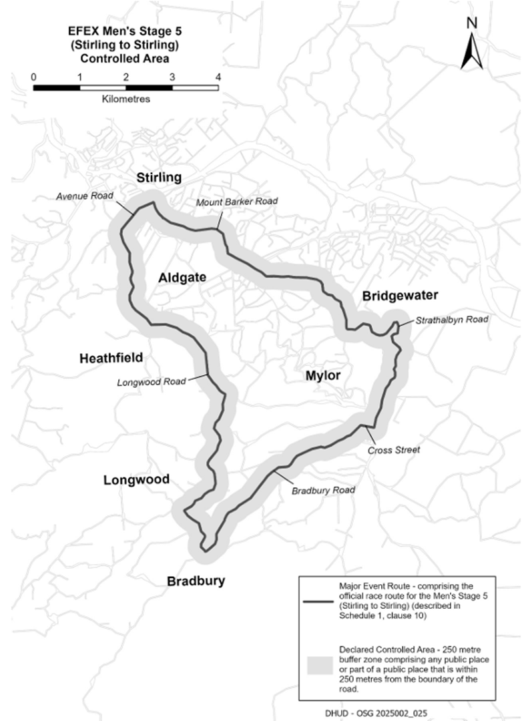
The official race route for EFEX Men’s Stage 5 (Stirling to Stirling) comprises the portion of road commencing at the intersection of Mount Barker Road and Garrod Crescent in Stirling, then north-westerly along Mount Barker Road to its intersection with Avenue Road, then south-easterly along Avenue Road until it becomes Longwood Road, then southerly, south-easterly, southerly, south-westerly and generally southerly along Longwood Road to its intersection with Bradbury Road in Bradbury, then generally north-easterly along Bradbury Road to its intersection with Cross Street in Mylor, then easterly along Cross Road its intersection with Strathalbyn Road,
then northerly, generally westerly, northerly and north-westerly along Strathalbyn Road until it becomes Mount Barker Road in Aldgate, then north-westerly along Mount Barker Road to the point of commencement.

Local Government Instruments

City Of Port Adelaide Enfield
Local Government Act 1999—Section 210
Proposed Declaration—Conversion of Private Road to Public Road
Portion of Church Street, Port Adelaide
Notice is hereby given that the City of Port Adelaide Enfield resolved at its meeting held on 8 July 2025 that it proposes pursuant to Section 210(2)(b) of the Local Government Act 1999, to declare a private road identified as the whole of the land comprised in Allotment 360 on ‘Approved—Not Yet Filed’ Plan F260888, to be a public road, including the creation of public utility rights, if required (‘the Road’).
It is also proposed pursuant to Section 219(1) of the Local Government Act 1999, to assign the name of ‘Church Street’ to the Road.
A copy of a survey plan showing the location of the private road, and a copy of the notice published in the South Australian Government Gazette, are on display in the Civic Centre, 163 St Vincent Street, Port Adelaide and are available for inspection on Council’s website:
www.cityofpae.sa.gov.au.
If people have questions or want to learn more about the proposed declaration, they can telephone: 8405 6600 or email:
service@cityofpae.sa.gov.au.
Dated: 15 January 2026
Mark Withers
Chief Executive Officer

Adelaide Hills Council
Local Government Act 1999
Adelaide Hills Council (Miscellaneous) Amendment By law 2026
By-law No. 1 of 2026
To amend the Council’s Local Government Land By-law No 3 of 2025.
Part 1—Preliminary
1. Short title
This By-law may be cited as the Adelaide Hills Council (Miscellaneous) Amendment By-law 2026.
2. Commencement
This By-law will come into operation on the day in which it is published in the Gazette in accordance with Section 249(6)(b) of the Local Government Act 1999.
3. Amendment Provisions
In this By-law, a provision under a heading referring to the amendment of a specified By-law amends the By-law so specified.
Part 2—Amendment of Local Government Land By-law No 3 of 2025
4. Amendment of Paragraph 3—Definitions
4.1 Paragraph 3.1—delete ‘;’ and insert after ‘fish’ ‘but does not include a dog;’.
5. Amendment of Paragraph 4.24—Flora, Fauna and Other Living Things
5.1 Paragraph 4.24.2—before ‘remove,’ insert ‘except for lawful fishing activities,’.
5.2 Paragraph 4.24.3—before ‘use,’ insert ‘except for lawful fishing activities,’.
6. Amendment of Paragraph 10—Exemptions
6.1 Paragraph 10.2—after ‘paragraph’ delete ‘4.16.3’ and insert ‘4.15.3’.
6.2 Paragraph 10.3—after ‘4.7,’ delete ‘4.19, 4.21.1, 4.21.2 and 4.21.4’ and insert ‘4.18, 4.20.1, 4.20.2 and 4.20.4’.
7. Amendment of Paragraph 11—Application
7.1 Paragraph 11—after ‘4.25,’ delete ’26.2’ and insert ‘4.26.2’.
Part 6—Expiry
8. Expiry
This By-law will expire 24 hours after it comes into operation in accordance with Section 251(1) of the Local Government Act 1999.
Note: In accordance with Section 32(2)(c) of the Legislation Interpretation Act 2021, the expiry of this By-law does not affect any direct amendments made by this By-law.
The foregoing By-law was duly made and passed at a meeting of the Council of the Adelaide Hills Council held on the 9th day of December 2025 by an absolute majority of the members for the time being constituting the Council, there being at least two thirds of the members present.
Dated: 15 January 2026
Greg Georgopoulos
Chief Executive Officer

Berri Barmera Council
Resignation of Councillor
Notice is hereby given in accordance with Section 54(6) of the Local Government Act 1999, that a vacancy has occurred due to the resignation of Councillor Andrew Kassebaum, effective 2 January 2026.
Date: 15 January 2026
Timothy Pfeiffer
Chief Executive Officer

Public Notices

Trustee Act 1936
Public Trustee
Estates of Deceased Persons
In the matter of the estates of the undermentioned deceased persons:
CARRUTHERS Ian Albert late of 7 Raymond Grove Glenelg Retired Farm Hand who died 17 November 2023
CURNOW Malcolm Northey late of 6 Morgan Road Eudunda Wool Classer who died 6 July 2025
DALLWITZ Peter Leighton late of 17 Morrow Avenue Evanston Park Retired Security Officer who died 23 May 2025
FINNIS-HARE Janet Lesley late of 9 Cockburn Street Mount Gambier Administration clerk who died 26 July 2025
FRANKS Robert Edmund late of 43 High Street Strathalbyn Retired Greenkeeper who died 20 June 2025
GIBSON Roma late of 56 Monmouth Road Westbourne Park Retired Dressmaker/Designer who died 25 September 2025
GLINKA Shirley June late of 74 Conroy Street Port Augusta Retired Customer Services officer who died 25 May 2025
GLINSKI Aleks late of 69 Nicolson Avenue Whyalla Playford Retired Graphic Artist who died 22 August 2025
HALE Robert Raymond Hugh late of 18 Chapman Road Mansfield Park Retired Cook who died 14 November 2023
HOWITH Brian James late of 7 Franklin Street Kingscote Retired Cartographer who died on or about 21 March 2025
JORDAN Diana late of 7-8 Oakmont Court Salisbury East Retired School Assistant who died 11 July 2025
KAMP Henriette Theresia Maria late of 15 Elizabeth Street Wallaroo of no occupation who died 15 August 2023
LANGE Marjorie Winifred late of 36C Halsey Road Elizabeth East Retired Nurse who died 4 June 2025
LARBY Catherine Elizabeth otherwise known as ETHERINGTON Catherine Elizabeth late of 23 Jacaranda Road Davoren Park Retired Cleaner who died 5 July 2025
LAWRENCE Desmond Ross late of 1-13 Deland Avenue Gawler East Retired Office Administrator who died 30 June 2025
MCKAY Elsie Hilda late of 6A Dianne Street Klemzig of no occupation who died 10 June 2025
ROWBERRY Barbara Helen late of 20 Snead Crescent Fairview Park of no occupation who died 1 June 2025
SHERRITT Graeme Robert late of 15 Halliday Street Risdon Park of no occupation who died 30 July 2025
TSANGARIS Chris Paul late of 23 Beatrice Street Prospect Retired Motor Mechanic who died on or about 28 April 2025
ZEMAN Jane Louise late of 12 Silver Street Enfield Retired Chef who died 21 July 2024
Notice is hereby given pursuant to the Trustee Act 1936 (SA), the Succession Act 2023 (SA) and the Family Relationships Act 1975 (SA) that all creditors, beneficiaries, and other persons having claims against the said estates are required to send, in writing, to the office of Public Trustee at GPO Box 1338, Adelaide 5001, full particulars and proof of such claims, on or before the 13 February 2026 otherwise they will be excluded from the distribution of the said estate; and notice is also hereby given that all persons indebted to the said estates are required to pay the amount of their debts to the Public Trustee or proceedings will be taken for the recovery thereof; and all persons having any property belonging to the said estates are forthwith to deliver same to the Public Trustee.
Dated: 15 January 2026
T. Brumfield
Public Trustee

Notice Submission

The South Australian Government Gazette is published each Thursday afternoon.
Notices must be emailed by 4 p.m. Tuesday, the week of publication.
Submissions are formatted per the gazette style and a proof will be supplied prior to publication, along with a quote if applicable. Please allow one day for processing notices.
Alterations to the proof must be returned by 4 p.m. Wednesday.

Gazette notices must be submitted as Word files, in the following format:
• Title—the governing legislation
• Subtitle—a summary of the notice content
• Body—structured text, which can include numbered lists, tables, and images
• Date—day, month, and year of authorisation
• Signature block—name, role, and department/organisation authorising the notice

Please provide the following information in your email:
• Date of intended publication
• Contact details of the person responsible for the notice content
• Name and organisation to be charged for the publication—Local Council and Public notices only
• Purchase order, if required—Local Council and Public notices only

Email: governmentgazettesa@sa.gov.au
Phone: (08) 7133 3552
Website: www.governmentgazette.sa.gov.au

All instruments appearing in this gazette are to be considered official, and obeyed as such

Printed and published weekly by authority of T. Foresto, Government Printer, South Australia
$9.50 per issue (plus postage), $479.00 per annual subscription—GST inclusive
Online publications: www.governmentgazette.sa.gov.au

