
No. 4 p. 79
THE SOUTH AUSTRALIAN
GOVERNMENT GAZETTE
Published by Authority

Adelaide, Thursday, 22 January 2026

Contents

Governor’s Instruments
Appointments, Resignations and General Matters 80
Proclamations—
Labour Hire Licensing (Scope of Act) Amendment Act (Commencement) Proclamation 2026 83
Summary Offences (Prohibition of Publication of
Certain Material) Amendment Act (Commencement) Proclamation 2026 83
Local Government (Boundary Alteration)
Proclamation 2026 84
State Government Instruments
Aquaculture Act 2001 91
Associations Incorporation Act 1985 91
Crown Land Management Act 2009 91
Dangerous Substances Act 1979 94
First Nations Voice Act 2023 94
Fisheries Management (Prawn Fisheries) Regulations 2017 95
Fisheries Management Act 2007 95
Health Care Act 2008 96
Heritage Places Act 1993 97
Housing Improvement Act 2016 97
Hydrogen and Renewable Energy Act 2023 98
Juries (Remuneration for Jury Service) Regulations 2017 102
Justices of the Peace Act 2005 102
Land Acquisition Act 1969 102
Major Events Act 2013 106
Mental Health Act 2009 108
Remuneration Tribunal, The 108
Roads (Opening and Closing) Act 1991 110
Summary Offences Act 1953 112
Transplantation and Anatomy Act 1983 (SA) 116
Local Government Instruments
City of Salisbury 117
City of Tea Tree Gully 117
Town of Gawler 117
Public Notices
National Energy Retail Law (South Australia) Act 2011 118
Sale of Property 118
Trustee Act 1936 118
Unclaimed Goods Act 1987 119

Governor’s Instruments

Appointments, Resignations and General Matters
Department of the Premier and Cabinet
Adelaide, 22 January 2026
Her Excellency the Governor in Executive Council has been pleased to appoint the undermentioned to the Teachers Registration Board of South Australia, pursuant to the provisions of the Teachers Registration and Standards Act 2004:
Member: from 22 January 2026 until 21 January 2029
Lyn Sherise Rowberry
Amanda Jane Dempsey
Deputy Member: from 22 January 2026 until 21 January 2029
Catherine Jane Cavouras (Deputy to Dempsey)
Deputy Member: from 22 January 2026 until 30 June 2027
Colleen Anne Maria Tomlian (Deputy to Rowberry)
By command,
Clare Michele Scriven, MLC
For Premier
ME25/128

Department of the Premier and Cabinet
Adelaide, 22 January 2026
Her Excellency the Governor in Executive Council has been pleased to appoint the Honourable Virginia Bell AC to be a Commissioner to inquire into and report upon the matters set out in the commission issued to the Honourable Virginia Bell AC on 22 January 2026 - pursuant to the Royal Commissions Act 1917.
By command,
Clare Michele Scriven, MLC
For Premier
DPC26/005CS

Department of the Premier and Cabinet
Adelaide, 22 January 2026
HER EXCELLENCY THE HONOURABLE FRANCES JENNIFER ADAMSON, Companion of the Order of Australia, Governor in and over the State of South Australia:
TO
THE HONOURABLE VIRGINIA BELL AC
Greeting:
ACKNOWLEDGING the antisemitic terrorist attack on Jewish Australians that took place at Bondi Beach on 14 December 2025, and which resulted in the loss of 15 lives and the wounding of a further 40 individuals.
AND the determination of the Australian Government to respond to the attack, and the factors leading up to the attack, as a matter of urgency by addressing antisemitism within the Australian community, including since 7 October 2023.
AND that the Australian Government has adopted the International Holocaust Remembrance Alliance’s working definition of antisemitism.
AND recognising that strengthening the national consensus in support of democracy, freedom and the rule of law (social cohesion) provides the strongest defence against antisemitism and other forms of religious and ideologically motivated extremism.
AND that hearing from the Jewish Australian community will be important to informing the recommendations of your inquiry and recognising concerns relating to educational and cultural institutions, and other sectors of Australian society.
AND the necessity for the inquiry to be conducted in a manner that does not occasion prejudice to current or future criminal proceedings or national security or undermine social cohesion.
NOW THEREFORE I, the Governor, with the advice and consent of the Executive Council and under the Royal Commissions Act 1917, DO HEREBY APPOINT YOU to be a Commissioner and require and authorise you to inquire into the following matters:
(a) tackling antisemitism by:
(i) investigating the nature and prevalence of antisemitism in institutions and society, and examining its key drivers in Australia, including religious and ideologically motivated extremism and radicalisation, including in the lead up to the antisemitic Bondi terrorist attack on 14 December 2025;
(ii) identifying any opportunities to enhance the responses of governments to antisemitism including, but not limited to, best practice approaches to de-radicalisation and strengthening social cohesion;
(iii) making recommendations to counteract and prevent manifestations of antisemitism;
(iv) assessing the impact of antisemitism on the daily life of Jewish Australians including with respect to security, physical and mental health and wellbeing;
(b) making any recommendations to assist law enforcement, border control, immigration and security agencies to tackle antisemitism, including by:
(i) improvements to guidance and training within law enforcement, border control, immigration, and security agencies to respond to antisemitic conduct;
(ii) having regard to existing security arrangements for the Jewish community, improvement of protective security for Jewish places of worship, major sites, educational and cultural facilities, public events and community leaders;
(iii) whether these authorities have sufficient powers and resources to respond to antisemitic conduct;
(c) examine the circumstances surrounding the antisemitic Bondi terrorist attack on 14 December 2025, including:
(i) lead up to and planning of the attack;
(ii) the interaction and information sharing between Commonwealth agencies, between Commonwealth and State and Territory agencies, and between relevant Commonwealth and State agencies with the organisers of the Chanukah event at Bondi Beach on 14 December 2025;
(iii) security arrangements for the Chanukah event and Bondi Beach on 14 December 2025;
(iv) the attack;
(v) emergency response to the attack;
(vi) whether relevant Commonwealth, State and Territory intelligence and law enforcement agencies performed to maximum effectiveness, including whether they had adequate powers and the right systems, processes and procedures, and whether there was an appropriate authorising environment for information sharing with other Commonwealth, State and Territory agencies;
(vii) whether relevant Commonwealth, State and Territory intelligence and law enforcement agencies were prevented from taking prohibitive actions by the current legislative framework and authorising environment;
(viii) identifying any gaps in existing legal and regulatory frameworks that impede the ability for law enforcement, border control, immigration and security agencies to prevent and respond to attacks of this nature at both the state and federal levels;
(ix) identifying any lessons for security and law enforcement agencies to prevent and respond to similar attacks in the future;
(d) make any other recommendations arising out of your inquiry into the matters set out in paragraphs (a) to (c) that would contribute to strengthening social cohesion in Australia and countering the spread of ideologically and religiously motivated extremism in Australia;
(e) any matter reasonably incidental to a matter referred to in paragraphs (a) to (d) or that you believe is reasonably relevant to your inquiry.
AND I direct you to make any recommendations arising out of your inquiry that you consider appropriate, including recommendations about any policy, legislative, administrative or structural reforms.
AND I further declare that you are not required by this Commission to inquire, or to continue to inquire, into a particular matter to the extent that you are satisfied that the matter has been, is being, or will be, sufficiently and appropriately dealt with by another inquiry or investigation or a criminal or civil proceeding.
AND, without limiting the scope of your inquiry or the scope of any recommendations arising out of your inquiry that you may consider appropriate, I direct you, for the purposes of your inquiry and recommendations, to consider the following matters, and I authorise you, as you consider appropriate, having regard to the date by which you are required to submit your final report, to take (or refrain from taking) any action arising out of your consideration:
(f) the need to establish mechanisms to facilitate the timely communication of information, or the furnishing of evidence, documents or things, in accordance with section 6P of the Royal Commissions Act 1902 (Cth) or any other relevant law, including, for example, for the purpose of enabling the timely investigation and prosecution of offences;
(g) the need to establish appropriate arrangements in relation to current and previous inquiries, in Australia and elsewhere, for evidence and information to be shared with you in ways consistent with relevant obligations so that the work of those inquiries, including, with any necessary consents, the testimony of witnesses, can be taken into account by you in a way that avoids unnecessary duplication, improves efficiency and avoids unnecessary trauma to witnesses;
(h) the need to recognise and appropriately protect any intelligence information or operationally sensitive information obtained by you;
(i) the need to establish appropriate arrangements with the heads of the relevant Australian intelligence entities for obtaining, storing, accessing, using, disclosing and returning intelligence information relating to an Australian intelligence entity.
AND I declare that you are authorised to conduct your inquiry into any matter under this Commission in combination with any inquiry into the same matter, or a matter related to that matter, that you are directed or authorised to conduct by any Commission, or under any order or appointment, made by the Governor-General, the Governors of the States or by the Government of any of the Territories.
AND I declare that in this Commission:
Australian Defence Force has the same meaning as in the Defence Act 1903 (Cth).
Australian intelligence entity means:
(a) the Australian Secret Intelligence Service; or
(b) the Australian Security Intelligence Organisation; or
(c) the Australian Geospatial-Intelligence Organisation; or
(d) the Defence Intelligence Organisation; or
(e) the Australian Signals Directorate; or
(f) the Office of National Intelligence.
Department of Defence means the Department administered by the Minister administering the Defence Force Discipline Act 1982 (Cth).
head, of an Australian intelligence entity means:
(a) in relation to the Australian Security Intelligence Organisation—the Director-General of Security; or
(b) in relation to the Australian Secret Intelligence Service—the Director-General of the Australian Secret Intelligence Service; or
(c) in relation to the Australian Signals Directorate—the Director-General of the Australian Signals Directorate; or
(d) in relation to the part of the Department of Defence known as the Australian Geospatial-Intelligence Organisation—the Director of that part of the Department; or
(e) in relation to the part of the Department of Defence known as the Defence Intelligence Organisation—the Director of that part of the Department; or
(f) in relation to the Office of National Intelligence—the Director-General of National Intelligence.

intelligence information means information:
(a) that was acquired or prepared by or on behalf of an Australian intelligence entity in connection with its functions;
(b) that relates to the performance by an Australian intelligence entity of its functions; or
(c) that identifies a person as being, or having been, a staff member (within the meaning of the Intelligence Services Act 2001 (Cth)) or agent of the Australian Secret Intelligence Service or the Australian Security Intelligence Organisation.
law enforcement or security agency means any of the following agencies:
(a) the Australian Defence Force;
(b) the Australian Federal Police;
(c) the Australian Criminal Intelligence Commission;
(d) the Department administered by the Minister administering the Australian Border Force Act 2015 (Cth);
(e) the Office of the Special Investigator;
(f) the police force of a State or Territory.
operationally sensitive information means:
(a) information about information sources or operational activities or methods available to a law enforcement or security agency; or
(b) information about particular operations that have been, are being or are proposed to be undertaken by a law enforcement or security agency, or about proceedings relating to those operations; or
(c) information provided by a foreign government, or by an agency of a foreign government, where that government does not consent to the public disclosure of the information.
AND I:
(j) require you to begin your inquiry as soon as practicable; and
(k) require you to make your inquiry as expeditiously as possible; and
(l) require you to ensure the inquiry is conducted in a professional, impartial, respectful and courteous manner, including appropriately managing any actual or perceived conflicts of interest; and
(m) require you to submit to me an interim report that you consider appropriate not later than 30 April 2026, focusing on:
(i) the matters mentioned in paragraph (c); and
(ii) any other issues requiring urgent or immediate action; and
(n) require you to submit to me a report of the results of your inquiry, and your recommendations, not later than 14 December 2026.
Given under my hand and the Public Seal of South Australia, at Adelaide this 22nd day of January 2026.
By command,
Clare Michele Scriven, MLC
For Premier
Recorded in Register of Commissions, Letters Patent, Etc., Vol. XXXI
Brooke Harding
Clerk of Executive Council
GOD SAVE THE KING!

Proclamations
South Australia

Labour Hire Licensing (Scope of Act) Amendment Act (Commencement) Proclamation 2026
1—Short title
This proclamation may be cited as the Labour Hire Licensing (Scope of Act) Amendment Act (Commencement) Proclamation 2026.
2—Commencement of Act
The Labour Hire Licensing (Scope of Act) Amendment Act 2025 (No 72 of 2025) comes into operation on 29 January 2026.
Made by the Governor
with the advice and consent of the Executive Council
on 22 January 2026

South Australia

Summary Offences (Prohibition of Publication of Certain Material) Amendment Act (Commencement) Proclamation 2026
1—Short title
This proclamation may be cited as the Summary Offences (Prohibition of Publication of Certain Material) Amendment Act (Commencement) Proclamation 2026.
2—Commencement of Act
The Summary Offences (Prohibition of Publication of Certain Material) Amendment Act 2025 (No 40 of 2025) comes into operation on 16 February 2026.
Made by the Governor
with the advice and consent of the Executive Council
on 22 January 2026

South Australia

Local Government (Boundary Alteration) Proclamation 2026
under sections 9 and 11 of the Local Government Act 1999
1—Short title
This proclamation may be cited as the Local Government (Boundary Alteration) Proclamation 2026.
2—Commencement
This proclamation comes into operation on 1 July 2026.
3—Boundary alterations
(1) The boundaries of the areas of The Barossa Council and the Town of Gawler are altered by severing an area of land from the area of The Barossa Council and incorporating that area into the Town of Gawler, as is indicated by the map in Schedule 1 clause 1.
(2) The boundaries of the areas of the City of Playford and the Town of Gawler are altered by severing areas of land from the area of the City of Playford and incorporating those areas into the Town of Gawler, as is indicated by the maps in Schedule 1 clauses 2 and 3.
(3) The boundaries of the areas of Light Regional Council and the Town of Gawler are altered by severing an area of land from the area of Light Regional Council and incorporating that area into the Town of Gawler, as is indicated by the map in Schedule 1 clause 4.
(4) The boundaries of the areas of the Town of Gawler and the City of Playford are altered by severing areas of land from the area of the Town of Gawler and incorporating those areas into the City of Playford, as is indicated by the maps in Schedule 1 clauses 5 and 6.
Schedule 1—Boundary alterations
1—Boundary alteration—The Barossa Council and Town of Gawler
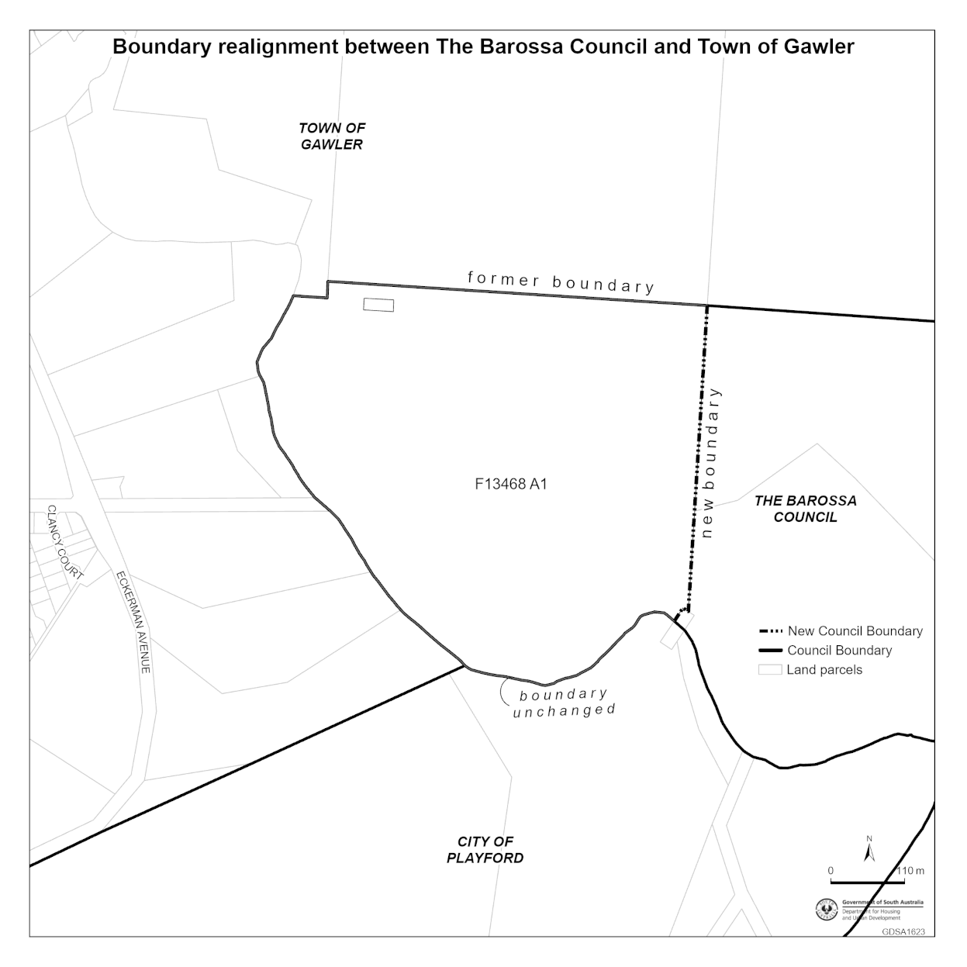
2—Boundary alteration—City of Playford and Town of Gawler
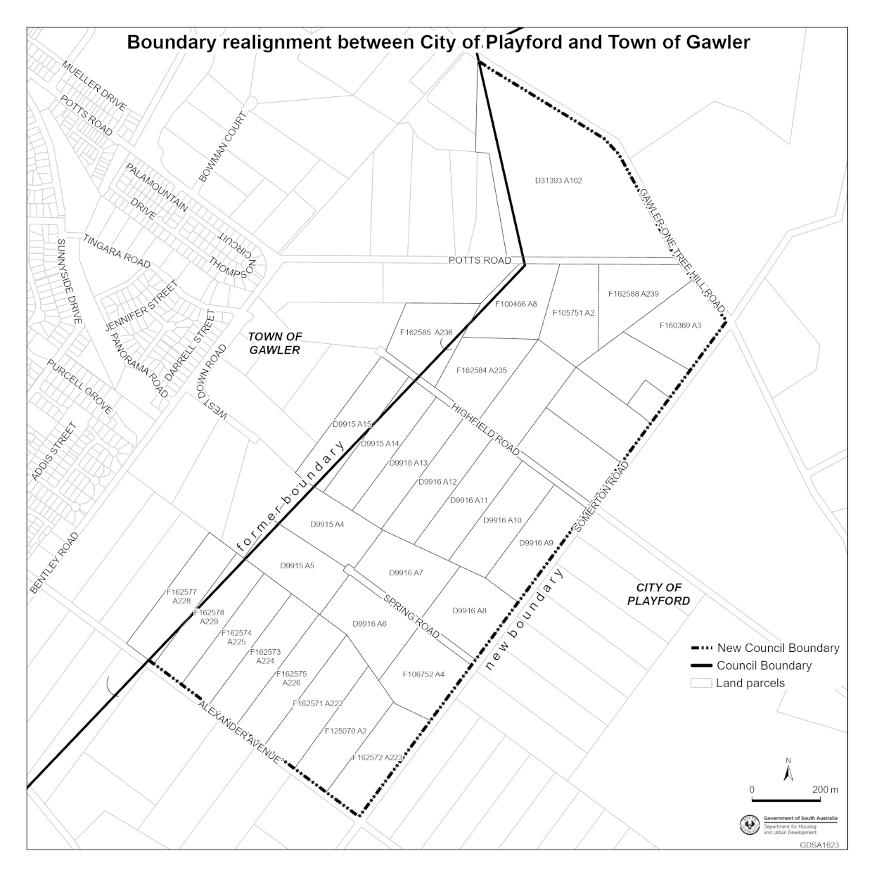
3—Boundary alteration—City of Playford and Town of Gawler
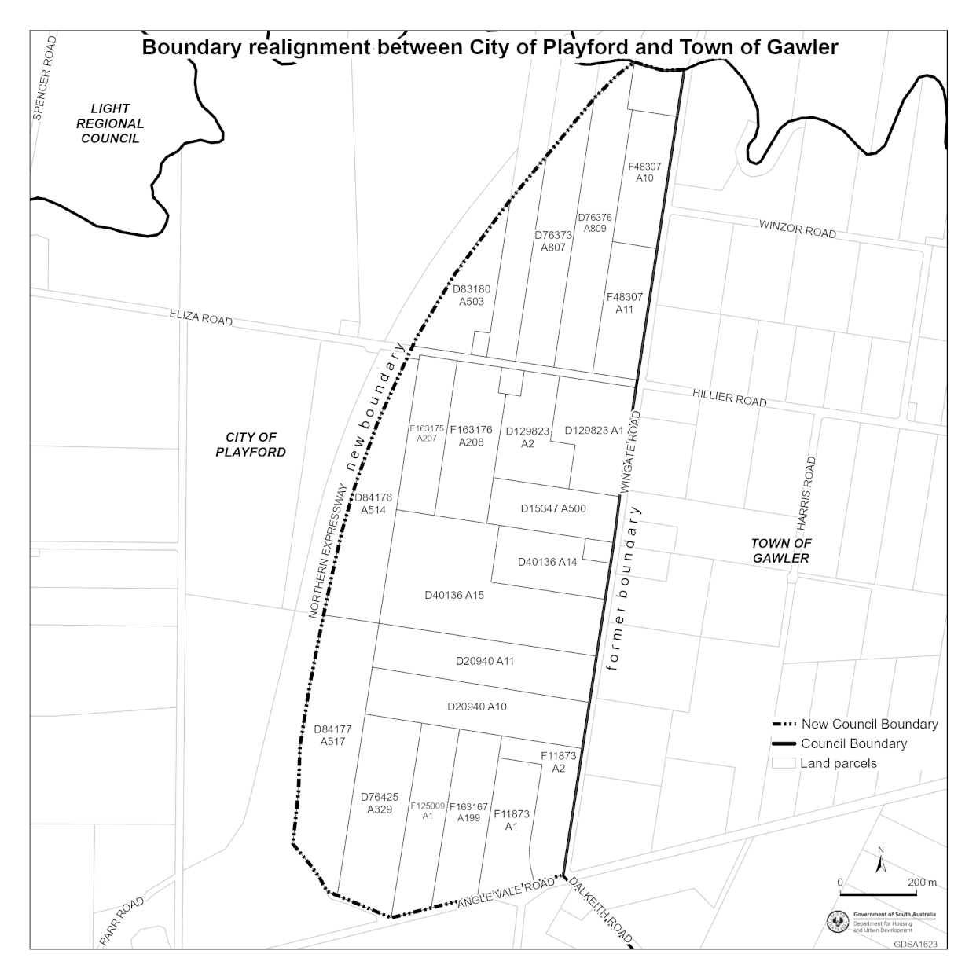
4—Boundary alteration—Light Regional Council and Town of Gawler
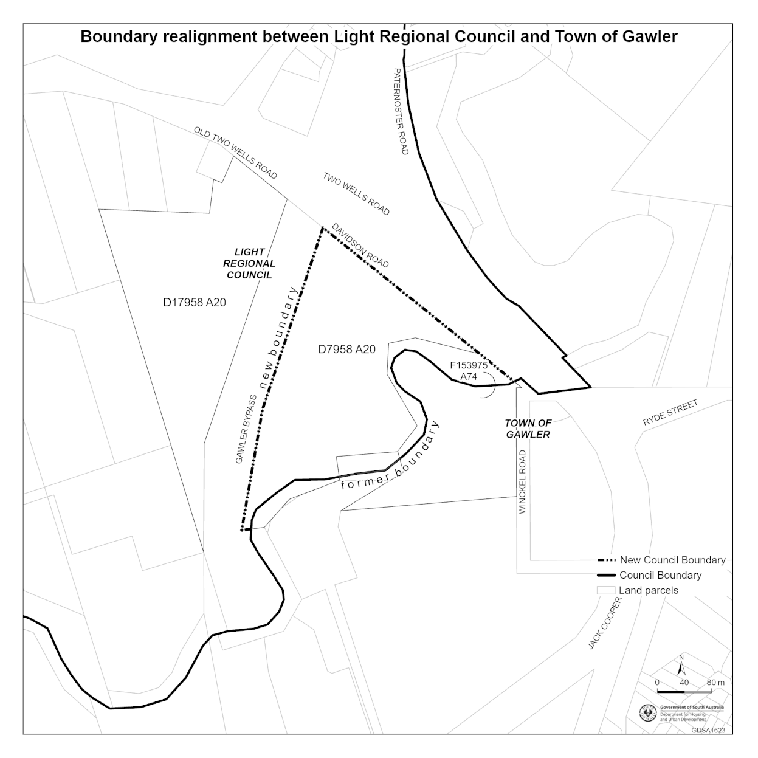
5—Boundary alteration—Town of Gawler and City of Playford
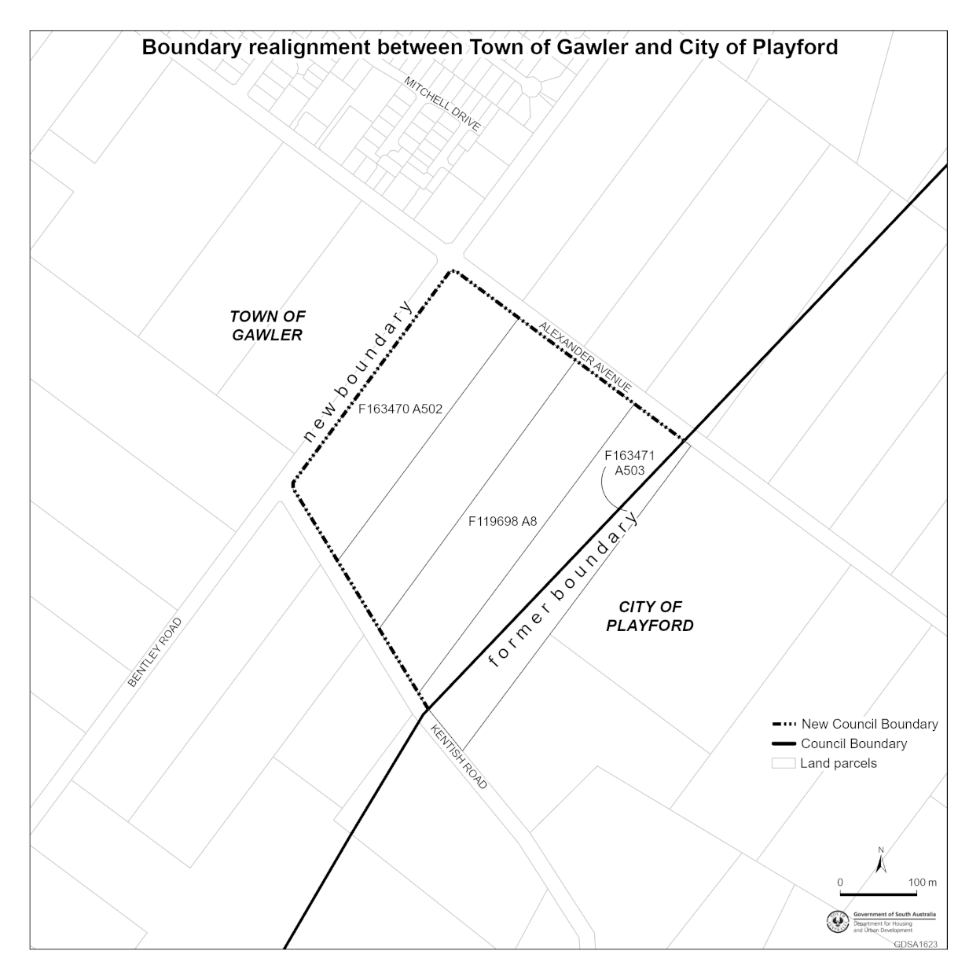
6—Boundary alteration—Town of Gawler and City of Playford
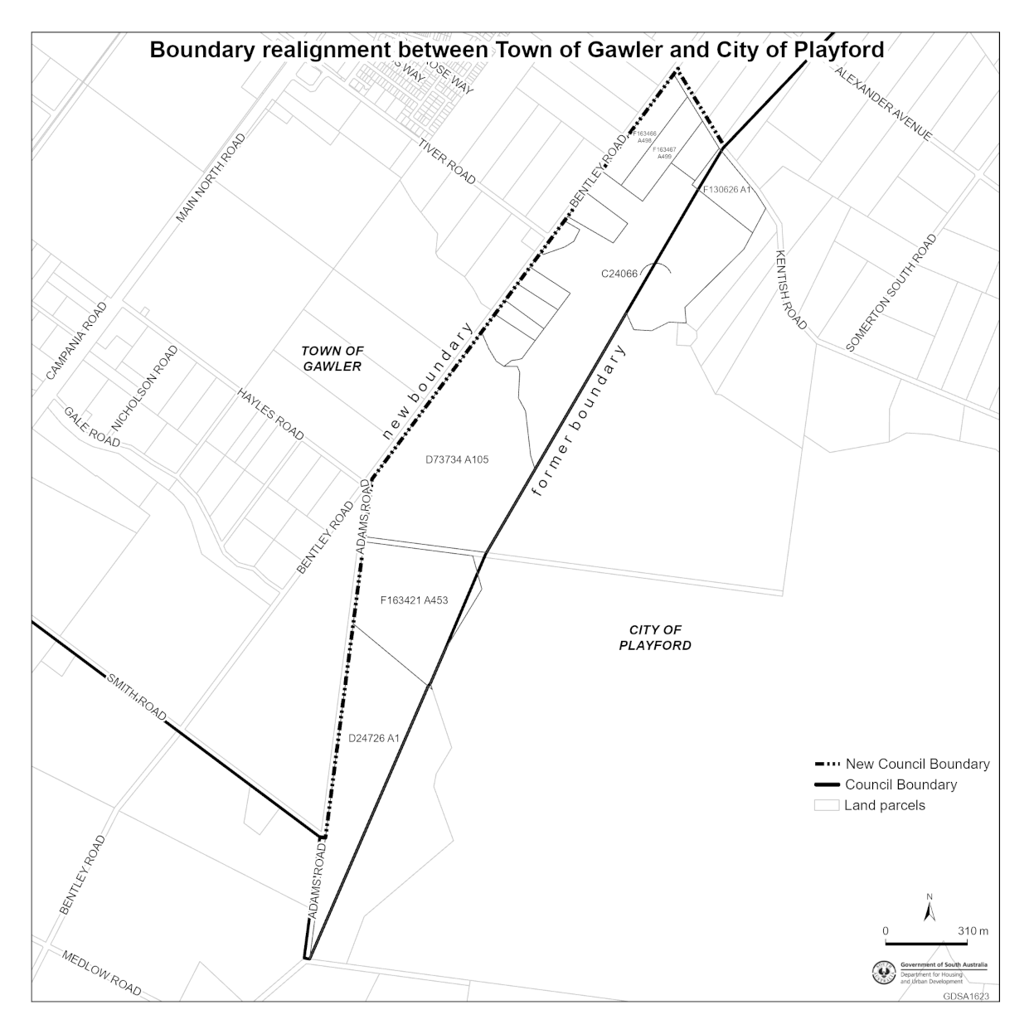
Made by the Governor
on the recommendation of the Minister and with the advice and consent of the Executive Council
on 22 January 2026

State Government Instruments

Aquaculture Act 2001
Grant of Aquaculture Lease
Pursuant to the provisions of Section 22 of the Aquaculture Act 2001, notice is hereby given of the grant of the following aquaculture lease for the purpose of aquaculture in State waters of Franklin Harbor, South Australia:
LA00099
Further details for the above lease are available through the Aquaculture Public Register; which can be found at
http://www.pir.sa.gov.au/aquaculture/aquaculture public register or by contacting Fisheries and Aquaculture, Leasing and Licensing by phone on (08) 8207 5332.
Dated: 16 January 2026
Matt Read
Acting Executive Director, Fisheries and Aquaculture

Associations Incorporation Act 1985
Section 42(2)
Dissolution of Association
Whereas the Corporate Affairs Commission (the Commission) pursuant to Section 42(1) of the Associations Incorporation Act 1985 (the Act) is of the opinion that the undertaking or operations of THE AUSTRALASIAN CORROSION ASSOCIATION INCORPORATED (the Association) being an incorporated association under the Act are being carried on, or would more appropriately be carried on by a Company Limited by Guarantee incorporated under the Corporations Act 2001 (Cth) and whereas the Commission was on 5 JANUARY 2026 requested by the Association to transfer its undertaking to AUSTRALASIAN CORROSION ASSOCIATION LTD (Australian Company Number 693 179 243), the Commission pursuant to Section 42(2) of the Act DOES HEREBY ORDER that on 27 FEBRUARY 2026 the Association will be dissolved, the property of the Association becomes the property of AUSTRALASIAN CORROSION ASSOCIATION LTD and the rights and liabilities of the Association become the rights and liabilities of AUSTRALASIAN CORROSION ASSOCIATION LTD.
Given under the seal of the Commission at Adelaide.
Dated: 16 January 2026
Aleena Dar
Delegate of the Corporate Affairs Commission

Associations Incorporation Act 1985
Section 42(2)
Dissolution of Association
Whereas the Corporate Affairs Commission (the Commission) pursuant to Section 42(1) of the Associations Incorporation Act 1985 (the Act) is of the opinion that the undertaking or operations of UNITINGCARE WESLEY BOWDEN INCORPORATED (the Association) being an incorporated association under the Act are being carried on, or would more appropriately be carried on by a Company Limited by Guarantee incorporated under the Corporations Act 2001 (Cth) and whereas the Commission was on 8 JANUARY 2026 requested by the Association to transfer its undertaking to UNITINGCARE WESLEY BOWDEN LIMITED (Australian Company Number 693 601 302), the Commission pursuant to Section 42(2) of the Act does hereby Order that on 1 APRIL 2026 the Association will be dissolved, the property of the Association becomes the property of UNITINGCARE WESLEY BOWDEN LIMITED and the rights and liabilities of the Association become the rights and liabilities of UNITINGCARE WESLEY BOWDEN LIMITED.
Given under the seal of the Commission at Adelaide.
Dated: 16 January 2026
Aleena Dar
Delegate of the Corporate Affairs Commission

Crown Land Management Act 2009
Duck Open Season Hunting on Unalienated Crown Lands
I, Michael Joseph Williams, Executive Director, National Parks and Public Lands, delegate of the Minister for Climate, Environment and Water, being the Minister for the Crown to whom the administration of the Crown Land Management Act 2009 is for the time being committed:
1. Hereby revoke all previous notices in respect of hunting on unalienated Crown lands, and
2. Declare that subject to Section 56A of the Crown Land Management Act 2009, open season duck hunting on unalienated Crown land is permitted for the duration of the 2026 Duck Hunting Open Season as declared by the Minister for Climate, Environment, and Water in a notice published in The Advertiser on Saturday, 17 January 2026, with the exception of the following locations:
Riverland and Murraylands Area
• The waters of the River Murray within 150 metres either side of any lock or weir or barrage structure.
• Allotment 82, Deposited Plan 115255, Hundred of Cadell.
• Pieces 17 and 18, Deposited Plan 115702, Hundred of Cadell (Cadell Lagoon).
• Sections 698 and 710, Hundred of Baker.
• Sections 146, 386, 387, 426, 479, Hundred of Cadell.
• Allotments 102, Deposited Plan 132417, Hundred of Holder (Maize Island).
• Allotment 1, Deposited Plan 33283; Allotment 12, Deposited Plan 78511; Allotment 82, Deposited Plan 115255; Allotment 101, Deposited Plan 55181; Piece 17, Deposited Plan 115702, Hundred of Cadell.
• Piece 18, Deposited Plan 115702, Hundred of Cadell (Cadell Lagoon).
• Allotment 2, Deposited Plan 34467, Hundred of Waikerie (Hart Lagoon).
• Allotment 2, Deposited Plan 26481; Allotment 101, Deposited Plan 28223; Allotment 201, Filed Plan 50403; Allotment 13, Deposited Plan 61131; Allotment 100, Deposited Plan 72725; Allotment 90, Deposited Plan 81505; Allotment 16, Deposited Plan 113848; Allotment 44, Deposited Plan 113849; Allotment 40, Deposited Plan 113850; Allotment 8, Deposited Plan 113851; Allotment 40, Deposited Plan 120886; Pieces 5 and 6, Deposited Plan 88864; 23, 24, 25, 26, 56, 57, 164, 168, 170, 175, 176, 180, 289, 305, 309, 310, 324, 419, 454, 455, and 456, Hundred of Paringa.
• Allotment 4, Deposited Plan 35957; Allotment 801, Deposited Plan 71116; Allotments 38, Deposited Plan 74947; Allotments 9, Deposited Plan 74948; Allotment 11, Deposited Plan 75393; Allotment 501, Deposited Plan 75723; Allotments 58, 59 and 60, Deposited Plan 133784; and Sections 40, 418, 525, and the Pike River channel bordered by the aforementioned land parcels, Hundred of Paringa (parts of the upper and lower Pike Floodplain).
• Pieces 5 and 6, Deposited Plan 48756, Cobdogla Irrigation Area (Cobdogla Evaporation Basin).
• Allotments 10, 11 and 12, Deposited Plan 57239, Hundred of Baker (Coorong).
• Allotments 200 and 202, Deposited Plan 68309, Hundred of Kingsford (Billiatt).
• Sections 469, 470, 474, 540 541 and 542, Hundred of Nangkita (Mundoo Island).
• Allotments 10 and 11, Deposited Plan 129483; and Sections 708 and 734, Hundred of Burdett (Sunnyside).
South East
• Allotment 55, Deposited Plan 114031; Allotment 2, Deposited Plan 114453 (Lake St Clair), Hundred of Waterhouse.
• Allotments 1 to 4, Deposited Plan 23394, Hundred of Hindmarsh (Lake Leake).
• Section 725, Hundred of Caroline (Eight Mile Creek).
• Section 80, Hundred of Lake George (Lake St Clair).
• Section 225, Hundred of Bray (Lake St Clair—CP).
• Section 583, Hundred of Waterhouse (Lake Eliza).
• Section 925, Hundred of Caroline.
• Section 925, Hundred of Macdonnell.
• Sections 398 and 399, Hundred of Waterhouse (Lake Hawdon North).
• Allotments 107 and 108, Deposited plan 76978; Section 89 Hundred of Ross (Lake Hawdon North).
• Section 173, Hundred of Bray (Lake Hawdon North).
Adelaide and Mount Lofty Ranges
• Allotments 17 and 18, Deposited Plan 116262; and Allotment 22, Deposited Plan 116317, Hundred of Port Adelaide (Port Adelaide).
• Allotment 1, Deposited Plan 23558; and Piece 112, Deposited Plan 119236, Hundred of Port Gawler (Port Gawler).
• Allotments 102, 103, and 105, Deposited Plan 44233; and Allotments 3 to 5, Deposited Plan 50216, Hundred of Port Adelaide.
• Allotment 53, Deposited Plan 54498, Hundred of Willunga.
• Pieces 571 and 572, Deposited Plan 68116, Hundred of Port Adelaide.
• Allotment 509, Deposited Plan 71009, Hundred of Adelaide (Thorndon Park Reservoir).
• Allotment 22, Deposited Plan 76309, Hundred of Port Adelaide (Mutton Cove).
• Allotment 21, Deposited Plan 79457 in the Hundred of Waitpinga.
• Allotment 1, Filed Plan 30401, Part Para Woodlands Reserve.
• All of the Crown land parcels within the Adelaide International Bird Sanctuary including Sections 314-316, 320-330, 337, 506-510, 512-515, 535, 615; Allotment 104 Deposited Plan 50216, Hundred of Port Adelaide.
• Sections 803, 805, 806 and 2115, Hundred of Willunga.
• Sections 703, 705-707, 809, 825, 827, 829 and 830, Hundred of Port Gawler.
• Section 743, Hundred of Encounter Bay.
• Sections 395 and 396, Hundred of Waitpinga (Cape Jervis).
• Allotment 12, Deposited Plan 125788 Hundred of Waitpinga (adjacent Deep Creek NP).
• Section 679, Hundred of Encounter Bay (adjacent Hindmarsh Valley NP).
Northern and Yorke
• Allotment 100, Deposited Plan 117037, Hundred of Carribie.
• Allotment 60, Deposited Plan 27952; Allotment 63, Deposited Plan 48781; and Allotment 72, Deposited Plan 28222 in the Hundred of Wallaroo (Wallaroo Mines).
• Allotment 103, Deposited Plan 92164, Hundred of Bright (Bright).
• Sections 128 and 131, Hundred of Carribie (Point Annie).
• Sections 49 and 50 Hundred of Hallett (Hallett).
• Sections 105, 108, 137 and 144 Hundred of Mongolata.
• Sections 47, 52 and 318, Hundred of Tomkinson (Caroona Creek).
• Sections 59, 583, 584, 585, 628, 629, Hundred of Clinton (Clinton).
• Section 458, Hundred of Hanson (Porter’s Lagoon).
• Sections 609, 648, 650, 651 and 652, Hundred of Cameron (Bumbunga Lake).
• Allotment 53, Deposited Plan 75877, Hundred of Howe (Beetaloo Reservoir).
West Area
• Allotment 410, Deposited Plan 60745, Hundred of Lake Wangary.
• Section 229, Hundred of Wrenfordsley (Cape Blanche).
• Piece 23, Deposited Plan 86605, Hundred of Wookata.
• Allotment 72, Deposited Plan 125221 and Section 176, Hundred of Rounsevell (Shag Rock).
Outback Area
• Block 422, Hundred 832300, OH (Kopperamanna) (Tirari Desert).
• Allotment 10 in Filed Plan 219154 (Lake Eyre (North) Kati Thanda).
• Allotments 63, 64, 65, 66, 67, 68, 69, 70, 71, 72, 87, 88, 89, 90, 91, 92, 93, 94, 95, 96, 97, 98, 99, 100, 115, 116, 117, 118, 127, 128, 129, 130, 131, 132, 135, 136, 151, 152, 153, 154, 155, 156, 157, 158, 159, 160, 161, 162, 163, 164, 168, 169, 170, 171, 172, 173, 174, 175, 188, 189, 190, 191, 192, 193, 194, 196, 200, 201 Town Plan 831601; Allotments 51 and 52, Deposited Plan 84007; Allotment 54, Deposited Plan 84009; and sections 791, 1081, 1082, 1083 and 1084, Hundred Plan 831600 (Innamincka town common).
Kangaroo Island Area
• Allotment 1, Deposited Plan 76540; Allotment 42, Deposited Plan 91868; and Section 507, Hundred of Dudley (Pelican Lagoon).
• Section 175, Hundred of Cassini (Lathami).
• Section 50, Hundred of Duncan (Stokes Bay).
3. Declare that hunting is not permitted on unalienated Crown land in Marine Park Sanctuary Zones as listed in the following schedule:
Schedule
• Allotment 171, Deposited Plan 22929, Hundred of Winninowie.
• Allotment 1, Deposited Plan 69184; Allotment 15, Deposited Plan 31182; Allotments 1 and 2, Deposited Plan 33131, Hundred of Lake Wangary.
• Sections 123, 511, 512, 517, 518 and 519, Hundred of Lake Wangary.
• Allotment 2, Deposited Plan 33127.
• Allotment 1, Deposited Plan 33129, Hundred of Clinton.
• Piece 3, Deposited Plan 33745, Hundred of Tiparra.
• Allotment 1, Deposited Plan 35927, Hundred of MacGillivray.
• Allotment 204, Deposited Plan 38929; Allotment 29, Deposited Plan 41664, Hundred of Wrenfordsley.
• Sections 158, 159, 175, 237, 240, 241 and 242, Hundred of Wrenfordsley.
• Piece 1, Deposited Plan 73266, Hundred of Wrenfordsley.
• Allotment 507, Deposited Plan 47651; Allotment 500, Deposited Plan 53874, Hundred of Jenkins.
• Section 123, Hundred of Jenkins.
• Piece 110, Deposited Plan 56246, Hundred of Poynton.
• Allotment 201, Deposited Plan 74635, Hundred of Dudley.
• Sections 458, 511 and 556, Hundred of Dudley.
• Pieces 6 and 7, Deposited Plan 78588, Hundred of Menzies.
• Section 438, Hundred of Menzies.
• Allotments 103, 106 and 109, Deposited Plan 80464, Hundred of Wallanippie.
• Section 95, Hundred of Wallanippie.
• Allotment 529, Filed Plan 55177.
• Sections 631, 685, 686, 687, 688, 689 and 745 all in the Hundred of Melville.
• Sections 702, Hundred of Port Gawler.
• Sections 756, 757 and 771, Hundred of Myponga.
• Section 320 of the Hundred of Yankalilla.
• Section 547 of the Hundred of Tiparra.
• Sections 999, 1086, 1087, 1154, 1155, 1156, 1157, 1158, 1226, 1227, 1228, 1246 and 1247, Hundred of Pirie.
• Section 233, Hundred of Baroota.
• Sections 972, 1047, 1209, 1210, 1230, 1231, 1232 and 1233, Hundred of Davenport.
• Pieces 9 and 10, Filed plan 219623, Hundred of Crozier.
• Sections 347, 348 and 349, Hundred of Hutchison.
• Section 189, Hundred of Warrow.
• Section 311, Hundred of Playford.
• Section 245, Hundred of Copley.
• Section 390, Hundred of Way.
• Section 70, Hundred of Poynton.
• Sections 123, 407, 489, 490 and 493 all in the Hundred of Randell.
• Sections 47, 48, 58 and 59, Hundred of Bartlett.
• Deposited Plan 132561; parcel 706, Hundred Moule.
Note that: maps showing the location of Marine Park Sanctuary Zones can be found at:
http://www.environment.sa.gov.au/marineparks/maps-and-coordinates
4. Declare that open season hunting on the waters and adjacent lands of Lake Bonney South East comprising:
• Allotment 1, Deposited Plan 61151; Sections 406, 411, 632 and 633, Hundred of Kongorong
• Allotment 2, Deposited Plan 74030; Allotment 12, Deposited Plan 75893; and Sections 428 and 442, Hundred of Benara
• Allotments 6 and 7, Deposited Plan 24914; Allotment 4, Deposited Plan 73335; and Sections 248, 413 and 449, Hundred of Mayurra
must not involve the use of any motorised vessel.
Dated: 19 January 2026
Michael J. Williams
Executive Director
National Parks and Public Lands

Dangerous Substances Act 1979
Authorised Officers
I, Glenn Stephen Farrell, Executive Director, SafeWork SA, in my capacity as the Competent Authority, hereby appoint the following person as an Authorised Officer for the purposes of the Dangerous Substances Act 1979 pursuant to Section 7(1) of the Act:
- Hao WANG
Dated: 19 January 2026
Glenn Farrell
Executive Director
Competent Authority
SafeWork SA

First Nations Voice Act 2023
2026 South Australian First Nations Voice to Parliament Election
Saturday, 21 March 2026
This election is for Aboriginal and Torres Strait Islander people to elect their representatives to the six Local First Nations Voices.
Close of Electoral Roll
Only Aboriginal and Torres Strait Islander people on the South Australian electoral roll can vote in the South Australian First Nations Voice Election.
Ensure you are enrolled, and your details are up to date by 5pm, Friday, 27 February 2026.
If you are unsure whether you are on the electoral roll, you can check your enrolment online at savoiceelection.sa.gov.au.
Have you recently turned 18 or changed your residential address?
If you have recently turned 18 or changed your residential or postal address, you must complete an electoral enrolment form available online at savoiceelection.sa.gov.au.
Nominating as a candidate
Nominations to be a candidate in the 2026 South Australian First Nations Voice Election open on Tuesday, 27 January 2026 and close at 5pm, Tuesday, 10 February 2026.
Any Aboriginal and Torres Strait Islander person can nominate to stand as a candidate in the South Australian First Nations Voice Election as long as they meet the relevant eligibility criteria.
More information on eligibility criteria is available at savoiceelection.sa.gov.au.
Local First Nations Voice vacancies are set out below:
Region 1—Kumangka Warrarna Wangkanthi (Central)—11 vacancies. 5 Male/5 Female/1 Any Gender.
Region 2—Far North—7 vacancies. 3 Male/3 Female/1 Any Gender.
Region 3—Flinders and Upper North—7 vacancies. 3 Male/3 Female/1 Any Gender
Region 4—Murraylands, Riverland and South East—7 vacancies. 3 Male/3 Female/1 Any Gender
Region 5—West and West Coast—7 vacancies. 3 Male/3 Female/1 Any Gender
Region 6—Yorke and Mid North—7 vacancies. 3 Male/3 Female/1 Any Gender
Candidates may nominate for the region in which they:
• Have their principal place of residence (as recorded on the electoral roll); or
• Are a traditional owner in relation to an area located wholly or partly within the region they are nominating for.
Declaration of nominations
Candidates for the 2026 South Australian First Nations Voice Election will be announced on Tuesday, 24 February 2026.
More information on the South Australian First Nations Voice Election can be found at savoiceelection.sa.gov.au or by calling 1300 655 232.
Dated: 15 January 2026
M. Sherry
Returning Officer

Fisheries Management (Prawn Fisheries) Regulations 2017
Temporary Prohibition on Fishing Activities in the Gulf St Vincent Prawn Fishery
Take notice that pursuant to Regulation 10 of the Fisheries Management (Prawn Fisheries) Regulations 2017, the act of, or an act preparatory to or otherwise involved in, the fishing activities specified in Schedule 1 are prohibited, during the period specified in Schedule 2, unless this notice is varied or revoked.
Schedule 1
The taking of aquatic resources prescribed in Schedule 1 of the Fisheries Management (Prawn Fisheries) Regulations 2017 in the waters of the Gulf St Vincent Prawn Fishery pursuant to a Gulf St Vincent Prawn Fishery Licence.
Schedule 2
From 16 January 2026 to 30 June 2026.
Dated: 16 January 2026
Matt Read
Acting Executive Director
Fisheries and Aquaculture
Delegate of the Minister for Primary Industries and Regional Development

Fisheries Management Act 2007
Section 115
Ministerial Exemption: ME9903404
Take notice that pursuant to Section 115 of the Fisheries Management Act 2007, the holder of a fishery licence issued under the Fisheries Management (Charter Boat Fishery) Regulations 2016 (the ‘exemption holder’) or a person endorsed on the licence as a registered master, are exempt from Section 70 of the Fisheries Management Act 2007 Regulation 5 and Clause 75 of Schedule 6 of the Fisheries Management (General) Regulations 2017 but only insofar as they may undertake the activity described in Schedule 1 (the ‘exempted activity’), in the waters described in Schedule 2, subject to the conditions specified in Schedule 3, from 15 January 2026 until 1800 hrs 31 May 2026, unless varied or revoked earlier.
Schedule 1
• Setting of recreational short term rock lobster pots registered to a person who has entered into a charter boat fishing agreement for the charter boat fishing services of the exemption holder prior to the intended charter fishing trip of the person to whom the rock lobster pot is registered.
• Retrieval of a registered rock lobster pot that has been set for a person who has entered into a charter boat fishing agreement for the charter boat fishing services of the exemption holder where the person to whom the rock lobster pot is registered is not present on the charter fishing trip (subject to condition 10).
Schedule 2
1. All marine waters of the State, excluding Aquatic Reserves, Marine Park Sanctuary Zones or Restricted Access Zones (unless otherwise authorised under the Marine Parks Act 2007).
Schedule 3
1. The exemption holder or registered master of the charter boat licence must be in possession of a copy of this notice at all times whilst undertaking the exempted activities and be able to produce it to a PIRSA Fisheries Officer or PIRSA Licensing Officer upon request.
2. The exemption holder or registered master must be able to prove that the recreational rock lobster pot being set or intended to be set is registered to a person who has entered a charter boat fishing agreement for the charter boat fishing services of the exemption holder and that person intends to retrieve the registered rock lobster pot as part of the charter boat fishing agreement.
3. When setting recreational rock lobster pots under this exemption, the exemption holder or registered master must be in possession of evidence that the holder of the rock lobster pot registration intends to participate in activities consistent with a charter boat fishing agreement for the charter boat fishing services of the exemption holder.
4. In the following instances the licence holder or the registered master must inform the Department by telephone on 1800 065 522 or via the Commercial reporting App:
(a) before a boat registered for use under a licence in respect of the Charter Boat Fishery commences a trip during which a registered recreational rock lobster pot is to be carried or set; or
(b) before re-setting any pots that have been operated/pulled during a trip
5. Pursuant to condition 4, the following information must be provided:
(a) The name of the person making the telephone call;
(b) Contact phone number of the caller;
(c) The licence number being fished;
(d) The name of the holder of the licence, or the registered master, operating the vessel;
(e) The name of the registration holder for each recreational rock lobster pot on board or being re-set;
(f) The tag number(s) held by each of the associated rock lobster pot registration holder(s) that is affixed to a rock lobster pot on board or being re-set;
(g) The estimated time and date of setting;
(h) The port of departure.
6. A maximum of 6 rock lobster pots may be set on any one day per boat being used under the licence for a charter boat activity.
7. The exemption holder or registered master must not use or have possession of recreational rock lobster pot tags registered in their name, or tags registered to any charter crew member while undertaking charter boat fishing services.
8. The recreational rock lobster pots set under this exemption must be marked with a 4 litre red buoy, a recreational rock lobster pot tag issued by the Department and a tag identifying the Charter Boat Fishery licence number (consistent with the specifications of Section 13(b)
of the Fisheries Management (General) Regulations 2017).
9. The recreational rock lobster pot may only be set under this exemption no more than three days prior to commencing the charter in which the registration holder is due to participate in, consistent with a charter boat fishing agreement for the charter boat fishing services of the exemption holder.
10. The exemption holder or registered master must ensure that the client(s) to whom the recreational rock lobster pot tag(s) are registered are engaged in the fishing activity to retrieve the registered rock lobster pot during the charter boat fishing services of the exemption holder, and that the owner of the tag(s) only retains a number of rock lobster consistent with their personal passenger limits.
11. If the person to whom the recreational rock lobster pot is registered is not able to be present during the agreed charter boat fishing service, the exemption holder or registered master must notify the Department by telephone on 1800 065 522 of the cancellation before commencing the trip. The exemption holder or registered master may then retrieve the rock lobster pot but must release any fish caught the pot back to the water immediately.
12. If the estimated date and time for the retrieval of a registered recreational rock lobster pot set under this exemption is earlier than the estimated time previously notified, or more than one (1) hour after that date and time, the exemption holder or registered master must notify the Department of the updated estimated retrieval date and time.
13. At least one (1) hour before landing the registered vessel from a fishing trip where registered recreational rock lobster pots have been operated by the holder of a recreational rock lobster pot registration, the licence holder or registered master(s) of a boat registered for use in the Charter Boat Fishery, must inform the Department by telephone on 1800 065 522 or via the Commercial reporting App of the following information:
(a) The name of the person making the telephone call;
(b) Contact phone number of the caller;
(c) The licence number being fished;
(d) The name of the holder of the licence, or the registered master, operating the vessel;
(e) The name of the registration holder for each recreational rock lobster pot(s) on board;
(f) The tag number(s) held by each of the associated rock lobster pot registration holder[s] that is affixed to a rock lobster pot on board
(g) The total number of rock lobster on board the vessel;
(h) The date and time of landing;
(i) The port of landing.
14. The licence holder or registered master must destroy the tag affixed to the short term rock lobster pot at the end of the registration period specified on the certificate of registration of the relevant short term rock lobster pot/s.
This notice does not purport to override the provisions or operation of any other Act including, but not limited to, the Marine Parks Act 2007. The exemption holder and his agents must comply with any relevant regulations, permits, requirements and directions from the Department for Environment and Water when undertaking activities within a marine park.
Dated: 16 January 2026
Matt Read
Executive Director
Fisheries and Aquaculture
Delegate of the Minister for Primary Industries and Regional Development

Health Care Act 2008
Section 64
Declaration of Authorised Quality Improvement Activity and Authorised Person—Notice by the Minister
Take notice that I, Blair Ingram Boyer, Acting Minister for Health and Wellbeing, pursuant to Section 64(1)(a)(i) and (b)(i) of the Health Care Act 2008 (the Act) do hereby:
Declare analysis of adverse event information for making and monitoring quality improvement recommendations to be an authorised quality improvement activity to which Part 7 of the Act applies; and
Declare Adelaide Community Health Alliance Incorporated Clinical Review Committee to be an authorised entity for the purposes of carrying out the authorised quality improvement activity of adverse events analysis, to which Part 7 of the Act applies;
being satisfied:
(a) that the performance of the activity within the ambit of this declaration and the functions or activities of the person or group of persons within the ambit of this declaration would be facilitated by the making of the declaration; and
(b) that the making of the declaration is in the public interest.
Dated: 9 January 2026
Hon Blair Ingram Boyer MP
Acting Minister for Health and Wellbeing

Health Care Act 2008
Section 64
Declaration of Authorised Quality Improvement Activity and Authorised Person—Notice by the Minister
Take notice that I, Blair Ingram Boyer, Acting Minister for Health and Wellbeing, pursuant to Section 64(1)(a)(i) and (b)(i) of the Health Care Act 2008 (the Act) do hereby:
Declare review of mortality and morbidity with the purpose of improving the quality of patient care outcomes to be an authorised quality improvement activity to which Part 7 of the Act applies; and
Declare St Andrew’s Hospital Mortality and Morbidity Committee to be an authorised entity for the purposes of carrying out the authorised quality improvement activity, to which Part 7 of the Act applies;
being satisfied:
(a) that the performance of the activity within the ambit of this declaration and the functions or activities of the person or group of persons within the ambit of this declaration would be facilitated by the making of the declaration; and
(b) that the making of the declaration is in the public interest.
Dated: 9 January 2026
Hon Blair Ingram Boyer MP
Acting Minister for Health and Wellbeing

Heritage Places Act 1993
South Australian Heritage Council Appointments
The Hon Lucy Hood MP, Minister for Climate, Environment and Water was pleased to appoint the undermentioned to the South Australian Heritage Council pursuant to the provisions of the Heritage Places Act 1993:
Chairperson: (from 2 April 2026 until 1 April 2029)
• Sandra Maaike Jayne Verschoor
Member: (from 2 April 2026 until 1 April 2029)
• Sandra Maaike Jayne Verschoor
• David William Edward Brooks
• Ellen Kathleen Liebelt
Dated: 14 December 2025
Hon Lucy Hood MP
Minister for Climate, Environment and Water

Housing Improvement Act 2016
Rent Control Revocations
In the exercise of the powers conferred by the Housing Improvement Act 2016, the Delegate of the Minister for Housing and Urban Development hereby revokes the maximum rental amount per week that shall be payable subject to Section 55 of the Residential Tenancies Act 1995, in respect of each premises described in the following table.
Address of Premises | Allotment Section | Certificate of Title  Volume/Folio
5338 Port Wakefield Highway, Windsor SA 5501 | Allotment 28 Deposited Plan 28027 Hundred of Dublin | CT5153/964
Dated: 22 January 2026
David Osborne
Acting Housing Regulator and Registrar
Housing Safety Authority
Delegate of the Minister for Housing and Urban Development

Hydrogen and Renewable Energy Act 2023
Section 10(1)
Declaration—Gawler Ranges East Release Area
Notice is hereby given pursuant to Section 10(1) of the Hydrogen and Renewable Energy Act 2023 (Act) that I, Tom Koutsantonis, Minister for Energy and Mining, declare the area of designated land described in Schedule 1 as the Gawler Ranges East release area.
An indicative map of the Gawler Ranges East release area is set out in Schedule 2.
Note: The indicative map is intended as a guide only and does not alter or replace the description of the Gawler Ranges release area in Schedule 1.
Dated: 22 January 2026
Tom Koutsantonis MP
Minister for Energy and Mining

Schedule 1
Description of Area
Gawler Ranges East Release Area
All that part of the State of South Australia, bounded as follows:
Commencing at a point being the intersection of the north-western boundary of Block 879 OH Yardea SI5303 and the south-western boundary of Block 854 OH Yardea SI5303, then beginning north-easterly along the boundary of the said Block 879 to a north-western boundary of Block 1138 OH Yardea SI5303, then generally north-easterly along the boundary of the said Block 1138 to a western boundary of Block 821 OH Yardea SI5303, then generally north-easterly along the boundary of the said Block 821 to the southern boundary of Block 1091 OH Yardea SI5303, then generally easterly along the boundary of the said Block 1091 to the northern boundary of the Gawler Ranges People Native Title Determination File Number SCD2011/005 (Registered 20/12/2011), then generally easterly then southerly along the boundary of the said Native Title boundary to a northern boundary of the Lake Gilles Conservation Park, then generally south-westerly along the boundary of the said Park to the southern boundary of Block 814 in the Hundred of Moseley, then west, northerly and north-westerly along the said Block 814 to a point at latitude 32°48′41.149″S GDA2020 and longitude 136°22′14.367″E GDA2020, then along the geodesic to a point on the northern boundary of the Barngarla Native Title Claim File Number SCD2016/001 (Registered 27/04/2018), then generally westerly then northerly along said Native Title boundary to a point at latitude 32°45′57.470″S GDA2020 and longitude 136°15′13.197″E GDA2020, then along the geodesic west to a point at latitude 32°45′57.467″S GDA2020 and longitude 136°15′12.428″E GDA2020, then north to the eastern boundary of Block 955A OH Yardea SI5303, then north along the said Block 955A to the southern boundary of Block 821 OH Yardea SI5303, then west then northerly along the said Block 821 to a south-western boundary of Block 1138 OH Yardea SI5303, then north-westerly along said Block 1138 to the south-eastern boundary of Block 879 OH Yardea SI5303, then westerly along said Block 879 to the point of commencement.

Schedule 2
Indicative Map of Area
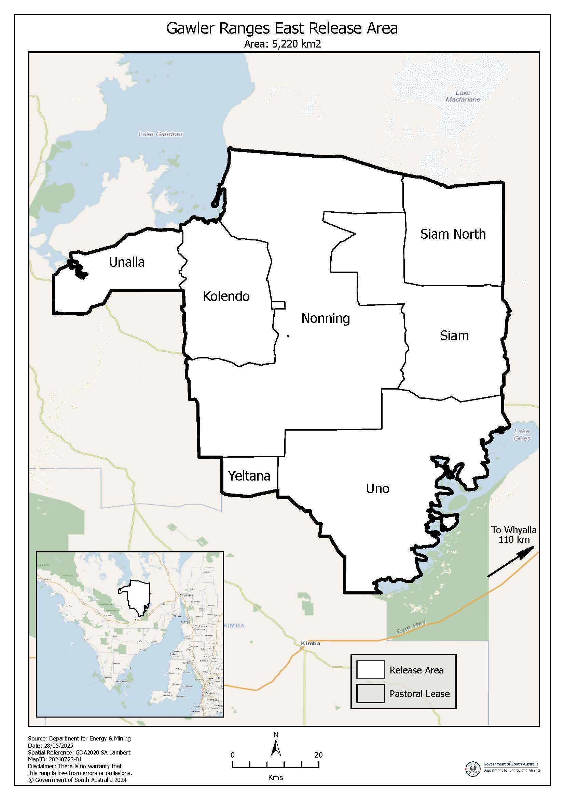

Hydrogen and Renewable Energy Act 2023
Section 10(1)
Declaration—Whyalla West Release Area
Notice is hereby given pursuant to Section 10(1) of the Hydrogen and Renewable Energy Act 2023 (Act) that I, Tom Koutsantonis, Minister for Energy and Mining, declare the area of designated land described in Schedule 1 as the Whyalla West release area.
An indicative map of the Whyalla West release area is set out in Schedule 2.
Note: The indicative map is intended as a guide only and does not alter or replace the description of the Whyalla West release area in Schedule 1.
Dated: 22 January 2026
Tom Koutsantonis MP
Minister for Energy and Mining

Schedule 1
Description of Area
Whyalla West Release Area
All that part of the State of South Australia, bounded as follows:
Commencing at a point being the intersection of latitude 32°10′07.009″S GDA2020 and longitude 136°50′27.691″E GDA2020 and the northern boundary of the Barngarla Native Title Claim File Number SCD2016/001 (Registered 27/04/2018), then beginning easterly along the said Native Title boundary to a southern boundary of the Lake Torrens National Park, then generally northerly along said Park boundary to the northern boundary of the Barngarla Native Title Claim File Number SCD2016/001 (Registered 27/04/2018), then generally easterly along said Native Title boundary to an eastern boundary of File Plan 252324 Allotment Piece 113, then generally south along said Allotment Piece 113 to a north-eastern boundary of Block 878 OH Port Augusta SI5304, then south along said boundary of Block 878 to a point at latitude 32°05′41.330″S GDA2020 and longitude 137°53′07.280″E GDA2020, then east along the geodesic to a point on the boundary of Block 878 OH Port Augusta SI5304, then beginning easterly along said Block 878 to a point at latitude 32°07′11.839″S GDA2020 and longitude 137°52′56.745″E GDA2020, then along the geodesic to a point on the boundary of Block 878 at latitude 32°07′11.828″S GDA2020 and longitude 137°52′53.102″E GDA2020, then generally westerly and southerly to a north-eastern boundary of Deposited Plan 47635 Allotment Piece 4, then south along said Allotment Piece 4 to the southern boundary of Deposited Plan 47635 Allotment Piece 104, then westerly along said Allotment Piece 104 to a point on the southern boundary of Deposited Plan 47635 Allotment Piece 3, then west along said Allotment Piece 3 to the south-eastern boundary of Section 2 the Hundred of Castine, then west along said Section 2 to a point at latitude 32°21′17.030″S GDA2020 and longitude 137°37′14.593″E GDA2020, then south along the geodesic to a point on the north-eastern boundary of Block 679 OH Port Augusta SI5304, then south along said Block 679 to a boundary of Section 234 in the Hundred of Copley, then south along said Section 234 to the north-western boundary of Section 311 in the Hundred of Copley, then south along said Section 311 to a point at latitude 32°22′07.212″S GDA2020 and longitude 137°37′13.517″E GDA2020, then south along the geodesic to a point on the western boundary of Section 311 in the Hundred of Copley, then south along said Section 311 to the eastern corner of Section 25 in the Hundred of Handyside, then beginning westerly along said Section 25 to the south-eastern boundary of Block 676 OH Port Augusta SI5304, then north-westerly along said Block 676 to the northern boundary of Deposited Plan 88907 Allotment Piece 5, then easterly along said Allotment Piece 5 to the south-eastern boundary of Deposited Plan 85852 Allotment Piece 92, then south-westerly along said Allotment Piece 92 to a point at latitude 32°44′48.419″S GDA2020 and longitude 137°06′49.467″E GDA2020, then south-east along the geodesic to a point on the northern boundary of Deposited Plan 85852 Allotment Piece 85, then easterly along said Allotment Piece 85 to a boundary of File Plan 250278 Allotment 104, then southerly along said Allotment 104 to a north-western boundary of File Plan 525386 Allotment Piece 1002, then easterly along said Allotment Piece 1002 to a point at latitude 32°57′14.665″S GDA2020 and longitude 137°10′59.833″E GDA2020, then east along the geodesic to a point on the north-western boundary of File Plan 252386 Allotment Piece 1000, then easterly along said Allotment Piece 1000 to the north-eastern boundary of Section 81 OH Port Augusta SI5304, then south along the said Section 81 to a point on the north-eastern boundary of File Plan 252386 Allotment Piece 1001, then south along said Allotment Piece 1001 to a point at latitude 33°00′33.763″S GDA2020 and longitude 137°17′46.343″E GDA2020, then south along the geodesic to a point on the north-eastern boundary of Deposited Plan 23001 Allotment Piece 24, then generally south and south-westerly along said Allotment Piece 24 to a point at latitude 33°03′47.477″S GDA2020 and longitude 137°11′57.540″E GDA2020, then west along the geodesic to a point on the south-eastern boundary of Deposited Plan 23001 Allotment Piece 22, then west along said Allotment Piece 22 to a point at latitude 33°03′46.949″S GDA2020 and longitude 137°10′30.174″E GDA2020, then west along the geodesic to a point on the south-eastern boundary of Deposited Plan 23001 Allotment Piece 20 at latitude 33°03′46.865″S GDA2020 and longitude 137°10′24.461″E GDA2020, then west along said Allotment Piece 20 to an eastern boundary of File Plan 250278 Allotment 106, then south-westerly along said Allotment 106 to the south-eastern boundary of File Plan 250278 Allotment 105, then west along said Allotment 105 to the eastern boundary of Lake Gilles Conservation Park, then generally north along said Park boundary to a point at latitude 33°01′26.274″S GDA2020 and longitude 136°48′40.472″E GDA2020, then north along the geodesic to a point on the south-eastern boundary of File Plan 55218 Allotment 100 at latitude 33°01′23.847″S GDA2020 and longitude 136°48′40.474″E GDA2020, then beginning north along said Allotment 100 to an eastern boundary of Lake Gilles Conservation Park, then generally north and north-easterly along said Park boundary to a boundary of the Barngarla Native Title Claim File Number SCD2016/001 (Registered 27/04/2018), then generally northerly along said Native Title boundary to a point at latitude 32°10′17.282″S GDA2020 and longitude 136°50′27.669″E GDA2020, then north along the geodesic to the point of commencement.

Schedule 2
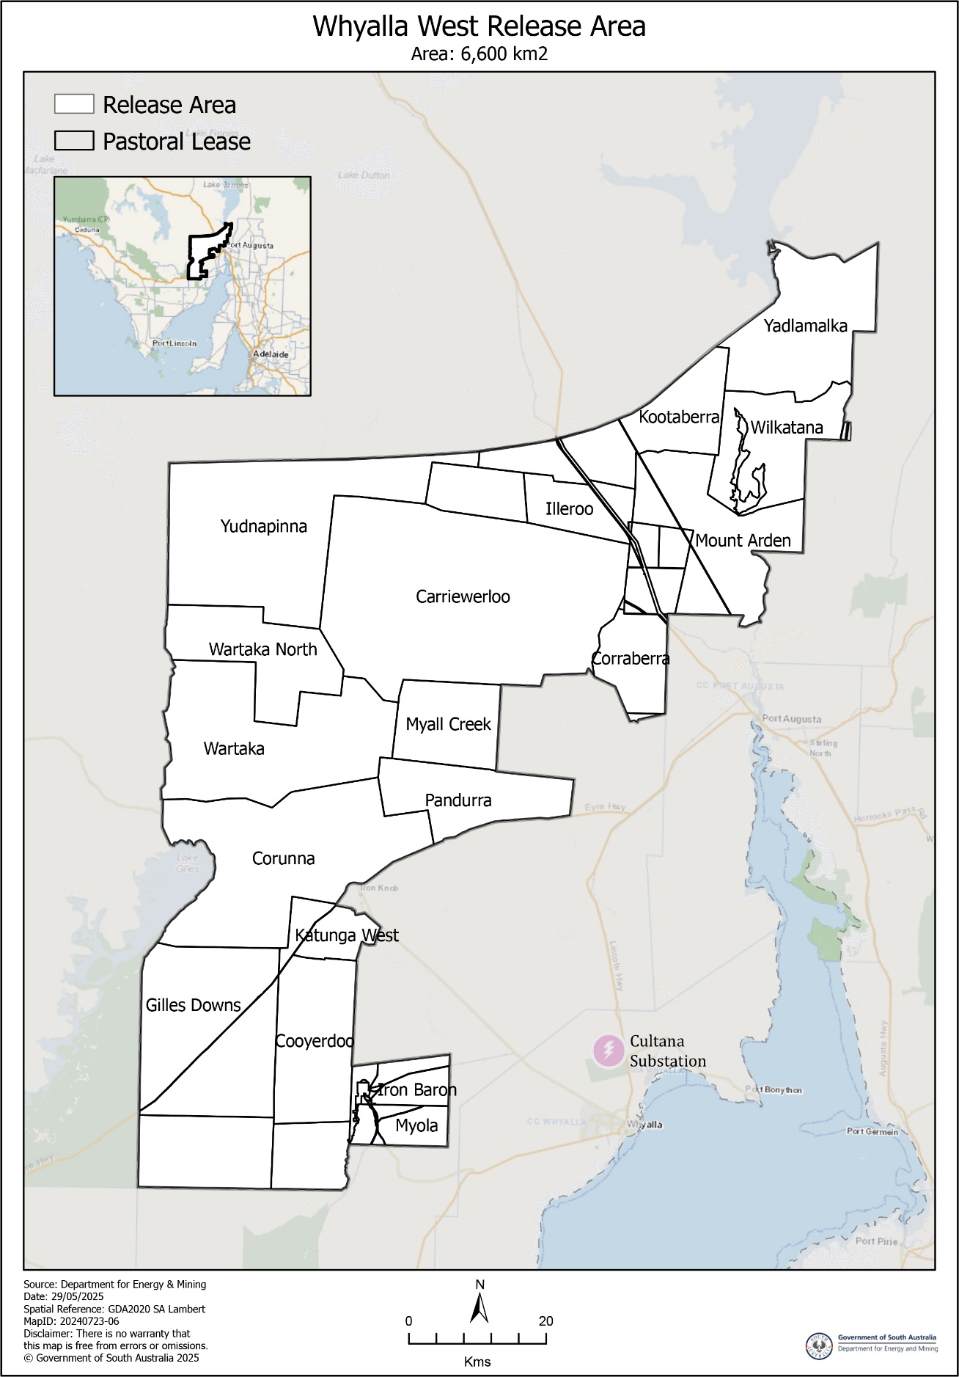
Indicative Map of Area

Juries (Remuneration for Jury Service) Regulations 2017
Declaration of Long Trials
Pursuant to Regulation 4(2) of the Juries (Remuneration for Jury Service) Regulations 2017 and on the advice of the relevant court,
I, Kyam Maher, Attorney-General, do hereby declare the criminal trials of R v Glastonbury and Ors (SCCRM-24-46602), R v Alzuain and Ors (SCCRM-21-100197), and R v Polymiadis (SCCRM-24-021190), to be long trials for the purposes of these Regulations.
Dated: 16 January 2025
Hon Kyam Maher MLC
Deputy Premier
Attorney-General

Justices of the Peace Act 2005
Section 4
Notice of Appointment of Justices of the Peace for South Australia
by the Commissioner for Consumer Affairs
I, Brett Humphrey, Commissioner for Consumer Affairs, delegate of the Attorney-General, pursuant to Section 4 of the Justices of the Peace Act 2005, do hereby appoint the people listed as Justices of the Peace for South Australia as set out below. It being a condition of appointment that the Justices of the Peace must take the oaths required of a justice under the Oaths Act 1936 and return the oaths of office form to Justice of the Peace Services within three months after the date of appointment:
For a period of ten years for a term commencing on 2 February 2026 and expiring on 1 February 2036:
Ewaz Ali TORANI
Anthony Richard TAYLOR
Nathelie Brigette SMITH
Naomi Narelle PARKER
Mary-Anne Jean LOVEGROVE
Amira Fayda KATARI
Tammy Dianne IRVINE-THOMAS
Sonu Sureshkumar GUPTA
Rebecca CARPENTER-MEW
Julian James BARSON
Emily Louise BARR
Dated: 19 January 2026
Brett Humphrey
Commissioner for Consumer Affairs
Delegate of the Attorney-General

Land Acquisition Act 1969
Section 26F
Form 6B—Notice of Acquisition of Underground Land
1. Notice of acquisition
The Commissioner of Highways (the Authority), of 83 Pirie Street, Adelaide SA 5000 acquires the following interests in the following land:
An unencumbered estate in fee simple in the whole of Allotment 930 in D138118 lodged in the Lands Titles Office, being portion of the land comprised in Certificate of Title Volume 5365 Folio 193.
This notice is given under Section 26F of the Land Acquisition Act 1969.
2. Compensation not payable unless certain water infrastructure or rights are affected
You are not entitled to compensation in relation to the acquisition of the underground land to which this notice relates, unless the following conditions are satisfied:
• you held at least one of the following interests in relation to the underground land immediately before the notice of acquisition was published in relation to the land—
◦ ownership of a lawful well that provides access to underground water in the underground land, and any underground infrastructure associated with the well; or
◦ a right to take underground water from the underground land by means of such a well;
• you notified the Authority of your interest in response to a notice given under Section 26G of the Land Acquisition Act 1969;
• the acquisition of the underground land either—
◦ involved the acquisition of your interest; or
◦ resulted in the discharge of your interest; or
◦ resulted in you being unable to take water by means of, or pursuant to, your interest;
• you make an application for compensation to the Authority under Section 26H of the Land Acquisition Act 1969.

3. Application for compensation under Section 26H
If you believe you are entitled to compensation, you must apply to the Authority for compensation within 6 months after the publication of the notice of acquisition in relation to the underground land to which this notice relates.
The application must be in the following manner and form:
“Application for Compensation for Acquisition of Underground Land” (enclosed) to be submitted by email to DIT.ULAapplications@sa.gov.au or by mail marked attention: Property Acquisition c/- GPO Box 1533, Adelaide SA 5001.
The application must be accompanied by the following information or documents:
Any relevant supporting documentation including, but not limited to water licences, bore licences etc.
After receiving your application, the Authority may (but is not required to) make you a written offer of compensation not exceeding $50,000.
See Section 26H(4) of the Land Acquisition Act 1969 for further details on the payment of compensation.
4. Inquiries
Inquiries should be directed to: T2D Project Team
GPO Box 1533
Adelaide SA 5001
Telephone: 1800 572 414
Dated: 19 January 2026
The Common Seal of the COMMISSIONER OF HIGHWAYS was hereto affixed by authority of the Commissioner in the presence of:
Rocco Caruso
Director, Property Acquisition
(Authorised Officer)
Department for Infrastructure and Transport
DIT: 2024/07288/01

Land Acquisition Act 1969
Section 26F
Form 6B—Notice of Acquisition of Underground Land
1. Notice of acquisition
The Commissioner of Highways (the Authority), of 83 Pirie Street, Adelaide SA 5000 acquires the following interests in the following land:
An unencumbered estate in fee simple in the whole of Allotment 1112 in D138049 lodged in the Lands Titles Office, being portion of the land comprised in Certificate of Title Volume 5679 Folio 893.
This notice is given under Section 26F of the Land Acquisition Act 1969.
2. Compensation not payable unless certain water infrastructure or rights are affected
You are not entitled to compensation in relation to the acquisition of the underground land to which this notice relates, unless the following conditions are satisfied:
• you held at least one of the following interests in relation to the underground land immediately before the notice of acquisition was published in relation to the land—
◦ ownership of a lawful well that provides access to underground water in the underground land, and any underground infrastructure associated with the well; or
◦ a right to take underground water from the underground land by means of such a well;
• you notified the Authority of your interest in response to a notice given under Section 26G of the Land Acquisition Act 1969;
• the acquisition of the underground land either—
◦ involved the acquisition of your interest; or
◦ resulted in the discharge of your interest; or
◦ resulted in you being unable to take water by means of, or pursuant to, your interest;
• you make an application for compensation to the Authority under Section 26H of the Land Acquisition Act 1969.
3. Application for compensation under Section 26H
If you believe you are entitled to compensation, you must apply to the Authority for compensation within 6 months after the publication of the notice of acquisition in relation to the underground land to which this notice relates.
The application must be in the following manner and form:
“Application for Compensation for Acquisition of Underground Land” (enclosed) to be submitted by email to DIT.ULAapplications@sa.gov.au or by mail marked attention: Property Acquisition c/- GPO Box 1533, Adelaide SA 5001.
The application must be accompanied by the following information or documents:
Any relevant supporting documentation including, but not limited to water licences, bore licences etc.
After receiving your application, the Authority may (but is not required to) make you a written offer of compensation not exceeding $50,000.
See Section 26H(4) of the Land Acquisition Act 1969 for further details on the payment of compensation.

4. Inquiries
Inquiries should be directed to: T2D Project Team
GPO Box 1533
Adelaide SA 5001
Telephone: 1800 572 414
Dated: 19 January 2025
The Common Seal of the COMMISSIONER OF HIGHWAYS was hereto affixed by authority of the Commissioner in the presence of:
Rocco Caruso
Director, Property Acquisition
(Authorised Officer)
Department for Infrastructure and Transport
DIT: 2024/07315/01

Land Acquisition Act 1969
Section 26F
Form 6B—Notice of Acquisition of Underground Land
1. Notice of acquisition
The Commissioner of Highways (the Authority), of 83 Pirie Street, Adelaide SA 5000 acquires the following interests in the following land:
An unencumbered estate in fee simple in the whole of Allotment 1116 in D138051 lodged in the Lands Titles Office, being portion of the land comprised in Certificate of Title Volume 5133 Folio 1.
This notice is given under Section 26F of the Land Acquisition Act 1969.
2. Compensation not payable unless certain water infrastructure or rights are affected
You are not entitled to compensation in relation to the acquisition of the underground land to which this notice relates, unless the following conditions are satisfied:
• you held at least one of the following interests in relation to the underground land immediately before the notice of acquisition was published in relation to the land—
◦ ownership of a lawful well that provides access to underground water in the underground land, and any underground infrastructure associated with the well; or
◦ a right to take underground water from the underground land by means of such a well;
• you notified the Authority of your interest in response to a notice given under Section 26G of the Land Acquisition Act 1969;
• the acquisition of the underground land either—
◦ involved the acquisition of your interest; or
◦ resulted in the discharge of your interest; or
◦ resulted in you being unable to take water by means of, or pursuant to, your interest;
• you make an application for compensation to the Authority under Section 26H of the Land Acquisition Act 1969.
3. Application for compensation under Section 26H
If you believe you are entitled to compensation, you must apply to the Authority for compensation within 6 months after the publication of the notice of acquisition in relation to the underground land to which this notice relates.
The application must be in the following manner and form:
“Application for Compensation for Acquisition of Underground Land” (enclosed) to be submitted by email to DIT.ULAapplications@sa.gov.au or by mail marked attention: Property Acquisition c/- GPO Box 1533, Adelaide SA 5001.
The application must be accompanied by the following information or documents:
Any relevant supporting documentation including, but not limited to water licences, bore licences etc.
After receiving your application, the Authority may (but is not required to) make you a written offer of compensation not exceeding $50,000.
See Section 26H(4) of the Land Acquisition Act 1969 for further details on the payment of compensation.
4. Inquiries
Inquiries should be directed to: T2D Project Team
GPO Box 1533
Adelaide SA 5001
Telephone: 1800 572 414
Dated: 19 January 2026
The Common Seal of the COMMISSIONER OF HIGHWAYS was hereto affixed by authority of the Commissioner in the presence of:
Rocco Caruso
Director, Property Acquisition
(Authorised Officer)
Department for Infrastructure and Transport
DIT: 2024/07317/01

Land Acquisition Act 1969
Section 26F
Form 6B—Notice of Acquisition of Underground Land
1. Notice of acquisition
The Commissioner of Highways (the Authority), of 83 Pirie Street, Adelaide SA 5000 acquires the following interests in the following land:
An unencumbered estate in fee simple in the whole of Allotment 1118 in D138052 lodged in the Lands Titles Office, being portion of the land comprised in Certificate of Title Volume 5146 Folio 234.
This notice is given under Section 26F of the Land Acquisition Act 1969.
2. Compensation not payable unless certain water infrastructure or rights are affected
You are not entitled to compensation in relation to the acquisition of the underground land to which this notice relates, unless the following conditions are satisfied:
• you held at least one of the following interests in relation to the underground land immediately before the notice of acquisition was published in relation to the land—
◦ ownership of a lawful well that provides access to underground water in the underground land, and any underground infrastructure associated with the well; or
◦ a right to take underground water from the underground land by means of such a well;
• you notified the Authority of your interest in response to a notice given under Section 26G of the Land Acquisition Act 1969;
• the acquisition of the underground land either—
◦ involved the acquisition of your interest; or
◦ resulted in the discharge of your interest; or
◦ resulted in you being unable to take water by means of, or pursuant to, your interest;
• you make an application for compensation to the Authority under Section 26H of the Land Acquisition Act 1969.
3. Application for compensation under Section 26H
If you believe you are entitled to compensation, you must apply to the Authority for compensation within 6 months after the publication of the notice of acquisition in relation to the underground land to which this notice relates.
The application must be in the following manner and form:
“Application for Compensation for Acquisition of Underground Land” (enclosed) to be submitted by email to DIT.ULAapplications@sa.gov.au or by mail marked attention: Property Acquisition c/- GPO Box 1533, Adelaide SA 5001.
The application must be accompanied by the following information or documents:
Any relevant supporting documentation including, but not limited to water licences, bore licences etc.
After receiving your application, the Authority may (but is not required to) make you a written offer of compensation not exceeding $50,000.
See Section 26H(4) of the Land Acquisition Act 1969 for further details on the payment of compensation.
4. Inquiries
Inquiries should be directed to: T2D Project Team
GPO Box 1533
Adelaide SA 5001
Telephone: 1800 572 414
Dated: 19 January 2026
The Common Seal of the COMMISSIONER OF HIGHWAYS was hereto affixed by authority of the Commissioner in the presence of:
Rocco Caruso
Director, Property Acquisition
(Authorised Officer)
Department for Infrastructure and Transport
DIT: 2024/07319/01

Major Events Act 2013
Section 6B
Declaration of a Major Event
Pursuant to Section 6B of the Major Events Act 2013, I, Hon. Zoe Bettison MP, Minister for Tourism declare the LIV Golf Adelaide 2026 tournament to be held from 12—15 February 2026 to be declared a major event.
By virtue of the provisions of the Major Events Act 2013, I do hereby:
1. Declare the LIV Golf Adelaide 2026 tournament to be a major event.
2. Specify the period of the major event legislation to be enacted for the event, being 12:01am on Tuesday, 10 February to 11:59pm on Sunday, 15 February 2026 inclusive, to allow for an official training day for all players and a Pro-Am event in the lead up to the event.
3. Declare the major event venue to be Grange Golf Club shown as the “Major Event Venue” in the map.
4. Declare the controlled areas to be any public place or a part of a public place that is within 350 metres of the boundary of the major event venue, as shown as the ‘Declared Controlled Area’ on the map.
5. Designate LIV Golf Events Ltd (ABN 74 672 604 232) to be the event organisers for the event.
6. Declare that the following provisions of Part 3 of the Act apply to the event, the event site and the declared controlled area for the event:
(a) Section 8
(b) Section 10
(c) Section 11
(d) Section 12
(e) Section 13
(f) Section 14
7. Being satisfied that the title “LIV Golf Adelaide” and the logos as they appear below are sufficiently connected with the identity and conduct of the major event, and that the event has commercial arrangements that are likely to be adversely affected by unauthorised use of the title and logos, I hereby declare, pursuant to Section 14(1) of the Act, that “LIV Golf Adelaide” is an official title and the logos as they appear below is official logos in respect of the event.

Dated: 19 January 2026
Hon Zoe Bettison MP
Minister for Tourism

Maps of Controlled Areas
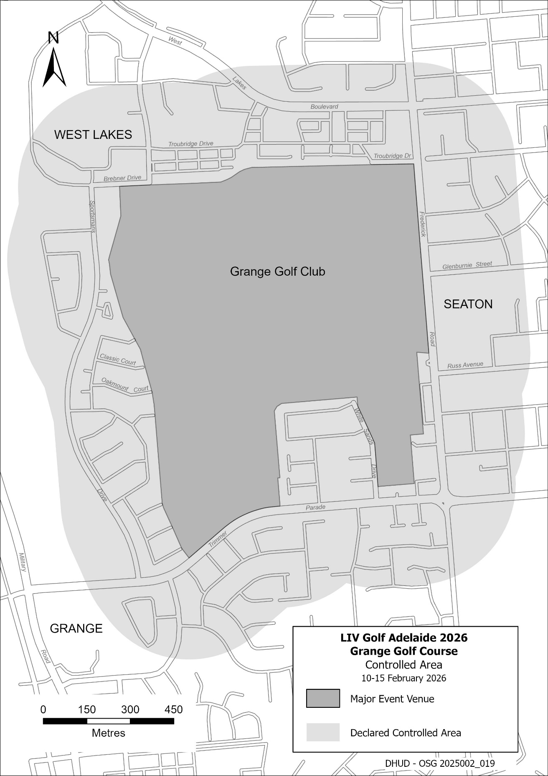
2026 LIV Golf Adelaide Tournament

Mental Health Act 2009
Authorised Mental Health Professional
Notice is hereby given in accordance with Section 94(1) of the Mental Health Act 2009, that the Chief Psychiatrist has determined the following persons as Authorised Mental Health Professionals:
Talia Bruin—née O’Keeffe (name update)—determination will expire on 11 January 2027.
The Chief Psychiatrist make vary or revoke these determinations at any time.
Dated: 22 January 2026
Dr JOHN BRAYLEY
Chief Psychiatrist

The Remuneration Tribunal
Report No. 1 of 2026
2025 Review of the Salary of the Governor of South Australia
Executive Summary
1. The Remuneration Tribunal (Tribunal) has conducted a review of Determination 12 of 2024 which sets the salary payable to Her Excellency the Governor of South Australia (the Governor).
2. The Tribunal has determined that from 1 February of each year, the salary of the Governor of South Australia will be increased as necessary to be equal to that of a Puisne Judge of the Supreme Court of South Australia. This will apply from 1 February 2026, based on the Tribunal’s most recent Determination of Judicial Salaries. Increases will not be backdated.
3. The Tribunal has issued a Determination which applies from 1 February 2026 and supersedes Determination 12 of 2024.
4. Of its own motion the Tribunal has reviewed the basis of the remuneration of the Governor. The Tribunal has adopted a simplified approach to assessing the Governor’s remuneration but generates the same amounts as the approach applied since 2021.
Background
5. Section 14 of the Remuneration Act 1990 (SA) (Act) and Section 73 of the Constitution Act 1934 (SA) (Constitution Act), provide that the Tribunal has jurisdiction to determine the salary payable to the Governor.
6. Consistent with Section 8 of the Act, the Tribunal has conducted an annual review of the salary of the Governor.
7. Since 2021 the Tribunal has determined that the Governor of South Australia should be remunerated at a level comparable to that of Governors in other Australian States by adopting the median salary of State Governors excluding the Governor of South Australia (State Governors).
The Review Process
8. On 2 December 2025, in accordance with Sections 10(2) and 10(4) of the Act, the Tribunal wrote to and invited submissions by 23 December 2025 in respect of this review from:
(a) Her Excellency the Governor of South Australia; and
(b) The Honourable Premier of South Australia—as the Minister responsible for the Act who may make submissions or introduce evidence in the public interest.
9. The Tribunal also placed a notice on its website from 2 December 2025 inviting submissions from affected persons by 23 December 2025.
10. On 5 December 2025, the Official Secretary to the Governor wrote to the Tribunal advising that the Governor did not intend to make a submission in relation to the Tribunal’s review of the Governor’s salary, leaving the matter to the discretion of the Tribunal.
11. On 18 December 2025, the Premier’s representative confirmed that the Premier did not intend to make a submission.
12. No other submissions were received by the Tribunal in relation to this review.
Consideration and Conclusion
13. Consistent with the remarks made in 2021, the Tribunal maintains its position that the remuneration of the Governor of South Australia should be comparable to that of Governors in other Australian States. This approach recognises the significant importance of this unique role within the State.
14. The Tribunal is committed to regular reviews which avoid sporadic but very substantial remuneration adjustments in the future.
15. However, the Tribunal is mindful that the reliance on the median of the State Governors could cause confusion. The median salary can vary depending on when the review is conducted, as salary adjustments apply from different dates across jurisdictions.
16. The Tribunal maintains a preference for a remuneration framework that ensures appropriate consistency with other State Governors but avoids complexities arising from reliance on decisions made in other jurisdictions and the timing of those decisions. The Tribunal notes that State publication practices for Governors differ in that some salary adjustments are made public, while others require interpretation or inference from related sources.
17. The Tribunal has again considered the current salaries of Governors in other jurisdictions and has had particular regard to the basis upon which those salaries are established. This information is summarised in the Appendix.
18. In most Australian States, the salary of the Governor is directly linked to the remuneration of members of that state’s Supreme Court or has a strong relationship to the remuneration of that state’s judiciary as detailed in the Appendix. Notably:
• The Victorian Governor receives 100% of the salary of a puisne Judge of the Supreme Court of Victoria.
• The Tasmanian Governor receives 90% of the salary of the Chief Justice of Tasmania, which is 100% of the salary of a puisne Judge of the Supreme Court of Tasmania. The Chief Justice’s salary is determined by reference to the average of the salaries of the Chief Justices of South Australia and Western Australia.
• The Western Australian Governor receives salary increases in line with those applied to puisne Judges of the Western Australian Supreme Court in the preceding 12 months, and their current at salary will be slightly below that of a puisne Judge in that State when their salaries increase on 1 December 2025.
• The Queensland Governor receives 100% of the salary of the Chief Justice of Queensland, excluding allowances.
19. Whilst the salary of the Governor-General of Australia has not been used previously in calculating the median salary, the Tribunal nevertheless notes that when the Federal Parliament most recently fixed the Governor General’s salary, it was done at a rate which was intended to be approximately equivalent to the salary of the Chief Justice of the High Court of Australia over the Governor-General’s time in office.
20. The adoption of an approach that is similar to that used in other States, and also ensures appropriate relativities, but is not dependent on the determined salaries of Governors in those jurisdictions. Links between the Governor’s salary and judicial salaries were applied in the past in South Australia in various forms.
21. The approach applied in Victoria and Tasmania, and a lesser extent Western Australia would establish the South Australian Governor’s salary in line with the current salary payable to a puisne Judge of the South Australian Supreme Court. This would result in a salary of $530,080. Coincidentally, if the Tribunal applied the method used in recent years namely setting the Governor’s salary in line with the median salary of other State Governors the salary of $530,080 would apply.
22. Linking the Governor’s remuneration to that of a puisne Judge of the South Australian Supreme Court is likely to achieve the same objectives as the approach taken since 2021, as the salary should retain a substantial amount of relativity to the salaries of the State Governors because their salaries are largely linked to the salaries of puisne Judges of their own Supreme Courts. However, the Tribunal reserves the discretion to apply other approaches depending on judicial salary movements across the nation.
23. Accordingly, the Tribunal has determined that the salary of the Governor will be equal to that of a puisne Judge of the Supreme Court of South Australia.
24. The Tribunal has noted that the application of judicial salary movements is generally delayed because of the Federal Parliamentary processes. Accordingly, the Tribunal has decided that the Governor’s salary will be increased from 1 February following the relevant increase for judicial officers.
25. To ensure the salary of the Governor retains relativity to the State Governors, the Tribunal will continue to review the remuneration yearly.
26. An accompanying Determination has been issued and will take effect from 1 February 2026.
Matthew O’Callaghan
President
Donny Walford
Member
Mark Young
Member
Dated: 19 January 2026

Appendix
Salaries of Governors in Other Jurisdictions
Jurisdiction* | Governor Salary Per Annum** | Relevant Authority | Details of the Base | Linked to the Salary of a Judge | Operative Date
QLD | $553,487 | Act of Parliament | The Governor’s salary is equal to that of the Chief Justice of Queensland, excluding the Jurisprudential Allowance and other allowances.  The Chief Justice’s salary is 113.2% of the salary of a Federal Court Judge. | Yes—equal to the salary of Chief Justice of Queensland | 1 July 2025
WA | $524,656 | Independent Tribunal | Salary and indexation methodology set by the Remuneration Tribunal on appointment. Then indexed by the Remuneration Tribunal by the increase applied to the puisne Judges of the WA Supreme Court in the preceding 12 months. | Yes—increased annually by the increase applied to the WA Supreme Court | 15 July 2025  (the anniversary of the Governor’s appointment)
CTH*** | $709,017 | Act of Parliament | In 2024 the Governor General Act 1974 (Cth) was amended for the salary to be moderately higher than the average of the Chief Justice of the High Court's salary over the Governor General's term. | Yes—legislated to be moderately higher than the Chief Justice over the Term | 1 July 2024
TAS | $525,280 | Act of Parliament | s4(1) of the Governor of Tasmania Act 1982 states the Governor’s salary is to be 90% of the salary of the Chief Justice of Tasmania.  Note: the salary the Governor is equal to that of a puisne Judge of the Supreme Court of Tasmania (90% of the CJ of Tasmania) and the Chief Justice’s salary is determined by the average of the Chief Justice of WA and SA. | Yes—90% of the salary of the CJ of Tasmania which is the average of the CJ of WA and SA. It is also 100% of the salary of a puisne Judge of the Tasmanian Supreme Court | 1 July 2025
VIC | $530,080 | Act of Parliament | s7(1) of the Constitution Act 1975 (1) states that the Governor is entitled to an annual salary equal to the annual salary payable to a judge of the Supreme Court. i.e. 100% of the puisne Judge of the Supreme Court of Victoria. | Yes—100% of the puisne Judge of the Supreme Court of Victoria | 28 October 2025
NSW | $539,980 | Independent Tribunal | The Tribunal applied a 3.5% increase to the salary | No | 1 October 2025
SA | $521,720 | Independent Tribunal | Median salary of Governors of Australian States ex SA | No | 1 February 2025
Median Salary ex SA | $530,080
Average Salary ex SA | $544,009
*NT and ACT have not been included as there is no office of Governor in those jurisdictions.
**Rounded to the nearest dollar.
***The Australian Constitution prevents the salary of the Governor-General from being altered during an incumbent’s time in office. For this review, the Governor-General of the Commonwealth of Australia’s salary has been excluded from the median calculation.

The Remuneration Tribunal
Determination No. 1 of 2026
Salary of the Governor of South Australia
Determination
1. Pursuant to Section 73 of the Constitution Act 1934 (SA), the Remuneration Tribunal determines that from 1 February of each year, the salary of the Governor of South Australia will be increased to be equal to that of a Puisne Judge of the Supreme Court of South Australia.
2. The increase to the Governor’s salary applies from 1 February of each year and is not backdated.
Date of Operation
3. This Determination operates from 1 February 2026.
Dated: 19 January 2026
Matthew O’Callaghan
President
Donny Walford
Member
Mark Young
Member

Roads (Opening and Closing) Act 1991
Section 24
NOTICE OF CONFIRMATION OF
ROAD PROCESS ORDER
Road Closure—Portion of Johns Road, Nalyappa
By Road Process Order made on 21 February 2025, the Yorke Peninsula Council ordered that:
1. Portion of unmade Public Road (Johns Road), Nalyappa, situated adjoining Sections 463, 464 and BE in the Hundred of Tiparra and Allotment 312 in Filed Plan 196873, more particularly lettered ‘A’ and ‘B’ in Preliminary Plan 24/0008 be closed.
2. Transfer the whole of the land subject to closure to Trevor Charles Johns in accordance with the Agreement for Transfer dated 21 February 2025 entered into between the Yorke Peninsula Council and Trevor Charles Johns.
On 16 January 2026 that order was confirmed by the Minister for Planning conditionally upon the deposit by the Registrar-General of Deposited Plan 135807 being the authority for the new boundaries.
Pursuant to Section 24(5) of the Roads (Opening and Closing) Act 1991, notice of the Order referred to above and its confirmation is hereby given.
Dated: 22 January 2026
Hon Nick Champion MP
Minister for Planning
2024/01227/01

Roads (Opening and Closing) Act 1991
Section 24
NOTICE OF CONFIRMATION OF
ROAD PROCESS ORDER
Road Closure—Portion of Mottled Cove Road, Arno Bay
By Road Process Order made on 23 February 2025, the District Council of Tumby Bay ordered that:
1. Portion of Mottled Cove Road, Port Neil, situated adjoining Section 186, Hundred of Dixson, more particularly delineated and lettered ‘A’ in Preliminary Plan 24/0017 be closed.
2. Transfer the whole of the land subject to closure to Gavin David Masters and Gillian Hope Masters in accordance with the Agreement for Transfer dated 28 November 2024 entered into between the District Council of Tumby Bay and Gavin David Masters and Gillian Hope Masters.
On 15 January 2026 that order was confirmed by the Minister for Planning conditionally upon the deposit by the Registrar-General of Deposited Plan 137341 being the authority for the new boundaries.
Pursuant to Section 24(5) of the Roads (Opening and Closing) Act 1991, notice of the Order referred to above and its confirmation is hereby given.
Dated: 22 January 2026
B. J. Slape
Surveyor-General
2024/02705/01

Roads (Opening and Closing) Act 1991
Section 24
NOTICE OF CONFIRMATION OF
ROAD PROCESS ORDER
Road Closure—Portion of Public Road, Clearview and Enfield
By Road Process Order made on 7 April 2025, the City of Port Adelaide Enfield ordered that:
1. Portion of Public Road, Clearview and Enfield, situated adjoining Allotment 1 in Deposited Plan 90422, Hundred of Yatala, more particularly lettered ‘A’ in Preliminary Plan 24/0022 be closed.
2. Transfer the whole of the land subject to closure to Elisa Janet Erskine Smith in accordance with the Agreement for Transfer dated 17 January 2025 entered into between the City of Port Adelaide Enfield and Elisa Janet Erskine Smith.
On 15 January 2026 that order was confirmed by the Minister for Planning conditionally upon the deposit by the Registrar-General of Deposited Plan 137713 being the authority for the new boundaries.
Pursuant to Section 24(5) of the Roads (Opening and Closing) Act 1991, notice of the Order referred to above and its confirmation is hereby given.
Dated: 22 January 2026
B. J. SLAPE
Surveyor-General
2024/03613/01

Roads (Opening and Closing) Act 1991
Section 24
NOTICE OF CONFIRMATION OF
ROAD PROCESS ORDER
Road Closure—Portion of West Terrace, Ardrossan
By Road Process Order made on 26 March 2025, the Yorke Peninsula Council ordered that:
1. Portion of West Terrace, situated adjoining Section 404, Allotments 101 and 102 in Filed Plan 206721, Hundred of Cunningham, more particularly delineated and lettered ‘A’ in Preliminary Plan 24/0007 be closed.
2. Transfer the whole of the land subject to closure to Minister for Education, Training and Skills in accordance with the Agreement for Transfer dated 26 March 2025 entered into between the Yorke Peninsula Council and Minister for Education, Training and Skills
3. The following easement is to be granted over portion of the land subject to closure:
Grant to the South Australian Water Corporation an easement for water supply purposes over the land marked ‘B’ in Deposited Plan 135868.
Grant to Distribution Lessor Corporation (subject to Lease 8890000) an easement for the transmission of electricity by overhead cable over the land marked ‘C’ in Deposited Plan 135868
On 16 January 2026 that order was confirmed by the Minister for Planning conditionally upon the deposit by the Registrar-General of Deposited Plan 135868 being the authority for the new boundaries.
Pursuant to Section 24(5) of the Roads (Opening and Closing) Act 1991, notice of the Order referred to above and its confirmation is hereby given.
Dated: 22 January 2026
Hon Nick Champion MP
Minister for Planning
2024/01223/01

Summary Offences Act 1953
Public Event Declaration
Notice is hereby given in accordance with Section 66ZE of the Summary Offences Act 1953 that the public events commonly known as Mourning in the Morning and Lights on the River 2026 are declared public events at the place, and during the times, shown below:
Place: The public places known as Elder Park and Pinky Flat in Adelaide bounded as follows: commencing at the point at which eastern boundary of King William Road intersects with the northern boundary of War Memorial Drive, then westerly along the northern boundary of War Memorial Drive to its intersection with Morphett Street, then southerly along the eastern boundary of Morphett Street to its intersection with North Terrace, then easterly along the northern boundary of North Terrace to its boundary with King William Road, then northerly along the eastern boundary of King William Road to the point of commencement at the north-eastern intersection of King William Road and War Memorial Road.
Commencing on: Monday, 26 January 2026 at 12:01am
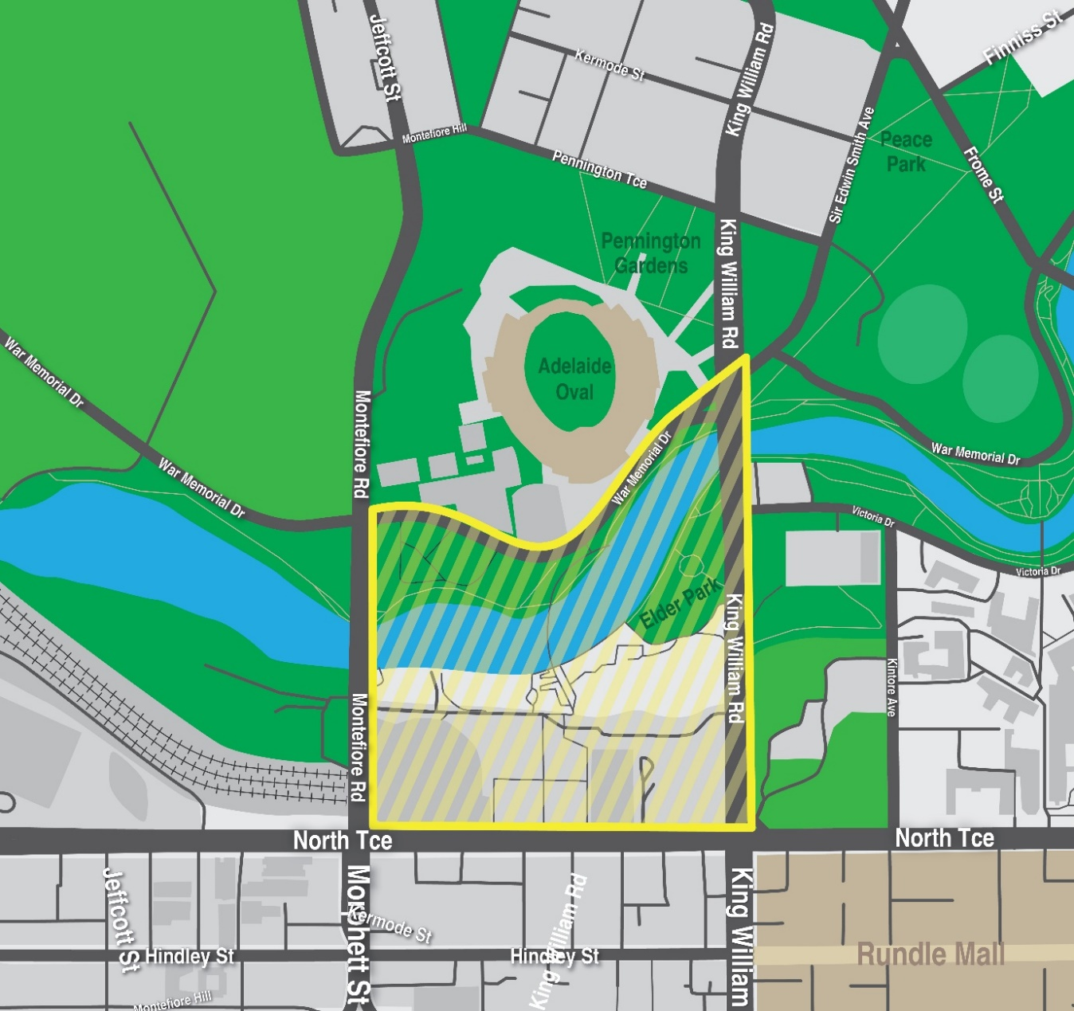
Ending on: Monday, 26 January 2026 at 11:59pm
During the declared public event, police officers may carry out a metal detector search in relation to any person who is at the relevant public place, or attempting to enter or leave the relevant public place, together with any property in the person’s possession.
Dated: 21 January 2026
John De Candia
Assistant Commissioner
Delegate of the Commissioner

Summary Offences Act 1953
Public Event Declaration
Notice is hereby given in accordance with Section 66ZE of the Summary Offences Act 1953 that the public event known as Survival Day 2026 is a declared public event at the place, and during the times, shown below:
Places: The public place known as Victoria Square/Tarntanyangga in Adelaide bounded to the north by the intersection of King William Street and Flinders Street, continuing southeast along Victoria Square to the intersection of Wakefield Street, continuing southwest along Victoria Square to the intersection of Angas Street, King William Street and Gouger Street, continuing northwest along Victoria Square to the intersection of Grote Street, and continuing northeast to the intersection of King William Street and Franklin Street.
The official march route comprising of the section of King William Street between the intersection of Franklin Street and Flinders Street to the south, and the intersection of North Terrace and King William Road to the north.
Commencing on: Monday, 26 January 2026 at 12:01am
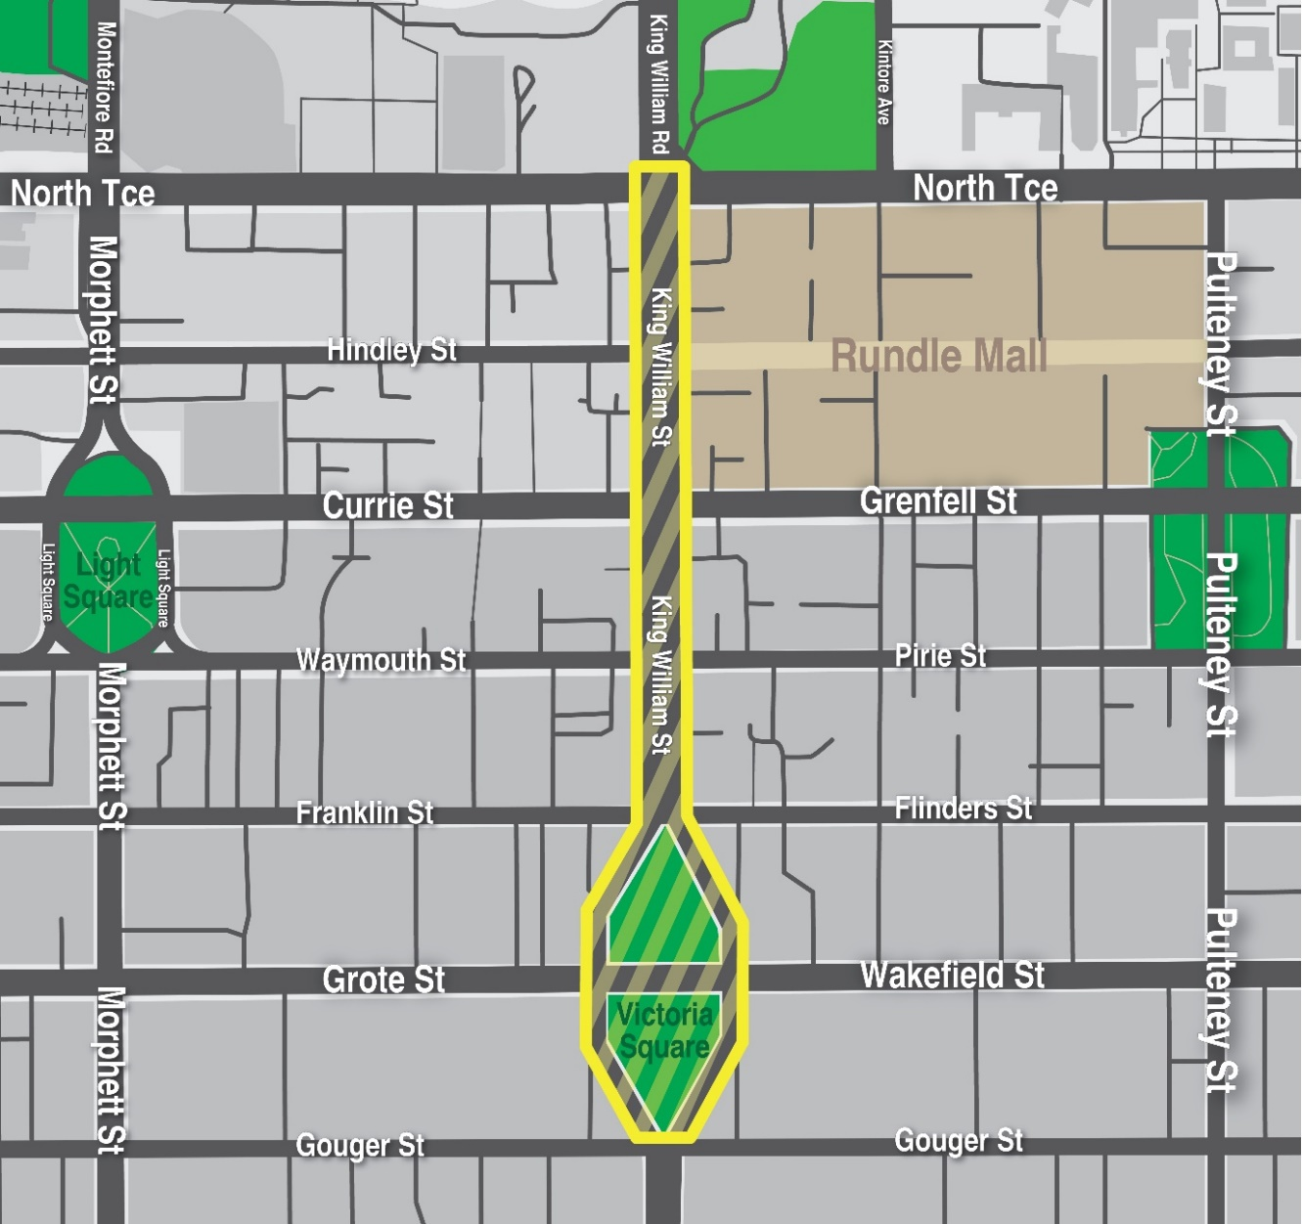
Ending on: Monday, 26 January 2026 at 11:59pm
During the declared public event, police officers may carry out a metal detector search in relation to any person who is at the relevant public place, or attempting to enter or leave the relevant public place, together with any property in the person’s possession.
Dated: 21 January 2026
John De Candia
Assistant Commissioner
Delegate of the Commissioner

Summary Offences Act 1953
Public Event Declaration
Notice is hereby given in accordance with Section 66ZE of the Summary Offences Act 1953 that the public event known as the
2026 Glenelg Australia Day events is a declared public event at the place, and during the times, shown below:
Place: The public place commonly known as Glenelg Precinct, Glenelg (including Wigley Reserve and Colley Reserve).
This includes any public place, or any part of a public place, bounded by:
• Southern boundary of the Stamford Grand Hotel west to the low tide shoreline of the Gulf St. Vincent.
• Low tide shoreline of the Gulf St. Vincent to the most northern point at low tide of the breakwater.
• The most northern point at low tide of the breakwater, to the southwest corner of the Holdfast Shores Marina (inclusive of Holdfast Promenade Plaza), the boundary of the southern end of the marina extending east to Anzac Highway (northern boundary).
• The northeastern corner of the Holdfast Shores Marina, east along the low tide shoreline then north to southern boundary of King Street then east on King Street to eastern boundary of Adelphi Terrace then south to the northern boundary of Anzac Highway.
• the northern boundary of Anzac Highway to the eastern boundary of Brighton Road.
• Eastern boundary of Brighton Road to the northern boundary of Dunbar Terrace, then east to the pedestrian crossing directly east of Tram Stop 15, across to the southern boundary of Maxwell Terrace and then west in a straight line to the eastern boundary of Brighton Road, then to the southern boundary of High Street.
• Southern boundary of High Street to the western boundary of Moseley Street, then to the southern boundary of College Street to the western boundary of St Johns Row, to the southern boundary of the Stamford Grand Hotel.
Commencing on: Monday, 26 January 2026 at 12:01am
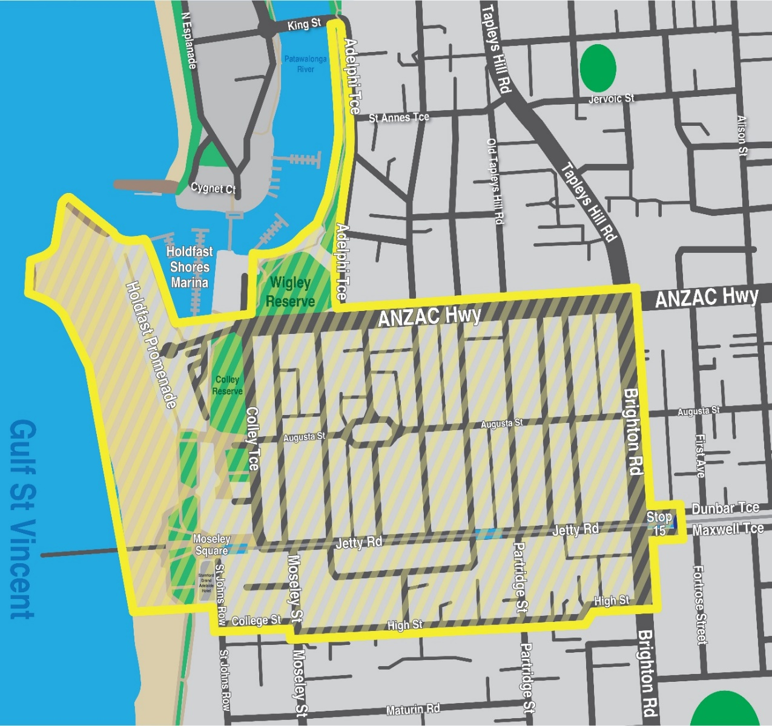
Ending on: Monday, 26 January 2026 at 11:59pm
During the declared public event, police officers may carry out a metal detector search in relation to any person who is at the relevant public place, or attempting to enter or leave the relevant public place, together with any property in the person’s possession.
Dated: 21 January 2026
John De Candia
Assistant Commissioner
Delegate of the Commissioner

Summary Offences Act 1953
Public Event Declaration
Notice is hereby given in accordance with Section 66ZE of the Summary Offences Act 1953 that the public event known as the Australia Day Rally SA 2026 is a declared public event at the place, and during the times, shown below:
Place: The public place known as Peace Park, Adelaide, being bounded by:
• Sir Edwin Smith Avenue;
• Frome Road; and
• The footpath south-west from Frome Road, intersecting University Oval Road and War Memorial Drive, to King William Road.
The roads that event attendees have agreed to march along, namely
• Sir Edwin Smith Avenue;
• King William Road (between Sir Edwin Smith Avenue and North Terrace; and
• North Terrace (at the intersection with King William Road).
Commencing on: Monday, 26 January 2026 at 10:00am
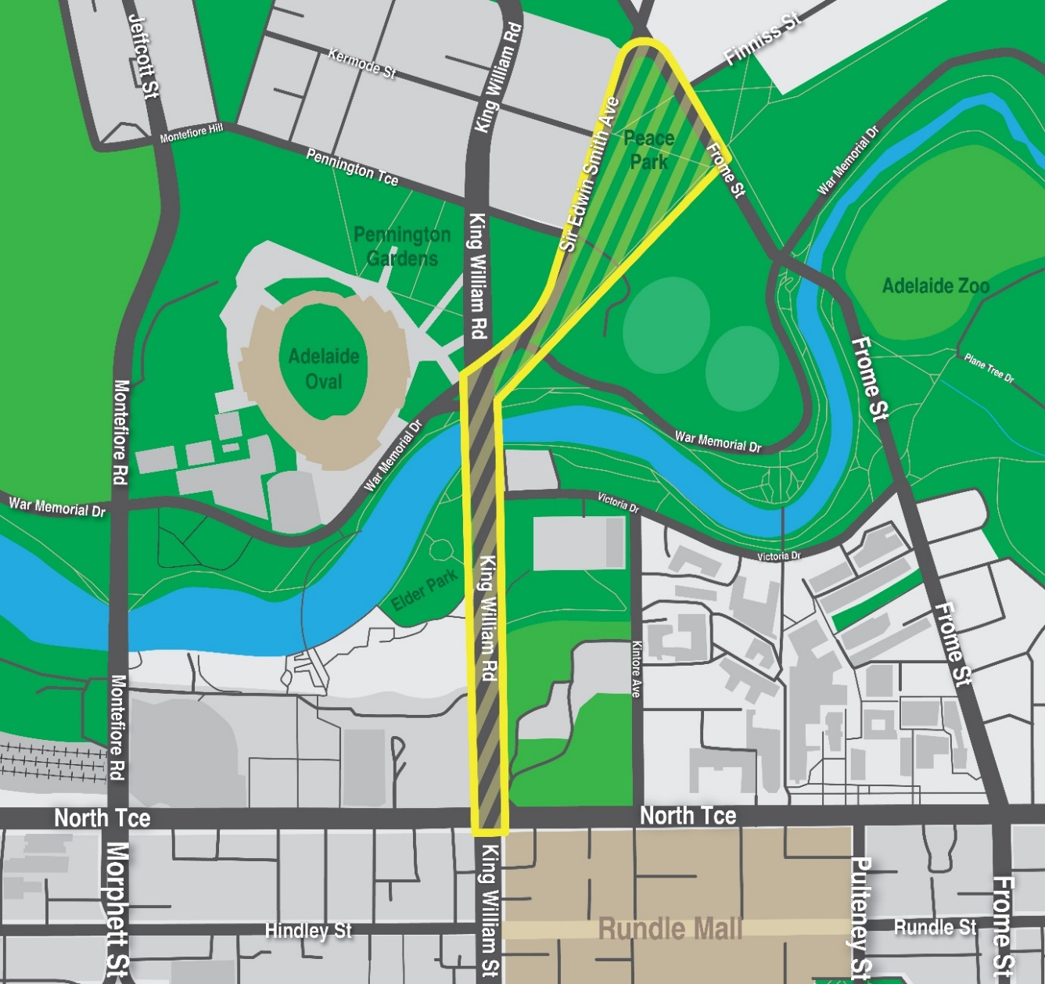
Ending on: Monday, 26 January 2026 at 4:00pm
During the declared public event, police officers may carry out a metal detector search in relation to any person who is at the relevant public place, or attempting to enter or leave the relevant public place, together with any property in the person’s possession.
Dated: 21 January 2026
John De Candia
Assistant Commissioner
Delegate of the Commissioner

Transplantation and Anatomy Act 1983 (SA)
Section 33, Part 6
Instrument of Authorisation
Pursuant to Section 33(2) of the Transplantation and Anatomy Act 1983 (“the Act”), I, Chris Picton, Minister for Health and Wellbeing, hereby authorise the establishment of a school of anatomy for the teaching and study of anatomy and for the carrying on of the practice of anatomy, within the South Australian Health and Medical Research Institute, being a prescribed institution pursuant to Section 33(1) of the Act.
This authorisation is for the use of pre-prepared cadaveric material for imaging and for the conduct of surgical anatomy training workshops, including using robotic surgical techniques within the South Australian Health and Medical Research Institute’s Preclinical, Imaging and Research Laboratories located at 101 Blacks Road, Gilles Plains, South Australia.
This authorisation operates from 1 January 2026 and has effect until 30 June 2027.
This authorisation may be varied or revoked by the Minister for Health and Wellbeing at any time.
Dated: 8 December 2025
Hon Chris Picton
Minister for Health and Wellbeing

Local Government Instruments

City of Salisbury
Planning, Development and Infrastructure Act 2016
City of Salisbury Urban Tree Fund
Notice is hereby given in accordance with Section 200(1) of the Act that the City of Salisbury has established an Urban Tree Fund, applying to all land within the City of Salisbury as mapped under the Planning and Design Code, as amended from time to time (designated area).
The Urban Tree Fund is established for the purposes of Section 200 of the Act.
Dated: 15 January 2026
J. Harry
Chief Executive Officer

City of Tea Tree Gully
Proposed Declaration of Private Road as Public Road—Dinan Court, Tea Tree Gully
The City of Tea Tree Gully gives notice that it proposes to make a declaration under Section 210(1) of the Local Government Act 1999 (SA) to convert the following private road within its Council area into a public road:
• The private road currently described as PRIVATE ROAD in DP 12354 and commonly known as Dinan Court.
The proposed declaration will take effect no earlier than 22 April 2026.
Public notice of the proposed declaration has also been published on City of Tea Tree Gully website.
Dated: 22 January 2026
Ryan McMahon
Chief Executive Officer

Town of Gawler
Local Government Act 1999
Notice of Vacancy in the Office of Member of Council
Notice is hereby given in accordance with Section 54(6) of the Local Government Act 1999 that the office of area councillor for the Town of Gawler, formerly occupied by Paul Koch, became vacant by operation of Section 54(1)(a) of the Local Government Act 1999 on 3 January 2026.
Dated: 22 January 2026
Chris Cowley
Chief Executive Officer

Town of Gawler
Local Government Act 1999
Revocation and Adoption of Community Land Management Plans
At its meeting held on 28 October 2025, the Town of Gawler resolved to revoke its existing Community Land Management Plans and adopt the Community Land Management Plan—Overview Document and Community Land Management Plan—Community and Business Areas, pursuant to Sections 198(1) and 196(1) of the Local Government Act 1999.
Further information about community land and the adopted Community Land Management Plans is available at:
https://www.gawler.sa.gov.au/your-council/engineering/Community-Land
Dated: 22 January 2026
Chris Cowley
Chief Executive Officer

Public Notices

National Energy Retail Law (South Australia) Act 2011
Notice of Making and Publication of the Notifiable Instrument
In accordance with Section 2(2) of the National Energy Retail Law (South Australia) Act 2011 (SA) (NERL), notice is given of the making and publication of the notifiable instrument under the National Energy Retail Law (ACT) Act 2012, Section 24 (3) (Local instruments for National Energy Retail Law (ACT))
The Regulations prescribe modifications to the National Energy Retail Law (ACT) to apply Section 22(1A) of the NERL to the ACT and to thereon introduce a two-year time limited flat rate tariff obligation on specific retailers operating in the ACT.
For the National Energy Retail Law (ACT), Section 22(1A)(c), a flat tariff structure is prescribed in relation to a retailer who, on 30 June 2025, offered customer retail services with a flat tariff structure to small customers (whether or not to small customers with interval meters).
The instrument was signed on 18 January 2026 and commences 2 months after its notification date 20 January 2026. This instrument expires 2 years after the day this section commences. The notifiable instrument has been published on the ACT’s legislation website (ACT Legislation Register). Queries may be directed to the ACT City and Environment Directorate via email at EPSDDEnergyPolicy@act.gov.au.
Dated: 18 January 2026
Suzanne Orr MLA
Minister for Climate Change, Environment, Energy and Water

Sale of Property
Warrant of Sale
Auction Date: Wednesday, 28 January 2026 at 4.00pm
Location: Unit 65/7 Arcadia Ct, North Haven, South Australia
Notice: Notice is hereby given that on the above date at the time and place stated, by virtue of the Warrant of Sale issued out of the Magistrates Court of South Australia, Action No. 000138 of 2022 directed to the Sheriff of South Australia in an action wherein Strata Plan 10344 Inc is the Plaintiff and Merydith Ann Carlin is the Defendant, I Leslie Turner, Sheriff of the State of South Australia, will
by my auctioneers, Harcourts Adelaide, make sale of the estate, right, title or interest whatsoever it may be of the defendant, Merydith Ann Carlin the registered proprietor of an estate in fee simple in the following:
That piece of land situated in the area named North Haven, being Unit 65/7 Arcadia Ct, North Haven, Hundred of Port Adelaide, being the property comprised in Certificate of Title Register Book Volume 5025 Folio 697.
Further particulars from the auctioneers.
Stephen Neal
Harcourts Adelaide
685 Port Road,
Woodville Park SA 5011
Telephone 08 7009 429
Dated: 22 January 2026
Leslie Turner
Sheriff

Trustee Act 1936
Deceased Estate
Notice to Creditors, Claimants and Other Persons
All persons having claims against the estate of Keith John Douglass, late of Unit 28/3 Bingham Street, Goolwa, South Australia, who died on 24 October 2025, are required to send particulars of their claim to the Executor of the estate, Tanya Marie Quesnel, care of tanya.douglass7@gmail.com, within 30 days from the date of publication of this notice.
After the expiration of that period, the Executor may distribute the estate having regard only to the claims of which she then has notice.
Dated: 22 January 2026
Tanya Marie Quesnel
tanya.douglass7@gmail.com

Trustee Act 1936
Public Trustee
Estates of Deceased Persons
In the matter of the estates of the undermentioned deceased persons:
ALEXOWITZ Horst Norbert Emil late of 20 Littler Drive Fairview Park Retired Boilermaker/Welder who died 31 August 2025
BINGHAM Gerard Joseph late of 1099 Grand Junction Road Hope Valley Retired Fitter and Turner who died 31 August 2025
BUTLER Glenys Margaret late of 150 Bay Road Encounter Bay of no occupation who died 4 September 2025
COOPER Patrick George late of 4-6 Pridmore Avenue McLaren Vale Retired Orderly who died 16 July 2025
GERSCHWITZ Eric Gordon late of 23 Edward Street Glynde Retired AMP Insurance Salesman who died 4 September 2025
HICKMAN Margaret Mary late of 206 Sir Donald Bradman Drive Cowandilla Retired Administration Officer who died 11 July 2025
HUGHES Wallace late of 43 High Street Strathalbyn Retired Factory Worker who died 8 July 2025
HUTCHINSON Craig late of 5C Bowaka Street Park Holme Retired Clerical Officer who died 15 August 2025
KAMP Jaspar late of 15 Elizabeth Street Wallaroo Retired Clergyman who died 20 November 2024
LE BRIQUE Domany Jordan Kasia late of 72 Beach Road Goolwa South of no occupation who died 20 August 2024
MOUSTAKAS Mudite late of 147 St Bernards Road Rostrevor Retired Auditor who died 6 May 2025
PAPINI Damiano late of 16 Adele Street Athol Park of no occupation who died 11 July 2024
PATTISON Ronald John late of 26 Mark Road Elizabeth South Retired Engineer who died 29 August 2025
REDMAN Marlene Mary late of 1-13 Deland Avenue Gawler East Tax Comptometer Operator who died 5 September 2025
RICHARDS Phoebe Elizabeth late of 6 Booth Avenue Linden Park Retired School Assistant who died 13 May 2025
SLATER Geoffrey John late of 22 Palomino Drive Angle Vale Retired Police Officer who died 14 June 2025
STEPHENS Marjorie Elizabeth late of 324 Military Road Semaphore 5019 of no occupation who died 6 January 2025
TROJANOWSKI Edward late of 21 Davenport Terrace Wayville Public Servant who died 16 September 2025
Notice is hereby given pursuant to the Trustee Act 1936 (SA), the Succession Act 2023 (SA) and the Family Relationships Act 1975 (SA) that all creditors, beneficiaries, and other persons having claims against the said estates are required to send, in writing, to the office of Public Trustee at GPO Box 1338, Adelaide 5001, full particulars and proof of such claims, on or before the 20 February 2026 otherwise they will be excluded from the distribution of the said estate; and notice is also hereby given that all persons indebted to the said estates are required to pay the amount of their debts to the Public Trustee or proceedings will be taken for the recovery thereof; and all persons having any property belonging to the said estates are forthwith to deliver same to the Public Trustee.
Dated: 22 January 2026
T. Brumfield
Public Trustee

Unclaimed Goods Act 1987
Notice of Intention to Sell
Manheim Pty Ltd of 180 Phillip Hwy, Elizabeth South, SA 5112 intends to sell the following vehicles under the Unclaimed Goods Act 1987. Owners of the vehicles have been sent notices that state that they are ready for collection. If said owners do not make arrangements for payment within 28 days from now they will be disposed of to settle any outstanding debt.
Make | Model Description | Registration No. | VIN
Holden | Commodore VSIII Ute | WXZ724 | 6H8VSK80HXL433457
Dated: 22 January 2026
Rebecca Barry
Cox Automotive Australia & New Zealand
Ph: 1800 326 243

Notice Submission

The South Australian Government Gazette is published each Thursday afternoon.
Notices must be emailed by 4 p.m. Tuesday, the week of publication.
Submissions are formatted per the gazette style and a proof will be supplied prior to publication, along with a quote if applicable. Please allow one day for processing notices.
Alterations to the proof must be returned by 4 p.m. Wednesday.

Gazette notices must be submitted as Word files, in the following format:
• Title—the governing legislation
• Subtitle—a summary of the notice content
• Body—structured text, which can include numbered lists, tables, and images
• Date—day, month, and year of authorisation
• Signature block—name, role, and department/organisation authorising the notice

Please provide the following information in your email:
• Date of intended publication
• Contact details of the person responsible for the notice content
• Name and organisation to be charged for the publication—Local Council and Public notices only
• Purchase order, if required—Local Council and Public notices only

Email: governmentgazettesa@sa.gov.au
Phone: (08) 7133 3552
Website: www.governmentgazette.sa.gov.au

All instruments appearing in this gazette are to be considered official, and obeyed as such

Printed and published weekly by authority of T. Foresto, Government Printer, South Australia
$9.50 per issue (plus postage), $479.00 per annual subscription—GST inclusive
Online publications: www.governmentgazette.sa.gov.au

