
No. 5 p. 121
THE SOUTH AUSTRALIAN
GOVERNMENT GAZETTE
Published by Authority

Adelaide, Thursday, 29 January 2026

Contents

Governor’s Instruments
Appointments, Resignations and General Matters 122
Notices—
Trans-Tasman Mutual Recognition
(Tobacco and other Products) Notice 2026 124
Proclamations—
Criminal Law (Forensic Procedures) (Blood Testing)
Amendment Act (Commencement) Proclamation 2026 129
Liquor Licensing (Conferral of Authority)
Proclamation 2026 129
Regulations—
Police (Police Security Officers)
Amendment Regulations 2026—No. 7 of 2026 130
State Government Instruments
Fisheries Management Act 2007 134
Housing Improvement Act 2016 135
Land Acquisition Act 1969 135
Mental Health Act 2009 136
Motor Vehicles Act 1959 136
National Parks and Wildlife Act 1972 155
Planning, Development and Infrastructure Act 2016 155
Return to Work Act 2014 157
South Australian Skills Act 2008 162
Local Government Instruments
City of Holdfast Bay 166
City of Mount Gambier 166
City of Norwood Payneham & St Peters 167
City of Onkaparinga 167
City of Playford 167
City of Port Adelaide Enfield 168
Kangaroo Island Council 168
District Council of Yankalilla 168
Public Notices
National Electricity Law 169
National Gas Law 169

Governor’s Instruments

Appointments, Resignations and General Matters
Department of the Premier and Cabinet
Adelaide, 29 January 2026
Her Excellency the Governor in Executive Council has been pleased to appoint the undermentioned to the South Australian Metropolitan Fire Service Disciplinary Committee, pursuant to the provisions of the Fire and Emergency Services Act 2005:
Member: from 1 February 2026 until 31 January 2029
Luke Dominic Paul Holland
Philip John Rogers
Ashley Michael Westbrook
Presiding Member: from 1 February 2026 until 31 January 2029
Luke Dominic Paul Holland
By command,
Natalie Fleur Cook, MP
For Premier
25MES0015CS

Department of the Premier and Cabinet
Adelaide, 29 January 2026
Her Excellency the Governor in Executive Council has been pleased to appoint the undermentioned to the South Australian Country Arts Trust, pursuant to the provisions of the South Australian Country Arts Trust Act 1992:
Member: from 29 January 2026 until 28 July 2026
Christabel Lucy Anthoney
Presiding Member: from 29 January 2026 until 28 July 2026
Christabel Lucy Anthoney
By command,
Natalie Fleur Cook, MP
For Premier
26ART0002CS

Department of the Premier and Cabinet
Adelaide, 29 January 2026
Her Excellency the Governor in Executive Council has been pleased to appoint the undermentioned to the Adelaide Festival Corporation Board, pursuant to the provisions of the Adelaide Festival Corporation Act 1998:
Member: from 29 January 2026 until 30 June 2026
Tam Thi Thanh Nguyen
By command,
Natalie Fleur Cook, MP
For Premier
26ART0004CS

Department of the Premier and Cabinet
Adelaide, 29 January 2026
Her Excellency the Governor in Executive Council has been pleased to appoint the Honourable Chief Justice Christopher John Kourakis as Governor's Deputy of South Australia from 4.20pm on Tuesday, 3 February 2026 until 10.15am on Thursday, 5 February 2026, or, if the Governor has not returned to Adelaide by the specified time and date, until the Governor's return.
By command,
Natalie Fleur Cook, MP
For Premier

Department of the Premier and Cabinet
Adelaide, 29 January 2026
Her Excellency the Governor in Executive Council has been pleased to appoint Katrina Jane Bochner, Associate Justice of the Supreme Court of South Australia, to the office of Puisne Judge of the Supreme Court of South Australia, effective from 19 February 2026 - pursuant to the provisions of the Supreme Court Act 1935.
By command,
Natalie Fleur Cook, MP
For Premier
AGO0006-26CS

Department of the Premier and Cabinet
Adelaide, 29 January 2026
Her Excellency the Governor in Executive Council has been pleased to appoint Kristopher Gareth Handshin, Judge of the District Court of South Australia, to the office of Puisne Judge of the Supreme Court of South Australia, effective from 19 February 2026 - pursuant to the provisions of the Supreme Court Act 1935.
By command,
Natalie Fleur Cook, MP
For Premier
AGO0006-26CS

Department of the Premier and Cabinet
Adelaide, 29 January 2026
Her Excellency the Governor in Executive Council has been pleased to appoint Domenico Petraccaro SC as a Judge of the District Court of South Australia, effective from 19 February 2026 - pursuant to the provisions of the District Court Act 1991.
By command,
Natalie Fleur Cook, MP
For Premier
AGO0006-26CS

Department of the Premier and Cabinet
Adelaide, 29 January 2026
Her Excellency the Governor in Executive Council has been pleased to designate Domenico Petraccaro SC as a Judge of the Environment, Resources and Development Court of South Australia, effective from 19 February 2026 - pursuant to the provisions of the Environment, Resources and Development Court Act 1993.
By command,
Natalie Fleur Cook, MP
For Premier
AGO0006-26CS

Department of the Premier and Cabinet
Adelaide, 29 January 2026
Her Excellency the Governor in Executive Council has been pleased to appoint Amy Sarah Wingate Teakle as a Clerk of Executive Council commencing on 29 January 2026 - pursuant to the Letters Patent and section 68 of the Constitution Act 1934.
By command,
Natalie Fleur Cook, MP
For Premier
DPC26/003CS

Department of the Premier and Cabinet
Adelaide, 29 January 2026
Her Excellency the Governor in Executive Council has approved the amendments to the Standing Orders adopted by the House of Assembly on 13 November 2025 - pursuant to section 55(2) of the Constitution Act 1934.
By command,
Natalie Fleur Cook, MP
For Premier
DPC26/001CS

Notices
South Australia

Trans-Tasman Mutual Recognition (Tobacco and Other Products) Notice 2026
under section 43 of the Trans-Tasman Mutual Recognition Act 1997 of the Commonwealth as adopted by section 4 of the Trans-Tasman Mutual Recognition (South Australia) Act 1999
1—Short title
This notice may be cited as the Trans-Tasman Mutual Recognition (Tobacco and Other Products) Notice 2026.
2—Commencement
This notice comes into operation on the day on which it is made.
3—Endorsement of regulations
The proposed regulations set out in Schedule 1 are endorsed for the purposes of section 45 of the Trans-Tasman Mutual Recognition Act 1997 of the Commonwealth.
Schedule 1—Proposed regulations
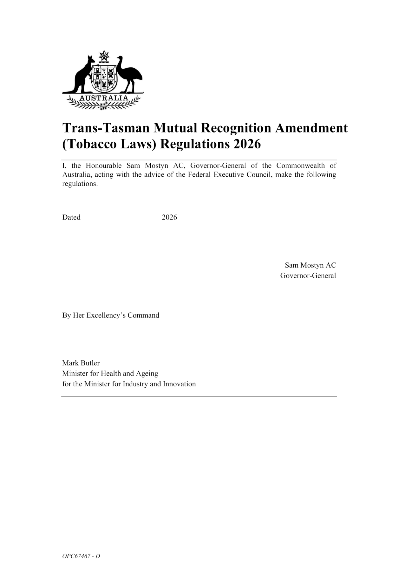
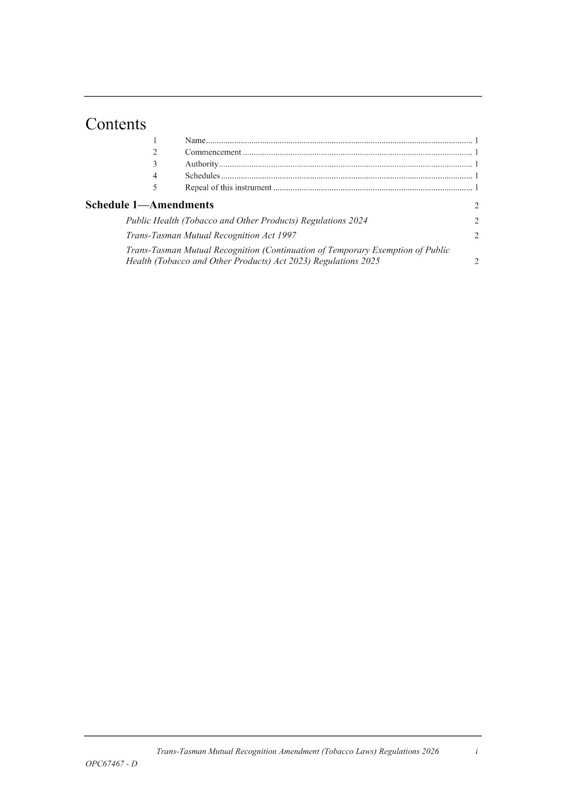
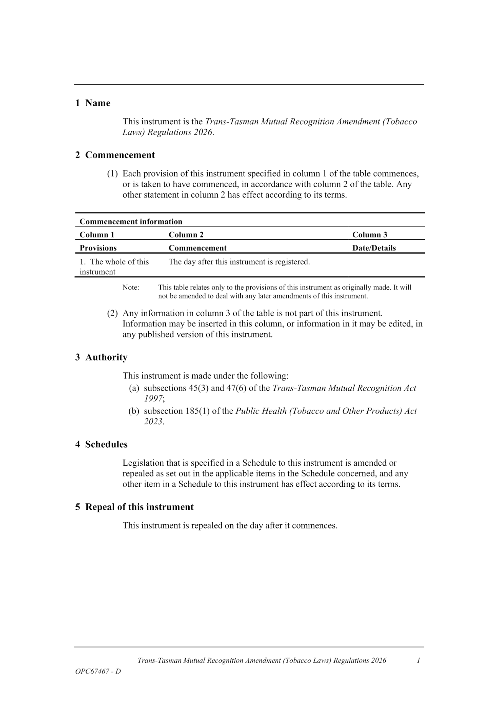
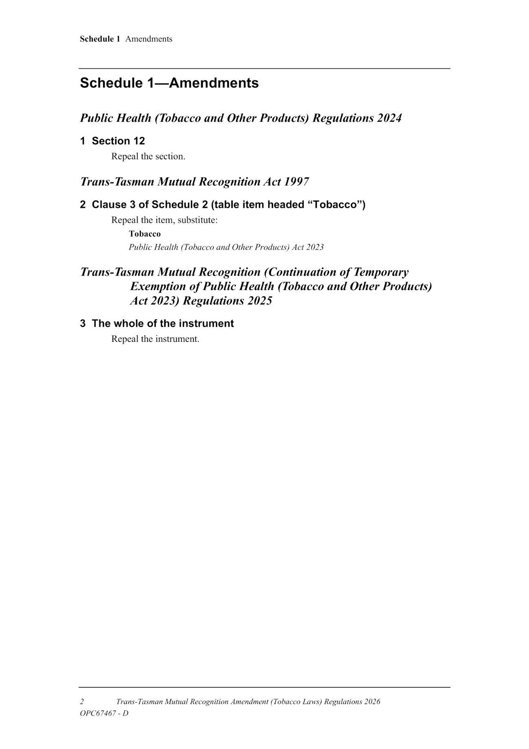
Made by the Governor
with the advice and consent of the Executive Council
on 29 January 2026

Proclamations
South Australia

Criminal Law (Forensic Procedures) (Blood Testing) Amendment Act (Commencement) Proclamation 2026
1—Short title
This proclamation may be cited as the Criminal Law (Forensic Procedures) (Blood Testing) Amendment Act (Commencement) Proclamation 2026.
2—Commencement of Act
The Criminal Law (Forensic Procedures) (Blood Testing) Amendment Act 2025 (No 33 of 2025) comes into operation on 1 April 2026.
Made by the Governor
with the advice and consent of the Executive Council
on 29 January 2026

South Australia

Liquor Licensing (Conferral of Authority) Proclamation 2026
under section 15 of the Liquor Licensing Act 1997
1—Short title
This proclamation may be cited as the Liquor Licensing (Conferral of Authority) Proclamation 2026.
2—Commencement
This proclamation comes into operation on 19 February 2026.
3—Conferral of authority on District Court Judge
Authority is conferred on the District Court Judge named in Schedule 1 to exercise the jurisdiction of the Licensing Court of South Australia.
Schedule 1—District Court Judge on whom authority is conferred
His Honour Judge Domenico Petraccaro
Made by the Governor
with the advice and consent of the Executive Council
on 29 January 2026

Regulations
South Australia

Police (Police Security Officers) Amendment Regulations 2026
under the Police Act 1998

Contents
Part 1—Preliminary
1 Short title
2 Commencement
Part 2—Amendment of Police Regulations 2014
3 Amendment of regulation 94—Interpretation
4 Amendment of regulation 95—Application of Part
5 Insertion of regulation 95A
95A Additional duties
6 Amendment of regulation 96—Power of arrest of certain police security officers
7 Amendment of regulation 97—Person apprehended by police security officer without warrant—how dealt with
8 Amendment of regulation 98—Other powers etc of police security officers performing additional duties
9 Amendment of Schedule 3—Form of oath or affirmation

Part 1—Preliminary
1—Short title
These regulations may be cited as the Police (Police Security Officers) Amendment Regulations 2026.
2—Commencement
These regulations come into operation on the day on which they are made.
Part 2—Amendment of Police Regulations 2014
3—Amendment of regulation 94—Interpretation
Regulation 94, definition of additional duties—delete the definition and substitute:
additional duties means the additional duties set out in regulation 95A.
Note—
The Commissioner may impose 1 or more of those additional duties on police security officers generally, a class of police security officers of which a police security officer is a member, or a police security officer personally—see section 63M of the Act.

4—Amendment of regulation 95—Application of Part
Regulation 95(4)—delete subregulation (4)
5—Insertion of regulation 95A
After regulation 95 insert:
95A—Additional duties
Pursuant to section 63D(2) of the Act, a police security officer may perform the following additional duties:
(a) guarding persons in the custody of South Australia Police;
(b) conveying persons in the custody of South Australia Police;
(c) conveying children under the guardianship of the Chief Executive of the Department for Child Protection;
(d) undertaking duties at events and incidents;
(e) undertaking Operation NOMAD duties;
(f) implementing and maintaining traffic cordon at events and incidents;
(g) guarding crime scenes;
(h) conveying and guarding exhibit property;
(i) recovering stolen and abandoned vehicles;
(j) undertaking related duties by order of another person possessing the requisite authority.
6—Amendment of regulation 96—Power of arrest of certain police security officers
(1) Regulation 96, heading—delete "arrest" and substitute:
detention
(2) Regulation 96—delete "apprehend" and substitute:
detain
7—Amendment of regulation 97—Person apprehended by police security officer without warrant—how dealt with
(1) Regulation 97, heading—delete "apprehended" and substitute:
detained
(2) Regulation 97(1)—delete "apprehended" and substitute:
detained
(3) Regulation 97(2)—delete "apprehended" and substitute:
detained
(4) Regulation 97(2)(a)—delete "apprehension" and substitute:
detention

(5) Regulation 97(3)—delete "into whose custody" and substitute:
to whom
(6) Regulation 97(4) and (5)—delete subregulations (4) and (5) and substitute:
(4) A police security officer may use reasonable force for the purposes of detaining a person under regulation 96.
8—Amendment of regulation 98—Other powers etc of police security officers performing additional duties
(1) Regulation 98, heading—delete "performing additional duties"
(2) Regulation 98—after its present contents (now to be designated as subregulation (1)) insert:
(2) A police security officer performing duties under the Act (including, to avoid doubt, additional duties contemplated by section 63D(2) of the Act) has the powers conferred by section 63N of the Act, subject to the following limitations:
(a) the powers may only be exercised by a police security officer who has completed such training relating to protective security duties as may be determined by the Commissioner;
(b) the powers may only be exercised by a police security officer who has been assessed as competent to undertake protective security duties in accordance with any determination of the Commissioner;
(c) the powers may only be exercised by a police security officer acting with the authority of a police officer or police security officer who may themselves exercise such powers.
9—Amendment of Schedule 3—Form of oath or affirmation
(1) Schedule 3, Form 1—delete "Her Majesty Queen Elizabeth II" and substitute:
His Majesty King Charles III
(2) Schedule 3, Form 1—delete "Her" (second and third occurring) and substitute in each case:
His
(3) Schedule 3, Form 2—delete "Her Majesty Queen Elizabeth II" and substitute:
His Majesty King Charles III
(4) Schedule 3, Form 2—delete "Her" (second occurring) and substitute:
His
(5) Schedule 3, Form 3—delete "Her Majesty Queen Elizabeth II" and substitute:
His Majesty King Charles III
(6) Schedule 3, Form 3—delete "Her" (second occurring) and substitute:
His

Editorial note—
As required by section 10AA(2) of the Legislative Instruments Act 1978, the Minister has certified that, in the Minister's opinion, it is necessary or appropriate that these regulations come into operation as set out in these regulations.

Made by the Governor
with the advice and consent of the Executive Council
on 29 January 2026
No 7 of 2026

State Government Instruments

Fisheries Management Act 2007
Section 115
Ministerial Exemption ME9903408
Take notice that pursuant to Section 115 of the Fisheries Management Act 2007 (the Act), Dr Sylvia Zukowski of Nature Glenelg Trust (ACN: 153 577 907), 16 Anglesea Road, Victor Harbor SA 5211 (the ‘exemption holder’) and her nominated agents, are exempt from Sections 70, 71(1) and 71(2) of the Fisheries Management Act 2007 and Clauses 40, 42, 47 and 74 of Schedule 6 of the Fisheries Management (General) Regulations 2017 but only insofar as they may use the fishing gear specified in Schedule 1, in the waters specified in Schedule 2 to collect fish species listed, subject to the conditions specified in Schedule 3, from 20 January 2026 until 19 January 2027, unless varied or revoked earlier.
Schedule 1
• 24 x Fyke nets (maximum wingspan of 7m, minimum mesh size of 2mm)
• 5 x Seine nets (maximum length of 25m, minimum mesh size of 3mm)
• 10 x Soft-release enclosures (maximum dimension of 1m2, minimum mesh size of 4mm)
• 2 x Dip Nets (maximum 400mm gape, minimum 3mm mesh)
Schedule 2
Wetlands within the SA Murray-Darling Basin between the South Australian border and the Murray Mouth, including the fringing wetlands of Lakes Alexandrina and Lake Albert and the Murray Mouth, and waters within the Western and Eastern Mount Lofty Region, and the Ewan and Piccaninnie Ponds System, and sites listed under Ministerial Permit MP0257 and MP0258.
Schedule 3
1. The exemption holder will be deemed responsible for the conduct of all persons conducting the activities under this notice. Any person conducting activities as an agent under this exemption must be provided with a copy of this notice, which they must sign as an indication that they have read and understand the conditions of the exemption.
2. The maximum number of combined captured juvenile and adult fish species to be retained per a site.
• 1000 x Southern Purple-spotted Gudgeon (Mogurnda adspersa).
• 100 x Freshwater Catfish (Tandanus tandanus).
• 50 x River Blackfish (Gadopsis marmoratus).
• 10,000 x Southern Pygmy Perch (Nannoperca australis).
• 100 x Variegated Pygmy Perch (Nannoperca variegate).
• 10,000 x Olive Perchlet (Ambassis agassizii).
• 10,000 x Yarra Pygmy Perch (Nannoperca obscura).
• 500 x Little Galaxias (Galaxiella toourtkoourt).
• 10,000 x Murray Hardyhead (Craterocephalus fluviatilis).
3. Other than the fish specified in condition 2 that may be collected under this exemption all native fish taken pursuant to the exempted activity must be returned to the water in the locations where they were captured.
4. Any specimens collected and retained by the exemption holder must be translocated in accordance with the conditions of Ministerial permit MP0258 or be held in accordance with MP0257 for translocation purposes only and must not be sold.
5. Any noxious fish collected during the exempted activity must not be returned to the water and must be destroyed and disposed of appropriately.
6. The following persons are authorised to act as agents under this Ministerial exemption (ME9903408):
• Dr Nick Whiterod
• Matt Jacobs
• Cory Young
• Ida Moore
7. Before conducting the exempted activity, the exemption holder must contact the Department of Primary Industries and Regions (PIRSA) Fishwatch on 1800 065 522 and answer a series of questions about the exempted activity and be able to provide information about the area and time of the exempted activity, the vehicles and/or boats involved, the number of agents undertaking the exempted activity and other related issues.
8. The exemption holder must provide a report in writing detailing the outcomes of the research and the collection of organisms pursuant to this notice to the Executive Director PIRSA Fisheries and Aquaculture, (GPO Box 1625, Adelaide SA 5001) within 2 weeks of completion of the last activity to occur under this notice or within 2 weeks of the expiry of this notice, whichever occurs first, giving the following details:
• the date and location of sampling;
• the number of and types of nets used;
• the description of all species collected (fish, invertebrates, turtles) for purposes of identification;
• the number of each species collected.
9. While engaging in the exempted activity, the exemption holder or a person acting as their agent must be in possession of a copy of this notice. Such notice must be produced to a Fisheries Officer if requested.
10. The exemption holder must not contravene or fail to comply with the Fisheries Management Act 2007 or any Regulations made under that Act, except where specifically exempted by this notice or any other notice issued under that Act.
This notice does not purport to override the provisions or operation of any other Act including, but not limited to, the River Murray Act 2003. The exemption holder and their agents must comply with any relevant regulations, permits, requirements and directions from the Department for Environment and Water when undertaking activities within the River Murray.
Dated: 21 January 2026
Matt Read
Acting Executive Director
Fisheries and Aquaculture
Delegate of the Minister for Primary Industries and Regional Development

Housing Improvement Act 2016
Rent Control Revocations
In the exercise of the powers conferred by the Housing Improvement Act 2016, the Delegate of the Minister for Housing and Urban Development hereby revokes the maximum rental amount per week that shall be payable subject to Section 55 of the Residential Tenancies Act 1995, in respect of each premises described in the following table.
Address of Premises |  | Allotment Section | Certificate of Title  Volume/Folio
27A Rivett Avenue, Fulham Gardens SA 5024 |  | Allotment 1 Deposited Plan 31052 Hundred of Yatala | CT5289/356
28A Campbell Road, Paradise SA 5075 |  | Allotment 101 Deposited Plan 14953 Hundred of Adelaide | CT5699/65
Unit 1, 13 Harradine Street, Gawler East SA 5118 |  | Unit 1 Strata Plan 7856 Hundred of Nuriootpa | CT5004/16
87 Days Road, Croydon Park SA 5008 |  | Allotment 458 Deposited Plan 3421 Hundred of Yatala | CT5155/151
Dated: 29 January 2026
Craig Thompson
Housing Regulator and Registrar
Housing Safety Authority
Delegate of the Minister for Housing and Urban Development

Land Acquisition Act 1969
Section 26F
Form 6B—Notice of Acquisition of Underground Land
1. Notice of acquisition
The Commissioner of Highways (the Authority), of 83 Pirie Street, Adelaide SA 5000 acquires the following interests in the following land:
An unencumbered estate in fee simple in the whole of Allotment 1114 in D138050 lodged in the Lands Titles Office, being portion of the land comprised in Certificate of Title Volume 5920 Folio 362.
This notice is given under Section 26F of the Land Acquisition Act 1969.
2. Compensation not payable unless certain water infrastructure or rights are affected
You are not entitled to compensation in relation to the acquisition of the underground land to which this notice relates, unless the following conditions are satisfied:
• you held at least one of the following interests in relation to the underground land immediately before the notice of acquisition was published in relation to the land—
◦ ownership of a lawful well that provides access to underground water in the underground land, and any underground infrastructure associated with the well; or
◦ a right to take underground water from the underground land by means of such a well;
• you notified the Authority of your interest in response to a notice given under Section 26G of the Land Acquisition Act 1969;
• the acquisition of the underground land either—
◦ involved the acquisition of your interest; or
◦ resulted in the discharge of your interest; or
◦ resulted in you being unable to take water by means of, or pursuant to, your interest;
• you make an application for compensation to the Authority under Section 26H of the Land Acquisition Act 1969.
3. Application for compensation under Section 26H
If you believe you are entitled to compensation, you must apply to the Authority for compensation within 6 months after the publication of the notice of acquisition in relation to the underground land to which this notice relates.
The application must be in the following manner and form:
“Application for Compensation for Acquisition of Underground Land” (enclosed) to be submitted by email to DIT.ULAapplications@sa.gov.au or by mail marked attention: Property Acquisition c/- GPO Box 1533, Adelaide SA 5001.
The application must be accompanied by the following information or documents:
Any relevant supporting documentation including, but not limited to water licences, bore licences etc.
After receiving your application, the Authority may (but is not required to) make you a written offer of compensation not exceeding $50,000.
See Section 26H(4) of the Land Acquisition Act 1969 for further details on the payment of compensation.
4. Inquiries
Inquiries should be directed to: T2D Project Team
GPO Box 1533
Adelaide SA 5001
Telephone: 1800 572 414
Dated: 20 January 2026
The Common Seal of the COMMISSIONER OF HIGHWAYS was hereto affixed by authority of the Commissioner in the presence of:
Rocco Caruso
Director, Property Acquisition
(Authorised Officer)
Department for Infrastructure and Transport
DIT: 2024/07316/01

Mental Health Act 2009
Authorised Medical Practitioner
Notice is hereby given in accordance with Section 93(1) of the Mental Health Act 2009 that the Chief Psychiatrist has determined the following person as an Authorised Medical Practitioner:
Jennifer Rossiter
A determination will be automatically revoked upon the person being registered as a specialist psychiatrist with the Australian Health Practitioner Regulation Agency and as a fellow of the Royal Australian and New Zealand College of Psychiatrists.
The Chief Psychiatrist may vary or revoke this determination at any time.
Dated: 29 January 2026
Dr John Brayley
Chief Psychiatrist

Mental Health Act 2009
Authorised Mental Health Professional
Notice is hereby given in accordance with Section 94(1) of the Mental Health Act 2009, that the Chief Psychiatrist has determined the following persons as Authorised Mental Health Professionals:
Ottavia Edwards
The determination will expire three years after the commencement date.
The Chief Psychiatrist make vary or revoke these determinations at any time.
Dated: 29 January 2026
Dr John Brayley
Chief Psychiatrist

Motor Vehicles Act 1959
Section 47A
Classes, Specifications and Design of Number Plates—
Notice by the Registrar of Motor Vehicles
Pursuant to Section 47A of the Motor Vehicles Act 1959 (‘the Act’), I, Emma Kokar, Registrar of Motor Vehicles (Registrar):
(a) revoke the following notices made under Section 47A of the Act:
• notice dated 2 December 2025 published in the Gazette No. 70 on Thursday, 4 December 2025 (pages 4763-4783).
(b) establish the classes of number plates set out in Schedule 1 and numbered 1 to 13 and 15 to 23 (inclusive) for the purposes of Section 47(1) of the Act;
(c) prescribe the specifications and design set out in Schedule 2 to be the specifications and design to which number plates of each class established by this notice must conform;
(d) declare the classes of number plates set out in Schedule 3 to be classes of number plates that the Registrar may enter into an agreement pursuant to Section 47A(4) of the Act.
Schedule 1
Classes of Number Plates
Class 1—Numeric
Class 2—Alpha Numeric (non-slogan)
Class 3—Slogan
Class 4—Personalised
Class 5—Jubilee
Class 6—Australian Grand Prix
Class 7—Towtruck
Class 8—Government Vehicle
Class 9—Name Plates
Class 10—Custom
Class 11—Taxi Plates
Class 12—Chauffeured Vehicle
Class 13—Consular Corps
Class 15—Premium Number
Class 16—Bike Rack
Class 17—Centenary of Federation
Class 18—Country Taxi Plates
Class 19—SA – Heavy Vehicle
Class 20—Euro Vehicle
Class 21—National Heavy Vehicle
Class 22—Japanese Plates
Class 23—Motorsport
Schedule 2
Specifications and Design of Number Plates
Class 1—Numeric Number Plates
A numeric number plate must bear a number consisting entirely of a figure, or figures (except for the letters “SA” designating the State of issue), and may be issued under an agreement between the Registrar and the applicant. The plate must conform to the following additional specifications and designs:
 | 129mm Min./371mm Max.
Steel/Aluminium Embossed |  |  | 133mm Min
White Figures |  |  | Black Background
 |  | Motor Vehicles other than Motor Bikes |  | Motor Bikes
Height of figure |  | 77-80mm |  | 50mm
Width of every line in each figure |  | 12mm |  | 6mm
The dimensions of a motor bike plate must be 215 ± 1.0mm in length and 95 ± 1.0mm in height.
Class 2—Alpha Numeric Plates (Non-Slogan)
An alpha-numeric plate (non-slogan) must bear a number consisting of a combination of letters and figures and may be issued under an agreement between the Registrar and the applicant. The plate must conform to the following additional specifications and design:
2.1.1 Special Purpose Vehicle and Motor Bike (“S” 6 character set)
 | 215 ± 1.0mm
Steel/Aluminium Embossed |  |  | 100 ± 1.0mm
Black Letters and Figures |  |  | White Retroreflective Background
Height of figure or letter |  | 50mm
Width of every line in each figure or letter |  | 6-8mm
2.1.2 Special Purpose Vehicle and Motor Bike
 | 215 ± 1.0mm
Steel/Aluminium Embossed |  |  | 100 ± 1.0mm
Black Letters and Figures |  |  | White Retroreflective Background
Height of figure or letter |  | 50mm
Width of every line in each figure or letter |  | 6-8mm
2.2 Other Vehicles
 | 371 ± 1.0mm
Steel/Aluminium Embossed |  |  | 133 ± 1.0mm
Black Letters and Figures |  |  | White Retroreflective Background
Height of figure or letter |  | 70-77mm
Width of every line in each figure or letter |  | 12mm

2.3 Corporate Number Plates
Alpha numeric plates (non-slogan) in the corporate plate format (class 2.2 only) may contain a background, logo and/or slogan or other promotional pictures or information deemed appropriate, in accordance with an agreement between the Registrar and the applicant.
The plate must conform to the following specifications and design:
The height of the plate 133 + 1.0mm and width 371 + 1.0mm.
Height of figure or letter | 60mm
Width of every line in each figure or letter | 10mm
Class 3—Slogan Number Plates
A slogan number plate must bear a number consisting of a combination of letters and figures and may be issued under an agreement between the Registrar and the applicant. The plate must be of the type known as metal embossed and must conform to the following additional specifications and design:
3.1 South Australia Plate
 | 371 ± 1.0mm
Steel/Aluminium Embossed |  | 133 ± 1.0mm
Black Letters and Figures |  | White Retroreflective Background
Slogan (Black): SOUTH AUSTRALIA
 | Motor Vehicles other than Motor Bikes
Height of figure or letter | 70-77mm
Width of every line in each figure or letter | 10-12mm
3.1.1 South Australia Trailer Plate
 | 371 ± 1.0mm
Steel/Aluminium Embossed |  | 133 ± 1.0mm
Black Letters and Figures |  | White Retroreflective Background
Slogan (Black): SOUTH AUSTRALIA
Height of figure or letter | 70-77mm
Width of every line in each figure or letter | 10-12mm
3.1.2 South Australia Non-Standard Trailer Plate
 | 252 ± 1.0mm
Steel/Aluminium Embossed |  | 98 ± 1.0mm
Black Letters and Figures |  | White Retroreflective Background
Slogan (Black): SOUTH AUSTRALIA
Height of figure or letter | 50mm
Width of every line in each figure or letter | 6mm
3.1.3 Aerial Plate
 | 252 ± 1.0mm
Steel/Aluminium Embossed |  | 98 ± 1.0mm
Black Letters and Figure |  | White Background Retroreflective
Slogan (Black): SOUTH AUSTRALIA
Height of figure or letter | 50mm
Width of every line in each figure or letter | 6mm
The dimensions of an aerial mount plate must be 252 ± 1.0mm in length and 98 ± 1.0mm in width and are only available to vehicles granted registration under the Act.
3.2 Corporate Number Plates
Slogan number plates in the corporate plate format may contain a background, logo and/or slogan or other promotion pictures or information deemed appropriate, in accordance with an agreement between the Registrar and the applicant. The plate must conform to the following specifications and design:
The height of the plate 133mm + 1.0mm and length of the plate 371mm + 1.0mm.
Height of figure or letter | 60mm
Width of every line in each figure or letter | 10mm
3.3 Festival State (Discontinued)
 | 371 ± 1.0mm
Steel/Aluminium Embossed |  | 133 ± 1.0mm
Black Letters and Figures  Slogan Blue |  | White Retroreflective Background
Blue Slogan: SA • The Festival State
Black State Badge (Piping Shrike)
 | Motor Vehicles other than Motor Bikes
Height of figure or letter | 70-77mm
Width of every line in each figure or letter | 10-12mm
3.3.1 Festival State Trailer Plate (Discontinued)
 | 371 ± 1.0mm
Steel/Aluminium Embossed |  | 133 ± 1.0mm
Black Letters and Figures  Slogan Blue |  | White Retroreflective Background
Blue Slogan: SA • The Festival State
Black State Badge (Piping Shrike)
 | Motor Vehicles other than Motor Bikes
Height of figure or letter | 70-77mm
Width of every line in each figure or letter | 10-12mm
3.3.2 Festival State Non-Standard Trailer Plate (Discontinued)
 | 252 ± 1.0mm
Steel/Aluminium Embossed |  | 98 ± 1.0mm
Black Letters and Figures  Slogan Blue |  | White Retroreflective Background
Blue Slogan: SA • The Festival State
Black State Badge (Piping Shrike)
Height of figure or letter | 50mm
Width of every line in each figure or letter | 6mm
3.4.1 Wine State (remake only)
 | 371 ± 1.0mm
Steel/Aluminium Embossed |  | 133 ± 1.0mm
Black Letters and Figures  Slogan Purple |  | White Retroreflective Background
Slogan Purple: SOUTH AUSTRALIA—THE WINE STATE
Black State Badge (Piping Shrike)
Background: (Light Green, Green)—Design approved by the Registrar)
Height of figure or letter | 60mm
Width of every line in each figure or letter | 10mm
3.4.2 Rose State (remake only)
 | 371 ± 1.0mm
Steel/Aluminium Embossed |  | 133 ± 1.0mm
Black Letters and Figures  Slogan Pink |  | White Retroreflective Background
Slogan Pink: SOUTH AUSTRALIA—THE ROSE STATE
Black State Badge (Piping Shrike)
Background: (Light Green, Green, Pink, Red)—Design approved by the Registrar)
Height of figure or letter | 60mm
Width of every line in each figure or letter | 10mm
3.4.3 Creative State (remake only)
 | 371 ± 1.0mm
Steel/Aluminium Embossed |  | 133 ± 1.0mm
Black Letters and Figures  Slogan Black |  | Yellow Background
Slogan Black: SOUTH AUSTRALIA—THE CREATIVE STATE
Black State Badge (Piping Shrike)
Background: (White, Grey, Red)—Design approved by the Registrar)
Height of figure or letter | 60mm
Width of every line in each figure or letter | 10mm
3.4.4 Defence State (remake only)
 | 371 ± 1.0mm
Steel/Aluminium Embossed | 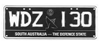 | 133 ± 1.0mm
White Letters and Figures  Slogan White with Black Background |  | Blue Background
Slogan White: SOUTH AUSTRALIA—THE DEFENCE STATE
Black State Badge (Piping Shrike)
Background: (Blue)—Design approved by the Registrar)
Height of figure or letter | 60mm
Width of every line in each figure or letter | 10mm
3.4.5 Gateway to the Outback (remake only)
 | 371 ± 1.0mm
Steel/Aluminium Embossed | 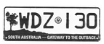 | 133 ± 1.0mm
Black Letters and Figures  Slogan White with Black Background |  | White Retroreflective Background
Slogan White: SOUTH AUSTRALIA—GATEWAY TO THE OUTBACK
Black State Badge (Piping Shrike)
Background: (Yellow, Purple)—Design approved by the Registrar)
Height of figure or letter | 60mm
Width of every line in each figure or letter | 10mm

3.4.6 The Electronics State (remake only)
 | 371 ± 1.0mm
Steel/Aluminium Embossed |  | 133 ± 1.0mm
Black Letters and Figures  Slogan White with Green Background |  | Green and White Retroreflective Background
Slogan White: SOUTH AUSTRALIA—THE ELECTRONICS STATE
Black State Badge (Piping Shrike)
Background: (White, Green)—Design approved by the Registrar)
Height of figure or letter | 60mm
Width of every line in each figure or letter | 10mm
3.4.7 SA The Koala State
 | 371 ± 1.0mm
Steel/Aluminium Embossed | 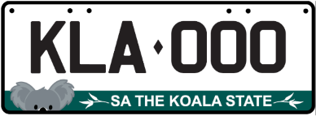 | 133 ± 1.0mm
Black Letters and Figures  Slogan White with Teal Background |  | White and Teal Retroreflective Background
Slogan White: SA THE KOALA STATE
Background: (White, Teal)—Design approved by the Registrar)
Height of figure or letter | 60mm
Width of every line in each figure or letter | 10mm
Class 4—Personalised Number Plates
A personalised number plate must bear a number consisting of a combination of letters and figures nominated by an applicant and approved by the Registrar, and issued under an agreement between the Registrar and the applicant.
The plate must be of the type known as metal embossed and must conform to the following additional specifications and design:
Option | Letters and Figures (colour) | Background (colour) | State Badge Piping Strike (colour)
1 | Retroreflective White | Blue | White
2 | Retroreflective White | Magenta | White
3 | Retroreflective White | Red | White
4 | Retroreflective White | Maroon | White
5 | Retroreflective White | Green | White
6 | Blue | Retroreflective White | Black
7 | Magenta | Retroreflective White | Black
8 | Red | Retroreflective White | Black
9 | Maroon | Retroreflective White | Black
10 | Green | Retroreflective White | Black
11 | Green | Retroreflective Yellow | Black
The Piping Shrike emblem will appear after the last letter and before the first number.
4.1 Standard Personalised
 | 371 ± 1.0mm
Aluminium Embossed | 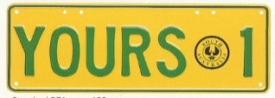 |  | 133 ± 1.0mm
 |  | Motor Vehicles and Trailers other than Motor Bikes and Non-Standard Trailers |  | Motor Bikes
Height of figure or letter |  | 70-72mm |  | 50mm
Width of every line in each figure or letter |  | 10-12mm |  | 6mm
The dimensions of a motor bike plate must be 252mm ± 1.0mm in length and 98mm ± 1.0mm in height.

4.2 Slim Personalised
 | 371 ± 1.0mm
Aluminium Embossed | 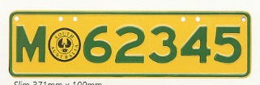 |  |  | 100 ± 1.0mm
 |  | Motor Vehicles other than  Motor Bikes or Trailers | Motor Bikes
Height of figure or letter |  | 54 or 60mm | 50mm
Width of every line in each figure or letter |  | 10mm | 6mm
The dimensions of a motor bike plate must be 252mm ± 1.0mm in length and 98mm ± 1.0mm in height.
4.3 Non-Standard Personalised Trailer
 | 252 ± 1.0mm
Aluminium Embossed |  |  | 98 ± 1.0mm
Height of figure or letter |  | 50mm
Width of every line in each figure or letter |  | 6mm
4.4 Corporate Number Plates
Personalised number plates in the corporate plate format may contain a background, logo and/or slogan or other promotion pictures or information deemed appropriate, in accordance with an agreement between the Registrar and the applicant. The plate must conform to the following specifications and design:
The height of the plate 133mm + 1.0mm and length of the plate 371mm + 1.0mm.
Height of figure or letter | 60mm
Width of every line in each figure or letter | 10mm
Class 5—Jubilee Number Plates
A limited series of number plates numbered 001J—999J and 001S—999S preceded by the J150 logo and has the words “SOUTH AUSTRALIA” printed under the numbers, were issued to commemorate South Australia’s 150th Jubilee. The plate is issued under an agreement between the Registrar and the applicant and must be of the type known as metal embossed and must conform to the following additional specifications and design:
 | 371 ± 1.0mm
Steel/Aluminium Embossed |  | 133 ± 1.0mm
Black Letters and Figures |  | Silver-White Retroreflective Background
Slogan Black: SOUTH AUSTRALIA
Jubilee Slogan (to the left of the characters) according to the copyright specifications
Height of figure or letter | 77mm
Width of every line in each figure or letter | 12mm
Class 6—Australian Grand Prix Number Plates
6.1 Special Series
A limited series of number plates numbered 1—199 preceded by the Grand Prix Logo, were issued to commemorate the Australian Formula 1 Grand Prix in Adelaide. The plate is issued under an agreement between the Registrar and the applicant and must be of the type known as metal embossed and must conform to the following additional specifications and design:
 | 371 ± 1.0mm
Steel/Aluminium Embossed | 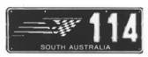 | 133 ± 1.0mm
White Figures |  | Black Background
Slogan White: SOUTH AUSTRALIA
Logo Green, Yellow, Black and White (to the left of the digits) according to the copyright specifications
Height of figure or letter | 77mm
Width of every line in each figure or letter | 12mm
6.2 Standard Series
A limited series of number plates numbered 200—9999 preceded by the Grand Prix Logo, was issued to commemorate the Australian Formula 1 Grand Prix in Adelaide. The plate is issued under an agreement between the Registrar and the applicant and must be of the type known as metal embossed and must conform to the following additional specifications and design:
 | 371 ± 1.0mm
Steel/Aluminium Embossed | 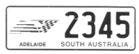 | 133 ± 1.0mm
Black Figures |  | White Retroreflective Background
Slogan Black: SOUTH AUSTRALIA
Logo Green, Yellow, Black and White (to the left of the digits) according to the copyright specifications
Height of figure or letter | 77mm
Width of every line in each figure or letter | 12mm
Class 7—Towtruck Number Plates
A Towtruck number plate must be issued to a Towtruck approved by the Registrar for use in the operation of the accident towing roster scheme. The number is preceded by the letters “ATT” and the plate must conform to the following additional specifications and design:
 | 371 ± 1.0mm
Steel/Aluminium Embossed | 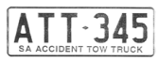 | 133 ± 1.0mm
Blue Letters and Figures |  | Yellow Retroreflective Background
Slogan Blue: SA ACCIDENT TOWTRUCK
Height of figure or letter | 77mm
Width of every line in each figure or letter | 12mm
Class 8—Government Vehicle Number Plates
Vehicles owned by the State of South Australia may be issued with a number plate or plates consisting of a combination of letters and figures, which conform to the following additional specifications and design (unless otherwise authorised):
8.1.1 Government Vehicle or Trailer Number Plate (“S” 7 character set)
 | 371 ± 1.0mm
Steel/Aluminium Embossed |  | 133 ± 1.0mm
Blue Letters and Figures |  | White Retroreflective Background
Slogan Blue: SA GOVERNMENT
Height of figure or letter | 70-77mm
Width of every line in each figure or letter | 10-12mm
8.1.2 Government Motor Bike (“S” 6 character set)
 | 215 ± 1.0mm
Steel/Aluminium Embossed | 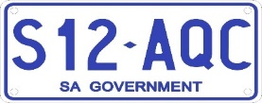 | 95 ± 1.0mm
Blue Letters and Figures |  | White Retroreflective Background
Slogan Blue: SA GOVERNMENT
Height of figure or letter | 50mm
Width of every line in each figure or letter | 6mm

8.1.3 Aerial Plate
 | 252 ± 1.0mm
Steel/Aluminium Embossed |  | 98 ± 1.0mm
Blue Letters and Figure |  | White Retroreflective Background
Slogan Blue: SA GOVERNMENT
Height of figure or letter | 50mm
Width of every line in each figure or letter | 6mm
The dimensions of an aerial mount plate must be 252 ± 1.0mm in length and 98 ± 1.0mm in width and are only available to vehicles granted registration under the Act.
8.2 Government Vehicle Number Plate (remake only)
 | 371 ± 1.0mm
Steel/Aluminium Embossed | 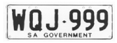 | 133 ± 1.0mm
Blue Letters and Figures |  | White Retroreflective Background
Slogan Blue: SA GOVERNMENT
 | Motor Vehicles other than Motor Bikes | Motor Bikes
Height of figure or letter | 77mm | 50mm
Width of every line in each figure or letter | 12mm | 6mm
The dimensions of a motor bike plate must be 215 ± 1.0mm in length and 95 ± 1.0mm in width.
Class 9—Name Plates
A name plate must bear a number which consists of all letters issued under an agreement between the Registrar and the applicant. The plate must be of the type known as retroreflective metal or acrylic.
Option | Letters and Figures  (colour) | Background  (colour)
1 | Retroreflective White | Blue
2 | Retroreflective White | Magenta
3 | Retroreflective White | Red
4 | Retroreflective White | Maroon
5 | Retroreflective White | Green
6 | Blue | Retroreflective White
7 | Magenta | Retroreflective White
8 | Red | Retroreflective White
9 | Maroon | Retroreflective White
10 | Green | Retroreflective White
11 | Black | Gold
12 | Black | Silver
13 | Gold | Black
14 | Silver | Black
15 | Black | Retroreflective White
16 | Black | Retroreflective Lemon
17 | Black | Retroreflective Yellow
18 | Green | Retroreflective Lemon
19 | Green | Retroreflective Yellow
20 | Blue | Retroreflective Lemon
21 | Blue | Retroreflective Yellow
22 | Black | Burnt Orange
23 | Burnt Orange | Black
24 | Black | Electric Blue
25 | Electric Blue | Black
26 | Black | Electric Green
27 | Electric Green | Black
28 | Black | Electric Red
29 | Electric Red | Black
30 | Black | Hot Pink
31 | Hot Pink | Black
The size of the plate and height and width of every figure appearing on the plate are at the discretion of the Registrar.
Class 10—Custom Number Plates
A custom number plate must bear a number nominated by an applicant and approved by the Registrar, which may consist of letters or a combination of letters and figures and issued under an agreement between the Registrar and the applicant authorising the applicant to display the number.
The plate must be of the type known as metal embossed and must conform to the following additional specifications and design:
10.1 Standard Custom
 | 371 ± 1.0mm
Aluminium Embossed | 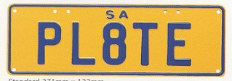 |  | 133 ± 1.0mm
 |  | Motor Vehicles and Trailers other than Motor Bikes |  | Motor Bikes
Height of figure or letter 1 to 6 letters |  | 77mm |  | 50mm
Width of every line in each figure or letter for 1 to 6 letters |  | 12mm |  | 6mm
Height or figure or letter 7 letters or 6 letters with space |  | 70-72mm |  | 50mm
Width of every line in each figure or letter for 7 letters or 6 letters  with space |  | 10-12mm |  | 6mm
The dimensions of a motor bike plate must be:
1 to 6 digits 215mm ± 1.0mm in length and 95mm ± 1.0mm in width.
7 digits 252mm ± 1.0mm in length and 98mm ± 1.0mm in width.
10.2 Slim Custom
 | 371 ± 1.0mm
Aluminium Embossed | 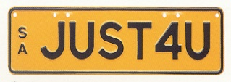 |  | 100 ± 1.0mm
 |  | Motor Vehicles other than Motor Bikes
Height of figure or letter |  | 54mm or 60mm
Width of every line in each figure or letter |  | 10mm
10.3 Square Two Line Custom
 | 306 ± 1.0mm
Aluminium Embossed |  |  | 150 ± 1.0mm
 |  | Motor Vehicles other than Motor Bikes
Height of figure or letter |  | 54mm or 60mm
Width of every line in each figure or letter |  | 10mm

10.4 Square Custom
 | 306 ± 1.0mm
Aluminium Embossed | 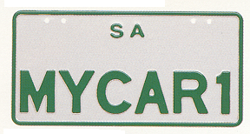 |  | 150 ± 1.0mm
 |  | Motor Vehicle other than Motor Bikes
Height of figure or letter |  | 54mm or 60mm
Width of every line in each figure or letter |  | 10mm
The dimensions of a motor bike plate must be:
1 to 6 digits 215mm ± 1.0mm in length and 95mm ± 1.0mm in width.
7 digits 252mm ± 1.0mm in length and 98mm ± 1.0mm in width.
10.5 Corporate Number Plates
Custom number plates in the corporate plate format may contain a background, logo and/or slogan or other promotional pictures or information deemed appropriate, in accordance with an agreement between the Registrar and the applicant. The plate must conform to the following specifications and design:
371mm + 1.0mm in length and 133mm + 1.0mm in height
Height of Figure or Letter | 60mm
Width of every line in each figure or letter | 10mm
Class 11—Taxi Plates
A taxi plate must be issued to taxis which are accredited by the Passenger Transport Act 1994 as general purpose metropolitan taxis, standby taxis or “special vehicle licence” vehicles (wheelchair accessible vehicle). The number is preceded by the letters ‘TAXI’ and the plate must conform to the following additional specifications and design:
11.1 Standard Taxi Plate
 | 371 ± 1.0mm
Steel/Aluminium Embossed | 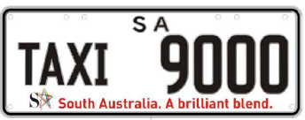 | 133 ± 1.0mm
Black Letters and Figures |  | White Retroreflective Background
Slogan: SA South Australia. A Brilliant Blend
(according to the copyright specifications of SA TOURISM COMMISSION)
 | Motor Vehicle
Height of figure  Height of letter | 70mm  51mm
Width of every line in each figure  Width of every line in each letter | 10mm  6mm
11.2 Standby/Access Taxi Plate
Standby taxi plates and “special vehicle licence” vehicle (wheelchair accessible vehicle) plates (accredited by the Passenger Transport Act 1994) may have letters “TAXI” displayed with white letters on a black background.
 | 371 ± 1.0mm
Steel/Aluminium Embossed |  | 133 ± 1.0mm
Black Figures  Retroreflective White Letters on a Black  60 x 120mm Background |  | White Retroreflective Background
Slogan: SA South Australia. A Brilliant Blend
(according to the copyright specifications of SA TOURISM COMMISSION)
 | Motor Vehicle
Height of figure  Height of letter | 70mm  51mm
Width of every line in each figure  Width of every line in each letter | 10mm  6mm

11.3 Taxi Licence Plate
 | 371 ± 1.0mm
Aluminium Embossed |  | 133 ± 1.0mm
White Retroreflective Letters and Figures |  | Blue Background
The piping shrike emblem will appear after the last letter and before the first number
Slogan: South Australia
 | Motor Vehicle
Height of figure  Height of letter | 70mm  51mm
Width of every line in each figure  Width of every line in each letter | 10mm  6mm
Class 12—Chauffeured Vehicle Plates
A Chauffeured Vehicle number plate must bear a number consisting of a combination of figures and letters and be issued to vehicles and bikes which are accredited to operate for hire under the Passenger Transport Act 1994. These plates must be of the type known as metal embossed and must conform to the following additional specifications and design:
12.1 Standard
 | 371 ± 1.0mm
Steel/Aluminium Embossed | 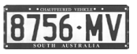 | 133 ± 1.0mm
Blue Letters and Figures |  | White Retroreflective Background
Blue Border with White Slogan: CHAUFFEURED VEHICLE (above plate number) and SOUTH AUSTRALIA (below plate number)
 | Motor Vehicles other than Motor Bikes
Height of figure or letter | 70-77mm
Width of every line in each figure or letter | 10-12mm
12.2 Square
 | 306 ± 1.0mm
Steel/Aluminium Embossed |  | 150 ± 1.0mm
Blue Letters and Figures |  | White Retroreflective Background
Blue Border with White Slogan: CHAUFFEURED VEHICLE (above plate number) and SOUTH AUSTRALIA (below plate number)
 | Motor Vehicles other than Motor Bikes
Height of figure or letter | 60mm
Width of every line in each figure or letter | 10mm
12.3 Motor Bike
 | 252 ± 1.0mm
Steel/Aluminium Embossed |  | 98 ± 1.0mm
Blue Letters and Figures |  | White Retroreflective Background
Blue Border with White Slogan: CHAUFFEURED VEHICLE (above plate number) and SOUTH AUSTRALIA (below plate number)
 | Motor Bikes
Height of figure or letter | 50mm
Width of every line in each figure or letter | 6mm
Class 13—Consular Corps Plates
Consular Corps number plates may only be issued to an accredited Diplomatic Officer or accredited Consular Officer de carriere, who is a national of a country which he or she represents and who resides in this State, or to an Honorary Consul accredited by the Department of Foreign Affairs and Trade, who also resides in this State. The plates must be of the type known as metal embossed and must conform to the following additional specifications and design:
 | 371 ± 1.0mm
Steel/Aluminium Embossed | 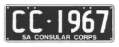 | 133 ± 1.0mm
White Letters and Figures |  | Black Background
Slogan White: SA CONSULAR CORPS
 | Motor Vehicles
Height of figure or letter | 77mm
Width of every line in each figure or letter | 12mm
Class 15—Premium Number Plates
A premium plate must bear a number consisting of two letters, three figures followed by a further letter and may be issued under an agreement between the Registrar and the applicant. The plate must be of the type known as metal embossed and must conform to the following additional specifications and design:
15.1 Front
 | 371 ± 1.0mm
Aluminium Embossed | 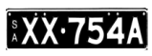  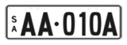 |  | 83 ± 1.0mm
Black Letters and Figures  OR  Retroreflective White Letters and Figures  OR  Opaque White Letters and Figures (discontinued) |  |  | White Retroreflective Background  OR  Black Background
 |  | Motor Vehicles other than Motor Bikes
Height of figure or letter |  | 53mm—54mm
Width of every line in each figure or letter |  | 8mm—10mm
15.1a Rear
 | 371 ± 1.0mm
Aluminium Embossed |  |  | 106 ± 1.0mm
Black Letters and Figures  OR  Retroreflective White Letters and Figures  OR  Opaque White Letters and Figures (discontinued) |  |  | White Retroreflective Background  OR  Black Background
 |  | Motor Vehicles other than Motor Bikes
Height of figure or letter |  | 70mm—75mm
Width of every line in each figure or letter |  | 10mm—12mm
15.2 Front
 | 371 ± 1.0mm
Aluminium Embossed | 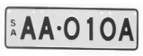 |  | 100 ± 1.0mm
Black Letters and Figures |  |  | White Retroreflective Background
 |  | Motor Vehicles other than Motor Bikes
Height of figure or letter |  | 60mm
Width of every line in each figure or letter |  | 10mm
15.2a Rear
 | 306 ± 1.0mm
Aluminium Embossed | 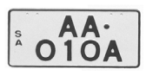 |  | 150 ± 1.0mm
Black Letters and Figures |  |  | White Retroreflective Background
 |  | Motor Vehicles other than Motor Bikes
Height of figure or letter |  | 60mm
Width of every line in each figure or letter |  | 10mm
15.3 Front and Rear Square
 | 306 ± 1.0mm
Aluminium Embossed |  |  | 150 ± 1.0mm
Black Letters and Figures |  |  | White Retroreflective Background
 |  | Motor Vehicles other than Motor Bikes
Height of figure or letter |  | 54-62mm
Width of every line in each figure or letter |  | 10mm
15.4 Corporate Number Plates
Premium number plates in the corporate plate format may contain a background, logo and/or slogan or other promotional pictures or information deemed appropriate, in accordance with an agreement between the Registrar and the applicant. The plate must conform to the following specifications and design:
371mm + 1.0mm in length and 133mm + 1.0mm in height
Height of figure or letter | 60mm
Width of every line in each figure or letter | 10mm
Class 16—Bike Rack Number Plates
A Bike Rack plate must bear the number allotted to the vehicle to which the bike rack is attached and must conform to the following additional specifications and design:
16.1 SA Better by Bike (discontinued)
 | 252 ± 1.0mm
Steel/Aluminium Embossed | 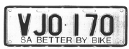 | 98 ± 1.0mm
Black Letters and Figures |  | White Retroreflective Background
Slogan: SA BETTER BY BIKE
Height of figure or letter | 50mm
Width of every line in each figure or letter | 6mm
16.2 SA Cycle instead
 | 252 ± 1.0mm
Steel/Aluminium Embossed | 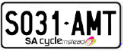 | 98 ± 1.0mm
Black Letters and Figures |  | White Retroreflective Background
Slogan: SA Cycle instead and logo, as endorsed by the Registrar
Height of figure or letter | 50mm
Width of every line in each figure or letter | 6mm
Class 17—Centenary of Federation Number Plates
17.1 Centenary Limited Series Number Plates
A limited series of number plates numbered 1901 CF-2001 CF, with the Centenary of Federation logo between the letters and figures, were issued to commemorate the Centenary of Federation. The plate is issued under an agreement between the Registrar and the applicant and must be of the type known as metal embossed and must conform to the following additional specifications and design:
Steel/Aluminium Embossed  White Letters and Figures | 371 ± 1.0mm
  133 ± 1.0mm
  Black Background
Grey watermark of Rotunda in background
Slogan White: SA—Centenary of Federation
Centenary of Federation Logo (between the numbers and the letters) according to the registered trademark owned by the Commonwealth.
 | Motor Vehicles
Height of figure or letter | 60mm
Width of every line in each figure or letter | 10mm
17.2 Centenary Vogue Series Number Plates
A limited series of number plates numbered 000C-999C and 000F-999F with the Centenary of Federation logo between the letters and figures, were issued to commemorate the Centenary of Federation. The plate is issued under an agreement between the Registrar and the applicant and must be of the type known as metal embossed and must conform to the following additional specifications and design:
 | 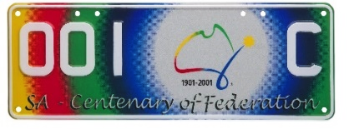  371 ± 1.0mm
  Steel/Aluminium Embossed
  White Letters and Figures
  133 ± 1.0mm
  Yellow, Red, Green, Blue Retroreflective Background
Slogan White: SA—Centenary of Federation
Centenary of Federation Logo (between the numbers and the letters) according to the registered trademark owned by the Commonwealth.
 | Motor Vehicles
Height of figure or letter | 60mm
Width of every line in each figure or letter | 10mm
Class 18—Country Taxi Plates
A Country Taxi Plate must be issued to taxis which have country taxi accreditation under the Passenger Transport Act 1994. The number is preceded by the letters ‘TAXI’ and the plate must conform to the following additional specifications and design:
 | 371 ± 1.0mm
Steel/Aluminium Embossed |  | 133 ± 1.0mm
Black Letters and Figures |  | Lemon Retroreflective Background
Slogan Red: SOUTH AUSTRALIA (above plate number)
COUNTRY TAXI (below plate number)
Black State Badge (Piping Shrike) (between the word TAXI and figures).
 | Motor Vehicles
Height of figure | 70mm
Height of letter | 50mm
Width of every line in each figure | 10mm
Width of every line in each letter | 6mm

Class 19—SA—Heavy Vehicle
A SA Heavy Vehicle Plate may be issued to a vehicle with a mass or GVM over 4.5 tonnes. The plate must be of the type known as metal embossed and must conform to the following additional specifications and design:
19.1 Standard
 | 371 ± 1.0mm
Aluminium Embossed | 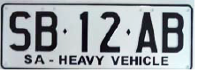 | 133 ± 1.0mm
Black Letters and Figures |  | White Retroreflective Background
Slogan Black: SA—HEAVY VEHICLE
 | Motor Vehicles
Height of figure or letter | 77mm
Width of every line in each figure or letter | 12mm
19.2 Trailer
A SA Heavy Trailer Plate may be issued to a vehicle with a mass or GTM over 4.5 tonnes. The plate must be of the type known as metal embossed and must conform to the following additional specifications and design:
 | 371 ± 1.0mm
Aluminium Embossed |  | 133 ± 1.0mm
Black Letters and Figures |  | White Retroreflective Background
Slogan Black: SA—HEAVY VEHICLE
 | Motor Vehicles
Height of figure or letter | 77mm
Width of every line in each figure or letter | 12mm
Class 20—Euro Number Plates
A Euro plate must bear a number consisting of the letter S followed by two letters, two figures followed by a further letter, with the State Coat of Arms of South Australia appearing between the letter S and the first two letters, and may be issued under an agreement between the Registrar and the applicant. The plate must be of the type known as metal embossed and must conform to the following additional specifications and design:
20.1 White Background Euro Plate
 | 522 ± 1.0mm
Steel/Aluminium Embossed |  | 113.6 ± 1.0mm
Black Letters and Figures  Logo—Sturt Desert Pea |  | White Retroreflective Background
Blue Sash on the left of the plate with the characters “SA” screen printed in white with the S printed directly above the A
The State Coat of Arms of South Australia (between the “S” and the first two letters) as endorsed by the Department of the Premier and Cabinet’s Protocol Branch.
 | Motor Vehicles
Height of figure or letter | 75.5mm
Width of every line in each figure or letter | 10mm

20.2 Black Background Euro Plate
 | 522 + 1.0mm
Steel/Aluminium  Embossed | 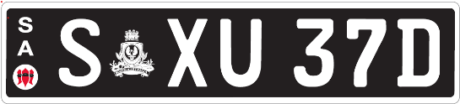 | 113.6 + 1.0mm
White Retroreflective  Letters and Figures  Logo—Sturt Desert Pea |  | Black  Background
On the left of the plate the characters “SA” screen printed in white with the S printed directly above the A
The State Coat of Arms of South Australia (white) (between the “S” and the first two letters) as endorsed by the Department of the Premier and Cabinet Protocol Branch.
 | Motor Vehicles
Height of figure or letter | 75.5mm
Width of every line in each figure or letter | 12mm
Class 21—National Heavy Vehicle Plate
A National Heavy Vehicle Plate may be issued to a vehicle with a mass or GVM over 4.5 tonnes. The plate must be of the type known as metal embossed and must conform to the following additional specifications and design:
21.1 Standard
 | 372 ± 1.0mm
Aluminium Embossed | 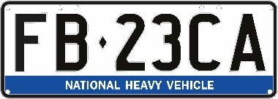 | 134 ± 1.0mm
Black Letters and Figures |  | White Retroreflective Background  Containing a Directional Security Mark (Kangaroo in circle)
Sash Colour Blue with White slogan and logo—National Heavy Vehicle
 | Motor Vehicles
Height of figure or letter | 77mm
Width of every line in each figure or letter | 12mm
21.2 Trailer
A Heavy Trailer Vehicle Plate may be issued to a vehicle with a mass or GTM over 4.5 tonnes. The plate must be of the type known as metal embossed and must conform to the following additional specifications and design
 | 372 ± 1.0mm
Aluminium Embossed |  | 134 ± 1.0mm
Black Letters and Figures |  | White Retroreflective Background  Containing a Directional Security Mark (Kangaroo in circle)
Sash Colour Blue with White slogan and logo—National Heavy Vehicle
 | Motor Vehicles
Height of figure or letter | 77mm
Width of every line in each figure or letter | 12mm
21.3 Bike Rack
A bike rack plate issued for a heavy vehicle or heavy trailer with a mass or GVM/GTM over 4.5 tonnes must bear the number allotted to the vehicle to which the bike rack is attached and must conform to the following additional specifications and design:
 | 254 ± 1.0mm
Aluminium Embossed |  | 100 ± 1.0mm
Black Letters and Figures |  | White Retroreflective Background
Sash Colour Blue with White slogan and logo—National Heavy Vehicle
 | Motor Vehicles
Height of figure or letter | 50mm
Width of every line in each figure or letter | 6mm

Class 22—Japanese Number Plates
A Japanese number plate may be issued under an agreement between the Registrar and the applicant.
The plate must be of the type known as metal embossed and must conform to the following additional specifications and design:
22.1 Standard
A Standard Japanese number plate consists of two numbers, followed by three letters.
The plate must be of the type known as metal embossed and must conform to the following additional specifications and design:
 | 330 ± 1.0mm
Aluminium Embossed | 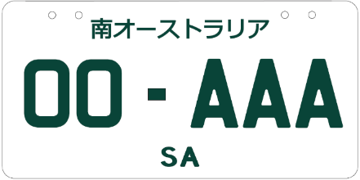 | 165 ± 1.0mm
Green Letters and Figures |  | White Retroreflective Background
Japanese text of ‘南オーストラリア’, meaning ‘South Australia’ located at the top of the number plate with ‘SA’ located in the bottom centre.
 | Motor Vehicles
Height of figure or letter | 58mm-60mm
Width of every line in each figure or letter | 8mm—10mm
22.2 Special Edition
A Special Edition Japanese number plate consists of up to two numbers, followed by three letters ‘JDM’.
The plate must be of the type known as metal embossed and must conform to the following additional specifications and design:
 | 330 ± 1.0mm
Aluminium Embossed | 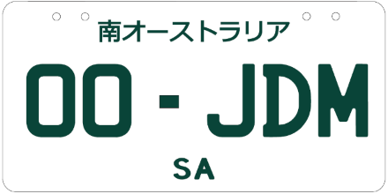 | 165 ± 1.0mm
Green Letters and Figures |  | White Retroreflective Background
Japanese text of ‘南オーストラリア’, meaning ‘South Australia’ located at the top of the number plate with ‘SA’ located in the bottom centre.
 | Motor Vehicles
Height of figure or letter | 58mm-60mm
Width of every line in each figure or letter | 8mm-10mm
22.3 Custom Japanese
A Custom Japanese number plate must bear a number nominated by an applicant and approved by the Registrar, which may consist of letters or a combination of letters and figures and issued under an agreement between the Registrar and the applicant authorising the applicant to display the number.
The plate must be of the type known as metal embossed and must conform to the following additional specifications and design:
Option | Letters and Figures (colour) |  | Background (colour)
1 | Black |  | Retroreflective White
2 | Blue |  | Retroreflective White
3 | Green |  | Retroreflective White
4 | Maroon |  | Retroreflective White
 |  | 330 ± 1.0mm
Aluminium Embossed |  | 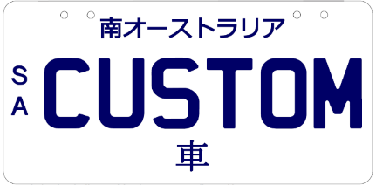 |  | 165 ± 1.0mm
Japanese text of ‘南オーストラリア’, meaning ‘South Australia’ located at the top of the number plate with ‘車’, meaning ‘car’, located in the bottom centre of the plate. ‘SA’ written vertically in the centre left of the number plate.
 | Motor Vehicles
Height of figure or letter | 58mm-60mm
Width of every line in each figure or letter | 8mm-10mm
Class 23—Motorsport Number Plates
23.1 Adelaide 500 Special Edition Series
A special edition Adelaide 500 series of number plates displaying the Adelaide 500 25-year anniversary logo before the SA, preceded by the number sequence 1ADL—25ADL. The plate is issued under an agreement between the Registrar and the applicant and must be of the type known as metal embossed and must conform to the following additional specifications and design:
 | 371 ± 1.0mm
Aluminium Embossed | 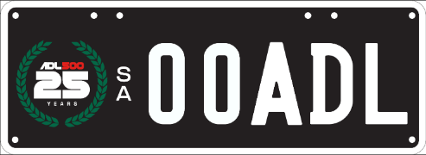 | 133 ± 1.0mm
White Letters and Figures. Adelaide 500 25th anniversary logo |  | Black Retroreflective Background
An Adelaide 500 25th anniversary logo in a green wreath is located to left of the number plate. ‘SA’ written vertically in the centre
 | Motor Vehicles
Height of figure or letter | 70mm
Width of every line in each figure or letter | 10mm
23.2 Adelaide Grand Final Set Series
A set series Adelaide Grand Final number plate must bear a number consisting of a letter followed by three figures, followed by a further letter and issued under an agreement between the Registrar and the applicant. -The plate must be of the type known as metal embossed and must conform to the following additional specifications and design:
 | 371 ± 1.0mm
Aluminium Embossed | 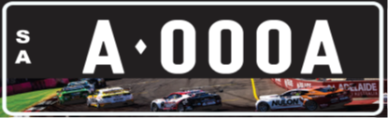 | 133 ± 1.0mm
White Retroreflective Letters & Figures. |  | Black Background
On the left of the plate the characters “SA” printed in white with the S printed directly above the A.
The banner depicting supercars racing on the Adelaide Street circuit is located on the bottom of the number plate.
 | Motor Vehicles
Height of figure or letter | 60mm
Width of every line in each figure or letter | 10mm
General Specifications and Design
1. The dimensions of the letters or words ‘SA’, ‘SOUTH AUSTRALIA’, ‘THE FESTIVAL STATE’ or any other slogan approved by the Registrar whether preceding the number or appearing in a central position above or below the registration number on which they are permitted, unless otherwise prescribed, must be as follows:
 | Motor Bikes  (except Class 12) | Motor Bikes  Class 12 | All Other Classes
Height of figure or letter | 10mm | 8mm | 8-20mm
Width of every line in all parts thereof | 2mm | 1-2mm | 1-3mm
(Except Corporate Number Plates which may vary at the discretion of the Registrar).
2. The dimensions of the State Badge (Piping Shrike) appearing on the number plates on which they are permitted, must be as follows:
 | Class 3 | Class 4 | Class 4 Motor Bike
Diameter | 24-30mm | 50mm | 27mm
3. The dimensions of the slogan “SA Cycle instead” appearing on the Bike Rack number plate must be as follows:
 | Class 16
Height of figure or letter | 13mm
Width of every line in all parts thereof | 2mm
4. A number plate will be taken to comply with the requirements of this notice relating to the size of the plate and the size of letters and figures on the plate if the size of the plate or of any figure or letter on the plate:
(a) does not exceed the size prescribed by this notice by more than 1.0mm; or
(b) is not more than 1.0mm less than the size prescribed by this notice.
5. Notwithstanding the prescribed design and specifications for number plates, a number plate (other than a trailer or bike rack plate) may bear a plate and/or label that complies with the relevant Australian Standard, if the vehicle to which the number plate is affixed, is equipped to be Electric, Hydrogen or uses LP Gas/Natural Gas (as detailed in the Road Traffic (Light Vehicle Standards) Rules 2018 or the Heavy Vehicle (Vehicle Standards) National Regulation (as applicable). However, the plate and label on the number plate must be placed in such a position so as not to obscure any letter, figure, logo or slogan appearing on the number plate.
Transitional Provision
A number plate that was manufactured before the date of this notice will be taken to comply with this notice if it complies with the notice under Section 47A of the Act published in the Gazette on 4 December 2025 (see Gazette No. 70, pages 4763-4783).
Schedule 3
Classes of Number Plates Which may be Displayed
Pursuant to an Agreement under Section 47A(4) of the Act
Class 1—Numeric
Class 2—Alpha Numeric (Non-slogan)
Class 3—Slogan
Class 4—Personalised
Class 5—Jubilee
Class 6—Australian Grand Prix
Class 9—Name Plates
Class 10—Custom
Class 15—Premium
Class 17—Centenary of Federation
Class 20—Euro
Class 22—Japanese
Class 23—Motorsport
Dated: 22 January 2026
Approved by
E. Kokar
Registrar of Motor Vehicles

National Parks and Wildlife Act 1972
Adoption of Management Plan
I, Lucy Hood, Minister for Climate, Environment and Water, (being the Minister of the Crown to whom the administration of the
National Parks and Wildlife Act 1972 is for the time being committed), pursuant to Section 38 of the National Parks and Wildlife Act 1972, hereby adopt the Deep Creek National Park, Talisker Conservation Park and small parks of the Southern Fleurieu Peninsula Management Plan.
Dated: 11 January 2026
Hon Lucy Hood MP
Minister for Climate, Environment and Water

Planning, Development and Infrastructure Act 2016
Section 76
Amendment to the Planning and Design Code
Preamble
It is necessary to amend the Planning and Design Code (the Code) in operation at 15 January 2026 (Version 2026.01) in order to make changes of form relating to the Code’s spatial layers and their relationship with land parcels. Note: There are no changes to the application of zone, subzone or overlay boundaries and their relationship with affected parcels or the intent of policy application as a result of this amendment.
1. Pursuant to Section 76 of the Planning, Development and Infrastructure Act 2016 (the Act), I hereby amend the Code in order to make changes of form (without altering the effect of underlying policy), correct errors and make operational amendments as follows:
(a) Undertake minor alterations to the geometry of the spatial layers and data in the Code to maintain the current relationship between the parcel boundaries and Code data as a result of the following:
(i) New plans of division deposited in the Land Titles Office between 7 January 2026 and 20 January 2026 affecting the following spatial and data layers in the Code:
A. Zones and subzones
B. Technical and Numeric Variations
• Building Heights (Levels)
• Building Heights (Metres)
• Concept Plan
• Gradient Minimum Frontage
• Minimum Dwelling Allotment Size
• Minimum Frontage
• Minimum Site Area
• Minimum Primary Street Setback
• Minimum Side Boundary Setback
• Future Local Road Widening Setback
C. Overlays
• Affordable Housing
• Character Area
• Character Preservation District
• Coastal Areas
• Dwelling Excision
• Environment and Food Production Area
• Future Road Widening
• Hazards (Bushfire—High Risk)
• Hazards (Bushfire—Medium Risk)
• Hazards (Bushfire—General Risk)
• Hazards (Bushfire—Urban Interface)
• Hazards (Bushfire—Regional)
• Hazards (Bushfire—Outback)
• Heritage Adjacency
• Limited land Division
• Local Heritage Place
• Noise and Air Emissions
• Regulated and Significant Tree
• Significant Interface Management
• Significant Retirement Facility and Supported Accommodation Sites
• State Heritage Place
• Stormwater Management
• Urban Tree Canopy
(b) In Part 13 of the Code—Table of Amendments, update the publication date, Code version number, amendment type and summary of amendments within the ‘Table of Planning and Design Code Amendments’ to reflect the amendments to the Code as described in this Notice.
2. Pursuant to Section 76(5)(a) of the Act, I further specify that the amendments to the Code as described in this Notice will take effect upon the date those amendments are published on the SA planning portal.
Dated: 28 January 2026
Brett Steiner
Director, Growth Planning
Department for Housing and Urban Development
Delegate of the Minister for Planning

PLANNING, DEVELOPMENT AND INFRASTRUCTURE ACT 2016
Section 78
Amendment to the Planning and Design Code
Preamble
It is necessary to amend the Planning and Design Code (the Code) in operation at 25 September 2025 (Version 2025.18) in the interests of the orderly and proper development of an area of the State, and in order to counter applications for undesirable development within the area affected by the Yankalilla District Local Heritage—Stage 1 (Delamere, Normanville, Yankalilla) Code Amendment (the Amendment).
- Pursuant to Section 78 of the Planning, Development and Infrastructure Act 2016 (the Act), I hereby declare that the Amendment will come into operation on an interim basis on the day it is published on the SA planning portal.
Dated: 21 November 2025
Nick Champion
Minister for Planning

Planning, Development and Infrastructure Act 2016
Section 78
Amendment to the Planning and Design Code
Preamble
It is necessary to amend the Planning and Design Code (the Code) in operation at 23 October 2025 (Version 2025.20) in the interests of the orderly and proper development of an area of the State, and in order to counter applications for undesirable development within the area affected by the Romalo House Complex—Heritage Code Amendment (the Amendment).
1. Pursuant to Section 78 of the Planning, Development and Infrastructure Act 2016 (the Act), I hereby declare that the Amendment will come into operation on an interim basis on the day it is published on the SA planning portal.
Dated: 21 November 2025
Nick Champion
Minister for Planning

Planning, Development and Infrastructure Act 2016
Section 78
Amendment to the Planning and Design Code
Preamble
It is necessary to amend the Planning and Design Code (the Code) in operation at 15 January 2026 (Version 2025.21) in the interests of the orderly and proper development of an area of the State, and in order to counter applications for undesirable development within the area affected by the Southwark Grounds Code Amendment (the Amendment).
1. Pursuant to Section 78 of the Planning, Development and Infrastructure Act 2016 (the Act), I hereby declare that the Amendment will come into operation on an interim basis on the day it is published in the Planning and Design Code on the SA planning portal.
Dated: 23 January 2026
Nick Champion
Minister for Planning

Return To Work Act 2014
Publication of Authority and Consent Form for the Employer and/or Return to Work Corporation of
South Australia to be Present at Examination or Treatment of Worker
Preamble
This Notice is given in accordance with the powers delegated to me, Michael Francis, Chief Executive Officer, by the Board of the
Return to Work Corporation of South Australia (‘the Corporation’) under an Instrument of Delegations dated 12 June 2025.
Section 17A of the Return to Work Act 2014 (‘the Act’) provides that a worker's employer or the Corporation must not be present while a worker is:
(a) being physically or clinically examined, or treated, by a health practitioner; or
(b) undergoing any diagnostic examination or test required for the purposes of the worker's treatment by a health practitioner
unless the worker gives written agreement to their presence in the designated form.
Section 4(15) of the Act provides that a reference in a provision of the Act to a designated form is a reference to a form designated for the purposes of that provision by the Corporation from time to time by notice in the Gazette.
Notice
Designated Form
Pursuant to Section 17A(2)(a) of the Act, I give notice that from the date of publication, the Authority and Consent Form for the Employer and/or Return to Work Corporation of South Australia to be Present at Examination or Treatment of Worker at Attachment 1 is the ‘form designated for the purposes of that provision by the Corporation’.
Confirmed as a true and accurate record of the decision of the Corporation.
Dated: 23 January 2026
Michael Francis
Chief Executive Officer


Attachment 1
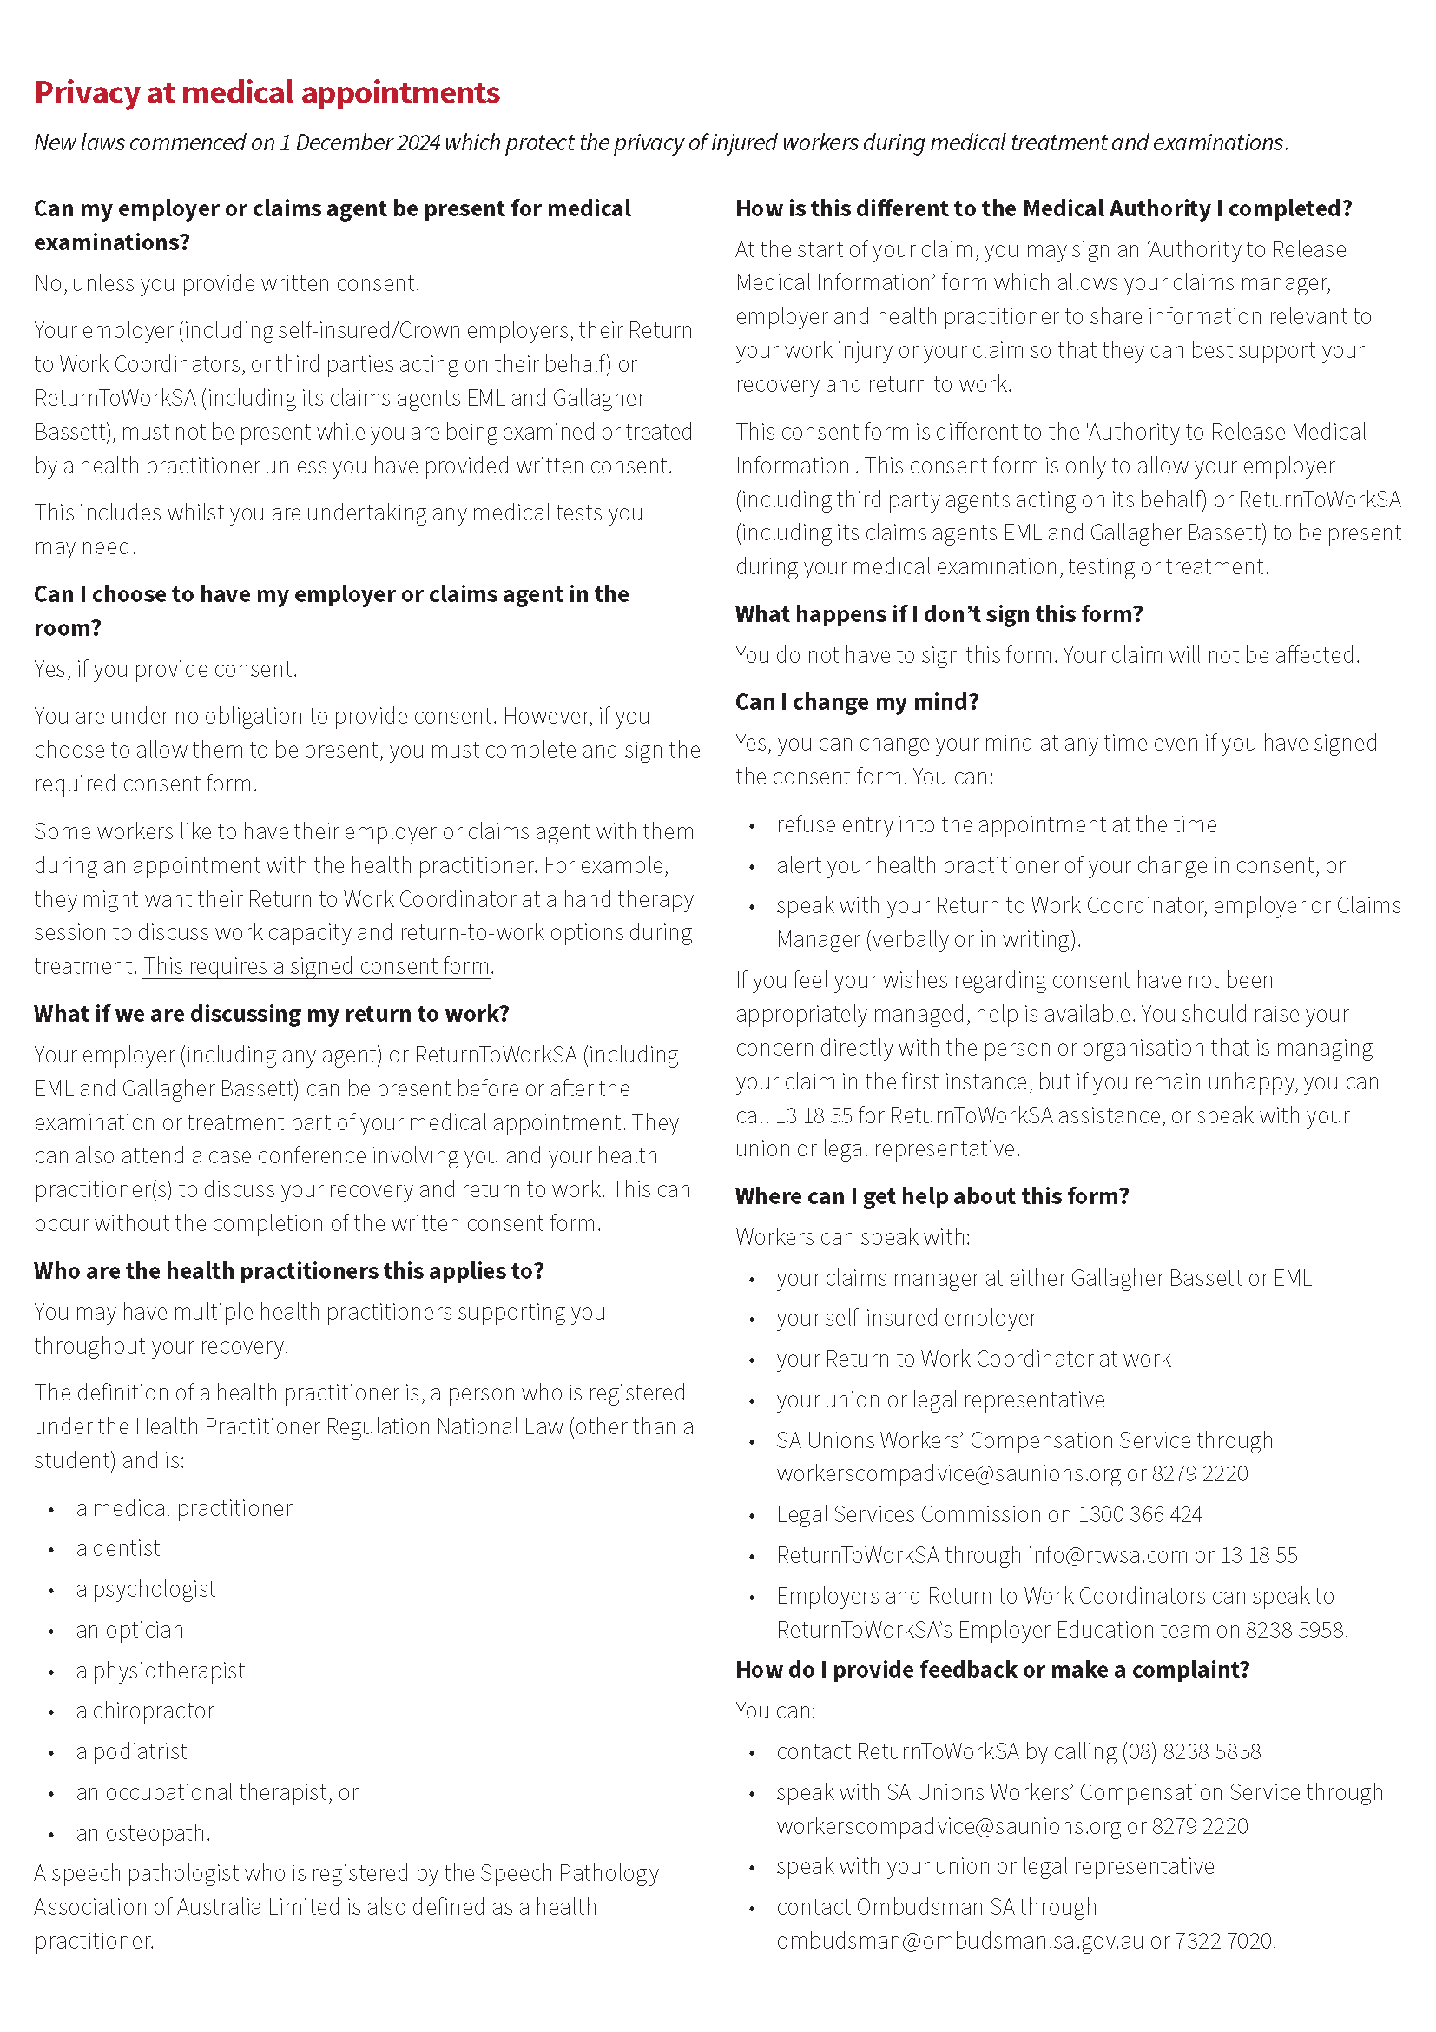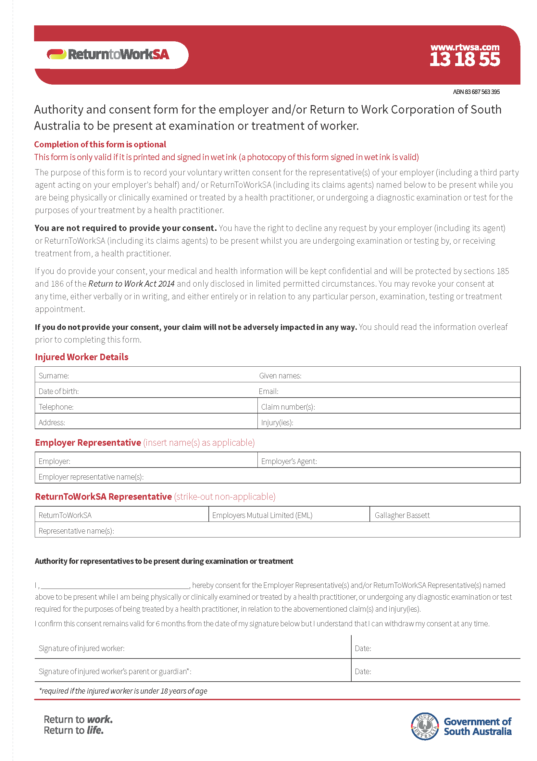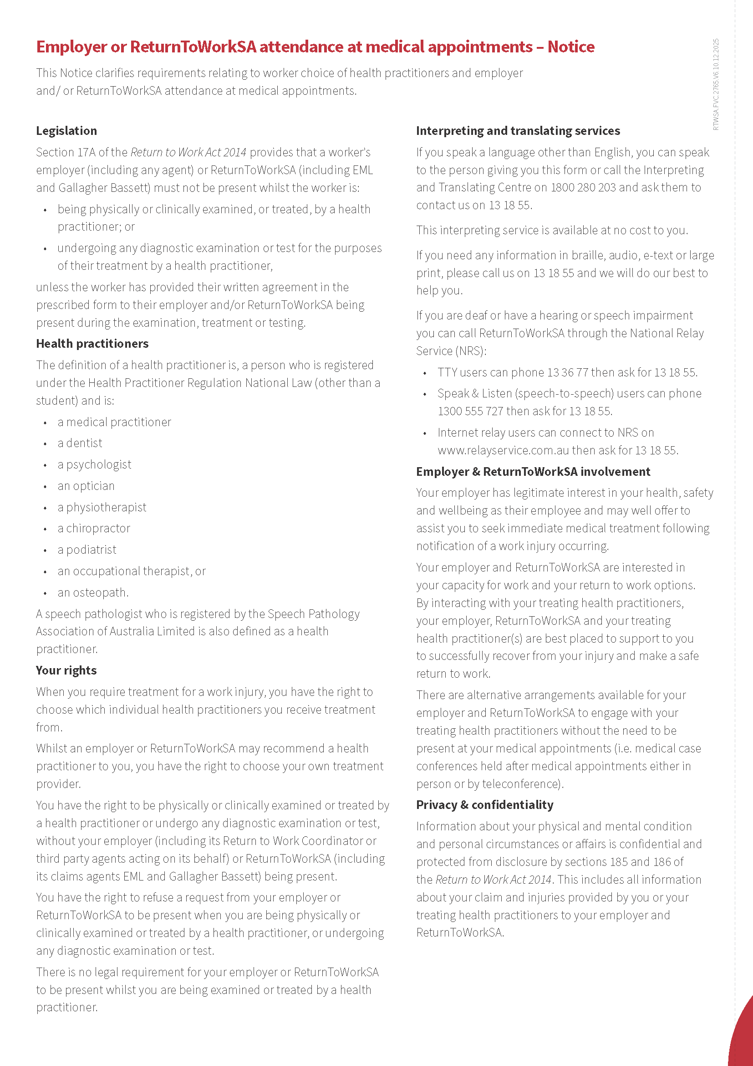

South Australian Skills Act 2008
Part 4—Apprenticeships, Traineeships and Training Contracts
Pursuant to the South Australian Skills Act 2008, the South Australian Skills Commission gives notice that the following qualifications and training contract conditions for Trades or Declared Vocations are archived and not currently active. An archived pathway may be reinstated upon application to the Commission, subject to standard assessment processes.
Occupational Title | Trade/ Declared Vocation | Qualification Code | Qualification Title | Nominal Term | Original Gazettal Date
Animal Attendant | DV | ACM30321 | Certificate III in Wildlife and Exhibited Animal Care | 24 months | 21/10/2021
Animal Attendant | DV | ACM40222 | Certificate IV in Animal Facility Management | 36 months | 11/8/2022
Animal Attendant | DV | ACM40322 | Certificate IV in Animal Behaviour and Training | 36 months | 8/9/2022
Animal Management Officer | DV | ACM40122 | Certificate IV in Animal Regulation and Management | 36 months | 11/8/2022
Aquaculture Farm Hand | DV | SFI40119 | Certificate IV in Aquaculture | 36 months | 11/7/2019
Aquaculture Technician | DV | SFI50119 | Diploma of Aquaculture | 48 months | 11/7/2019
Environment Worker | DV | AHC31522 | Certificate III in on Country Management | 36 months | 16/3/2023
Environment Worker | DV | AHC51222 | Diploma of Community Group Coordination and Facilitation | 48 months | 16/3/2023
Environment Worker | DV | AHC60422 | Advanced Diploma of Conservation and Ecosystem Management | 48 months | 16/2/2023
Farm Operation | DV | AHC10222 | Certificate I in Agriculture | 12 months | 16/3/2023
Farming | DV | AHC41616 | Certificate IV in Organic Farming | 24 months | 15/12/2016
Farming | DV | AHC51422 | Diploma of Agribusiness Management | 36 months | 1/9/2022
Farming | DV | AHC51816 | Diploma of Organic Farming | 24 months | 17/10/2017
Farming | DV | AHC60319 | Advanced Diploma of Agribusiness Management | 48 months | 8/10/2020
Forest Products Operators | DV | FWP20122 | Certificate II in Forest Operations | 12 months | 16/3/2023
Forest Products Operators | DV | FWP40121 | Certificate IV in Forest Operations | 36 months | 8/9/2022
Forest Products Operators | DV | FWP40222 | Certificate IV in Timber and  Wood Products Operations | 36 months | 16/3/2023
Forest Products Operators | DV | FWP50121 | Diploma of Forest Operations | 48 months | 8/9/2022
General Foods Processing | DV | FBP20122 | Certificate II in Food Processing | 18 months | 16/2/2023
Horticulture | DV | AHC50820 | Diploma of Nursery Management | 48 months | 11/2/2021
Racing Operations | DV | RGR50118 | Diploma of Racing (Racehorse Trainer) | 48 months | 15/11/2018
Clerical Processing  (Library Assistant) | DV | BSB30420 | Certificate III in Library and  Information Services | 12 months | 8/4/2021
Management | DV | BSB60520 | Advanced Diploma of Marketing  and Communication | 24 months | 8/4/2021
Entertainment Industry Worker | DV | CUA40920 | Certificate IV in Music | 24 months | 21/10/2021
Customer Servicing  (Financial Institutions) | DV | FNS20120 | Certificate II in Financial Services | 12 months | 21/10/2021
Customer Servicing  (Financial Institutions) | DV | FNS40122 | Certificate IV in Credit Management | 24 months | 23/6/2022
Customer Servicing  (Financial Institutions) | DV | FNS41521 | Certificate IV in Life Insurance | 36 months | 8/9/2022
Customer Servicing  (Financial Institutions) | DV | FNS41720 | Certificate IV in Insurance Broking | 24 months | 21/10/2021
Customer Servicing  (Financial Institutions) | DV | FNS42022 | Certificate IV in Banking Services | 24 months | 23/6/2022
Customer Servicing  (Financial Institutions) | DV | FNS42222 | Certificate IV in Personal Trust Administration | 24 months | 23/6/2022
Customer Servicing  (Financial Institutions) | DV | FNS50722 | Diploma of Superannuation | 36 months | 8/9/2022
Customer Servicing  (Financial Institutions) | DV | FNS50922 | Diploma of Banking Services Management | 36 months | 8/9/2022
Customer Servicing  (Financial Institutions) | DV | FNS51022 | Diploma of Financial Markets | 24 months | 23/6/2022
Customer Servicing  (Financial Institutions) | DV | FNS51120 | Diploma of General Insurance | 36 months | 21/10/2021
Customer Servicing  (Financial Institutions) | DV | FNS51522 | Diploma of Credit Management | 24 months | 23/6/2022
Customer Servicing  (Financial Institutions) | DV | FNS52022 | Diploma of Personal Trusts | 18 months | 23/6/2022
Customer Servicing  (Financial Institutions) | DV | FNS60222 | Advanced Diploma of Accounting | 48 months | 8/9/2022
Customer Servicing  (Financial Institutions) | DV | FNS60622 | Advanced Diploma of Banking Services Management | 48 months | 23/6/2022
Financial Services Officer | DV | FNS30420 | Certificate III in Mercantile Agents | 12 months | 21/10/2021
Financial Services Officer | DV | FNS40920 | Certificate IV in Superannuation | 12 months | 21/10/2021
Systems Security Administrator | DV | 22603VIC | Certificate IV in Cyber Security | 24 months | 1/1/2023
Telecommunications Installing | DV | ICT20319 | Certificate II in Telecommunications Technology | 12 months | 10/9/2020
Asset Maintenance | DV | CPP40919 | Certificate IV in Waste Management | 36 months | 24/12/2020
Carpentry and/or Joinery | T | CPC30120 | Certificate III in Shopfitting | 48 months | 11/2/2021
Coopering and Vatmaking | T | MSF30322 | Certificate III in Cabinet Making and Timber Technology | 48 months | 16/3/2023
Drilling | DV | RII32020 | Certificate III in Drilling Oil and Gas (Onshore) | 24 months | 10/12/2020
Extractive Industries Operator | DV | RII40320 | Certificate IV in Underground Metalliferous Mining Operations | 36 months | 1/4/2021
Extractive Industries Operator | DV | RII40520 | Certificate IV in Resource Processing | 36 months | 1/4/2021
Extractive Industries Operator | DV | RII50315 | Diploma of Minerals Processing | 36 months | 30/6/2016
Furniture Tradesperson | DV | MSF20322 | Certificate II in Cabinet Making and Timber Technology | 12 months | 16/3/2023
Gas Fitter | T | CPC32720 | Certificate III in Gas Fitting | 48 months | 11/2/2021
GIS Assistant | DV | CPP41721 | Certificate IV in Surveying and Spatial Information Services | 36 months | 11/2/2021
Plumbing Contractor | DV | CPC40920 | Certificate IV in Plumbing and Services | 48 months | 8/4/2021
Steel Fixer | DV | CPC31120 | Certificate III in Steelfixing | 24 months | 11/2/2021
Water Industry Operator | DV | NWP40120 | Certificate IV in Water Industry Operations | 42 months | 11/2/2021
Advanced Tradesperson (Hazardous Areas—Electrical) | T | UEE42622 | Certificate IV in Hazardous areas—Electrical | 24 months | 22/12/2022
Advanced Tradesperson (Industrial Electronics  and Control) | T | UEE40920 | Certificate IV in Industrial Electronics  and Control | 24 months | 10/12/2020
Engineering Technician | DV | UEE60220 | Advanced Diploma of Electronics and Communications Engineering | 48 months | 10/12/2020
Split Air-conditioning and  Heat Pump Systems Installer | DV | UEE20120 | Certificate II in Split Air Conditioning and Heat Pump Systems | 12 months | 10/12/2020
Disability Worker | DV | CHC43415 | Certificate IV in Leisure and Health | 24 months | 3/12/2015
Health Support Worker | DV | HLT23221 | Certificate II in Health Support Services | 12 months | 22/12/2022
Health Support Worker | DV | HLT31020 | Certificate III in Ambulance Communications (Call-taking) | 12 months | 8/4/2021
Health Support Worker | DV | HLT37415 | Certificate III in Pathology Assistance | 12 months | 3/12/2015
Mental Health  (Non Clinical Worker) | DV | CHC43415 | Certificate IV in Leisure and Health | 24 months | 3/12/2015
Outside School Hours Care (OSHC) | DV | 10983NAT | Certificate III in Outside School Hours Care | 24 months | 10/3/2022
Recreation Industry Worker | DV | SIS20122 | Certificate II in Sport and Recreation | 12 months | 16/3/2023
Recreation Industry Worker | DV | SIS20221 | Certificate II in Sport—Developing Athlete | 12 months | 2/12/2021
Recreation Industry Worker | DV | SIS20419 | Certificate II in Outdoor Recreation | 12 months | 14/11/2019
Recreation Industry Worker | DV | SIS30421 | Certificate III in Sport—Athlete | 12 months | 2/12/2021
Recreation Industry Worker | DV | SIS40122 | Certificate IV in Sport, Aquatics and Recreation | 18 months | 16/3/2023
Recreation Industry Worker | DV | SIS40321 | Certificate IV in Sport Coaching | 18 months | 2/12/2021
Recreation Industry Worker | DV | SIS40621 | Certificate IV in Outdoor Leadership | 24 months | 12/5/2022
Recreation Industry Worker | DV | SIS50122 | Diploma of Sport, Aquatics and Recreation Management | 24 months | 16/3/2023
Recreation Industry Worker | DV | SIS50421 | Diploma of Outdoor Leadership | 36 months | 12/5/2022
Aircraft Maintenance Worker (Mechanical Non Trade) | DV | MEA20418 | Certificate II in Aeroskills | 12 months | 27/9/2018
Automotive Air Conditioning Serviceperson | DV | AUR20220 | Certificate II in Automotive  Air Conditioning Technology | 12 months | 11/2/2021
Automotive Vehicle Serviceperson (Underbody) | DV | AUR21220 | Certificate II in Automotive Underbody Technology | 12 months | 4/3/2021
Carton Manufacture and Corrugating Operations | DV | ICP31320 | Certificate III in Print Binding, Finishing and Packaging | 48 months | 17/12/2020
Composites Tradesperson | T | MEM31119 | Certificate III in Engineering—  Composites Trade | 48 months | 11/7/2019
Diesel Engine Technician | T | AUR31520 | Certificate III in Automotive Diesel Engine Technology | 48 months | 11/2/2021
Engineering Tradesperson (Electrical/Electronics) | T | MEM30422 | Certificate III in Engineering—  Electronic Trade | 48 months | 16/3/2023
Existing Worker in a Trade or Declared Vocation | DV | MSS30322 | Certificate III in Competitive Systems  and Practices | 12 months | 16/3/2023
Existing Worker in a Trade or Declared Vocation | DV | MSS50322 | Diploma of Competitive Systems and Practices | 36 months | 16/3/2023
Leading Hand—Dry Cleaning | DV | MST30922 | Certificate III in Dry Cleaning Operations | 36 months | 16/2/2023
Silversmith | T | MEM31719 | Certificate III in Engineering—  Casting and Moulding Trade | 48 months | 24/12/2020
Clerical Processing  (Office Administration) | DV | PSP40122 | Certificate IV in Government | 24 months | 8/9/2022
Clerical Processing  (Office Administration) | DV | PSP60122 | Advanced Diploma of Government | 48 months | 8/9/2022
Emergency Communications Centre Operator | DV | PUA30822 | Certificate III in Public Safety (Emergency Communications Centre Operations) | 12 months | 22/12/2022
Firefighter and Emergency Operator | DV | PUA20622 | Certificate II in Public Safety (Firefighting and Emergency Operations) | 12 months | 22/12/2022
Firefighting Supervisor | DV | PUA40319 | Certificate IV in Public Safety (Firefighting Supervision) | 48 months | 8/8/2019
Management | DV | PSP60616 | Advanced Diploma of Procurement and Contracting | 48 months | 2/3/2017
Local Government Officer | DV | LGA20120 | Certificate II in Local Government | 12 months | 21/10/2021
Clerical Processing  (Office Administration) | DV | PSP30122 | Certificate III in Government | 12 months | 8/9/2022
Food and Beverage Attendant | DV | SIT20322 | Certificate II in Hospitality | 12 months | 23/6/2022
Guest Services Attendant | DV | SIT20322 | Certificate II in Hospitality | 12 months | 23/6/2022
Tourism Sales Consultant | DV | SIT30122 | Certificate III in Tourism | 24 months | 10/11/2022
Wholesale Tour Operator | DV | SIT30222 | Certificate III in Travel | 24 months | 23/6/2022
Aircraft Refueller | DV | AVI30319 | Certificate III in Aviation  (Ground Operations and Service) | 24 months | 12/8/2020
Airport Reporting Officer | DV | AVI30319 | Certificate III in Aviation  (Ground Operations and Service) | 24 months | 28/11/2019
Export Airfreight Operator | DV | AVI30319 | Certificate III in Aviation  (Ground Operations and Service) | 24 months | 28/11/2019
Rail Transport (Civil Infrastructure) | DV | TLI21921 | Certificate II in Track Protection | 12 months | 24/2/2022
Rail Transport (Civil Infrastructure) | DV | TLI27121 | Certificate II in Rail Infrastructure | 12 months | 24/2/2022
Rail Transport (Civil Infrastructure) | DV | TLI31921 | Certificate III in Mechanical Rail Signalling | 24 months | 24/2/2022
Rail Transport (Civil Infrastructure) | DV | TLI32121 | Certificate III in Rail Structures | 18 months | 24/2/2022
Rail Transport (Civil Infrastructure) | DV | TLI32721 | Certificate III in Track Protection | 18 months | 24/2/2022
Rail Transport (Civil Infrastructure) | DV | TLI32821 | Certificate III in Rail Operations | 18 months | 24/2/2022
Rail Transport (Civil Infrastructure) | DV | TLI37122 | Certificate III in Rail Infrastructure | 18 months | 11/8/2022
Rail Transport (Civil Infrastructure) | DV | TLI40921 | Certificate IV in Rail Network Control | 24 months | 24/2/2022
Rail Transport (Civil Infrastructure) | DV | TLI47121 | Certificate IV in Rail Infrastructure | 24 months | 24/2/2022
Rail Transport (Train Operations) | DV | TLI30521 | Certificate III in Passenger Train Guard | 18 months | 24/2/2022
Rail Transport (Train Operations) | DV | TLI31421 | Certificate III in Light Rail Driving | 18 months | 24/2/2022
Rail Transport (Train Operations) | DV | TLI33122 | Certificate III in Rail Customer Service | 24 months | 22/12/2022
Road Transport Operator | DV | TLI21221 | Certificate II in Driving Operations | 12 months | 24/2/2022
Road Transport Operator | DV | TLI22421 | Certificate II in Furniture Removal | 12 months | 24/2/2022
Dated: 29 January 2026
Commissioner Cameron Baker
Chair of the South Australian Skills Commission

Local Government Instruments

City Of Holdfast Bay
Resignation of Councillor
Notice is hereby given in accordance with Section 54(6) of the Local Government Act 1999, that a vacancy has occurred due to the resignation of Councillor Annette Bradshaw, effective 20 January 2026.
Dated: 29 January 2026
Pamela Jackson
Chief Executive Officer

City Of Mount Gambier
Application of Local Government Land By-law 2025, Dogs By-law 2025 and Cats By-law 2025
Pursuant to Section 246(4a) of the Local Government Act 1999 (the Act), notice is hereby given that at its meeting on 16 December 2025 and pursuant to the power contained in Section 246(3)(e) of the Act, the City of Mount Gambier (the Council) made resolutions to apply certain provisions of the Local Government Land By-law No. 2 of 2025 (the Land By-law) and Dogs By-law No. 5 of 2025 (the Dogs By-law) to land in the Council’s area.
More specifically, the Council has resolved:
1. for the purposes of Clause 7.2 of the Land By-law, a fee as described in the Council's Schedule of Fees and Charges from time to time will apply to the portion of Local Government land located at 26 Chute Street, Mount Gambier which comprises the fenced area of Engelbrecht Cave;
2. for the purposes of Clause 9.11.2.1 of the Land By-law, that a boat may be launched and retrieved without permission from the Council from or on to the boat ramps located at Section 591, Hundred of Blanche (Valley Lake, Lot 100, Bay Road, Mount Gambier) in accordance with any conditions specified on a sign displayed on or in the vicinity of the boat ramp;
3. for the purposes of Clause 9.15.2.2 of the Land By-law, that the portions of the Blue Lake Caravan Park identified in the plan contained in Annexure A of the By-law Review report (Item 19.6) accompanying the Council Agenda of 16 December 2025 (the Report) are designated camping areas where camping may occur without the permission of the Council in accordance with any conditions specified on a sign displayed on or in the vicinity of the area;
4. for the purposes of Clause 9.26.5 of the Land By-law, that golf may be played or practised without permission of the Council on the Local Government land comprising the portions of The Blue Lake Golf Club identified in the plan contained in Annexure A of the Report in accordance with any conditions specified on a sign displayed on or in the vicinity of that land;
5. for the purposes of Clause 9.1 of the Dogs By-law, the Local Government land or public places listed below and as shown on the maps identified in Annexure A of the Report, are locations where dogs are required to be on-leash at all times:
(a) Mount Gambier Rail Trail;
(b) Engelbrecht Cave, located at 26 Chute Street, Mount Gambier;
(c) Vansittart Park, located at 104 Commercial Street West, Mount Gambier (and not extending to the playground areas where dogs are prohibited under Clause 10.1 of the By-law);
(d) Lady Nelson Reserve, located at 35 Jubilee Highway East, Mount Gambier;
(e) Valley Lake/Ketla Malpi, located at Allotment 100 Bay Road, Mount Gambier, (and not extending to the playground areas where dogs are prohibited under Clause 10.1 of the By-law);
(f) Olympic Park, located at 7 Margaret Street, Mount Gambier;
(g) Cave Gardens/Thugi, located at 38 Commercial Street East, Mount Gambier; and
(h) Umpherston Sinkhole/Balumbul, located at 160 Jubilee Highway East, Mount Gambier.
6. For the purposes of Clause 10.2 of the Dogs By-law, a person is prohibited from taking a dog into, or allowing a dog to remain, at the following locations:
(a) all playing surfaces at Blue Lake Sports Park, located at 200 Jubilee Highway East, Mount Gambier and as shown on the maps identified in Annexure A of the Report; and
(b) the inside of all buildings owned by or containing facilities operated by the Council.
7. Pursuant to Clause 7.1 of By-law No. 6—Cats 2025 the Council hereby grants permission to all residents of the City of Mount Gambier to keep, cause, or suffer or permit to be kept, up to three (3) cats on any premises.
Further, the Council also gives notice that at its meeting on 16 December 2025, it resolved to apply the Cats By-law No. 6 of 2025 (the Cats By-law) as follows:
1. for the purposes of Clause 7.1 of the Cats By-law, to grant permission to all residents of the City of Mount Gambier to keep, cause, or suffer or permit to be kept, up to three (3) cats on any premises;
2. for the purposes of Clause 10 of the Cats By-law:
(a) to adopt a registration scheme for cats effective from 1 July 2026, from which date a person who keeps a cat in the Council’s area for more than 14 days must ensure the cat is registered in accordance with Clause 10 of the Cats By-law 2025; and
(b) that a registration fee for the keeping of a cat as described in Council's Schedule of Fees and Charges from time to time will apply.
Further information regarding the Council’s By-laws, including the plans contained in Annexure A as referred to above, is available on the Council’s website and at the Council’s offices during business hours.
Dated: 29 January 2026
Paul Simpson
Chief Executive Officer
City of Mount Gambier

City Of Norwood Payneham & St Peters
AMENDMENT BY-LAW 2026
By-law No. 8 of 2026
A By-law to amend the Council’s Local Government Land By-Law 2025 and Waste Management By-law 2025 to amend typographic errors
PART 1 – PRELIMINARY

1. Title
This By-law may be cited as the ‘Amendment By-law 2026’ and is By-law No. 8 of City of Norwood Payneham & St Peters.

2. Authorising Law
This By-law is made under sections 246 and 249 of the Act.

3. Purpose
The objective of this By-law is to make a minor amendment, as requested by the Legislative Review Committee and as set out in Part 2, to each of the LGL By-law and to the Waste Management By-law to correct typographic errors.

4. Commencement, Revocation and Expiry

4.1 Pursuant to section 249(6)(d) of the Act this By-law will take effect on the date that is it published in the Government Gazette.

4.2 This By-law will expire on 1 January 2033.

5. Interpretation
In this By-law, unless the contrary intention appears:

5.1 Act means the Local Government Act 1999;

5.2 Council means the City of Norwood Payneham & St Peters;

5.3 LGL By-law means the Local Government Land By-law 2025 made by the Council on 4 August 2025 and published in the Government Gazette on 14 August 2025; and

5.4 Waste Management By-law means the Waste Management By-law of 2025 made by the Council on 4 August 2025 and published in the Government Gazette on 14 August 2025; and
PART 2 – AMENDMENT TO BY-LAWS

6. Amendment to LGL By-law
As and from the date that this By-law takes effect, subclause 9.5.1 of the LGL By-law is deleted and substituted with the following:
9.5.1 Cause or allow an animal to stray onto, move over, graze or be left unattended except on any Local Government land to which the Council has resolved this clause applies and provided that the animal or animals are under effective control.

7. Amendment to Waste Management By-law
As and from the date that this By-law takes effect, subclause 10.8 of the LGL By-law is deleted and substituted with the following:

10.8 Removal of container
not, without a reasonable excuse (as determined by an authorised person acting reasonably), fail to remove all waste containers from the road on the same day as the collection of waste has occurred;
This By-law was duly made and passed at a meeting of the City of Norwood Payneham & St Peters held on 20 January 2026 by an absolute majority of the members for the time being constituting the Council, there being at least two thirds of the members present.
Mario Barone
Chief Executive Officer

City Of Onkaparinga
Roads (Opening and Closing) Act 1991
Road Closing—Peel Creek Drive, Old Reynella
Notice is hereby given, pursuant to Section 10 of the Roads (Opening and Closing) Act 1991 that the City of Onkaparinga proposes to make a Road Process Order to close and merge with allotment 1001 in D135407 the whole of Peel Creek Drive (allotment 706 in D129786), more particularly delineated and lettered ‘A’ on Preliminary Plan 26/0001.
The Preliminary Plan is available for public inspection at the office of the City of Onkaparinga, Ramsay Place Noarlunga Centre, and the Adelaide Office of the Surveyor-General located at Level 10, 83 Pirie Street Adelaide, during normal office hours. The Preliminary Plan can also be viewed at www.sa.gov.au/roadsactproposals.
Any application for easement or objection must set out the full name, address and details of the submission and must be fully supported by reasons. The application for easement or objection must be made in writing to the City of Onkaparinga, PO Box 1 Noarlunga Centre SA 5168, within 28 days of this notice and a copy must be forwarded to the Surveyor-General at GPO Box 1815, Adelaide 5001. Where a submission is made, the applicant must be prepared to support their submission in person upon council giving notification of a meeting at which the matter will be considered.
Dated: 29 January 2026
Jani Baker
Acting Chief Executive Officer

City Of Playford
Local Government Act 1999
Vacancy in the Office of Member of Council
Notice is given in accordance with Section 54(6) of the Local Government Act 1999 (SA) that a vacancy has occurred in the office of ward councillor for Ward 4, formerly occupied by Katrina Tarr, became vacant by operation of Section 54(1)(b) of the Local Government Act 1999 on 21 January 2026.
Dated: 22 January 2026
Sam Green
Chief Executive Officer

City Of Port Adelaide Enfield
Local Government Act 1999
Change of Name of Public Place
Notice is hereby given that the Council of the City of Port Adelaide Enfield, at its meeting held on 11 November 2025, resolved pursuant to Section 219(1) of the Local Government Act 1999 that Allotment 580 and 581 in Deposited Plan 90277 and Allotment (Reserve) 295 Deposited Plan 3507, known as “Blair Athol Reserve”, be renamed to “Carol Martin Reserve”.
Dated: 29 January 2026
M. Withers
Chief Executive Officer

Kangaroo Island Council
Local Government Act 1999
Adoption of Amended Community Land Management Plan
Notice is hereby given pursuant to Section 192(4) and 198(4) of the Local Government Act 1999, that the Kangaroo Island Council at its ordinary council meeting held on the 20 January 2026, resolved to assume care and control of the following parcels and amend its Community Land Management Plan:
• Section 521, Hog Bay Road, Brown Beach in Plan HP110200, Hundred of Dudley CR5766/870
• Section 522, Hog Bay Road, Brown Beach in Plan HP110200, Hundred of Dudley CR5766/871
A copy of the Council Lands Management Plan incorporating all the above amendment may now be viewed by visiting Council’s website www.kangarooisland.sa.gov.au.
Dated: 21 January 2026
D. Buckingham
Chief Executive Officer

District Council Of Yankalilla
Roads (Opening and Closing) Act 1991
Road Closing—Unmade Public Road near Sampson Road, Myponga Beach
Notice is hereby given, pursuant to Section 10 of the Roads (Opening and Closing) Act 1991, that the District Council of Yankalilla proposes to make a Road Process Order to close and merge with Pieces 47 and 48 of D56120 in the Hundred of Myponga the whole of the public road between Pieces 47 and 48 of D56120 delineated and lettered “B” on preliminary plan PP25/0030.
A copy of the preliminary plan and a statement of persons affected are available for public inspection at the offices of the District Council of Yankalilla at 1 Charles Street, Yankalilla and the Adelaide Office of the Surveyor-General during normal office hours. The Preliminary Plan can also be viewed at www.sa.gov.au/roadsactproposals.
Any application for easement or objection must set out the full name, address and details of the submission and must be fully supported by reasons. The application for easement or objection must be made in writing to the District Council of Yankalilla at PO Box 9, Yankalilla SA 5203
within 28 days of this notice and a copy must be forwarded to the Surveyor-General at GPO Box 1815, Adelaide 5001. Where a submission is made, the applicant must be prepared to support their submission in person upon council giving notification of a meeting at which the matter will be considered.
Dated: 29 January 2026
Nathan Cunningham
Chief Executive Officer

Public Notices

National Electricity Law
Notice of Consolidation
Notice of Draft Determination
The Australian Energy Market Commission (AEMC) gives notice under the National Electricity Law as follows:
Under s 93(1)(a), the rule change requests for ERC0356 and ERC0374 have been consolidated. The consolidated request is named Calculating the cumulative price (Ref. ERC0356).
Under s 99, the making of a draft determination and related draft rule on the Calculating the cumulative price proposal (Ref. ERC0356). Written requests for a pre-determination hearing must be received by 5 February 2026. Submissions must be received by 12 March 2026.
Submissions can be made via the AEMC’s website. Before making a submission, please review the AEMC’s privacy statement on its website, and consider the AEMC’s Tips for making a submission. The AEMC publishes all submissions on its website, subject to confidentiality.
Written requests should be sent to submissions@aemc.gov.au and cite the reference in the title. Before sending a request, please review the AEMC’s privacy statement on its website.
Documents referred to above are available on the AEMC’s website and are available for inspection at the AEMC’s office.
Australian Energy Market Commission
Level 15, 60 Castlereagh St
Sydney NSW 2000
Telephone: (02) 8296 7800
www.aemc.gov.au
Dated: 29 January 2026

National Gas Law
Notice of Initiation
The Australian Energy Market Commission (AEMC) gives notice under the National Gas Law as follows:
Under s 303, The Honourable Chris Bowen MP, Minister for Climate Change and Energy has requested the Gas cyber security roles and responsibilities for AEMO (Ref. GRC0091) proposal. The proposal seeks to embed and formalise AEMO’s roles and responsibilities in cyber security uplift and preparedness for the gas sector. Submissions must be received by 26 February 2026.
Submissions can be made via the AEMC’s website. Before making a submission, please review the AEMC’s privacy statement on its website, and consider the AEMC’s Tips for making a submission. The AEMC publishes all submissions on its website, subject to confidentiality.
Documents referred to above are available on the AEMC’s website and are available for inspection at the AEMC’s office.
Australian Energy Market Commission
Level 15, 60 Castlereagh St
Sydney NSW 2000
Telephone: (02) 8296 7800
www.aemc.gov.au
Dated: 29 January 2026

Notice Submission

The South Australian Government Gazette is published each Thursday afternoon.
Notices must be emailed by 4 p.m. Tuesday, the week of publication.
Submissions are formatted per the gazette style and a proof will be supplied prior to publication, along with a quote if applicable. Please allow one day for processing notices.
Alterations to the proof must be returned by 4 p.m. Wednesday.

Gazette notices must be submitted as Word files, in the following format:
• Title—the governing legislation
• Subtitle—a summary of the notice content
• Body—structured text, which can include numbered lists, tables, and images
• Date—day, month, and year of authorisation
• Signature block—name, role, and department/organisation authorising the notice

Please provide the following information in your email:
• Date of intended publication
• Contact details of the person responsible for the notice content
• Name and organisation to be charged for the publication—Local Council and Public notices only
• Purchase order, if required—Local Council and Public notices only

Email: governmentgazettesa@sa.gov.au
Phone: (08) 7133 3552
Website: www.governmentgazette.sa.gov.au

All instruments appearing in this gazette are to be considered official, and obeyed as such

Printed and published weekly by authority of T. Foresto, Government Printer, South Australia
$9.50 per issue (plus postage), $479.00 per annual subscription—GST inclusive
Online publications: www.governmentgazette.sa.gov.au

