
No. 39 p. 2151
THE SOUTH AUSTRALIAN
GOVERNMENT GAZETTE
Published by Authority

Adelaide, Thursday, 2 July 2026

Contents

Governor’s Instruments
Acts 2152
Appointments, Resignations and General Matters 2152
Regulations—
Road Traffic (Miscellaneous) (GDA2020)
Amendment Regulations 2026—No. 45 of 2026 2153
State Government Instruments
Ageing and Adult Safeguarding Act 1995 2154
Dangerous Substances Act 1979 2154
Education and Children’s Services Regulations 2020 2155
Essential Services Commission Act 2002 2155
Fisheries Management (Prawn Fisheries) Regulations 2017 2156
Housing Improvement Act 2016 2156
Land Acquisition Act 1969 2156
Landscape South Australia Act 2019 2158
Liquor Licensing Act 1997 2162
Mental Health Act 2009 2162
Outback Communities (Administration and
Management) Act 2009 2162
Pastoral Land Management and Conservation Act 1989 2163
Planning, Development and Infrastructure Act 2016 2164
Professional Standards Act 2004 2171
TAFE SA Act 2025 2175
Local Government Instruments
City of Burnside 2181
City of Holdfast Bay 2181
City of Marion 2181
City of Mount Gambier 2182
City of Onkaparinga 2182
City of Playford 2183
City of Port Lincoln 2183
City of Prospect 2183
City of Salisbury 2184
City of Unley 2185
City of Whyalla 2185
Town of Gawler 2186
Light Regional Council 2189
Lower Eyre Council 2191
District Council of Loxton Waikerie 2191
Municipal Council of Roxby Downs 2192
District Council of Streaky Bay 2193
Tatiara District Council 2195
Yorke Peninsula Council 2196

Governor’s Instruments

Acts
Department of the Premier and Cabinet
Adelaide, 2 July 2026
Her Excellency the Governor directs it to be notified for general information that she has in the name and on behalf of His Majesty The King, this day assented to the undermentioned Bills passed by the Legislative Council and House of Assembly in Parliament assembled, viz.:
No. 6 of 2026—Local Government (Elections) (Periodic Elections) Amendment Bill 2026
An Act to amend the Local Government (Elections) Act 1999 and to make related amendments to the Local Government Act 1999
No. 7 of 2026—Return to Work (Presumptive Firefighter Injuries) Amendment Bill 2026
An Act to amend the Return to Work Act 2014
By command,
Rhiannon Kate Pearce, MP
For Premier

Appointments, Resignations And General Matters
Department of the Premier and Cabinet
Adelaide, 2 July 2026
Her Excellency the Governor in Executive Council has been pleased to appoint the Honourable Rhiannon Kate Pearce, MP as Acting Minister for Infrastructure and Transport from 6 July 2026 until 26 July 2026 inclusive, during the absence of the Honourable Joseph Karl Szakacs, MP.
By command,
Rhiannon Kate Pearce, MP
For Premier
DPC26/026CS

Department of the Premier and Cabinet
Adelaide, 2 July 2026
Her Excellency the Governor in Executive Council has been pleased to appoint Christian Haebich as a Magistrates Court Judicial Registrar for a term of seven years commencing on 6 July 2026 and expiring on 5 July 2033 - pursuant to section 7AB of the Magistrates Court Act 1991.
By command,
Rhiannon Kate Pearce, MP
For Premier
AGOO0040-26CS

Department of the Premier and Cabinet
Adelaide, 2 July 2026
Her Excellency the Governor in Executive Council has been pleased to appoint Phuong My Chau as the Commissioner of the Lotteries Commission of South Australia for a term commencing on 3 July 2026 and expiring on 26 May 2028, or whenever she ceases to hold an executive level position in the Department of Treasury and Finance, whichever is the earlier - pursuant to the provisions of the State Lotteries Act 1966.
By command,
Rhiannon Kate Pearce, MP
For Premier
T&F26/0016CS

Department of the Premier and Cabinet
Adelaide, 2 July 2026
Her Excellency the Governor in Executive Council has been pleased to appoint Lisa Kate Teburea, John Alan Stimson and David Andrew O’Loughlin as members of the State Planning Commission for three years commencing on 3 July 2026 and expiring on
2 July 2029 - pursuant to the Planning, Development and Infrastructure Act 2016.
By command,
Rhiannon Kate Pearce, MP
For Premier
26MPCS10276

Regulations
South Australia

Road Traffic (Miscellaneous) (GDA2020) Amendment Regulations 2026
under the Road Traffic Act 1961

Contents
Part 1—Preliminary
1 Short title
2 Commencement
Part 2—Amendment of Road Traffic (Miscellaneous) Regulations 2014
3 Amendment of regulation 3—Interpretation

Part 1—Preliminary
1—Short title
These regulations may be cited as the Road Traffic (Miscellaneous) (GDA2020) Amendment Regulations 2026.
2—Commencement
These regulations come into operation on the day on which they are made.
Part 2—Amendment of Road Traffic (Miscellaneous) Regulations 2014
3—Amendment of regulation 3—Interpretation
Regulation 3(1), definition of GDA2020—delete the definition and substitute:
GDA2020 means the Geocentric Datum of Australia 2020 as defined in the determination under section 8A of the National Measurement Act 1960 of the Commonwealth for the recognised-value standard of measurement of position;
Editorial note—
As required by section 10AA(2) of the Legislative Instruments Act 1978, the Minister has certified that, in the Minister's opinion, it is necessary or appropriate that these regulations come into operation as set out in these regulations.
Made by the Governor
with the advice and consent of the Executive Council
on 2 July 2026
No 45 of 2026

State Government Instruments

Ageing And Adult Safeguarding Act 1995
Notice of Adult Safeguarding Unit Charter of Rights
and Freedoms by the Minister for Human Services
Pursuant to Section 20(5)(a) of the Ageing and Adult Safeguarding Act 1995, I, Katrine Hildyard, the Minister for Human Services, revoke the Charter of Rights and Freedoms of Vulnerable Adults published by the former Minister for Health and Wellbeing on 12 September 2019 and publish the Adult Safeguarding Unit Charter of Rights and Freedoms.
Pursuant to Section 20(5)(b) of the Act, the Adult Safeguarding Unit Charter of Rights and Freedoms document is available at the following webpage: https://dhs.sa.gov.au/how-we-help/ageing-well/support-for-adult-safety-and-wellbeing/about-the-adult-safeguarding-unit.
Dated: 29 June 2026
Hon Katrine Hildyard MP
Minister for Human Services

Ageing and Adult Safeguarding Act 1995
Notice of Code of Practice by the Minister for Human Services
Pursuant to Section 21(1) of the Ageing and Adult Safeguarding Act 1995 (the Act), I, Katrine Hildyard, the Minister for Human Services, revoke the Adult Safeguarding Unit Code of Practice published by the former Minister for Health and Wellbeing on 12 September 2019, as varied from time to time, and substitute it with the Adult Safeguarding Unit Code of Practice.
The Adult Safeguarding Unit Code of Practice is available on the following webpage: https://dhs.sa.gov.au/how-we-help/ageing-well/support-for-adult-safety-and-wellbeing/about-the-adult-safeguarding-unit or, pursuant to Section 21(4) of the Act, is available for public inspection at:
Department of Human Services
Office for Ageing Well
115 North Terrace
Adelaide SA 5000
Dated: 27 June 2026
Hon Katrine Hildyard MP
Minister for Human Services

Dangerous Substances Act 1979
Authorised Officers
I, Glenn Stephen Farrell, Executive Director, SafeWork SA, in my capacity as the Competent Authority, hereby appoint the following persons as an Authorised Officer for the purposes of the Dangerous Substances Act 1979 pursuant to Section 7(1) of the Dangerous Substances Act 1979:
Samuel Thomas ALVINO
Jack Riley ANEAR
Jason Stuart BERRYMAN
Man-Jiuan CHANG
Kim Gwendolyn GREGORY
Garry Victor HARDING
Benjamin KHA
Kathryn Yu-lee KHOR
Charmaine Georgia LESTER
Andrew David McGIFFERT
Damien Brett MODRA
Varun SAI MANDAVA
Miguel Angel SERRANO IACONO
Racheal Victoria THOMAS-TEMESI
Dated: 24 June 2026
Glenn Farrell
Executive Director
SafeWork SA
Competent Authority

Education And Children’s Services Regulations 2020
Regulation 13(2)(a)
Guidelines Concerning Full Time Participation in an Approved Learning Program
and the Nature of the Activities Which Constitute Participation in an Approved Learning Program
1. Minimum number of hours which constitute full time participation of a child of compulsory education age in an approved learning program delivered through a school, university, TAFE SA or other registered training organisation, or under an apprenticeship or traineeship:
Approved Learning Program | Minimum Full-Time Hours
Senior/senior secondary education undertaken in Year 10/Year 11 | 600 instruction hours per school year
Senior/senior secondary education undertaken in Year 12 | 500 instruction hours per school year
Higher education provided by a university that counts towards or is otherwise required for the award of a degree, diploma or other award. | As specified by the university in the award course requirements.
Course of technical and further education provided by TAFE SA or an accredited course provided by a registered training organisation | 450 instruction hours per academic year
Apprenticeship or traineeship provided under the  South Australian Skills Act 2008. | As specified in the student’s training contract.
Instruction hours may also be referred to by terms such as teaching time or contact hours (without limitation).
2. The minimum hours of participation of a child of compulsory education age in an approved learning program delivered through a school, TAFE SA or other registered training organisation could include (without limitation):
• participating in instruction delivered face-to-face (in-person attendance at school/TAFE SA/other registered training organisation on every day, and for such parts of every day, that instruction is provided in relation to the program);
• participating in instruction delivered online (online attendance, eg Open Access College/TAFE SA/other registered training organisation on every day, and for such parts of every day, that instruction is provided in relation to the program).
3. It is noted that an approved learning program delivered through a school, TAFE SA or other registered training organisation has specific curriculum requirements that must be met in order to satisfactorily complete the program and achieve a qualification. These requirements are in addition to the minimum full-time instruction hours for the approved learning program and may include (without limitation):
• self-directed study/learning (connected to the curriculum of the approved learning program in which the child is participating);
• work/work experience/placement as it relates to the course (structured workplace learning or on-the-job training opportunities);
• completion of assignments, practical exercises and other assessable tasks (as part of the curriculum requirements of the approved learning program).
Dated: 25 June 2026
Hon Lucy Hood MP
Minister for Education, Training and Skills

Essential Services Commission Act 2002
Small-scale Electricity Networks Code
Prepayment Meter System Code
Small-scale Gas Networks Code
Water Retail Code—Major Retailers
Notice is hereby given that:
1. Pursuant to Section 28(2) of the Essential Services Commission Act 2002, the Essential Services Commission has varied the Small-scale Electricity Networks Code (designated as SENC/02) and the Prepayment Meter System Code (designated as PMSC/04) to apply to the South Australian electricity industry, a regulated industry under the Electricity Act 1996.
2. Pursuant to Section 28(2) of the Essential Services Commission Act 2002, the Essential Services Commission has varied the Small-scale Gas Networks Code (designated as SGNC/04) to apply to the South Australian gas industry, a regulated industry under the Gas Act 1997.
3. Pursuant to Section 28(2) of the Essential Services Commission Act 2002, the Essential Services Commission has varied the Water Retail Code—Major Retailers (designated as WRC-MR/07), to apply to the South Australian water industry, a regulated industry under the Water Industry Act 2012.
4. The Small-scale Electricity Networks Code, Prepayment Meter System Code, Small-scale Gas Networks Code and Water Retail Code—Major Retailers, as varied, will take effect on and from 1 July 2026.
5. Copies of the Small-scale Electricity Networks Code, Prepayment Meter System Code, Small-scale Gas Networks Code and Water Retail Code—Major Retailers may be inspected or obtained from the Essential Services Commission, Level 1, 151 Pirie Street, Adelaide and are also available at www.escosa.sa.gov.au.
6. Queries may be directed to the Essential Services Commission, Level 1, 151 Pirie Street, Adelaide. Telephone (08) 8463 4444, Freecall 1800 633 592 or email escosa@escosa.sa.gov.au.
Execution:
The varied Small-scale Electricity Networks Code, Prepayment Meter System Code, Small-scale Gas Networks Code and Water Retail Code—Major Retailers were executed by the Chief Executive Officer of the Essential Services Commission with due authority on 19 June 2026.
Dated: 2 July 2026
A. Wilson
Chief Executive Officer
Authorised Signatory
Essential Services Commission

Fisheries Management (Prawn Fisheries) Regulations 2017
Temporary Prohibition on Fishing Activities in the Gulf St Vincent Prawn Fishery
Take notice that pursuant to Regulation 10 of the Fisheries Management (Prawn Fisheries) Regulations 2017, the act of, or an act preparatory to or otherwise involved in, the fishing activities specified in Schedule 1 are prohibited, during the period specified in Schedule 2, unless this notice is varied or revoked.
Schedule 1
The taking of aquatic resources prescribed in Schedule 1 of the Fisheries Management (Prawn Fisheries) Regulations 2017, in the waters of the Gulf St Vincent Prawn Fishery pursuant to a Gulf St Vincent Prawn Fishery Licence.
Schedule 2
From 1 July 2026 to 30 June 2027.
Dated: 23 June 2026
Professor Gavin Begg
Executive Director
Fisheries and Aquaculture
Delegate of the Minister for Primary Industries and Regional Development

Housing Improvement Act 2016
Rent Control
In the exercise of the powers conferred by the Housing Improvement Act 2016, the Delegate of the Minister for Housing and Urban Development hereby fixes the maximum rental amount per week that shall be payable subject to Section 55 of the Residential Tenancies Act 1995, in respect
of each premises described in the following table. The amount shown in the said table shall come into force on the date of this publication in the Gazette.
Address of Premises |  | Allotment Section | Certificate of Title  Volume/Folio | Maximum Rental per week payable
25 Loader Street, Glynde SA 5070 |  | Allotment 20 Deposited Plan 2312 Hundred of Adelaide | CT5630/461 | $0.00
Dated: 2 July 2026
Craig Thompson
Housing Regulator and Registrar
Housing Safety Authority
Delegate of the Minister for Housing and Urban Development

HOUSING IMPROVEMENT ACT 2016
Rent Control Revocations
In the exercise of the powers conferred by the Housing Improvement Act 2016, the Delegate of the Minister for Housing and Urban Development hereby revokes the maximum rental amount per week that shall be payable subject to Section 55 of the Residential Tenancies Act 1995, in respect of each premises described in the following table.
Address of Premises | Allotment Section | Certificate of Title  Volume/Folio
18 Whiting Street, St Kilda SA 5110 | Allotment 23 Filed Plan 114684 Hundred of Port Adelaide | CT6151/972
Unit 5/557 Lower North East Road,  Campbelltown SA 5074 | Allotment 26 Deposited Plan 3736 Hundred of Adelaide | CT5612/938
Dated: 2 July 2026
Craig Thompson
Housing Regulator and Registrar
Housing Safety Authority
Delegate of the Minister for Housing and Urban Development

Land Acquisition Act 1969
Section 16
Form 5—Notice of Acquisition
1. Notice of acquisition
The Minister for Infrastructure and Transport (the Authority), of 83 Pirie Street, Adelaide SA 5000, acquires the following interests in the following land:
Comprising an unencumbered estate in fee simple in that piece of land being portion of Allotment 58 in Deposited Plan 6327 comprised in Certificate of Title Volume 6110 Folio 122, and being the whole of the land identified as Allotment 582 in D140573 lodged in the Lands Titles Office.
This notice is given under Section 16 of the Land Acquisition Act 1969.
2. Compensation
A person who has or had an interest consisting of native title or an alienable interest in the land that is divested or diminished by the acquisition or the enjoyment of which is adversely affected by the acquisition who does not receive an offer of compensation from the Authority may apply to the Authority for compensation.
2A. Payment of professional costs relating to acquisition (Section 26B)
If you are the owner in fee simple of the land to which this notice relates, you may be entitled to a payment of up to $10,000 from the Authority for use towards the payment of professional costs in relation to the acquisition of the land.
Professional costs include legal costs, valuation costs and any other costs prescribed by the Land Acquisition Regulations 2019.
3. Inquiries
Inquiries should be directed to: Philip Cheffirs
GPO Box 1533
Adelaide SA 5001
Telephone: (08) 7133 2395
Dated: 30 June 2026
Signed for and on behalf of the MINISTER FOR INFRASTRUCTURE AND TRANSPORT by his duly constituted Attorney, pursuant to Power of Attorney No. 14256314 (who certifies that he has not received notice of the revocation of that Power of Attorney):
Rocco Caruso
Director, Property Acquisition
(Authorised Officer)
Department for Infrastructure and Transport
File Reference: 2021/17880/01

Land Acquisition Act 1969
Section 16
Form 5—Notice of Acquisition
1. Notice of acquisition
The Minister for Infrastructure and Transport (the Authority), of 83 Pirie Street, Adelaide SA 5000, acquires the following interests in the following land:
Comprising an unencumbered estate in fee simple in that piece of land being portion of public road known as Gawler Bypass between Piece 152 in D33709 and Piece 153 in D33709 and being the whole of the land identified as Allotment 201 in D139577 lodged in the Lands Titles Office.
This notice is given under Section 16 of the Land Acquisition Act 1969.
2. Compensation
A person who has or had an interest consisting of native title or an alienable interest in the land that is divested or diminished by the acquisition or the enjoyment of which is adversely affected by the acquisition who does not receive an offer of compensation from the Authority may apply to the Authority for compensation.
2A. Payment of professional costs relating to acquisition (Section 26B)
If you are the owner in fee simple of the land to which this notice relates, you may be entitled to a payment of up to $10,000 from the Authority for use towards the payment of professional costs in relation to the acquisition of the land.
Professional costs include legal costs, valuation costs and any other costs prescribed by the Land Acquisition Regulations 2019.
3. Inquiries
Inquiries should be directed to: Philip Cheffirs
GPO Box 1533
Adelaide SA 5001
Telephone: (08) 7133 2395
Dated: 30 June 2026
Signed for and on behalf of the MINISTER FOR INFRASTRUCTURE AND TRANSPORT by his duly constituted Attorney, pursuant to Power of Attorney No. 14256314 (who certifies that he has not received notice of the revocation of that Power of Attorney):

Rocco Caruso
Director, Property Acquisition
(Authorised Officer)
Department for Infrastructure and Transport
File Reference: 2021/17880/01

LAND ACQUISITION ACT 1969
Section 16
Form 5—Notice of Acquisition
1. Notice of acquisition
The Commissioner of Highways (the Authority), of 83 Pirie Street, Adelaide SA 5000, acquires the following interests in the following land:
Comprising an unencumbered estate in fee simple in that piece of land being the whole of Allotment 102 in Filed Plan 8355 comprised in Certificate of Title Volume 5494 Folio 398.
This notice is given under Section 16 of the Land Acquisition Act 1969.
2. Compensation
A person who has or had an interest consisting of native title or an alienable interest in the land that is divested or diminished by the acquisition or the enjoyment of which is adversely affected by the acquisition who does not receive an offer of compensation from the Authority may apply to the Authority for compensation.
2A. Payment of professional costs relating to acquisition (Section 26B)
If you are the owner in fee simple of the land to which this notice relates, you may be entitled to a payment of up to $10,000 from
the Authority for use towards the payment of professional costs in relation to the acquisition of the land.
Professional costs include legal costs, valuation costs and any other costs prescribed by the Land Acquisition Regulations 2019.
3. Inquiries
Inquiries should be directed to: Philip Cheffirs
GPO Box 1533
Adelaide SA 5001
Telephone: 08 7133 2395
Dated: 30 June 2026
The Common Seal of the COMMISSIONER OF HIGHWAYS was hereto affixed by authority of the Commissioner in the presence of:
Rocco Caruso
Director, Property Acquisition
(Authorised Officer)
Department for Infrastructure and Transport
File Reference: 2026/02840/01

Landscape South Australia Act 2019
Notice of Authorisation to Take Water from the Gawler River
Prescribed Watercourse—Ref. 291759
Pursuant to Section 105 of the Landscape South Australia Act 2019 (the Act), I, Dan Jordan, delegate for the Minister for Climate, Environment and Water (the Minister) to whom the Act is committed, hereby authorise the taking of water from the Gawler River Prescribed Watercourse (the ‘Watercourse’) prescribed under the Natural Resources Management (Western Mount-Lofty Ranges—Prescribed Watercourses) Regulations 2005 from the areas specified in Schedule A, for the purposes set out in Schedule B and subject to the conditions specified in Schedule C.
Schedule A
Areas
Allotment (reserve) 47 of Deposited Plan 94551, within the Hundred of Mudla Wirra.
Schedule B
Purpose
To supply water to municipal and agricultural users either directly or via managed aquifer recharge and recovery activities, through the operation of the Gawler Water Reuse Scheme.
Schedule C
Conditions
1. Water may only be taken by Bunyip Water Pty Ltd (the ‘water user’) which includes persons permitted by Bunyip Water Pty Ltd to take water on behalf of Bunyip Water Pty Ltd.
2. Water may only be taken from the date of publication of this notice until 30 June 2030.
3. A total maximum volume of 3,200,000 kilolitres of water per water use year may be taken from the Watercourse, from the area specified in Schedule A for the purpose specified in Schedule B.
4. Structures associated with the purpose must be consistent with the objectives and principles of Section 8 (in particular Section 8.5) of the Western Mount Lofty Ranges Prescribed Water Resources Area Water Allocation Plan and standards and guidelines as approved by the Minister or their representative.
5. Water must not be taken from the Watercourse when the rate of flow in the Watercourse is less than 616 litres per second (threshold flow rate) at the approved point of extraction.
6. The water user must monitor and record the:
(a) time (hh:mm);
(b) date (dd/mm/yy);
(c) flow rate;
(d) flow depth; and
(e) meter read
at the point of extraction:
(a) immediately prior to extraction;
(b) when commencing extraction;
(c) at hourly intervals during extraction (recorded on the hour); and
(d) immediately after extraction.
7. Monitoring of surface water flow, depth or volumes associated with the purpose must be consistent with relevant standards and guidelines as approved by the Minister or their representative.
8. The water user must not take water except through a meter(s) supplied, installed and maintained in accordance with the South Australian Licensed Water Use Meter Specification, approved by the Minister, as may be amended from time to time.
9. The water user must take meter readings from each meter through which water is taken pursuant to this authorisation. Meter reading(s) must be taken within the first fourteen days of the date of this authorisation, during the first fourteen calendar days of July each year and within the first fourteen days of the expiry date of this authorisation.

10. The water user must provide a report annually to the Minister’s representative, not more than 30 days after the cessation of each water use year. The report will be provided in the form specified by the Minister’s representative and include all monitoring data taken in accordance with the preceding Conditions, and a summary of the volumes of water taken for the previous water use year. The report is to be emailed to dew.mar@sa.gov.au and dewwaterlicensing@sa.gov.au.
11. If any device used to measure and collect data relevant to this authorisation fails to accurately measure or record, or there is any reason to suspect that the device may be defective, then the water user must notify the Minister’s representative immediately, or replace or repair the device as soon as practical and provide suitable alternative data to supplement missing data.
12. The water user must comply with the provisions applying to meters set out in Regulation 12 of the Landscape South Australia (Water Management) Regulations 2020. It is an offence to contravene or fail to comply with those provisions.
For the purposes of this authorisation:
‘Water user’ means a person who is authorised to take water pursuant to this notice.
‘Water use year’ means a period of 12 months commencing on 1 July and ending 30 June the following calendar year.
‘Watercourse’ means the Gawler River Prescribed Watercourse.
Words used in this authorisation that are defined in the Act shall have the meanings as set out in the Act.
This authorisation will commence on the date below and will remain in effect until 30 June 2030 unless earlier varied or revoked.
Dated: 2 July 2026
Dan Jordan
A/Executive Director, Water and River Murray
Department for Environment and Water
Delegate for the Minister for Climate, Environment and Water

LANDSCAPE SOUTH AUSTRALIA ACT 2019
Notice of Authorisation to Take Water from the River Torrens/Karrawirra Parri
Prescribed Watercourse—Ref. 255827
Pursuant to Section 105 of the Landscape South Australia Act 2019 (the Act), I, Dan Jordan, delegate for the Minister for Climate, Environment and Water (the Minister) to whom the Act is committed, hereby authorise the City of Charles Sturt to take water from the River Torrens/Karrawirra Parri Prescribed Watercourse (the ‘Watercourse’) prescribed under the Natural Resources Management (Western Mount Lofty Ranges—Prescribed Watercourses) Regulations 2005 from the areas specified in Schedule A, for the purposes set out in Schedule B and subject to the conditions specified in Schedule C.
Schedule A
Areas
Allotment 102 of Deposited Plan 135247 and Allotment 14 of Deposited Plan 85638 within the Hundred of Adelaide; and Allotment 17 of Deposited Plan 86067 within the Hundred of Yatala.
Schedule B
Purpose
Supplying water for injection via the Waterproofing the West Managed Aquifer Recharge and Recovery Scheme (the MAR Scheme), irrigating land used for recreation within the boundary of the City of Charles Sturt, and maintaining wetlands located at the following geographic decimal coordinates:
Site | Longitude | Latitude
St Clair Wetland start | 138.534525 | -34.870969
St Clair Wetland middle | 138.533369 | -34.869572
St Clair Wetland end | 138.530194 | -34.864459
Old Port Road Wetland middle | 138.509570 | -34.863788
Old Port Road Wetland end | 138.503810 | -34.859941
West Lakes Golf Course Wetland | 138.502908 | -34.869778
Schedule C
Conditions
1. Water may only be taken by the City of Charles Sturt (the ‘water user’) which includes persons permitted by the City of Charles Sturt to take water on behalf of the City of Charles Sturt.
2. Water may only be taken from the date of publication of this notice until 30 June 2030.
3. Subject to Condition 2, a total maximum volume of 2,400,000 kilolitres of water per water use year may be taken from the Watercourse, from the area specified in Schedule A, for the purpose specified in Schedule B.
4. The MAR Scheme must be operated in accordance with a Risk Monitoring and Management Plan approved by the Minister or their representative.
5. Structures associated with the purpose must be consistent with the objectives and principles of Section 8 (in particular Section 8.5) of the Western Mount Lofty Ranges Prescribed Water Resources Area Water Allocation Plan and standards and guidelines as approved by the Minister or their representative.
6. The water user must not take water from the Watercourse during the months October to November (inclusive) and April to May (inclusive) unless the flow rate of the Watercourse at the point of extraction is greater than 1,000 litres per second or a flow depth of at least 100mm (threshold flow rate).
7. The water user must not take water from the Watercourse during all months except for October to November (inclusive) and April to May (inclusive), unless the flow rate of the River at the point of extraction is greater than 200 litres per second (threshold flow rate).

8. The water user must monitor and record the:
(a) time (hh:mm);
(b) date (dd/mm/yy);
(c) flow rate;
(d) flow depth; and
(e) meter read
at the point of extraction
(f) immediately prior to extraction;
(g) when commencing extraction;
(h) at hourly intervals during extraction (recorded on the hour); and
(i) immediately after extraction.
9. Monitoring of surface water flow, depth or volumes associated with the purpose must be consistent with relevant standards and guidelines as approved by the Minister or their representative.
10. The water user must not take water except through a meter(s) supplied, installed and maintained in accordance with the
South Australian Licensed Water Use Meter Specification approved by the Minister, as may be amended from time to time.
11. The water user must take meter readings(s) from each meter through which water is taken pursuant to this authorisation. Meter reading(s) must be taken within the first fourteen days of the date of this authorisation, during the first fourteen calendar days of July each year and within the first fourteen days of the expiry date of this authorisation.
12. The water user must submit an annual report to the Minister’s representative within 30 days after the end of each water use year.
The report must be provided in the form specified by the Minister’s representative and include:
(a) all monitoring data required under the preceding conditions; and
(b) any annual monitoring and reporting requirements relevant only to this authorisation, as set out in the MAR Scheme’s
Risk Monitoring and Management Plan, for the previous water use year.
This report is separate from the MAR Scheme licence reporting requirements. The report must be submitted by email to:
dew.mar@sa.gov.au and dewwaterlicensing@sa.gov.au.
13. If any device used to measure and collect data relevant to this authorisation fails to accurately measure or record, or there is any reason to suspect that the device may be defective, then the water user must notify the Minister’s representative immediately, or replace or repair the device as soon as practical and provide suitable alternative data to supplement missing data.
14. The water user must comply with the provisions applying to meters set out in Regulation 12 of the Landscape South Australia (Water Management) Regulations 2020. It is an offence to contravene or fail to comply with those provisions.
For the purposes of this authorisation:
‘Water user’ means a person who is authorised to take water pursuant to this notice.
‘Water use year’ means a period of 12 months commencing on 1 July and ending 30 June the following calendar year.
‘Watercourse’ means the River Torrens/Karrawirra Parri Prescribed Watercourse.
Words used in this authorisation that are defined in the Act shall have the meanings as set out in the Act.
This authorisation will commence on the date below and will remain in effect until 30 June 2030 unless earlier varied or revoked.
Dated: 2 July 2026
Dan Jordan
Acting Executive Director, Water and River Murray
Department for Environment and Water
Delegate for the Minister for Climate, Environment and Water

LANDSCAPE SOUTH AUSTRALIA ACT 2019
Notice of Authorisation to Take Water from the River Torrens/Karrawirra Parri
Prescribed Watercourse—Ref. 257403
Pursuant to Section 105 of the Landscape South Australia Act 2019 (the Act), I, Dan Jordan, delegate of the Minister for Climate, Environment and Water (the Minister) to whom the Act is committed, hereby authorise the take of water from the River Torrens/Karrawirra Parri Prescribed Watercourse (the ‘Watercourse’) prescribed under the Natural Resources Management (Western Mount Lofty Ranges—Prescribed Watercourses) Regulations 2005 from the area specified in Schedule A, for the purposes set out in Schedule B and subject to the conditions specified in Schedule C.
Schedule A
Area
The River Torrens/Karrawirra Parri Prescribed Watercourse within the reserve at Allotment 64 of Deposited Plan 6278 within the Hundred of Yatala.
Schedule B
Purpose
For replenishing and maintaining the Grange Lakes system meaning the Grange Lakes artificial waterway and surrounding linear reserve extending from Grange Road (south) to Trimmer Parade (north), in the metropolitan suburb of Grange, in Adelaide, South Australia.

Schedule C
Conditions
1. Water may only be taken by the City of Charles Sturt (the ‘water user’) which includes persons permitted by the City of Charles Sturt to take water on behalf of the City of Charles Sturt.
2. Water may only be taken from the date of publication of this notice until 30 June 2030.
3. Subject to Condition 2, a total maximum volume of 350,000 kilolitres of water per water use year may be taken from the area specified in Schedule A, for the purpose specified in Schedule B.
4. Structures associated with the purpose must be consistent with the objectives and principles of Section 8 (in particular Section 8.5) of the Western Mount Lofty Ranges Prescribed Water Resources Area Water Allocation Plan and standards and guidelines as approved by the Minister or their representative.
5. The water user may only take water from the Watercourse in conjunction with a released dilution flow of water to the Torrens Lake, as per the Dilution Flow Extraction Trial Risk Management Plan, in particular, the water user:
(a) may commence pumping once water has reached the Holbrooks Road surface water monitoring station and the flow rate past this point has reached the minimum threshold flow rate of either:
(i) greater than 1,000 litres per second or a flow depth of at least 100mm during the months of October to November (inclusive) and April to May (inclusive); or
(ii) greater than 200 litres per second during all other months.
6. The water user must monitor and record the:
(a) time (hh:mm);
(b) date (dd/mm/yy); and
(c) meter read
from the point of extraction; and
(d) time (hh:mm);
(e) date (dd/mm/yy);
(f) flow rate; and
(g) flow depth
from the Holbrooks Road surface water monitoring station
(a) immediately prior to extraction;
(b) when commencing extraction;
(c) at hourly intervals during extraction (recorded on the hour); and
(d) immediately after extraction.
7. Monitoring of surface water flow, depth or volumes associated with the purpose must be consistent with relevant standards and guidelines as approved by the Minister or their representative.
8. The water user must not take water except through a meter(s) supplied, installed and maintained in accordance with the South Australian Licensed Water Use Meter Specification approved by the Minister, as may be amended from time to time.
9. The water user must take meter reading(s) from each meter through which water is taken pursuant to this authorisation. Meter reading(s) must be taken within the first fourteen days of the date of this authorisation, during the first fourteen calendar days of July each year and within the first fourteen days of the expiry date of this authorisation.
10. The water user must submit an annual report to the Minister’s representative within 30 days after the end of each water use year. The report must be provided in the form specified by the Minister’s representative and include:
(a) all monitoring data required under the preceding conditions; and
(b) any annual monitoring and reporting requirements relevant only to this authorisation, as set out in the MAR Scheme’s Risk Monitoring and Management Plan, for the previous water use year.
This report is separate from the MAR Scheme licence reporting requirements. The report must be submitted by email to: dew.mar@sa.gov.au and dewwaterlicensing@sa.gov.au.
11. If any device used to measure and collect data relevant to this authorisation fails to accurately measure or record, or there is any reason to suspect that the device may be defective, then the water user must notify the Minister’s representative immediately, or replace or repair the device as soon as practical and provide suitable alternative data to supplement missing data.
12. The water user must comply with the provisions applying to meters set out in Regulation 12 of the Landscape South Australia (Water Management) Regulations 2020. It is an offence to contravene or fail to comply with those provisions.
For the purposes of this authorisation:
‘Water user’ means a person who is authorised to take water pursuant to this notice.
‘Water use year’ means a period of 12 months commencing on 1 July and ending 30 June the following calendar year.
‘Watercourse’ means the River Torrens/Karrawirra Parri Prescribed Watercourse.
Words used in this authorisation that are defined in the Act shall have the meanings as set out in the Act.
This authorisation will commence on the date below and will remain in effect until 30 June 2030 unless earlier varied or revoked.
Dated: 2 July 2026
Dan Jordan
A/Executive Director, Water and River Murray
Department for Environment and Water
Delegate for the Minister for Climate, Environment and Water

Landscape South Australia Act 2019
Notice of Volume of Water Available for Allocation from the River Murray Consumptive Pools
Pursuant to Section 121(4) of the Landscape South Australia Act 2019 (‘the Act’), I, Dan Jordan, delegate of the Minister for Climate, Environment and Water and Minister to whom the Act is committed, hereby determine the volume of water available for allocation from each of the Consumptive Pools within the River Murray Prescribed Watercourse to water access entitlement holders for the period 1 July 2026 to 30 June 2027, as set out in Schedule 1 below:
Schedule 1
Consumptive Pool | Classes | Volume of Water  Available for Allocation |  | Water Access Entitlement | Water Allocation Rate as % of Nominal Maximum  Water Allocation Rate of 1kL/unit share
 |  | kL |  | unit share | (%)
Metropolitan Adelaide | Class 6 |  | 100,100,000 | 130,000,000 | 77
All Purpose | Class 1 |  | 8,368,662 | 8,368,662 | 100
 | Class 2 |  | 46,000,000 | 50,000,000 | 92
 | Class 3 |  | 559,174,355 | 607,798,212 | 92
 | Class 5 |  | 5,568,841 | 5,568,841 | 100
 | Class 8 |  | 20,424,000 | 22,200,000 | 92
 | Sub Total |  | 639,535,858 | 693,935,715
Wetland | Class 9 |  | 38,953,915 | 38,953,915 | 100
Environmental | *Class 9 |  | 7,244,800 | 7,244,800 | 100
 | Total | 785,834,573 |  | 870,134,430
*Riverine Recovery Program
This Notice will remain in effect until 30 June 2027, unless varied earlier.
Dated: 29 June 2026
Dan Jordan
A/Executive Director, Water and River Murray
Department for Environment and Water
Delegate of the Minister for Climate, Environment and Water

Liquor Licensing Act 1997
Ministerial Notice
Declaration
I, Michael Brown MP, Minister for Consumer and Business Affairs, pursuant to Section 131AA(2) of the Liquor Licensing Act 1997 declare that the liquor product known as ‘Boozicles’ is prohibited.
I am satisfied under Subsection 131AA(3)(a) of the Liquor Licensing Act 1997 that the liquor is likely to have a special appeal to minors.
The effect of this Notice is the prohibition of the manufacture, sale or supply of Boozicles for a period of 42 days.
This Notice commences with immediate effect on 2 July 2026.
Dated: 23 June 2026
Michael Brown MP
Minister for Consumer and Business Affairs

Mental Health Act 2009
Authorised Mental Health Professional
Notice is hereby given in accordance with Section 94(1) of the Mental Health Act 2009, that the Chief Psychiatrist has determined the following persons as Authorised Mental Health Professionals:
Frank Hall
Myles Jantzen
The above determinations will expire three years after the commencement date.
The Chief Psychiatrist make vary or revoke these determinations at any time.
Dated: 2 July 2026
Associate Professor Melaine Turner
Chief Psychiatrist

Outback Communities (Administration And Management) Act 2009
Outback Communities Authority
Declaration of Community Contribution (Copley) for 2026-2027
Notice is hereby given that on 17 June 2026, the Outback Communities Authority, for the financial year ending 30 June 2027 and in exercise of the powers contained in Division 2, Part 3 of the Outback Communities (Administration and Management) Act 2009, resolved as follows:

Declaration of the Community Contribution
To declare a community contribution for the rateable land in the township of Copley.
Purpose of Community Contribution
Declare a fixed charge of $308 per property unit on rateable land for the purpose of funding a household waste collection service in Copley.
Payment of Community Contribution
Pursuant to Section 181(2) of the Local Government Act 1999, that the community contribution is payable in four equal or approximately equal instalments as follows:
• first instalment, payable on 17 September 2026;
• second instalment, payable on 17 December 2026;
• third instalment, payable on 18 March 2027; and
• fourth instalment, payable on 17 June 2027.
Fixed charge amount approved by the Minister for Local Government on 29 June 2026.
Dated: 29 June 2026
M. Howard
Director
(A7562878)

OUTBACK COMMUNITIES (ADMINISTRATION AND MANAGEMENT) ACT 2009
Outback Communities Authority
Declaration of Community Contribution (Iron Knob) for 2026-2027
Notice is hereby given that on 17 June 2026, the Outback Communities Authority, for the financial year ending 30 June 2027 and in exercise of the powers contained in Division 2, Part 3 of the Outback Communities (Administration and Management) Act 2009, resolved as follows:
Declaration of the Community Contribution
To declare a community contribution for the rateable land in the township of Iron Knob.
Purpose of Community Contribution
Declare a fixed charge of $600 per property unit on rateable land for the purposes of raising revenue for the provision of services and support to the community of Iron Knob.
Payment of Community Contribution
Pursuant to Section 181(2) of the Local Government Act 1999, that the community contribution is payable in four equal or approximately equal instalments as follows:
• first instalment, payable on 17 September 2026;
• second instalment, payable on 17 December 2026;
• third instalment, payable on 18 March 2027; and
• fourth instalment, payable on 17 June 2027.
Fixed charge amount approved by the Minister for Local Government on 29 June 2026.
Dated: 29 June 2026
M. Howard
Director
(A7563113)

Pastoral Land Management And Conservation Act 1989
Public Access Route Cancellation of Closure 2026
Notice of Intent to Cancel Temporary Closure of Public Access Route Number 8, Pedirka
Notice is hereby given of the intent to cancel the temporary closure of the Pedirka Public Access Route from Hamilton Homestead to the Witjira National Park boundary from 25 June 2026 until further notice, pursuant to Section 45(7) of the Pastoral Land Management and Conservation Act 1989. Notification of the re-opening of the Public Access Route will be provided on the Department for Infrastructure and Transport’s Outback Road Warnings website at https://dit.sa.gov.au/OutbackRoads/outback-road-report.
Notice of Intent to Cancel Temporary Closure of Public Access Route Number 12, Old Peake Telegraph
Notice is hereby given of the intent to cancel the temporary closure of the Old Peake Telegraph Public Access Route from the turn off on the Oodnadatta Track to the Freeling Springs carpark and the Old Peake ruins from 25 June 2026 until further notice, pursuant to Section 45(7) of the Pastoral Land Management and Conservation Act 1989. Notification of the re-opening of the Public Access Route will be provided on the Department for Infrastructure and Transport’s Outback Road Warnings website at https://dit.sa.gov.au/OutbackRoads/outback-road-report.
Notice of Intent to Cancel Temporary Closure of Public Access Route Number 18, Lake Cadibarrawirracanna
Notice is hereby given of the intent to cancel the temporary closure of the Lake Cadibarrawirracanna Public Access Route from William Creek road turn off to the lookout from 25 June 2026 until further notice, pursuant to Section 45(7) of the Pastoral Land Management and Conservation Act 1989. Notification of the re-opening of the Public Access Route will be provided on the Department for Infrastructure and Transport’s Outback Road Warnings website at https://dit.sa.gov.au/OutbackRoads/outback-road-report.
Dated: 25 June 2026
Mark May
Pastoral Board Delegate
Program Leader, Pastoral Operations
Department for Environment and Water

Planning, Development And Infrastructure Act 2016
Section 76
Amendment to the Planning and Design Code
Preamble
It is necessary to amend the Planning and Design Code (the Code) in operation at 18 June 2026 (Version 2026.11) in order to make changes of form relating to the Code’s spatial layers and their relationship with land parcels. Note: There are no changes to the application of zone, subzone or overlay boundaries and their relationship with affected parcels or the intent of policy application as a result of this amendment.
1. Pursuant to Section 76 of the Planning, Development and Infrastructure Act 2016 (the Act), I hereby amend the Code in order to make changes of form (without altering the effect of underlying policy), correct errors and make operational amendments as follows:
(a) Undertake minor alterations to the geometry of the spatial layers and data in the Code to maintain the current relationship between the parcel boundaries and Code data as a result of the following:
(i) New plans of division deposited in the Land Titles Office between 10 June 2026 and 23 June 2026 affecting the following spatial and data layers in the Code:
A. Zones and subzones
B. Technical and Numeric Variations
• Building Heights (Levels)
• Building Heights (Metres)
• Concept Plan
• Finished Ground and Floor Levels
• Interface Height
• Minimum Frontage
• Minimum Site Area
• Minimum Primary Street Setback
• Minimum Side Boundary Setback
• Future Local Road Widening Setback
C. Overlays
• Affordable Housing
• Character Area
• Coastal Areas
• Coastal Flooding
• Defence Aviation Area
• Design
• Dwelling Excision
• Future Local Road Widening
• Hazards (Bushfire—High Risk)
• Hazards (Bushfire—Medium Risk)
• Hazards (Bushfire—General Risk)
• Hazards (Bushfire—Urban Interface)
• Hazards (Bushfire—Regional)
• Hazards (Bushfire—Outback)
• Heritage Adjacency
• Historic Area
• Limited Dwelling
• Limited Land Division
• Local Heritage Place
• Noise and Air Emissions
• River Murray Flood Plain Protection Area
• Significant Retirement Facility and Supported Accommodation Sites
• State Heritage Place
• Stormwater Management
• Urban Tree Canopy
(b) In Part 13 of the Code—Table of Amendments, update the publication date, Code version number, amendment type and summary of amendments within the ‘Table of Planning and Design Code Amendments’ to reflect the amendments to the Code as described in this Notice.
2. Pursuant to Section 76(5)(a) of the Act, I further specify that the amendments to the Code as described in this Notice will take effect upon the date those amendments are published on the SA planning portal.
Dated: 24 June 2026
Greg van Gaans
Director, Geospatial Information Services,
Department for Housing and Urban Development
Delegate of the Minister for Planning

PLANNING, DEVELOPMENT AND INFRASTRUCTURE ACT 2016
Section 76
Amendment to the Planning and Design Code
Preamble
It is necessary to amend the Planning and Design Code (the Code) in order to make the following minor or operational amendments:
• spatially amend the Marine Parks (Managed Use) Overlay and Marine Parks (Restricted Use) Overlay.
1. Pursuant to Section 76 of the Planning, Development and Infrastructure Act 2016 (the Act), I hereby amend the Code in order to make the following minor or operational amendments:
(a) Spatially amend the Marine Parks (Managed Use) Overlay and Marine Parks (Restricted Use) Overlay as identified in the maps contained in Attachments A—G.
(b) In Part 13—Table of Amendments, update the publication date, Code version number, amendment type and summary of amendments within the ‘Table of Planning and Design Code Amendments’ to reflect the amendments to the Code as described in this Notice.
2. Pursuant to Section 76(5)(a) of the Act, I further specify that the amendments to the Code as described in this Notice will take effect upon the date those amendments are published on the SA planning portal.
Dated: 29 June 2026
Amy Barratt
Acting Manager Code Amendments
Department for Housing and Urban Development
Delegate of the Minister for Planning

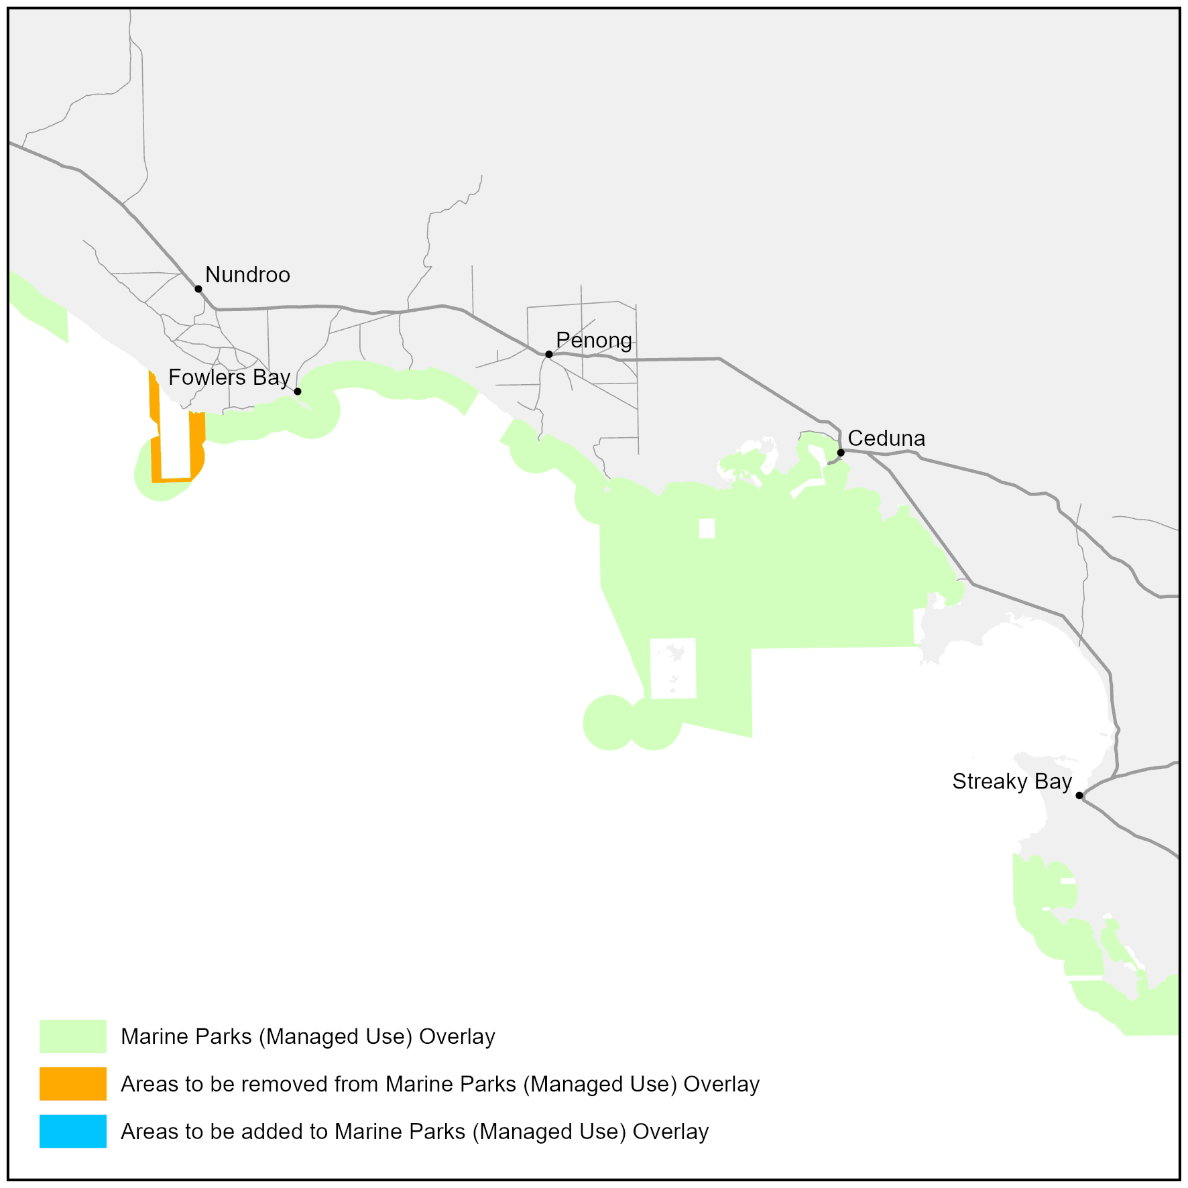
Attachment A

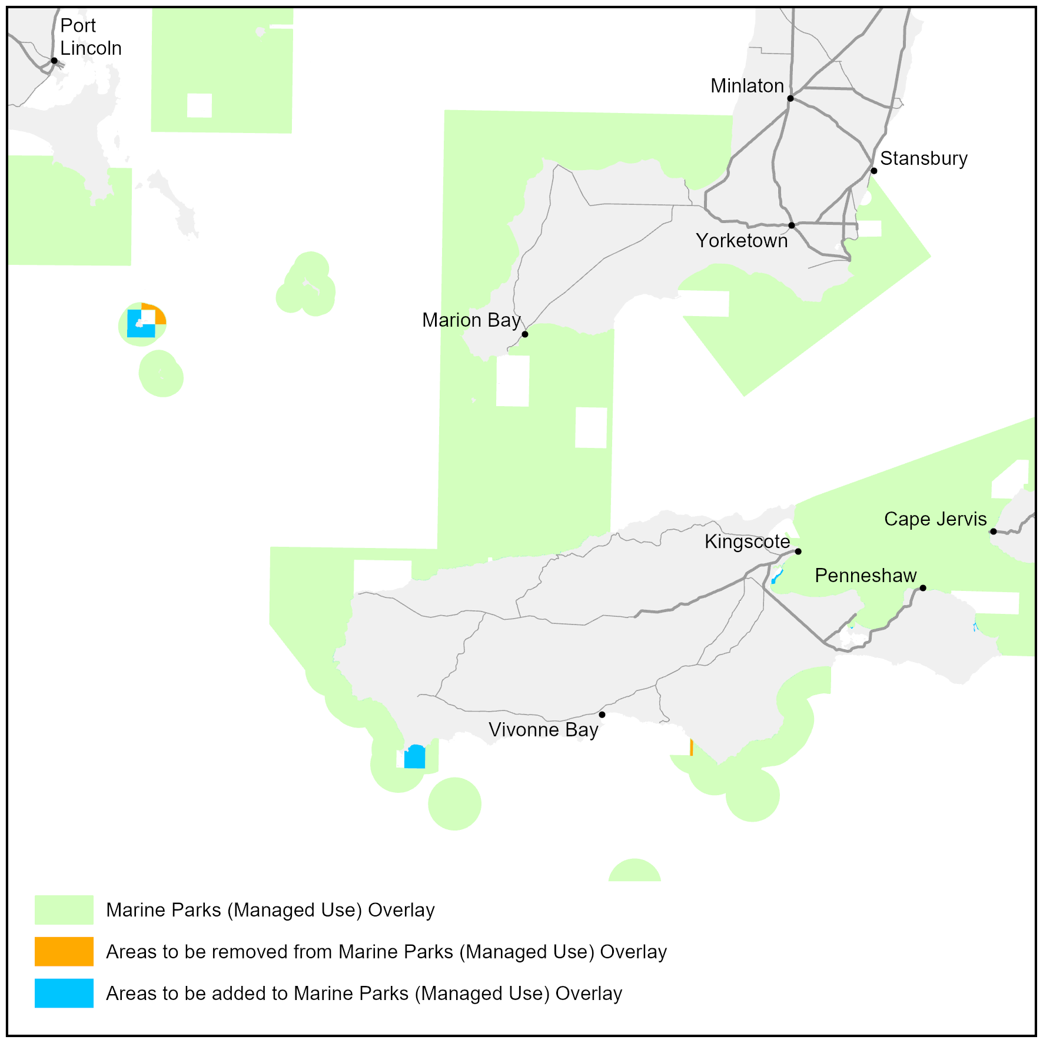
Attachment B

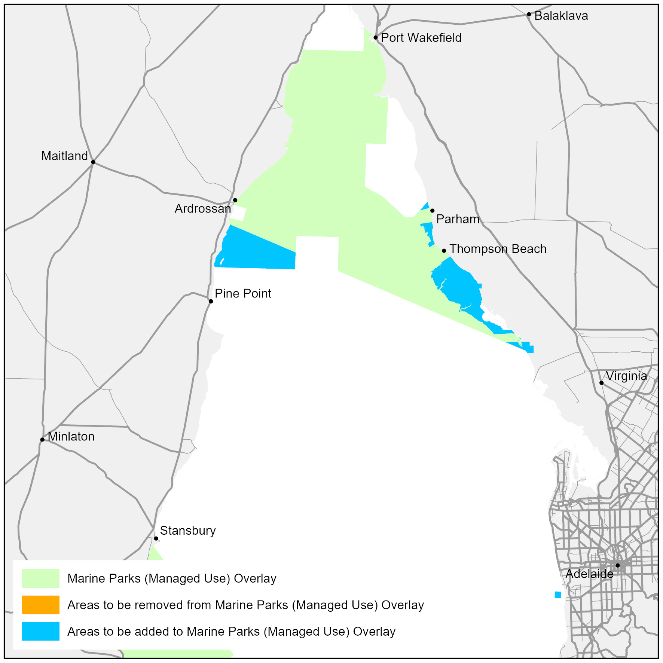
Attachment C

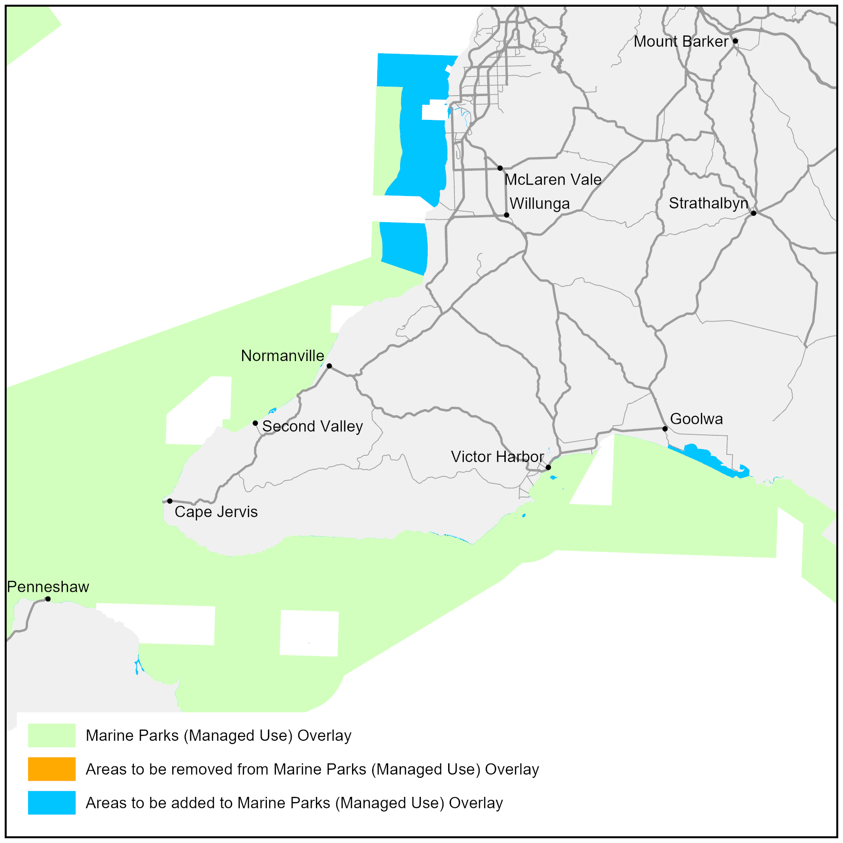
Attachment D

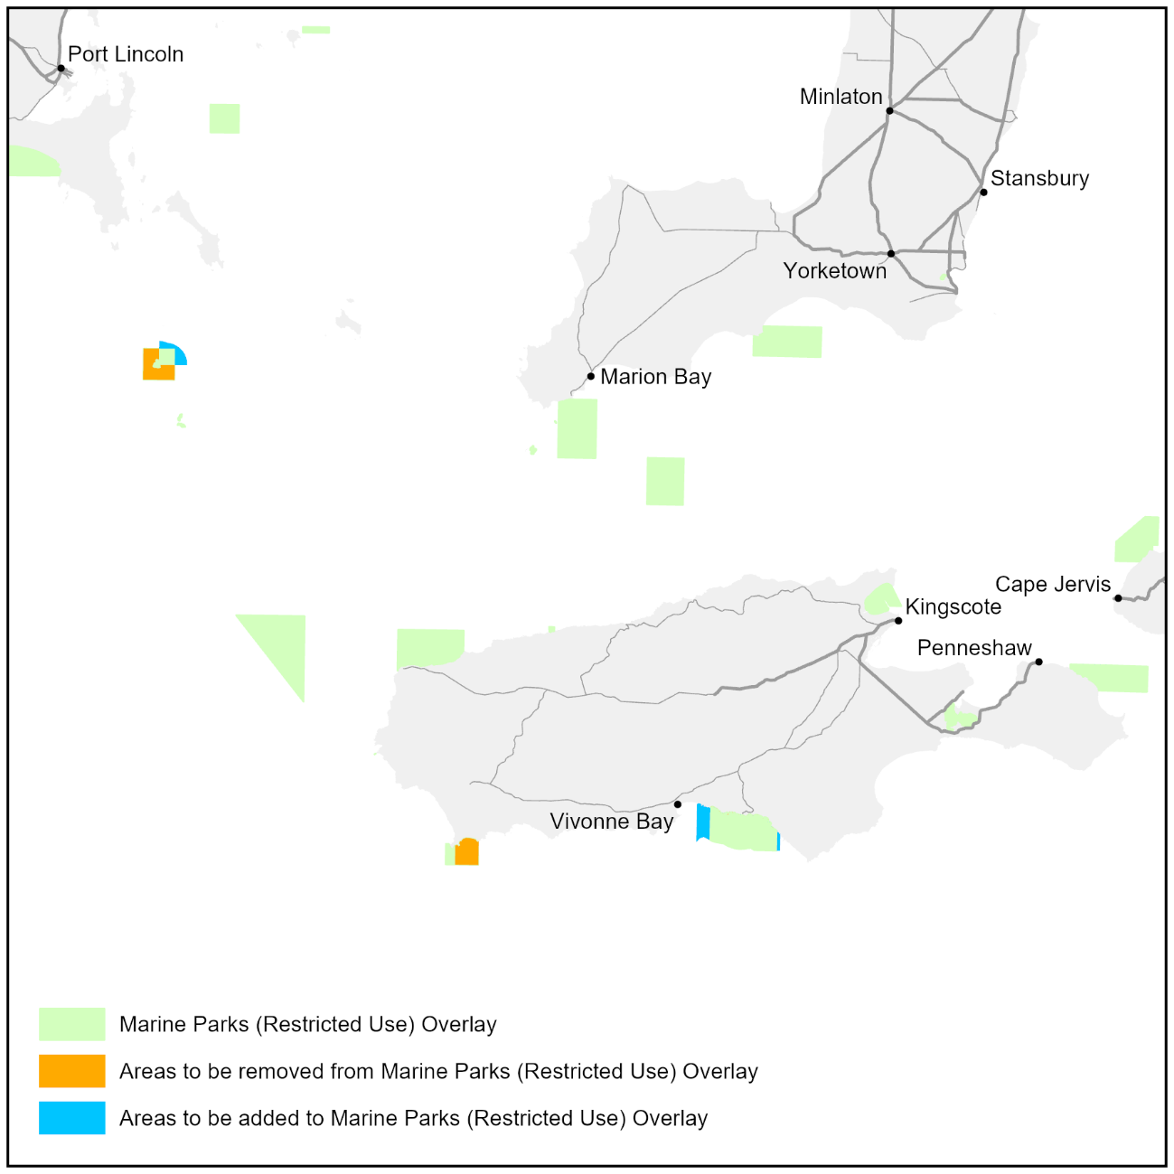
Attachment E

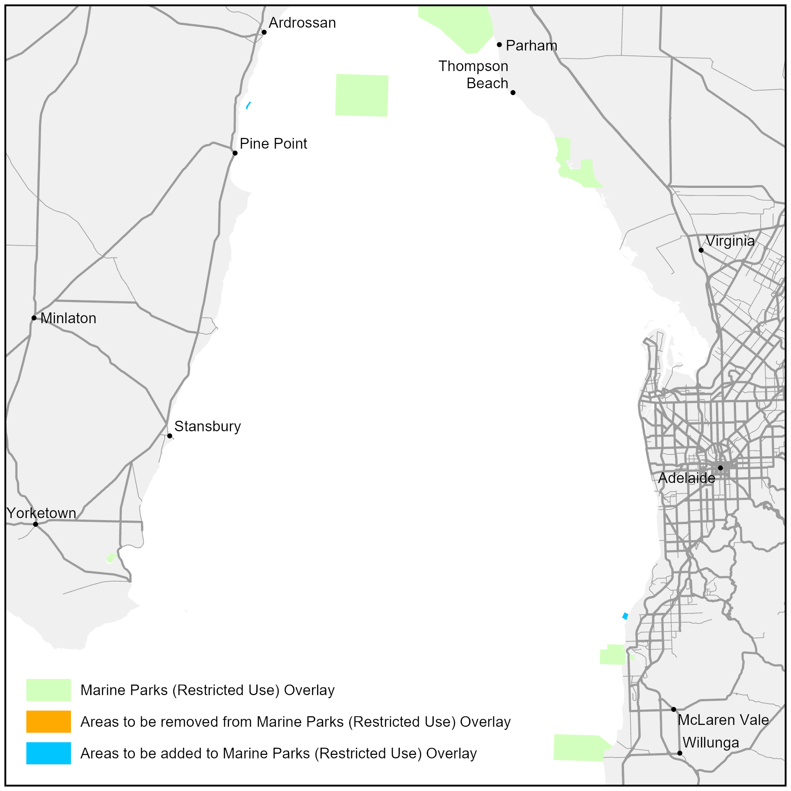
Attachment F

Attachment G

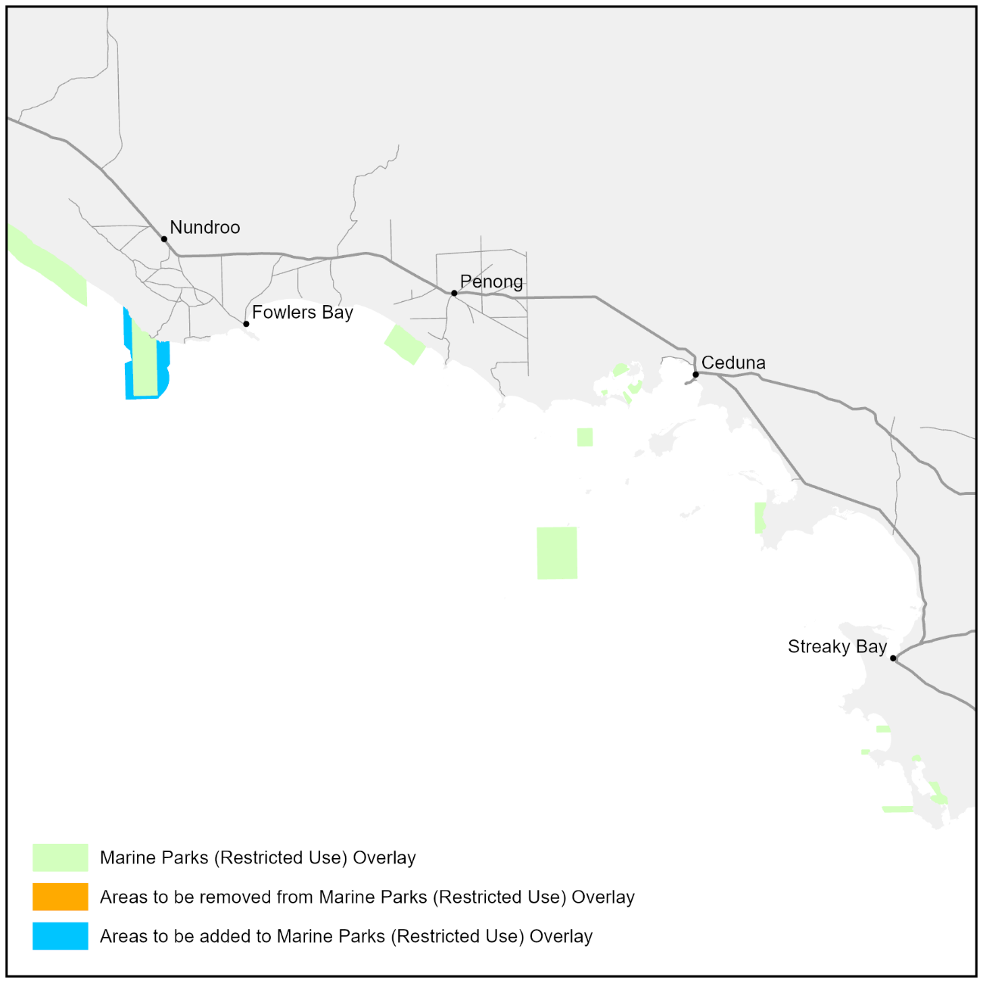

Professional Standards Act 2004
The Australian Property Institute Valuers Limited Professional Standards Scheme
Pursuant to Section 14 of the Professional Standards Act 2004, I authorise the publication in the Gazette of the Australian Property Institute Valuers Limited Professional Standards Scheme.
Pursuant to Section 15(1)(a) of the Professional Standards Act 2004, I specify 1 September 2026 as the date of commencement of the Australian Property Institute Valuers Limited Professional Standards Scheme.
Dated: 15 June 2026
Hon Kyam Maher MLC
Attorney-General

Professional Standards Act 2003 (Vic)
Australian Property Institute Valuers Limited Professional Standards Scheme
Interpretations
In this Scheme Instrument, unless the context otherwise requires:
1. headings or sub-headings are for convenience and navigation purposes only and should not be used in the interpretation of this Scheme Instrument;
2. a reference to a Clause shall be a reference to all of its Sub-clauses;
3. words in the singular form should also be interpreted to include the plural form, and vice versa.
Preamble
A. The Australian Property Institute Valuers Limited (APIV) is an occupational association for the purposes of the Professional Standards Act 2003 (Vic) (the Act).
B. The Scheme is prepared by the APIV for the purposes of limiting Occupational Liability to the extent to which such liability may be limited under the Act.
C. The Scheme applies to all Members of APIV, subject to Clause 2 below.
D. The Scheme will have force in Victoria, the Australian Capital Territory, New South Wales, the Northern Territory, Queensland, South Australia, Tasmania, and Western Australia. To the extent that the scheme applies to limit liability in the other jurisdictions, it is subject to the professional standards legislation of those jurisdictions.
E. The APIV has furnished the Professional Standards Council (“the Council”) with a detailed list of the risk management strategies, currently in place and intended to be implemented, in respect of its Members and the means by which those strategies are intended to be implemented.
F. The APIV has furnished the Council with APIV Insurance Standards with which Participating Members must comply for purposes of this Scheme. The APIV will not amend these insurance standards while the scheme is in force without prior approval of the Council.
G. The APIV has advised Members to whom the Scheme applies that they must have the benefit of a Professional Indemnity Insurance Policy that complies with APIV Insurance Standards and that they remain liable for the amount of any difference between the amount payable to a plaintiff under the policy and the Monetary Ceiling specified in the Scheme.
H. The APIV has furnished the Council with details of its complaints system and discipline system.
I. The APIV and its Members to whom the Scheme applies have undertaken to comply with all reporting obligations associated with the Scheme, in furtherance of the statutory objects of improvement of the occupational standards of its Members, and protection of the consumers of such Members’ services.
J. The APIV has undertaken to remit all fees payable under the Professional Standards Regulations 2017 (Vic) to the Council as and when these become due.
K. The Scheme is intended, subject to applicable legislation in various jurisdictions, to commence on 1 September 2026 and remain in force for five (5) years from its commencement unless, prior to that time, it is revoked, its operation ceases, or it is extended pursuant to Section 34 of the Act.
L. Sections 12GNA(2) of the Australian Securities and Investments Commission Act 2001 (Cth), 137(2) of the Competition and Consumer Act 2010 (Cth), and 1044B(2) of the Corporations Act 2001 (Cth) provide for limited liability where a Professional Standards Scheme is prescribed in the relevant regulation. The Scheme does not apply to limit any liability under a Commonwealth law unless it has been prescribed under regulations by the Commonwealth.
THE AUSTRALIAN PROPERTY INSTITUTE VALUERS LIMITED PROFESSIONAL STANDARDS SCHEME
1. Occupational Association
1.1 The Australian Property Institute Valuers Limited Professional Standards Scheme is a scheme under the Act prepared by the APIV whose registered address is:
Suite 1, Level 6, 66 Clarence Street
Sydney NSW 2000
2. Persons to Whom the Scheme Applies
2.1 The Scheme applies to:
2.1.1 all Members who are natural persons and who hold API certification of Certified Practising Valuer, Certified Practising Valuer (Residential), Residential Property Valuer and/or Certified Practising Valuer (Plant & Machinery) and are eligible to participate in the Scheme;
2.1.2 all Corporate Members; and
2.1.3 all Persons to whom the Scheme applies by virtue of the Act and the Corresponding Laws of other jurisdictions in which the Scheme applies.
2.2 The APIV may, on application by an individual referred to in Clause 2.1.1, exempt that individual from participating in the Scheme from the date on which the exemption is granted or a later date specified in the exemption.
3. Jurisdiction
3.1 The Scheme applies in Victoria.
3.2 In addition to Victoria, the Scheme is intended to operate in the Australian Capital Territory, New South Wales, the Northern Territory, Queensland, South Australia, Tasmania and Western Australia in accordance with the Professional Standards Legislation of those states and territories and subject to the requirements of that legislation (“the Corresponding Laws”), so that references to a provision of the Act, the application of the scheme to a liability, the limit of a liability under the Act, or what constitutes Occupational Liability, are intended to pick up the relevant provisions of the Corresponding Laws to the extent that is necessary for the application of the Scheme in any of those jurisdictions.
4. Limitation of Liability
4.1 This Scheme only affects the liability for Damages arising from a single cause of action to the extent to which the liability results in Damages exceeding $1,000,000.
4.2 If a Person, who or which was, at the time of the act or omission giving rise to Occupational Liability, a Participating Member and against whom a proceeding relating to Occupational Liability is brought, is able to satisfy the court that such person has the benefit of an insurance policy:
(a) of a kind which complies with the APIV Insurance Standards;
(b) insuring such Person against the Occupational Liability to which the cause of action relates; and
(c) under which the amount payable in respect of that Occupational Liability is not less than the applicable Monetary Ceiling specified in the table at Clause 4.3,
then that Person is not liable in Damages in relation to that cause of action above the Monetary Ceiling specified in Clause 4.3 of this Scheme.

4.3 The Monetary Ceiling is to be determined according to the following table:
Category | Assessed Value or Indicative Value | Monetary Ceiling
Category 1  Services | $0 to $3,500,000 | $1,000,000 (fixed)
Category 1  Services | $3,500,001 to $7,500,000 | Assessed Value x 33%
Real Property Valuation and Desktop Services | $7,500,001 to $100,000,000 | $2,000,000 + (Assessed Value x 7.5%)
Real Property Valuation and Desktop Services | $100,000,001 or greater | $10,000,000 (fixed)
Category | Category Description | Monetary Ceiling
Category 2  Services | Low Risk Valuation Services | $1,000,000 (fixed)
Category 3  Services | Plant & Machinery Valuations | $1,000,000 (fixed)
Category 4  Services | Other Occupational Services | $1,000,000 (fixed)
4.4 This Scheme limits the Occupational Liability in respect of a cause of action founded on an act or omission occurring during the period when the Scheme was in force of any Person to whom the Scheme applied at the time the act or omission occurred.
4.5 Clause 4.2 does not limit the amount of Damages to which a Person to whom the Scheme applies is liable if the amount is less than the amount specified for the purpose in this Scheme in relation to a Person to whom the Scheme applies.
4.6 For the avoidance of doubt, the applicable limitation of liability in respect of a Claim is the Monetary Ceiling as in force at the time at which the act or omission giving rise to the cause of action concerned occurred.
4.7 Where a Person, who at the time of the acts or omissions referred to in Clause 4.2 incurs an Occupational Liability as a result of:
4.7.1 an act or omission by that Person in the performance of Category 1 Services; and
4.7.2 an act or omission by that Person in the performance of:
(a) Category 2 Services;
(b) Category 3 Services;
(c) Category 4 Services; or
(d) any combination of Category 2 Services, Category 3 Services and/or Category 4 Services;
such Person’s Occupational Liability under this Scheme for Damages in excess of the amount specified in Clause 4.1 will be determined in accordance with those provisions of the Scheme relating to Category 1 Services only, as set out in the table at Clause 4.3.
4.8 Where a Person who at the time of the acts or omissions incurs an Occupational Liability as a result of:
4.8.1 an act or omission in the performance of a Category 1 Service; and
4.8.2 an act or omission in the performance of one or more other Category 1 Service the Monetary Ceiling shall be calculated by reference to the Assessed Value or Indicative Value.
4.9 Where, in respect of a Government Valuation, a Person who was a Participating Member:
4.9.1 expressly extends reliance in respect of such Government Valuation to a Non-Government Entity; and
4.9.2 incurs a liability to such Non-Government Entity as a result of an act or omission by that Participating Member in the performance of the Government Valuation; the relevant Occupational Service, for the purpose of calculating the applicable Monetary Ceiling in respect of such liability to the Non- Government Entity in accordance with Clause 4.3 (only), will be deemed to be a Category 1 Service.
4.10 Notwithstanding anything to the contrary contained in this Scheme if, in particular circumstances giving rise to Occupational Liability, the liability of any Person who is subject to this Scheme is capped both by this Scheme and also by any other scheme under Professional Standards Legislation (whether of this jurisdiction or under the law of any other Australian state or territory) and, if the amount of such caps should differ, then the cap on the liability of such Person arising from such circumstances which is higher shall be the applicable cap.
5. Conferral of Discretionary Authority
5.1 Pursuant to Section 26 of the Act, the APIV has discretionary authority, on application by a Person referred to in Clause 2.1, to specify in relation to that Person a higher Monetary Ceiling (maximum amount of liability) not exceeding $20 million, than would otherwise apply under the Scheme, in all cases or in any specified case or class of case.
6. Commencement and Duration
6.1 The Scheme will commence:
6.1.1 in New South Wales, the Northern Territory, Queensland, Tasmania, Victoria and Western Australia, on 1 September 2026; and
6.1.2 in the Australian Capital Territory and in South Australia, on this same date, or such other later date, provided the date is specified in the relevant Minister’s notice in relation to the Scheme; or
6.1.3 in all other cases, subject to the statutory provisions of each applicable jurisdiction.
6.2 The scheme will be in force in all applicable jurisdictions for five (5) years from the date of its commencement in Victoria.
6.3 Clause 6.2 is subject to the provisions of each jurisdiction in relation to the revocation, extension, or cessation of a Scheme.

7. Definitions
7.1 The definitions below and elsewhere in this Scheme Instrument have been included for interpretation and understanding of certain stated terms used within this Scheme Instrument.
7.2 For the avoidance of doubt, the use and meanings of defined terms in this Scheme Instrument take precedence over a common meaning or interpretation of the same term.
7.3 Where a defined term is included in this Scheme Instrument it is shown as a Title Case term. Where not shown as Title Case the ordinary meaning of the term applies in the context in which it is used.
“Act” means the Professional Standards Act 2003 (Vic).
“API” means the Australian Property Institute Ltd ACN 608 309 128.
“APIV” means the Australian Property Institute Valuers Limited ACN 143 638 975.
“APIV Insurance Standards” means the insurance standards approved by the APIV and presented to, and considered by, the Professional Standards Councils in connection with the Councils’ approval of the Scheme (subject to any amendment to such APIV Insurance Standards as are subsequently approved by the APIV and presented to the Councils and approved or endorsed by the Councils in writing).
“Assessed Value” means an express statement of professional opinion by a natural person who is or was a Participating Member as to the value of any right, interest or benefit related to the ownership, occupation or use of real property or plant, machinery or equipment as a result of a Valuation Process. Where a valuation report states a range of values, rather than a single value, the Assessed Value shall be deemed to be the mid-point value in such range.
“Category 1 Services” means any Valuation of Real Property or Desktop of Real Property in Australia excluding any Low Risk Valuation Services.
“Category 2 Services” means the provision of Low Risk Valuation Services in Australia.
“Category 3 Services” means the provision of Plant & Machinery Valuation Services in Australia.
“Category 4 Services” means the provision of Other Occupational Services in Australia.
“Corporate Member” means a corporation which has been admitted as a Member pursuant to the eligibility criteria prescribed by the APIV Constitution.
“Corresponding laws” has the same meaning as it has in the Act.
“Court” has the same meaning as it has in the Act.
“Damages” has the meaning given in Section 4 of the Act.
“Government Valuation” means any valuation or desktop prepared on instructions from any:
(a) Government in Australia (including Federal, State or Territory and Local government);
(b) Government department; or
(c) Government agency; or
(d) Government statutory or non-statutory body or authority.
“Indicative Value” means a qualified estimate by a natural person who is or was a Participating Member as to the value of any right, interest or benefit related to the ownership, occupation or use of real property or plant machinery or equipment, where the scope of work is limited or restricted such that the valuer does not undertake all the necessary enquiries, investigations, procedures and processes to fully inform the valuer’s reasoning and analysis that is a prerequisite for a Valuation Process. Where a report states a range of indicative values, rather than a single indicative value, the Indicative Value shall be deemed to be the mid-point of such range.
“Low Risk Valuation Services” means any:
(a) Valuation of Real Property or Desktop of Real Property undertaken in the capacity as an arbitrator;
(b) Valuation of Real Property or Desktop of Real Property undertaken for the purpose of asset means testing;
(c) Expert Determination;
(d) Expert Evidence Valuation;
(e) Financial Reporting Valuation;
(f) Government Valuation;
(g) Insurance Valuation;
(h) assessment of any unit entitlement in respect of any subdivision, strata title, company title (or similar) property;
(i) Valuation of Real Property or Desktop of Real Property undertaken for the purpose of determining a rate, tax, duty or levy that applies in respect of the property including but not limited to any council rates, Good & Services Tax or stamp duty; or
(j) Valuation of Real Property or Desktop of Real Property undertaken for Resumption purposes.
“Member” means a member of the APIV.
“Monetary Ceiling” means the applicable monetary ceiling specified in the table at Clause 3.4 of this document.
“Non-Government Entity” means a person or entity which is not a government entity of the type identified in the definition of Government Valuation at Clause 5.1 (including, for the avoidance of doubt, any joint venture or partnership between one or more Government Entity(s) with one or more Non-Government Entity(s)).
“Occupational Liability” has the same meaning as it has in the Act.
“Other Occupational Services” means any Occupational Services provided by a Participating Member in the performance of the Occupation other than any:
(a) Category 1 Services;
(b) Category 2 Services;
(c) Category 3 Services.

“Participating Member” means a Member to whom the Scheme applies pursuant to Clause 2.1 and who has not been granted an exemption pursuant to Clause 2.2.
“Plant & Machinery Valuation Services” means any valuation or desktop of any right, interest or benefit related to the ownership, possession or use of plant, machinery or equipment expressed as an Assessed Value or Indicative Value.
“Person” means an individual or a body corporate.
“Professional Indemnity Insurance Policy” means a policy of insurance that provides cover for the Participating Member in compliance with the APIV Insurance Standards.
“Professional Standards Legislation” means:
(a) the Act;
(b) Professional Standards Act 1994 (NSW);
(c) Professional Standards Act 2004 (Qld);
(d) Professional Standards Act 2004 (SA);
(e) Professional Standards Act 2005 (Tas);
(f) Professional Standards Act 1997 (WA);
(g) Professional Standards Act 2004 (NT); and
(h) Civil Law (Wrongs) Act 2002 (ACT).
“Real Property Valuation and Desktop Services” means any Valuation of Real Property or Desktop of Real Property but excluding any Low Risk Valuation Services.
“Scheme” means The Australian Property Institute Valuers Limited Professional Standards Scheme set out in this document.

^{i} “Valuation Process” means an established evidence based process for assessing the value of a tangible asset which includes all the necessary enquiries, investigations, procedures and processes including the physical inspection of the asset by the valuer, required to fully inform the valuer’s reasoning and analysis in accordance with practice accepted as proper by the API.
^{ii} “Valuation of Real Property” means any valuation, undertaken in accordance with Rule 11 of the API Rules of Professional Conduct, of any right, interest or benefit related to the ownership, occupation or use of real property including land and all things that are a natural part of the land as well as any improvements to the land (but excluding plant, machinery and equipment) expressed as an Assessed Value.
^{iii} “Desktop of Real Property” means any desktop, undertaken in accordance with Rule 12 of the API Rules of Professional Conduct, of any right, interest or benefit related to the ownership, occupation or use of real property including land and all things that are a natural part of the land as well as any improvements to the land (but excluding plant, machinery and equipment) expressed as an Indicative Value.
^{iv} “Expert Determination” means any Valuation of Real Property or Desktop of Real Property undertaken for the purpose of making a determination acting as an expert pursuant to an agreement or deed where all relevant parties have agreed to indemnify, release or hold the valuer harmless in respect of any liability in connection with the valuation. An Expert Determination can be binding or non-binding.
^{v} “Expert Evidence Valuation” means any Valuation of Real Property or Desktop of Real Property undertaken for the purpose of providing expert evidence in relation to a proceeding before a court or tribunal where the expert’s primary duty is to the court or tribunal (excluding a Valuation of Real Property or Desktop of Real Property undertaken for Resumption purposes).
^{vi} “Financial Reporting Valuation” means any Valuation of Real Property or Desktop of Real Property undertaken for the purpose of the preparation and issue of financial reports by any entity in the general course of the entity’s operations. It excludes special purpose financial reports prepared in respect of a specific transaction including any sale, merger, takeover or fundraising.
^{vii} “Insurance Valuation” means any assessment of the cost of replacement of destructible improvements to real property or plant, machinery or equipment undertaken for the purpose of advising on the insurable value of such property in connection with the entry into, or proposed entry into, a contract of insurance.
^{vii} “Resumption” means compulsory acquisition of land (including compulsory acquisition or appropriation of Crown land) under the provision of any Act of the Commonwealth or of a State or Territory authorising compulsory acquisition or appropriation of land.
^{ix} “Occupational Services” means any Category 1 Services, the Category 2 Services, the Category 3 Services and the Category 4 Services provided by a Participating Member in the performance of the Occupation.
^{x} “Occupation” means the occupational vocation carried out by Participating Members by application of the qualifications, training, skills, practices, disciplines, specialisations, standards, guidelines and experience of a natural person holding the API certification of Certified Practicing Valuer, Certified Practising Valuer (Residential), Residential Property Valuer and/or Certified Practising Valuer (Plant & Machinery).

Tafe Sa Act 2025
By-laws 2026
By-laws made by TAFE SA under Section 20 of the TAFE SA Act 2025 and in accordance with the other requirements of that section.
Part 1—Preliminary
1—Interpretation
(1) In these by-laws, unless the contrary intention appears—
the Act means the TAFE SA Act 2025;
authorised person means a person authorised in writing by TAFE SA to act as an authorised person under these by-laws;
Board means the TAFE SA Board established under Section 9 of the Act;
commercial vehicle means a vehicle constructed, adapted or used solely or mainly for the carriage of goods;
disabled person’s parking permit means—
(a) a permit issued under Part 3D of the Motor Vehicles Act 1959; or
(b) a similar permit or authority issued under the law of another State or a Territory of the Commonwealth;
drive, in relation to a vehicle, includes ride;
e-cigarette has the same meaning as in the Tobacco and E-Cigarette Products Act 1997;
firearm has the same meaning as in the Firearms Act 2015;
offensive weapon has the same meaning as in Section 21A of the Summary Offences Act 1953;
officially designated, in relation to an area within TAFE SA grounds—see subclause (2);
official sign means a sign that conveys a message authorised by the Board, and includes lines or markings or a sign together with lines or markings;
owner, in relation to a vehicle, means—
(a) a person registered or recorded as the owner or an owner of the vehicle under the Motor Vehicles Act 1958 or a corresponding law of another State or of a Territory; or
(b) if the vehicle is registered in the name of a business under the Motor Vehicles Act 1958 or a corresponding law of another State or of a Territory—any person carrying on that business; or
(c) a person to whom a trader’s plate, a permit or other authority has been issued under the Motor Vehicles Act 1958 or a corresponding law of another State or of a Territory, by virtue of which the vehicle is permitted to be driven on roads,
and includes—
(d) if ownership of the vehicle has been transferred but the transferee has not yet been registered or recorded as the owner or an owner of the vehicle—a person to whom the ownership of the vehicle has been transferred; or
(e) if a person has possession of the vehicle by virtue of the hire or bailment of the vehicle—that person;
park, in relation to a vehicle, includes stand;
prohibited weapon means a prohibited weapon under Part 3A of the Summary Offences Act 1953;
smoke has the same meaning as in the Tobacco and E-Cigarette Products Act 1997;
tobacco product has the same meaning as in the Tobacco and E-Cigarette Products Act 1997;
vehicle includes—
(a) a motor vehicle, motor cycle or trailer; and
(b) a bicycle; and
(c) an animal-driven vehicle, and an animal that is being ridden or drawing a vehicle; and
(d) a motorised or battery powered wheelchair that can travel at over 10 kilometres per hour (on level ground),
but does not include other types of wheelchairs or a wheeled recreational device;
wheeled recreational device means a wheeled device, built to transport a person, generally propelled by human power or gravity, and ordinarily used for recreation or play, and—
(a) includes:
(i) rollerblades, rollerskates, a skateboard, scooter, unicycle or similar wheeled device; and
(ii) an electric transporter within the meaning of the Road Traffic (Miscellaneous) Regulations 2014; but
(b) does not include a pram, stroller, trolley, bicycle, wheelchair or wheeled toy.
(2) In these by-laws, an area of the TAFE SA grounds is taken to be officially designated as being an area for a particular purpose if an official sign is displayed in or near the area indicating the purpose.
(3) For the purposes of these by-laws, an area is any part of TAFE SA grounds.
(4) For the purposes of these by-laws, a permit will be taken to be displayed in a vehicle only if the permit is displayed in the inside of the windscreen (or if the vehicle does not have a windscreen, in some other prominent position) so as to be easily legible to a person standing beside the vehicle.
2—Ability for Chief Executive to act instead of Board
(1) The Chief Executive is authorised, by force of this by-law, to grant an approval or provide an authorisation under these by-laws on behalf of the Board.
(2) Subclause (1) does not limit the power or ability of the Board to—
(a) act in any matter; or
(b) make a delegation under the Act; or
(c) direct the Chief Executive to act, or not to act, in a particular matter or case on behalf of the Board.
Part 2—Driving, riding and parking on TAFE SA grounds
Division 1—Driving and riding
3—Driving and riding
A person must not, without the approval of the Board—
(a) fail to comply with any traffic prohibition, restriction or direction (including in relation to speed, mass or traffic flow) indicated on an official sign in or near where the vehicle is being driven; or
(b) drive a vehicle within TAFE SA grounds in a dangerous or careless manner, without reasonable consideration for others, or in a manner that causes undue noise to be emitted from the vehicle; or
(c) ride a wheeled recreational device in an area where to do so is prohibited by an official sign in or near the area.

Division 2—Parking
4—Parking—general provisions
(1) A person must not, without the approval of the Board—
(a) park a vehicle within TAFE SA grounds except in an officially designated area for the parking of vehicles; or
(b) park a vehicle in an area officially designated as a parking area for persons holding a permit unless—
(i) the person, or a passenger in the vehicle, is a holder of a permit of the relevant class; and
(ii) the permit is displayed in the vehicle; and
(iii) the vehicle is parked in accordance with any terms of the permit; or
(c) park a vehicle in an area in which parking spaces are marked out so that part of the vehicle, or anything in, on or attached to the vehicle, protrudes into another parking space, a roadway or driveway, or a place set aside for the use of pedestrians; or
(d) park a vehicle in a parking space that is already occupied by another vehicle; or
(e) without limiting a preceding paragraph—park a vehicle within TAFE SA grounds in contravention of an official sign, or in a manner that is inconsistent with an official sign, that is displayed in or near the area where the vehicle is parked or otherwise relates to the area where the vehicle is parked.
(2) Subclause (1)(c) does not apply if—
(a) the parking spaces provide for parallel parking; and
(b) the length of a vehicle, including any trailer, caravan or other vehicle attached to the vehicle, exceeds the length of a parking space; and
(c) the vehicle takes up more than 1 parallel parking space.
(3) Subclause (1)(d) does not apply to 2 or more motor cycles parked in the same parking space.
(4) In the case of a sign that provides for a Loading Area, the only purpose for which the area may be used is for a vehicle where—
(a) the vehicle is a commercial vehicle that is being loaded or unloaded and the vehicle is parked for no longer than the time necessary to complete the loading or unloading but, in any event, for no longer than 30 minutes; or
(b) the vehicle is a vehicle other than a commercial vehicle and the following circumstances apply:
(i) the vehicle is being loaded or unloaded;
(ii) the cargo is difficult to load or unload because of its weight or size;
(iii) the vehicle is parked for no longer than the time necessary to complete the loading or unloading but, in any event, for no longer than 10 minutes; or
(c) the vehicle is parked only for the purpose of the immediate setting down or picking up of a passenger or goods.
5—Time limits
(1) A person must not park a vehicle in an area designated by an official sign as an area in which parking of a vehicle is subject to a specified time limit for a period in excess of the specified time limit.
(2) However, in the case of a vehicle in which a disabled person’s parking permit is displayed in the vehicle, the time limit for the parking of the vehicle will be as follows:
(a) if the specified time limit is less than 30 minutes—the time limit for the parking of that vehicle is 30 minutes;
(b) if the specified time limit is 30 minutes or more but less than or equal to 1 hour—the time limit for the parking of that vehicle is 2 hours;
(c) if the specified time limit is more than an hour—the time limit for the parking of that vehicle is twice the period indicated on the sign.
(3) Subclause (2) does not apply in relation to an area officially designated as a parking area for a vehicle being used by a person holding a disabled person’s parking permit.
Division 3—Related matters
6—Direction by authorised person
(1) A person must not, without reasonable excuse, fail to comply with a direction of an authorised person in connection with the driving, riding or parking of a vehicle on TAFE SA grounds.
(2) Without limiting subclause (1), a person being the driver of, or otherwise in charge of, a vehicle on TAFE SA grounds must remove the vehicle from TAFE SA grounds, or a specified part of TAFE SA grounds, at the direction of an authorised person.
7—Owner/driver contravening this Part
(1) If a vehicle is driven or parked in a manner that contravenes these by-laws, the driver of the vehicle and the owner of the vehicle are each guilty of the offence.
(2) However, the owner and driver of a vehicle are not both liable for contravening the by-law arising out of the same circumstances and consequently conviction of the owner or expiation by the owner exonerates the driver and conversely conviction of the driver or expiation by the driver exonerates the owner.
8—Owner may name driver
(1) If an expiation notice or expiation reminder notice is given under the Expiation of Offences Act 1996 to the owner of a vehicle for an alleged offence against these by-laws involving the vehicle, the owner may, if the owner was not the driver at the time of the alleged offence, provide TAFE SA, within 21 days after the date of the notice, with a statutory declaration—
(a) setting out the name and address of the driver; or
(b) if the owner had transferred ownership of the vehicle to another person prior to the time of the alleged offence and has complied with the Motor Vehicles Act 1959 in respect of the transfer—setting out details of the transfer (including the name and address of the transferee).
(2) Before proceedings are commenced against the owner of a vehicle for an offence against these by-laws involving the vehicle, TAFE SA must send the owner a notice—
(a) setting out particulars of the alleged offence; and
(b) inviting the owner, if the owner was not the driver at the time of the alleged offence, to provide TAFE SA, within 21 days after the date of the notice, with a statutory declaration setting out the matters referred to in subclause (1).
(3) Subclause (2) does not apply to—
(a) proceedings commenced where an owner has elected under the Expiation of Offences Act 1996 to be prosecuted for the offence; or
(b) proceedings commenced against an owner of a vehicle who has been named in a statutory declaration under this by-law as the driver of the vehicle.
(4) Subject to subclause (5), in proceedings against the owner of a vehicle for an offence against these by-laws, it is a defence to prove—
(a) that, in consequence of some unlawful act, the vehicle was not in the possession or control of the owner at the time of the alleged offence; or
(b) that the owner provided TAFE SA with a statutory declaration under this by-law.
(5) The defence in subclause (4)(b) does not apply if it is proved that the owner made the declaration knowing it to be false in a material particular.
9—Removal of vehicle
(1) An authorised person may remove a vehicle that is on TAFE SA grounds in contravention of a by-law.
(2) The vehicle must be removed to a place that is reasonably secure and appropriate for the storage of the vehicle.
(3) TAFE SA is entitled to recover the reasonable costs of removing and storing the vehicle from the owner of the vehicle.
10—Exemptions
A by-law relating to the driving or parking of a vehicle does not apply to—
(a) a vehicle that is being use by a person authorised to issue expiation notices for alleged offences against these by-laws; or
(b) a vehicle that is being used by a police officer or other public official in the course of official duties; or
(c) a fire-services vehicle, ambulance or similar vehicle; or
(d) a vehicle that is being used for the purposes of the State Emergency Service; or
(e) a vehicle that is being used for purposes related to safety, maintenance or repair of any part of TAFE SA grounds or any TAFE SA facilities; or
(f) a vehicle driven or parked within TAFE SA grounds in accordance with an authorisation given by the Board or an authorised person for the purposes of this by-law.
Part 3—Access and conduct
11—Access
A person must not enter a part of TAFE SA grounds in contravention of an official sign.
12—Disorderly, offensive or other prohibited behaviour
(1) A person must not, while on TAFE SA grounds or in connection with activities conducted on TAFE SA grounds—
(a) behave in a manner—
(i) that is disrespectful or unfair towards another person; or
(ii) that endangers, compromises or otherwise puts at risk the safety or wellbeing of another person; or
(b) disrupt or interfere with any TAFE SA activity, disturb a person’s learning, or disrupt TAFE SA’s learning environment; or
(c) hinder or interfere with any other activity conducted by, or on behalf of, TAFE SA; or
(d) without limiting a preceding paragraph—act in an offensive, threatening or disorderly manner.
(2) A person must not—
(a) smoke a tobacco product on TAFE SA grounds; or
(b) smoke an e-cigarette on TAFE SA grounds.
(3) A person must not conduct, promote or take part in a meeting on TAFE SA grounds that has been prohibited by the Board.
13—Damage to TAFE SA grounds or property
(1) A person must not cause damage to—
(a) any part of TAFE SA grounds or structures or items on TAFE SA grounds; or
(b) property owned or used by TAFE SA; or
(c) any other thing forming part of TAFE SA grounds, or used or placed on TAFE SA grounds by or on behalf of TAFE SA.
(2) A person must not, without the approval of the Board, remove or alter a TAFE SA sign, notice or notice board.
(3) A person must not deposit or leave litter, refuse or waste matter on any part of TAFE SA grounds (other than in a receptacle provided for that purpose).
(4) TAFE SA is entitled to recover compensation from a person who causes damage to TAFE SA grounds or property of TAFE SA.
14—Firearms and weapons
(1) A person must not, without the approval of the Board, bring on to TAFE SA grounds, or carry or use on TAFE SA grounds, a firearm, offensive weapon or prohibited weapon.
(2) This by-law does not apply where possession of the firearm, offensive weapon or prohibited weapon forms part of a course conducted by TAFE SA.
15—Dogs and other animals
(1) A person must not bring a dog or other animal on to TAFE SA grounds, or permit a dog or other animal to remain on TAFE SA grounds, in contravention of an official sign.
(2) A person who brings a dog or other animal on to TAFE SA grounds must not allow the dog or other animal to act in a disruptive way.
(3) A person who brings a dog or other animal on to TAFE SA grounds must immediately remove the dog or other animal from TAFE SA grounds, or from a specified area within TAFE SA grounds, at the direction of an authorised person.
(4) This clause does not apply in relation to—
(a) a dog that is an accredited assistance dog under the Dog and Cat Management Act 1995; or
(b) a dog that is being used by a person for genuine assistance, support or companionship because of a physical or mental disability or condition; or
(c) a dog or other animal that is being used, or is to be used, for a course conducted by TAFE SA.
16—Property or items left on TAFE SA grounds
A person who has left their property or any other item on TAFE SA grounds must immediately remove that property or other item from TAFE SA grounds, or from a specified area within TAFE SA grounds, at the direction of an authorised person.
17—Structures
(1) A person must not, without the approval of the Board, erect a structure on TAFE SA grounds.
(2) This by-law does not apply where the structure is erected for the purposes of—
(a) a course conducted by TAFE SA; or
(b) other functions performed by TAFE SA; or
(c) services provided by TAFE SA.
18—Unauthorised activities
A person must not, without the approval of the Board, conduct an activity on TAFE SA grounds that does not form part of, or is not undertaken for the purposes of—
(a) a course conducted by TAFE SA; or
(b) other functions performed by TAFE SA; or
(c) services provided by TAFE SA.
19—Directions
(1) A person must not, while on TAFE SA grounds, fail to comply with any reasonable direction of—
(a) a member of the TAFE SA staff; or
(b) an authorised person; or
(c) an emergency services worker.
(2) Subclause (1) does not limit any other by-law.
Part 4—Miscellaneous
20—Request to leave TAFE SA grounds
(1) An authorised person may request a person to leave TAFE SA grounds if the authorised person believes, on reasonable grounds, that the person—
(a) has acted in contravention of a by-law; or
(b) is intoxicated.
(2) A person must not, without reasonable excuse, fail to comply with a request under subclause (1).
(3) An authorised person may remove, or cause to be removed, a person who fails to comply with a request under subclause (1).
21—Request for identification
(1) This by-law applies if an authorised person believes, on reasonable grounds, that a person has acted, or is acting, in contravention of a by-law.
(2) The authorised person may request the person to provide to the authorised person—
(a) their name and address; and
(b) evidence of their name and address.
(3) A person must not, without reasonable excuse, fail to comply with a request under subclause (2).
22—Confiscation of property
(1) An authorised person may confiscate anything brought onto, left on, possessed or used on TAFE SA grounds in contravention of a by-law (including after failing to comply with a direction of an authorised person).
(2) The authorised person may request a person apparently in control of a thing that may be confiscated under this by-law to provide the thing to the authorised person.
(3) A person must not, without reasonable excuse, fail to comply with a request under subclause (2).
(4) Anything confiscated under this by-law becomes the property of TAFE SA.
23—General offence and expiation
(1) A person who contravenes or fails to comply with a by-law is guilty of an offence.
(2) A person who is guilty of an offence is liable to a fine not exceeding $2 500.
(3) A person who is allegedly guilty of an offence is liable to an expiation fee of $210.
24—Revocation
The by-laws in force under the Act immediately before the day on which these by-laws take effect are revoked.
25—Commencement
These by-laws take effect on the day on which they are published in the Gazette under Section 20(4)(d) of the Act.
Dated: 25 June 2026
Approved by the Minister,
Lucy Hood MP
Minister for Education, Training and Skills

Local Government Instruments

City Of Burnside
Adoption of Valuations and Declaration of Rates
Notice is hereby given that on 16 June 2026, the City of Burnside, pursuant to the provisions of the Local Government Act 1999, for the financial year ending 30 June 2027:
1. Adopted the capital valuations to apply in its area for rating purposes for the 2026/2027 financial year as provided by the Valuer-General totalling $35,460,628,120.
2. Declared differential general rates in the dollar based on capital value as follows:
(a) 0.16292 cents in the dollar on rateable land of Category (a)—Residential, Category (b)—Commercial Shop, Category (c)—Commercial Office, Category (d)—Commercial Other, Category (e)—Industry Light, Category (f)—Industry Other, Category (g)—Primary Production and Category (i)—Other.
(b) 0.40730 cents in the dollar on rateable land of Category (h)—Vacant Land.
3. Resolved that the minimum amount payable by way of general rates in respect of rateable land within the area be $1,189; and
4. Declared a Separate Rate (Regional Landscape Levy) of 0.005892 cents in the dollar on all rateable land in the Council’s area and within the area of the Green Adelaide Landscape Board Area;
Dated: 2 July 2026
J. Grant
Chief Executive Officer

City Of Holdfast Bay
Adoption of Valuations and Declaration of Rates
Notice is given that at its meeting on 23 June 2026, and in relation to the 2026/2027 financial year, the Council, in exercise of the powers contained in Chapter 10 of the Local Government Act 1999:
1. Adopted for rating purposes the most recent valuations of the State Valuation Office of the capital value of all land in its area totalling $26,568,024,960.
2. Declared a differential general rate of 0.1807032 cents in the dollar of the capital value of rateable land, with Residential and Other Land uses.
3. Declared a differential general rate of 0.302210 cents in the dollar of the capital value of rateable land, with Commercial (Shop), Commercial (Office), Commercial (Other), Industrial (Light), Industrial (Other) and Vacant Land uses.
4. Fixed a minimum amount payable by way of general rate of $1,380.
5. Declared a differential separate rate of 0.117074 cents in the dollar of the capital value of rateable land:
(a) with a frontage to Jetty Road, Glenelg or Moseley Square: and
(b) within the side streets that intersect with Jetty Road, Glenelg between High Street, Glenelg and Augusta Street, Glenelg; and
(c) the entire site referred to as the Holdfast Shores 2B Entertainment Centre; and
(d) that has a land use of Category 2 (Commercial—Shop), Category 3 (Commercial—Office) and Category 4 (Commercial—Other).
6. Declared a separate rate of 0.999936 cents in the dollar of the capital value of rateable land within the Patawalonga basin bounded by the high water mark and fixed the maximum amount payable by way of this separate rate at $1,020.
7. Declared a separate rate by way of a levy of 0.0060478 cents in the dollar of the capital value of rateable land in the Council’s area for the Regional Landscape Levy in the catchment area of the Green Adelaide Board.
Due dates for rates being 1 September 2026, 1 December 2026, 1 March 2027 and 1 June 2027.
Dated: 2 July 2026
P. Jackson
Chief Executive Officer

City Of Marion
Adoption of Valuations and Declaration of Rates
Notice is hereby given that on 23 June 2026 the Council of the City of Marion, pursuant to the provisions of the Local Government Act 1999, for the year ending 30 June 2027:
Adoption of Valuations
Adopted the capital valuations to apply in its area for rating purposes for the 2026-27 financial year as supplied by the Valuer-General totalling $44,688,347,680.
Declaration of Rates
Declared differential general rates in the dollar based on capital value as follows:
(a) 0.213061 cents in the dollar on rateable land of Category 1—Residential, Category 7—Primary Production and Category 9—Other.
(b) 0.564611 cents in the dollar on rateable land of Category 2—Commercial Shop, Category 3—Commercial Office, Category 4—Commercial Other.
(c) 0.564611 cents in the dollar on rateable land of Category 5—Industrial Light, Category 6—Industrial Other.
(d) 0.468734 cents in the dollar on rateable land of Category 8—Vacant Land.
Resolved that the minimum amount payable by way of general rates in respect of rateable land within the area for the year ending 30 June 2027 be $1,322.00; and
Declared a Separate Rate of 0.005944 cents in the dollar on all rateable land within the Green Adelaide Board Area within the area.
The Council resolved that rates will be payable in four equal or approximately equal instalments, and that the due dates for those instalments will be 1 September 2026, 1 December 2026, 1 March 2027 and 1 June 2027.
Dated: 2 July 2026
Tony Harrison
Chief Executive

City Of Mount Gambier
Adoption of Valuations and Declaration of Rates
Notice is hereby given that the Council, in exercise of the powers contained in Chapters 8, 9 and 10 of the Local Government Act 1999 and the Landscape South Australia Act 2019 at a meeting held on 25 June 2026 and for the financial year ending 30 June 2027:
1. Adoption of Valuations
Adopted for rating purposes, the capital valuations of the Valuer-General’s most recent valuations applicable to land within the area of the Council totalling $8,153,993,260.
2. Declaration of Rates
(i) Declared differential general rates in the dollar based on capital values as follows:
(a) 0.195275 cents in the dollar on rateable land of categories (a) Residential and (i) Other land uses; and
(b) 0.253858 cents in the dollar on rateable land of categories (g) Primary Production; and
(c) 0.4881880 cents in the dollar on rateable land of categories (b) Commercial—Shop, (c) Commercial—Office,
(d) Commercial—Other, (e) Industry—Light, (f) Industry—Other and (h) Vacant Land uses.
(ii) Declared a fixed charge as a component of the general rates of $650.35.
(iii) Declared separate rates with a fixed charge amount that depends upon the use of the land to recover the contribution to the Regional Landscape Levy for the Limestone Coast Landscape Region as follows:
(a) $98.05 per assessment on rateable land categories (a) Residential, (h) Vacant Land and (i) Other,
(b) $142.00 per assessment on rateable land categories (b) Commercial—Shop, (c) Commercial—Office and (d) Commercial—Other,
(c) $228.00 per assessment on rateable land categories (e) Industry—Light and (f) Industry—Other, and
(d) $419.00 per assessment on rateable land category (g) Primary Production.
3. Service Charge
Imposed a Waste Service Charge of $390.00 on all land to which it provides or makes available the prescribed service.
Dated: 2 July 2026
Paul Simpson
Chief Executive Officer

City Of Onkaparinga
Adoption of Valuations and Declaration of Rates for 2026-27
Notice is given that at its meeting held on 25 June 2026 the Council, for the financial year ending 30 June 2027:
Adoption of Valuation
Adopted for rating purposes the Valuer-General’s most recent valuation of capital values of land within the Council’s area being $68,179,975,900.00.
Declaration of General Rates
Declared differential general rates based on two components:
1. one being based on the value of the land and varying according to land use, as follows:
(i) 0.16286093 cents in the dollar on rateable land of category (a) (Residential) use;
(ii) 0.28958405 cents in the dollar on rateable land of categories (b), (c), (d), (Commercial—Shop, Office and Other respectively) and (e) and (f) (Industrial—Light and Other respectively) uses;
(iii) 0.24559593 cents in the dollar on rateable land of category (g) (Primary Production) use;
(iv) 0.18569847 cents in the dollar on rateable land of category (h) (Vacant Land) use;
(v) 0.14762978 cents in the dollar on rateable land of category (i) (Other) use; and
2. the other being a fixed charge of $820.00
Declaration of Separate Rates—Landscape Levies
Declared separate rates as follows:
(vi) 0.00943205 cents in the dollar on all rateable land in the Council area of the Hills and Fleurieu landscape management region
(vii) 0.00605045 cents in the dollar on all rateable land in the Council area of the Green Adelaide landscape management region
Service Charges
Imposed a community wastewater management annual service charge on all land (rateable and non-rateable) to which it provides or makes available the CWMS prescribed service of collection, disposal and treatment of waste based on the CWMS Property Units Code of:
• $1,232.55 per unit on each occupied allotment; and
• $1,232.55 per unit on each vacant allotment.
Dated: 26 June 2026
Sharon Mason
Chief Executive Officer

City Of Playford
Adoption of Valuations and Declaration of Rates for 2026/27
Notice is hereby given that the City of Playford at its meeting held on 16 June 2026, resolved as follows:
Adoption of Valuations
1. Pursuant to Section 167(2)(a) of the Local Government Act 1999 (the Act), the Council adopts for rating purposes for the year ending 30 June 2027 the Valuer-General’s Capital Valuation of land within the Council’s area, being $37,218,821,700, of which $36,168,523,158 represents rateable land.
Declaration of General Rate
2. That having considered and taken into account the general principles of rating contained in Section 150 of the Act, and in accordance with Section 153(2) of the Act issues of consistency and comparability across council areas in the imposition of rates on various sectors of the business and wider community, the Council pursuant to Sections 152(1)(c),153(1)(b) and 156(1)(a) of the Act and Regulation 14 of the Local Government (General) Regulations 2013, declares the following differential general rates for the year ending 30 June 2027, to apply to all rateable land within the Council area based on the following two components:
2.1 one being a fixed charge of $1,304.30
2.2 the other being a differential general rate based on the capital value of the land varying accordingly to land use as follows:
(a) $0.00126763 in the dollar of the capital value on rateable land of land uses Category 1 (residential), Category 7 (primary production), Category 8 (vacant land) and Category 9 (other) land use.
(b) $0.01034459 in the dollar of the capital value on rateable land of land uses Category 2 (commercial shop), Category 3 (commercial office), Category 4 (commercial other), Category 5 (industry light) and Category 6 (industry other) land use.
Maximum Increase for Principal Place of Residence
3. Pursuant to Section 153(3) of the Act, the Council has determined that it will not apply a maximum increase (rates cap) on general rates to be imposed on rateable land constituting the principal place of residence of a principal ratepayer.
Separate Rate (Regional Landscape Levy)
4. Pursuant to Section 69 of the Landscape South Australia Act 2019 and Section 154 of the Act, the Council imposes a separate rate of $0.00005579 in the dollar for the year ending 30 June 2027 on the capital value of all rateable land in the Council area and the Green Adelaide Region, so as to reimburse the Council for the amount contributed or to be contributed by the Council to the Green Adelaide Board of $1,962,910.
Dated: 2 July 2026
Sam Green
Chief Executive Officer

City Of Port Lincoln
Impounded Vehicle
Notice is hereby given that pursuant to Section 237 of the Local Government Act (1999), the following vehicle has been impounded by the City of Port Lincoln.
Make: VW Golf
Rego No: CC141B
Colour: Grey
Location: Borthwick Ct, Port Lincoln
Impound Date: 07/04/2026
Council has been unable to locate the registered owner of the vehicle.
If any vehicle is not claimed by the registered owner and all expenses related to its impounding are not paid within 1 month of the date of this notice, the vehicle will be offered for sale by public auction or public tender by the Council.
Please contact Council on (08) 8621 2300 to arrange collection of your vehicle.
Dated: 30 June 2026
Eric Brown
Chief Executive Officer

City Of Prospect
Notice of Revocation of Classification of Community Land
Notice is hereby given that the City of Prospect, at its meeting of Council held on 23 June 2026, resolved as follows:
Portion of Allotment 1 Deposited Plan 35462 contained in Certificate of Title Volume 5204 Folio 868; Allotment 100 Filed Plan 109765 contained in Certificate of Title Volume 5737 Folio 308; Allotment 203 Deposited Plan 65890 contained in Certificate of Title Volume 5932 Folio 12; Allotment 200 Deposited Plan 45359 contained in Certificate of Title Volume 5391 Folio 365; Allotment 1 Filed Plan 107568 contained in Certificate of Title Volume 5183 Folio 615; Allotment 28 Filed Plan 104083 contained in Certificate of Title Volume 5141 Folio 680; Allotment 1 Deposited Plan 1354 contained in Certificate of Title Volume 5140 Folio 974; Allotment 2 Deposited Plan 1354 contained in Certificate of Title Volume 5140 Folio 974: and Allotment 12 Deposited Plan 2265 contained in Certificate of Title Volume 5261 Folio 763 to have their classification as Community Land revoked pursuant to Section 194(3)(b) of the Local Government Act 1999.
Adoption of Valuation and Declaration of Rates 2026-2027
Notice is hereby given that City of Prospect, at a meeting of Council held on 23 June 2026 for the year ending 30 June 2027 resolved as follows:
Adoption of Valuations
Pursuant to Section 167(2)(a) of the Act, the Council adopts for rating purposes for the year ending 30 June 2027 the Valuer-General’s Capital Valuation of land within the Council’s area, being $13,176,727,960, of which $12,844,054,375 represents rateable land.
Declaration of Differential General Rates
That the Council of the City of Prospect, pursuant to Sections 152(1)(a), 153(1)(b) and 156(1)(c) of the Local Government Act 1999, hereby declares differential general rates on rateable land within the area, which rates vary by reference to the uses of land designated by Regulation 14 of the Local Government (General) Regulations 2013.
(a) Residential: A rate of 0.194523 cents in the dollar on the capital value of such rateable land.
(b) Commercial—Shop: A rate of 0.533351 cents in the dollar on the capital value of such rateable land.
(c) Commercial—Office: A rate of 0533351 cents in the dollar on the capital value of such rateable land.
(d) Commercial—Other: A rate of 0.533351 cents in the dollar on the capital value of such rateable land.
(e) Industry—Light: A rate of 0.533351 cents in the dollar on the capital value of such rateable land.
(f) Industry—Other: A rate of 0.533351 cents in the dollar on the capital value of such rateable land.
(g) Primary Production: A rate of 0.533351 cents in the dollar on the capital value of such rateable land.
(h) Vacant Land (Residential Planning Zone): A rate of 0.583570 cents in the dollar on the capital value of such rateable land.
(i) Vacant Land (Non-Residential Planning Zone): A rate of 1.7333919 cents in the dollar on the capital value of such rateable land.
(j) Other: A rate of 0.533351 cents in the dollar on the capital value of such rateable land.
Declaration of a Minimum Amount
That the Council of the City of Prospect, pursuant to Section 158(1)(a) of the Local Government Act 1999, hereby fixes, in respect of the year ending 30 June 2027, a minimum amount of $1,610 that shall be payable by way of general rates on rateable land within the Council’s area.
Declaration of a Separate Rate (Prospect Village Heart Marketing Fund)
City of Prospect, pursuant to Sections 154(1) and 154(2)(c) of the Local Government Act 1999, hereby declares separate rate by fixed charge of $310.00 on rateable land within Land Uses of 2, 3, 4, 5, 6 and 9 on Prospect Road, Prospect South Australia bordered at the North by Gladstone Road and Alpha Road and the South by Buller Street and Ballville Street.
Declaration of a Separate Rate (Regional Landscape Levy)
That pursuant to Section 69 of the Landscape South Australia Act 2019 and Section 154 of the Local Government Act 1999, Council declares for the year ending 30 June 2027 a separate rate of 0.00572201 cents in the dollar on the capital valuation of all rateable properties within the area of the City of Prospect.
Payment of Rates
Notice is hereby given that pursuant to Section 181 of the Local Government Act 1999, the rates shall be payable in four equal or approximately equal instalments due and payable on 1 September 2026, 1 December 2026, 1 March 2027 and 1 June 2027.
Dated: 2 July 2026
C. White
Chief Executive Officer

City Of Salisbury
Declaration of Public Road
Notice is hereby given that at a council meeting held on 28 August 2023, council resolved:
That pursuant to Section 208 of the Local Government Act 1999, Council declared that Allotment 87 in Deposited Plan 10869, be a public road and named McKay Road.
Dated: 2 July 2026
John Harry
Chief Executive Officer

City of Salisbury
Draft Community Engagement Policy
The City of Salisbury invites feedback on their draft Community Engagement Policy, which sets out the standards on how community can expect to engage with Council.
Feedback can be submitted in writing by:
• emailing city@salisbury.sa.gov.au
• posting a letter to PO Box 8, Salisbury SA 5108.
Consultation is open between Wednesday 1 July and 5pm Tuesday 21 July 2026.
Find information about the draft Community Engagement Policy at www.salisbury.sa.gov.au/council/haveyoursay.
Dated: 2 July 2026
John Harry
Chief Executive Officer

City Of Unley
Adoption of Valuations and Declaration of Rates
Notice is hereby given that the Corporation of the City of Unley at a meeting on 22 June 2026 for the financial year ending 30 June 2027 resolved as follows:
Adoption of Valuations
Adopt for rating purposes the Government assessment of capital value being $28,450,270,000 as detailed in the valuation roll prepared by the Valuer-General in relation to the Council area and specified 1 July 2026 as the day as and from which the valuations shall become and be the valuations of the Council.
Declaration of Rates
Declared differential general rates, based upon the capital value of the land as follows:
(a) in respect to rateable land, which is categorised as Residential, a differential general rate of 0.0016495 rate in the dollar;
(b) in respect to rateable land which is categorised as Commercial—Shop, Industry—Light, Industry—Other, Primary Production, Vacant Land and Other, a differential general rate of 0.003960 rate in the dollar; and
(c) in respect to rateable land which is categorised as Commercial—Office and Commercial—Other, a differential general rate of 0.004639 rate in the dollar.
Fix a minimum amount payable by way of general rates at $1,063.00.
A separate rate of 0.00006217 rate in the dollar as the Regional Landscape Levy in accordance with the requirements of the Landscape South Australia Act 2019.
Differential Separate rates as follows:
• in that part of the Council’s area comprising rateable land with an Unley Road address, a differential separate rate of 0.0002984 rate in the dollar, capped at $2,000 in respect of land uses: Commercial—Shop, Commercial—Office and Commercial—Other.
• in that part of the Council’s area comprising rateable land with a Goodwood Road address and situated between Mitchell Street/Arundel Avenue to the south and Leader Street/Parsons Street to the North, a differential separate rate of 0.0008907 rate in the dollar, capped at $2,000 in respect of land uses: Commercial—Shop, Commercial—Office and Commercial—Other.
• in that part of the Council’s area comprising rateable land with a King William Road address and situated between Greenhill Road and Commercial Road, a differential separate rate of 0.001410 rate in the dollar capped at $2,000 in respect of land use: Commercial—Shop.
• in that part of the Council’s area comprising rateable land along Fullarton Road between Cross Road and Fisher Street, a fixed charge of $309.90 in respect of land uses: Commercial—Shop, Commercial—Office and Commercial—Other.
Dated: 2 July 2026
P. Tsokas
Chief Executive Officer

City Of Whyalla
Adoption of Valuations and Declaration of Rates 2026-2027
Notice is given that the City of Whyalla at a meeting of Council held on 29 June 2026, resolved for the financial year ending 30 June 2027 as follows:
Adoption of Valuations
To adopt the valuations, as at 26 June 2026, of the capital value made by the Valuer-General for rating purposes for the year ending 30 June 2027 with a total area aggregate of $3,774,328,200 of which $3,563,099,800 is the valuation of rateable land.
Declaration of Rates
To declare differential General Rates according to the locality of the land in various zones defined in the Planning and Design Code, established pursuant to the Planning, Development and Infrastructure Act 2016, and according to the use of the land, pursuant to Regulation 14(1) of
the Local Government (General) Regulations 2013, as follows:
(a) Locality and use of differentiating factors:
(i) In respect of all rateable land situated in the Rural Living, Rural Shack Settlement and Rural Settlement zones, a differential general rate of 0.2171 cents in the dollar, excluding any land categorised as Commercial-Shop, Commercial-Office, Commercial-Other, Industry-Light and Industry-Other and for which the general differential rate is declared in paragraph (b) hereunder;
(ii) In respect of all rateable land situated in the Significant Industry zone, a differential general rate of 6.8311 cents in the dollar, excluding any land categorised as Commercial-Other, Primary Production and Vacant Land and for which the general differential rate is declared in paragraph (b) hereunder;
(iii) In respect of all rateable land situated in the Visitor Experience zone, a differential general rate of 6.8311 cents in the dollar, excluding any land categorised as Commercial-Other, Vacant Land and Other and for which the general differential rate is declared in paragraph (b) hereunder;
(iv) In respect of all rateable land situated in the Strategic Employment zone, a differential general rate of 6.8311 cents in the dollar, excluding any land categorised as Commercial-Other, Industry-Light, Industry-Other and Vacant Land and for which the general differential rate is declared in paragraph (b) hereunder;
(b) Land use as a differentiating factor in respect of all land not otherwise falling within paragraph (a) above, as follows:
(i) Residential—a differential general rate of 0.3101 cents in the dollar;
(ii) Commercial-Shop—a differential general rate of 0.8838 cents in the dollar;
(iii) Commercial-Office—a differential general rate of 0.8838 cents in the dollar;
(iv) Commercial-Other—a differential general rate of 0.8838 cents in the dollar;
(v) Industry-Light—a differential general rate of 1.1629 cents in the dollar;
(vi) Industry-Other—differential general rate of 1.1629 cents in the dollar;
(vii) Primary Production—a differential general rate of 0.0310 cents in the dollar;
(viii) Vacant Land—a differential general rate of 1.1629 cents in the dollar;
(ix) Other—a differential general rate of 0.8838 cents in the dollar.
Fixed Charge
To impose a fixed charge of $869.00 payable by way of General Rates on rateable land within the area of the Council.
Declaration of Separate Rates—Regional Landscape Levy
To declare a separate rate based on a fixed charge and differentiated according to land use on all rateable land within its area and within the area of the Eyre Peninsula Landscape Board for the purpose of the Regional Landscape Levy.
Residential $96.78
Commercial $145.17
Industrial $145.17
Primary Producer $193.55
Other/Vacant $96.78
Note: The Regional Landscape Levy is collected on behalf of, and funds the operations of, the Eyre Peninsula Landscape Board.
Declaration of Service Charges
To impose an annual service charge of $440.00 on rateable land within its area for the provision of the prescribed service of collection, treatment and disposal of hard waste where such a service is provided.
Aerodrome Fees Act 1998
Notice is hereby given that, pursuant to the Aerodrome Fees Act 1998, the City of Whyalla hereby advises that Arrival and Departure Fees at the Whyalla Airport are fixed as follows and are effective from 1 July 2026:
Landing Fees
Aircraft (including helicopters) < 5,700kg—$15.40/tonne
Aircraft (including helicopters) > 5,700kg—$18.20/tonne
Military - Fixed Wing—$24.30/tonne
Military - Helicopters—$12.00/tonne
Regular Use—$320.00/annum
Note-all above fees are GST inclusive and exclude Regular Passenger Transport
Dated: 2 July 2026
J. Commons
Chief Executive Officer

Town Of Gawler
Adoption of Valuation and Declaration of Rates 2026-2027
Notice is hereby given that the Town of Gawler, at its meeting held on Monday, 22 June 2026 adopted Valuations of Capital Value and Declared Rates and Charges for the financial year commencing 1 July 2026 and ending 30 June 2027, as follows:
Adoption of Valuation
Pursuant to Section 167(2)(a) of the Local Government Act 1999, adopted for rating purposes, the Valuer-General’s Valuation of Capital Values applicable to all land within the Council area totalling $8,588,968,040 and specified 1 July 2026 as the date on which these valuations are adopted.
Differential General Rates
Having taken into account the general principles of rating contained in Section 150, and the requirements of Section 153(2), and in exercise of the powers in Section 153(1)(b) and pursuant to Section 156(1)(a) and subject (as below) to Section 158(1)(b) of the Local Government Act 1999, Council declared differential general rates, based on the Capital Value of rateable land, such differential rates varying according to the use of the land as designated in Regulation 14(1) of the Local Government (General) Regulations 2013, as follows:
(a) Residential—a rate of 0.003331 in the dollar
(b) Commercial—Shop—a rate of 0.008960 in the dollar
(c) Commercial—Office—a rate of 0.008960 in the dollar
(d) Commercial—Other—a rate of 0.008960 in the dollar
(e) Industry—Light—a rate of 0.008960 in the dollar
(f) Industry—Other—a rate of 0.008960 in the dollar
(g) Primary Production—a rate of 0.003331 in the dollar
(h) Vacant Land—a rate of 0.007328 in the dollar
(i) Other—a rate of 0.003331 in the dollar
Minimum Rate
Pursuant to Section 158(1)(a) of the Local Government Act 1999 and in accordance with the provisions of Section 153(2) of the Local Government Act 1999, fixed the minimum amount payable by way of general rates on rateable land within the Council area at $1,320.
Alteration of General Rates for Commercial and Industrial properties
Pursuant to Section 158(1)(b) of the Local Government Act 1999, altered the amount of general rate that would otherwise be payable in respect of land with a land use of Category 2 (Commercial—Shop), Category 3 (Commercial—Office), Category 4 (Commercial—Other), Category 5 (Industry—Light) and Category 6 (Industry—Other), as follows:
Property Valuation Range $ | Effective Net General Rate  (Rate in the Dollar)
0-199,000 | Minimum Rate
200,000-499,000 | 0.006326
500,000-749,000 | 0.006899
750,000-999,000 | 0.007477
1,000,000-1,499,000 | 0.008624
1,500,000-1,999,000 | 0.009755
2,000,000 plus | 0.010900
Alteration of General Rates for properties affected by the Town of Gawler Boundary Change Proposal
In accordance with the 22 January 2026, Local Government (Boundary Alteration) Proclamation 2026, to give effect to changes to the boundaries of the Council area (effective from 1 July 2026), for land affected by the boundary alteration, any adjustment, capping, remission or other transitional rating treatment will be applied in accordance with any such arrangements in accordance with the requirements, conditions and timeframes set out in the relevant proclamation, direction or legislative instrument.
Waste Management Annual Service Charge
Pursuant to Section 155 of the Local Government Act 1999, imposed an annual service charge of $290 based on the nature of the service, on all occupied land in the Council area (excluding primary production properties with no, or minimal built form) to which the Council provides or makes available the prescribed service of waste collection, treatment and disposal.
Separate Rate for Town Centre Business Development and Marketing
Pursuant to Section 154 of the Local Government Act 1999, declared a separate differential rate for the purpose of business development and marketing on all rateable land within the Gawler Town Centre Business Zone of 0.00051215 in the dollar based on the capital value of the land with a land use of Category 2 (Commercial—Shop), Category 3 (Commercial—Office), Category 4 (Commercial—Other), Category 5 (Industry—Light) and Category 6 (Industry—Other).
Separate Rate for Non-Town Centre Business Development
Pursuant to Section 154 of the Local Government Act 1999, declared a separate differential rate for the purpose of business development and marketing on all rateable land within the Council area excluding the Gawler Town Centre Business Zone of 0.00022361 in the dollar based on the capital value of the land, with a land use of Category 2 (Commercial—Shop), Category 3 (Commercial—Office), Category 4 (Commercial—Other), Category 5 (Industry—Light) and Category 6 (Industry—Other).
Separate Rates for State Government Regional Landscape Levies
Pursuant to Section 69 of the Landscape South Australia Act 2019 and Section 154 of the Local Government Act 1999, and for the purposes of reimbursing to the Council the amounts of:
(a) $702,888 contributed to the Northern and Yorke Landscape Board and
(b) $3,528 contributed to the Green Adelaide Landscape Board,
declared separate rates based upon the capital value of rateable land and imposed on all rateable land within the Council area that is situated within the Northern and Yorke Landscape Board and the Green Adelaide Landscape Board areas as follows:
(a) Northern and Yorke Landscape Board area—a rate of 0.00008406 in the dollar
(b) Green Adelaide Landscape Board area—a rate of 0.00005872 in the dollar
Separate Rate—Gawler East Transport Infrastructure
Pursuant to Section 154 of the Local Government Act 1999, declared a proportionate separate rate on the following land parcels for the purpose of securing developer contributions towards construction of the Gawler East Link Road and associated deferred infrastructure (including trees), which will be of direct benefit to the land and occupiers of the land:
Assessment | Title Details | Total Area (Ha) | Per Ha Rate  Payable $ | Total Contribution  Payable $
Development Area—Springwood
164438 | CT 6244/939 | 31.21 | $41,930.86 | $1,308,662.27
164373 | CT 6118/249 | 32.34 | $34,988.77 | $1,131,536.92
164398 | CT 6293/361 | 14.27 | $34,100.69 | $486,616.78
161087 | CT 6293/360 | 7.50 | $34,113.37 | $255,850.24
164381 | CT 6293/359 | 47.33 | $34,104.27 | $1,614,155.12
166478 | CT 6184/173 | 30.20 | $25,893.00 | $781,968.66
Development Area—Other Future Developers (OFD)
144572 | CT 6208/637 | 1.60 | $100,782.46 | $161,352.71
144564 | CT 6208/636 | 1.41 | $101,504.00 | $143,019.13
144556 | CT 6208/635 | 3.10 | $67,413.95 | $208,915.84
68584 | CT 5462/883 | 1.00 | $100,587.59 | $100,788.76
68576 | CT 5462/882 | 1.00 | $100,688.07 | $100,788.76
68827 | CT 5636/60 | 3.26 | $100,943.58 | $328,571.37
68568 | CT 5463/945 | 1.32 | $100,384.69 | $132,005.87
88222 | CT 5809/64 | 1.58 | $100,725.01 | $159,246.24
79776 | CT 5809/65 | 1.38 | $100,642.90 | $139,088.49
68819 | CT 5636/59 | 5.59 | $99,007.56 | $553,056.25
68802 | CT 5592/947 | 4.22 | $39,701.55 | $167,540.56
149866 | CT 5456/200 | 5.52 | $75,441.76 | $416,589.37
149899 | CT 5098/618 | 3.62 | $43,340.16 | $156,761.37
67345 | CT 5786/841 | 1.00 | $100,788.76 | $100,788.76
149874 | CT 5162/73 | 2.02 | $61,203.42 | $123,875.72
149882 | CT 5162/74 | 2.02 | $78,160.43 | $158,040.40
150421 | CT 6206/115 | 2.91 | $72,015.33 | $209,708.65
67086 | CT 5899/721 | 4.31 | $90,240.58 | $388,846.65
68535 | CT 6112/595 | 0.53 | $100,788.77 | $53,418.05
67191 | CT 5481/177 | 5.15 | $46,511.25 | $239,532.95
67183 | CT 5125/726 | 4.05 | $50,941.31 | $206,312.30
67175 | CT 5894/916 | 4.10 | $23,773.04 | $97,469.47
133348 | CT 6181/286 | 3.04 | $19,395.64 | $58,962.75
144491 | CT 6207/896 | 3.94 | $81,426.83 | $320,496.02
67159 | CT 6193/982 | 4.62 | $31,993.30 | $147,809.04
67142 | CT 5485/704 | 4.08 | $12,230.59 | $49,900.79
164195 | CT 6315/74 | 4.35 | $23,863.45 | $103,806.02
Separate Rate—Gawler East Community Infrastructure
Pursuant to Section 154 of the Local Government Act 1999, declared a proportionate separate rate on the following land parcels for the purpose of securing developer contributions towards community infrastructure, which will be of direct benefit to the land and occupiers of the land:
Assessment | Title Details | Total Area (Ha) | Per Ha Rate  Payable $ | Total Contribution  Payable $
Development Area—Springwood
164438 | CT 6244/939 | 31.21 | $26,142.09 | $815,894.57
164373 | CT 6118/249 | 32.34 | $21,872.83 | $707,367.28
164398 | CT 6293/361 | 14.27 | $18,062.46 | $257,751.24
161087 | CT 6293/360 | 7.50 | $21,202.63 | $159,019.70
164381 | CT 6293/359 | 47.33 | $21,196.97 | $1,003,252.82
166478 | CT 6184/173 | 30.20 | $15,787.00 | $476,767.40
Development Area—Other Future Developers (OFD)
144572 | CT 6208/637 | 1.60 | $45,203.12 | $72,370.20
144564 | CT 6208/636 | 1.41 | $45,556.03 | $64,188.44
144556 | CT 6208/635 | 3.10 | $30,631.36 | $94,926.57
68584 | CT 5462/883 | 1.00 | $45,112.91 | $45,203.13
68576 | CT 5462/882 | 1.00 | $45,157.98 | $45,203.13
68827 | CT 5636/60 | 3.26 | $45,272.57 | $147,362.20
68568 | CT 5463/945 | 1.32 | $45,031.26 | $59,216.10
88222 | CT 5809/64 | 1.58 | $45,174.54 | $71,420.95
79776 | CT 5809/65 | 1.38 | $45,137.71 | $62,380.32
68819 | CT 5636/59 | 5.59 | $44,426.28 | $248,165.18
68802 | CT 5592/947 | 4.22 | $18,531.14 | $78,201.41
149866 | CT 5456/200 | 5.52 | $34,135.65 | $188,497.05
149899 | CT 5098/618 | 3.62 | $20,120.83 | $72,777.04
67345 | CT 5786/841 | 1.00 | $45,203.13 | $45,203.13
149874 | CT 5162/73 | 2.02 | $27,916.95 | $56,503.91
149882 | CT 5162/74 | 2.02 | $35,321.93 | $71,420.95
150421 | CT 6206/115 | 2.91 | $32,644.98 | $95,062.17
67086 | CT 5899/721 | 4.31 | $40,597.84 | $174,936.11
68535 | CT 6112/595 | 0.53 | $45,203.12 | $23,957.65
67191 | CT 5481/177 | 5.15 | $21,504.40 | $110,747.67
67183 | CT 5125/726 | 4.05 | $23,438.66 | $94,926.57
67175 | CT 5894/916 | 4.10 | $11,576.41 | $47,463.29
133348 | CT 6181/286 | 3.04 | $9,665.14 | $29,382.04
144491 | CT 6207/896 | 3.94 | $36,750.51 | $144,650.01
67159 | CT 6193/982 | 4.62 | $15,165.55 | $70,064.86
67142 | CT 5485/704 | 4.08 | $6,536.73 | $26,669.85
164195 | CT 6315/74 | 4.35 | $11,742.42 | $51,079.53
Separate Rate—Gawler East Traffic Interventions
Pursuant to Section 154 of the Local Government Act 1999, declared a proportionate separate rate on the following land parcels for the purpose of securing developer contributions towards Gawler East Traffic Interventions infrastructure, which will be of direct benefit to the land and occupiers of the land:
Assessment | Title Details | Total Area (Ha) | Per Ha Rate  Payable $ | Total Contribution  Payable $
Development Area—Springwood
164438 | CT 6244/939 | 31.21 | $58,578.02 | $1,828,220.10
164373 | CT 6118/249 | 32.34 | $48,820.25 | $1,578,846.85
164398 | CT 6293/361 | 14.27 | $50,658.32 | $722,894.16
161087 | CT 6293/360 | 7.50 | $47,621.07 | $357,158.05
164381 | CT 6293/359 | 47.33 | $47,608.38 | $2,253,304.48
166478 | CT 6184/173 | 30.20 | $36,172.78 | $1,092,417.90
Development Area—Other Future Developers (OFD)
144572 | CT 6208/637 | 1.60 | $20,136.15 | $32,237.97
144564 | CT 6208/636 | 1.41 | $20,293.35 | $28,593.32
144556 | CT 6208/635 | 3.10 | $13,645.02 | $42,285.91
68584 | CT 5462/883 | 1.00 | $20,095.96 | $20,136.15
68576 | CT 5462/882 | 1.00 | $20,116.04 | $20,136.15
68827 | CT 5636/60 | 3.26 | $20,167.08 | $65,643.85
68568 | CT 5463/945 | 1.32 | $20,059.58 | $26,378.34
88222 | CT 5809/64 | 1.58 | $20,123.41 | $31,815.12
79776 | CT 5809/65 | 1.38 | $20,107.01 | $27,787.89
68819 | CT 5636/59 | 5.59 | $19,790.09 | $110,547.44
68802 | CT 5592/947 | 4.22 | $8,254.87 | $34,835.54
149866 | CT 5456/200 | 5.52 | $15,206.04 | $83,967.73
149899 | CT 5098/618 | 3.62 | $8,963.01 | $32,419.20
67345 | CT 5786/841 | 1.00 | $20,136.15 | $20,136.15
149874 | CT 5162/73 | 2.02 | $12,435.86 | $25,170.19
149882 | CT 5162/74 | 2.02 | $15,734.48 | $31,815.12
150421 | CT 6206/115 | 2.91 | $14,542.00 | $42,346.32
67086 | CT 5899/721 | 4.31 | $18,084.68 | $77,926.88
68535 | CT 6112/595 | 0.53 | $20,136.13 | $10,672.15
67191 | CT 5481/177 | 5.15 | $9,579.33 | $49,333.56
67183 | CT 5125/726 | 4.05 | $10,440.97 | $42,285.91
67175 | CT 5894/916 | 4.10 | $5,156.82 | $21,142.94
133348 | CT 6181/286 | 3.04 | $4,305.43 | $13,088.50
144491 | CT 6207/896 | 3.94 | $16,370.85 | $64,435.67
67159 | CT 6193/982 | 4.62 | $6,755.63 | $31,211.03
67142 | CT 5485/704 | 4.08 | $2,911.84 | $11,880.32
164195 | CT 6315/74 | 4.35 | $5,230.77 | $22,753.85
Residential Rates Cap
Pursuant to Section 153(3) of the Local Government Act 1999, and upon application from the principal ratepayer, determined to fix a maximum increase in general rates to be charged on rateable land that constitutes the principal place of residence of the principal ratepayer and which complies with the eligibility criteria in the Strategic Rating Policy, as follows:
• a maximum increase of 10% for self-funded retirees or ratepayers whose primary income source is a fixed government benefit;
• a maximum increase of 20% for all other eligible ratepayers.
Payment of General Rates and Service Charges
Determined that, pursuant to Section 181(2) of the Local Government Act 1999, rates and charges will be payable in four (4) equal or approximately equal instalments falling due on:
(a) 1 September 2026;
(b) 1 December 2026;
(c) 1 March 2027; and
(d) 1 June 2027
Dated: 23 June 2026
C. Cowley
Chief Executive Officer

Light Regional Council
Adoption of Valuation and Declaration of Rates and Charges
Notice is hereby given that at its Meeting held on 23 June 2026, in relation to the financial year ending 30 June 2027, the Light Regional Council, in exercise of the powers contained within Chapter 10 of the Local Government Act 1999, made the following resolution:
Adoption of Property Valuation
For the financial year ending 30 June 2027, pursuant to Section 167(2)(a) of the Local Government Act 1999, adopt the valuations of the Valuer-General of South Australia and available to the Council as at 23 June 2026 of the capital value of land in the Council area for rating purposes (subject to alteration), such valuations to govern the assessment of rates in the Council area for the financial year commencing 1 July 2026, and totalling $7,727,805,720 of which $7,550,157,361 is assessable (valuation week 51).
Declaration of General Rate
For the financial year ending 30 June 2027, having taken into account the general principles of rating outlined in Section 150 of the Local Government Act 1999 and in accordance with Section 153(2) of the Local Government Act 1999, issues of consistency and comparability across council areas in the imposition of rates on various sectors of the business and wider community and pursuant to Sections 153(1)(b) and 156(1)(a) of the Local Government Act 1999, and Regulation 14 of the Local Government (General) Regulations 2013, declares the following differential general rates based on the capital value of rateable land varying according to the land use category and locality:

Land Use Category | Locality | Rate (cents in the dollar of  capital value of the land)
Category 1—Residential | All localities | 0.3272
Category 2—Commercial Shop | All localities | 0.4908
Category 3—Commercial Office | All localities | 0.4908
Category 4—Commercial Other | All localities | 0.7558
Category 5—Industrial Light | All localities | 0.9849
Category 6—Industrial Other | All localities | 0.9849
Category 7—Primary Production | Planning & Design Code Zone:  Master Planned Neighbourhood (MPN) | 0.7500
Category 7—Primary Production | Planning & Design Code Zone:  Neighbourhood (N) | 0.7500
Category 7—Primary Production | Planning & Design Code Zone:  Strategic Employment (SE) | 0.7500
Category 7—Primary Production | All other localities | 0.2618
Category 8—Vacant Land | All localities | 0.7500
Category 9—Other | All localities | 0.3272
Maximum Increase for Principal Place of Residence
Pursuant to Section 153(3) of the Act, the Council has determined that it will not fix a maximum increase in the general rate to be charged on rateable land constituting the principal place of residence of a principal ratepayer.
Adoption of Minimum Rate
Pursuant to Section 158(1)(a) of the Local Government Act 1999, for the financial year ending 30 June 2027, fix a minimum amount payable by way of the general rate of $1,057.00 in respect of all rateable land within the Council area.
Community Wastewater Management System (CWMS) Annual Service Charge
For the financial year ending 30 June 2027 pursuant to Section 155 of the Local Government Act 1999, impose the following annual service charge based on the nature of the service on each assessment, whether vacant or occupied, to which the Council provides or makes available a Community Wastewater Management System Annual Service Charge: $670.00
Domestic Refuse and Recycling Annual Service Charge
For the financial year ending 30 June 2027, pursuant to Section 155 of the Local Government Act 1999 declare an annual service charge based on the nature of the service of refuse collection and recycling of $425.00 per assessment in respect of all land to which Council makes available the 3-bin service, and of $300.00 per assessment in respect of all land to which Council provides or makes available the 2-bin service on the basis that the sliding scale provided for in Regulation 13 of the Local Government (General) Regulations 2013 will be applied to reduce the service charge payable, as prescribed. An additional recycling or organics recycling bin can be requested for $98.00 per annum.
Water Reuse Scheme Separate Rate
For the financial year ending 30 June 2027, pursuant to Section 154 of the Local Government Act 1999 declare a separate rate (based on a fixed charge against the land subject to the rate) of $375,000 to be levied against the rateable assessment number 6512, Valuer-General of South Australian assessment number 3120415503, described as Allotment 100 of Filed Plan 35604, Certificate of Title Volume 5253 Folio 627.
Further, in identifying the aforementioned relevant rateable assessment, Council has formed the opinion that the making available of access to the scheme is to be of particular benefit to the land, occupiers of the land and visitors to that part of the Council’s area by allowing the land to have access to the water reuse scheme.
Regional Landscape Levy
For the financial year ending 30 June 2027 in exercise of the powers contained in the Landscape South Australian Act 2019, and Section 154 of the Local Government Act 1999, and in order to reimburse the Council for the amount contributed to the Northern & Yorke Landscape Board, being $620,000 including collection fee, declare a separate rate of 0.0082078 cents in the dollar of the Capital Value of land, in respect of all rateable land in the Council’s area and in the area of that Board, the Capital Value of such land totalling $7,549,758,861 (week 51).
Due Dates for Payment of Rates
(a) Pursuant to Section 181 of the Local Government Act 1999, rates and charges imposed in respect of the financial year ending 30 June 2027, shall be payable in four equal or approximately equal instalments, such instalments being due and payable by:
(i) Friday, 4 September 2026 (first instalment);
(ii) Friday, 4 December 2026 (second instalment);
(iii) Friday, 5 March 2027 (third instalment); and
(iv) Friday, 4 June 2027 (final instalment).
provided that in cases where the initial account requiring payment of rates is not sent at least 30 days prior to this date, or an amended account is required to be sent, authority to fix the date by which rates must be paid in respect of those assessments affected is hereby delegated to the Chief Executive Officer, and
(b) In exercise of the powers contained in Section 44 of the Local Government Act 1999, the Council hereby delegates on this 23rd day of June 2026 to the person occupying the office of Chief Executive Officer of the Council the power pursuant to Section 181(4)(b) of the Local Government Act 1999, in any case where he considers it necessary or desirable to do so, to agree with the Principal Ratepayer that rates will be payable in such instalments falling due on such days as may be specified in the agreement and in that event that ratepayers rates will thereby be payable accordingly.
Dated: 2 July 2026
D. Whicker
Chief Executive Officer

Lower Eyre Council
Adoption of Valuation and Declaration of Rates
Notice is hereby given that on 17 June 2026, the Lower Eyre Council, pursuant to Chapter 10 of the Local Government Act 1999 and for the financial year ending 30 June 2027:
1. Adopted for rating purposes the most recent capital valuations made by the Valuer-General and available to Council that apply to rateable land within its area totalling $4,553,902,460.
2. Declared differential general rates varying according to the locality of land as follows:
• 0.6038 cents in the dollar for all rateable land within the Employment (Bulk Handling) and Rural Zones under the Planning and Design Code with a Land Use of Commercial Other;
• 0.1502 cents in the dollar for all rateable land with a Land Use of Residential, Commercial Shop, Commercial Office, Industry Light, Vacant Land, Other and Primary Production;
• 0.1953 cents in the dollar for all other rateable land with a Land Use of Commercial Other and Industry Other.
3. Provides a general rate rebate to any rateable land that meets the following criteria:
• Has a general rate increase that exceeds 10% of the gross general rates levied for year ending 30 June 2026;
• Excluding all rateable land with a general rate increase that exceeds 10% but has a total general rate increase of less than $150 of the gross general rates levied for year ending 30 June 2026;
• Excluding all rateable land with a Residential land use;
• Excluding all rateable land that was provided a mandatory or discretionary general rate rebate in the year ending 30 June 2026; and
• Excluding all rateable land within the Rural Zone under the Planning and Design Code with a Land Use of Commercial Other.
That based on the above criteria the rebate provided ensures the maximum rate increase levied to each rateable property is the greater of:
• A 10% increase on the gross general rates levied for year ending 30 June 2026; or
• A minimum $150 increase on the gross general rates levied for year ending 30 June 2026
4. Declared a fixed charge of $806.50 in respect of all rateable land within the area of the Council.
5. Declared the following separate rates in respect of all rateable land within the area of the Eyre Peninsula Regional Landscape Board and within the area of the Council:
$97.70 per Residential Property
$146.55 per Commercial—Shop Property
$146.55 per Commercial—Office Property
$146.55 per Commercial—Other Property
$146.55 per Industry—Light Property
$146.55 per Industry—Other Property
$195.50 per Primary Production Property
$97.70 per Vacant Land Property
$97.70 per Other Property
6. Imposed the following annual service charges based on the nature of the service in respect of all land to which it provides or makes available Community Wastewater Management Systems within the Council area:
Occupied Allotment Charge $676.30
Vacant Allotment Charge $457.90
Full Pump Reduction Charge $457.90
Power Only Pump Reduction Charge $644.20
Extra Pump Out Charge – Coffin Bay Township $92.30
7. Imposed an annual service charge of $148.00 on all properties within the townships of Cummins, Coffin Bay, Edillilie, North Shields, Louth Bay, Poonindie, Boston, Wanilla, Yeelanna, Tulka & Tiatukia and the residential areas of Point Boston to which Council will provide the prescribed service of fortnightly kerbside recycling collection.
Dated: 2 July 2026
Sacheen Hopewell
Acting Chief Executive Officer

District Council Of Loxton Waikerie
Adoption of Valuations and Declaration of Rates for 2026/2027
Notice is hereby given that at its meeting on 17 June 2026 the District Council of Loxton Waikerie for the financial year ending 30 June 2027 and in exercise of the powers contained in Chapter 10 of the Local Government Act 1999, resolved as follows:
1. Adoption of Valuation
To adopt, for rating purposes, the most recent valuations of the Valuer-General available to the Council of the capital value of land within the Council area, totalling $3,976,871,860 of which $3,884,424,947 is in respect to rateable land.

2. Declaration of the Differential General Rates
To declare differential general rates in respect of all rateable land within its area varying according to the locality of the land and its use:
1. for land uses located within the townships of Loxton and Waikerie the following differential rates:
Residential—0.24319 cents in the dollar
Commercial (Shop, Office, Other)—0.34879 cents in the dollar
Industrial (Light, Other)—0.24178 cents in the dollar
Primary Production—0.42001 cents in the dollar
Vacant Land—0.29629 cents in the dollar
Other—0.36501 cents in the dollar
2. for land uses located outside the townships of Loxton and Waikerie the following differential rates:
Residential—0.22349 cents in the dollar
Commercial (Shop, Office, Other)—0.60278 cents in the dollar
Industrial (Light, Other)—0.37612 cents in the dollar
Primary Production—0.25873 cents in the dollar
Vacant Land—0.29425 cents in the dollar
Other—0.24143 cents in the dollar
3. Fixed Charge
To impose a fixed charge of $405 as part of the general rates upon each separate piece of rateable land.
4. Service Charges—Community Wastewater Management Systems
To declare the following annual service charges on rateable and non rateable land where a common effluent connection point is provided:
• for the Waikerie Community Wastewater Management System scheme—$625 per unit on each occupied allotment and $602 per unit on each vacant allotment.
• for the Loxton Community Wastewater Management Scheme system—$625 per unit on each occupied allotment and $602 per unit on each vacant allotment:
◦ for the Moorook Community Wastewater Management System scheme—$550 per unit on each occupied allotment and $527 per unit on each vacant allotment.
◦ for the Kingston on Murray Community Wastewater Management System scheme—$550 per unit on each occupied allotment and $527 per unit on each vacant allotment.
5. Service Charges—Kerbside Waste Collection
To declare the following annual service charges based on the nature of the service for the collection and disposal of kerbside waste and recycling in respect of all land:
• within the townships of Loxton and Waikerie for all serviced retirement village properties an amount of $233
• within the townships of Loxton and Waikerie for all other properties an amount of $350
• outside any area designated as Loxton and Waikerie townships but within the prescribed collection area an amount of $285
6. Separate Rate
• in order to raise the amount of $546,035 payable to the Murraylands and Riverland Regional Landscape Board to declare a separate rate of 0.020277 cents in the dollar (but with a maximum amount payable of $100.00), on all rateable land in the Council area.
Dated: 24 June 2026
David Beaton
Chief Executive Officer

Municipal Council Of Roxby Downs
Adoption of Valuations and Declaration of Rates 2026-2027
Notice is hereby given that the Municipal Council of Roxby Downs at its meeting held on the 24 June 2026, resolved that:
Adoption of Valuations
Pursuant to Section 12(6)(b) of the Roxby Downs (Indenture Ratification) Act 1982 and Section 167(2)(a) of the Local Government Act 1999 the Council adopts for rating purposes the most recent capital valuations available to the Council made by the Valuer-General within Council’s area totalling $565,216,100 of which $502,264,127 represents rateable land.
Declaration of Differential General Rates
Pursuant to Sections 152(1)(c) and 153(1)(b) of the Local Government Act 1999 a general rate is declared for the year ending 30 June 2027 which consists of two components, one being a fixed charge and the other being a differential rate based on the value of the land the subject to the rate, as more particularly described below:
First component—Fixed Charge
The fixed charge component of the general rate is $861.00 in respect of each separate piece of rateable land in the Council area.
Second Component—Differential Rate Based on the Value of the Land
The differential rate based on the value of the land, varying according to the use of land, is as follows: :
(i) Residential—a differential rate of 0.6762 cents in the dollar of the capital value of the land
(ii) Commercial Shop—a differential rate of 1.9844 cents in the dollar of the capital value of the land
(iii) Commercial Office—a differential rate of 2.5506 cents in the dollar of the capital value of the land
(iv) Commercial Other—a differential rate of 2.3557 cents in the dollar of the capital value of the land
(v) Industrial Light—a differential rate of 1.6137 cents in the dollar of the capital value of the land
(vi) Industrial Other—a differential rate of 1.1145 cents in the dollar of the capital value of the land
(vii) Vacant Land—a differential rate of 2.4815 cents in the dollar of the capital value of the land
(viii) Other—a differential rate of 0.9592 cents in the dollar of the capital value of the land
Declaration of Service Charge
Pursuant to Section 155(2) of the Local Government Act 1999 the Council imposes a service charge of $790.20 upon each separate piece of rateable land to which the Council provides or makes available a service for the collection, treatment, recycling, and disposal of domestic waste (excluding organics), on the basis that the sliding scale provided for in Regulation 13 of the Local Government (General) Regulations 2013 will be applied to reduce the service charge payable, as prescribed.
In accordance with Section 155(3)(b) of the Local Government Act 1999 and Regulation 12(4)(a) of the Local Government (General) Regulations 2013, this service charge will only apply to land of the Residential category.
Declaration of Separate Rate—Regional Landscape Levy
Pursuant to Section 69 of the Landscape South Australia Act 2019 and Section 154 of the Local Government Act 1999, a separate rate based on a fixed charge of $49.06 for Residential/Vacant/Other land use types and $98.12 for Commercial/Industrial land use types is declared on all rateable land in the Council area to reimburse the Council the amount of $97,285 contributed to the SA Arid Lands Landscape Board.
Declaration of a Maximum Increase
Pursuant to Section 153(3) and (4) of the Local Government Act 1999, a maximum increase in general rates is fixed for the year ending 30 June 2026 to be charged on any rateable land which constitutes the principal place of residence of a principal ratepayer, at 12% over and above the general rates levied for the 2025/2026 financial year with respect to that land, provided that each of the following conditions are met:
(i) the property has been the principal place of residence of the principal ratepayer since at least 1 July 2025;
(ii) the property has not been subject to a change in land use since 1 July 2025;
(iii) the property has not been subject to improvements with a value of more than $20,000 since 1 July 2025; and
(iv) an owner of the property makes an application in writing addressed to the Council on or before 15 September 2026 claiming the benefit of the maximum increase.
Due Dates for Payment of Rates
In accordance with Section 181 of the Local Government Act 1999, rates declared in respect of the year ending 30 June 2027 shall be due in four (4) equal or approximately equal instalments payable on 15 September 2026, 15 December 2026, 15 March 2027 and 15 June 2027.
Approval under Roxby Downs (Indenture Ratification) Act 1982
The rates resolved herein are operative with the agreement of the Joint Venturers under Clause 29(3)(a) of the Schedule to the Roxby Downs (Indenture Ratification) Act 1982.
Dated: 1 July 2026
M. Nelson
Chief Executive Officer

District Council Of Streaky Bay
Adoption of the Annual Business Plan Budget
Adoption of Declaration of Rates 2026-2027
Notice is hereby given that at its Ordinary Council Meeting held on 16 June 2026 the District Council of Streaky Bay resolved the following:
Adoption of the Annual Business Plan 2026-2027
That Council, pursuant to the provisions of Section 123(6) of the Local Government Act 1999 and Regulation 6 of the Local Government (Financial Management) Regulations 2011, having considered all submissions in accordance with Section 123(6) of the Local Government Act 1999, the Annual Business Plan 2026-2027 for the financial year ending 30 June 2027, as amended, be adopted.
Adoption of the Annual Budget 2026-2027
That Council, pursuant to Section 123(7) of the Local Government Act 1999 and Regulation 7 of the Local Government (Financial Management) Regulations 2011, adopt the Annual Budget for the financial year ending 30 June 2027, as presented in the Annual Business Plan 2026-2027 which includes:
(a) a budgeted income statement, balance sheet and statement of cash flows, presented in a manner consistent with the Model Financial Statements; and a statement whether projected operating income is sufficient to meet projected operating expenses for the relevant financial year; and
(b) a summary of operating and capital investment activities presented in a manner consistent with the note in the Model Financial Statements entitled Uniform Presentation of Finances; and
(c) estimates with respect to the Council’s operating surplus ratio, asset sustainability ratio and net financial liabilities ratio presented in a manner consistent with the note in the Model Financial Statements.
Adoption of Valuations
Council area pursuant to Section 167(2)(a) of the Local Government Act 1999, for the financial year ending 30 June 2027, adopts for rating purposes, the most recent valuations of the Valuer-General available to the Council of the Capital Value of land within the Council area, totalling $1,251,480,660 rateable land and $35,783,680 of non-rateable land and hereby specifies 16 June 2026 as the day from which such valuations shall become and be the valuations of Council, subject to such alterations as may appear necessary.
Residential Rate Cap
That Council, pursuant to Section 153 (3) of the Local Government Act 1999, for the financial year ending 30 June 2027, has determined not to fix a maximum increase in the general rate charged on rateable land that constitutes the principal place of residence of a principal ratepayer.
Declaration of Rates
That Council, having taken into consideration the general principles of rating contained in Section 150 of the Local Government Act 1999 and having observed the requirements of Section 153 of the Local Government Act 1999, pursuant to Sections 151(1)(c), 152(1)(c), 153(1)(b) and 156(1)(c) of the Local Government Act 1999, for the financial year ending 30 June 2027:
Declares differential rates on the basis of locality and land use as follows:
Land Use
• Residential Category
(.2317) cents in the dollar of the capital value of rateable land
• Commercial—Shop
(.2548) cents in the dollar of the capital value of rateable land
• Commercial—Office
(.2548) cents in the dollar of the capital value of rateable land
• Commercial—Other
(.2548) cents in the dollar of the capital value of rateable land
• Industrial—Light
(.2548) cents in the dollar of the capital value of rateable land
• Industrial—Other
(.2317) cents in the dollar of the capital value of rateable land
• Primary Production
(.2317) cents in the dollar of the capital value of rateable land
• Vacant Land
(.2317) cents in the dollar of the capital value of rateable land
• Other
(.2317) cents in the dollar of the capital value of rateable land
Locality and Land Use
• Employment—Bulk Handling/Silos
(1.9110) cents in the dollar of the capital value of rateable land
Fixed Charge
The Council has imposed a fixed charge of $814.00. The fixed charge is levied against the whole of an allotment (including land under a separate lease or licence) and only one fixed charge is levied against two or more pieces of adjoining land (whether intercepted by a road or not) if they are owned by the same owner and occupied by the same occupier. The reasons for imposing a fixed charge are:
• the Council considers it appropriate that all rateable properties make a contribution to the cost of administering the Council’s activities;
the Council considers it appropriate that all rateable properties contribute to the cost of creating and maintaining the physical infrastructure that supports each.
Annual Service Charge
Pursuant to Section 155 of the Local Government Act 1999 and in accordance with Regulation 12(4)(b) of the Local Government (General) Regulations 2013, the Council imposes annual service charges as set out below:
• $627.00 on all applicable land;
to which it provides or makes available the Community Wastewater Management Systems, being services for the collection and disposal of waste:
• $293.00 on all applicable land
within the Waste Management Collection service area that have an occupiable dwelling, outbuilding or other class of structure and those en-route that are outside of the collection area that receive a Waste Management Collection service.
Regional Landscape Levy (RL Levy)
Pursuant to Section 95 of the Landscape South Australia Act 2019 and Section 154(7) of the Local Government Act 1999 the Council declares differential separate rates, in respect of all rateable land in the area of the Eyre Peninsula Landscape Board and within the area of the Council in order to recover the amount of $215,523 being Council’s contribution to the Board for the period ending 30 June 2026. The rates are as below:
• Residential $96.75
• Commercial $145.15
• Industrial $145.15
• Primary Production $193.55
• Other and Vacant Land $96.75
Schedule of Fees and Charges
That Council, pursuant to section 188 of the Local Government Act 1999 adopt the fees and charges for the financial year ending 30 June 2027.
Payment Dates
That for the financial year ending 30 June 2027, all rates declared and imposed shall, pursuant to Section 181(1) and 181(2) and subject to Section 181(4)(b) of the Local Government Act 1999, fall due in a single instalment on 9 September 2026 or four equal or approximately equal instalments on:
• 9 September 2026,
• 9 December 2026,
• 10 March 2027 and
• 9 June 2027.
Dated: 2 July 2026
Damian Carter
Chief Executive Officer

District Council of Streaky Bay
Adoption of the Aerodrome Fees 2026-2027
Notice is hereby given that at its Ordinary Council Meeting held on 16 June 2026 the District Council of Streaky Bay resolved to increase the Landing Fees for the Streaky Bay Aerodrome for 2026-2027 to:
Landing Fees per 1,000kg MTOW—$10.50
(Minimum charge $10.00)
Dated: 2 July 2026
Damian Carter
Chief Executive Officer

Tatiara District Council
Road (Opening and Closing) Act 1991
Unmade Road Reserve, Wolseley
Notice is hereby given, pursuant to Section 10 of the Roads (Opening and Closing) Act 1991, that the Tatiara District Council hereby gives notice of its intent to implement a Road Process Order to close the Public Road and merge with the adjoining Section 792 in H400600 in the Hundred of Tatiara more particularly delineated and lettered as “A” in Preliminary Plan 26/0023.
The Preliminary Plan and Statement of Persons Affected is available for public inspection at the offices of the Tatiara District Council, 43 Woolshed Street, Bordertown SA 5268 also Council’s website www.tatiara.sa.gov.au and the Adelaide Office of the Surveyor-General during office hours. The Preliminary Plan can also be viewed at www.sa.gov.au/roadsactproposals.
Any application for easement or objection must set out the full name, address and details of the submission and must be fully supported by reasons. The application for easement or objection must be made in writing to the Council at PO Box 346, Bordertown SA 5268 within 28 days of this notice and a copy must be forwarded to the Surveyor-General at GPO Box 1815, Adelaide 5001. Where a submission is made, the Council will give notification of a meeting at which the matter will be considered.
Dated:2 July 2026
Kingsley Green
Chief Executive Officer

TATIARA DISTRICT COUNCIL
Adoption of Valuations and Declaration of Rates
Notice is given that the Tatiara District Council at its Special Meeting held on 25 June 2026 resolved the following:
Adoption of Valuations
To adopt for rating purposes the most recent valuations of the Valuer-General available to the Council of the capital values of land within the Council area, totaling $5,586,380,780, comprising $5,506,885,000 in respect of rateable land and $79,495,780 in respect of non-rateable land.
Declaration of Differential General Rates
To declare differential general rates on rateable land within the Council area according to the use of the land as follows:
• 0.302422 cents in the dollar in respect of all rateable land with land use categories (a) (Residential), (h) (Vacant Land) and (i) (Other).
• 0.290877 cents in the dollar in respect of all rateable land with land use categories (b) (Commercial—Shop), (c) (Commercial—office) and (d) (Commercial—Other) (e) (Industry—Light) and (f) (Industry—Other); and
• 0.166525 cents in the dollar in respect of all rateable land with land use category (g) (Primary Production).
Minimum Rate
To fix a minimum amount of $655.00 payable by way of general rates on rateable land within the Council area.
Regional Landscape Levy
To declare a separate rate based on a fixed charge on rateable land in the area of the Council and that of the Board of:
• $99.20 in respect of rateable land with land use Categories (a), (h) and (i)
• $152.00 in respect of rateable land with land use Categories (b), (c) and (d)
• $223.20 in respect of rateable land with land use Categories (e) and (f)
• $429.20 in respect of rateable land with land use Categories (g)
Community Wastewater Management Schemes
To impose service charges on all land within its area to which Council provides or makes available the Community Wastewater Management System varying according to whether the land is vacant or occupied as follows:
Bordertown CWMS | Vacant Land | $194.00
 | Occupied Land | $420.00
Keith CWMS | Vacant Land | $194.00
 | Occupied Land | $420.00
Mundulla CWMS | Vacant Land | $194.00
 | Occupied Land | $420.00
Wolseley CWMS | Vacant Land | $194.00
 | Occupied Land | $420.00

Waste Management and Recycling Collection Annual/Service Charge
To declare an annual service charge of $545.00 based on the nature of the service in respect of all land to which it provides or makes available the service of a 3 bin Garbage, Green Waste and Recycling Collection Service.
Dated: 2 July 2026
K. Green
Chief Executive Officer

Yorke Peninsula Council
Assignment of Name to Public Place
Notice is hereby given that the Yorke Peninsula Council (‘the Council’), at its meeting held on the 10 June 2026 and pursuant to Section (219) of the Local Government Act 1999, resolved to assign the name ‘Kent Treloar Park’ to a portion of public space at Section 297 West Terrace, Minlaton SA 5575.
A copy of the Council resolution, including depicting the location of ‘Kent Treloar Park’, is available for inspection on Council’s website:
www.yorke.sa.gov.au
Dated: 25 June 2026
Andrew Cameron
Chief Executive Officer

Notice Submission

The South Australian Government Gazette is published each Thursday afternoon.
Notices must be emailed by 4 p.m. Tuesday, the week of publication.
Submissions are formatted per the gazette style and a proof will be supplied prior to publication, along with a quote if applicable. Please allow one day for processing notices.
Alterations to the proof must be returned by 4 p.m. Wednesday.

Gazette notices must be submitted as Word files, in the following format:
• Title—the governing legislation
• Subtitle—a summary of the notice content
• Body—structured text, which can include numbered lists, tables, and images
• Date—day, month, and year of authorisation
• Signature block—name, role, and department/organisation authorising the notice

Please provide the following information in your email:
• Date of intended publication
• Contact details of the person responsible for the notice content
• Name and organisation to be charged for the publication—Local Council and Public notices only
• Purchase order, if required—Local Council and Public notices only

Email: governmentgazettesa@sa.gov.au
Phone: (08) 7133 3552
Website: www.governmentgazette.sa.gov.au

All instruments appearing in this gazette are to be considered official, and obeyed as such

Printed and published weekly by authority of T. Foresto, Government Printer, South Australia
$9.50 per issue (plus postage), $479.00 per annual subscription—GST inclusive
Online publications: www.governmentgazette.sa.gov.au

