
SUPPLEMENTARY GAZETTE
THE SOUTH AUSTRALIAN
GOVERNMENT GAZETTE
Published by Authority

Adelaide, Tuesday, 30 June 2026

Contents

State Government Instruments

Fisheries Management Act 2007 2144

Marine Parks Act 2007 2148

Public Sector Act 2009 2149

State Government Instruments

Fisheries Management Act 2007
Section 79
South East Fishing Zone—Recreational Snapper Fishing Arrangements
Temporary prohibition of Fishing Activity
Pursuant to Section 79 of the Fisheries Management Act 2007, I Professor Gavin Begg, Executive Director Fisheries and Aquaculture, delegate of the Minister for Primary Industries and Regional Development, hereby declare that it will be unlawful for an unlicensed person, other than a person fishing on a lawful fishing charter or a person undertaking a lawful commercial fishing activity of a class constituted as a fishery, to engage in any fishing activity specified in Schedule 1 or have possession or control of Snapper in the circumstances specified in Schedule 2, during the period specified in Schedule 3.
Schedule 1
1. The taking of Snapper by an unlicensed person from a boat in the waters of the South East Fishing Zone that is carrying three (3) or more unlicensed persons and from which 15 Snapper (including large Snapper and small Snapper) have already been taken on the same day.
2. The taking of more than five (5) Snapper (including large Snapper and small Snapper) by an unlicensed person in any one (1) day, in the waters of the South East Fishing Zone.
Schedule 2
Being in possession of any Snapper taken from the waters of the South East Fishing Zone in the following circumstances:
1. Where the Snapper have been taken by an unlicensed person from a boat, and the person has not, before the Snapper was brought ashore or landed, contacted the Department, by using the SA Fishing app or by calling Fishwatch 1800 065 522 and provided the following information:
(a) the full name of the person submitting the report and responsible for the boat and fishing activity;
(b) the mobile phone number of the person submitting the report;
(c) the number of people participating in the fishing activity;
(d) the number of Snapper taken from the boat;
(e) the boat number from which the Snapper were taken, or the registration number of the vehicle used to tow the boat to the point of landing;
(f) the location of the point of landing.
2. Where the Snapper have been taken by an unlicensed person but not been taken from a boat, and the person has not, prior to departing the location where the Snapper was caught, already provided to the Department by using the SA Fishing app or by calling Fishwatch 1800 065 522, the following information:
(a) the full name of the person fishing and submitting the report;
(b) the mobile phone number of the person submitting the report;
(c) the number of Snapper taken;
(d) the location from where the Snapper was taken.
Schedule 3
00:00 hours 1 July 2026 until 23:59 hours on 30 June 2027.
For the purposes of this notice:
Day means during the period commencing at midnight and ending at the midnight next following;
Landed means a boat has been landed/ brought to shore for retrieval (i.e. at a boat ramp);
Large Snapper means Snapper that exceed 60 centimetres in length;
Point of Landing means any location a boat can be retrieved after a fishing activity;
Responsible Person means the owner of the boat or any person in control of the use of the boat that is enabling the fishing activity;
SA Fishing App means an application of the same name downloaded from the ‘Apple App Store’ or ‘Google Play’;
Small Snapper means Snapper that are at least 38 centimetres in length but do not exceed 60 centimetres in length;
Snapper means Chrysophrys auratus and includes large snapper and small snapper;
Waters of the South East Fishing Zone means the waters adjacent the south east coast of South Australia contained within and bounded by a line commencing at Mean High Water Springs closest to 35°38′26.13″ South, 138°07′28.73″ East (southern Fleurieu Peninsula), then beginning south-easterly following the line of Mean High Water Springs to the location closest to 38°03′39.05″ South, 141°00′00.02″ East (South Australian-Victorian border), but excluding the Murray Mouth, then southerly to 38°59′59.95″ South, 141°00′00.02″ East, then westerly to 38°59′59.95″ South, 140°00′00.02″ East, then northerly to 37°59′59.95″ South, 140°00′00.02″ East, then westerly to 37°59′59.95″ South, 136°00′00.03″ East, then northerly to 35°59′59.95″ South, 136°00′00.03″ East, then easterly to 35°59′59.95″ South, 136°41′04.52″ East (south-western Kangaroo Island), then beginning south-easterly following the line of Mean High Water Springs to the location closest to 35°48′07.14″ South, 138°07′28.73″ East (Cape St Albans, Kangaroo Island), then northerly to the point of commencement (GDA2020).
Dated: 26 June 2026
Professor Gavin Begg
Executive Director
Fisheries and Aquaculture
Delegate of the Minister for Primary Industries and Regional Development

Fisheries Management Act 2007
Section 79
Take of Yellowtail Kingfish
Temporary Yellowtail Kingfish limit—Commercial Marine Scalefish Fishery
Pursuant to Section 79 of the Fisheries Management Act 2007, I, Professor Gavin Begg, Executive Director Fisheries and Aquaculture, delegate of the Minister for Primary Industries and Regional Development, hereby declare that it will be unlawful for any person fishing pursuant to a Marine Scalefish Fishery licence issued under the Fisheries Management Act 2007 to take more than three Yellowtail Kingfish (Seriola lalandi) under the licence in any one day from the waters of the State, from 1 July 2026 until 30 June 2027.
For the purpose of this notice:
In any one day—means during the period commencing at midnight and ending at the midnight next following.
Dated: 29 June 2026
Professor Gavin Begg
Executive Director
Fisheries and Aquaculture
Delegate of the Minister for Primary Industries and Regional Development

Fisheries Management Act 2007
Section 79
Temporary Reduction in Estuarine Large Mesh Gill Nets
for the Estuarine Waters of the Lakes and Coorong
Pursuant to Section 79 of the Fisheries Management Act 2007, I Professor Gavin Begg, Executive Director Fisheries and Aquaculture, delegate of the Minister for Primary Industries and Regional Development, hereby declare that it shall be unlawful for the holder of a licence in the Lakes and Coorong Fishery or their registered master to engage in a fishing activity under the fishery licence using more than the quantity of nets specified in Schedule 1 within the area described in Schedule 2 during the period specified in Schedule 3.
Schedule 1
The act of using more than the following number of Large Mesh Gillnet at the same time:
• If the licence has a 25 net unit entitlement endorsed, a maximum of 21 nets
• If the licence has a 50 net unit entitlement endorsed, a maximum of 42 nets
• If the licence has a 75 net unit entitlement endorsed, a maximum of 63 nets
• If the licence has a 100 net unit entitlement endorsed, a maximum of 84 nets.
Schedule 2
The estuarine waters of the Lakes and Coorong:
1. Coorong Area 1 comprises the waters of the Coorong separated from the Lower Murray, and from Lake Alexandrina, by the Goolwa, Mundoo, Boundary Creek, Ewe Island and Tauwitchere Barrages, separated from the waters of the Coorong south east of Tauwitchere Barrage by a line from the location on Mean High Water Springs closest to 35°35.620′ South, 139°01.442′ East (Pelican Point) to the location on Mean High Water Springs closest to 35°35.677′ South, 139°00.743′ East (Gnurlung Point), and separated from the ocean by Sir Richard Peninsula and Younghusband Peninsula, and by a line from the location on Mean High Water Springs closest to the mouth of the River Murray on the northern side of the headland of Sir Richard Peninsula to the location on Mean High Water Springs closest to the northern side of the headland of Younghusband Peninsula.
2. Coorong Area 2 comprises the waters of the Coorong that are South East of a line from the location on Mean High Water Springs closest to 35°35.620′ South, 139°01.442′ East (Pelican Point) to the location on Mean High Water Springs closest to 35°35.677′ South, 139°00.743′ East (Gnurlung Point), and separated from the ocean by Younghusband Peninsula.
Schedule 3
From 1 July 2026 until 30 June 2027.
For the purposes of this notice all lines are geodesics and coordinates are expressed in terms of the Geocentric Datum of Australia 2020 (GDA2020). GDA2020 has the same meaning as in the National Measurement (Recognized-Value Standard of Measurement of Position) Determination 2017 made under Section 8A of the National Measurement Act 1960 of the Commonwealth.
Dated: 29 June 2026
Professor Gavin Begg
Executive Director
Fisheries and Aquaculture
Delegate of the Minister for Primary Industries and Regional Development

FISHERIES MANAGEMENT ACT 2007
Section 115
Ministerial Exemption ME9903436
Take Notice that pursuant to Section 115 of the Fisheries Management Act 2007 (the Act), unlicensed persons (excluding persons fishing pursuant to a charter boat fishing agreement) (exemption holders), are exempt from Sections 70 of the Act and the provisions of Regulation 5, Clause 63(2) of Schedule 6 of the Fisheries Management (General) Regulations 2017, but only insofar as the exemption holders may take large Snapper in the quantities specified in Schedule 1 from the waters of the South East Fishing Zone (the ′exempted activity′), from 1 July 2026 to 30 June 2027, unless varied or revoked earlier.

Schedule 1
1. The exempted persons may only take and be in possession of a maximum quantity of five (5) Snapper (being large Snapper or small Snapper) per person per day (bag limit).
2. Where Snapper are taken from a boat on which there are three (3) or more unlicensed persons on board, a maximum quantity of fifteen (15) Snapper (being large Snapper or small Snapper) may be taken per boat per day (boat limit).
For the purpose of this notice:
Day means during the period commencing at midnight and ending at the midnight next following;
Large Snapper means Snapper that exceed 60 centimetres in length;
Small Snapper means Snapper that are at least 38 centimetres in length but do not exceed 60 centimetres in length;
Snapper means Chrysophrys auratus and includes large snapper and small snapper;
Waters of the South East Fishing Zone meaning the waters adjacent the south east coast of South Australia contained within and bounded by a line commencing at Mean High Water Springs closest to 35°38′26.13″ South, 138°07′28.73″ East (southern Fleurieu Peninsula), then beginning south-easterly following the line of Mean High Water Springs to the location closest to 38°03′39.05″ South, 141°00′00.02″ East (South Australian-Victorian border), but excluding the Murray Mouth, then southerly to 38°59′59.95″ South, 141°00′00.02″ East, then westerly to 38°59′59.95″ South, 140°00′00.02″ East, then northerly to 37°59′59.95″ South, 140°00′00.02″ East, then westerly to 37°59′59.95″ South, 136°00′00.03″ East, then northerly to 35°59′59.95″ South, 136°00′00.03″ East, then easterly to 35°59′59.95″ South, 136°41′04.52″ East (south-western Kangaroo Island), then beginning south-easterly following the line of Mean High Water Springs to the location closest to 35°48′07.14″ South, 138°07′28.73″ East (Cape St Albans, Kangaroo Island), then northerly to the point of commencement (GDA2020).
Dated: 30 June 2026
Professor Gavin Begg
Executive Director
Fisheries and Aquaculture
Delegate of the Minister for Primary Industries and Regional Development

FISHERIES MANAGEMENT ACT 2007
Section 115
Ministerial Exemption ME9903437
Take Notice that pursuant to Section 115 of the Fisheries Management Act 2007 (the Act), unlicensed persons fishing pursuant to a charter boat fishing agreement with the holder of a licence issued under the Fisheries Management (Charter Boat Fishery) Regulations 2016 (the ‘exemption holder’) are exempt from the provisions of Section 79 of the Act but only insofar as an unlicensed person may transit through the waters described in schedule 1 while in possession of Snapper lawfully taken from the South East Fishing Zone during the period 1 July 2026 to 30 June 2027.
Schedule 1
The waters of the Gulf St. Vincent and Kangaroo Island Fishing Zone, the Spencer Gulf Fishing Zone, the West Coast Fishing Zone, and the Port Adelaide River estuary.
For the purpose of this Notice:
Gulf St. Vincent and Kangaroo Island Fishing Zone, Spencer Gulf Fishing Zone and West Coast Fishing Zone have the same respective meanings as in the Fisheries Management (Marine Scalefish Fishery) Regulations 2017.
Port Adelaide River Estuary has the same meaning as in the Fisheries Management (General) Regulations 2017.
This notice does not purport to override the provisions or operation of any other Act including, but not limited to, the Marine Parks Act 2007. The exemption holder and agents must comply with any relevant regulations, permits, requirements and directions from the Department for Environment and Water when undertaking activities within a marine park.
Dated: 26 June 2026
Professor Gavin Begg
Executive Director
Fisheries and Aquaculture
Delegate of the Minister for Primary Industries and Regional Development

FISHERIES MANAGEMENT ACT 2007
Section 115
Ministerial Exemption ME9903438
Take Notice that pursuant to Section 115 of the Fisheries Management Act 2007 (the Act), licensed persons fishing pursuant to a licence issued under the Fisheries Management (Marine Scalefish Fishery) Regulations 2017 or the Fisheries Management (Rock Lobster fisheries) Regulations 2017 (the ‘exemption holder’) are exempt from the provisions of Section 79 but only insofar as a licensed person may transit through the waters described in Schedule 1 while in possession of Snapper lawfully taken from the South East Fishing Zone, subject to the conditions in Schedule 2, during the period 1 July 2026 to 30 June 2027.
Schedule 1
The waters of the Gulf St. Vincent and Kangaroo Island Fishing Zone, the Spencer Gulf Fishing Zone, the West Coast Fishing Zone, and the Port Adelaide River estuary.
Schedule 2
1. The licensed person must make an ‘entering fishing zones’ report prior to entering the waters of a closed fishing zone in accordance with the requirements of the Ministerial Determination made for the purposes of Regulations 24, 25A, 25B and 25C of the Fisheries Management (Marine Scalefish Fishery) Regulations 2017 and 21, 21A, 21B and 21C of the Fisheries Management (Rock Lobster Fisheries) Regulations 2017.

For the purpose of this Notice:
Gulf St. Vincent and Kangaroo Island Fishing Zone, Spencer Gulf Fishing Zone and West Coast Fishing Zone have the same respective meanings as in the Fisheries Management (Marine Scalefish Fishery) Regulations 2017.
Port Adelaide River Estuary has the same meaning as in the Fisheries Management (General) Regulations 2017.
This notice does not purport to override the provisions or operation of any other Act including, but not limited to, the Marine Parks Act 2007. The exemption holder and agents must comply with any relevant regulations, permits, requirements and directions from the Department for Environment and Water when undertaking activities within a marine park.
Dated: 26 June 2026
Professor Gavin Begg
Executive Director
Fisheries and Aquaculture
Delegate of the Minister for Primary Industries and Regional Development

FISHERIES MANAGEMENT ACT 2007
Section 115
Variation for Ministerial Exemption—ME9903410
Take Notice that pursuant to Section 115(1)(b) of the Fisheries Management Act 2007, I, Professor Gavin Begg, Executive Director Fisheries and Aquaculture, delegate of the Minister for Primary Industries and Regional Development, hereby vary Ministerial Exemption (ME9903410) dated 4 February 2026, being the first notice published on page 343 of the South Australian Government Gazette of
12 February 2026, issued to Neil Schmucker (M012), Yanni Retsas (M092), Daniel Hertz (M238) and Con Retsas (M126) (hereinafter referred to as the “exemption holders”) or their registered masters or replacement masters (hereinafter referred to as the “agents”), with the following effective from 1 July 2026:
In the first paragraph, delete the words Sections 55(3), 70 and 72(2)(c) of the Act and Regulations 5(a) and 6, Schedule 6 Clause 21(c)(i) and 21(d)(ii) of the Fisheries Management (General) Regulations 2017 and substitute:
‘Sections 55(3), 70 and 79 of the Act and Regulations 5(a), Schedule 6 Clause 21(c)(i) and 21(d)(ii) of the Fisheries Management (General) Regulations 2017’.
Dated: 23 June 2026
Professor Gavin Begg
Executive Director
Fisheries and Aquaculture
Delegate of the Minister for Primary Industries and Regional Development

FISHERIES MANAGEMENT ACT 2007
Section 115
Variation for Ministerial Exemption—ME9903414
Take notice that pursuant to Section 115(1)(b) of the Fisheries Management Act 2007, I, Professor Gavin Begg, Executive Director Fisheries and Aquaculture, as delegate of the Minister for Primary Industries and Regional Development, hereby vary Ministerial Exemption (ME9903414) dated 3 February 2026, being the first notice published on page 1466 of the South Australian Government Gazette of 14 May 2026, issued to holders of a Commonwealth concession issued under the Fisheries Management Act 1991 (Commonwealth), with the following effective from 1 July 2026:
In the first paragraph, delete Section 72 of the Fisheries Management Act 2007 and Regulation 6(1)(c) of the Fisheries Management (General) Regulations 2017 and substitute:
‘Section 79 of the Fisheries Management Act 2007’.
Dated: 23 June 2026
Professor Gavin Begg
Executive Director
Fisheries and Aquaculture
Delegate of the Minister for Primary Industries and Regional Development

Marine Parks Act 2007
Temporary Prohibition Notice to Protect Giant Australian Cuttlefish—Upper Spencer Gulf Marine Park
Notice is hereby given pursuant to Section 18(2) of the Marine Parks Act 2007, that it is prohibited for any member of the public to enter, remain in, or undertake any activity(including in-water recreational activities, swimming, snorkelling, diving and vessel anchoring) in the designated zone at Stony Point, near Port Bonython in Upper Spencer Gulf Marine Park, with the exception of innocent passage by marine vessels.
The designated zone is from Stony Point to Black Point at the location marked in the attached Schedule.
This prohibition operates for a period of 90 days from 1 July 2026, to protect the Giant Australian Cuttlefish while numbers are low.
The purpose of the prohibition is to minimise any disturbance on breeding cuttlefish, and to help protect cuttlefish eggs and hatchlings.
Failure to comply with this notice may result in liability for criminal prosecution with a maximum penalty of $100,000 or two years’ imprisonment.
Dated: 1 July 2026

J. Irving
Director, Park Planning and Visitor Experience
Delegate of the Minister for Climate, Environment and Water

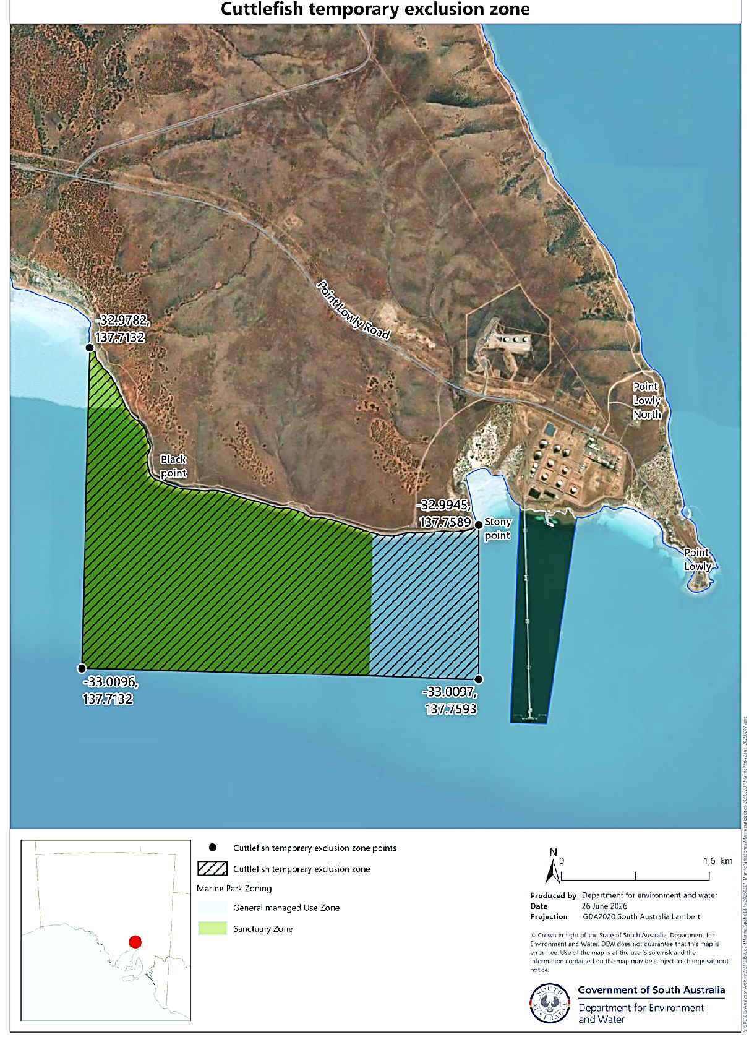
Schedule

Public Sector Act 2009
South Australia
Public Sector (Reorganisation of Public Sector Operations) Notice 2026
under Section 9(1) of the Public Sector Act 2009
1—Short title
This notice may be cited as the Public Sector (Reorganisation of Public Sector Operations) Notice 2026.
2—Commencement
This notice will come into operation on 1 July 2026.
3—Transfer of employees
(1) The employees listed in column 1 of the table below are transferred to employment in the public sector agency listed in column 2 opposite the reference to the employee on the same basis of engagement as applied before the transfer.
(2) A reference to a public sector division or business unit in column 1 includes any employees of that division or business unit who are:
(a) Currently working on a term basis in another public sector agency and who have a right of return to duties pursuant to Regulation 6 of the Public Sector Regulations 2025.
(b) Absent from their substantive duties on any form of paid or unpaid leave and who have a right of return to their duties at the conclusion of such leave.
Column 1—Employees | Column 2—Public Sector Agency
All employees of the CreateSA division (including the Art Gallery of South Australia, State Library of South Australia, South Australian Museum, Carrick Hill Trust and Artlab Australia) within the Department of the Premier and Cabinet immediately before 1 July 2026. | Attorney-General’s Department
All employees of the following units within the Department of the Premier and Cabinet immediately before 1 July 2026:  • Multicultural Affairs  • Office for Autism | Department of Human Services

All employees of the division known as Innovation Places and Lot Fourteen within the Department of the Premier and Cabinet immediately before 1 July 2026. | Department of State Development
All employees of the division known as Thriving Kids within the Department of the Premier and Cabinet immediately before 1 July 2026. | Office for Early Childhood Development
Made by the Premier
On 29 June 2026
DPC26/020CS

All instruments appearing in this gazette are to be considered official, and obeyed as such

Printed and published weekly by authority of T. Foresto, Government Printer, South Australia
$9.50 per issue (plus postage), $479.00 per annual subscription—GST inclusive
Online publications: www.governmentgazette.sa.gov.au

