
No. 14 p. 561
THE SOUTH AUSTRALIAN
GOVERNMENT GAZETTE
Published by Authority

Adelaide, Thursday, 5 March 2026

Contents

State Government Instruments
Associations Incorporation Act 1985 562
Education and Children’s Services Act 2019 562
Electoral Act 1985 579
Energy Resources Act 2000 583
Fisheries Management Act 2007 585
Housing Improvement Act 2016 585
Road Traffic Act 1961 586
Veterinary Services Act 2023 587
Local Government Instruments
City of Adelaide 605
Town of Gawler 605
District Council of Mount Remarkable 605
Yorke Peninsula Council 606
Public Notices
National Energy Retail Law 607
Trustee Act 1936 607

State Government Instruments

Associations Incorporation Act 1985
Section 42(2)
Dissolution of Association
Whereas the Corporate Affairs Commission (the Commission) pursuant to Section 42(1) of the Associations Incorporation Act 1985 (the Act) is of the opinion that the undertaking or operations of RAISING LITERACY AUSTRALIA INCORPORATED (the Association) being an incorporated association under the Act are being carried on, or would more appropriately be carried on by a Company Limited by Guarantee incorporated under the Corporations Act 2001 (Cth) and whereas the Commission was on 11 February 2026 requested by
the Association to transfer its undertaking to RAISING LITERACY AUSTRALIA LTD (Australian Company Number 693 367 896), the Commission pursuant to Section 42(2) of the Act does hereby Order that on 11 Mach 2026 the Association will be dissolved,
the property of the Association becomes the property of RAISING LITERACY AUSTRALIA LTD and the rights and liabilities of the Association become the rights and liabilities of RAISING LITERACY AUSTRALIA LTD.
Given under the seal of the Commission at Adelaide.
Dated: 18 February 2026
Aleena Dar
Delegate of the Corporate Affairs Commission

Education and Children’s Services Act 2019
Amending the Constitution of a Governing Council for a Government School
I, Caroline Fishpool, Lead Director, Conditions for Learning, Schools and Preschools, consider it necessary to amend the constitution of Central Yorke School to ensure that it takes the form of the model constitution for a school with a school-based preschool, and therefore in accordance with Section 40(1) and (2) of the Education and Children’s Services Act 2019, I amend the governing councils’ constitution such that they now read as follows:
Central Yorke School Governing Council Incorporated
Constitution
Table of Contents
1. Name
2. Interpretation
3. Object
4. Powers of the Governing Council
5. Functions of the Council
6. Functions of the Principal on Council
7. Membership
8. Term of Office
9. Office Holders and Executive Committee
9.1 Appointment
9.2 Removal from Office
9.3 The Chairperson
9.4 The Secretary
9.5 The Treasurer
10. Vacancies
11. Meetings
11.1 General Meetings of the School Community
11.2 Council Meetings
11.3 Extraordinary Council Meetings
11.4 Voting
12. Proceedings of the Council
12.1 Meetings
12.2 Conflict of Interest
13. Election of Council Members
13.1 Eligibility for Nomination for Election
13.2 Eligibility to Vote
13.3 Conduct of Elections for Parent Council Members
13.4 Notice of Election
13.5 Election Without Ballot
13.6 Contested Elections
13.7 Scrutineers
13.8 Declaration of Election
13.9 Further Nomination for Unfilled Positions
13.10 Nomination and Appointment of Council Members
14. Minutes
15. Subcommittees
15.1 Committees
15.2 Terms of Reference
15.3 Finance Advisory Committee
16. Finance and Accounts
17. Audit
18. Reporting to the School Community and the Minister
19. The Common Seal
20. Records
21. Amendment of the Constitution
22. Code of Practice
23. Dispute Resolution
24. Public Access to the Constitution and Code of Practice
25. Dissolution
26. Prohibition against Securing Profits for Members
Governing Council Model Constitution
(School with a school-based preschool)
1. Name
The name of the council is Central Yorke School Governing Council Incorporated.
2. Interpretation
In this constitution, unless the contrary intention appears:
‘the Act’ means the Education and Children’s Services Act 2019 as amended.
‘administrative instructions’ means administrative instructions issued pursuant to Section 9 of the Act.
‘administrative unit’ means a government department or attached office.
‘adult’ means a person who has attained 18 years of age.
‘affiliated committee’ means a committee affiliated with the governing council operating under the model constitution for affiliated committees or a constitution approved by the Minister in accordance with Section 36 and 39 of the Act.
‘chairperson’ means the presiding member of the governing council as referred to in Section 35(3) of the Act.
‘Chief Executive’ means the Chief Executive of the Department for Education.
‘governing council’ means the Central Yorke School Governing Council established under Section 34 of the Act.
‘council member’ are the members of the governing council.
‘department’ means the Department for Education.
‘financial year’ means the year ending 31 December or as varied by administrative instruction.
‘general meeting’ means a public meeting of the school community.
‘government school’ means a school established under the Act, or a repealed Act and includes (other than for the purposes of Part 5 of the Act) a special purpose school.
‘majority’ means more than half the total number.
‘Minister’ means the person to whom the administration of the Act is committed, pursuant to the Administrative Arrangements Act 1994.
‘parent’—the Act uses the term “person responsible for a child or student”. In this constitution, the term “parent” will be used instead. This term includes parents, guardians, and persons standing in loco parentis to a student or child, but excludes any person whose custody or guardianship of a student or child, or whose responsibility for a student or child, has been excluded under any Act or law (for example, the Family Law Act 1975 (Cth)).
‘principal’ means the person for the time being designated by the Chief Executive as the principal of the school.
‘regulations’ means the Education and Children’s Services Regulations 2020.
‘school’ means a school at which primary or secondary education or both is, or is to be, provided (whether or not preschool education is also provided at the school).
‘school community’ means parents, students enrolled in or children who are to attend the school, staff of the school and all other persons who have a legitimate interest in or connection with the school.
‘school improvement plan’ means the agreement signed by the principal and the presiding member of the council that summarises the school’s contribution to improving student learning at the site.
‘special resolution’ of the council means a resolution passed by a duly convened meeting of the council where:
(1) at least 14 days written notice has been given to all council members specifying the intention to propose the resolution as a special resolution; and
(2) it is passed by a majority of not less than three quarters of council members who vote in person or by proxy at that meeting.
‘student’ is a person enrolled in the school or approved learning program.

3. Object
The object of the council is to involve the school community in the governance of the school to strengthen and support public education in the community.
4. Powers of the Governing Council
4.1 In addition to the powers conferred under the Act, the council may:
4.1.1 employ persons, except as teachers, as members of the staff of the school on terms and conditions approved by the Chief Executive
4.1.2 enter into contracts
4.1.3 construct any building or structure for the benefit of the school, or make any improvements to the premises or grounds of the school, with the approval of the Chief Executive
4.1.4 purchase or take a lease or licence of premises for student residential facilities, and enter into any other agreements or arrangements for the establishment, management, staffing and operation of such facilities;
4.1.5 establish and conduct, or arrange for the conduct of, facilities and services to enhance the education, development, care, safety, health or welfare of children and students.
4.1.6 do all those acts and things incidental to the exercise of these powers.
4.2 The Council’s powers must be exercised in accordance with legislation, administrative instructions and this constitution.
5. Functions of the Council
5.1 In the context of the council’s joint responsibility with the principal for the governance of the school, the council must perform the following functions:
5.1.1 involve the school community in the governance of the school by:
(i) providing a forum for the involvement of parents and others in the school community
(ii) determining the educational needs of the local community, and their attitude towards educational developments within the school
(iii) ensuring that the cultural and social diversity of the community is considered and particular needs are appropriately identified.
5.1.2 strategic planning for the school including:
(i) developing, monitoring and reviewing the objectives and targets of the strategic plan
(ii) considering, approving and monitoring human resource and asset management plans.
5.1.3 determine local policies for the school.
5.1.4 determine the application of the total financial resources available to the school including the regular review of the budget.
5.1.5 present plans and reports on the council’s operations to the school community and Minister.
5.2 The council must be responsible for the proper care and maintenance of any property owned by the council.
5.3 The council may perform such functions as necessary to establish and conduct, or arrange for the conduct of:
5.3.1 facilities and services to enhance the education, development, care, safety, health or welfare of children and students;
5.3.2 residential facilities for the accommodation of students.
5.4 The council may raise money for school related purposes.
5.5 The council may perform other functions as determined by the Minister or Chief Executive.
5.6 The council may do all those acts and things incidental to the exercise of these functions.
5.7 The council’s functions must be exercised in accordance with legislation, administrative instructions and this constitution.
6. Functions of the Principal on Council
The functions of the principal on council are undertaken in the context of the principal’s joint responsibility with the council for the governance of the school.
6.1 The principal is answerable to the Chief Executive for providing educational leadership in the school and for other general responsibilities prescribed in the Act and Regulations.
6.2 The principal must also:
6.2.1 implement the school’s strategic plan, the school improvement plan and school policies
6.2.2 provide accurate and timely reports, information and advice relevant to the council’s functions
6.2.3 report on learning, care, training and participation outcomes to council
6.2.4 supervise and promote the development of staff employed by the council
6.2.5 be responsible for the financial, physical and human resource management of the school
6.2.6 be an ex-officio member of council with full voting rights
6.2.7 be the returning officer for the election, nomination and appointment of council members
6.2.8 chair the first meeting of the council held for the purpose of receiving nominations from nominating bodies, the direct appointment of council members by the council and the election of office holders
6.2.9 contribute to the formulation of the agenda of council meetings.

7. Membership
7.1 The Central Yorke School Governing Council must comprise 9 council members including:
1 | Principal of the school (ex-officio)
5 | Elected parent members (including preschool parents)
1 | Staff members nominated by the staff of the school (as per ratio in the administrative instructions)
2 | Student representatives nominated by SRC or the students of the school
7.2 The majority of council members must be elected parents of the school.
7.3 At the time of election, nomination or appointment, persons who are on the staff of a government school, persons who are employees of an administrative unit for which the Minister is responsible, and those appointed under the Act, or the Technical and Further Education Act, 1975, must not comprise the majority of elected parent members and must not comprise the majority of council members.
7.4 In considering any nominations to the council by a nominating body or direct appointments by the council, the council must observe the requirements of 7.3.
7.5 A person is not eligible for election, appointment or nomination to the council, if the person:
7.5.1 is an undischarged bankrupt or is receiving the benefit of a law for the relief of insolvent debtors;
7.5.2 has been convicted of any offence prescribed by administrative instruction;
7.5.3 is subject to any other disqualifying circumstances a prescribed by administrative instruction.
8. Term of Office
8.1 Elected parent members will be appointed for a term not exceeding two years, except in the case of the first council only, where one-half (or, if the total number of council members to be elected is odd, the highest integer that is less than one-half) of the parent members elected at the Annual General Meeting of the school will be elected for a term not exceeding one year.
8.2 A council member nominated by an affiliated committee will be nominated for a term not exceeding two years, subject to the provisions that:
8.2.1 for the first council only, where two or more affiliated committees each nominate a council member, one will be appointed for a term not exceeding one year. The person so appointed must be determined by agreement between the affiliated committees, or on failure to agree, by lot.
8.2.2 the nomination may be revoked, in writing, by the affiliated committee.
8.3 Any council member nominated by the Student Representative Council (or equivalent) or elected by the body of students will hold office for a term not exceeding one year or until the nomination is revoked, in writing, by the nominating body.
8.4 A council member elected by the staff of the school will hold office for a term not exceeding one year subject to being a member of the staff of the school.
8.5 Each council member directly appointed by the council, will serve for a period not exceeding two years.
8.6 Upon expiry of term of office, each council member will remain incumbent until the position is declared vacant at the Annual General Meeting.
8.7 Council members are eligible for subsequent re-election, re-nomination or re-appointment.
9. Office Holders and Executive Committee
9.1 Appointment
9.1.1 The office holders of the council are the chairperson, deputy chairperson, secretary and treasurer who must be elected by the council from amongst its council members within one month of the Annual General Meeting.
9.1.2 The chairperson must not be a member of the staff of the school, a person employed in an administrative unit for which the Minister is responsible.
9.1.3 The treasurer must not be a member of the staff of the school.
9.1.4 The council may appoint an executive committee comprising the office holders and the principal, which is to
(i) meet to carry out business delegated or referred by the council; and
(ii) report to subsequent council meetings.
9.2 Removal from Office
9.2.1 The position of any office holder absent for three consecutive executive committee meetings without leave of absence automatically becomes vacant. Acceptance of an apology at the executive committee meeting will be deemed a grant of such leave.
9.2.2 An office holder of the council may be removed from office, but not from membership of the council, by special resolution of the council, provided that:
(i) at least 14 days written notice is given to all council members and to the office holder concerned of any proposed resolution, giving reasons for the proposed removal;
(ii) the office holder is given the right to be heard at the council meeting;
(iii) voting on the special resolution is by secret ballot.

9.3 The Chairperson
9.3.1 The chairperson must:
(i) call and preside at the meetings of the council and the executive committee;
(ii) in consultation with the principal and secretary, prepare the agenda for all council meetings;
(iii) include on the agenda any item requested by the principal;
(iv) facilitate full and balanced participation in meetings by all council members and decide on the manner in which meetings are conducted and matters of order;
(v) report at the Annual General Meeting on the proceedings and operations of the Council for the period since the date of the previous Annual General Meeting.
9.3.2 The chairperson must act as spokesperson on behalf of the council unless an alternative spokesperson has been appointed by the council. The spokesperson may only comment on council matters.
9.3.3 In the chairperson’s absence or inability to act, the deputy chairperson must undertake any role or function normally fulfilled by the chairperson.
9.3.4 If the chairperson and deputy chairperson of the council are absent or unable to preside at a meeting, a council member elected by the council must preside.
9.4 The Secretary
9.4.1 The secretary must ensure that notices of meetings are given in accordance with the provisions of this constitution.
9.4.2 The secretary is responsible for ensuring the maintenance and safekeeping of:
(i) the constitution of the council and the code of practice;
(ii) official records of the business of the council and a register of minutes of meetings;
(iii) copies of notices, a file of correspondence and records of submissions or reports made by or on behalf of the council;
(iv) the register of council members;
(v) contracts or agreements entered into by the council;
(vi) copies of policies of the council.
9.4.3 The secretary must ensure that copies of the constitution and the code of practice are available for public inspection at the school during normal school hours, and that any copies requested are provided.
9.4.4 The secretary must ensure the safekeeping of the common seal and must ensure a record is kept of every use of the common seal.
9.4.5 Prior to each meeting, the secretary must ensure that a copy of the meeting agenda is forwarded to each council member.
9.4.6 The secretary must conduct the official correspondence of the council.
9.4.7 The secretary must ensure that the minutes of meetings are recorded and forwarded to each council member prior to the next meeting.
9.5 The Treasurer
9.5.1 The treasurer must be the chairperson of the Finance Advisory Committee of the council and preside at the meetings of this committee.
9.5.2 The treasurer must:
(i) ensure that the council’s financial budgets and statements are prepared
(ii) submit a report of those finances to each council meeting;
(iii) present the council’s statement of accounts to the Annual General Meeting.
10. Vacancies
10.1 Membership of the council ceases when a council member:
10.1.1 dies;
10.1.2 in the case of an elected council member or a council member nominated or appointed for a term, completes a term of office and is not re-elected, re-nominated or re-appointed;
10.1.3 ceases to hold office in accordance with 8.2.2 and 8.3;
10.1.4 in the case of a member nominated by the staff of the school, is no longer a staff member of the school;
10.1.5 resigns by written notice to the council;
10.1.6 is removed from office by the Minister in accordance with Section 44 of the Act;
10.1.7 is declared bankrupt or applies for the benefit of a law for the relief of insolvent debtors;
10.1.8 has been convicted of any offence prescribed by administrative instruction;
10.1.9 is subject to any disqualifying circumstance as prescribed by administrative instruction; or
10.1.10 is absent from three consecutive council meetings without leave of absence approved by the council. Acceptance of an apology at a council meeting will be deemed a grant of such leave.
10.2 The council may appoint a person to temporarily fill a casual vacancy in its membership until a council member can be elected, nominated or appointed in accordance with this constitution.

11. Meetings
11.1 General meetings of the School Community
11.1.1 Subject to 13.2, all persons within the school community are eligible to attend general meetings of the school community and vote on any matters proposed for resolution.
11.1.2 The chairperson of the council must call and preside at general meetings of the school community, the timing to be agreed between the chairperson and the principal of the school.
11.1.3 At least 14 days written notice of the meeting must be given to the school community by the means generally used to communicate with the school community. The notice must specify the date, time and place of the meeting.
11.1.4 A general meeting must be held:
(i) at least once annually (the Annual General Meeting) to present reports, to elect parents to the council and/or declare election results;
(ii) for any other reason relating to the affairs, functions or membership of the council, determined by agreement between the chairperson and the principal.
11.1.5 The period between each Annual General Meeting must not exceed 16 months.
11.1.6 A general meeting must be held to elect council members, to discuss the finances of the council or for any other reason relating to the affairs or functions of the council:
(i) at the request of the Chief Executive;
(ii) by the resolution of the council;
(iii) at the request of 20 parents or one half of the parents of the school, whichever is less.
11.1.7 A conference by telephone or other electronic means will be taken to be a general meeting of the school community provided that all procedures in this constitution relating to general meetings are complied with and each participating member is capable of communicating with every other participating member during the conference.
11.2 Council Meetings
11.2.1 The council must meet at least twice in each school term.
11.2.2 Notice of meetings must be given at the previous council meeting or by at least 7 days written notice distributed to all council members or in an emergency by such other notice as the council may determine.
11.2.3 A conference by telephone or other electronic means between the council members will be taken to be a meeting of the council provided that all procedures in this constitution relating to council meetings are complied with and each participating member is capable of communicating with every other participating member during the conference.
11.3 Extraordinary Council Meetings
11.3.1 The chairperson of the council must call an extraordinary meeting of the council by written request from at least 3 council members.
11.3.2 Notice of meeting must be given by written notice to all council members within a reasonable time, setting out the time, date, place and object of the meeting.
11.3.3 The business of any extraordinary meeting must be confined to the object for which it is convened.
11.4 Voting
11.4.1 Voting must be by show of hands, or in the case of a meeting held pursuant to 11.1.7 and 11.2.3, by voices or in writing, but a secret ballot must be conducted for:
(i) a contested election; or
(ii) a special resolution to remove an office holder from office.
11.4.2 For the purposes of voting on a special resolution, each council member is entitled to appoint another council member as their proxy.
12. Proceedings of the Council
12.1 Meetings
12.1.1 The quorum for a council meeting is a majority of the filled positions of the council.
12.1.2 If at the expiration of 30 minutes after the appointed time for the meeting there is no quorum present, the meeting must stand adjourned to such time and place as those council members present determine.
12.1.3 Except in the case of a special resolution, a decision of the majority of those council members present and eligible to vote is the decision of the council.
12.1.4 The chairperson must have a deliberative vote only. In the event of an equality of votes, the chairperson does not have a second or casting vote and the motion must be taken to be defeated.
12.1.5 The council or any committee of council may, at its discretion, allow non-members who have special interests or knowledge relevant to the council to attend its meetings as observers and, if it agrees, take part in discussions on particular issues. Non-members cannot vote. This clause does not apply to the finance advisory committee.
12.1.6 Where there are one or more vacancies in the membership of the council, the council is not prevented from acting by the requirement that the majority of its members must be elected parents of the school or by any other requirement of membership (except the requirement as to quorum).
12.1.7 The council may from time to time determine procedures to facilitate and expedite its business.
12.2 Conflict of Interest
12.2.1 In accordance with Section 37 of the Act, a council member who has a direct or indirect pecuniary interest in a contract or proposed contract with the council must:

(i) disclose the nature of the interest to the council as soon as the council member becomes aware of the interest;
(ii) not take part in deliberations or decisions of the council with respect to that contract;
(iii) not vote in relation to the contract; and
(iv) be absent from the meeting room when any such discussion or voting is taking place.
12.2.2 A disclosure of such an interest, and any associated actions taken to mitigate the disclosed interest, must be recorded in the minutes of the council.
12.2.3 If a council member discloses an interest in a contract or proposed contract:
(i) the contract is not liable to be avoided by the council on any ground arising from the fiduciary relationship between the council member and the council; and
(ii) the member is not liable to account for the profits derived from the contract.
13. Election of Council Members
13.1 Eligibility for Nomination for Election
Subject to 7.5, all people who are parents of the school are eligible to nominate for election as a council member.
13.2 Eligibility to Vote
Only parents of the school may vote to elect parent council members.
13.3 Conduct of Elections for Parent Council Members
The principal must conduct elections for parent council members by one of the following methods, as determined by the council:
(i) an election at a general meeting of the school community;
(ii) a postal ballot of the parents of the school.
13.4 Notice of Election
13.4.1 The timetable for an election must be determined by the council, in consultation with the principal.
13.4.2 Notice of the date and time for an election must be specified by the principal by the means generally used to communicate with the school community.
13.4.3 The notice must:
(i) fix the period during which nominations for election as council members must be accepted and outline the process to be followed;
(ii) fix the date and time of the general meeting for the election (not being less than 14 days from publication of the notice); and
(iii) in the case of the postal ballot:
(a) fix the date by which ballot papers must be available and advise how they may be obtained; and
(b) fix the date by which ballot papers must be returned and advise how they must be lodged.
13.4.4 In consultation with the council, the principal must determine the form for nominations and the period during which nominations will be accepted.
13.4.5 A nomination for election as a council member must be:
(i) in a form approved by the principal; and
(ii) received by the principal at or before the time the nomination is due.
13.5 Election without Ballot
If the number of persons nominated is the same or less than the number of vacancies to be filled by election, the principal may declare that the vacancy or vacancies has or have been filled by the person or persons nominated.
13.6 Contested Elections
13.6.1 If the number of persons nominated is greater than the number of vacancies to be filled, the ballot conditions apply.
13.6.2 A contested election must be conducted by secret ballot.
13.7 Scrutineers
The principal must permit such scrutineers, who are independent of the election, to be present at the counting of votes as the principal sees fit. A candidate in the election cannot be a scrutineer.
13.8 Declaration of Election
13.8.1 The principal must declare the candidate or candidates elected to fill the vacancy or vacancies:
(i) at a general meeting of the school community; or
(ii) in the form generally used to communicate with the school community.
13.8.2 The new council comes into operation at the declaration of the election.
13.9 Further Nomination for Unfilled Positions
After the result of an election has been declared and if the required number of positions of elected parent council member positions has not been filled, parents present at a general meeting may be invited to nominate and be elected by a further ballot to the remaining vacancies.

13.10 Nomination and Appointment of Council Members
13.10.1 As soon as is practicable after the declaration of the results of an election, the principal must call and preside at the first council meeting for the purpose only of:
(i) receiving the nominations from nominating bodies and determining the direct appointment of members of the community; and
(ii) electing office holders.
13.10.2 The first meeting of the council must be adjourned to a date decided by the meeting if the purpose of the meeting cannot be achieved.
13.10.3 If upon the resumption of the meeting the appointment of community members or receiving nominations cannot be resolved, the council may proceed to the election of office holders.
14. Minutes
14.1 Proper minutes of council meetings, the Annual General Meeting and general meetings of the school community must be appropriately kept.
14.2 The minutes must be confirmed at the next respective annual, general or council meeting and signed by the chairperson of the meeting at which the proceedings took place or by the chairperson of the subsequent meeting.
14.3 Upon reasonable notice, copies of the minutes of any meetings must be made available for inspection by any council member.
15. Subcommittees
15.1 Committees
The council may appoint committees, comprised of council members or both council members and non-council members, which will meet as directed by the council and report to the council at subsequent council meetings. Any committee must consist of at least three people and at least one of those must be a council member.
15.2 Terms of Reference
The council must specify terms of reference for its committees.
15.3 Finance Advisory Committee
15.3.1 The council must establish a Finance Advisory Committee to advise the council on budgetary and financial matters, including the preparation of the preliminary budget showing:
(i) the anticipated income available for the ensuing twelve months (both from normal transactions and from fund-raising activities);
(ii) the proposed expenditure to be made; and
(iii) details of any funds held for special purposes.
15.3.2 The membership must be determined by the council and must include
(i) the treasurer;
(ii) the principal or nominee.
15.3.3 The Finance Advisory Committee must meet at least once each school term to examine receipts and payments and review the school budget.
16. Finance and Accounts
16.1 The council must ensure that proper accounts are kept of its financial affairs, and in controlling any account must ensure proper books and accounts are kept of all funds paid to that account, together with details of any dealing involving those funds.
16.2 All accounts must be operated on the basis of the designated finance year, which is a calendar year ending on 31 December.
16.3 All accounts must be kept in accordance with provisions of the Act, regulations, this constitution and administrative instructions.
16.4 The funds of the council must only be expended for school related purposes.
16.5 The council may transfer funds as it thinks fit to:
16.5.1 an affiliated committee;
16.5.2 another existing or proposed Government school.
17. Audit
17.1 The Council must make available to the Chief Executive or the Auditor-General any accounts under its control, including all relevant records and papers connected with an account, for inspection or audit at any time.
17.2 The council may arrange for accounts to be audited at such other intervals as the council determines, by a person appointed by the council.
17.3 The audit of any accounts under the control of the council must be in accordance with the provisions of the Act, regulations, this constitution and administrative instructions.
18. Reporting to the School Community and the Minister
18.1 The council must report to the school community at least once a year, at the Annual General Meeting called by the chairperson.
18.2 At that meeting:

18.2.1 the chairperson must report on:
(i) strategic and other plans;
(ii) the proceedings and operations of the council for the period since the date of the previous Annual General Meeting of the school community;
(iii) the outcomes of those proceedings in relation to the functions of the council; and
18.2.2 the treasurer must present an up-to-date statement of receipts and expenditure with respect to all accounts controlled by the council, and a copy of the statement of receipts and expenditure of the council for the year ended as at the designated financial year.
18.3 Where any statement has been subject to an audit, the audited statement is to be subsequently made available for inspection, at the school, as determined at the meeting.
18.4 The council must report to the Minister at least once a year, in accordance with administrative instructions.
19. The Common Seal
19.1 The council must have a common seal. The common seal must be affixed only by resolution of the council and in the presence of two council members, one of whom must be the principal or the chairperson of the council.
19.2 The council must keep a record of every use of the seal, including date, purpose and any other relevant information.
20. Records
20.1 The council is responsible for the safe and proper storage of its records.
20.2 The council must make the records available at any time to the Minister or to any person authorised by the Minister and allow those records to be removed by any such person.
21. Amendment of the Constitution
21.1 This constitution may be altered, modified or substituted at the direction of the Minister, in accordance with Section 40 of the Act.
21.2 This constitution may also be amended, altered, modified or substituted by the council by special resolution and approval in writing by the Minister.
21.3 An amendment to the constitution has no effect until submitted to and approved by the Minister.
22. Code of Practice
Members of the council must comply with the code of practice approved by the Minister.
23. Dispute Resolution
The council must participate in a scheme for the resolution of disputes between the council and the department/principal, as prescribed in administrative instruction.
24. Public Access to the Constitution and Code of Practice
The council must keep available for public inspection a copy of its constitution (as in force from time to time) and the code of practice, at the school, during normal school hours.
25. Dissolution
In accordance with Section 43 of the Act, the Minister may dissolve the council.
26. Prohibition against Securing Profits for Members
The assets and income of the council must be applied exclusively for school related purposes and no portion may be paid or distributed directly or indirectly to council members in their role as a council member, except for expenses incurred on behalf of the council.
These amendments take effect from the date of publication of this notice in the Gazette.
Dated: 5 March 2026
Caroline Fishpool
Lead Director, Conditions for Learning, Schools and Preschools
Delegate of the Minister for Education

EDUCATION AND CHILDREN’S SERVICES ACT 2019
Amending the Constitution of a Governing Council for a Government School
I, Caroline Fishpool, Lead Director, Conditions for Learning, Schools and Preschools, consider it necessary to amend the constitution of Sturt Street Community School to ensure that it takes the form of the model constitution for a school without a school-based preschool, and therefore in accordance with Section 40(1) and (2) of the Education and Children’s Services Act 2019, I amend the governing councils’ constitution such that they now read as follows:
Sturt Street Community School Governing Council Incorporated
Constitution
Table of Contents
1. Name
2. Interpretation
3. Object
4. Powers of the Governing Council
5. Functions of the Council
6. Functions of the Principal on Council
7. Membership
8. Term of Office
9. Office Holders And Executive Committee
9.1 Appointment
9.2 Removal from Office
9.3 The Chairperson
9.4 The Secretary
9.5 The Treasurer
10. Vacancies
11. Meetings
11.1 General Meetings of the School Community
11.2 Council Meetings
11.3 Extraordinary Council Meetings
11.4 Voting
12. Proceedings of the Council
12.1 Meetings
12.2 Conflict of Interest
13. Election of Council Members
13.1 Eligibility for Nomination for Election
13.2 Eligibility to Vote
13.3 Conduct of Elections for Parent Council Members
13.4 Notice of Election
13.5 Election Without Ballot
13.6 Contested Elections
13.7 Scrutineers
13.8 Declaration of Election
13.9 Further Nomination for Unfilled Positions
13.10 Nomination and Appointment of Council Members
14. Minutes
15. Subcommittees
15.1 Committees
15.2 Terms of Reference
15.3 Finance Advisory Committee
16. Finance and Accounts
17. Audit
18. Reporting to the School Community and the Minister
19. The Common Seal
20. Records
21. Amendment of the Constitution
22. Code of Practice
23. Dispute Resolution
24. Public Access to the Constitution and Code of Practice
25. Dissolution
26. Prohibition Against Securing Profits for Members
Governing Council Model Constitution
(School without a school-based preschool)
1. Name
The name of the council is Sturt Street Community School Governing Council Incorporated.
2. Interpretation
In this constitution, unless the contrary intention appears:
‘the Act’ means the Education and Children’s Services Act 2019 as amended.
‘administrative instructions’ means administrative instructions issued pursuant to Section 9 of the Act.
‘administrative unit’ means a government department or attached office.
‘adult’ means a person who has attained 18 years of age.
‘affiliated committee’ means a committee affiliated with the governing council operating under the model constitution for affiliated committees or a constitution approved by the Minister in accordance with Section 36 and 39 of the Act.
‘chairperson’ means the presiding member of the governing council as referred to in Section 35 (3) of the Act.
‘Chief Executive’ means the Chief Executive of the Department for Education.
‘governing council’ means the Sturt Street Community School Governing Council established under Section 34 of the Act.
‘council member are the members of the governing council.
‘department’ means the Department for Education.
‘financial year’ means the year ending 31 December or as varied by administrative instruction.
‘general meeting’ means a public meeting of the school community.
‘government school’ means a school established under the Act, or a repealed Act and includes (other than for the purposes of Part 5 of the Act) a special purpose school.
‘majority’ means more than half the total number.
‘Minister’ means the person to whom the administration of the Act is committed, pursuant to the Administrative Arrangements Act 1994.
‘parent’—the Act uses the term “person responsible for a child or student”. In this constitution, the term “parent” will be used instead. This term includes parents, guardians, and persons standing in loco parentis to a student or child, but excludes any person whose custody or guardianship of a student or child, or whose responsibility for a student or child, has been excluded under any Act or law (for example, the Family Law Act 1975 (Cth)).
‘principal’ means the person for the time being designated by the Chief Executive as the principal of the school.
‘regulations’ means the Education and Children’s Services Regulations 2020.
‘school’ means a school at which primary or secondary education or both is, or is to be, provided (whether or not preschool education is also provided at the school).
‘school community’ means parents, students enrolled in or children who are to attend the school, staff of the school and all other persons who have a legitimate interest in or connection with the school.
‘school improvement plan’ means the agreement signed by the principal and the presiding member of the council that summarises the school’s contribution to improving student learning at the site.
‘special resolution’ of the council means a resolution passed by a duly convened meeting of the council where:
(1) at least 14 days written notice has been given to all council members specifying the intention to propose the resolution as a special resolution; and
(2) it is passed by a majority of not less than three quarters of council members who vote in person or by proxy at that meeting.
‘student’ is a person enrolled in the school or approved learning program.
3. Object
The object of the council is to involve the school community in the governance of the school to strengthen and support public education in the community.
4. Powers of the Governing Council
4.1 In addition to the powers conferred under the Act, the council may:
4.1.1 employ persons, except as teachers, as members of the staff of the school on terms and conditions approved by the Chief Executive
4.1.2 enter into contracts
4.1.3 construct any building or structure for the benefit of the school, or make any improvements to the premises or grounds of the school, with the approval of the Chief Executive
4.1.4 purchase or take a lease or licence of premises for student residential facilities, and enter into any other agreements or arrangements for the establishment, management, staffing and operation of such facilities;
4.1.5 establish and conduct, or arrange for the conduct of, facilities and services to enhance the education, development, care, safety, health or welfare of children and students.
4.1.6 do all those acts and things incidental to the exercise of these powers.
4.2 The Council’s powers must be exercised in accordance with legislation, administrative instructions and this constitution.
5. Functions of the Council
5.1 In the context of the council’s joint responsibility with the principal for the governance of the school, the council must perform the following functions:
5.1.1 involve the school community in the governance of the school by:
(i) providing a forum for the involvement of parents and others in the school community
(ii) determining the educational needs of the local community, and their attitude towards educational developments within the school
(iii) ensuring that the cultural and social diversity of the community is considered and particular needs are appropriately identified.
5.1.2 strategic planning for the school including:
(i) developing, monitoring and reviewing the objectives and targets of the strategic plan
(ii) considering, approving and monitoring human resource and asset management plans.
5.1.3 determine local policies for the school.
5.1.4 determine the application of the total financial resources available to the school including the regular review of the budget.
5.1.5 present plans and reports on the council’s operations to the school community and Minister.
5.2 The council must be responsible for the proper care and maintenance of any property owned by the council.
5.3 The Council may perform such functions as necessary to establish and conduct, or arrange for the conduct of:
5.3.1 facilities and services to enhance the education, development, care, safety, health or welfare of children and students;
5.3.2 residential facilities for the accommodation of students.
5.4 The council may raise money for school related purposes.
5.5 The council may perform other functions as determined by the Minister or Chief Executive.
5.6 The council may do all those acts and things incidental to the exercise of these functions.
5.7 The council’s functions must be exercised in accordance with legislation, administrative instructions and this constitution.
6. Functions of the Principal on Council
The functions of the principal on council are undertaken in the context of the principal’s joint responsibility with the council for the governance of the school.
6.1 The principal is answerable to the Chief Executive for providing educational leadership in the school and for other general responsibilities prescribed in the Act and Regulations.
6.2 The principal must also:
6.2.1 implement the school’s strategic plan, the school improvement plan and school policies
6.2.2 provide accurate and timely reports, information and advice relevant to the council’s functions
6.2.3 report on learning, care, training and participation outcomes to council
6.2.4 supervise and promote the development of staff employed by the council
6.2.5 be responsible for the financial, physical and human resource management of the school
6.2.6 be an ex-officio member of council with full voting rights
6.2.7 be the returning officer for the election, nomination and appointment of council members
6.2.8 chair the first meeting of the council held for the purpose of receiving nominations from nominating bodies, the direct appointment of council members by the council and the election of office holders
6.2.9 contribute to the formulation of the agenda of council meetings.
7. Membership
7.1 The Sturt Street Community School Governing Council must comprise 8 council members including:
1 | Principal of the school (ex-officio)
5 | Elected parent members
1 | Staff member nominated by the staff of the school (as per ratio in the administrative instructions)
1 | Community members appointed by the council
7.2 The majority of council members must be elected parents of the school.
7.3 At the time of election, nomination or appointment, persons who are on the staff of a government school, persons who are employees of an administrative unit for which the Minister is responsible, and those appointed under the Act or the Technical and Further Education Act 1975, must not comprise the majority of elected parent members and must not comprise the majority of council members.
7.4 In considering any nominations to the council by a nominating body or direct appointments by the council, the council must observe the requirements of 7.3.
7.5 A person is not eligible for election, appointment or nomination to the council, if the person:
7.5.1 is an undischarged bankrupt or is receiving the benefit of a law for the relief of insolvent debtors;
7.5.2 has been convicted of any offence prescribed by administrative instruction;
7.5.3 is subject to any other disqualifying circumstances a prescribed by administrative instruction.
8. Term of Office
8.1 Elected parent members will be appointed for a term not exceeding two years, except in the case of the first council only, where one-half (or, if the total number of council members to be elected is odd, the highest integer that is less than one-half) of the parent members elected at the Annual General Meeting of the school will be elected for a term not exceeding one year.
8.2 A council member nominated by an affiliated committee will be nominated for a term not exceeding two years, subject to the provisions that:
8.2.1 for the first council only, where two or more affiliated committees each nominate a council member, one will be appointed for a term not exceeding one year. The person so appointed must be determined by agreement between the affiliated committees, or on failure to agree, by lot.
8.2.2 the nomination may be revoked, in writing, by the affiliated committee.
8.3 Any council member nominated by the Student Representative Council (or equivalent) or elected by the body of students will hold office for a term not exceeding one year or until the nomination is revoked, in writing, by the nominating body.
8.4 A council member elected by the staff of the school will hold office for a term not exceeding one year subject to being a member of the staff of the school.
8.5 Each council member directly appointed by the council, will serve for a period not exceeding two years.
8.6 Upon expiry of term of office, each council member will remain incumbent until the position is declared vacant at the Annual General Meeting.
8.7 Council members are eligible for subsequent re-election, re-nomination or re-appointment.

9. Office Holders and Executive Committee
9.1 Appointment
9.1.1 The office holders of the council are the chairperson, deputy chairperson, secretary and treasurer who must be elected by the council from amongst its council members within one month of the Annual General Meeting.
9.1.2 The chairperson must not be a member of the staff of the school, a person employed in an administrative unit for which the Minister is responsible.
9.1.3 The treasurer must not be a member of the staff of the school.
9.1.4 The council may appoint an executive committee comprising the office holders and the principal, which is to
(i) meet to carry out business delegated or referred by the council; and
(ii) report to subsequent council meetings.
9.2 Removal from office
9.2.1 The position of any office holder absent for three consecutive executive committee meetings without leave of absence automatically becomes vacant. Acceptance of an apology at the executive committee meeting will be deemed a grant of such leave.
9.2.2 An office holder of the council may be removed from office, but not from membership of the council, by special resolution of the council, provided that:
(i) at least 14 days written notice is given to all council members and to the office holder concerned of any proposed resolution, giving reasons for the proposed removal;
(ii) the office holder is given the right to be heard at the council meeting;
(iii) voting on the special resolution is by secret ballot.
9.3 The chairperson
9.3.1 The chairperson must:
(i) call and preside at the meetings of the council and the executive committee;
(ii) in consultation with the principal and secretary, prepare the agenda for all council meetings;
(iii) include on the agenda any item requested by the principal;
(iv) facilitate full and balanced participation in meetings by all council members and decide on the manner in which meetings are conducted and matters of order;
(v) report at the Annual General Meeting on the proceedings and operations of the Council for the period since the date of the previous Annual General Meeting.
9.3.2 The chairperson must act as spokesperson on behalf of the council unless an alternative spokesperson has been appointed by the council. The spokesperson may only comment on council matters.
9.3.3 In the chairperson’s absence or inability to act, the deputy chairperson must undertake any role or function normally fulfilled by the chairperson.
9.3.4 If the chairperson and deputy chairperson of the council are absent or unable to preside at a meeting, a council member elected by the council must preside.
9.4 The secretary
9.4.1 The secretary must ensure that notices of meetings are given in accordance with the provisions of this constitution.
9.4.2 The secretary is responsible for ensuring the maintenance and safekeeping of:
(i) the constitution of the council and the code of practice;
(ii) official records of the business of the council and a register of minutes of meetings;
(iii) copies of notices, a file of correspondence and records of submissions or reports made by or on behalf of the council;
(iv) the register of council members;
(v) contracts or agreements entered into by the council;
(vi) copies of policies of the council.
9.4.3 The secretary must ensure that copies of the constitution and the code of practice are available for public inspection at the school during normal school hours, and that any copies requested are provided.
9.4.4 The secretary must ensure the safekeeping of the common seal and must ensure a record is kept of every use of the common seal.
9.4.5 Prior to each meeting, the secretary must ensure that a copy of the meeting agenda is forwarded to each council member.
9.4.6 The secretary must conduct the official correspondence of the council.
9.4.7 The secretary must ensure that the minutes of meetings are recorded and forwarded to each council member prior to the next meeting.
9.5 The treasurer
9.5.1 The treasurer must be the chairperson of the Finance Advisory Committee of the council and preside at the meetings of this committee.
9.5.2 The treasurer must:
(i) ensure that the council’s financial budgets and statements are prepared
(ii) submit a report of those finances to each council meeting;
(iii) present the council’s statement of accounts to the Annual General Meeting.
10. Vacancies
10.1 Membership of the council ceases when a council member:
10.1.1 dies;
10.1.2 in the case of an elected council member or a council member nominated or appointed for a term, completes a term of office and is not re-elected, re-nominated or re-appointed;
10.1.3 ceases to hold office in accordance with 8.2.2 and 8.3;
10.1.4 in the case of a member nominated by the staff of the school, is no longer a staff member of the school;
10.1.5 resigns by written notice to the council;
10.1.6 is removed from office by the Minister in accordance with Section 44 of the Act;
10.1.7 is declared bankrupt or applies for the benefit of a law for the relief of insolvent debtors;
10.1.8 has been convicted of any offence prescribed by administrative instruction;
10.1.9 is subject to any disqualifying circumstance as prescribed by administrative instruction; or
10.1.10 is absent from three consecutive council meetings without leave of absence approved by the council. Acceptance of an apology at a council meeting will be deemed a grant of such leave.
10.2 The council may appoint a person to temporarily fill a casual vacancy in its membership until a council member can be elected, nominated or appointed in accordance with this constitution.
11. Meetings
11.1 General meetings of the school community
11.1.1 Subject to 13.2, all persons within the school community are eligible to attend general meetings of the school community and vote on any matters proposed for resolution.
11.1.2 The chairperson of the council must call and preside at general meetings of the school community, the timing to be agreed between the chairperson and the principal of the school.
11.1.3 At least 14 days written notice of the meeting must be given to the school community by the means generally used to communicate with the school community. The notice must specify the date, time and place of the meeting.
11.1.4 A general meeting must be held:
(i) at least once annually (the Annual General Meeting) to present reports, to elect parents to the council and/or declare election results;
(ii) for any other reason relating to the affairs, functions or membership of the council, determined by agreement between the chairperson and the principal.
11.1.5 The period between each Annual General Meeting must not exceed 16 months.
11.1.6 A general meeting must be held to elect council members, to discuss the finances of the council or for any other reason relating to the affairs or functions of the council:
(i) at the request of the Chief Executive;
(ii) by the resolution of the council;
(iii) at the request of 20 parents or one half of the parents of the school, whichever is less.
11.1.7 A conference by telephone or other electronic means will be taken to be a general meeting of the school community provided that all procedures in this constitution relating to general meetings are complied with and each participating member is capable of communicating with every other participating member during the conference.
11.2 Council meetings
11.2.1 The council must meet at least twice in each school term.
11.2.2 Notice of meetings must be given at the previous council meeting or by at least 7 days written notice distributed to all council members or in an emergency by such other notice as the council may determine.
11.2.3 A conference by telephone or other electronic means between the council members will be taken to be a meeting of the council provided that all procedures in this constitution relating to council meetings are complied with and each participating member is capable of communicating with every other participating member during the conference.
11.3 Extraordinary council meetings
11.3.1 The chairperson of the council must call an extraordinary meeting of the council by written request from at least 3 council members.
11.3.2 Notice of meeting must be given by written notice to all council members within a reasonable time, setting out the time, date, place and object of the meeting.
11.3.3 The business of any extraordinary meeting must be confined to the object for which it is convened.
11.4 Voting
11.4.1 Voting must be by show of hands, or in the case of a meeting held pursuant to 11.1.7 and 11.2.3, by voices or in writing, but a secret ballot must be conducted for:
(i) a contested election; or
(ii) a special resolution to remove an office holder from office.
11.4.2 For the purposes of voting on a special resolution, each council member is entitled to appoint another council member as their proxy.

12. Proceedings of the Council
12.1 Meetings
12.1.1 The quorum for a council meeting is a majority of the filled positions of the council.
12.1.2 If at the expiration of 30 minutes after the appointed time for the meeting there is no quorum present, the meeting must stand adjourned to such time and place as those council members present determine.
12.1.3 Except in the case of a special resolution, a decision of the majority of those council members present and eligible to vote is the decision of the council.
12.1.4 The chairperson must have a deliberative vote only. In the event of an equality of votes, the chairperson does not have a second or casting vote and the motion must be taken to be defeated.
12.1.5 The council or any committee of council may, at its discretion, allow non-members who have special interests or knowledge relevant to the council to attend its meetings as observers and, if it agrees, take part in discussions on particular issues. Non-members cannot vote. This clause does not apply to the finance advisory committee.
12.1.6 Where there are one or more vacancies in the membership of the council, the council is not prevented from acting by the requirement that the majority of its members must be elected parents of the school or by any other requirement of membership (except the requirement as to quorum).
12.1.7 The council may from time to time determine procedures to facilitate and expedite its business.
12.2 Conflict of interest
12.2.1 In accordance with Section 37 of the Act, a council member who has a direct or indirect pecuniary interest in a contract or proposed contract with the council must:
(i) disclose the nature of the interest to the council as soon as the council member becomes aware of the interest;
(ii) not take part in deliberations or decisions of the council with respect to that contract;
(iii) not vote in relation to the contract; and
(iv) be absent from the meeting room when any such discussion or voting is taking place.
12.2.2 A disclosure of such an interest, and any associated actions taken to mitigate the disclosed interest, must be recorded in the minutes of the council.
12.2.3 If a council member discloses an interest in a contract or proposed contract:
(i) the contract is not liable to be avoided by the council on any ground arising from the fiduciary relationship between the council member and the council; and
(ii) the member is not liable to account for the profits derived from the contract.
13. Election of Council Members
13.1 Eligibility for nomination for election
Subject to 7.5, all people who are parents of the school are eligible to nominate for election as a council member.
13.2 Eligibility to vote
Only parents of the school may vote to elect parent council members.
13.3 Conduct of elections for parent council members
The principal must conduct elections for parent council members by one of the following methods, as determined by the council:
(i) an election at a general meeting of the school community;
(ii) a postal ballot of the parents of the school.
13.4 Notice of election
13.4.1 The timetable for an election must be determined by the council, in consultation with the principal.
13.4.2 Notice of the date and time for an election must be specified by the principal by the means generally used to communicate with the school community.
13.4.3 The notice must:
(i) fix the period during which nominations for election as council members must be accepted and outline the process to be followed;
(ii) fix the date and time of the general meeting for the election (not being less than 14 days from publication of the notice); and
(iii) in the case of the postal ballot:
(a) fix the date by which ballot papers must be available and advise how they may be obtained; and
(b) fix the date by which ballot papers must be returned and advise how they must be lodged.
13.4.4 In consultation with the council, the principal must determine the form for nominations and the period during which nominations will be accepted.
13.4.5 A nomination for election as a council member must be:
(i) in a form approved by the principal; and
(ii) received by the principal at or before the time the nomination is due.
13.5 Election without ballot
If the number of persons nominated is the same or less than the number of vacancies to be filled by election, the principal may declare that the vacancy or vacancies has or have been filled by the person or persons nominated.

13.6 Contested elections
13.6.1 If the number of persons nominated is greater than the number of vacancies to be filled, the ballot conditions apply.
13.6.2 A contested election must be conducted by secret ballot.
13.7 Scrutineers
The principal must permit such scrutineers, who are independent of the election, to be present at the counting of votes as the principal sees fit. A candidate in the election cannot be a scrutineer.
13.8 Declaration of election
13.8.1 The principal must declare the candidate or candidates elected to fill the vacancy or vacancies:
(i) at a general meeting of the school community; or
(ii) in the form generally used to communicate with the school community.
13.8.2 The new council comes into operation at the declaration of the election.
13.9 Further nomination for unfilled positions
After the result of an election has been declared and if the required number of positions of elected parent council member positions has not been filled, parents present at a general meeting may be invited to nominate and be elected by a further ballot to the remaining vacancies.
13.10 Nomination and appointment of council members
13.10.1 As soon as is practicable after the declaration of the results of an election, the principal must call and preside at the first council meeting for the purpose only of:
(i) receiving the nominations from nominating bodies and determining the direct appointment of members of the community; and
(ii) electing office holders.
13.10.2 The first meeting of the council must be adjourned to a date decided by the meeting if the purpose of the meeting cannot be achieved.
13.10.3 If upon the resumption of the meeting the appointment of community members or receiving nominations cannot be resolved, the council may proceed to the election of office holders.
14. Minutes
14.1 Proper minutes of council meetings, the Annual General Meeting and general meetings of the school community must be appropriately kept.
14.2 The minutes must be confirmed at the next respective annual, general or council meeting and signed by the chairperson of the meeting at which the proceedings took place or by the chairperson of the subsequent meeting.
14.3 Upon reasonable notice, copies of the minutes of any meetings must be made available for inspection by any council member.
15. Subcommittees
15.1 Committees
The council may appoint committees, comprised of council members or both council members and non-council members, which will meet as directed by the council and report to the council at subsequent council meetings. Any committee must consist of at least three people and at least one of those must be a council member.
15.2 Terms of reference
The council must specify terms of reference for its committees.
15.3 Finance Advisory Committee
15.3.1 The council must establish a Finance Advisory Committee to advise the council on budgetary and financial matters, including the preparation of the preliminary budget showing:
(i) the anticipated income available for the ensuing twelve months (both from normal transactions and from fund-raising activities);
(ii) the proposed expenditure to be made; and
(iii) details of any funds held for special purposes.
15.3.2 The membership must be determined by the council and must include
(i) the treasurer;
(ii) the principal or nominee.
15.3.3 The Finance Advisory Committee must meet at least once each school term to examine receipts and payments and review the school budget.
16. Finance and Accounts
16.1 The council must ensure that proper accounts are kept of its financial affairs, and in controlling any account must ensure proper books and accounts are kept of all funds paid to that account, together with details of any dealing involving those funds.
16.2 All accounts must be operated on the basis of the designated finance year, which is a calendar year ending on 31 December.
16.3 All accounts must be kept in accordance with provisions of the Act, Regulations, this constitution and administrative instructions.
16.4 The funds of the council must only be expended for school related purposes.
16.5 The council may transfer funds as it thinks fit to:
16.5.1 an affiliated committee;
16.5.2 another existing or proposed Government school.
17. Audit
17.1 The Council must make available to the Chief Executive or the Auditor-General any accounts under its control, including all relevant records and papers connected with an account, for inspection or audit at any time.
17.2 The council may arrange for accounts to be audited at such other intervals as the council determines, by a person appointed by the council.
17.3 The audit of any accounts under the control of the council must be in accordance with the provisions of the Act, Regulations, this constitution and administrative instructions.
18. Reporting to the School Community and the Minister
18.1 The council must report to the school community at least once a year, at the Annual General Meeting called by the chairperson.
18.2 At that meeting:
18.2.1 the chairperson must report on:
(i) strategic and other plans;
(ii) the proceedings and operations of the council for the period since the date of the previous Annual General Meeting of the school community;
(iii) the outcomes of those proceedings in relation to the functions of the council; and
18.2.2 the treasurer must present an up-to-date statement of receipts and expenditure with respect to all accounts controlled by the council, and a copy of the statement of receipts and expenditure of the council for the year ended as at the designated financial year.
18.3 Where any statement has been subject to an audit, the audited statement is to be subsequently made available for inspection,
at the school, as determined at the meeting.
18.4 The council must report to the Minister at least once a year, in accordance with administrative instructions.
19. The Common Seal
19.1 The council must have a common seal. The common seal must be affixed only by resolution of the council and in the presence of two council members, one of whom must be the principal or the chairperson of the council.
19.2 The council must keep a record of every use of the seal, including date, purpose and any other relevant information.
20. Records
20.1 The council is responsible for the safe and proper storage of its records.
20.2 The council must make the records available at any time to the Minister or to any person authorised by the Minister and allow those records to be removed by any such person.
21. Amendment of the Constitution
21.1 This constitution may be altered, modified or substituted at the direction of the Minister, in accordance with Section 40 of the Act.
21.2 This constitution may also be amended, altered, modified or substituted by the council by special resolution and approval in writing by the Minister.
21.3 An amendment to the constitution has no effect until submitted to and approved by the Minister.
22. Code of Practice
Members of the council must comply with the code of practice approved by the Minister.
23. Dispute Resolution
The council must participate in a scheme for the resolution of disputes between the council and the department/principal, as prescribed in administrative instruction.
24. Public Access to the Constitution and Code of Practice
The council must keep available for public inspection a copy of its constitution (as in force from time to time) and the code of practice, at the school, during normal school hours.
25. Dissolution
In accordance with Section 43 of the Act, the Minister may dissolve the council.
26. Prohibition Against Securing Profits for Members
The assets and income of the council must be applied exclusively for school related purposes and no portion may be paid or distributed directly or indirectly to council members in their role as a council member, except for expenses incurred on behalf of the council.
These amendments take effect from the date of publication of this notice in the Gazette.
Dated: 5 March 2026
Caroline Fishpool
Lead Director, Conditions for Learning, Schools and Preschools
Delegate of the Minister for Education

Electoral Act 1985
Part 3, Division 2
Remote Subdivisions
Pursuant to Section 15 of the Electoral Act 1985, I, Mick Sherry, Electoral Commissioner, hereby revoke the declaration contained on page 321 of the South Australian Government Gazette dated 3 February 2022 and declare the following subdivisions to be remote subdivisions:
Flinders-Grey
MacKillop-Bark
Narungga-Grey
Stuart-Grey
Dated: 5 March 2026
Mick Sherry
Electoral Commissioner

Electoral Act 1985
Part 9, Division 5
Declared Institutions
Pursuant to Section 83 of the Electoral Act 1985, I, Mick Sherry, Electoral Commissioner, hereby revoke the Schedule of Declared Institutions in the South Australian Government Gazette dated 8 November 2024 and pronounce the following as Declared Institutions:
ACH Group—Perry Park Residential Facility, 26 River Road, Port Noarlunga 5167
ACH Group—ViTA Daw Park Residential Care Home, 17 Rockville Avenue, Daw Park 5041
ACH Group Colton Court, 84 Valley View Drive, McLaren Vale 5171
ACH Group Milpara, 147 Street Bernards Road, Rostrevor 5073
ACH Healthia Residential Care Home Elizabeth South, 26 Mark Road, Elizabeth South 5112
Adelaide Pre-release Centre, Grand Junction Road, Northfield 5085
Adelaide Remand Centre, 208 Currie Street, Adelaide 5000
Adelaide Womens Prison, Grand Junction Road, Northfield 5085
Aldersgate Aged Care, 160-168 OG Road, Felixstow 5070
Alwyndor Aged Care, 52 Dunrobin Road, Hove 5048
Amber Aged Care, 58 Avenue Road, Paradise 5075
Aminya Village Hostel, 14 Adelaide Road, Mannum 5238 (Aminya—Mid Murray Homes for the Aged)
Ananda Aged Care Findon, 2 Malken Way, Findon 5023
AnglicareSA—Brompton, 2-10 First Street, Brompton 5007
AnglicareSA—Trott Park, 4 Kangaroo Thorn Road, Trott Park 5158
AnglicareSA—Westbourne Park, 56 Monmouth Road, Westbourne Park 5041
AnglicareSA—Elizabeth Dutton Court, 33 Catalina Road, Elizabeth East 5112
AnglicareSA—Elizabeth East, 36C Halsey Road, Elizabeth East 5112
Ardrossan Seaview Aged Care, (Ardrossan Community Hospital) 37 Fifth Street, Ardrossan 5571
Ashford Hospital, 55 Anzac Hwy, Ashford 5035
Ashman Grove Residential Aged Care, 58 Chief Street, Brompton 5007
Barossa Village Inc, 9 Atze Parade, Nuriootpa 5355
Barunga Village, 11 Edmund Street Port, Broughton 5522
Bellara Retirement Village, 98 Newton Road, Campbelltown 5074
Bene—Campbelltown, 565 Lower North East Road, Campbelltown 5074
Bene Aged Care Street Clair, 2 Jelley Street, Woodville 5011
Bene Italian Village (Bene St. Agnes), 6 Mumford Avenue, St. Agnes 5097
Bene St Paul's, 7 Braun Drive, Hahndorf 5245
Bethsalem Care, 10 Education Road, Happy Valley 5159
Boandik Crouch Street, 26 Crouch Street, South Mount Gambier 5290
Boandik St Marys, 71 Boandik Terrace, Mount Gambier 5290
Bolton Clarke—Walkerville, 160 Walkerville Terrace, Walkerville 5081
Bolton Clarke Carinya, 39 Fisher Street, Myrtle Bank 5064
Bolton Clarke Charles Young, 53 Austral Terrace, Morphettville 5043
Bolton Clarke Hillside, 177 Longwood Road, Heathfield 5153
Bolton Clarke Holly, 16-24 Penneys Hill Road, Hackham 5163
Bolton Clarke Marten, 110 Strathfield Terrace, Largs North 5016
Bolton Clarke Ridgehaven, Gate 3—Hazel Grove, Ridgehaven 5097
Bolton Clarke Ross Robertson, 19 Cornhill Road, Victor Harbor 5211
Bolton Clarke Smithfield, 1 Warooka Drive, Smithfield 5114
Boneham Aged Care Services (Mary Cecelia Hart Court Hostel), 82 Williams Road, Millicent 5280
Bonney Lodge, 24 Hawdon Street, Barmera 5345
Booleroo Hospital—Community Health Services, 3-13 Stephens Street, Booleroo Centre 5482
Bordertown Hospital and Charla Lodge Aged Care, 23 South Terrace, Bordertown 5268
Brook-Lyn Supportive Care, 377 Henley Beach Road, Brooklyn Park 5032
Bupa—Campbelltown, 1 Steele Street, Campbelltown 5074
Bupa—Morphettville, 29 Austral Terrace, Morphettville 5043
Bupa—Woodville, 104 Woodville Road, Woodville 5011
Bupa Aged Care, 5 Bradford Court, Enfield 5085
Burra Multi-Purpose Service, 46 Commercial Street, Burra 5417
Cadell Training Centre, Boden Road, Cadell 5321
Calvary—Kingswood, 22 Harrow Terrace, Kingswood 5062
Calvary—Adelaide Hospital, 120 Angas Street, Adelaide 5000
Calvary—Brighton, 580 Brighton Road, South Brighton 5048
Calvary—Flora McDonald, 206 Sir Donald Bradman Drive, Cowandilla 5033
Calvary—Oaklands, 2 Jean Street, Oaklands Park 5046
Calvary—St Catherine's, 23 McGilton Road, Berri 5343
Calvary—Trevu House, 1-13 Deland Avenue, Gawler East 5118
Ceduna Hospital—Ceduna Multipurpose Service (Ceduna Senior Citizens Village) 3 O'Loughlin Terrace, Ceduna 5690
Clayton Church Homes—Magill Manor Residential Care Home, 43 Fisher Street, Magill 5072
Clayton Church Homes—Park Village Residential Care Home, 30 Shillabeer Road, Elizabeth Park 5113
Clayton Church Homes—Prospect Residences Residential Care Home, 156 Main North Road, Prospect 5082
Clayton Church Homes—Summerhill Residential Care Home, 1144 Greenhill Road, Uraidla 5142
Clayton Church Homes—Woodside Lodge Residential Care Home, 38 Nairne Road, Woodside 5244
Country Health Connect Kapunda Homes, 24-30 Nash Street, Kapunda 5373
Crystal Brook Hospital—Multi Purpose Service, Edmund Terrace, Crystal Brook 5523
Dunbar Homes Salisbury, 11 Mawson Road, Salisbury 5108
Edenfield Family Care—Nerrilda, 71 Stokes Terrace, Port Augusta West 5700
Edenfield Family Care—Parafield Gardens, 20-36 Gardenia Drive, Parafield Gardens 5107
Edenfield Family Care—Ramsay, 77 Seaview Road, Port Augusta 5700
Edenfield Family Care—West Park, 7 Partridge Street, Goolwa 5214
Edenfield Family Care—Yankalilla, 175 Main South Road, Yankalilla 5203
Eldercare—Evanston Park, 17 Morrow Avenue, Evanston Park 5116
Eldercare—Goodwood, 21 Victoria Street, Goodwood 5034
Eldercare—Hope Valley, 95-97 Awoonga Road, Hope Valley 5090
Eldercare—Oxford, 35 Hulbert Street, Hove 5048
Eldercare—Seaford, 100 Seaford Road, Seaford 5169
Eldercare—The Village, 6 Centenary Avenue, Maitland 5573
Eldercare—Acacia Court, 81 Tapleys Hill Road, Hendon 5014
Eldercare—Allambi, 86 Oaklands Road, Glengowrie 5044
Eldercare—Cottage Grove, 150 Reynell Road, Woodcroft 5162
Eldercare—Sash Ferguson, 8 Fletcher Road, Mount Barker 5251
Eldercare—The Lodge, 14-24 King William Road, Wayville 5034
Eldercare—Trowbridge House, 9 Luhrs Road, Payneham South 5070
Estia Health—Aldgate, 4 Gibb Road, Aldgate 5154
Estia Health—Burton, 367-379 Waterloo Corner Road, Burton 5110
Estia Health—Craigmore, 150 Adams Road, Craigmore 5114
Estia Health—Daw Park, 7 Lancelot Drive, Daw Park 5041
Estia Health—Encounter Bay, 150 Bay Road, Encounter Bay 5211
Estia Health—Flagstaff Hill, 40-42 Skyline Drive, Flagstaff Hill 5159
Estia Health—Golden Grove, 27 Captain Robertson Avenue, Golden Grove 5125
Estia Health—Hope Valley, 1099 Grand Junction Road, Hope Valley 5090
Estia Health—Kadina, 8 Mine Street, Kadina 5554
Estia Health—Kensington Gardens, 421 The Parade, Kensington Gardens 5068
Estia Health—Lockleys, 8 Mellor Avenue, Lockleys 5032
Estia Health—Myrtle Bank, 32 Cross Road, Myrtle Bank 5064
Estia Health—Parkside, 17 Robsart Street, Parkside 5063
Estia Health—Salisbury, 7 Salisbury Highway, Salisbury 5108
Estia Health—Strathalbyn, 7 Langhorne Creek Road, Strathalbyn 5255
Estia Health—Valley View, 66 Nelson Road, Valley View 5093
Eudunda Senior Citizens Hostel, 40 Ward Street, Eudunda 5374
Eyre Peninsula Old Folks Home, 26 Flinders Highway, Port Lincoln 5606
Flinders Medical Centre—Margaret Tobin Centre & Mental Health Short Stay Unit, 3 Flinders Drive, Bedford Park 5042
Flinders Medical Centre—Ward 18V, 3 Flinders Drive, Bedford Park 5042
Flinders Medical Centre, Flinders Drive, Bedford Park 5042
Franklin Harbour Aged Care Hostel, 19 South Terrace, Cowell 5602 (Cowell District Hospital and Aged Care)
Gawler Hillside Care Communities, 3 Duffield Street, Gawler East 5118
Gawler Supportive Care, 1 Main North Road, Evanston 5116
Glen Osmond Grove Care Community, 550 Portrush Road, Glen Osmond 5064
Hawdon House, 24 Scott Avenue, Barmera 5345
Hawksbury Gardens Aged Care (UnitingSA), 8 Elmgrove Road, Salisbury North 5108
Helping Hand—Golden Grove, 209 The Golden Way, Golden Grove 5125
Helping Hand—Ingle Farm, 7-31 Shackleton Avenue, Ingle Farm 5098
Helping Hand—Lightsview, 1-17 East Parkway, Lightsview 5085
Helping Hand—Mawson Lakes, 2-10 The Strand, Mawson Lakes 5095
Helping Hand—North Adelaide, 49 Buxton Street, North Adelaide 5006
Helping Hand—Parafield Gardens, 437 Salisbury Highway, Parafield Gardens 5107
Helping Hand Aged Care Belalie Lodge, 1-7 Cumnock Street, Jamestown 5491
Helping Hand Aged Care Carinya, 17-19A Victoria Road, Clare 5453
Helping Hand Aged Care Copperhouse Court, 43A Flinders Avenue, Whyalla Stuart 5608
Helping Hand Aged Care Lealholme, 15 Halliday Street, Risdon Park 5540
Helping Hand—Yeltana, 25 Newton Street, Whyalla 5600
House of Saint Hilarion (The Society of Saint Hilarion), 7 Kelly Avenue, Seaton 5023
Infinite Care—Hahndorf, 1A Mount Barker Road, Hahndorf 5245
Infinite Care—Christies Beach, 50 Gulfview Road, Christies Beach 5165
Infinite Care—Churchill Retreat, 470 Churchill Road, Kilburn 5084
Infinite Care—Klemzig, 2 Leighton Avenue, Klemzig 5087
Infinite Care—Rose Court, 1-3 Grant Avenue, Gilles Plains 5086
Ira Parker Nursing Home (Balaklava Hospital), 16 War Memorial Drive, Balaklava 5461
James Nash House, 140 Hilltop Drive, Oakden 5086
Jamestown Hospital and Health Service, South Terrace, Jamestown 5491
Joslin Manor Care Community, 251 Payneham Road, Joslin 5070
Kalyra Belair Residential Aged Care, 2 Kalyra Road, Belair 5052
Kalyra McLaren Vale Aged Care, 19 Aldersey Street, Mclaren Vale 5171
Kalyra Woodcroft Aged Care, 54 Woodcroft Drive, Morphett Vale 5162
Kangaroo Island Health Service (Carnarvon Hostel), 3-7 The Esplanade, Kingscote 5223
Kara House, 6 Webb Street, Clare 5453
Keith and District Healthcare, 35 Hill Avenue, Keith 5267
Kimba Pioneer Memorial Hostel, 13-15 Martin Terrace, Kimba 5641
Kingston Hospital—Elanora, 28 Young Street, Kingston SE 5275
Kingston Hospital—Lighthouse Lodge, 12 Acraman Street, Kingston SE 5275
Lambert Village, 87 Gray Street, Mount Gambier 5290
Lameroo District Hospital, 1a Vardon Terrace, Lameroo 5302
Laura & District Hospital- Multi Purpose Service, 51-57 Mill Street, Laura 5480
Lerwin Nursing Home, 67 Joyce Street, Murray Bridge 5253
Little Para (Bolton Clarke), 24-28 Wayford Street, Elizabeth Vale 5112
Longridge Aged Care, 900 Attiwill Street, Naracoorte 5271
Loxton Hospital Complex—Loxton District Nursing Home, 41 Drabsch Street, Loxton 5333
Lutheran Homes Group—Fullarton, 14 Frew Street, Fullarton 5063
Lutheran Homes Group—Glynde, 23 Edward Street, Glynde 5070
Lutheran Homes Group—Hope Valley, 1215-1217 Grand Junction Road, Hope Valley 5090
Magill Lodge, 524 Magill Road, Magill 5072
Matthew Flinders Home, 61-63 Oxford Terrace, Port Lincoln 5606
Meningie Hospital—Meningie Multi-purpose Service, 2 South Terrace, Meningie 5264
Mind Australia—Glenside, 22/30 Mulberry Road, Glenside 5065
Miroma Place, 19-21 Tumby Bay Road, Cummins 5631
Mobilong Prison, 434 Maurice Road, Murray Bridge 5253
Mount Gambier & Districts Health Service, 276-300 Wehl Street North, Mount Gambier 5290
Mount Gambier Prison, 871 Carpenter Rocks Road, Moorak 5291
Mt View Homes, 31 Arthur Street, Booleroo Centre 5482
Naracoorte Hospital—Moreton Bay House, 101 Jenkins Terrace, Naracoorte 5271
Noarlunga Hospital—Morier Ward & Mental Health Rehabilitation Unit, Alexander Kelly Drive, Noarlunga Centre 5168
North Eastern Community Hospital Aged Care, 580 Lower North East Road, Campbelltown 5074
Oakwood Aged Care, 6 Ellis Street, Enfield 5085
Ocean Grove Supportive Care, 39 Beach Road, Brighton 5048
Ocean Grove Supportive Care at Myrtle Bank, 494 Fullarton Road, Myrtle Bank 5064
Ocean Grove Supportive Care on Sturt Road, 48 Sturt Road, Brighton 5048
Olive Grove Aged Care, 67 Porter Street, Salisbury 5108
One Care Support Hindmarsh Lodge, 88-94 Robert Street, West Croydon 5008
One Care Support Woodville West, 15 Rosemary Street, Woodville West 5011
Opal Health Care—Aldinga Beach Care Community, 6 Pridham Boulevard, Aldinga Beach 5173
Opal HealthCare Reynella Hillside, 7 Railway Terrace, Old Reynella 5161
Orroroo Community Home, 32 Fifth Street, Orroroo 5431
Orroroo Hospital Aged Care, 68 Price Maurice Road, Orroroo 5431
Para Hills Residential Care, 50 Kesters Road, Para Hills West 5096
Parkview Aged Care, 7-12 Majors Road, Moonta 5558
Penola Pichunga Aged Care—Penola War Memorial Hospital, 18 Church Street, Penola 5277
Pennwood Kings Park, 262 Cross Road, Kings Park 5034
Pennwood Village, 19 Windsor Avenue, Pennington 5013
Pinnaroo Hospital—Pinnaroo Multi-purpose Service, 1 Bundey Terrace, Pinnaroo 5304
Pleasant Valley Aged Care, 28 Hospital Road, Mount Pleasant 5235
Port Augusta Prison, Highway 1, Stirling North 5710
Port Lincoln Prison, Pound Lane, Port Lincoln 5607
Port Pirie Regional Health Service—Hammill House, 151 The Terrace, Port Pirie 5540
Quorn Health Service—RACF, 2 Hospital Road, Quorn 5433
Ramsay Clinic Adelaide, 33-36 Park Terrace, Gilberton 5081
Regis—Burnside, 6 Booth Avenue, Linden Park 5065
Regis—Kingswood, 9 Brenchley Grove, Kingswood 5062
Regis—Marleston, 18 Cudmore Terrace, Marleston 5033
Regis—Playford, 1 Wilton Street, Davoren Park 5113
Rembrandt Living (Rembrandt Court), 1 Madras Street, Oaklands Park 5046
Renmark Paringa District Hospital—Renmark Nursing Home, 185 Ral Ral Avenue, Renmark 5341
Repat Health Precinct—Hospital, 216 Daws Road, Daw Park 5041
Resthaven—Bellevue Heights, 47 Eve Road, Bellevue Heights 5050
Resthaven—Leabrook, 336 Kensington Road, Leabrook 5068
Resthaven—Malvern, 43 Marlborough Street, Malvern 5061
Resthaven—Marion, 10 Township Road, Marion 5043
Resthaven—Mitcham, 17 Hill Street, Kingswood 5062
Resthaven—Mount Gambier, 24 Elizabeth Street, Mount Gambier 5290
Resthaven—Murray Bridge, 53 Swanport Road, Murray Bridge 5253 (37 Swanport Road, Murray Bridge 5253)
Resthaven—Paradise, 61 Silkes Road, Paradise 5075
Resthaven—Port Elliot, 3 Frederik Street, Port Elliot 5212
Resthaven—Westbourne Park, 30 Sussex Terrace, Westbourne Park 5041
Resthaven—Craigmore, 200 Adams Road, Craigmore 5114
Restvale Hostel (Restvale Aged Care), 8 Woodside Road, Lobethal 5241
Ridleyton Greek Home for the Aged, 89 Hawker Street, Brompton 5007
Romani Aged Care, 40 Tumbella Drive, Murray Bridge 5253
Royal Adelaide Hospital, Port Road, Adelaide 5000
RSL Care SA Morlancourt, 18 Trafford Street, Angle Park 5010
RSL Care SA War Veteran's Home, 55 Ferguson Avenue, Myrtle Bank 5064
Salisbury Private Nursing Home, 147 Frost Road, Salisbury South 5106
Salvation Army Linsell Lodge Aged Care Centre, 2-16 Cardigan Street, Angle Park 5010
Semaphore Residential Care Centre, 122 Esplanade, Semaphore 5019
Serene Residential Care Services, 1 Myzantha Street, Lockleys 5032
Sheoak Lodge Aged Care Facility (Millicent Hospital), Towers Road, Millicent 5280
Snowtown Hospital (Lumeah Aged Care)- RACF, South Terrace, Snowtown 5520
Southern Cross Care—Bellevue Court Residential Care, 9 Bellevue Court, Gawler East 5118
Southern Cross Care—Carmelite Residential Care, 7 Spence Avenue, Myrtle Bank 5064
Southern Cross Care—Labrina Village Residential Care, 63-71 Labrina Avenue, Prospect 5082
Southern Cross Care—McCracken Views, 31 Adelaide Road, McCracken 5211
Southern Cross Care—Oakfield Lodge, 15 Hawthorn Road, Mount Barker 5251
Southern Cross Care—Sandpiper Lodge Residential Care, 35 Washington Street, Goolwa 5214
Southern Cross Care—The Philip Kennedy Centre Residential Care, 477-479 Military Road, Largs Bay 5016
Southern Cross Care—West Beach Residential Care 655-674 Burbridge Road, West Beach 5024
Southern Cross Care—Bucklands Residential Care, 333 Marion Road, North Plympton 5037
Southern Cross Care—Fullarton Residential Care, 345 Fullarton Road, Fullarton 5063
Southern Cross Care—Mount Carmel Residential Care, 740 Torrens Road, Rosewater 5013
Southern Cross Care—Oaklands Park Lodge Residential Care, 393 Morphett Road, Oaklands Park 5046
Southern Cross Care—Onkaparinga Lodge, 28 Liddell Drive, Huntfield Heights 5163
Southern Cross Care—The Lodge Lourdes Valley Residential Care, 18 Cross Road, Myrtle Bank 5064
Southern Cross Care—The Pines Lodge Residential Care, 342 Marion Road, North Plympton 5037
St Anna's Residential and Home Care, 41 Burley Griffin Boulevard, Brompton 5007
St Basil's—Croydon Park, 83-93 Regency Road, Croydon Park 5008
St Basil's—St Peters, 9 Winchester Street, St Peters 5069
St Basil's Aegean Village, 10 Morton Road, Christie Downs 5164
St Joseph's House, 22 Norman Street, Port Pirie 5540
St Louis Nursing Home, 21 Foster Street, Parkside 5063
St Raphaels Home for the Aged, 2 Franciscan Avenue, Lockleys 5032
Strathalbyn and District Aged Care, 43 High Street, Strathalbyn 5255
Streaky Bay Hospital—Elmhaven Hostel, 3 Flinders Drive, Streaky Bay 5680
Sunnydale Supportive Care, 247 Military Road, Semaphore 5019
Tailem Bend Hospital—Tailem Bend Multi-Purpose Service, 74 Princes Highway, Tailem Bend 5260
Tanunda Lutheran Homes, 27 Bridge Street, Tanunda 5352
The Jamie Larcombe Centre, Eucalyptus Lane, Glenside 5065
The Oaks Aged Care, 209 Ruwoldt Road, Yahl 5291
The Queen Elizabeth Hospital, 28 Woodville Road, Woodville South 5011
The Willochra Home, Lot 10 Allan Street, Crystal Brook 5523
The Woolshed, 37 Henry Martin Road, Ashbourne 5157
Torrens Valley Aged Care—Gumeracha (Gumeracha District Soldiers Memorial Hospital), 2 Albert Street, Gumeracha 5233
Tumby Bay Hospital—Uringa Hostel, 8 Esplanade, Tumby Bay 5605
Uniting Communities Murray Mudge Aged Care, 7 Raymond Grove, Glenelg 5045
UnitingSA—Seaton Aged Care, 172 Trimmer Parade, Seaton 5023
UnitingSA—Wesley House Aged Care, 324 Military Road, Semaphore Park 5019
UnitingSA—West Lakes Aged Care, 1 Charles Street, West Lakes 5021
UnitingSA—Westminster Village Aged Care, Corner Fort Street and Sylvan Way, Grange 5022
Villa St Hilarion, 21 Farncomb Road, Fulham 5024
Waikerie Health Services—Waikerie Multi-Purpose Service, 1 Lawrie Terrace, Waikerie 5330
Walara Balaklava Millcourt Homes, 7 Railway Terrace, Balaklava 5461
Walara Gilbert Valley, 20 Masters Street, Riverton 5412
Walara Hamley Bridge Aged Care, 19 Albert Street, Hamley Bridge 5401
Walkerville Lodge Supportive Care, 6 James Street, Cheltenham 5014
Warrina Court, 46 McShane Street, Campbelltown 5074
Warrina Crescent, 22 Kylie Crescent, Ingle Farm 5098
Warrina Park, 59 George Street, Paradise 5075
Warrina Vales, 60-66 States Road, Morphett Vale 5162
Wheatfields Residential Care, 8 Cherry Street, Freeling 5373
Wirraminna Care, 5 Memorial Drive, Williamstown 5351
Yatala Labour Prison, Peter Brown Drive, Northfield 5085
Dated: 5 March 2026
Mick Sherry
Electoral Commissioner

Energy Resources Act 2000
Application for the Renewal of Pipeline Licence—PL 16
Pursuant to Section 65(6) of the Energy Resources Act 2000, notice is hereby given that an application for the renewal of Pipeline Licence (PL) 16 has been received from:
APT Pipelines (SA) Pty Limited
The application for renewal will be determined after 3 April 2026.
Pipeline Licence 16 extends from the South Australia—Victoria border to the Ladbroke Grove Power Plant. It is approximately 22.8 kilometres in length.
Further information regarding the pipeline and its location can be found on the Department for Energy and Mining website at:
https://www.energymining.sa.gov.au/industry/energy-resources/licensing-and-land-access/onshore-licensing/registers
Dated: 27 February 2026
Michael Smith
Director, Regulatory Risk and Resource Tenure
Regulation and Compliance Division
Department for Energy and Mining
Delegate of the Minister for Energy and Mining

Energy Resources Act 2000
Notification of Successful Applications for Areas
OT2025 RSEL-A, OT2025 RSEL-B, OT2025 RSEL-E,
OT2025 GEL-A, OT2025 GSEL-B, PO2025 RSEL-A
Pursuant to Section 22(6)(a) of the Energy Resources Act 2000, notice is hereby given that the following applicants were successful in an application for licences over the designated 2025 Acreage Release areas.
Further, it is notified that the successful applicants for these areas were selected on the basis of the selection criteria published in Gazette dated 29 May 2025, for the grant of regulated substance exploration licences, geothermal exploration licences and gas storage exploration licences.
The successful applicants’ proposed work programs are as follows:

OT2025 RSEL-A—H2EX Ltd & Thor Energy PLC
Year | Work Program
1 | G&G studies
2 | G&G studies; Magnetotelluric survey;  Soil gas survey and fluid inclusion analysis  200km seismic reprocessing
3 | G&G studies
4 | Drill one exploration well
5 | G&G studies

OT2025 RSEL-B—H2EX Ltd & Thor Energy PLC
Year | Work Program
1 | G&G studies
2 | G&G studies; Magnetotelluric survey;  Soil gas survey and fluid inclusion analysis  200km seismic reprocessing
3 | G&G studies
4 | Drill one exploration well
5 | G&G studies

OT2025 RSEL-E—Adelaide Energy Pty Ltd & Tri-Star Otway Pty Ltd
Year | Work Program
1 | G&G studies;  300km seismic reprocessing
2 | 60km² 3D seismic acquisition
3 | G&G studies
4 | G&G studies
5 | Drill one exploration well

OT2025 GEL-A—Lucas Sage SA1 Pty Ltd
Year | Work Program
1 | G&G studies
2 | G&G studies
3 | G&G studies
4 | G&G studies
5 | Drill one exploration well

OT2025 GSEL-B—ACV Otway Pty Ltd
Year | Work Program
1 | G&G studies
2 | G&G studies
3 | 400km seismic reprocessing
4 | Drill one exploration well
5 | G&G studies

PO2025 RSEL-A—Koloma Australia Pty Ltd
Year | Work Program
1 | G&G studies; 400km 2D seismic acquisition;  Geochemical sampling; Airborne gravity and magnetics
2 | 100km² 3D seismic acquisition
3 | Drill one exploration well
4 | G&G studies
5 | G&G studies

Dated: 3 March 2026
Michael Smith
Director, Regulatory Risk and Resource Tenure
Regulation and Compliance Division
Department for Energy and Mining
Delegate of the Minister for Energy and Mining

Fisheries Management Act 2007
Section 79
Temporary Prohibition on the Take and Possession of Abalone
Waters of Southern Zone Abalone Fishery
Pursuant to Section 79 of the Fisheries Management Act 2007, I Professor Gavin Begg, Executive Director Fisheries and Aquaculture, delegate of the Minister for Primary Industries and Regional Development, hereby declare that it shall be unlawful for any person to engage in the act of, or an act preparatory to or otherwise involved in, the fishing activities specified in Schedule 1, or to have possession or control of abalone within the area described in Schedule 2 during the period specified in Schedule 3.
Schedule 1
The taking of abalone by any means within the waters of the Southern Zone Abalone Fishery as defined in the Fisheries Management (Abalone Fisheries) Regulations 2017—being waters adjacent to South Australia east of the meridian of longitude 139° East (GDA 2020); or
Schedule 2
The possession of abalone within the waters of the Southern Zone Abalone Fishery as defined in the Fisheries Management (Abalone Fisheries) Regulations 2017—being waters adjacent to South Australia east of the meridian of longitude 139° East (GDA 2020) including the area landward to the high water mark.
Schedule 3
From 12:01 hours, 5 March 2026 to 4 March 2027 unless varied or revoked earlier.
Dated: 27 February 2026
Professor Gavin Begg
Executive Director
Fisheries and Aquaculture
Delegate of the Minister for Primary Industries and Regional Development

Housing Improvement Act 2016
Rent Control
In the exercise of the powers conferred by the Housing Improvement Act 2016, the Delegate of the Minister for Housing and Urban Development hereby fixes the maximum rental amount per week that shall be payable subject to Section 55 of the Residential Tenancies Act 1995, in respect of each premises described in the following table. The amount shown in the said table shall come into force on the date of this publication in the Gazette.
Address of Premises | Allotment Section | Certificate of Title  Volume/Folio | Maximum Rental per week payable
Unit 1/14 Childers Street, North Adelaide SA 5006 | Allotment 6 Filed Plan 26971  Hundred of Yatala | CT6005/107 | $345.00
Unit 2/14 Childers Street, North Adelaide SA 5006 | Allotment 6 Filed Plan 26971  Hundred of Yatala | CT6005/107 | $230.00
Dated: 5 March 2026
Craig Thompson
Housing Regulator and Registrar
Housing Safety Authority
Delegate of the Minister for Housing and Urban Development

Housing Improvement Act 2016
Rent Control Revocations
In the exercise of the powers conferred by the Housing Improvement Act 2016, the Delegate of the Minister for Housing and Urban Development hereby revokes the maximum rental amount per week that shall be payable subject to Section 55 of the Residential Tenancies Act 1995, in respect of each premises described in the following table.
Address of Premises | Allotment Section | Certificate of Title  Volume/Folio
217 Sturt Street, Adelaide SA 5000 | Allotment 399 Filed Plan 182801 Hundred of Adelaide | CT280/147, CT5821/457
315 Bridge Road, Para Hills SA 5096 | Allotment 25 Deposited Plan 7056 Hundred of Yatala | CT5354/559
215 Sturt Street, Adelaide SA 5000 | Allotment 340 Filed Plan 182802 Hundred of Adelaide | CT280/146, CT5821/456
4 Scotland Street, Wallaroo SA 5556 | Allotment 275 Filed Plan 190027 Hundred of Wallaroo | CT5382/703
Unit 1/26 Maitland Street, Mitcham SA 5062 | Unit 1 Strata Plan 397 Hundred of Adelaide | CT5044/142
Dated: 5 March 2026
Craig Thompson
Housing Regulator and Registrar
Housing Safety Authority
Delegate of the Minister for Housing and Urban Development

HOUSING IMPROVEMENT ACT 2016
Rent Control Variations
In the exercise of the powers conferred by the Housing Improvement Act 2016, the Delegate of the Minister for Housing and Urban Development hereby varies the maximum rental amount per week that shall be payable subject to Section 55 of the Residential Tenancies Act 1995, in respect of each premises described in the following table. The amount shown in the said table shall come into force on the date of this publication in the Gazette.
Address of Premises | Allotment Section |  | Certificate of Title  Volume/Folio | Reason for Variation | Maximum Rental per week payable
293-295 Waymouth ST, Adelaide SA 5000 (AKA 22 Spencer Street, AKA 293 & 295) | Allotment 413 Filed Plan 181255 Hundred of Adelaide |  | CT5789/894 |  | $0.00
Dated: 5 March 2026
Craig Thompson
Housing Regulator and Registrar
Housing Safety Authority
Delegate of the Minister for Housing and Urban Development

Road Traffic Act 1961
Authorisation to Operate Breath Analysing Instruments
I, Grant Stevens, Commissioner of Police, do hereby notify that on and from 20 February, 2026, the following persons were authorised by the Commissioner of Police to operate breath analysing instruments as defined in and for the purposes of the:
• Road Traffic Act 1961;
• Harbors and Navigation Act 1993;
• Security and Investigation Industry Act 1995; and
• Rail Safety National Law (South Australia) Act 2012.
PD Number | Officer Name
15842 | CONNELLY, Matthew Thomas
12364 | CORBIN, Bailey Rhys
15480 | GEDDIE, Jason Scott
17983 | LEE, Cameron
14789 | LEWIS, Jackson Diago
15240 | MANNERS, Shane Michael
15623 | MAURICI, Georgia Kate
16815 | PITCHFORD, Eliza Jayne
15991 | SIMPSON, Harrison Joe
15634 | SWINCER, David Grant
Dated: 5 March 2026
Grant Stevens
Commissioner of Police
Reference: 2026-0016

Veterinary Services Act 2023
Sections 13, 14(4)(b), 27(8), 28(17), 39(4), 67(3), 72(2) and 82
Determination of Website to Publish Appointments, Registers and Other Documents Under the
Veterinary Services Act 2023
Pursuant to Sections 13, 14(4)(b), 27(8), 28(17), 39(4), 67(3), 72(2) and 82 of the Veterinary Services Act 2023, the Veterinary Surgeons Board of South Australia (“Board”), determines that to meet the requirements of publication for the sections of the Act specified in Column 1 and described in Column 2, the website of publication will be the Board’s website.
Column 1  Section of the Act | Column 2  Brief Description
13 | Publication of appointments of members to the Board.
14(4)(b) | Publication of Board endorsed codes, standards or guidelines.
27(8) | Publication of register of the general register, the specialist register, persons removed from a register, and the deemed registrations.
28(17) | Publication of requirements for registered veterinarians who are transitioning to practising.
39(4) | Publication of register of veterinary premises.
67(3) | Publication of complaints process for veterinarian conduct.
72(2) | Publication of types of complaints which may be dealt with under Division 3 as determined by the Board and the Minister.
82 | Publication of guidelines for conducting investigations and inspections for the purposes of the Act.
Definitions:
Board’s website means the website for the Veterinary Services Regulatory Board of South Australia https://vsrb.sa.gov.au.
This notice commences on the day in which the Veterinary Services Act 2023 commences and will remain in force until amended or revoked by a subsequent notice.
Dated: 26 February 2026
Sonya Beyers
Presiding Member
Veterinary Surgeons Board of South Australia

VETERINARY SERVICES ACT 2023
Section 14(4)(b)
Publication of the Veterinary Premises Standard
Pursuant to 14(4)(b) of the Veterinary Services Act 2023 (“the Act”), the Veterinary Surgeons Board of South Australia (“the Board”) endorses the Veterinary Premises Standard as prepared by the Board as a requirement under Section 40 of the Act to be the minimum requirements for registered premises and published in Attachment 1. A copy of the Veterinary Premises Standard will also be published on the Board’s website at https://vsrb.sa.gov.au.
This Notice will commence on the day in which the Act commences and will remain in force until amended or revoked by a subsequent Notice.
Dated: 26 February 2026
Sonya Beyers
Presiding Member
Veterinary Surgeons Board of South Australia


Attachment 1

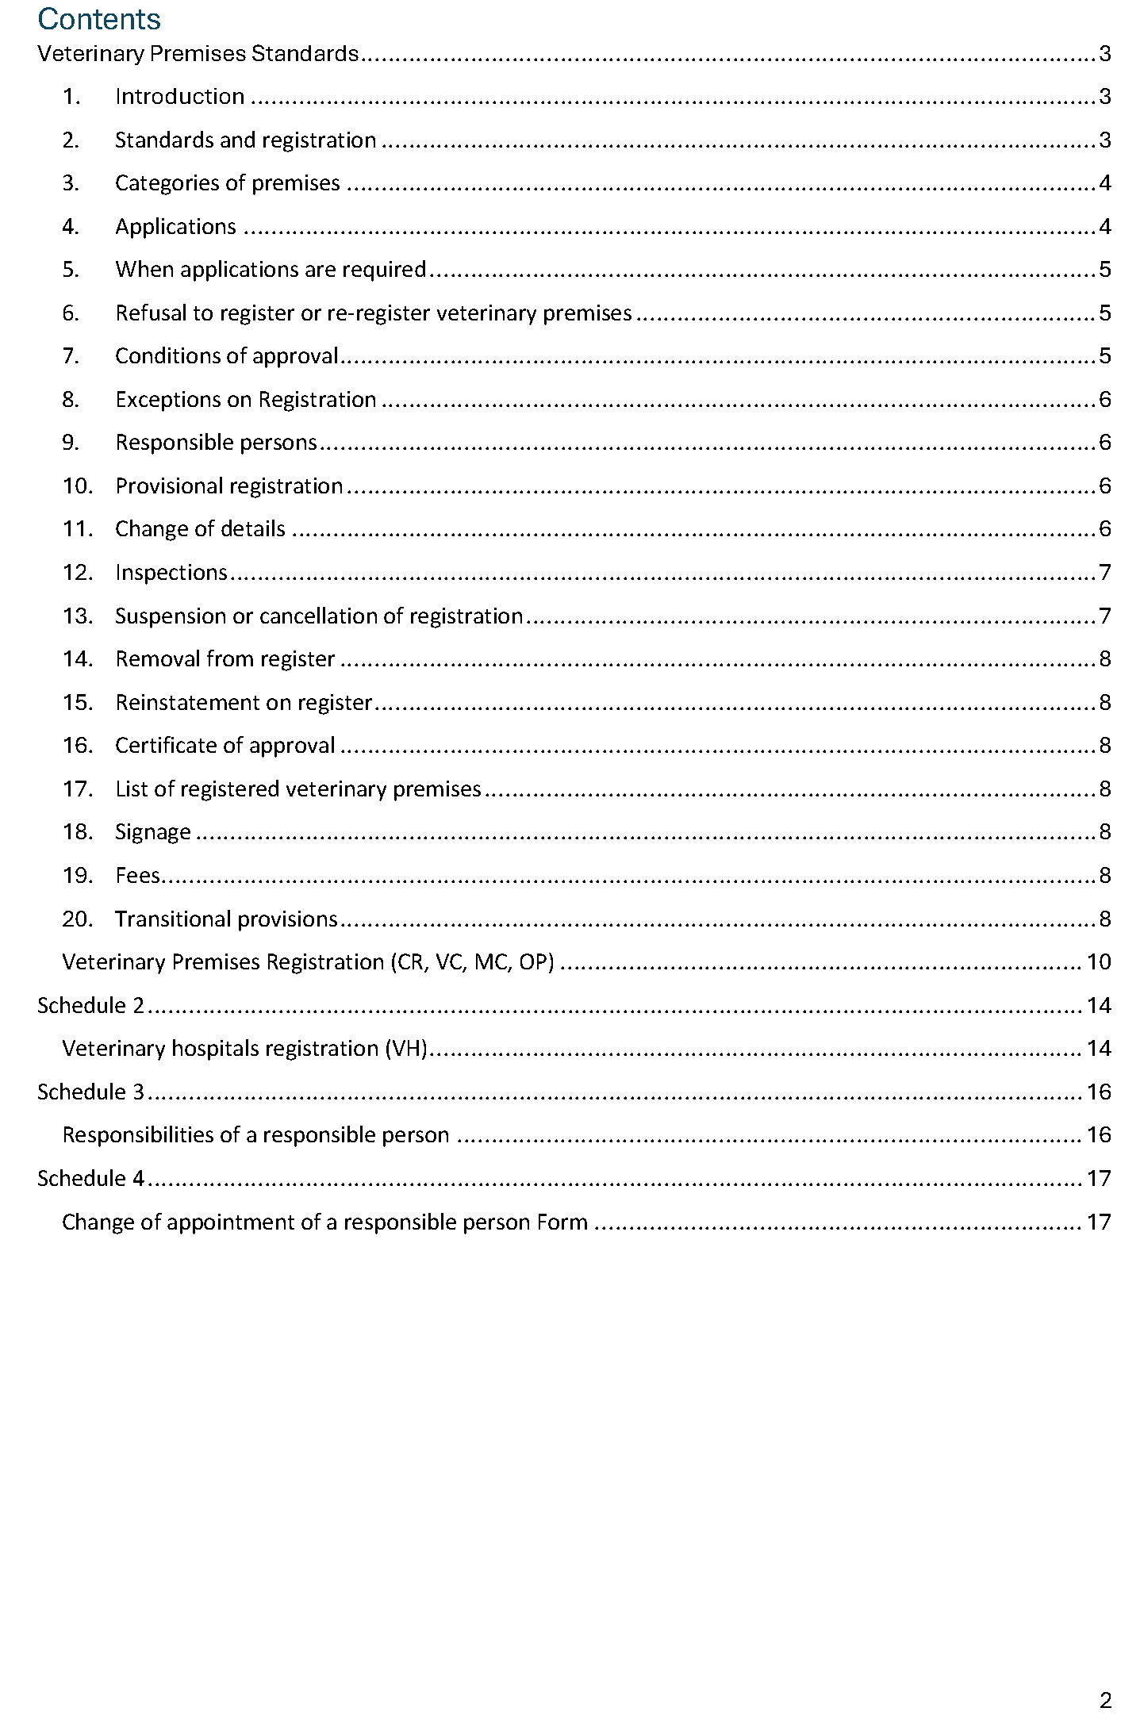

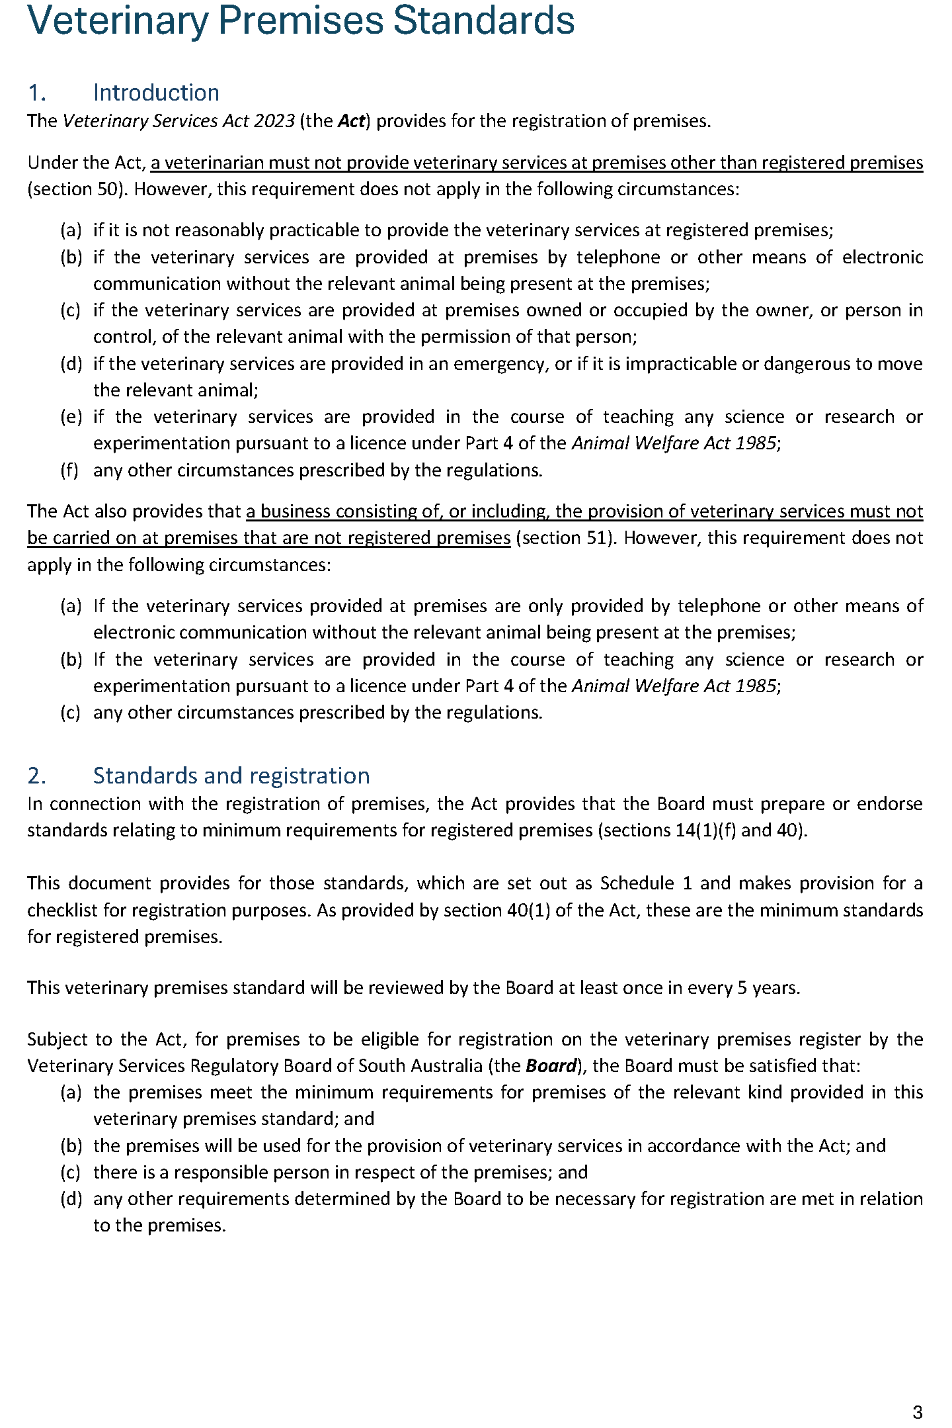

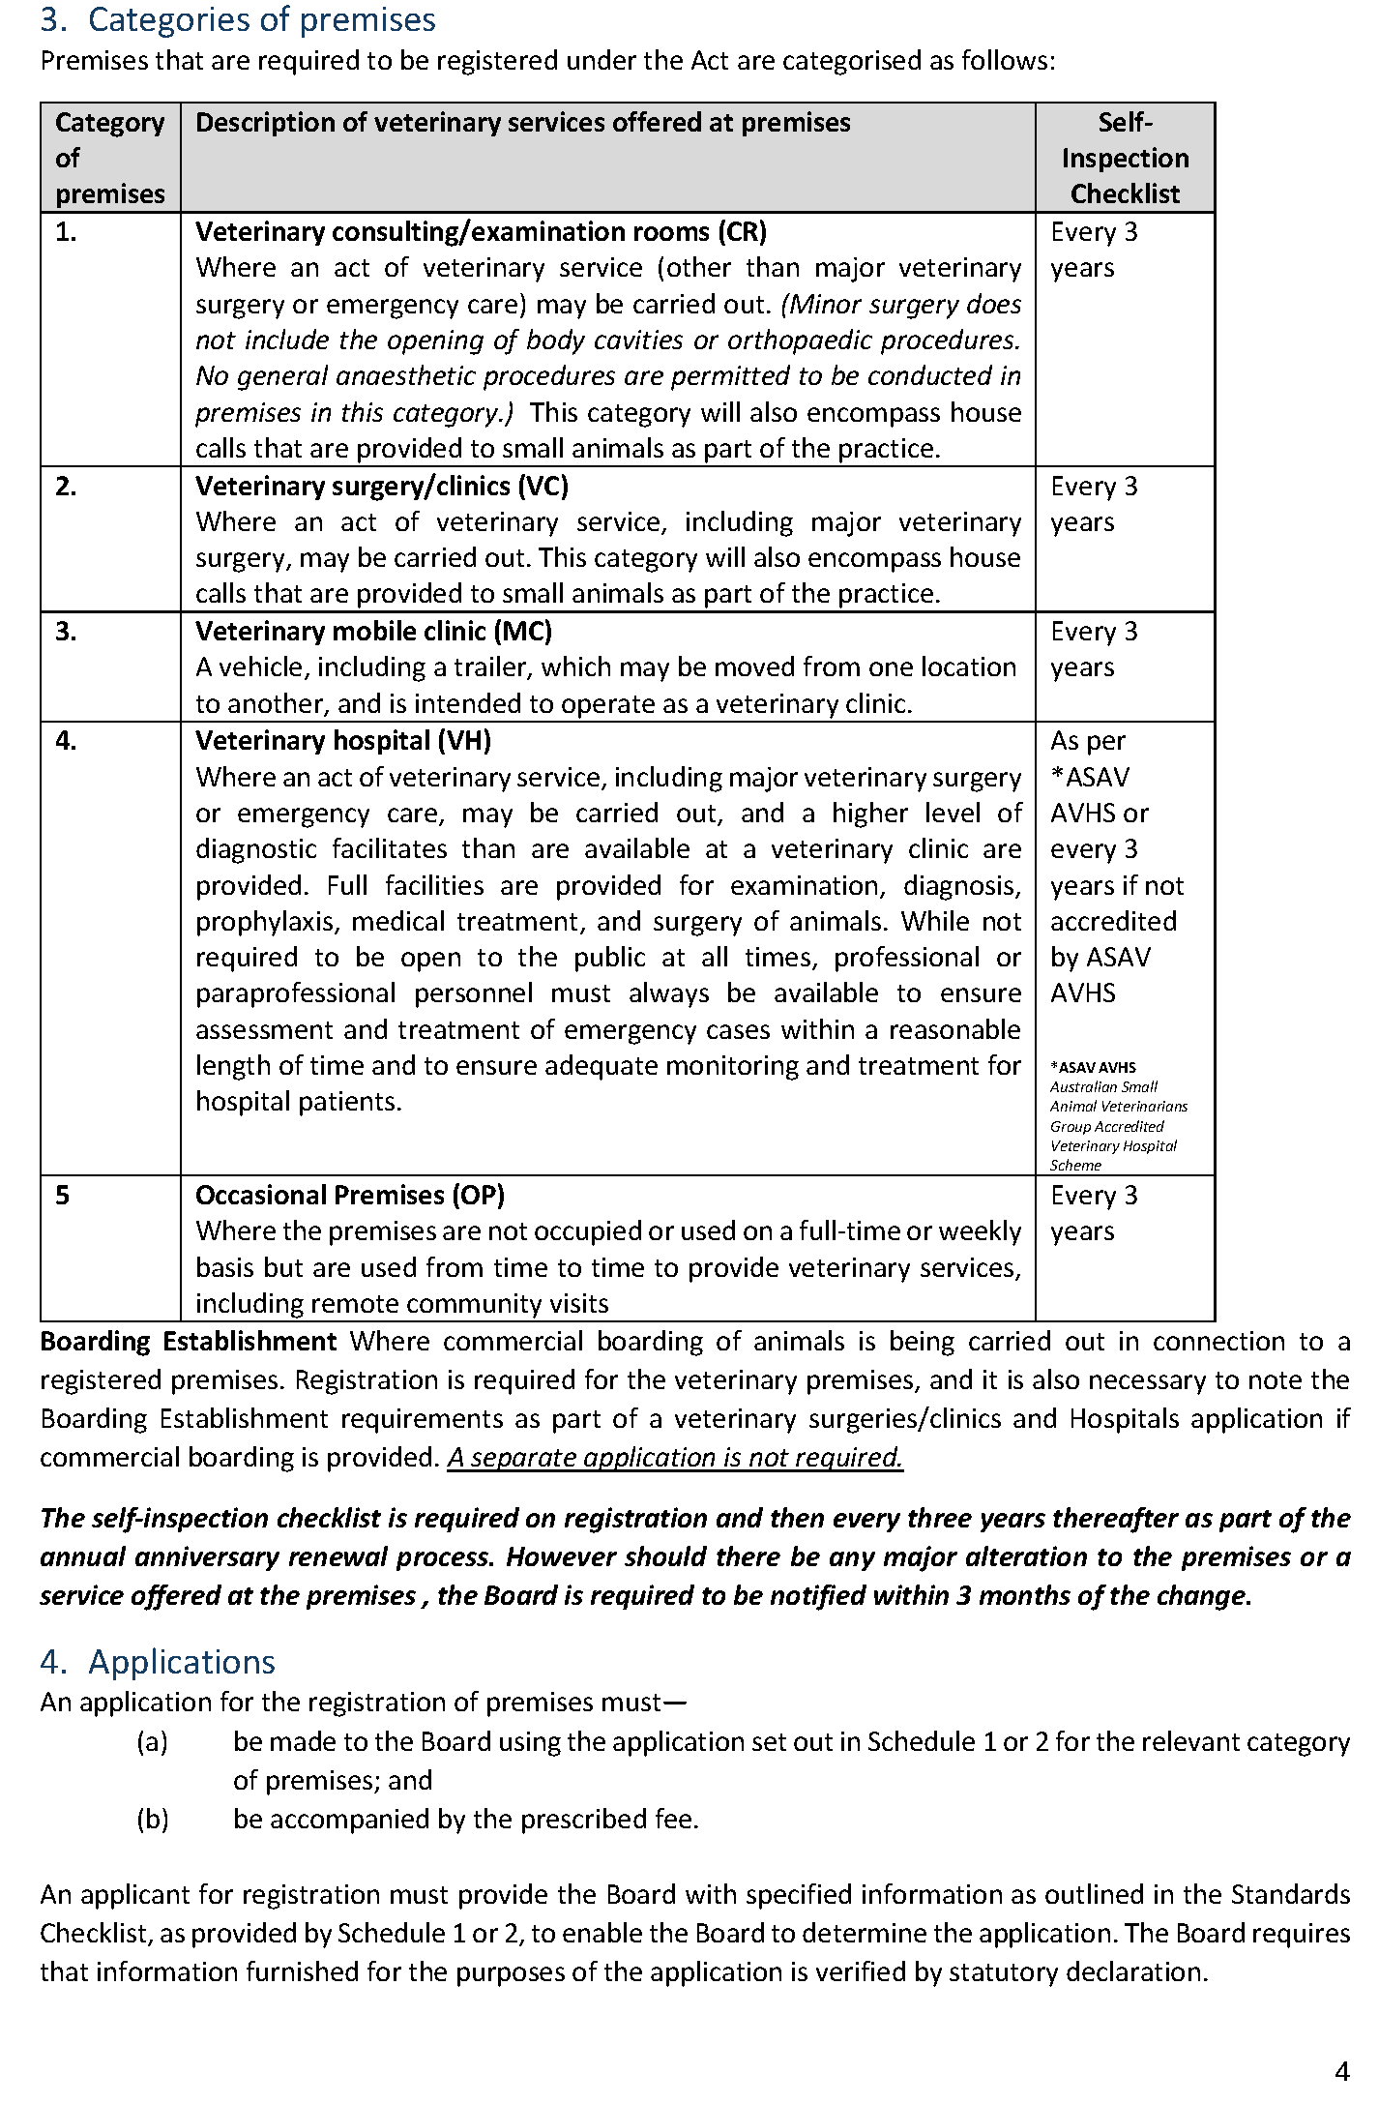

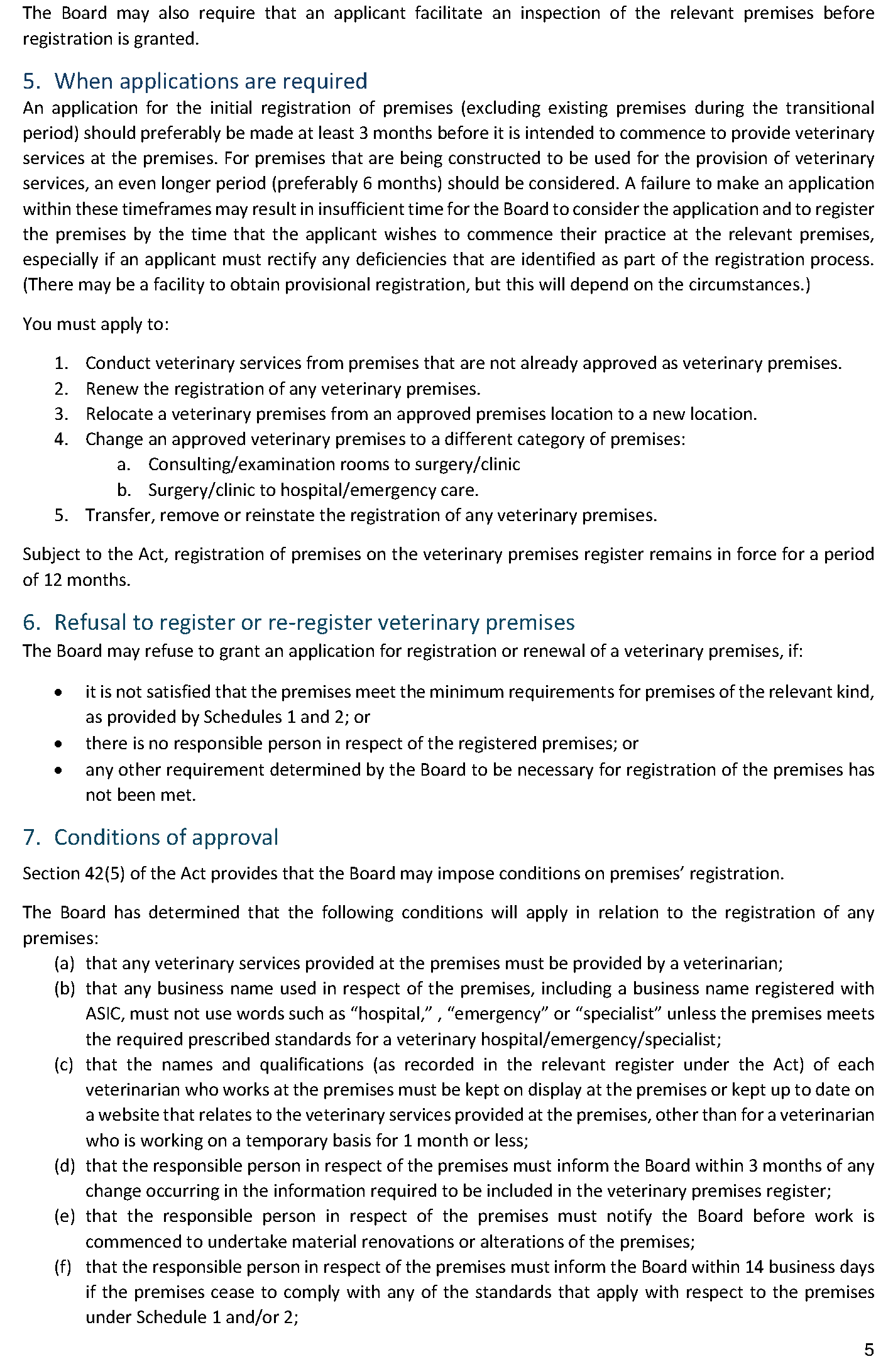

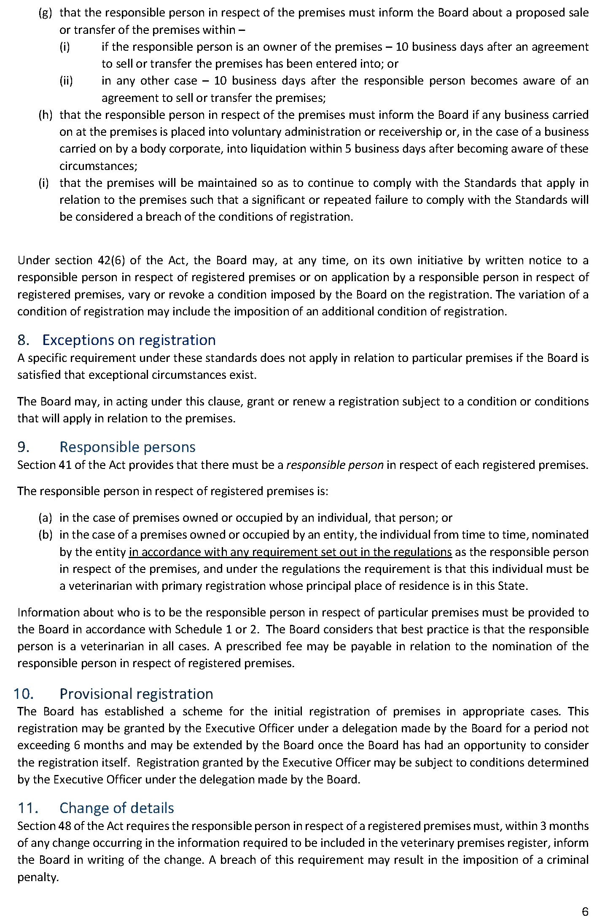

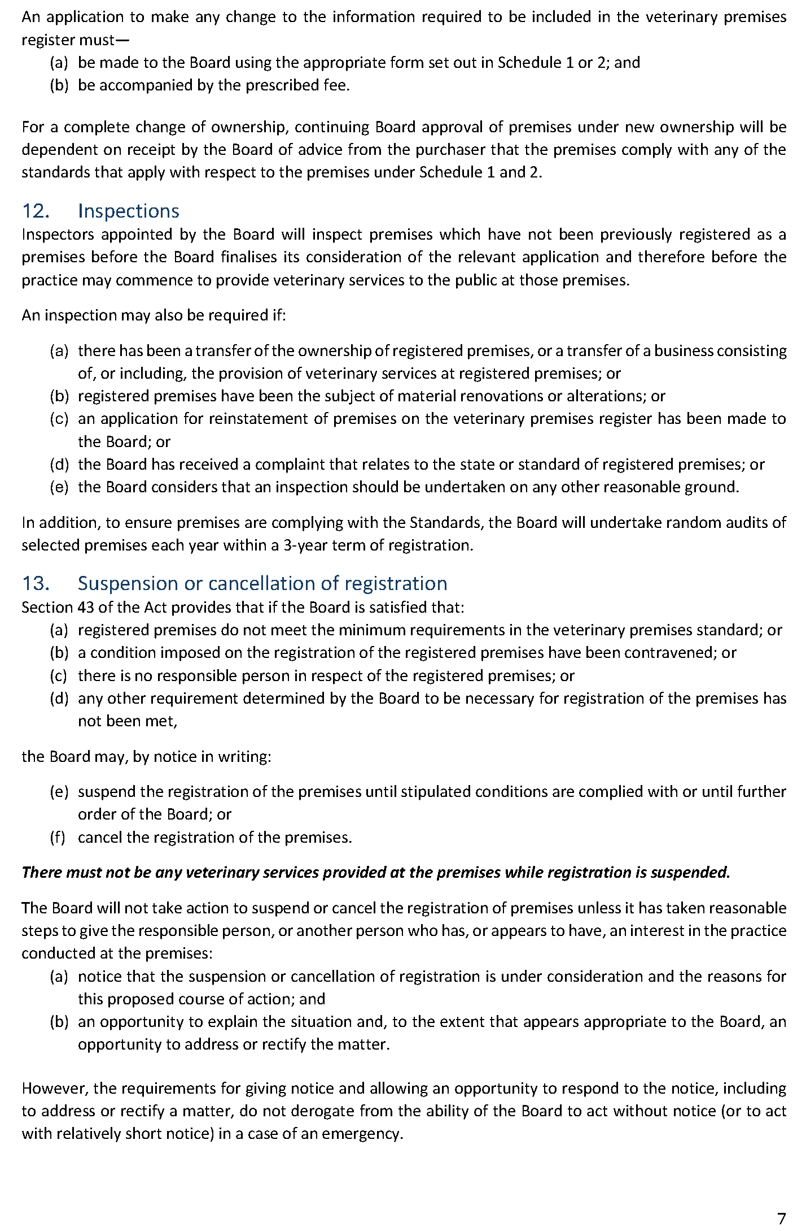

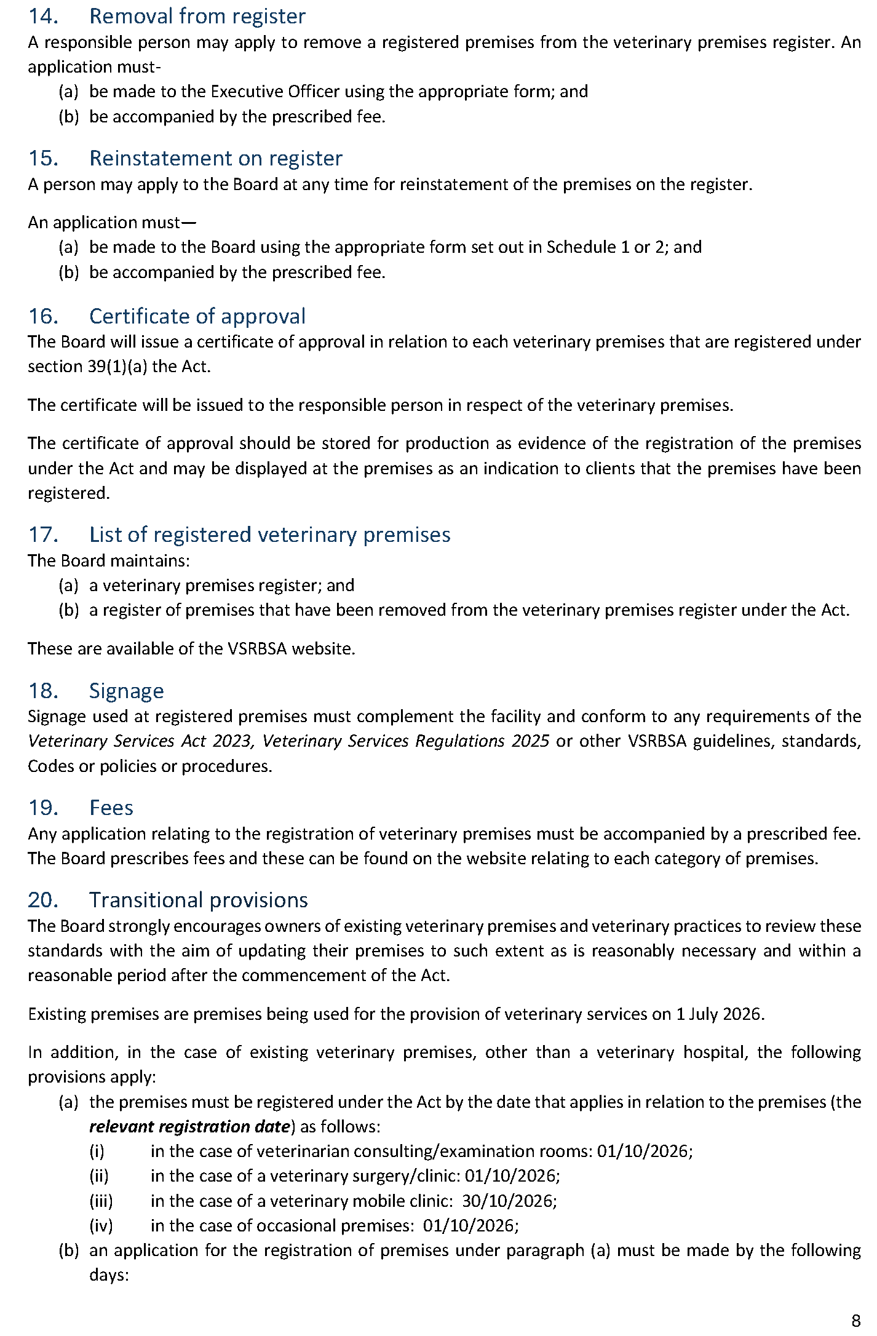

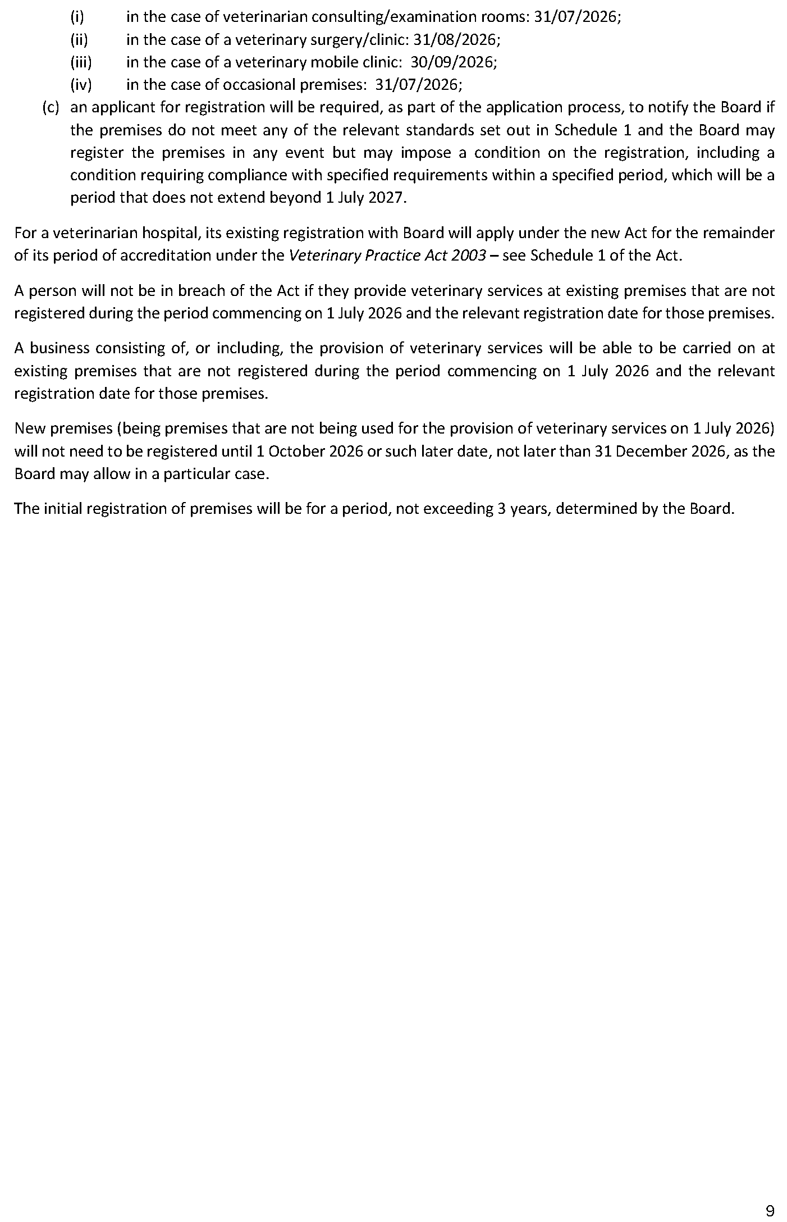

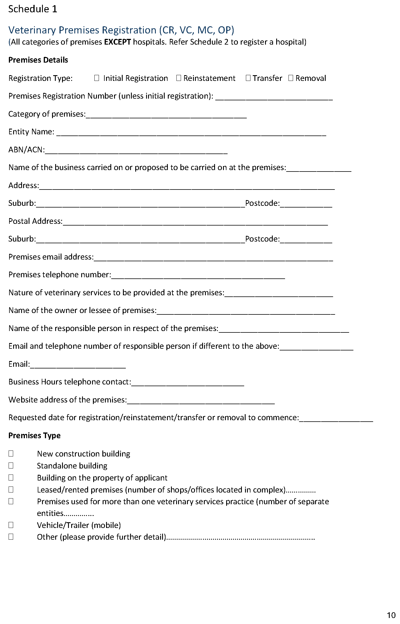

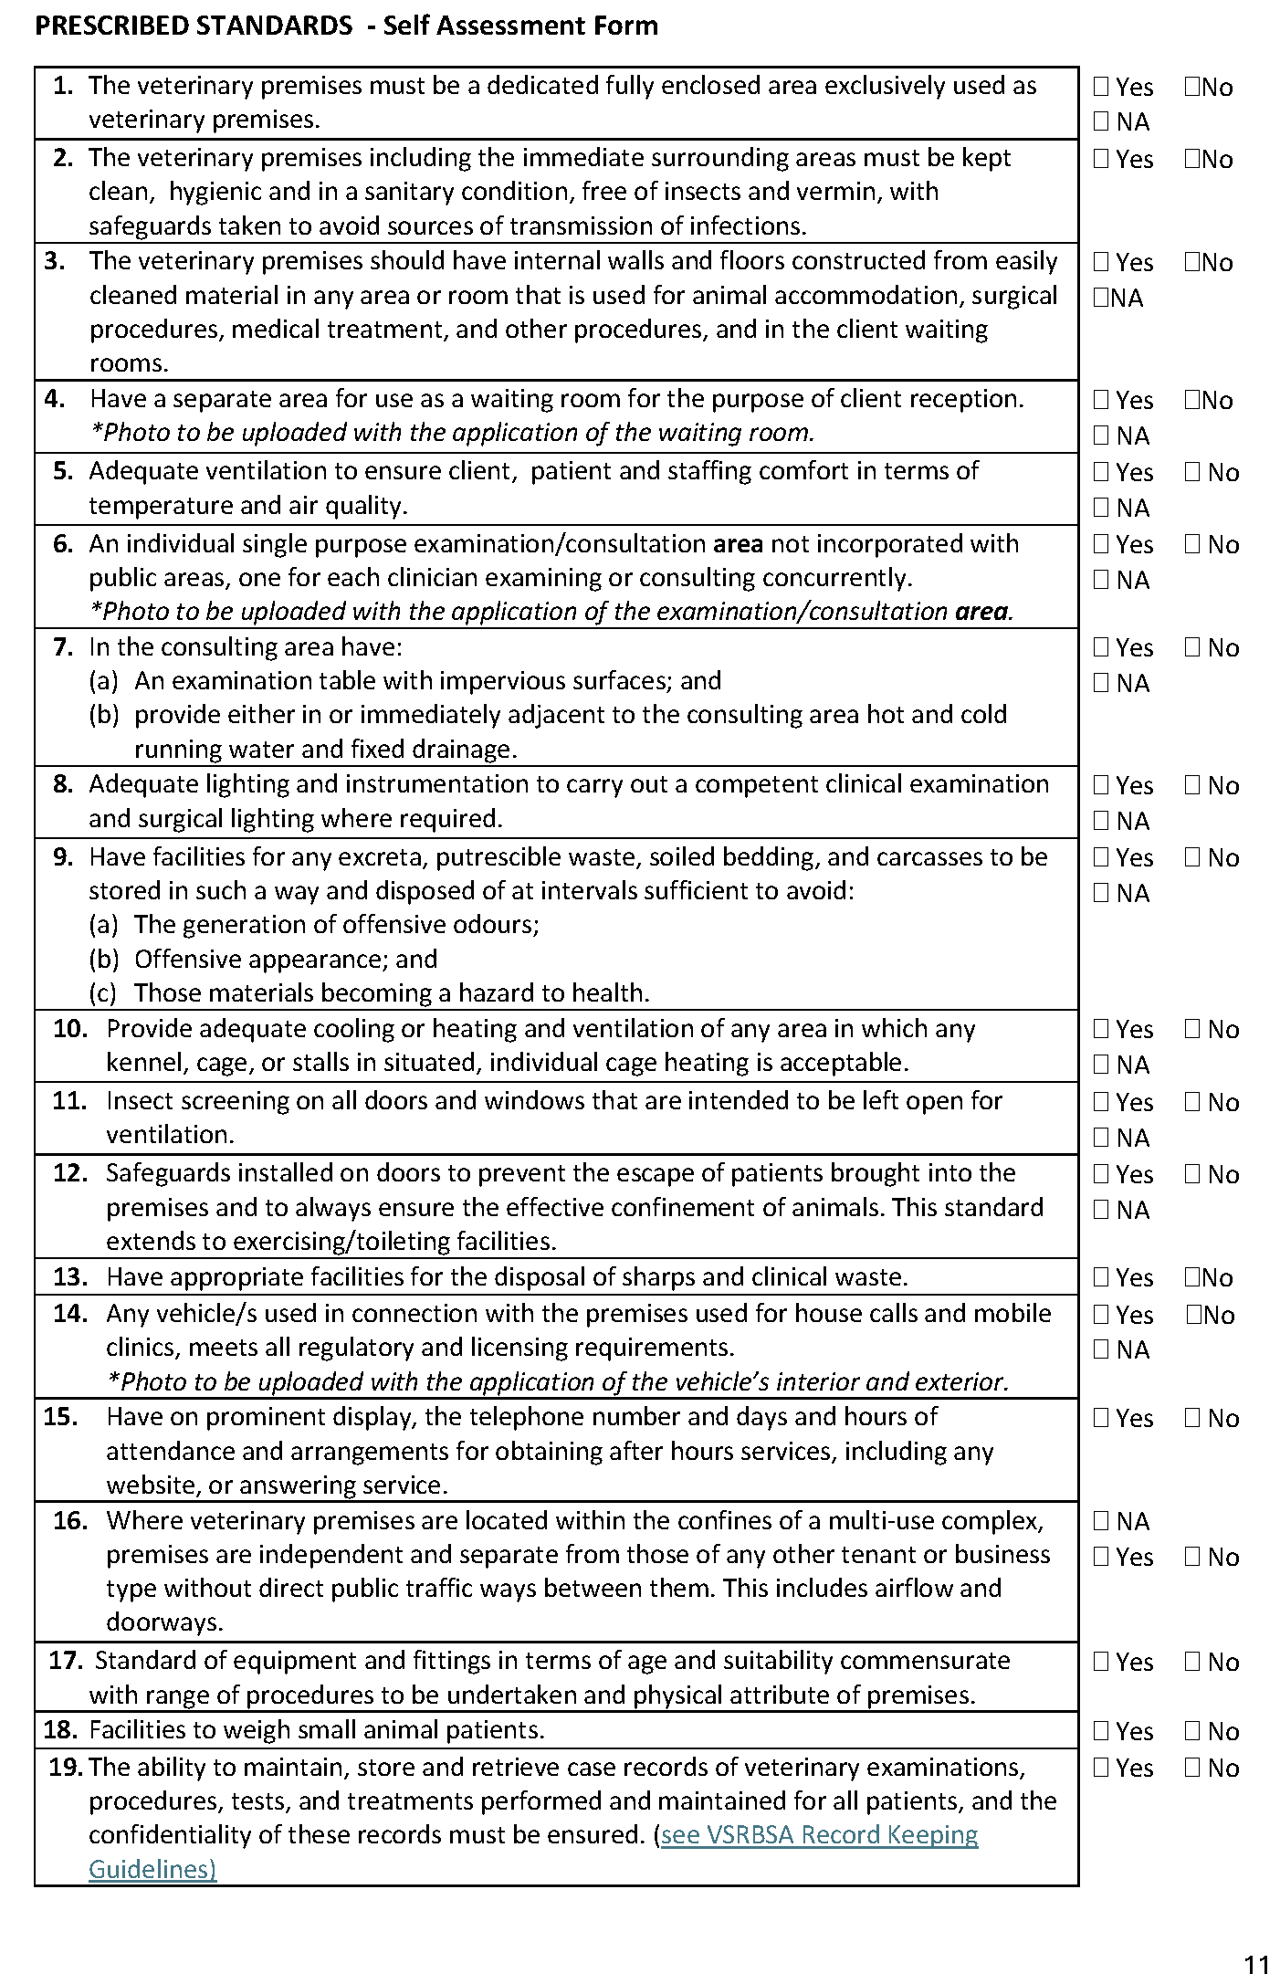

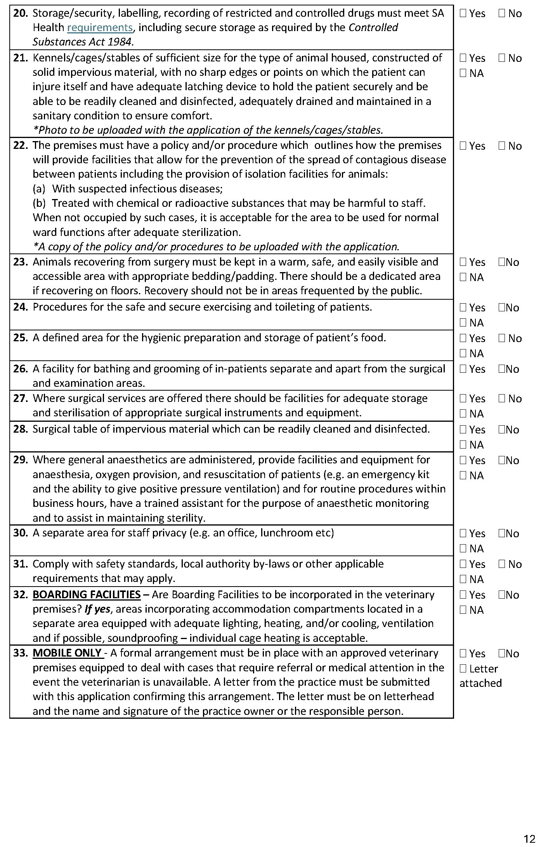

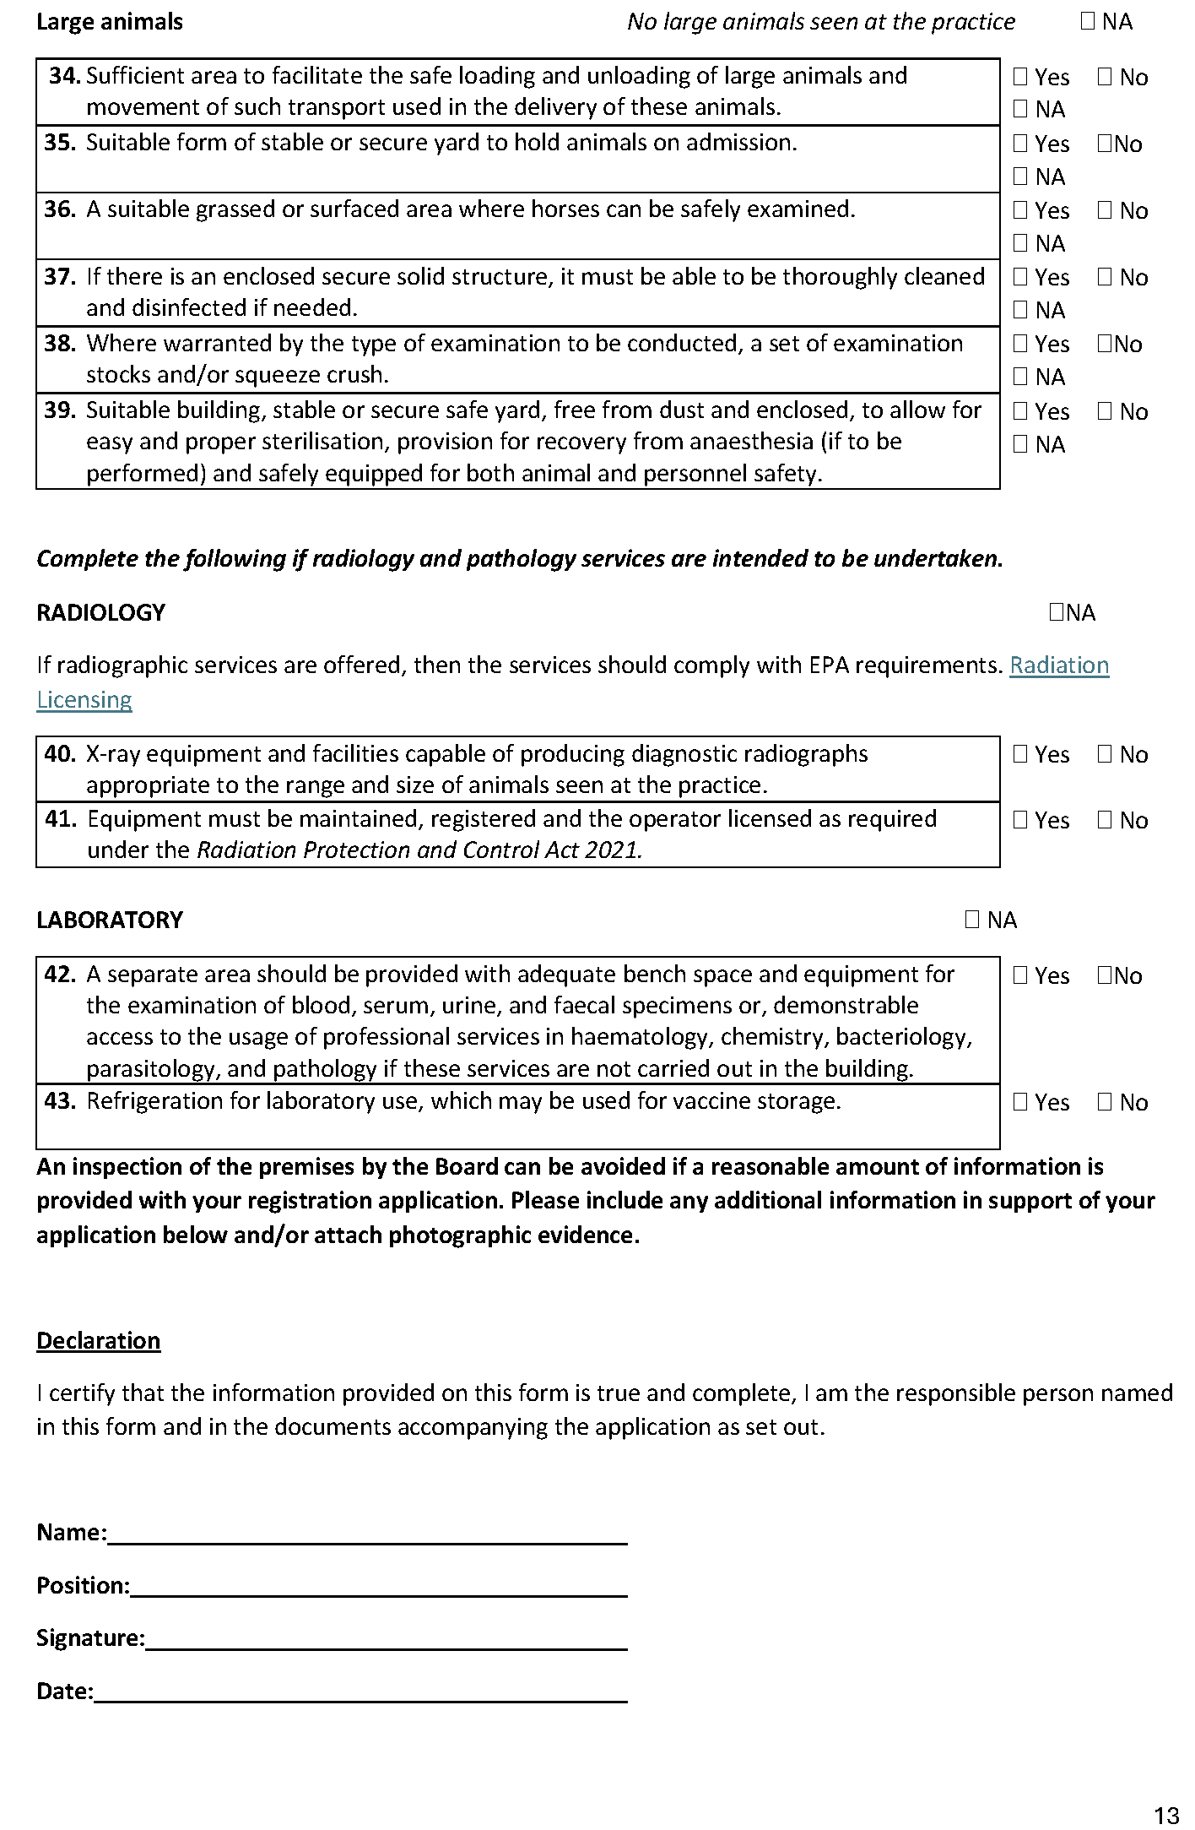

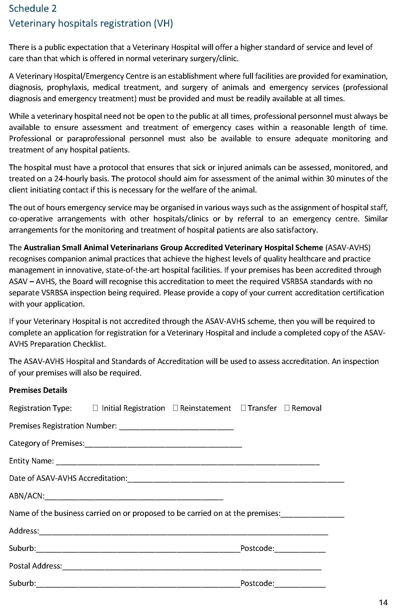

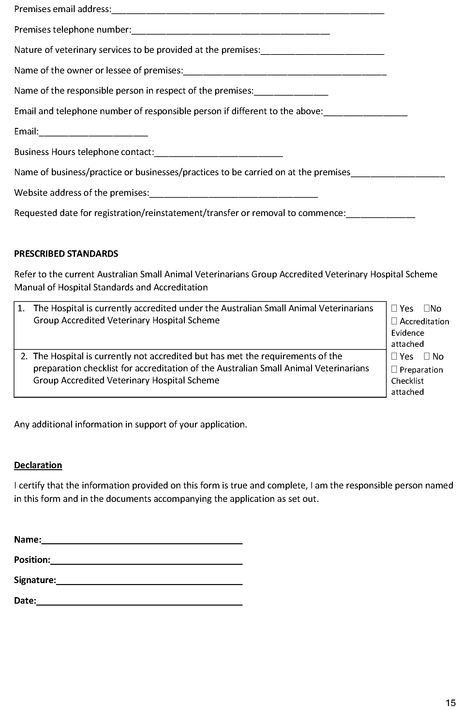

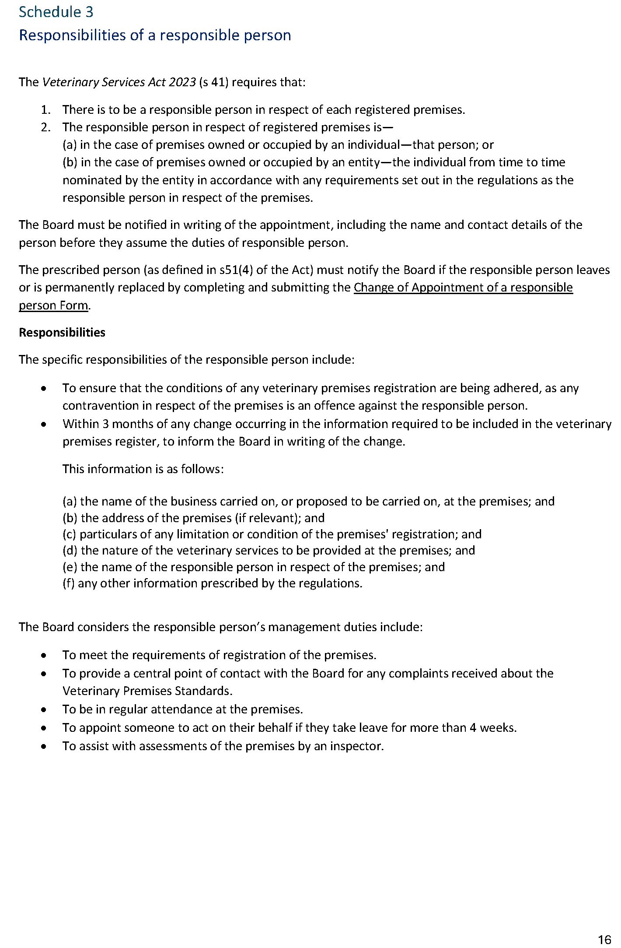

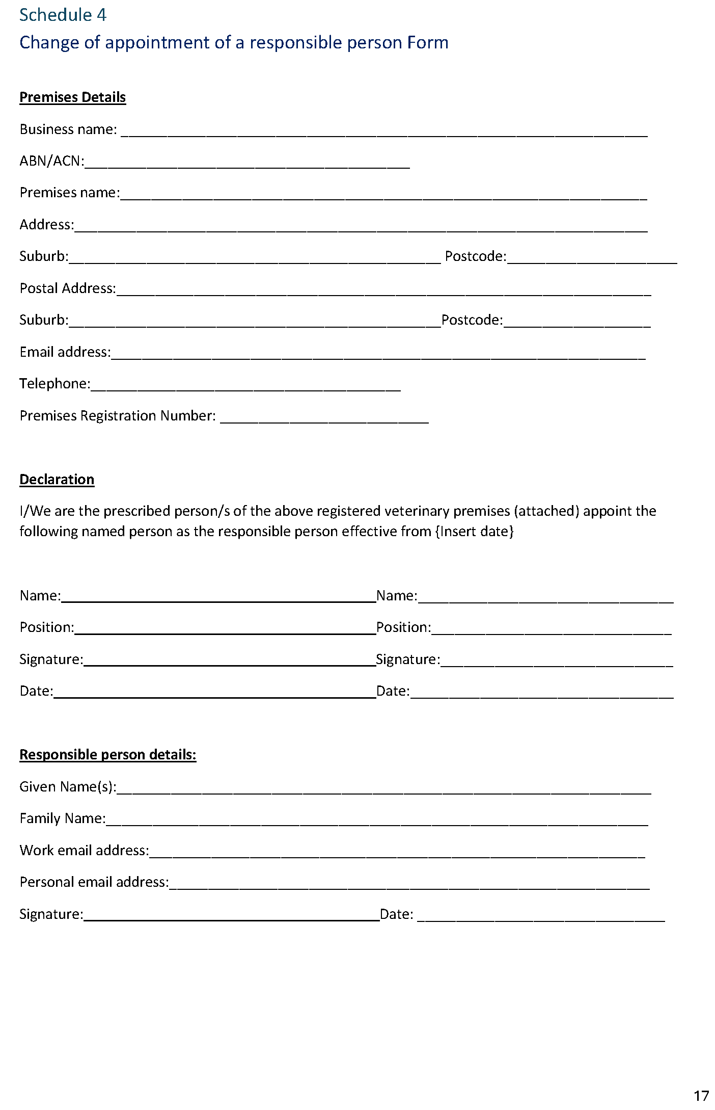

Local Government Instruments

City of Adelaide
Local Government Act 1999
Assigning of Road Name / Changing of Road Name
Notice is hereby given, pursuant to Section 219(4) of the Local Government Act 1999, that on 10 February 2026 Council:
1. Approved the renaming of the private lane currently known as ‘Clubhouse Lane’ (lettered ‘A’ and ‘B’ in Deposited Plan 25478 and lettered ‘A’ in Filed Plan 12375, which commences at 83-89 Hindley Street and runs in a southerly direction for approximately 32 metres and then turns and runs in a easterly direction for approximately 47 metres) to ‘Hilltop Hoods Lane’.
Dated: 26 February 2026
Michael Sedgman
Chief Executive Officer

Town of Gawler
Local Government Act 1999—Section 220(3)
Notice of Intent to Alter Street Numbering—Warren Street, Gawler
Notice is hereby given pursuant to Section 220(3) of the Local Government Act 1999 that the Town of Gawler proposes to alter the street numbering of properties on the western side of Warren Street, Gawler.
Following the subdivision of 163 Murray Street, Gawler (Lot 2 in Deposited Plan 82275, Certificate of Title Volume 6051 Folio 438),
a new allotment has been created being Lot 162 in Deposited Plan 137698, Certificate of Title Volume 6321 Folio 917. The new allotment requires a Warren Street address.
The existing numbering configuration does not allow for a logically sequential number to be allocated. Council therefore proposes to renumber properties on the western side of Warren Street restore sequential alignment.
Current Street Number | New Street Number
Lot 162 Murray Street, Gawler | 4 Warren Street, Gawler
Unit 1, 2 Warren Street Gawler | Unit 1, 6 Warren Street Gawler
Unit 2, 2 Warren Street Gawler | Unit 2, 6 Warren Street Gawler
Unit 3, 2 Warren Street Gawler | Unit 3, 6 Warren Street Gawler
Unit 4, 2 Warren Street Gawler | Unit 4, 6 Warren Street Gawler
Unit 5, 2 Warren Street Gawler | Unit 5, 6 Warren Street Gawler
The above alterations will take effect from Monday, 6 April 2026.
Dated: 5 March 2026
Sharon Perkins
Executive Manager Finance and Corporate Governance

District Council of Mount Remarkable
Roads (Opening and Closing) Act 1991
Road Closure—Block 9 Road, Wirrabara
Notice is hereby given, pursuant to Section 10 of the Roads (Opening and Closing) Act 1991, that the District Council of Mount Remarkable proposes to make a Road Process Order to close and merge the portions of the public road adjoining Section 9, Hundred of Darling more particularly delineated and lettered ‘A’ and ‘B’ in Preliminary Plan No. 25/0029 and to open as road, allotments numbered 28 and 29 to be named Block 9 Road, in Preliminary Plan No. 25/0029 in exchange for land taken for new road.
The Preliminary Plan and Statement of Persons Affected is available for public inspection at the offices of the District Council of Mount Remarkable and the Adelaide Office of the Surveyor-General during normal office hours. The Preliminary Plan may also be viewed at www.sa.gov.au/roadsactproposals.
Any application for easement or objection must set out the full name, address and details of the submission and must be fully supported by reasons.
The application for easement or objection must be made in writing to the District Council of Mount Remarkable, Stuart Street,
Melrose Within 28 Days of This Notice and a copy must be forwarded to the Surveyor-General at GPO Box 1815 Adelaide 5001. Where an objection is made, the District Council of Mount Remarkable will give notification of a meeting at which the matter will be considered.
Dated: 5 March 2026
Marc Gardner
Chief Executive Officer

Yorke Peninsula Council
Roads (Opening and Closing) Act 1991
Road Closing—Springfield Road, Yorketown
Notice is hereby given, pursuant to Section 10 of the Roads (Opening and Closing) Act 1991 that the Yorke Peninsula Council proposes to make a Road Process Order to close and sell to the adjoining landowner the Unmade Public Road (Springfield Road) adjoining Sections 334 & 332 in the Hundred of Dalrymple, more particularly delineated and lettered ‘A’ on Preliminary Plan 26/0005.
The Preliminary Plan is available for public inspection at the office of the Yorke Peninsula Council, 8 Elizabeth Street Maitland, and the Adelaide Office of the Surveyor-General located at Level 10, 83 Pirie Street Adelaide, during normal office hours. The Preliminary Plan can also be viewed at www.sa.gov.au/roadsactproposals.
Any application for easement or objection must set out the full name, address and details of the submission and must be fully supported by reasons. The application for easement or objection must be made in writing to the Yorke Peninsula Council, PO Box 57, Maitland SA 5573 within 28 days of this notice and a copy must be forwarded to the Surveyor-General at GPO Box 1815, Adelaide 5001. Where a submission is made, the applicant must be prepared to support their submission in person upon council giving notification of a meeting at which the matter will be considered.
Dated: 5 March 2026
Andrew Cameron
Chief Executive Officer

Public Notices

National Energy Retail Law
Notice of Draft Determination
The Australian Energy Market Commission (AEMC) gives notice under the National Energy Retail Law as follows:
Under s 256, the making of a draft determination and related draft rule on the Improving life support processes rule change (Ref. RRC0064) proposal. Written requests for a pre-determination hearing must be received by 12 March 2026. Submissions must be received by 16 April 2026.
Submissions can be made via the AEMC’s website. Before making a submission, please review the AEMC’s privacy statement on its website, and consider the AEMC’s Tips for making a submission. The AEMC publishes submissions on its website, subject to confidentiality and other considerations.
Written requests should be sent to submissions@aemc.gov.au and cite the reference in the title. Before sending a request, please review the AEMC’s privacy statement on its website.
Documents referred to above are available on the AEMC’s website and are available for inspection at the AEMC’s office.
Australian Energy Market Commission
Level 15, 60 Castlereagh St
Sydney NSW 2000
Telephone: (02) 8296 7800
www.aemc.gov.au
Dated: 5 March 2026

Trustee Act 1936
Public Trustee
Estates of Deceased Persons
In the matter of the estates of the undermentioned deceased persons:
CHITTLEBOROUGH William Ross late of 196 Greenways Road Nildottie Retired Council Worker who died between 15 January 2023 and 18 January 2023
FRANKLIN Albert late of 77 Seaview Road Port Augusta of no occupation who died 4 July 2025
HENRICHS Gerda Ilse late of 1 Myzantha Street Lockleys of no occupation who died 15 August 2025
HOLBROOK David Ronald late of 18 David Street Vista Retired Aircraft Engineer who died 22 May 2025
HUTSON Trent Leigh late of 19 Carr Street Mount Barker of no occupation who died 21 January 2025
MART Frank Henry late of 14 Capri Close West Lakes of no occupation who died 1 September 2025
PAGETT Patricia Violet late of 393 Morphett Road Oaklands Park Retired University Lecturer who died 17 January 2025
ROBINSON Susan Dorothy May late of 50 Gulfview Road Christies Beach Retired Bank Officer who died 26 October 2025
TAYLOR Malcom Harvey otherwise TAYLOR Malcolm Harvey late of 150 Bay Road Encounter Bay Retired Teacher who died 10 July 2025
YULE John Stephen late of 37 Hudson Avenue Croydon Park of no occupation who died 28 November 2023
Notice is hereby given pursuant to the Trustee Act 1936 (SA), the Succession Act 2023 (SA) and the Family Relationships Act 1975 (SA) that all creditors, beneficiaries, and other persons having claims against the said estates are required to send, in writing, to the office of Public Trustee at GPO Box 1338, Adelaide, 5001, full particulars and proof of such claims, on or before the 3 April 2026 otherwise they will be excluded from the distribution of the said estate; and notice is also hereby given that all persons indebted to the said estates are required to pay the amount of their debts to the Public Trustee or proceedings will be taken for the recovery thereof; and all persons having any property belonging to the said estates are forthwith to deliver same to the Public Trustee.
Dated: 5 March 2026
T. Brumfield
Public Trustee

Notice Submission

The South Australian Government Gazette is published each Thursday afternoon.
Notices must be emailed by 4 p.m. Tuesday, the week of publication.
Submissions are formatted per the gazette style and a proof will be supplied prior to publication, along with a quote if applicable. Please allow one day for processing notices.
Alterations to the proof must be returned by 4 p.m. Wednesday.

Gazette notices must be submitted as Word files, in the following format:
• Title—the governing legislation
• Subtitle—a summary of the notice content
• Body—structured text, which can include numbered lists, tables, and images
• Date—day, month, and year of authorisation
• Signature block—name, role, and department/organisation authorising the notice

Please provide the following information in your email:
• Date of intended publication
• Contact details of the person responsible for the notice content
• Name and organisation to be charged for the publication—Local Council and Public notices only
• Purchase order, if required—Local Council and Public notices only

Email: governmentgazettesa@sa.gov.au
Phone: (08) 7133 3552
Website: www.governmentgazette.sa.gov.au

All instruments appearing in this gazette are to be considered official, and obeyed as such

Printed and published weekly by authority of T. Foresto, Government Printer, South Australia
$9.50 per issue (plus postage), $479.00 per annual subscription—GST inclusive
Online publications: www.governmentgazette.sa.gov.au

