
No. 60 p. 3147
THE SOUTH AUSTRALIAN
GOVERNMENT GAZETTE
Published by Authority

Adelaide, Thursday, 8 October 2026

Contents

State Government Instruments
Building Work Contractors Act 1995 3148
Controlled Substances (Poisons) Regulations 2011 3150
Fisheries Management Act 2007 3150
Housing Improvement Act 2016 3151
Major Events Act 2013 3151
Planning, Development and Infrastructure Act 2016 3158
Prices Act 1948 3159
Road Traffic Act 1961 3162
Roads (Opening and Closing) Act 1991 3162
South Australian Motor Sport Act 1984 3163
Local Government Instruments
Brown Hill and Keswick Creeks Stormwater Board 3165
Public Notices
National Electricity Law 3166

State Government Instruments

Building Work Contractors Act 1995
Exemption
Take notice that, pursuant to Section 45 of the Building Work Contractors Act 1995, I, Brett Humphrey as a delegate for the Minister for Consumer and Business Affairs, do hereby exempt the licensee named in Schedule 1 from the application of Division 3 of Part 5 of the above Act in relation to domestic building work described in Schedule 2 and subject to the conditions specified in Schedule 3.
Schedule 1
GOOLWA JETTY BUILDERS PTY LTD (BLD 262904)
Schedule 2
Jetty construction on Council-owned reserve land adjacent to Allotment 367 Filed Plan 166741, being a portion of land as described in Certificate of Title Volume 5844 Folio 99, more commonly known as 184 Liverpool Road, Goolwa SA 5214.
Schedule 3
1. This exemption is limited to domestic building work personally performed by the licensee in relation to the building work described in Schedule 2.
2. This exemption does not apply to any domestic building work the licensee contracts to another building work contractor, for which that contractor is required by law to hold building indemnity insurance.
3. That the licensee ensures all required approvals are sought from relevant statutory authorities.
Dated: 1 October 2026
Brett Humphrey
Commissioner for Consumer Affairs
Delegate for the Minister for Consumer and Business Affairs

Building Work Contractors Act 1995
Exemption
Take notice that, pursuant to Section 45 of the Building Work Contractors Act 1995, I, Brett Humphrey as a delegate for the Minister for Consumer and Business Affairs, do hereby exempt the licensee named in Schedule 1 from the application of Division 3 of Part 5 of the above Act in relation to domestic building work described in Schedule 2 and subject to the conditions specified in Schedule 3.
Schedule 1
JAMES MICHAEL BURNELL (BLD 250591)
Schedule 2
Conversion of an existing church building into a residential dwelling at Allotments 91 and 92 Filed Plan 216160, being a portion of the land described in Certificate of Title Volume 5618 Folio 168, more commonly known as 72 Duncan Street, Whyalla Playford SA 5600.
Schedule 3
1. This exemption is limited to domestic building work personally performed by the licensee in relation to the building work described in Schedule 2.
2. This exemption does not apply to any domestic building work the licensee contracts to another building work contractor, for which that contractor is required by law to hold building indemnity insurance.
3. That the licensee does not transfer his interest in the land or let or lease the property for valuable consideration prior to five years from the date of completion of the building work the subject of this exemption, without the prior authorisation of Consumer and Business Services (CBS). Before giving such authorisation, CBS may require the licensee to take any reasonable steps to protect the future purchaser(s) of the property, including but not limited to:
• Providing evidence that an adequate policy of building indemnity insurance is in force to cover the balance of the five-year period from the date of completion of the building work the subject of this exemption;
• Providing evidence of an independent expert inspection of the building work the subject of this exemption;
• Making an independent expert report available to prospective purchasers of the property;
• Giving prospective purchasers of the property notice of the absence of a policy of building indemnity insurance.
Dated: 2 October 2026
Brett Humphrey
Commissioner for Consumer Affairs
Delegate for the Minister for Consumer and Business Affairs

Building Work Contractors Act 1995
Exemption
Take notice that, pursuant to Section 45 of the Building Work Contractors Act 1995, I, Brett Humphrey as a delegate for the Minister for Consumer and Business Affairs, do hereby exempt the licensee named in Schedule 1 from the application of Division 3 of Part 5 of the above Act in relation to domestic building work described in Schedule 2 and subject to the conditions specified in Schedule 3.
Schedule 1
PHILLIP MURRAY EBERT (BLD 292244)
Schedule 2
Construction of an addition to a single story dwelling at Allotment 67 Deposited Plan 17456, being a portion of the land described in Certificate of Title Volume 5320 Folio 756, more commonly known as 19 Jacaranda Ave, Woodside SA 5244.
Schedule 3
1. This exemption is limited to domestic building work personally performed by the licensee in relation to the building work described in Schedule 2.
2. This exemption does not apply to any domestic building work the licensee contracts to another building work contractor, for which that contractor is required by law to hold building indemnity insurance.
3. That the licensee does not transfer his interest in the land or let or lease the property for valuable consideration prior to five years from the date of completion of the building work the subject of this exemption, without the prior authorisation of Consumer and Business Services (CBS). Before giving such authorisation, CBS may require the licensee to take any reasonable steps to protect the future purchaser(s) of the property, including but not limited to:
• Providing evidence that an adequate policy of building indemnity insurance is in force to cover the balance of the five-year period from the date of completion of the building work the subject of this exemption;
• Providing evidence of an independent expert inspection of the building work the subject of this exemption;
• Making an independent expert report available to prospective purchasers of the property;
• Giving prospective purchasers of the property notice of the absence of a policy of building indemnity insurance.
Dated: 1 October 2026
Brett Humphrey
Commissioner for Consumer Affairs
Delegate for the Minister for Consumer and Business Affairs

Building Work Contractors Act 1995
Exemption
Take notice that, pursuant to Section 45 of the Building Work Contractors Act 1995, I, Brett Humphrey as a delegate for the Minister for Consumer and Business Affairs, do hereby exempt the licensee named in Schedule 1 from the application of Division 3 of Part 5 of the above Act in relation to domestic building work described in Schedule 2 and subject to the conditions specified in Schedule 3.
Schedule 1
REECE ANTHONY JOLLY (BLD 298348)
Schedule 2
Two-storey addition to an existing detached dwelling at Allotment 33 Deposited Plan 9180, being a portion of the land described in Certificate of Title Volume 5740 Folio 503, more commonly known as 24 David Street, Happy Valley SA 5159.
Schedule 3
1. This exemption is limited to domestic building work personally performed by the licensee in relation to the building work described in Schedule 2.
2. This exemption does not apply to any domestic building work the licensee contracts to another building work contractor, for which that contractor is required by law to hold building indemnity insurance.
3. That the licensee does not transfer his interest in the land or let or lease the property for valuable consideration prior to five years from the date of completion of the building work the subject of this exemption, without the prior authorisation of Consumer and Business Services (CBS). Before giving such authorisation, CBS may require the licensee to take any reasonable steps to protect the future purchaser(s) of the property, including but not limited to:
• Providing evidence that an adequate policy of building indemnity insurance is in force to cover the balance of the five-year period from the date of completion of the building work the subject of this exemption;
• Providing evidence of an independent expert inspection of the building work the subject of this exemption;
• Making an independent expert report available to prospective purchasers of the property;
• Giving prospective purchasers of the property notice of the absence of a policy of building indemnity insurance.
Dated: 2 October 2026
Brett Humphrey
Commissioner for Consumer Affairs
Delegate for the Minister for Consumer and Business Affairs

Controlled Substances (Poisons) Regulations 2011
Prescribed Health Service Facility
Notice is hereby given in accordance with Regulation 44A of the Controlled Substances (Poisons) Regulations 2011, that the Minister for Health and Wellbeing has determined the following facility to be a prescribed health service facility, commencing from the date of publication of this notice:
Hamster Cottage
Dated: 8 October 2026
Hon. Blair Boyer MP
Minister for Health and Wellbeing

Fisheries Management Act 2007
Section 115
Ministerial Exemption: ME9903459
Take notice that pursuant to Section 115 of the Fisheries Management Act 2007, the holder of a fishery licence issued under the Fisheries Management (Charter Boat Fishery) Regulations 2016 (the ‘exemption holder’) or a person endorsed on the licence as a registered master, are exempt from Section 70 of the Fisheries Management Act 2007 and Regulation 5, Clause 75 of Schedule 6 of the Fisheries Management (General) Regulations 2017 but only insofar as they may undertake the activity described in Schedule 1 (the ‘exempted activity’), in the waters described in Schedule 2, subject to the conditions specified in Schedule 3, from 7 October 2026 until 1800 hrs 31 May 2027, unless varied or revoked earlier.
Schedule 1
1. Setting of recreational rock lobster pots registered to a person who has entered into a charter boat fishing agreement for the charter boat fishing services of the exemption holder no more than 3 days prior to the intended charter fishing trip of the person to whom the rock lobster pot is registered.
2. Retrieval of a registered rock lobster pot that has been set for a person who has entered into a charter boat fishing agreement for the charter boat fishing services of the exemption holder where the person to whom the rock lobster pot is registered is not able to be present on the agreed charter fishing trip.
Schedule 2
1. All marine waters of the State, excluding Aquatic Reserves, Marine Park Sanctuary Zones or Restricted Access Zones
(unless otherwise authorised under the Marine Parks Act 2007).
Schedule 3
1. The exemption holder or registered master of a charter boat licence must be in possession of a copy of this notice at all times whilst undertaking the exempted activities and be able to produce it to a PIRSA Fisheries Officer or PIRSA Licensing Officer upon request.
2. The exemption holder or registered master must be able to prove that the recreational rock lobster pot being set or intended to be set is registered to a person who has entered a charter boat fishing agreement for the charter boat fishing services of the exemption holder on a particular date and that person intends to retrieve the registered rock lobster pot as part of the charter boat fishing agreement.
3. When setting recreational rock lobster pots under this exemption, the exemption holder or registered master must be in possession of evidence that the holder of the rock lobster pot registration intends to participate in activities consistent with a charter boat fishing agreement for the charter boat fishing services of the exemption holder.
4. A maximum of 6 rock lobster pots may be set on any one day per boat being used under the licence for a charter boat activity.
5. The exemption holder or registered master must not use or have possession of recreational rock lobster pot tags registered in their name, or tags registered to any charter crew member while undertaking charter boat fishing services.
6. The exemption holder, registered master or crew member who holds or has an interest in a rock lobster licence in South Australia or through corresponding interstate law, must not store or hold rock lobster on their registered vessel whilst undertaking activities pursuant to this exemption.
7. When fishing pursuant to this exemption, the exemption holder, registered master or crew member must not operate any fishing equipment registered under a commercial fishery authority, including an authority under a corresponding law.
8. The recreational rock lobster pots set under this exemption must be marked with a 4 litre red buoy, a recreational rock lobster pot tag issued by the Department and a tag identifying the Charter Boat Fishery licence number (consistent with the specifications of Section 13(b) of the Fisheries Management (General) Regulations 2017).
9. The recreational rock lobster pot must not be set under this exemption more than three days prior to commencing the charter on which the registration holder is due to participate in, consistent with a charter boat fishing agreement for the charter boat fishing services of the exemption holder.
10. The exemption holder or registered master must ensure that the client(s) to whom the recreational rock lobster pot tag(s) are registered are engaged in the fishing activity to retrieve the registered rock lobster pot during the charter boat fishing services of the exemption holder, and that the owner of the tag(s) only retains a number of rock lobster consistent with their personal passenger limits.
11. Once retrieved in accordance with condition 10, the rock lobster pot(s) must either be decked or reset with:
(a) The same client(s) tag affixed, if that client will be retrieving the pot(s) again on the same day or on a subsequent day within the period of registration; or
(b) A different/new clients(s) registered tag affixed, where that client has entered a charter boat fishing agreement for the charter boat fishing services of the exemption holder and that person intends to retrieve the registered rock lobster pot as part of the charter boat fishing agreement on a subsequent day, being no more than three days from when the pot is reset.
12. If the person to whom the recreational rock lobster pot is registered is not able to be present during the agreed charter boat fishing service, the exemption holder or registered master must notify the Department by telephone on 1800 065 522 of the cancellation before commencing the trip. The exemption holder or registered master may then retrieve the rock lobster pot but must release all aquatic species caught in the pot back to the water immediately.

13. At least 30 minutes before landing the registered vessel from a fishing trip where registered recreational rock lobster pot(s) have been operated during the trip by a holder of a recreational rock lobster pot registration, the licence holder or registered master(s) of a boat registered for use in the Charter Boat Fishery, must inform the Department by telephone on 1800 065 522 or via the Commercial reporting App of the following information—
(a) The name of the person making the call/report;
(b) Contact phone number of the person making the call/report;
(c) The licence number being fished;
(d) The name of the holder of the licence, or the registered master, operating the vessel;
(e) The name of the registration holder for each recreational rock lobster pot(s) on board;
(f) The tag number(s) held by each of the associated rock lobster pot registration holder[s] that is affixed to a rock lobster pot on board;
(g) The total number of rock lobster on board the vessel;
(h) The date and time of landing;
(i) The port of landing.
14. If the estimated date and time for the landing of the registered vessel where recreational rock lobster pot(s) were set under this exemption is earlier than the estimated time previously notified, or more than one (1) hour after that date and time, the exemption holder or registered master must notify the Department of the updated estimated landing date and time in accordance with condition 13.
15. The licence holder or registered master must destroy the tag affixed to the short-term rock lobster pot at the end of the registration period specified on the certificate of registration of the relevant short-term rock lobster pot/s and retain the end of the tag displaying the registration number until the conclusion of the exemption period. The exemption holder must be able to produce the tag end if required by a Fisheries Officer.
This notice does not purport to override the provisions or operation of any other Act including, but not limited to, the Marine Parks Act 2007. The exemption holder and his agents must comply with any relevant regulations, permits, requirements and directions from the Department for Environment and Water when undertaking activities within a marine park.
Dated: 6 October 2026
Professor Gavin Begg
Executive Director
Fisheries and Aquaculture
Delegate of the Minister for Primary Industries and Regional Development

Housing Improvement Act 2016
Rent Control Revocations
In the exercise of the powers conferred by the Housing Improvement Act 2016, the Delegate of the Minister for Housing and Urban Development hereby revokes the maximum rental amount per week that shall be payable subject to Section 55 of the Residential Tenancies Act 1995, in respect of each premises described in the following table.
Address of Premises | Allotment Section | Certificate of Title  Volume/Folio
150 Waterfall Gully Road, Waterfall Gully SA 5066 | Allotment 8 Deposited Plan 4777 Hundred of Adelaide | CT5236/514, CT5449/268
11 Blanche Street, Edithburgh SA 5583 | Allotment 230 Filed Plan 195652 Hundred of Melville | CT5429/793
2 The Fairway, Tea Tree Gully SA 5091 | Allotment 234 Deposited Plan 6505 Hundred of Yatala | CT5576/9
2 Matthew Street, Bedford Park SA 5042 | Allotment 117 Deposited Plan 6261  Hundred of Adelaide and Noarlunga | CT5448/205
205 Symes Road, Waterloo Corner SA 5110 | Allotments 49 Filed Plan 114510 Hundred of Port Adelaide | CT5862/981
Dated: 8 October 2026
David Osborne
Manager
Housing Safety Authority
Delegate of the Minister for Housing and Urban Development

Major Events Act 2013
Section 6B
Declaration of a Major Event
Pursuant to Section 6B of the Major Events Act 2013, I, Hon. Emily Bourke MLC, Minister for Tourism declare the 2026 Shannons Adelaide Rally to be held from 16–18 October 2026 to be declared a major event.
By virtue of the provisions of the Major Events Act 2013, I do hereby:
1. Declare the 2026 Shannons Adelaide Rally to be a major event.
2. Specify the period of the event, for which the declaration of the major event is in force is 5:00am on Friday, 16 October to 11:59pm on Sunday, 18 October 2026.
3. Declare the major event venues to be the areas as shown in descriptions and maps specifically covering King William Street, O’Connell Street, Tynte Street, a designated section of Victoria Park (Park 16) and the rally stage routes.
4. Declare the controlled areas to be any public place or a part of a public place that is within 250 metres of the boundary of King William Street, O’Connell Street, Tynte Street, a designated section of Victoria Park (Park 16) or the rally stage route, as shown as the ‘Controlled area’ on the map.
5. Designate Massive Events Corp P/L (ABN 55 984 494 841) to be the event organisers for the event.
6. Declare that the following provisions of Part 3 of the Act apply to the event, the event site and the declared controlled area for the event:
(a) Section 8
(b) Section 10
(c) Section 11
(d) Section 12
(e) Section 13
(f) Section 14

7. Being satisfied that the title “Shannons Adelaide Rally” and the logo as it appears below are sufficiently connected with the identity and conduct of the major event, and that the event has commercial arrangements that are likely to be adversely affected by unauthorised use of the title and logo, I hereby declare, pursuant to Section 14(1) of the Act, that “Shannons Adelaide Rally” is an official title and the logo as it appears below is an official logo in respect of the event.

Dated: 25 September 2026
Hon. Emily Bourke MLC
Minister for Tourism

Maps of Controlled Areas
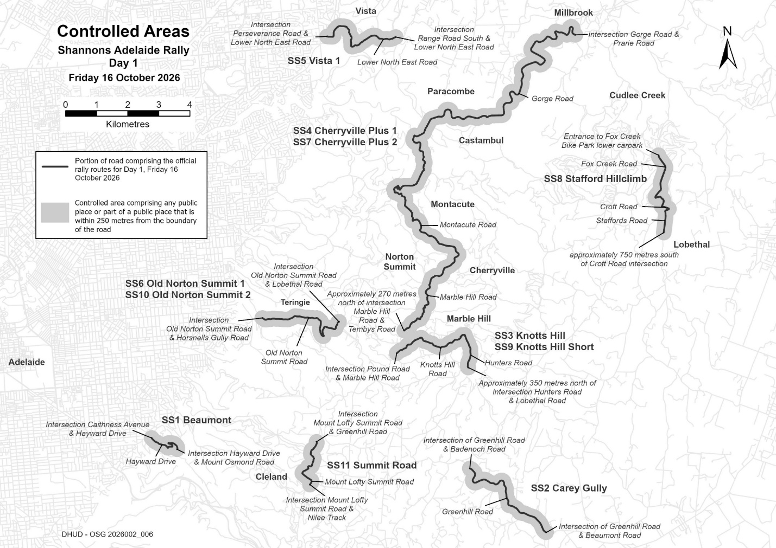
2026 Shannons Adelaide Rally

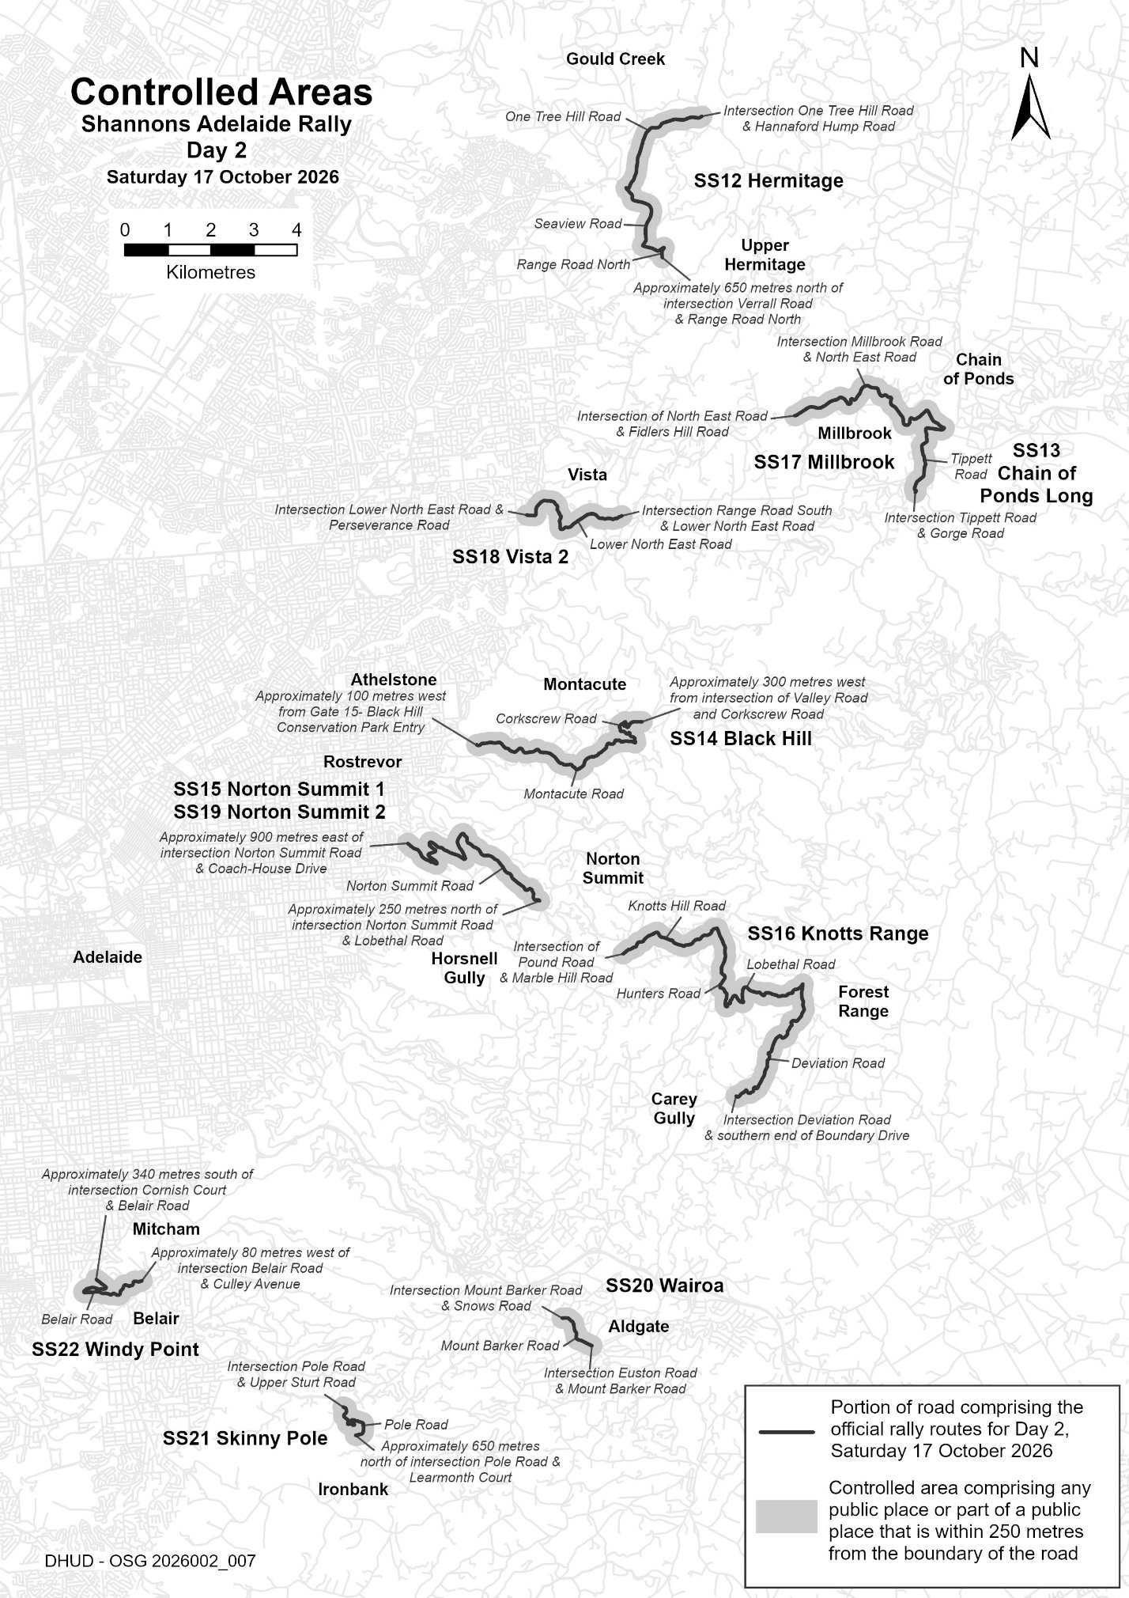
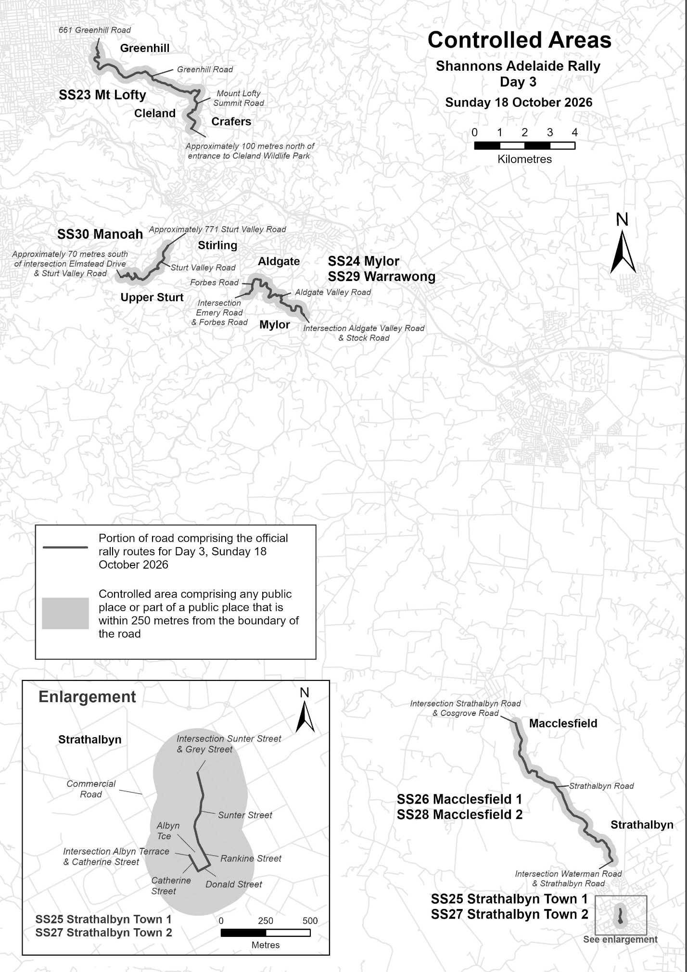

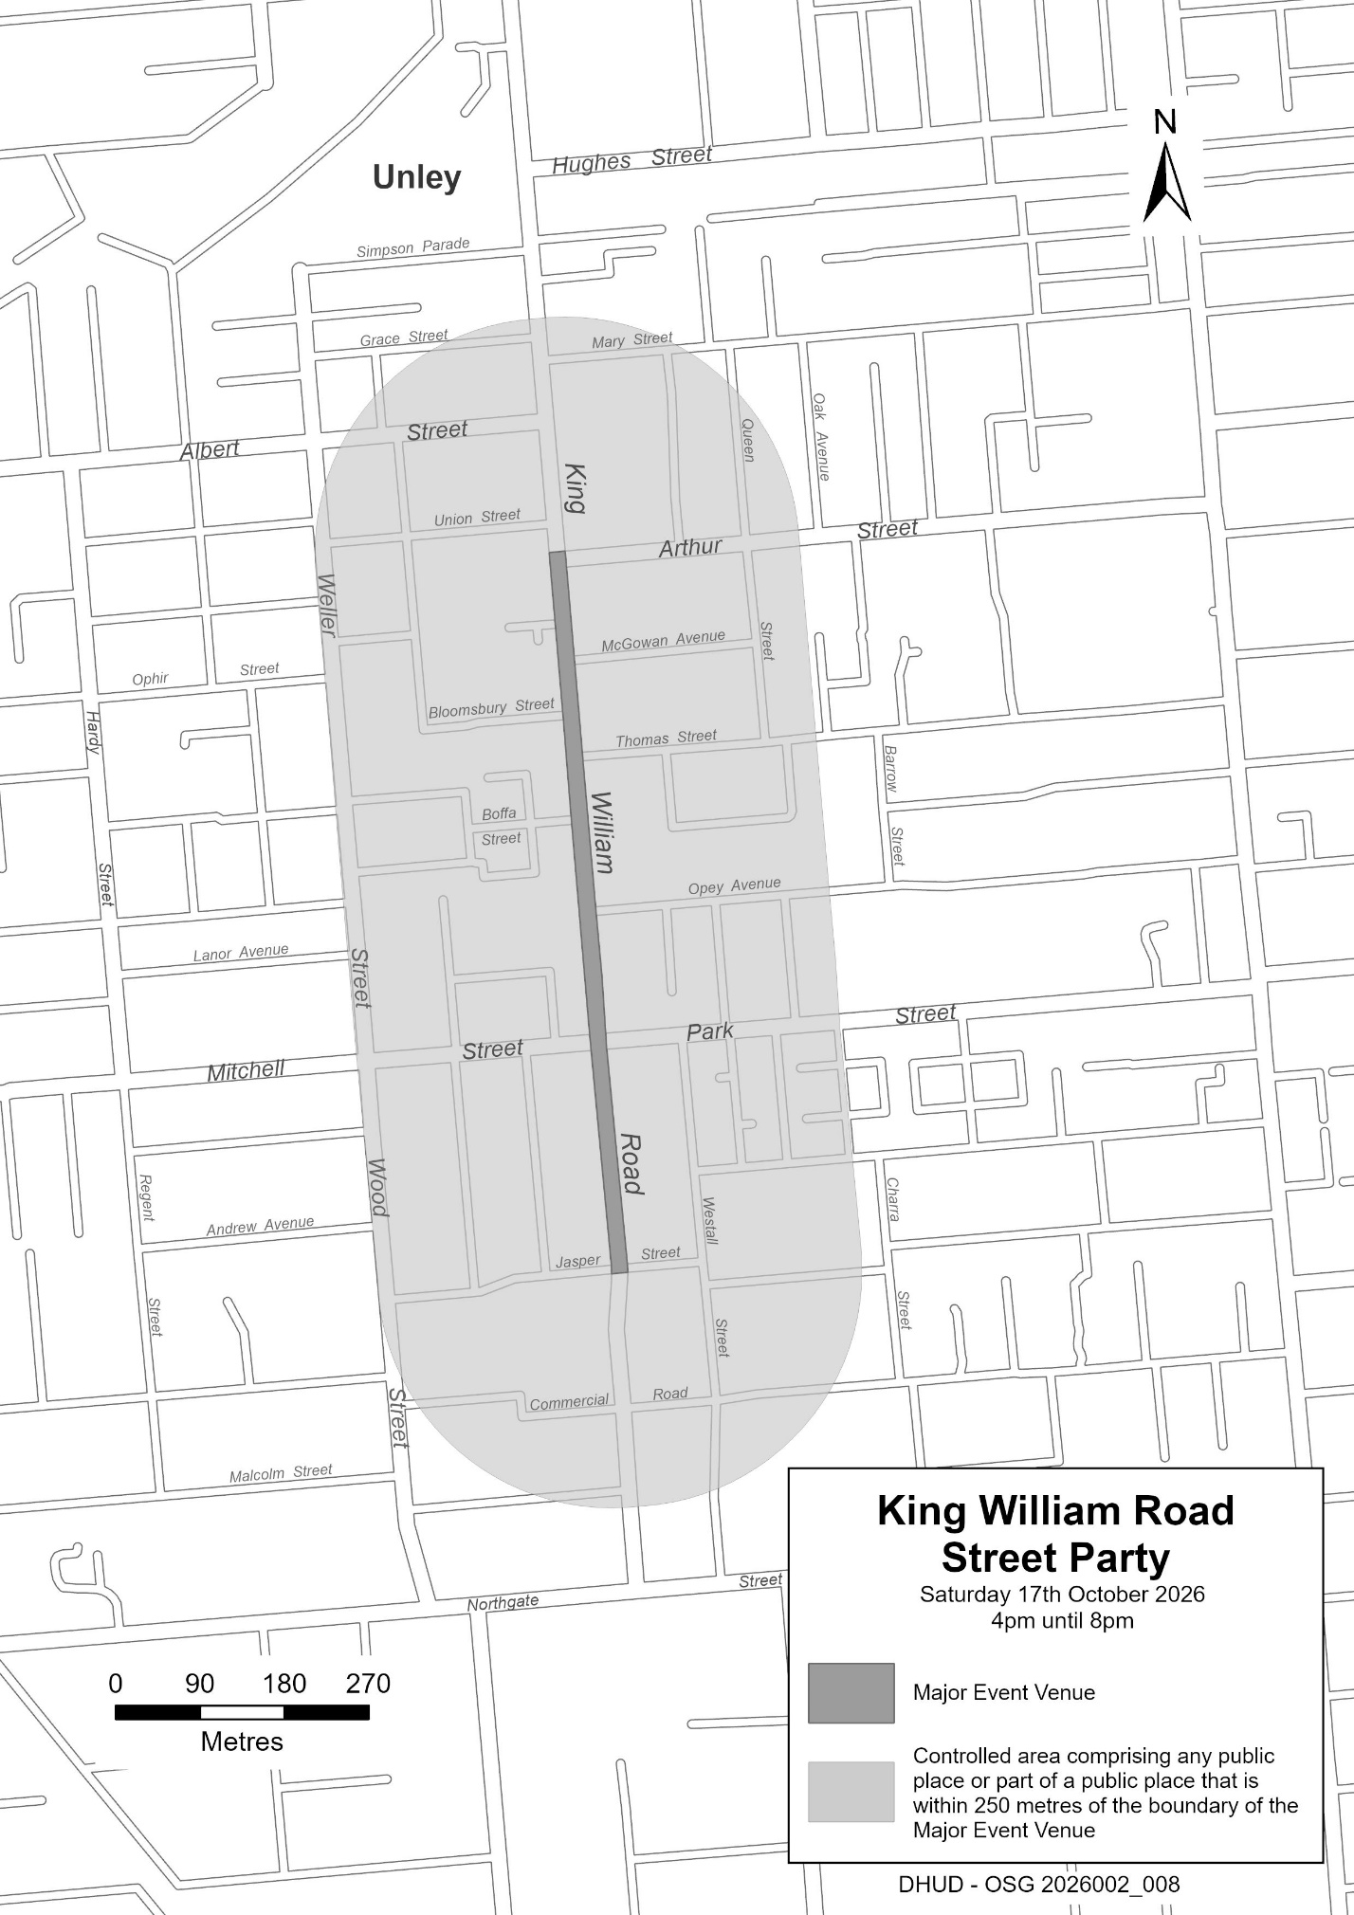
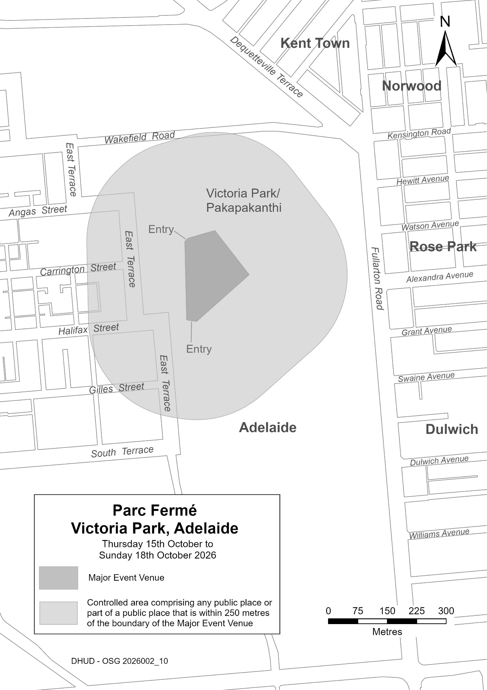
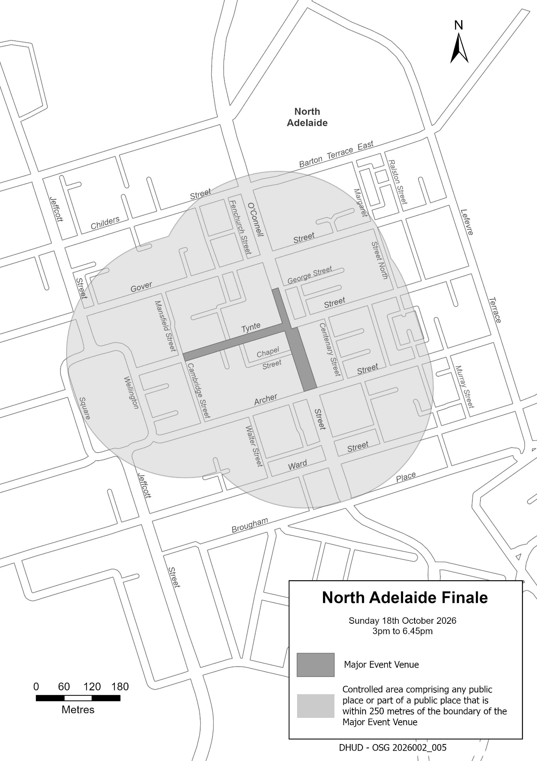

Planning, Development and Infrastructure Act 2016
Section 76
Amendment to the Planning and Design Code
Preamble
It is necessary to amend the Planning and Design Code (the Code) in operation at 24 September 2026 (Version 2026.18) in order to make changes of form relating to the Code’s spatial layers and their relationship with land parcels. Note: There are no changes to the application of zone, subzone or overlay boundaries and their relationship with affected parcels or the intent of policy application as a result of this amendment.
1. Pursuant to Section 76 of the Planning, Development and Infrastructure Act 2016 (the Act), I hereby amend the Code in order to make changes of form (without altering the effect of underlying policy), correct errors and make operational amendments as follows:
(a) Undertake minor alterations to the geometry of the spatial layers and data in the Code to maintain the current relationship between the parcel boundaries and Code data as a result of the following:
(i) New plans of division deposited in the Land Titles Office between 16 September 2026 and 29 September 2026 affecting the following spatial and data layers in the Code:
A. Zones and subzones
B. Technical and Numeric Variations
• Building Heights (Levels)
• Building Heights (Metres)
• Minimum Dwelling Allotment Size
• Minimum Frontage
• Minimum Site Area
• Minimum Primary Street Setback
• Minimum Side Boundary Setback
• Future Local Road Widening Setback
• Site Coverage
C. Overlays
• Affordable Housing
• Character Area
• Coastal Areas
• Co-located Housing
• Defence Aviation Area
• Dwelling Excision
• Future Local Road Widening
• Future Road Widening
• Hazards (Bushfire—High Risk)
• Hazards (Bushfire—Medium Risk)
• Hazards (Bushfire—General Risk)
• Hazards (Bushfire—Urban Interface)
• Hazards (Bushfire—Regional)
• Hazards (Bushfire—Outback)
• Heritage Adjacency
• Historic Area
• Limited Land Division
• Local Heritage Place
• Regulated and Significant Tree
• Significant Retirement Facility and Supported Accommodation Sites
• State Heritage Place
• Stormwater Management
• Urban Tree Canopy
(b) In Part 13 of the Code—Table of Amendments, update the publication date, Code version number, amendment type and summary of amendments within the ‘Table of Planning and Design Code Amendments’ to reflect the amendments to the Code as described in this Notice.
2. Pursuant to Section 76(5)(a) of the Act, I further specify that the amendments to the Code as described in this Notice will take effect upon the date those amendments are published on the SA planning portal.
Dated: 1 October 2026
Greg van Gaans
Director, Geospatial Information Services,
Department for Housing and Urban Development
Delegate of the Minister for Planning

Planning, Development and Infrastructure Act 2016
Section 76
Amendment to the Regional Plans
Preamble
It is necessary to amend the Regional Plans to make the following minor or operational amendments:
• to update the Greater Adelaide Regional Plan to amend the City of Adelaide Annual Housing Targets graph to make the numbers legible.
• to update the Greater Adelaide Regional Plan to remove the City of Adelaide subregion and its contents from the Employment Sectors and Land Use section.
• to correct an error identified in the Yorke Peninsula and Mid North Regional Plan to remove an incorrect reference to the Eyre and Western region.
• to correct an error identified in the Eyre and Western Regional Plan to remove an incorrect reference to the River Murray.
1. Pursuant to Section 76 of the Planning, Development and Infrastructure Act 2016 (the Act), I hereby amend the Regional Plans to make the following minor or operational amendments:
(a) in the Greater Adelaide Regional Plan, under ‘Implementation and delivery’, ‘City of Adelaide’ drop down box, amend the Annual Housing Targets graph to make the numbers legible.
(b) in the Greater Adelaide Regional Plan, under ‘Context’, ‘Employment trends and land supply’ and ‘Subregion’, remove the City of Adelaide drop down box, as the City of Adelaide does not function as a growth area for land-intensive employment uses such as traditional industry or freight and logistics.
(c) in the Yorke Peninsula and Mid North Regional Plan, under ‘People, housing and liveability’, ‘Outcome 1’, ‘Identifying enough land for the dwellings we need’, remove an incorrect reference to Eyre and Western.
(d) in the Eyre and Western Regional Plan, under ‘Productive Economy’, ‘Tourism and Events’, ‘Cultural and heritage tourism’ drop down box, remove an incorrect reference to the River Murray.
2. Pursuant to Section 76(5)(a) of the Act, I further specify that the amendments to the Plan as described in this Notice will take effect upon the date those amendments are published on the SA planning portal.
Dated: 6 October 2026
Jason Bailey
Director, Strategic Planning
Department for Housing and Urban Development
Delegate of the Minister for Planning

Prices Act 1948
Section 12(2)
Records Required to be Kept in Relation to Recovery, Towing, Storage and Quotation for
Repair of Motor Vehicles Damaged in Accidents within the Declared Area
Notice of the Commissioner for Prices
Pursuant to Section 12(2) of the Prices Act 1948, I, Brett Humphrey, Commissioner for Prices, require persons who, in the course of a business, supply a declared service to which Prices Order No. 1142 (S.A.) applies to keep, in respect of each service so supplied, a record setting out:
(a) the time and date when the service was ordered;
(b) the name of the person who ordered the service or other information sufficient to identify that person;
(c) the number of running kilometres travelled for the purposes of supplying the service;
(d) the time and date of arrival at the place of storage or repair of the vehicle to which the service relates and of return to the registered premises of the person supplying the service;
(e) if the work involved in supplying the service was carried out partly during normal hours and partly outside normal hours - details of the work carried out during normal hours and outside normal hours;
(f) if more than one tow truck was used in supplying the service or more than one person was engaged in supplying the service - the number of tow trucks used or persons engaged; and
(g) how the total charge for supplying the service was calculated.
Words and expressions used in this notice have the same meaning as in Prices Order No. 1142 (S.A.).
This notice will take effect on the day on which Prices Order No. 1142 (S.A.) comes into operation.
Dated: 8 October 2026
B. Humphrey
Commissioner for Prices

Prices Act 1948
Section 24
Declaration of Maximum Prices for Recovery, Towing, Storage and Quotation for Repair of
Motor Vehicles Damaged in Accidents within the Declared Area
Order by the Minister for Consumer and Business Affairs
Pursuant to Section 24 of the Prices Act 1948, I, Hon Michael Brown MP, Minister for Consumer and Business Affairs, do hereby make the following order:
Citation
1. This order may be cited as Prices Order No. 1142 (S.A.).
Commencement
2. This order will come into operation on the day it is published in the Government Gazette.
Order No. 1140 (S.A.) Superseded
3. This order supersedes Prices Order No. 1141 (S.A.) (see Gazette No. 27, 27 April 2023 pp. 882—884).
Interpretation
4. (1) In this order:
‘GST’ means the tax payable under the GST law; ‘GST law’ means:
(a) A New Tax System (Goods and Services Tax) Act 1999 (Commonwealth); and
(b) the related legislation of the Commonwealth dealing with the imposition of a tax on the supply of goods, services and other things;
‘motor car’ means a motor vehicle (as defined in Section 5 of the Motor Vehicles Act 1959):
(a) designed for the principal purpose of carrying passengers; and
(b) designed to carry not more than 8 adult persons (including the driver),
and includes a motor vehicle of the type commonly known as a utility, station sedan or panel van;
‘normal hours’ means the hours between 7:30am and 5:00pm on any day other than a Saturday, Sunday or public holiday;
‘prescribed motor vehicle’ means a motor car, motor bike, caravan or trailer;
‘running kilometres’, in relation to the distance travelled for the purposes of supplying a service to which this order applies, means the number of kilometres travelled from the registered premises of the person supplying the service to the scene of the accident, from the scene of the accident to the place of repair or storage of the prescribed motor vehicle to which the services relate and from the place of repair or storage of the vehicle to those registered premises.
(2) In this order the expressions ‘accident’, ‘caravan’, ‘declared area’, ‘motor bike’, ‘quotation for repair’, ‘registered premises’, ‘tow’, ‘tow truck’ and ‘trailer’ have the same meaning as in the Motor Vehicles Act 1959.
Services to Which Order Applies
5. This order applies to the following services:
(a) the recovery and towing at or from the scene of an accident occurring within the declared area of a prescribed motor vehicle damaged in the accident;
(b) the storage of a prescribed motor vehicle damaged in an accident occurring within the declared area;
(c) the quotation for repair of a prescribed motor vehicle damaged in an accident occurring within the declared area.
Declaration of Maximum Prices
6. (1) Subject to this Clause, I declare that the maximum price (inclusive of GST component) at which a service specified in the
first column of the table in the Schedule may be supplied is:
(a) in the case of a service provided during normal hours—the amount specified opposite in the second column of the table;
(b) in the case of a service provided outside normal hours—the amount specified opposite in the third column of the table.
(2) If the work involved in supplying a service to which this order applies is carried out partly during normal hours and partly outside normal hours, the maximum price that may be charged for providing the service must be calculated according to the maximum price specified in the Schedule for providing the service during the time of the day at which the work is actually carried out.
(3) The maximum price that may be charged for supplying a service for which the Schedule specifies a maximum price per hour is to be calculated in accordance with the following formula:
A = __B__ x C
10
Where
A is the maximum amount that may be charged for the service;
B is the maximum price per hour for the service specified in the Schedule;
C is the number of complete 6 minute periods spent in providing the service.
(4) If the use of more than one tow truck is necessary to supply a service to which this order applies, the maximum price specified in the Schedule may be charged in respect of each tow truck used in supplying the service.

Order Not to Apply to Supply of Services by Certain Persons
7. This order does not apply in relation to a person who supplies a service referred to in Clause 5 while there is in force an order under Section 24 of the Prices Act 1948 fixing a maximum price for the supply of that service by that particular person.
I hereby recommend, in accordance with the Prices Act 1948, that the following Schedule be published in the Government Gazette to be effective as from the date of its publication.
Dated: 8 October 2026
Hon Michael Brown MP
Minister for Consumer and Business Services

Schedule of Recommended Fees for Charges for Towing, Recovery, Storage & Quotation
for Repair of Motor Vehicles (Accident Towing Roster Scheme)
Service | Maximum Price  (Normal Hours) | Maximum Price  (Outside Normal Hours)
1. Recovery of a prescribed motor vehicle at the scene of an accident and towing the vehicle:  • from the scene of the accident to a place of repair or storage; or  • from a place of storage to a place of repair:  ◦ for a distance not exceeding 20 running kilometres  ◦ for each running kilometre in excess of  20 running kilometres  Note: The above charge includes:  (a) 30 minutes of waiting time or working time at the scene of the accident; and  (b) The use of a power winch, trailer and any other specialised equipment necessary to recover and tow the vehicle.  Waiting time or working time at the scene of the accident in excess of 30 minutes  Waiting or working time at the scene of the accident where more than one person is engaged to recover the vehicle—for each additional person so engaged  2. Storage of a prescribed motor vehicle:  • Maximum Fee  3. Quotation for repair of a prescribed motor vehicle where the estimated cost of repairs:  • does not exceed $1,000  • exceeds $1,000 but does not exceed $2,000  • exceeds $2,000 | $456.00  $4.00  $68.00 per hour or part of an hour  $50.00 per hour of part of an hour  $26.00 per day  $3.08 per each $100 of the estimated cost or part of $100  $31.02 plus $2.34 per each $100 of the estimated cost or part of $100  $54.64 plus $7.83 per each $1,000 of the estimated cost or part of $1,000 up to an additional maximum charge of $86.83 | $533.00  $6.00  $103.00 per hour or part of an hour  $86.00 per hour or part of an hour  $26.00 per day  $3.08 per each $100 of the estimated cost or part of $100  $31.02 plus $2.34 per each $100 of the estimated cost or part of $100  $54.64 plus $7.83 per each $1,000 of the estimated cost or part of $1,000 up to an additional maximum charge of $86.83

Road Traffic Act 1961
Authorisation to Operate Breath Analysing Instruments
I, Grant Stevens, Commissioner of Police, do hereby notify that on and from 28 September 2026, the following persons were authorised by the Commissioner of Police to operate breath analysing instruments as defined in and for the purposes of the:
• Road Traffic Act 1961;
• Harbors and Navigation Act 1993;
• Security and Investigation Industry Act 1995; and
• Rail Safety National Law (South Australia) Act 2012.
PD Number | Officer Name
15222 | GRIFFIN, Hope Alice
17768 | LENATHEN, Aimee Elizabeth
16817 | LOTFI, Sam
15036 | MCGINLAY, Reghan Grace
15478 | MULLIGAN, Elliot Luke
16558 | RUSSELL, Nikki Erin
18239 | SCHRADER, Barry
15661 | SRAN, Lovepreet Singh
72644 | VAN DONGEN, Keith
16886 | WARREN, Sam Nicholas
15395 | WEIDNER, James Andrew
Dated: 8 October 2026
Grant Stevens
Commissioner of Police
Reference: 2026-0127

Road Traffic Act 1961
Authorisation to Operate Breath Analysing Instruments
I, Grant Stevens, Commissioner of Police, do hereby notify that on and from 28 September 2026, the following persons were authorised by the Commissioner of Police to operate breath analysing instruments as defined in and for the purposes of the:
• Road Traffic Act 1961;
• Harbors and Navigation Act 1993;
• Security and Investigation Industry Act 1995; and
• Rail Safety National Law (South Australia) Act 2012.
PD Number | Officer Name
77006 | BISSET, Rachel Elise
15997 | BURCHELL, Declan Mcgregor
16319 | FABBRO, Bridget Hope
12797 | KRAUSE, Jack
11066 | LANE, Benjamin Aaron
73934 | REES, Daniel Grant
13324 | SMEE, Matthew John
12482 | SMITH, Nikhili Surinder
12065 | TOWNS, Ryan Jordy
17994 | WILLIAMSON, Philip James
Dated: 8 October 2026
Grant Stevens
Commissioner of Police
Reference: 2026-0160

Roads (Opening and Closing) Act 1991
Section 24
NOTICE OF CONFIRMATION OF
ROAD PROCESS ORDER
Road Closure—Portion of Springfield Road (Unmade Public Road), Yorketown
By Road Process Order made on 17 July 2026, the Yorke Peninsula Council ordered that:
- Portion of Springfield Road (Unmade Public Road) situated adjoining Sections 332 and 334 Hundred of Dalrymple, more particularly delineated and lettered ‘A’ in Preliminary Plan 26/0005 be closed.
- Transfer the whole of the land subject to closure to Jonathan Howard Pillow and Alister Henry Pillow in accordance with the Agreement for Transfer dated 17 July 2026 entered into between the Yorke Peninsula Council and Jonathan Howard Pillow and Alister Henry Pillow.
- The following easement is to be granted over portion of the land subject to closure:
Grant an easement for water supply purposes over the land marked ‘B’ in Deposited Plan 141176.
On 2 October 2026, the Road Process Order was confirmed by me, as delegate of the Minister for Planning, conditionally upon the deposit of Deposited Plan 141176 by the Registrar-General.
Notice of the Road Process Order and its confirmation is hereby given in accordance with Sections 24(4) and (5) of the Roads (Opening and Closing) Act 1991, following the confirmation of the Road Process Order and fulfilment of the condition of that confirmation.
Dated: 8 October 2026
B. J. Slape
Surveyor-General
Delegate of the Minster for Planning
2026/03299/01

Roads (Opening and Closing) Act 1991
Section 24
NOTICE OF CONFIRMATION OF
ROAD PROCESS ORDER
Road Closure—Re-advertised—Portion of Peel Creek Drive, Old Reynella
By Road Process Order made on 16 July 2026, the City of Onkaparinga ordered that:
- Whole of Peel Creek Drive, Old Reynella, (being whole of allotment 706 in Deposited Plan 129786) situated adjoining allotment 1001 in Deposited Plan 135407 and allotment 101 in Deposited Plan 129786, Hundred of Noarlunga, more particularly delineated and lettered ‘A’ in Preliminary Plan 26/0001 be closed.
- Transfer the whole of the land subject to closure to Tarac Properties Pty. Ltd. in accordance with the Agreement for Transfer dated 24 June 2026 entered into between the City of Onkaparinga and Tarac Properties Pty. Ltd.
- The following easements are to be granted over the whole of the land subject to closure:
Grant a free and unrestricted right of way in favour of the council for the area over the land marked ‘A’ in Deposited Plan 140435.
Grant an easement for drainage purposes in favour of the council for the area over the land marked ‘A’ in Deposited Plan 140435.
On 18 September 2026, the Road Process Order was confirmed by me, as delegate of the Minister for Planning, conditionally on the deposit of Deposited Plan 140435 by the Registrar-General.
Notice of the Road Process Order and its confirmation is hereby given in accordance with Sections 24(4) and (5) of the
Roads (Opening and Closing) Act 1991, following the confirmation of the Road Process Order and fulfilment of the condition of that confirmation.
Dated: 8 October 2026
B. J. Slape
Surveyor-General
Delegate of the Minster for Planning
2026/02208/01

South Australian Motor Sport Act 1984
Section 26
Availability of Plans for Public Inspection—Notice by the Minister
Pursuant to Section 26 of the South Australian Motor Sport Act 1984, I, the Minister to whom powers and functions of that Act have been delegated, hereby designates the site office of the South Australian Motor Sport Board, Victoria Park/Pakapakanthi, Adelaide SA 5000 as the place at which may be inspected by members of the public plans of all works proposed to be carried out by the South Australian Motor Sport Board in relation to the event known as the ‘2027 MotoGP Grand Prix of Australia’.
Dated: 2 October 2026
Hon. Blair Ingram Boyer MP
Minister for Health and Wellbeing
Delegate for the Minister Responsible for the South Australian Motor Sport Act 1984

SOUTH AUSTRALIAN MOTOR SPORT ACT 1984
Section 20(1)
Declaration of Area, Period and Prescribed Works Period—Notice by the Minister
Pursuant to Section 20(1) of the South Australian Motor Sport Act 1984, I, the Minister to whom powers and functions of that Act have been delegated, in respect of the motor sport event promoted by the South Australian Motor Sport Board under the name ‘2027 MotoGP Grand Prix of Australia’, after consultation with the Board, declare:
• that the area delineated on the plan in the schedule will be the declared area under the Act for the purposes of the event;
• that a period of five days in November 2027, to be confirmed by later declaration, will be the declared period under the Act for the purposes of the event; and
• that the prescribed works period in respect of works necessary for the purpose of staging the 2027 MotoGP Grand Prix of Australia, known as the Adelaide Circuit Redevelopment Project, be the period commencing on 9 October 2026 and concluding on 10 November 2027 inclusive.
Dated: 2 October 2026
Hon. Blair Ingram Boyer MP
Minister for Health and Wellbeing
Delegate for the Minister Responsible for the South Australian Motor Sport Act 1984

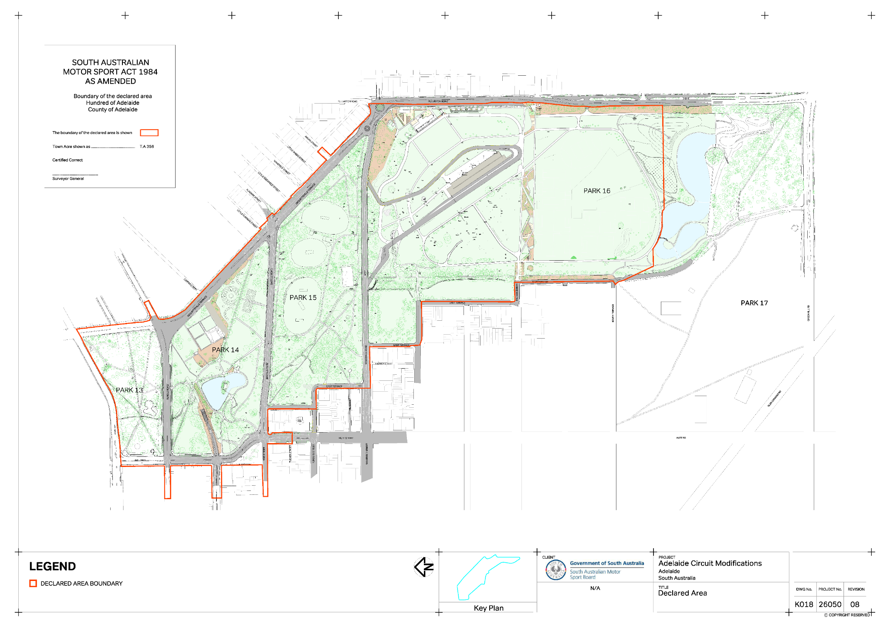
Schedule

Local Government Instruments

Brown Hill and Keswick Creeks Stormwater Board
Local Government Act 1999 (Sa)
Amendment of Charter for the Brown Hill and Keswick Creeks Stormwater Board
The constituent councils of the Brown Hill and Keswick Creeks Stormwater Board (Board) being the City of Adelaide (23 June 2026), the City of Burnside (16 June 2026), the City of Mitcham (30 June 2026), the City of Unley (22 June 2026) and the City of West Torrens (16 June 2026), have each resolved to amend the Board’s Charter.
In accordance with Schedule 2, Clause 19(5)(b) and (c) of the Local Government Act 1999, a copy of the amended Charter has been furnished to the Minister for Local Government and has been published on the Board's website and is available for inspection at: www.bhkcstormwater.com.au.
Dated: 8 October 2026
Peta Mantzarapis
Project Director
Brown Hill and Keswick Creeks Stormwater Board

Public Notices

National Electricity Law
Notice of Draft Determination Extension
The Australian Energy Market Commission (AEMC) gives notice under the National Electricity Law as follows:
Under s 107, the time for making the draft determination on the Security framework enhancements (Ref. ERC0424) proposal has been extended to 27 May 2027.
Australian Energy Market Commission
Level 15, 60 Castlereagh St
Sydney NSW 2000
Telephone: (02) 8296 7800
www.aemc.gov.au
Dated: 8 October 2026

Notice Submission

The South Australian Government Gazette is published each Thursday afternoon.
Notices must be emailed by 4 p.m. Tuesday, the week of publication.
Submissions are formatted per the gazette style and a proof will be supplied prior to publication, along with a quote if applicable. Please allow one day for processing notices.
Alterations to the proof must be returned by 4 p.m. Wednesday.

Gazette notices must be submitted as Word files, in the following format:
• Title—the governing legislation
• Subtitle—a summary of the notice content
• Body—structured text, which can include numbered lists, tables, and images
• Date—day, month, and year of authorisation
• Signature block—name, role, and department/organisation authorising the notice

Please provide the following information in your email:
• Date of intended publication
• Contact details of the person responsible for the notice content
• Name and organisation to be charged for the publication—Local Council and Public notices only
• Purchase order, if required—Local Council and Public notices only

Email: governmentgazettesa@sa.gov.au
Phone: (08) 7133 3552
Website: www.governmentgazette.sa.gov.au

All instruments appearing in this gazette are to be considered official, and obeyed as such

Printed and published weekly by authority of T. Foresto, Government Printer, South Australia
$9.50 per issue (plus postage), $479.00 per annual subscription—GST inclusive
Online publications: www.governmentgazette.sa.gov.au

