
No. 61 p. 3169
THE SOUTH AUSTRALIAN
GOVERNMENT GAZETTE
Published by Authority

Adelaide, Thursday, 15 October 2026

Contents

Governor’s Instruments
Appointments, Resignations and General Matters 3170
Proclamations—
Local Government (Defaulting Council)
(Prudential Requirements) Amendment
Proclamation 2026 3171
State Government Instruments
Building Work Contractors Act 1995 3172
Controlled Substances (Poisons) Regulations 2011 3173
Electoral Act 1985 3173
Energy Resources Act 2000 3173
Environment Protection Act 1993 3174
Fire and Emergency Services Act 2005 3176
Housing Improvement Act 2016 3176
Justices of the Peace Act 2005 3176
Letters Patent Constituting the Office of Governor 3177
Liquor Licensing Act 1997 3177
Motor Vehicles Act 1959 3212
National Parks and Wildlife Act 1972 3231
National Parks and Wildlife (Mamungari
Conservation Park) Regulations 2019 3231
National Parks and Wildlife (National Parks)
Regulations 2016 3231
Professional Standards Act 2004 3237
Remuneration Tribunal, The 3237
South Australian Skills Act 2008 3241
Summary Offences Act 1953 3241
Wilderness Protection Regulations 2021 3242
Local Government Instruments
City of Onkaparinga 3244
City of Port Adelaide Enfield 3244
Port Augusta City Council 3246
City of Salisbury 3247
City of Victor Harbor 3247
Wattle Range Council 3248
Yorke Peninsula Council 3250
Public Notices
National Electricity Law 3251
Trustee Act 1936 3251

Governor’s Instruments

Appointments, Resignations and General Matters
Department of the Premier and Cabinet
Adelaide, 15 October 2026
His Excellency the Administrator in Executive Council has been pleased to appoint the undermentioned to the Prescribed Psychiatric Treatment Panel, pursuant to the provisions of the Mental Health Act 2009:
Member: from 4 November 2026 until 3 November 2031
Kylie Anne Thorsen
Jaklin Ardath Eliott
By command,
Clare Michele Scriven, MLC
For Premier
HEAC-2026-00028

Department of the Premier and Cabinet
Adelaide, 15 October 2026
His Excellency the Administrator in Executive Council has been pleased to appoint the undermentioned to the South Australian Film Corporation, pursuant to the provisions of the South Australian Film Corporation Act 1972:
Member: from 15 October 2026 until 14 October 2029
Michael David Rann
Brian Robert Michael Hayes
Rachel Veda Gardner
Presiding Member: from 15 October 2026 until 14 October 2029
Michael David Rann
Member: from 30 November 2026 until 29 November 2029
Clara Joan Reeves
By command,
Clare Michele Scriven, MLC
For Premier
ART0018-26CS

Department of the Premier and Cabinet
Adelaide, 15 October 2026
His Excellency the Administrator in Executive Council has been pleased to appoint the Honourable Joseph Karl Szakacs, MP as Acting Deputy Premier, Acting Minister for Aboriginal Affairs, Acting Attorney-General, Acting Minister for Industrial Relations, Acting Minister for Arts and Acting Special Minister of State from 16 October 2026 until 25 October 2026, inclusive, during the absence of the Honourable Kyam Joseph Maher, MLC - pursuant to section 67 of the Constitution Act 1934.
By command,
Clare Michele Scriven, MLC
For Premier
AGO0061-26CS

Department of the Premier and Cabinet
Adelaide, 15 October 2026
His Excellency the Administrator in Executive Council has directed that a cash payment be made to Judge Nicolas Alexandrides, a Judge of the District Court of South Australia, upon his retirement, in lieu of his unused leave entitlement - pursuant to section 13H(2) of the Supreme Court Act 1935 and section 14(1) of the District Court Act 1991.
By command,
Clare Michele Scriven, MLC
For Premier
AGO0063-26CS

Proclamations
South Australia

Local Government (Defaulting Council) (Prudential Requirements) Amendment Proclamation 2026
under section 273 of the Local Government Act 1999
Part 1—Preliminary
1—Short title
This proclamation may be cited as the Local Government (Defaulting Council) (Prudential Requirements) Amendment Proclamation 2026.
2—Commencement
This proclamation comes into operation on the day on which it is made.
Part 2—Amendment of Local Government (Defaulting Council) Proclamation 2019 (Gazette 24.1.2019 p272) as amended
3—Amendment of Schedule 1—Provisions of Acts and regulations excluded or modified (section 273(12) of Act)
Schedule 1, table—after row relating to section 39 insert:

Section 48 | Delete the section
Made by the Administrator
with the advice and consent of the Executive Council
on 15 October 2026

State Government Instruments

Building Work Contractors Act 1995
Exemption
Take notice that, pursuant to Section 45 of the Building Work Contractors Act 1995, I, Brett Humphrey as a delegate for the Minister for Consumer and Business Affairs, do hereby exempt the licensee named in Schedule 1 from the application of Division 3 of Part 5 of the above Act in relation to domestic building work described in Schedule 2 and subject to the conditions specified in Schedule 3.
Schedule 1
BRIDGE URBAN PROJECTS PTY LTD (BLD 337272)
Schedule 2
Construction of a two bedroom detached ancillary dwelling (commonly referred to as a granny flat) on Allotment 1 Deposited Plan 4390, being a portion of land as described in Certificate of Title Volume 5397 Folio 79, more commonly known as 7 Torquay Road, Sturt SA 5047.
Schedule 3
- This exemption is limited to domestic building work arranged by the licensee in relation to the building work described in Schedule 2.
- This exemption does not apply to any domestic building work the licensee or the property owner Monique Shemikka contracts to another building work contractor, for which that contractor is required by law to hold building indemnity insurance.
- That the property owner Monique Shemikka does not transfer their interest in the land prior to five years from the date of completion of the building work the subject of this exemption, without prior authorisation of Consumer and Business Services (CBS). Before giving such authorisation, CBS may require the licensee to take any reasonable steps to protect the future purchaser(s) of the property, including but not limited to:
- Providing evidence that an adequate policy of building indemnity insurance is in force to cover the balance of the five-year period from the date of completion of the building work the subject of this exemption;
- Providing evidence of an independent expert inspection of the building work the subject of this exemption;
- Making an independent expert report available to prospective purchasers of the property;
- Giving prospective purchasers of the property notice of the absence of a policy of building indemnity insurance.
Dated: 9 October 2026
Brett Humphrey
Commissioner for Consumer Affairs
Delegate for the Minister for Consumer and Business Affairs

Building Work Contractors Act 1995
Exemption
Take notice that, pursuant to Section 45 of the Building Work Contractors Act 1995, I, Brett Humphrey as a delegate for the Minister for Consumer and Business Affairs, do hereby exempt the licensee named in Schedule 1 from the application of Division 3 of Part 5 of the above Act in relation to domestic building work described in Schedule 2 and subject to the conditions specified in Schedule 3.
Schedule 1
KYE JOHNS (BLD 306779)
Schedule 2
Construction of two single storey detached dwellings at Allotment 2 in Deposited Plan 10060 being a portion of the land described in Certificate of Title Volume 5215 Folio 950, more commonly known as 3 Kelvin Road, Ingle Farm SA 5098.
Schedule 3
1. This exemption is limited to domestic building work personally performed by the licensee in relation to the building work described in Schedule 2.
2. This exemption does not apply to any domestic building work the licensee contracts to another building work contractor, for which that contractor is required by law to hold building indemnity insurance.
3. That the licensee does not transfer his interest in the land or let or lease the property for valuable consideration prior to five years from the date of completion of the building work the subject of this exemption, without the prior authorisation of Consumer and Business Services (CBS). Before giving such authorisation, CBS may require the licensee to take any reasonable steps to protect the future purchaser(s) of the property, including but not limited to:
• Providing evidence that an adequate policy of building indemnity insurance is in force to cover the balance of the five-year period from the date of completion of the building work the subject of this exemption;
• Providing evidence of an independent expert inspection of the building work the subject of this exemption;
• Making an independent expert report available to prospective purchasers of the property;
• Giving prospective purchasers of the property notice of the absence of a policy of building indemnity insurance.
Dated: 7 October 2026
Brett Humphrey
Commissioner for Consumer Affairs
Delegate for the Minister for Consumer and Business Affairs

Building Work Contractors Act 1995
Exemption
Take notice that, pursuant to Section 45 of the Building Work Contractors Act 1995, I, Brett Humphrey as a delegate for the Minister for Consumer and Business Affairs, do hereby exempt the licensee named in Schedule 1 from the application of Division 3 of Part 5 of the above Act in relation to domestic building work described in Schedule 2 and subject to the conditions specified in Schedule 3.
Schedule 1
SHAYNE ROBERT HOGER (BLD 351340)
Schedule 2
Construction of a single story dwelling with detached garage at Allotment 304 Deposited Plan 89701, being a portion of the land described in Certificate of Title Volume 6099 Folio 849, more commonly known as Lot 304 Woodlawn Road, Streaky Bay SA 5680.
Schedule 3
1. This exemption is limited to domestic building work personally performed by the licensee in relation to the building work described in Schedule 2.
2. This exemption does not apply to any domestic building work the licensee contracts to another building work contractor, for which that contractor is required by law to hold building indemnity insurance.
3. That the licensee does not transfer his interest in the land or let or lease the property for valuable consideration prior to five years from the date of completion of the building work the subject of this exemption, without the prior authorisation of Consumer and Business Services (CBS). Before giving such authorisation, CBS may require the licensee to take any reasonable steps to protect the future purchaser(s) of the property, including but not limited to:
• Providing evidence that an adequate policy of building indemnity insurance is in force to cover the balance of the five-year period from the date of completion of the building work the subject of this exemption;
• Providing evidence of an independent expert inspection of the building work the subject of this exemption;
• Making an independent expert report available to prospective purchasers of the property;
• Giving prospective purchasers of the property notice of the absence of a policy of building indemnity insurance.
Dated: 7 October 2026
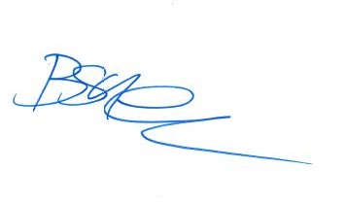Brett Humphrey
Commissioner for Consumer Affairs
Delegate for the Minister for Consumer and Business Affairs

Controlled Substances (Poisons) Regulations 2011
Prescribed Health Service Facility
Notice is hereby given in accordance with Regulation 44A of the Controlled Substances (Poisons) Regulations 2011, that the determination of Hamster Cottage as a prescribed health service facility is revoked by the Minister for Health and Wellbeing, effective from the date of publication of this notice.
Dated: 15 October 2026
Hon. Blair Boyer MP
Minister for Health and Wellbeing

Electoral Act 1985
Part 6—Registration of Political Parties
Notice is hereby given that I have on this day de-registered the political party named below for failing to have the appropriate number of members to continue as an eligible political party under the provision of Section 45 of the Act:
Name of Party: Sarah Game Fair Go for Australians
Dated: 15 October 2026
Leah Mclay
Acting Electoral Commissioner

Energy Resources Act 2000
Suspension of Petroleum Exploration Licence—PEL 182
Associated Activities Licence—AAL 224
Pursuant to Section 90 of the Energy Resources Act 2000, notice is hereby given that the abovementioned Licences have been suspended for the period from 7 April 2026 to 6 October 2026 inclusive, pursuant to delegated powers.
The expiry date of PEL 182 and AAL 224 is now determined to be 20 May 2027.
Dated: 7 October 2026
Paul De Ionno
Executive Director
Regulation and Compliance Division
Department for Energy and Mining
Delegate of the Minister for Energy and Mining

Environment Protection Act 1993
Section 69
Approval of the Collection Depot
I, Nicholas Stewart, Delegate of the Environment Protection Authority (‘the Authority’), pursuant to Section 69 of the Environment Protection Act 1993 (SA) (‘the Act’) hereby:
Vary the approval of the collection depot listed at Schedule 1 of this notice, that was granted under the Act prior to the date of this Notice and impose the conditions of this approval to be as follows:
1.1 Approval of Collection Depot:
The collection depot identified by reference to the following matters is approved:
(a) the name of the collection depot described in Column 1 of Schedule 1 of this Notice;
(b) the name of the company identified in Column 2 of Schedule 1 of this Notice;
(c) the name of the proprietor of the depot identified in Column 3 of Schedule 1 of this Notice;
(d) the location of the depot described in Columns 4-7 of Schedule 1 of this Notice.
The collection depot listed at Schedule 1 of this Notice is approved in relation to all classes of containers, which were approved under the Act, at or subsequent to the date of this Notice, as Category B Containers.
1.2 Conditions of approval:
Impose the following conditions on the approval:
1. If the Approval Holder’s name or postal address (or both) changes, then the Approval Holder must inform the Authority in writing, within 28 days of the change occurring.
2. If the collection depot is sold to another party, the Approval Holder must inform the Authority in writing, within 28 days of settlement.
3. The Approval Holder who wishes to cease operation of the depot shall notify the Authority in writing no less than 14 days from the date of closing.
4. The Approval Holder, or a person acting on his or her behalf, must not pay a refund on, or seek reimbursement for, containers that the Approval Holder, or the person acting on his or her behalf, knows were not purchased in South Australia.
5. The Approval Holder must ensure that prominent signage is displayed, detailing the offence and the penalties under Section 69 of the Act, for presenting interstate containers for refund.
Dated: 15 October 2026
Nicholas Stewart
Delegate of the Environment Protection Authority

Schedule 1
Column 1 | Column 2 | Column 3 | Column 4 | Column 5 | Column 6 | Column 7
Depot Name | Company  Name | Proprietors | Depot Location Street | Depot Location Suburb | Certificate of Title/Volume | Collection Area
Redeco | Redeco | Macaulay Smith | 10 Gosse Street | Roxby Downs | n/a | Regional

ENVIRONMENT PROTECTION ACT 1993
Prohibition on Taking Water Affected by Site Contamination
I, Wendy Boyce, Manager Site Contamination and Delegate of the Environment Protection Authority (‘the Authority’), being satisfied that site contamination exists that affects or threatens groundwater and that action is necessary pursuant to Section 103S of the
Environment Protection Act 1993 to prevent actual or potential harm to human health or safety hereby prohibit the taking of groundwater (as defined below) within the area specified in the map to this notice, other than for environmental assessment or environmental monitoring purposes or as approved in writing by the Authority.
This Notice relates to groundwater in:
(i) The watertable aquifer and any deeper water bearing zones hydraulically connected to the watertable aquifer, being the body of groundwater 0 to approximately 20 metres below ground surface within the specified area (see map).
The site contamination affecting the groundwater is in the form of chlorinated hydrocarbons, primarily trichloroethene (TCE). which represent actual or potential harm to human health or safety. This prohibition becomes official upon the gazettal of this notice.
Dated: 15 October 2026
W. Boyce
Manager Site Contamination
Environment Protection Authority

Map
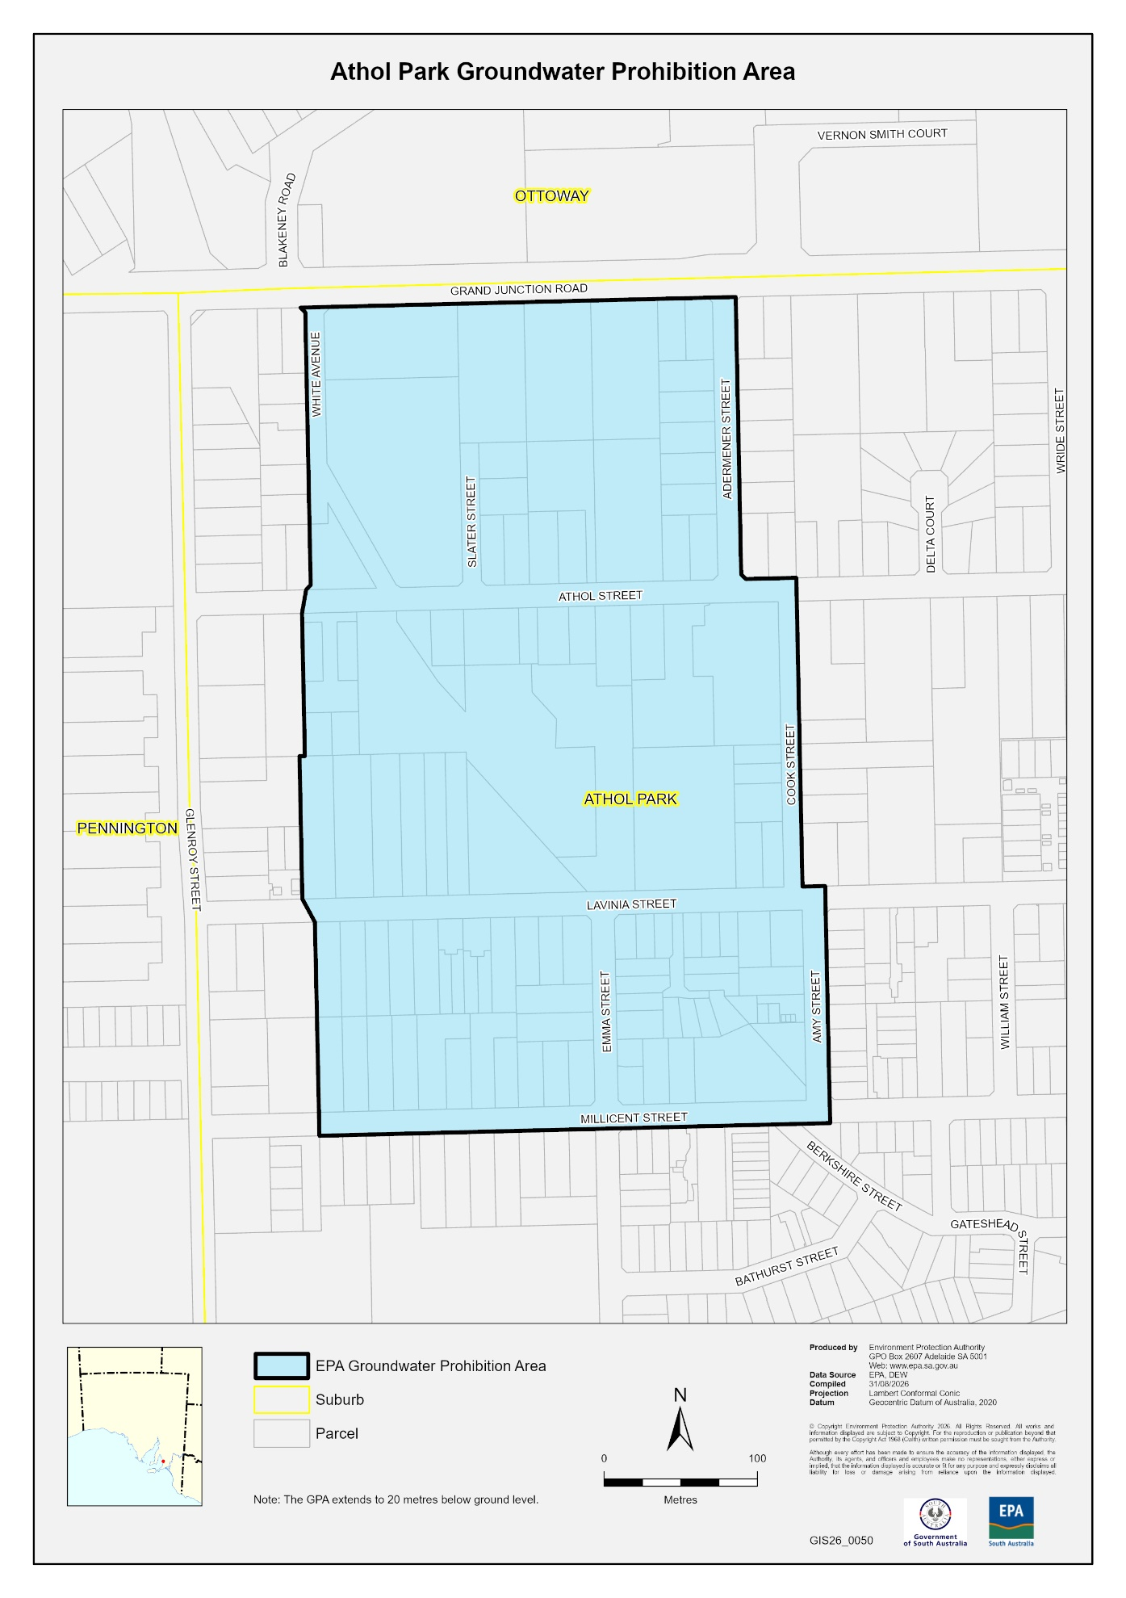

Fire and Emergency Services Act 2005
Section 78
Fire Danger Season
The South Australian Country Fire Service hereby:
- Fixes the date of the Fire Danger Season within the part of the State defined as the Riverland Fire Ban District so as to commence on 1 November 2026 and to end on 30 April 2027.
- Fixes the date of the Fire Danger Season within the part of the State defined as the Murraylands Fire Ban District so as to commence on 1 November 2026 and to end on 30 April 2027.
- Fixes the date of the Fire Danger Season within the part of the State defined as the Upper South East Fire Ban District so as to commence on 1 November 2026 and to end on 30 April 2027.
- Fixes the date of the Fire Danger Season within the part of the State defined as the Lower South East Fire Ban District so as to commence on 1 November 2026 and to end on 30 April 2027.
Dated: 13 October 2026
Brett Loughlin AFSM
Chief Officer
SA Country Fire Service

Housing Improvement Act 2016
Rent Control
In the exercise of the powers conferred by the Housing Improvement Act 2016, the Delegate of the Minister for Housing and Urban Development hereby fixes the maximum rental amount per week that shall be payable subject to Section 55 of the
Residential Tenancies Act 1995, in respect of each premises described in the following table. The amount shown in the said table shall come into force on the date of this publication in the Gazette.
Address of Premises | Allotment Section | Certificate of Title  Volume/Folio | Maximum Rental per week payable
10 Jacaranda Boulevard, Glenside SA 5065 | Allotment 129 Deposited Plan 120714 Hundred of Adelaide | CT6222/997 | $512.00
Dated: 15 October 2026
Craig Thompson
Registrar, Housing Regulation
Housing Safety Authority
Delegate of the Minister for Housing and Urban Development

Justices of the Peace Act 2005
Section 4
Notice of Appointment of Justices of the Peace for South Australia
by the Commissioner for Consumer Affairs
I, Brett Humphrey, Commissioner for Consumer Affairs, delegate of the Attorney-General, pursuant to Section 4 of the Justices of the Peace Act 2005, do hereby appoint the people listed as Justices of the Peace for South Australia as set out below.
For a period of ten years for a term commencing on 17 November 2026 and expiring on 16 November 2036:
Kiera Leanne WILKINSON
Thomas Samuel Judd WHITTENBURY
Sheryn Leanne WHITFIELD
Angela Candida Penelope SMITH
Maninderbir SINGH
Brian Joseph ROBERTS
Bennett Andreas Alexander REISINGER
Rodney Kenneth PARNELL
Marija MUDRI
Jason Andrew MCARTHUR
Lisa Nicole MARTIN
Mieke ISABEL
Suzanne Maree HORSNELL
Christopher Edward HARE
Philip Adrian GRECO
Jarred Luke GILBERT
Kimberley Jane GESTI
Thomas James GARLAND
Terry Arthur FRANCIS
Kay Louise DIGBY
John Bruno CARBINE
Emily Anne BUDDLE
Annette Ruth BRYAN

Jenny Louise BRUCE
Julie Anne BROWN
Ashley Wayne BENNETT
Joanne Rosalie ARNOLD
Dated: 12 October 2026
Brett Humphrey
Commissioner for Consumer Affairs
Delegate of the Attorney-General

Letters Patent Constituting the Office of Governor
Assumption of the Administration of the State by an Administrator
Take notice that, due to the vacancy in the office of Governor in and over the State of South Australia, I have requested that the
Honourable Chief Justice Laura Grace Stein assume the administration of the State as Administrator from 12:00am on Monday, 19 October 2026 until 11:59pm on Tuesday, 20 October 2026, and that Dr Richard Harris, the Lieutenant-Governor of South Australia, assume the administration of the State as Administrator from 12:00am on Wednesday, 21 October 2026 until 11:59pm on Saturday, 24 October 2026, pursuant to the Letters Patent constituting the Office of Governor made on 14 February 1986, as amended by the Governor of the State of South Australia by Order in Council on 25 October 2001 and 29 June 2023.
Dated: 30 September 2026
Peter Malinauskas
Premier

Liquor Licensing Act 1997
South Australia
Liquor Licensing (Dry Areas) Notice 2026
under Section 131(1a) of the Liquor Licensing Act 1997
1—Short title
This notice may be cited as the Liquor Licensing (Dry Areas) Notice 2026.
2—Commencement
This notice comes into operation on 26 December 2026.
3—Interpretation
(1) In this notice—
principal notice means the Liquor Licensing (Dry Areas) Notice 2015 published in the Gazette on 5 January 2015, as in force from time to time.
(2) Clause 3 of the principal notice applies to this notice as if it were the principal notice.
4—Consumption etc of liquor prohibited in dry areas
(1) Pursuant to Section 131 of the Act, the consumption and possession of liquor in the area described in the Schedule is prohibited in accordance with the provisions of the Schedule.
(2) The prohibition has effect during the periods specified in the Schedule.
(3) The prohibition does not extend to private land in the area described in the Schedule.
(4) Unless the contrary intention appears, the prohibition of the possession of liquor in the area does not extend to—
(a) a person who is genuinely passing through the place if—
(i) the liquor is in the original container in which it was purchased from licensed premises; and
(ii) the container has not been opened; or
(b) a person who has possession of the liquor in the course of carrying on a business or in the course of their employment by another person in the course of carrying on a business; or
(c) a person who is permanently or temporarily residing at premises near the public place and who enters the public place solely for the purpose of passing through it to enter those premises or who enters the public place from those premises for the purpose of leaving the place; or
(d) a person who possesses or consumes the liquor for sacramental or other similar religious purposes.
Schedule—Beachport Area 1
1—Extent of prohibition
The consumption of liquor is prohibited and the possession of liquor is prohibited.
2—Period of prohibition
From 12:01 midnight to 7:00am on each day from 26 December 2026 to 31 December 2026 (inclusive); and
From 7:01am on 31 December 2026 to 12 noon on 2 January 2027.
3—Description of area
The area in Beachport generally known as Centennial Park, comprising Lot 2, DP 41193.
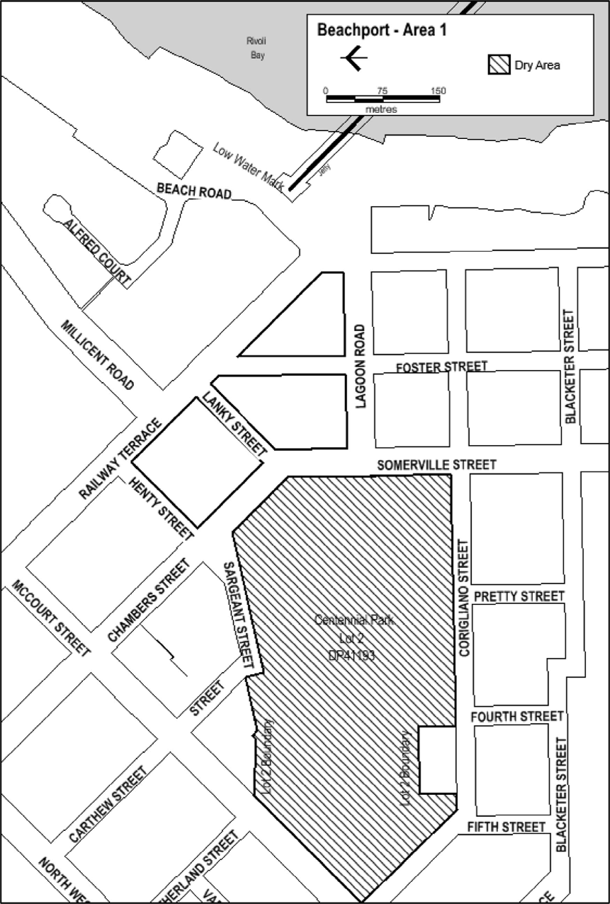
Made by the Liquor and Gambling Commissioner
Alison Selleck
Acting Assistant Director Licensing
Delegate of the Liquor and Gambling Commissioner
On 11 October 2026

Liquor Licensing Act 1997
South Australia
Liquor Licensing (Dry Areas) Notice 2026
under Section 131(1a) of the Liquor Licensing Act 1997
1—Short title
This notice may be cited as the Liquor Licensing (Dry Areas) Notice 2026.
2—Commencement
This notice comes into operation on 26 December 2026.
3—Interpretation
(1) In this notice—
principal notice means the Liquor Licensing (Dry Areas) Notice 2015 published in the Gazette on 5 January 2015, as in force from time to time.
(2) Clause 3 of the principal notice applies to this notice as if it were the principal notice.
4—Consumption etc of liquor prohibited in dry areas
(1) Pursuant to Section 131 of the Act, the consumption and possession of liquor in the area described in the Schedule is prohibited in accordance with the provisions of the Schedule.
(2) The prohibition has effect during the periods specified in the Schedule.
(3) The prohibition does not extend to private land in the area described in the Schedule.
(4) Unless the contrary intention appears, the prohibition of the possession of liquor in the area does not extend to—
(a) a person who is genuinely passing through the place if—
(i) the liquor is in the original container in which it was purchased from licensed premises; and
(ii) the container has not been opened; or
(b) a person who has possession of the liquor in the course of carrying on a business or in the course of their employment by another person in the course of carrying on a business; or
(c) a person who is permanently or temporarily residing at premises near the public place and who enters the public place solely for the purpose of passing through it to enter those premises or who enters the public place from those premises for the purpose of leaving the place; or
(d) a person who possesses or consumes the liquor for sacramental or other similar religious purposes.

Schedule—Beachport Area 2

1—Extent of prohibition
The consumption of liquor is prohibited and the possession of liquor is prohibited.
2—Period of prohibition
From 12 noon on 26 December 2026 to 12 noon on 2 January 2027.
3—Description of area
The area in and adjacent to Beachport comprising the following roads and other areas:
(a) Railway Terrace between the south-eastern boundary of McCourt Street and the north-western boundary of Beach Road;
(b) Chambers Street and Somerville Street between the south-eastern boundary of McCourt Street and the southern boundary of Lagoon Road;
(c) Lagoon Road between the eastern boundary of Somerville Street and the western boundary of Beach Road;
(d) Henty Street;
(e) Lanky Street;
(f) Foster Street between Railway Terrace and the southern boundary of Lagoon Road;
(g) the area commencing at the point at which the prolongation in a straight line of the southern boundary of Lagoon Road intersects the low water mark on the western side of Rivoli Bay, then westerly along that prolongation to the western boundary of Beach Road, then generally northerly, north-easterly and northerly along that boundary of Beach Road to the southern boundary of Alfred Court, then along the prolongation in a straight line of that southern boundary of Alfred Court to the low water mark on the western side of Rivoli Bay, then generally south-westerly along the low water mark to the point of commencement.
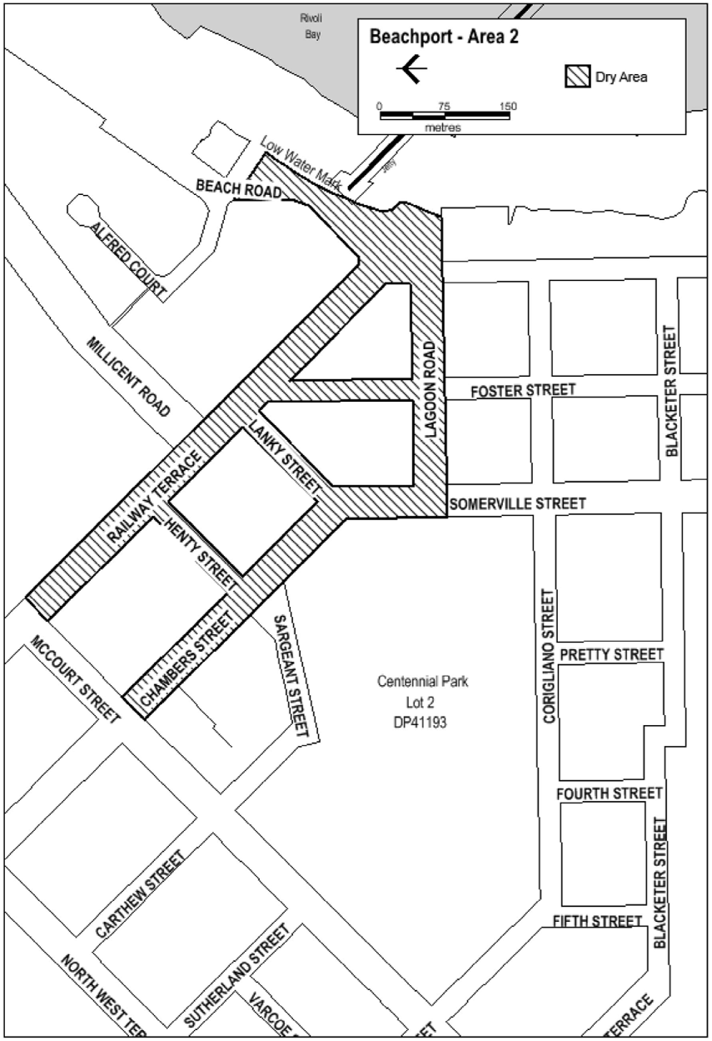
Made by the Liquor and Gambling Commissioner
Alison Selleck
Acting Assistant Director Licensing
Delegate of the Liquor and Gambling Commissioner
On 11 October 2026

Liquor Licensing Act 1997
South Australia
Liquor Licensing (Dry Areas) Notice 2026
under Section 131(1a) of the Liquor Licensing Act 1997
1—Short title
This notice may be cited as the Liquor Licensing (Dry Areas) Notice 2026.
2—Commencement
This notice comes into operation on 30 December 2026.
3—Interpretation
(1) In this notice—
principal notice means the Liquor Licensing (Dry Areas) Notice 2015 published in the Gazette on 5 January 2015, as in force from time to time.
(2) Clause 3 of the principal notice applies to this notice as if it were the principal notice.
4—Consumption etc of liquor prohibited in dry areas
(1) Pursuant to Section 131 of the Act, the consumption and possession of liquor in the area described in the Schedule is prohibited in accordance with the provisions of the Schedule.
(2) The prohibition has effect during the periods specified in the Schedule.
(3) The prohibition does not extend to private land in the area described in the Schedule.
(4) Unless the contrary intention appears, the prohibition of the possession of liquor in the area does not extend to—
(a) a person who is genuinely passing through the place if—
(i) the liquor is in the original container in which it was purchased from licensed premises; and
(ii) the container has not been opened; or
(b) a person who has possession of the liquor in the course of carrying on a business or in the course of their employment by another person in the course of carrying on a business; or
(c) a person who is permanently or temporarily residing at premises near the public place and who enters the public place solely for the purpose of passing through it to enter those premises or who enters the public place from those premises for the purpose of leaving the place; or
(d) a person who possesses or consumes the liquor for sacramental or other similar religious purposes.

Schedule 1—Chiton Rocks Car Park, (Chiton Rocks Area 1)
1—Extent of prohibition
The consumption of liquor is prohibited and the possession of liquor is prohibited.
2—Period of prohibition
From 6:00pm on 30 December 2026 – 6:00am on 2 January 2027.
3—Description of area
Chiton Area1
Chiton Rocks Surf Life Saving Club - car park area and adjacent beach area to the low water mark. The area adjacent to Victor Harbor generally known as the Chiton Rocks Surf Lifesaving Club car park and the adjacent beach, being the area bounded on the north by the northern boundaries of
Lot 469 DP 3482 and Lot 440 DP 3207, on the west by the prolongation in a straight line of the western boundary of Lot 433 DP 3207, on the south by the low water mark on Encounter Bay and on the east by the prolongation in a straight line of the eastern boundary of Lot 463 DP 3482.
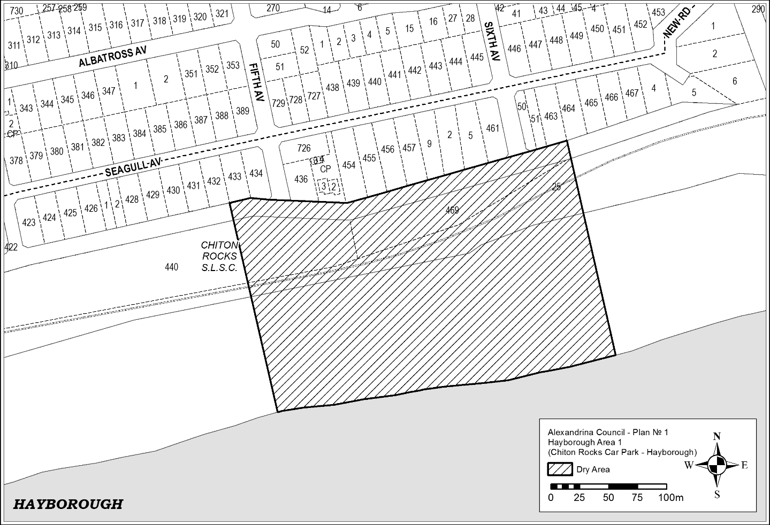

Schedule 2—Port Elliot—Area 2—Boomer Beach to Horseshoe Bay (Port Elliot Area 2)
1—Extent of prohibition
The consumption of liquor is prohibited and the possession of liquor is prohibited.
2—Period of prohibition
From 6.:00pm on 30 December 2026 – 6:00am on 2 January 2027.
3—Description of area
Port Elliot Area 2
The area in and adjacent to Port Elliot bounded as follows: commencing at the point at which the eastern boundary of Lot 26 of DP 74300 meets the northern boundary of Railway Terrace (approximately 50 metres west of the western boundary of Bennett Road), then easterly along the northern boundary of Railway Terrace to the western boundary of Carfax Street, then northerly along that boundary of Carfax Street to the point at which it is intersected by the prolongation in a straight line of the northern boundary of Battunga Avenue, then generally easterly, south-easterly and easterly along that prolongation and boundary of Battunga Avenue and the prolongation in a straight line of that boundary to the eastern boundary of Rosetta Terrace, then southerly along that boundary of Rosetta Terrace to the northern boundary of Barbara Street, then easterly along that boundary of Barbara Street to the point at which it intersects the eastern boundary of Hutton Street, then southerly along that boundary of Hutton Street to the northern boundary of Merrilli Place, then easterly along that boundary of Merrilli Place to the point at which it is intersected by the prolongation in a straight line of the eastern boundary of The Esplanade, then south-easterly along that prolongation and boundary of The Esplanade to the western boundary of Lot 101 of DP 46201, then south-easterly and easterly along the western and southern boundaries of Lot 101 and the southern boundaries of the adjoining Lots to the western boundary of The Strand, then northerly along that boundary of The Strand to the point at which it intersects the southern boundary of Torrens Street, then in a straight line by the shortest route (across The Strand) to the point at which the southern boundary of Murray Place meets the eastern boundary of The Strand, then easterly and north-easterly along that boundary of Murray Place to the point at which it meets the prolongation in a straight line of the southern boundary of Freeling Street, then north-easterly along that prolongation of the southern boundary of Freeling Street to the point at which it intersects the low water mark of Horseshoe Bay, then generally south-westerly, south-easterly, south-westerly and westerly along the low water mark to the point at which the low water mark is intersected by the prolongation in a straight line of the eastern boundary of Lot 26 of DP 74300, then northerly along that prolongation of the eastern boundary of Lot 26 to the point of commencement. The area includes the whole of any wharf, jetty, boat ramp, breakwater or other structure that projects below the low water mark from within the area described above (as well as any area beneath such a structure).

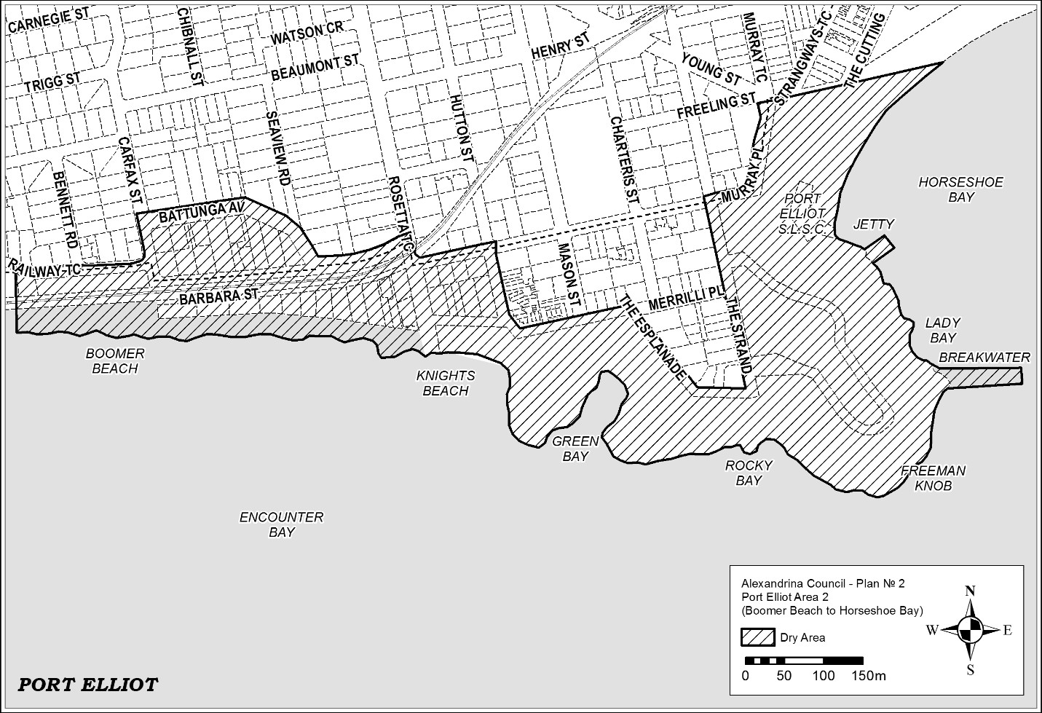

Schedule 3—Middleton Point Foreshore Area, Middleton Beach (Middleton Area 1)
1—Extent of prohibition
The consumption of liquor is prohibited, and the possession of liquor is prohibited.
2—Period of prohibition
From 6:00pm on 30 December 2026 – 6:00am on 2 January 2027.
3—Description of area
Middleton Area 1
The area in and adjacent to Middleton bounded as follows: commencing at the point at which the prolongation in a straight line of the western boundary of Basham Beach Road intersects the high water mark of Encounter Bay, then north-westerly along that prolongation and boundary to the point at which it is intersected by the prolongation in a straight line of the southern boundary of Set Road, then north-easterly along that prolongation and boundary of Set Road to the western boundary of Seaview Avenue, then generally south-easterly and north-easterly along that boundary of Seaview Avenue to the point at which it meets the eastern boundary of Lot 101 DP 10654, then south-easterly along that boundary of Lot 101 to the south-western corner of Lot 19 DP 3145, then generally north-easterly along the south-eastern boundary of Lot 19, the south-eastern boundaries of the adjoining Lots and the northern boundary of Ocean Parade to the south-eastern corner of Lot 133 FP 166507, then generally north-easterly and northerly along the easternmost boundaries of Lot 133 and the adjoining Lots (including the eastern boundary of Dover Road) to the north-eastern corner of Lot 39 DP 3262, then in a straight line by the shortest route to the north-western corner of Lot 160 DP 9417, then easterly along the southern boundary of the Esplanade to the western boundary of Lot 3 DP 13398, then northerly, easterly and southerly along the western, northern and eastern boundaries of that Lot to its south-eastern corner, then along the northern boundary of Section 345, Hundred of Goolwa, (the southern boundary of Surfer's Parade) to the point at which it is intersected by the prolongation in a straight line of the eastern boundary of Lot 39 DP 6156, then along that prolongation to the point at which it intersects the high water mark of Encounter Bay, then generally westerly and south-westerly along the high water mark to the point of commencement.

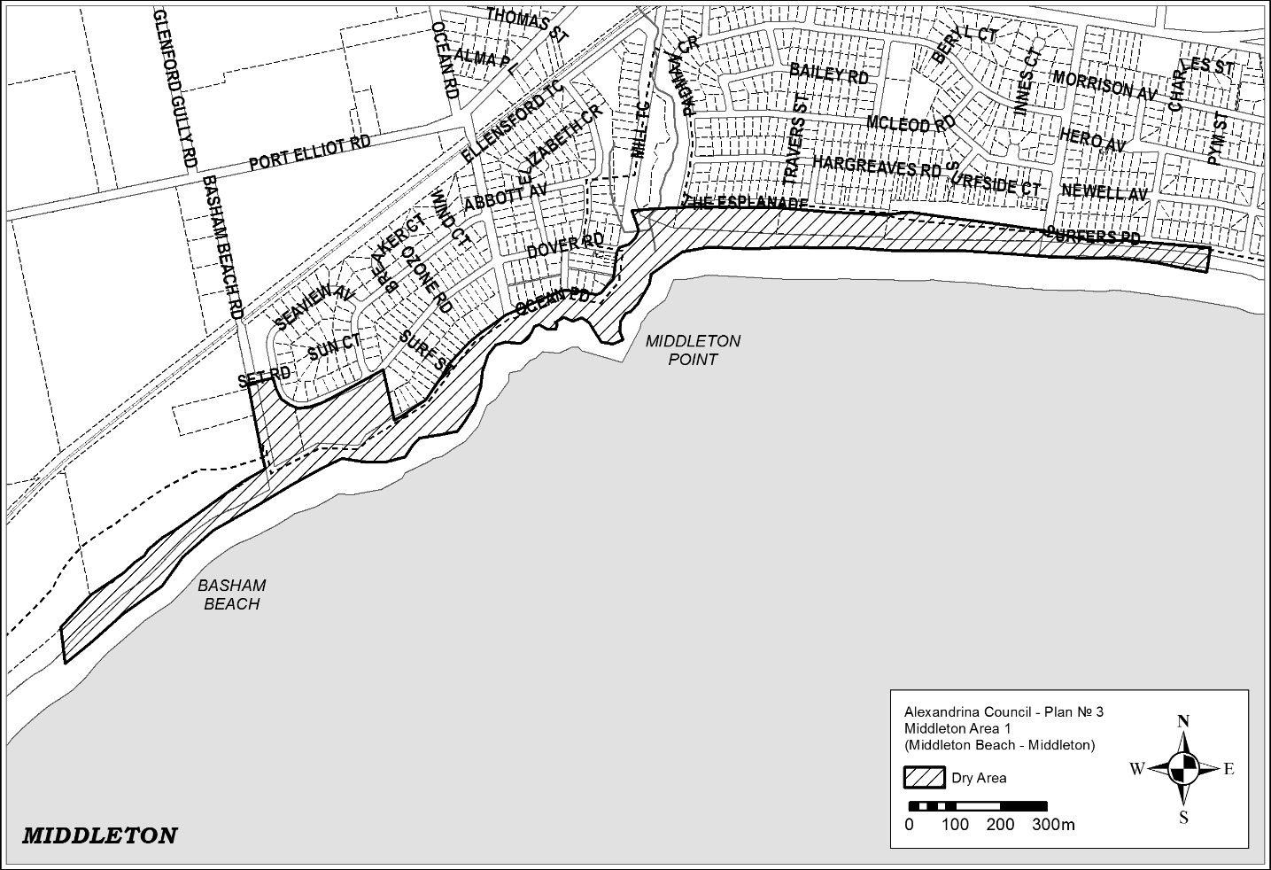
Schedule 4—Goolwa Wharf Precinct (Goolwa Area 3)
1—Extent of prohibition
The consumption of liquor is prohibited and the possession of liquor is prohibited.
2—Period of prohibition
From 6:00pm on 30 December 2026 – 6:00am on 2 January 2027.
3—Description of area
Goolwa Area 3
The area in Goolwa Central and Port of Goolwa (generally known as the Wharf Precinct) and to be known as Goolwa Area 3 bounded as follows:
Commencing at the north eastern corner of Section 315, Hundred of Goolwa, and then due west to the eastern side of the railway reserve. Then follow the easterly side of the railway reserve until reaching the south western underside of the Goolwa and Hindmarsh Island Bridge. Head in a north westerly direction, along the south western side of Brooking Street, until the round-about intersection of Brooking Street, Liverpool Road and Goolwa Terrace. Follow the south eastern side of Goolwa Terrace until the intersection of Cadell Street and Goolwa Terrace. Traversing the north eastern side of Cadell Street, past the Cadell Street and Cutting Road intersection. Continue along Cadell Street and enter Hayes Street then to the Hayes Street and Porter Street intersection. Head south east to the Porter Street and Admiral Terrace intersection. Then head south west and continue along the eastern side of Admiral Terrace past the intersections of Goyder Street, Hutchinson Street, Sidmouth Street until the Admiral Terrace and Baronet Street intersection. Head east south east and traverse around the jetty and return to the eastern side of the boardwalk. Head north east along the eastern side of the boardwalk then a straight line, by the shortest route, to the southern side of the jetty. Then in a straight line by the shortest route to the south eastern side of the Goolwa Wharf. Traverse the south eastern side of the Goolwa Wharf under the Goolwa and Hindmarsh Island Bridge along the River Murray bank to the south eastern side of Section 315 returning to the point of commencement.
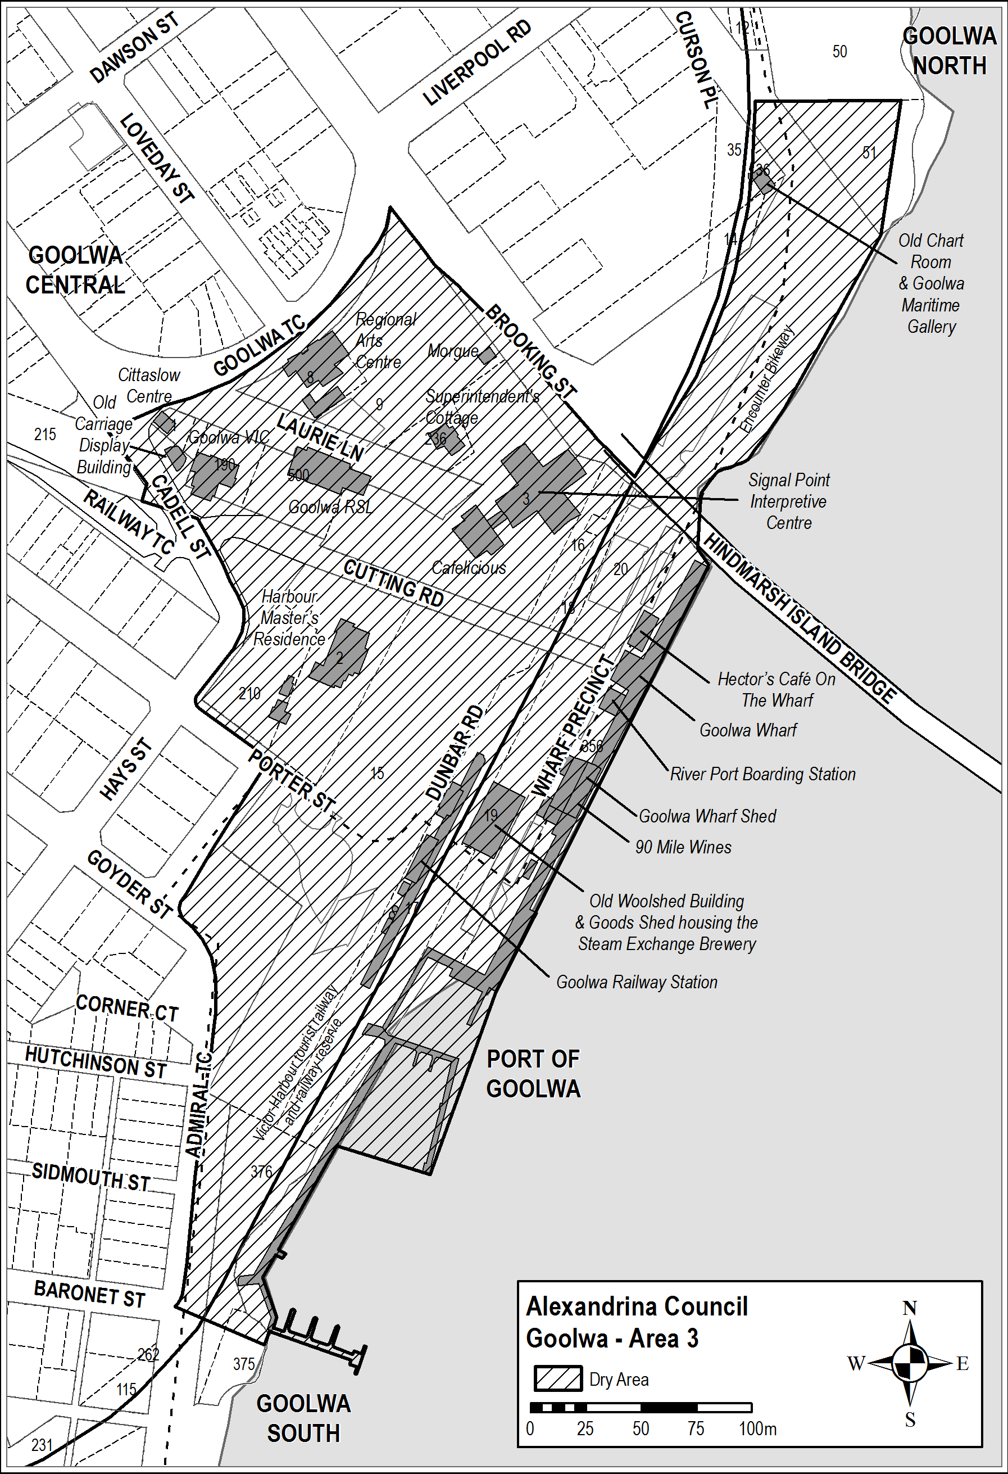
Schedule 5—Goolwa Beach Car Park (Goolwa Beach Area 1)
1—Extent of prohibition
The consumption of liquor is prohibited, and the possession of liquor is prohibited.
2—Period of prohibition
From 6:00pm on 30 December 2026 – 6:00am on 2 January 2027.
3—Description of area
Goolwa Beach Area 1
The area in Goolwa Beach and Goolwa South (generally known as the Goolwa Beach car park) bounded as follows: commencing at the north-eastern corner of Section 279, Hundred of Goolwa, then westerly and southerly along the northern and western boundaries of Section 279 to the northern boundary of Section 367, Hundred of Goolwa, then southerly and easterly along the western and southern boundaries of Section 367 to the south-eastern corner of the Section, then in a straight line by the shortest route to the south-western corner of Section 368, Hundred of Goolwa, then easterly and northerly along the southern and eastern boundaries of Section 368 to the southern boundary of Section 278, Hundred of Goolwa, then northerly and westerly along the eastern and northern boundaries of Section 278 to the north-western corner of the Section, then in a straight line by the shortest route across Goolwa Beach Road to the point of commencement.

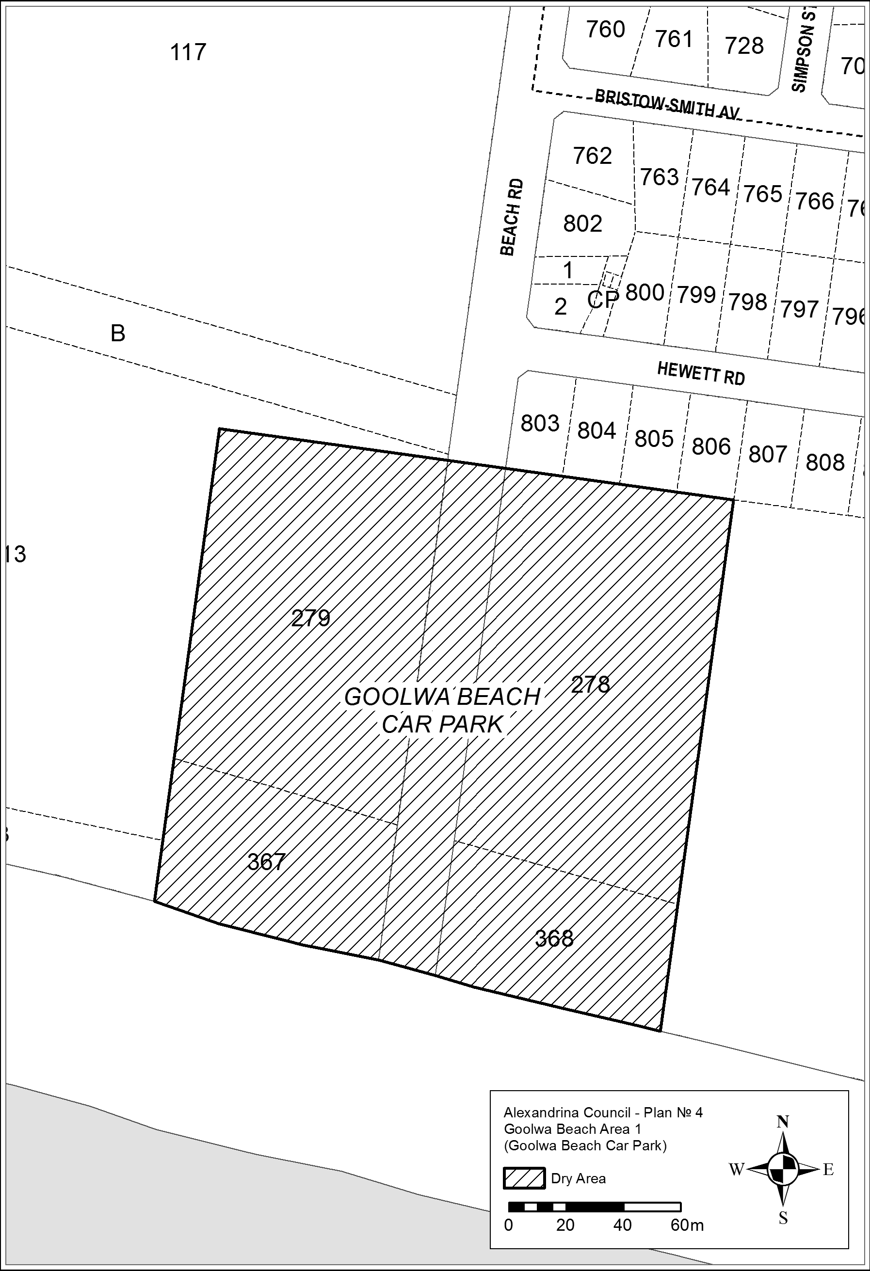
Schedule 6—Basham Beach Port Elliot—Middleton (Basham Beach Area 1)
1—Extent of prohibition
The consumption of liquor is prohibited, and the possession of liquor is prohibited.
2—Period of prohibition
From 6:00pm on 30 December 2026 – 6:00am on 2 January 2027.
3—Description of area
Basham Beach Area 1
Commencing at the point at which the western boundary of Basham Beach Road, Middleton, intersects the southern boundary of the railway reserve for the Victor Harbor Tourist Railway, then south-easterly along that boundary of Basham Beach Road to the northern boundary of Lot 96 FP 166155, then south-westerly, south-easterly and north-easterly along the northern, western and southern boundaries of Lot 96 to the western boundary of Basham Beach Road, then south-easterly along that boundary of Basham Beach Road and the prolongation in a straight line of that boundary to the low water mark of Encounter Bay, then generally south-westerly, southerly, south-easterly, easterly, southerly, south-westerly and north-westerly along the low water mark to the prolongation in a straight line of the western boundary of Lot 2 DP 52281, then northerly along that prolongation and boundary of Lot 2 to the southern boundary of Lot 1 DP 52281 (the southern boundary of the Port Elliot Caravan Park), then generally easterly, south-easterly, north-easterly and northerly along that boundary of Lot 1 and the eastern boundary of Lot 858 FP 166107 to the northern boundary of Lot 858, then south-westerly along the northern boundary of Lot 858 and the northern boundaries of the adjoining allotments to the eastern boundary of the railway reserve for the Victor Harbor Tourist Railway, then generally north-easterly along that boundary of the railway reserve to the point of commencement.
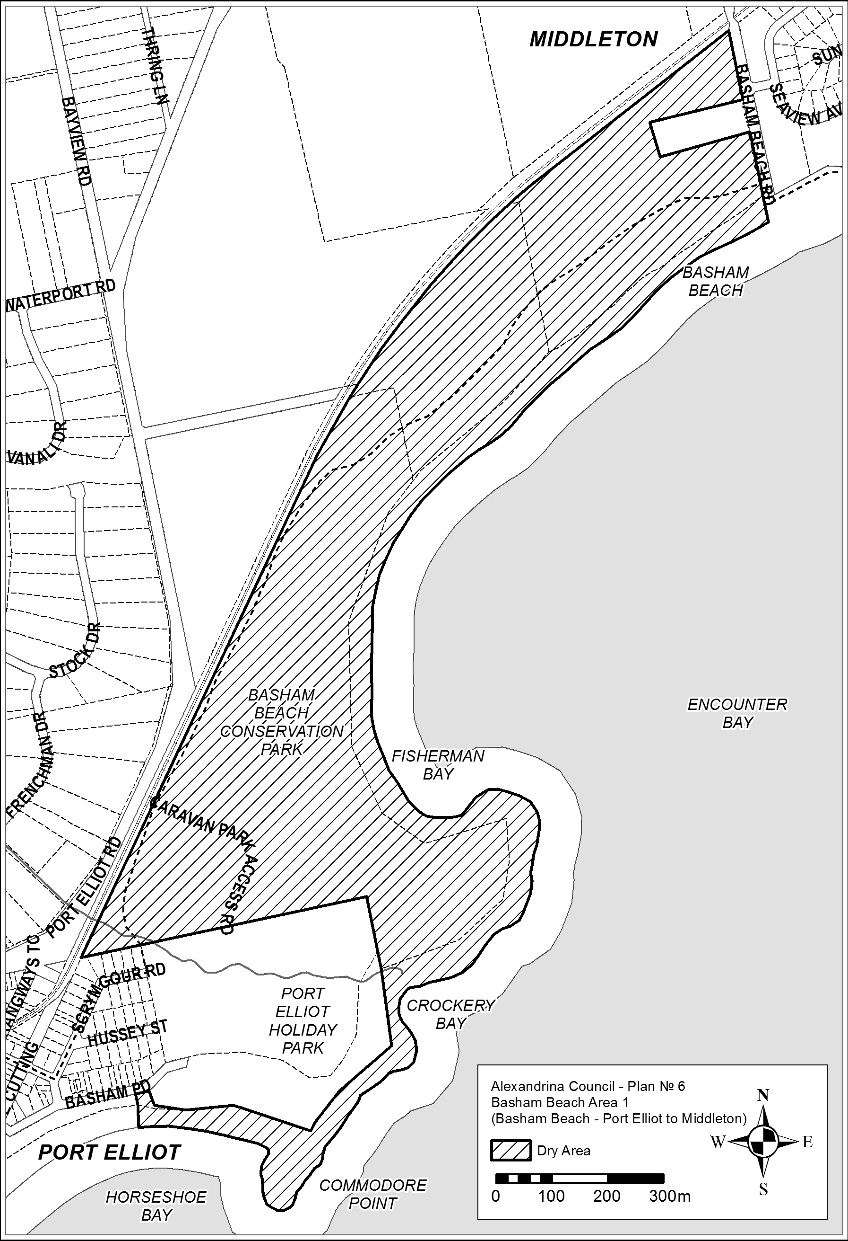
Made by the Liquor and Gambling Commissioner
Alison Selleck
Acting Assistant Director Licensing
Delegate of the Liquor and Gambling Commissioner
On 11 October 2026

Liquor Licensing Act 1997
South Australia
Liquor Licensing (Dry Areas) Notice 2026
under Section 131(1a) of the Liquor Licensing Act 1997
1—Short title
This notice may be cited as the Liquor Licensing (Dry Areas) Notice 2026.
2—Commencement
This notice comes into operation on 19 November 2026.
3—Interpretation
(1) In this notice—
principal notice means the Liquor Licensing (Dry Areas) Notice 2015 published in the Gazette on 5 January 2015, as in force from time to time.
(2) Clause 3 of the principal notice applies to this notice as if it were the principal notice.
4—Consumption etc of liquor prohibited in dry areas
(1) Pursuant to Section 131 of the Act, the consumption and possession of liquor in the area described in the Schedule is prohibited in accordance with the provisions of the Schedule.
(2) The prohibition has effect during the periods specified in the Schedule.
(3) The prohibition does not extend to private land in the area described in the Schedule.
(4) Unless the contrary intention appears, the prohibition of the possession of liquor in the area does not extend to—
(a) a person who is genuinely passing through the place if—
(i) the liquor is in the original container in which it was purchased from licensed premises; and
(ii) the container has not been opened; or
(b) a person who has possession of the liquor in the course of carrying on a business or in the course of their employment by another person in the course of carrying on a business; or
(c) a person who is permanently or temporarily residing at premises near the public place and who enters the public place solely for the purpose of passing through it to enter those premises or who enters the public place from those premises for the purpose of leaving the place; or
(d) a person who possesses or consumes the liquor for sacramental or other similar religious purposes.

Schedule 1—Middleton Point Foreshore, Middleton Beach (Middleton Area 1)
1—Extent of prohibition
The consumption of liquor is prohibited and the possession of liquor is prohibited.
2—Period of prohibition
From 8:00am on 19 November 2026 to 10:00am on 23 November 2026.
3—Description of area
Middleton Area 1
The area in and adjacent to Middleton bounded as follows: commencing at the point at which the prolongation in a straight line of the western boundary of Basham Beach Road intersects the high water mark of Encounter Bay, then north-westerly along that prolongation and boundary to the point at which it is intersected by the prolongation in a straight line of the southern boundary of Set Road, then north-easterly along that prolongation and boundary of Set Road to the western boundary of Seaview Avenue, then generally south-easterly and north-easterly along that boundary of Seaview Avenue to the point at which it meets the eastern boundary of Lot 101 DP 10654, then south-easterly along that boundary of Lot 101 to the south-western corner of Lot 19 DP 3145, then generally north-easterly along the south-eastern boundary of Lot 19, the south-eastern boundaries of the adjoining Lots and the northern boundary of Ocean Parade to the south-eastern corner of Lot 133 FP 166507, then generally north-easterly and northerly along the easternmost boundaries of Lot 133 and the adjoining Lots (including the eastern boundary of Dover Road) to the north-eastern corner of Lot 39 DP 3262, then in a straight line by the shortest route to the north-western corner of Lot 160 DP 9417, then easterly along the southern boundary of the Esplanade to the western boundary of Lot 3 DP 13398, then northerly, easterly and southerly along the western, northern and eastern boundaries of that Lot to its south-eastern corner, then along the northern boundary of Section 345, Hundred of Goolwa, (the southern boundary of Surfer's Parade) to the point at which it is intersected by the prolongation in a straight line of the eastern boundary of Lot 39 DP 6156, then along that prolongation to the point at which it intersects the high water mark of Encounter Bay, then generally westerly and south-westerly along the high water mark to the point of commencement.
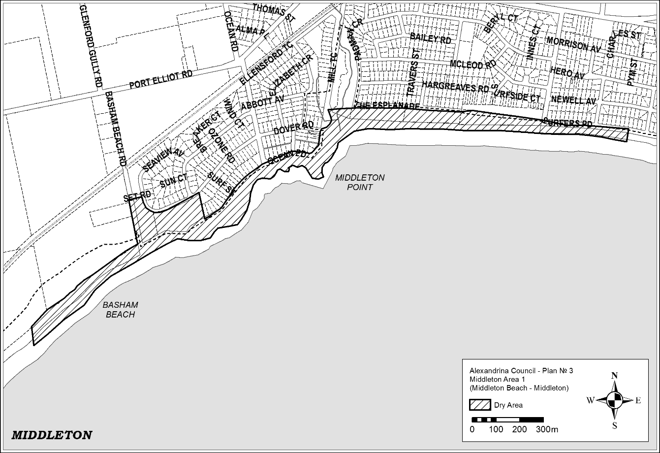
Schedule 2—The Harbour Masters Reserve, Port Elliot (Port Elliot Area 3)
1—Extent of prohibition
The consumption of liquor is prohibited and the possession of liquor is prohibited.
2—Period of prohibition
From 8:00am on 19 November 2026 to 10:00am on 23 November 2026.
3—Description of area
Port Elliot Area 3
Commencing at the South Eastern corner of the intersection of The Strand and Murray Place and then traversing along the Eastern side of The Strand until the North Eastern side of the intersection of The Stand and Freeman Lookout. Then traverse along the Northern side of Freeman Lookout until the Eastern post of the gate into the Obelisk reserve then head West North West along the Western edge of the Soldiers’ Memorial Gardens until Murray Place returning to the point of commencement.

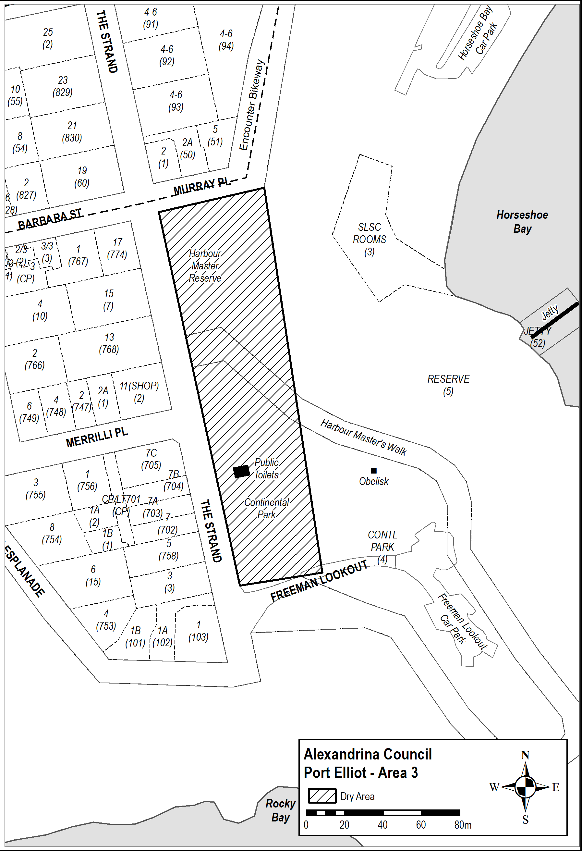
Made by the Liquor and Gambling Commissioner
Alison Selleck
Acting Assistant Director Licensing
Delegate of the Liquor and Gambling Commissioner
On 11 October 2026

Liquor Licensing Act 1997
South Australia
Liquor Licensing (Dry Areas) Notice 2026
under Section 131(1a) of the Liquor Licensing Act 1997
1—Short title
This notice may be cited as the Liquor Licensing (Dry Areas) Notice 2026.
2—Commencement
This notice comes into operation on 26 December 2026.
3—Interpretation
(1) In this notice—
principal notice means the Liquor Licensing (Dry Areas) Notice 2015 published in the Gazette on 5 January 2015, as in force from time to time.
(2) Clause 3 of the principal notice applies to this notice as if it were the principal notice.
4—Consumption etc of liquor prohibited in dry areas
(1) Pursuant to Section 131 of the Act, the consumption and possession of liquor in the area described in the Schedule is prohibited in accordance with the provisions of the Schedule.
(2) The prohibition has effect during the periods specified in the Schedule.
(3) The prohibition does not extend to private land in the area described in the Schedule.
(4) Unless the contrary intention appears, the prohibition of the possession of liquor in the area does not extend to—
(a) a person who is genuinely passing through the place if—
(i) the liquor is in the original container in which it was purchased from licensed premises; and
(ii) the container has not been opened; or
(b) a person who has possession of the liquor in the course of carrying on a business or in the course of their employment by another person in the course of carrying on a business; or
(c) a person who is permanently or temporarily residing at premises near the public place and who enters the public place solely for the purpose of passing through it to enter those premises or who enters the public place from those premises for the purpose of leaving the place; or
(d) a person who possesses or consumes the liquor for sacramental or other similar religious purposes.

Schedule—Robe Area 1

1—Extent of prohibition
The consumption of liquor is prohibited and the possession of liquor is prohibited.
2—Period of prohibition
From 12 noon on 26 December 2026 to 12 noon on 3 January 2027.
3—Description of area
The area in and adjacent to Robe bounded as follows: commencing at the western end of the northern boundary of Dawson Drive, then in a straight line by the shortest route to the low water mark of Guichen Bay on the eastern side of the entrance to Fox's Lake, then in a straight line by the shortest route (across the entrance) to the low water mark on the western side of the entrance, then generally westerly along the low water mark to the eastern side of the entrance to Lake Butler, then in a straight line by the shortest route (across the entrance) toD the eastern boundary of the breakwater on the western side of the entrance to the lake, then northerly, north-easterly, westerly and south-westerly around the outer boundary of the breakwater back to the low water mark on the shore on the western side of the breakwater, then generally north-westerly and southerly along the low water mark to the point at which it is intersected by the prolongation in a straight line of the southern boundary of Evans Cave Road (the northern boundary of Section 363 Hundred of Waterhouse), then generally easterly along that prolongation and boundary of Evans Cave Road, and the prolongation in a straight line of that boundary, to the eastern boundary of Robe Street, then northerly along that boundary of Robe Street to the southern boundary of Beacon Hill Road, then generally easterly along that boundary of Beacon Hill Road to the point at which it meets the north-eastern boundary of Lot 5 of DP 78111, then generally south-easterly and easterly along that boundary of Lot 5 and easterly and north-easterly along the northern boundary of Section 289 Hundred of Waterhouse to the eastern boundary of Section 289, then in a straight line by the shortest route to the south-western corner of Lot 11 of DP 64831, then easterly along the southern boundary of Lot 11 and the prolongation in a straight line of that boundary to the point at which the prolongation intersects the eastern boundary of Nora Creina Road, then northerly along that boundary of Nora Creina Road to the point at which it meets the southern boundary of Wildfield Road, then generally easterly along that boundary of Wildfield Road and the prolongation in a straight line of that boundary to the point at which the prolongation intersects the northern boundary of Southern Ports Highway, then generally north-westerly and south-westerly along that boundary of Southern Ports Highway and the northern boundary of Main Road to the eastern boundary of Dawson Drive, then generally north-westerly and westerly along that boundary of Dawson Drive to the point of commencement. The area includes any wharf, jetty, boat ramp, breakwater or other structure projecting below low water mark from within the area described above (as well as any area beneath such a structure).

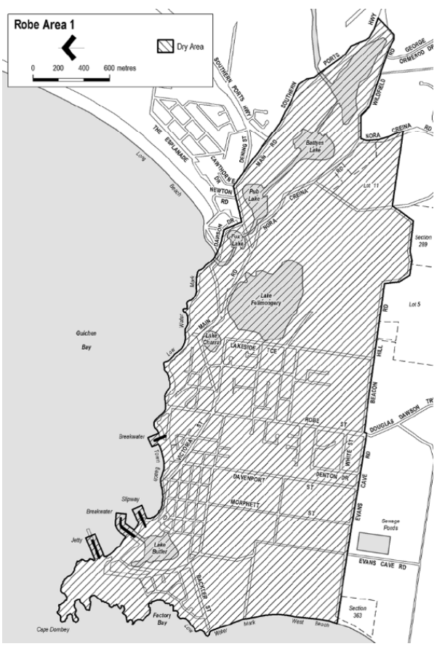
Made by the Liquor and Gambling Commissioner
Alison Selleck
Acting Assistant Director Licensing
Delegate of the Liquor and Gambling Commissioner
On 11 October 2026

Liquor Licensing Act 1997
South Australia
Liquor Licensing (Dry Areas) Notice 2026
under Section 131(1a) of the Liquor Licensing Act 1997
1—Short title
This notice may be cited as the Liquor Licensing (Dry Areas) Notice 2025.
2—Commencement
This notice comes into operation on 26 December 2026.
3—Interpretation
(1) In this notice—
principal notice means the Liquor Licensing (Dry Areas) Notice 2015 published in the Gazette on 5 January 2015, as in force from time to time.
(2) Clause 3 of the principal notice applies to this notice as if it were the principal notice.
4—Consumption etc of liquor prohibited in dry areas
(1) Pursuant to Section 131 of the Act, the consumption and possession of liquor in the area described in the Schedule is prohibited in accordance with the provisions of the Schedule.
(2) The prohibition has effect during the periods specified in the Schedule.
(3) The prohibition does not extend to private land in the area described in the Schedule.
(4) Unless the contrary intention appears, the prohibition of the possession of liquor in the area does not extend to—
(a) a person who is genuinely passing through the place if—
(i) the liquor is in the original container in which it was purchased from licensed premises; and
(ii) the container has not been opened; or
(b) a person who has possession of the liquor in the course of carrying on a business or in the course of their employment by another person in the course of carrying on a business; or
(c) a person who is permanently or temporarily residing at premises near the public place and who enters the public place solely for the purpose of passing through it to enter those premises or who enters the public place from those premises for the purpose of leaving the place; or
(d) a person who possesses or consumes the liquor for sacramental or other similar religious purposes.

Schedule—Robe Area 2

1—Extent of prohibition
The consumption of liquor is prohibited and the possession of liquor is prohibited.
2—Period of prohibition
From 12 noon on 26 December 2026 to 12 noon on 3 January 2027.
3—Description of area
The area in and adjacent to Robe bounded as follows: commencing at the western end of the northern boundary of Dawson Drive, then in a straight line by the shortest route to the low water mark of Guichen Bay on the eastern side of the entrance to Fox’s Lake, then generally
north-easterly along the low water mark to the point at which it is intersected by the prolongation in a straight line of the northern boundary of Section 573 Hundred of Waterhouse, then easterly along that prolongation and boundary of Section 573 to the eastern boundary of the Section, then generally southerly and south-westerly along that boundary of Section 573 to the north-eastern boundary of Section 390 Hundred of Waterhouse, then south-easterly along that boundary of Section 390 to the point at which it is intersected by the prolongation in a straight line of the northern boundary of Dennis Avenue, then easterly along that prolongation and boundary of Dennis Avenue, and the prolongation in a straight line of that boundary, to the point at which the prolongation intersects the western boundary of Lot 223 of FP 205569, then generally south-westerly and southerly along that boundary of Lot 223 and the prolongation in a straight line of that boundary to the point at which the prolongation intersects the south-eastern boundary of Southern Ports Highway, then south-westerly along that boundary to the western boundary of Lot 2 of FP 9707, then southerly along that boundary of Lot 2 to the southern boundary of the Lot, then generally north-westerly and south-westerly along the northern boundary of Southern Ports Highway and the northern boundary of Main Road to the eastern boundary of Dawson Drive, then generally north-westerly and westerly along that boundary of Dawson Drive to the point of commencement.

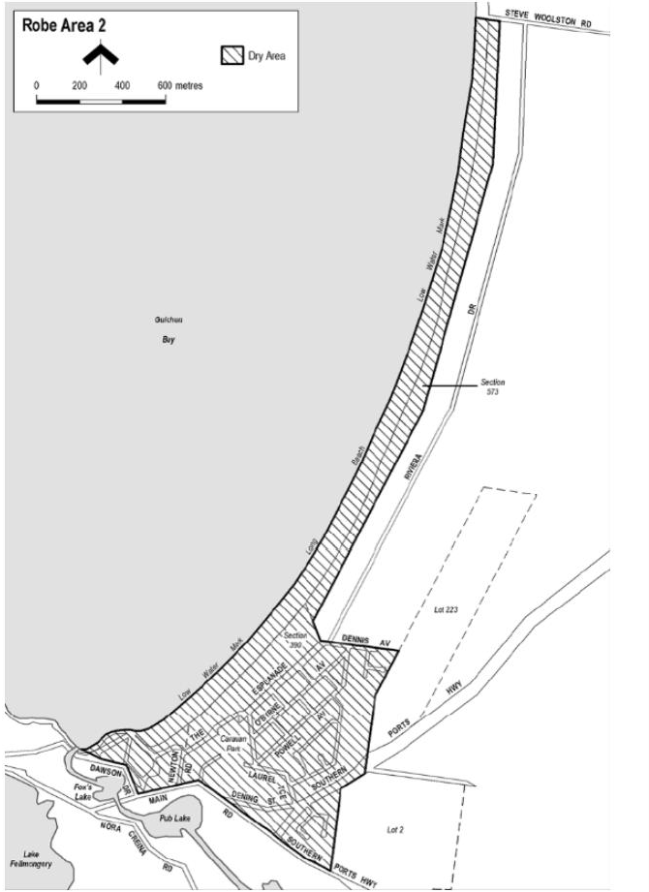
Made by the Liquor and Gambling Commissioner
Alison Selleck
Acting Assistant Director Licensing
Delegate of the Liquor and Gambling Commissioner
On 11 October 2026

Liquor Licensing Act 1997
South Australia
Liquor Licensing (Dry Areas) Notice 2026
under Section 131(1a) of the Liquor Licensing Act 1997
1—Short title
This notice may be cited as the Liquor Licensing (Dry Areas) Notice 2026.
2—Commencement
This notice comes into operation on 16 November 2026.
3—Interpretation
(1) In this notice—
principal notice means the Liquor Licensing (Dry Areas) Notice 2015 published in the Gazette on 5.1.15, as in force from time to time.
(2) Clause 3 of the principal notice applies to this notice as if it were the principal notice.
4—Consumption etc of liquor prohibited in dry areas
(1) Pursuant to Section 131 of the Act, the consumption and possession of liquor in the area described in the Schedule is prohibited in accordance with the provisions of the Schedule.
(2) The prohibition has effect during the periods specified in the Schedule.
(3) The prohibition does not extend to private land in the area described in the Schedule.
(4) Unless the contrary intention appears, the prohibition of the possession of liquor in the area does not extend to—
(a) a person who is genuinely passing through the area if—
(i) the liquor is in the original container in which it was purchased from licensed premises; and
(ii) the container has not been opened; or
(b) a person who has possession of the liquor in the course of carrying on a business or in the course of his or her employment by another person in the course of carrying on a business; or
(c) a person who is permanently or temporarily residing at premises within the area or on the boundary of the area and who enters the area solely for the purpose of passing through it to enter those premises or who enters the area from those premises for the purpose of leaving the area.
Schedule—Victor Harbor Area 2

1—Extent of prohibition
The consumption of liquor is prohibited and the possession of liquor is prohibited.
2—Period of prohibition
From 8am Monday, 16 November 2026 to 10am Monday, 23 November 2026.
3—Description of area
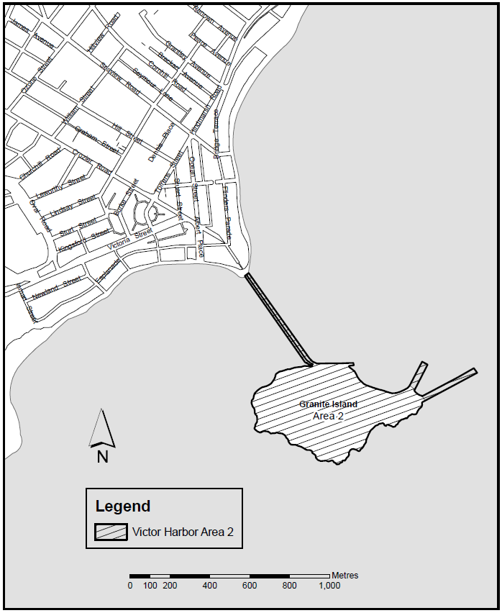
The whole of Granite Island to low water mark, together with the whole of the causeway linking the mainland and Granite Island (apart from the part of the causeway above the low water mark on the mainland as well as any area beneath the causeway. In addition to the causeway, the area also includes the whole of any wharf, jetty, boat ramp, breakwater or other structure extending below low water mark from Granite Island, as well as any area beneath such a structure.
Made by the Liquor and Gambling Commissioner
Alison Selleck
Acting Assistant Director Licensing
Delegate of the Liquor and Gambling Commissioner
On 11 October 2026

Liquor Licensing Act 1997
South Australia
Liquor Licensing (Dry Areas) Notice 2026
under Section 131(1a) of the Liquor Licensing Act 1997
1—Short title
This notice may be cited as the Liquor Licensing (Dry Areas) Notice 2026.
2—Commencement
This notice comes into operation on 16 November 2026.
3—Interpretation
(1) In this notice—
principal notice means the Liquor Licensing (Dry Areas) Notice 2015 published in the Gazette on 5.1.15, as in force from time to time.
(2) Clause 3 of the principal notice applies to this notice as if it were the principal notice.
4—Consumption etc of liquor prohibited in dry areas
(1) Pursuant to Section 131 of the Act, the consumption and possession of liquor in the area described in the Schedule is prohibited in accordance with the provisions of the Schedule.
(2) The prohibition has effect during the periods specified in the Schedule.
(3) The prohibition does not extend to private land in the area described in the Schedule.
(4) Unless the contrary intention appears, the prohibition of the possession of liquor in the area does not extend to—
(a) a person who is genuinely passing through the area if—
(i) the liquor is in the original container in which it was purchased from licensed premises; and
(ii) the container has not been opened; or
(b) a person who has possession of the liquor in the course of carrying on a business or in the course of his or her employment by another person in the course of carrying on a business; or
(c) a person who is permanently or temporarily residing at premises within the area or on the boundary of the area and who enters the area solely for the purpose of passing through it to enter those premises or who enters the area from those premises for the purpose of leaving the area.

Schedule—Victor Harbor Area 4
1—Extent of prohibition
The consumption of liquor is prohibited and the possession of liquor is prohibited.
2—Period of prohibition
From 8am on Monday, 16 November 2026 to 10am on Monday, 23 November 2026.
3—Description of area
The area in and adjacent to Victor Harbor bounded as follows: commencing at the point at which the north-western boundary of Hindmarsh Road intersects the southern bank of the Hindmarsh River, then generally westerly, north-easterly and north-westerly along that bank of the Hindmarsh River to the point at which it is intersected by the prolongation in a straight line of the northern boundary of Dinan Road, then easterly along that prolongation and boundary of Dinan Road and the prolongation in a straight line of that boundary to the western boundary of Laxton Street, then generally south-westerly and south-easterly along that boundary of Laxton Street, the south-western boundary of Adare Avenue and the prolongation in a straight line of the south-western boundary of Adare Avenue to the south-eastern boundary of Hindmarsh Road, then generally south-westerly along that boundary of Hindmarsh Road to the point at which it intersects the northern bank of the Hindmarsh River, then along that bank of the Hindmarsh River to the low water mark of Encounter Bay, then generally south-westerly and southerly along the low water mark to the eastern side of the causeway linking Granite Island to the mainland, then in a straight line by the shortest route to the low water mark on the western side of the causeway, then generally westerly, south-westerly, southerly and south-westerly along the low water mark to the point at which it is intersected by the prolongation in a straight line of the south-western boundary of Harbour View Terrace, then north-westerly along that prolongation and boundary of Harbour View Terrace to the point at which it is intersected by the prolongation in a straight line of the north-western boundary of Kent Drive, then generally north-easterly, northerly and north-westerly along that prolongation and boundary of Kent Drive to the point at which it is intersected by the prolongation in a straight line of the south-eastern boundary of a foot bridge across the Inman River (being the foot bridge closest to the mouth of the river), then north-easterly along the line of that south-eastern boundary of the foot bridge across the river to the south-western boundary of the Victor Harbor Beachfront Holiday Park, then generally south-easterly and north-easterly along the boundary of the park to the south-western boundary of Inman Street, then north-westerly along that boundary of Inman Street and the prolongation in a straight line of that boundary to the north-western boundary of Victoria Street, then north-easterly along that boundary of Victoria Street to the
south-western boundary of George Main Road, then north-westerly along that boundary of George Main Road to the northern bank of the Inman River, then westerly along that bank of the river to the point at which it is intersected by the prolongation in a straight line of the western boundary of Lot 57 of FP 20694, then north-westerly along that prolongation to the kerb line on the south-eastern side of Bay Road, then generally north-easterly along that kerb line to the kerb line on the south-western side of George Main Road, then in a straight line by the shortest route across George Main Road to the north-eastern boundary of that road, then north-westerly along that boundary of George Main Road to the point at which the north-eastern boundary of George Main Road meets the eastern boundary of Lot 11 DP 14245 (Victor Harbor High School), then north-easterly, north-westerly, north-easterly, north-westerly and south-westerly along that boundary of Lot 11 to the point at which it meets the south-eastern boundary of Kullaroo Road, then north-easterly along the south-eastern boundary of Kullaroo Road and the prolongation in a straight line of that boundary to the north-eastern corner of Lot 333 FP 165581, then in a straight line by the shortest route to the point at which the north-western boundary of Leworthy Street meets the north-eastern boundary of Oval Road, then generally north-easterly along that north-western boundary of Leworthy Street and the prolongation in a straight line of that boundary to the north-eastern boundary of Crozier Road, then south-easterly along that boundary of Crozier Road to the north-western boundary of Acraman Street, then north-easterly along the
north-western boundaries of Acraman Street and Carlyle Street to the point at which the north-western boundary of Carlyle Street intersects the north-eastern boundary of Cornhill Road, then south-easterly along that north-eastern boundary of Cornhill Road to the north-western boundary of Hindmarsh Road, then north-easterly along that boundary of Hindmarsh Road to the north-eastern boundary of Peace Avenue, then north-westerly along that boundary of Peace Avenue to the south-eastern boundary of Broadway Terrace, then north-easterly along that boundary of Broadway Terrace to the south-western boundary of Renown Avenue, then south-easterly along that boundary of Renown Avenue to the north-western boundary of Hindmarsh Road, then generally north-easterly along that boundary of Hindmarsh Road to the point of commencement. The area includes the whole of any wharf, jetty, boat ramp, breakwater or other structure that extends below low water mark from within the area (as well as any area beneath such a structure), but does not include that part of the causeway to Granite Island that lies within the area to which the prohibition in Victor Harbor Area 2 applies.

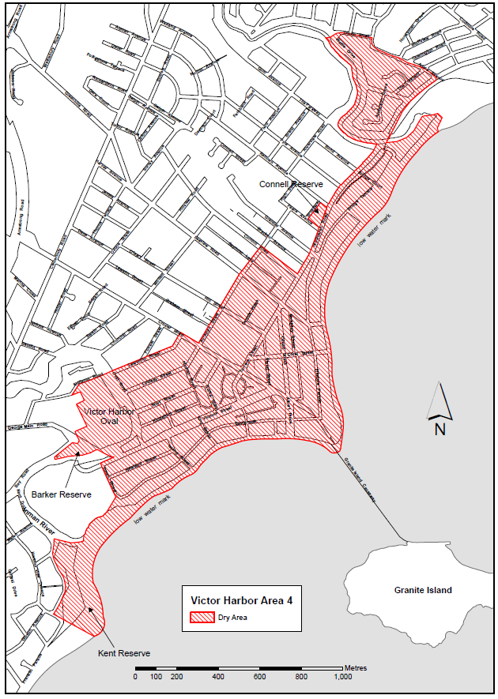
Made by the Liquor and Gambling Commissioner
Alison Selleck
Acting Assistant Director Licensing
Delegate of the Liquor and Gambling Commissioner
On 11 October 2026

Motor Vehicles Act 1959
Section 47A
Classes, Specifications and Design of Number Plates—
Notice by the Registrar of Motor Vehicles
Pursuant to Section 47A of the Motor Vehicles Act 1959 (‘the Act’), I, Emma Kokar, Registrar of Motor Vehicles (Registrar):
(a) revoke the following notices made under Section 47A of the Act:
• notice dated 22 January 2026 published in the Gazette No. 6 on Monday, 2 February 2026 (pages 172-192).
(b) establish the classes of number plates set out in Schedule 1 and numbered 1 to 13 and 15 to 23 (inclusive) for the purposes of Section 47(1) of the Act;
(c) prescribe the specifications and design set out in Schedule 2 to be the specifications and design to which number plates of each class established by this notice must conform;
(d) declare the classes of number plates set out in Schedule 3 to be classes of number plates that the Registrar may enter into an agreement pursuant to Section 47A(4) of the Act.
Schedule 1
Classes of Number Plates
Class 1—Numeric
Class 2—Alpha Numeric (non-slogan)
Class 3—Slogan
Class 4—Personalised
Class 5—Jubilee
Class 6—Australian Grand Prix
Class 7—Towtruck
Class 8—Government Vehicle
Class 9—Name Plates
Class 10—Custom
Class 11—Taxi Plates
Class 12—Chauffeured Vehicle
Class 13—Consular Corps
Class 15—Premium Number
Class 16—Bike Rack
Class 17—Centenary of Federation
Class 18—Country Taxi Plates
Class 19—SA – Heavy Vehicle
Class 20—Euro Vehicle
Class 21—National Heavy Vehicle
Class 22—Japanese Plates
Class 23—Motorsport

Schedule 2
Specifications and Design of Number Plates
Class 1—Numeric Number Plates
A numeric number plate must bear a number consisting entirely of a figure, or figures (except for the letters “SA” designating the State of issue), and may be issued under an agreement between the Registrar and the applicant. The plate must conform to the following additional specifications and designs:
 | 129mm Min./371mm Max.
Steel/Aluminium Embossed | 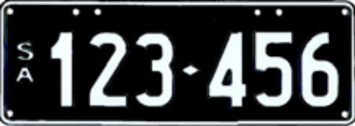 |  | 133mm Min
White Figures |  |  | Black Background
 |  | Motor Vehicles other than Motor Bikes |  | Motor Bikes
Height of figure |  | 77-80mm |  | 50mm
Width of every line in each figure |  | 12mm |  | 6mm
The dimensions of a motor bike plate must be 215 ± 1.0mm in length and 95 ± 1.0mm in height.
Class 2—Alpha Numeric Plates (Non-Slogan)
An alpha-numeric plate (non-slogan) must bear a number consisting of a combination of letters and figures and may be issued under an agreement between the Registrar and the applicant. The plate must conform to the following additional specifications and design:
2.1.1 Special Purpose Vehicle and Motor Bike (“S” 6 character set)
 | 215 ± 1.0mm
Steel/Aluminium Embossed | 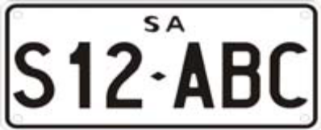 |  | 100 ± 1.0mm
Black Letters and Figures |  |  | White Retroreflective Background
Height of figure or letter |  | 50mm
Width of every line in each figure or letter |  | 6-8mm
2.1.2 Special Purpose Vehicle and Motor Bike
 | 215 ± 1.0mm
Steel/Aluminium Embossed | 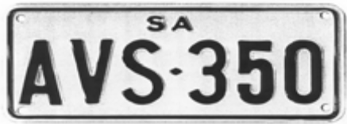 |  | 100 ± 1.0mm
Black Letters and Figures |  |  | White Retroreflective Background
Height of figure or letter |  | 50mm
Width of every line in each figure or letter |  | 6-8mm
2.2 Other Vehicles (remake only)
 | 371 ± 1.0mm
Steel/Aluminium Embossed | 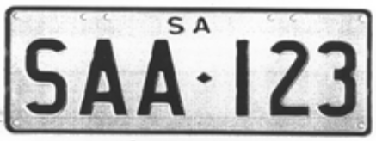 |  | 133 ± 1.0mm
Black Letters and Figures |  |  | White Retroreflective Background
Height of figure or letter |  | 70-77mm
Width of every line in each figure or letter |  | 12mm

2.3 Corporate Number Plates
Alpha numeric plates (non-slogan) in the corporate plate format (class 2.2 only) may contain a background, logo and/or slogan or other promotional pictures or information deemed appropriate, in accordance with an agreement between the Registrar and the applicant.
The plate must conform to the following specifications and design:
The height of the plate 133 + 1.0mm and width 371 + 1.0mm.
Height of figure or letter | 60mm
Width of every line in each figure or letter | 10mm
2.4 Classic Alpha Numeric Other Vehicles
A Classic Alpha Numeric Other Vehicle number plate must bear a number consisting of a combination of letters and figures and be issued under an agreement between the Registrar and the applicant. The plate must conform to the following additional specifications and design:
 | 371 ± 1.0 mm
Steel/Aluminium  Embossed | 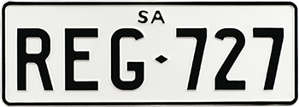 |  | 133 ± 1.0 mm
Black Letters & Figures |  |  | White Retroreflective Background
Height of figure or letter |  | 70-77mm
Width of every line in each figure or letter |  | 12mm
Class 3—Slogan Number Plates
A slogan number plate must bear a number consisting of a combination of letters and figures and may be issued under an agreement between the Registrar and the applicant. The plate must be of the type known as metal embossed and must conform to the following additional specifications and design:
3.1 South Australia Plate
 | 371 ± 1.0mm
Steel/Aluminium Embossed |  | 133 ± 1.0mm
Black Letters and Figures |  | White Retroreflective Background
Slogan (Black): SOUTH AUSTRALIA
 | Motor Vehicles other than Motor Bikes
Height of figure or letter | 70-77mm
Width of every line in each figure or letter | 10-12mm
3.1.1 South Australia Trailer Plate
 | 371 ± 1.0mm
Steel/Aluminium Embossed |  | 133 ± 1.0mm
Black Letters and Figures |  | White Retroreflective Background
Slogan (Black): SOUTH AUSTRALIA
Height of figure or letter | 70-77mm
Width of every line in each figure or letter | 10-12mm
3.1.2 South Australia Non-Standard Trailer Plate
 | 252 ± 1.0mm
Steel/Aluminium Embossed |  | 98 ± 1.0mm
Black Letters and Figures |  | White Retroreflective Background
Slogan (Black): SOUTH AUSTRALIA
Height of figure or letter | 50mm
Width of every line in each figure or letter | 6mm

3.1.3 Aerial Plate
 | 252 ± 1.0mm
Steel/Aluminium Embossed |  | 98 ± 1.0mm
Black Letters and Figure |  | White Background Retroreflective
Slogan (Black): SOUTH AUSTRALIA
Height of figure or letter | 50mm
Width of every line in each figure or letter | 6mm
The dimensions of an aerial mount plate must be 252 ± 1.0mm in length and 98 ± 1.0mm in width and are only available to vehicles granted registration under the Act.
3.2 Corporate Number Plates
Slogan number plates in the corporate plate format may contain a background, logo and/or slogan or other promotion pictures or information deemed appropriate, in accordance with an agreement between the Registrar and the applicant. The plate must conform to the following specifications and design:
The height of the plate 133mm + 1.0mm and length of the plate 371mm + 1.0mm.
Height of figure or letter | 60mm
Width of every line in each figure or letter | 10mm
3.3 Festival State (Discontinued)
 | 371 ± 1.0mm
Steel/Aluminium Embossed | 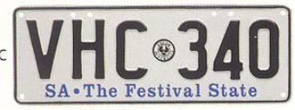 | 133 ± 1.0mm
Black Letters and Figures  Slogan Blue |  | White Retroreflective Background
Blue Slogan: SA • The Festival State
Black State Badge (Piping Shrike)
 | Motor Vehicles other than Motor Bikes
Height of figure or letter | 70-77mm
Width of every line in each figure or letter | 10-12mm
3.3.1 Festival State Trailer Plate (Discontinued)
 | 371 ± 1.0mm
Steel/Aluminium Embossed |  | 133 ± 1.0mm
Black Letters and Figures  Slogan Blue |  | White Retroreflective Background
Blue Slogan: SA • The Festival State
Black State Badge (Piping Shrike)
 | Motor Vehicles other than Motor Bikes
Height of figure or letter | 70-77mm
Width of every line in each figure or letter | 10-12mm
3.3.2 Festival State Non-Standard Trailer Plate (Discontinued)
 | 252 ± 1.0mm
Steel/Aluminium Embossed |  | 98 ± 1.0mm
Black Letters and Figures  Slogan Blue |  | White Retroreflective Background
Blue Slogan: SA • The Festival State
Black State Badge (Piping Shrike)
Height of figure or letter | 50mm
Width of every line in each figure or letter | 6mm
3.4.1 Wine State (remake only)
 | 371 ± 1.0mm
Steel/Aluminium Embossed | 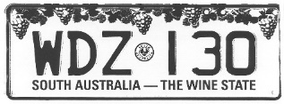 | 133 ± 1.0mm
Black Letters and Figures  Slogan Purple |  | White Retroreflective Background
Slogan Purple: SOUTH AUSTRALIA—THE WINE STATE
Black State Badge (Piping Shrike)
Background: (Light Green, Green)—Design approved by the Registrar)
Height of figure or letter | 60mm
Width of every line in each figure or letter | 10mm
3.4.2 Rose State (remake only)
 | 371 ± 1.0mm
Steel/Aluminium Embossed |  | 133 ± 1.0mm
Black Letters and Figures  Slogan Pink |  | White Retroreflective Background
Slogan Pink: SOUTH AUSTRALIA—THE ROSE STATE
Black State Badge (Piping Shrike)
Background: (Light Green, Green, Pink, Red)—Design approved by the Registrar)
Height of figure or letter | 60mm
Width of every line in each figure or letter | 10mm
3.4.3 Creative State (remake only)
 | 371 ± 1.0mm
Steel/Aluminium Embossed |  | 133 ± 1.0mm
Black Letters and Figures  Slogan Black |  | Yellow Background
Slogan Black: SOUTH AUSTRALIA—THE CREATIVE STATE
Black State Badge (Piping Shrike)
Background: (White, Grey, Red)—Design approved by the Registrar)
Height of figure or letter | 60mm
Width of every line in each figure or letter | 10mm
3.4.4 Defence State (remake only)
 | 371 ± 1.0mm
Steel/Aluminium Embossed | 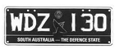 | 133 ± 1.0mm
White Letters and Figures  Slogan White with Black Background |  | Blue Background
Slogan White: SOUTH AUSTRALIA—THE DEFENCE STATE
Black State Badge (Piping Shrike)
Background: (Blue)—Design approved by the Registrar)
Height of figure or letter | 60mm
Width of every line in each figure or letter | 10mm

3.4.5 Gateway To The Outback (remake only)
 | 371 ± 1.0mm
Steel/Aluminium Embossed |  | 133 ± 1.0mm
Black Letters and Figures  Slogan White with Black Background |  | White Retroreflective Background
Slogan White: SOUTH AUSTRALIA—GATEWAY TO THE OUTBACK
Black State Badge (Piping Shrike)
Background: (Yellow, Purple)—Design approved by the Registrar)
Height of figure or letter | 60mm
Width of every line in each figure or letter | 10mm
3.4.6 The Electronics State (remake only)
 | 371 ± 1.0mm
Steel/Aluminium Embossed |  | 133 ± 1.0mm
Black Letters and Figures  Slogan White with Green Background |  | Green and White Retroreflective Background
Slogan White: SOUTH AUSTRALIA—THE ELECTRONICS STATE
Black State Badge (Piping Shrike)
Background: (White, Green)—Design approved by the Registrar)
Height of figure or letter | 60mm
Width of every line in each figure or letter | 10mm
3.4.7 SA The Koala State
 | 371 ± 1.0mm
Steel/Aluminium Embossed | 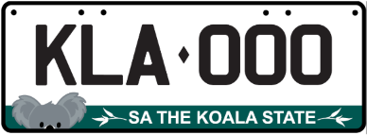 | 133 ± 1.0mm
Black Letters and Figures  Slogan White with Teal Background |  | White and Teal Retroreflective Background
Slogan White: SA THE KOALA STATE
Background: (White, Teal)—Design approved by the Registrar)
Height of figure or letter | 60mm
Width of every line in each figure or letter | 10mm
Class 4—Personalised Number Plates
A personalised number plate must bear a number consisting of a combination of letters and figures nominated by an applicant and approved by the Registrar, and issued under an agreement between the Registrar and the applicant.
The plate must be of the type known as metal embossed and must conform to the following additional specifications and design:
Option | Letters and Figures (colour) | Background (colour) | State Badge Piping Strike (colour)
1 | Retroreflective White | Blue | White
2 | Retroreflective White | Magenta | White
3 | Retroreflective White | Red | White
4 | Retroreflective White | Maroon | White
5 | Retroreflective White | Green | White
6 | Blue | Retroreflective White | Black
7 | Magenta | Retroreflective White | Black
8 | Red | Retroreflective White | Black
9 | Maroon | Retroreflective White | Black
10 | Green | Retroreflective White | Black
11 | Green | Retroreflective Yellow | Black
The Piping Shrike emblem will appear after the last letter and before the first number.

4.1 Standard Personalised
 | 371 ± 1.0mm
Aluminium Embossed | 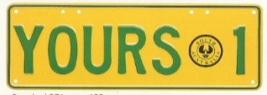 |  | 133 ± 1.0mm
 |  | Motor Vehicles and Trailers other than Motor Bikes and Non-Standard Trailers |  | Motor Bikes
Height of figure or letter |  | 70-72mm |  | 50mm
Width of every line in each figure or letter |  | 10-12mm |  | 6mm
The dimensions of a motor bike plate must be 252mm ± 1.0mm in length and 98mm ± 1.0mm in height.
4.2 Slim Personalised
 | 371 ± 1.0mm
Aluminium Embossed | 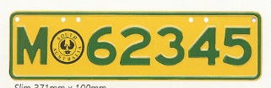 |  |  | 100 ± 1.0mm
 |  | Motor Vehicles other than  Motor Bikes or Trailers | Motor Bikes
Height of figure or letter |  | 54 or 60mm | 50mm
Width of every line in each figure or letter |  | 10mm | 6mm
The dimensions of a motor bike plate must be 252mm ± 1.0mm in length and 98mm ± 1.0mm in height.
4.3 Non-Standard Personalised Trailer
 | 252 ± 1.0mm
Aluminium Embossed |  |  | 98 ± 1.0mm
Height of figure or letter |  | 50mm
Width of every line in each figure or letter |  | 6mm
4.4 Corporate Number Plates
Personalised number plates in the corporate plate format may contain a background, logo and/or slogan or other promotion pictures or information deemed appropriate, in accordance with an agreement between the Registrar and the applicant. The plate must conform to the following specifications and design:
The height of the plate 133mm + 1.0mm and length of the plate 371mm + 1.0mm.
Height of figure or letter | 60mm
Width of every line in each figure or letter | 10mm
Class 5—Jubilee Number Plates
A limited series of number plates numbered 001J—999J and 001S—999S preceded by the J150 logo and has the words “SOUTH AUSTRALIA” printed under the numbers, were issued to commemorate South Australia’s 150th Jubilee. The plate is issued under an agreement between the Registrar and the applicant and must be of the type known as metal embossed and must conform to the following additional specifications and design:
 | 371 ± 1.0mm
Steel/Aluminium Embossed |  | 133 ± 1.0mm
Black Letters and Figures |  | Silver-White Retroreflective Background
Slogan Black: SOUTH AUSTRALIA
Jubilee Slogan (to the left of the characters) according to the copyright specifications
Height of figure or letter | 77mm
Width of every line in each figure or letter | 12mm
Class 6—Australian Grand Prix Number Plates

6.1 Special Series
A limited series of number plates numbered 1—199 preceded by the Grand Prix Logo, were issued to commemorate the Australian Formula 1 Grand Prix in Adelaide. The plate is issued under an agreement between the Registrar and the applicant and must be of the type known as metal embossed and must conform to the following additional specifications and design:
 | 371 ± 1.0mm
Steel/Aluminium Embossed | 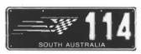 | 133 ± 1.0mm
White Figures |  | Black Background
Slogan White: SOUTH AUSTRALIA
Logo Green, Yellow, Black and White (to the left of the digits) according to the copyright specifications
Height of figure or letter | 77mm
Width of every line in each figure or letter | 12mm
6.2 Standard Series
A limited series of number plates numbered 200—9999 preceded by the Grand Prix Logo, was issued to commemorate the Australian Formula 1 Grand Prix in Adelaide. The plate is issued under an agreement between the Registrar and the applicant and must be of the type known as metal embossed and must conform to the following additional specifications and design:
 | 371 ± 1.0mm
Steel/Aluminium Embossed | 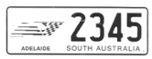 | 133 ± 1.0mm
Black Figures |  | White Retroreflective Background
Slogan Black: SOUTH AUSTRALIA
Logo Green, Yellow, Black and White (to the left of the digits) according to the copyright specifications
Height of figure or letter | 77mm
Width of every line in each figure or letter | 12mm
Class 7—Towtruck Number Plates
A Towtruck number plate must be issued to a Towtruck approved by the Registrar for use in the operation of the accident towing roster scheme. The number is preceded by the letters “ATT” and the plate must conform to the following additional specifications and design:
 | 371 ± 1.0mm
Steel/Aluminium Embossed | 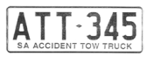 | 133 ± 1.0mm
Blue Letters and Figures |  | Yellow Retroreflective Background
Slogan Blue: SA ACCIDENT TOWTRUCK
Height of figure or letter | 77mm
Width of every line in each figure or letter | 12mm
Class 8—Government Vehicle Number Plates
Vehicles owned by the State of South Australia may be issued with a number plate or plates consisting of a combination of letters and figures, which conform to the following additional specifications and design (unless otherwise authorised):
8.1.1 Government Vehicle or Trailer Number Plate (“S” 7 character set)
 | 371 ± 1.0mm
Steel/Aluminium Embossed |  | 133 ± 1.0mm
Blue Letters and Figures |  | White Retroreflective Background
Slogan Blue: SA GOVERNMENT
Height of figure or letter | 70-77mm
Width of every line in each figure or letter | 10-12mm

8.1.2 Government Motor Bike (“S” 6 character set)
 | 215 ± 1.0mm
Steel/Aluminium Embossed | 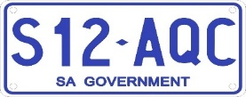 | 95 ± 1.0mm
Blue Letters and Figures |  | White Retroreflective Background
Slogan Blue: SA GOVERNMENT
Height of figure or letter | 50mm
Width of every line in each figure or letter | 6mm
8.1.3 Aerial Plate
 | 252 ± 1.0mm
Steel/Aluminium Embossed |  | 98 ± 1.0mm
Blue Letters and Figure |  | White Retroreflective Background
Slogan Blue: SA GOVERNMENT
Height of figure or letter | 50mm
Width of every line in each figure or letter | 6mm
The dimensions of an aerial mount plate must be 252 ± 1.0mm in length and 98 ± 1.0mm in width and are only available to vehicles granted registration under the Act.
8.2 Government Vehicle Number Plate (remake only)
 | 371 ± 1.0mm
Steel/Aluminium Embossed | 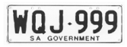 | 133 ± 1.0mm
Blue Letters and Figures |  | White Retroreflective Background
Slogan Blue: SA GOVERNMENT
 | Motor Vehicles other than Motor Bikes | Motor Bikes
Height of figure or letter | 77mm | 50mm
Width of every line in each figure or letter | 12mm | 6mm
The dimensions of a motor bike plate must be 215 ± 1.0mm in length and 95 ± 1.0mm in width.
Class 9—Name Plates
A name plate must bear a number which consists of all letters issued under an agreement between the Registrar and the applicant. The plate must be of the type known as retroreflective metal or acrylic.
The size of the plate and height and width of every figure appearing on the plate are at the discretion of the Registrar.
Class 10—Custom Number Plates
A custom number plate must bear a number nominated by an applicant and approved by the Registrar, which may consist of letters or a combination of letters and figures and issued under an agreement between the Registrar and the applicant authorising the applicant to display the number.
The plate must be of the type known as metal embossed and must conform to the following additional specifications and design:
Option | Letters and Figures  (colour) | Background  (colour)
1 | Retroreflective White | Blue
2 | Retroreflective White | Magenta
3 | Retroreflective White | Red
4 | Retroreflective White | Maroon
5 | Retroreflective White | Green
6 | Blue | Retroreflective White
7 | Magenta | Retroreflective White
8 | Red | Retroreflective White
9 | Maroon | Retroreflective White
10 | Green | Retroreflective White
11 | Black | Gold
12 | Black | Silver
13 | Gold | Black
14 | Silver | Black
15 | Black | Retroreflective White
16 | Black | Retroreflective Lemon
17 | Black | Retroreflective Yellow
18 | Green | Retroreflective Lemon
19 | Green | Retroreflective Yellow
20 | Blue | Retroreflective Lemon
21 | Blue | Retroreflective Yellow
22 | Black | Burnt Orange
23 | Burnt Orange | Black
24 | Black | Electric Blue
25 | Electric Blue | Black
26 | Black | Electric Green
27 | Electric Green | Black
28 | Black | Electric Red
29 | Electric Red | Black
30 | Black | Hot Pink
31 | Hot Pink | Black
10.1 Standard Custom
 | 371 ± 1.0mm
Aluminium Embossed | 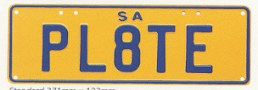 |  | 133 ± 1.0mm
 |  | Motor Vehicles and Trailers other than Motor Bikes |  | Motor Bikes
Height of figure or letter 1 to 6 letters |  | 77mm |  | 50mm
Width of every line in each figure or letter for 1 to 6 letters |  | 12mm |  | 6mm
Height or figure or letter 7 letters or 6 letters with space |  | 70-72mm |  | 50mm
Width of every line in each figure or letter for 7 letters or 6 letters  with space |  | 10-12mm |  | 6mm
The dimensions of a motor bike plate must be:
1 to 6 digits 215mm ± 1.0mm in length and 95mm ± 1.0mm in width.
7 digits 252mm ± 1.0mm in length and 98mm ± 1.0mm in width.
10.2 Slim Custom
 | 371 ± 1.0mm
Aluminium Embossed | 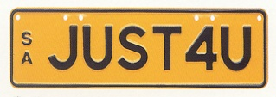 |  | 100 ± 1.0mm
 |  | Motor Vehicles other than Motor Bikes
Height of figure or letter |  | 54mm or 60mm
Width of every line in each figure or letter |  | 10mm
10.3 Square Two Line Custom
 | 306 ± 1.0mm
Aluminium Embossed |  |  | 150 ± 1.0mm
 |  | Motor Vehicles other than Motor Bikes
Height of figure or letter |  | 54mm or 60mm
Width of every line in each figure or letter |  | 10mm
10.4 Square Custom
 | 306 ± 1.0mm
Aluminium Embossed | 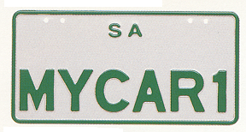 |  | 150 ± 1.0mm
 |  | Motor Vehicle other than Motor Bikes
Height of figure or letter |  | 54mm or 60mm
Width of every line in each figure or letter |  | 10mm
The dimensions of a motor bike plate must be:
1 to 6 digits 215mm ± 1.0mm in length and 95mm ± 1.0mm in width.
7 digits 252mm ± 1.0mm in length and 98mm ± 1.0mm in width.
10.5 Corporate Number Plates
Custom number plates in the corporate plate format may contain a background, logo and/or slogan or other promotional pictures or information deemed appropriate, in accordance with an agreement between the Registrar and the applicant. The plate must conform to the following specifications and design:
371mm + 1.0mm in length and 133mm + 1.0mm in height
Height of Figure or Letter | 60mm
Width of every line in each figure or letter | 10mm
Class 11—Taxi Plates
A taxi plate must be issued to taxis which are accredited by the Passenger Transport Act 1994 as general purpose metropolitan taxis, standby taxis or “special vehicle licence” vehicles (wheelchair accessible vehicle). The number is preceded by the letters ‘TAXI’ and the plate must conform to the following additional specifications and design:
11.1 Standard Taxi Plate (Discontinued)
 | 371 ± 1.0mm
Steel/Aluminium Embossed | 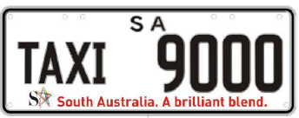 | 133 ± 1.0mm
Black Letters and Figures |  | White Retroreflective Background
Slogan: SA South Australia. A Brilliant Blend
(according to the copyright specifications of SA TOURISM COMMISSION)
 | Motor Vehicle
Height of figure  Height of letter | 70mm  51mm
Width of every line in each figure  Width of every line in each letter | 10mm  6mm
11.2 Standby/Access Taxi Plate
Standby taxi plates and “special vehicle licence” vehicle (wheelchair accessible vehicle) plates (accredited by the Passenger Transport Act 1994) may have letters “TAXI” displayed with white letters on a black background.
 | 371 ± 1.0mm
Steel/Aluminium Embossed |  | 133 ± 1.0mm
Black Figures  Retroreflective White Letters on a Black  60 x 120mm Background |  | White Retroreflective Background
Slogan: SA South Australia. A Brilliant Blend
(according to the copyright specifications of SA TOURISM COMMISSION)
 | Motor Vehicle
Height of figure  Height of letter | 70mm  51mm
Width of every line in each figure  Width of every line in each letter | 10mm  6mm
11.3 Taxi Licence Plate
 | 371 ± 1.0mm
Aluminium Embossed |  | 133 ± 1.0mm
White Retroreflective Letters and Figures |  | Blue Background
The piping shrike emblem will appear after the last letter and before the first number
Slogan: South Australia
 | Motor Vehicle
Height of figure  Height of letter | 70mm  51mm
Width of every line in each figure  Width of every line in each letter | 10mm  6mm
Class 12—Chauffeured Vehicle Plates
A Chauffeured Vehicle number plate must bear a number consisting of a combination of figures and letters and be issued to vehicles and bikes which are accredited to operate for hire under the Passenger Transport Act 1994. These plates must be of the type known as metal embossed and must conform to the following additional specifications and design:
12.1 Standard
 | 371 ± 1.0mm
Steel/Aluminium Embossed |  | 133 ± 1.0mm
Blue Letters and Figures |  | White Retroreflective Background
Blue Border with White Slogan: CHAUFFEURED VEHICLE (above plate number) and SOUTH AUSTRALIA (below plate number)
 | Motor Vehicles other than Motor Bikes
Height of figure or letter | 70-77mm
Width of every line in each figure or letter | 10-12mm
12.2 Square
 | 306 ± 1.0mm
Steel/Aluminium Embossed |  | 150 ± 1.0mm
Blue Letters and Figures |  | White Retroreflective Background
Blue Border with White Slogan: CHAUFFEURED VEHICLE (above plate number) and SOUTH AUSTRALIA (below plate number)
 | Motor Vehicles other than Motor Bikes
Height of figure or letter | 60mm
Width of every line in each figure or letter | 10mm
12.3 Motor Bike
 | 252 ± 1.0mm
Steel/Aluminium Embossed |  | 98 ± 1.0mm
Blue Letters and Figures |  | White Retroreflective Background
Blue Border with White Slogan: CHAUFFEURED VEHICLE (above plate number) and SOUTH AUSTRALIA (below plate number)
 | Motor Bikes
Height of figure or letter | 50mm
Width of every line in each figure or letter | 6mm
Class 13—Consular Corps Plates
Consular Corps number plates may only be issued to an accredited Diplomatic Officer or accredited Consular Officer de carriere, who is a national of a country which he or she represents and who resides in this State, or to an Honorary Consul accredited by the Department of Foreign Affairs and Trade, who also resides in this State. The plates must be of the type known as metal embossed and must conform to the following additional specifications and design:
 | 371 ± 1.0mm
Steel/Aluminium Embossed | 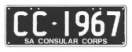 | 133 ± 1.0mm
White Letters and Figures |  | Black Background
Slogan White: SA CONSULAR CORPS
 | Motor Vehicles
Height of figure or letter | 77mm
Width of every line in each figure or letter | 12mm
Class 15—Premium Number Plates
A premium plate must bear a number consisting of two letters, three figures followed by a further letter and may be issued under an agreement between the Registrar and the applicant. The plate must be of the type known as metal embossed and must conform to the following additional specifications and design:
15.1 Front
 | 371 ± 1.0mm
Aluminium Embossed | 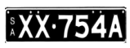  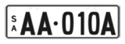 |  | 83 ± 1.0mm
Black Letters and Figures  OR  Retroreflective White Letters and Figures  OR  Opaque White Letters and Figures (discontinued) |  |  | White Retroreflective Background  OR  Black Background
 |  | Motor Vehicles other than Motor Bikes
Height of figure or letter |  | 53mm—54mm
Width of every line in each figure or letter |  | 8mm—10mm
15.1a Rear
 | 371 ± 1.0mm
Aluminium Embossed |  |  | 106 ± 1.0mm
Black Letters and Figures  OR  Retroreflective White Letters and Figures  OR  Opaque White Letters and Figures (discontinued) |  |  | White Retroreflective Background  OR  Black Background
 |  | Motor Vehicles other than Motor Bikes
Height of figure or letter |  | 70mm—75mm
Width of every line in each figure or letter |  | 10mm—12mm
15.2 Front
 | 371 ± 1.0mm
Aluminium Embossed | 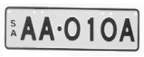 |  | 100 ± 1.0mm
Black Letters and Figures |  |  | White Retroreflective Background
 |  | Motor Vehicles other than Motor Bikes
Height of figure or letter |  | 60mm
Width of every line in each figure or letter |  | 10mm
15.2a Rear
 | 306 ± 1.0mm
Aluminium Embossed | 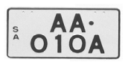 |  | 150 ± 1.0mm
Black Letters and Figures |  |  | White Retroreflective Background
 |  | Motor Vehicles other than Motor Bikes
Height of figure or letter |  | 60mm
Width of every line in each figure or letter |  | 10mm
15.3 Front and Rear Square
 | 306 ± 1.0mm
Aluminium Embossed |  |  | 150 ± 1.0mm
Black Letters and Figures |  |  | White Retroreflective Background
 |  | Motor Vehicles other than Motor Bikes
Height of figure or letter |  | 54-62mm
Width of every line in each figure or letter |  | 10mm
15.4 Corporate Number Plates
Premium number plates in the corporate plate format may contain a background, logo and/or slogan or other promotional pictures or information deemed appropriate, in accordance with an agreement between the Registrar and the applicant. The plate must conform to the following specifications and design:
371mm + 1.0mm in length and 133mm + 1.0mm in height
Height of figure or letter | 60mm
Width of every line in each figure or letter | 10mm
Class 16—Bike Rack Number Plates
A Bike Rack plate must bear the number allotted to the vehicle to which the bike rack is attached and must conform to the following additional specifications and design:
16.1 SA Better by Bike (discontinued)
 | 252 ± 1.0mm
Steel/Aluminium Embossed | 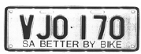 | 98 ± 1.0mm
Black Letters and Figures |  | White Retroreflective Background
Slogan: SA BETTER BY BIKE
Height of figure or letter | 50mm
Width of every line in each figure or letter | 6mm

16.2 SA Cycle instead
 | 252 ± 1.0mm
Steel/Aluminium Embossed | 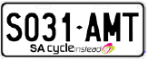 | 98 ± 1.0mm
Black Letters and Figures |  | White Retroreflective Background
Slogan: SA Cycle instead and logo, as endorsed by the Registrar
Height of figure or letter | 50mm
Width of every line in each figure or letter | 6mm
Class 17—Centenary of Federation Number Plates
17.1 Centenary Limited Series Number Plates
A limited series of number plates numbered 1901 CF-2001 CF, with the Centenary of Federation logo between the letters and figures, were issued to commemorate the Centenary of Federation. The plate is issued under an agreement between the Registrar and the applicant and must be of the type known as metal embossed and must conform to the following additional specifications and design:
Steel/Aluminium Embossed  White Letters and Figures | 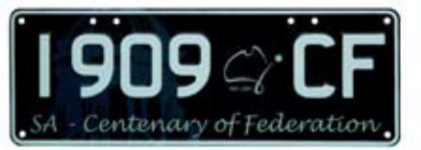  371 ± 1.0mm
  133 ± 1.0mm
  Black Background
Grey watermark of Rotunda in background
Slogan White: SA—Centenary of Federation
Centenary of Federation Logo (between the numbers and the letters) according to the registered trademark owned by the Commonwealth.
 | Motor Vehicles
Height of figure or letter | 60mm
Width of every line in each figure or letter | 10mm
17.2 Centenary Vogue Series Number Plates
A limited series of number plates numbered 000C-999C and 000F-999F with the Centenary of Federation logo between the letters and figures, were issued to commemorate the Centenary of Federation. The plate is issued under an agreement between the Registrar and the applicant and must be of the type known as metal embossed and must conform to the following additional specifications and design:
 | 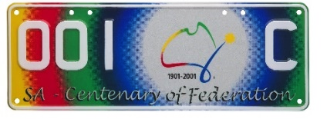  371 ± 1.0mm
  Steel/Aluminium Embossed
  White Letters and Figures
  133 ± 1.0mm
  Yellow, Red, Green, Blue Retroreflective Background
Slogan White: SA—Centenary of Federation
Centenary of Federation Logo (between the numbers and the letters) according to the registered trademark owned by the Commonwealth.
 | Motor Vehicles
Height of figure or letter | 60mm
Width of every line in each figure or letter | 10mm
Class 18—Country Taxi Plates
A Country Taxi Plate must be issued to taxis which have country taxi accreditation under the Passenger Transport Act 1994. The number is preceded by the letters ‘TAXI’ and the plate must conform to the following additional specifications and design:
 | 371 ± 1.0mm
Steel/Aluminium Embossed |  | 133 ± 1.0mm
Black Letters and Figures |  | Lemon Retroreflective Background
Slogan Red: SOUTH AUSTRALIA (above plate number)
COUNTRY TAXI (below plate number)
Black State Badge (Piping Shrike) (between the word TAXI and figures).
 | Motor Vehicles
Height of figure | 70mm
Height of letter | 50mm
Width of every line in each figure | 10mm
Width of every line in each letter | 6mm
Class 19—SA—Heavy Vehicle
A SA Heavy Vehicle Plate may be issued to a vehicle with a mass or GVM over 4.5 tonnes. The plate must be of the type known as metal embossed and must conform to the following additional specifications and design:
19.1 Standard
 | 371 ± 1.0mm
Aluminium Embossed | 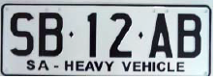 | 133 ± 1.0mm
Black Letters and Figures |  | White Retroreflective Background
Slogan Black: SA—HEAVY VEHICLE
 | Motor Vehicles
Height of figure or letter | 77mm
Width of every line in each figure or letter | 12mm
19.2 Trailer
A SA Heavy Trailer Plate may be issued to a vehicle with a mass or GTM over 4.5 tonnes. The plate must be of the type known as metal embossed and must conform to the following additional specifications and design:
 | 371 ± 1.0mm
Aluminium Embossed |  | 133 ± 1.0mm
Black Letters and Figures |  | White Retroreflective Background
Slogan Black: SA—HEAVY VEHICLE
 | Motor Vehicles
Height of figure or letter | 77mm
Width of every line in each figure or letter | 12mm
Class 20—Euro Number Plates
A Euro plate must bear a number consisting of the letter S followed by two letters, two figures followed by a further letter, with the State Coat of Arms of South Australia appearing between the letter S and the first two letters, and may be issued under an agreement between the Registrar and the applicant. The plate must be of the type known as metal embossed and must conform to the following additional specifications and design:
20.1 White Background Euro Plate
 | 522 ± 1.0mm
Steel/Aluminium Embossed | 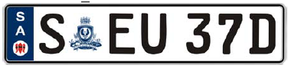 | 113.6 ± 1.0mm
Black Letters and Figures  Logo—Sturt Desert Pea |  | White Retroreflective Background
Blue Sash on the left of the plate with the characters “SA” screen printed in white with the S printed directly above the A
The State Coat of Arms of South Australia (between the “S” and the first two letters) as endorsed by the Department of the Premier and Cabinet’s Protocol Branch.
 | Motor Vehicles
Height of figure or letter | 75.5mm
Width of every line in each figure or letter | 10mm
20.2 Black Background Euro Plate
 | 522 + 1.0mm
Steel/Aluminium  Embossed | 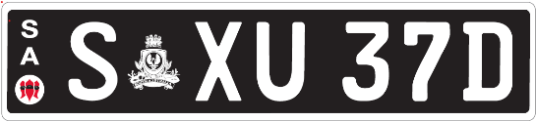 | 113.6 + 1.0mm
White Retroreflective  Letters and Figures  Logo—Sturt Desert Pea |  | Black  Background
On the left of the plate the characters “SA” screen printed in white with the S printed directly above the A
The State Coat of Arms of South Australia (white) (between the “S” and the first two letters) as endorsed by the Department of the Premier and Cabinet Protocol Branch.
 | Motor Vehicles
Height of figure or letter | 75.5mm
Width of every line in each figure or letter | 12mm
Class 21—National Heavy Vehicle Plate
A National Heavy Vehicle Plate may be issued to a vehicle with a mass or GVM over 4.5 tonnes. The plate must be of the type known as metal embossed and must conform to the following additional specifications and design:
21.1 Standard
 | 372 ± 1.0mm
Aluminium Embossed |  | 134 ± 1.0mm
Black Letters and Figures |  | White Retroreflective Background  Containing a Directional Security Mark (Kangaroo in circle)
Sash Colour Blue with White slogan and logo—National Heavy Vehicle
 | Motor Vehicles
Height of figure or letter | 77mm
Width of every line in each figure or letter | 12mm
21.2 Trailer
A Heavy Trailer Vehicle Plate may be issued to a vehicle with a mass or GTM over 4.5 tonnes. The plate must be of the type known as metal embossed and must conform to the following additional specifications and design
 | 372 ± 1.0mm
Aluminium Embossed |  | 134 ± 1.0mm
Black Letters and Figures |  | White Retroreflective Background  Containing a Directional Security Mark (Kangaroo in circle)
Sash Colour Blue with White slogan and logo—National Heavy Vehicle
 | Motor Vehicles
Height of figure or letter | 77mm
Width of every line in each figure or letter | 12mm
21.3 Bike Rack
A bike rack plate issued for a heavy vehicle or heavy trailer with a mass or GVM/GTM over 4.5 tonnes must bear the number allotted to the vehicle to which the bike rack is attached and must conform to the following additional specifications and design:
 | 254 ± 1.0mm
Aluminium Embossed |  | 100 ± 1.0mm
Black Letters and Figures |  | White Retroreflective Background
Sash Colour Blue with White slogan and logo—National Heavy Vehicle
 | Motor Vehicles
Height of figure or letter | 50mm
Width of every line in each figure or letter | 6mm

Class 22—Japanese Number Plates
A Japanese number plate may be issued under an agreement between the Registrar and the applicant.
The plate must be of the type known as metal embossed and must conform to the following additional specifications and design:
22.1 Standard
A Standard Japanese number plate consists of two numbers, followed by three letters.
The plate must be of the type known as metal embossed and must conform to the following additional specifications and design:
 | 330 ± 1.0mm
Aluminium Embossed | 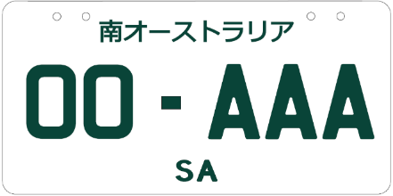 | 165 ± 1.0mm
Green Letters and Figures |  | White Retroreflective Background
Japanese text of ‘南オーストラリア’, meaning ‘South Australia’ located at the top of the number plate with ‘SA’ located in the bottom centre.
 | Motor Vehicles
Height of figure or letter | 58mm-60mm
Width of every line in each figure or letter | 8mm—10mm
22.2 Special Edition
A Special Edition Japanese number plate consists of up to two numbers, followed by three letters ‘JDM’.
The plate must be of the type known as metal embossed and must conform to the following additional specifications and design:
 | 330 ± 1.0mm
Aluminium Embossed | 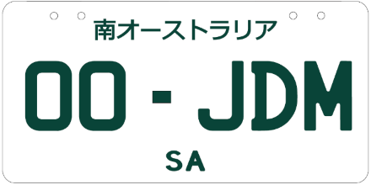 | 165 ± 1.0mm
Green Letters and Figures |  | White Retroreflective Background
Japanese text of ‘南オーストラリア’, meaning ‘South Australia’ located at the top of the number plate with ‘SA’ located in the bottom centre.
 | Motor Vehicles
Height of figure or letter | 58mm-60mm
Width of every line in each figure or letter | 8mm-10mm
22.3 Custom Japanese
A Custom Japanese number plate must bear a number nominated by an applicant and approved by the Registrar, which may consist of letters or a combination of letters and figures and issued under an agreement between the Registrar and the applicant authorising the applicant to display the number.
The plate must be of the type known as metal embossed and must conform to the following additional specifications and design:
Option | Letters and Figures (colour) |  | Background (colour)
1 | Black |  | Retroreflective White
2 | Blue |  | Retroreflective White
3 | Green |  | Retroreflective White
4 | Maroon |  | Retroreflective White
 |  | 330 ± 1.0mm
Aluminium Embossed |  | 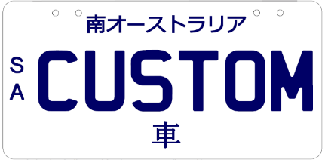 |  | 165 ± 1.0mm
Japanese text of ‘南オーストラリア’, meaning ‘South Australia’ located at the top of the number plate with ‘車’, meaning ‘car’, located in the bottom centre of the plate. ‘SA’ written vertically in the centre left of the number plate.
 | Motor Vehicles
Height of figure or letter | 58mm-60mm
Width of every line in each figure or letter | 8mm-10mm
Class 23—Motorsport Number Plates
23.1 Adelaide 500 Special Edition Series
A special edition Adelaide 500 series of number plates displaying the Adelaide 500 25-year anniversary logo before the SA, preceded by the number sequence 1ADL—25ADL. The plate is issued under an agreement between the Registrar and the applicant and must be of the type known as metal embossed and must conform to the following additional specifications and design:
 | 371 ± 1.0mm
Aluminium Embossed | 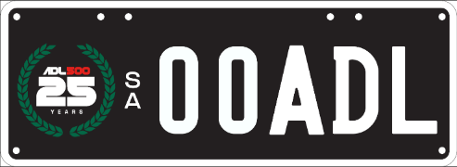 | 133 ± 1.0mm
White Letters and Figures. Adelaide 500 25th anniversary logo |  | Black Retroreflective Background
An Adelaide 500 25th anniversary logo in a green wreath is located to left of the number plate. ‘SA’ written vertically in the centre
 | Motor Vehicles
Height of figure or letter | 70mm
Width of every line in each figure or letter | 10mm
23.2 Adelaide Grand Final Set Series
A set series Adelaide Grand Final number plate must bear a number consisting of a letter followed by three figures, followed by a further letter and issued under an agreement between the Registrar and the applicant. The plate must be of the type known as metal embossed and must conform to the following additional specifications and design:
 | 371 ± 1.0mm
Aluminium Embossed | 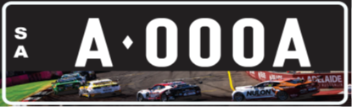 | 133 ± 1.0mm
White Retroreflective Letters & Figures. |  | Black Background
On the left of the plate the characters “SA” printed in white with the S printed directly above the A.
The banner depicting supercars racing on the Adelaide Street circuit is located on the bottom of the number plate.
 | Motor Vehicles
Height of figure or letter | 60mm
Width of every line in each figure or letter | 10mm
General Specifications and Design
1. The dimensions of the letters or words ‘SA’, ‘SOUTH AUSTRALIA’, ‘THE FESTIVAL STATE’ or any other slogan approved by the Registrar whether preceding the number or appearing in a central position above or below the registration number on which they are permitted, unless otherwise prescribed, must be as follows:
 | Motor Bikes  (except Class 12) | Motor Bikes  Class 12 | All Other Classes
Height of figure or letter | 10mm | 8mm | 8-20mm
Width of every line in all parts thereof | 2mm | 1-2mm | 1-3mm
(Except Corporate Number Plates which may vary at the discretion of the Registrar).
2. The dimensions of the State Badge (Piping Shrike) appearing on the number plates on which they are permitted, must be as follows:
 | Class 3 | Class 4 | Class 4 Motor Bike
Diameter | 24-30mm | 50mm | 27mm
3. The dimensions of the slogan “SA Cycle instead” appearing on the Bike Rack number plate must be as follows:
 | Class 16
Height of figure or letter | 13mm
Width of every line in all parts thereof | 2mm
4. A number plate will be taken to comply with the requirements of this notice relating to the size of the plate and the size of letters and figures on the plate if the size of the plate or of any figure or letter on the plate:
(a) does not exceed the size prescribed by this notice by more than 1.0mm; or
(b) is not more than 1.0mm less than the size prescribed by this notice.
5. Notwithstanding the prescribed design and specifications for number plates, a number plate (other than a trailer or bike rack plate) may bear a plate and/or label that complies with the relevant Australian Standard, if the vehicle to which the number plate is affixed, is equipped to be Electric, Hydrogen or uses LP Gas/Natural Gas (as detailed in the Road Traffic (Light Vehicle Standards) Rules 2018 or the Heavy Vehicle (Vehicle Standards) National Regulation (as applicable). However, the plate and label on the number plate must be placed in such a position so as not to obscure any letter, figure, logo or slogan appearing on the number plate.
Transitional Provision
A number plate that was manufactured before the date of this notice will be taken to comply with this notice if it complies with the notice under Section 47A of the Act published in the Gazette on 2 February 2026 (see Gazette No. 6, pages 172-192).
Schedule 3
Classes of Number Plates Which may be Displayed
Pursuant to an Agreement under Section 47A(4) of the Act
Class 1—Numeric
Class 2—Alpha Numeric (Non-slogan)
Class 3—Slogan
Class 4—Personalised
Class 5—Jubilee
Class 6—Australian Grand Prix
Class 9—Name Plates
Class 10—Custom
Class 15—Premium
Class 17—Centenary of Federation
Class 20—Euro
Class 22—Japanese
Class 23—Motorsport
Dated: 12 October 2026
Approved by
E. Kokar
Registrar of Motor Vehicles

National Parks and Wildlife Act 1972
Nilpena Ediacara National Park Management Plan
I, Emily Bourke, Minister for Climate, Environment and Water, hereby give notice under the provisions of Section 38 of the National Parks and Wildlife Act 1972 that, on 9 September 2026, I adopted a plan of management for Nilpena Ediacara National Park Management Plan.
Copies of the plan may be obtained from:
- https://www.environment.sa.gov.au/topics/park-management/statewide-park-strategies/park-management-plans
• Department for Environment and Water Customer Service Centre, ground floor, 81-95 Waymouth Street, Adelaide SA 5000
Dated: 9 September 2026
Hon. Emily Bourke MLC
Minister for Climate, Environment and Water

National Parks and Wildlife (Mamungari Conservation Park) Regulations 2019
Mamungari Conservation Park—Fire Restrictions
Pursuant to Regulation 14 of the National Parks and Wildlife (Mamungari Conservation Park) Regulations 2019, the Mamungari Conservation Park Co-management Board imposes fire restrictions for Mamungari Conservation Park as follows:
All wood fires or solid fuel fires are prohibited from 15 October 2026 to 24 March 2027. Gas fires or liquid fuel fires are permitted other than on days of total fire ban.
The purpose of these fire restrictions is to ensure the safety of visitors using the reserve, and in the interests of protecting the reserve and neighbouring properties.
For further information, please refer to the DEW website www.environment.sa.gov.au or contact the DEW Information Line (08) 8204 1910 or CFS Fire Bans Hotline 1800 362 361.
Dated: 12 October 2026
R. Sleep
Board Deputy Member

National Parks and Wildlife (National Parks) Regulations 2016
National Parks and Wildlife Reserves—Fire Restrictions
Pursuant to Regulation 15 of the National Parks and Wildlife (National Parks) Regulations 2016, I, Stuart Anthony Maxwell Paul, authorised delegate of the Director of National Parks and Wildlife and authorised delegate of the Witjira National Park Co-management Board and Lake Gairdner National Park Co-management Board, in my capacity as Director, Park Operations and Community Partnerships, impose fire restrictions for National Parks and Wildlife Reserves located in the South Australian Country Fire Service Fire Ban Districts as listed in Schedule 1 below.
The purpose of these fire restrictions is to ensure the safety of visitors using the Reserves, and in the interests of protecting the Reserves and neighbouring properties.
Dated: 13 October 2026
S. A. M. Paul
Director, Park Operations and Community Partnerships

Schedule 1
1. Adelaide Metropolitan
All Reserves:
All wood fires, solid fuel fires, gas fires and liquid fuel fires are prohibited throughout the year.
Exceptions:
Cobbler Creek Recreation Park, Glenthorne National Park-Ityamaiitpinna Yarta—All wood fires and solid fuel fires are prohibited throughout the year. Gas fires and liquid fuel fires are permitted in designated areas only, other than on days of total fire ban.
For further information, please refer to the DEW website http://www.environment.sa.gov.au or contact the Adelaide and Mount Lofty Ranges regional office (08) 8336 0901 or CFS Information Hotline 1800 362 361.
2. Mount Lofty Ranges
Currency Creek Game Reserve, Deep Creek National Park, Lawari Conservation Park:
All wood fires and solid fuel fires are prohibited from 1 December 2026 to 24 March 2027. Gas fires and liquid fuel fires are permitted other than on days of total fire ban.
Onkaparinga River National Park, Para Wirra Conservation Park:
All wood fires and solid fuel fires are prohibited from 1 December 2026 to 24 March 2027, wood fires are permitted outside of these dates in designated areas and for cooking purposes only. Gas fires and liquid fuel fires are permitted in designated areas other than on days of total fire ban.
Coorong National Park:
All wood fires and solid fuel fires are prohibited throughout the year. Gas fires and liquid fuel fires are permitted other than on days of total fire ban.
Exceptions:
42 Mile Crossing campground—All wood fires and solid fuel fires are prohibited from 1 November 2026 to 24 March 2027 and on days of total fire ban. Fires are permitted outside of these dates in designated areas only.
Ocean beach foreshore—Wood fires and solid fuel fires are permitted between high water mark and low water mark throughout the year other than on days of total fire ban.
Anstey Hill Recreation Park, Ballaparudda Creek Recreation Park, Belair National Park, Black Hill Conservation Park, Brownhill Creek Recreation Park, Cleland National Park, Granite Island Recreation Park, Morialta Conservation Park, Newland Head Conservation Park, Shepherds Hill Recreation Park, Sturt Gorge Recreation Park:
All wood fires and solid fuel fires are prohibited throughout the year. Gas fires and liquid fuel fires are permitted in designated areas only other than on days of total fire ban.
Exceptions:
Belair National Park—Designated fixed gas barbeques may be used on days of total fire ban other than when the Director has formally closed the Reserve in accordance with Regulation 7(3)(b) of the National Parks and Wildlife (National Parks) Regulations 2016.
All other Reserves:
All wood fires, solid fuel fires, liquid fuel and gas fires are prohibited throughout the year.
For further information, please refer to the DEW website www.environment.sa.gov.au or contact the Adelaide and Mount Lofty Ranges regional office (08) 8336 0901 or CFS Information Hotline 1800 362 361.
3. Kangaroo Island
Cape Gantheaume Conservation Park:
All wood fires and solid fuel fires are prohibited throughout the year. Gas fires and liquid fuel fires are permitted other than on days of total fire ban.
Exceptions:
Sewer Beach carpark, Murray Lagoon, D’Estrees Bay, Tea Trees, Wheaton Beach Campgrounds—All wood fires and solid fuel fires are prohibited from 1 December 2026 to 24 March 2027 and on days of total fire ban. Fires are permitted outside of these dates in designated areas only.
Flinders Chase National Park:
All wood fires and solid fuel fires are prohibited throughout the year. Gas fires and liquid fuel fires are permitted other than on days of total fire ban.
Exceptions:
Rocky River, West Bay, Harvey’s Return, Snake Lagoon, Cupgum, Hakea, Banksia Campgrounds, and May’s Homestead, Postman’s Cottage, Cape du Couedic Lighthouse Cottages—All wood fires and solid fuel fires are prohibited from 1 December 2026 to 24 March 2027 and on days of total fire ban. Fires are permitted outside of these dates in designated areas only.
Kelly Hill Conservation Park:
All wood fires and solid fuel fires are prohibited throughout the year. Gas fires and liquid fuel fires are permitted other than on days of total fire ban.
Exceptions:
Tea Tree Campsite, Grassdale—All wood fires and solid fuel fires are prohibited from 1 December 2026 to 24 March 2027 and on days of total fire ban. Fires are permitted outside of these dates in designated areas only.
Lashmar Conservation Park:
All wood fires and solid fuel fires are prohibited throughout the year. Gas fires and liquid fuel fires are permitted other than on days of total fire ban.
Exceptions:
Antechamber Bay and Chapman River Campgrounds—All wood fires and solid fuel fires are prohibited from 1 December 2026 to 24 March 2027, fires are permitted outside of these dates in designated areas only.

All other Reserves:
All wood fires and solid fuel fires are prohibited throughout the year. Gas fires and liquid fuel fires are permitted other than on days of total fire ban.
For further information, please refer to the DEW website www.environment.sa.gov.au or contact the Kangaroo Island regional office (08) 8553 4444 or CFS Information Hotline 1800 362 361.
4. Mid North
Caroona Creek Conservation Park, Hopkins Creek Conservation Park, Jaki-Ina Worlds End Gorge National Park, Martindale Hall Conservation Park, Pandappa Conservation Park, Red Banks Conservation Park, Spring Gully Conservation Park, Clinton Conservation Park, Wapma Thura-Southern Flinders Ranges National Park:
All wood fires and solid fuel fires are prohibited throughout the year. Gas fires and liquid fuel fires are permitted other than on days of total fire ban.
Adelaide International Bird Sanctuary National Park—Winaityiatyi Pangkara:
All wood fires and solid fuel fires are prohibited throughout the year. Gas fires and liquid fuel fires are permitted other than on days of total fire ban.
Exceptions:
Ocean beach foreshores—Wood fires and solid fuel fires are permitted between high water mark and low water mark, throughout the year other than on days of total fire ban.
All other Reserves:
All wood fires, solid fuel fires, gas fires and liquid fuel fires are prohibited throughout the year.
For further information, please refer to the DEW website www.environment.sa.gov.au or contact the Yorke and Mid North regional office (08) 8841 3400 or CFS Information Hotline 1800 362 361.
5. Yorke Peninsula
Dhilba Guuranda-Innes National Park:
All wood fires and solid fuel fires are prohibited from 1 November 2026 to 24 March 2027, fires are permitted outside of these dates in designated areas only. Gas fires and liquid fuel fires are permitted other than on days of total fire ban.
All other Reserves:
All wood fires and solid fuel fires are prohibited throughout the year. Gas fires and liquid fuel fires are permitted other than on days of total fire ban.
For further information, please refer to the DEW website www.environment.sa.gov.au or contact the Yorke and Mid North regional office (08) 8841 3400 or CFS Information Hotline 1800 362 361.
6. Murraylands
Bandon Conservation Park, Billiatt Conservation Park, Carcuma Conservation Park, Ettrick Conservation Park, Karte Conservation Park, Lowan Conservation Park, Mantung Conservation Park, Ngarkat Conservation Park, Peebinga Conservation Park, Ridley Conservation Park, Swan Reach Conservation Park, Tolderol Game Reserve:
All wood fires and solid fuel fires are prohibited from 1 November 2026 to 24 March 2027. Gas fires and liquid fuel fires are permitted other than on days of total fire ban.
Brookfield Conservation Park:
All wood fires and solid fuel fires are prohibited throughout the year. Gas fires and liquid fuel fires are permitted for cooking purposes only, other than on days of total fire ban.
Exceptions:
Scientific Camp—All wood fires and solid fuel fires are prohibited from 1 November 2026 to 24 March 2027. Gas fires and liquid fuel fires are permitted other than on days of total fire ban.
Marne Valley Conservation Park:
All wood fires and solid fuel fires are prohibited throughout the year. Gas fires and liquid fuel fires are permitted, other than on days of total fire ban.
Ngaut Ngaut Conservation Park:
Please refer to separate notice published by the Ngaut Ngaut Conservation Park Co-management Board.
All other Reserves:
All wood fires, solid fuel fires, gas fires and liquid fuel fires are prohibited throughout the year.
Exception:
Kinchina Conservation Park, Monarto Woodlands Conservation Park—Fires may be permitted for an event through a permit or other agreement.
For further information, please refer to the DEW website www.environment.sa.gov.au or contact the Riverland and Murraylands regional office (08) 8595 2111 or CFS Information Hotline 1800 362 361.
7. Riverland
Bakara Conservation Park, Chowilla Game Reserve, Loch Luna Game Reserve, Maize Island Lagoon, Moorook Game Reserve, Morgan Conservation Park, Pooginook Conservation Park, Ramco Point Conservation Park, Roonka Conservation Park:
All wood fires and solid fuel fires are prohibited from 1 November 2026 to 24 March 2027. Gas fires and liquid fuel fires are permitted other than on days of total fire ban.
Exception:
Roonka Conservation Park—Fires for cultural purposes are permitted throughout the year other than on days of total fire ban.

Murray River National Park:
All wood fires and solid fuel fires are prohibited from 1 November 2026 to 24 March 2027. Gas fires and liquid fuel fires are permitted other than on days of total fire ban.
Exception:
Paringa Paddock—All wood fires and solid fuel fires are prohibited throughout the year. Gas and liquid fuel fires are permitted in designated locations only.
All other Reserves:
All wood fires and solid fuel fires are prohibited throughout the year. Gas fires and liquid fuel fires are permitted other than on days of total fire ban.
For further information, please refer to the DEW website www.environment.sa.gov.au or contact either the Riverland and Murraylands regional office (08) 8595 2111 or CFS Information Hotline 1800 362 361.
8. Upper South East
Bangham Conservation Park, Christmas Rocks Conservation Park, Custon Conservation Park, Geegeela Conservation Park, Gum Lagoon Conservation Park, Kelvin Powrie Conservation Park, Martin Washpool Conservation Park, Messent Conservation Park, Mud Islands Game Reserve, Padthaway Conservation Park, Pine Hill Soak Conservation Park, Salt Lagoon Islands Conservation Park, Wolseley Common Conservation Park:
All wood fires and solid fuel fires are prohibited from 1 November 2026 to 24 March 2027. Gas fires and liquid fuel fires are permitted other than on days of total fire ban.
Coorong National Park:
All wood fires and solid fuel fires are prohibited throughout the year. Gas fires and liquid fuel fires are permitted other than on days of total fire ban.
Exceptions:
42 Mile Crossing campground—All wood fires and solid fuel fires are prohibited from 1 November 2026 to 24 March 2027 and on days of total fire ban. Fires are permitted outside of these dates in designated areas only.
Ocean beach foreshore—Wood fires and solid fuel fires are permitted between high water mark and low water mark throughout the year other than on days of total fire ban.
All other Reserves:
All wood fires and solid fuel fires are prohibited throughout the year. Gas fires and liquid fuel fires are permitted other than on days of total fire ban.
For further information, please refer to the DEW website www.environment.sa.gov.au or contact the Limestone Coast regional office (08) 8735 1177 or CFS Information Hotline 1800 362 361.
9. Lower South East
Beachport Conservation Park, Big Heath Conservation Park, Calectasia Conservation Park, Canunda National Park, Desert Camp Conservation Park, Dingley Dell Conservation Park, Douglas Point Conservation Park, Fairview Conservation Park, Glen Roy Conservation Park, Gower Conservation Park, Grass Tree Conservation Park, Guichen Bay Conservation Park, Hanson Scrub Conservation Park, Jip Jip Conservation Park, Kungari Conservation Park, Lake St Clair Conservation Park, Mary Seymour Conservation Park, Mount Scott Conservation Park, Mullinger Swamp Conservation Park, Naracoorte Caves National Park, Nene Valley Conservation Park, Penambol Conservation Park, Penola Conservation Park, Reedy Creek Conservation Park, Talapar Conservation Park, Telford Scrub Conservation Park, Tilley Swamp Conservation Park, Vivigani Ardune Conservation Park, Woakwine Conservation Park:
All wood fires and solid fuel fires are prohibited from 1 November 2026 to 24 March 2027. Gas fires and liquid fuel fires are permitted other than on days of total fire ban.
Coorong National Park:
All wood fires and solid fuel fires are prohibited throughout the year. Gas fires and liquid fuel fires are permitted other than on days of total fire ban.
Exceptions:
42 Mile Crossing campground—All wood fires and solid fuel fires are prohibited from 1 November 2026 to 24 March 2027 and on days of total fire ban. Fires are permitted outside of these dates in designated areas only.
Ocean beach foreshore—Wood fires and solid fuel fires are permitted between high water mark and low water mark throughout the year other than on days of total fire ban.
Little Dip Conservation Park:
All wood fires and solid fuel fires are prohibited from 1 November 2026 to 24 March 2027. Gas fires and liquid fuel fires are permitted other than on days of total fire ban.
Exception:
Old Man Lake Campground—All wood fires and solid fuel fires are prohibited throughout the year. Gas fires and liquid fuel fires are permitted other than on days of total fire ban.
Piccaninnie Ponds Conservation Park:
All wood fires and solid fuel fires are prohibited throughout the year. Gas fires and liquid fuel fires are permitted other than on days of total fire ban.
Exception:
Ocean beach foreshore—Wood fires and solid fuel fires are permitted between high water mark and low water mark throughout the year other than on days of total fire ban.
Mullins Swamp Conservation Park:
All wood fires, solid fuel fires, gas fires and liquid fuel fires are prohibited throughout the year.
All other Reserves:
All wood fires and solid fuel fires are prohibited throughout the year. Gas fires and liquid fuel fires are permitted other than on days of total fire ban.
For further information, please refer to the DEW website www.environment.sa.gov.au or contact the Limestone Coast regional office (08) 8735 1177 or CFS Information Hotline 1800 362 361.
10. Flinders
Ikara-Flinders Ranges National Park:
All wood fires and solid fuel fires are prohibited from 15 October 2026 to 24 March 2027, fires are permitted outside of these dates in designated areas only. Gas fires and liquid fuel fires are permitted other than on days of total fire ban.
Exception:
Within Wilpena Pound (does not apply to Wilpena Pound Resort)—All wood fires, solid fuel fires, liquid fuel and gas fires are prohibited throughout the year other than that at Wilcolo Camp where gas fires are permitted other than days of total fire ban.
Ippinitchie Campgrounds:
All wood fires and solid fuel fires are prohibited from 15 October 2026 to 24 March 2027, fires are permitted outside of these dates in designated areas only. Gas fires and liquid fuel fires are permitted other than on days of total fire ban.
Mount Remarkable National Park:
All wood fires and solid fuel fires are prohibited throughout the year. Gas fires and liquid fuel fires are permitted other than on days of total fire ban.
Exception:
Mambray Creek and Baroota Vehicle Campgrounds—All wood fires and solid fuel fires are prohibited from 15 October 2026 to 24 March 2027 and on days of total fire ban. Fires are permitted outside of these dates in designated areas only.
Black Rock Conservation Park, Mount Brown Conservation Park, The Dutchmans Stern Conservation Park, Winninowie Conservation Park, Yalpara Conservation Park:
All wood fires and solid fuel fires are prohibited throughout the year. Gas fires and liquid fuel fires are permitted other than on days of total fire ban.
All other Reserves:
All wood fires, solid fuel fires, gas fires and liquid fuel fires are prohibited throughout the year.
For further information, please refer to the DEW website www.environment.sa.gov.au or contact the Flinders and Outback regional office (08) 8648 5300, Yorke and Mid North regional office (08) 8841 3400, or Wilpena Visitor Centre (08) 8648 0048 or CFS Information Hotline 1800 362 361.
11. North East Pastoral
Chowilla Regional Reserve, Innamincka Regional Reserve, Lake Frome National Park, Lake Torrens National Park, Munga-Thirri—Simpson Desert National Park, Nilpena Ediacara National Park, Vulkathunha-Gammon Ranges National Park:
All wood fires and solid fuel fires are prohibited from 15 October 2026 to 24 March 2027. Gas fires and liquid fuel fires are permitted other than on days of total fire ban.
Danggali Conservation Park:
All wood fires and solid fuel fires are prohibited from 15 October 2026 to 24 March 2027. Gas fires and liquid fuel fires are permitted other than on days of total fire ban.
Exception:
Canopus Shearer’s Quarters—Wood fires and solid fuel fires are permitted throughout the year other on days of total fire ban. Gas fires and liquid fuel fires are permitted other than on days of total fire ban.
Witjira National Park:
All wood fires are prohibited throughout the year. Solid fuel fires are prohibited from 15 October 2026 to 24 March 2027, solid fuel fires are permitted outside of these dates in portable fire pits, braziers with trays, or similar receptacles, other than on days of total fire ban. Gas fires and liquid fuel fires are permitted other than on days of total fire ban.
Exception:
Mt Dare Campground—Wood fires and solid fuel fires are prohibited from 15 October 2026 to 24 March 2027. Gas fires and liquid fuel fires are permitted other than on days of total fire ban.
Bimbowrie Conservation Park:
All wood fires and solid fuel fires are prohibited throughout the year. Gas fires and liquid fuel fires are permitted other than on days of total fire ban.
Exception:
Antro Shearer’s Quarters—Wood fires and solid fuel fires are prohibited from 15 October 2026 to 24 March 2027. Gas fires and liquid fuel fires are permitted other than on days of total fire ban.
Kati Thanda-Lake Eyre National Park, Malkumba-Coongie Lakes National Park, Pualco Range Conservation Park, Wabma Kadarbu Mound Springs Conservation Park:
All wood fires and solid fuel fires are prohibited throughout the year. Gas fires and liquid fuel fires are permitted other than on days of total fire ban.
All other Reserves:
All wood fires, solid fuel fires, gas fires and liquid fuel fires are prohibited throughout the year.
For further information, please refer to the DEW website www.environment.sa.gov.au or contact the Riverland and Murraylands regional office (08) 8595 2111, Yorke and Mid North regional office (08) 8841 3400, Flinders and Outback regional office (08) 8648 5300 or CFS Information Hotline 1800 362 361.
12. Eastern Eyre Peninsula
Caralue Bluff Conservation Park, Carappee Hill Conservation Park, Darke Range Conservation Park, Franklin Harbor Conservation Park, Heggaton Conservation Park, Ironstone Hill Conservation Park, Lake Gilles Conservation Park, Middlecamp Hills Conservation Park, Munyaroo Conservation Park, Pinkawillinie Conservation Park, Pinkawillinie Reservoir Conservation Reserve, Rudall Conservation Park, Sheoak Hill Conservation Park, The Plug Range Conservation Park, Verran Tanks Conservation Park, Wharminda Conservation Park, Yeldulknie Conservation Park:
All wood fires and solid fuel fires are prohibited from 15 October 2026 to 24 March 2027. Gas fires and liquid fuel fires are permitted other than on days of total fire ban.
Hincks Conservation Park, Malgra Conservation Park, Poolgarra Conservation Reserve, Whyalla Conservation Park:
All wood fires and solid fuel fire are prohibited throughout the year. Gas fires and liquid fuel fires are permitted other than on days of total fire ban.
All other Reserves:
All wood fires, solid fuel fires, gas fires and liquid fuel fires are prohibited throughout the year.
For further information, please refer to the DEW website www.environment.sa.gov.au or contact the Eyre and Far West regional office (08) 8688 3111 or CFS Information Hotline 1800 362 361.
13. North West Pastoral
Lake Gairdner National Park, Lake Torrens National Park, Nullarbor Regional Reserve, Tallaringa Conservation Park, Yellabinna Regional Reserve:
All wood fires and solid fuel fires are prohibited from 15 October 2026 to 24 March 2027. Gas fires and liquid fuel fires are permitted other than on days of total fire ban.
Kanku-Breakaways Conservation Park:
Please refer to separate notice published by the Coober Pedy Council.
Mamungari Conservation Park:
Please refer to separate notice published by the Mamungari Conservation Park Co-management Board.
For further information, please refer to the DEW website www.environment.sa.gov.au or contact either the Eyre and Far West regional office (08) 8688 3111, Flinders and Outback regional office (08) 8648 5300 or CFS Information Hotline 1800 362 361.
14. Lower Eyre Peninsula
Kellidie Bay Conservation Park, Murrunatta Conservation Park, Sir Joseph Banks Group Conservation Park, Sleaford Mere Conservation Park:
All wood fires and solid fuel fires are prohibited from 15 November 2026 to 24 March 2027. Gas fires and liquid fuel fires are permitted other than on days of total fire ban.
Coffin Bay National Park, Lincoln Nation Park:
All wood fires and solid fuel fires are prohibited from 15 November 2026 to 24 March 2027. Gas fires and liquid fuel fires are permitted other than on days of total fire ban.
Exception:
Ocean beach foreshore—Wood fires and solid fuel fires are permitted between high water mark and low water mark throughout the year other than on days of total fire ban.
Kathai Conservation Park, Lincoln Conservation Park, Moody Tank Conservation Park, Shannon Conservation Park, Tucknott Scrub Conservation Park, Wanilla Conservation Park, Wanilla Land Settlement Conservation Park:
All wood fires and solid fuel fires are prohibited throughout the year. Gas fires and liquid fuel fires are permitted other than on days of total fire ban.
All other Reserves:
All wood fires, solid fuel fires, gas fires and liquid fuel fires are prohibited throughout the year.
For further information, please refer to the DEW website www.environment.sa.gov.au or contact the Eyre and Far West regional office (08) 8688 3111 or CFS Information Hotline 1800 362 361.
15. West Coast
Acraman Creek Conservation Park, Barwell Conservation Park, Bascombe Well Conservation Park, Boondina Conservation Park, Calpatanna Waterhole Conservation Park, Cape Blanche Conservation Park, Caratoola Recreation Park, Chadinga Conservation Park, Cocata Conservation Park, Corrobinnie Hill Conservation Park, Fowlers Bay Conservation Park, Gawler Ranges Conservation Park, Gawler Ranges National Park, Kulliparu Conservation Park, Lake Newland Conservation Park, Laura Bay Conservation Park, Nullarbor Regional Reserve, Nullarbor National Park, Peachna Conservation Park, Pinkawillinie Conservation Park, Point Bell Conservation Park, Point Labatt Conservation Park, Pureba Conservation Park, Sceale Bay Conservation Park, Searcy Bay Conservation Park, Venus Bay Conservation Park, Wahgunyah Conservation Park, Wittelbee Conservation Park, Yellabinna Regional Reserve, Yumbarra Conservation Park:
All wood fires and solid fuel fires are prohibited from 15 October 2026 to 24 March 2027. Gas fires and liquid fuel fires are permitted other than on days of total fire ban.
All other Reserves:
All wood fires, solid fuel fires, gas fires and liquid fuel fires are prohibited throughout the year.
For further information, please refer to the DEW website www.environment.sa.gov.au or contact the Eyre and Far West regional office (08) 8688 3111 or CFS Information Hotline 1800 362 361.

National Parks and Wildlife (National Parks) Regulations 2016
Ngaut Ngaut Conservation Park—Fire Restrictions
Pursuant to Regulation 15 of the National Parks and Wildlife (National Parks) Regulations 2016, the Ngaut Ngaut Conservation Park Co-management Board imposes fire restrictions for Ngaut Ngaut Conservation Park as follows:
All wood fires or solid fuel fires are prohibited from 1 November 2026 to 30 April 2027. Gas fires or liquid fuel fires are permitted other than on days of total fire ban.
The purpose of these fire restrictions is to ensure the safety of visitors using the reserve, and in the interests of protecting the reserve and neighbouring properties.
For further information, please refer to the DEW website www.environment.sa.gov.au or contact the NPWS office Berri (08) 842 99611 or CFS Fire Bans Hotline 1300 362 361.
Dated: 21 September 2026
Ivy Campbell
Board Chairperson

Professional Standards Act 2004
Institute of Public Accountants Ltd Professional Standards Scheme
Pursuant to Section 34(2) of the Professional Standards Act 2004, I Kyam Maher, Attorney General for the State of South Australia, hereby extend the period for which the Institute of Public Accountants Professional Standards Scheme is in force in South Australia to 31 December 2027.
Dated: 9 October 2026
Hon. Kyam Maher MLC
Attorney-General

The Remuneration Tribunal
Report No. 7 of 2026
2026 Review of Electorate Allowances for Members of the Parliament of South Australia
Executive Summary
1. The Remuneration Tribunal (Tribunal) has conducted a review of Determination 17 of 2022 which sets Electorate Allowances for Members of Parliament.
2. As explained in this report, the Tribunal has determined to retain the current allocation of Electorate Allowances and Determination 17 of 2022.
3. The Tribunal notes that the Electorate Allowance applicable to the Electorate of Giles appears to be inconsistent with the characteristics of the electorate in comparison with other electorates and may be reduced at the next review.
Background
4. Sections 3A(2) and 4(1)(c) of the Parliamentary Remuneration Act 1990 (SA) (PR Act) in conjunction with Section 14 of the Remuneration Act 1990 (SA) (Act) provide that the Tribunal has jurisdiction to set Electorate Allowances for Members of Parliament.
5. The Tribunal has used this jurisdiction to consider Electorate Allowances for Members of Parliament which were last increased by Determination 17 of 2022.
6. The Electorate Allowances are intended to compensate Members of Parliament for the expenses they necessarily incur in the performance of their duties representing their electorates.
7. The Tribunal understands that until the early 2000s, the major component of the Electorate Allowances reflected car and travel costs. In 2004 the Government established an administrative scheme which provides a motor vehicle to each Member of Parliament for a fixed cost contribution of $7,000 (plus any additional costs for optional accessories) (Motor Vehicle Scheme). The contribution for the Motor Vehicle Scheme is then deducted from the Electorate Allowance of the Member of Parliament. That scheme has not changed since it was established.
8. Since at least 2022, the Tribunal has held concerns about the basis of the Electorate Allowances because the Tribunal did not have current data on how Members spend the remainder of the Electorate Allowance.
9. Accordingly, the Tribunal conducted an extensive review of these issues in 2023 (Report 16 of 2023). The Tribunal noted that, although the costs of the Motor Vehicle Scheme were met from Electorate Allowances, these costs had not been reviewed and were outside the Tribunal’s jurisdiction.
10. In terms of the residual amounts, the Tribunal noted that information to clarify the continuing relevance of the categories of expenditure which had been considered in the last substantive consideration of this allowance was not available. Those categories are accommodation and travel, donations, subscriptions, telephone, stationery, and postage.
11. In 2023 the Tribunal surveyed Members of Parliament about their expenditure of the Electorate Allowance. This survey did not yield useful results as only one Member participated.
12. Consequently, in Report 16 of 2023, the Tribunal confirmed its position that the absence of appropriate information about how the Electorate Allowances were used meant that no basis for an increase had been established.
13. Similarly, in its 2024 and 2025 reviews of the Electorate Allowances, the Tribunal again observed that there was no information available to it to warrant a change. Each report invited Members of Parliament to make submissions providing information with sufficient detail to enable suitable consideration of the Electorate Allowance at the next review.
14. The Tribunal would usually conduct reviews of the Electorate Allowances in November of each year, on the anniversary of its previous reviews, as required by Section 8 of the Act.
15. On 15 April 2026, after the Tribunal published its 2025 review and upon the conclusion of the 2026 State Election, the Tribunal received correspondence from the Hon Geoff Brock MP, Member for Stuart seeking a review of the Electorate Allowance for the Electorate of Stuart in the context of the changes made to the electorate’s boundaries by the Electoral Districts Boundaries Commission in 2024. These changes came into effect at the 2026 State Election (2024 Redistribution). As the issues raised in this letter were significantly expanded upon in the Hon Mr Brock’s submissions to this Review, the Tribunal has not summarised them here to avoid repetition.
16. Because of the request from the Hon Mr Brock, the Tribunal exercised its discretion under Section 8 of the Act to bring forward the annual review of the Electorate Allowances to consider the impact of the 2024 Redistribution as it changed the boundaries of multiple electorates.
17. Because of the potential for those changes to impact on other Members of Parliament, and in consideration of the issues raised by the Hon Mr Brock, the Tribunal decided there should be an opportunity for all Members of Parliament to provide submissions.
The Review Process
18. On 29 April 2026, the Tribunal wrote to the Hon Mr Brock advising him that because of his request for a review, an invitation for submissions would be issued to all Members of Parliament that day.
19. On 29 April 2026, and in accordance with Sections 10(2) and 10(4) of the Act, the Tribunal wrote to and invited submissions by
30 July 2026 in respect of this review from:
(a) The Honourable Premier of South Australia—as the Minister responsible for the Act who may make submissions or introduce evidence on any question relevant to the public interest;
(b) All Members of Parliament;
(c) The Treasurer; and
(d) The Independent Commissioner Against Corruption.
20. The Tribunal also placed a notice on its website from 29 April 2026 inviting submissions from affected persons by 30 July 2026.
21. Each invitation and the notice on the Tribunal’s website included a detailed guide setting out the matters on which the Tribunal sought information. These included:
• The Electorate Allowance is provided for expenses associated with discharging parliamentary, electoral or community duties (but not party-political) in the electoral district the Member represents. Any items that are covered by any other allowance or reimbursement are not Electorate Allowance expenses. For example, items that are covered by the Global Allowance.
• The quantum of Electorate Allowances varies and the exact basis for these variations cannot be easily determined. However, they can largely be traced back to the arrangements that operated to recognise travel costs within different sized electorates prior to the introduction of the Motor Vehicle Scheme. Consequently, if the geographic size of an electorate or other differentiating factors are relied on as the basis for a change to any Electorate Allowance, the Tribunal requested advice of the basis for additional (or reduced) costs.
• Other travel costs, or accommodation costs, separate from vehicles, that Members of Parliament wished the Tribunal to consider.
• The Tribunal is also cognisant that Electorate Allowances may be used for sundry expenses related to community events and that precise records of those expenditures may not be available.
• Subscriptions, telephone, stationery and postage, together with other administrative expenses that may be relevant to this review.
• Other relevant expenses could also be drawn to the Tribunal’s attention.
• Where the Tribunal's attention is directed to potential anomalies in the quantum of Electorate Allowances, those submissions were requested to be founded on what costs the Electorate Allowance should cover, rather than simply a comparative assessment made in the absence of expenditure evidence.
22. On 6 May 2026, the Independent Commissioner Against Corruption confirmed that no submission would be made.
23. On 20 July 2026, the Premier’s representative confirmed that no submission would be made.
24. On 21 July 2026, the Tribunal received the Hon Mr Brock’s submission which sought an increase to the Electorate Allowance for Stuart to recognise Stuart’s significant expansion because of the 2024 Redistribution. This submission sought recognition of the electorate’s geographic size, remoteness, and the increased travel requirements and representation costs caused by the 2024 Redistribution. The Hon Mr Brock later expanded on this submission by providing a summary of expenditures allocated to the Stuart Electorate Allowance. The Tribunal notes this submission is the only current information it has received regarding the expenditure of Electorate Allowances.
25. No other submissions were received.
Consideration and Conclusion
26. In reviewing the Electorate Allowances, the Tribunal has had regard to the necessary statutory considerations provided for by Section 4(2) of the PR Act which provides as follows:
The Remuneration Tribunal must, in determining electorate allowances and other remuneration for members of Parliament—
(a) have regard not only to their parliamentary duties but also to—
(i) their duty to be actively involved in community affairs; and
(ii) their duty to represent and assist their constituents in dealings with governmental and other public agencies and authorities; and
(b) must not reduce an amount payable merely because there has been a change in basic salary.
27. In addition to reviewing Electorate Allowances generally, the Tribunal has specifically reviewed the Electorate Allowance applicable to the Electorate of Stuart, taking into account the submissions and information provided by the Hon Mr Brock.
28. Those submissions advised that the 2024 Redistribution substantially increased the size, remoteness, travel requirements and representation obligations associated with the electorate of Stuart, resulting in materially higher costs for the Member of Parliament. In particular:
• The geographic area of Stuart increased by approximately 97% from 323,131km² to 636,489km²;
• Stuart now covers approximately 65 per cent of South Australia's land mass and is one of the largest parliamentary electorates in Australia;
• The 2024 Redistribution added numerous towns and communities to Stuart, including the APY Lands, Andamooka, Burra, Coober Pedy, Jamestown, Oodnadatta, Roxby Downs, Spalding, part of the Regional Council of Goyder and the remainder of the Northern Areas Council, while removing the remainder of the Port Augusta City Council;
• The 2024 Redistribution has significantly increased the number of communities, towns and localities requiring representation
by 120, from 157 to 277;
• As well as adding over 100 community organisations, sporting clubs, volunteer groups and local associations which regularly seek assistance, advocacy and engagement from their local Member of Parliament;
• The 2024 Redistribution has also increased the cost of servicing remote communities, which has resulted in greater travel requirements, more overnight stays, increased engagement over a broader geographic area and greater reliance on air travel to reach remote communities.
• Access to communities such as those in the APY Lands frequently requires chartered air travel, with individual flights costing several thousand dollars. For example, a recent charter flight from Leigh Creek to Mungerannie cost approximately $5,400. This consumed more than half of what the Hon Mr Brock described as the $10,000 Charter Flight allocation.
29. The Tribunal has also had regard to the Hon Mr Brock’s submissions about abnormalities within the Electorate Allowance framework. The Tribunal was grateful to the Hon Mr Brock for the details provided in his submission. The Tribunal noted the Hon Mr Brock’s submission was focused on a desire to ensure that future aspirants to the position of MP for Stuart would not be discouraged by what may be regarded as insufficient Electoral Allowances.
Electorate Allowances Generally
30. Electorate Allowances form one of a series of allowances payable to Members of Parliament. As the Tribunal recognised in its 2023 Report, there is considerable flexibility available to Members of Parliament to allocate expenditures to these different allowances.
31. The Electorate Allowances for metropolitan electorates are currently set at $17,815.
32. The table below sets out the Electorate Allowance Amounts for each non-metropolitan electorate, as well as the geographic area and number of electors as applicable because of the 2024 Redistribution:
Group | Electorate | Electorate Allowance Amount | Geographic Size (km²) | Electors
B | Heysen | $24,989 | 927.6 | 29,298
 | Kavel | $24,989 | 288.5 | 26,817
 | Taylor | $24,989 | 242.2 | 25,616
C | Finniss | $29,202 | 1,396 | 28,080
 | Ngadjuri (formerly Frome) | $29,202 | 6,386 | 26,530
 | Mount Gambier | $29,202 | 1,936 | 26,134
 | Schubert | $29,202 | 2,181 | 28,681
D | Chaffey | $37,735 | 30,124 | 26,068
 | Hammond | $37,735 | 3,340 | 27,923
 | Mawson | $37,735 | 5,360 | 28,322
 | Narungga | $37,735 | 11,381 | 27,427
E | MacKillop | $42,674 | 34,138 | 27,601
F | Flinders | $49,013 | 221,669 | 26,001
G | Giles | $54,416 | 28,690 | 26,954
 | Stuart | $54,416 | 636,489 | 28,043
33. The Tribunal has noted that the publicly available information on expenditures allocated to Global Allowances suggests divergent approaches to the allocation of expenses. This reflects the discretion available to Members.
34. The Tribunal accepts that the quantum of the Electorate Allowance applicable to each electorate is impacted by the electorate’s geographic size. This clearly reflects the historical vehicle travel arrangements. However, absent any data to demonstrate a current direct link between the electorate’s geographic size and increased costs, the Tribunal is not able to discern the direct monetary impact of additional travel, accommodation and associated costs that relate to the larger distances involved.
35. If the Electorate Allowances are contrasted with each other on the basis of geographic areas, the quantum of the Electorate Allowance for Giles appears most inconsistent.
36. Given the numbers of electors within each electorate are required to be approximately the same⁴, the numbers of electors within each electorate do not provide a sustainable basis for determining differential Electorate Allowance amounts.
37. The available information about the characteristics and dispersion of electors and/or population within the electorates generally does not explain the differences in the current Electorate Allowances. This information may provide a basis for establishing revised allowance amounts, however absent information about the ways in which the Electorate Allowances are applied, a basis for review is difficult.
38. The Tribunal acknowledges that electorate differences, including travel costs, may have a substantial impact on the utilisation of the Electorate Allowance. Some Members may operate two Electorate Offices resulting in overnight accommodation and meal costs to service the office further away from their home, and some Members may travel more frequently within their electorates resulting in additional overnight accommodation and meal costs. The Tribunal has accepted that the Electorate Allowance is used by Members of Parliament to offset the costs of representing their electorates, and particularly the costs of travelling within their electorate.
39. The Electoral Districts Boundaries Commission made changes to electorate boundaries in 2020. These changes took effect at the 2022 State Election (2020 Redistribution).
40. The Tribunal has looked at the effects of the 2020 Redistribution and the 2024 Redistribution since the Electorate Allowances were last re-allocated in 2019. In short, electorate boundaries and areas can change substantially between elections. This compounds the difficulty in assessing Electorate Allowances in the absence of better and more extensive information provided from a significant representation of Members of Parliament with regards as to how the Electorate Allowances are spent and how they interact with other allowances payable to Members of Parliament.
41. The information provided for the electorate of Stuart demonstrates expenditures that may be funded from other allowances available to Members of Parliament, such as the Global Allowance.
42. Further categories of expenditure are of a discretionary nature and cannot be exclusively linked to a particular electorate. Collectively, these do not represent a basis for an increase to the Electorate Allowance in this instance.
43. No other basis for broad adjustments to Electoral Allowances has been provided to the Tribunal. Absent a sustainable basis for these payments the Tribunal does not consider that an increase to them can be substantiated.
44. Notwithstanding this concern, the Tribunal is unable to identify any basis for the retention of the current quantum of the Electoral Allowance for Giles. Population and area considerations indicate that this Electorate Allowance should be reduced to be comparable with that applicable to the electorate of Chaffey.
45. The Tribunal is sympathetic to the matters raised in the submission from the Member for Stuart and if it could obtain more extensive and detailed responses from other Members of Parliament for future reviews, then this may assist the development of a sustainable model that underpins the setting of Electoral Allowances.
46. Because it may be the case that there are characteristics unique to the Electorate of Giles which substantiate the Electorate Allowance Amount, the Tribunal has not implemented a reduction in this Review. However, without information that supports the retention of the current amount, the Tribunal is likely to implement this reduction at the next review.
47. That review will again provide an opportunity for submissions to be made addressing the basis of the Electorate Allowances.
48. Apart from the submissions provided by the Hon Mr Brock, there is no additional information available to the Tribunal which would form the basis for a general increase, or a decrease in the current Electorate Allowances.
49. Consequently, the Tribunal has not altered allowances generally and has considered the allowance applicable to the Electorate of Stuart on the information available to it.
The Electorate of Stuart
50. Both Stuart and Giles currently receive Electorate Allowances of $54,416 but their geographic sizes are markedly different. Giles is 28,690km², whereas Stuart is now more than 22 times larger than Giles at 636,489km². The Hon Mr Brock does not suggest that the Electorate Allowance for Stuart should be increased at the expense of Giles.
51. The Tribunal has noted that when the allocation of Electorate Allowances was last considered by the Tribunal, Giles was 497,005km² and Stuart 330,656km². The 2020 Redistribution made them approximately comparable at 335,187km² and 323,131km² respectively. However, the 2024 Redistribution adjusted the electorates to their current sizes.
52. The electorate of Flinders was also increased in size from 58,901km² for the 2018 State Election, and then to over 221,000km² from the 2022 State Election onwards.
53. If the basis for the calculation of the Electoral Allowance was the geographic size of the electorate, the disparate sizes of Stuart and Giles could be characterised as an anomaly. However, as noted above, that anomaly would focus attention on the extent to which the Electorate Allowance applicable to Giles appears inconsistent with the allowances applicable to other country electorates rather than forming a basis to increase the allowance for Stuart.
54. The Hon Mr Brock’s details of his expenditure of the Stuart Electorate Allowance demonstrate that expenditures on travel related matters for himself and his staff are substantial, but well within the Electorate Allowance amount.
55. Notwithstanding the Hon Mr Brock’s preference to travel by car, he has confirmed to the Tribunal that chartered air travel is also necessary.
56. Since 1978 there has been an allowance for chartered air travel available for the Members for Giles and Stuart for travel within their electorates (Air Charter Allowance). The Air Charter Allowance is currently $10,000 per annum. This amount does not accumulate from year to year. The Air Charter Allowance has not altered since 2001 and is paid by the House of Assembly on the presentation of an invoice. The Tribunal understands that the conditions and quantum of the Air Charter Allowance are set by the Government. The Air Charter Allowance is completely separate from the Electorate Allowance and is outside the jurisdiction of the Tribunal.
57. Consequently, to the extent that the Hon Mr Brock has concerns about the quantum of the Air Charter Allowance, the Tribunal considers these concerns are best directed to the Government.
58. The information provided by the Hon Mr Brock confirms a significant level of discretionary expenditure. There is no suggestion that this expenditure is inappropriate or unjustified with regards the obligations associated with representing or serving the electorate of Stuart.
59. However, the nature and quantum of the expenditure is such that it is problematic using this as a basis for an increase to the Electorate Allowance absent more extensive information relative to other electorates. If that information was available to the Tribunal a different position may have been adopted.
60. The Tribunal may consider adopting a different approach to the setting of future Electorate Allowances if, for future reviews, there is better and more extensive information provided from a significant representation of Members of Parliament with regards as to how the Electorate Allowances are spent and how they interact with other allowances payable to Members of Parliament
61. Accordingly, Determination 17 of 2022 will continue in operation.
Dated: 8 October 2026
Matthew O’Callaghan
President
Donny Walford
Member
Mark Young
Member

South Australian Skills Act 2008
Part 4—Apprenticeships, Traineeships and Training Contracts
Pursuant to the provision of the South Australian Skills Act 2008, the South Australian Skills Commission (SASC) gives notice that determines the following qualification and training contract conditions for Trades or Declared Vocations, in addition to those published in past gazette notices.
*Trade/ #Declared Vocation/ Other Occupation | Qualification Code | Qualification Title | Nominal Term of Training Contract | Probationary Period | Supervision Level Rating
Vehicle Body Repair Technician * | AUR32126 | Certificate III in Automotive  Body Repair Technology | 48 months | 90 days | M
Automotive Tyre Fitter # | AUR21926 | Certificate II in Automotive  Tyre Servicing Technology | 12 months | 60 days | M
Condition/s | N/A
Dated: 15 October 2026
John Evangelista
Director, Traineeship and Apprenticeship Services
South Australian Skills Commission

Summary Offences Act 1953
Declared Public Precincts
Notice of Ministerial Determination
I, Kyam Maher, Attorney-General in the State of South Australia, being the Minister responsible for the administration of Part 14B—Declared Public Precincts of the Summary Offences Act 1953, do hereby determine pursuant to the provisions of Section 66 of the said Act that the area contained within the following boundaries:
• Southern boundary of High Street to western boundary of Moseley Street, north to southern boundary of College Street, then west to the western boundary of St Johns Row, north to the southern boundary of the Stamford Grand Hotel, west along the southern boundary of the Stamford Grand Hotel to the eastern boundary of South Esplanade, south on the eastern boundary of South Esplanade to the northern boundary of Kent Street, taking a straight-line west to the low tide shoreline of St. Vincent Gulf
• North along the low tide shoreline of St Vincent Gulf to the northern most point at low tide of the breakwater (inclusive of Glenelg Jetty),
• The northern most point at low tide of the breakwater, to the northeast corner of the Holdfast Shores Marina (inclusive of Holdfast Promenade Plaza), east and north following the low tide shoreline to the southern boundary of King Street then east on King Street to eastern boundary of Adelphi Terrace
• South along the eastern boundary of Adelphi Terrace to southern boundary of Anzac Highway, west along the southern boundary of Anzac Highway to eastern boundary of Colley Terrace, south on Colley Terrace to northern boundary of Augusta Street
• East on the northern boundary of Augusta Street to the eastern boundary of Brighton Road including the northern boundary of Torrens Square
• eastern boundary of Brighton Road to southern boundary of High Street
• Tram Stop 15:
◦ including the northern boundary of Dunbar Terrace from Brighton Road to Service Road
◦ from the northern boundary of Dunbar Terrace extending in a straight line along the eastern boundary of the tram line pedestrian crossing to the southern side of Maxwell Terrace
◦ the southern side of Maxwell Terrace to the eastern boundary of Brighton Road.
will be a Declared Public Precinct for a period of 12 hours from 3:00pm on each Friday, Saturday and Sunday night commencing on 16 October 2026, until declared otherwise or until 3:00am on 12 April 2027, whichever occurs sooner.
will with the exception only for Friday, 1 January 2027 during the Declared Public Precinct period, commencing at 6:00pm.
will additionally be a Declared Public Precinct:
for 12 hours from 6:00pm on 31 December 2026 to 6:00am 1 January 2027
This Declaration provides no period greater than 12 hours in any 24-hour period.
References to boundaries identified by streets, roads, or terraces for the purpose of this declaration will be taken to mean and include the area up to the applicable building or fence lines, or the imagined projection thereof, on the relevant boundary.
I am satisfied that there is, during the period specified in this declaration, a reasonable likelihood of conduct posing a risk to public order and safety in the area specified.
I am satisfied that the inclusion of each public place in the area is reasonable having regard to that identified risk.
Dated: 13 October 2026
Kyam Joseph Maher
Attorney-General

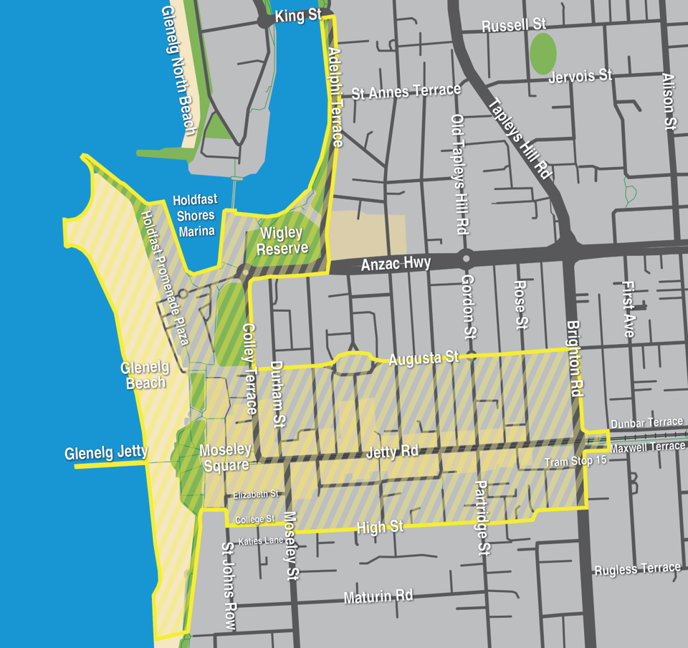

Wilderness Protection Regulations 2021
Wilderness Protection Areas—Fire Restrictions
Pursuant to Regulation 13 of the Wilderness Protection Regulations 2021, I, Stuart Anthony Maxwell Paul, authorised delegate of the Director of National Parks and Wildlife, impose fire restrictions for Wilderness Protection Areas located in the South Australian Country Fire Service Fire Ban Districts as listed in Schedule 1 below.
The purpose of these fire restrictions is to ensure the safety of visitors, and in the interests of protecting the Wilderness Protection Areas and neighbouring properties.
Dated: 13 October 2026
S. A. M. Paul
Director, Park Operations and Community Partnerships

Schedule 1
1. Kangaroo Island
Cape Bouger Wilderness Protection Area, Cape Gantheaume Wilderness Protection Area, Cape Torrens Wilderness Protection Area, Ravine des Casoars Wilderness Protection Area, Western River Wilderness Protection Area:
All wood fires and solid fuel fires are prohibited throughout the year. Gas fires and liquid fuel fires are permitted other than on days of total fire ban.
For further information, please refer to the DEW website www.environment.sa.gov.au or contact the Kangaroo Island regional office (08) 8553 4444 or CFS Information Hotline 1800 362 361.

2. Eastern Eyre Peninsula
Hambidge Wilderness Protection Area, Hincks Wilderness Protection Area:
All wood fires or solid fuel fires are prohibited throughout the year. Gas fires or liquid fuel fires are permitted other than on days of total fire ban.
For further information, please refer to the DEW website www.environment.sa.gov.au or contact the Eyre and Far West regional office (08) 8688 3111 or CFS Information Hotline 1800 362 361.
3. Lower Eyre Peninsula
Memory Cove Wilderness Protection Area:
All wood fires, solid fuel fires, gas fires and liquid fuel fires are prohibited throughout the year.
Exception:
Visitor zone—gas fires fires and liquid fuel fires permitted other than on days of total fire ban.
For further information, please refer to the DEW website www.environment.sa.gov.au or contact the Eyre and Far West regional office (08) 8688 3111 or CFS Information Hotline 1800 362 361.
4. Murraylands
Billiatt Wilderness Protection Area:
All wood fires and solid fuel fires are prohibited from 1 November 2026 to 24 March 2027. Gas fires and liquid fuel fires are permitted other than on days of total fire ban.
For further information, please refer to the DEW website www.environment.sa.gov.au or contact the Riverland and Murraylands regional office (08) 8595 2111 or CFS Information Hotline 1800 362 361.
5. North East Pastoral
Danggali Wilderness Protection Area:
All wood fires, solid fuel fires, gas fires and liquid fuel fires are prohibited throughout the year.
For further information, please refer to the DEW website www.environment.sa.gov.au or contact the Riverland and Murraylands
regional office (08) 8595 2111, Yorke and Mid North regional office (08) 8841 3400, Flinders and Outback regional office (08) 8648 5300 or CFS Information Hotline 1800 362 361.
6. North West Pastoral
Yellabinna Wilderness Protected Area:
All wood fires and solid fuel fires are prohibited from 15 October 2026 to 24 March 2027. Gas fires and liquid fuel fires are permitted other than on days of total fire ban.
For further information, please refer to the DEW website www.environment.sa.gov.au or contact the Eyre and Far West regional office (08) 8688 3111, Flinders and Outback regional office (08) 8648 5300 or CFS Information Hotline 1800 362 361.
7. West Coast
Nullarbor Wilderness Protection Area:
All wood fires and solid fuel fires are prohibited from 15 October 2026 to 24 March 2027. Gas fires and liquid fuel fires are permitted other than on days of total fire ban.
Investigator Group Wilderness Protection Area, Nuyts Archipelago Wilderness Protection Area:
All wood fires, solid fuel fires, gas fires and liquid fuel fires are prohibited throughout the year.
For further information, please refer to the DEW website www.environment.sa.gov.au or contact the Eyre and Far West regional office (08) 8688 3111 or CFS Information Hotline 1800 362 361.

Local Government Instruments

City of Onkaparinga
Notice of Removal of Vehicle
Notice is hereby given that pursuant to Section 237(4)(b) of the Local Government Act 1999 the following vehicles have been removed and impounded by Council.
- Blue cage trailer—no plates, from Brodie Road Lonsdale at 13:30 on 29 September 2026.
Take note—
(a) your vehicle has been removed; and
(b) if you do not, within one month after service of this notice—
(i) take possession of the vehicle; and
(ii) pay all expenses in connection with the removal, custody and maintenance of the vehicle and of serving, posting or publishing this notice,
Council will take steps to sell or dispose of the vehicle in accordance with Section 237 of the Local Government Act 1999.
Please contact Council on (08) 8384 0666 during ordinary office hours to arrange collection of your vehicle.
Dated: 15 October 2026
Nicole Moore
Manager Community Safety and Property Acting

City of Port Adelaide Enfield
Liquor Licensing Act 1997—Section 131(1ab)
Liquor Licensing (Dry Areas) Notice 2026
1—Short title
This notice may be cited as the Liquor Licensing (Dry Areas) Notice 2026.
2—Commencement
This notice comes into operation on 31 December 2026
3—Interpretation
(1) In this notice—
principal notice means the Liquor Licensing (Dry Areas) Notice 2015 published in the Gazette on 5 January 2015, as in force from time to time.
(2) Clause 3 of the principal notice applies to this notice as if it were the principal notice.
4—Consumption etc of liquor prohibited in dry areas
(1) Pursuant to Section 131 of the Act, the consumption and possession of liquor in the area described in the Schedule is prohibited in accordance with the provisions of the Schedule.
(2) The prohibition has effect during the periods specified in the Schedule.
(3) The prohibition does not extend to private land in the area described in the Schedule.
(4) Unless the contrary intention appears, the prohibition of the possession of liquor in the area does not extend to—
(a) a person who is genuinely passing through the place if—
(i) the liquor is in the original container in which it was purchased from licensed premises; and
(ii) the container has not been opened; or
(b) a person who has possession of the liquor in the course of carrying on a business or in the course of their employment by another person in the course of carrying on a business; or
(c) a person who is permanently or temporarily residing at premises near the public place and who enters the public place solely for the purpose of passing through it to enter those premises or who enters the public place from those premises for the purpose of leaving the place; or
(d) a person who possesses or consumes the liquor for sacramental or other similar religious purposes.
Schedule—Semaphore Area 4
1—Extent of prohibition
The consumption of liquor is prohibited, and the possession of liquor is prohibited.
2—Period of prohibition
From 12 noon on 31 December 2026 to 12 noon on 1 January 2027.
3—Description of area
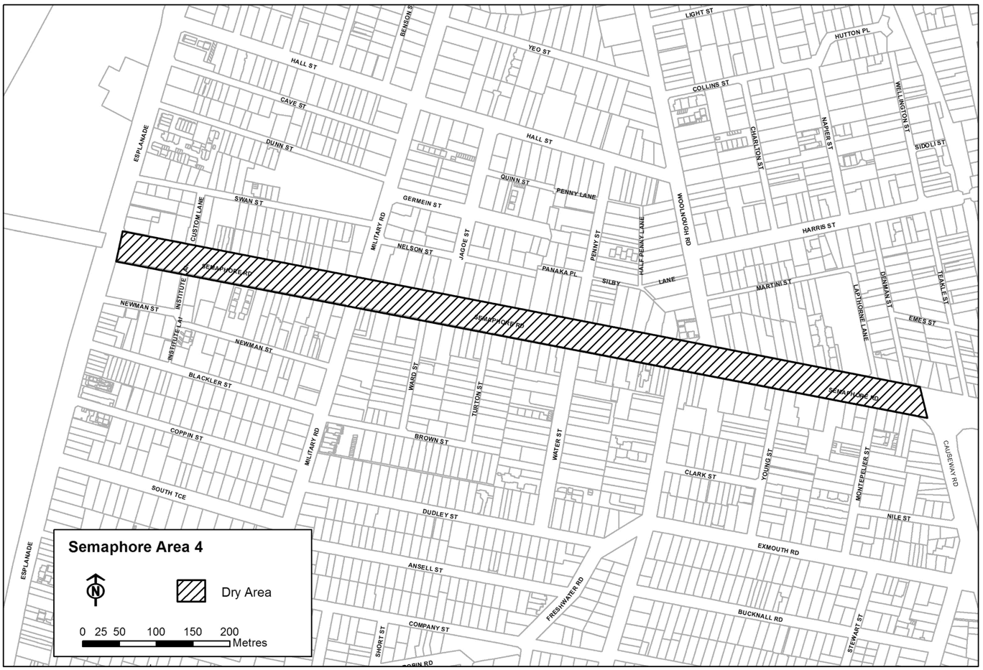
The area in Semaphore and Exeter comprising Semaphore Road between the eastern boundary of the Esplanade and the prolongation in a straight line of the marked centre line of Causeway Road.
Dated: 15 September 2026
Mark Withers
Chief Executive Officer

City of Port Adelaide Enfield
Local Government Act 1999
Notice of Proposed Revocation of Community Land Classification—Fletcher’s Slip at New Port
Notice is hereby given pursuant to Section 194 of the Local Government Act 1999, that the City of Port Adelaide Enfield at its meeting held on 27 January 2026, resolved to commence the process to revoke the community land classification of land at Fletcher’s Slip, New Port, being:
- The whole of the land comprised in Certificate of Title Volume 6264 Folio 575 and described as Allotment (Reserve) 8003 in Deposited Plan 128600;
- The whole of the land comprised in Certificate of Title Volume 6264 Folio 578 and described as Allotment (Reserve) 8006 in Deposited Plan 128600;
- The whole of the land comprised in Certificate of Title Volume 6264 Folio 585 and described as Allotment (Reserve) 8021 in Deposited Plan 128611;
- The whole of the land comprised in Certificate of Title Volume 6264 Folio 586 and described as Allotment (Reserve) 8022 in Deposited Plan 128611;
- The whole of the land comprised in Certificate of Title Volume 6278 Folio 29 and described as Allotment (Reserve) 9000 in Deposited Plan 130916,
(collectively ‘the Revocation Land’).
If was further resolved that the whole of the land contained within the Revocation Land be declared surplus to Council requirements and that the Chief Executive Officer or his delegate be authorised to implement the community consultation process as outlined in the Community Engagement Policy.
A Section 194—Local Government Act 1999 Report for Public Consultation (‘the Report’) has been prepared which describes the proposal, the reasons for the proposal, identifies the land and where it is located, describes any registered interests, dedication, reservation or trust that may affect the land, and explains the possible future use of the land.
The Report is available for public viewing at the City of Port Adelaide Enfield’s Civic Centre, located at 163 St Vincent Street, Port Adelaide between the hours of 8:30am and 5:00pm, Monday to Friday and on the Council’s website at: www.cityofpae.sa.gov.au.
The public is invited to make a submission on the proposal. Any comments must be made in writing and submitted to the City of Port Adelaide Enfield by post to PO Box 110, Port Adelaide SA 5015 or via email to consultation@cityofpae.sa.gov.au by 5:00pm Monday,
9 November 2026. Any enquiries can be made by telephoning (08) 8405 6600.
Dated: 15 October 2026
Mark Withers
Chief Executive Officer

Port Augusta City Council
Roads (Opening and Closing) ACT 1991
Proposed Road Closing—Public Road Reserve, Stirling North
Notice is hereby given, pursuant to Section 10 of the Roads (Opening and Closing) Act 1991, that the Port Augusta City Council proposes to make a Road Process Order to:
Close portion of Public Road to become titles to be transferred to the adjoining owner, more particularly delineated and lettered “A” and “B” on preliminary Plan PP26/0030.
The Preliminary Plan and Statement of Persons Affected are available for public inspection at Port Augusta City Council and at the Adelaide office of the Surveyor-General during normal office hours. The Preliminary Plan can also be viewed at:
https://www.sa.gov.au/topics/housing-and-property/planning-and-property/suburb-road-and-place-names/road-opening-and-closing-proposals.
Any application for easement or objection must set out the full name, address, and details of the submission and must be fully supported by reasons. The application for easement or objection must be made in writing to the Port Augusta City Council within 28 days of this notice and a copy must also be forwarded to the Surveyor-General at GPO Box 1815, Adelaide SA 5001.Where a submission is made, the applicant must be prepared to support their submission in person upon Council giving notification of a meeting at which the matter will be considered.
Dated: 15 October 2026
John Banks
Chief Executive Officer

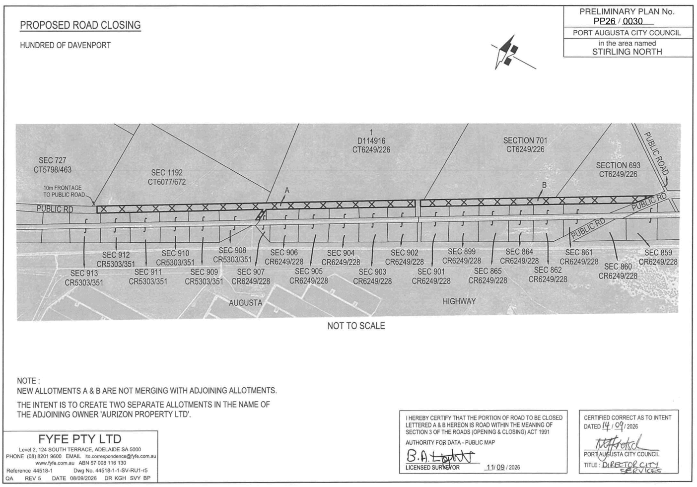

City of Salisbury
Disposal of Abandoned Vehicles
Notice is hereby given that in accordance with the powers contained in Section 237(2) of the Local Government Act 1999, or 40N of the Road Traffic Act 1961 Council has impounded the following vehicle(s):
• Mazda Station wagon Grey S688DBF towed from Salisbury Highway Mawson Lakes SA 5095.
Unless claimed by the owner(s), and all expenses paid, the vehicle(s) will be disposed of in the manner provided in the above Act, at the expiration of 1 month of the date of this notice.
For further information, please contact the Community Compliance Team on 8406 8222.
Dated: 15 October 2026
J. Harry
Chief Executive Officer

City of Victor Harbor
Local Government Act 1999
Notice of Naming of Reserve
The City of Victor Harbor hereby gives notice pursuant to Section 219(1) of the Local Government Act 1999, and in accordance with the Council’s resolution OC3242026 of 28 September 2026, that the unnamed reserve, at 30 Yalladoola Road, Victor Harbor SA 5211, comprising of CT6294/759 and CT6294/762 be named Marjorie Tripp Reserve.
A copy of this notice and further information can be obtained from the Council’s office at 1 Bay Road, Victor Harbor SA 5211, during ordinary business hours or on the Council’s website at www.victor.sa.gov.au
Dated: 15 October 2026
Karen Rokincinski
Acting Chief Executive Officer

Wattle Range Council
South Australia
Liquor Licensing (Dry Areas) Notice 2026
under Section 131(1ab) of the Liquor Licensing Act 1997
1—Short title
This notice may be cited as the Liquor Licensing (Dry Areas) Notice 2026.
2—Commencement
This notice comes into operation on 31 December 2026.
3—Interpretation
(1) In this notice—
principal notice means the Liquor Licensing (Dry Areas) Notice 2015 published in the Gazette on 5 January 2015, as in force from time to time.
(2) Clause 3 of the principal notice applies to this notice as if it were the principal notice.
4—Consumption etc. of liquor prohibited in dry areas
(1) Pursuant to Section 131 of the Act, the consumption and possession of liquor in the area described in the Schedule is prohibited in accordance with the provisions of the Schedule.
(2) The prohibition has effect during the periods specified in the Schedule.
(3) The prohibition does not extend to private land in the area described in the Schedule.
(4) Unless the contrary intention appears, the prohibition of the possession of liquor in the area does not extend to—
(a) a person who is genuinely passing through the area if—
(i) the liquor is in the original container in which it was purchased from licensed premises; and
(ii) the container has not been opened; or
(b) a person who has possession of the liquor in the course of carrying on a business or in the course of his or her employment by another person in the course of carrying on a business; or
(c) a person who is permanently or temporarily residing at premises within the area or on the boundary of the area and who enters the area solely for the purpose of passing through it to enter those premises or who enters the area from those premises for the purpose of leaving the area.
Schedule—Beachport Area 3
1—Extent of prohibition
The consumption of liquor is prohibited and the possession of liquor is prohibited.
2—Period of prohibition
From 12 noon on 31 December 2026 to 12 noon on 1 January 2027.
3—Description of area
The area in and adjacent to Beachport comprising the following roads and other areas—
(a) Beach Road between the property boundaries and low water marker, from the Lake George Outlet up to and including Glenn Point;
(b) The Beachport Jetty;
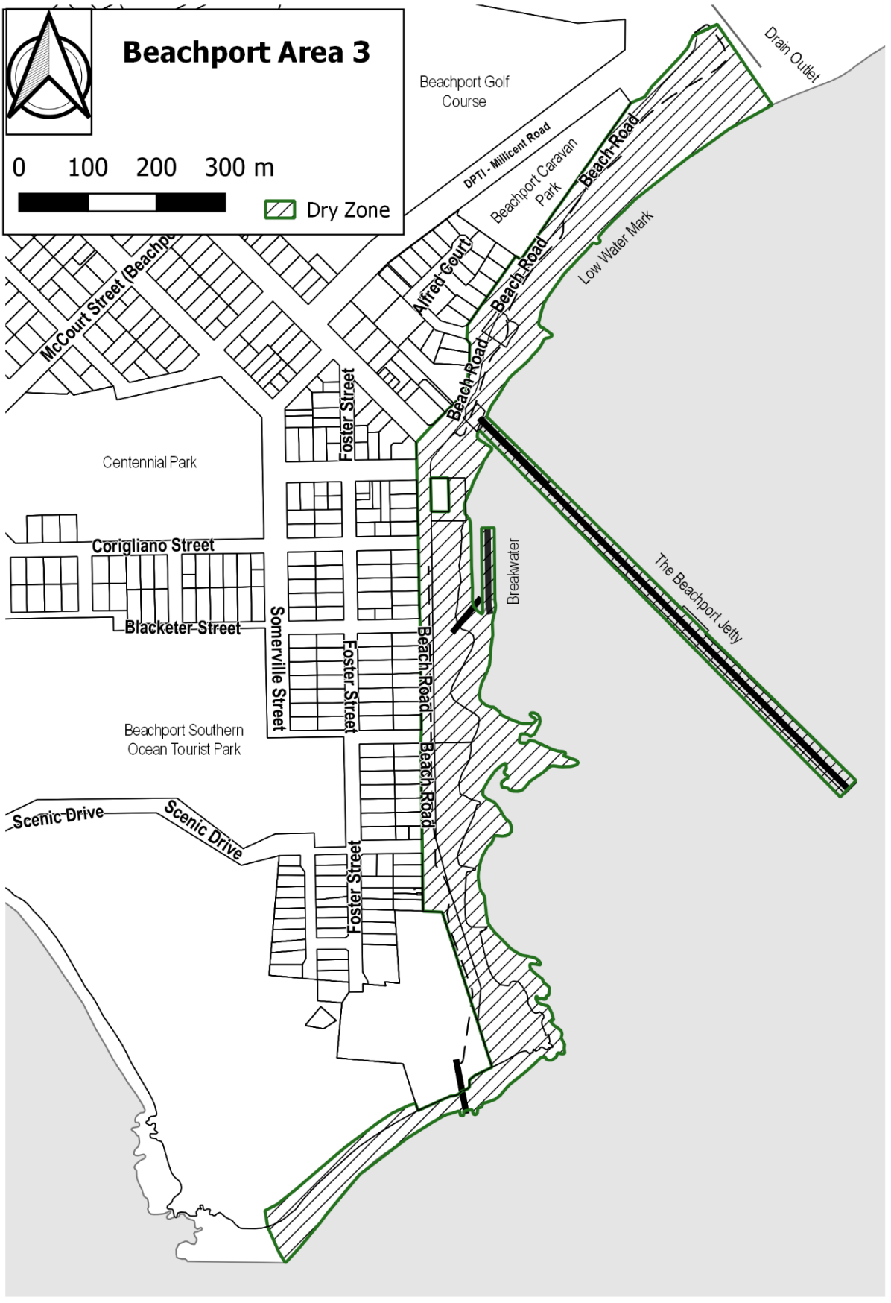
(c) All breakwaters/groins and Beachport Boat Ramp off Beach Road.

Dated: 12 October 2026
B. J. Gower
Chief Executive Officer

Yorke Peninsula Council
Roads (Opening and Closing) Act 1991
Re-advertised: Road Closing—Public Road, Wool Bay
Notice is hereby given, pursuant to Section 10 of the Roads (Opening and Closing) Act 1991 that the Yorke Peninsula Council proposes to make a Road Process Order to close and sell to the adjoining landowner the Unmade Public Road between the intersections of
Coringie Road and Green Flat Road adjoining Sections 128, 129, 142, 145, 148, 149 in the Hundred of Dalrymple, more particularly delineated and lettered ‘A’ and ‘B’ on Preliminary Plan 26/0009.
The Preliminary Plan is available for public inspection at the office of the Yorke Peninsula Council, 8 Elizabeth Street Maitland, and the Adelaide Office of the Surveyor-General located at Level 10, 83 Pirie Street, Adelaide, during normal office hours. The Preliminary Plan can also be viewed at www.sa.gov.au/roadsactproposals.
Any application for easement or objection must set out the full name, address and details of the submission and must be fully supported by reasons. The application for easement or objection must be made in writing to the Yorke Peninsula Council, PO Box 57, Maitland SA 5573 within 28 days of this notice and a copy must be forwarded to the Surveyor-General at GPO Box 1815, Adelaide 5001. Where a submission is made, the applicant must be prepared to support their submission in person upon council giving notification of a meeting at which the matter will be considered.
Dated: 15 October 2026
Andrew Cameron
Chief Executive Officer

Public Notices

National Electricity Law
Notice of Final Determination and Final Rule
The Australian Energy Market Commission (AEMC) gives notice under the National Electricity Law as follows:
Under ss 102, 102A and 103, the making of the National Electricity Amendment (Improving Compensation Frameworks) Rule 2026 No. 9 (Ref. ERC0425) and related final determination. Schedule 1 of the rule commences on 2 September 2027, Schedule 2 commences on 2 July 2028, Schedule 3 commences on 3 June 2029, and Schedule 4 commences on 29 October 2026.
Documents referred to above are available on the AEMC’s website and are available for inspection at the AEMC’s office.
Australian Energy Market Commission
Level 15, 60 Castlereagh St
Sydney NSW 2000
Telephone: (02) 8296 7800
www.aemc.gov.au
Dated: 15 October 2026

Trustee Act 1936
Public Trustee
Estates of Deceased Persons
In the matter of the estates of the undermentioned deceased persons:
ARBON David Francis late of 43 Franklin Street Adelaide Army Defence Force Officer who died 23 August 2025
BRANDER Ruth Anne late of 6 Pridham Boulevard Aldinga of no occupation who died 16 September 2025
BURGESS Thomas Maxwell late of 19781 Horrocks Highway Wongyarra Hobby Farmer who died 6 November 2025
CAMPBELL Janet Dawn late of 49 Vindana Road Paralowie Retired Public Servant who died 26 January 2026
CORSTON Roslyn Ann late of 18 Martini Street Exeter of no occupation who died 12 May 2026
DAVIDSON Jean late of 70 Stokes Terrace Port Augusta West of no occupation who died 7 July 2025
FREEMAN George Alexander late of 24 Buchanan Road Smithfield Plains Retired Nurse who died 28 August 2025
GELEWACZUK Elizabeth late of 1 Myzantha Street Lockleys of no occupation who died 21 May 2026
HIGGINS Andrew John late of 13A Ena Street Croydon Park Rigger who died 11 April 2026
JURKOWSKI Gwendoline Kate late of 1 Wilton Street Davoren Park Retired Office Administrator who died 7 April 2026
KNIBBS Barbara Colleen late of 393 Morphett Road Oaklands Park Retired Farm Hand who died 7 June 2025
LANGSFORD Raymond Dudley late of 151 The Terrace Port Pirie of no occupation who died 6 September 2025
MASGAL Peter John late of 6 James Street Cheltenham Butcher who died on or about 14 December 2025
MURPHY Michael Benedict late of 7 Broad Street Marden Retired Store Manager who died 1 May 2026
NICHOLSON Robert Angus late of 110 Strathfield Terrace Largs North of no occupation who died 10 November 2025
RAY Pinaki Sankar late of 32 Park Terrace Gilberton Retired Physicist who died 30 January 2026
SMALL Lesley late of 14 Frew Street Fullarton Retired Croupier who died 25 February 2026
SOLC Aaron Sean late of 1 Scott Avenue Clovelly Park Gardener who died 2 June 2026
TRIGG Marie Joan late of 19 Hay Terrace Kongorong of no occupation who died 21 March 2026
WONGA Jason Lee late of 127 Second Street Oodnadatta Station Hand who died 25 August 2025
Notice is hereby given pursuant to the Trustee Act 1936 (SA), the Succession Act 2023 (SA) and the Family Relationships Act 1975 (SA) that all creditors, beneficiaries, and other persons having claims against the said estates are required to send, in writing, to the office of Public Trustee at GPO Box 1338, Adelaide 5001, full particulars and proof of such claims, on or before the 13 November 2026 otherwise they will be excluded from the distribution of the said estate; and notice is also hereby given that all persons indebted to the said estates are required to pay the amount of their debts to the Public Trustee or proceedings will be taken for the recovery thereof; and all persons having any property belonging to the said estates are forthwith to deliver same to the Public Trustee.
Dated: 15 October 2026
T. Brumfield
Public Trustee

Notice Submission

The South Australian Government Gazette is published each Thursday afternoon.
Notices must be emailed by 4 p.m. Tuesday, the week of publication.
Submissions are formatted per the gazette style and a proof will be supplied prior to publication, along with a quote if applicable. Please allow one day for processing notices.
Alterations to the proof must be returned by 4 p.m. Wednesday.

Gazette notices must be submitted as Word files, in the following format:
• Title—the governing legislation
• Subtitle—a summary of the notice content
• Body—structured text, which can include numbered lists, tables, and images
• Date—day, month, and year of authorisation
• Signature block—name, role, and department/organisation authorising the notice

Please provide the following information in your email:
• Date of intended publication
• Contact details of the person responsible for the notice content
• Name and organisation to be charged for the publication—Local Council and Public notices only
• Purchase order, if required—Local Council and Public notices only

Email: governmentgazettesa@sa.gov.au
Phone: (08) 7133 3552
Website: www.governmentgazette.sa.gov.au

All instruments appearing in this gazette are to be considered official, and obeyed as such

Printed and published weekly by authority of T. Foresto, Government Printer, South Australia
$10.80 per issue (plus postage), $546.00 per annual subscription—GST inclusive
Online publications: www.governmentgazette.sa.gov.au

Remuneration Tribunal—Report Relating to Determination 17 of 2022.
Electoral district areas (km²) are derived from Electoral Commission of South Australia district profiles and are calculated by reference to the electoral district boundaries established by the 2024 Redistribution. Electoral Commission of South Australia, ‘Electoral District Profiles’, Electoral Commission of South Australia (Web Page) <https://www.ecsa.sa.gov.au/electoral-districts/electoral-district-profiles>; Electoral Districts Boundaries Commission (SA), Report of the Electoral Districts Boundaries Commission 2024 (Final Report, 12 December 2024).
Electoral Districts Boundaries Commission (SA), Report of the Electoral Districts Boundaries Commission 2024 (Final Report, 12 December 2024) Appendix 11. 4 Constitution Act 1934 (SA) s 77.

