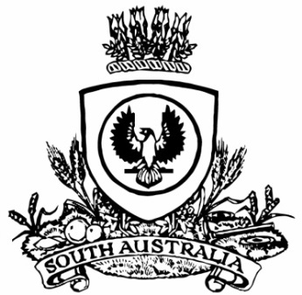
SUPPLEMENTARY GAZETTE
THE SOUTH AUSTRALIAN
GOVERNMENT GAZETTE
Published by Authority

Adelaide, Friday, 11 September 2026

Contents

State Government Instruments

South Australian Motor Sport Act 1984 3010

South Australian Motor Sport Regulations 2014 3012

State Government Instruments
SOUTH AUSTRALIAN MOTOR SPORT ACT 1984
Section 26
Availability of Plans for Public Inspection
Pursuant to Section 26 of the South Australian Motor Sport Act 1984, I, the Minister to whom powers and functions of that Act have been delegated, hereby designates the offices of the South Australian Motor Sport Board, Level 5, 182 Victoria Square Adelaide SA 5000, as the place at which may be inspected by members of the public plans of all works proposed to be carried out by the South Australian Motor Sport Board in relation to the event known as the ‘bp Adelaide Grand Final’.
Dated: 10 September 2026
Hon. Blair Ingram Boyer MP
Minister for Health and Wellbeing
Delegate for the Minister responsible for the South Australian Motor Sport Act 1984

South Australian Motor Sport Act 1984
Section 20(1)
Declaration of Area, Period and Prescribed Works Period
Pursuant to Section 20(1) of the South Australian Motor Sport Act 1984, I, the Minister to whom powers and functions of that Act have been delegated, in respect of the motor sport event promoted by the South Australian Motor Sport Board under the name ‘2026 bp Adelaide Grand Final’, after consultation with the Board, declare:
• that the area delineated on the plan in the Schedule will be the declared area under the Act for the purposes of the event;
• that the period commencing on 25 November 2026 and ending on 29 November 2026 (both days inclusive) will be the declared period under the Act for the purposes of the event; and
• that the prescribed works period in respect of works necessary for the purpose of staging the bp Adelaide Grand Final, be the period commencing on 11 September 2026 and concluding on 7 February 2027 inclusive.
Dated: 10 September 2026
Hon. Blair Ingram Boyer MP
Minister for Health and Wellbeing
Delegate for the Minister responsible for the South Australian Motor Sport Act 1984

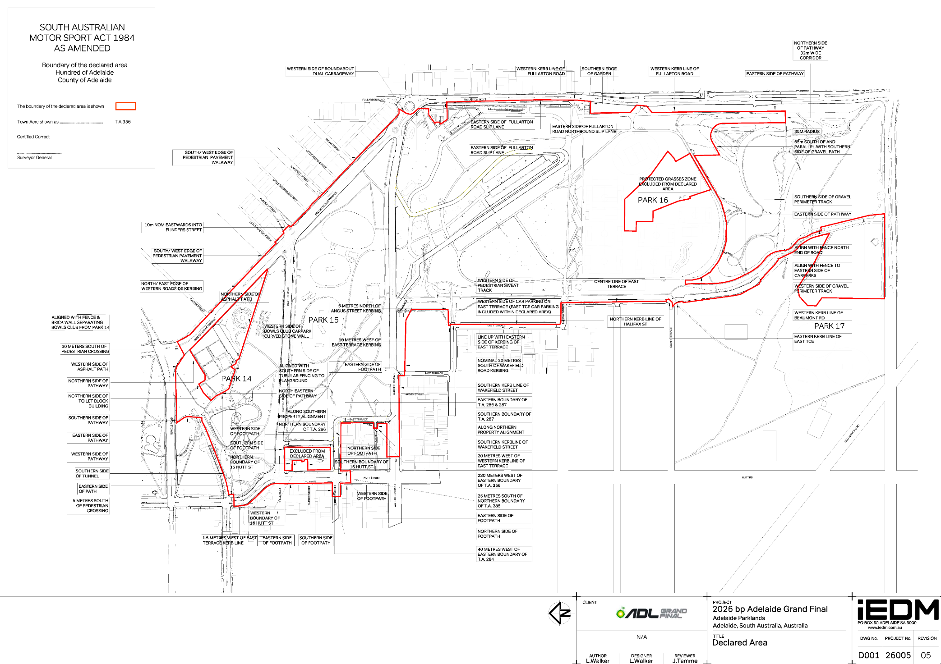
Schedule

South Australian Motor Sport Regulations 2014
Regulation 11
Conditions Imposed on Permits, Authorisations and Tickets—2026 bp Adelaide Grand Final
Pursuant to regulation 11 of the South Australian Motor Sport Regulations 2014 (SA), the Minister to whom powers and functions of the South Australian Motor Sport Act 1984 (SA) (Act) have been delegated hereby imposes the following conditions in respect of a permit, authorisation or ticket (collectively, Ticket) sold or granted by the SAMSB allowing entry to the motor sport event known as the bp Adelaide Grand Final (Event), in addition to any term stated or referred to in the Ticket. Every Ticket allowing entry to the Event is subject to:
(a) these conditions, as amended by the SAMSB from time to time (displayed at Event entrances and available at—https://adelaidegrandfinal.com.au);
(b) the Act and regulations made under the Act;
(c) any applicable law, regulation and government direction, including but not limited to emergency declarations and directions related to public health; and
(d) any reasonable direction issued by SAMSB, its employees, officers, agents, professional advisers, or any person appointed as an authorised person pursuant to Regulation 20 under the Act (Authorised Person), (collectively, Conditions). Any person who, at any time, holds, purchases or otherwise acquires a Ticket (Patron) to enter the Event accepts and understands as binding the Conditions and any accompanying risks, obligations and responsibilities. It is each Patron’s responsibility to inform themselves of all the Conditions.
1. Motor Sport Activities are inherently dangerous recreational activities and there is significant risk of injury, disability or death.
If you do not wish to be exposed to such risks, then you should not attend at or participate in Motor Sport Activities.
WARNING: If you participate in these activities your rights to sue the supplier under the Competition and Consumer Act 2010 if you are killed or injured because the activities were not supplied with due care and skill or were not reasonably fit for their purpose, are excluded, restricted or modified in the way set out in these Conditions.
In exchange for being able to attend or participate in the Motor Sport Activities, you agree:
• to release the SAMSB, the Crown in the right of South Australia, Motorsport Australia (MA) and the Entities* to the extent that any or all of them are providing Recreational Services from all liability for:
- your death;
- any physical or mental injury (including the aggravation, acceleration or recurrence of such an injury);
- the contraction, aggravation or acceleration of a disease including but not only COVID-19;
- the coming into existence, the aggravation, acceleration or recurrence of any other condition, circumstance, occurrence, activity, form of behaviour, course of conduct or state of affairs:
- that is or may be harmful or disadvantageous to you or the community; or
- that may result in harm or disadvantage to you or the community,
- any claim for any costs and expenses you may incur as a consequence of any of the above; howsoever arising from your participation in or attendance at the Motor Sport Activities;
• to indemnify and hold harmless and keep indemnified SAMSB, the Crown in the Right of South Australia, MA and each of the Entities to the maximum extent permitted by law in respect of any Claim by any person; and
• to attend at or participate in the Motor Sport Activities at your own risk.
NOTE: The change to your rights, as set out in these Conditions, does not apply if your death or injury is due to reckless conduct on the supplier's part. “Reckless Conduct” means conduct where the supplier of the recreational services is aware, or should reasonably have been aware, of a significant risk that the conduct could result in personal injury to another person and engages in the conduct despite the risk and without adequate justification. See Section 139A of the Competition and Consumer Act 2010.
* “Entities” means event and competition organisers/promoters/managers, land and track owners/managers/ administrators/lessees, Speedway Australia, Motorcycling Australia, MA affiliated clubs, state and territory governments and insured listed in MA public/product/professional indemnity insurance policies and each of their related bodies corporate (including their related bodies corporate) and each of their organisations and agencies, officers/president/directors/executives, employees, servants, agents, partners, providers, members, competitors, drivers, co-drivers, navigators, officials, crew members, pit crew, delegates, licence holders, representatives, commissions, committees, advisers, trustees, councils, panels, shareholders, volunteers, officials, appointees, delegated bodies and sponsors.
2. At the Event, Patrons must not:
(a) post, stick or place any poster, placard, bill, banner, print, paper or any advertising material on any building, structure, fence, ground space or tree;
(b) bring in or carry protest or offensive material into and around the event or display at or near the event
(c) wear or display on the Patron’s body any words, symbols or images that may be considered offensive to other Patrons, SAMSB or Entities;
(d) promote any advertising or promotional material, samples of goods or services or any other matter or thing or otherwise engage in ambush marketing;
(e) disrupt, interrupt or behave in any manner that may disrupt or interrupt any official or employee or contractor of the SAMSB, or any race, event or activity;
(f) act or conduct oneself in such a way as to hinder, obstruct or interfere with a driver of any vehicle taking part in a race or to adversely affect the safety of the public;
(g) deliberately obstruct the view of any Patron seated in a seat in the immediate vicinity, or cause unreasonable inconvenience to any Patron, official or employee or contractor of the SAMSB, or interfere with the comfort of any Patron or their enjoyment of the Event;
(h) use racist, indecent or obscene language or threatening or insulting words or otherwise behave in a threatening, abusive, riotous, indecent or insulting manner;
(i) interfere with, obstruct or hinder the SAMSB or an Authorised Person in the exercise of their powers, functions or duties;
(j) ignite any flare or firework, explosive or smoke bomb;
(k) become intoxicated, use banned drugs or supply alcohol to minors;
(l) smoke and/or vape anywhere other than in a designated ‘outdoor smoking’ area; or
(m) refuse to follow any reasonable direction issued by the SAMSB.
3. Patrons are prohibited from entry to or remaining on licensed premises that are:
(a) wearing clothing, jewellery or accessories which are associated with declared criminal organisations;
(b) displaying tattoos associated with a declared criminal organisation;
(c) identified by a Police Officer as being a member or associate of a declared criminal organisation. For the purpose of compliance, “reasonable steps” means:
(d) refusing subject person(s) entry to the licensed premises; or
(e) requesting subject person(s) to leave the licensed premises; or
(f) requesting Police attendance, in the event that personal safety or a reasonable fear of danger to personal safety is apparent.
4. Patrons must not have in their possession at the Event, or bring into the Event any:
(a) alcoholic beverage (unless purchased at the Event);
(b) glass bottle or glass container (unless purchased at the Event);
(c) beverage container with the manufacturer’s seal broken (unless purchased at the Event);
(d) hard cased esky or ice box (cooler bags acceptable);
(e) chair, lounge, bench or stool, other than a folding chair or folding stool;
(f) clothing bearing any racist, indecent or obscene language or images, patch, insignia or logo (Colours);
(g) skateboards, rollerblades, bicycles or scooters including e-scooters
(h) prohibited or controlled weapon, firearm, or any dangerous goods;
(i) animal, other than an assistance animal;
(j) flare, firework, laser pointer, drone, RPAS—Remote Piloted Aircraft System, AUV—Unmanned Aircraft Vehicles and
UAD—Unmanned Aircraft Devices or distress signal; or
(k) item the possession of which does not have an ordinary and reasonable use by a Patron at the Event and which may be used to damage or deface property, buildings or any part of the area used for the Event (including without limitation any spray paint), disrupt or interrupt the Event, hinder, obstruct or interfere with any driver taking part in the Event, adversely affect public safety, excavate any part of the area used for the Event or erect any structure.
5. The SAMSB may, at any time, require a Patron to open for inspection any vehicle, bag, basket or other receptacle, or turn out their pockets. Patrons who fail to comply with such a request may be refused entry or directed to leave the Event.
6. The SAMSB may direct any Patron at any time at the Event to produce a valid Ticket.
7. At all times, Tickets remain the property of the SAMSB.
8. The SAMSB may set aside:
(a) certain areas as reserved areas;
(b) certain blocks of seats as reserved blocks of seats; and
(c) certain seats as reserved seats.
A person who is not the holder of a Ticket conferring an entitlement to:
(a) enter and remain in a reserved area; or
(b) occupy a seat in a reserved block of seats; or
(c) occupy a reserved seat, must not enter or remain in that area or occupy that seat.
9. Each Patron must keep his or her Ticket safe and in good condition, as the SAMSB is not obliged to replace any Ticket under any circumstances, including but not limited to loss or theft—however the SAMSB may, in its sole and absolute discretion, replace a Ticket which has been lost or stolen (and may charge a fee for that replacement).
10. Each Patron’s entry to the Event is not transferable. If a Patron is exiting the Event and seeks re-entry, the Patron must have scanned their valid Ticket for that day upon exiting to allow for said Ticket to be rescanned to regain entry on the same day.
11. Patrons holding a concession ticket must provide identification confirming concession status at the time of entry.
12. Unless otherwise authorised by the SAMSB, every child entering the Event must be accompanied by an adult Patron (18 years of age or over) at all times during attendance at the Event. The SAMSB or its representatives may require evidence of the child Patron’s age or make a reasonable assessment of the Patron’s age in which case SAMSB’s, or its representative’s assessment will be final and determinative. If the SAMSB (or its representative) assesses any child Patron to be older than the age applicable to the policy applicable to child entry, the SAMSB may:
(a) refuse entry or direct the Patron to leave the Event without refund; or
(b) direct the person to purchase a Ticket that is available to persons of that age. Patrons who accompany children at the Event are responsible for the care, conduct and supervision of those children and must keep those children within sight at all times. Children may not be permitted to enter certain areas at the Event as determined or advised by the SAMSB in its absolute discretion.
13. The SAMSB reserves the right to add, withdraw or substitute any drivers, performers, activations, or activities including any concerts or other entertainment associated with the Event, vary programs, other conveniences and attractions and audience capacity from time to time.
14. The SAMSB will not be liable to any Patron for any loss or damage (including indirect or consequential loss or damage) suffered as a result of or arising from or in any way connected to cancellation, postponement or change to the Event (or any part of the Event).
15. The SAMSB will not be liable to any Patron for any loss or damage (including indirect or consequential loss or damage) to personal possessions. Patrons choosing to leave valuables unattended on the premises at the event, do so at their own risk.
16. The SAMSB will refund payments made by Patrons to the SAMSB for Tickets only if the entire Event is cancelled and cannot be rescheduled.

17. Patrons must not, without the written approval of the SAMSB:
(a) broadcast, telecast or transmit by any means whatsoever any sound or moving image of the Event or any part of the Event; or
(b) make any sound recording or any visual record or moving images of the Event or any part of the Event for profit or gain, from within or outside the Event area.
18. Patrons acknowledge that the SAMSB and third parties authorised by the SAMSB may make, create, store, record, transmit, reproduce or use recordings and images or any likenesses at or in relation to the Event (including, without limitation, of Patrons). Each Patron grants the SAMSB, and third parties authorised by it, permission to use any recordings, images or likenesses of the Patron in any media world-wide and for any purpose without identification, compensation or payment of any kind.
19. The SAMSB, its representatives, including any Authorised Person, may refuse entry to any Patron or direct any Patron to leave the Event. Any person who does not comply with the Conditions may be refused entry or directed to leave the Event.
20. Patrons acknowledge and agree that any part or parts of these Conditions that is illegal or unenforceable may be severed from these Conditions and the remaining part or parts of the Conditions continue in force.
21. A person who contravenes or fails to comply with these Conditions is subject to a maximum penalty of $1,250.
22. These Conditions are governed by, and are to be construed in accordance with, the law of the state of South Australia.
Dated: 10 September 2026
Hon. Blair Ingram Boyer MP
Minister for Health and Wellbeing
Delegate for the Minister responsible for the South Australian Motor Sport Act 1984

All instruments appearing in this gazette are to be considered official, and obeyed as such

Printed and published weekly by authority of T. Foresto, Government Printer, South Australia
$10.80 per issue (plus postage), $546.00 per annual subscription—GST inclusive
Online publications: www.governmentgazette.sa.gov.au

