
No. 54 p. 3015
THE SOUTH AUSTRALIAN
GOVERNMENT GAZETTE
Published by Authority

Adelaide, Thursday, 17 September 2026

Contents

Governor’s Instruments
Appointments, Resignations and General Matters 3016
Regulations—
Planning, Development and Infrastructure (General)
(Section 8 of Act) Amendment
Regulations 2026—No. 80 of 2026 3017
Criminal Law (Forensic Procedures) (Qualified Persons)
Amendment Regulations 2026—No. 81 of 2026 3019
Controlled Substances (Poisons) (Drugs of Dependence)
Amendment Regulations 2026—No. 82 of 2026 3020
State Government Instruments
Building Work Contractors Act 1995 3022
Education and Children’s Services Regulations 2020 3023
Employment Agents Registration Act 1993 3024
Fisheries Management Act 2007 3025
Housing Improvement Act 2016 3025
Hydrogen and Renewable Energy Act 2023 3026
Mental Health Act 2009 3027
Motor Vehicles Act 1959 3027
Radiation Protection and Control Act 2021 3044
South Australian Skills Act 2008 3045
Uniform Civil Rules 2020 (SA) 3045
Local Government Instruments
City of Playford 3046
City of Salisbury 3046
District Council of Kimba 3046
Eyre Peninsula Local Government Association 3047
Public Notices
Trustee Act 1936 3052

Governor’s Instruments

Appointments, Resignations and General Matters
Department of the Premier and Cabinet
Adelaide, 17 September 2026
Her Excellency the Governor in Executive Council has been pleased to appoint the undermentioned to the Adelaide Festival Centre Trust, pursuant to the provisions of the Adelaide Festival Centre Trust Act 1971:
Member: from 17 September 2026 until 30 June 2027 or upon him ceasing to be a member of the City of Adelaide local council, whichever is the earlier
Phillip Robert Martin
Member: from 17 September 2026 until 16 September 2029
Penelope Zoe Griggs
Member: from 7 December 2026 until 6 December 2029
Yasmeen Shahin
By command,
Anastasios Koutsantonis, MP
For Premier
ART0013-26CS

Department of the Premier and Cabinet
Adelaide, 17 September 2026
Her Excellency the Governor in Executive Council has been pleased to appoint the undermentioned to the Architectural Practice Board of South Australia, pursuant to the provisions of the Architectural Practice Act 2009:
Member: from 5 October 2026 until 22 April 2029
Dario Salvatore
By command,
Anastasios Koutsantonis, MP
For Premier
26MPCS11546

Department of the Premier and Cabinet
Adelaide, 17 September 2026
Her Excellency the Governor in Executive Council has been pleased to appoint the Honourable Christopher James Picton, MP as Acting Minister for Education, Training and Skills, Acting Minister for Autism and Acting Minister for the City of Adelaide from 20 September 2026 until 27 September 2026 inclusive, during the absence of the Honourable Lucy Penelope Hood, MP.
By command,
Anastasios Koutsantonis, MP
For Premier
26CABME029

Department of the Premier and Cabinet
Adelaide, 17 September 2026
Her Excellency the Governor in Executive Council has been pleased to appoint Mary Elizabeth Chalmers as the Director of Public Prosecutions for a term of seven years commencing on 17 September 2026 and expiring on 16 September 2033 - pursuant to the provisions of the Director of Public Prosecutions Act 1991.
By command,
Anastasios Koutsantonis, MP
For Premier
AGO0057-26CS

Department of the Premier and Cabinet
Adelaide, 17 September 2026
Her Excellency the Governor in Executive Council has approved the resignation of Justice Judith Hughes as the President of the South Australian Civil and Administrative Tribunal, with her last day in office being 30 October 2026, pursuant to the provisions of the South Australian Civil and Administrative Tribunal Act 2013.
By command,
Anastasios Koutsantonis, MP
For Premier
AGO0058-26CS

Regulations
South Australia

Planning, Development and Infrastructure (General) (Section 8 of Act) Amendment Regulations 2026
under the Planning, Development and Infrastructure Act 2016

Contents
Part 1—Preliminary
1 Short title
2 Commencement
Part 2—Amendment of Planning, Development and Infrastructure (General) Regulations 2017
3 Amendment of regulation 3A—Application of Act (section 8)

Part 1—Preliminary
1—Short title
These regulations may be cited as the Planning, Development and Infrastructure (General) (Section 8 of Act) Amendment Regulations 2026.
2—Commencement
These regulations come into operation on the day on which they are made.

Part 2—Amendment of Planning, Development and Infrastructure (General) Regulations 2017
3—Amendment of regulation 3A—Application of Act (section 8)
Regulation 3A—after regulation (4) insert:
(4a) Pursuant to section 8(2)(b) of the Act, section 74 of the Act applies with the following prescribed variation:
Section 74(6)—delete subsection (6) and substitute:
(6) Subject to subsection (7)—
(a) unless paragraph (b) applies, if the period of 28 days referred to in subsection (5) would, but for this subsection, expire in a particular case between 15 December in 1 year and 15 January in the next year (both days inclusive), the period applying for the purposes of subsection (5) will be extended on the basis that any days falling on or between those 2 dates will not be taken into account for the purposes of calculating the period that applies under subsection (5); or
(b) if the day on which a designated instrument was referred to the ERD Committee falls between 15 December in 1 year and 15 January in the next year (both days inclusive), the period of 28 days referred to in subsection (5) will be taken to commence on 16 January in that next year.
Editorial note—
As required by section 10AA(2) of the Legislative Instruments Act 1978, the Minister has certified that, in the Minister's opinion, it is necessary or appropriate that these regulations come into operation as set out in these regulations.
Made by the Governor
with the advice and consent of the Executive Council
on 17 September 2026
No 80 of 2026

South Australia

Criminal Law (Forensic Procedures) (Qualified Persons) Amendment Regulations 2026
under the Criminal Law (Forensic Procedures) Act 2007

Contents
Part 1—Preliminary
1 Short title
2 Commencement
Part 2—Amendment of Criminal Law (Forensic Procedures) Regulations 2022
3 Amendment of regulation 8—Persons qualified to carry out forensic procedures (sections 24 and 55 of Act)

Part 1—Preliminary
1—Short title
These regulations may be cited as the Criminal Law (Forensic Procedures) (Qualified Persons) Amendment Regulations 2026.
2—Commencement
These regulations come into operation on the day on which they are made.
Part 2—Amendment of Criminal Law (Forensic Procedures) Regulations 2022
3—Amendment of regulation 8—Persons qualified to carry out forensic procedures (sections 24 and 55 of Act)
Regulation 8(1)(a)—after "nurse" insert:
or a midwife
Editorial note—
As required by section 10AA(2) of the Legislative Instruments Act 1978, the Minister has certified that, in the Minister's opinion, it is necessary or appropriate that these regulations come into operation as set out in these regulations.
Made by the Governor
with the advice and consent of the Executive Council
on 17 September 2026
No 81 of 2026

South Australia

Controlled Substances (Poisons) (Drugs of Dependence) Amendment Regulations 2026
under the Controlled Substances Act 1984

Contents
Part 1—Preliminary
1 Short title
2 Commencement
Part 2—Amendment of Controlled Substances (Poisons) Regulations 2026
3 Amendment of regulation 23—Exemptions from section 18A of Act

Part 1—Preliminary
1—Short title
These regulations may be cited as the Controlled Substances (Poisons) (Drugs of Dependence) Amendment Regulations 2026.
2—Commencement
These regulations come into operation on the day on which they are made.
Part 2—Amendment of Controlled Substances (Poisons) Regulations 2026
3—Amendment of regulation 23—Exemptions from section 18A of Act
(1) Regulation 23—after subregulation (2) insert:
(2a) A registered health practitioner authorised to prescribe or supply a drug of dependence to which this subregulation applies is exempt from section 18A(1)(a) of the Act in relation to the prescription or supply of such a drug to a person, regardless of whether or not a section 18A authority exists in respect of the person, if the drug is prescribed or supplied (as the case may be) in accordance with the Monitored Drugs Prescribing Code.
(2b) Subregulation (2a) applies to the following drugs of dependence:
(a) Dexamfetamine;
(b) Lisdexamfetamine;
(c) Methylphenidate.

(2) Regulation 23(3)—before the definition of section 18A authority insert:
Monitored Drugs Prescribing Code means the document of that name published by the Department (whether before or after the commencement of subregulation (2a)), as in force from time to time;
Editorial note—
As required by section 10AA(2) of the Legislative Instruments Act 1978, the Minister has certified that, in the Minister's opinion, it is necessary or appropriate that these regulations come into operation as set out in these regulations.
Made by the Governor
after consultation by the Minister with the Controlled Substances Advisory Council and with the advice and consent of the Executive Council
on 17 September 2026
No 82 of 2026

State Government Instruments

Building Work Contractors Act 1995
Exemption
Take notice that, pursuant to Section 45 of the Building Work Contractors Act 1995, I, Brett Humphrey as a delegate for the Minister for Consumer and Business Affairs, do hereby exempt the licensee named in Schedule 1 from the application of Division 3 of Part 5 of the above Act in relation to domestic building work described in Schedule 2 and subject to the conditions specified in Schedule 3.
Schedule 1
DANIEL RAYMOND COCKER (BLD 301290)
Schedule 2
Additions to an existing dwelling and construction of a detached garage at Allotment 290 Filed Plan 166664, being a portion of the land described in Certificate of Title Volume 5322 Folio 61, more commonly known as 23 Farquhar Street, Goolwa SA 5214.
Schedule 3
1. This exemption is limited to domestic building work personally performed by the licensee in relation to the building work described in Schedule 2.
2. This exemption does not apply to any domestic building work the licensee contracts to another building work contractor, for which that contractor is required by law to hold building indemnity insurance.
3. That the licensee does not transfer his interest in the land prior to five years from the date of completion of the building work the subject of this exemption, without the prior authorisation of Consumer and Business Services (CBS). Before giving such authorisation, CBS may require the licensee to take any reasonable steps to protect the future purchaser(s) of the property, including but not limited to:
• Providing evidence that an adequate policy of building indemnity insurance is in force to cover the balance of the five-year period from the date of completion of the building work the subject of this exemption;
• Providing evidence of an independent expert inspection of the building work the subject of this exemption;
• Making an independent expert report available to prospective purchasers of the property;
• Giving prospective purchasers of the property notice of the absence of a policy of building indemnity insurance.
Dated: 14 September 2026
Brett Humphrey
Commissioner for Consumer Affairs
Delegate for the Minister for Consumer and Business Affairs

Building Work Contractors Act 1995
Exemption
Take notice that, pursuant to Section 45 of the Building Work Contractors Act 1995, I, Brett Humphrey as a delegate for the Minister for Consumer and Business Affairs, do hereby exempt the licensee named in Schedule 1 from the application of Division 3 of Part 5 of the above Act in relation to domestic building work described in Schedule 2 and subject to the conditions specified in Schedule 3.
Schedule 1
KYLE FRANCIS SMITH (BLD 168672)
Schedule 2
Additions to an existing dwelling at Allotment 65 Deposited Plan 3087, being a portion of the land described in Certificate of Title Volume 5411 Folio 865, more commonly known as 22 Taunton Parade, Christies Beach SA 5165.
Schedule 3
1. This exemption is limited to domestic building work personally performed by the licensee in relation to the building work described in Schedule 2.
2. This exemption does not apply to any domestic building work the licensee contracts to another building work contractor, for which that contractor is required by law to hold building indemnity insurance.
3. That the licensee does not transfer his interest in the land prior to five years from the date of completion of the building work the subject of this exemption, without the prior authorisation of Consumer and Business Services (CBS). Before giving such authorisation, CBS may require the licensee to take any reasonable steps to protect the future purchaser(s) of the property, including but not limited to:
• Providing evidence that an adequate policy of building indemnity insurance is in force to cover the balance of the five-year period from the date of completion of the building work the subject of this exemption;
• Providing evidence of an independent expert inspection of the building work the subject of this exemption;
• Making an independent expert report available to prospective purchasers of the property;
• Giving prospective purchasers of the property notice of the absence of a policy of building indemnity insurance.
Dated: 15 September 2026
Brett Humphrey
Commissioner for Consumer Affairs
Delegate for the Minister for Consumer and Business Affairs

Education and Children’s Services Regulations 2020
Notice of Revocation of Policy by the Minister for Education, Training and Skills
Pursuant to Regulation 12(3) of the Education and Children’s Services Regulations 2020, I, the Minister for Education, Training and Skills revoke the Morialta Secondary College Capacity Management Plan, published in the Gazette on 29 May 2025.
Dated: 24 August 2026
Lucy Hood
Minister for Education, Training and Skills

Education and Children’s Services Regulations 2020
Notice of Policy by the Minister for Education, Training and Skills
Pursuant to Regulation 12(1) of the Education and Children’s Services Regulations 2020, I, the Minister for Education, Training and Skills publish the following Capacity Management Plan in relation to the enrolment of a child of compulsory school age at Morialta Secondary College:
Capacity Management Plan
Morialta Secondary College
This Capacity Management Plan sets out the conditions for enrolment at Morialta Secondary College (“the school”) effective for the enrolment of a child to attend in 2027.
Morialta Secondary College Zone
A school zone is a defined area from which the school accepts its core intake of students. Morialta Secondary College operates a school zone, which is reflected within the Notice of Policy by the Minister for Education, Training and Skills published in the Government Gazette on 6 January 2022.
An online map of the Morialta Secondary College zone and a search tool to indicate if an applicant’s home address is within the school zone is available at: https://www.education.sa.gov.au/findaschool.
Student Enrolment Numbers
As a new school, Morialta Secondary College will have a progressive enrolment process. This process will introduce a new Year 7 cohort at the start of each school year, beginning in 2023 until the school has all year levels in 2028. In 2027, Morialta Secondary College will have offerings of Year 7—Year 11.
Year 7
The student enrolment ceiling for Year 7 is limited to 200, unless there are more applications that have met the enrolment criteria below.
Inclusive Learning Community
The Inclusive Learning Community at Morialta Secondary College includes special options classes providing facilities for students requiring adjustments to engage and learn alongside their similar aged peers. The inclusive learning community can enrol up to a maximum of 24 students within the school’s special options classes.
Placement into the inclusive learning community is determined through the department’s state-wide Special Education Options panel process and must align with the school’s progressive enrolment process, which includes year 7—year 11 enrolments in 2027.
International Education Program
No International Education Program places will be offered at the school.
Enrolment Criteria—by Year Level
Year 7—Applications through the Statewide Transition Process
Applications for enrolment from parents of prospective Year 7 students require that the student must be enrolled in a government or non-government school in South Australia at the time the parents apply for enrolment through the state-wide registration of interest process.
The applicant must meet one of the following requirements to be eligible for a Year 7 allocation through the state-wide registration of interest process for the coming school year:
• The child is living in the Morialta Secondary College zone.
• The child identifies as Aboriginal and/or Torres Strait Islander and has registered through the Enter for Success strategy (by the end of term 4).
• The child has been granted enrolment due to special or extenuating circumstances, including but not limited to a child in care where there is a custody or guardianship order made under the Children and Young People (Safety) Act 2017.
Year 7—Students Living Outside the School Zone with Siblings Currently at the School
There is no automatic entry to the school for Year 7 students who live outside the school’s zone and have siblings who currently attend the school, however they will be considered for enrolment if places are available.
Year 7—Late Applications Prior to Commencing Secondary School
Applications for enrolment from parents of prospective year 7 students who move into, or who are already living in the school zone that are lodged after the department’s registration of interest process is completed (end of term 2), will have their applications considered if or when vacancies exist. Priority consideration will be afforded to those applicants already on the school’s enrolment register.
If no vacancies exist, the school will assist the family to enrol at a neighbouring school and, upon request, the applicant will be placed on the school’s enrolment register for consideration for enrolment at a future time.
Year 7 to 11—Students who have already Commenced Secondary School
Applications for enrolment from parents of prospective students who have already commenced secondary school and are living in the school zone will be considered if or when vacancies exist.
If no vacancies exist the applicant will be encouraged to remain at their current secondary school (if applicable), or the school will support the family to enrol at a neighbouring school. Upon request, the applicant will be placed on the school’s enrolment register for consideration pending future enrolment vacancies.
Year 12—Students who have already Commenced Secondary School
Applications for enrolment in year 12 will not be accepted for 2027.
The applicant will be encouraged to remain at their current secondary school (if applicable), or the school will support the family to enrol at a neighbouring school.
Out of Zone Applications with Siblings Currently at the School
There is no automatic entry to the school for any year level for students who live outside of the school’s zone and have siblings who currently attend the school. If there are places available after all students who meet the above enrolment criteria have been accommodated, out of zone siblings will be considered for enrolment.
Enrolment Criteria—General
Special Circumstances
Enrolment applications for consideration based on special or extenuating circumstances, including but not limited to a child in care where there is custody or guardianship orders made under the Children and Young People (Safety) Act 2017, may be granted by the Principal in consultation with the Education Director.
These applications will be assessed on a case-by-case basis.
Enrolment Process
Enrolment Register
If vacancies have become available for the following year, the school will contact parents whose child’s name has been placed on the enrolment register from term 3 to offer a place for the following year. All enrolments from the enrolment register will be completed by the end of week 3, term 4 for the following year.
Students on the register must be ranked in order, based on the following criteria prior to offering places:
• the child currently has a sibling attending the school
• the distance of the child’s primary place of residence from the school
• curriculum focus (excluding special interest programs)
• transportation/location convenience
• social/family links.
The enrolment register will be reviewed and updated annually by the school.
The position that a child’s name appears on the register is confidential and will only be disclosed as required by law.
Monitoring and Enforcement
It is the parent’s responsibility when applying for enrolment to verify, to the satisfaction of the school’s Principal, that the information provided is true and factual.
If a child was enrolled at the school based on false or misleading information (including residential address), the Chief Executive may direct that the child be instead enrolled at another Government school pursuant to Section 63(1) of the Education and Children’s Services Act 2019.
The Principal is responsible for the implementation of this Capacity Management Plan and all decisions on enrolments.
This Capacity Management Plan will be reviewed annually.
Dated: 24 August 2026
Lucy Hood
Minister for Education, Training and Skills

Employment Agents Registration Act 1993
Exemption
Notice is hereby given that, pursuant to Section 4(1) of the Employment Agents Registration Act 1993, I, Kyam Maher MLC, Deputy Premier, Minister for Industrial Relations, hereby exempt uPaged Pty Ltd of New South Wales (85 William Street, Darlinghurst, NSW 2010) from:
• Section 7(3) of the Employment Agents Registration Act 1993 (SA) in relation to the requirement that, in making an application for a licence, the applicant must furnish the name of a natural person, who is a resident of the State and is to act as manager of the business;
• Section 11(1) of the Employment Agents Registration Act 1993 (SA) in relation to the requirement that the business conducted in pursuance of the licence must be managed under the personal supervision of a natural person who is a resident of the State;
• Section 16(1) of the Employment Agents Registration Act 1993 (SA) in relation to the requirement that the holder of a licence must not carry on the business of an employment agent except at premises registered under this section;
• Section 17 of the Employment Agents Registration Act 1993 (SA) in relation to the requirement that a person carrying on business as an employment agent in pursuance of a licence must maintain in a conspicuous position at any registered premise a notice clearly displaying the name of the agent as it appears in the licence or a registered business name in which the agent carries on business as an agent and if a manager has been appointed, the name of the manager of the business; and
• Section 19(1) of the Employment Agents Registration Act 1993 (SA) in relation to the requirement to display a notice clearly showing the scale of fees for the time being chargeable by the agent in respect of his or her business at the registered premises; and
• Section 22(3) of the Employment Agents Registration Act 1993 (SA) in relation to the requirement for records, accounts and documents to be kept at registered premises for the period of one year.
Dated: 10 September 2026
Kyam Maher
Deputy Premier
Minister for Industrial Relations

Fisheries Management Act 2007
Section 115
Ministerial Exemption: ME9903428
Take notice that pursuant to Section 115 of the Fisheries Management Act 2007, I Professor Gavin Begg, as delegate for the Minister of Primary Industries and Regional Development, hereby exempt Dr Dion Iervasi of Austral Research and Consulting, 23 Buntings Road Kirkstall, Victoria 3283 (the ‘exemption holder’) and his nominated agents, from Section 70 and 71(2) of the Fisheries Management Act 2007 and Regulation 5 and Clauses 42, 74 and 95 of Schedule 6 and ‘other waters’ as defined in Schedule 7 of the Fisheries Management (General) Regulations 2017 but only insofar as the exemption holder may engage in European Carp (Cyrpinus carpio) removal and native species monitoring from waters specified in Schedule 1 using the gear specified in Schedule 2 subject to the conditions set out in Schedule 3, from
15 September 2026 until 14 September 2027, unless varied or revoked earlier.
Schedule 1
• Valley Lake, Mt Gambier (Carp removal only)
• Nangwarry Swamp, Nangwarry; being located on land parcel CT6311-164 (Hundred of Nangwarry) (Carp removal and native species monitoring)
Schedule 2
• 1 x Grassl boat mounted Electrofishing device
• 4 x backpack Electrofishing devices (Smith-Root 7.5, Smith-Root APEX, Smith-Root LR24 and eFish 500W)
• 12 x Fyke nets being any combination of 900mm fyke nets with 8m double wings and 20mm mesh or 600mm fyke nets with single 6m wings or 600mm fyke nets with single wings, incorporating 20mm mesh reducing through to 2mm and 4mm mesh
Schedule 3
1. The exemption holder will be deemed responsible for the conduct of all persons conducting the exempted activities under this notice. Any person conducting activities under this exemption must be provided a copy of this notice, which they must have signed as an indication that they have read and understand the conditions under it.
2. Any native fish species captured incidentally while undertaking the exempted activity must be returned to the water as soon as practicable.
3. All noxious fish taken under this exemption must be humanely destroyed immediately and cannot be sold or used for any commercial purpose and must be disposed of appropriately at an approved waste facility.
4. Each fyke net must be deployed with at least one float >10cm diameter in the cod end (final chamber).
5. All fyke nets left unattended must be clearly marked with name and Ministerial exemption number on a tag if set close to shore or on a 2L buoy if set away from shore.
6. All fyke nets that are set overnight must be checked and cleared the following morning and any non-target aquatic species captured (other than noxious species) must be released as soon as practicable.
7. The following persons are authorised to act as agents under this Ministerial exemption (ME9903428):
• | Jackson Lamin | 23 Buntings Road, Kirkstall, VIC 3283
• | Braeden Lampard | 332 Belar Avenue, Irymple, VIC 3498
8. The exemption holder and their nominated agents must operate electrofishing devices listed under this exemption in accordance with the Australian Code of Electrofishing Practice 1997, to the extent that it relates to the exempted activity.
9. Before undertaking the exemption activity, the exemption holder or a person acting as his agent must contact PIRSA FISHWATCH on 1800 065 522 and answer a series of questions about the exemption activity. The exemption holder or nominated agent will need to have a copy of the exemption at the time of making the call and be able to provide information about the area and time of the exempted activity, the vehicles and/or boats involved, the number of agents undertaking the exemption activity and other related questions.
10. While engaging in the exempted activity, the exemption holder or their nominated agents must be in possession of a copy of this notice. Such notice must be produced to a Fisheries Officer upon request.
11. The exemption holder or agents must not contravene or fail to comply with the Fisheries Management Act 2007 or any regulations made under that Act, except where specifically exempted by this notice.
This notice does not purport to override the provisions or operation of any other Act.
Dated: 14 September 2026
Professor Gavin Begg
Executive Director
Fisheries and Aquaculture
Delegate of the Minister for Primary Industries and Regional Development

Housing Improvement Act 2016
Rent Control
In the exercise of the powers conferred by the Housing Improvement Act 2016, the Delegate of the Minister for Housing and Urban Development hereby fixes the maximum rental amount per week that shall be payable subject to Section 55 of the Residential Tenancies Act 1995, in respect of each premises described in the following table. The amount shown in the said table shall come into force on the date of this publication in the Gazette.
Address of Premises |  | Allotment Section | Certificate of Title  Volume/Folio | Maximum Rental per week payable
Unit 707 15 Fourth Street, Bowden SA 5007 |  | Allotment 707 Secondary Community  Strata Plan 42621 Hundred of Yatala | CT6262/766 | $0.00
43 Amber Road, Highbury SA 5089 |  | Allotment 11 Deposited Plan 6759  Hundred of Yatala | CT5627/331 | $0.00
Unit 9/466 Pulteney Street, Adelaide SA 5000 |  | Lot 9 Primary Community Strata Plan  22335 Hundred of Adelaide | CT5952/104 | $325.00
387 Tarcoola Street, Renmark West SA 5341 |  | Allotment 52 Deposited Plan 49186  Hundred of Renmark Irrigation District | CT5565/346 | $0.00
Dated: 17 September 2026
Craig Thompson
Registrar, Housing Regulation
Housing Safety Authority
Delegate of the Minister for Housing and Urban Development

HOUSING IMPROVEMENT ACT 2016
Rent Control Revocations
In the exercise of the powers conferred by the Housing Improvement Act 2016, the Delegate of the Minister for Housing and Urban Development hereby revokes the maximum rental amount per week that shall be payable subject to Section 55 of the Residential Tenancies Act 1995, in respect of each premises described in the following table.
Address of Premises | Allotment Section | Certificate of Title  Volume/Folio
22 Wecoma Street, Holden Hill SA 5088 | Allotment 191 Deposited Plan 6985 Hundred of Yatala | CT5099/17
85 Charles Street, Prospect SA 5082 | Allotment 127 Deposited Plan 991 Hundred of Yatala | CT5699/551
45 Barry Street, Risdon Park South SA 5540 | Allotment 34 Deposited Plan 47883 Hundred of Pirie | CT5485/251
Dated: 17 September 2026
David Osborne
Manager
Housing Safety Authority
Delegate of the Minister for Housing and Urban Development

Hydrogen and Renewable Energy Act 2023
Grant of Associated Infrastructure Licence—AIL 16
Notice is hereby given that the undermentioned Associated Infrastructure Licence has been granted with effect from 14 September 2026, under the provisions of the Hydrogen and Renewable Energy Act 2023, pursuant to delegated powers.
Licence number | Licensees | Locality | Area in km² | Reference
AIL 16 | NTBESS ProjectCo Pty Ltd as trustee for the NTBESS Project Trust | Port Augusta | 0.08 | F2025/002859
Description of Area
All that part of the State of South Australia, bounded as follows:
All coordinates in GDA2020, Zone 53
763953.59mE 6397631.36mN
764004.77mE 6397566.17mN
764032.00mE 6397531.48mN
764074.74mE 6397502.06mN
764107.83mE 6397479.30mN
764083.57mE 6397430.23mN
764060.86mE 6397350.90mN
763946.53mE 6397238.50mN
763887.70mE 6397263.19mN
763847.72mE 6397281.66mN
763755.34mE 6397376.54mN
763816.64mE 6397476.51mN
763853.39mE 6397527.42mN
763885.34mE 6397566.77mN
763915.36mE 6397601.05mN
763953.59mE 6397631.36mN
AREA: 0.08 square kilometres approximately
Dated: 14 September 2026
Paul De Ionno
Executive Director
Regulation and Compliance Division
Department for Energy and Mining
Delegate of the Minister for Energy and Mining

Mental Health Act 2009
Authorised Medical Practitioner
Notice is hereby given in accordance with Section 93(1) of the Mental Health Act 2009, that the Chief Psychiatrist has determined the following person as an Authorised Medical Practitioner:
Premkumar Sinkaram
A determination will be automatically revoked upon the person being registered as a specialist psychiatrist with the Australian Health Practitioner Regulation Agency and as a fellow of the Royal Australian and New Zealand College of Psychiatrists.
The Chief Psychiatrist may vary or revoke this determination at any time.
Dated: 17 September 2026
Associate Professor Melaine Turner
Chief Psychiatrist

MENTAL HEALTH ACT 2009
Authorised Mental Health Professional
Notice is hereby given in accordance with Section 94(1) of the Mental Health Act 2009, that the Chief Psychiatrist has determined the following person as an Authorised Mental Health Professional:
Robert Caley
The above determinations will expire three years after the commencement date.
The Chief Psychiatrist make vary or revoke these determinations at any time.
Dated: 17 September 2026
Associate Professor Melaine Turner
Chief Psychiatrist

Motor Vehicles Act 1959
South Australia
Motor Vehicles (Approval of Motor Bikes and Motor Trikes) Notice 2026 No 4
under the Motor Vehicles Act 1959
1—Short title
This notice may be cited as the Motor Vehicles (Approval of Motor Bikes and Motor Trikes) Notice 2026.
2—Commencement
This notice will come into operation on the date of publication in this Gazette.
3—Approved motor bikes and motor trikes
For the purposes of Schedules 2 and 3 of the Motor Vehicles Regulations 2025 the motor bikes and motor trikes specified in Schedule 1 are approved.
Schedule 1—Approved motor bikes and motor trikes
The following are approved:
• All motor bikes and motor trikes built before December 1960 with an engine capacity not exceeding 660ml
• All motor bikes and motor trikes with an engine capacity not exceeding 260 millilitres and a power to weight ratio not exceeding 150 kilowatts per tonne, except the following:
Suzuki RGV250
Kawasaki KR250 (KR-1 and KR1s models)
Honda NSR250
Yamaha TZR250
Aprilia RS250
• All motor bikes and motor trikes with electric powered engines, with a power output not in excess of 25kw
Motor bikes and Motor trikes with electric powered engines listed in the table below are approved:
MAKE | MODEL | VARIANT NAME | YEAR(S) | CAPACITY
BRAAAP | MotoE | 5000w | 2022-on | Electric
 | MotoE | 8000w | 2022-on | Electric
 | MotoE | 10000w | 2022-on | Electric
EVOKE | URBAN S | URBAN S | 2020-on | Electric
 | URBAN CLASSIC | URBAN CLASSIC | 2020-on | Electric
FONZARELLI | 125  125 | 125  Arthur Range | 2014-2015  2026-on | Electric  Electric
KAWASAKI | NX011A | NR011A (Ninja e-1)  NX011A (Ninja e-1) | 2023-on | Electric
KYBURZ | DXP | KYBURZ | 2017-current | Electric
SUPER SOCO | CPX  TC MAX | CPX  TC MAX | 2021-on  2020-on | Electric  Electric
SURRON | ULTRA BEE  STORM BEE | QL6000DY-01 and QL6000DY-02  QL10000DY | 2024-on  2022-on | Electric  Electric
UBCO | 2018 2x2 | UBCO | 2018 | Electric
 | Duty | Duty | 2024-on | Electric
 | 2x2 ADV | 2x2 ADV | 2020-on | Electric
ZERO | DS | Zero DS | Unit 2015 | Electric
 | S | Zero S | Until 2015 | Electric
Motor trikes with an engine capacity not less than 261ml and not exceeding 660ml listed in the table below are approved:
MAKE | MODEL | VARIANT NAME | YEAR(S) | CAPACITY
CAN-AM | CAN-AM RYKER | ROTAX 600 ACE | 2019-on | 599
GILERA | FUOCO 500 | FUOCO 500 | 2007-13 | 493
OZ TRIKE | FUN 500 | FUN 500 | pre 2008 | 500
PEUGEOT | METROPOLIS | AA | 2018-on | 399
PIAGGIO | PSI M59 (MP3 400)  MP3 500 | M59101 (400ie RL)  MP3 500 | 2006-08  2012-on | 399  493
YAMAHA | Tricity 300 (MWD300) | Tricity 300 (MWD300) | 2020-on | 292
Motor bikes with an engine capacity not less than 261ml and not exceeding 660ml listed in the table below are approved:
MAKE | MODEL | VARIANT NAME | YEAR(S) | CAPACITY
AJP | PR7 | PR7 | 2016-on | 600
AJS | MODEL 18 | MODEL 18 | pre 1966 | 497
 | MODEL 20 | MODEL 20 | 1955-61 | 498
APRILIA | KV | RS 660 LAMS & Tuono 660 LAMS | 2020-on | 659
 | Moto 6.5 | Moto 6.5 | 1998-2000 | 649
 | M35 | SR MAX 300 | 2012-2018 | 278
 | PEGASO 650 | DUAL SPORTS | 1994-01 | 652
 | PEGASO 650 | OUTBACK | 2000-01 | 652
 | PEGASO 650 | Factory 650 | 2007-08 | 660
 | PEGASO 650 I.E. | OUTBACK | 2001-02 | 652
 | PEGASO 650 I.E. | DUAL SPORTS | 2001-06 | 652
 | SCARABEO 300 | VRG | 2009-13 | 278
 | SCARABEO 400 | SCARABEO 400 | 2007 | 399
 | SCARABEO 500 | SCARABEO 500 | 2006-12 | 460
 | SPORTCITY300 | SPORTCITY300 | 2010-13 | 300
 | STRADA 650 | ROAD | 2006-08 | 659
 | STRADA 650 | TRAIL | 2006-08 | 659
 | VP (RXV 450) | VPV-VPT-VPH 18.3kW | 2006-10 | 449
 | VP (RXV 550) | VPZ- VPX- VPL 20kW | 2006-10 | 553
 | VS (SXV 450) | SXV 450 (VSR-VSH) 14kW | 2006-09 | 449
 | VS (SXV 550) | SXV 550 (VSS-VSL) 14.5kW | 2006-12 | 553
 | XC | Tuareg 660 (LAMS) | 2022-on | 659
 | XE (RS 457)  XE (TUONO 457) | XEA  XEB | 2024-on  2025-on | 457  457
 | XH | XHB00, RS 660 Factory LAMS | 2025-on | 659
 | XH | XHE00, Tuono 660 Factory LAMS | 2025-on | 659
 | XH | XHL00, RS 660 LAMS | 2025-on | 659
 | XM | XMA00, Tuareg 660 (LAMS) | 2025-on | 659
 | XM | XMB00, Tuareg 660 Rally (LAMS) | 2025-on | 659
ASIAWING | LD450 | ODES MCF450 | 2011-13 | 449
ATK | 605 | 605 | 1995 | 598
BENDA | N500  C500  DF5COMM | Napoleonbob 500  Chinchilla 500  Dark Flag 500 Commander | 2026-on  2026-on  2026-on | 475  475  496
BENELLI | LEON | Leoncino, Leoncino Trail | 2018-on | 500
 | VELVET DUSK | Velvet 400 Dusk, Velvet Touring 400 | 2002-06 | 383
 | P10 | BN 302 | 2015-on | 300
 | P16 | TRK 502X | 2018-on | 500
 | P18 | LEONCINO 500 | 2017-on | 500
 | P18 | LEONCINO 500 TRAIL | 2018-on | 500
 | P18  P16 | BENELLI  TRK502 | 2017  2017 | 500  500
 | P25 | GT600 RESTRICTED | 2014-16 | 600
 | P25 | BN 600 RESTRICTED | 2013-on | 600
 | P36 | 502C | 2019-on | 500
 | VELVET DUSK | VELVET DUSK | 2002-06 | 383
BETA | BETA | FUPA RR E3 | 2018-on | 293
 | BMA RR | RR350 15 | 2018-on | 349
 | BMA RR | RR390 16 | 2018-on | 386
 | BMA RR | RR430 17 | 2018-on | 431
 | BMA RR | RR480 18 | 2018-on | 478
 | FUPA E5/Xtrainer | E5 00 | 2015-on | 293
 | FUPA E5/Xtrainer | E8/03 | 2016-on | 293
 | FUPA RR E3 | RR 2T 300 | 2012-on | 293
 | FUPA RR E3 | RR350 20 & RR350 15 | 2016-on | 349
 | FUPA RR E3 | RR390 31 & RR390 16 | 2016-on | 386
 | FUPA RR E3 | RR430 32 & RR430 17 | 2016-on | 431
 | FUPA RR E3 | RR480 33 & RR480 18 | 2016-on | 478
 | RR E3 | RR350 | 2011-on | 349
 | RR E3 | RR400 | 2010-14 | 398
 | RR E3 | RR450 | 2010-14 | 449
 | RR E3 | RR520 | 2010-11 | 498
 | RR300 2T | RR300 2T | 2018-on | 293
 | RR350 4T | RR350 4T | 2019-on | 349
 | RR390 4T | RR390 4T | 2019-on | 386
 | RR430 4T | RR430 4T | 2019-on | 431
 | RR450 | RR450 | 2000-08 | 448
 | RR480 4T | RR480 4T | 2019-on | 478
 | RR525 | RR525 | 2000-08 | 510
 | XTRAINER 300 2T | XTRAINER 300 2T | 2019-on | 293
 | TE | 17/3 Alp 4.0 17/C Alp X | 2026-on | 348
BMW | C400X | 0C09/C400X | 2018-on | 350
 | C400GT | 0C06, C400GT | 2018-on | 350
 | C650 | C600 SPORT | ALL | 647
 | C650 | C650 GT/Sport | All | 647
 | 0R31 | F 450 GS | 2026-on | 420
 | F650 | FUNDURO | 1995-00 | 652
 | F650 | G650 GS | 2009-2016 | 652
 | F650 | G650 GS Sertao | 2012-2016 | 652
 | F650CS | SCARVER | 2002-06 | 652
 | F650CS | SE ROAD | 2004-06 | 652
 | F650GS | DAKAR | 2000-08 | 652
 | F650GS | F650GS | 2000-10 | 652
 | F650ST | F650ST | 1998 | 652
 | G 450 X | G 450 X | 2008-10 | 450
 | G310 | G310R-0G01 | 2016-on | 313
 | G310GS | G310GS-0G02 | 2016-on | 313
 | G650GS | Sertao | All | 650
 | R45 | R45 | All | 453
 | R50 | R50 | All | 499
 | R60 | R60 | 1960-78 | 590
 | R65 | R65 | 1978-88 | 650
 | R65LS | R65LS | 1981-86 | 650
 | R69 | R69S | 1961-67 | 600
BOLWELL | LM25W | FIRENZE | 2009 | 263
BOLLINI | All models | All models under 250 | All | 250
BRAAAP | Moto4 | Moto Range, Cruiser 400 | 2021-on | 400
 | ST | 450 | 2016-on | 450
 | ST400 | Shadow | 2022-on | 367
BSA | 650 Series  A50 | SCRAMBLER, GOLDSTAR  A50 | 2026-on  1964-70 | 652  500
 | A65 | A65 | 1966-69 | 650
 | A7 | A7 | 1961 | 500
 | B40 | B40 | 1969 | 350
 | B44 | B44 | 1967-71 | 440
 | B50 | B50 | 1971 | 495
 | B50SS GOLDSTAR | B50SS GOLDSTAR | 1971 | 498
 | GOLD STAR | GOLD STAR | 1938-63 | 500
 | LIGHTNING  Series 350 | LIGHTNING  BANTAM. Series 350 | 1964  2026-on | 654  334
 | SPITFIRE MKIII | SPITFIRE MKIII | 1967 | 650
 | THUNDERBOLT | THUNDERBOLT | 1968 | 499
BUELL | Blast | STREET FIGHTER | 2002-07 | 491
BUG | SEE KYMCO
BULTACO | ALPINA | ALPINA | 1974 | 350
 | FRONTERA | FRONTERA | 1974 | 360
 | SHERPA | SHERPA | 1974 | 350
CAGIVA | 360WR | 360WR | 1998-02 | 348
 | 410TE | 410TE | 1996 | 399
 | 610TEE | 610TEE | 1998 | 576
 | 650 ALAZZURA | 650 ALAZZURA | 1984-88 | 650
 | 650 ELFANT | 650 ELFANT | 1985-88 | 650
 | CANYON 500 | DUAL SPORTS | 1999-06 | 498
 | CANYON 600 | DUAL SPORTS | 1996-98 | 601
 | RIVER 600 | RIVER 600 | 1995-98 | 601
 | W16 600 | W16 600 | 1995-97 | 601
CCM | GP Series | GP450-1(A1 30kW) | 2015-16 | 450
 | GP Series | GP450-2(A1 30kW) | 2015-16 | 450
CFMOTO | CF300-7F | 300CL-X | 2023-on | 292
 | CF 400-6F | 450SR | 2022-on | 449
 | CF 400-10F | 450CL-C | 2024-on | 449
 | CF450MT | CF450MT | 2024-on | 449
 | CF450NK | CF450NK | 2024-on | 449
 | CF 650 | CF650NK-LAM | 2012-on | 649
 | CF 650 | CF650TK-LAM | 2013-17 | 649
 | CF 650 | 650NK-LAM | 2016-18 | 649
 | CF 650 | 650MT | 2016-on | 649
 | CF 650 | 650GT | 2019-on | 649
 | CF 650 (400NK)  CF 250-A | 400NK  CF 250-A, 250NK | 2016-18  2018-on | 400  249
 | CF250-A | CF300, 300NK | 2019-on | 292
 | CF250-A | CF300SR, 300SR | 2020-on | 292
CHANGJIANG | CJ650B with sidecar | Nomad, Tourer | 2023-on | 649
COSSCK | 650 | Ural | 1974 | 649
DERBI | MULHACEN | MULHACEN | 2008 | 659
 | RAMBLA | RA 300 | 2010 | 278
DNEPR | K650 | K650 | 1972 | 650
 | K650 | K650 DNEPR | 1967-74 | 650
 | MT9 | MT9 | 1974 | 650
DUCATI | 400 MONSTER | 400 MONSTER | 2002 | 398
 | 400 SIE | 400 S I E monster |  | 398
 | 400 SS JUNIOR | 400 SS | 1989-96 | 398
 | 400SS | 400SS | 1992-95 | 398
 | 500 DESMO | 500 Sport Desmo | 1977-83 | 497
 | 500GTL | 500GTL | 1975-77 | 497
 | 500SL | PANTAH | 1984 | 499
 | 600 MONSTER | 600 MONSTER | 1994-01 | 583
 | 600 MONSTER | DARK | 1998-01 | 583
 | 600 S | 600 SUPERSPORT | 1994-97 | 583
 | 600M | 600M | 1994-01 | 583
 | 600SL | PANTAH | 1980-84 | 583
 | 600SS | 600SS | 1994-98 | 583
 | 620 MONSTER LITE | M620 LITE | 2003-07 | 618
 | 620 MULTISTRADA LITE | MTS620 24.5Kw | 2005-07 | 618
 | 659 Monster | Monster 659 | All | 659
 | DM 350 | 350 | pre 85 | 350
 | DM 450 | 450 | pre 85 | 448
 | DM450 | DM450 | 1972 | 450
 | DM500 | DM500 | 1981-84 | 498
 | F3 | 350 F3 | 1986-1989 | 349
 | F4 | 400 F4 | 1986 | 400
 | KA (Scrambler) | 00AA Sixty2 | 2015-on | 399
 | M4 | M620ie LITE | 2003-04 | 620
 | M5 | Monster 659 | 2011 | 659
 | MD | 02AU | 2017 | 659
 | 1E | 00 DMH (Desmo 450 EDS) | 2026-on | 450
ELSTAR SHINERAY | XY400 | CAFÉ RACER | 2018 | 397
 | XY400 | CAFÉ RACER F | 2018 | 397
 | XY400 | CLASSIC C | 2018 | 397
 | XY400 | SCRAMBLER C | 2018 | 397
 | XY400 | WB400 & WB400c | 2015-17 | 397
ENFIELD | BULLET | CLASSIC | 1993-08 | 499
 | BULLET | DELUXE | 1993-08 | 499
 | BULLET | ELECTRA ROAD | 2006-08 | 499
 | BULLET 350 | DELUXE | 1988-01 | 346
 | BULLET 350 | SUPERSTAR | 1988-95 | 346
 | BULLET 350 | CLASSIC | 1993-01 | 346
 | BULLET 500 | 500 | 1995-08 | 499
 | BULLET 65 | ROAD | 2003-04 | 499
 | LIGHTNING | ROAD | 2000-08 | 499
 | MILITARY | ROAD | 2002-08 | 499
 | TAURUS | DIESEL | 2001 | 325
FANTIC | CA50 | Flat Track | 2020-on | 449
 | CA50 | Scrambler | 2020-on | 449
 | CA50 | Rally | 2020-on | 449
 | TZ | EC300 | 2011-12 | 300
 | TZ | Gas Gas EC30 | 2012 | 300
GAS-GAS | 4E | EC 30 | 2017 | 299
 | 4E | EC25 | 2017 | 299
 | 4E (IPA 48807) | EC 30 | 2018 | 299
 | CONTACT ES | 280 ES | 2018 | 272
 | EC ENDURO | EC30 | 2016-17 | 299
 | EC Series | EC300 | 2001-on | 293
 | EC Series | EC350F | 2021-on | 350
 | EC300 | SM SUPERMOTARD | 2002 | 299
 | EC300 | ENDURO | 2001-on | 299
 | EC300 | EC300 | 2024-on | 293
 | EC350F | EC350F | 2024-on | 299
 | EC400 | FSE ENDURO | 2002-03 | 399
 | EC450 | FSE ENDURO | 2003-05 | 449
 | EC450 | FSE SUPERMOTARD | 2003-08 | 449
 | EC450 | FSR ENDURO | 2006-12 | 449
 | EC450F | EC450F | 2024-on | 450
 | EC500F | EC500F | 2024-on | 510
 | FS 400 | FS40A | 2006 | 398
 | FS 450 | FS45 | 2006 | 443
 | FS 500 | FS50 (503) | 2006-2009 | 503
 | FSE 400 | 400 | 2002 | 398
 | FSE 450 | 450 | 2003-08 | 398
 | PAMPERA | 320 TRAIL | 1998-02 | 333
 | PAMPERA | 400 TRAIL | 2006-08 | 399
 | PAMPERA | 450 | 2007-09 | 443
 | SM400 | SUPERMOTARD | 2003-08 | 399
 | SM450 | SUPERMOTARD | 2003-08 | 443
 | TT300 | EC300 | 1998-08 | 295
GILERA | NEXUS 500 | NEXUS 500 | 2003-08 | 460
HARLEY DAVIDSON | LWZ Series | X350 | 2023-on | 353
 | LWZ Series | X500 | 2023-on | 500
 | SS350 | Sprint | 69-1974 | 350
 | XGS SERIES | Street 500 -XG500 16MY | 2014-15 | 494
 | XGS SERIES | Street 500 | 2015-on | 494
HONDA | 600V TRANSALP | 600V | 1988 | 583
 | BROS400 | BROS400 | 1988 | 399
 | C70 | DREAM | pre 1970 | 305
 | CB300 (FA) | CB300FA | 2014-18 | 286
 | CB300R | CBF300NA | 2018-on | 286
 | CB350 | CB350 | 1969-72 | 348
 | CB350F | CB350F | 1972-74 | 325
 | CB360 | CB360 | 1973-76 | 360
 | CB400 | CB400 | 1981-2014 | 395
 | CB400 ABS | CB400 ABS | 2008-2016 | 399
 | CB400F | CB400F | 1975-77 | 408
 | CB400N | CB400N | 1981 | 395
 | CB400T | CB400T | 1977 | 408
 | CB450 | CB450 | 1967-75 | 450
 | CB500 FOUR | CB500-FOUR K,K1,K2 | 1971-73 | 498
 | CB500 TWIN | CB500T | 1974-78 | 498
 | CB500F  CB500FA | CB500FA/F  CB500FA | 2012-on  2023-on | 471  471
 | CB500XA | CB500XA | 2013-on | 471
 | CB500XK | CB500XK | 2019-on | 471
 | CB550 | CB550 | 1974-78 | 544
 | CB650 | CB650 | 1979-85 | 627
 | CB650F | CB650FA-LTD-16ym | 2015-2017 | 649
 | CB650F | CB650FL | 2015-20 | 649
 | CBR300R | CBR300R | 2014-16 | 286
 | CBR300R | CBR300RA | 2014-18 | 286
 | CBR500R | CBR500RA, CBR500R (ABS) | 2012-on | 471
 | CBR650F | CBR650F LAMS CBR650F LAMS (CBR650FL) | 2015-2019 | 649
 | CBR650R | CBR650R ABS, CBR650R E-Clutch | 2019-on | 649
 | CBX550 | CBX550F | 1982-85 | 572
 | CJ360 | CJ360 | 1976 | 356
 | CL350 | CL350 Scrambler | 1971-73 | 325
 | CL360 | CL360 Scrambler | 1974-76 | 356
 | CL450 | CL450 Scrambler | 1965-77 | 444
 | CL500 | CL500 | 2023-on | 471
 | CL77 | CL77 Scrambler | 1965-68 | 305
 | CMX500 | CMX500 S ABS,CMX500 | 2016-on | 471
 | CMX500A | CMX500A | 2016-20 | 471
 | CRF300 | CRF300 Rally | 2020-on | 286
 | CRF300 | CRF300L | 2020-on | 286
 | CRF400R | CRF400R | 2013 | 399
 | CRF450L | CRF450L | 2018-on | 449
 | CRF450L | CRF450L2019YM | 2018-on | 449
 | CRF450X | CRF450X | 2005-09 | 449
 | CX500 | CX500, CX500 A, CX500C, CX500EC | 1977-84 | 495
 | DEAUVILLE | NT650V | 2000-07 | 647
 | FJS400 | SILVERWING 400 | 2009-10 | 399
 | FJS600D | SILVERWING 600 | 2006-09 | 582
 | Fortza 300 | NSS300 Forza | All | 279
 | FT500 | FT500 Ascot | 1982-84 | 498
 | FTS600D | SILVERWING | 2006-08 | 582
 | GB350 | GB350 | 2023-on | 348
 | GB350C | GB350C | 2024-on | 348
 | GB350S | GB350S | 2025-on | 348
 | GB400 | GB400 | All | 400
 | GB400TT | GB400 TT | All | 399
 | GB500 | GB500 TT | 1975-91 | 498
 | GL400 | GL400 | 1985 | 396
 | GL500 S | Silverwing 500 | 1981-82 | 498
 | NF02 | SH300 | 2009 | 279
 | NSS300 | NSS300 Forza | 2013-on | 279
 | NSS350 | NSS350 Forza | 2020-on | 330
 | NT400 | NT400 | 1989-92 | 400
 | NT650V | DEAUVILLE | 2003-07 | 647
 | NTV650 | REVERE | 1989-92 | 647
 | NX500 | NX500/NX500 E-Clutch | 2024-on | 471
 | NX650 | DOMINATOR | 1988-00 | 644
 | OBI RVF400 VFR400 | OBI RVF400 Otobai import model only | All | 400
 | REVERE | REVERE | 1990 | 647
 | SH300i | SH300i | 2009-11 | 297
 | SL350 | SL350 | 1970-72 | 348
 | Steed | steed | 2002 | 398
 | VT400 | VT 400 | All | 398
 | VT400C | SHADOW | All | 399
 | VT500E | Ascot (VT500E) | 1983-87 | 491
 | VT600C | VT600C | 1993-00 | 583
 | VT600C | SHADOW VLX | 1988-2008 | 583
 | XBR500 | XBR500 | 1986-89 | 499
 | XBR500S | XBR500SH | 1986-89 | 499
 | XL350 | XL350 | 1973-74 | 339
 | XL500 | XL500 | 1979-84 | 498
 | XL600R | XL600R | 1983-88 | 589
 | XL600RMG | XL600RMG | 1986-88 | 591
 | XL600VH | XL 600 TRANSALP | 1983-89 | 583
 | XL650 | TRANSALP | 2005 | 647
 | XL650V | TRANSALP | 2002-08 | 647
 | XR350 | XR350 | 1983 | 339
 | XR350R | XR350R | 1983-86 | 339
 | XR350R | XR350R | 1985-86 | 353
 | XR400 | XR400 | 1996-08 | 397
 | XR400 MOTARD | XR400M | 1996-08 | 397
 | XR400R | XR400R | 1996-08 | 397
 | XR500R | XR500R | 1983-84 | 498
 | XR600R | XR600R | 1985-00 | 591
 | XR650L | XR650L/ XR650R | 2001-06 | 644
 | XR650R | XR650R KSS and MSS (only) | 2004-05 | 649
 | XR650R | XR650R (Australian version only) | 1999-2001 | 649
HUNTER | DD350E-2 | BOBBER | 2011-13 | 320
 | DD350E-6C | DAYTONA | 2010-13 | 320
 | DD350E-6C | SPYDER | 2010-13 | 320
HUSABERG | FE01 | FE450 MY05 (Ab) | 2004 | 449
 | FE01 | FS650 MY05 (Db) | 2004 | 628
 | FE350 | ENDURO | All | 350
 | FE390 | FE390 | 2009-12 | 393
 | FE400 | ENDURO | All | 399
 | FE450 | ENDURO | 2008-14 | 449
 | FE501 | ENDURO | 2012-on | 510
 | FE501E | ENDURO | 1997-12 | 501
 | FE570 | ENDURO | 2008-10 | 565
 | FE600E | ENDURO | 1997-00 | 595
 | FE650E | ENDURO | 2004-08 | 628
 | FE650E | ENDURO | 2000-04 | 644
 | FS450 | SUPERMOTARD | 2008-10 | 449
 | FS450E | ENDURO | 2004 | 449
 | FS570 | SUPERMOTARD | 2009-10 | 565
 | FS650C/E | SUPERMOTARD | 2004-08 | 628
 | FS650E | SUPERMOTARD | 2002-04 | 644
 | TE300 | TE Series | 2010-14 | 293
HUSQVARNA | 300WR | WR300 | 2008-12 | 298
 | 310TE | TE310 A3 | 2009-13 | 303
 | 310TE | TE310 A2 | 2008-10 | 298
 | 350TE | TE350 | 1995 | 349
 | 400SM | SUPERMOTARD | 2002-04 | 400
 | 400TE | ENDURO | 2000-01 | 400
 | 410TE | ENDURO | 1998-00 | 400
 | 410TE | ENDURO | 1994-97 | 415
 | 450SM/R/RR | SUPERMOTARD | 2003-08 | 449
 | 450TC | MOTOCROSS | 2001-08 | 449
 | 450TE | ENDURO | 2001-10 | 449
 | 450TE-IE | ENDURO | 2007-08 | 449
 | 450TXC | TRAIL | 2007-08 | 449
 | 510SM | SUPERMOTARD | 2006-10 | 501
 | 510TC | MOTOCROSS | 2004-07 | 501
 | 510TE | ENDURO | 1986-2008 | 510
 | 510TE-IE | TE510IE | 2008 | 510
 | 570TE | 570TE(RP) | 2000 | 577
 | 610SM | SUPERMOTARD | 2000-08 | 577
 | A6 SMR 449 | A600AB | 2010-12 | 450
 | A6 SMR 511 | A601AB | 2010-12 | 478
 | A6 SMR 511 | A602AB | 2012 | 478
 | A6 TE 449 | A600AATE449 | 2010-13 | 450
 | A6 TE 511 | A601AATE511 | 2010-13 | 478
 | A8 | 0H11B 35kW | 2013 | 652
 | AE430 | ENDURO | 1986-88 | 430
 | FE | FE350 | 2014-on | 350
 | FE | FE450 | 2014 on | 449
 | FE | FE450 | 2016-on | 450
 | FE | FE501 | 2014 on | 501
 | FE | FE501 | 2016-on | 510
 | Pilen Series | VP 401 | 2018-on | 373
 | Pilen Series | SP 401 | 2018-on | 373
 | SMR449 | SMR449 | 2011 | 449.6
 | SMR511 | SMR511 | 2012 | 447.5
 | SMS630 | A401AB SMS630 | 2010-on | 600
 | SVARTPILEN | SP 401 | 2023-on | 399
 | TE | TE300 | 2014 on | 298
 | TE | TE300 | 2016-17 | 293
 | TE449 | Enduro 2014 | 2013 | 449.6
 | TE510 (A2) | Enduro 2013 | 2006-2013 | 477.5
 | TE610 | TE610(RP), dual sports | 2000-on | 577
 | TE630 | A401AA TE630 | 2010-on | 600
 | TR650 | TR650 Terra | 2013 | 652
 | TR650 Strada | 0H11F 35kW | 2013-on | 652
 | TR650 Terra | 0H11B 35kW and 0H11D 35kW | 2013-on | 652
 | VITPILEN | VP 401 | 2023-on | 399
 | WR260 | ENDURO | 1990-91 | 260
 | WR300 | ENDURO | 2010-13 | 293
 | WR360 | ENDURO | 1991-03 | 349
 | WR400 | ENDURO | 1984-88 | 396
 | WR430 | ENDURO | 1988 | 430
HYOSUNG | GT650 EFI | GT650EFI Lams | All | 647
 | GT650R EFI | GT650R EFI Learner | All | 647
 | GV650C/S | Lams model | All | 647
INDIAN | VELO | VELO | 1969 | 500
JAWA | 350 | 350 | 1974 | 350
 | 634 ROAD | 634 ROAD | 1984-85 | 343
 | 638 ROAD | 638 ROAD | 1985-86 | 343
JONWAY | MALIBU | MALIBU 320 | 2012 | 320
KAWASAKI | EL450A | EL450A L, EL450B L, Eliminator, Eliminator SE | 2023-on | 451
 | EN400 | Vulcan | 1986 | 400
 | EN450 | 450LTD | 1985-87 | 454
 | EN500 | Vulcan | 1990-02 | 500
 | EN650B | Vulcan S ABS/ABS L | 2014-current | 649
 | EN650B | EN650E ABS L 1&2 | 2016-17 | 649
 | EN650C | VULCAN S, VULCAN S L | 2016-on | 649
 | ER300B | ER300B (Z300 ABS) | 2015-on | 296
 | ER-5 | ER500 | 1999-06 | 498
 | ER-650C | ER-6nL | 2009-10 | 649
 | ER-650C | ER-6nL ABS | 2009-16 | 649
 | EN650D | EN650D (Vulcan S Lams) | 2026-on | 649
 | EN650D | EN650E LAMS (Vulcan S Café Lams) | 2026-on | 649
 | ER650F | ER-6nl ABS learner model | 2012-2016 | 649
 | ER650H | ER650H LAMS (Z650L) | 2016-on | 649
 | ER650H | ER659K LAM (Z650L) | 2019-on | 649
 | ER650H | ER650M LAMS (Z650RS) | 2021-on | 649
 | ER650H | ER650R L | 2023-on | 649
 | ER650H | ER650S L | 2021-on | 649
 | ER650R | ER650R (Z650RS) | 2026-on | 649
 | EX300A | Ninja 300/Ninja 300 ABS | 2012-18 | 296
 | EX300B | EX300B | 2015-on | 296
 | EX400 | GPX 400R | 1987-94 | 399
 | EX400G | Ninja 400 & EX400G | 2018-on | 399
 | EX400G | Z400 and ER400D | 2019-on | 399
 | EX500G | Ninja 500 & Z500 | 2024-on | 451
 | EX500G | Ninja 500/500 SE/ER500E (Z500)/ER500F (Z500SE) | 2026-on | 451
 | EX500J | Ninja 500SE/KRT Edition | 2025-on | 451
 | EX650F | Ninja 650L (2012) | 2012 | 649
 | EX650K | EX650S L | 2021-on | 649
 | EX650K (LAMS) | Ninja 650 L | 2016-on | 649
 | GPZ550 | GPZ550 | 1981-90 | 553
 | GT550 | Z550 | 1983-88 | 553
 | KL600 | KLR600 | 1984-87 | 564
 | KL650 | KLR650 | 1987-99 | 651
 | KL650E | KLR650, KLR650S | 2013-on | 652
 | KL650E | KLR650 Adventure | 2021-on | 652
 | KLE300C | KLE300C VERSYS-X 300 | 2017-on | 295
 | KLE500 | DUAL SPORTS | 1992-08 | 498
 | KLE500 | KLE500 | 1992-2008 | 498
 | KLE650F | Versys 650L ABS | 2014-on | 649
 | KLE650F | KLE650F ABS L & ABS L MY17 | 2016-on | 649
 | KLE650F | KLE650H L | 2021-on | 649
 | KLR600 | KL600 | 1984-87 | 564
 | KLR650E | KL650E | 1987-2012 | 651
 | KLX300 | KLX300 | 2025-on | 292
 | KLX300R | KLX300R | 1996-on | 292
 | KLX400 | KLX400 | 2002-05 | 400
 | KLX450A | KLX450A, KLX450R | 2007-on | 449
 | KLX650 | KLX650 | 1989-95 | 651
 | KLX650R | ENDURO | 1993-04 | 651
 | KZ400 | KZ400 | 1974-84 | 398
 | KZ440 | KZ440D OR Z440 | 1980-85 | 443
 | KZ500 | KZ500 | 1979 | 497
 | KZ550  LE500C/D | KZ550, ZX550A  KLE500, KLE500 SE | 1981-86  2026-on | 547  451
 | LE650D | Versys 650L ABS | 2010 | 649
 | LE650D | Versys 650L ABS | 2011-on | 649
 | LTD440 | LTD440 | 1982 | 443
 | LX400 | LX400 Eliminator | 1989 | 398
 | Ninja 650 | Ninja 650RL ABS | 2009-11 | 649
 | Ninja 650 | Ninja 650L ABS | 2011-16 | 649
 | Ninja 650 L model | Ninja 650RL | 2009 | 649
 | S2 | S2 | 1972 | 346
 | S3 | S3 | 1974 | 400
 | W400 | EJ400AE | 2006-09 | 399
 | Z400B2 | KZ400B2 | 1979 | 398
 | Z400D | KZ400D | 1975 | 398
 | Z500 | Z500 | 1979-84 | 498
 | Z500 SE | Z500 SE | 2024-on | 451
 | Z500 (ER500) | Z500 (ER500) | 2024-on | 451
 | ZR550 | ZEPHYR 550, ZR550A | 1983-99 | 553
 | ZZ-R400 | ZZR400 | 1984-92 | 399
KTM | 2T-EXC | 300 EXC | 2012-on | 293
 | 300 exc | 300exc | All | 300
 | 300EXC | ENDURO | 1984-2011 | 293
 | 300EXC-E | ENDURO | 2007-08 | 293
 | 300GS | ENDURO | 1990-95 | 280
 | 350EXC Special-R | ENDURO | 2005-06 | 350
 | 350EXC-F | ENDURO | 2011-on | 347
 | 360EXC | ENDURO | 1996-98 | 360
 | 380EXC | ENDURO | 2000 | 368
 | 390 Duke | 390 Duke | All | 390
 | 400EXC | ENDURO | 2008-11 | 393
 | 400GS | ENDURO | 1993-99 | 400
 | 400SC | 400SC | 1996-98 | 400
 | 400TE | 400TE | 2001 | 400
 | 450EXC | ENDURO | 2002-07 | 448
 | 450EXC | ENDURO | 2005-11 | 449
 | 450EXC | ENDURO | 2011-on | 449
 | 4T-EXC RACING | 350 EXC-F | 2012-on | 350
 | 4T-EXC RACING | 450 EXC | 2012-on | 449
 | 4T-EXC RACING | 500 EXC | 2012-on | 510
 | 500EXC | ENDURO | 2011-on | 510
 | 500GS | ENDURO | 1984-91 | 553
 | 510EXC | ENDURO | 1999-02 | 510
 | 520EXC | ENDURO | 2000-02 | 510
 | 525EXC | ENDURO | 2002-05 | 510
 | 525EXC-R | ENDURO | 2005-07 | 510
 | 530EXC | ENDURO | 2008-11 | 510
 | 600 ENDURO | ENDURO | 1987-93 | 553
 | 600 ENDURO INCAS | ENDURO | 1989-90 | 553
 | 625SMC | 625SMC | 2004 | 609
 | 640 4T -EGS | 640 LC4-EMY04 | 2004-05 | 625
 | 640 4T -EGS | 640 LC4-MY05 | 2004-05 | 625
 | 660 SMC | 4T-EGS | 2004 | 654
 | Adventure | 390 Adventure | 2020-on | 373
 | Freeride | Freeride (MY12 on) | 2012 | 350
 | IS DUKE | 390 DUKE (C3) | 2013 | 373
 | IS RC | RC 390 | 2016-on | 373
 | Rally | 450 RALLY | 2017-on | 449
 | Rally | 690 RALLY | 2017 | 654
 | RC390 | RC390 | all | 390
KYMCO | AGILITY 300 | T4 (300) | 2020-on | 276
 | AK Series  AK Series | AK 550  AK 575 (E10005) | 2017-on  2026-on | 550  574
 | Downtown Series | Downtown GT (E90000. E90100) | 2024-on | 321
 | DT Series | DT X360/E70000 | 2021-on | 321
 | V2 | Downtown 350i (V200010, V20020, V20030, V23010-V23000, C71100)) | 2015-on | 321
 | XCITING S 400 | D62001 & D62000 | 2019-on | 400
 | X-Town | KS60A (300i) | 2016-on | 276
LAMBRETTA | All model | Lambretta | pre 2008 | under 660
 | G350 | G350 | 2025-on | 330
 | X300 | X300A | 2024-on | 275
LARO | DD350E-6C | Pro Street 350 | 2011 | 320
 | SPT series | SPT350 | 2011 | 320
LAVERDA | 500 | 500 | 1979 | 497
LIFAN | All model | All models | 2009-10 | under 300
LIFENG | Regal Raptor | CRUISER 350 | 2011 | 320
MAICO | Enduro | 500E | 1984-88 | 488
MATCHLESS | G12 | G12 | pre 1966 | 646
 | G80 | HARRIS | 1988-90 | 494
 | G80 | G80 | pre 1963 | 497
MBK | FALCONE | YAMAHA XT660R/X | 2005-08 | 660
MONTESA | COTA 330 | TRIAL | 1985-86 | 328
 | COTA 335 | TRIAL | 1986-88 | 327
 | COTA 348T | TRIAL | 1984-87 | 305
 | COTA 350 | TRIAL | 1984-85 | 349
MOTO GUZZI | 350 GT | 350 GT | 1992 | 350
 | Falcone | Falcone | 1972 | 498
 | V35 | V35 | 1977-90 | 346
 | V50 | V50 | 1977-79 | 490
 | V50 | Monza | 1980-85 | 490
 | V65 | V65 | 1982-94 | 643
 | V65 | Lario | 1984-89 | 643
MOTO MORINI | 3.5 ROAD | 3.5 ROAD | 1984-85 | 344
 | 350 SPORT | 350 SPORT | 1974-85 | 344
 | 500 CAMEL | TRAIL | 1984-86 | 479
 | 500 SEI | 500 SEI | 1984-85 | 479
 | 500 STRADA | 500 STRADA | 1977-85 | 479
MUZ | BAGHIRA | ENDURO | 1999-02 | 660
 | MASTIFF | SUPERMOTARD | 1999-02 | 660
 | SKORPION | REPLICA | 1998-02 | 660
 | SKORPION | SPORT | 1998-02 | 660
 | SKORPION | TRAVELLER | 1998-02 | 660
 | SKORPION | TOUR | 1998-02 | 660
MV AGUSTA | 350 | 350 | 1972-76 | 349
NORTON | 650SS | 650SS | 1961-68 | 650
 | ES2 | ES2 | pre 1963 | 490
 | MANX | MANX | All | Under 660
 | MODEL 50 | MODEL 50 | 1933-63 | 348
 | MODEL 88 | DOMINATOR | pre 1966 | 497
 | NAVIGATOR | NAVIGATOR | 1964 | 350
OZ TRAIL | FUN 500 | FUN500 | Pre 2008 | 500
PANTHER | MODEL 100 | 600 | pre 1963 | 598
 | MODEL 120 | 650 | pre 1966 | 645
PEUGEOT | GEOPOLIS | AEAA | 2007-08 | 399
 | SATELIS | AEAA | 2007-08 | 399
 | SATELIS | AFAA | 2007-08 | 493
 | XP400 OR Y2 | XP400 | 2023-on | 399
PIAGGIO | All Models  PSI Beverly Series  PSI M27 (X9 500) | All models  BEVERLY S 400 hpe  X9 500 | 2010-17  2021-on  2004-on | under 350  399  459
 | PSI M52 | M52101 XEVO 400ie | 2006-08 | 399
QJ MOTORCYCLES | BJ60 | BJ60 | All | 600
 | P25 | BJ600 | All | 600
RICKMAN | 650 | Triumph | 1964 | 649
RIEJU | MR5E | MR300 ENDURO | 2020-on | 293
 | MR5E  MR6  Rally 307 | MR300 ENDURO PRO  MR300  Rally 307 | 2020-on  2025-on  2026-on | 293  297  292
RIYA | RY300T (RY) | RY300T | 2012-15 | 288
ROYAL ALLOY | GP300 | GP300 | 2020-on | 278
ROYAL ENFIELD | All models  BULLET | All models under 660  BULLET 350 | till 2014  2023-on | under 660  349
 | Classic 350  Classic 650  CNEX | Classic 350  Classic 650  Bullet 650 | 2016-on  2025-on  2026-on | 349  648  648
 | CNEX | Bear 650 | 2024-on | 648
 | CNEX | CNEG (CONTINENTAL GT 650) | 2018-on | 648
 | CNEX | CNEH (INTERCEPTOR 650) | 2018-on | 648
 | CNEX | Shotgun 650 | 2024-on | 648
 | CNEX | Super Meteor 650 | 2023-on | 648
 | CNEX  Himalayan 450  Himalayan 450  Hunter  J1  Meteor  UMI CONTINENTAL  UMI BULLET  UMI BULLET  D4A5C  D4A5C | Super Meteor 650 Touring  G1 Guerrilla 450  K1  Hunter 350  GOAN 350  Meteor 350  CONTINENTAL GT  U3S  BULLET 500 CKE or Classic 500  D4A5C EFI and Himalayan  Scram 411 | 2023-on  2024-on  2024-on  2022-on  2025-on  2020-on  2015  2015-19  2015-on  2015-on  2022-on | 648  452  452  349  349  349  535  346  499  499  411
RS HONDA | XR400M | MOTARD | 2005-08 | 397
RUDGE WHITWORTH | 650 | Rudge | pre 1961 | 650
SHERCO | S4 | ENDURO 450 | 2007-2010 | 448
 | S4 | ENDURO 510 | 2007-2010 | 510
 | S4 | ENDURO 300 | 2010 | 290
 | S6 | 300 2ST | 2014-on | 293
 | S6 | 300 4ST | 2015-on | 303
 | S6 | 450 4ST | 2015-on | 449
 | S6 | 480ST | 2021-on | 479
 | S6 | 500 4ST | 2018-on | 510
SUZUKI | AN400 | AN 400 | 2004-on | 400
 | AN400 | BURGMAN | 2008-18 | 400
 | AN400 | AN400 | 2008-18 | 400
 | AN650 | BURGMAN | 2008-18 | 638
 | Burgman | Burgman 400ABS (AN400A) | 2014-on | 400
 | DL650 | DL650 AUE & DL650X AUE | 2016-20 | 645
 | DL650AUE | V Strom | 2014-on | 645
 | DL650XAUE | V-Strom 650 XT learner approved | 2015-on | 645
 | DR350 | All | 1991-98 | 349
 | DR400 | DR400 | 1999 | 400
 | DR500 | All | 1981-84 | 498
 | DR600 | DR600 | 1984-86 | 589
 | DR600R | DR600R | 1985-90 | 598
 | DR650 | All | 1990-08 | 644
 | DR650SE | DR650SE | 1995-on | 644
 | DR-Z400E | DR-Z400E | All | 398
 | DR-Z400E | DR-Z400 (2006 MY~) | All | 398
 | DR-Z400E | DR-Z400 | All
 | DR-Z400S | DR-Z400S | 2005-on | 398
 | DR-Z4S | DR-Z4S | 2025-on | 398
 | DR-Z4SM | DR-Z4SM | 2025-on | 398
 | DR-Z400SM | DR-Z400SM | 2005-on | 398
 | Gladius 650 LAMS (SFV650U) | Gladius 650 LAMS | 2009-17 | 645
 | GN400 | GN400 | 1980-81 | 400
 | GR650 | All | 1983-88 | 651
 | GS400 | GS400 | 1976-82 | 400
 | GS450 | All | 1981-89 | 450
 | GS500 | GS500 | 2000-13 | 487
 | GS500E | GS500E | 1976-99 | 492
 | GS500F | GS500F | 2003-13 | 487
 | GS550 | All | 1977-82 | 549
 | GSR400 | GSR400 | 2006-08 | 398
 | GSX400 | F | 1981-04 | 398
 | GSX400 | E | 1981-84 | 398
 | GSX650F | GSX650 /FU | 2008-12 | 656
 | GT380 | GT380 | 1973-78 | 380
 | GT500 | GT500 | 1976-78 | 500
 | GT550 | GT550 | 1973-78 | 550
 | KATANA 550 | KATANA 550 | 1981-83 | 550
 | LS650S4 | Boulevard S40 | 2014-on | 652
 | LS650 | SAVAGE | 1986-89 | 652
 | LS650 | LS650 | 2018 | 652
 | PE400 | PE400 | 1980-83 | 400
 | RE5 | ROTARY | 1974 | 500
 | RMX450  (market name RMX450Z) | RMX450 | 2014-15 | 449
 | SFV650U | SFV650U | 2009-17 | 645
 | SP370 | ENDURO | 1978 | 370
 | SV650-3 | SV650 UA | 2015-on | 645
 | SV650S LAMS | SV650SU LAMs Gladdius | 2008/2013 | 645
 | SV650SL | SV650SU LAMS | 2008-13 | 645
 | SV650UA | SV650 LAMS ABS | 2016-on | 645
 | SV650 | SV650UA LAMS | 2016-on | 645
 | SV650XAUE | SV650XA LAMS | 2018-on | 645
 | SVF650  (Market name-Gladius) | SVF650 U/UA | 2009-2014 | 645
 | T350 | T350 Rebel | 1969-75 | 315
 | T500 | T500 | 1970-74 | 500
 | TM400 | TM400 Cyclone | 1973 | 396
 | TS400 | TS400 | 1976 | 400
 | XF650 | FREEWIND | 1997-01 | 644
SWM | A1 | 01/AA and 01/AB | 2015-2017 | 600
 | A2 | 01/AA | 2016 | 300
 | A2 | 03/AA and 03/AB | 2016 | 500
 | A3 | 00-01-02 | 2016 | 445
 | B3 | Silver Vase, Gran Milano | 2016-on | 445
SYM | All Models | All models under 400 | 2008-12 | 400
 | LN | GTS 300i Sport | 2015-16 | 278
 | LX | MaxSYM 400i | 2012-on | 399
TGB | All Models | All models under 300 | 2012 | 300
TM | 3002T | ENDURO | 2010 | 297
 | 300E | ENDURO | 2000-08 | 294
 | 400E | ENDURO | 2002-03 | 400
 | 4504T | ENDURO | 2010 | 450
 | 450E | ENDURO | 2003-08 | 449
 | 450MX | 450MX | 2008 | 449
 | 5304T | ENDURO | 2010 | 528
 | 530E | ENDURO | 2003-08 | 528
 | 530MX | 530MX | 2008 | 528
TRIUMPH | 21 | 21 | 1963 | 350
 | DAYTONA 500 | DAYTONA 500 | 1967-73 | 490
 | HD Series | HD418MY | 2017 | 660
 | L Series | TRIDENT 660 | 2020-on | 660
 | L Series  LG21  LG23  LG23 | TIGER SPORT 660  Daytona 660 LAMS  Trident 660 - LAMS  Tiger Sport 660 - LAMS | 2022-on  2024-on  2024-on  2024-on | 660  660  660  660
 | Street triple | LAMs Street Triple 659 L67Ls7 | 2014-on | 659
 | T010  T010  T010 | Speed 400  Tracker 400  Thruxton 400 | 2023-on  2026-on  2026-on | 398  398  398
 | T010 | Scrambler 400 X | 2023-on | 398
 | T010 | Scrambler 400 XC | 2025-on | 398
 | T100 | TIGER | pre-1970 | 498
 | T120 | BONNEVILLE | 1959-1974 | 649
 | TR5 | TROPHY | 1969 | 449
 | TR6 | TROPHY | 1961 - 73 | 649
 | TR7 | TIGER | 1971 | 649
 | Trident 660 | Trident 660 - LAMS | 2024-on | 660
 | TRIBSA | TRIBSA | 1960-70 | 650
 | Z010 | TF450-E | 2025-on | 450
URAL | DNEPR | DNIEPNER | 1974 | 650
 | K650 | K650 | 1967-74 | 650
 | MT9 | MT9 | 1974 | 650
 | THRUXTON | THRUXTON | 1965-67 | 499
VESPA | All Models | All models | until 1/09/2013 | 50-300
 | GTS 300 | GTS 300 (Super/Sport/Super Sport/Tech) | 2008-on | 278
 | GTV 300 | MD3109 | All | 278
 | PSI M45 | M45200 300 S/SS | 2016-on | 278
 | PSI M45 | M45202 300 ABS | 2018-on | 278
 | PSI M45 | M45710 300 S/SS | 2018-on | 278
 | PSI M45 | M45715 300 S/TECH | 2019-on | 278
 | PSI M45 | M45710 300 | 2018 | 278
 | PSI M45 | M45719 GTS 300 SS HPE | 2020-on | 278
 | PSI M45 | M45724 GTS 300 SG | 2020-on | 278
 | PSI M45 | M45200 300 S/SS | 2016-on | 278
 | PSI M45 | M45202 300 ABS | 2018-on | 278
 | PSI M45 | M45710 300 S/SS | 2018-on | 278
 | PSI MA3 | MA330 300 E4 (GTS/SUPER/SS) | 2016-17 | 278
VOR | 400 ENDURO | 400 ENDURO | 2000 | 399
 | 450 ENDURO | 450 ENDURO | 2002 | 450
 | 500 ENDURO | 500 ENDURO | 2001 | 503
 | 530 ENDURO | 530 ENDURO | 2001 | 530
 | VOR ENDURO | 400SM | 2000-01 | 399
 | VOR ENDURO | 500SM | 2000-01 | 503
XINGYUE | XY400Y | XY400Y | 2008-09 | 400
YAMAHA | CZD300 (X-Max300) | CZD300-A | 2016-on | 292
 | DT400 | DT400 | 1976-81 | 400
 | FZ600 | FZ600 | All | 600
 | FZ6R | FZ6R | All | 600
 | IT426 | IT426 | 1987 | 426
 | IT465 | IT465 | 1987 | 465
 | IT490 | IT490 | 1983-85 | 490
 | MT 07 | MT07 LAMS, MTN660-A | 2015-on | 655
 | MT 07 | MT07, MTN660 | 2015-on | 655
 | MT-03 | MT03 | 2011 on | 660
 | MT-07 | MT-07 LAMs | 2015-on | 655
 | MTM660 | XSR700 | 2016-on | 655
 | MTN320 | MTN320-A | All | 321
 | MTT660-A | RM 161 | 2016-17 | 655
 | MX400 | MX400 | 1976 | 400
 | RD350 | RD350 | to 1975 | 350
 | RD400 | RD400 | 1976-80 | 398
 | RT2 | RT2 | 1970 | 360
 | RT350 | RT350 | 1972 | 347
 | SR400 | SR400 | All | 400
 | SR500 | SR500 | 1978-1981 | 499
 | SRX400 | SRX400 | 1985-90 | 400
 | SRX600 | SRX600 | 1986-96 | 608
 | SZR660 | SZR660 | 1997 | 659
 | T MAX | Tmax 530 | All | 530
 | Tenere | Tener | All | 660
 | TT350 | TT350 | 1986-01 | 346
 | TT500 | TT500 | 1975 | 500
 | TT600 | TT600 | All | 595
 | TT600E | TT600E | All | 595
 | TT600R | TT600R | All | 595
 | TX650 | TX650 | 1976 | 653
 | WR400F | WR400F | 1998 - 2000 | 399
 | WR426F | Belgarda import ONLY | 2001 | 426
 | WR450F | WR450F | All | 450
 | WR450F | WR450F (2GC) | All | 449
 | XJ550 | XJ550 | 1981-83 | 528
 | XJ6 | XJ6FL/NL (25kW & 35kW) | All | 600
 | XJ6 | XJ6SL (25kW) | All | 600
 | XJR400 | XJR400 | 1999 | 400
 | XJR400 | 4HM | 2003 | 399
 | XP500 | TMAX (XP500) | All | 499
 | XP530 | TMAX 530 (XP530) | All | 530
 | XP560D | TMAX (XP560D) | 2022-on | 562
 | XS360 | XS360 | All | 359
 | XS400 | XS400 | All | 391
 | XS650 | XS650 | 1972-1984 | 653
 | XSR700 | RM131 | 2015-17 | 655
 | XT350 | XT350 | All | 346
 | XT500 | XT500 | All | 499
 | XT550 | XT550 | All | 552
 | XT600 | XT600 | All | 590
 | XT660R | XT660R | All | 659
 | XT660X | XT660X | All | 659
 | XT660Z T N R | XT660Z | All | 660
 | XTZ660 | XT660Z Tenere | All | 659
 | XV400 | XV400 Virago | 1983 | 399
 | XV535 | XV535 Virago | All | 535
 | XVS400 | XVS400 Dragstar | 2001-08 | 399
 | XVS650A/custom | XVS650 custom and classic | All | 649
 | XZ400 | XZ400 | 1982 | 399
 | XZ550 | XZ550 | 1982-84 | 550
 | YP400 | MAJESTY | All | 395
 | YZF R3 | YZF R3A | All | 321
 | YZF320-A | YZF320-A | 2022-on | 321
 | YZF660 | YZF-R7 LAMS | 2021-on | 649
ZHEJIANG | HT300T | Base | 2015 | 275
An approved motor bike and motor trike must:
• Be the standard model and variant as specified on the above list; and
• Not be modified in any way that increases its power-to-weight ratio.
Schedule 2—Revocation
The Motor Vehicles (Approval of Motor Bikes and Motor Trikes) Notice 2026 No 3 made on 7 May 2026.
(Gazette no.25, p.1097) is revoked.
Stuart Gilbert
Deputy Registrar of Motor Vehicles
On 10 September 2026

Radiation Protection and Control Act 2021
Section 76
Exemption
Pursuant to Section 76 of the Radiation Protection and Control Act 2021 (the Act), I, Andrew Camilleri, Director Science Services, Environment Protection Authority, Delegate of the Minister for Climate, Environment and Water, exempt operators of ionising radiation apparatus from the requirements of Regulation 104 of the Radiation Protection and Control Regulations 2022, subject to the following conditions:
This exemption only applies to the exposure of a person to ionising radiation for the purposes of plain diagnostic radiography where:
1. the exposure has been authorised by the Registered Nurse, who is a person employed as a Registered Nurse in the Emergency Department of the health unit listed in Column 1 of Schedule 1, who is approved to participate in the Nurse Initiated X-ray (NIXR) Program by the person holding the position listed in Column 2 of Schedule 1, and has successfully completed training approved by the Environment Protection Authority; and
2. the exposure is limited to a person who has been classified by the Registered Nurse giving the authorisation as triage category 3, 4 or 5; and
3. limited to the authorisation by the Registered Nurse for the purpose of plain radiography; limited to the items and regions specified in Schedule 2 below; and
4. in addition to the requirements of Regulation 106(2) of the Radiation Protection and Control Regulations 2022, the authorisation referred to in condition 3 must:
(a) indicate that the exposure is authorised as part of the NIXR Program; and
(b) indicate that the person to be examined has been classified as triage category 3, 4 or 5; and

5. the person holding or acting in the position listed in Column 2 of The Schedule must, when directed by the Environment Protection Authority, provide a written report on diagnostic radiography authorised by the Registered Nurses per the direction. The report must contain statistics regarding examinations authorised by the Registered Nurse(s), details of any radiation safety issues associated with examinations, or any other matter as required by the direction.
Schedule 1
Column 1 | Column 2
Royal Adelaide Hospital | Site Director, Emergency Department RAH
Lyell McEwin Hospital | Director, Emergency Department, Lyell McEwin Hospital
Modbury Hospital | Head of Unit Modbury Emergency Department
Flinders Medical Centre | Deputy Network Clinical Director FMC Emergency Department
The Queen Elizabeth Hospital | Director, Emergency Department
Noarlunga Health Services | Clinical Director Emergency Department, Noarlunga Health Service
Women’s and Children’s Hospital | Medical Unit Head, Paediatric Emergency Department
Schedule 2
Item | Region
57509 | Hand, wrist, forearm, elbow or humerus (R)
57515 | Hand and wrist, or hand, wrist and forearm, or forearm and elbow, or elbow and humerus (R)
57521 | Foot, ankle, leg, knee or femur (R)
57527 | Foot and ankle, or ankle and leg, or leg and knee, or knee and femur (R)
57703 | Shoulder or scapula (R)
57709 | Clavicle (R)
57712 | Hip Joint (R)
57715 | Pelvic Girdle (R)
57721 | Femur, internal fixation or neck or intertrochanteric (pertrochanteric) fracture (R)
Item Region
This exemption shall take effect commencing on the date of publication of this notice in the Government Gazette.
The exemption Notice RPC202401-07 published in the South Australian Government Gazette No. 2, dated 11 January 2024 is hereby revoked.
Dated: 10 September 2026
A. Camilleri
Delegate of the Minister for Climate, Environment and Water

South Australian Skills Act 2008
Part 4—Apprenticeships, Traineeships and Training Contracts
Pursuant to the provision of the South Australian Skills Act 2008, the South Australian Skills Commission (SASC) gives notice that determines the following qualification and training contract conditions for Trades or Declared Vocations, in addition to those published in past gazette notices.
*Trade/ #Declared Vocation/ Other Occupation | Qualification Code | Qualification Title | Nominal Term of Training Contract | Probationary Period | Supervision Level Rating
Project Management Professional* | BBPMA | Bachelor of Business (Majoring in Project Management) | 48 months | 180 days | M
Condition/s | The pathway is not suitable for school-based apprentices
Dated: 17 September 2026
Commissioner Cameron Baker
Chair of the South Australian Skills Commission

Uniform Civil Rules 2020 (SA)
Supreme Court of South Australia
Notice Pursuant to Rule 263.7(4)
Pursuant to Rule 263.7(4) of the Uniform Civil Rules 2020 (SA), I give notice that on Tuesday, 8 September 2026, the Supreme Court appointed the following persons as Senior Counsel:
• BLEWETT, Simon James
• GARNAUT, Benjamin Leigh
Dated: 14 September 2026
The Honourable Laura Stein
Chief Justice
Supreme Court of South Australia

Local Government Instruments

City of Playford
Roads (Opening and Closing) Act 1991
Road Closing—Trinity Way, Angle Vale
Notice is hereby given, pursuant to Section 10 of the Roads (Opening and Closing) Act 1991, that the City of Playford proposes to make a Road Process Order to close and merge with the adjoining landowner a portion of Trinity Way adjoining allotment 37 in D64037, more particularly delineated and lettered ‘A’ on Preliminary Plan 26/0029.
The Preliminary Plan is available for public inspection at the Playford Civic Centre (10 Playford Boulevard, Elizabeth), the Stretton Centre (307 Peachey Road, Munno Para), and the Adelaide Office of the Surveyor-General located at Level 10, 83 Pirie Street Adelaide, during normal office hours. The Preliminary Plan can also be viewed at www.sa.gov.au/roadsactproposals or playford.engagementhub.com.au/.
Any application for easement or objection must set out the full name, address and details of the submission and must be fully supported by reasons. The application for easement or objection must be made in writing to the City of Playford 12 Bishopstone Road, Davoren Park SA 5113 Within 28 Days of This Notice, and a copy must be forwarded to the Surveyor-General at PO Box 1815, Adelaide 5001. Where a submission is made, the applicant must be prepared to support their submission in person upon council giving notification of a meeting at which the matter will be considered.
Dated: 17 September 2026
Sam Green
Chief Executive Officer

City of Salisbury
Disposal of Abandoned Vehicles
Notice is hereby given that in accordance with the powers contained in Section 237(2) of the Local Government Act 1999, or 40N of the Road Traffic Act 1961, Council has impounded the following vehicle(s):
• Mazda Station Wagon No plates Burnt out—Mendez Street, Paralowie.
Unless claimed by the owner(s), and all expenses paid, the vehicle(s) will be disposed of in the manner provided in the above Act, at the expiration of 1 month of the date of this notice.
For further information, please contact the Community Compliance Team on 8406 8222.
Dated: 17 September 2026
J. Harry
Chief Executive Officer

District Council of Kimba
Adoption of Community Land Management Plans
Notice is hereby given pursuant to Section 197(3) of the Local Government Act 1999 that the District Council of Kimba, at its meeting held on 9 September 2026, adopted the following Community Land Management Plans:
• Parklands and Reserves (Crown)
• Kimba Pioneer Memorial Village
• Kimba Cemetery (Crown)
• Kimba Refuse Dept (Crown)
• Community Wastewater Management Scheme Evaporation Ponds (Crown)
• Roora Water Catchment Reserve and Dam (Crown)
• Council Houses
• Kimba Aerodrome
• Kimba Institute Hall and Gardens
• Water Reserve, Section 81 HD Kelly (Crown)
• Recreation Reserve
• Lot 5 Ferry Street HD Solomon
• Section 224 HD Solomon
• Vacant Reserve Sec 204 HD Solomon (Crown)
• Reserve—Whites Knob
• Undeveloped Reserve—Walking Trail (Crown)
• Lot 230 HD Solomon
• Motorcycle Club
• Lot 119 HD Solomon—Old Pistol Club (Crown)
• Lot 100 Railway Terrace—Gawler Ranges Information Bay
• Caralue Picnic Grounds (Crown)
• Old Pinkawillinie School Site (Crown)
• Section 28 HD of Panitya (Crown)
Dated: 17 September 2026
Deb Larwood
Chief Executive Officer

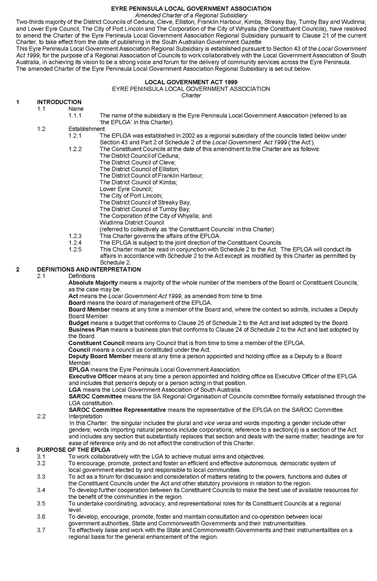
Eyre Peninsula Local Government Association
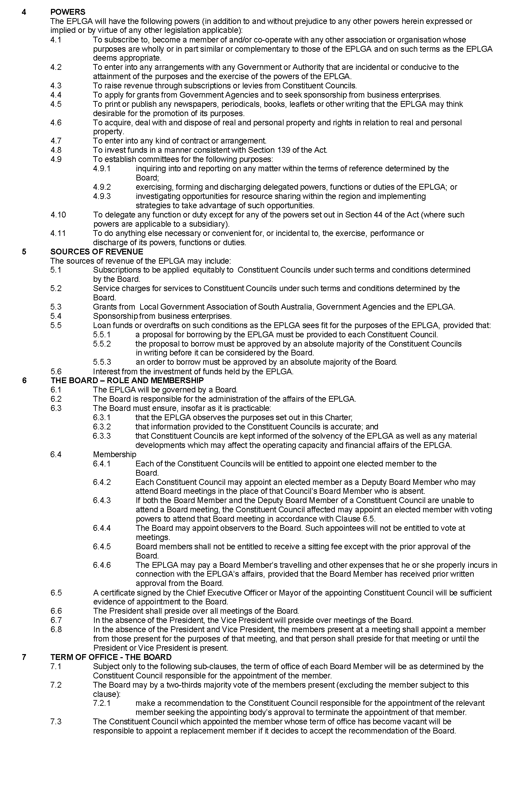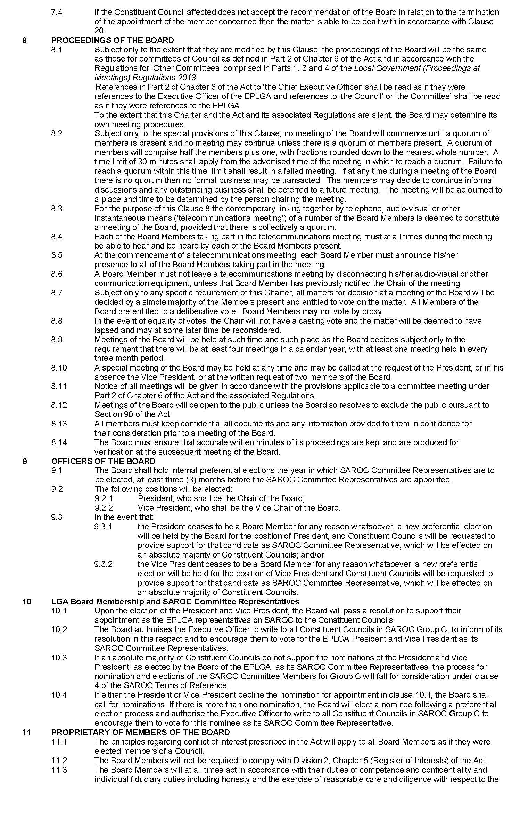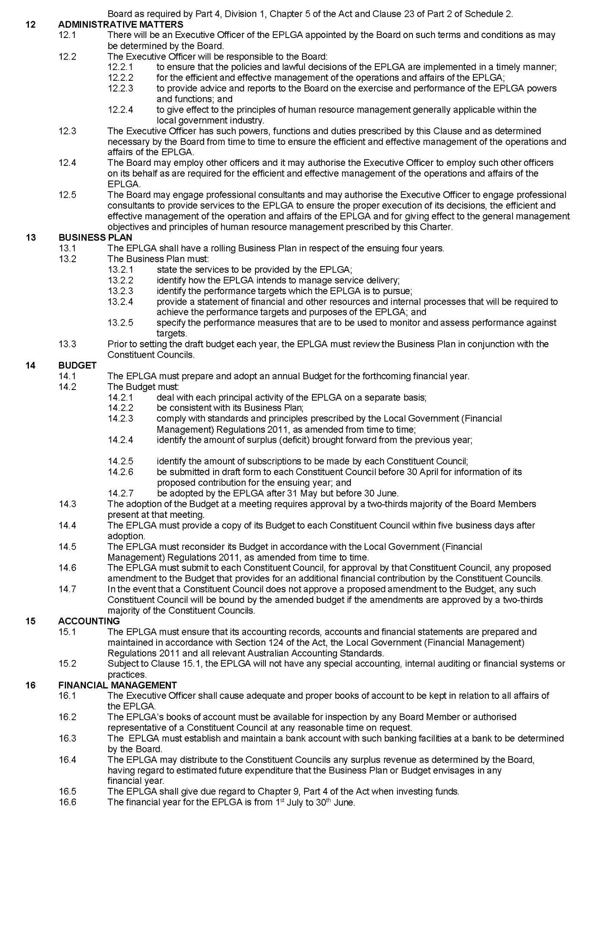
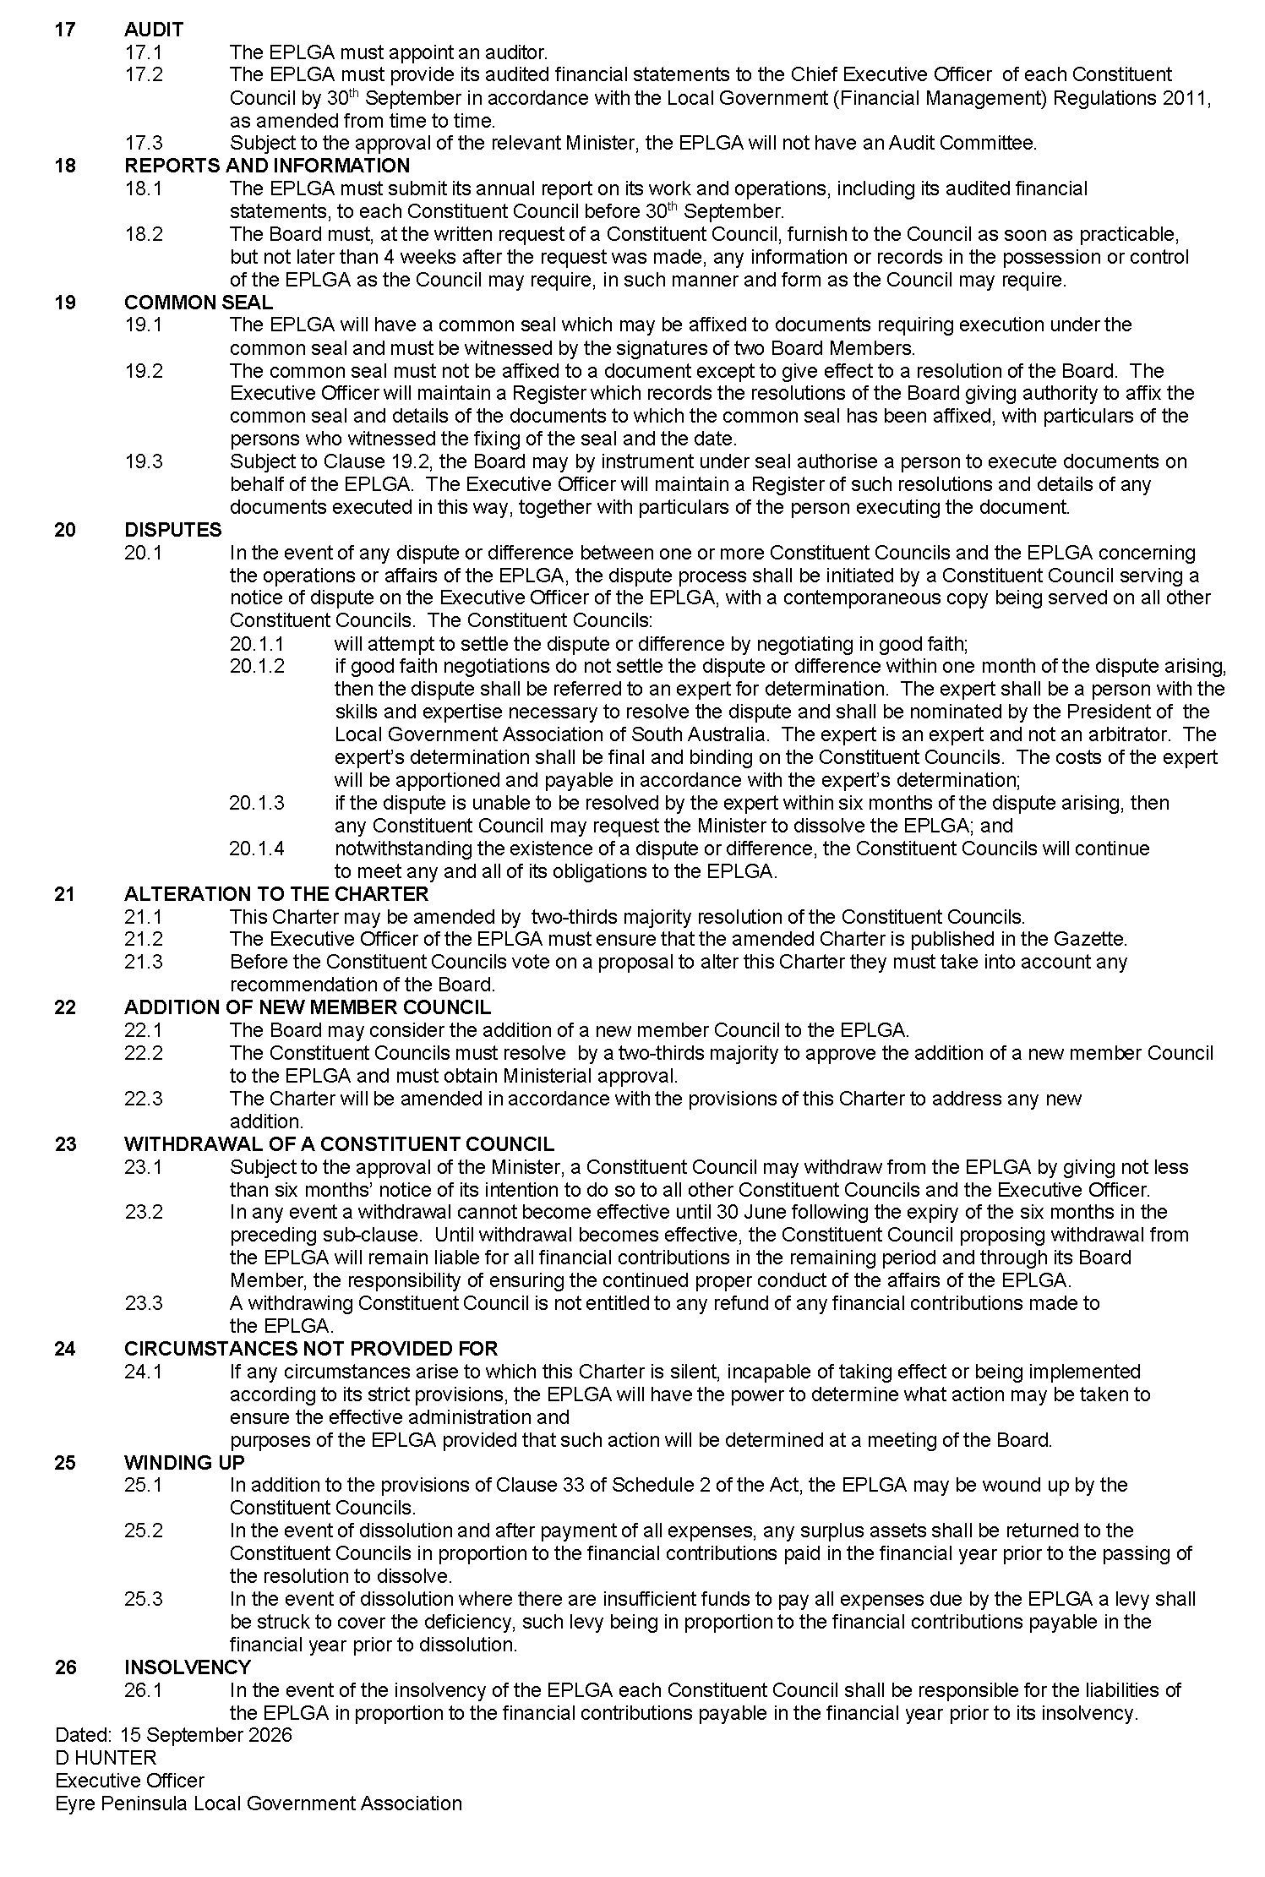
Dated: 15 September 2026
D. Hunter
Executive Officer

Public Notices

Trustee Act 1936
Deceased Estate—Section 29
Notice to Creditors, Beneficiaries and Others
In the Estate of Michael Driscoll, late of 12 Forrest Avenue, Marino, South Australia 5049, who died on or about 14 May 2026.
Letters of Administration of the estate were granted by the Supreme Court of South Australia to Joshua William Arthur on 18 August 2026 (Action No. PROB-26-005521).
Creditors, beneficiaries and all other persons having any claim against, or interest in, the estate of the deceased are required to send full particulars of their claim in writing to the administrator, care of O’Dea Lawyers, 991 South Road, Melrose Park SA 5039, on or before Monday, 12 October 2026, after which date the administrator may distribute the estate having regard only to the claims of which he then has notice, and will not be liable, in respect of the estate so distributed, to any person of whose claim he did not have notice at the time of distribution.
Dated: 9 September 2026
O’Dea Lawyers
Solicitors for the Administrator
991 South Road, Melrose Park SA 5039
Telephone: (08) 8004 5006
Reference SS:261207

Notice Submission

The South Australian Government Gazette is published each Thursday afternoon.
Notices must be emailed by 4 p.m. Tuesday, the week of publication.
Submissions are formatted per the gazette style and a proof will be supplied prior to publication, along with a quote if applicable. Please allow one day for processing notices.
Alterations to the proof must be returned by 4 p.m. Wednesday.

Gazette notices must be submitted as Word files, in the following format:
• Title—the governing legislation
• Subtitle—a summary of the notice content
• Body—structured text, which can include numbered lists, tables, and images
• Date—day, month, and year of authorisation
• Signature block—name, role, and department/organisation authorising the notice

Please provide the following information in your email:
• Date of intended publication
• Contact details of the person responsible for the notice content
• Name and organisation to be charged for the publication—Local Council and Public notices only
• Purchase order, if required—Local Council and Public notices only

Email: governmentgazettesa@sa.gov.au
Phone: (08) 7133 3552
Website: www.governmentgazette.sa.gov.au

All instruments appearing in this gazette are to be considered official, and obeyed as such

Printed and published weekly by authority of T. Foresto, Government Printer, South Australia
$9.50 per issue (plus postage), $479.00 per annual subscription—GST inclusive
Online publications: www.governmentgazette.sa.gov.au

