
No. 56 p. 3057
THE SOUTH AUSTRALIAN
GOVERNMENT GAZETTE
Published by Authority

Adelaide, Thursday, 24 September 2026

Contents

Governor’s Instruments
Acts 3058
Appointments, Resignations and General Matters 3058
Proclamations—
Liquor Licensing (Conferral of Authority)
Proclamation 2026 3060
South Australian Civil and Administrative Tribunal (Appointment of President) Proclamation 2026 3061
State Government Instruments
Associations Incorporation Act 1985 3062
Building Work Contractors Act 1995 3062
Dog Fence Act 1946 3063
Electoral Act 1985 3064
Energy Resources Act 2000 3064
Fisheries Management (Prawn Fisheries) Regulations 2017 3065
Fisheries Management Act 2007 3067
Housing Improvement Act 2016 3069
Hydrogen and Renewable Energy Act 2023 3069
Justices of the Peace Act 2005 3070
Land Acquisition Act 1969 3071
Liquor Licensing Act 1997 3071
Mental Health Act 2009 3075
Planning, Development and Infrastructure Act 2016 3075
Plant Health Act 2009 3081
Remuneration Tribunal, The 3085
Retail and Commercial Leases Act 1995 3086
Roads (Opening and Closing) Act 1991 3087
South Australian Civil and Administrative Tribunal 3087
Local Government Instruments
City of Charles Sturt 3089
City of Playford 3089
City of Salisbury 3089
Barossa Council, The 3090
District Council of Ceduna 3090
Wudinna District Council 3094
Public Notices
National Electricity Law 3095
Trustee Act 1936 3095

Governor’s Instruments

Acts
Department of the Premier and Cabinet
Adelaide, 24 September 2026
Her Excellency the Governor directs it to be notified for general information that she has in the name and on behalf of His Majesty The King, this day assented to the undermentioned Bills passed by the Legislative Council and House of Assembly in Parliament assembled, viz.:
No. 11 of 2026—Liquor Licensing (Royal Commission Recommendations) Amendment Bill 2026
An Act to amend the Liquor Licensing Act 1997
No. 12 of 2026—National Gas (South Australia) (Application of Rules) Amendment Bill 2026
An Act to amend the National Gas (South Australia) Act 2008
No. 13 of 2026—Employment Agents Bill 2026
An Act to regulate employment agents, to repeal the Employment Agents Registration Act 1993 and for other purposes
No. 14 of 2026—Northern Water Project (Land and Infrastructure) Bill 2026
An Act to facilitate the Northern Water project and for other purposes
By command,
Christopher James Picton, MP
For Premier

Appointments, Resignations and General Matters
Department of the Premier and Cabinet
Adelaide, 24 September 2026
Her Excellency the Governor in Executive Council has been pleased to appoint the Honourable Michael Edison Brown, MP as Acting Minister for Housing and Urban Development, Acting Minister for Housing Infrastructure and Acting Minister for Planning from 26 September 2026 until 28 September 2026 inclusive, during the absence of the Honourable Nicholas David Champion, MP.
By command,
Christopher James Picton, MP
For Premier
26MHCS10404

Department of the Premier and Cabinet
Adelaide, 24 September 2026
Her Excellency the Governor in Executive Council has been pleased to appoint the Honourable Emily Sarah Bourke, MLC as Acting Minister for Housing and Urban Development, Acting Minister for Housing Infrastructure and Acting Minister for Planning from 29 September 2026 until 2 October 2026 inclusive, during the absence of the Honourable Nicholas David Champion, MP.
By command,
Christopher James Picton, MP
For Premier
26MHCS10404

Department of the Premier and Cabinet
Adelaide, 24 September 2026
Her Excellency the Governor in Executive Council has been pleased to appoint the Honourable Michael Edison Brown, MP as Acting Minister for Housing and Urban Development, Acting Minister for Housing Infrastructure and Acting Minister for Planning from 3 October 2026 until 9 October 2026 inclusive, during the absence of the Honourable Nicholas David Champion, MP.
By command,
Christopher James Picton, MP
For Premier
26MHCS10404

Department of the Premier and Cabinet
Adelaide, 24 September 2026
Her Excellency the Governor in Executive Council has been pleased to appoint the Honourable Christopher James Picton, MP as Acting Minister for Primary Industries and Regional Development and Acting Minister for Forest Industries from 28 September 2026 until 2 October 2026 inclusive, during the absence of the Honourable Clare Michele Scriven, MLC.
By command,
Christopher James Picton, MP
For Premier
MPIRDF2026/130

Department of the Premier and Cabinet
Adelaide, 24 September 2026
Her Excellency the Governor in Executive Council has been pleased to appoint the Honourable Emily Sarah Bourke, MLC as Acting Minister for Primary Industries and Regional Development and Acting Minister for Forest Industries from 3 October 2026 until 9 October 2026 inclusive, during the absence of the Honourable Clare Michele Scriven, MLC.
By command,
Christopher James Picton, MP
For Premier
MPIRDF2026/130

Department of the Premier and Cabinet
Adelaide, 24 September 2026
Her Excellency the Governor in Executive Council has been pleased to appoint Stephanie Jane Jude Halliday as a Judge of the District Court of South Australia, effective from 6 October 2026 - pursuant to the provisions of the District Court Act 1991.
By command,
Christopher James Picton, MP
For Premier
AGO0058-26CS

Department of the Premier and Cabinet
Adelaide, 24 September 2026
Her Excellency the Governor in Executive Council has designated Stephanie Jane Jude Halliday as a Judge of the Environment, Resources and Development Court of South Australia, effective from 6 October 2026 - pursuant to the provisions of the Environment, Resources and Development Court Act 1993.
By command,
Christopher James Picton, MP
For Premier
AGO0058-26CS

Proclamations
South Australia

Liquor Licensing (Conferral of Authority) Proclamation 2026
under section 15 of the Liquor Licensing Act 1997
1—Short title
This proclamation may be cited as the Liquor Licensing (Conferral of Authority) Proclamation 2026.
2—Commencement
This proclamation comes into operation on 6 October 2026.
3—Conferral of authority on District Court Judge
Authority is conferred on the District Court Judge named in Schedule 1 to exercise the jurisdiction of the Licensing Court of South Australia.
Schedule 1—District Court Judge on whom authority is conferred
Her Honour Stephanie Jane Jude Halliday
Made by the Governor
with the advice and consent of the Executive Council
on 24 September 2026

South Australia

South Australian Civil and Administrative Tribunal (Appointment of President) Proclamation 2026
under section 10 of the South Australian Civil and Administrative Tribunal Act 2013
1—Short title
This proclamation may be cited as the South Australian Civil and Administrative Tribunal (Appointment of President) Proclamation 2026.
2—Commencement
This proclamation comes into operation on 2 November 2026.
3—Appointment of President
Stephanie Jane Jude Halliday, a Judge of the District Court, is appointed to be the President of the South Australian Civil and Administrative Tribunal from 2 November 2026.
Made by the Governor
after consultation by the Attorney-General with the Chief Justice of the Supreme Court and with the advice and consent of the Executive Council
on 24 September 2026

State Government Instruments

Associations Incorporation Act 1985
Section 43A
Deregistration of Associations
Notice is hereby given that the Corporate Affairs Commission approves the applications for deregistration received from the associations named below pursuant to Section 43A of the Associations Incorporation Act 1985 (SA). Deregistration takes effect on the date of publication of this notice.
THE SOUTH AUSTRALIAN YOUTH FORUM INCORPORATED (A45286)
ACACIA PARK ASSOCIATION INCORPORATED (A7963)
ADELAIDE CHINESE STUDENT SOCIETY INCORPORATED (A42581)
PENONG WOOLSHED COTTAGE CRAFTS INCORPORATED (A20897)
HARDWICKE BAY EFFLUENT SCHEME INCORPORATED (A24571)
ROTARY CLUB OF MILLICENT INCORPORATED (A7270)
Given under the seal of the Commission at Adelaide.
Dated: 24 September 2026
Calem Chandler
Acting Team Leader, Gambling and Associations
Delegate of the Corporate Affairs Commission

Associations Incorporation Act 1985
Section 42(2)
Dissolution of Association
Whereas the Corporate Affairs Commission (the Commission) pursuant to Section 42(1) of the Associations Incorporation Act 1985 (the Act) is of the opinion that the undertaking or operations of SKYLIGHT MENTAL HEALTH INCORPORATED (the Association) being an incorporated association under the Act are being carried on, or would more appropriately be carried on by a Company Limited by Guarantee incorporated under the Corporations Act 2001 (Cth) and whereas the Commission was on 11 SEPTEMBER 2026 requested by the Association to transfer its undertaking to SKYLIGHT MENTAL HEALTH LIMITED (Australian Company Number 701 972 410), the Commission pursuant to Section 42(2) of the Act does hereby order that on 1 OCTOBER 2026, the Association will be dissolved, the property of the Association becomes the property of SKYLIGHT MENTAL HEALTH LIMITED and the rights and liabilities of the Association become the rights and liabilities of SKYLIGHT MENTAL HEALTH LIMITED.
Given under the seal of the Commission at Adelaide.
Dated: 21 September 2026
Kirsty Lawrence
Delegate of the Corporate Affairs Commission

Building Work Contractors Act 1995
Exemption
Take notice that, pursuant to Section 45 of the Building Work Contractors Act 1995, I, Brett Humphrey as a delegate for the Minister for Consumer and Business Affairs, do hereby exempt the licensee named in Schedule 1 from the application of Division 3 of Part 5 of the above Act in relation to domestic building work described in Schedule 2 and subject to the conditions specified in Schedule 3.
Schedule 1
WAYNE BRENNAN (BLD 55387)
Schedule 2
Construction of a single storey dwelling at Allotment 9 Filed Plan 134660, being a portion of the land described in Certificate of Title Volume 5689 Folio 333, more commonly known as 101 Ashbrook Avenue, Trinity Gardens SA 5068.
Schedule 3
1. This exemption is limited to domestic building work personally performed by the licensee in relation to the building work described in Schedule 2.
2. This exemption does not apply to any domestic building work the licensee contracts to another building work contractor, for which that contractor is required by law to hold building indemnity insurance.
3. That the licensee does not transfer his interest in the land prior to five years from the date of completion of the building work the subject of this exemption, without the prior authorisation of Consumer and Business Services (CBS). Before giving such authorisation, CBS may require the licensee to take any reasonable steps to protect the future purchaser(s) of the property, including but not limited to:
• Providing evidence that an adequate policy of building indemnity insurance is in force to cover the balance of the five-year period from the date of completion of the building work the subject of this exemption;
• Providing evidence of an independent expert inspection of the building work the subject of this exemption;
• Making an independent expert report available to prospective purchasers of the property;
• Giving prospective purchasers of the property notice of the absence of a policy of building indemnity insurance.
Dated: 16 September 2026
Brett Humphrey
Commissioner for Consumer Affairs
Delegate for the Minister for Consumer and Business Affairs

Dog Fence Act 1946
Declaration of Ratable Land
Pursuant to Section 25(1) of the Dog Fence Act 1946, the Dog Fence Board hereby declares that, for the financial year ending 30 June 2027, any land holding of more than 10 square kilometres situated within the declared rateable area inside the Dog Fence is ratable land.
This declaration does not apply to Lake Torrens National Park or Lake Gairdner National Park.
Dated: 23 September 2026
Geoff Power
Chair, Dog Fence Board

Dog Fence Act 1946
Declaration of Rate
Pursuant to Section 25(2) of the Dog Fence Act 1946, the Dog Fence Board, with the approval of the Minister for Primary Industries and Regional Development, hereby declares, for the financial year ending 30 June 2027, the following rates on rateable land and minimum amounts payable by way of rates, namely:
Rates
1. No rate shall apply to any portion of a land holding situated inside the Counties or Hundreds identified in Column A of Table 1.
2. A rate of $1.76 per square kilometre shall apply to any portion of a land holding situated inside the Hundreds identified in Column B of Table 1.
Minimum Amount Payable
3. No minimum amount is payable by way of rates for any land holding that falls entirely within the Counties or Hundreds identified in Column A of Table 1.
4. A minimum amount of $253.10 is payable by way of rates for any land holding that falls entirely within the Hundreds identified in Column B of Table 1.
Table 1
Column A |  | Column B
The whole of the Counties of:  Adelaide, Albert, Alfred, Buccleuch, Buckingham, Cardwell, Carnarvon, Chandos, Daly, Fergusson, Flinders, Gawler, Grey, Hindmarsh, MacDonnell, Musgrave, Robe, Russell and Sturt.  The whole of the Hundreds of:  Andrews, Anna, Appila, Bagot, Baroota, Belvidere, Blyth, Booleroo, Boonerdo, Boothby, Booyoolie, Boucaut, Brooker, Bundaleer, Butler, Campoona, Caralue, Clare, Cocata, Cootra, Crystal Brook, Darke, Darling, Dixson, Downer, Dutton, Everard, Fisher, Gilbert, Goyder, Hall, Hambidge, Hanson, Hart, Hawker, Hincks, Howe, Jellicoe, Kappakoola, Kapunda, Koolunga, Light, Mann, Milne, Moody, Moorooroo, Murlong, Napperby, Narridy, Nicholls, Nuriootpa, OH (Kimba), Palkagee, Pascoe, Pirie, Playford, Roberts, Rudall, Saddleworth, Skurray, Smeaton, Stanley, Stow, Telowie, Tooligie, Upper Wakefield, Verran, Wandearah, Warramboo, Wilton, Wongyarra, Yackamoorundie, Yadnarie and Yangya. |  | The whole of the Hundreds of:  Adams, Addison, Anne, Apoinga, Arkaba, Ash, Ayers, Bagster, Baldina, Barna, Barndioota, Bartlett, Batchelor, Beatty, Belalie, Bendleby, Bice, Black Rock Plain, Blacker, Bockelberg, Bonython, Boolcunda, Bower, Bright, Brownlow, Buckleboo, Bundey, Bunyeroo, Burgoyne, Caldwell, Caltowie, Campbell, Carawa, Carina, Carr, Castine, Catt, Cavenagh, Chandada, Charleston, Chillundie, Coglin, Cohen, Condada, Coomooroo, Coonatto, Copley, Corrobinnie, Cortlinye, Cotabena, Crozier, Cudlamudla, Cultana, Cungena, Cunyarie, Davenport, Eba, Edeowie, English, Erskine, Eurelia, Eurilpa, Finlayson, Forrest, French, Giles, Gillen, Glynn, Goode, Gregory, Gumbowie, Guthrie, Hague, Hallett, Handyside, Hardy, Haslam, Hay, Heggaton, Hill, Horn, Inkster, James, Jamieson, Jenkins, Julia Creek, Kaldoonera, Kanyaka, Karcultaby, Katarapko, Keith, Kelly, Ketchowla, Kevin, King, Kingston, Koolgera, Koongawa, Kooringa, Lindley, Loveday, Lucy, Magarey, Mamblin, Mangalo, Mannanarie, Markaranka, Maude, May, Mcgregor, Miller, Miltalie, Minbrie, Minburra, Minnipa, Mongolata, Moockra, Moonabie, Moorkitabie, Moralana, Morgan, Moseley, Moule, Murray, Nackara, Nash, Neales, Nilginee, Nilpena, Nunnyah, OConnor, OH (Andamooka), OH (Barton), OH (Billakalina), OH (Burra), OH (Callabonna), OH (Childara), OH (Chowilla), OH (Herbert), OH (Kimberley), OH (Lytton), OH (Coober Pedy), OH (Copley), OH (Curdimurka), OH (Curnamona), OH (Elliston), OH (Fowler), OH (Frome), OH (Gairdner), OH (Kingoonya), OH (Lake Eyre), OH (Marree), OH (Murloocoppie), OH (Olary), OH (Orroroo), OH (Parachilna), OH (Port Augusta), OH (Pt Augusta), OH (Renmark), OH (Tallaringa), OH (Tarcoola), OH (Torrens), OH (Yardea), Oladdie, OLoughlin, Oratunga, Palabie, Palmer, Panitya, Parachilna, Paratoo, Parcoola, Parnaroo, Peella, Pekina, Perlubie, Pethick, Petina, Pichi Richi, Pildappa, Pinbong, Pinda, Pinkawillinie, Pooginook, Pordia, Poynton, Pureba, Pygery, Randell, Rees, Reynolds, Ripon, Rounsevell, Russell, Scott, Solomon, Stuart, Sturdee, Tarcowie, Tarlton, Terowie, Tomkinson, Travers, Trunch, Uroonda, Wallala, Wallanippie, Wallis, Walloway, Walpuppie, Wandana, Wannamana, Warcowie, Waroonee, Warrakimbo, Warren, Waterloo, Whyte, Wilcherry, Willochra, Willowie, Winninowie, Wirreanda, Witera, Wonna, Wonoka, Wookata, Woolundunga, Woolyana, Wrenfordsley, Wright, Wudinna, Wyacca, Yalanda, Yalpara, Yaninee, Yantanabie, Yanyarrie, Yarrah, Yednalue and Yongala
Dated: 23 September 2026
Geoff Power
Chair, Dog Fence Board

Dog Fence Act 1946
Section 35C
Local Dog Fence Board Membership
Pursuant to Section 35C of the Dog Fence Act 1946, on the recommendation of the Dog Fence Board, I vary the proclamation made under that Act on 2 October 1975 (see Gazette 2 October 1975 p. 1819), as varied, as follows:
(a) by striking out the names “Julie Nutt” and “Bruce Nutt” from the list under the heading Central Local Dog Fence Board in the Second Schedule;
(b) by adding the names “Tom Martin”, “Conner Cosgrove” and “Ben Hewitt” to the list under the heading Central Local Dog Fence Board in the Second Schedule;
(c) by striking out the name “Kevin Dawes” from the list under the heading Marree Local Dog Fence Board in the Second Schedule;
(d) by adding the names “Ben Carn” and “Kaelie May” to the list under the heading Marree Local Dog Fence Board in the Second Schedule;
(e) by adding the names “Nick Pritchard” and “Brenton Bergmann” to the list under the heading Penong Local Dog Fence Board in the Second Schedule;
(f) by adding the names “Flynn Treloar”, “Charlotte Rosa” and “Michael Goldsworthy” to the list under the heading Frome Local Dog Fence Board in the Second Schedule.
Dated: 23 September 2026
Hon. Clare Scriven MLC
Minister for Primary Industries and Regional Development

Electoral Act 1985
Part 6—Registration of Political Parties
Notice is hereby given that I have on this day de-registered the political party named below for failing to have the appropriate number of members to continue as an eligible political party under the provision of Section 45 of the Act:
Name of Party: Jing Lee—Better Community
Dated: 24 September 2026
Leah McLay
Acting Electoral Commissioner

ELECTORAL ACT 1985
Part 6—Registration of Political Parties
Notice is hereby given that I have on this day de-registered the political party named below following application for de-registration made under the provision of Section 44 of the Act:
Name of Party: SA-BEST Incorporated
Dated: 24 September 2026
Leah McLay
Acting Electoral Commissioner

Energy Resources Act 2000
Application for Grant of Associated Activities Licence—AAL 342
Pursuant to Section 65(6) of the Energy Resources Act 2000, notice is hereby given that an application for the grant of an associated activities licence over the area described below has been received from:
Impress (Cooper Basin) Pty Ltd
Springfield Oil & Gas Pty Ltd
The application will be determined on or after 8 October 2026.
Description of Application Area
All that part of the State of South Australia, bounded as follows:
All coordinates in GDA2020, Zone 54
349949.25mE 6964653.10mN
350269.42mE 6964657.00mN
350263.77mE 6964144.48mN
351873.31mE 6964145.11mN
351875.61mE 6963954.70mN
351603.72mE 6963955.98mN
351601.58mE 6963624.23mN
351288.54mE 6963627.02mN
351287.56mE 6963952.02mN
350090.23mE 6963943.60mN
350088.45mE 6963374.89mN
349528.52mE 6963365.65mN
349375.53mE 6961642.39mN
349569.74mE 6961091.58mN

349436.33mE 6960509.84mN
349180.29mE 6960503.87mN
349493.27mE 6959224.06mN
349627.50mE 6957905.12mN
349337.51mE 6957902.05mN
349308.42mE 6958561.46mN
348792.71mE 6958561.46mN
348720.42mE 6958893.81mN
349293.09mE 6958895.68mN
348830.16mE 6961390.06mN
349328.68mE 6963594.30mN
349870.58mE 6963737.37mN
349949.25mE 6964653.10mN
AREA: 3.07 square kilometres approximately
Dated: 21 September 2026
Lee Kinnear
General Manager
Energy Resources Licensing
Regulation and Compliance Division
Department for Energy and Mining
Delegate of the Minister for Energy and Mining

Energy Resources Act 2000
Suspension of Condition Extension of Licence Term
Petroleum Exploration Licence—PEL 676
Associated Activities Licence—AAL 308
Pursuant to Section 76A of the Energy Resources Act 2000, notice is hereby given that Condition 1 of the abovementioned Licences have been suspended for the period from 2 September 2025 to 1 September 2026 inclusive, pursuant to delegated powers.
The terms of PEL 676 and AAL 308 have been extended by a period corresponding to the period of suspension, such that PEL 676 will now expire on 1 September 2029 and AAL 308 will now expire 7 March 2027.
Dated: 21 September 2026
Paul De Ionno
Executive Director
Regulation and Compliance Division
Department for Energy and Mining
Delegate of the Minister for Energy and Mining

Fisheries Management (Prawn Fisheries) Regulations 2017
Surveying in the Spencer Gulf Prawn Fishery
Take notice that pursuant to Regulation 10 of the Fisheries Management (Prawn Fisheries) Regulations 2017, the notice dated 7 September 2026 on page 2991 of the South Australian Government Gazette of 10 September 2026, prohibiting fishing activities in the Spencer Gulf Prawn Fishery is hereby varied such that it will not apply to the holders of a Spencer Gulf Prawn Fishery licence issued pursuant to the Fisheries Management (Prawn Fisheries) Regulations 2017 listed in Schedule 1 or their registered master insofar as they may use prawn trawl nets in accordance with the conditions of their fishery licence for the purpose of undertaking a prawn survey during the period specified in Schedule 2, subject to the conditions contained in Schedule 3 unless this notice is varied or revoked.
Schedule 1
Licence Number | Licence Holder | Boat Name
P04 | Melanie B Nominees Pty Ltd | Melanie B
P06 | Lunar Sea Holdings Pty Ltd | Lunar Sea
P08 | Nansi Blaslov-Nelligan | Grozdana B
P09 | Vidov Fisheries Pty Ltd | Sachi V
P12 | Fromager Pty Ltd | Frank Cori
P13 | A Lukin Nominees Pty Ltd | Kylie
P14 | Ross Hamilton Haldane | Bartalumba K
P15 | D&R Holdings SA Pty Ltd | Millennium III
P16 | Jillandra Nominees Pty Ltd | Night Stalker
P19 | Lukina Lakkana Lukin | Lukina
P21 | Spencer Gulf Nominees Pty Ltd | Kylett
P24 | Darryl Gordon Scharfe | Sandy S
P26 | Ljiljana Vitlov | Michelle
P28 | Lukina Lakkana Lukin | Skandia
P29 | Leila Jo Pty Ltd | Leila Jo
P30 | PQ Nominees Pty Ltd | Roslyn Ann
P31 | Nunan Nominees Pty Ltd | Evelyn-L
P33 | Marnikol Fisheries Pty Ltd | Beauie J
P34 | Ljubica Bralic | Cvita B
P36 | Spencer Gulf Challenge Pty Ltd | Challenge
P37 | Lindarosa Enterprises Pty Ltd | Liberty V
P38 | Tacoma Pty Ltd | Atlas

Schedule 2
Commencing at sunset on 30 September 2026 and ending at sunrise on 30 September 2027.
Schedule 3
1. For the purposes of this notice the trawl survey areas cannot include any waters of a habitat protection zone or a sanctuary zone of a marine park established under the Marine Parks Act 2007.
2. The licence holders listed in Schedule 1 or their registered master must comply with all regulations and conditions that apply to fishing activities undertaken pursuant to their licence, in addition to the conditions imposed by this notice.
3. The vessels participating in a survey, either a stock assessment or spot survey, must be listed in the table attached as Table 1. Table 1 is to be completed by either the Executive Officer or the Coordinator at Sea from the Spencer Gulf and West Coast Prawn Association and emailed to pirsa.fishwatch@sa.gov.au and the Prawn Fishery Manager at least one hour prior to departure of the first vessel from port to engage in the activity permitted under this notice.
4. All fish, other than Western King Prawns, Southern Calamari and Balmain Bugs taken during the activity permitted under this notice, are to be returned to the water immediately after capture.
5. While engaged in fishing activities or unloading the survey catch, the licence holders listed in Schedule 1 or their register master must have a copy of this notice on board the boat or near his person. This notice must be produced to a Fisheries Officer if requested.
6. No fishing activity may be undertaken between the prescribed times of sunrise and sunset for Adelaide (as published in the South Australian Government Gazette) during the period specified in Schedule 2.
7. The licence holders listed in Schedule 1 or their register master must not contravene or fail to comply with the Fisheries Management Act 2007, or any other regulations made under that Act except where specifically exempted by this notice.
8. This notice does not purport to override the provisions or operation of any other Act. The notice holder and his agents must comply with any relevant regulations, permits, requirements and directions from the Department of Environment, Water and Natural Resources when undertaking activities within a marine park.
Dated: 16 September 2026
Meg Stevens
Executive Officer, Spencer Gulf and West Coast Prawn Association, Inc.
Delegate of the Minister for Primary Industries and Regional Development

Table 1
Survey Report for the Spencer Gulf Prawn Fishery
Required Fields | Vessel 1 | Vessel 2 | Vessel 3 | Vessel 4 | Vessel 5 | Vessel 6 | Vessel 7 | Vessel 8 | Vessel 9 | Vessel 10
1. Licence Prefix
2. Licence No.
3. Port Commencing from
4. Earliest date leaving port
5. Earliest time leaving port
6. Port of return
7. Activity undertaken
8. Name of person conducting activity
9. Dates of trawling commencement
10. Times of trawling
11. Where will activity
take place

Fisheries Management Act 2007
Section 115
Ministerial Exemption: ME9903447
Take notice that pursuant to Section 115 of the Fisheries Management Act 2007, Dr Scotte Wedderburn of Adelaide University, North Terrace, Adelaide SA 5005 (the ʻexemption holder’) and his nominated agents, are exempt from Section 70 and 71 of the Fisheries Management Act 2007 and Regulation 5 and Clauses 42 and 74 of Schedule 6 of the Fisheries Management (General) Regulations 2017 but only insofar as the exemption holder and his nominated agents may use the fishing gear specified in Schedule 1 (the exempted activity), in the waters specified in Schedule 2, subject to the conditions set out in Schedule 3, from 7 October 2026 until 6 October 2027, unless varied or revoked earlier.
Schedule 1
Up to a maximum of 12 fyke nets that each have a single 6m wing, with 5mm half mesh and a 600mm hoop.
Schedule 2
The wetland habitats associated with Lake Albert and Lake Alexandrina, South Australia at the following sites:
• Lawari Conservation Park:  Latitude: 35°31′35.5″S  Longitude: 138°53′55.7″E | • Boggy Creek:  Latitude: 35°31′15.9″S  Longitude: 138°55′43.8″E
• Hunters Creek:  Latitude: 35°31′42.8″S  Longitude: 138°53′55.7″E | • Mundoo Island 2:  Latitude: 35°32′46.5″S  Longitude: 138°55′44.6″E
• Channel off Steamer Drain:  Latitude: 35°31′53.3″S  Longitude: 138°54′32.6″E | • Shadows Lagoon:  Latitude: 35°31′03.5″S  Longitude: 138°55′03.2″E
• Dunn Lagoon:  Latitude: 35°29′32.9″S  Longitude: 138°56′01.2″E | • Black Swamp:  Latitude: 35°26′01.8″S  Longitude: 138°50′53.8″E
• Currency Creek:  Latitude: 35°29′33.0″S  Longitude: 138°49′23.3″E | • Waltowa (Lake Albert):  Latitude: 35°36′31.0″S  Longitude: 139°22′32.4″E
• Narrung (Lake Albert):  Latitude: 35°30′46.9″S  Longitude: 139°10′36.5″E | • Nindethana (Lake Albert):  Latitude: 35°37′34.5″S  Longitude: 139°13′03.3″E
• Mundoo Island:  Latitude: 35°32′54.6″S  Longitude: 138°54′56.4″E | • Belcanoe (Lake Albert):  Latitude: 35°39′15.7″S  Longitude: 139°12′08.6″E
• Dog Lake:  Latitude: 35°21′53.0″S  Longitude: 139°07′42.2″E | • Shadows Lagoon – West:  Latitude: 35°31′09.0″S  Longitude: 138°54′42.1″E
• Old Clayton:  Latitude: 35°29′40.4″S  Longitude: 138°54′39.7″E | • Shadows Lagoons – Hunter Creek:  Latitude: 35°31′21.0″S  Longitude: 138°54′47.7″E
• Mundoo Island-Boundary Creek:  Latitude: 35°33′08.7″S  Longitude: 138°56′42.7″E | • Shadows Lagoon Channel:  Latitude: 35°31′10.3″S  Longitude: 138°55′06.4″E
• Hunters Creak-Steamer Drain:  Latitude: 35°31′39.3″S  Longitude: 138°54′17.6″E | • Mundoo Island 3:  Latitude: 35°32′29.4″S  Longitude: 138°56′11.8″E
• Goolwa Channel:  Latitude: 35°31′36.6″S  Longitude: 138°48′03.8″E | • Channel Off Hunters Creek:  Latitude: 35°31′34.0″S  Longitude: 138°53′44.7″E
Schedule 3
1. The exemption holder will be deemed responsible for the conduct of all persons conducting the exempted activities under this notice. Any person conducting activities under this exemption must be provided a copy of this notice, which they must have signed as an indication that they have read and understand the conditions under it.
2. The exemption holder or the nominated agents may only catch fish in the locations specified in Schedule 1, using the equipment specified in Schedule 2, for research purposes related to the research project ʻCondition Monitoring of Threatened Fish Populations in Lake Alexandrina and Lake Albertʼ.
3. The exemption holder and the nominated agents may only catch fish for the purpose of identification and recording and thereafter the fish (other than noxious species) must be immediately returned to the water in the location where they were caught.
4. All native fish must be returned to the water in which they were captured within 30 minutes of retrieval from the fyke nets.
5. Noxious fish captured during the exempted activity may not be returned to the water and must be humanely destroyed.
6. A maximum of three (3) fyke nets may be set at any one site at a time, and the nets set must be retrieved from the water no later than the following morning.
7. All fyke nets must be located within 10m of the shore at each survey site.

8. Fyke nets must be deployed with at least two 10cm round floats in the cod end (final chamber) to permit surface access for air-breathing by-catch. Any animals (other than fish) captured must be immediately released on retrieval of the fyke net.
9. A two-litre white buoy tagged with the Ministerial exemption number and the name of the exemption holder must be attached to the outer wing of the fyke net.
10. Any equipment used to collect fish during the exempted activity must be decontaminated prior to and after undertaking the research activities.
11. The nominated agents of the exemption holder are:
• Colin Bailey, Adelaide University
• Thomas Barnes, Adelaide University.
12. Before undertaking the exemption activity, the exemption holder or a person acting as his agent must contact PIRSA FISHWATCH on 1800 065 522 and answer a series of questions about the exemption activity. The exemption holder or nominated agent will need to have a copy of the exemption at the time of making the call and be able to provide information about the area and time of the exempted activity, the vehicles and/or boats involved, the number of agents undertaking the exemption activity and other related questions.
13. The exemption holder must provide a report in writing detailing the activities carried out pursuant to this notice to the Executive Director, Fisheries and Aquaculture (GPO Box 1625, Adelaide SA 5001 or PIRSA.MinisterialExemptionsandPermits@sa.gov.au) within 30 days of the expiry of this exemption that includes the following details:
• The date and location of the sampling;
• The gear used;
• The number and description of all species collected;
• Any interactions with the protected species and marine mammals; and
• Other information regarding size, breeding, or anything deemed relevant or of interest that is able to be volunteered.
14. While engaging in the exempted activity, the exemption holder or his nominated agents must be in possession of a copy of this notice. Such notice must be produced to a Fisheries Officer upon request.
15. The exemption holder or nominated agents must not contravene or fail to comply with the Fisheries Management Act 2007 or any regulations made under that Act, except where specifically exempted by this notice.
This notice does not purport to override the provisions or operation of any other Act including, but not limited to, the River Murray Act 2003. The exemption holder and his agents must comply with any relevant regulations, permits, requirements and directions from the Department for Environment and Water when undertaking activities within a marine park, national park or specially protected area.
Dated: 16 September 2026
Professor Gavin Begg
Executive Director
Fisheries and Aquaculture
Delegate of the Minister for Primary Industries and Regional Development

Fisheries Management Act 2007
Section 115
Ministerial Exemption: ME9903449
Take notice that pursuant to Section 115 of the Fisheries Management Act 2007, I Professor Gavin Begg, as delegate for the Minister of Primary Industries and Regional Development, hereby exempt the holder of a River Fishery or a Lakes and Coorong Fishery licence or their registered master (the ‘exemption holders’) from Section 53(2) and 55 of the Fisheries Management Act 2007 and Regulation 5 and Clauses 6 and 21 of Schedule 6 of the Fisheries Management (General) Regulations 2017 but only insofar as the exemption holder may use a ‘Commercial Yabby Trap’ as described in Schedule 1, to take Yabby in inland waters under their fishery licence (exempted activity) subject to the conditions specified in Schedule 2 from 17 September 2026 to 16 September 2027, unless varied or revoked earlier.
Schedule 1
For the purposes of this exemption a Commercial Yabby Trap is a trap constructed of a rigid, non-collapsible frame enclosed with wire mesh that:
• Must not be more than 1 metre at its greatest dimension;
• Must not have more than 2 entrance funnels;
• Must not have any entrance funnel that exceeds 4.5 centimetres at its narrowest part, or, where the commercial yabby trap is open at the top with a 20cm × 20cm square opening, must not have any entrance funnel that exceeds 7.5cm at its narrowest part;
• Must be buoyed with a 2 litre white float displaying licence number.
Schedule 2
1. The exempted activity can only be undertaken by licence holders with pyramid nets registered on their licence.
2. The exemption holder must not cause the total number of Commercial Yabby Traps or a combination of Commercial Yabby Traps and pyramid nets to be used at any one time exceeding the number of pyramid net devices endorsed on the fishery licence, subject to the conditions of the licence.
3. While engaging in the exempted activity, the exemption holder must be in possession of a copy of this notice. This notice must be produced to a Fisheries Officer if requested.
4. While engaging in the exempted activity, the exemption holder must ensure that all interactions with the Commercial Yabby Trap from air-breathing animals or any other threatened, endangered and protected species (TEPS) are reported in the Department of Primary Industries and Regions electronic catch and effort log.
5. The exemption holder or agents must not contravene or fail to comply with the Fisheries Management Act 2007 or any regulations made under that Act, except where specifically exempted by this notice.

This notice does not purport to override the provisions or operation of any other Act including, but not limited to, the Marine Parks Act 2007 or River Murray Act 2003. The exemption holder must comply with any relevant regulations, permits, requirements and directions from the Department for Environment and Water when undertaking activities within a specially protected area.
Dated: 16 September 2026
Professor Gavin Begg
Executive Director
Fisheries and Aquaculture
Delegate of the Minister for Primary Industries and Regional Development

Housing Improvement Act 2016
Rent Control
In the exercise of the powers conferred by the Housing Improvement Act 2016, the Delegate of the Minister for Housing and Urban Development hereby fixes the maximum rental amount per week that shall be payable subject to Section 55 of the Residential Tenancies Act 1995, in respect of each premises described in the following table. The amount shown in the said table shall come into force on the date of this publication in the Gazette.
Address of Premises |  | Allotment Section | Certificate of Title  Volume/Folio | Maximum Rental per week payable
Apt 103, 44 Churchill Road, Ovingham SA 5082 |  | Lot 103 Strata Plan 41019  Hundred of Yatala | CT6194/160 | $235.00
2 Arcowie Road, Dernancourt SA 5075 |  | Allotment 327 Deposited Plan 7986  Hundred of Yatala | CT5331/263 | $0.00
17 Mackirdy Street, Fulham SA 5024 |  | Allotment 33 Deposited Plan 5274  Hundred of Adelaide | CT5661/339 | $250.00
Dated: 24 September 2026
Craig Thompson
Registrar, Housing Regulation
Housing Safety Authority
Delegate of the Minister for Housing and Urban Development

HOUSING IMPROVEMENT ACT 2016
Rent Control Revocations
In the exercise of the powers conferred by the Housing Improvement Act 2016, the Delegate of the Minister for Housing and Urban Development hereby revokes the maximum rental amount per week that shall be payable subject to Section 55 of the Residential Tenancies Act 1995, in respect of each premises described in the following table.
Address of Premises | Allotment Section | Certificate of Title  Volume/Folio
99 Commercial Road, Port Noarlunga South SA 5167 | Allotment 761 Filed Plan 210737 Hundred of Willunga | CT5776/780
Dated: 24 September 2026
David Osborne
Manager
Housing Safety Authority
Delegate of the Minister for Housing and Urban Development

Hydrogen and Renewable Energy Act 2023
Grant of Associated Infrastructure Licence—AIL 29
Notice is hereby given that the undermentioned Associated Infrastructure Licence has been granted with effect from 21 September 2026, under the provisions of the Hydrogen and Renewable Energy Act 2023, pursuant to delegated powers.
Licence Number | Licensee | Locality | Area in km² | Reference
AIL 29 | Regional Council of Goyder | Burra | 0.05 | F2026/001746
Description of Area
All that part of the State of South Australia, bounded as follows:
All coordinates in GDA2020, Zone 54
306845.83mE | 6272881.96mN
306845.87mE | 6272882.01mN
306960.06mE | 6272784.99mN
306960.03mE | 6272784.97mN
306946.53mE | 6272769.27mN
306932.57mE | 6272739.26mN
306934.85mE | 6272727.10mN
306869.60mE | 6272687.62mN

306829.38mE | 6272704.00mN
306803.83mE | 6272705.93mN
306759.89mE | 6272713.70mN
306726.07mE | 6272702.14mN
306711.16mE | 6272691.97mN
306707.74mE | 6272691.45mN
306695.73mE | 6272688.66mN
306686.47mE | 6272688.03mN
306675.79mE | 6272688.59mN
306662.41mE | 6272689.65mN
306654.04mE | 6272690.81mN
306633.88mE | 6272696.62mN
306604.94mE | 6272714.67mN
306581.49mE | 6272750.81mN
306571.64mE | 6272765.26mN
306558.28mE | 6272783.74mN
306583.35mE | 6272805.77mN
306605.49mE | 6272853.15mN
306643.07mE | 6272866.22mN
306688.77mE | 6272849.61mN
306693.91mE | 6272847.72mN
306762.61mE | 6272845.11mN
306775.39mE | 6272846.59mN
306837.53mE | 6272865.58mN
306845.83mE | 6272881.96mN
AREA: 0.05 square kilometres approximately
Dated: 21 September 2026
Paul De Ionno
Executive Director
Regulation and Compliance Division
Department for Energy and Mining
Delegate of the Minister for Energy and Mining

Justices of the Peace Act 2005
Section 4
Notice of Appointment of Justices of the Peace for South Australia
by the Commissioner for Consumer Affairs
I, Brett Humphrey, Commissioner for Consumer Affairs, delegate of the Attorney-General, pursuant to Section 4 of the Justices of the Peace Act 2005, do hereby appoint the people listed as Justices of the Peace for South Australia as set out below. It being a condition of appointment that the Justices of the Peace must take the oaths required of a justice under the Oaths Act 1936 and return the oaths of office form to Justice of the Peace Services within three months after the date of appointment:
For a period of ten years for a term commencing on 8 October 2026 and expiring on 7 October 2036:
Chantelle Pearl WINDERS
Megan Elizabeth TILLEY
Inderbir SINGH
Adele Angela PROSPERI-PORTA
Kal Ed NIAZEE
Ursula Katrin NAJAR
Wayne Scott MAIDMENT
Shelley Gayle KOCH
Gregory Kenneth William JONES
Daniel William Wayne JEFFRIES
Rijad JAZVIN
Graham Stephen HOUGHTON
Bronwyn Margaret HEARD
Dragana GAVRILOVIC
Karen Lisa CUCCHIARELLI
Romeo James COLACO
Kwan Leung CHIA
Alison Marie CASEY
Benjamin Mark Anthony BRUSNAHAN
Rebecca Josephine ADAMI
Dated: 21 September 2026
Brett Humphrey
Commissioner for Consumer Affairs
Delegate of the Attorney-General

Land Acquisition Act 1969
Section 16
Form 5—Notice of Acquisition
1. Notice of acquisition
The Commissioner of Highways (the Authority), of 83 Pirie Street, Adelaide SA 5000, acquires the following interests in the following land:
Comprising an unencumbered estate in fee simple in that piece of land being portion of Section 2022 in Hundred Stanley comprised in Certificate of Title Volume 6058 Folio 925, and being the whole of the land identified as Allotment 50 in D141995 lodged in the Lands Titles Office.
This notice is given under Section 16 of the Land Acquisition Act 1969.
2. Compensation
A person who has or had an interest consisting of native title or an alienable interest in the land that is divested or diminished by the acquisition or the enjoyment of which is adversely affected by the acquisition who does not receive an offer of compensation from the Authority may apply to the Authority for compensation.
2A. Payment of professional costs relating to acquisition (Section 26B)
If you are the owner in fee simple of the land to which this notice relates, you may be entitled to a payment of up to $10,000 from the Authority for use towards the payment of professional costs in relation to the acquisition of the land.
Professional costs include legal costs, valuation costs and any other costs prescribed by the Land Acquisition Regulations 2019.
3. Inquiries
Inquiries should be directed to: Philip Cheffirs
GPO Box 1533
Adelaide SA 5001
Telephone: (08) 7133 2395
Dated: 22 September 2026
The Common Seal of the COMMISSIONER OF HIGHWAYS was hereto affixed by authority of the Commissioner in the presence of:
Rocco Caruso
Director, Property Acquisition
(Authorised Officer)
Department for Infrastructure and Transport
File Reference: 2026/02864/01

Liquor Licensing Act 1997
Section 131AA(2)
Declaration
I, Michael Brown, Minister for Consumer and Business Affairs, pursuant to Section 131AA(2) of the Liquor Licensing Act 1997 declare that the liquor product known as ‘Boozicles’ is prohibited.
I am satisfied under subsection 131AA(3)(a) of the Liquor Licensing Act 1997 that the liquor is likely to have a special appeal to minors.
The effect of this Notice is the prohibition of the manufacture, sale or supply of Boozicles for a period of 42 days.
This Notice commences with immediate effect on 24 September 2026.
Dated: 21 September 2026
Michael Brown
Minister for Consumer and Business Affairs

Liquor Licensing Act 1997
South Australia
Liquor Licensing (Dry Areas) Notice 2026
under Section 131(1) of the Liquor Licensing Act 1997
1—Short title
This notice may be cited as the Liquor Licensing (Dry Areas) Notice 2026.
2—Commencement
This notice comes into operation on 10 December 2026.
3—Interpretation
(1) In this notice—
principal notice means the Liquor Licensing (Dry Areas) Notice 2015 published in the Gazette on 5.1.15, as in force from time to time.
(2) Clause 3 of the principal notice applies to this notice as if it were the principal notice.
4—Consumption etc of liquor prohibited in dry areas
(1) Pursuant to Section 131 of the Act, the consumption and possession of liquor in the area described in the Schedule is prohibited in accordance with the provisions of the Schedule.
(2) The prohibition has effect during the periods specified in the Schedule.
(3) The prohibition does not extend to private land in the area described in the Schedule.
(4) Unless the contrary intention appears, the prohibition of the possession of liquor in the area does not extend to—
(a) a person who is genuinely passing through the place if—
(i) the liquor is in the original container in which it was purchased from licensed premises; and
(ii) the container has not been opened; or
(b) a person who has possession of the liquor in the course of carrying on a business or in the course of their employment by another person in the course of carrying on a business; or
(c) a person who is permanently or temporarily residing at premises near the public place and who enters the public place solely for the purpose of passing through it to enter those premises or who enters the public place from those premises for the purpose of leaving the place; or
(d) a person who possesses or consumes the liquor for sacramental or other similar religious purposes.

Schedule—Lobethal Area 1

1—Extent of prohibition
The consumption of liquor is prohibited and the possession of liquor is prohibited.
2—Period of prohibition
From 7:00pm to 7:00am, 10 December 2026 to 1 January 2027.
3—Description of area
The area in and adjacent to Lobethal bounded as follows: commencing at the point at which the western boundary of Mill Road meets the north-western boundary of the Adelaide to Lobethal Road, then generally northerly along that boundary of Mill Road and the prolongation in a straight line of that boundary to the point at which it is intersected by the prolongation in a straight line of the northern boundary of Pioneer Avenue, then easterly along that prolongation and boundary of Pioneer Avenue to the point at which it meets the north-western boundary of Main Street, then generally north-easterly and easterly along that boundary of Main Street and the northern boundary of the Lobethal to Mount Torrens Road to the point at which that northern boundary is intersected by the prolongation in a straight line of the eastern boundary of Frick Street, then southerly along that prolongation and boundary of Frick Street to the point at which it is intersected by the prolongation in a straight line of the southern boundary of Kumnick Street, then westerly along that prolongation and boundary of Kumnick Street to the eastern boundary of Ridge Road, then southerly and south-westerly along that boundary of Ridge Road to the point at which it meets the northern boundary of the Lobethal to Woodside Road, then in a straight line by the shortest route to the point at which the eastern boundary of Golf Links Road meets the southern boundary of the Lobethal to Woodside Road, then generally south-westerly along that boundary of Golf Links Road to the point at which it is intersected by the prolongation in a straight line of the southern boundary of the sewage pond in Lot 200 of DP 71985, then westerly along that prolongation to the eastern boundary of Lot 200, then generally north-easterly along that eastern boundary to the north-eastern boundary of Lot 200, then north-westerly along the north-eastern boundary of Lot 200 and the prolongation in a straight line of that boundary across Jeffery Street to the north-western boundary of Jeffery Street, then north-easterly along that boundary of Jeffery Street to the southern boundary of the Lobethal to Woodside Road, then westerly along that boundary of the Lobethal to Woodside Road to the south-eastern boundary of the Adelaide to Lobethal Road, then south-westerly along that boundary of the Adelaide to Lobethal Road to the point at which it is intersected by the prolongation in a straight line of the western boundary of Mill Road, then northerly along that prolongation to the point of commencement.
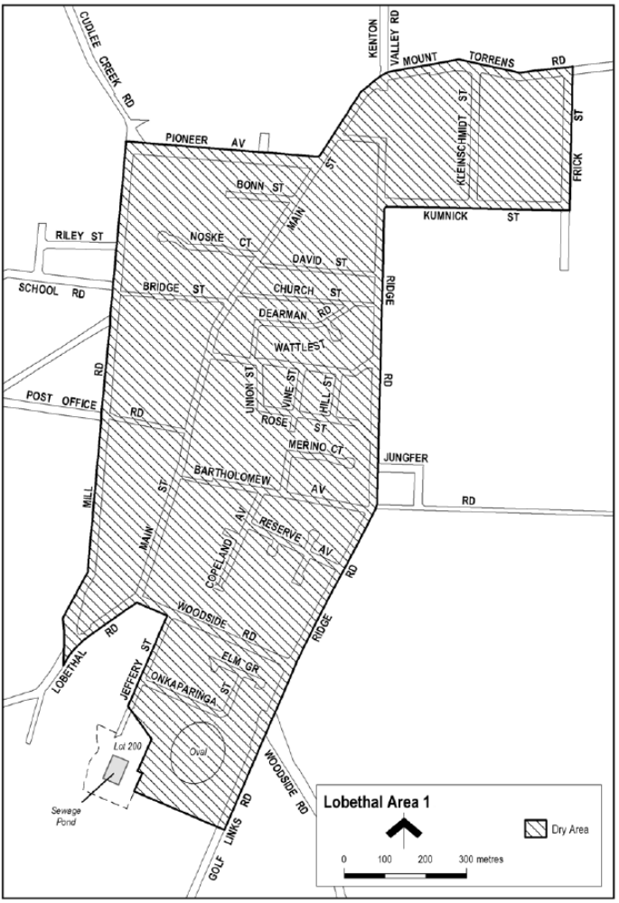
Schedule
Made by the Minister for Consumer and Business Affairs
On 16 September 2026

Mental Health Act 2009
Authorised Mental Health Professional
Notice is hereby given in accordance with Section 94(1) of the Mental Health Act 2009, that the Chief Psychiatrist has determined the following person as an Authorised Mental Health Professional:
Michelle Haine
Tonya Hedges
Julie Turner
Steven Letcher
Christine Dickinson
Megan Kennard
Angela Bui
Katelyn Reynolds
Sukhdeep Sekhon
Heidi McKinlay
Diva Alvita
Samuel Merret
Nicola Byrne
Julia Rebholz
Feba Saju
Michelle Capewell
Qinqin Yang
The above determinations will expire three years after the commencement date.
The Chief Psychiatrist make vary or revoke these determinations at any time.
Dated: 24 September 2026
Associate Professor Melanie Turner
Chief Psychiatrist

Planning, Development and Infrastructure Act 2016
Section 76
Amendment to the Planning and Design Code
Preamble
It is necessary to amend the Planning and Design Code (the Code) in operation at 10 September 2026 (Version 2026.17) in order to make changes of form relating to the Code’s spatial layers and their relationship with land parcels. Note: There are no changes to the application of zone, subzone or overlay boundaries and their relationship with affected parcels or the intent of policy application as a result of this amendment.
1. Pursuant to Section 76 of the Planning, Development and Infrastructure Act 2016 (the Act), I hereby amend the Code in order to make changes of form (without altering the effect of underlying policy), correct errors and make operational amendments as follows:
(a) Undertake minor alterations to the geometry of the spatial layers and data in the Code to maintain the current relationship between the parcel boundaries and Code data as a result of the following:
(i) New plans of division deposited in the Land Titles Office between 2 September 2026 and 15 September 2026 affecting the following spatial and data layers in the Code:
A. Zones and subzones
B. Technical and Numeric Variations
• Building Heights (Levels)
• Building Heights (Metres)
• Interface Height
• Minimum Frontage
• Minimum Site Area
• Minimum Primary Street Setback
• Minimum Side Boundary Setback
• Future Local Road Widening Setback
C. Overlays
• Affordable Housing
• Airport Building Heights (Regulated)
• Co-located Housing
• Future Local Road Widening
• Future Road Widening
• Hazards (Bushfire—High Risk)
• Hazards (Bushfire—Medium Risk)
• Hazards (Bushfire—General Risk)
• Hazards (Bushfire—Urban Interface)
• Hazards (Bushfire—Regional)
• Hazards (Bushfire—Outback)
• Heritage Adjacency
• Historic Area

• Local Heritage Place
• Noise and Air Emissions
• Regulated and Significant Tree
• Significant Retirement Facility and Supported Accommodation Sites
• State Heritage Place
• Stormwater Management
• Urban Tree Canopy
(ii) Improved spatial data for existing land parcels in the following locations (as described in Column A) that affect data layers in the Code (as shown in Column B):
Location (Column A) | Layers (Column B)
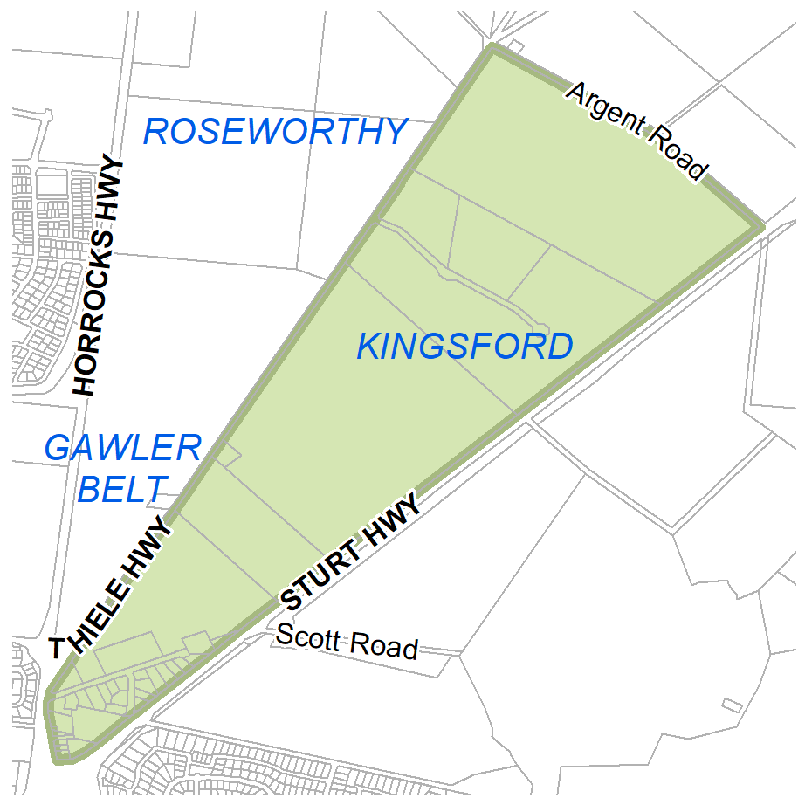  Gawler Belt | Zones  Overlays  - Interface Management  - Major Urban Transport Routes
(b) In Part 13 of the Code—Table of Amendments, update the publication date, Code version number, amendment type and summary of amendments within the ‘Table of Planning and Design Code Amendments’ to reflect the amendments to the Code as described in this Notice.
2. Pursuant to Section 76(5)(a) of the Act, I further specify that the amendments to the Code as described in this Notice will take effect upon the date those amendments are published on the SA planning portal.
Dated: 16 September 2026
Greg van Gaans
Director, Geospatial Information Services,
Department for Housing and Urban Development
Delegate of the Minister for Planning

Planning, Development and Infrastructure Act 2016
Regulation 57(1)
Determination of the Form for a Notice of a Decision
Preamble
Regulation 57(1) of the Planning, Development and Infrastructure (General) Regulations 2017 provides that notice of a decision on an application under Part 7 of the Planning, Development and Infrastructure Act 2016 (other than Subdivision 4 of Division of that Part) must be given in a form determined by the Minister for Planning (being a form published by the Minister in the Gazette).
Notice
Pursuant to Regulation 57(1) of the Planning, Development and Infrastructure (General) Regulations 2017, I, Andy Humphries, as the delegate of the Minister administering this regulation under the Planning, Development and Infrastructure Act 2016, have determined that the form contained in ‘Attachment A’ comprises the form for a notice of a decision on an application given under Part 7 of the Planning, Development and Infrastructure Act 2016 (other than Subdivision 4 of Division 2 of that Part).
The form may be adapted into a digital format for use on the SA planning portal.
This notice will come into force on 24 September 2026.
Dated: 17 September 2026
Andy Humphries
Director Development, Planning and Building
Department for Housing and Urban Development
Delegate of the Minister for Planning

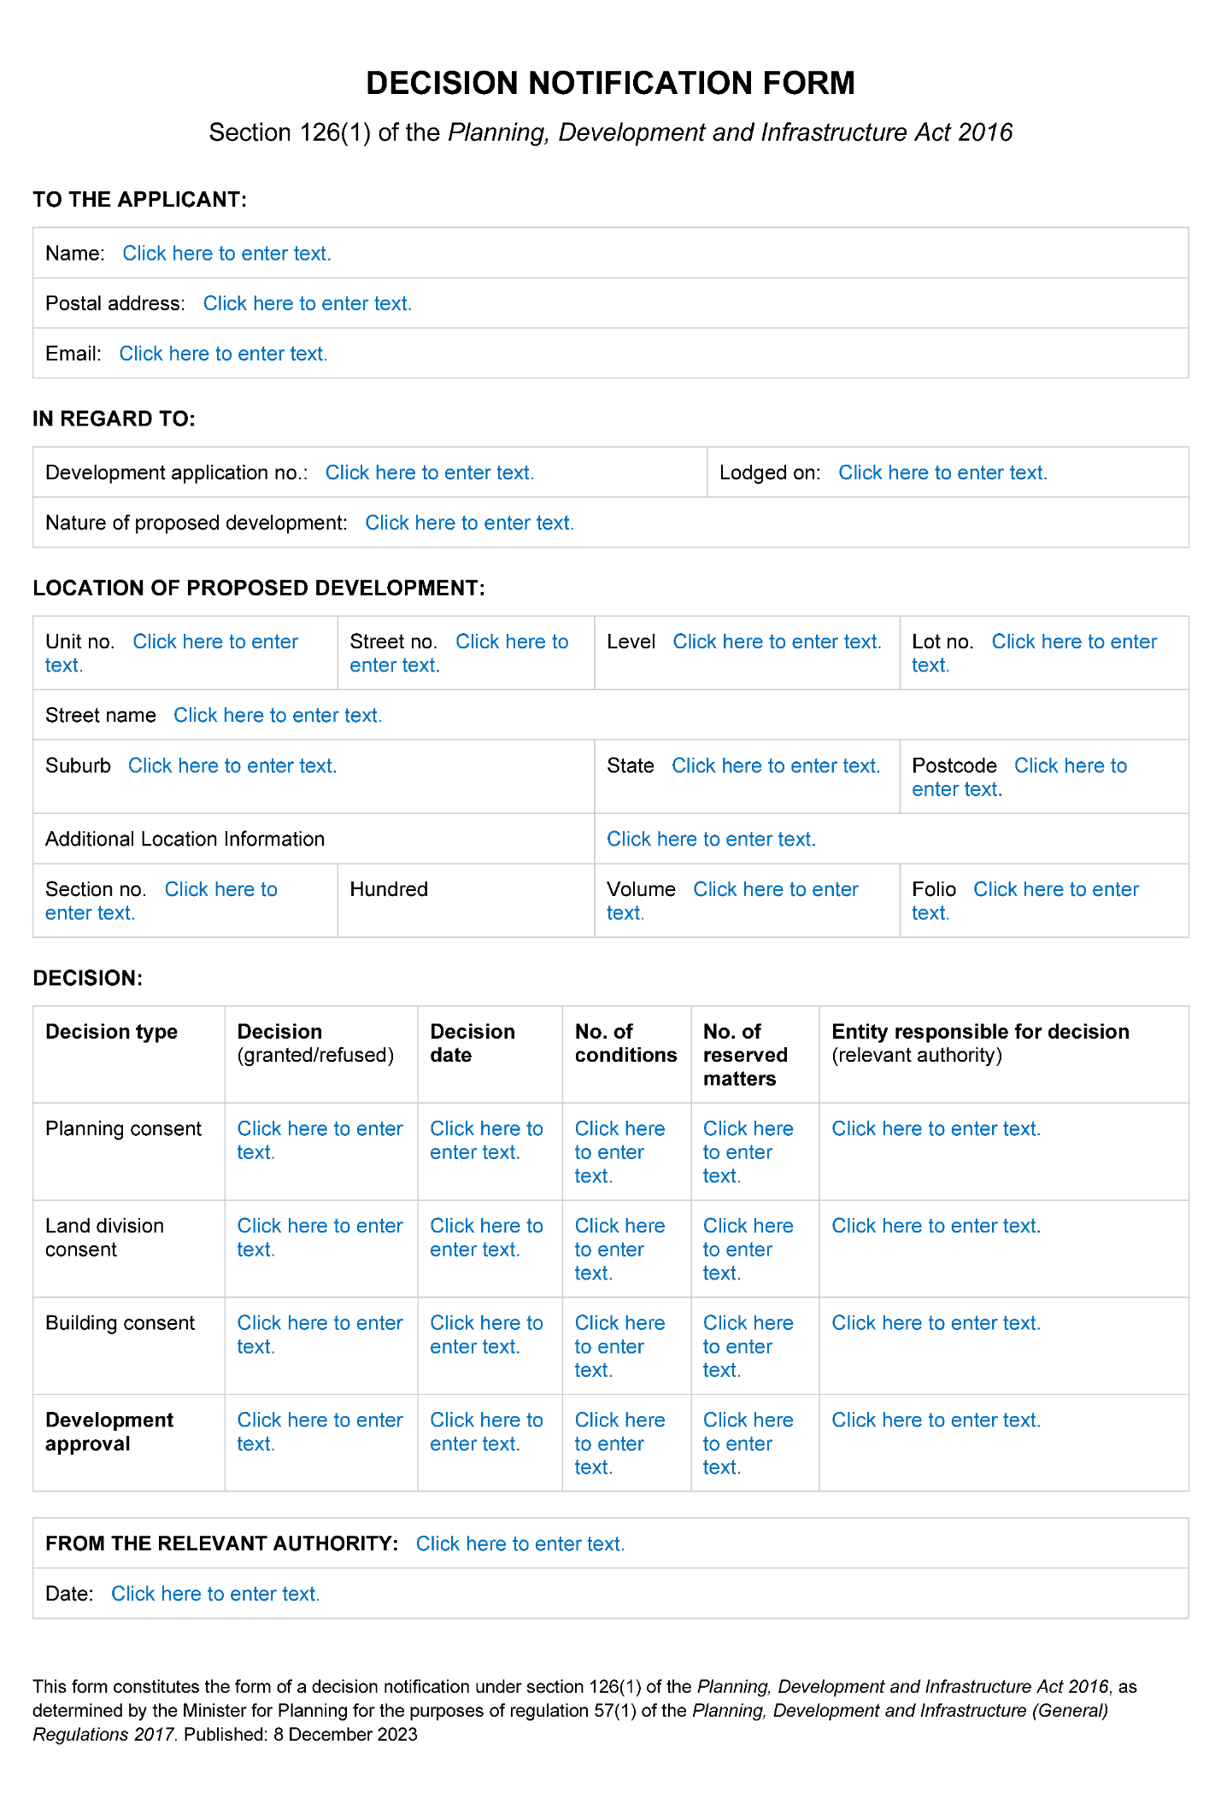
Attachment A
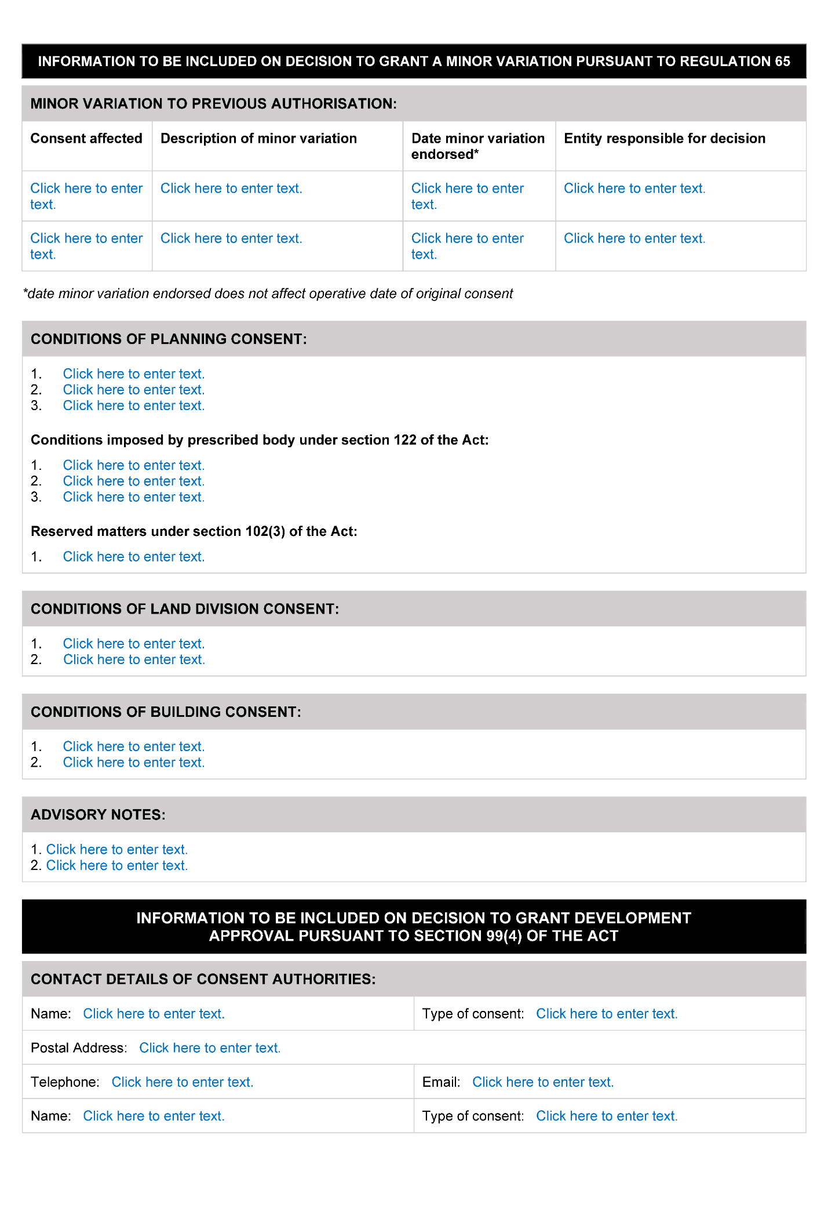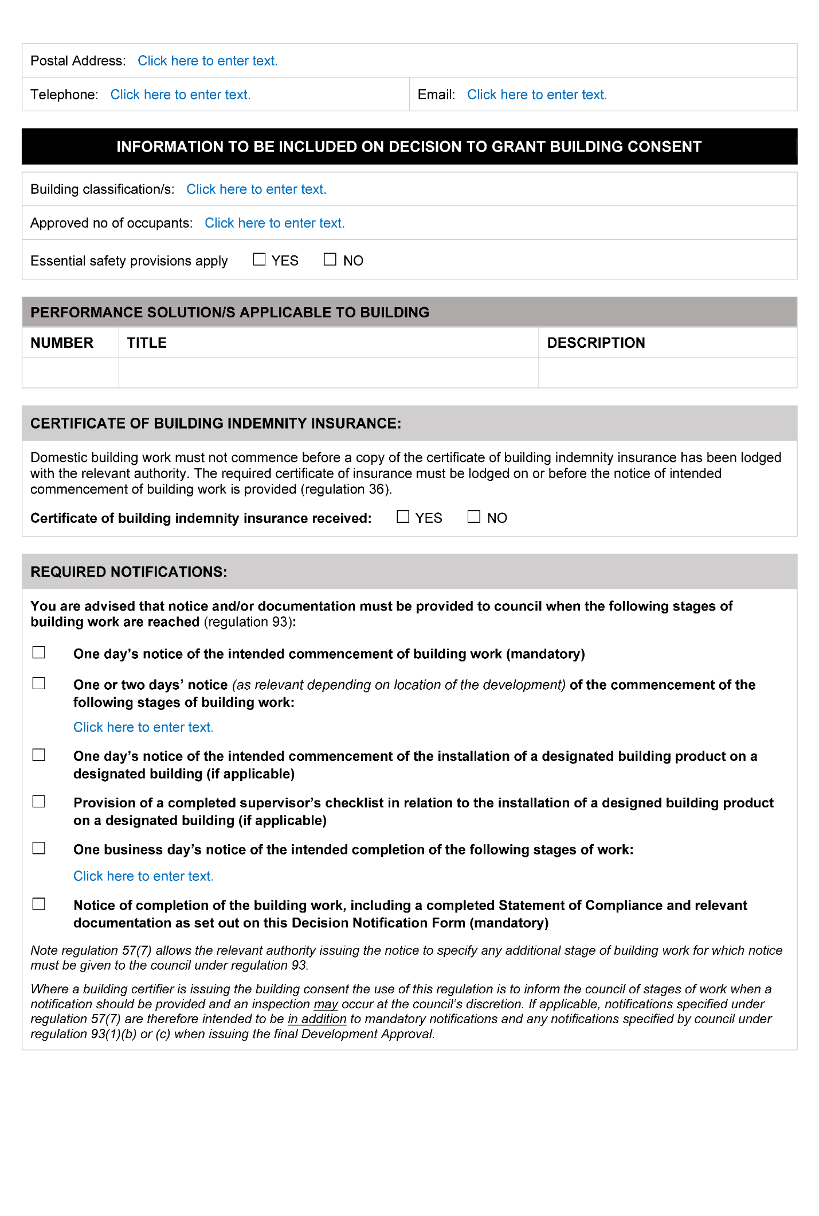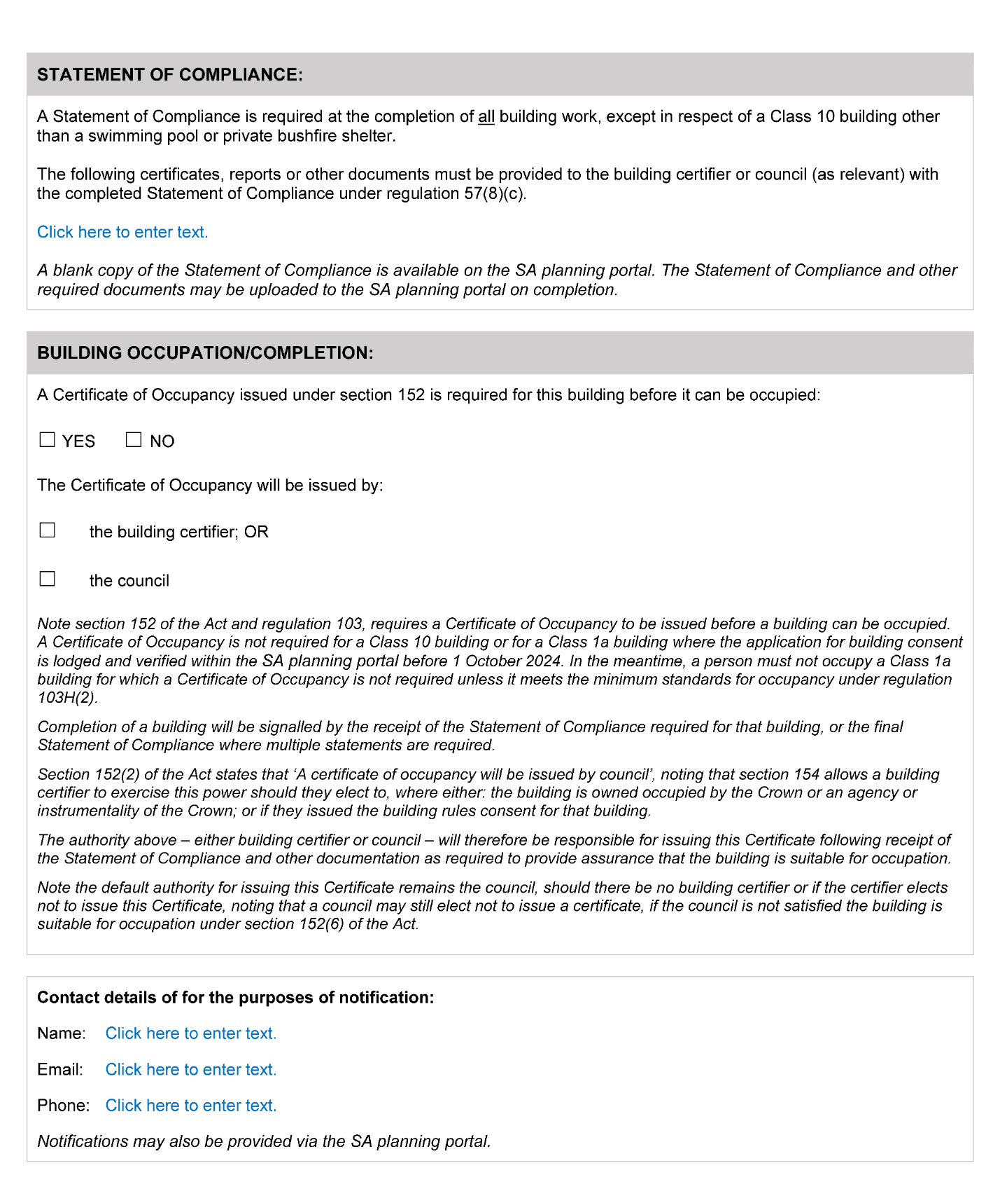

Plant Health Act 2009
Section 4
Declaration of Pests
Pursuant to Section 4(3) of the Plant Health Act 2009, I, Nick Secomb, Chief Inspector and Delegate of the Minister for Primary Industries and Regional Development revoke the previous Section 4 and 8 notices made on 3 September 2025 and published on 4 September 2025 on page 3790.
Pursuant to Section 4 of the Plant Health Act 2009, I, Nick Secomb, Chief Inspector and Delegate of the Minister for Primary Industries and Regional Development, hereby declare the following pests specified by common name or scientific name are declared to be pests for the purposes of the Act:
Common Name(s) | Scientific Name(s)
African citrus psyllid | Trioza erytreae
American serpentine leaf miner | Liriomyza trifolii
Anthracnose of Brassica crops | Colletotrichum higginsianum
Asian citrus psyllid | Diaphorina citri
Asian longicorn beetle | Anaplophora glabripennis
Asian subterranean termite | Cryptotermes gestroi
Australian plague locust | Chortoicetes terminifera
Bacterial wilt of potato | Ralstonia solanacearum Race 3
Barley stem gall midge | Mayetiola hordei
Barley stripe rust | Puccinia striiformis f. sp. hordei
Blueberry rust | Thekopsora minima
Boil smut of maize | Ustilago maydis
Brown marmorated stink bug | Halyomorpha halys
Browsing ant | Lepisiota frauenfeldi
Budapest slug | Tandonia budapestensis
Burning moth | Hylesia nigricans
Caracollina lenticula | Caracollina lenticula
Ceratocystis wilt | Ceratocystis manginecans, Ceratocystis spp. (exotic species)
Chestnut blight | Cryphonectria parasitica
Chickpea leaf miner | Liriomyza cicerina
Chocolate-band snail | Eobania vermiculata
Citrus blight | (unknown causal agent)
Citrus canker | Xanthomonas citri subsp. citri
Citrus longicorn beetle | Anaplophora chinensis
Citrus red mite | Panonychus citri
Citrus tristeza virus—sweet orange stem pitting strain | Citrus tristeza closterovirus—sweet orange stem pitting strain
Citrus variegated chlorosis | Xylella fastidiosa
Columnea latent viroid (CLVd) | Columnea latent viroid
Cucumber fruit mottle mosaic virus (CFMMV) | Cucumber fruit mottle mosaic tobamovirus
Cucumber green mottle mosaic virus (CGMMV) | Cucumber green mottle mosaic tobamovirus
Drywood termite | Cryptotermes dudleyi
Electric ant | Wasmannia auropunctata
European House Borer | Hylotrupes bajulus
Exotic gypsy moth | Lymantria spp. (L. dispar and sub-species, L. monacha)
Fire blight | Erwinia amylovora
Fruit flies | Pest species of Tephritidae family
Fusarium wilt of tomatoes | Fusarium oxysporum f.sp. lycopersicon Race 3
Giant African snail | Lissachatina fulica
Giant pine scale | Marchalina hellenica
Glassy-winged sharpshooter | Homalodisca vitripennis
Golden apple snail | Pomacea canaliculata
Grape phylloxera | Daktulosphaira vitifolliae
Grapevine leaf rust | Phakopsora euvitis
Grapevine red blotch-associated virus | Grapevine red blotch-associated geminivirus
Green snail | Cantareus apertus
Guava Root Knot Nematode | Meloidogyne enterolobii
Harlequin lady beetle | Harmonia axyridis
Hessian fly | Mayetiola destructor
Huanglongbing disease of citrus | ‘Candidatus liberibacter’ spp.
Intonsa flower thrip | Frankliniella intonsa
Karnal bunt | Tilletia indica
Khapra beetle | Trogoderma granarium
Kyuri green mottle mosaic virus (KGMMV) | Kyuri green mottle mosaic tobamovirus
Melon necrotic spot virus (MNSV) | Melon necrotic spot carmovirus
Melon thrips | Thrips palmi
Myrtle rust | Puccinia psidii (syn. Uredo rangelii)
Myrtle rust (exotic strains) | Austropuccinia psidii (syn. Puccinia psidii, Uredo rangelii)—exotic strains
Parlatoria date scale | Parlatoria blanchardi
Pepino mosaic virus (PepMV) | Pepino mosaic potexvirus
Pepper chat fruit viroid (PCFVd) | Pepper chat fruit viroid
Phoney peach disease | Xylella fastidiosa
Phytophthora blight | Phytophthora kernoviae
Pierce’s disease of grapevines | Xylella fastidiosa
Pine wilt nematode | Bursaphelenchus spp. including B. xylophilus
Pitch canker | Fusarium circinatum
Polyphagous shot hole borer | Euwallacea fornicatus
Polyphagous shot hole borer-associated fusarium wilt | Fusarium euwallaceae
Potato blackleg and soft rot | Dickeya spp. Including D. dianthicola, D. dadantii and D. solani
Potato cyst nematode | Globodera pallida
Potato cyst nematode | Globodera rostochiensis
Potato late blight | Phytophthora infestans (A2 mating type)
Potato mop top virus (PMTV) | Pomovirus solani
Potato spindle tuber viroid (PSTVd) | Potato spindle tuber pospiviroid
Pyriform scale | Protopulvinaria pyriformis
Red imported fire ant | Solenopsis invicta
Sawyer beetles | Monochamus spp. Including M. alternatus, M. galloprovincialis, M. scutellatus, M. titillator
Sharka | Plum pox potyvirus
Small plague grasshopper | Austroicetes cruciata
Spotted-winged drosophila (fruit fly) | Drosophila suzukii
Strawberry latent ringspot virus (SLRSV) | Strawberry latent ringspot virus
Stubborn disease of citrus | Spiroplasma citri
Subterranean termite | Coptotermes formosanus
Sudden oak death | Phytophthora ramorum
Tarnished plant bug | Lygus lineolaris
Teratosphaeria canker | Teratosphaeria destructans and T. zuluensis
Tomato apical stunt viroid (TASVd) | Tomato apical stunt viroid
Tomato black ring virus (TBRV) | Tomato black ring nepovirus
Tomato brown rugose fruit virus (ToBRFV) | Tomato brown rugose fruit tobamovirus
Tomato chlorotic dwarf viroid (TCDVd) | Tomato chlorotic dwarf viroid
Tomato leaf miner | Liriomyza bryoniae
Tomato mottle mosaic virus (ToMMV) | Tomato mottle mosaic tobamovirus
Tomato planta macho viroid (TPMVd) | Tomato planta macho viroid
Tomato-potato psyllid | Bactericera cockerelli
Tropical fire ant | Solenopsis geminata
Vegetable leaf miner | Liriomyza sativae
Watermelon green mottle mosaic virus (WGMMV) | Watermelon green mottle mosaic tobamovirus
West Indian drywood termite | Cryptotermes brevis
Western plant bug | Lygus hesperus
Wheat stem rust (exotic strains) | Puccinia graminis f. sp. tritici (exotic strains)
Wheat stem sawfly | Cephus spp. (C. cinctus, C. pygmeaus)
Yellow crazy ant | Anoplolepis gracilipes
Zebra chip of potatoes, ‘yellows’ and other diseases of solanaceous and apiaceous plants | ‘Candidatus Liberibacter solanacearum’ (all Haplotypes)
Zucchini green mottle mosaic virus (ZGMMV) | Zucchini green mottle mosaic tobamovirus
In this Notice:
“the Act” means the Plant Health Act 2009.
This Notice will remain in force until revoked by subsequent Notice.
Dated: 18 September 2026
Nick Secomb
Chief Inspector
Delegate for the Minister for Primary Industries and Regional Development

Plant Health Act 2009
Section 8
Declaration of Quarantine Areas
Pursuant to Section 8(3) of the Plant Health Act 2009, I, Nick Secomb, Chief Inspector and Delegate of the Minister for Primary Industries and Regional Development revoke the previous Section 8 notice made on 3 September 2025 and published on 4 September 2025 on page 3792.
Pursuant to Section 8 of the Plant Health Act 2009, I, Nick Secomb, Chief Inspector and Delegate of the Minister for Primary Industries and Regional Development, hereby declare the portions of the State listed in Part 1 of this notice to be quarantine areas for the purposes of the Act.
Part 1
1.1 The following portions of the State are declared to be quarantine areas:
(1) the whole of Kangaroo Island with respect to the declared pests of potatoes. This quarantine area is to be known as the ‘Kangaroo Island Protected Production Area’.
(2) with respect to pest fruit flies, for the purposes of control and eradication, a “Controlled Movement Zone” (as defined in Part 2 of this Notice).
(3) with respect to pest fruit flies, for the purpose of excluding fruit flies from the Riverland of South Australia (“Riverland Pest Free Area”), the:
(i) County of Hamley; and
(ii) Hundreds of Bookpurnong, Cadell, Gordon, Holder, Katarapko, Loveday, Markaranka, Moorook, Murtho, Parcoola, Paringa, Pooginook, Pyap, Stuart, Waikerie, Eba, Fisher, Forster, Hay, Murkbo, Nildottie, Paisley, Ridley and Skurray.
(4) with respect to Cantareus apertus, for the purposes of control and eradication, the following is declared a quarantine area and will be known as the ‘Green Snail Quarantine Area’:
(i) the area extending outwards for 2km from the parcel boundary of the place known as Ferguson Conservation Park located on Hallett Road, Stonyfell, Certificate of Title Volume 5772 Folio 813.
1.2 Measures to be taken in quarantine areas:
(1) the owner or occupier of any premises within the ‘Kangaroo Island Protected Production Area’ established under Part 1 1.1(1) must take the measures prescribed in the Standard for eradication of the declared diseases of potatoes;
(2) for the purposes of control and eradication of fruit flies, unless permitted within the Standard, host fruit grown in or introduced into a Controlled Movement Zone must not be moved within or removed from the Controlled Movement Zone without approval from the Chief Inspector or delegate; and
(3) the owner or occupier of any premises within a portion of the State declared to be a:
(i) Delimitation Zone (as defined in Part 2 of this Notice) must take the measures prescribed in the Standard for the control and eradication of such flies from a fruit fly outbreak zone;
(ii) Corrective Action Zone (as defined in Part 2 of this Notice) must take the measures prescribed in the Standard for the control and eradication of such flies from a fruit fly outbreak area; and
(iii) Export Assurance Zone (as defined in Part 2 of this Notice) must take the measures prescribed in the Standard for the control and eradication of such flies from a fruit fly suspension area.
(4) Measures for the exclusion of fruit flies from the Riverland of South Australia (“Riverland Pest Free Area”):
(i) Introduction of host fruits, as specified under Section 7 of the Act, into the Riverland Pest Free Area is prohibited unless:
(a) in transit through the Riverland Pest Free Area; or
(b) if the host fruit was produced in a State or Territory other than South Australia or interstate Fruit Fly Pest Free Area (FF-PFA): the host fruit complies with the treatments described within Part 1, paragraph 1.2(4)(iii) below and is accompanied with plant health certification; or
(c) if the host fruit was produced in any part of South Australia outside the Riverland Pest Free Area, the host fruit has been certified by an inspector as having been either:
(i) grown in an area free of fruit flies as defined by the Standard; or
(ii) treated in compliance with the treatments described in Part 1, paragraph 1.2(4)(iii) below; or
(d) moved under an accreditation arrangement as approved by the Minister under Part 4 Division 2 of the Act and Regulation 7 of the Plant Health Regulations 2022; or
(e) accompanied by an itemised retail purchase docket applicable to that produce and issued by an Approved PFA suitable retail store.
(ii) If the host fruit was originally produced in the Riverland Pest Free Area or an interstate Fruit Fly Pest Free Area, but has moved outside that area and is now proposed to be re-introduced, or introduced for the first time as the case may be, into the Riverland Pest Free Area, the produce must be:
(a) maintained under secure conditions throughout the duration that it was outside the Riverland Pest Free Area or interstate Fruit Fly Pest Free Area; and
(b) labelled in accordance with the Plant Health Regulations 2022 and accompanied with documentation demonstrating the origin and destination of the host fruit; or
(c) moved under an accreditation arrangement as approved by the Minister under Part 4 Division 2 of the Act and Regulation 7 of the Plant Health Regulations 2022; or
(d) Treated in compliance with the treatments described in Part 1, paragraph 1.2(4)(iii) below and is accompanied with plant health certification.
(iii) The following treatments are prescribed for the purpose of moving produce into the Riverland Pest Free Area:
(a) Treatment in accordance with Condition 9 (Area Freedom for fruit flies/secure transportation) as described in the Standard
(b) Treatment in accordance with Condition 10.1 (Hard green or similar condition for Fruit Fly) as described in the Standard
(c) Treatment in accordance with Condition 11 (Disinfestation by Cold Storage) as described in the Standard
(d) Treatment in accordance with Condition 12 (Disinfestation using Dimethoate—Queensland fruit fly) as described in the Standard
(e) Treatment in accordance with Condition 12E (Winegrapes Secure Transportation—Queensland Fruit Fly/Mediterranean Fruit Fly—Systems Approach—ICA 33) as described in the Standard
(f) Treatment in accordance with Condition 13 (Disinfestation by Methyl Bromide fumigation) as described in the Standard
(g) Treatment in accordance with Condition 14 (Disinfestation by Irradiation) as described in the Standard
(h) Treated or consigned under conditions approved by the Chief Inspector.
(5) With respect to Green Snail, (Cantareus apertus) the owner or occupier of any premises within the Green Snail Quarantine Area must take the following measures:
(i) Any host item located on a property within the Green Snail Quarantine Area which may harbour Cantareus apertus is prohibited from leaving the property unless it meets the conditions laid out in Part 1, paragraphs 1.2(5)(i)(a) to (d) below:
(a) The host item is inspected by an inspector and the inspector is satisfied that the item is free of Cantareus apertus; and
(b) if Cantareus apertus are found during inspection, or the item cannot be inspected to satisfy that the host item is free of Cantareus apertus, the host item must be cleaned or treated using a method approved by the Chief Inspector; and
(c) the host item is removed from the Green Snail Quarantine Area immediately upon being inspected in accordance with Part 1, paragraph 1.2(5)(i)(a) or (b) above; or immediately upon being cleaned or treated in accordance with Part 1, paragraph 1.2(5)(i)(c) above; or
(d) in the case of residential garden waste, host items must be disposed of by placing inside a green waste bin located on the residential property which is kept closed when not in use and is placed for collection on the designated local government area collection day; or
(e) is otherwise consigned under conditions prescribed by the Chief Inspector.
(ii) One of the following prescribed treatments must be applied before moving host items out of the Green Snail Quarantine Area:
(a) treatment in accordance with Condition 23 (Hosts of Green Snail) as described in the Standard; and
(b) accompanied with Plant Health Certification issued by a Plant Health Inspector certifying the host items meets Condition 23 of the Standard; or
(c) moved under an accreditation arrangement as approved by the Minister under Part 4 Division 2 of the Act and Regulation 7 of the Plant Health Regulations 2022; and
(d) is accompanied with a Plant Health Assurance Certificate issued by a business accredited under the Act; or
(e) is otherwise consigned under conditions prescribed by the Chief Inspector.
Part 2
In this Notice:
“the Act” means the Plant Health Act 2009.
“annual vegetation” means plants that grow for only a single year and not purposely grown for amenity reasons.
“Approved PFA suitable retail store” means a retail store who holds an accreditation arrangement as approved by the Minister under Part 4 Division 2 of the Act and Regulation 7 of the Plant Health Regulations 2022, and as having verified systems for the management and traceability of host fruit, and does not receive, display or sell any host fruit that does not meet the requirements of Part 1, paragraph 1.2(4)(iii) of this Notice.
“Controlled Movement Zone” (also known as the Fruit Fly Affected Area) means the entire area within a circle of pre-determined radius surrounding a fruit fly outbreak centre Epicentre in which area freedom status is suspended and movement controls are applied:
• Unless otherwise determined by the Chief Inspector, the pre-determined radius of the Controlled Movement Zone is 15 kilometres in the case of an outbreak of Queensland fruit fly.
• Unless otherwise determined by the Chief Inspector, the pre-determined radius of the Controlled Movement Zone is 7.5 kilometres in the case of an outbreak of Mediterranean fruit fly.
“Corrective Action Zone” (also known as the fruit fly outbreak area) means an area within 1.5 kilometres radius of a fruit fly outbreak centre Epicentre, unless otherwise determined by the Chief Inspector.
“Delimitation Zone” (also known as the fruit fly outbreak zone) means all of the land within a 200 metre radius around each fruit fly Discovery Point once the outbreak trigger has been met, unless otherwise determined by the Chief Inspector.
“Discovery Point” means the physical location where:
• One or more suspect adult flies have been collected during a single inspection of a trap (regardless of whether the detection triggers and outbreak or not); or
• Host material containing fruit fly larvae was grown.
“Export Assurance Zone” (also known as the fruit fly suspension area) means the area starting at the outer boundary of the Corrective Action Zone to the pre-determined radius surrounding an Epicentre in which area freedom status is suspended and movement controls are applied:
• The pre-determined radius of the fruit fly Export Assurance Zone is 15 kilometres in the case of an outbreak of Queensland fruit fly, unless otherwise determined by the Chief Inspector.
• The pre-determined radius of the fruit fly Export Assurance Zone is 7.5 kilometres in the case of an outbreak of Mediterranean fruit fly, unless otherwise determined by the Chief Inspector.
“Epicentre” (also known as the fruit fly outbreak centre) means the means the location related to each single detection or grouping of detections that triggers an outbreak. An Epicentre may be:
• the Discovery Point where the first larvae or gravid female was detected; or
• a location between a grouping of male flies that precipitated the outbreak.
“fruit fly outbreak trigger” means the detection of fruit fly larvae in locally grown fruit, the detection of one gravid female fruit fly, or the detection of a predetermined number of male fruit flies or non-gravid female fruit flies within a 1 kilometre radius within a consecutive fourteen-day period:
• The pre-determined number of male fruit flies or non-gravid female fruit flies is five for Queensland fruit fly.
• The pre-determined number of male fruit flies or non-gravid female fruit flies is three for Mediterranean fruit fly.
“host fruit” means the host fruits of fruit flies as specified under Section 7 of the Act. “host item” for the purposes of Cantareus apertus means:
• Soil originating from within the Green Snail Quarantine Area;
• Machinery or equipment that has been used within the Green Snail Quarantine Area which is capable of carrying adherent soil; or
• Any plant material originating from within the Green Snail Quarantine Area, including, but not limited to leafy vegetables, peas, beans, asparagus, strawberries, strawberry plants, cut flowers, turf, hay straw, fodder and potted plants generally, provided that such plants or plant products have been grown or remained within the Green Snail Quarantine Area, and excluding defoliated cuttings of all plants and bare rooted plants or bare rooted trees, provided they have no leaves or fruit.

“inspector” means an inspector appointed pursuant to Section 41 of the Act.
“interstate Fruit Fly Pest Free Area” means an area outside of South Australia certified by the Commonwealth Government department responsible for agriculture as a Fruit Fly Pest Free Area.
“introduced into”, for the purposes of control and eradication of fruit flies only, excludes host fruit in transit. “the Minister” means the Minister for Primary Industries and Regional Development.
“molluscicide” means a pesticide that will kill snails and slugs. “plant-related product” has the same meaning as in the Act.
“plant health certification” means assurance certificate or plant health certificate certifying the consignment as treated with the requirements described in Part 1, paragraph 1.2(4)(iii).
“quarantine area” means the area described in Part 1 of this Notice.
“retail purchase docket” means a sale provided by an Approved PFA suitable retail store for fruit or fruiting vegetables sold to the public for personal consumption rather than for resale.
“the Standard” means the document prepared and published by the Department of Primary Industries and Regions entitled the “Plant Quarantine Standard South Australia”.
“transiting” or “in transit” means the movement of securely contained plant product, either directly through South Australia or through another quarantine area for a plant pest, that is accompanied by documentation that can demonstrate both the origin and destination of product, and, whilst in South Australia or another quarantine area, is not subject to off- loading, reloading or storage.
“securely contained” means transported in a manner that prevents infestation of product with a quarantine pest and/or release of a quarantine pest and, for fruit fly purposes, meets the requirements of Condition 9 of the Standard.
This Notice will remain in force until revoked by subsequent Notice.
Dated: 17 September 2026
Nick Secomb
Chief Inspector
Delegate for the Minister for Primary Industries and Regional Development

The Remuneration Tribunal
Report No. 5 of 2026
Overseas Accommodation and Daily Allowance
Annual Meeting of the International Association of Judges—President Dolphin
Executive Summary
1. The Remuneration Tribunal (Tribunal) has made a determination providing for an Overseas Accommodation and Daily Allowance for the Honourable Justice Steven Dolphin, President of the South Australian Employment Tribunal (President Dolphin) to attend the Annual Meeting of the International Association of Judges in Lisbon, Portugal.
2. The Determination allows President Dolphin to be paid a reasonable daily allowance for meals and incidentals, as well as to be reimbursed for reasonable accommodation expenses (Overseas Accommodation and Daily Allowance).
3. The Tribunal has issued an accompanying determination granting an Overseas Accommodation and Daily Allowance for President Dolphin, which applies from 13 August 2026.
Background
4. The Remuneration Act 1990 (SA) (Act) provides that the Tribunal has jurisdiction to set the remuneration payable to the members of the judiciary.
5. The Tribunal has used this jurisdiction to provide for Overseas Accommodation and Daily Allowances for Members of the Judiciary for travel in the course of their official duties.
6. For the reasons set out in Report 9 of 2025, the Tribunal has continued to consider each application for an Overseas Accommodation and Daily Allowance on a case-by-case basis.
7. On 13 August 2026 the Tribunal received an application from President Dolphin for an Overseas Accommodation and Daily Allowance to attend the Annual Meeting of the International Association of Judges in Lisbon, Portugal (Conference) in October 2026. President Dolphin is seeking the Overseas Accommodation and Daily Allowance for the duration of the Conference.
The Review Process
8. On 25 August 2026, in accordance with Sections 10(2) and 10(4) of the Act, the Tribunal wrote to and invited submissions by
15 September 2026 in respect of this review from:
(a) The Honourable Premier of South Australia—as the Minister responsible for the Act who may make submissions or introduce evidence in the public interest; and
(b) The Judicial Remuneration Coordinating Committee (JRCC).
9. The Tribunal also placed a notice on its website on 25 August 2026 inviting submissions from affected persons by 26 September 2026.
10. On 25 August, the Premier’s representative confirmed that no submission would be made.
11. On 25 August the JRCC confirmed that it supports the application.
12. On 31 August the Tribunal wrote to President Dolphin to confirm the dates he was seeking an Overseas Accommodation and Daily Allowance.
13. On 1 September 2026 President Dolphin confirmed that his application was seeking an Overseas Accommodation and Daily Allowance for the dates of the Conference, being 15 - 21 October 2026.
14. No further submissions were received.
Consideration and Conclusion
15. The application can be summarised as follows:
(a) President Dolphin will be attending the Conference as a delegate of the Australian Judicial Officer’s Association; and
(b) President Dolphin has requested a reasonable Overseas Accommodation and Daily Allowance for the duration of the Conference from 15 October to 21 October 2026 inclusive.
16. The Tribunal recognises the necessity for judicial officers to travel internationally in the course of their official duties, noting that such travel has been infrequent. Consistent with past practice, the Tribunal has handled this application individually instead of determining a standing arrangement for overseas travel.
17. Having regard to the application and the submissions in response, the Tribunal has determined to approve the application on the terms set out in the accompanying Determination.
18. In determining President Dolphin’s entitlement to and the allowance amounts for each of the components of Overseas Accommodation and Daily Allowance for this overseas travel, the Tribunal has followed the same approach as the Commonwealth Remuneration Tribunal (Official Travel) Determination 2026.
19. The Commonwealth Remuneration Tribunal has updated the Official Travel Determination since this Tribunal last considered an application for an Overseas Accommodation and Daily Allowance, however the applicable principles and approach remain the same.
20. The Tribunal notes that President Dolphin has only claimed an Overseas Accommodation and Daily Allowance not in excess of the conference days. This is consistent with the Tribunal’s previous observations that the Overseas Accommodation and Daily Allowance is not appropriate for days a judicial officer is travelling and has access to airport lounges or is provided with meals as part of a long-haul flight.
21. Accordingly, a Daily Allowance of $340 (for meals and incidentals in Portugal) has been determined using tables 8 and 9 in the most recent Australian Taxation Office Determination (TD 2026/4) concerning reasonable amounts for overseas travel expenses on meals and incidentals.
22. Again, consistent with the approach in the Commonwealth Remuneration Tribunal (Official Travel) Determination 2026, the Tribunal has also determined to approve President Dolphin being reimbursed for the overseas accommodation directly associated with his attendance at the Conference, provided the reimbursement does not exceed the costs of accommodation of a standard reasonably equivalent to that which would be provided to His Honour in Australia for official duties.
Operative Date
25. The accompanying Determination will operate from 13 August 2026, being the date the application was received.
Dated: 16 September 2026
Matthew O’Callaghan
President
Donny Walford
Member
Mark Young
Member

The Remuneration Tribunal
Determination No. 5 of 2026
Overseas Accommodation and Daily Allowance
Annual Meeting of the International Association of Judges—President Dolphin
Scope of Determination
1. This Determination applies to the Honourable Justice Steven Dolphin, President of the South Australian Employment Tribunal.
Determination
2. President Dolphin will be entitled to the following in respect of his attendance at the Annual Meeting of the International Association of Judges in Lisbon, Portugal from 15 to 21 October 2026:
2.1. A daily allowance of A$340 set by reference to the most recent Australian Taxation Office determination (TD 2026/4) concerning reasonable meals and incidentals. This will be for 7 days; and
2.2. Reimbursement for his accommodation directly associated with his attendance at the conference, provided the reimbursement does not exceed the costs of accommodation of a standard reasonably equivalent to that provided to the President in Australia for official duties.
Date of Operation
3. This Determination operates from 13 August 2026.
Dated: 16 September 2026
Matthew O’Callaghan
President
Donny Walford
Member
Mark Young
Member

Retail and Commercial Leases Act 1995
Exemption
Pursuant to Section 77(2) of the Retail and Commercial Leases Act 1995 (SA) I, Daniel van Holst Pellekaan, Small Business Commissioner for the State of South Australia, exempt the Lease agreement which commenced on 1 March 2026, between Evolution MIT Services Pty Ltd (ACN 627 198 476) and World Wire Cables Pty Ltd (ACN 079 817 379) in relation to those portions of the Land comprised in Certificate of Title Volume 6289 Folio 89 and marked “Warehouse 1”, “Office 2”, “Yard 3” and “Accessway and Carpark 4” as described in FX257634 (Lease), from the entirety of the Retail and Commercial Leases Act 1995.
Dated: 18 September 2026
Hon. Daniel van Holst Pellekaan
Small Business Commissioner

Roads (Opening and Closing) Act 1991
Section 24
NOTICE OF CONFIRMATION OF
ROAD PROCESS ORDER
Road Closure—Portion of Legoe Road Tippets Bridge Road, Riverlea Park
By Road Process Order made on 19 March 2026, the City of Playford ordered that:
1. Portion of Legoe Road and Tippets Bridge Road, situated adjoining Allotment 9012 in Deposited Plan 132334, Block 66 in Deposited Plan 1671 and Section 174, Hundred of Port Adelaide, more particularly delineated and lettered ‘A’ and ‘B’ in Preliminary Plan 25/0014 be closed.
2. Issue a Certificate of Title to the City of Playford for the whole of the land subject to closure in accordance with the Application for Document of Title dated 19 March 2026.
3. The following easement is to be granted over portion of the land subject to closure:
Grant to the South Australian Water Corporation an easement for water supply purposes over the land marked ‘A’ in Deposited Plan 139922.
On 16 September 2026, the Road Process Order was confirmed by me, as delegate of the Minister for Planning, conditionally upon the deposit of Deposited Plan 139922 by the Registrar-General.
Notice of the Road Process Order and its confirmation is hereby given in accordance with Sections 24(4) and (5) of the Roads (Opening and Closing) Act 1991, following the confirmation of the Road Process Order and fulfilment of the condition of that confirmation.
Dated: 24 September 2026
B. J. Slape
Surveyor-General
Office of the Surveyor General
Delegate of the Minster for Planning
2025/04880/01

Roads (Opening and Closing) Act 1991
Section 24
NOTICE OF CONFIRMATION OF
ROAD PROCESS ORDER
Road Closure—Portion of Peel Creek Drive, Old Reynella
By Road Process Order made on 16 July 2026, the City of Onkaparinga ordered that:
1. Whole of Peel Creek Drive, Old Reynella, (being whole of allotment 706 in Deposited Plan 129786) situated adjoining allotment 1001 in Deposited Plan 135407 and allotment 101 in Deposited Plan 129786, Hundred of Noarlunga, more particularly delineated and lettered ‘A’ in Preliminary Plan 26/0001 be closed.
2. Transfer the whole of the land subject to closure to Tarac Properties Pty. Ltd. in accordance with the Agreement for Transfer dated 24 June 2026 entered into between the City of Onkaparinga and Tarac Properties Pty. Ltd.
3. The following easements are to be granted over the whole of the land subject to closure:
Grant a free and unrestricted right of way in favour of the council for the area over the land marked ‘A’ in Deposited Plan 140435.
Grant an easement for drainage purposes in favour of the council for the area over the land marked ‘B’ in Deposited Plan 140435.
On 18 September 2026, the Road Process Order was confirmed by me, as delegate of the Minister for Planning, conditionally on the deposit of Deposited Plan 140435 by the Registrar-General.
Notice of the Road Process Order and its confirmation is hereby given in accordance with Sections 24(4) and (5) of the Roads (Opening and Closing) Act 1991, following the confirmation of the Road Process Order and fulfilment of the condition of that confirmation.
Dated: 24 September 2026
B. J. Slape
Surveyor-General
Delegate of the Minster for Planning
2026/02208/01

South Australian Civil and Administrative Tribunal
SACAT Reference Number: 2026/SEO000002
Renewal and Granting of Exemption Before Tribunal Member Alex Reilly
I Hereby certify that on 14 September 2026, the South Australian Civil and Administrative Tribunal, on application of BAE Systems Australia Limited and ASC Shipbuilding Pty Limited made the following orders for renewal of an exemption:
1. Pursuant to Section 92 of the Equal Opportunity Act 1984 (SA) (the Act), the Applicants are exempted from compliance with the provisions of Sections 52, 54 and 103(1) of the Act to the extent that they may:
(a) request nationality and place of birth information from existing and potential employees and contractors;
(b) take a person’s nationality and place of birth into account in determining who should be offered employment or contract work in areas requiring access to material controlled under the International Traffic in Arms Regulations (ITAR) 22 CFR § 120 (2003) (USA), the Export Administration Regulations (EAR) and the Defence Trade Controls 2012 (Cth) when making decisions as to the participation of employees or contractors in such work;
(c) maintain records of the nationalities and places of birth of all employees and contractors who have or may have access to USA export controlled materials, and Australian export controlled materials;

(d) ensure that USA export controlled materials are disclosed only to persons who are authorised by ITAR controls or EAR controls to receive it;
(e) impose limitations or prohibitions on persons of particular nationalities or places of birth having access to USA export controlled materials and DSGL Technology;
(f) disclose to the ADF the nationalities and places of birth of all employees and contractors who will have access to USA export controlled materials;
(g) disclose to USA-based contractors for whom the Applicants perform work under subcontract and to the USA government, the nationalities and places of birth of all employees and contractors who will have access to USA export controlled materials in the performance of their work;
(h) establish security systems which will prevent the unauthorised re-export or re-transfer of USA and Australian export controlled materials.
2. This order does not permit the Applicants to terminate any employee’s employment on the grounds of nationality or place of birth.
3. The exemption is granted for a period of three years and will be subject to the following conditions:
(a) It will apply only to conduct by the Applicants where:
(i) that conduct is necessary to enable it to enter into and/or perform contractual undertakings requiring access to USA export-controlled materials; and
(ii) it has taken all steps that are reasonably available (including steps which might be taken in negotiating and performing the terms of its agreements with contractors in the USA) to avoid the necessity for engaging in conduct which would otherwise be in breach of Sections 52, 54 and 103(1) of the Act.
(b) Where, in the exercise of this exemption, an employee or contract worker is moved from a project involving the use of USA export controlled materials to any other work controlled by the Applicants or any of their related entities, the Applicants must through a duly authorised officer explain to the person why he or she is being transferred and must otherwise take all reasonable steps to avoid or limit harm or loss to that person.
(c) Where the Applicants use systems of security passes to reflect the fact of access to USA export controlled materials or levels of access to any security sensitive material by employees and contract workers, the passes may be coded but not in such a way as to identify the nationality or place of birth of the person or the reasons for that person’s level of access.
(d) All information relating to security passes, security clearance levels and access to USA export controlled materials shall be restricted to the Applicants’ Chief Counsel, Director of Export Controls, Director of Security, Chief People Officer (or such other equivalent positions as are in place from time to time) and to their properly appointed nominees on a “need to know” basis.
(e) The Applicants’ employment policies shall refer to the terms of this exemption, including all conditions attaching to it, and to make it clear that the purpose of the request for information regarding nationality and place of birth is made solely for the purposes of compliance with the laws of the USA.
(f) The Applicants will report to the Commissioner for Equal Opportunity on an annual basis on the following matters.
(i) The training and education provided to new and existing employees on these Orders and their implementation
(ii) The steps taken by the Applicants to implement these Orders.
(iii) How the Applicants monitor compliance with these Orders.
(iv) The number of persons affected by these Orders and the nature of those effects.
(v) The steps taken by the Applicants to address any adverse effects on existing employees as a result of these Orders
(vi) The steps taken by the Applicants to minimise the impact of these orders on current and future employees.
4. In these orders, Applicants mean each of:
(a) BAE Systems Australia Limited,
(b) ASC Shipbuilding Pty Limited
Dated: 17 September 2026
Anne Lindsay
Principal Registrar
South Australian Civil and Administrative Tribunal

Local Government Instruments

City of Charles Sturt
Roads (Opening and Closing) Act 1991
Road Closing—5 Gething Crescent, Bowden
Notice is hereby given, pursuant to Section 10 of the Roads (Opening and Closing) Act 1991, that the City of Charles Sturt proposes to make a Road Process Order to close and merge with Closed Roads Marked F and G in Road Plan 3019 portion of Gething Cresent adjoining Closed Roads Marked F and G in Road Plan 3019, more particularly delineated and lettered ‘A’ and ‘B’ respectively on Preliminary Plan 26/0033.
The Preliminary Plan and Statement of Persons Affected are available for public inspection at the office of the Council at 72 Woodville Road, Woodville SA 5011 and the Adelaide Office of the Surveyor-General during normal office hours. The Preliminary Plan can also be viewed at www.sa.gov.au/roadsactproposals.
Any application for easement or objection must set out the full name, address and details of the submission and must be fully supported by reasons. The application for easement or objection must be made in writing to the City of Charles Sturt at PO Box 1, Woodville SA 5011 within 28 days of this notice and a copy must be forwarded to the Surveyor-General at GPO Box 1815, Adelaide 5001. Where a submission is made, the Council will give notification of a meeting at which the matter will be considered.
Dated: 24 September 2026
Paul Sutton
Chief Executive Officer

City of Playford
Roads (Opening and Closing) Act 1991
Road Closing—Beagle Hole Road and Public Road, Riverlea Park
Notice is hereby given, pursuant to Section 10 of the Roads (Opening and Closing) Act 1991, that the City of Playford proposes to make a Road Process Order to:
(i) Close and sell to the adjoining landowner a portion of Beagle Hole Road and Public Road adjoining pieces 1,2,3,4 in F40207, allotment 6 in F16853, piece 11 in F114472 and piece 20 in F108216 more particularly delineated and lettered ‘A’, ‘C’ and ‘D’ on Preliminary Plan 25/0013.
(ii) Close and retain by the council adjoining allotment 15 in F108212 more particularly delineated and lettered ‘B’ on Preliminary Plan 25/0013.
The proposed road closure is required to support the construction of stormwater infrastructure for the Riverlea development. Specifically, the closures will facilitate the construction of stormwater infrastructure between Carmelo Road and Thompson Creek. The completed stormwater infrastructure will be vested in the ownership of Council.
The Preliminary Plan is available for public inspection at the Playford Civic Centre offices (10 Playford Boulevard, Elizabeth), the Stretton Centre (307 Peachey Road, Munno Para), and the Adelaide Office of the Surveyor-General located at Level 10, 83 Pirie Street Adelaide, during normal office hours. The Preliminary Plan can also be viewed at www.sa.gov.au/roadsactproposals or playford.engagementhub.com.au.
Any application for easement or objection must set out the full name, address and details of the submission and must be fully supported by reasons. The application for easement or objection must be made in writing to the City of Playford, 12 Bishopstone Road, Davoren Park SA 5113 within 28 days of this notice, and a copy must be forwarded to the Surveyor-General at PO Box 1815, Adelaide 5001. Where a submission is made, the applicant must be prepared to support their submission in person upon council giving notification of a meeting at which the matter will be considered.
Dated: 24 September 2026
Sam Green
Chief Executive Officer

City of Salisbury
Disposal of Abandoned Vehicles
Notice is hereby given that in accordance with the powers contained in Section 237(2) of the Local Government Act 1999, or Section 40N of the Road Traffic Act 1961, Council has impounded the following vehicle(s):
• Toyota Hilux white burnt out 1XG4CC Vic 32-40 Greyhound Road, Waterloo Corner SA 5110.
Unless claimed by the owner(s), and all expenses paid, the vehicle(s) will be disposed of in the manner provided in the above Act, at the expiration of 1 month of the date of this notice.
For further information, please contact the Community Compliance Team on 8406 8222.
Dated: 24 September 2026
J. Harry
Chief Executive Officer

City of Salisbury
Disposal of Abandoned Vehicles
Notice is hereby given that in accordance with the powers contained in Section 237(2) of the Local Government Act 1999, or Section 40N of the Road Traffic Act 1961, Council has impounded the following vehicle(s):
• VW Black sedan DD018U—29 Bremen Drive, Salisbury South SA 5106.
Unless claimed by the owner(s), and all expenses paid, the vehicle(s) will be disposed of in the manner provided in the above Act, at the expiration of 1 month of the date of this notice.
For further information, please contact the Community Compliance Team on 8406 8222.
Dated: 24 September 2026
J. Harry
Chief Executive Officer

The Barossa Council
Roads (Opening and Closing) Act 1991
Road Closing—Goat Square, Tanunda
Notice is hereby given, pursuant to Section 10 of the Roads (Opening and Closing) Act 1991, that The Barossa Council proposes to make a Road Process Order to close and merge with Allotment 200 in Deposited Plan 132298 portion of Goat Square adjoining Allotment 200 in Deposited Plan 132298 and Allotment 4 in Filed Plan 122730, more particularly delineated and lettered “A” on Preliminary Plan 26/0032.
The preliminary plan and statement of persons affected is available for public inspection at the offices of The Barossa Council,
43-51 Tanunda Road, Nuriootpa SA 5355 and the Adelaide Office of the Surveyor-General during normal office hours. The preliminary plan can also be viewed at www.sa.gov.au/roadsactproposals and www.barossa.sa.gov.au.
Any application for easement or objection must set out the full name, address and details of the submission and must be fully supported by reasons. The application for easement or objection must be made in writing to The Barossa Council, PO Box 867, Nuriootpa SA 5355 within 28 days of this notice and a copy must be forwarded to the Surveyor-General at GPO Box 1815, Adelaide SA 5001. Where a submission is made, the applicant must be prepared to support their submission in person upon council giving notification of a meeting at which the matter will be considered.
Dated: 24 September 2026
Martin McCarthy
Chief Executive Officer

District Council of Ceduna
Local Government Act 1999
Dog and Cat Management Act 1995
By-law No. 4 of 2026—Dogs By-law 2026
For the management and control of dogs within the Council’s area.
Part 1—Preliminary
1. Short Title
This by-law may be cited as the Dogs By-law 2026.
2. Commencement
This by-law will come into operation four months after the day on which it is published in the Gazette in accordance with Section 249(5) of the Local Government Act 1999.
3. Definitions
In this by-law:
3.1 approved kennel establishment means a building, structure or area approved by the relevant authority, pursuant to the
Planning, Development and Infrastructure Act 2016 for the keeping of dogs on a temporary or permanent basis;
3.2 assistance dog has the same meaning as in the Dog and Cat Management Act 1995;
3.3 control, in relation to a dog, includes the person having ownership, possession or charge of, or authority over, the dog;
3.4 dog has the same meaning as in the Dog and Cat Management Act 1995;
3.5 effective control means a person exercising effective control of a dog either:
3.5.1 by means of a physical restraint;
3.5.2 by command, the dog being in close proximity to the person, and the person being able to see the dog at all times;
3.6 keep includes the provision of food or shelter;
3.7 leash includes any chain, cord or leash;
3.8 local government land has the same meaning as in the Local Government Act 1999;
3.9 park has the same meaning as in the Dog and Cat Management Act 1995;
3.10 premises includes:
3.10.1 land;
3.10.2 a part of any premises or land;
3.11 public place has the same meaning as in the Dog and Cat Management Act 1995;
3.12 township has the same meaning as in the Local Government Act 1999.
Part 2—Dog Management and Control
4. Dog Free Areas
4.1 A person must not allow a dog in that person’s control to be in or remain in a dog free area.
4.2 For the purposes of this paragraph, a dog free area is any local government land or public place to which the Council has resolved this paragraph applies.
4.3 The restrictions in subparagraph 4.1 do not apply to any assistance dog.
5. Dog on Leash Areas
5.1 A person must not allow a dog under that person’s control to be in, or remain in, a dog on leash area unless the dog is secured by a strong leash not exceeding two metres in length which is either:
5.1.1 tethered securely to a fixed object capable of securing the dog; or
5.1.2 held by a person capable of controlling the dog and preventing it from being a nuisance or a danger to other persons.
5.2 For the purposes of this paragraph, a dog on leash area is any local government land or public place to which the Council has resolved that this paragraph applies.
5.3 The restrictions in subparagraph 5.1 do not apply to any assistance dog.
6. Dog Exercise Areas
6.1 Subject to paragraphs 4 and 5, a person may enter any dog exercise area for the purpose of exercising a dog under their control.
6.2 For the purposes of this paragraph, a dog exercise area is any:
6.2.1 park; or
6.2.2 local government land that the Council has resolved is a dog exercise area.
6.3 A person must ensure that any dog under their control remains under effective control while the dog is in a dog exercise area.
7. Events with Dogs
Subject to paragraphs 4, 5 and 6, a person must not, without permission, conduct, promote, organise or participate in any event involving ten or more dogs on local government land to which this paragraph applies.
8. Limit on Dog Numbers
8.1 A person must not, without permission, keep any dog on any premises where the number of dogs on the premises exceeds the prescribed limit.
8.2 Subject to subparagraph 8.3, the prescribed limit on the number of dogs to be kept on premises:
8.2.1 in a township, is two dogs;
8.2.2 in a community or homeland, is two dogs; and
8.2.3 outside of a township, is three dogs (other than working livestock dogs).
8.3 For the purposes of calculating the prescribed limit, any dog that is under three months of age is to be disregarded.
8.4 The prescribed limit does not apply to:
8.4.1 an approved kennel establishment operating in accordance with all required approvals and consents;
8.4.2 a veterinary practice;
8.4.3 a pet shop;
8.4.4 any premises that the Council has exempted from the requirements of this paragraph; or
8.4.5 any business involving dogs provided that the business is registered in accordance with the Dog and Cat Management Act 1995.
8.5 The Council may require a premises that is the subject of an application for permission to keep additional dogs, to be inspected by an authorised person for the purpose of assessing the suitability of the premises for housing dogs.
8.6 No dog is to be kept on any premises where, in the opinion of an authorised person, there is no secure or appropriate area where a dog may be effectively confined.
8.7 For the purposes of this paragraph, a community or homeland means the following areas of Council as determined by Council and identified by notice published in the Gazette:
8.7.1 Koonibba;
8.7.2 Dinahline;
8.7.3 Yarilena;
8.7.4 Betts Corner;
8.7.5 Koongawa Dundee;
8.7.6 Warevilla;
8.7.7 Tia Tukia; and
8.7.8 any other parcel of land declared by the Council to constitute a community or homeland for the purposes of this definition.
Part 3—Miscellaneous
9. Application
9.1 The Council may from time to time, by resolution, identify local government land as a dog exercise area in accordance with subparagraph 6.2.2 of this by-law.
9.2 Any of paragraphs 4.2, 5.2, 6.2 and 7 of this by-law shall apply only in such portion or portions of the area as the Council may from time to time, by resolution, direct in accordance with Section 246 of the Local Government Act 1999.
9.3 Where the Council makes a resolution under either of subparagraphs 9.1 or 9.2, the Council’s Chief Executive Officer must ensure that:
9.3.1 the area is denoted by signs erected by the Council; and
9.3.2 information is provided to the public on the Council’s website and in any other manner determined by the Council’s Chief Executive Officer.
10. Revocation
Council’s By-law No 4—Dogs and Cats, published in the Gazette on 31 October 2019, is revoked on the day on which this by-law comes into operation.
The foregoing by-law was duly made and passed at a meeting of the District Council of Ceduna held on the 16th day of September 2026 by an absolute majority of the members for the time being constituting the Council, there being at least two thirds of the members present.
Dated: 16 September 2026
Ben Taylor
Chief Executive Officer

District Council of Ceduna
Local Government Act 1999
By-law No. 7 of 2026—Cats By-law 2026
For the management and control of cats within the Council’s area.
Part 1—Preliminary
1. Short Title
This by-law may be cited as the Cats By-law 2026.
2. Commencement
This by-law will come into operation four months after the day on which it is published in the Gazette in accordance with Section 249(5) of the Local Government Act 1999.
3. Definitions
In this by-law:
3.1 cat means an animal of the species ‘Felis catus’ over four months of age;
3.2 cattery means a building, structure, premises or area approved by the relevant authority pursuant to the Planning, Development and Infrastructure Act 2016 for the keeping of cats on a temporary or permanent basis;
3.3 keep includes the provision of food or shelter;
3.4 premises includes:
3.4.1 land;
3.4.2 a part of any premises or land;
3.5 prescribed premises means:
3.5.1 a cattery;
3.5.2 a veterinary practice;
3.5.3 a pet shop; or
3.5.4 any premises for which the Council has granted an exemption.
3.6 For the purposes of this by-law:
3.6.1 the prescribed limit, in respect of the number of cats to be kept on premises, is two cats;
3.6.2 the prescribed manner in which a cat is to be identified at all times while the cat is not effectively confined to premises of which the owner of the cat is the occupier is by means of a collar around its neck to which a tag is attached legibly setting out:
3.6.2.1 the name of the owner of the cat, or of a person entitled to possession of the cat; and
3.6.2.2 either:
(a) the address of the owner or other person; or
(b) the telephone number of the owner or other person.
Part 2—Registration and Identification of Cats
4. Cats Must be Registered
4.1 Every cat must be registered under this by-law.
4.2 If a cat is unregistered, any person who owns or is responsible for the control of the cat is guilty of an offence.
4.3 If a person is guilty of an offence by reason of a cat being unregistered, the person is guilty of a continuing offence for each day that the cat remains unregistered.
4.4 A person is not guilty of an offence by reason of the fact that the cat is unregistered if:
4.4.1 less than 14 days has elapsed since the person first owned or became responsible for the control of the cat; or
4.4.2 the cat:
4.4.2.1 is travelling with the person; and
4.4.2.2 is not usually kept within the area of the Council; or
4.4.3 the person is responsible for the control of the cat only by reason of the cat being kept for business purposes at prescribed premises.
5. Registration Procedure for Cats
5.1 An application for registration of a cat must:
5.1.1 be made to the Council in the manner and form approved by the Council; and
5.1.2 nominate a person of or over 16 years of age who consents to the cat being registered in their own name; and
5.1.3 nominate, with reference to an address of premises, the place at which the cat will usually be kept; and
5.1.4 include the unique identification number assigned to the microchip implanted in the cat; and
5.1.5 be accompanied by the registration fee (if any) and, if applicable, any late payment fee set by resolution of the Council for the cat.
5.2 Subject to subparagraph 5.3, on application and payment of the registration fee (if any) and, if applicable, any fee for late payment of the registration fee, the Council must register the cat in the name of the person nominated and issue to that person a certificate of registration in the form approved by Council.
5.3 The Council may refuse to register a cat under this by-law if:
5.3.1 the number of cats kept or proposed to be kept at premises exceeds the prescribed limit;
5.3.2 keeping a cat at the proposed premises would be contrary to any Act, Regulation or By-law.
5.4 A cat registered in the name of a particular person must, on application to the Council, be registered in the name of some other person who is of or over 16 years of age and consents to the cat being registered in their name.
6. Duration and Renewal of Registration
6.1 Registration under this by-law remains in force until 30 June next ensuing after registration was granted and may be renewed from time to time for further periods of 12 months.
6.2 If an application for renewal of registration is made before 31 August of the year in which the registration expired, the renewal operates retrospectively from the date of expiry.
7. Accuracy of Records
7.1 The person in whose name a cat is individually registered must inform the Council as soon as practicable after any of the following occurs:
7.1.1 the cat is removed from the place recorded in the register as the place at which the cat is usually kept with the intention that it will be usually kept at some other place (whether in the area of the Council, in a different Council area or outside the State);
7.1.2 the cat dies;
7.1.3 the cat has been missing for more than 72 hours;
7.1.4 the residential address or telephone number of the owner of the cat change;
7.1.5 the ownership of the cat is transferred to another person.
7.2 Information given to the Council under this paragraph must include such details as may be reasonably required for the purposes of ensuring the accuracy of records kept under the Dog and Cat Management Act 1995 and this by-law.
7.3 If ownership of a cat is transferred from the person in whose name the cat is individually registered, the person must give to the new owner the certificate of registration last issued in respect of the cat.
8. Identification of Cats
8.1 Every cat must be identified in the prescribed manner at all times while the cat is not effectively confined to premises of which the owner of the cat is the occupier.
8.2 If a cat is not identified in the prescribed manner required by paragraph 8.1, any person who owns or is responsible for the control of the cat is guilty of an offence.
8.3 A person is not guilty of an offence by reason of the fact that the cat is not identified in the prescribed manner if:
8.3.1 the cat:
8.3.1.1 is travelling with the person; and
8.3.1.2 is not usually kept within the area of the Council; or
8.3.2 the person is responsible for the control of the cat only by reason of the cat being kept, for business purposes, at prescribed premises; or
8.3.3 the Council has granted the owner of the cat an exemption from the requirements of this paragraph or an extension of time within which to comply with the requirements.
Part 3—Cat Management and Control
9. Cats Not to be a Nuisance
9.1 A person who owns or is responsible for the control of a cat must not allow the cat to cause a nuisance.
9.2 In this paragraph, a cat causes a nuisance if the cat, alone or together with other cats if in the reasonable opinion of the authorised person:
9.2.1 creates or is responsible for noise;
9.2.2 creates or is responsible for odour;
9.2.3 defecates or urinates on premises without consent of the owner or occupier of the premises;
9.2.4 causes damage to the property of another,
which persistently occurs or continues to such a degree that it unreasonably interferes with the peace, comfort and convenience of a person.
10. Limit on Cat Numbers
10.1 A person must not, without permission, keep any cat on any premises where the number of cats on the premises exceeds the prescribed limit.
10.2 Permission under this paragraph may be given if the Council is satisfied that:
10.2.1 no insanitary condition exists on the premises as a result of the keeping of cats;
10.2.2 a nuisance is not caused to any neighbour as a result of the keeping of cats on the premises; and
10.2.3 all cats kept on the premises are desexed in accordance with any requirements of the Dog and Cat Management Act 1995.
10.3 The limit does not apply to prescribed premises.
The foregoing by-law was duly made and passed at a meeting of the District Council of Ceduna held on the 16th day of September 2026 by an absolute majority of the members for the time being constituting the Council, there being at least two thirds of the members present.
Dated: 16 September 2026
Ben Taylor
Chief Executive Officer

Wudinna District Council
Aerodrome Fees
Notice is hereby given that, pursuant to the Aerodrome Fees Act 1998, the Wudinna District Council hereby advises that Arrival Fees at the Wudinna Airport are fixed as follows and are effective from 24 September 2026.
Landing Fees
General Aviation Landing Fee—$18/tonne for all aircraft (including helicopters) except Royal Flying Doctor Service (RFDS) and Angel Flight.
Note—all amounts are inclusive of GST.
Dated: 24 September 2026
Calvin Hoye
Acting Chief Executive Officer

WUDINNA DISTRICT COUNCIL
Community Engagement Policy 2026-2030
Public Consultation Period—15 September 2026 to 20 October 2026
The Community Engagement Policy 2026-2030 is available at the Wudinna District Council Office, 11 Burton Terrace, and www.wudinna.sa.gov.au.
Both written and/or verbal submissions will be considered at Council’s meeting, to be held Tuesday, 20 October 2025, whereby one hour has been allocated within the meeting (11am to 12pm) for submissions and any representations to be made by interested persons.
Written submissions regarding the Plan will be received up until 5pm on Friday, 16 October 2026. Please address them to the Chief Executive Officer, PO Box 6, Wudinna SA 5652 or via email admin@wudinna.sa.gov.au.
Dated: 24 September 2026
Calvin Hoye
Acting Chief Executive Officer

Public Notices

National Electricity Law
Notice of Draft Rule and Draft Determination
Notice of Initiation
Notice of Extension of Draft Determination
Notice of Extension of Final Determination
The Australian Energy Market Commission (AEMC) gives notice under the National Electricity Law as follows:
Under s 99, the making of a draft determination and related draft rule on the Facilitating electric vehicle charging infrastructure rollout under Commonwealth grants proposal (Ref. ERC0436). Written requests for a pre-determination hearing must be received by 1 October 2026. Submissions must be received by 5 November 2026.
Under s 95, the Honourable Chris Bowen MP, Minister for Climate Change and Energy has requested the Cost recovery for network augmentations—Package 1 (Ref. ERC0448) proposal. The proposal seeks to ensure network cost recovery arrangements for data centres and large loads do not inappropriately impact other consumers. Submissions must be received by 5 November 2026.
Under s 107, the time for making the draft determination on the Cost recovery for network augmentations—Package 1 (Ref. ERC0448) proposal has been extended to 1 April 2027.
Under s 107, the time for making the final determination on the Cost recovery for network augmentations—Package 1 (Ref. ERC0448) proposal has been extended to 22 July 2027.
Under s 95, the Honourable Chris Bowen MP, Minister for Climate Change and Energy has requested the Cost recovery for network augmentations—Package 2 (Ref. ERC0456) proposal. The proposal seeks to ensure network cost recovery arrangements for data centres and large loads do not inappropriately impact other consumers. Submissions must be received by 5 November 2026.
Under s 107, the time for making the draft determination on the Cost recovery for network augmentations—Package 2 (Ref. ERC0456) proposal has been extended to 1 April 2027.
Under s 107, the time for making the final determination on the Cost recovery for network augmentations—Package 2 (Ref. ERC0456) proposal has been extended to 22 July 2027.
Submissions can be made via the AEMC’s website. Before making a submission, please review the AEMC’s privacy statement on its website, and consider the AEMC’s Tips for making a submission. The AEMC publishes submissions on its website, subject to confidentiality and other considerations.
Written requests should be sent to submissions@aemc.gov.au and cite the reference in the title. Before sending a request, please review the AEMC’s privacy statement on its website.
Documents referred to above are available on the AEMC’s website and are available for inspection at the AEMC’s office.
Australian Energy Market Commission
Level 15, 60 Castlereagh St
Sydney NSW 2000
Telephone: (02) 8296 7800
www.aemc.gov.au
Dated: 24 September 2026

Trustee Act 1936
Deceased Estate
Notice to Creditors and Claimants
Mark Paul Albers, late of 1215–1217 Grand Junction Road, Hope Valley SA 5090, deceased, who died on 17 May 2026.
All creditors, beneficiaries and other persons having claims against the estate of the above-named deceased, to which Section 29 of the Trustee Act 1936 (SA) relates, are required to send in writing to the Executor of the estate, Timothy John Albers, to alberstim57@gmail.com, full particulars and proof of such claims within thirty (30) days of the date of publication of this notice.
After that date, the Executor will proceed to distribute the estate amongst the persons entitled thereto, having regard only to the claims of which the Executor then has notice.
Dated: 24 September 2026
Timothy John Albers
alberstim57@gmail.com

Notice Submission

The South Australian Government Gazette is published each Thursday afternoon.
Notices must be emailed by 4 p.m. Tuesday, the week of publication.
Submissions are formatted per the gazette style and a proof will be supplied prior to publication, along with a quote if applicable. Please allow one day for processing notices.
Alterations to the proof must be returned by 4 p.m. Wednesday.

Gazette notices must be submitted as Word files, in the following format:
• Title—the governing legislation
• Subtitle—a summary of the notice content
• Body—structured text, which can include numbered lists, tables, and images
• Date—day, month, and year of authorisation
• Signature block—name, role, and department/organisation authorising the notice

Please provide the following information in your email:
• Date of intended publication
• Contact details of the person responsible for the notice content
• Name and organisation to be charged for the publication—Local Council and Public notices only
• Purchase order, if required—Local Council and Public notices only

Email: governmentgazettesa@sa.gov.au
Phone: (08) 7133 3552
Website: www.governmentgazette.sa.gov.au

All instruments appearing in this gazette are to be considered official, and obeyed as such

Printed and published weekly by authority of T. Foresto, Government Printer, South Australia
$9.50 per issue (plus postage), $479.00 per annual subscription—GST inclusive
Online publications: www.governmentgazette.sa.gov.au

