No. 112 4385

THE SOUTH AUSTRALIAN

GOVERNMENT GAZETTE
www.governmentgazette.sa.gov.au

PUBLISHED BY AUTHORITY

ALL PUBLIC ACTS appearing in this GAZETTE are to be considered official, and obeyed as such

ADELAIDE, THURSDAY, 22 DECEMBER 2005

CONTENTS

Page
Associations Incorporation Act 1985—Notice 4392
Authorised Betting Operations Act 2000—Notices 4386
Building Work Contractors Act 1995—Notice 4392
Corporations and District Councils—Notices 4458
Crown Lands Act 1929—Notices 4393
Development Act 1993—Notice 4393
Environment Protection Act 1993—Notices 4397
Firearms Act 1977—Notice 4393
Fisheries Act 1982—Notices 4393
Land and Business (Sale and Conveyancing) Act 1994—
Notices 4400
Liquor Licensing Act 1997—Notices 4401
Mining Act 1971—Notices 4405
National Electricity Law—Notices 4406

Page
National Parks Regulations 2001—Notices 4407
Natural Resources Management Act 2004—
Notice 4408
Petroleum Act 2000—Notices 4412
Public Trustee Office—Administration of Estates 4460
Remuneration Tribunal—Determination of 4413
Roads (Opening and Closing) Act 1991—Notices 4449
Sewerage Act 1929—Notice 4407
State Lotteries Act 1966—Notice 4450
Survey Act 1992—Notice 4407
Training and Skills Development Act 2003—Notices 4451
Water Mains and Sewers—Mains Laid, Replaced, Etc. 4455
Waterworks Act 1932—Notice 4454
Wilderness Protection Act 1992—Notice 4456

GOVERNMENT GAZETTE NOTICES
ALL poundkeepers’ and private advertisements forwarded for publication in the South Australian Government Gazette must be PAID FOR PRIOR TO INSERTION; and all notices, from whatever source, should be legibly written on one side of the paper only and sent to Government Publishing SA so as to be received no later
than 4 p.m. on the Tuesday preceding the day of publication. Phone 8207 1045 or Fax 8207 1040. E-mail: governmentgazette@saugov.sa.gov.au. Send as attachments in Word format and please confirm your transmission with a faxed copy of your document, including the date the notice is to be published and to whom the notice will be charged. The Government Gazette is available online at: www.governmentgazette.sa.gov.au

THE Independent Gambling Authority, having made rules under section 62 of the Authorised Betting Operations Act 2000 on 19 December 2005, hereby publishes those rules for the purposes of section 11 of the Subordinate Legislation Act 1978.

R. C. J. Chappell, Secretary to the Authority

AUTHORISED BETTING OPERATIONS ACT 2000

No. 1 of 2005

Rules to amend the Bookmakers Licensing Rules with respect to the risks bookmakers may be required to undertake at the exhibited or quoted price and for other purposes

Bookmakers Licensing (Prescribed Minimum Risks) Rules 2005

[19 December 2005]

The Independent Gambling Authority makes the following rules:
1. Citation, commencement
(1) These rules may be cited as the Bookmakers Licensing (Prescribed Minimum Risks) Rules 2005.
(2) The Bookmakers Licensing Rules 2000* are referred to in these rules as “the Principal Rules”.
(3) These rules come into operation on 1 January 2006.
(4) These rules are made under section 62 of the Authorised Betting Operations Act 2000.
2. Amendment of rule 2—Definitions
In rule 2(1) of the Principal Rules, the definitions—
‘foot racing ground’;
‘foot race meeting’;
‘greyhound race’ or ‘greyhound racing’;
‘greyhound racing ground’;
‘greyhound race meeting’;
‘harness race’ or ‘harness racing’;
‘harness racing ground’;
‘harness racing meeting’;
‘horse race’ or ‘horse racing’;
‘horse race meeting’;
‘metropolitan area’;
‘metropolitan meeting’;
‘metropolitan thoroughbred racecourse’;
‘Presiding Member’;
‘provincial meeting’;
‘race’ or ‘racing’;
‘racecourse’;
‘race meeting’—
are revoked.
3. Insertion of rule 2B—classification of race meetings
After rule 2A of the Principal Rules, insert—
“2B. Classification of race meetings
(1) For the purposes of these rules, race meetings (including meetings other than those conducted by a licensed racing club or on a racecourse) are classified as—
(a) Class A, Class B, Class C or Class D—as deter-mined from time to time by the Commissioner; or
(b) Class E—being race meetings not otherwise classified.
(2) In making a determination for the purposes of this rule, the Commissioner may have regard to—
(a) the amount likely to be bet on the races forming part of the race meeting;
(b) the day, date, time and place for the race meeting;
(c) the prizes offered on the races forming part of the race meeting;
(d) the identity of the race meeting or of one or more of the races forming part of the race meeting;
(e) whether the race meeting is being conducted by one body on behalf of another, or has been transferred from one place or time to another place or time;
( f ) whether the race meeting is to be conducted by a licensed racing club or on a racecourse.”.
4. Amendment of rule 5—responsible gambling code of practice to prevail
over rules
After rule 5(2) of the Principal Rules, insert—
“(3) Where a requirement of the responsible gambling code of practice set out in Schedule 3 is inconsistent with a requirement of another provision of these Rules, the former shall prevail to the extent of the inconsistency.”.
5. Substitution of rules 29 and 29A—prescribed minimum risks
For rules 29 and 29A of the Principal Rules, substitute—
“29. Prescribed minimum risks
(1) A licensed bookmaker may refuse a bet which is not a multiple of $1.
(2) A licensed bookmaker who quotes odds for a bet must accept that bet unless to do so would result in the bookmaker risking more than the relevant risk limit set out in sub-rule (3) or sub-rule (4).
(3) The relevant risk limit for a bet on a race is—
(a) if the bookmaker is operating in a betting auditorium, $2 000;
(b) in respect of a race forming part of a race meeting, at which the bookmaker is operating, which is—
(i) a Class A race meeting—
(A) in a premium betting area, $3 000;
(B) other than in a premium betting area, $2 000;
(ii) a Class B race meeting, $1 500;
(iii) a Class C race meeting, $1 200;
(iv) a Class D race meeting, $1 000;
(v) a Class E race meeting, $750;
(c) in respect of a bookmaker operating at a race meeting and a race conducted at a place other than the racecourse where the bookmaker is operating, the amount determined in respect of that race by the Commissioner.
(4) The relevant risk limit for a bet in respect of an event other than a race is $1 500, regardless of the circum-stances in which the odds are quoted.
(5) If—
(a) a bettor offers a bet for an amount greater than that which a licensed bookmaker is required to accept by sub-rule (2); and
(b) the licensed bookmaker is not willing to accept that risk—
the bookmaker—
(c) must inform the bettor of the maximum amount which the bookmaker is required to accept and give the bettor the option of a bet on those terms being accepted; and
(d) may propose an alternative accommodation for the amount of the excess.
(5) In this rule—
‘bet’ includes a bet made or to be made by telephone or other telecommunications device;
‘quote’ includes exhibit.
29A. Minimum risks—particular bets
Nothing in rule 29 operates to require a licensed bookmaker to accept from a bettor, in respect of a runner in a race, a bet or bets for a place (or other bet type) in aggregate greater than the bets accepted from the bettor for a win.”.
6. Amendment of rule 89—amount of security
For sub-paragraph (ii) of rule 89(1)(a) of the Principal Rules,
substitute—
“(ii) in the case of a licensed individual book-maker conducting betting operations on his or her own account—
(A) at a Class A race meeting in a premium betting area: $50 000; or
(B) at a Class A race meeting, other than in a premium betting area or an area designated as ‘flat’: $40 000; or
(C) other than as mentioned elsewhere in this sub-paragraph: $20 000; and”.
7. Substitution of rule 96—betting rings
For rule 96 of the Principal Rules, substitute—
“96. Betting rings
(1) The licensed racing club holding a race meeting must provide at least one betting ring of a kind and area, and in a situation, approved by the Commissioner from time to time.
(2) The Commissioner may, in respect of a racecourse, desig-nate part or all of one or more betting rings as a premium betting area or as ‘flat’.
(3) The Commissioner may require the relevant licensed racing club or, if there is no relevant licensed racing club, the relevant licensee to supply to the Commissioner a plan showing the kind and area, and situation of, the betting ring or rings (including the the positions and numbers of the bookmakers’ stands).”.
8. Insertion of rule 140—Prescribed minimum risks—transitional
After rule 139 of the Principal Rules, insert—
“140. Transitional (Prescribed Minimum Risks)
(1) Despite the substitution of rule 96 by rule 7 of the Bookmakers Licensing (Minimum Risks) Rules 2005, an area which, immediately before the commencement of that rule, was a betting ring, a premium betting area or an area designated as ‘flat’ continues so to be following that commencement.
(2) The Commissioner is deemed, on the commencement of the Bookmakers Licensing (Prescribed Minimum Risks) Rules 2005, to have made determinations for the purposes of rule 29(3)(c) as follows—
(a) if the race the subject of betting is conducted at a place within South Australia, the relevant risk limit is the lesser of—
(i) the amount which that rule would require the bookmaker to risk if the bookmaker were at that place; and
(ii) $1 000;
(b) if the race the subject of betting is conducted at a place outside South Australia, the relevant risk limit is—
(i) for metropolitan thoroughbred races, $1 000;
(ii) otherwise, $750.
(3) The Commissioner is deemed, on the commencement of the Bookmakers Licensing (Prescribed Minimum Risks) Rules 2005, to have made determinations under rule 2B classifying race meetings as follows—
(a) Class A: a horse race meeting held by or on behalf of South Australian Jockey Club Incorporated or Oakbank Racing Club Incorporated;
(b) Class B—
(i) a horse race meeting—
(A) held by or on behalf of Balaklava Racing Club Inc, Gawler and Barossa Jockey Club Inc, Murray Bridge Racing Club Inc, Strathalbyn Racing Club Inc; or
(B) forming part of an annual “Cup Carnival” of Kangaroo Island Racing Club Inc, Mount Gambier Racing Club Inc, Naracoorte Racing Club Inc, Port Augusta Racing Club Inc, Port Lincoln Racing Club Inc;
(ii) a harness race meeting held at Globe Derby Park, Gawler or Kapunda racecourse;
(iii) a greyhound race meeting held, to commence on any day on or after 4 p.m., at Angle Park racecourse;
(c) Class C: a greyhound race meeting held, to commence before 4 p.m. on any day other than a Wednesday, at Angle Park racecourse;
(d) Class D—
(i) a horse race meeting held by or on behalf of a licensed racing club other than Thoroughbred Racing SA Limited, South Australian Jockey Club Incorporated, Oakbank Racing Club Incorporated or a club mentioned in paragraph (b)(i);
(ii) a harness race meeting held at a racecourse other than Globe Derby Park, Gawler or Kapunda racecourse.”.

AUTHORISED BETTING OPERATIONS ACT 2000
Section 4 (1) (b)
Notice of Approval of Contingencies
No. 6 of 2005
INDEPENDENT GAMBLING AUTHORITY, by this notice, approves contingencies relating to sporting or other events within or outside Australia for the purposes of betting operations conducted under the major betting operations licence:
1. Citation
(1) This notice may be cited as the Approved Contingencies (Further Additional Fixed Odds—SA TAB) Notice 2005.
(2) This notice amends the notice dated 11 December 2001 published in the Government Gazette on 13 December 2001 at page 5549, in this notice called ‘the Principal Notice’.
2. Approval of additional single event based contingencies
(1) Under the column heading ‘Approved Contingencies’ for Item 1—All Approved Sports in the Table in Division 1 of Part 2 of the Principal Notice, insert at the appropriate point in the alphabetical sequence:
(a) ‘Advance to next round;’;
(b) ‘Last Aussie;’;
(c) ‘Method of result;’;
(d) ‘Number scored;’;
(e) ‘Overall performance;’;
(f) ‘Top scorer;’.
(2) Under the column heading ‘Approved Contingencies’ for Item 2—Australian Rules Football Games in the Table in Division 1 of Part 2 of the Principal Notice, insert at the appropriate point in the alphabetical sequence:
‘Most disposals;’.
(3) Under the column heading ‘Approved Contingencies’ for Item 5—Cricket Events in the Table in Division 1 of Part 2 of the Principal Notice, insert at the appropriate point in the alphabetical sequence:
‘Number of run outs;’.
3. Approval of additional other contingencies
After Item 3 in the Table in Division 2 of Part 2 of the Principal Notice, insert the following new item:
‘ | 4. | Multi-bet | The contingency of identifying the winning outcome of a selection of at least two and not more than 11 approved contingencies (other than a multi-bet contingency). | ’.
4. Insertion of definitions
Insert, in the appropriate alphabetical sequence in the Principal Notice, the following definitions:
‘ “Advance to next round” means the contingency that, in relation to an Event, a specified Entrant will advance to the next round (or discrete part or stage) of the Event;’;
‘ “Last Aussie” means the contingency that a specified player or Entrant in an Event (having been identified by the Licensee prior to the commencement of betting as an Australian) will be the last such person remaining in the Event;’;
‘ “Method of result” means the contingency that an Event will be decided by a specified method (being one of an exhaustive list of methods by which the Event could be decided identified prior to the commence-ment of betting);’;
‘ “Most disposals” means the contingency that—
(a) a specified member of a football team will, in one or more, or a group of, games, be credited with more disposals than any other member of that team, or of that team and the opposing teams in that game or games; or
(b) an AFL team will be credited with more disposals than one or more other teams in one or more, or a group of, games—
as recorded in the official statistics of the AFL;’;
‘ “Number of run outs” means the contingency that a specified team will, in an innings, match or series of matches, receive runouts (that is, take wickets by running players out) of a specified number, within a specified range or, in relation to a series of matches, by reference to a ranking order of the teams’ run outs;’;
‘ “Number scored” means the contingency that a specified player(s) or Entrant(s) will score a specific number of runs, tries, goals, points or equivalent during an Event or a number of runs, goals, tries, points or equivalent within a specified range;’;
‘ “Overall performance” means the contingency that a specified Entrant will progress to a certain stage of, or win, the Event;’;
‘ “Top scorer” means the contingency that a specified player or Entrant will score the most number of runs, goals, tries, points or equivalent at a specified time during an Event;’.
Dated 22 December 2005.
R. C. J. Chappell, Secretary to the Independent Gambling Authority

ASSOCIATIONS INCORPORATION ACT 1985
Deregistration of Associations
NOTICE is hereby given that the Corporate Affairs Commission approves the applications for deregistration received from the Associations named below pursuant to section 43A of the Associations Incorporation Act 1985. Deregistration takes effect on the date of publication of this notice:
Anglican Community Services Children’s Care Fund Incorporated
Caledonian Crafts Centre Incorporated
Cowell Christian Assembly Incorporated
The Family of George Johnson Association Incorporated
Fellowship of Australian Writers S.A. Incorporated
Hawthorn Croquet Club Incorporated
Konanda Aboriginal Resource and Welfare Centre Incorporated
Millicent Pleasure Harness Club Incorporated
The Onkaparinga District Hospital Incorporated
Seacombe Road Baptist Church Incorporated
Skills Track 21 Incorporated
South Australian Aviation Unit Incorporated
S.A. Process Manufacturing Industry Training Advisory Board Incorporated
Sparc Disability Foundation Incorporated
South Australian Rehabilitation Providers Association Incorporated
The Metropolitan Local Government Chief Executive Officers’ Association Incorporated
Given at Adelaide, 19 December 2005.
B. Colquist, a delegate of the Corporate Affairs Commission

BUILDING WORK CONTRACTORS ACT 1995
Exemption
TAKE notice that pursuant to section 45 of the Building Work Contractors Act 1995, I, Mark Bodycoat, Commissioner for Consumer Affairs, do hereby exempt the licensee named in Schedule 1 from the application of Division 3 of Part 5 of the Act. In relation to domestic building work described in Schedule 2 and subject to the conditions specified in Schedule 3.
Schedule 1
Daryn Quick, BLD 170388.
Schedule 2
Domestic building work performed by the licensee for the construction of a single-storey, four bedroom dwelling including verandah and shade house for the licensee’s new family residence at Lots 55-57, George Street, Manoora.
Schedule 3
That the licensee does not transfer his interest in the land prior to five years from the date of completion of the building work, the subject of this exemption, without the authorisation of the Commissioner for Consumer Affairs.
Dated 9 December 2005.
M. Bodycoat, Commissioner for Consumer Affairs
Ref.: 610/05-00078

CROWN LANDS ACT 1929: SECTION 5
TAKE NOTICE that pursuant to the Crown Lands Act 1929, I, JOHN HILL, Minister for Environment and Conservation, Minister of the Crown to whom the administration of the Crown Lands Act 1929 is committed DO HEREBY dedicate the Crown Land defined in The Schedule as Public Road.
The Schedule
Allotment 206 of Deposited Plan 57808, Hundred of Pirie, County of Victoria, being within the Port Pirie Regional Council district.
Dated 22 December 2005.
J. Hill, Minister for Environment and Conservation
DEH 13/0950

CROWN LANDS ACT 1929: SECTION 5
TAKE NOTICE that pursuant to the Crown Lands Act 1929, I, JOHN HILL, Minister for Environment and Conservation, Minister of the Crown to whom the administration of the Crown Lands Act 1929 is committed DO HEREBY dedicate the Crown Land defined in The Schedule as a Recreation Reserve and declare that such land shall be under the care, control and management of the District Council of the Copper Coast.
The Schedule
Allotment 2 of Deposited Plan 65551, Hundred of Wallaroo, County of Daly, exclusive of all necessary roads, being the whole of the land comprised in Crown Record Volume 5955, Folio 7, subject nevertheless to:
1. An existing easement to the District Council of the Copper Coast (TG 7610471) over that portion of Allotment 2 marked A on Deposited Plan 65551.
2. An existing easement to the Minister for Transport (TG 10035217) over that portion of Allotment 2 marked B on Deposited Plan 65551.
Dated 22 December 2005.
J. Hill, Minister for Environment and Conservation
DENR 10/0686

DEVELOPMENT ACT 1993, SECTION 25 (17): CITY OF CHARLES STURT—CENTRES MINOR AMENDMENTS AND BULKY GOODS PLAN AMENDMENT
Preamble
1. The Development Plan amendment entitled ‘City of Charles Sturt—Centres Minor Amendments and Bulky Goods Plan Amendment’ (the Plan Amendment) has been finalised in accordance with the provisions of the Development Act 1993.
2. The Minister for Urban Development and Planning has decided to approve the Plan Amendment.
Notice
PURSUANT to section 25 of the Development Act 1993, I—
(a) approve the Plan Amendment; and
(b) fix the day on which this notice is published in the Gazette as the day on which the Plan Amendment will come into operation.
Dated 22 December 2005.
Paul Holloway, Minister for Urban Development and Planning
PLN 04/0493

FIREARMS ACT 1977: SECTION 37
Declaration of a General Amnesty
TAKE notice that with the approval of the Minister and pursuant to section 37 of the Firearms Act 1977, I, Malcolm Arthur Hyde, Registrar of Firearms do hereby declare a General Amnesty from those provisions of the Firearms Act 1977 and Firearms Regula-tions 1993, specified in Schedule 1, subject to the conditions specified in Schedule 2.
This Amnesty shall commence on 1 January 2006 and remain in force until midnight on 31 March 2006.
Schedule 1
1. This Amnesty relates to the following provisions of the Firearms Act 1977:
Sections 11 (1), 14 (1), 14A (1), 15B (13), 21B (2), 23 (1),
23 (3), 24A, 29A (1) and 29A (2).
2. This Amnesty relates to the following provisions of the Firearms Regulations 1993:
Regulations 32 (2) and 32 (3).
Schedule 2
1. This Amnesty relates to all firearms, ammunition, receivers and firearm parts, fittings and mechanisms.
2. This Amnesty relates only to persons who are in possession of a firearm, ammunition, a receiver or a firearm part, fitting or mechanism for the purpose of surrendering that item to a member of the police force.
Dated 14 December 2005.
M. A. Hyde, Registrar of Firearms

FISHERIES ACT 1982: SECTION 59
TAKE notice that pursuant to section 59 of the Fisheries Act 1982, Coast & Marine Conservation Staff, Department for Environment and Heritage, 1 Richmond Road, Keswick, S.A. 5035 (the ‘exemption holders’) are exempt from the Fisheries Act 1982 and Fisheries (General) Regulations 2001, but only insofar as they may engage in the activities specified in Schedule 1 (the ‘exempted activity’), subject to the conditions set out in Schedule 2, from 31 December 2005 until 31 December 2007, unless varied or revoked earlier.
Schedule 1
The collection of aquatic organisms from all marine waters of South Australia.
Schedule 2
1. The specimens collected by the exemption holder are for scientific and research purposes only and must not be sold. Any unwanted specimens must be returned to the water immediately or sent to the SA Museum.
2. The exemption holders must not use any explosive or poisonous substances to collect marine organisms.
3. Before collecting any specimens pursuant to this notice, the exemption holder must contact the PIRSA Fisheries Compliance Unit on 1800 065 522 and answer a series of questions about the exempted activity. The exemption holder will need to have a copy of the exemption at the time of making the call and be able to provide information about the area and time of the exempted activity, the vehicles and/or boats involved, the number of agents undertaking the exempted activity and other related questions.
4. While engaged in the exempted activity, the exemption holders must be in possession of a copy of this notice. Such notice must be produced to a PIRSA Fisheries Compliance Officer if requested.
5. A person acting as an agent must have on him/her a signed letter from the exemption holder stating that they are acting as an agent during the exempted activity.
6. The exemption holders must not contravene or fail to comply with the Fisheries Act 1982, or any regulations made under that Act, except where specifically exempted by this notice.
Dated 19 December 2005.
W. Zacharin, Director of Fisheries

FISHERIES ACT 1982: SECTION 59
TAKE notice that, pursuant to section 59 of the Fisheries Act 1982, Sime Sarin, P.O. Box 1073, Port Lincoln, S.A. 5607, or a registered master endorsed on Marine Scalefish Fishery Licence No. M433 (the ‘exemption holder’) is exempt from section 34 of the Fisheries Act 1982, insofar as the exemption holder shall not be guilty of an offence when taking red bait (Emmelichthys nitidus) and mackerel (Trachurus declivis, T. symmetricus,
T. novaezelandiae and Scomber australasicus) for the purpose of trade or business in the waters described in Schedule 1 (the ‘exempted activity’) subject to the conditions contained in Schedule 2.
Schedule 1
Waters adjacent to South Australia extending out to three nautical miles, excluding State internal waters.
Schedule 2
1. The exempted activity may be undertaken from 20 December 2005 until 30 June 2006, unless this notice is revoked earlier.
2. This exemption is valid only in respect of the fishing boat Maria Luisa (the ‘permitted boat’) and only while that boat is registered and endorsed on the exemption holder’s Marine Scalefish Fishery Licence No. M433.
3. The exempted activity may only be undertaken using a registered pilchard net that is endorsed on Marine Scalefish Fishery Licence No. M433 and is being used pursuant to that licence and the conditions of that licence.
4. The exempted activity must not be undertaken in waters less than 10 m in depth.
5. The exempted activity may only be undertaken using one pilchard net at any one time.
6. While engaged in the exempted activity the exemption holder must not use any other registered devices endorsed on Marine Scalefish Fishery Licence No. M433.
7. The exemption holder must provide a separate statistical catch and effort written report, clearly marked with catches of red bait (Emmelichthys nitidus) and mackerel (Trachurus declivis,
T. symmetricus, T. novaezelandiae and Scomber australasicus) (including zero returns if no fish have been taken during that calendar month) for each calendar month. The report must be submitted within 15 days of the completion of each calendar month. This report is to include the following information:
• Dates of fishing activity.
• Exact locations of fishing activity.
• Total weight of fish collected.
• Mean size of fish collected.
• Weight and use of any fish sold.
• Any other information as requested from time to time by the Director of Fisheries.
8. The exemption holder must notify the PIRSA Fisheries Compliance Unit on 1800 065 522 prior to conducting the exempted activity and provide the following information:
• the intended area of conducting the exempted activity; and
• the place and time of departure and landing.
9. While engaged in the exempted activity the exemption holder must have in his possession a copy of this notice, and produce that notice to a PIRSA Fisheries Compliance Officer upon request.
10. The exemption holder must not contravene or fail to comply with the Fisheries Act 1982, or any regulations made under that Act, except where specifically exempted by this notice.
Dated 19 December 2005.
W. Zacharin, Director of Fisheries

FISHERIES ACT 1982: SECTION 59
TAKE note that the notice made under section 59 of the Fisheries Act 1982, and published in the South Australian Government Gazette on page number 3095, dated 25 August 2005, being the second notice on that page, referring to Sime Sarin and being for the exemption to take red bait and mackerel for business or trade, is hereby revoked.
Dated 19 December 2005.
W. Zacharin, Director of Fisheries

FISHERIES ACT 1982: SECTION 59
TAKE notice that pursuant to section 59 of the Fisheries Act 1982, Scotte Wedderburn (the ‘exemption holder’), from the School of Earth and Environmental Sciences, The University of Adelaide, S.A. 5005, is exempt from Schedule 1 of the Fisheries (General) Regulations 2000, but only insofar as he may engage in the collection of Murray Hardy Head from the waters listed in Schedule 1 using the gear specified in Schedule 2 (the ‘exempted activity’), subject to the conditions set out in Schedule 3 from
22 December 2005 until 31 December 2006, unless varied or revoked earlier.
Schedule 1
The waters of the River Murray in South Australia.
Schedule 2
• 1 x 10 m x 1 m seine net
• 8 fyke nets
• 10 box traps
Schedule 3
1. The specimens collected pursuant to this notice may be used for scientific research purposes only and must not be sold. Any native fish other than those specified in this notice that are captured must be immediately returned to the water.
2. No more than one tissue sample is to be taken from each animal, and no more than 10 animals are to be sampled from each site, with no more than 350 samples to be collected in total from South Australian waters.
3. Before collecting any specimens pursuant to this notice, the exemption holder must advise the PIRSA Fisheries Compliance Unit on 1800 065 522, at least 2 hours prior to undertaking the exempted activity, and answer a series of questions about the exempted activity. The exemption holder will need to have a copy of the exemption with them at the time of making the call and be able to provide information about the area and time of the exempted activity, the vehicles and boats involved, the number of agents undertaking the exempted activity and other related questions.
4. The exemption holder must advise the relevant Department of Environment and Heritage Officer (National Parks and Wildlife District Ranger) at least 24 hours prior to undertaking the exempted activity within a National Park.
5. The exemption holder must not conduct any other fishing activity including recreational fishing whilst undertaking the exempted activity.
6. The exemption holder must provide a report in writing to the Director of Fisheries, G.P.O. Box 1625, Adelaide, S.A. 5001, within 14 days of the expiry of this notice, giving the following details:
• the date, soak time and location of collection;
• the number of nets used;
• the description of all species collected;
• the number of each species collected; and
• any other information regarding size, breeding or anything deemed relevant or of interest that is able to be volunteered.
7. The exemption holder must not contravene or fail to comply with the Fisheries Act 1982, or any regulations made under that Act, except where specifically exempted by this notice.
Dated 15 December 2005.
W. Zacharin, Director of Fisheries

FISHERIES ACT 1982: SECTION 59
TAKE notice that pursuant to section 59 of the Fisheries Act 1982, persons of the class described in Schedule 1 are exempt from paragraph 8 (2) (b) of the Fisheries (General) Regulations 2000, insofar as they are exempt from paying the fee for renewal of registration of a recreational mesh net, if the application for renewal is received during the period commencing on 1 January 2006 and ending on 31 December 2006.
Schedule 1
A person who currently holds a registration in accordance with Regulation 8 of the Fisheries (General) Regulations 2000, that allows the holder of the registration to use a mesh net for purposes other than trade or business in the waters of Lake George only.
Dated 13 December 2005.
R. McEwen, Minister for Agriculture, Food and Fisheries

FISHERIES ACT 1982: SECTION 59
TAKE notice that pursuant to section 59 of the Fisheries Act 1982, Tracy Warland, P.O. Box 2236, Port Lincoln, S.A. 5606 (the ‘exemption holder’), or a person acting as her agent, is exempt from the Fisheries (General) Regulations 2000, but only insofar as the exemption holder shall not be guilty of an offence when engaging in the collection of the organisms listed in Schedule 1 in the waters described in Schedule 2 (the ‘exempted activity’), subject to the conditions specified in Schedule 3, from 1 January 2006 until 31 December 2006, unless varied or revoked earlier.
Schedule 1
• Up to two egg-bearing male and two female weedy seadragon (Phyllopteryx taeniolatus);
• One egg bearing male leafy seadragon (Phycodorus eques);
• Up to 10 spotted pipefish (Stigmatopora argus);
• Up to 10 wide bodied pipefish (Stigmatopora nigra);
• Up to 10 short-snouted seahorses (Hippocampus breviceps); and
• Up to 10 pot bellied seahorses (Hippocampus abdominalis) or (Hippocampus bleekeri).
Schedule 2
South Australian coastal waters excluding aquatic reserves and excluding waters within one nautical mile of the jetties at Rapid Bay and Second Valley.
Schedule 3
1. All specimens taken pursuant to this notice may be used for broodstock purposes only and may not be sold or traded without written consent from the Director of Fisheries.
2. Seadragons of the same sex must not be collected within 5 km of each other.
3. No more than five short-snouted seahorses (Hippocampus breviceps) may be collected within 5 km of any one collection site.
4. No more than five pot bellied seahorses (Hippocampus abdominalis) or (Hippocampus bleekeri) may be collected within 5 km of any one collection site.
5. No more than five spotted pipefish (Stigmatopora argus) of the same sex may be collected within 5 km of any one collection site.
6. No more than five wide bodied pipefish (Stigmatopora nigra) of the same sex may be collected within 5 km of any one collection site.
7. All specimens taken pursuant to this notice must be retained at the site endorsed on land based Aquaculture Licence No. FT00550.
8. The exemption holder must provide a written report on the number of animals taken, specific location and their condition to the Director of Fisheries (Attention: Alex Chalupa, P.O. Box 1625, Adelaide, S.A. 5001) within seven days of the completion of each collection.
9. The exemption holder must provide a written report on the progress of captive breeding of any gravid seadragons collected (Phycodorus eques or Phyllopteryx taeniolatus) including methods used and survival rates of offspring, to the Director of Fisheries (Attention: Alex Chalupa, P.O. Box 1625, Adelaide, S.A. 5001) prior to 31 December 2005.
10. Before collecting any specimens pursuant to this notice, the exemption holder must contact the PIRSA Fisheries Compliance Unit on 1800 065 522 and answer a series of questions about the exempted activity. The exemption holder will need to have a copy of the exemption with them at the time of making the call, and be able to provide information about the area and time of the exempted activity, the vehicles and boats involved, the number of agents undertaking the exempted activity and other related issues.
11. While engaged in the exempted activity the exemption holder must be in possession of a copy of this notice. Such notice must be produced to a PIRSA Fisheries Compliance Officer if requested.
12. The exemption holder must not contravene or fail to comply with the Fisheries Act 1982, or any regulations made under that Act, except where specifically exempted by this notice.
Dated 14 December 2005.
W. Zacharin, Director of Fisheries

FISHERIES ACT 1982: SECTION 59
TAKE notice that pursuant to section 59 of the Fisheries Act 1982, Michael Hammer of Native Fish Australia (SA), 15A King Edward Avenue, Hawthorn, S.A. 5062 (the ‘exemption holder’), or a person acting as his agent, is exempt from section 42 of
the Fisheries Act 1982 and the provisions of Schedule 1 of the Fisheries (General) Regulations 2000, but only insofar as the exemption holder may take protected fish species specified in Schedule 1 (the ‘exempted activity’), using the gear specified
in Schedule 2, subject to the conditions specified in Schedule 3, from 9 December 2005 until 31 December 2006 unless varied or revoked earlier.
Schedule 1
The collection of protected native fish of the family Percichthyidae (specifically genus Gadopsis, Nannoperca and Mogurnda) from the inland waters of South Australia.
Schedule 2
2 seine nets (maximum length 25 m, minimum mesh 6 mm).
60 fish traps (maximum dimension 1 m, maximum entrance size 10 cm).
1 dab net per person.
10 fyke nets (maximum width 10 m, minimum mesh size 3 mm).
1 backpack electrofisher.
1 modified crab hoop net with 2 mm mesh.
2 dive torches.
Schedule 3
1. All fish of the family Gadopsidae and Percicthyidae collected pursuant to this notice must be returned to the water on completion of scientific evaluation.

2. All other native fish must be either returned to the water on completion of scientific evaluation or lodged with the South Australian Museum.
3. The exemption holder must provide a report in writing detailing the outcomes of the research and the collection of organisms pursuant to this notice to the Director of Fisheries, G.P.O. Box 1625, Adelaide, S.A. 5001 within three months of the expiry of this notice, giving the following details:
• the date, soak time and location of collection;
• the number of nets used;
• the description of all species collected (fish, invertebrates, turtles);
• the number of each species collected; and
• any other information regarding size, breeding or anything deemed relevant or of interest that is able to be volunteered.
4. Before collecting any specimens pursuant to this notice, the exemption holder must advise the PIRSA Fisheries Compliance Unit on 1800 065 522 with details of the proposed locations, the names of the persons undertaking the activity, and the dates on which the collections are to be made.
5. While engaged in the exempted activity, the exemption holder must be in possession of a copy of this notice. Such notice must be produced to a PIRSA Fisheries Compliance Officer if requested.
6. The exemption holder must not contravene or fail to comply with the Fisheries Act 1982, or any regulations made under that Act, except where specifically exempted by this notice.
Dated 14 December 2005.
W. Zacharin, Director of Fisheries

ENVIRONMENT PROTECTION ACT 1993
Approval of Category B Containers
I, STEPHEN RICHARD SMITH, Senior Adviser, Container Deposit Legislation and Delegate of the Environment Protection Authority (‘the Authority’), pursuant to section 69 of the Environment Protection Act 1993 (SA) (‘the Act’) hereby:
Approval of Category B Containers:
Approve as Category B Containers, subject to the conditions in subclauses (i), (ii) and (iii) below, each of the classes of containers identified by reference to the following matters described in the first 4 columns of Schedule 1 of this Notice which are sold in South Australia:
(a) the product which each class of containers shall contain;
(b) the size of the containers;
(c) the type of containers;
(d) the name of the holders of these approvals.
(i) Subsection 69 (3) Arrangements:
The holders of these approvals must ensure that the empty containers which belong to their respective class of containers hereby approved as Category B Containers are collected from collection depots approved under section 69 of the Act by the party named in Column 5 of Schedule 1 of this Notice; and
(ii) Approved Refund Markings:
(a) The holders of these approvals must ensure that each container which belongs to their respective class of containers hereby approved as Category B Containers bears the refund marking approved by the Authority in respect of that class of containers.
(b) The refund marking that appears on each container that belongs to the class of containers hereby approved, must be a minimum 1.5 mm for the smallest letter in the statement and a minimum 3 mm for the numeric (‘5’) in the statement.
(c) The holder of these approvals must ensure that if a sticker bearing the refund marking has been approved, and is applied to the container, then the sticker must not be placed on any portion of the opening mechanism or in any other place that would require complete or partial removal of the sticker before the contents may be consumed.
(iii) Limited Approval Period
This approval is valid for a limited period, being six months from the date of this notice. Upon expiration, the EPA will review the application, in particular the refund markings that appear on the containers.
Schedule 1

Column 1 | Column 2 | Column 3 | Column 4 | Column 5
Product Name | Container  Size (mL) | Container Type | Approval Holder | Collection  Arrangements
Heineken | 330 | Green Glass with Paper Label | J. & J. Wholesale Distributors | Statewide Recycling
Cintra | 330 | Brown Glass with Paper Label | J. & J. Wholesale Distributors | Statewide Recycling
Stella | 330 | Green Glass with Paper Label | J. & J. Wholesale Distributors | Statewide Recycling
Becks | 330 | Green Glass with Paper Label | J. & J. Wholesale Distributors | Statewide Recycling
Corona | 330 | Clear Glass with Paper Label | J. & J. Wholesale Distributors | Statewide Recycling

ENVIRONMENT PROTECTION ACT 1993
Variation to Existing Approval of Collection Depot
I, STEPHEN RICHARD SMITH, Senior Adviser, Container Deposit Legislation and Delegate of the Environment Protection Authority (‘the Authority’), pursuant to section 69 of the Environment Protection Act 1993 (SA) (‘the Act’) hereby:
Variation to Existing Approval of Collection Depot
Vary the approval of the collection depot, listed at Schedule 1 of this Notice, that was granted under the Act prior to the date of this Notice and impose the conditions of this approval to be as follows:
Approval of Collection Depot
The collection depot identified by reference to the following matters is approved:
(a) the name of the collection depot described in Column 1 of Schedule 1 of this Notice;
(b) the name of the proprietor of the depot identified in Column 3 of Schedule 1 of this Notice;
(c) the location of the depot described in Columns 4 and 5 of Schedule 1 of this Notice; and
(d) the collection area in relation to which the collection depot is approved referred to in Column 6 of Schedule 1 of this Notice.
The collection depot listed at Schedule 1 of this Notice is approved in relation to all classes of containers which were approved under the Act, at or subsequent to the date of this Notice, as Category B Containers.
Conditions of Approval
Impose the following conditions on the approval:
(a) The person in charge of a collection depot shall ensure the depot premises complies with Council Planning Regulations and shall be kept in an orderly condition.
(b) The person in charge of the collection depot who wishes to transfer the operation of a depot to another person or intends to change the location of a depot shall notify the Authority in writing within one month of the change occurring.
(c) The person in charge of a collection depot who wishes to cease operation of that depot shall give notice in writing to the Authority.
(d) The person in charge of a collection depot shall take such measures as are necessary in the operation and maintenance of the depot to prevent or control:
(i) A nuisance or offensive condition.
(ii) A risk to health or safety.
(iii) Damage to the environment.
(e) The person in charge of a collection depot is reminded of the general environmental duty, as required by section 25 of the Environment Protection Act 1993, to take all reasonable and practical measures to ensure that the activities on the whole site, do not pollute the environment in a way which causes or may cause environmental harm.
Schedule 1

Column 1 | Column 2 | Column 3 | Column 4 | Column 5 | Column 6
Depot Name | Company/  Trading Name | Proprietors | Depot Location  Street | Depot Location Suburb | Collection Area
S. M. and T. J. Lange | Lange’s Can & Bottle Depot | Stan and Trevor Lange | 20 Newcastle Street | Angaston | Southern

ENVIRONMENT PROTECTION ACT 1993
Approval of Additional Collection Depot
I, STEPHEN RICHARD SMITH, Senior Adviser, Container Deposit Legislation and Delegate of the Environment Protection Authority (‘the Authority’), pursuant to section 69 of the Environment Protection Act 1993 (SA) (‘the Act’) hereby:
Approval of Additional Collection Depot
1. Approval of Collection Depot
Approve the collection depot identified by reference to the following matters, to receive all containers belonging to a class of containers which is, at or subsequent to the date of this Notice, approved as Category B Containers:
(a) the name of the collection depot described in Column 1 of Schedule 1 of this Notice;
(b) the name of the proprietor of the depot identified in Column 3 of Schedule 1 of this Notice;
(c) the location of the depot described in Columns 4-6 of Schedule 1 of this Notice; and
(d) the collection area in relation to which the collection depot is approved referred to in Column 7 of Schedule 1 of this Notice.
2. Conditions of Approval
Impose the following conditions of these approvals:
(a) The person in charge of a collection depot shall ensure the depot premises complies with Council planning regulations and shall be kept in an orderly condition.
(b) The person in charge of a collection depot who wishes to transfer the operation of a depot to another person or intends to change the location of a depot shall notify the Authority in writing within one month of the change occurring.
(c) The person in charge of a collection depot who wishes to cease operation of that depot shall give notice in writing to the Authority.
(d) The person in charge of a collection depot shall take such measures as are necessary in the operation and maintenance of the depot to prevent or control:
(i) a nuisance or offensive condition;
(ii) a risk to health or safety;
(iii) damage to the environment.
(e) The person in charge of a collection depot is reminded of the general environmental duty, as required by section 25 of the Environment Protection Act 1993, to take all reasonable and practical measures to ensure that the activities on the whole site, do not pollute the environment in a way which causes or may cause environmental harm.
Schedule 1

Column 1 | Column 2 | Column 3 | Column 4 | Column 5 | Column 6 | Column 7
Depot Name | Company/  Trading Name | Proprietors | Depot Location  Street | Depot Location Suburb | Certificate of  Title No.  Volume/Folio No. | Collection Area
Naracoorte Recyclables | Naracoorte Recyclables | M. L. and C. A. Healy | Lot 10, Brighton Drive | Naracoorte | N/A | Southern

LAND AND BUSINESS (SALE AND CONVEYANCING)
ACT 1994
Exemption
TAKE notice that, pursuant to section 23 (3) of the Land and Business (Sale and Conveyancing) Act 1994, I, Karlene Maywald, Minister for Consumer Affairs, do hereby exempt the person named in Schedule 1 from the application of section 23 (2) of the Act in relation to the purchase of the land specified in Schedule 2.
Schedule 1
Melanie Elizabeth Winter, an employee of Kalew Pty Ltd.
Schedule 2
The whole of the land described in certificate of title register book volume 5159, folio 726, situated at 18 Mitchell Court, Littlehampton, S.A. 5250.
Dated 22 December 2005.
Signed for and on behalf of the Minister for Consumer Affairs by the Commissioner for Consumer Affairs.
M. Bodycoat, Commissioner

LAND AND BUSINESS (SALE AND CONVEYANCING)
ACT 1994
Exemption
TAKE notice that, pursuant to section 23 (3) of the Land and Business (Sale and Conveyancing) Act 1994, I, Karlene Maywald, Minister for Consumer Affairs, do hereby exempt the person named in Schedule 1 from the application of section 23 (2) of the Act in relation to the purchase of the land specified in Schedule 2.
Schedule 1
Angela Maria Vrbanc, an employee of M. A. & P. G. Collett Pty Ltd.
Schedule 2
The whole of the land described in certificate of title register book volume 5224, folio 699, situated at 24 Lacrington Street, Goolwa Beach, S.A. 5214.
Dated 22 December 2005.
Signed for and on behalf of the Minister for Consumer Affairs by the Commissioner for Consumer Affairs.
M. Bodycoat, Commissioner

LAND AND BUSINESS (SALE AND CONVEYANCING)
ACT 1994
Exemption
TAKE notice that, pursuant to section 23 (3) of the Land and Business (Sale and Conveyancing) Act 1994, I, Karlene Maywald, Minister for Consumer Affairs, do hereby exempt the person named in Schedule 1 from the application of section 23 (2) of the Act in relation to the purchase of the land specified in Schedule 2.
Schedule 1
Jody Lee Walker-Lloyd, an employee of Delfin Realty Pty Ltd.
Schedule 2
The whole of the land described in certificate of title register book volume 5914, folio 354, situated at Lot 911, The Strand, Mawson Lakes, S.A. 5095.
Dated 22 December 2005.
Signed for and on behalf of the Minister for Consumer Affairs by the Commissioner for Consumer Affairs.
M. Bodycoat, Commissioner

LAND AND BUSINESS (SALE AND CONVEYANCING)
ACT 1994
Exemption
TAKE notice that, pursuant to section 23 (3) of the Land and Business (Sale and Conveyancing) Act 1994, I, Karlene Maywald, Minister for Consumer Affairs, do hereby exempt the person named in Schedule 1 from the application of section 23 (2) of the Act in relation to the purchase of the land specified in Schedule 2.
Schedule 1
Graeme Rees Jones, an employee of Elders Ltd.
Schedule 2
The whole of the land described in certificate of title register book volume 5474, folio 305, situated at 7 King Street, Port Augusta, S.A. 5700.
Dated 22 December 2005.
Signed for and on behalf of the Minister for Consumer Affairs by the Commissioner for Consumer Affairs.
M. Bodycoat, Commissioner

LAND AND BUSINESS (SALE AND CONVEYANCING)
ACT 1994
Exemption
TAKE notice that, pursuant to section 23 (3) of the Land and Business (Sale and Conveyancing) Act 1994, I, Karlene Maywald, Minister for Consumer Affairs, do hereby exempt the person named in Schedule 1 from the application of section 23 (2) of the Act in relation to the purchase of the land specified in Schedule 2.
Schedule 1
Karley Marcelle Drinkwater, an employee of Kyzac Pty Ltd.
Schedule 2
The whole of the land described in certificate of title register book volume 5353, folio 836, situated at 4 Mitchell Street, Kadina, S.A. 5554.
Dated 22 December 2005.
Signed for and on behalf of the Minister for Consumer Affairs by the Commissioner for Consumer Affairs.
M. Bodycoat, Commissioner

LAND AND BUSINESS (SALE AND CONVEYANCING)
ACT 1994
Exemption
TAKE notice that, pursuant to section 23 (3) of the Land and Business (Sale and Conveyancing) Act 1994, I, Karlene Maywald, Minister for Consumer Affairs, do hereby exempt the person named in Schedule 1 from the application of section 23 (2) of the Act in relation to the purchase of the land specified in Schedule 2.
Schedule 1
Kenneth Lloyd Moore, an employee of Delfin Realty Pty Ltd.
Schedule 2
A portion of the land described in certificate of title register book volume 5931, folio 260, situated at Lot 177, Emerald Street, Mawson Lakes, S.A. 5095.
Dated 22 December 2005.
Signed for and on behalf of the Minister for Consumer Affairs by the Commissioner for Consumer Affairs.
M. Bodycoat, Commissioner

LAND AND BUSINESS (SALE AND CONVEYANCING)
ACT 1994
Exemption
TAKE notice that, pursuant to section 23 (3) of the Land and Business (Sale and Conveyancing) Act 1994, I, Karlene Maywald, Minister for Consumer Affairs, do hereby exempt the person named in Schedule 1 from the application of section 23 (2) of the Act in relation to the purchase of the land specified in Schedule 2.
Schedule 1
Alan Donald Miller, an employee of Delfin Realty Pty Ltd.
Schedule 2
A portion of the land described in certificate of title register book volume 5951, folio 225, situated at Lot 81, Robinson Street, Mawson Lakes, S.A. 5095.
Dated 22 December 2005.
Signed for and on behalf of the Minister for Consumer Affairs by the Commissioner for Consumer Affairs.
M. Bodycoat, Commissioner

LAND AND BUSINESS (SALE AND CONVEYANCING)
ACT 1994
Exemption
TAKE notice that, pursuant to section 23 (3) of the Land and Business (Sale and Conveyancing) Act 1994, I, Karlene Maywald, Minister for Consumer Affairs, do hereby exempt the person named in Schedule 1 from the application of section 23 (2) of the Act in relation to the purchase of the land specified in Schedule 2.
Schedule 1
Paul Howarth, an employee of C. R. Browne & Associates Pty Ltd.
Schedule 2
The whole of the land described in certificate of title register book volume 5869, folio 198, situated at 7 Plover Street, Mawson Lakes, S.A. 5095.
Dated 22 December 2005.
Signed for and on behalf of the Minister for Consumer Affairs by the Commissioner for Consumer Affairs.
M. Bodycoat, Commissioner

LAND AND BUSINESS (SALE AND CONVEYANCING)
ACT 1994
Exemption
TAKE notice that, pursuant to section 23 (3) of the Land and Business (Sale and Conveyancing) Act 1994, I, Karlene Maywald, Minister for Consumer Affairs, do hereby exempt the person named in Schedule 1 from the application of section 23 (2) of the Act in relation to the purchase of the land specified in Schedule 2.
Schedule 1
Giann Angelo Cirelli, an employee of Delfin Realty Pty Ltd.
Schedule 2
A portion of the land described in certificate of title register book volume 5931, folio 260, situated at Lot 178, Emerald Street, Mawson Lakes, S.A. 5095.
Dated 22 December 2005.
Signed for and on behalf of the Minister for Consumer Affairs by the Commissioner for Consumer Affairs.
M. Bodycoat, Commissioner

LIQUOR LICENSING ACT 1997
Notice of Application
NOTICE is hereby given, pursuant to section 52 (2) (b) of the Liquor Licensing Act 1997, that David Robert Cormick and Kerry May James have applied to the Licensing Authority for the transfer of a Restaurant Licence in respect of premises situated at 13 Commercial Street East, Mount Gambier, S.A. 5290, known as Ella’s Cafe Bistro and to be known as Blue Lake Town Hall Cafe.
The application has been set down for hearing on 31 January 2006 at 11 a.m.
Any person may object to the application by lodging a notice of objection in the prescribed form with the Liquor and Gambling Commissioner and serving a copy of the notice on the applicants at the applicants’ address given above, at least seven days before the hearing date (viz: 23 January 2006).
The applicants’ address for service is c/o Herman Bersee Barristers & Solicitors, 29 Bay Road, Mount Gambier, S.A. 5290.
Plans in respect of the premises the subject of the application are open to public inspection without fee at the Office of the Liquor and Gambling Commissioner, 9th Floor, East Wing, 50 Grenfell Street, Adelaide, S.A. 5000. Phone 8226 8410, Fax:
8226 8512. Email: olgc@agd.sa.gov.au.
Dated 19 December 2005.
Applicants

LIQUOR LICENSING ACT 1997
Notice of Application
NOTICE is hereby given, pursuant to section 52 (2) (b) of the Liquor Licensing Act 1997, that McLaren Vale Studio Winery Pty Ltd has applied to the Licensing Authority for a Special Circumstances Licence with Extended Trading Authorisation and Entertainment Consent in respect of premises situated at Lot 3, corner Foggo Road and Kangarilla Road, McLaren Vale, S.A. 5171 and to be known as Redheads Studio.
The application has been set down for hearing on 3 February 2006 at 9 a.m.
Conditions
The following licence conditions are sought:
• Liquor may be sold or supplied for consumption on or off the licensed premises on any day between 9 a.m. and 3 a.m. the following day and on Sundays between 8 a.m. and midnight, except for the following days:
Christmas Eve: 9 a.m. to 2 a.m. the following day;
Sunday Christmas Eve: 8 a.m. to 2 a.m. the following day;
Maundy Thursday: 9 a.m. to 2 a.m. the following day;
New Year’s Eve: 9 a.m. to 5 a.m. the following day;
Days preceding other Public Holidays: 9 a.m. to 3 a.m. the following day;
Sundays preceding Public Holidays: 8 a.m. to 3 a.m. the following day.
• Liquor may be sold or supplied for consumption on the licensed premises with or without a meal provided by the licensee.
• Liquor distributed by the licensee may be sold or supplied through direct sales transactions.
• Liquor distributed by the licensee may be supplied by way of sample.
• Liquor sold or supplied by the licensee may include grape products produced by participating wineries and may include grape products originating from countries other than Australia.
• The licensee may provide live entertainment on the licensed premises in accordance with trading hours listed above but limited to 12 special function events per annum and entertainment otherwise at all other times as listed above by means of a CD player.
• The licensee may at any time and on any day, with the consent of the relevant Council, sell wine produced and/or distributed by the licensee, for consumption at a function off the licensed premises and for the purpose of this licence the licensed premises are, for the period for which the licensee supplies liquor at the function, to be regarded as including the premises at which the function is held.
Any person may object to the application by lodging a notice of objection in the prescribed form with the Liquor and Gambling Commissioner and serving a copy of the notice on the applicant at the applicant’s address given above, at least seven days before the hearing date (viz: 26 January 2006).
The applicant’s address for service is c/o Southern Vales Legal, John Roger, 169 Main Road, McLaren Vale, S.A. 5171.
Plans in respect of the premises the subject of the application are open to public inspection without fee at the Office of the Liquor and Gambling Commissioner, 9th Floor, East Wing, 50 Grenfell Street, Adelaide, S.A. 5000. Phone 8226 8410, Fax:
8226 8512. Email: olgc@agd.sa.gov.au.
Dated 16 December 2005.
Applicant

LIQUOR LICENSING ACT 1997
Notice of Application
NOTICE is hereby given, pursuant to section 52 (2) (b) of the Liquor Licensing Act 1997, that Public Schools’ Club Inc. has applied to the Licensing Authority for the variation to Extended Trading Authorisation and Entertainment Consent in respect of premises situated at Sandford House, 207 East Terrace, Adelaide, S.A. 5000 and known as Public Schools’ Club.
The application has been set down for hearing on 20 January 2006 at 9 a.m.
Conditions
The following licence conditions are sought:
• Variation to current Extended Trading Authorisation to include the deck area and to include:
Sundays: 9 a.m. to 11 a.m.
• Entertainment Consent is applied for as per plans lodged with this office.
Any person may object to the application by lodging a notice of objection in the prescribed form with the Liquor and Gambling Commissioner and serving a copy of the notice on the applicant at the applicant’s address given above, at least seven days before the hearing date (viz: 12 January 2006).
The applicant’s address for service is c/o 207 East Terrace, Adelaide, S.A. 5000.
Plans in respect of the premises the subject of the application are open to public inspection without fee at the Office of the Liquor and Gambling Commissioner, 9th Floor, East Wing, 50 Grenfell Street, Adelaide, S.A. 5000. Phone 8226 8410, Fax:
8226 8512. Email: olgc@agd.sa.gov.au.
Dated 15 December 2005.
Applicant

LIQUOR LICENSING ACT 1997
Notice of Application
NOTICE is hereby given, pursuant to section 52 (2) (b) of the Liquor Licensing Act 1997, that Henry Martin Wines Pty Ltd has applied to the Licensing Authority for the transfer of a Wholesale Liquor Merchant’s Licence in respect of premises situated at Stonyfell Winery, Stonyfell Road, Stonyfell, S.A. 5066 and known as Henry Martin Wines.
The application has been set down for hearing on 23 January 2006 at 10 a.m.
Any person may object to the application by lodging a notice of objection in the prescribed form with the Liquor and Gambling Commissioner and serving a copy of the notice on the applicant at the applicant’s address given above, at least seven days before the hearing date (viz: 13 January 2006).
The applicant’s address for service is c/o David Watts and Associates, 1 Cator Street, Glenside, S.A. 5065.
Plans in respect of the premises the subject of the application are open to public inspection without fee at the Office of the Liquor and Gambling Commissioner, 9th Floor, East Wing, 50 Grenfell Street, Adelaide, S.A. 5000. Phone 8226 8410, Fax:
8226 8512. Email: olgc@agd.sa.gov.au.
Dated 15 December 2005.
Applicant

LIQUOR LICENSING ACT 1997
Notice of Application
NOTICE is hereby given, pursuant to section 52 (2) (b) of the Liquor Licensing Act 1997, that Carmela Lillo and Daniel Zuzolo have applied to the Licensing Authority for a Producer’s Licence in respect of premises situated at 90 Turners Avenue, Hawthorndene, S.A. 5051 and to be known as Hawthorndene Wines.
The application has been set down for hearing on 20 January 2006 at 9 a.m.
Any person may object to the application by lodging a notice of objection in the prescribed form with the Liquor and Gambling Commissioner and serving a copy of the notice on the applicants at the applicants’ address given above, at least seven days before the hearing date (viz: 12 January 2006).
The applicants’ address for service is c/o Carmela Lillo, 3 Grace Street, Goodwood, S.A. 5051.
Plans in respect of the premises the subject of the application are open to public inspection without fee at the Office of the Liquor and Gambling Commissioner, 9th Floor, East Wing, 50 Grenfell Street, Adelaide, S.A. 5000. Phone 8226 8410, Fax:
8226 8512. Email: olgc@agd.sa.gov.au.
Dated 16 December 2005.
Applicants

LIQUOR LICENSING ACT 1997
Notice of Application
NOTICE is hereby given, pursuant to section 52 (2) (b) of the Liquor Licensing Act 1997, that Marion Sports & Community Club Inc. has applied to the Licensing Authority for the variation to an Extended Trading Authorisation, variation to Entertainment Consent, Alterations and Redefinition in respect of premises situated at 262 Sturt Road, Marion, S.A. 5043 and known as Marion Sports & Community Club.
The application has been set down for hearing on 20 January 2006 at 9 a.m.
Conditions
The following licence conditions are sought:
• Redefinition and Alterations of the licensed premises to the Balcony and Areas 1 and 2.
• Variation to Extended Trading Authorisation, designated dining areas and variation to Entertainment Consent to include the abovementioned areas.
Any person may object to the application by lodging a notice of objection in the prescribed form with the Liquor and Gambling Commissioner and serving a copy of the notice on the applicant at the applicant’s address given above, at least seven days before the hearing date (viz: 12 January 2006).
The applicant’s address for service is c/o P.O. Box 170, Oaklands Park, S.A. 5046.
Plans in respect of the premises the subject of the application are open to public inspection without fee at the Office of the Liquor and Gambling Commissioner, 9th Floor, East Wing, 50 Grenfell Street, Adelaide, S.A. 5000. Phone 8226 8410, Fax:
8226 8512. Email: olgc@agd.sa.gov.au.
Dated 14 December 2005.
Applicant

LIQUOR LICENSING ACT 1997
Notice of Application
NOTICE is hereby given, pursuant to section 52 (2) (b) of the Liquor Licensing Act 1997, that H. D. Thinh Pty Ltd has applied to the Licensing Authority for the transfer of a Restaurant Licence in respect of premises situated at 95 Commercial Street East, Mount Gambier, S.A. 5290 and known as Golden Chopsticks Restaurant.
The application has been set down for hearing on 23 January 2006 at 11 a.m.
Any person may object to the application by lodging a notice of objection in the prescribed form with the Liquor and Gambling Commissioner and serving a copy of the notice on the applicant at the applicant’s address given above, at least seven days before the hearing date (viz: 13 January 2006).
The applicant’s address for service is c/o John Cusack Solicitors, P.O. Box 2224, Mount Gambier, S.A. 5290.
Plans in respect of the premises the subject of the application are open to public inspection without fee at the Office of the Liquor and Gambling Commissioner, 9th Floor, East Wing, 50 Grenfell Street, Adelaide, S.A. 5000. Phone 8226 8410, Fax:
8226 8512. Email: olgc@agd.sa.gov.au.
Dated 15 December 2005.
Applicant

LIQUOR LICENSING ACT 1997
Notice of Application
NOTICE is hereby given, pursuant to section 52 (2) (b) of the Liquor Licensing Act 1997, that Ranjila Reddy has applied to the Licensing Authority for the transfer of a Restaurant Licence in respect of premises situated at 97-101 St Vincent Street, Port Adelaide, S.A. 5015, known as Thanh Dam Restaurant and to be known as Nayan’s Indian Restaurant.
The application has been set down for hearing on 24 January 2006 at 10 a.m.
Any person may object to the application by lodging a notice of objection in the prescribed form with the Liquor and Gambling Commissioner and serving a copy of the notice on the applicant at the applicant’s address given above, at least seven days before the hearing date (viz: 13 January 2006).
The applicant’s address for service is c/o Fittock & Co., 11th Floor, 118 King William Street, Adelaide, S.A. 5000.
Plans in respect of the premises the subject of the application are open to public inspection without fee at the Office of the Liquor and Gambling Commissioner, 9th Floor, East Wing, 50 Grenfell Street, Adelaide, S.A. 5000. Phone 8226 8410, Fax:
8226 8512. Email: olgc@agd.sa.gov.au.
Dated 19 December 2005.
Applicant

LIQUOR LICENSING ACT 1997
Notice of Application
NOTICE is hereby given, pursuant to section 52 (2) (b) of the Liquor Licensing Act 1997, that Bovard Pty Ltd as trustee for Bovard Trust has applied to the Licensing Authority for a Restaurant Licence with section 34 (1) (c), Extended Trading Authorisation and Entertainment Consent in respect of premises situated at Shops 13 and 17, 13 Gawler Street, Port Noarlunga, S.A. 5167 and to be known as Salty Lime Cafe.
The application has been set down for hearing on 20 January 2006 at 9 a.m.
Conditions
The following licence conditions are sought:
• Approval under section 34 (1) (c) to sell liquor for consumption on the licensed premises by persons:
(a) seated at a table; or
(b) attending a function at which food is provided.
• Extended Trading Authorisation:
Sunday: 8 a.m. to 11 a.m. and 8 p.m. to midnight.
• Entertainment Consent:
Monday to Sunday: 8 a.m. to midnight.
Any person may object to the application by lodging a notice of objection in the prescribed form with the Liquor and Gambling Commissioner and serving a copy of the notice on the applicant at the applicant’s address given above, at least seven days before the hearing date (viz: 12 January 2006).
The applicant’s address for service is c/o Kelly & Co., Level 17, Santos House, 91 King William Street, Adelaide, S.A. 5000 (Attention: Jarrod Ryan).
Plans in respect of the premises the subject of the application are open to public inspection without fee at the Office of the Liquor and Gambling Commissioner, 9th Floor, East Wing, 50 Grenfell Street, Adelaide, S.A. 5000. Phone 8226 8410, Fax:
8226 8512. Email: olgc@agd.sa.gov.au.
Dated 16 December 2005.
Applicant

LIQUOR LICENSING ACT 1997
Notice of Application
NOTICE is hereby given, pursuant to section 52 (2) (b) of the Liquor Licensing Act 1997, that Danielle Lee Mangelsdorf and Rohan Orlando Richards have applied to the Licensing Authority for a Restaurant Licence with section 34 (1) (c) and Entertainment Consent in respect of premises situated at 164A Goodwood Road, Goodwood, S.A. 5034 and to be known as a Taste of Jamaica.
The application has been set down for hearing on 20 January 2006 at 9 a.m.
Conditions
The following licence conditions are sought:
• Approval under section 34 (1) (c) to sell liquor for consumption on the licensed premises by persons:
(a) seated at a table; or
(b) attending a function at which food is provided.
• Entertainment Consent:
On any day: 11 a.m. to 1 a.m. the following day.
Any person may object to the application by lodging a notice of objection in the prescribed form with the Liquor and Gambling Commissioner and serving a copy of the notice on the applicants at the applicants’ address given above, at least seven days before the hearing date (viz: 12 January 2006).
The applicants’ address for service is c/o Rohan Richards, 164A Goodwood Road, Goodwood, S.A. 5034.
Plans in respect of the premises the subject of the application are open to public inspection without fee at the Office of the Liquor and Gambling Commissioner, 9th Floor, East Wing, 50 Grenfell Street, Adelaide, S.A. 5000. Phone 8226 8410, Fax:
8226 8512. Email: olgc@agd.sa.gov.au.
Dated 13 December 2005.
Applicants

LIQUOR LICENSING ACT 1997
Notice of Application
NOTICE is hereby given, pursuant to section 52 (2) (b) of the Liquor Licensing Act 1997, that Highway Inn Hotel (SA) Pty Ltd has applied to the Licensing Authority for Alterations, Redefinition, variation to Extended Trading Authorisation and variation to Entertainment Consent in respect of premises situated at 290 Anzac Highway, Plympton, S.A. 5038 and known as Highway Inn.
The application has been set down for hearing on 20 January 2006 at 9 a.m.
Conditions
The following licence conditions are sought:
• Approval of the proposed Alterations and Redefinitions depicted on the plan.
• Variation to the Extended Trading Authorisation (with Entertainment Consent) for the whole of the licensed premises as shown on the plan:
Monday to Saturday: Midnight to 4 a.m. the following day;
Sunday: 8 a.m. to 11 a.m. and 8 p.m. to 4 a.m. the following day;
Good Friday: Midnight to 2 a.m.;
Christmas Day: Midnight to 2 a.m.
Any person may object to the application by lodging a notice of objection in the prescribed form with the Liquor and Gambling Commissioner and serving a copy of the notice on the applicant at the applicant’s address given above, at least seven days before the hearing date (viz: 12 January 2006).
The applicant’s address for service is c/o Wallmans Lawyers, 173 Wakefield Street, Adelaide, S.A. 5000 (Attention: Peter Hoban or Ben Allen).
Plans in respect of the premises the subject of the application are open to public inspection without fee at the Office of the Liquor and Gambling Commissioner, 9th Floor, East Wing, 50 Grenfell Street, Adelaide, S.A. 5000. Phone 8226 8410, Fax:
8226 8512. Email: olgc@agd.sa.gov.au.
Dated 19 December 2005.
Applicant

LIQUOR LICENSING ACT 1997
Notice of Application
NOTICE is hereby given, pursuant to section 52 (2) (b) of the Liquor Licensing Act 1997, that Gilberts Siding Vintners Pty Ltd has applied to the Licensing Authority for a Special Circumstances Licence including Extended Trading Authorisation and Entertainment Consent in respect of premises situated at Mount Barker Railway Station, Gawler Street, Mount Barker, S.A. 5171 and to be known as Jardim Do Bomfim.
The application has been set down for hearing on 20 January 2006 at 9 a.m.
Conditions
The following licence conditions are sought:
• To sell and supply liquor for consumption on the licensed premises at any time on any day (including Extended Trading Authorisation):
(a) with or ancillary to food provided by the licensee;
(b) by persons attending a pre-booked function at which food is provided;
(c) by persons attending a reception;
(d) by way of sample.
• To sell and supply liquor for consumption off the licensed premises at any time on any day. Liquor sold and supplied under this section shall be restricted to liquor produced by the licensee.
• Entertainment Consent is sought for the whole of the licensed premises:
On any day: 12 noon to midnight.
New Year’s Eve: 12 noon to 2 a.m. the following day.
Any person may object to the application by lodging a notice of objection in the prescribed form with the Liquor and Gambling Commissioner and serving a copy of the notice on the applicant at the applicant’s address given above, at least seven days before the hearing date (viz: 12 January 2006).
The applicant’s address for service is c/o David Watts, 1 Cator Street, Glenside, S.A. 5065.
Plans in respect of the premises the subject of the application are open to public inspection without fee at the Office of the Liquor and Gambling Commissioner, 9th Floor, East Wing, 50 Grenfell Street, Adelaide, S.A. 5000. Phone 8226 8410, Fax:
8226 8512. Email: olgc@agd.sa.gov.au.
Dated 16 December 2005.
Applicant

LIQUOR LICENSING ACT 1997
Notice of Application
NOTICE is hereby given, pursuant to section 52 (2) (b) of the Liquor Licensing Act 1997, that Roxby Downs Club Inc. has applied to the Licensing Authority for a variation to Conditions in respect of premises situated at 21 Burgoyne Street, Roxby Downs, S.A. 5725 and known as Roxby Downs Club.
The application has been set down for hearing on 20 January 2006 at 9 a.m.
Conditions
The following licence conditions are sought:
• Variation to Conditions:
From:
For consumption off the licensed premises:
Monday to Saturday: 10 p.m. to midnight.
To:
For consumption off the licensed premises:
Monday to Saturday: 6 p.m. to midnight.
Any person may object to the application by lodging a notice of objection in the prescribed form with the Liquor and Gambling Commissioner and serving a copy of the notice on the applicant at the applicant’s address given above, at least seven days before the hearing date (viz: 12 January 2006).
The applicant’s address for service is c/o Roxby Downs Club, P.O. Box 170, Roxby Downs, S.A. 5725 (Attention: Steven Ellard).
Plans in respect of the premises the subject of the application are open to public inspection without fee at the Office of the Liquor and Gambling Commissioner, 9th Floor, East Wing, 50 Grenfell Street, Adelaide, S.A. 5000. Phone 8226 8410, Fax:
8226 8512. Email: olgc@agd.sa.gov.au.
Dated 16 December 2005.
Applicant

LIQUOR LICENSING ACT 1997 AND GAMING MACHINES ACT 1992
Notice of Application
NOTICE is hereby given, pursuant to section 52 of the Liquor Licensing Act 1997 and section 29 of the Gaming Machines Act 1992, that Eureka Enterprises Pty Ltd as trustee for the Vivien Tonkin Unit Trust has applied to the Licensing Authority for the transfer of a Hotel and Gaming Machine Licence and variation to Extended Trading Authorisation in respect of premises situated at 32 North Terrace, Port Elliot, S.A. 5212 and known as Royal Family Hotel.
The application has been set down for hearing on 20 January 2006 at 9 a.m.
Conditions
The following licence conditions are sought:
• Variation to the Extended Trading Authorisation for consumption on the licensed premises:
Monday to Wednesday: Midnight to 2 a.m. the following day;
Sunday: 8 a.m. to 11 a.m. and 8 p.m. to 2 a.m. the following day;
Good Friday: Midnight to 2 a.m.;
Christmas Day: Midnight to 2 a.m.;
Sunday Christmas Eve: 8 p.m. to 2 a.m. the following day;
Days preceding other Public Holidays: Midnight to 2 a.m. the following day;
Sundays preceding Public Holidays: 8 p.m. to 2 a.m. the following day.
• Variation to Extended Trading Authorisation for consumption off the licensed premises:
Sunday: 8 a.m. to 11 a.m. and 8 p.m. to 9 p.m.
Any person may object to the application by lodging a notice of objection in the prescribed form with the Liquor and Gambling Commissioner and serving a copy of the notice on the applicant at the applicant’s address given above, at least seven days before the hearing date (viz: 12 January 2006).
The applicant’s address for service is c/o Duncan Basheer Hannon, Barristers & Solicitors, G.P.O. Box 2, Adelaide, S.A. 5001 (Attention: David Tillett or John Williams).
Plans in respect of the premises the subject of the application are open to public inspection without fee at the Office of the Liquor and Gambling Commissioner, 9th Floor, East Wing, 50 Grenfell Street, Adelaide, S.A. 5000. Phone 8226 8410, Fax:
8226 8512. Email: olgc@agd.sa.gov.au.
Dated 16 December 2005.
Applicant

MINING ACT 1971
NOTICE is hereby given in accordance with section 28 (5) of the Mining Act 1971, that the Minister for Mineral Resources Development proposes to grant an Exploration Licence over the undermentioned area:
Applicant: Flinders Power Partnership
Location: Gum Glen area⎯Approximately 80 km east and north-east of Port Augusta.
Term: 1 year
Area in km²: 259
Ref.: 2005/00654
Plan and co-ordinates can be found on the PIRSA Sarig website: http://www.minerals.pir.sa.gov.au/sarig or by phoning Mineral Tenements on (08) 8463 3103.
H. Tyrteos, Mining Registrar

MINING ACT 1971
NOTICE is hereby given in accordance with section 28 (5) of the Mining Act 1971, that the Minister for Mineral Resources Development proposes to grant an Exploration Licence over the undermentioned area:
Applicant: Flinders Diamonds Ltd
Location: Margaret Creek area⎯Approximately 170 km west of Marree.
Term: 1 year
Area in km²: 771
Ref.: 2005/00645
Plan and co-ordinates can be found on the PIRSA Sarig website: http://www.minerals.pir.sa.gov.au/sarig or by phoning Mineral Tenements on (08) 8463 3103.
H. Tyrteos, Mining Registrar

MINING ACT 1971
NOTICE is hereby given in accordance with section 28 (5) of the Mining Act 1971, that the Minister for Mineral Resources Development proposes to grant an Exploration Licence over the undermentioned area:
Applicant: Flinders Diamonds Ltd
Location: Francis Swamp area⎯Approximately 170 km west-north-west of Marree.
Term: 1 year
Area in km²: 734
Ref.: 2005/00644
Plan and co-ordinates can be found on the PIRSA Sarig website: http://www.minerals.pir.sa.gov.au/sarig or by phoning Mineral Tenements on (08) 8463 3103.
H. Tyrteos, Mining Registrar

MINING ACT 1971
NOTICE is hereby given in accordance with section 28 (5) of the Mining Act 1971, that the Minister for Mineral Resources Development proposes to grant an Exploration Licence over the undermentioned area:
Applicant: Southern Gold Ltd
Location: Lake Torrens area⎯Approximately 90 km north of Port Augusta.
Term: 1 year
Area in km²: 860
Ref.: 2005/00441
Plan and co-ordinates can be found on the PIRSA Sarig website: http://www.minerals.pir.sa.gov.au/sarig or by phoning Mineral Tenements on (08) 8463 3103.
H. Tyrteos, Mining Registrar

MINING ACT 1971
NOTICE is hereby given in accordance with section 28 (5) of the Mining Act 1971, that the Minister for Mineral Resources Development proposes to grant an Exploration Licence over the undermentioned area:
Applicant: Southern Gold Ltd
Location: Streaky Bay area⎯Immediately east of Streaky Bay.
Term: 1 year
Area in km²: 905
Ref.: 2005/00499
Plan and co-ordinates can be found on the PIRSA Sarig website: http://www.minerals.pir.sa.gov.au/sarig or by phoning Mineral Tenements on (08) 8463 3103.
H. Tyrteos, Mining Registrar

MINING ACT 1971
NOTICE is hereby given in accordance with section 28 (5) of the Mining Act 1971, that the Minister for Mineral Resources Development proposes to grant an Exploration Licence over the undermentioned area:
Applicant: Southern Gold Ltd
Location: Harris Crossing area⎯Approximately 40 km north of Port Augusta.
Term: 1 year
Area in km²: 634
Ref.: 2005/00477
Plan and co-ordinates can be found on the PIRSA Sarig website: http://www.minerals.pir.sa.gov.au/sarig or by phoning Mineral Tenements on (08) 8463 3103.
H. Tyrteos, Mining Registrar

MINING ACT 1971
NOTICE is hereby given in accordance with section 28 (5) of the Mining Act 1971, that the Minister for Mineral Resources Development proposes to grant an Exploration Licence over the undermentioned area:
Applicant: Debnal Pty Ltd
Location: Eucolo Creek area⎯Approximately 25 km west of Woomera.
Term: 1 year
Area in km²: 528
Ref.: 2005/00641
Plan and co-ordinates can be found on the PIRSA Sarig website: http://www.minerals.pir.sa.gov.au/sarig or by phoning Mineral Tenements on (08) 8463 3103.
H. Tyrteos, Mining Registrar

MINING ACT 1971
NOTICE is hereby given in accordance with section 28 (5) of the Mining Act 1971, that the Minister for Mineral Resources Development proposes to grant an Exploration Licence over the undermentioned area:
Applicant: Afmeco Mining and Exploration Pty Ltd
Location: Elliston area⎯Approximately 100 km south-east of Streaky Bay.
Term: 1 year
Area in km²: 994
Ref.: 2005/00487
Plan and co-ordinates can be found on the PIRSA Sarig website: http://www.minerals.pir.sa.gov.au/sarig or by phoning Mineral Tenements on (08) 8463 3103.
H. Tyrteos, Mining Registrar

NATIONAL ELECTRICITY LAW
Notice of Proposed Rule Under Section 95
National Electricity Amendment (Reform of the Regulatory Test Principles) Rule 2005
THE Australian Energy Market Commission (Commission) gives notice under section 95 of the National Electricity Law (NEL) that the Ministerial Council on Energy has made a request for the making of a Rule.
The Rule proposal relates to new principles that the Australian Energy Regulator must adopt in promulgating the regulatory test. The regulatory test is used to evaluate proposed new regulated transmission investment against all other reasonable network and non-network alternatives.
A draft of the proposed Rule and a copy of the Rule proposal are published on the Commission’s website and are available for inspection at the offices of the Commission.
The Commission invites written submissions from any person or body in relation to the Rule proposal. Submissions must be received no later than 24 February 2006.
Australian Energy Market Commission
Postal Address:  P.O. Box H166  Australia Square, N.S.W. 1215 | Offices:  Level 16, 1 Margaret Street,  Sydney, N.S.W. 2000
Phone: (02) 8296 7800  Facsimile: (02) 8296 7899 | Email to register for public hearing:  aemc@aemc.gov.au.
Email for making submissions:  submissions@aemc.gov.au. | Website:  www.aemc.gov.au.
Dated 22 December 2005.
J. Tamblyn, Chairman, Australian Energy Market Commission

NATIONAL ELECTRICITY LAW
Notice of Proposed Rule Under Section 95
The National Electricity Amendment (Reliability Safety Net Extension) Rule 2005
THE Australian Energy Market Commission (Commission) gives notice under section 95 of the National Electricity Law (NEL) that the Reliability Panel of the Commission has made a request for the making of a Rule. The Rule proposal relates to extending the period of operation for the reliability safety net provisions of Clause 3.12.1 and Part 7 of Chapter 8A of the National Electricity Rules from 30 June 2006 to 30 June 2008.
A draft of the proposed Rule and a copy of the Rule proposal are published on the Commission’s website and are available for inspection at the offices of the Commission.
The Commission invites written submissions from any person or body in relation to the reliability safety net extension Rule change request. Submissions must be received no later than Friday,
3 February 2006.
Australian Energy Market Commission
Postal Address:  P.O. Box H166  Australia Square, N.S.W. 1215 | Offices:  Level 16, 1 Margaret Street,  Sydney, N.S.W. 2000
Phone: (02) 8296 7800  Facsimile: (02) 8296 7899 | Email to register for public hearing:  aemc@aemc.gov.au.
Email for making submissions:  submissions@aemc.gov.au. | Website:  www.aemc.gov.au.
Dated 22 December 2005.
J. Tamblyn, Chairman, Australian Energy Market Commission

NATIONAL ELECTRICITY LAW
Notice of Proposed Rule Under Section 95
National Electricity Amendment (Transmission Last Resort Planning) Rule 2005
THE Australian Energy Market Commission (Commission) gives notice under section 95 of the National Electricity Law (NEL) that the Ministerial Council on Energy has made a request for the making of a Rule. The Rule proposal relates to the creation of a transmission last resort planning regime.
A draft of the proposed Rule and a copy of the Rule proposal are published on the Commission’s website and are available for inspection at the offices of the Commission.
The Commission invites written submissions from any person or body in relation to the proposed Rule. Submissions must be received no later than 24 February 2005.
Australian Energy Market Commission
Postal Address:  P.O. Box H166  Australia Square, N.S.W. 1215 | Offices:  Level 16, 1 Margaret Street,  Sydney, N.S.W. 2000
Phone: (02) 8296 7800  Facsimile: (02) 8296 7899 | Email to register for public hearing:  aemc@aemc.gov.au.
Email for making submissions:  submissions@aemc.gov.au. | Website:  www.aemc.gov.au.
Dated 22 December 2005.
J. Tamblyn, Chairman, Australian Energy Market Commission

NATIONAL ELECTRICITY LAW
Notice of Proposed Rule Under Section 95
Reform of the Dispute Resolution Process for the Regulatory Test
THE Australian Energy Market Commission (Commission) gives notice under section 95 of the National Electricity Law (NEL) that Ministerial Council on Energy has made a request for the making of a Rule. The Rule proposal relates to implementation of a streamlined dispute resolution process for the regulatory test.
A draft of the proposed Rule and a copy of the Rule proposal is published on the Commission’s website and is available for inspection at the offices of the Commission.
The Commission invites written submissions from any person or body in relation to the proposed Rule. Submissions must be received no later than 24 February 2006.
Australian Energy Market Commission
Postal Address:  P.O. Box H166  Australia Square, N.S.W. 1215 | Offices:  Level 16, 1 Margaret Street,  Sydney, N.S.W. 2000
Phone: (02) 8296 7800  Facsimile: (02) 8296 7899 | Email to register for public hearing:  aemc@aemc.gov.au.
Email for making submissions:  submissions@aemc.gov.au. | Website:  www.aemc.gov.au.
Dated 22 December 2005.
J. Tamblyn, Chairman, Australian Energy Market Commission

NATIONAL PARKS REGULATIONS 2001
Closure of Red Banks Conservation Park
PURSUANT to Regulation 8 (3) (d) of the National Parks Regulations 2001, I, Edward Gregory Leaman, the Director of National Parks and Wildlife, close to the public the whole of Red Banks Conservation Park from 6 a.m. on Monday, 9 January 2006 until 6 p.m. on Monday, 16 January 2006.
The purpose of the closure is to ensure the safety of the public during a pest control and monitoring program within the reserve during the period indicated.
Use of Firearms within the Reserve
Pursuant to Regulations 8 (4), 20 (1) and 41 of the National Parks Regulations 2001, I, Edward Gregory Leaman, Director of National Parks and Wildlife, grant permission to members of the Sporting Shooters Association of South Australia (S.A. Branch) in possession of both a current Hunting Permit and a firearm to enter and remain in Red Banks Conservation Park from 6 a.m. on Monday, 9 January 2006 until 6 p.m. on Monday, 16 January 2006 for the purpose of taking feral animals.
This permission is conditional upon the observance by each of those persons of the requirements of the National Parks and Wildlife Act 1972, National Parks Regulations 2001 and the National Parks and Wildlife (Hunting) Regulations 1996, including those requiring compliance with the Director’s requests, requirements and orders of a Warden.
Dated 15 December 2005.
E. G. Leaman, Director of National Parks and Wildlife

NATIONAL PARKS REGULATIONS 2001
Closure of Caroona Creek Conservation Park
PURSUANT to Regulation 8 (3) (d) of the National Parks Regulations 2001, I, Edward Gregory Leaman, the Director of National Parks and Wildlife, close to the public the whole of Caroona Creek Conservation Park from 6 a.m. on Monday,
9 January 2006 until 6 p.m. on Monday, 16 January 2006.
The purpose of the closure is to ensure the safety of the public during a pest control and monitoring program within the reserve during the period indicated.
Use of Firearms within the Reserve
Pursuant to Regulations 8 (4), 20 (1) and 41 of the National Parks Regulations 2001, I, Edward Gregory Leaman, Director of National Parks and Wildlife grant permission to members of the Sporting Shooters Association of South Australia (S.A. Branch) in possession of both a current Hunting Permit and a firearm to enter and remain in Caroona Creek Conservation Park from 6 a.m. on Monday, 9 January 2006 until 6 p.m. on Monday, 16 January 2006 for the purpose of taking feral animals.
This permission is conditional upon the observance by each of those persons of the requirements of the National Parks and Wildlife Act 1972, National Parks Regulations 2001 and the National Parks and Wildlife (Hunting) Regulations 1996, including those requiring compliance with the Director’s requests, requirements and orders of a Warden.
Dated 15 December 2005.
E. G. Leaman, Director of National Parks and Wildlife

SEWERAGE ACT 1929
Addition of Land to Mount Gambier Country Drainage Area
PURSUANT to section 18 of the Sewerage Act 1929, the South Australian Water Corporation:
(a) adds to the Mount Gambier Country Drainage Area all the land contained in:
(i) allotment 575 in Filed Plan 193567;
(ii) allotment 1 in Filed Plan 102006;
(iii) allotment 20 in Filed Plan 35047;
(iv) the portion of Lake Terrace East, Mount Gambier and Yahl abutting allotment 575 in Filed Plan 193567 and allotment 1 in Filed Plan 102006; and
(b) declares that this notice has effect from the commence-ment of the financial year in which it is published in the Gazette.
Dated 14 December 2005.
Signed for and on behalf of the South Australian Water Corporation by a person duly authorised so to do:
A. Popplewell, General Manager Shared Services
In the presence of:
C. J. McNamara, Billing Manager
SAWATER 05/07428 D1293

SURVEY ACT 1992
NOTICE is hereby given that pursuant to section 50 (3) of the Survey Act 1992, the Confused Boundary Area at Renmark bounded by Eleventh Street, Cowra Street and Public Roads shown in LTO Filed Plan 46395 as allotments 300 to 303 is revoked.
Dated 22 December 2005.
P. M. Kentish, Surveyor-General
REF.: LTO 85/2004

NATURAL RESOURCES MANAGEMENT ACT 2004
Contributions by Constituent Councils
I, JOHN DAVID HILL, Minister for Environment and Conservation, on the recommendation of the NRM (Natural Resources Management) Council and in accordance with Clause 55 (1) (b) (ii) and (3) of Schedule 4 of the Natural Resources Management Act 2004, hereby determine that Contributions by Constituent Councils to Regional NRM Boards for the 6 month period ending on 30 June 2006 will be as follows:
Regional NRM Board |  | Council | $
Adelaide and Mount Lofty Ranges |  | Adelaide Hills Council | 72 915
 |  | Alexandrina Council | 2 672
 |  | The Barossa Council | 27 224
 |  | Town of Gawler | 8 951
 |  | Light Regional Council | 14 657
 |  | District Council of Mallala | 8 056
 |  | District Council of Mount Barker | 6 579
 |  | City of Onkaparinga | 46 462
 |  | City of Playford | 26 852
 |  | City of Salisbury | 12 761
 |  | City of Tea Tree Gully | 3 646
 |  | City of Victor Harbor | 15 449
 |  | District Council of Yankalilla | 23 231
Eyre Peninsula |  | District Council of Ceduna | 18 287
 |  | District Council of Cleve | 21 833
 |  | District Council of Elliston | 15 250
 |  | District Council of Franklin Harbour | 11 120
 |  | District Council of Kimba | 12 345
 |  | District Council of Le Hunte | 14 603
 |  | District Council of Lower Eyre Peninsula | 25 262
 |  | City of Port Lincoln | 5 903
 |  | District Council of Streaky Bay | 16 554
 |  | District Council of Tumby Bay | 21 836
 |  | Corporation of the City of Whyalla | 11 086
Kangaroo Island |  | Kangaroo Island Council | 21 538
Northern and Yorke |  | District Council of Barunga West | 11 309
 |  | Clare and Gilbert Valleys Council | 29 314
 |  | District Council of The Copper Coast | 11 309
 |  | The Flinders Ranges Council | 7 465
 |  | Regional Council of Goyder | 8 362
 |  | Light Regional Council | 14 657
 |  | District Council of Mallala | 18 796
 |  | District Council of Mount Remarkable | 20 359
 |  | Northern Areas Council | 34 261
 |  | District Council of Orroroo/Carrieton | 7 186
 |  | District Council of Peterborough | 4 457
 |  | Port Pirie Regional Council | 24 323
 |  | Corporation of the City of Port Augusta | 4 525
 |  | Wakefield Regional Council | 29 314
 |  | District Council of Yorke Peninsula | 52 021
SA Murray Darling Basin |  | Adelaide Hills Council | 3 838
 |  | Alexandrina Council | 50 760
 |  | The Barossa Council | 3 025
 |  | Berri Barmera Council | 25 555
 |  | The Coorong District Council | 30 412
 |  | Goyder Regional Council | 33 448
 |  | District Council of Karoonda East Murray | 12 369
 |  | District Council of Loxton Waikerie | 65 491
 |  | Mid Murray Council | 57 659
 |  | District Council of Mount Barker | 26 315
 |  | The Rural City of Murray Bridge | 44 358
 |  | District Council of Peterborough | 786
 |  | Renmark Paringa Council | 25 555
 |  | Southern Mallee District Council | 32 839
 |  | City of Victor Harbor | 813
South East |  | The Coorong District Council | 28 072
 |  | District Council of Grant | 48 376
 |  | Kingston District Council | 25 119
 |  | District Council of Robe | 16 405
 |  | District Council of Tatiara | 72 007
 |  | Naracoorte Lucindale Council | 50 570
 |  | Wattle Range Council | 49 625

Dated 9 December 2005.
John Hill, Minister for Environment and Conservation

GOVERNMENT GAZETTE ADVERTISEMENT RATES

To apply from 1 July 2005

$  Agents, Ceasing to Act as 36.50  Associations:  Incorporation 18.60  Intention of Incorporation 46.00  Transfer of Properties 46.00  Attorney, Appointment of 36.50  Bailiff’s Sale 46.00  Cemetery Curator Appointed 27.25  Companies:  Alteration to Constitution 36.50  Capital, Increase or Decrease of 46.00  Ceasing to Carry on Business 27.25  Declaration of Dividend 27.25  Incorporation 36.50  Lost Share Certificates:  First Name 27.25  Each Subsequent Name 9.35  Meeting Final 30.50  Meeting Final Regarding Liquidator’s Report on  Conduct of Winding Up (equivalent to ‘Final  Meeting’)  First Name 36.50  Each Subsequent Name 9.35  Notices:  Call 46.00  Change of Name 18.60  Creditors 36.50  Creditors Compromise of Arrangement 36.50  Creditors (extraordinary resolution that ‘the Com-pany be wound up voluntarily and that a liquidator be appointed’) 46.00  Release of Liquidator⎯Application⎯Large Ad. 72.50  ⎯Release Granted 46.00  Receiver and Manager Appointed 42.50  Receiver and Manager Ceasing to Act 36.50  Restored Name 34.50  Petition to Supreme Court for Winding Up 64.00  Summons in Action 54.50  Order of Supreme Court for Winding Up Action 36.50  Register of Interests⎯Section 84 (1) Exempt 82.50  Removal of Office 18.60  Proof of Debts 36.50  Sales of Shares and Forfeiture 36.50  Estates:  Assigned 27.25  Deceased Persons⎯Notice to Creditors, etc. 46.00  Each Subsequent Name 9.35  Deceased Persons⎯Closed Estates 27.25  Each Subsequent Estate 1.20  Probate, Selling of 36.50  Public Trustee, each Estate 9.35 |  | $  Firms:  Ceasing to Carry on Business (each insertion) 24.30  Discontinuance Place of Business 24.30  Land⎯Real Property Act:  Intention to Sell, Notice of 46.00  Lost Certificate of Title Notices 46.00  Cancellation, Notice of (Strata Plan) 46.00  Mortgages:  Caveat Lodgment 18.60  Discharge of 19.50  Foreclosures 18.60  Transfer of 18.60  Sublet 9.35  Leases⎯Application for Transfer (2 insertions) each 9.35  Lost Treasury Receipts (3 insertions) each 27.25  Licensing 54.50  Municipal or District Councils:  Annual Financial Statement⎯Forms 1 and 2 513.00  Electricity Supply⎯Forms 19 and 20 364.00  Default in Payment of Rates:  First Name 72.50  Each Subsequent Name 9.35  Noxious Trade 27.25  Partnership, Dissolution of 27.25  Petitions (small) 18.60  Registered Building Societies (from Registrar-  General) 18.60  Register of Unclaimed Moneys⎯First Name 27.25  Each Subsequent Name 9.35  Registers of Members⎯Three pages and over:  Rate per page (in 8pt) 233.00  Rate per page (in 6pt) 308.00  Sale of Land by Public Auction 46.50  Advertisements 2.60  ¼ page advertisement 109.00  ½ page advertisement 218.00  Full page advertisement 427.00  Advertisements, other than those listed are charged at $2.60 per column line, tabular one-third extra.  Notices by Colleges, Universities, Corporations and District Councils to be charged at $2.60 per line.  Where the notice inserted varies significantly in length from that which is usually published a charge of $2.60 per column line will be applied in lieu of advertisement rates listed.  South Australian Government publications are sold on the condition that they will not be reproduced without prior permission from the Government Printer.
All the above prices include GST

GOVERNMENT GAZETTE NOTICES
ALL private advertisements forwarded for publication in the South Australian Government Gazette must be PAID FOR PRIOR TO INSERTION; and all notices, from whatever source, should be legibly written on one side of the paper only and sent to Government Publishing SA so as to be received no later than 4 p.m. Tuesday preceding the day of publication. Phone 8207 1045 or Fax 8207 1040. E-mail: governmentgazette@saugov.sa.gov.au. Send as attachments in Word format. Please include date the notice is to be published and to whom the notice will be charged. The Government Gazette is available online at: www.governmentgazette.sa.gov.au.

MISCELLANEOUS LEGISLATION AND GOVERNMENT PUBLICATIONS PRICES AS FROM 1 JULY 2005

Acts, Bills, Rules, Parliamentary Papers and Regulations
Pages | Main | Amends | Pages | Main | Amends

1-16 | 2.20 | 1.00 | 497-512 | 31.00 | 30.00
17-32 | 3.00 | 1.85 | 513-528 | 32.00 | 30.75
33-48 | 3.90 | 2.80 | 529-544 | 33.00 | 32.00
49-64 | 4.90 | 3.75 | 545-560 | 34.00 | 33.00
65-80 | 5.75 | 4.75 | 561-576 | 34.75 | 34.00
81-96 | 6.70 | 5.55 | 577-592 | 35.75 | 34.50
97-112 | 7.60 | 6.50 | 593-608 | 36.75 | 35.50
113-128 | 8.55 | 7.45 | 609-624 | 37.50 | 36.50
129-144 | 9.60 | 8.50 | 625-640 | 38.50 | 37.00
145-160 | 10.50 | 9.35 | 641-656 | 39.50 | 38.50
161-176 | 11.50 | 10.30 | 657-672 | 40.00 | 39.00
177-192 | 12.40 | 11.30 | 673-688 | 41.75 | 40.00
193-208 | 13.40 | 12.30 | 689-704 | 42.50 | 41.00
209-224 | 14.20 | 13.10 | 705-720 | 43.00 | 42.00
225-240 | 15.10 | 14.00 | 721-736 | 44.75 | 43.00
241-257 | 16.20 | 14.70 | 737-752 | 45.25 | 44.00
258-272 | 17.10 | 15.70 | 753-768 | 46.25 | 44.50
273-288 | 18.00 | 16.90 | 769-784 | 46.75 | 46.00
289-304 | 18.80 | 17.70 | 785-800 | 47.75 | 47.00
305-320 | 19.90 | 18.70 | 801-816 | 48.50 | 47.50
321-336 | 20.70 | 19.60 | 817-832 | 49.75 | 48.50
337-352 | 21.80 | 20.60 | 833-848 | 50.75 | 49.50
353-368 | 22.60 | 21.60 | 849-864 | 51.50 | 50.00
369-384 | 23.60 | 22.50 | 865-880 | 52.50 | 51.50
385-400 | 24.50 | 23.40 | 881-896 | 53.00 | 52.00
401-416 | 25.50 | 24.20 | 897-912 | 54.50 | 53.00
417-432 | 26.50 | 25.25 | 913-928 | 55.00 | 54.50
433-448 | 27.50 | 26.25 | 929-944 | 56.00 | 55.00
449-464 | 28.25 | 27.00 | 945-960 | 57.00 | 55.50
465-480 | 28.75 | 28.00 | 961-976 | 58.25 | 56.50
481-496 | 30.00 | 28.75 | 977-992 | 59.25 | 57.00

Legislation—Acts, Regulations, etc: $
Subscriptions:
Acts 192.00
All Bills as Laid 460.00
Rules and Regulations 460.00
Parliamentary Papers 460.00
Bound Acts 213.00
Index 106.00
Government Gazette
Copy 5.00
Subscription 254.00
Hansard
Copy 14.00
Subscription—per session (issued weekly) 399.00
Cloth bound—per volume 172.00
Subscription—per session (issued daily) 399.00
Legislation on Disk
Whole Database 2 951.00
Annual Subscription for fortnightly updates 907.00
Individual Act(s) including updates POA
Compendium
Subscriptions:
Subscriptions 1 749.00
Updates 617.00
(All the above prices include GST)

All Legislation, Government Gazette, Hansard and Legislation on disk are available from:
Counter Sales Service SA, Government Legislation⁺ Outlet
and Mail Orders: Lands Titles Office, 101 Grenfell Street, Adelaide, S.A. 5000
Phone: 13 23 24 (local call cost), Fax: (08) 8204 1909
Postal: G.P.O. Box 1707, Adelaide, S.A. 5001

Online Shop: www.shop.service.sa.gov.au

Subscriptions and Government Publishing SA
Standing Orders: Box 9, Plaza Level, Riverside Centre, North Terrace, Adelaide, S.A. 5000
Phone: (08) 8207 0908, (08) 8207 0910, Fax: (08) 8207 1040

IMPORTANT NOTICE
Government Gazette Publication

********************

Australia Day Holiday Week Publishing Information

Government Gazette Notices
Publishing Date: Wednesday, 25 January 2006

Closing date for notices for publication will be
4 p.m. Monday, 23 January 2006

********************

PETROLEUM ACT 2000
Suspension of Exploration Licence—PEL 27
PURSUANT to section 90 of the Petroleum Act 2000, notice is hereby given that the abovementioned Exploration Licence has been suspended under the provisions of the Petroleum Act 2000, from and including 21 December 2005 to 20 November 2006, pursuant to delegated powers dated 28 March 2002, Gazetted
11 April 2002, page 1573.
The expiry date of Exploration Licence PEL 27 is now determined to be 31 December 2006.
Dated 15 December 2005.
B. A. Goldstein, Director Petroleum
Minerals and Energy Resources
Primary Industries and Resources SA
Delegate of the Minister for Mineral
Resources Development

PETROLEUM ACT 2000
Suspension of Exploration Licence—PEL 136
PURSUANT to section 90 of the Petroleum Act 2000, notice is hereby given that the abovementioned Exploration Licence has been suspended under the provisions of the Petroleum Act 2000, from and including 4 February 2006 to 27 December 2006, pursuant to delegated powers dated 28 March 2002, Gazetted
11 April 2002, page 1573.
The expiry date of Exploration Licence PEL 136 is now determined to be 31 December 2006.
Dated 15 December 2005.
B. A. Goldstein, Director Petroleum
Minerals and Energy Resources
Primary Industries and Resources SA
Delegate of the Minister for Mineral
Resources Development

PETROLEUM ACT 2000
Application for Grant of a Petroleum Production Licence—
PPL 212
PURSUANT to section 65 (6) of the Petroleum Act 2000 (the Act) and Delegation dated 28 March 2002, Gazetted 11 April 2002, page 1573, notice is hereby given that an application for the
grant of a production licence over the area described below, which falls within the area of Petroleum Exploration Licence PEL 107 has been received from Beach Petroleum Limited, Great Artesian Oil & Gas Limited and Magellan Petroleum (Southern) Pty Ltd.
Description of Application Area
All that part of the State of South Australia, bounded as follows: Commencing at a point being the intersection of latitude 28°08′45″S GDA94 and longitude 139°51′55″E GDA94, thence east to longitude 139°52′50″E GDA94, south to latitude 28°09′30″S GDA94, west to longitude 139°52′40″E GDA94, south to latitude 28°09′40″S GDA94, west to longitude 139°52′05″E GDA94, north to latitude 28°09′35″S GDA94, west to longitude 139°51′55″E GDA94, north to latitude 28°09′25″S GDA94, west to longitude 139°51′40″E GDA94, north to latitude 28°08′55″S GDA94, east to longitude 139°51′55″E GDA94, and north to the point of commencement.
Area: 2.79 km² approximately.
Dated 20 December 2005.
B. A. Goldstein, Director Petroleum
Minerals and Energy Resources
Primary Industries and Resources SA
Delegate of the Minister for Mineral Resources Development

PETROLEUM ACT 2000
Temporary Cessation of Suspension of Exploration Licence—
PEL 182
PURSUANT to section 90 of the Petroleum Act 2000, notice is hereby given that the suspension dated 19 September 2005 of the abovementioned Exploration Licence has been temporarily ceased under the provisions of the Petroleum Act 2000, from and including 19 December 2005, pursuant to delegated powers dated 28 March 2002, Gazetted 11 April 2002, page 1573.
The expiry date of PEL 182 is now determined to be 27 November 2010.
Dated 15 December 2005.
B. A. Goldstein, Director Petroleum
Minerals and Energy Resources
Primary Industries and Resources SA
Delegate of the Minister for Mineral
Resources Development

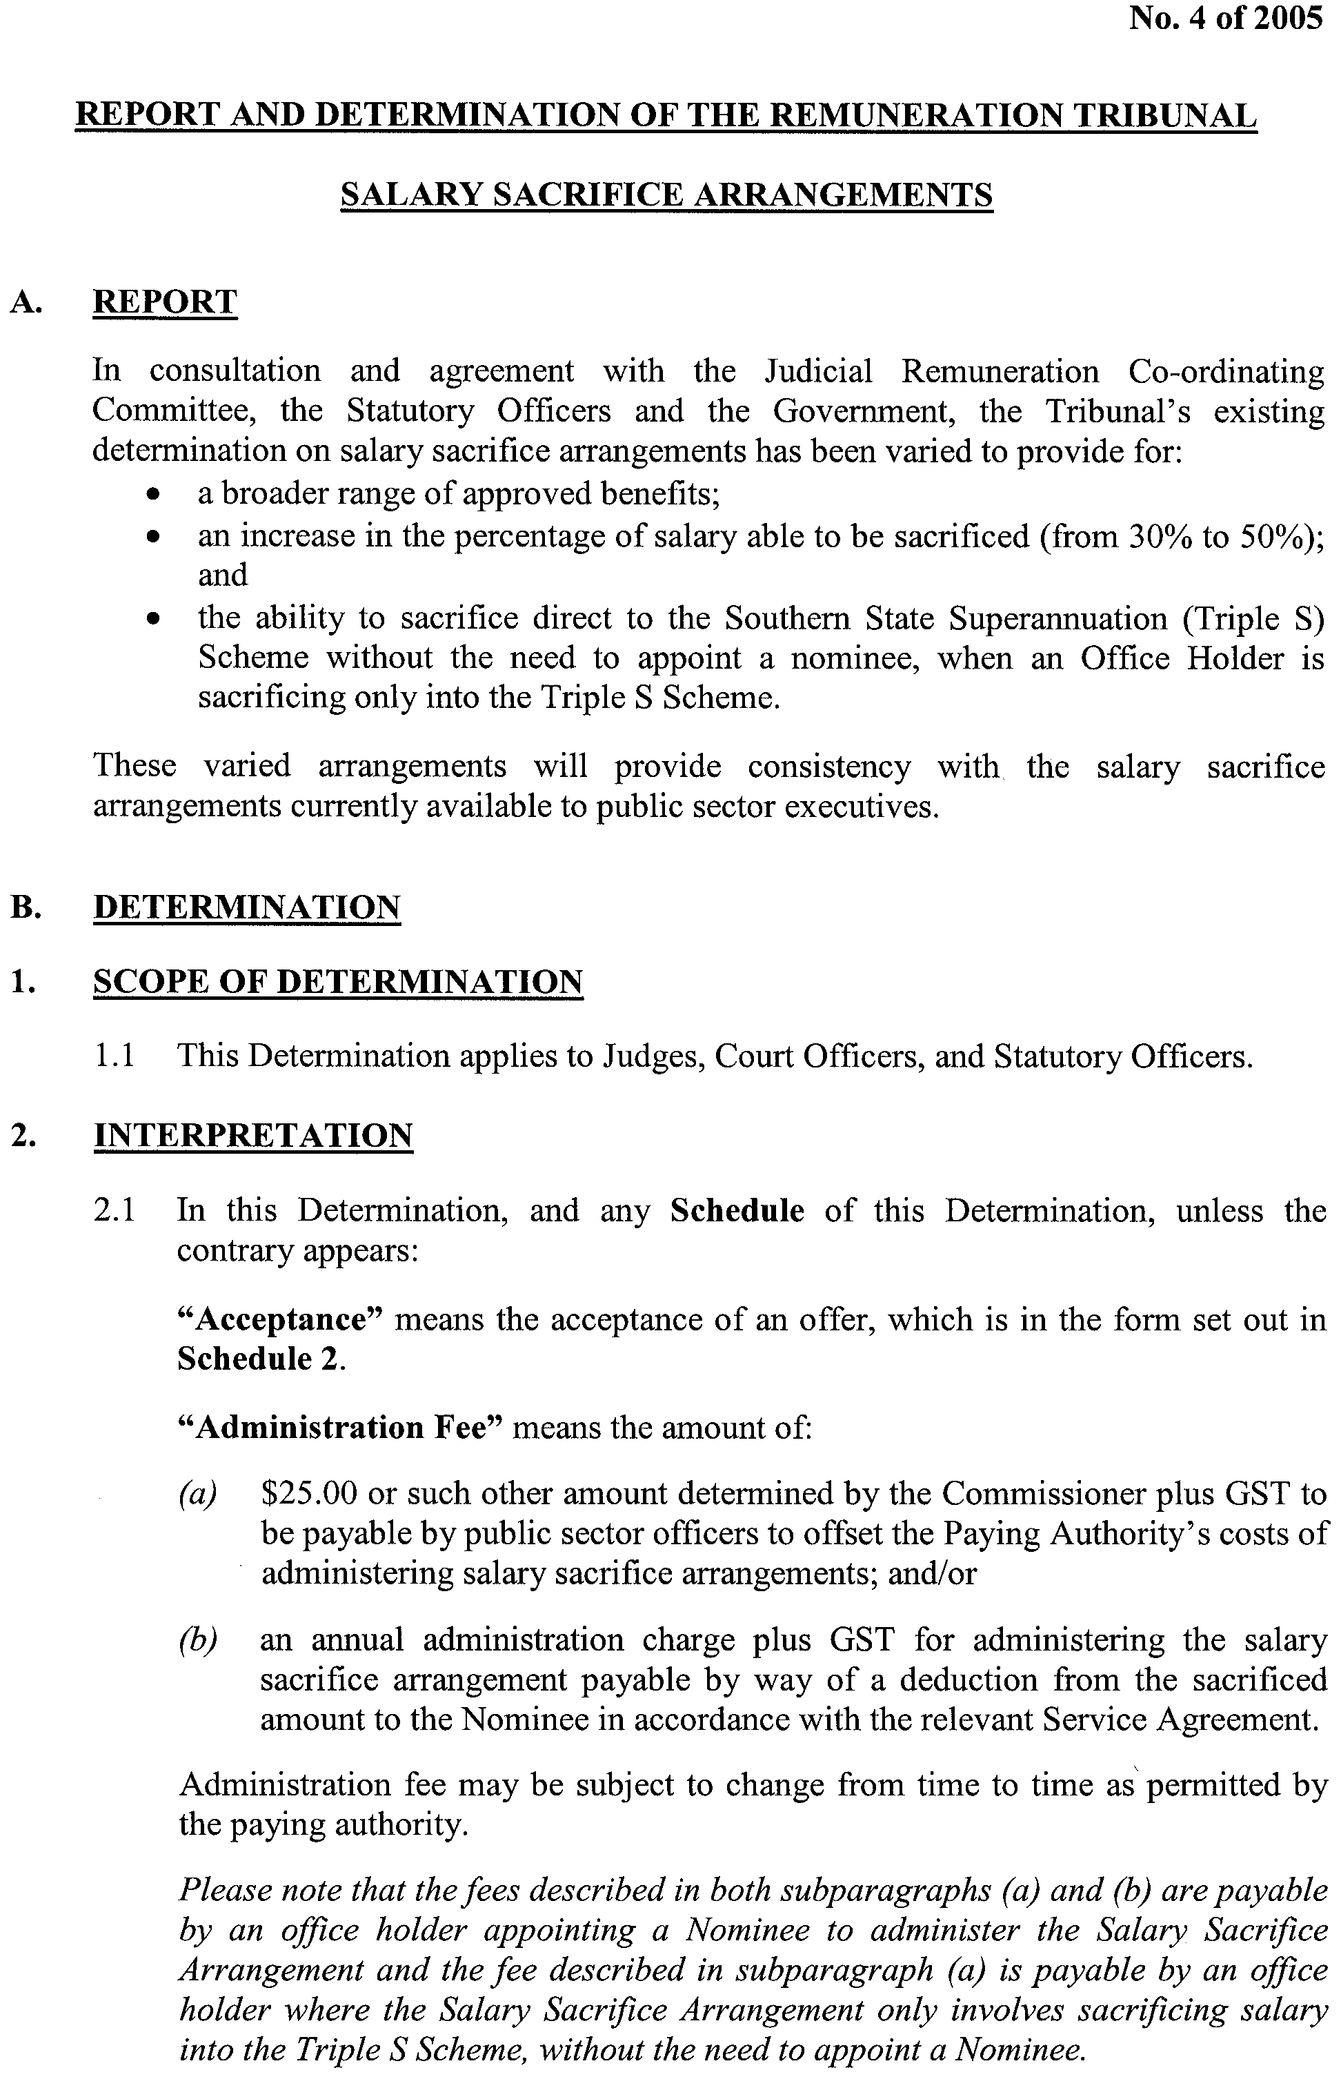
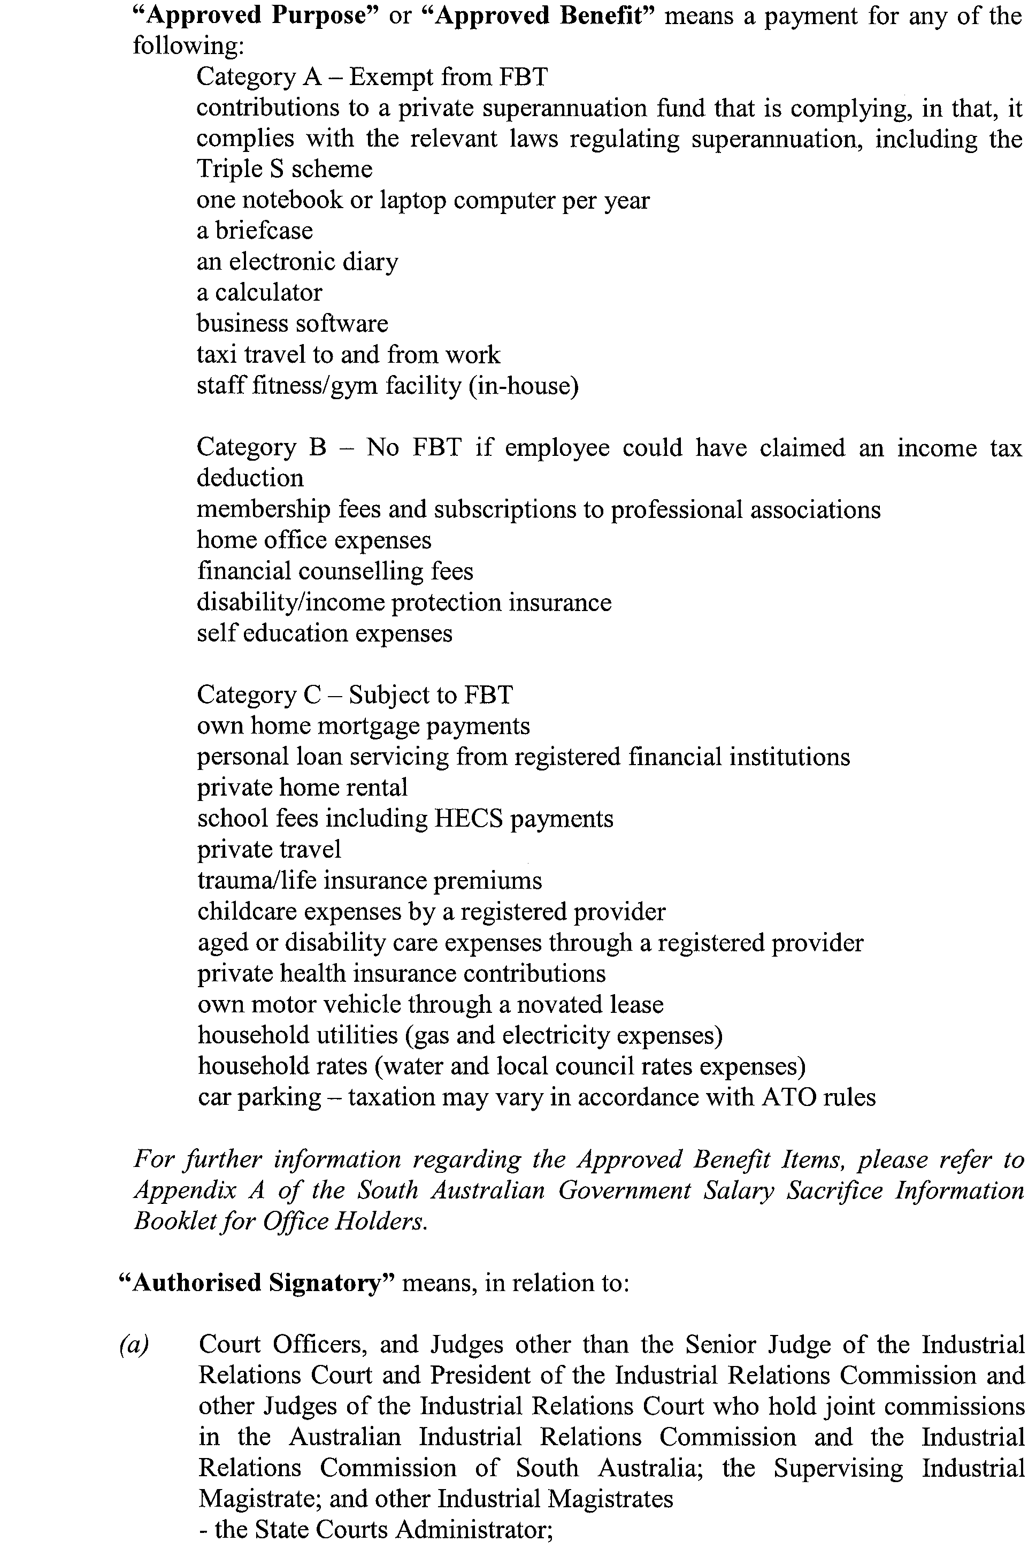
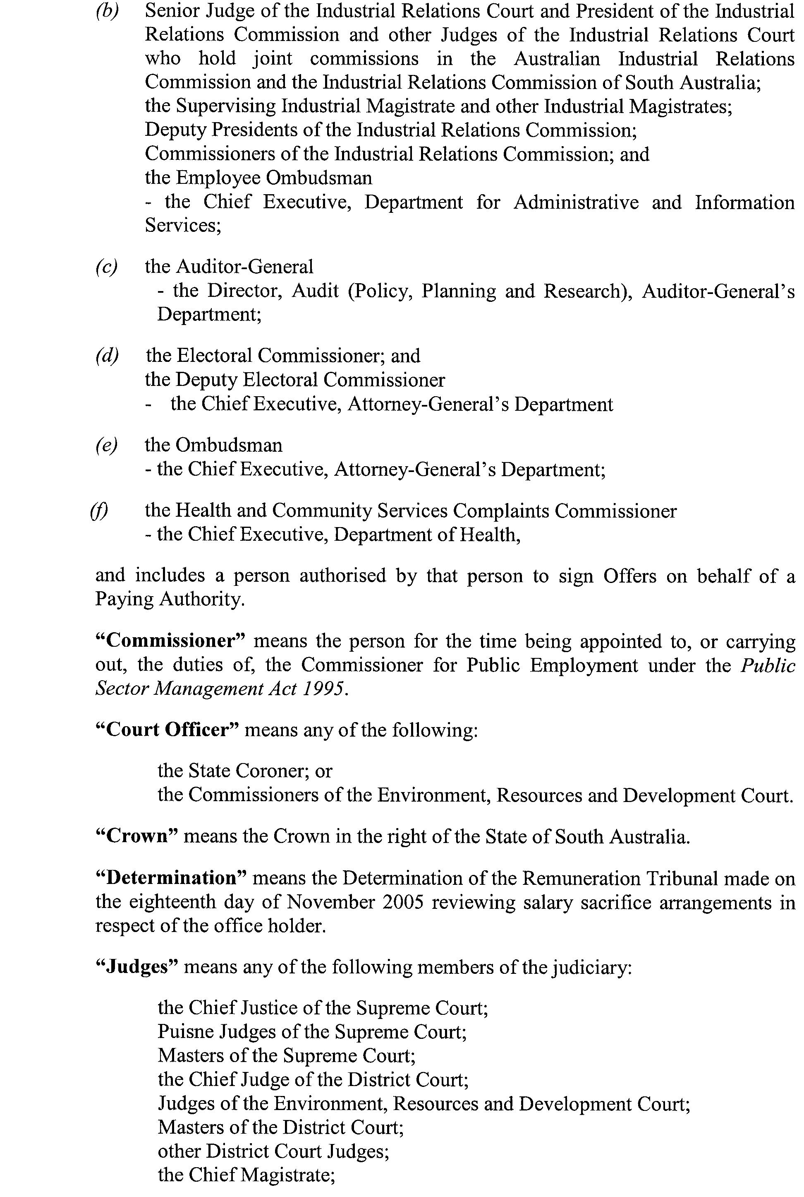

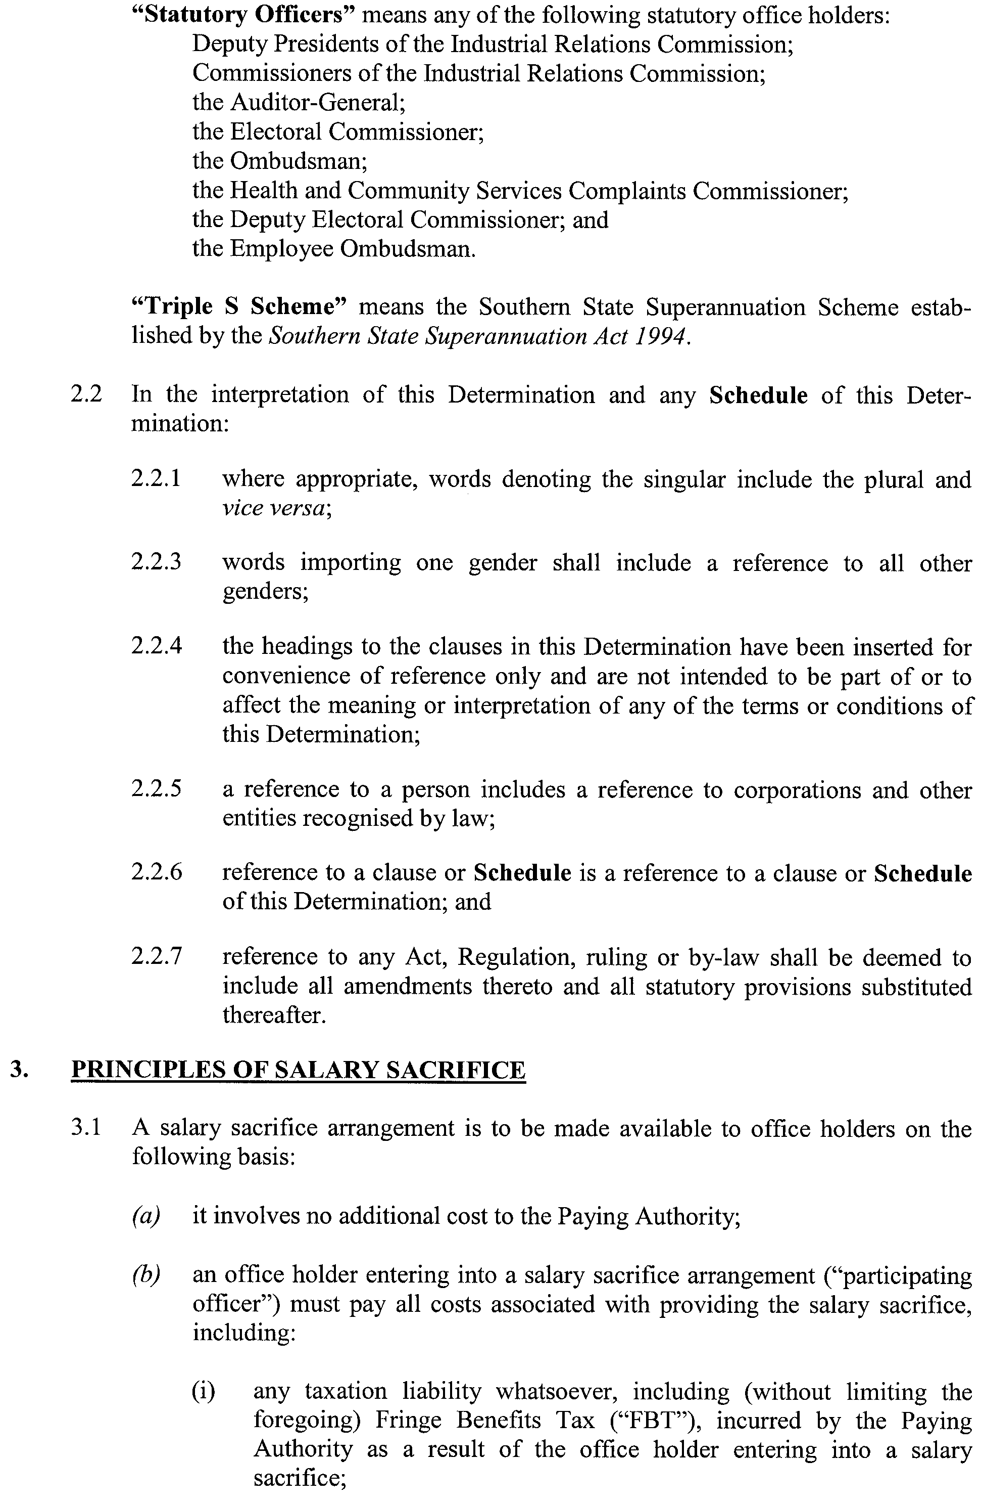

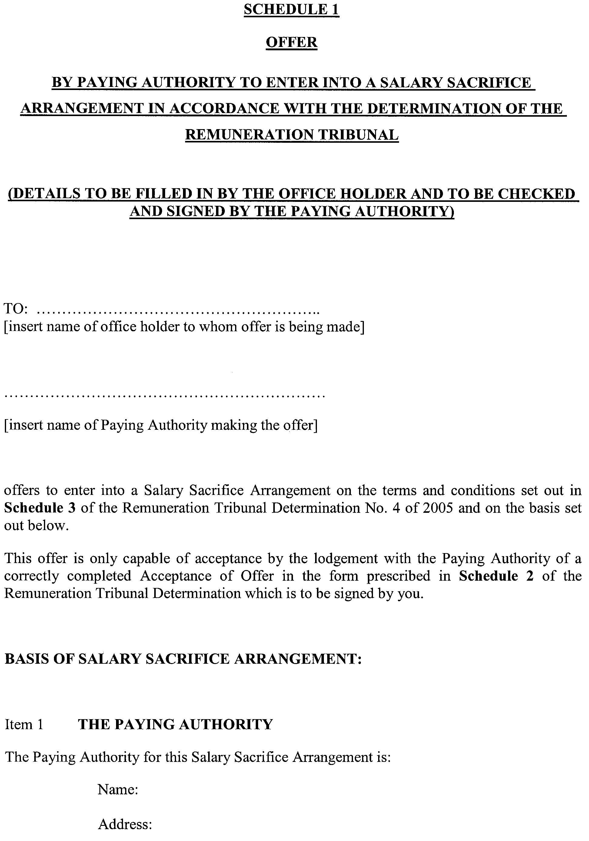

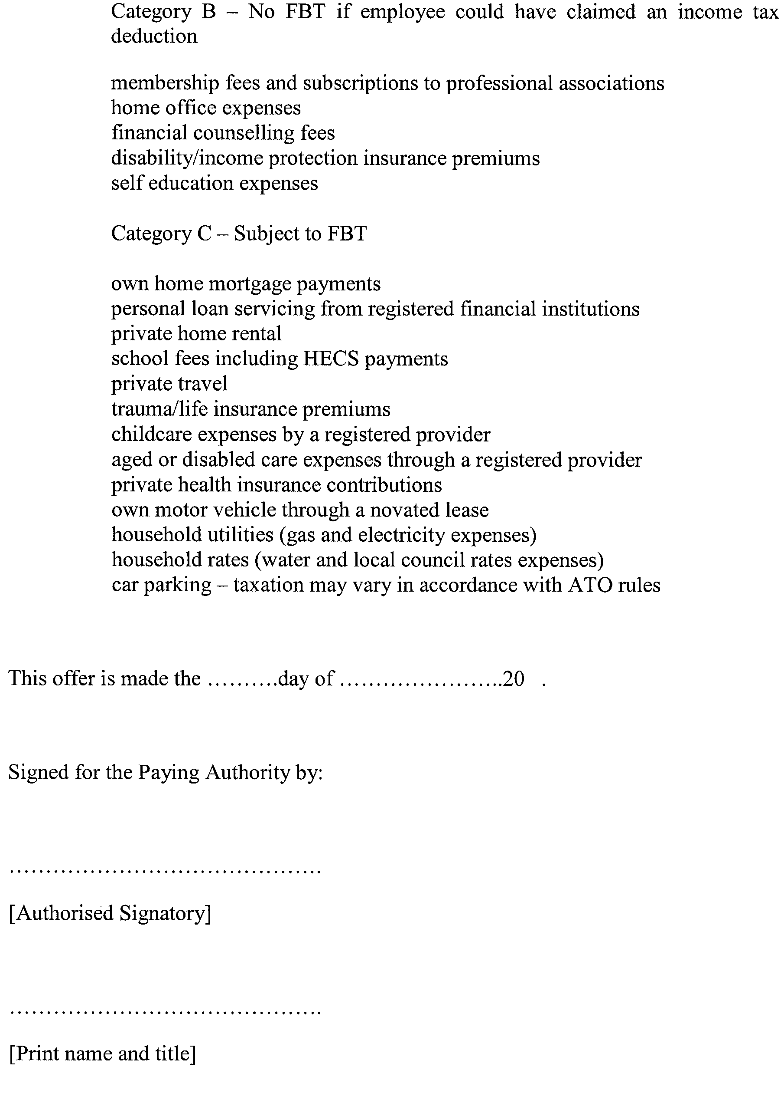

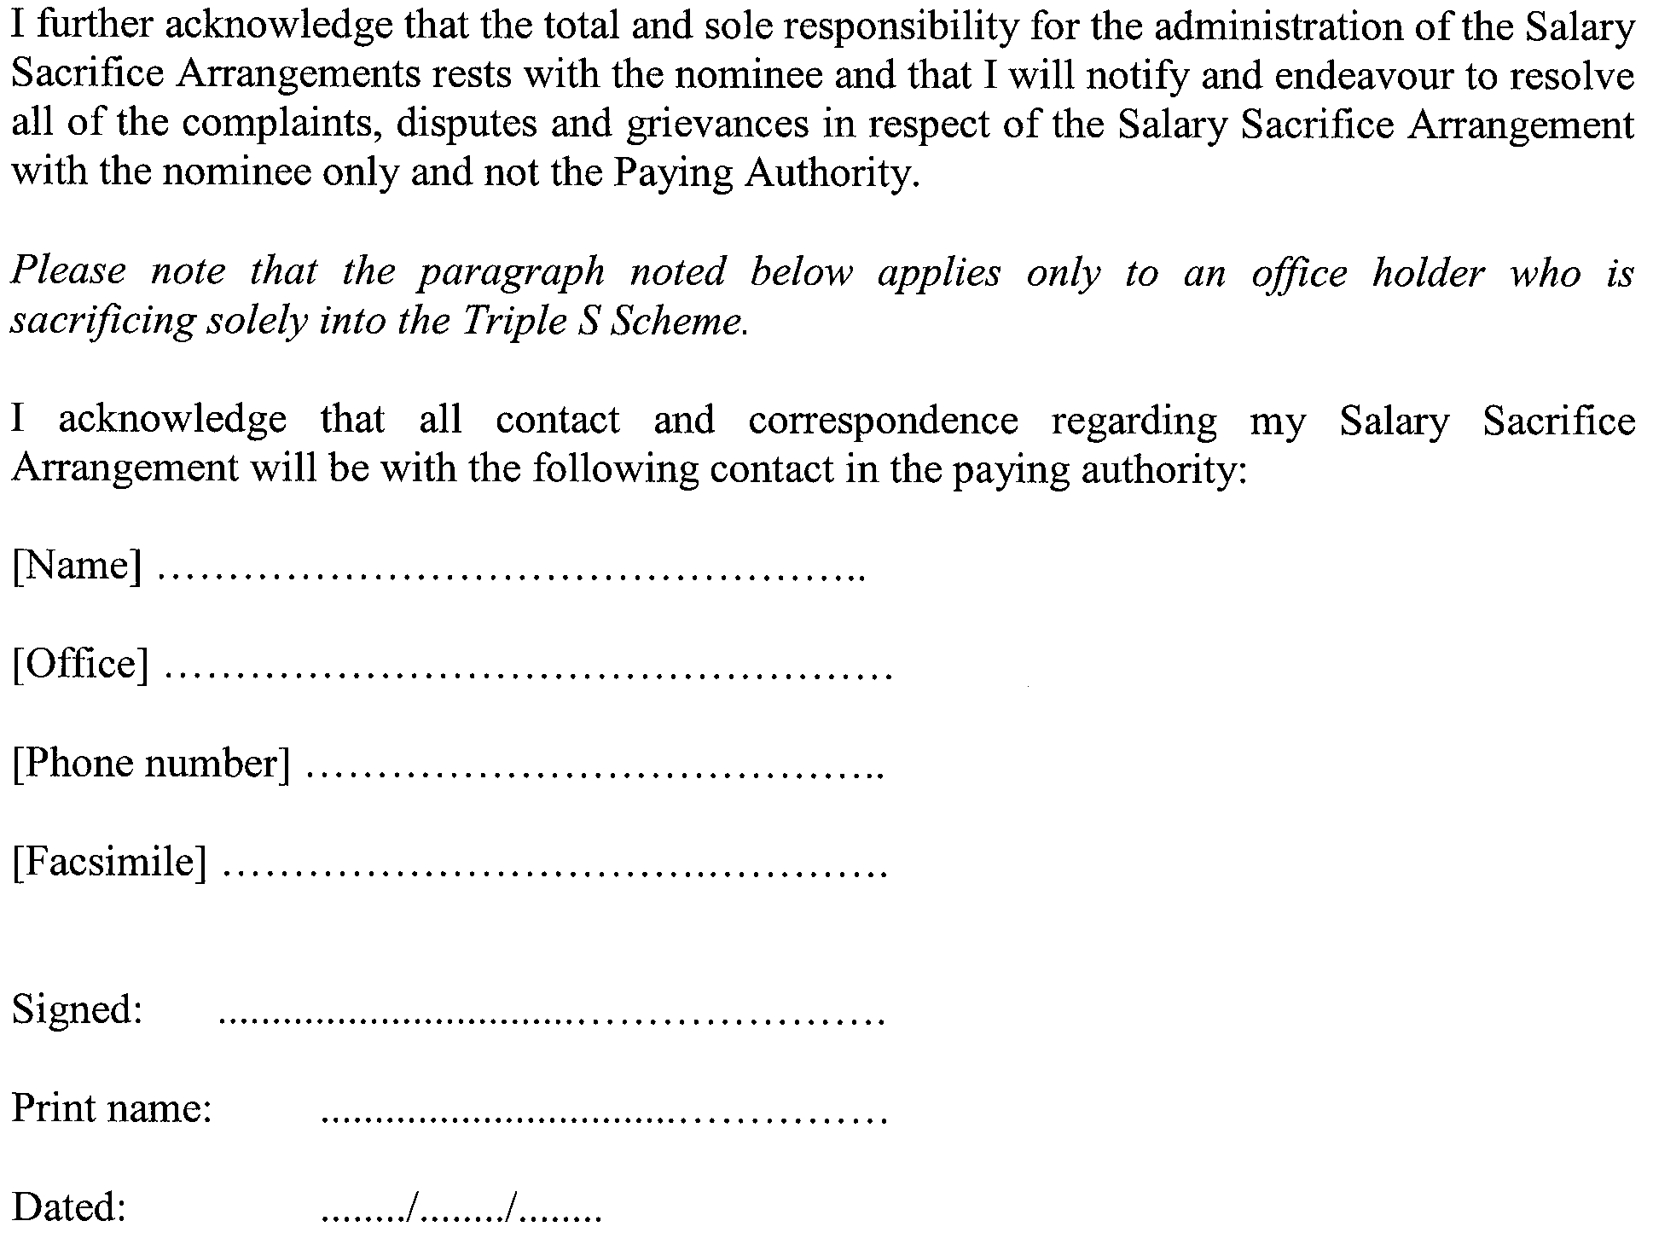
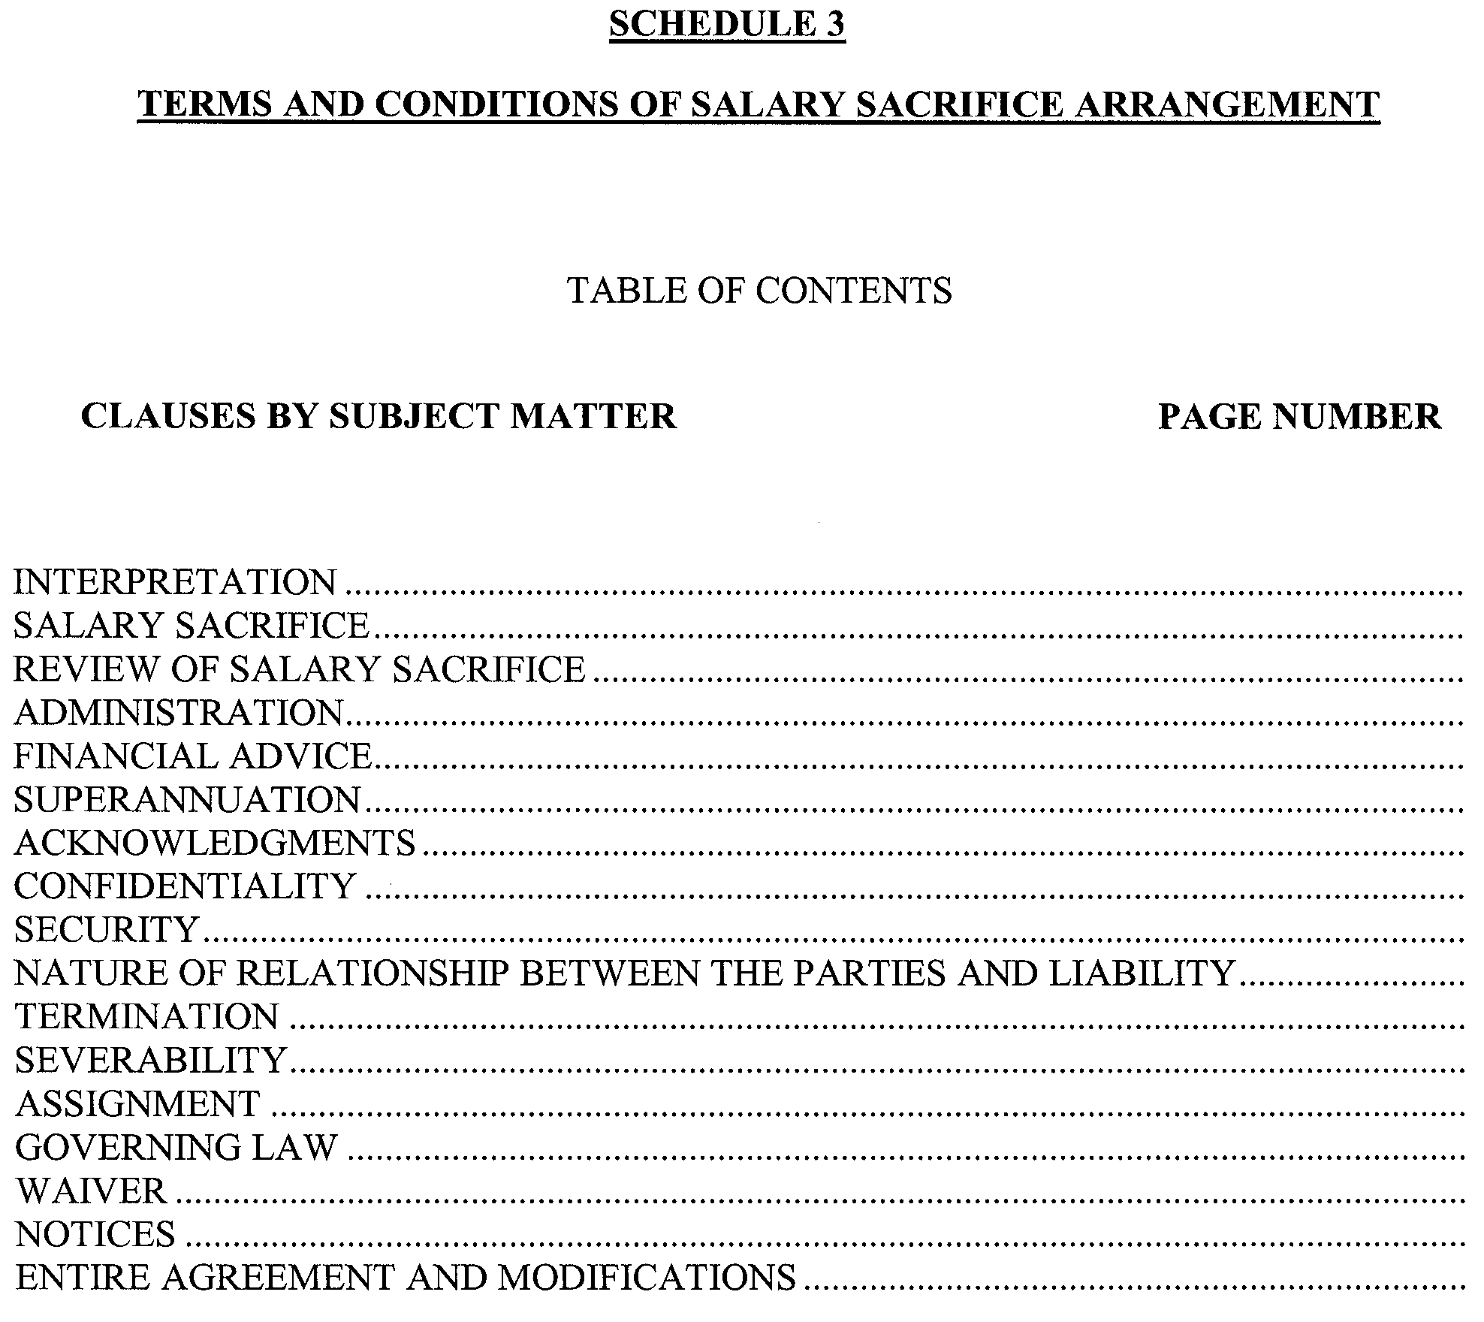
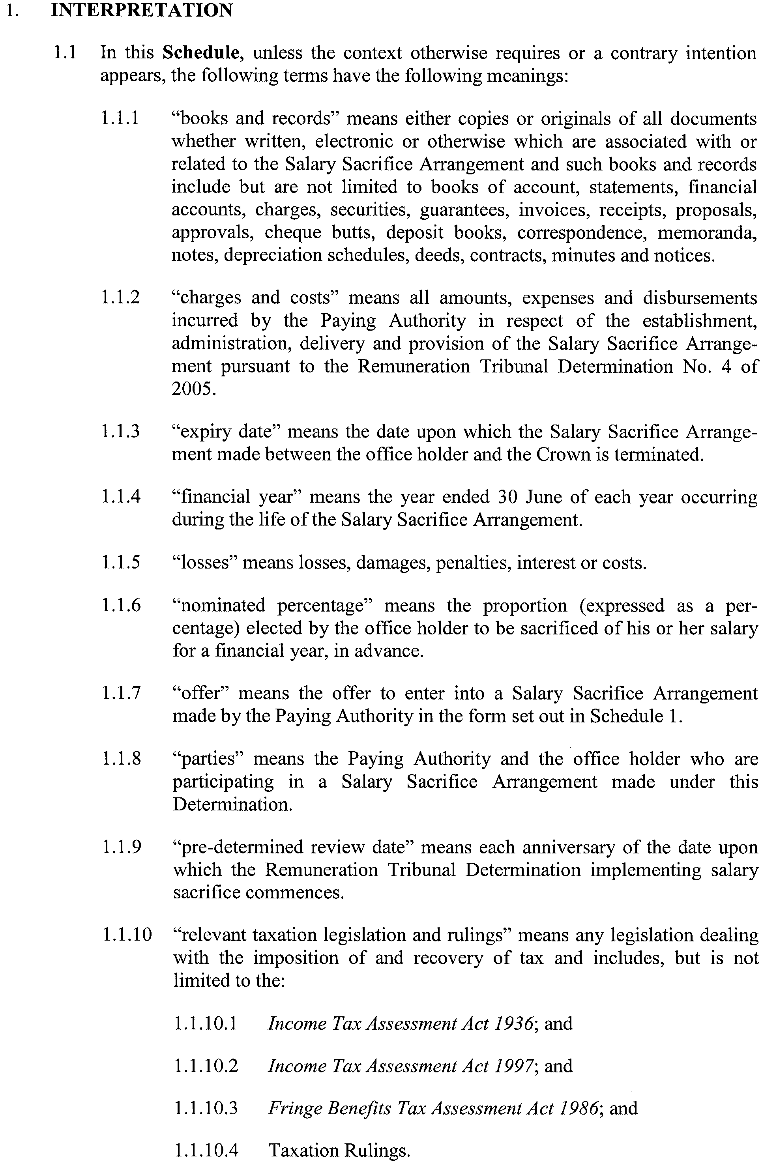
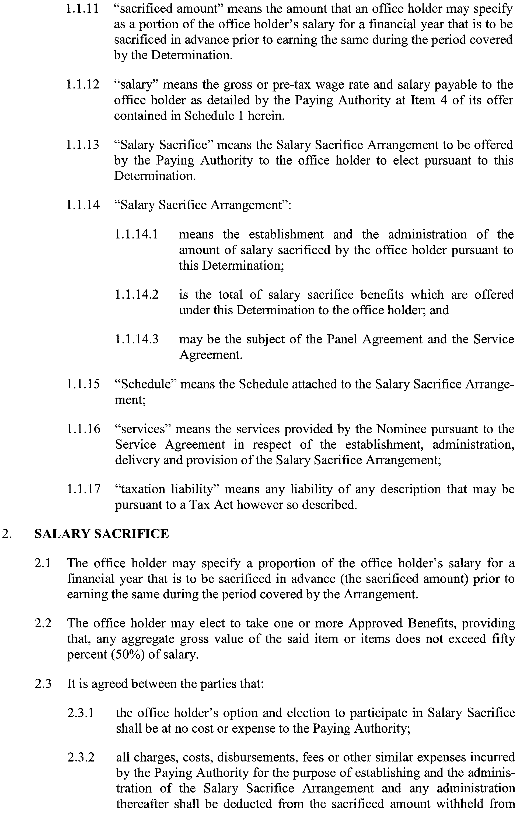
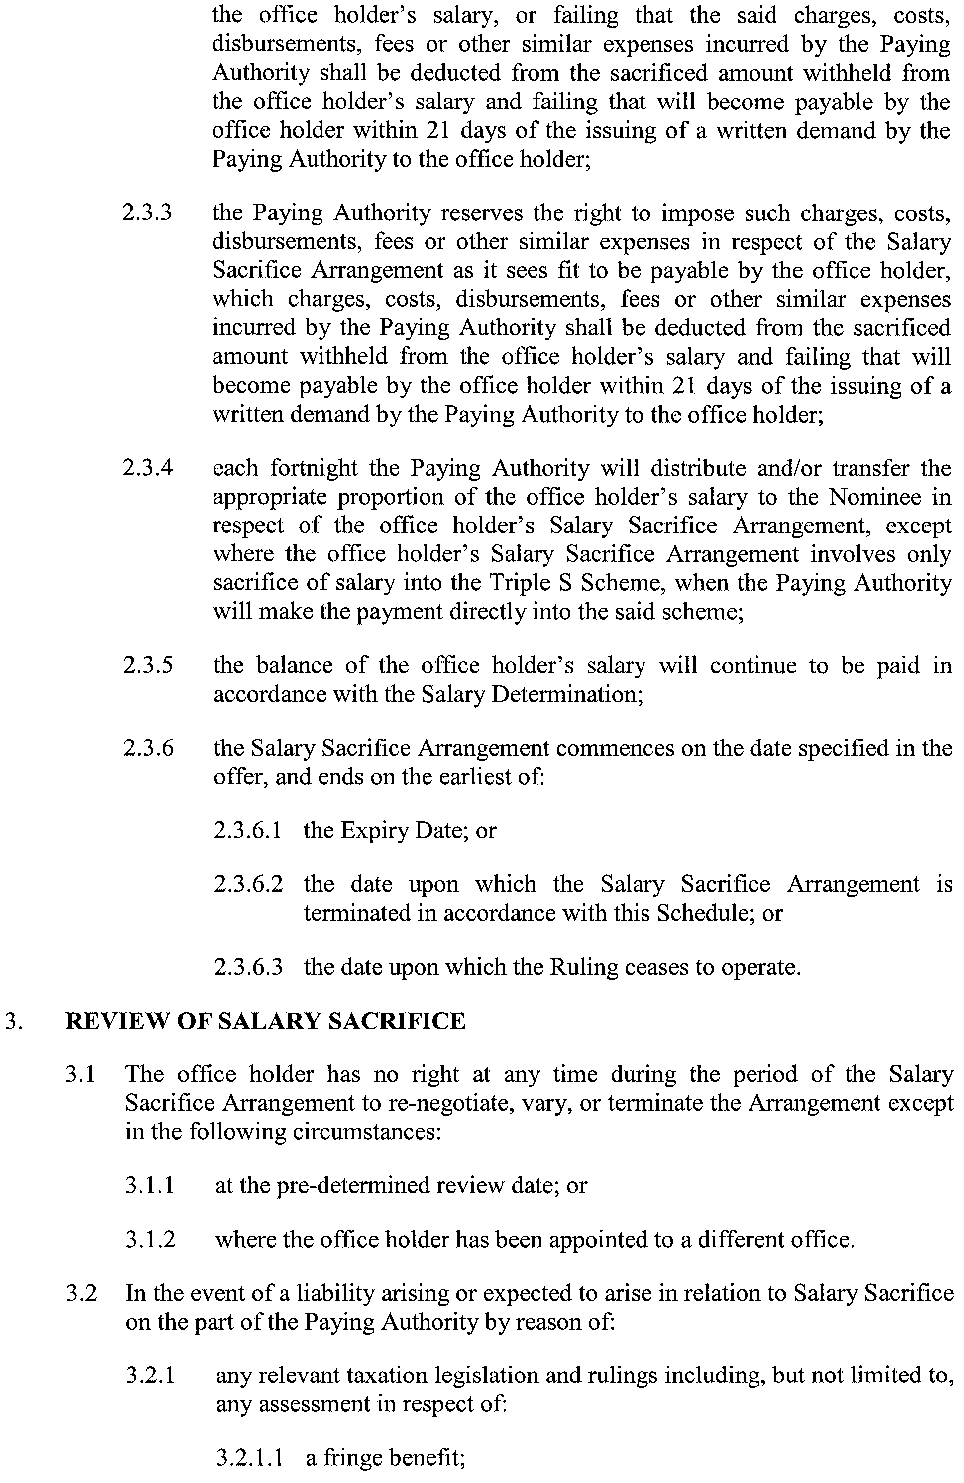
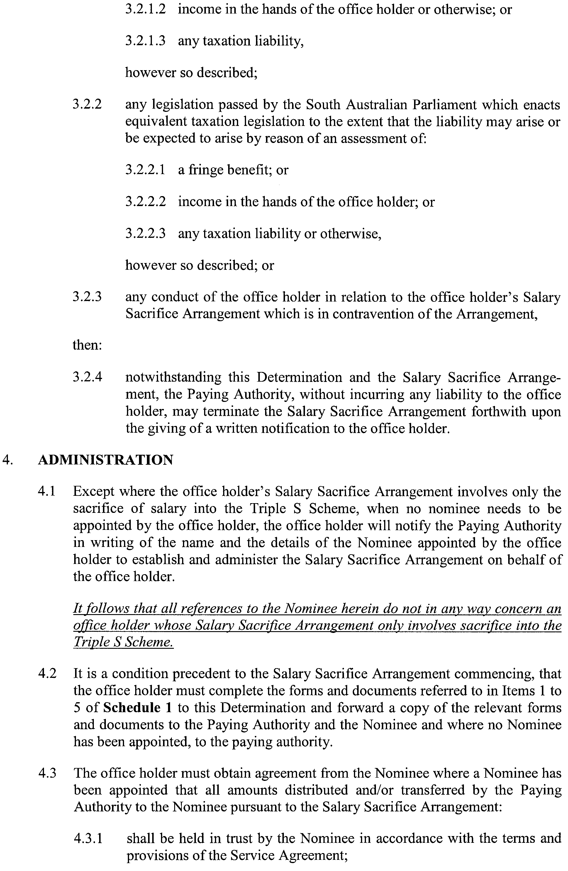
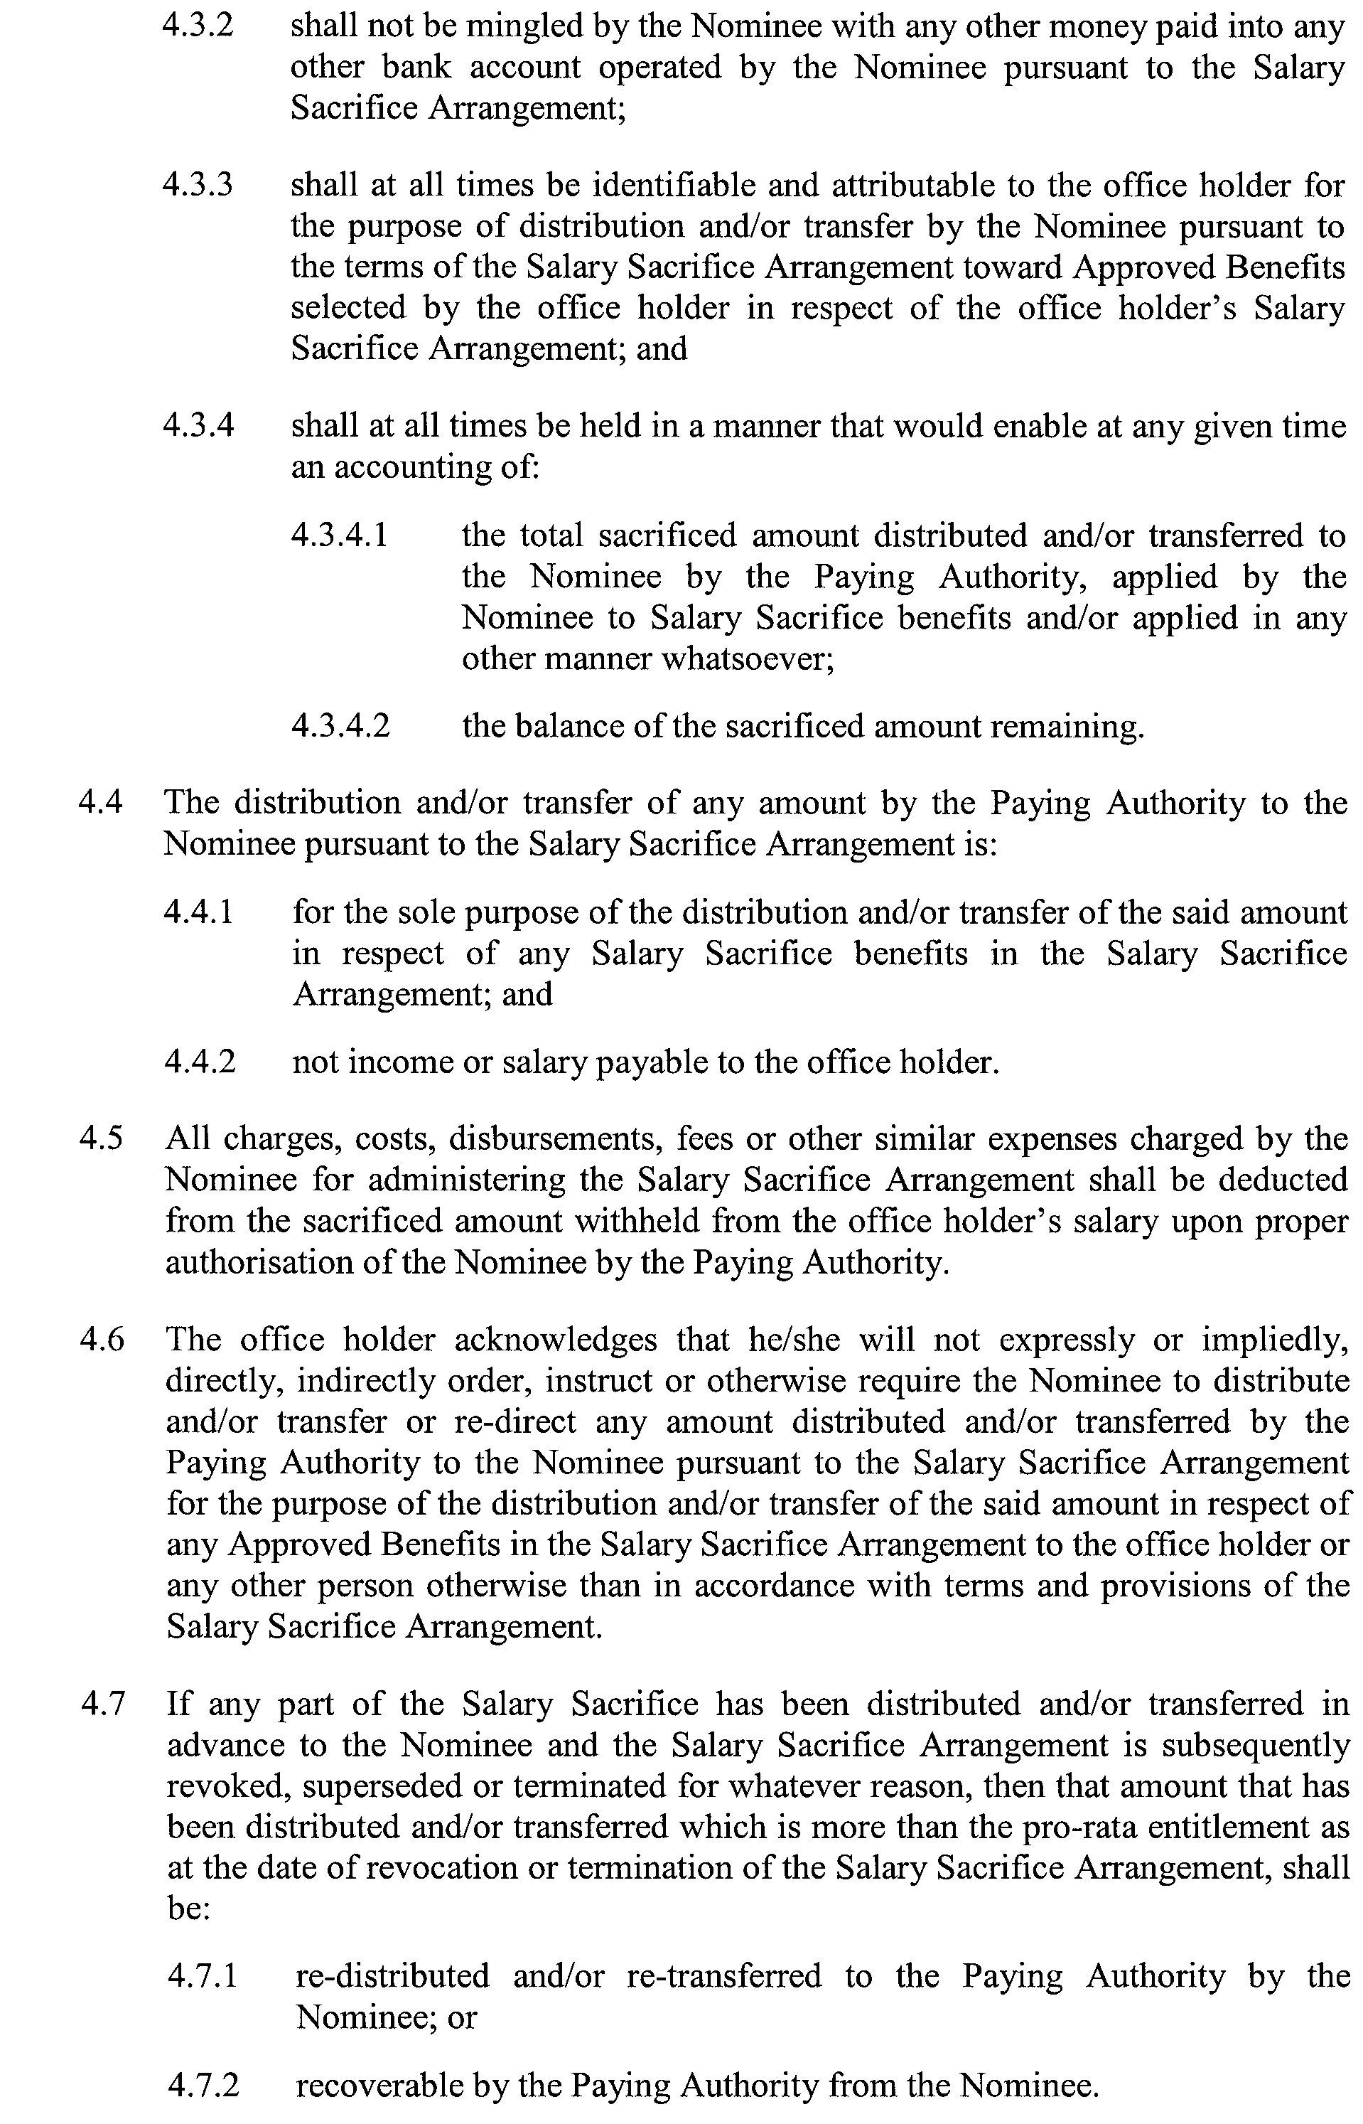
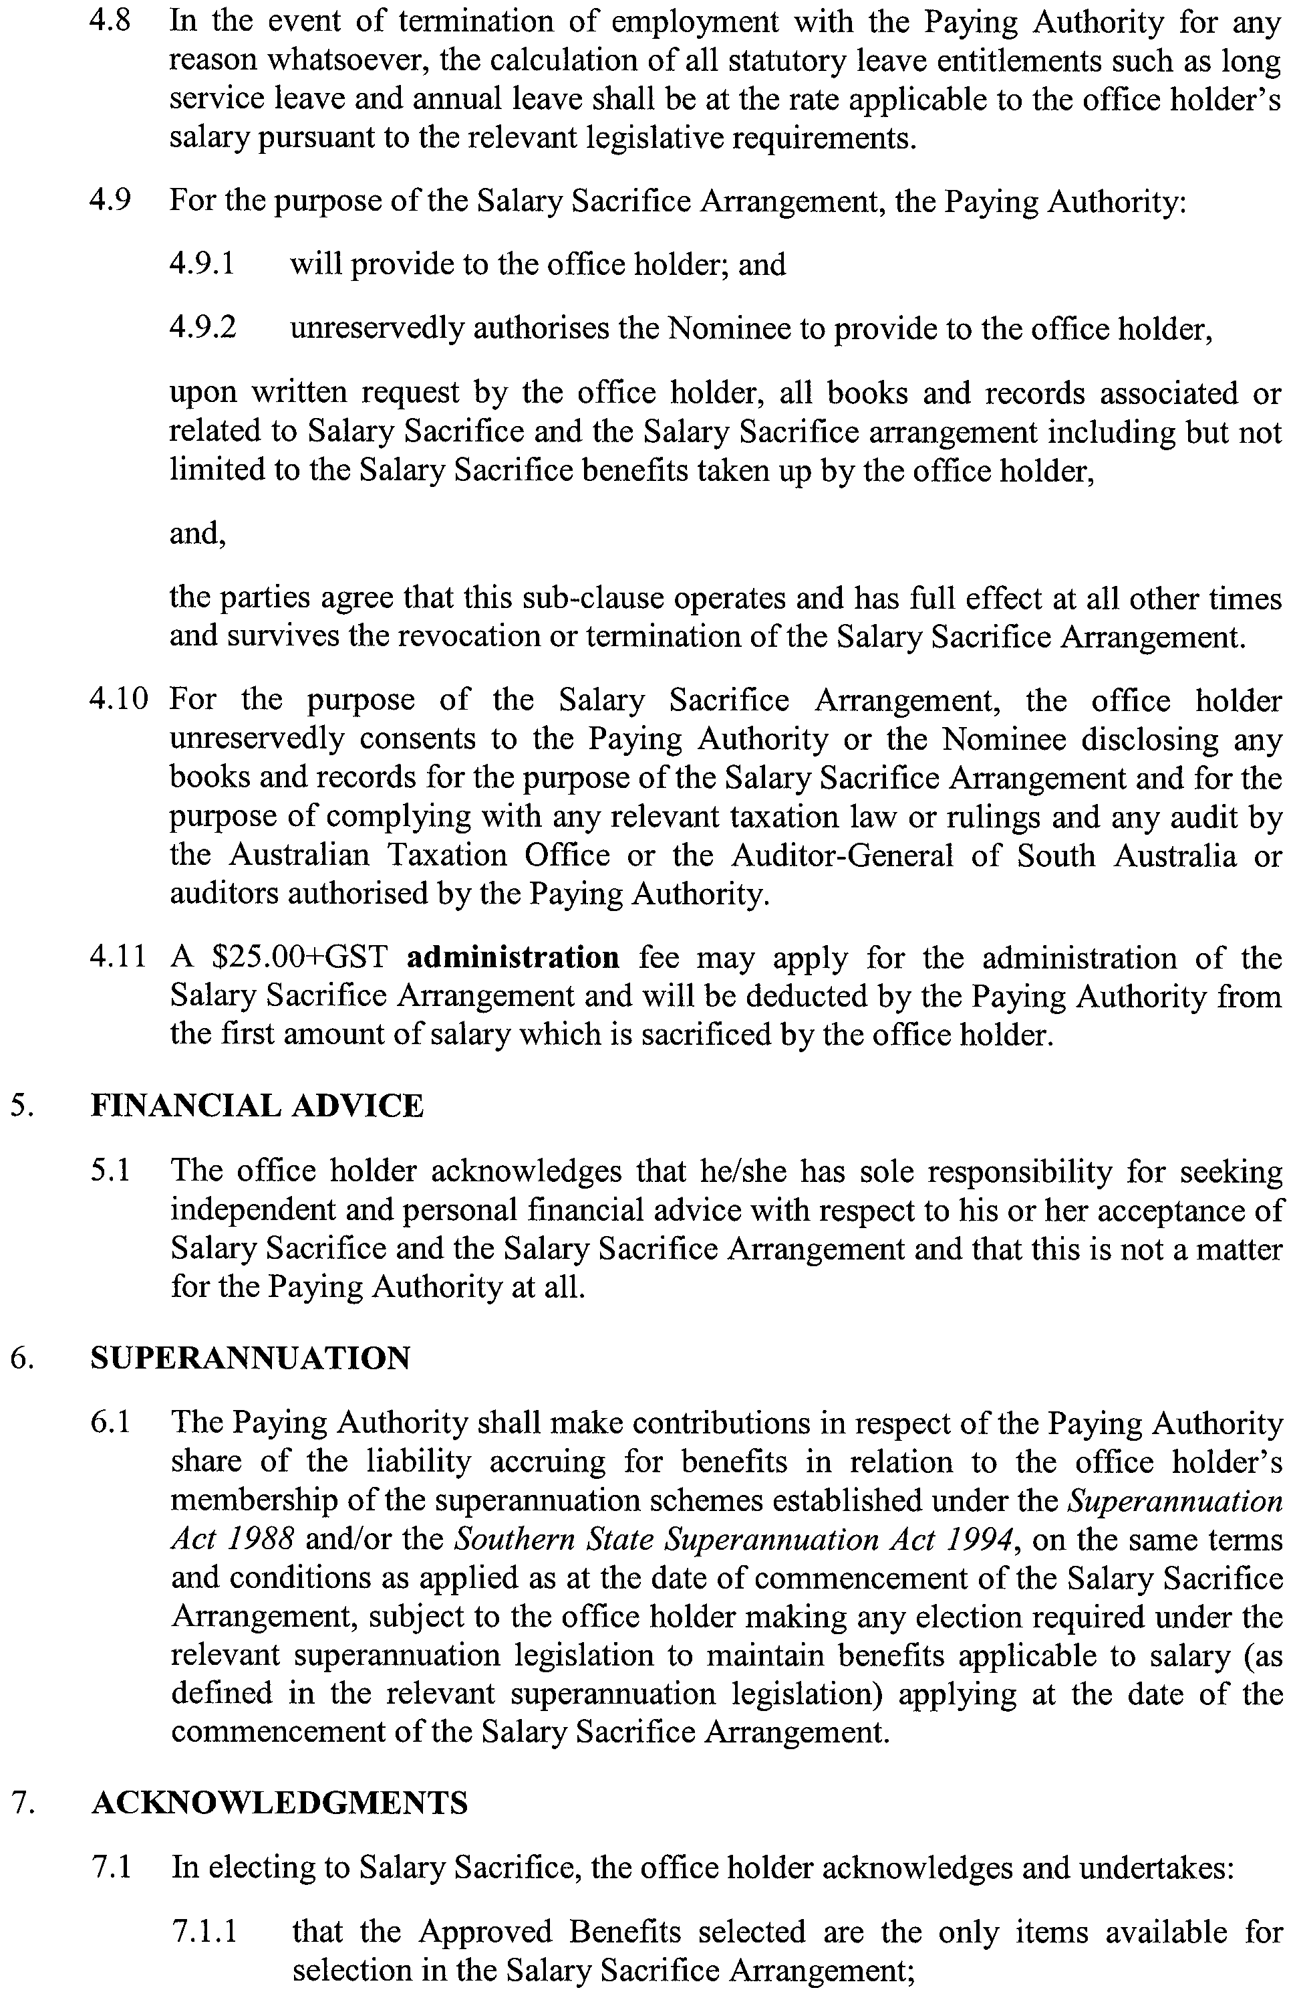
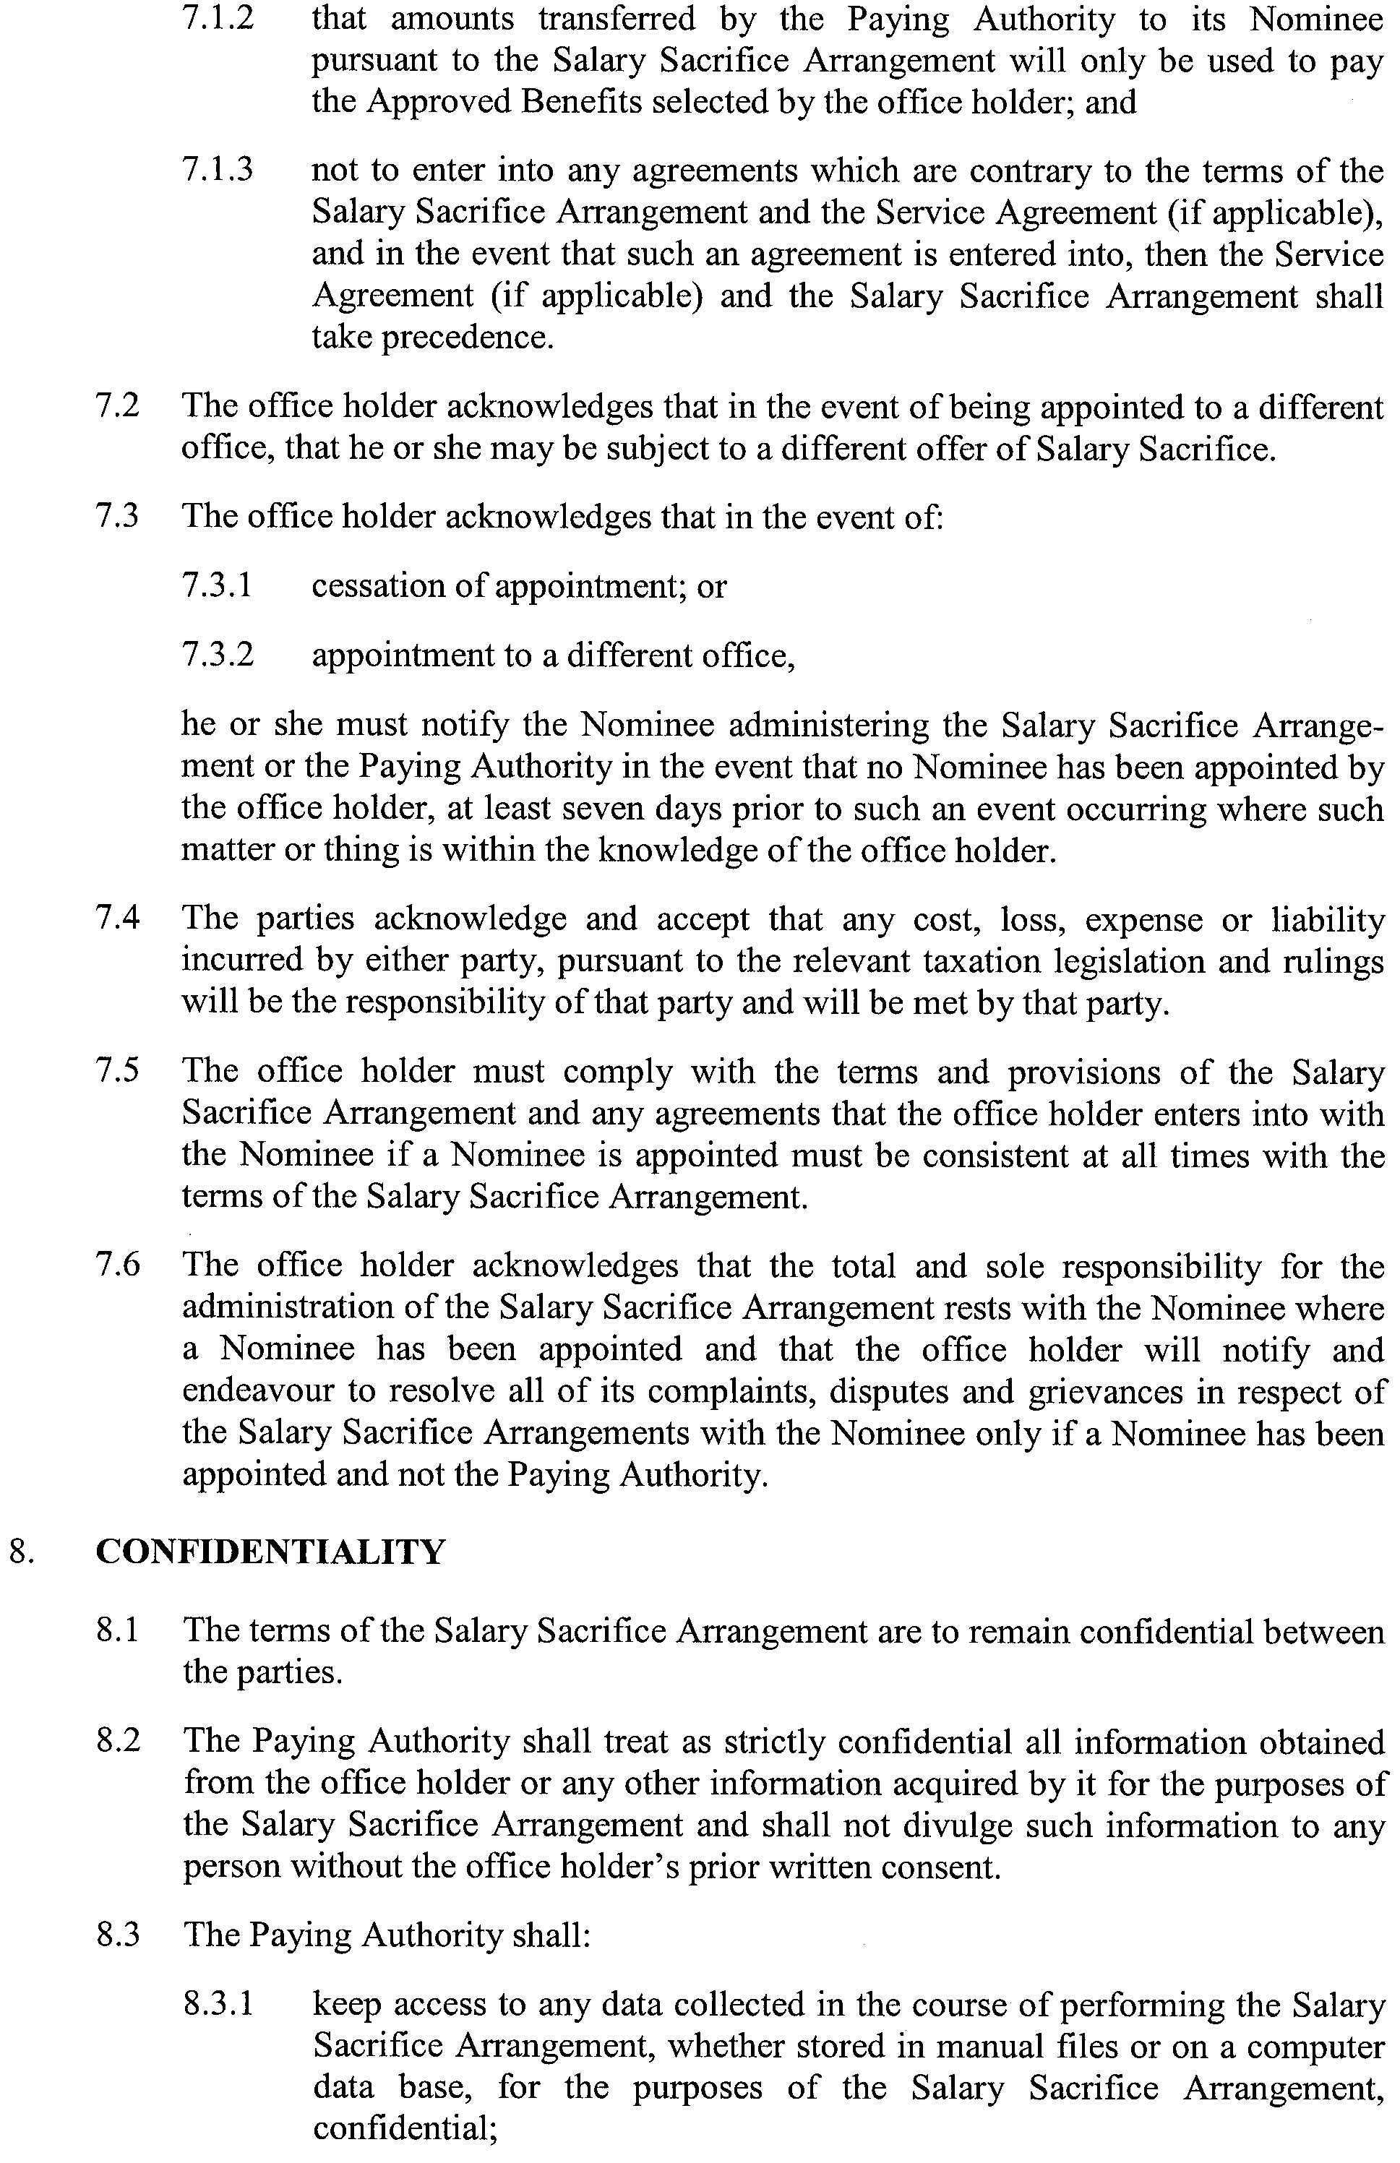
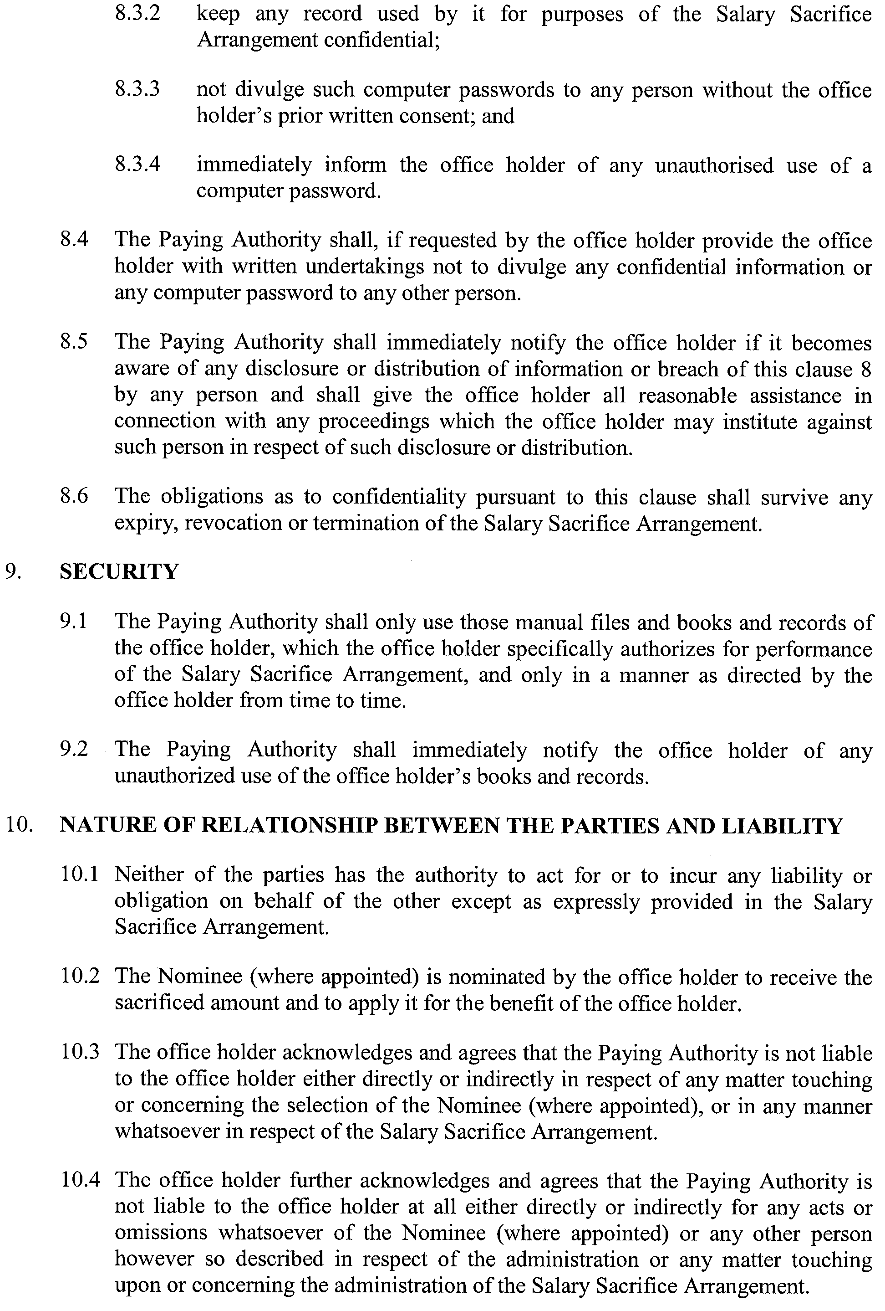
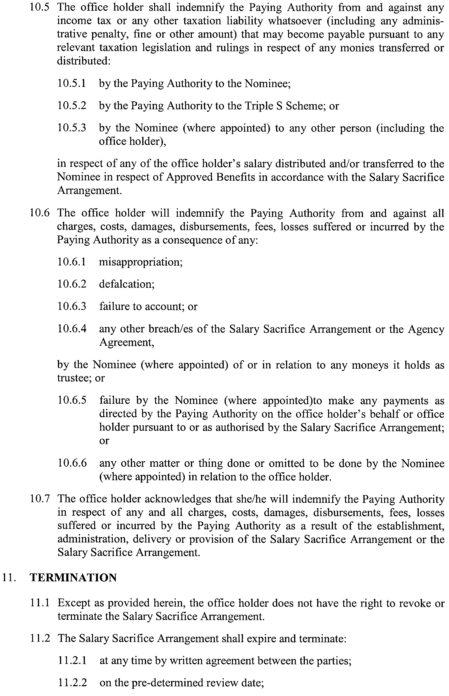
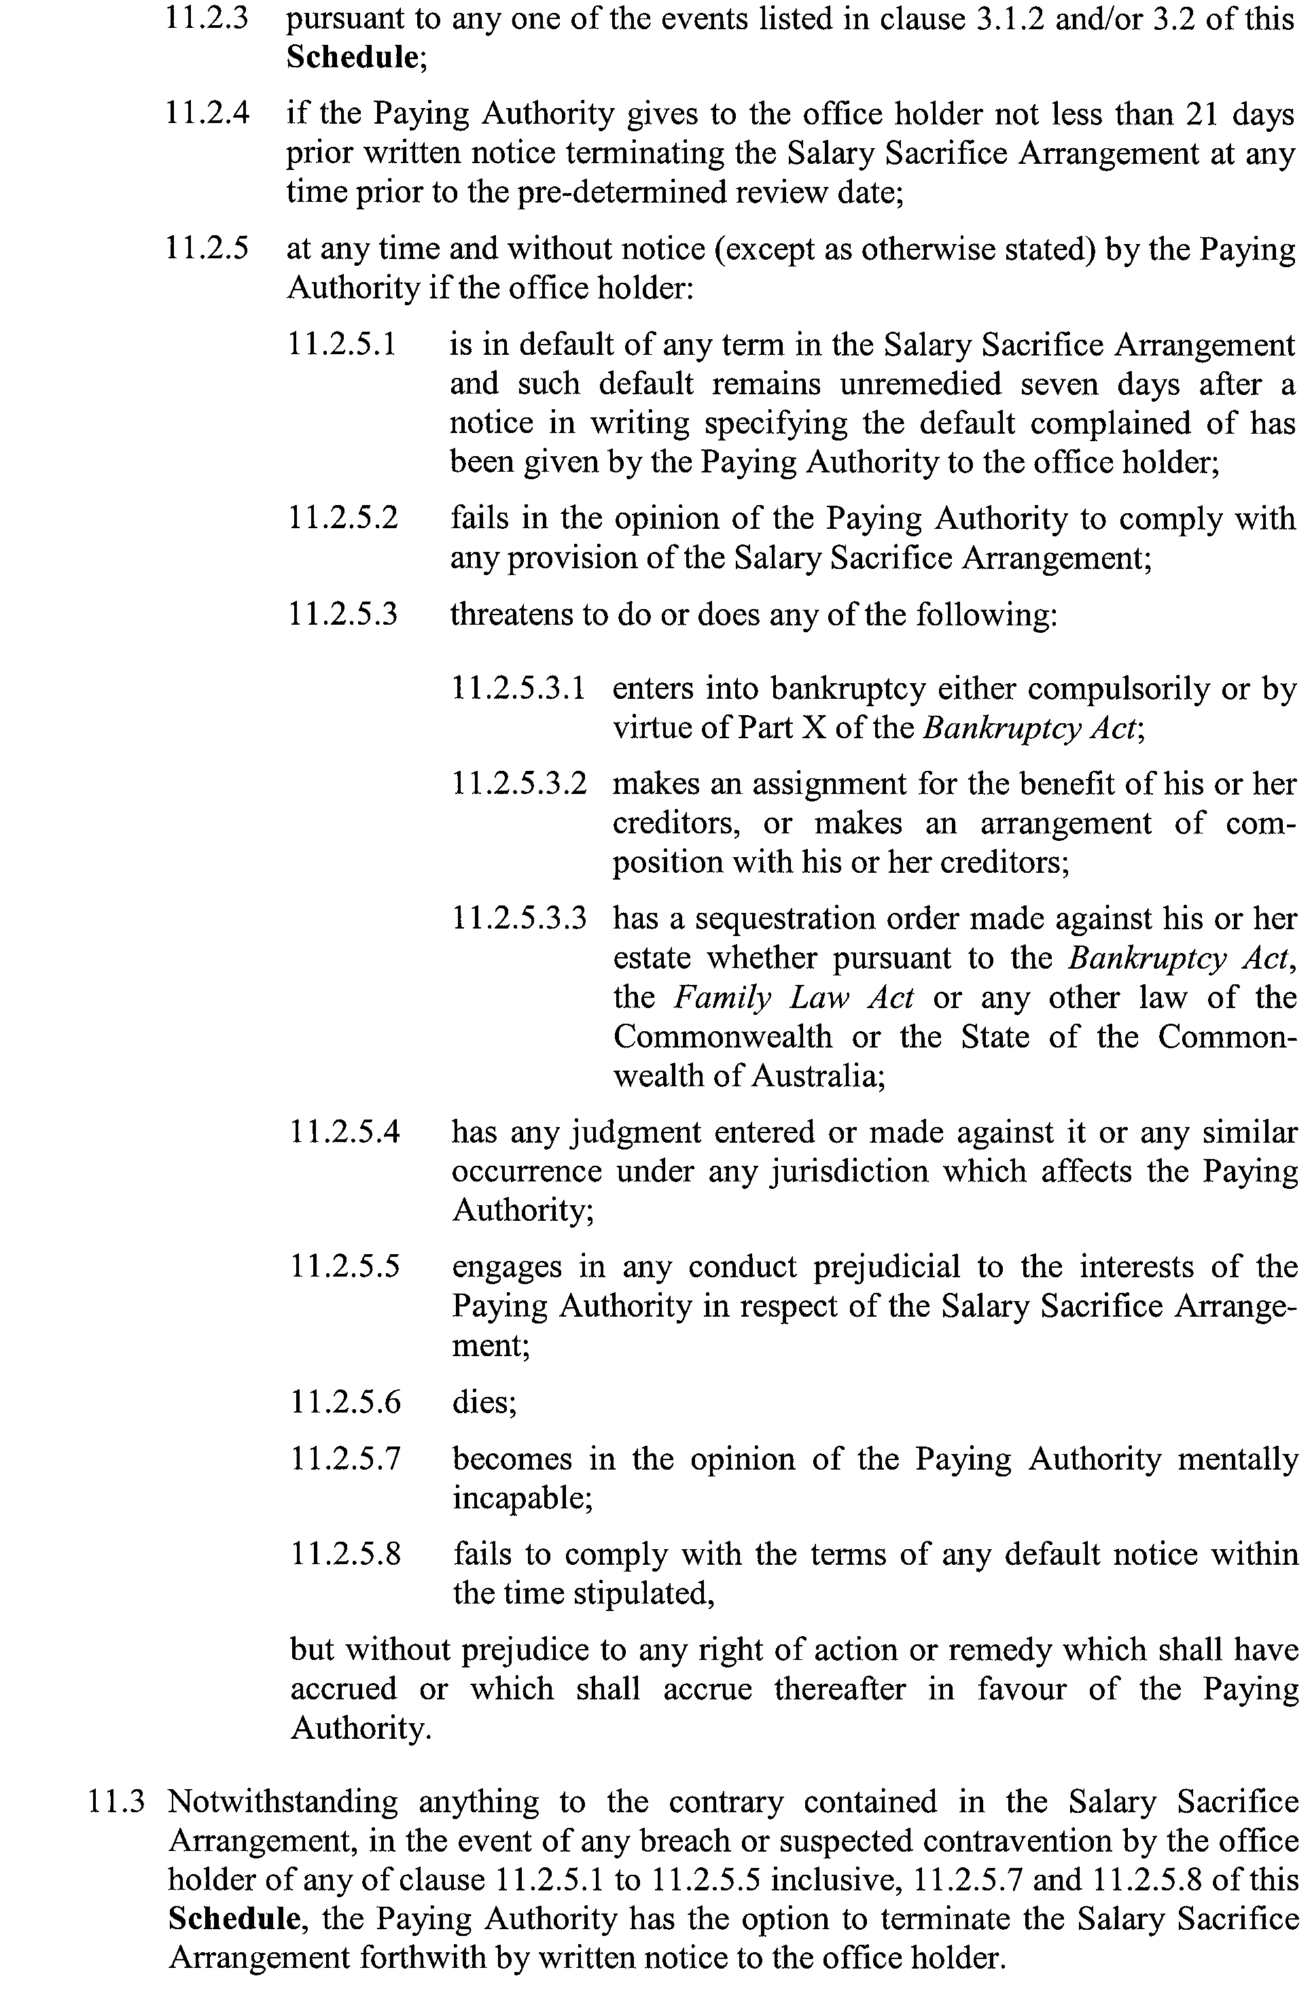
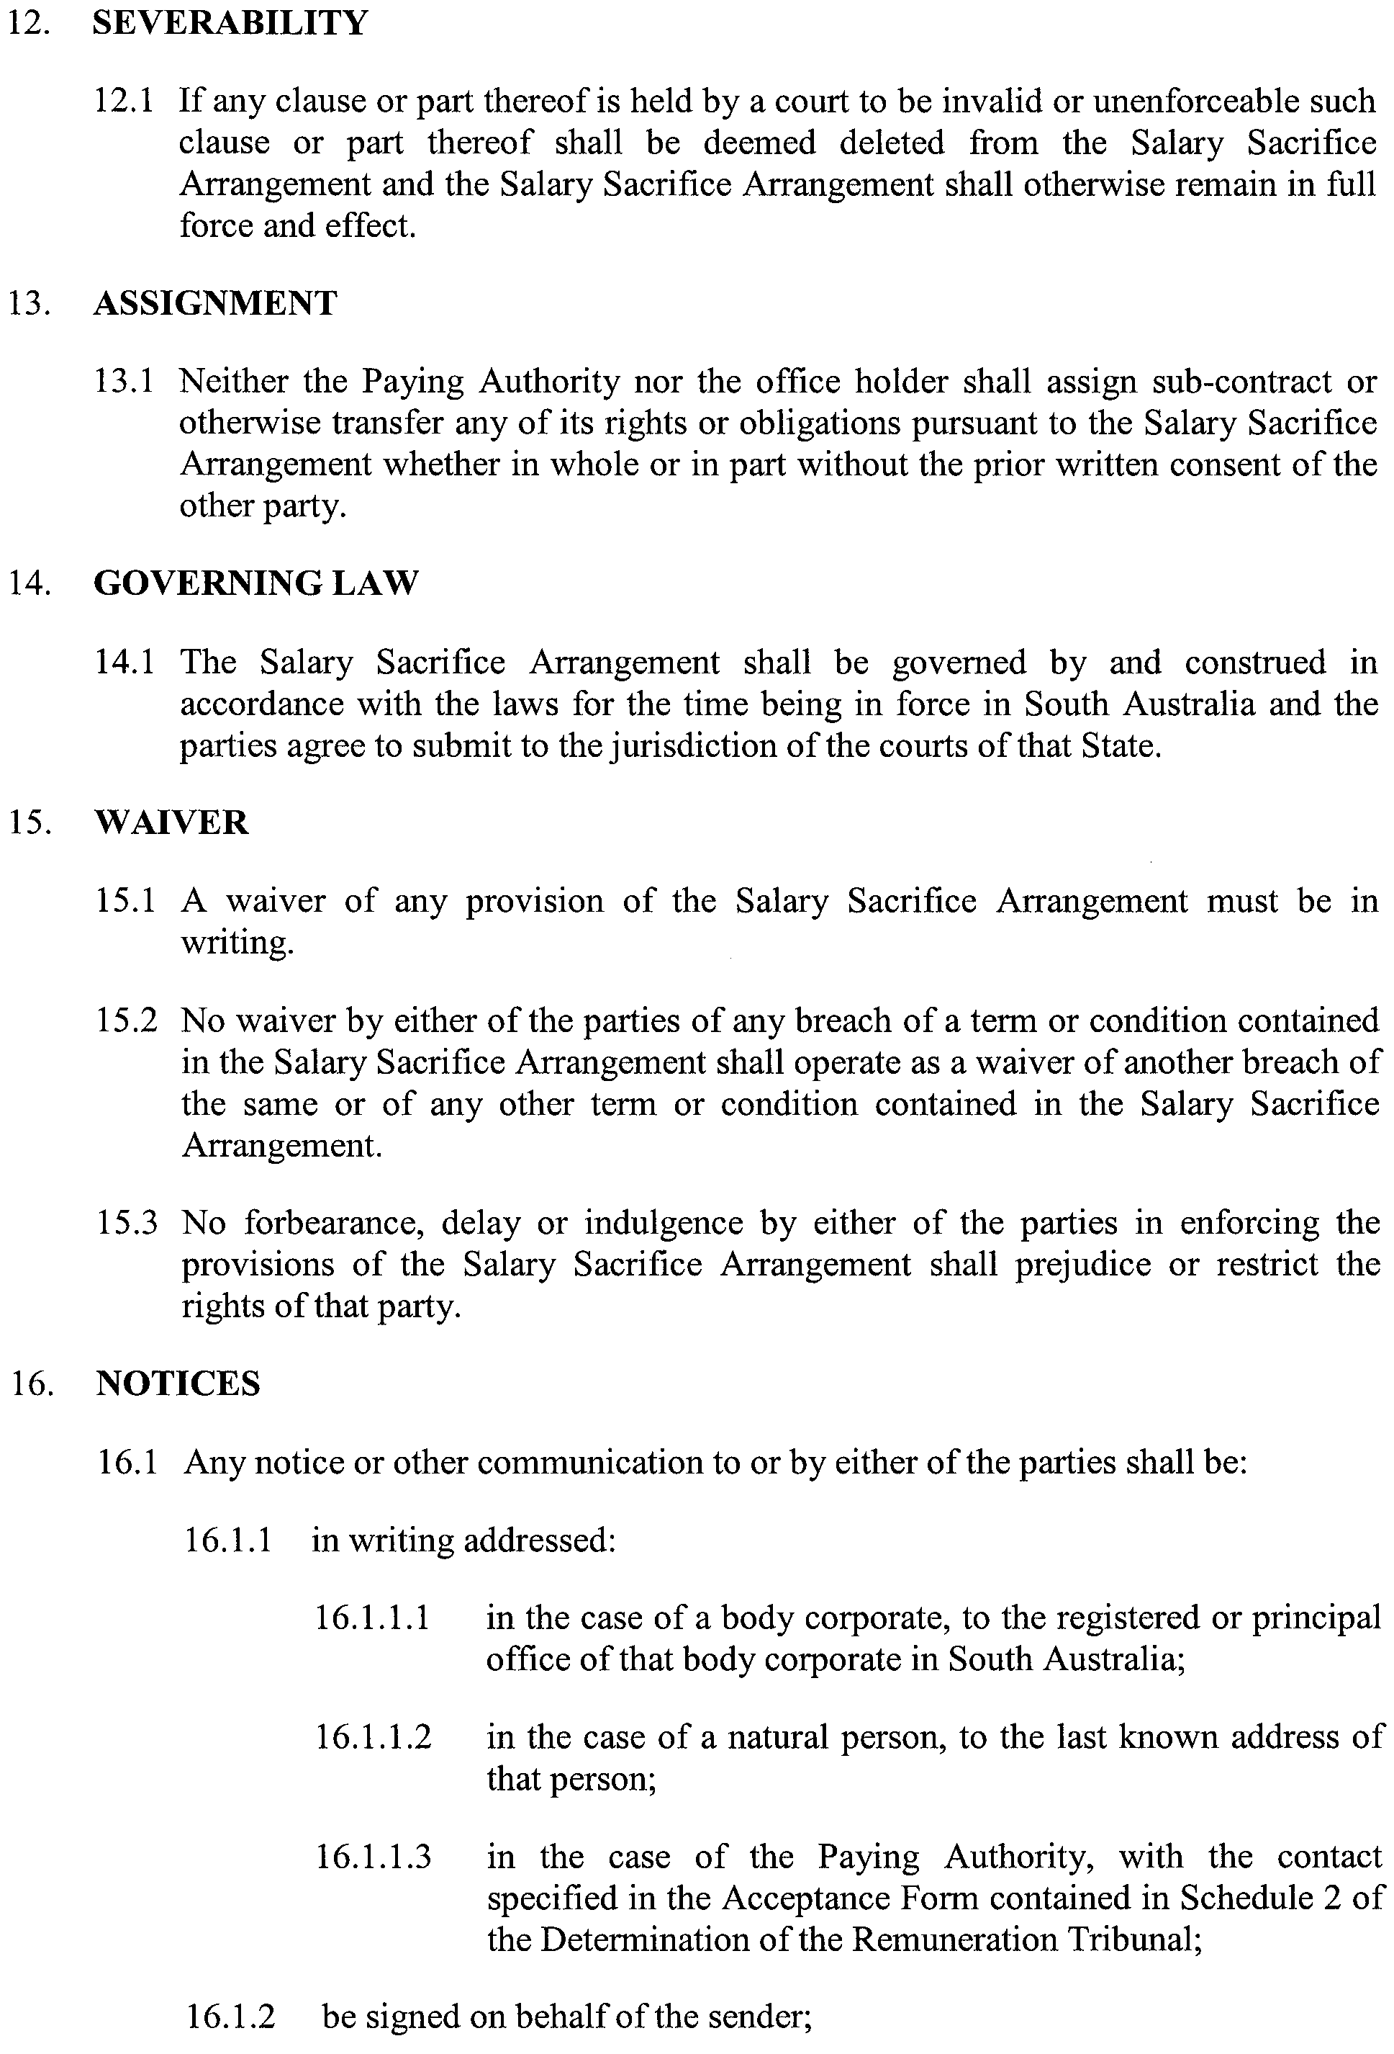
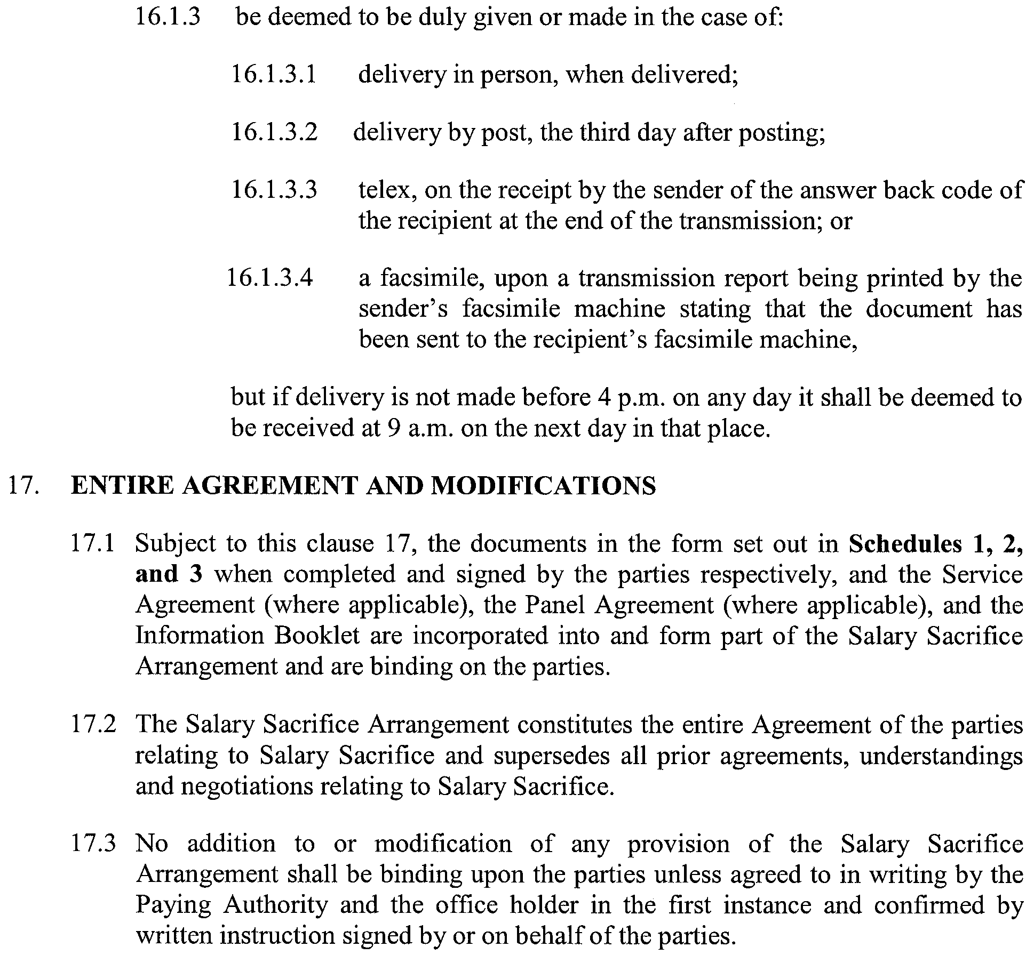
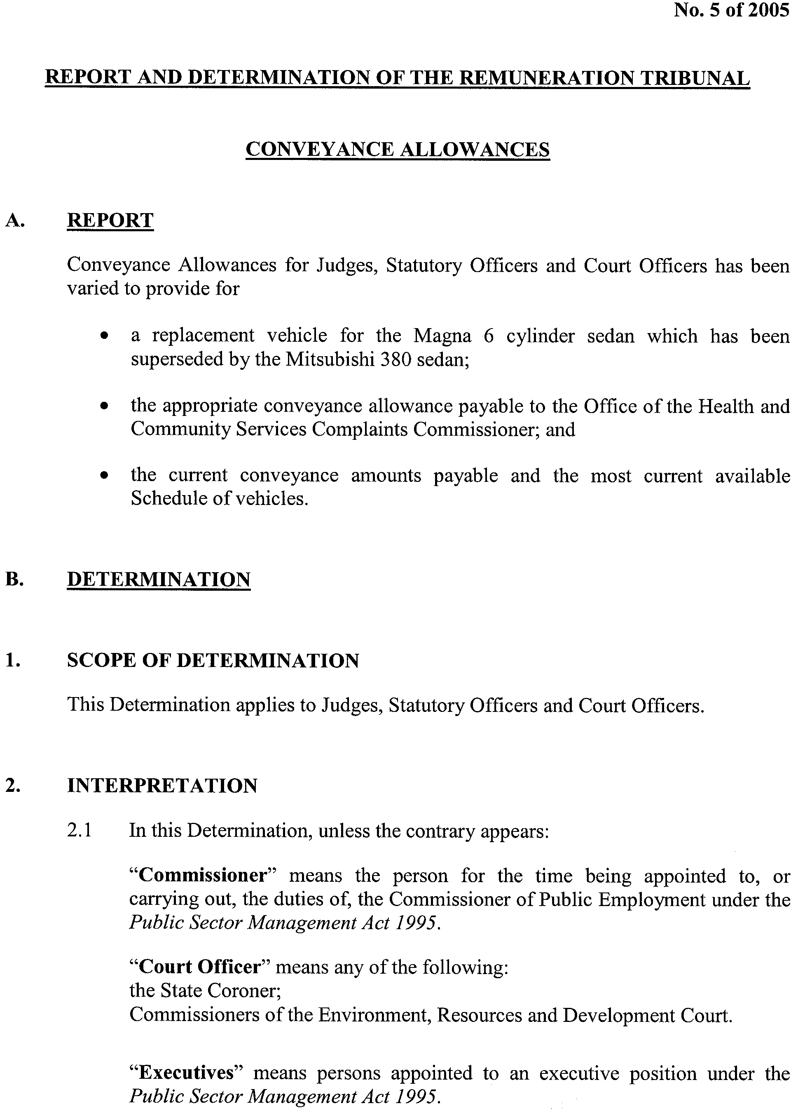

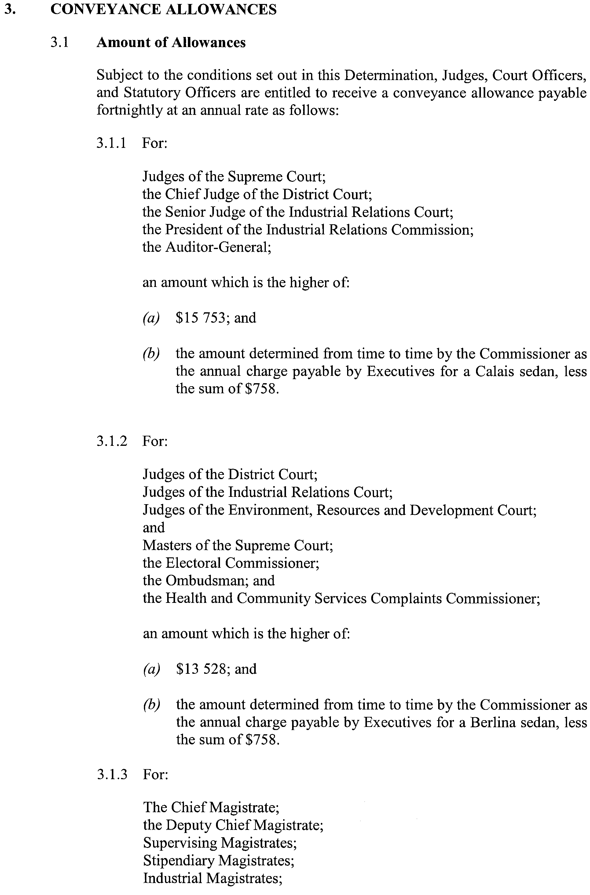
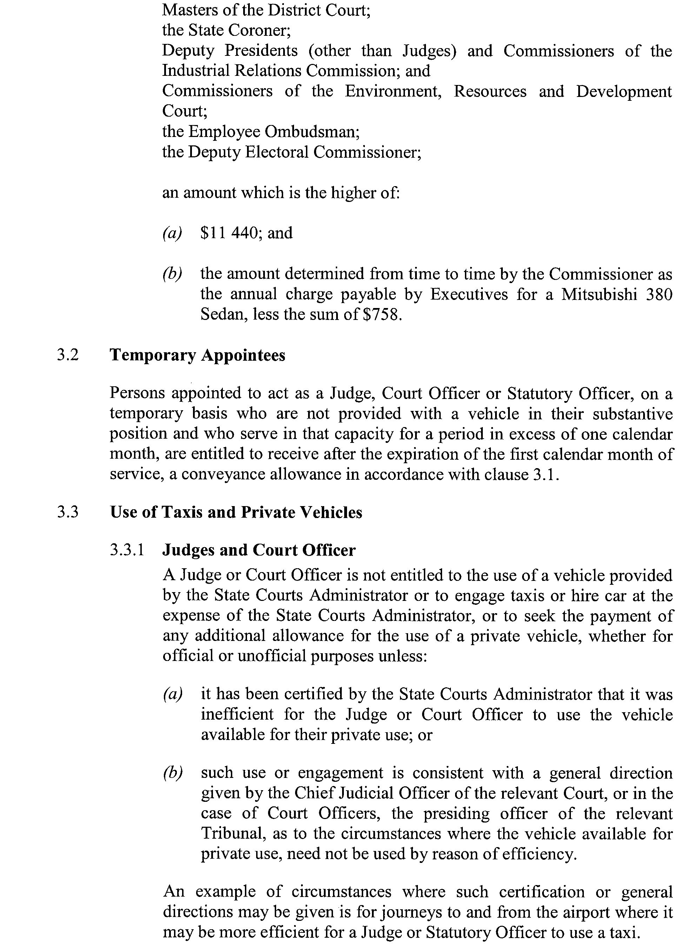
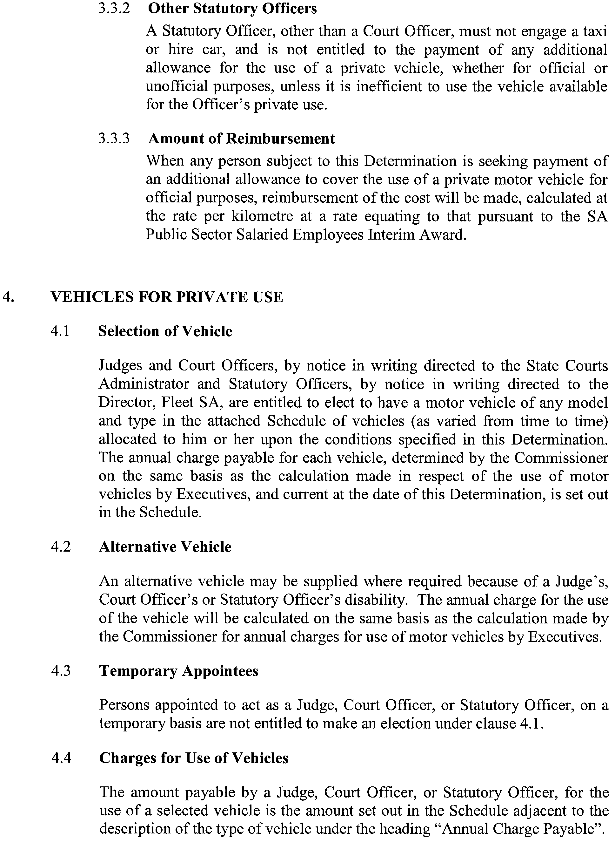
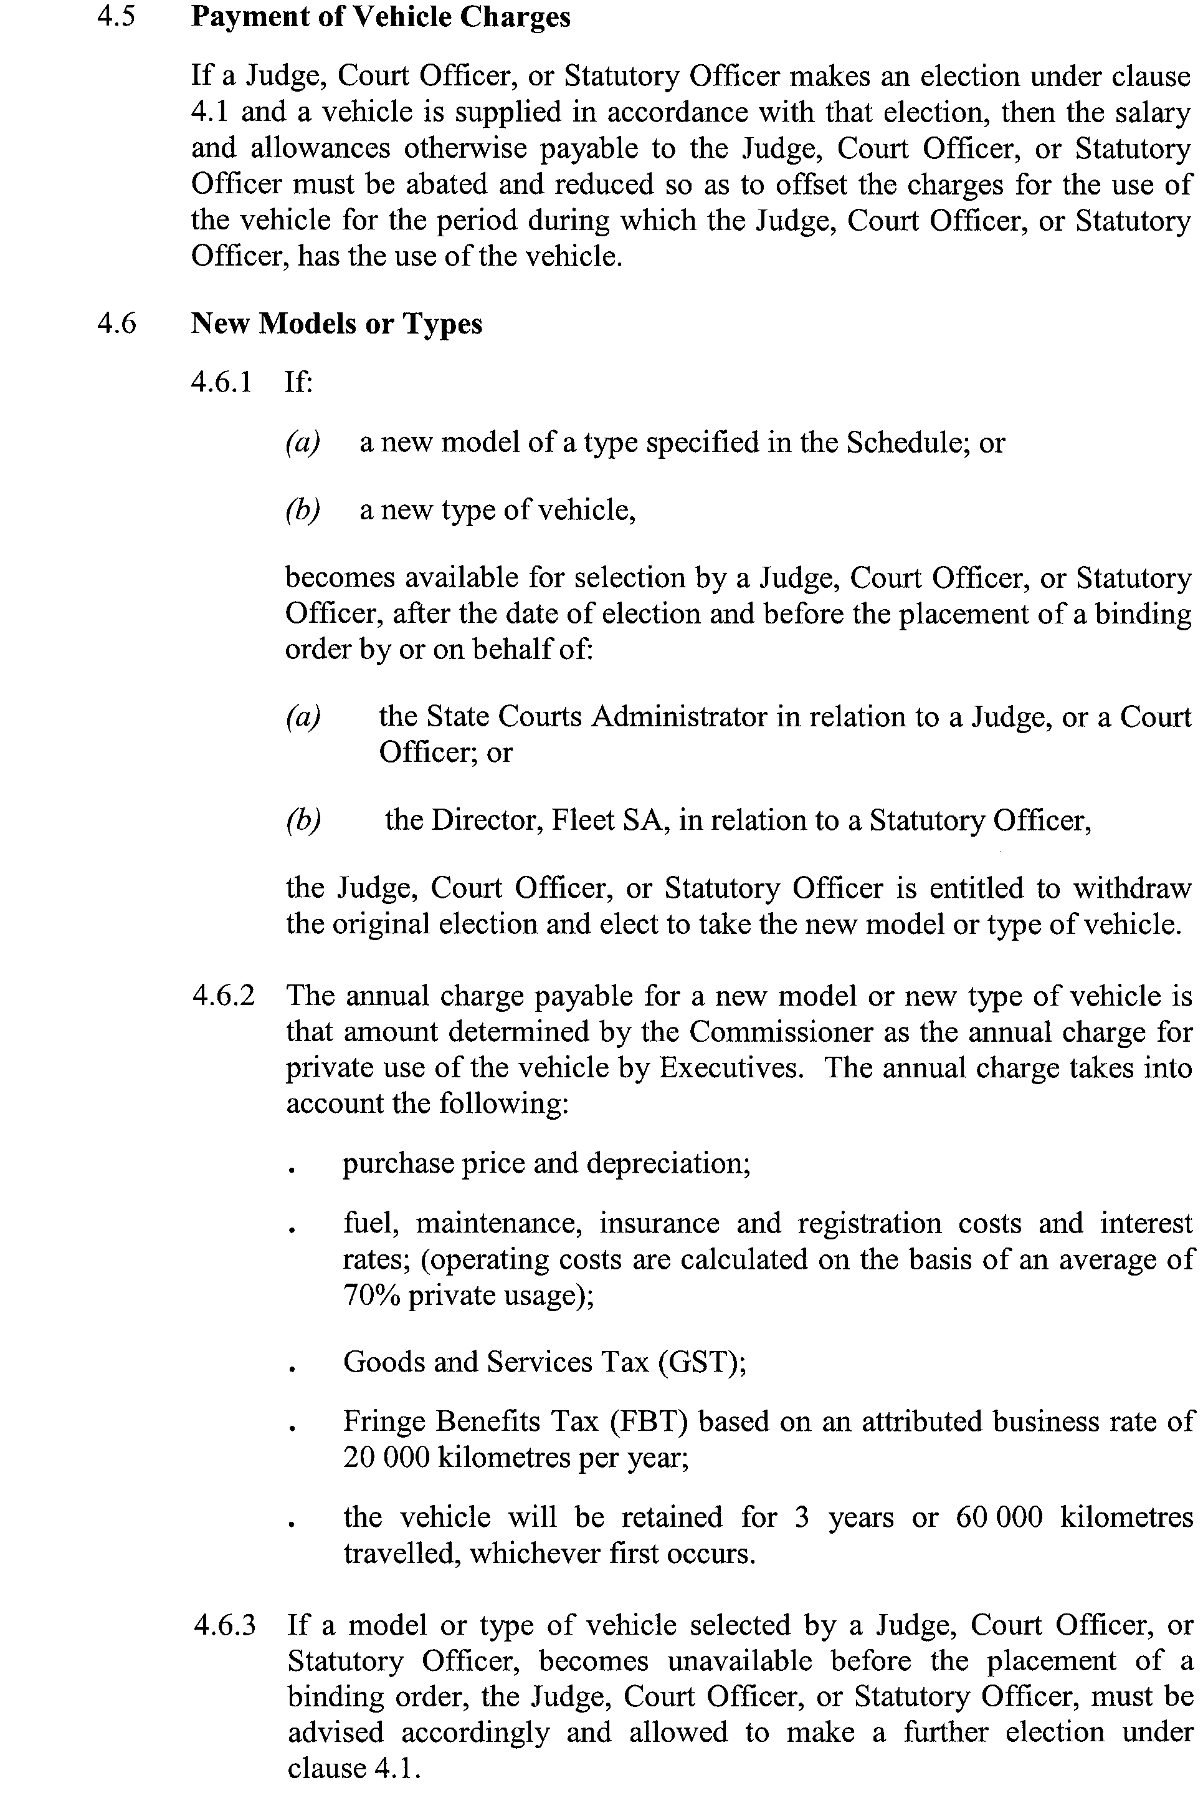
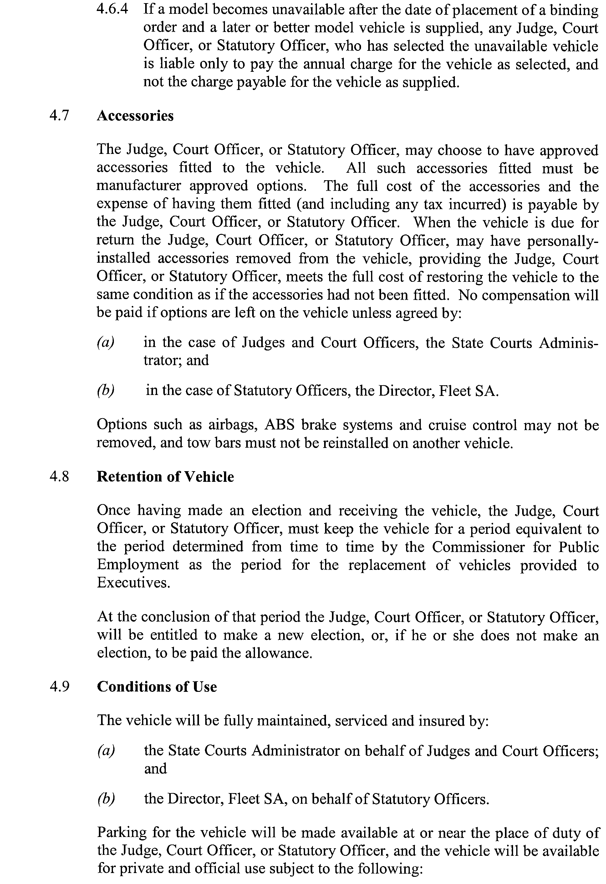
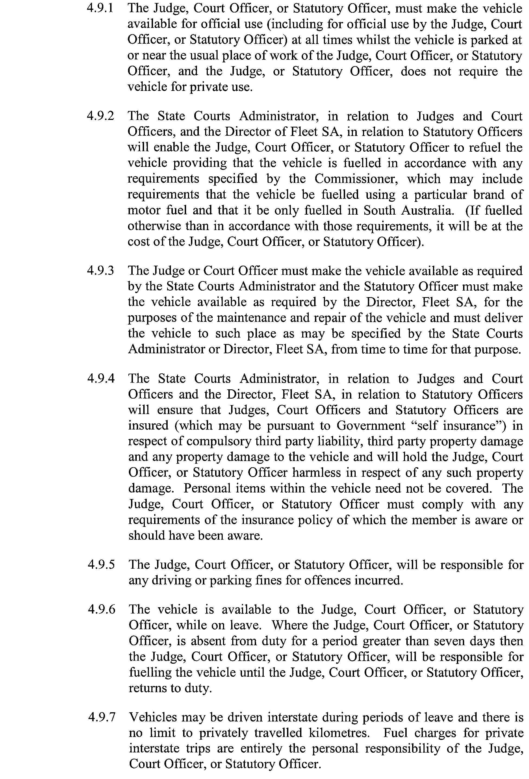
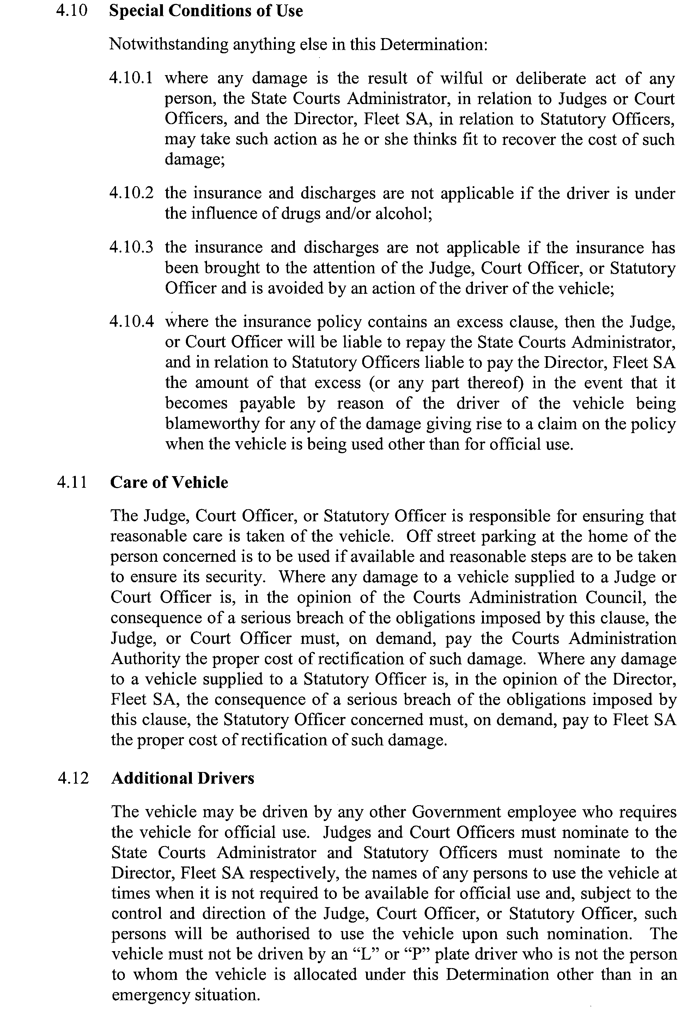
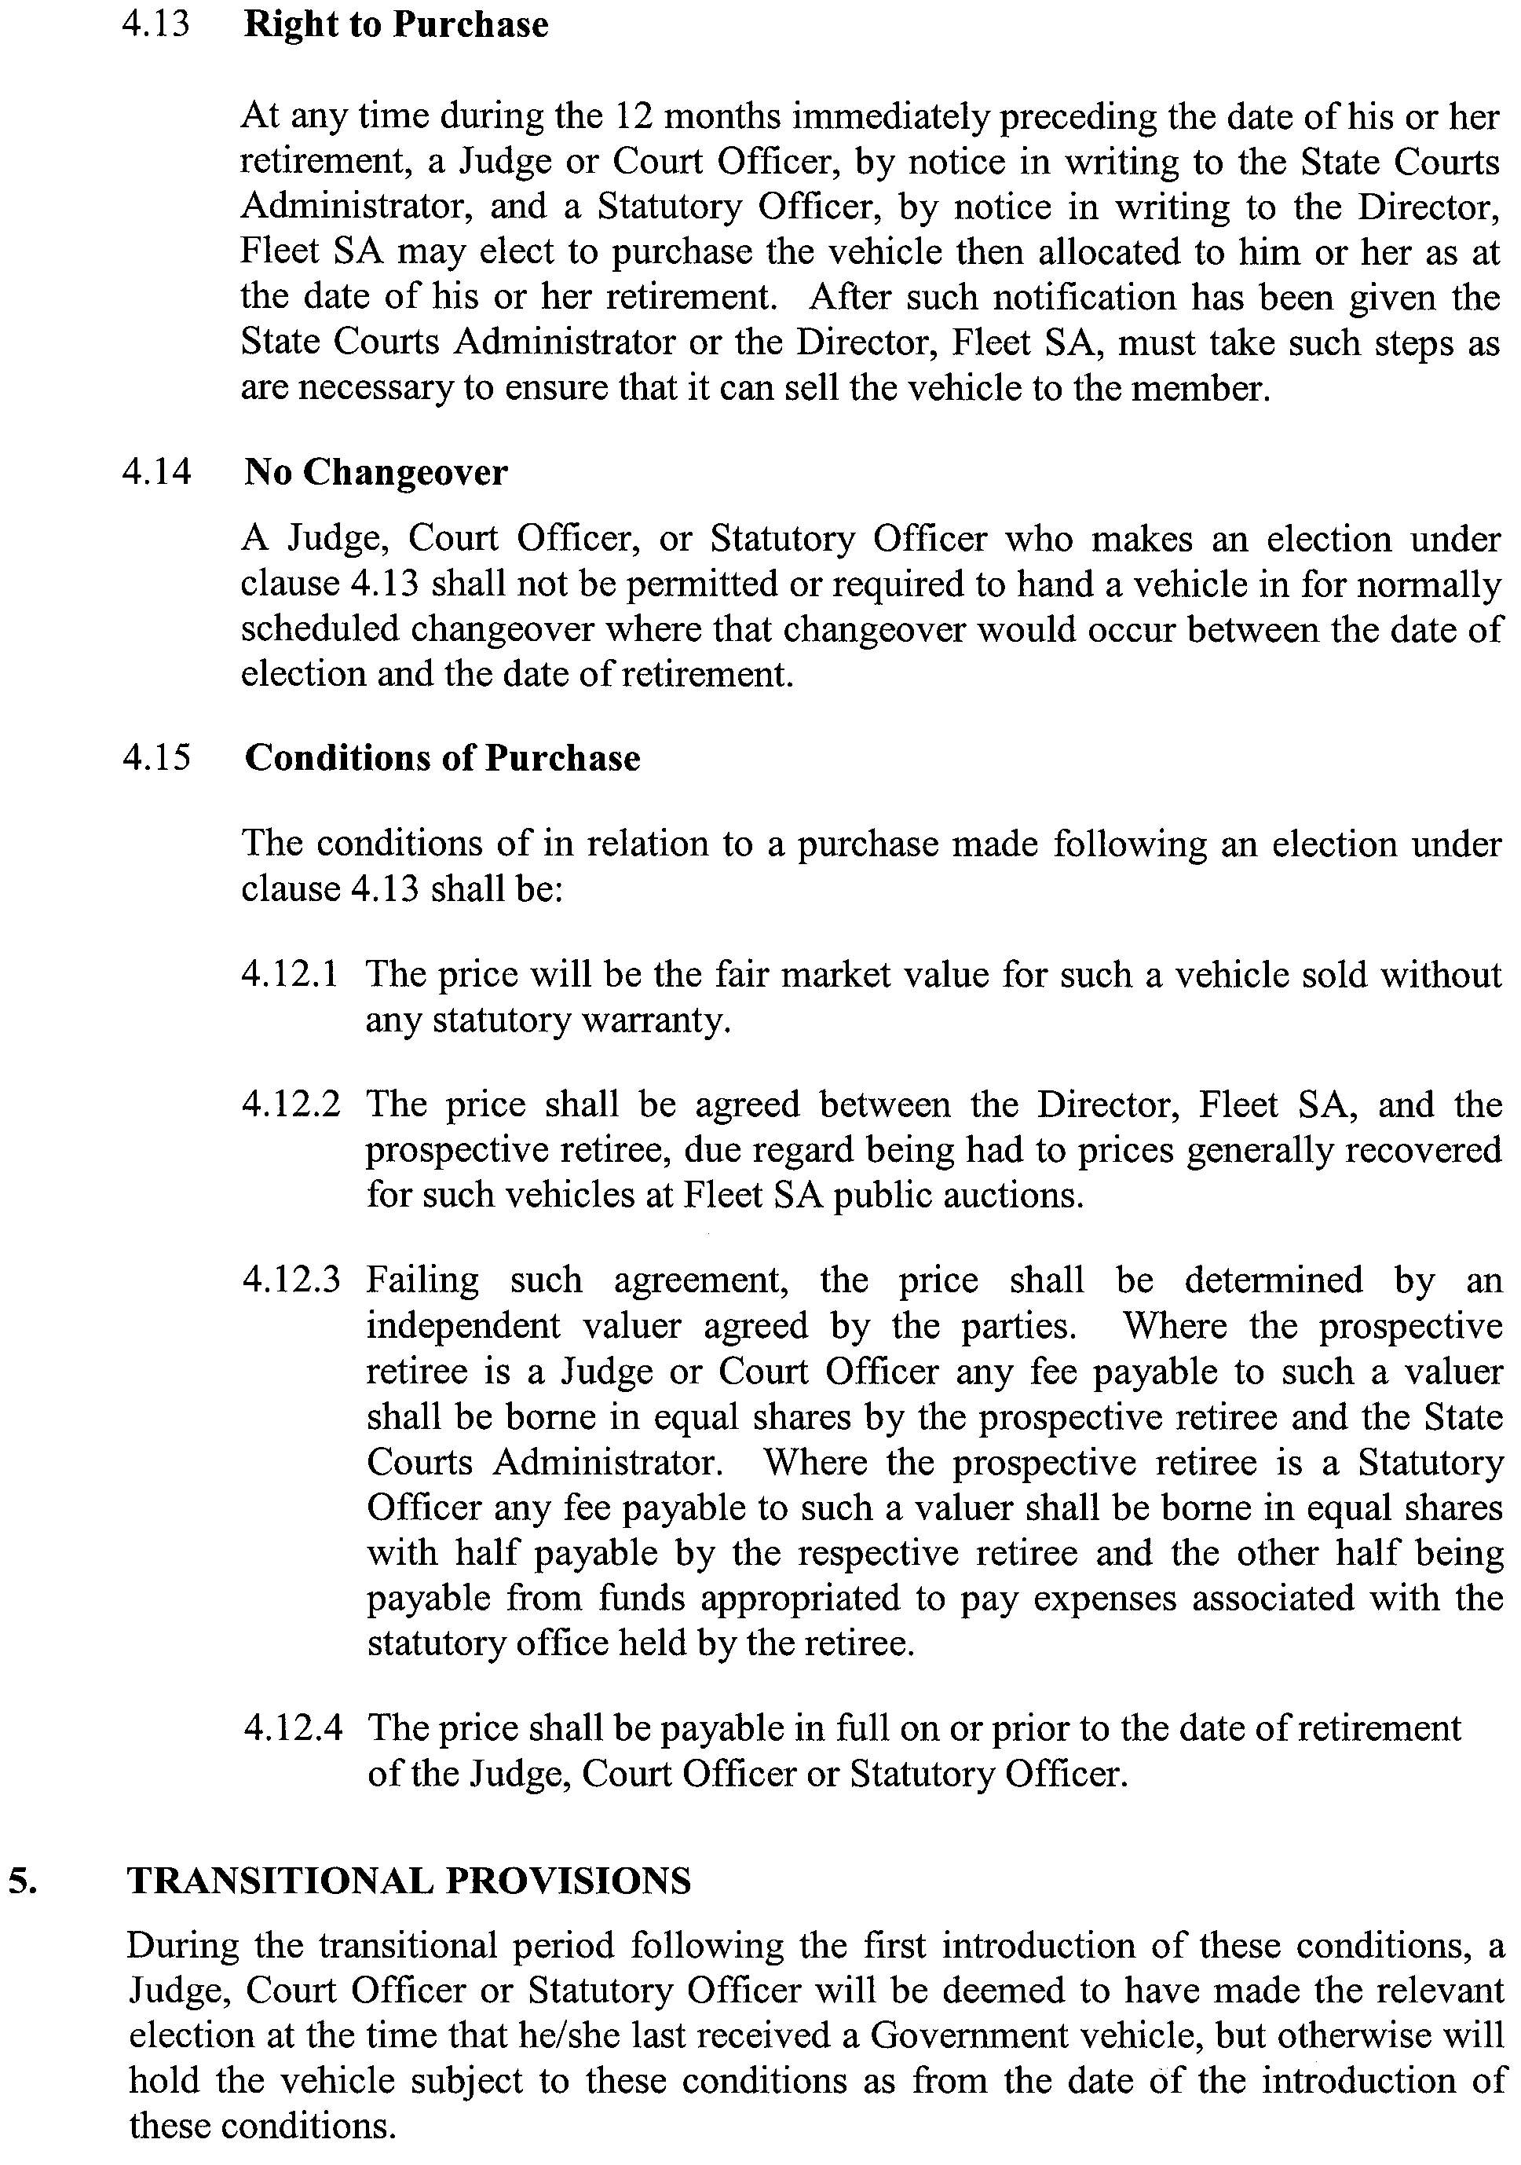
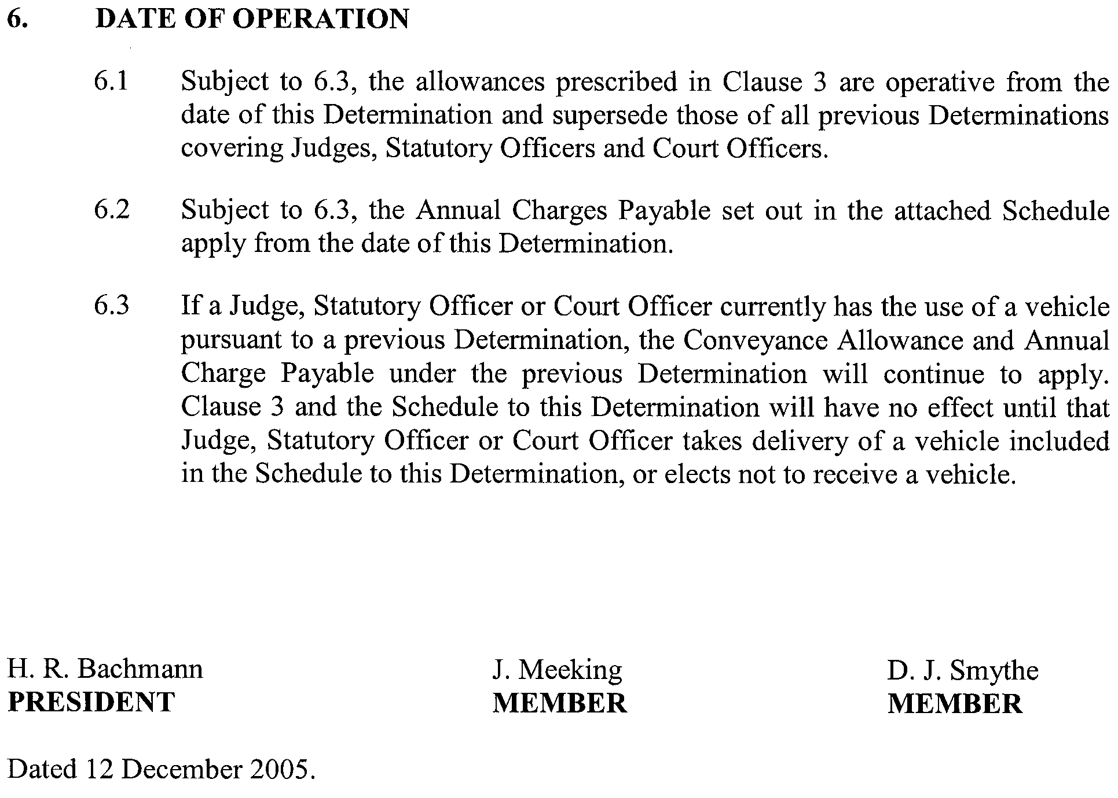
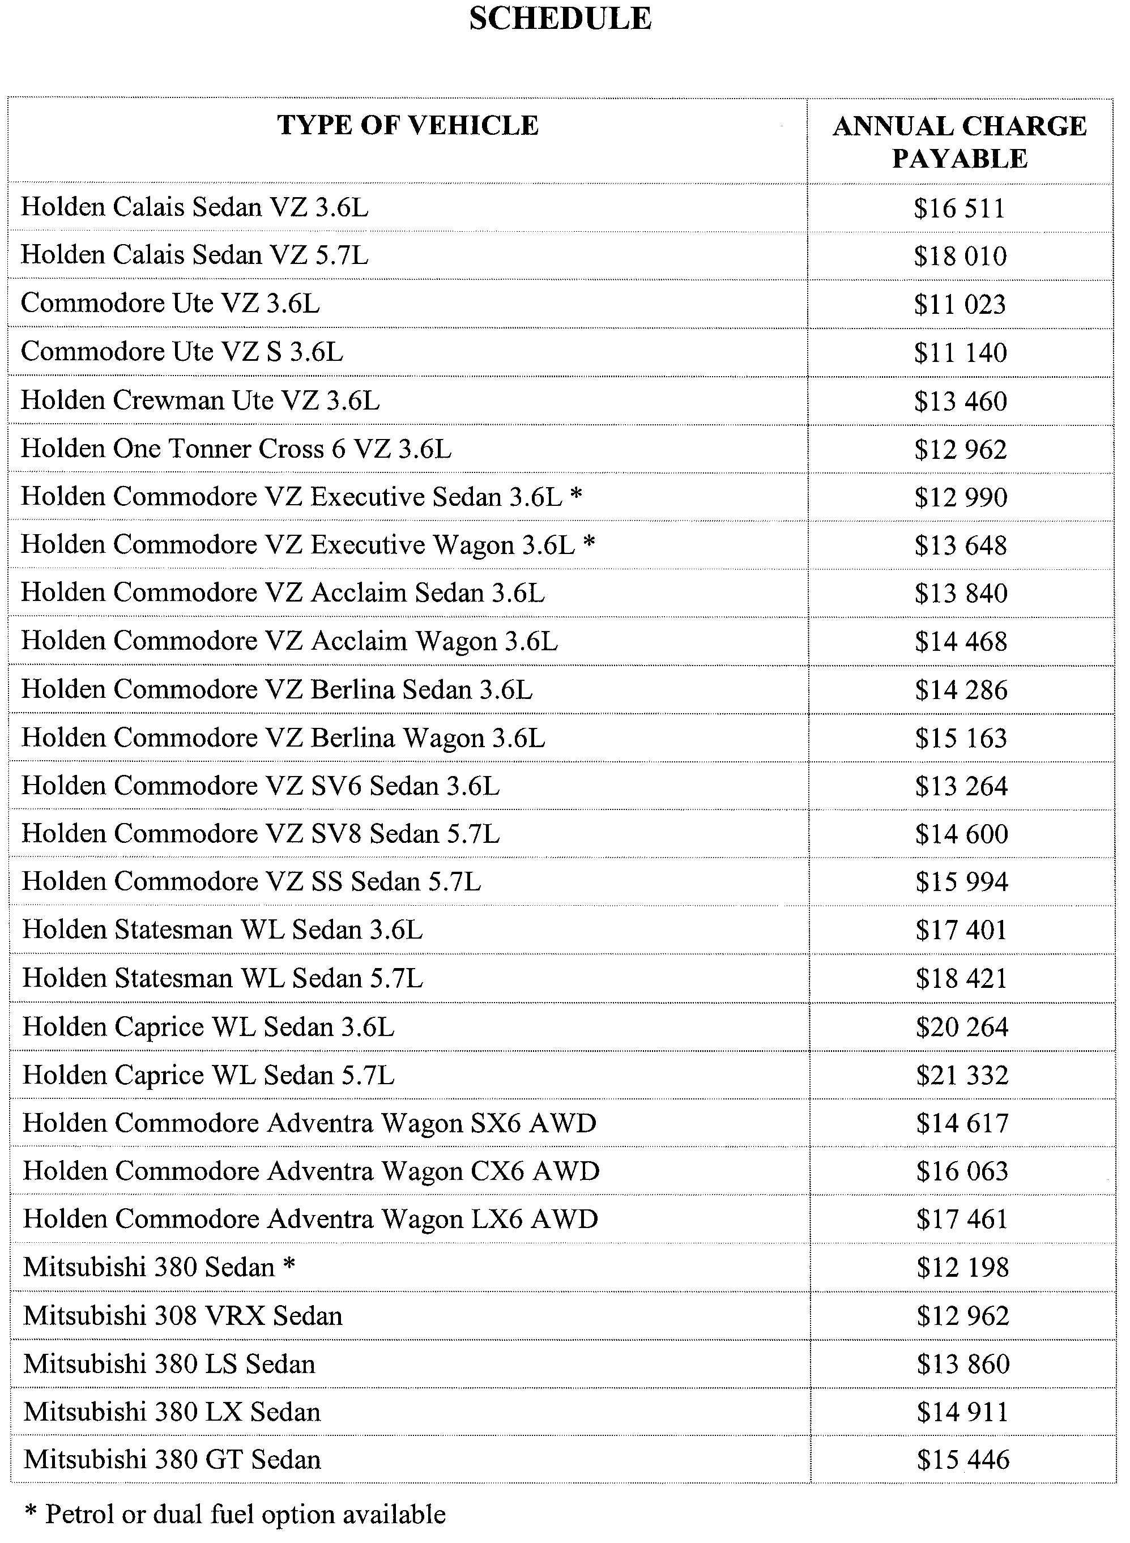

ROADS (OPENING AND CLOSING) ACT 1991:
SECTION 24
NOTICE OF CONFIRMATION OF ROAD
PROCESS ORDER
Road Closure
Walkway, Port Lincoln
BY Road Process Order made on 29 January 2005, the City of Port Lincoln ordered that:
1. The whole of the walkway between South Point Drive and Bridge Crescent and adjoining allotments 147 and 148 in Deposited Plan 38975, more particularly delineated and lettered ‘A’ and ‘B’ in Preliminary Plan No. 04/0098 be closed.
2. The whole of the land subject to closure lettered ‘A’ be transferred to Lincoln Cove Development Co Pty Ltd in accordance with agreement for transfer dated 29 January 2005 entered into between the City of Port Lincoln and Lincoln Cove Development Co Pty Ltd.
3. The whole of the land subject to closure lettered ‘B’ be transferred to Emily Krstina (Australia) Pty Ltd in accordance with agreement for transfer dated 25 January 2005 entered into between the City of Port Lincoln and Emily Krstina (Australia) Pty Ltd.
4. The following easement be granted over portion of the land subject to that closure:
Grant to the South Australian Water Corporation an easement for sewerage purposes.
On 28 July 2005 that order was confirmed by the Minister for Administrative Services conditionally upon the deposit by the Registrar-General of Deposited Plan 65099 being the authority for the new boundaries.
Pursuant to section 24 (5) of the Roads (Opening and Closing) Act 1991, NOTICE of the order referred to above and its confirmation is hereby given.
Dated 22 December 2005.
P. M. Kentish, Surveyor-General

ROADS (OPENING AND CLOSING) ACT 1991:
SECTION 24
NOTICE OF CONFIRMATION OF ROAD
PROCESS ORDER
Road Closure
Eight Mile Creek
BY Road Process Order made on 17 March 2005, the District Council of Grant ordered that:
1. The whole of the unnamed public road between Stratmans Road and Youngs Road and adjoining the southern boundary of sections 647 and 648 in the Hundred of MacDonnell, shown more particularly delineated and lettered ‘A’ and ‘B’ in the Preliminary Plan No. 04/0052 be closed.
2. The whole of the land subject to closure be transferred to David Noel Stratman and Deanne Jane Stratman in accordance with agreement for transfer dated 15 March 2005 entered into between the District Council of Grant and D. N. and D. J. Stratman.
On 19 December 2005 that order was confirmed by the Minister for Administrative Services conditionally upon the deposit by the Registrar-General of Deposited Plan 68133 being the authority for the new boundaries.
Pursuant to section 24 (5) of the Roads (Opening and Closing) Act 1991, NOTICE of the order referred to above and its confirmation is hereby given.
Dated 22 December 2005.
P. M. Kentish, Surveyor-General

ROADS (OPENING AND CLOSING) ACT 1991:
SECTION 24
NOTICE OF CONFIRMATION OF ROAD
PROCESS ORDER
Road Closure
La France Terrace, Port Augusta West
BY Road Process Order made on 17 January 2005, The Corporation of the City of Port Augusta ordered that:
1. The whole of the La France Terrace between Eyre Highway and Loudons Street and adjoining allotments 1 and 2 in Deposited Plan 945 and allotment 335 in Town of Port Augusta West, more particularly delineated and lettered ‘A’ in Preliminary Plan No. 04/0068 be closed.
2. Issue a Certificate of Title to The Corporation of the City of Port Augusta for the whole of the land subject to closure which land is being retained by Council for Public Purposes.
3. The following easement be granted over portion of the land subject to that closure:
Grant to the South Australian Water Corporation an easement for sewerage purposes.
On 19 December 2005 that order was confirmed by the Minister for Administrative Services conditionally upon the deposit by the Registrar-General of Deposited Plan 67085 being the authority for the new boundaries.
Pursuant to section 24 (5) of the Roads (Opening and Closing) Act 1991, NOTICE of the order referred to above and its confirmation is hereby given.
Dated 22 December 2005.
P. M. Kentish, Surveyor-General

ROADS (OPENING AND CLOSING) ACT 1991:
SECTION 24
NOTICE OF CONFIRMATION OF ROAD
PROCESS ORDER
Road Closure
Richards Avenue, Wudinna
BY Road Process Order made on 18 July 2005, the District Council of Le Hunte ordered that:
1. Portion of Richards Avenue between Ballantyne Street and Haines Street and adjoining piece 152 in the Deposited Plan 64960 and section 157 in the Hundred of Pygery, more particularly lettered ‘A’ and ‘B’ in the Preliminary Plan No. 05/0002 be closed.
2. Add the whole of the land subject to closure lettered ‘A’ to piece 152 in the Deposited Plan 64960 which land is dedicated under the Crown Lands Act 1929 for Parkland purposes.
3. Add the whole of the land subject to closure lettered ‘B’ to section 157 in the Hundred of Pygery which land is dedicated under the Crown Lands Act 1929 for Aged Persons Cottage Homes purposes.
On 19 December 2005 that order was confirmed by the Minister for Administrative Services conditionally upon the deposit by the Registrar-General of Deposited Plan 68738 being the authority for the new boundaries.
Pursuant to section 24 (5) of the Roads (Opening and Closing) Act 1991, NOTICE of the order referred to above and its confirmation is hereby given.
Dated 22 December 2005.
P. M. Kentish, Surveyor-General

STATE LOTTERIES ACT 1966
LOTTERIES (LOTTO) RULES
1. Preliminary
1.1 These Rules may be cited as the Lotteries (Lotto) Amendment Rules 2005
(No. 2).
1.2 The Lotteries (Lotto) Rules made under the State Lotteries Act 1966 and published in the Government Gazette on 19 July 1999, as amended by the amendments published in the Government Gazette on 27 March 2003, 26 February 2004 and 21 April 2005, are hereinafter referred to as the ‘Principal Rules’.
1.3 The Principal Rules are hereby amended effective from 7 p.m. on 11 March 2006 and these Rules will take effect immediately thereafter, except as provided in these Rules.

2. Amendment of Rule 10.1

Rule 10.1 of the Principal Rules is deleted and the following is substituted therefor:
‘The total prize pool will be distributed as follows:
Division 1—27.2% of the prize pool.
Division 2—6.45% of the prize pool.
Division 3—12.15% of the prize pool.
Division 4—20.85% of the prize pool.
Division 5—33.35% of the prize pool.’

The Common Seal of the Lotteries Commission of South Australia was affixed pursuant to a resolution of the Commission in the presence of:

Dated 17 November 2005.
(l.s.) Chris Crago, Commission Member
Stephen Shirley, Commission Member
Approved,
Kevin Foley, Treasurer

TRAINING AND SKILLS DEVELOPMENT ACT 2003

Part 4 – Apprenticeships/Traineeships

Pursuant to the provision of the Training and Skills Development Act 2003, the Training and Skills Commission (TaSC) gives notice that determines the following:
Trades, Declared Vocations or Other Occupations

The following schedule is additional to the gazettals of:

- 5 February 2004 | - 19 February 2004 | - 11 March 2004 | - 1 April 2004
- 1 July 2004 | - 15 July 2004 | - 22 July 2004 | - 30 September 2004
- 16 December 2004 | - 27 January 2005 | - 3 February 2005 | - 10 February 2005
- 10 March 2005 | - 24 March 2005 | - 5 May 2005 | - 12 May 2005
- 2 June 2005 | - 16 June 2005 | - 7 July 2005 | - 4 August 2005
- 18 August 2005 | - 1 September 2005 | - 15 September 2005 | - 22 September 2005
- 6 October 2005 | - 20 October 2005 | - 27 October 2005

which set out the Trades, Declared Vocations or Other Occupations and the terms and conditions applicable to the Trades, Declared Vocations or Other Occupations.

Trades, Declared Vocations or Other Occupations, required Qualifications and Contract of Training Conditions for the
Electrotechnology Training Package (UTE99)

*Trade/#Declared  Vocation/Other Occupation | Code | Title | Nominal  Duration | Probationary  Period
#Electrical/Electronics  Trades Assistant | UTE10102 | Certificate I in Electrotechnology | 12 months | 1 month
 | UTE20504 | Certificate II in Electrotechnology Servicing | 12 months | 1 month
*Television/Radio/  Electronics Tradesperson | UTE40302 | Certificate IV in  Electrotechnology Communications | 48 months | 3 months
 | UTE40602 | Certificate IV in  Electrotechnology Entertainment and Servicing | 48 months | 3 months
*Electrical Tradesperson (Electrician) | UTE41202 | Certificate IV in  Electrotechnology Systems Electrician | 48 months | 3 months

TRAINING AND SKILLS DEVELOPMENT ACT 2003

Part 4 – Apprenticeships/Traineeships

Pursuant to the provision of the Training and Skills Development Act 2003, the Training and Skills Commission (TaSC) gives notice that determines the following:
Trades, Declared Vocations or Other Occupations

The following schedule is additional to the gazettals of:

- 5 February 2004 | - 19 February 2004 | - 11 March 2004 | - 1 April 2004
- 1 July 2004 | - 15 July 2004 | - 22 July 2004 | - 30 September 2004
- 16 December 2004 | - 27 January 2005 | - 3 February 2005 | - 10 February 2005
- 10 March 2005 | - 24 March 2005 | - 5 May 2005 | - 12 May 2005
- 2 June 2005 | - 16 June 2005 | - 7 July 2005 | - 4 August 2005
- 18 August 2005 | - 1 September 2005 | - 15 September 2005 | - 22 September 2005
- 6 October 2005 | - 20 October 2005 | - 27 October 2005

which set out the Trades, Declared Vocations or Other Occupations and the terms and conditions applicable to the Trades, Declared Vocations or Other Occupations.

Trades, Declared Vocations or Other Occupations, required Qualifications and Contract of Training Conditions for the
Entertainment Industry Training Package (CUE03)

*Trade/#Declared  Vocation/Other  Occupation | Code | Title | Nominal Term  of Contract of  Training | Probationary  Period
#Entertainment  Industry Worker | CUE10103 | Certificate I in Live Production, Theatre and Events | Exit point only
 | CUE20103 | Certificate II in Live Production, Theatre and Events | 12 months | 1 month
 | CUE30103 | Certificate IV in Live Production, Theatre and Events (Construction and Manufacturing) | 12 months | 1 month
 | CUE30203 | Certificate III in Live Production, Theatre and Events (Technical Operations) | 12 months | 1 month
 | CUE30303 | Certificate III in Venues and Events (Customer Service) | 12 months | 1 month
 | CUE40103 | Certificate IV in Live Production, Theatre and Events (Construction and Manufacturing) | 24 months | 2 months
 | CUE40303 | Certificate IV in Live Production, Theatre and Events (Technical Operations) | 24 months | 2 months
 | CUE40403 | Certificate IV in Venues and Events (Customer Service) | 24 months | 2 months
#Entertainment  Industry Worker  cont’d | CUE50103 | Diploma of Live Production, Theatre and Events (Construction and Manufacturing) | 36 months | 3 months
 | CUE50303 | Diploma of Live Production, Theatre and Events (Technical Production) | 36 months | 3 months
 | CUE50403 | Diploma of Venues and Events | 36 months | 3 months
 | CUE60203 | Advanced Diploma of Live Production, Theatre and Events (Technical Production) | 36 months | 3 months
 | CUE60303 | Advanced Diploma of Stage Management | 36 months | 3 months
 | CUF40201 | Certificate IV in Make-up | 24 months | 2 months
 | CUF50201 | Diploma of Make-up | 24 months | 2 months

WATERWORKS ACT 1932
Addition of Land to Port Victor Water District
PURSUANT to section 6 of the Waterworks Act 1932, the South Australian Water Corporation:
(a) adds to the Port Victor Water District the land shown on the plan in the Schedule; and
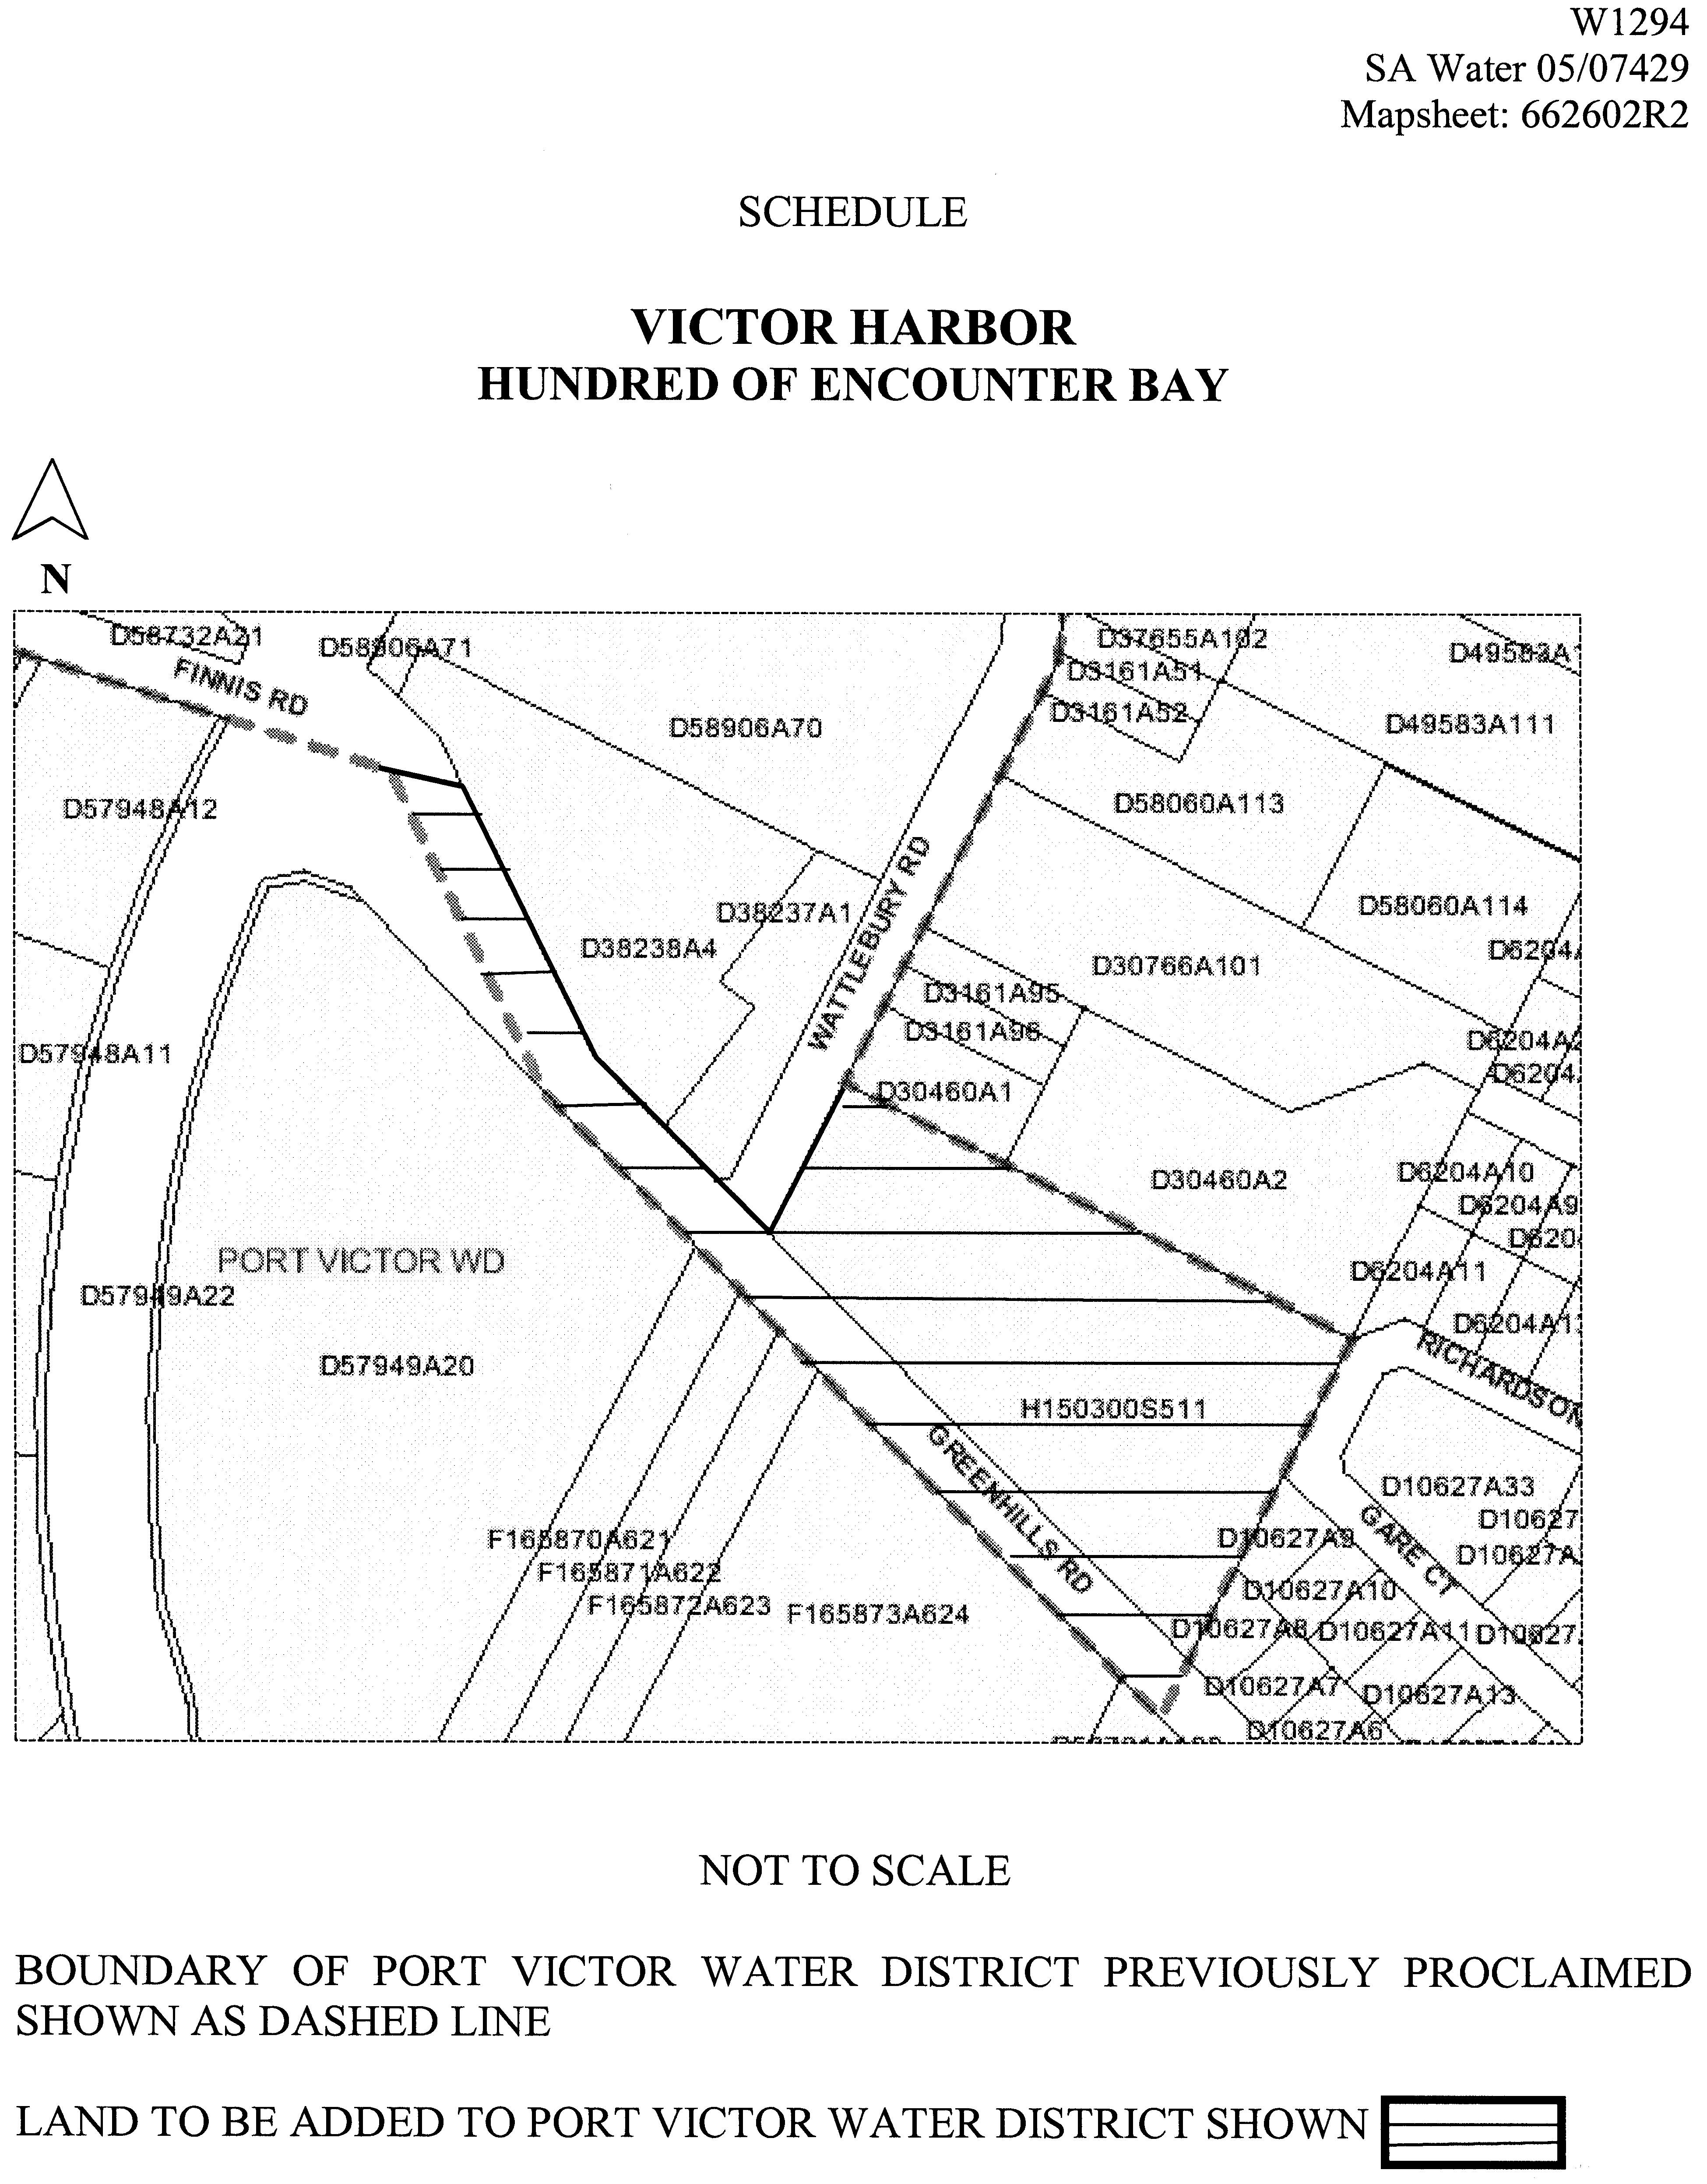
(b) declares that this notice has effect from the commencement of the financial year in which it is published in the Gazette.

Dated 14 December 2005.
Signed for and on behalf of the South Australian Water Corporation by a person duly authorised so to do:
A. Popplewell, General Manager Shared Services
In the presence of:
C. J. McNamara, Billing Manager
SAWATER 05/07429 W1294

WATER MAINS AND SEWERS

Office of the South Australian Water Corporation
Adelaide, 22 December 2005

WATER MAINS LAID

Notice is hereby given that the following main pipes or parts of main pipes have been laid down by the South Australian Water Corporation in or near the undermentioned water districts and are now available for a constant supply of water to adjacent land.

ADELAIDE WATER DISTRICT

CITY OF CHARLES STURT
Fifth Street, Brompton. p8

CITY OF NORWOOD PAYNEHAM AND ST PETERS
Webbe Street, Norwood. p9

BEETALOO COUNTRY LANDS WATER DISTRICT

DISTRICT COUNCIL OF THE COPPER COAST
Easement in lot 1000 in LTRO DP 66104, Patrick Street, Kadina. p3

KADINA WATER DISTRICT

DISTRICT COUNCIL OF THE COPPER COAST
Ireland Way, Kadina. p3 and 5
In and across John Olsen Drive, Kadina. p3-5
Easements in lot 1000 in LTRO DP 66104, Patrick Street, Kadina. p4
Easement in lot 996 in LTRO DP 66104, John Olsen Drive, and lot 40 in LTRO DP 66104, East Terrace, Kadina. p4 and 5
Schilling Street, Kadina. p3-5
Patrick Street, Kadina. p3-5

MOONTA WATER DISTRICT

DISTRICT COUNCIL OF THE COPPER COAST
Loller Street, Moonta Bay. p1 and 2
Easements in lot 904 in LTRO DP 69742, Rossiters Road, Moonta Bay. p1 and 2
Dimond Road, Moonta Bay. p1 and 2
Gulfview Heights Drive, Moonta Bay. p1 and 2

WHYALLA WATER DISTRICT

THE CORPORATION OF THE CITY OF WHYALLA
In public utility reserve (lot 6964), Whyalla Playford. p7
Across McEwin Street, Whyalla Playford. p7
In public utility reserve (lot 6967), Whyalla Playford. p7

WATER MAINS ABANDONED

Notice is hereby given that the undermentioned water mains have been abandoned by the South Australian Water Corporation.

ADELAIDE WATER DISTRICT

CITY OF CHARLES STURT
Fifth Street, Brompton. p8

CITY OF NORWOOD PAYNEHAM AND ST PETERS
Webbe Street, Norwood. p9

OUTSIDE TOWNSHIP OF BLINMAN WATER DISTRICT

OUT OF COUNCILS
Waterworks land ( section 379, hundred of Carr), Blinman. p14
Easements in sections 357 and 380, hundred of Carr, Blinman. p14 and 15
Across and in government road west of section 357, hundred of Carr, Blinman. p15 and 16
Easements in sections 180, 192-194, 207-209, 212, 211 and 213, hundred of Carr, Blinman. p15-17
Easement in lot 2 in LTRO FP 9813, Blinman. p17

STREAKY BAY TOWNSHIP WATER DISTRICT

DISTRICT COUNCIL OF STREAKY BAY
Wells Street, Streaky Bay. p10

STREAKY BAY COUNTRY LANDS WATER DISTRICT

DISTRICT COUNCIL OF STREAKY BAY
Wells Street, Streaky Bay. p10
Public road south-west of section 385, hundred of Ripon, Streaky Bay. p10

WHYALLA WATER DISTRICT

THE CORPORATION OF THE CITY OF WHYALLA
In public utility reserve (lot 6964), Whyalla Playford. p7
Across McEwin Street, Whyalla Playford. p7
In public utility reserve (lot 6967), Whyalla Playford. p7

WATER MAINS LAID

Notice is hereby given that the undermentioned water mains have been laid down by the South Australian Water Corporation and are not available for a constant supply of water to adjacent land.

ADELAIDE WATER DISTRICT

CITY OF MITCHAM
Waterworks land (lot 90 in LTRO FP 217639), Belair Road, Torrens Park. p11-13
In and across Belair Road, Torrens Park. p11-13

BARMERA WATERWORKS

OUTSIDE BARMERA WATER DISTRICT

THE BERRI BARMERA COUNCIL
Garrard Street, Barmera. p6
Danvers Road, Barmera. p6

OUTSIDE TOWNSHIP OF BLINMAN WATER DISTRICT

OUT OF COUNCILS
Waterworks land ( section 379, hundred of Carr), Blinman. p14
Easements in sections 357 and 380, hundred of Carr, Blinman. p14 and 15
Across and in government road west of section 357, hundred of Carr, Blinman. p15 and 16
Easements in sections 180, 192-194, 207-211, and 213, hundred of Carr, Blinman. p15-17
Easements in lots 2 and 1 in LTRO FP 9813, Blinman. p17

SEWERS LAID

Notice is hereby given that the following sewers have been laid down by the South Australian Water Corporation in the under-mentioned drainage area and are now available for house connections.

ADELAIDE DRAINAGE AREA

CITY OF HOLDFAST BAY
In and across Pier Street, Glenelg and Glenelg South. FB 1144 p17

TOWN OF GAWLER
Sewerage land ( section 883, hundred of Mudla Wirra), Willaston. FB 1144 p24
Main North Road, Willaston. FB 1144 p24

CITY OF PORT ADELAIDE ENFIELD
Jenkins Street, Rosewater. FB 1144 p25

CITY OF SALISBURY
Taylor Avenue, Salisbury Heights. FB 1144 p23

SEWERS ABANDONED

Notice is hereby given that the undermentioned sewer has been abandoned by the South Australian Water Corporation.

ADELAIDE DRAINAGE AREA

CITY OF HOLDFAST BAY
Pier Street, Glenelg. FB 1144 p17

SEWERS LAID

Notice is hereby given that the undermentioned sewers have been laid down by the South Australian Water Corporation and are not available for house connections.

ADELAIDE DRAINAGE AREA

CITY OF PORT ADELAIDE ENFIELD
Sewerage land (lot 27 in LTRO DP 18083), Cormack Road, Wingfield—150 mm PVC pumping main. FB 1144 p18
Across and in Cormack Road, Wingfield—150 mm PVC pumping main. FB 1144 p18
Magazine Road, Wingfield—150 mm PVC and DCTJ pumping main. FB 1144 p18
Sewerage land (allotment pieces 10 and 9 in LTRO DP 28342), Wingfield and Dry Creek—150 mm PVC and DCTJ pumping main. FB 1144 p18
Across public road between allotment pieces 10 and 9 in LTRO DP 28342, Wingfield and Dry Creek—150 mm PVC pumping main. FB 1144 p18

A. Howe, Chief Executive Officer, South Australian Water Corporation

WILDERNESS PROTECTION ACT 1992
Memory Cove Wilderness Protection Area Management Plan
I, JOHN HILL, Minister for Environment and Conservation, hereby give notice under the provisions of section 31 of the Wilderness Protection Act 1992, that on 5 December 2005, I adopted the Memory Cove Wilderness Protection Area Manage-ment Plan.
Copies of the plan may be inspected at or obtained from the offices of the Department for Environment and Heritage at:
• 1 Richmond Road, Keswick, S.A. 5035 (G.P.O. Box 1047, Adelaide, S.A. 5001), telephone 8124 4700.
• 75 Liverpool Street, Port Lincoln, S.A. 5606, telephone 8688 3111.
The plan may also be viewed at the Department’s website: http://www.environment.sa.gov.au/parks/management_plans.html.
Copies of this publication may be purchased at a cost of $10 per copy from the addresses above.
John Hill, Minister for Environment and Conservation

FAXING COPY?
IF you fax copy to Government Publishing SA for inclusion in the Government Gazette, there is no need to send a Confirmation Copy to us as well.
This creates confusion and may well result in your notice being printed twice.
Please use the following fax number:
Fax transmission: (08) 8207 1040
Phone Inquiries: (08) 8207 1045
Please include a contact person, phone number and order number so that we can phone back with any queries we may have regarding the fax copy.
NOTE: Closing time for lodging new copy (fax, hard copy or email) is 4 p.m. on Tuesday preceding the day of publication.

Government Gazette notices can be E-mailed.
The address is:
governmentgazette@saugov.sa.gov.au
Documents should be sent as attachments in Word format.
When sending a document via E-mail, please confirm your transmission with a faxed copy of your document, including the date the notice is to be published.
Fax transmission: (08) 8207 1040
Enquiries: (08) 8207 1045
NOTE: Closing time for lodging new copy (fax, hard copy or email) is 4 p.m. on Tuesday preceding the day of publication.

CITY OF NORWOOD, PAYNEHAM & ST PETERS
Supplementary Election for Councillor in Torrens Ward—Nominations Received
NOTICE is hereby given that at the close of nominations at
12 noon on Thursday, 15 December 2005, the following persons have been accepted as candidates and are listed in the order in which they will appear on the ballot paper:
Torrens Ward—(1 Vacancy):
Garner, Paul
Duke, Kevin
Postal Voting
The election will be conducted entirely by postal voting. No polling booth will be open for voting on polling day. Voting is not compulsory.
Voting material will be dispatched by post to every natural person, body corporate and group listed on the voters roll as at roll closure on Friday, 28 October 2005.
The mailout will commence on Tuesday, 10 January 2006, with all voting materials to be delivered by Monday, 16 January 2006.
A person who has not received voting material by Monday,
16 January 2006 and who believes that he or she is entitled to vote should apply to the State Electoral Office on 8401 4327.
A pre-paid addressed envelope for each elector entitlement will be provided. Completed ballot material must be returned to reach the Returning Officer no later than 12 noon on Monday,
30 January 2006.
A ballot box will be provided at the Council Office, 175 The Parade, Norwood for electors who wish to personally deliver their completed ballot material during office hours.
Place of Counting Votes
The scrutiny and counting of votes will take place in the Mayor’s Parlour, Norwood Town Hall, 175 The Parade, Norwood as soon as practicable after 12 noon on Monday, 30 January 2006. A provisional declaration will be made at the conclusion of the election count.
Campaign Donations Return
All candidates must forward a campaign donations return to the Council Chief Executive Officer within six weeks after the conclusion of the election.
K. Mousley, Returning Officer

ADELAIDE HILLS COUNCIL
Roads (Opening and Closing) Act 1991
Road Closure—Swamp Road, Uraidla
NOTICE is hereby given, pursuant to section 10 of the Roads (Opening and Closing) Act 1991, that the Adelaide Hills Council proposes to make a Road Process Order to close and transfer to SA Water portion of the public road (Swamp Road) being defined as the entirety of Allotment 32 in Filed Plan 129286 as more particularly delineated and lettered ‘A’ on Preliminary Plan No. 05/0070.
A copy of the plan and a statement of persons affected are available for public inspection at the offices of the Council, 28 Onkaparinga Valley Road, Woodside, 63 Mount Barker Road, Stirling, or at Council’s libraries at Woodside, Stirling or Gumeracha and the Adelaide office of the Surveyor-General during normal office hours.
Any application for easement or objection must set out the full name, address and details of the submission and must be fully supported by reasons.
The application for easement or objection must be made in writing to the Council, P.O. Box 44, Woodside, S.A. 5244 within 28 days of this notice and a copy must be forwarded to the Surveyor-General, G.P.O. Box 1354, Adelaide, S.A. 5001. Where a submission is made, the Council will give notification of a meeting at which the matter will be considered.
Dated 21 December 2005.
P. Peppin, Chief Executive Officer

ALEXANDRINA COUNCIL
January 2006 Council Meeting
NOTICE is hereby given that Council resolved at its meeting held on 5 December 2005, that there will only be one Council Meeting held in January 2006, with this being held on Monday, 16 January 2006 commencing at 1.30 p.m. in the Council Community Chambers, ‘Wal Yuntu Warrin’ in Goolwa.
J. L. Coombe, Chief Executive

DISTRICT COUNCIL OF CEDUNA
Roads (Opening and Closing) Act 1991
Road Closure—Woods Pit Road, Smoky Bay
NOTICE is hereby given pursuant to section 10 of the Roads (Opening and Closing) Act 1991, that Council proposes to make a Road Process Order to close and retain the whole of Woods Pit Road, north of Miltaburra Road and between sections 33 and 38 in the Hundred of Wallanippie as delineated ‘A’ in Preliminary Plan No. 05/0069.
A copy of the plan and statement of persons affected are avail-able for public inspection at Council’s Offices, 44 O’Loughlin Terrace, Ceduna and the Surveyor-General’s Office, 101 Grenfell Street, Adelaide, during normal office hours.
Any application for easement or objection must set out the full name, address and details of the submission and must be fully supported by reasons.
The application for easement or objection must be made in writing within 28 days of this notice to the Council, P.O. Box 175, Ceduna, S.A. 5690 and a copy must be forwarded to the Surveyor-General, G.P.O. Box 1354, Adelaide, S.A. 5001. Where a sub-mission is made, Council will give notification of a meeting to deal with the matter.
Dated 22 December 2005.
A. J. Irvine, Chief Executive Officer

COORONG DISTRICT COUNCIL
Community Land Management Plans
NOTICE is hereby given that pursuant to the Local Government Act 1999, section 197 (3), the Council at its meeting held on
8 November 2005, resolved to adopt Community Land Manage-ment Plans for the following groups of Community Land that have recently come under the care and control of Council:
Recreation and Conservation Reserve, Section 382, Hundred of Bonney in the area named Meningie. Crown Record volume 5926, folio 671 (Reserve, Princes Highway, Meningie).
Recreation and Conservation Reserve, Section 384, Hundred of Bonney in the area named Meningie. Crown Record volume 5926, folio 672 (Reserve, Princes Highway Meningie).
Recreation and Historic Building Reserve, Allotment 1, Deposited Plan 65168, Hundred of Malcolm, County of Russell, Crown Record volume 5667, folio 593 (Point Malcolm Lighthouse).
Dated 14 December 2005.
W. R. Paterson, Chief Executive Officer

KANGAROO ISLAND COUNCIL
Change of Meeting Dates for January 2006
NOTICE is hereby given pursuant to section 81 of the Local Government Act 1999, that the Ordinary Meeting of Council will be held on Wednesday, 18 January 2006 to be conducted in the Kangaroo Island Council Chambers, Drew Street, Kingscote, commencing at 1 p.m.
Notice is also hereby given that the next Development Assessment Panel meeting will be held on Monday, 16 January 2006 at 5 p.m. and thereafter on the first Monday of each month commencing at 5 p.m. in the Kangaroo Island Council Chambers, Drew Street, Kingscote.
N. Brown, Chief Executive Officer

DISTRICT COUNCIL OF KAROONDA EAST MURRAY
Temporary Road Closure
NOTICE is hereby given that at its meeting held on 8 November 2005, Council resolved to exercise the powers pursuant to section 33 of the Road Traffic Act 1961 and Clause F of the Instrument of General Approval of the Minister dated 12 March 2001, accordingly, Council pursuant to section 33 (1) (a) of the Road Traffic Act 1961, declares that the event to be conducted, being a New Years Eve Street Party is an event to which section 33 of the Road Traffic Act 1961 applies, and as such makes an order that Railway Terrace, Karoonda, between Bodey Street and East Terrace, will be closed to traffic from 5 p.m. on 31 December 2005 to 3 a.m. on 1 January 2006, and at its meeting held on 13 December 2005, Council resolved to exercise the powers pursuant to section 33 of the Road Traffic Act 1961 and Clause F of the Instrument of General Approval of the Minister dated 12 March 2001, accordingly, Council pursuant to section 33 (1) (a) of the Road Traffic Act 1961, declares that the event to be conducted, being a Christmas Street Party is an event to which section 33 of the Road Traffic Act 1961 applies, and as such makes an order that Railway Terrace, Karoonda, between Bodey Street and East Terrace, will be closed to traffic from 5 p.m. to 10.30 p.m. on 23 December 2005.
Pursuant to section 33 (1) (b) of the Road Traffic Act 1961, make an order directing that persons taking part in the event be exempted, in relation to roads, from the duty to observe the Australian Road Rules specified and attached to the exemption:
Rule 230—Crossing a Road—General.
P. Smithson, Chief Executive Officer

KINGSTON DISTRICT COUNCIL
Amendment to Community Land Management Plan
NOTICE is hereby given that Kingston District Council having complied with the requirements of section 198 of the Local Government Act 1999, have amended the Community Land Management Plan by inclusion of Section 501, Hundred of Lacepede being Crown Record 5623/714.
M. McCarthy, Chief Executive Officer

KINGSTON DISTRICT COUNCIL
Exclusion of Land from Community Land Classification
NOTICE is hereby given that Kingston District Council having complied with the requirements of section 194 (2) of the Local Government Act 1999 and having received approval from the Minister for Local Government, revoked the Community Land Classification of Lot 13, South Terrace, Hundred of Lacepede, CT 5708/540.
M. McCarthy, Chief Executive Officer

DISTRICT COUNCIL OF LE HUNTE
Roads (Opening and Closing) Act 1991
Simpson Road, Kyancutta
PURSUANT to section 10 of the Roads (Opening and Closing) Act 1991, the District Council of Le Hunte hereby gives notice of its intention to implement a Road Process in the Hundred of Wannamana to:
(i) open as road portion of the land dissecting section 45 numbered ‘1’ on Preliminary Plan No. 04/0100; and
(ii) close the whole of the public road (Simpson Road) where it divides section 45 from section 46 lettered ‘A’ on Preliminary Plan No. 04/0100.
Closed road ‘A’ is to be merged with section 45 in exchange for the new road numbered ‘1’.
A statement of persons affected by the process together with a copy of the preliminary plan is available for public inspection at the offices of the District Council of Le Hunte, 11 Burton Terrace, Wudinna and at the Adelaide office of the Surveyor-General during normal office hours.
Any person who may wish to object to the proposed Road Process, or any person who may wish to apply for an easement to be granted in that person’s favour over the land subject to the proposed closure must lodge with the said Council a notice of objection or an application for easement within 28 days of the date of this publication of this notice.
All objections shall be in writing stating the objector’s full name and address and the reasons for the objection and whether the objector wishes to appear in person or be represented at a meeting convened by the Council for the determination of objections.
An application for easement shall be in writing stating the applicant’s full name and address, the reasons for the application for the grant of easement, full details of the nature and location of the easement applied for and whether the easement will be in favour of adjoining or nearby land, and if so, specifying the land to which the easement will be annexed.
Where a submission is made the Council will give notification of a meeting at which the matter will be considered so that the person making the submission or their representative may attend if desired.
A copy of any notice or application shall, at the same time it is lodged with the District Council of Le Hunte, P.O. Box 6, Wudinna, S.A. 5652, be forwarded to the Adelaide office of the Surveyor-General, G.P.O. Box 1354, Adelaide, S.A. 5001.
Dated 30 August 2005.
A. McGuire, Chief Executive Officer

DISTRICT COUNCIL OF TUMBY BAY
Establishment of Bush Fire Prevention Committee
NOTICE is hereby given that the District Council of Tumby Bay at its meeting held on 12 December 2005, reconstituted the Tumby Bay Bushfire Prevention Committee, pursuant to section 75 of the Fire and Emergency Services Act in relation to the Council area and that the committee will continue to consist of all such officers, persons and representatives as are required to be appointed as members in accordance with the Act and any other deputies, persons, nominees or representatives as may be appointed in accordance with the Act and at the discretion of the Council.
E. A. Roberts, District Clerk

DISTRICT COUNCIL OF TUMBY BAY
Naming of Road
NOTICE is hereby given pursuant to section 219 of the Local Government Act 1999, that the Council of the District Council of Tumby Bay, at its meeting held on 12 December 2005, assigned the name Habib Road to the road reserve on the north-eastern side of Section 66, Hundred of Dixson.
E. A. Roberts, District Clerk

WAKEFIELD REGIONAL COUNCIL
Exclusion of Land from Classification as Community Land
NOTICE is hereby given that Council at its ordinary meeting held on 14 December 2005, resolved pursuant to section 193 (4) (a) of the Local Government Act 1999, as amended, to exclude the following parcel of land from Classification as Community Land for the purpose of future waste management operations:
Allotment 2 in Deposited Plan 36328, Hundred of Everard, as described under certificate of title volume 5157, folio 164.
P. Barry, Chief Executive Officer

WAKEFIELD REGIONAL COUNCIL
Appointment
NOTICE is hereby given that at a meeting of the Council held on 14 December 2005, Emily Jane Post was appointed as an Authorised Officer, pursuant to the Public and Environmental Health Act 1987 (section 7 (1)), Food Act 2001 (section 94), Dog and Cat Management Act 1995 (section 27), Local Government Act 1999 (section 260), Environment Protection Act 1993 (Burning Policy) and Development Act 1993 (section 18) and cancels the authorisations of Jimmy Huynh, Anthony Leonard Dewar and Lyndon George Addison.
P. Barry, Chief Executive Officer

IN the matter of the estates of the undermentioned deceased persons:
Abbott, Patricia Margaret, late of 10 Davenport Street, Millicent, home duties, who died on 25 September 2005.
Allen, Norma June, late of 32 Cross Road, Myrtle Bank, of no occupation, who died on 19 August 2005.
Cook, Cecil, late of 34 Livingstone Avenue, Prospect, retired bricklayer, who died on 10 April 2005.
Danks, William Albert, late of Brookside Road, Darlington, of no occupation, who died on 18 October 2005.
Dicker, Dean Spencer, late of 4 Kathleen Street, Dover Gardens, retired insurance assessor, who died on 30 August 2005.
Eastaughffe, Douglas Alexander John, late of 342 Marion Road, North Plympton, retired telecommunications manager, who died on 22 July 2005.
Eustice, Marian Gwendoline, late of 2 Jean Street, Oaklands Park, of no occupation, who died on 5 September 2005.
Fry, John Stanley, late of 71 Peters Street, Whyalla Playford, retired foreman, who died on 12 June 2005.
Lambert, Winifred Marion, late of 86 Oaklands Road, Glengowrie, of no occupation, who died on 28 October 2005.
Lloyd, Ernest William, late of 2-10 First Street, Brompton, retired public servant, who died on 10 May 2005.
Matousek, Jaroslav, late of 10 Marion Road, Brooklyn Park, retired labourer, who died on 6 July 2005.
O’Donnell, Keith Conan, late of 3 Grant Avenue, Gilles Plains, retired tinner, who died on 27 October 2005.
Rant, Peter, late of 233 Old South Road, Old Reynella, retired storeman, who died on 13 September 2005.
Sayle, Jean, late of 18 Cross Road, Myrtle Bank, of no occupation, who died on 20 September 2005.
Semmens, Anna Rachel, late of 550 Portrush Road, Glen Osmond, retired teacher, who died on 30 October 2005.
Smith, David Leonard, late of 175 Main Road, Yankalilla, retired storeman, who died on 2 November 2005.
Ward, Mercia Dorothy Mavis, late of 81 Tapleys Hill Road, Hendon, retired milliner, who died on 18 October 2005.
Notice is hereby given pursuant to the Trustee Act 1936, as amended, the Inheritance (Family Provision) Act 1972, and the Family Relationships Act 1975, that all creditors, beneficiaries, and other persons having claims against the said estates are required to send, in writing, to the Public Trustee, 25 Franklin Street, Adelaide, S.A. 5000, full particulars and proof of such claims, on or before 27 January 2006, otherwise they will be excluded from the distribution of the said estate; and notice is also hereby given that all persons who are indebted to the said estates are required to pay the amount of their debts to the Public Trustee or proceedings will be taken for the recovery thereof; and all persons having any property belonging to the said estates are forthwith to deliver the same to the Public Trustee.
Dated 22 December 2005.
C. J. O’Loughlin, Public Trustee

ATTENTION

CUSTOMERS requiring a proof of their notice for inclusion in the Government Gazette, please note that the onus is on you to inform Government Publishing SA of any subsequent corrections by 10 a.m. on Thursday, which is our publication deadline.

For any corrections to your notice please phone 8207 1045 or Fax 8207 1040 before 10 a.m. on Thursday.

If we do not receive any communication by 10 a.m. on Thursday (day of publication) we will presume the notice is correct and will print it as it is.

Remember—the onus is on you to inform us of any corrections necessary to your notice.

NOTE: Closing time for lodging new copy (electronically, fax or hard copy) is 4 p.m. on Tuesday preceding the day of publication. Phone 8207 1045—Fax 8207 1040.
Email: governmentgazette@saugov.sa.gov.au

Printed and published by authority every Thursday by K. O’CALLAGHAN, Government Printer, South Australia
Price: $5.00, plus postage; to subscribers, $254.00 per annum.
(The above prices are inclusive of GST)

* * Rules published in the South Australian Government Gazette on 5 October 2000 (No. 162 of 2000) at pages 2335–2356 and subsequently amended by rules published in the Gazette on 2 May 2001 (No. 50 of 2001) at pages 1701–1702; on 5 July 2001 (No. 82 of 2001) at pages 2556–2557; on 13 December 2001 (No. 117 of 2001) at pages 4130–4145; on 13 December 2001 (No. 165 of 2001) at pages 5541–5542; on 6 June 2002 (No. 67 of 2002) at pages 2055–2062; on 5 September 2002 (No. 99 of 2002) at pages 3340–3347; on 5 September 2002 (No. 99 of 2002) at pages 3348–3354; on 6 February 2003 (No. 13 of 2003) at pages 431–433; on 11 March 2004 (No. 23 of 2004) at pages 679–680; on 3 June 2004 (No. 46 of 2004) at pages 1685–1691; on 26 August 2004 (No. 77 of 2004) at pages 3334–3357; 23 December 2004 (No. 118 of 2004) at pages 4632–4624.

